BICOL UNIVERSITY
College of Science, Department of Information Technology
IT 124 — Capstone Project 2
Learning Module 01: System Design Refinement
Final Group Requirement
SYSTEM DESIGN DOCUMENT
Baranguard: Barangay Intelligence and Emergency Dispatch System
Field | Detail
Project / System Title | Baranguard: Barangay Intelligence and Emergency Dispatch System
Adviser | Prof. Ryan A. Rodriguez
Researchers | Baraquiel, Danilyn Kristin M. — Requirements Gathering & Systems Architecture Planning
 | Buenosaires, Jayson P. — Lead Researcher / Project Manager & Technical Feasibility
 | Macabuhay, Carelyn A. — UI/UX Prototyping & Literature Review Synthesis
 | Madrilejos, Polly Cristy P. — Methodology Documentation & Process Mapping
Document Basis | Capstone 1 Proposal Defense Revision Form (Proposal Defense) — see Section 2

Table of Contents
Table of Contents 2
1. Introduction and Problem Recap 3
2. Panel Recommendations Recap 3
2.1 Chapter-level recommendations 3
2.2 System-level recommendations 3
3. Finalized System Architecture 3
3.1 Component responsibilities 4
3.2 Technology stack 5
3.3 Implementation status 5
4. Finalized Database Schema (ERD) 5
4.1 Schema-refinement checklist 6
4.2 Key cardinality statements 7
4.3 Data dictionary (core entities) 7
4.4 Removed from core scope: KP / Lupon entities 8
5. Process and Data Flow Diagrams 8
5.1 Traceability cross-check 10
6. Panel Recommendation Traceability Matrix 11
7. Design Justification 11
Functionality 11
Security 12
Scalability 12
Problem alignment 12
8. UI/UX Refinement Summary 12
9. Group Identification 12

1. Introduction and Problem Recap
Baranguard is a barangay-level command-center system built for the four barangays of Pilar, Sorsogon (Dao, Binanuahan, Marifosque, Banuyo). It gives an Admin/dispatcher real-time visibility over incidents and Tanod (barangay watch) field responders, gives Tanods an offline-capable mobile app for logging incidents and signalling distress in the field, and gives a Punong Barangay read-only oversight of activity across the barangay.
The problem the project identifies has not changed since the Capstone 1 proposal: barangay watch operations are coordinated informally — by radio, phone call, or word of mouth — with no shared, timestamped record of who was dispatched where, no live location awareness during an emergency, and no structured way to see incident patterns over time. Baranguard's scope is now explicitly narrowed to that operational core — incident intake, Tanod dispatch, live GPS/SOS tracking, and after-the-fact reporting — per the panel's Recommendation 1 below.

2. Panel Recommendations Recap
The following recommendations were recorded on the Capstone 1 Proposal Defense Revision Form. Each is addressed, item by item, in the sections that follow and summarized in the traceability matrix in Section 6.

2.1 Chapter-level recommendations
Ch. | Recommendation
1 | Shift core direction & remove KP: the Katarungang Pambarangay (KP) mediation workflow is redundant given the national rollout of LGU-BIMS. Remove it entirely; refocus the study strictly on operational field response — Barangay Tanod dispatch and incident management.
1 | Architectural pivot: remove the localized LAN dependency. The system must use a cloud-hosted web dashboard for dispatchers, paired with an offline-first mobile application for Tanods, for resilience during disasters.
2 | Update theoretical framework: TAM and ISSM no longer fit the operational nature of the system. Replace them with Endsley's Model of Situational Awareness (Perception, Comprehension, Projection), mapped to the Input-Process-Output (IPO) model.
3 | Baseline metrics: add a pre-intervention baseline measurement phase before Sprint 0, quantifying current manual inefficiencies (e.g., dispatch time, logging time) to compare against post-deployment ISO 25010 evaluations.

2.2 System-level recommendations
# | Recommendation
1 | Implement an SMS best-effort fallback for the Tanod mobile application, so dispatch coordinates still reach the command center during partial broadband outages.
2 | Retain the local AI integration (Llama-SEA-LION) but restrict its scope strictly to unstructured narrative summarization and automated PII redaction, to comply with RA 10173 (Data Privacy Act).
3 | Update all system diagrams (DFD, Use Case, ERD) and UI mockups to reflect removal of the KP module and the introduction of the GIS heatmap and Tanod mobile app.

3. Finalized System Architecture
Architecture pattern chosen:
Layered (n-tier) architecture, cloud-hosted, with an offline-first mobile client and a self-hosted AI worker. A layered pattern was chosen over a modular monolith or microservices because Baranguard has one dominant workflow (report → dispatch → resolve) rather than several loosely related functional areas, and a small team cannot justify the operational overhead microservices would add at this scale (per the concept review's own guidance).
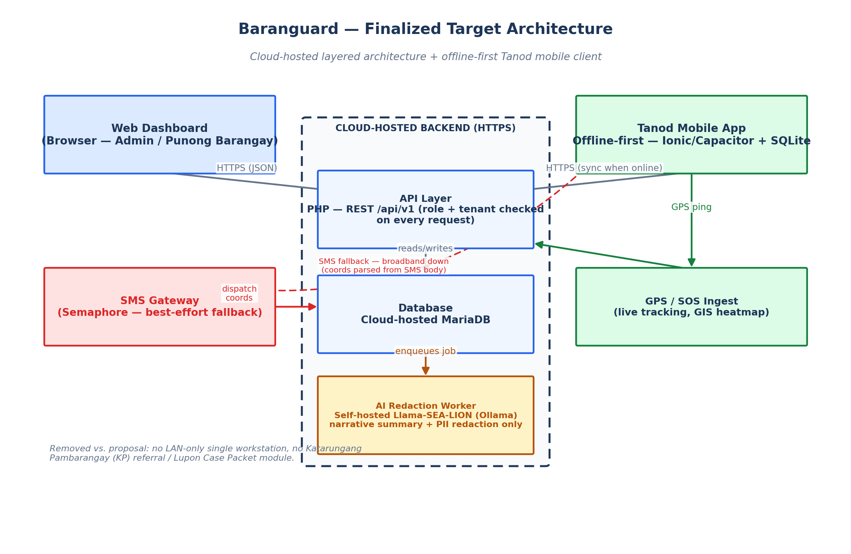
Figure 1 — Finalized target architecture: cloud-hosted API/database tier, browser-based dispatcher dashboard, offline-first Tanod mobile client, self-hosted AI redaction worker, and an SMS gateway fallback path.

3.1 Component responsibilities
Component | Responsibility
Web Dashboard | Browser-based interface for Admin (dispatch, users, reports) and Punong Barangay (read-only oversight); talks to the API over HTTPS.
API Layer | Stateless PHP REST API (/api/v1). Every request is checked for role and tenant (barangay) ownership; never trusts a client-side check.
Database | Cloud-hosted MariaDB — the single source of truth for incidents, dispatches, users, and audit history.
AI Redaction Worker | Separate self-hosted process that summarizes and redacts raw incident narratives. The API never calls the model directly, and the model never sees a request that didn't go through the queue.
Tanod Mobile App | Offline-first Android client (Ionic + Capacitor). Captures incident reports, GPS pings, and SOS signals locally in encrypted SQLite, and syncs when connectivity returns.
SMS Gateway | Best-effort fallback channel: when the mobile app cannot reach the API over data/Wi-Fi, dispatch coordinates are sent as SMS and parsed back into the same data store.

3.2 Technology stack
Layer | Technology | Notes
Backend / API | PHP 8.2, REST | No framework dependency — kept deliberately small and auditable.
Database | MariaDB 10.4 | Cloud-hosted in the finalized design (see 3.3 below for current status).
Web Dashboard | Vanilla JavaScript, no build step | Chosen for zero-dependency deployability on limited barangay hardware.
Mobile App | Ionic React + Capacitor, SQLCipher (encrypted SQLite) | Offline-first by design — every write persists locally before the user can leave the screen.
AI / NLP | Llama-SEA-LION-v3.5-8B-R via self-hosted Ollama | Self-hosted specifically so raw narrative text (which may contain personal data) never leaves the system's own infrastructure — see RA 10173 discussion in Section 7.
SMS Gateway | Semaphore API | Used for both the citizen/Admin messaging feature and the Tanod GPS fallback path.

3.3 Implementation status
Working as of this document: the deployed system currently runs as a single-workstation, LAN-only deployment (the pre-pivot architecture), which is intentionally being kept as the pilot/testing environment for the four barangays while the full field workflow (dispatch, GPS tracking, incident intake, AI redaction) is validated. The cloud-hosted migration described above is the finalized target design, not yet deployed — it is planned as the next infrastructure step once a hosting decision is made at the barangay/LGU level. Every other element of the finalized architecture (offline-first mobile client, self-hosted AI worker restricted to summarization/redaction, SMS gateway) is already built and running today.

4. Finalized Database Schema (ERD)
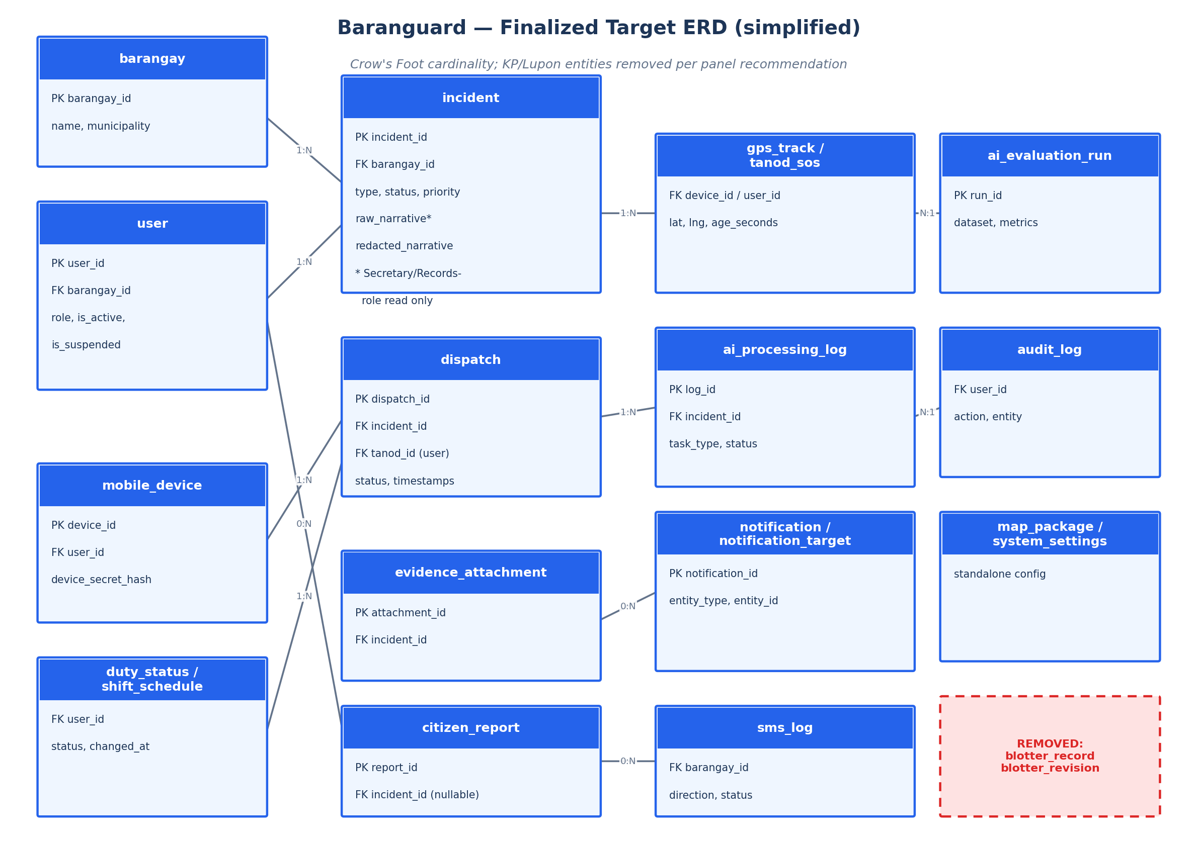
Figure 2 — Finalized target ERD (simplified to primary/foreign keys and defining attributes). blotter_record and blotter_revision are removed from the core schema per Recommendation 1 (see 4.4).

4.1 Schema-refinement checklist
Check | How it was applied
Entity completeness | Every actor and record implied by the narrative — barangay, user, mobile_device, incident, dispatch, gps_track, tanod_sos, evidence_attachment, citizen_report, notification, sms_log, ai_processing_log, audit_log — is a drawn entity, not just implied text.
Attribute definition | Every attribute has a defined type; user.password_hash is explicitly documented as a hashed field, never plain text (bcrypt).
Primary & foreign keys | Every entity has a single-column surrogate primary key; every relationship is expressed as an explicit foreign key (e.g., dispatch.incident_id, dispatch.tanod_id).
Cardinality & participation | Written out in sentence form for every relationship — see 4.2.
Normalization (3NF) | No repeating groups; incident's enum-valued columns (type, status, priority) are single atomic values, not comma-lists; no non-key attribute depends on another non-key attribute.
Referential integrity & cascade rules | Foreign keys that must not silently orphan (evidence_attachment, dispatch, ai_processing_log → incident) are ON DELETE RESTRICT; a deletion is an explicit, ordered, audited operation, never an implicit cascade.

4.2 Key cardinality statements
- A Barangay may have zero or many Users, and a User must belong to exactly one Barangay.
- A User (Tanod) may have zero or many Dispatches, and a Dispatch must be assigned to exactly one Tanod.
- An Incident may have zero or many Dispatches, and a Dispatch must belong to exactly one Incident.
- An Incident may have zero or many Evidence Attachments, and an Evidence Attachment must belong to exactly one Incident.
- A Mobile Device may have zero or many GPS Track pings, and a GPS Track ping must belong to exactly one Mobile Device.
- A Citizen Report may have zero or one linked Incident (once converted), and an Incident may originate from zero or one Citizen Report.

4.3 Data dictionary (core entities)
Entity.Attribute | Type | Constraint | Description
incident.incident_id | INT | PK | Surrogate key.
incident.barangay_id | INT | FK → barangay | Tenant-scoping column, checked on every request.
incident.raw_narrative | TEXT | NULLable, Secretary/Records-role read-only | Original unredacted report text; never leaves the system except through the AI pipeline.
incident.redacted_narrative | TEXT | NULLable | Output of the AI redaction pipeline, after human approval.
incident.status | ENUM | pending / dispatched / resolved | Operational dispatch state.
dispatch.dispatch_id | INT | PK | Surrogate key.
dispatch.incident_id | INT | FK → incident, ON DELETE RESTRICT
dispatch.tanod_id | INT | FK → user | The responding Tanod.
user.password_hash | VARCHAR(255) | NOT NULL, hashed (bcrypt) | Never stored or logged in plain text.
mobile_device.device_secret_hash | VARCHAR(255) | NOT NULL, hashed | Verifies the device on every mobile write.
gps_track.age_seconds | computed | — | Derived at read time; a location older than the staleness threshold is never shown as live.
ai_processing_log.task_type | ENUM | 'redaction' / 'summary' | Restricts the AI worker's job queue to exactly the two tasks Recommendation 2 (system-level) allows.

4.4 Removed from core scope: KP / Lupon entities
blotter_record and blotter_revision (the Katarungang Pambarangay referral / Lupon Case Packet entities) are removed from the finalized core schema. This follows the panel's Recommendation 1 directly: KP mediation is redundant given the national LGU-BIMS rollout, which does not include a KP module either. The two tables and their generated Lupon Case Packet PDF remain present in the current codebase as a complementary, non-core feature — they do not block or interfere with the operational dispatch workflow the system now centers on, and are not part of the finalized design going forward.

5. Process and Data Flow Diagrams
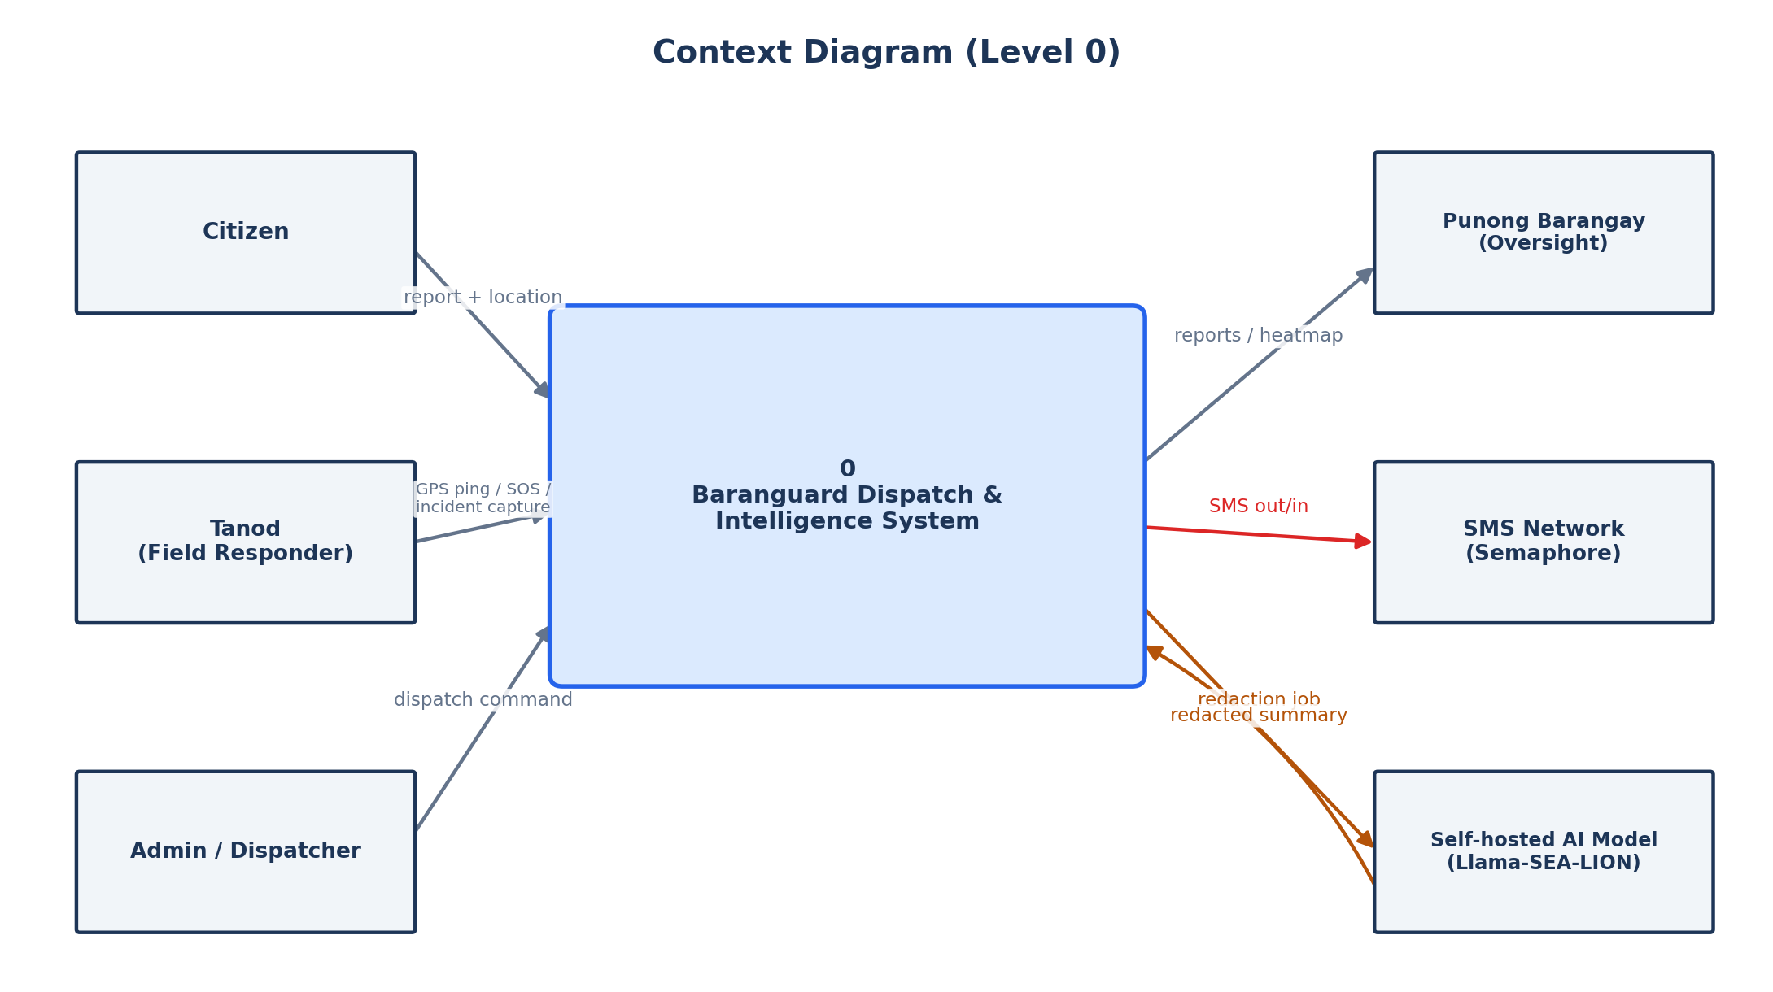
Figure 3 — Context Diagram (Level 0): Baranguard as a single process with its external entities and boundary.
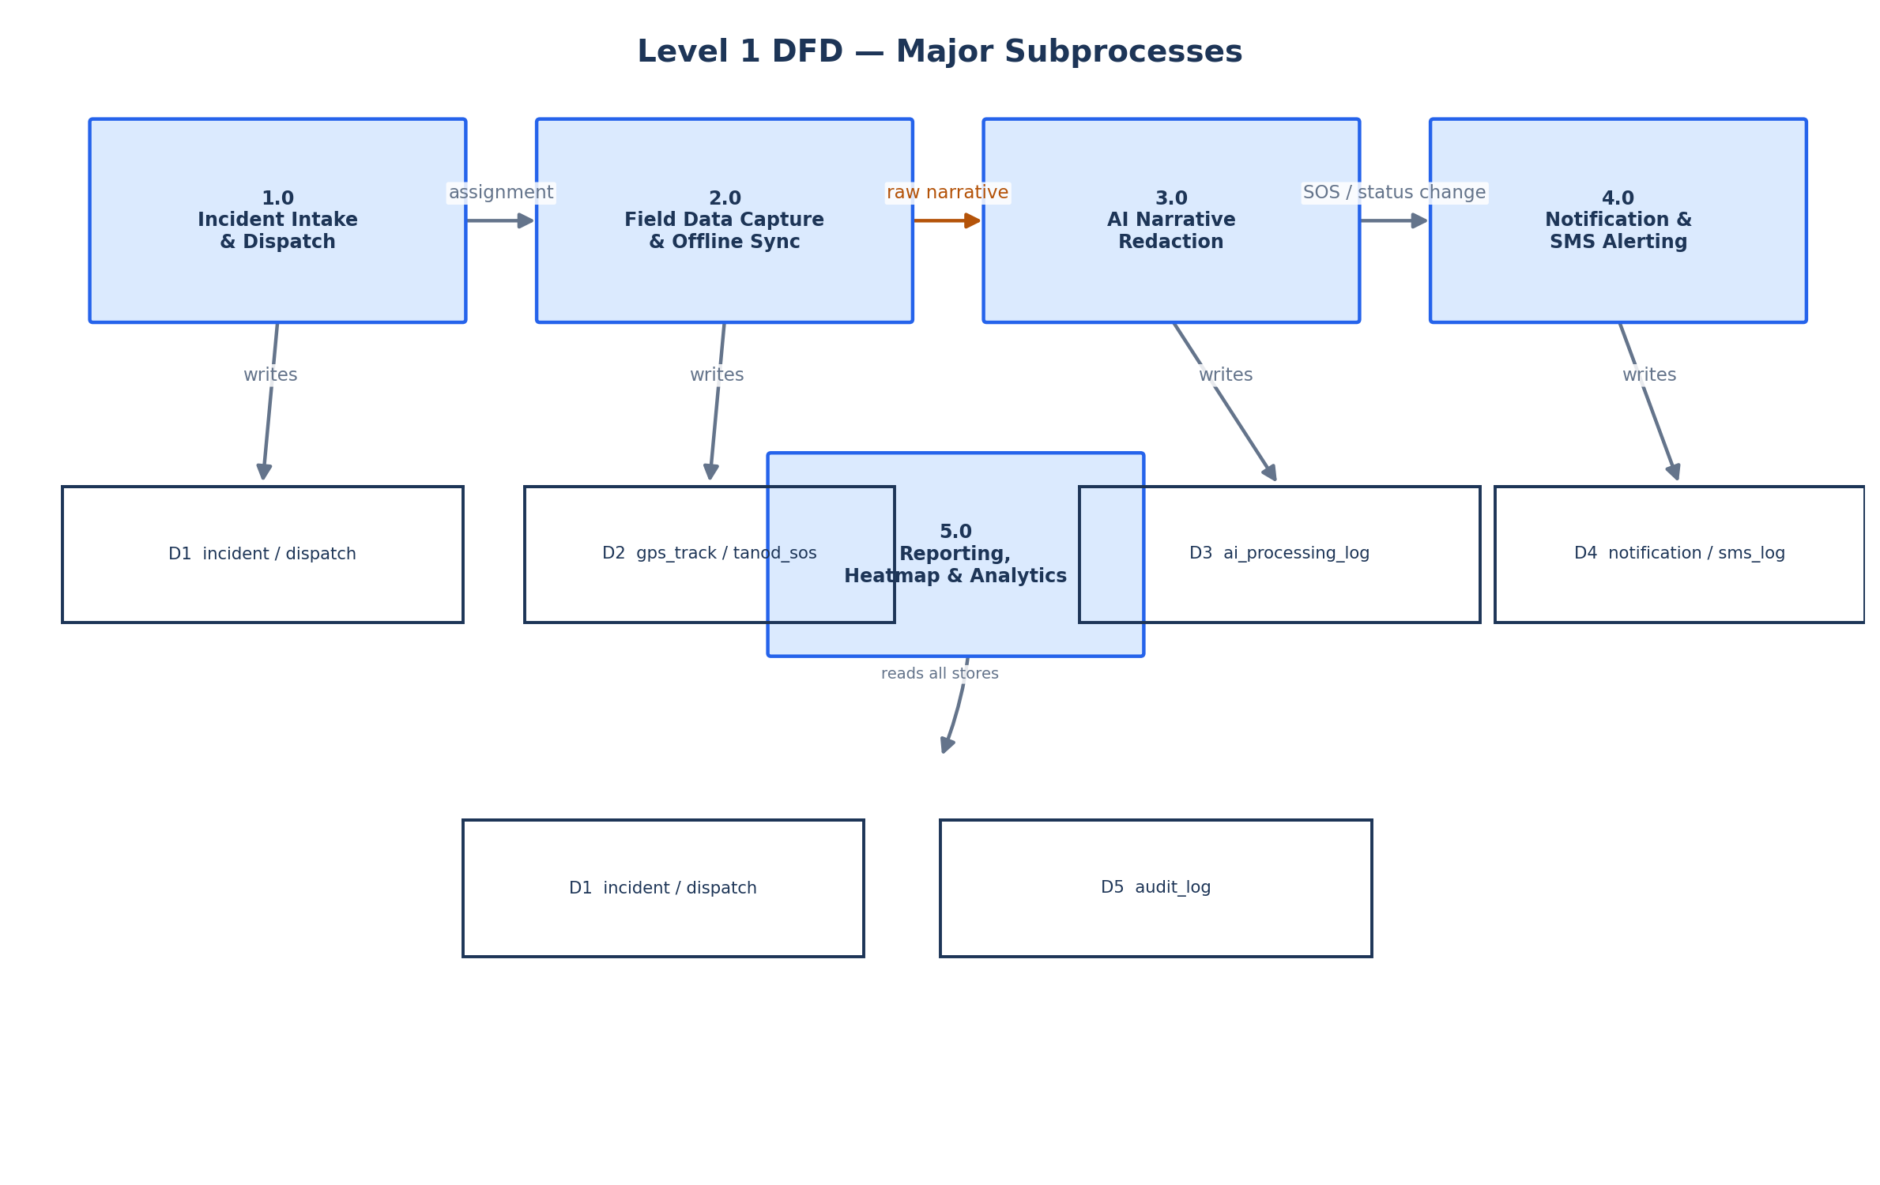
Figure 4 — Level 1 DFD: the five major subprocesses and the data stores each one reads from or writes to.

5.1 Traceability cross-check
Per the Design Review Checklist referenced in the concept review, every DFD data store below maps to a specific ERD entity, and every process maps to a component in the architecture diagram.
DFD Process | Data Store(s) | ERD Entity | Architecture Component
1.0 Incident Intake & Dispatch | D1 | incident, dispatch | API Layer + Database
2.0 Field Data Capture & Offline Sync | D2, D1 | gps_track, tanod_sos, incident | Tanod Mobile App → API Layer
3.0 AI Narrative Redaction | D3 | ai_processing_log | AI Redaction Worker
4.0 Notification & SMS Alerting | D4 | notification, sms_log | API Layer + SMS Gateway
5.0 Reporting, Heatmap & Analytics | D1–D5 (read-only) | all of the above | Web Dashboard

6. Panel Recommendation Traceability Matrix
Recommendation | Resolution | Where documented
Remove KP workflow; refocus on operational dispatch | blotter_record/blotter_revision removed from core ERD; scope narrowed to incident → dispatch → resolution | Sections 4.4, 1
Remove LAN dependency; cloud-hosted + offline-first | Target architecture is cloud-hosted API/DB with an offline-first Tanod app; current LAN deployment is the interim pilot | Sections 3, 3.3
Replace TAM/ISSM with Endsley's Situational Awareness | Perception = live GPS/SOS feed and incident intake; Comprehension = dashboard KPIs, heatmap, and status breakdowns; Projection = dispatch decision support (assign the nearest available Tanod) | Section 3 (architecture is the IPO realization of this model)
Add baseline measurement phase | A pre-intervention baseline (manual dispatch time, manual logging time) is a methodology step performed before Sprint 0, outside this document's system-design scope | Noted here; tracked in the project methodology chapter
SMS fallback for Tanod GPS coordinates | SMS Gateway component added to the architecture as a best-effort path when the mobile app cannot reach the API directly | Section 3, Figure 1
Restrict AI scope to summarization + PII redaction, RA 10173 | ai_processing_log.task_type is constrained to exactly two values; the API never calls the model directly, only a queue worker does | Sections 4.3, 7
Update all diagrams to remove KP, add GIS heatmap + mobile app | This document's ERD, Context Diagram, and Level 1 DFD are the updated versions | Sections 4, 5

7. Design Justification
Most significant design change: restricting the AI integration to narrative summarization and automated PII redaction only (system-level Recommendation 2), enforced end-to-end by the redaction pipeline's own architecture.

Functionality
The pipeline satisfies the requirement that a raw incident report be turned into a shareable, de-identified summary without a human having to manually strip personal details from every report: raw narrative → AI redaction draft → human (Secretary) review → approval → redacted narrative. No step in that chain does anything the panel didn't ask for — there is no open-ended "AI assistant" surface, only the two allowed tasks.

Security
The model is self-hosted (Llama-SEA-LION via a local Ollama instance) specifically so raw personal data never leaves infrastructure the barangay controls — a direct compliance mechanism for RA 10173, not just a stated goal. The API layer never calls the model directly; only a separate worker process does, so a compromised or misbehaving API request can never reach the model with unreviewed data. The raw narrative itself is restricted to a single role (the records custodian) at the database and API level, not just hidden in the UI.

Scalability
Redaction runs as an asynchronous queued job (ai_processing_log), not an inline request — a barangay with a backlog of reports after a disaster does not block the dispatch workflow waiting on the AI worker. The job table is indexed on status and incident_id so the worker can claim the next pending job in constant time regardless of table size.

Problem alignment
The original problem is barangay watch operations lacking a structured, shareable record of incidents. A redacted summary that can be shared with oversight (Punong Barangay) or, eventually, a partner LGU system without exposing a resident's personal details is what actually makes that record usable outside the barangay hall — restricting the AI's scope, rather than expanding it, is what keeps the feature aligned to that problem instead of becoming a generic, unjustified "AI feature."

8. UI/UX Refinement Summary
The dashboard and mobile mockups were reviewed against Nielsen's usability heuristics named in the concept review. Representative examples already implemented:
Heuristic | Where applied
Visibility of system status | A live “Updated hh:mm” timestamp and a loading skeleton on every data-driven screen; an “All Systems Operational” service-health indicator that reflects a real probe, never a hardcoded badge.
Error prevention & recovery | An inverted date range is caught and disabled client-side before the request is even sent, with an inline explanation, instead of surfacing a server error after the fact.
User control and freedom | A Caps Lock warning and a password-visibility toggle on the login form; a cancel/retry path on every failed action.
Consistency and standards | One shared status-pill/token system across every screen, so “Pending,” “Dispatched,” and “Resolved” always render the same color and shape regardless of which screen they appear on.
Match between system and the real world | Incident type and priority options are the barangay's own real vocabulary (theft, disturbance, medical emergency, …), not a generic ticketing taxonomy.
Accessibility | Every chart has a screen-reader-only data-table equivalent; every icon-only control carries an aria-label.

9. Group Identification
Field | Detail
Group Number
Project / System Title | Baranguard: Barangay Intelligence and Emergency Dispatch System
Member 1 (Name and Role) | Baraquiel, Danilyn Kristin M. — Requirements Gathering & Systems Architecture Planning
Member 2 (Name and Role) | Buenosaires, Jayson P. — Lead Researcher / Project Manager & Technical Feasibility
Member 3 (Name and Role) | Macabuhay, Carelyn A. — UI/UX Prototyping & Literature Review Synthesis
Member 4 (Name and Role) | Madrilejos, Polly Cristy P. — Methodology Documentation & Process Mapping
Member 5 (Name and Role)

