Project 1 Test Cases

Purpose: To ensure functionality of the Vigenere cipher in encryption, decryption, and cryptanalysis.

Descriptions: vigenere.py contains encryption and decryption functions. cryptanalysis.py performs frequency analysis on ciphertext to determine the encryption key used and recovered plaintext.

Approach: Each program will receive a one unit test each to demonstrate basic functionality (Test Cases 1 and 2). After passing functional tests, both programs will receive malformed, unorthodox, or lengthy input to perform boundary checks. These will be referred to as “fringe test cases” (Test Cases 3 and 4). Test Case 5 demonstrates input validation on ciphertext.

Language Used: Python v3.7.3

Outline: Each test has the following structure.

Test Case [number]

Program: script title

Input: input
Expected Output: output and relevant explanation

Screenshot(s):

Test Case 1

Program: vigenere.py

Input:
plaintext: ‘hello’
key: ‘dog’
Expected Output: ‘KSROC’

Screenshot(s):
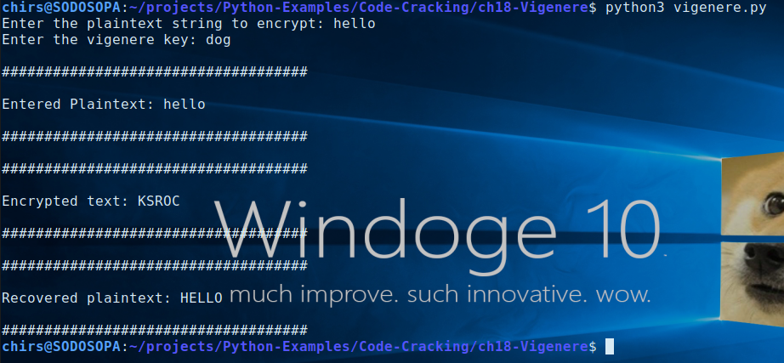

Test Case 2

Program: cryptanalysis.py

Input:
ciphertext: ‘SECGLEYWAMNRJUOTBXLEGGMRQFIHJZCIWLPNFWYETBFGLAYYWTXYGHENLMBRVXZRFLYGAFMGMGHRVBGRSGSBMMUYCTVBMMKHAVESWXNGZTNFSECGLEYQSGWRSGXTGWUAUXUAVZIGAFMHHAYEWZLNTUCAYFYGJRCAYMIQGLIZWWUAUXGBNXMGGBGVLTNRKXSZGNL’

period: 4
Expected Output:

Recovered plaintext: ‘ALITTLEJITTERBUGJERRONSEYMOURGIVESVANDERBILTTHELEADLOOKATTHEDEFENSETIMSTUNNEDIMEANYOUTALKABOUTQUICKFEETTHATSALITTLEDANCEANDGODANCEANDGOTIMSUPHEREGRABBINGMETRYINGTODOSOMEDANCEMOVESTOIMITATESEYMOUR’

Key used: ‘STUN’

Screenshot(s):

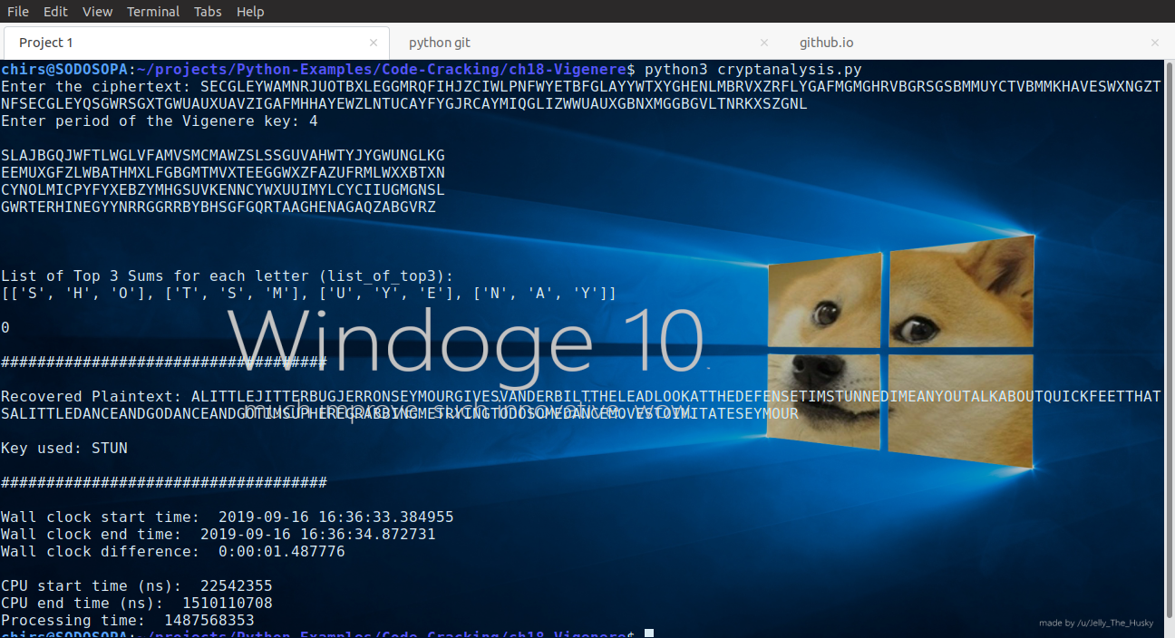

Test Case 3 (Fringe test case)

Program: vigenere.py

Input:
plaintext: ‘This is 0bviou$ly m4lFORm3d +ext’

key: ‘bad
Expected Output: ‘UHLTIVCVLPUOZMOGOUNDHYT’

Screenshot(s):

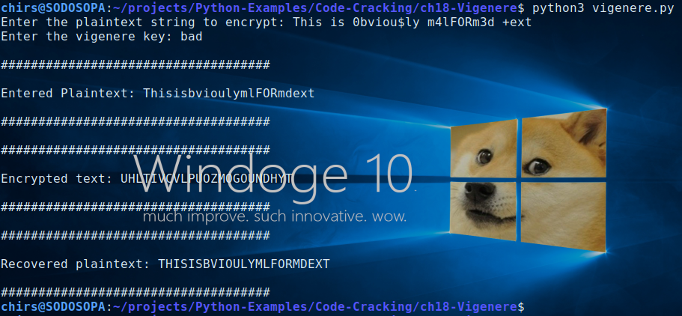

Test Case 4 (Fringe test case)

Program: cryptanalysis.py

Input:
ciphertext: ‘RORZEKNZRGZDPMHMMGRGDSXOAWTZSGFHBZEJQWHMTTCWDBGWAZTIPKAVSQAKZTXVQEMIGOANZWZKDQIKPIKTUJDZGEMNALQLHKNZQDQWFPDXEUBOPQFQNVGNMTXTXUDVNXQCOMMBDLRWGAI’

period: 10
Expected Output:

Recovered plaintext:
‘FOURSCOREANDSEVENYEARSAGOOURFATHERSBROUGHTFORTHONTHISCONTINENTANEWNATIONCONCEIVEDINLIBERTYANDDEDICATEDTOTHEPROPOSITIONTHATALLMENARECREATEDEQUAL’

Key used: ‘MAXIMIZING’

Screenshot(s):

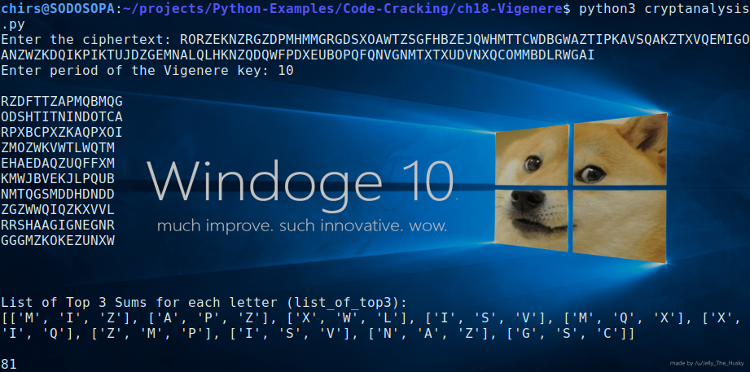
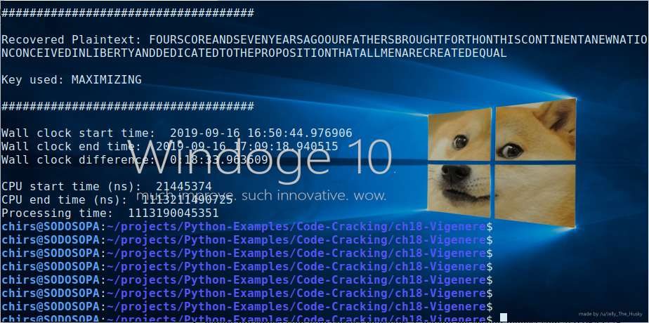

Observations:

Wall clock and CPU times were used to track performance of cryptanalysis.py. Below is the same output from the screenshots for better readability.

```
Wall clock start time: 2019-09-16 16:50:44.976906
Wall clock end time: 2019-09-16 17:09:18.940515
Wall clock difference: 0:18:33.963609

CPU start time (ns): 21445374
CPU end time (ns): 1113211490725
Processing time: 1113190045351
```

The plaintext used was “Four score and seven years ago our fathers brought forth on this continent, a new nation, conceived in Liberty, and dedicated to the proposition that all men are created equal.” using the key “maximizing” to create the input ciphertext. By simply appending the greatest sum to the recovered plaintext, the result of Test Case 4 was a key off by one character; specifically the sixth character ‘X’, to create “MAXIMXZING.” A table of sums can be reviewed when running the troubleshoot script (cryptanalysis-troubleshoot.py). Frequency analysis revealed the sixth character having ‘X’ as the largest sum with the correct character ‘I’ having the second highest sum at 0.0542775.

The current tested version (2.0) fixed this issue by taking the highest three sums of each letter position and creating all possible combinations using itertools.product(). However for a key length of 10, accurate cryptanalysis takes an exponential amount of time to complete; 18 minutes in this test case. For key sizes of greater length, it is perhaps a good idea to use the two highest sums instead of three to reduce calculation time.

Test Case 5

Program: cryptanalysis.py

Input:
ciphertext: ‘SECGLEYWAMNRJUOTBXLEGGMRQFIHJZCIWLPNFWYETBFGLAYYWTXYGHENLMBRVXZRFLYGAFMGMGHRVBGRSGSBMMUYCTVBMMKHAVESWXNGZTNFSECGLEYQSGWRSGXTGWUAUXUAVZIGAFMHHAYEWZLNTUCAYFYGJRCAYMIQGLIZWWUAUXGBNXMGGBGVLTNRKXSZGNL59!!!@~0009475675398392303+++_<>?’

period: 4
Expected Output:

Recovered plaintext: ‘ALITTLEJITTERBUGJERRONSEYMOURGIVESVANDERBILTTHELEADLOOKATTHEDEFENSETIMSTUNNEDIMEANYOUTALKABOUTQUICKFEETTHATSALITTLEDANCEANDGODANCEANDGOTIMSUPHEREGRABBINGMETRYINGTODOSOMEDANCEMOVESTOIMITATESEYMOUR’

Key used: ‘STUN’

Screenshot(s):

