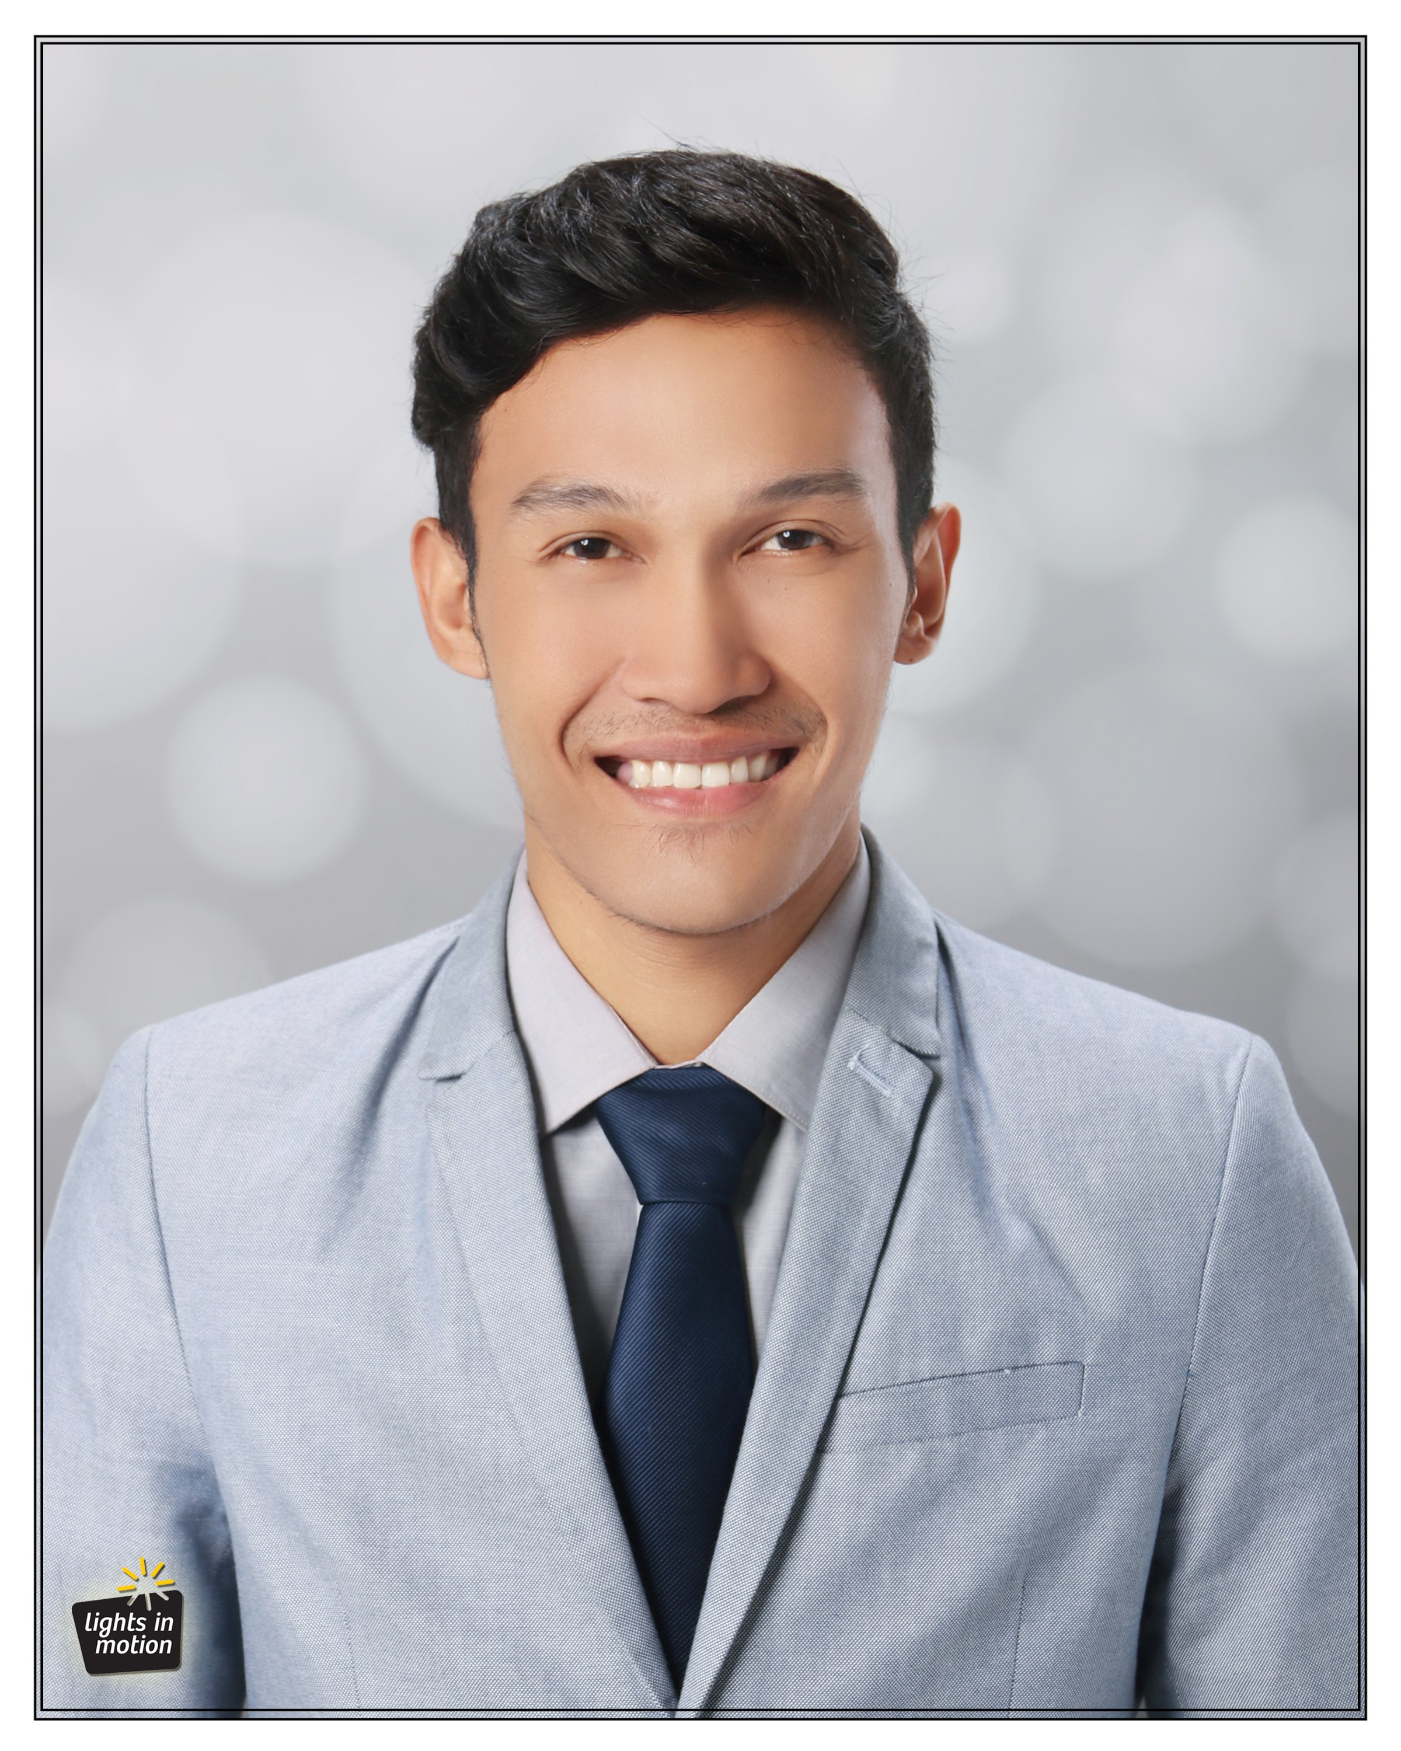**JOHN CHARLES C. TANGAPA**

Address: #263 Zomer Subd. Manga Tisa , Cebu City

Contact No.: 0938-880-4571

E-mail: Tangapjc@gmail.com

**OBJECTIVE**:

Willingness to learn about the actual job as well as my actual skill in my chosen profession.

**ACADEMIC BACKGROUND**:

Primary : Balud Elementary School , Dalaguete Cebu City

(S.Y.2000-2006)

Secondary : Dalaguete National High School (DNHS)

(S.Y. 2006-2011)

Tertiary : BS in Civil Engineering

University of Cebu

Sanciangko St. Cebu City

(S.Y. 2011-2018)

**SKILLS**:

* Basic knowledge in Auto-cad
* Knows how to drive 2/4 wheels vehicles

**ACHIEVEMENTS**:

* Board Passer, CE Board May 2019

**CHARACTER:**

* A team player and good in communication skills
* Flexible , Patient , Honest and Hardworking
* Able to adjust to any work environment

**REFERENCES:**

Mr. Joseph Emerson Johl Subong

Student Affairs Office -Director

University Of Cebu-Main Campus

Tel No. 0998-955-3808

Mr. Greg Belongilot

University of Cebu Main-Campus

Dean of College Engineering

Tel No. 0945-234-1207