Airline Delay and Operations Dashboard
Insights and Recommendations

Insights

Insight 1: Flight Volume
For AirTran Airways in the first quarter of 2011, the dashboard recorded a total of 224,000 flights. This is the baseline volume figure used for the other Executive Summary measures in this filtered view.
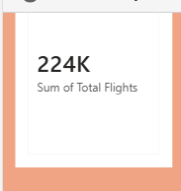
Figure 1: Total Flights card — 224K flights for AirTran Airways in Q1 2011.

Insight 2: Average Departure and Arrival Delay
The average departure delay for AirTran Airways in Q1 2011 is 6.86 minutes, while the average arrival delay is lower at 5.73 minutes. This gap suggests that although flights tend to leave a few minutes late on average, the airline generally makes up a small amount of that time in the air, arriving slightly closer to schedule than it departs.
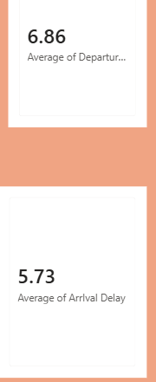
Figure 2: Average Departure Delay (6.86 minutes) and Average Arrival Delay (5.73 minutes) cards.

Insight 3: Cancellations
The dashboard shows 0 cancelled flights for AirTran Airways in this period. This is a strong result, indicating that during Q1 2011 the airline maintained full operational reliability with no recorded cancellations, at least within the filtered view.

Figure 3: Cancelled Flights card — zero cancellations in the filtered view.

Insight 4: Delay Spikes Over Time
The trend chart for January to March 2011 shows that daily departure delays generally stay low, fluctuating between 0 and 100 minutes on most days, aside from an early spike near 220 minutes in January. From February onward, several sharp spikes stand out, reaching roughly 380, 500, and 545 minutes on individual days, with the highest spike occurring in March. This pattern points to isolated severe-delay days rather than a steady elevated delay level, meaning the 6.86-minute average delay figure alone hides these extreme outlier days.
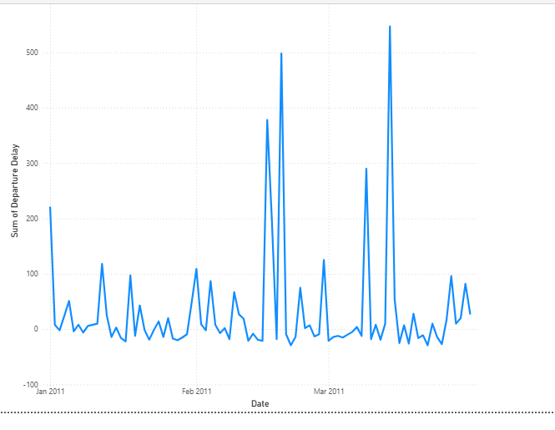
Figure 4: Daily departure delay trend, January to March 2011.

Insight 5: Scope of Current View
All figures above reflect AirTran Airways only, filtered to Q1 2011, since these were the only Airline and Quarter selections active on the dashboard when these values were captured. A full, unfiltered view across all airlines and all quarters is needed to confirm whether AirTran Airways' performance is typical or an outlier compared to the rest of the dataset.
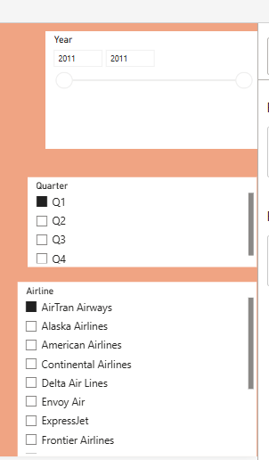
Figure 5: Year, Quarter and Airline slicers showing the filter selections behind these figures.

Recommendations
- Investigate the specific days behind the three major delay spikes (around 500, 380, and 545 minutes) in Q1 2011 to identify whether they were caused by weather, mechanical issues, or operational disruptions, since these outliers have a bigger impact on passengers than the 6.86-minute average suggests.
- Set up daily delay alerts for any day where departure delay exceeds a set threshold (for example, 150 minutes), so severe-delay days like the ones seen in January and February 2011 are caught and addressed in real time rather than only in quarterly review.
- Maintain the current zero-cancellation standard by documenting what operational practices kept cancellations at 0 in Q1 2011, and apply the same practices across other quarters and airlines.
- Compare AirTran Airways' 6.86-minute average departure delay against the other airlines in the dataset (Alaska, American, Delta, Frontier, and others) to determine whether this performance is above or below industry average within the dataset.
- Expand this analysis to a full-year, all-airline view before presenting to senior management, since the current figures are limited to one airline and one quarter and may not represent overall performance.

