Airline Delay and Operations Dashboard
Geographic, Segment and Drill-through Analysis
This section covers the analysis of flight destinations, airline performance, monthly activity and delay patterns in Power BI.

1. Geographic and Segment Analysis

Flight Volume by Destination
The map was used to show how flights are distributed across different destinations. The results show that flight activity is concentrated in certain areas, particularly North America. Some destinations have much higher flight volumes than others.
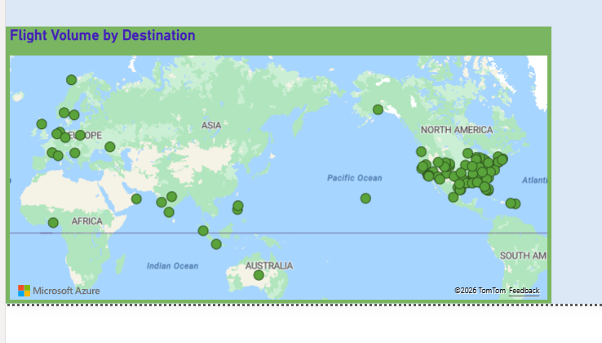
Figure 1: Flight volume by destination.

Airline Performance by Month
The matrix compares airlines across months using Total Flights, Delayed Flights and Severe Delay Rate. For example, in Month 1, Continental Airlines recorded approximately 6,001 flights, while Southwest Airlines recorded 3,667 flights. Southwest had a severe delay rate of 3.9%, compared with 2.5% for Continental.
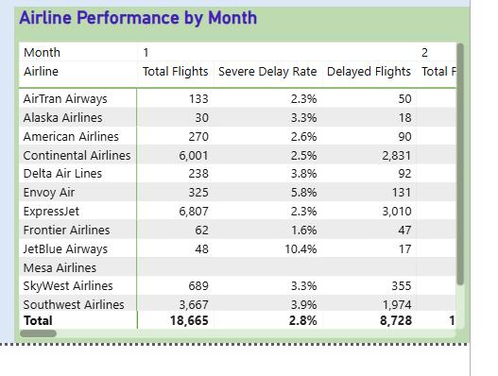
Figure 2: Airline performance by month.

Monthly Flight Activity
The ribbon chart was used to examine changes in airline flight activity across months. It shows that flight volumes vary throughout the year, helping identify possible seasonal travel patterns.
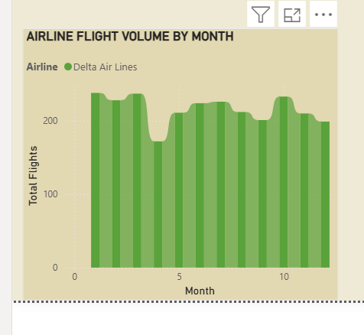
Figure 3: Monthly flight activity by airline.

2. Detailed Airline Analysis
A drill-through page was created to allow users to select an airline and view its detailed performance.
For Delta Air Lines, the dashboard shows:
- Total Flights: 224K
- On-Time Rate: 61.3%
- Average Distance: 723.35
- Total Routes: 4
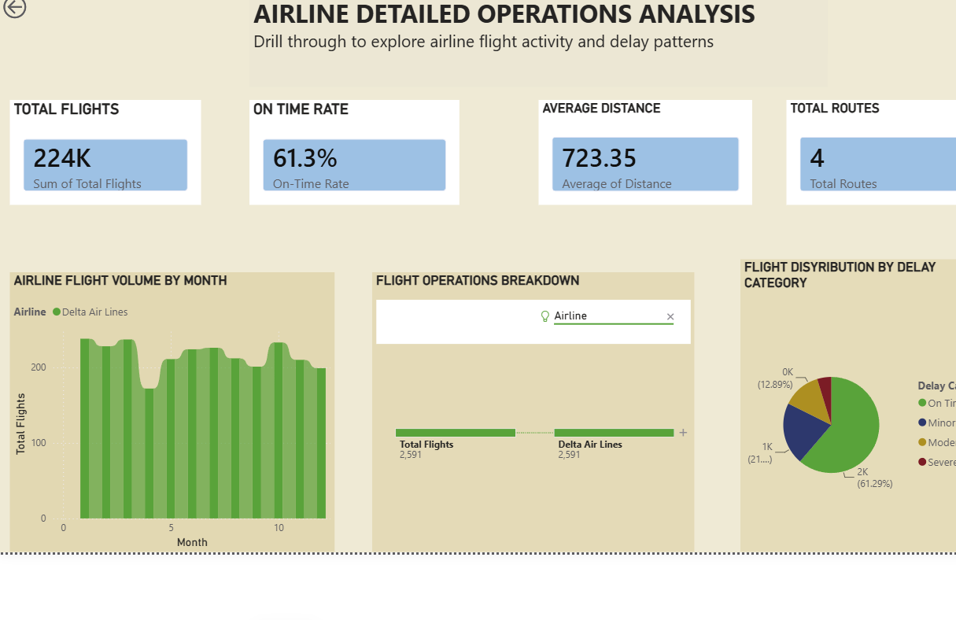
Figure 4: Detailed airline analysis page for Delta Air Lines.
The on-time rate of 61.3% indicates that there is still room for improvement in airline schedule reliability.

3. Delay Category Analysis
The pie chart shows Delta's flight distribution by delay category:
- On Time: 61.29%
- Minor Delay: approximately 21%
- Moderate Delay: approximately 12.9%
- Severe Delay: approximately 4%
The majority of flights were on time, while severe delays represented the smallest category.
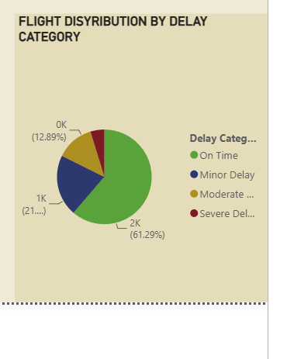
Figure 5: Flight distribution by delay category for Delta Air Lines.

4. Decomposition Tree and Drill-through
The decomposition tree allows total flights to be broken down by airline, destination, month, flight status and delay category. This makes it easier to investigate the factors behind flight activity.
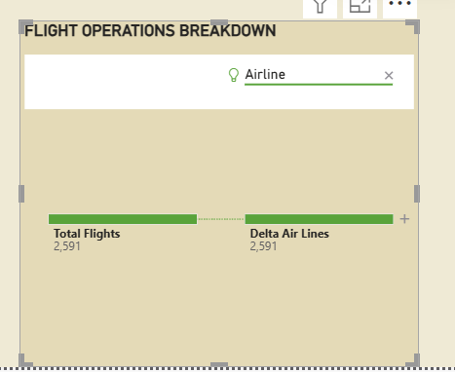
Figure 6: Decomposition tree breaking Total Flights down by airline.
The drill-through feature allows users to select an airline from the main dashboard and automatically move to a detailed airline analysis page.
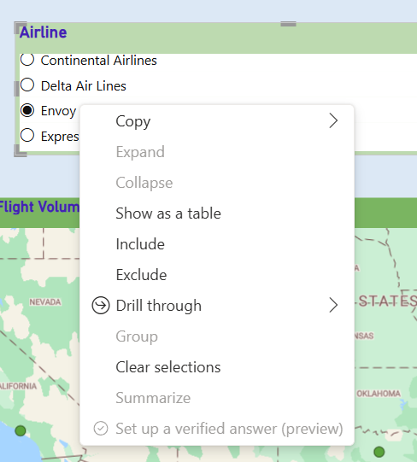
Figure 7: Drill-through option on the right-click menu of the airline selection.

5. Custom Tooltip
A custom tooltip was added to provide additional information when users hover over a visual without overcrowding the dashboard.
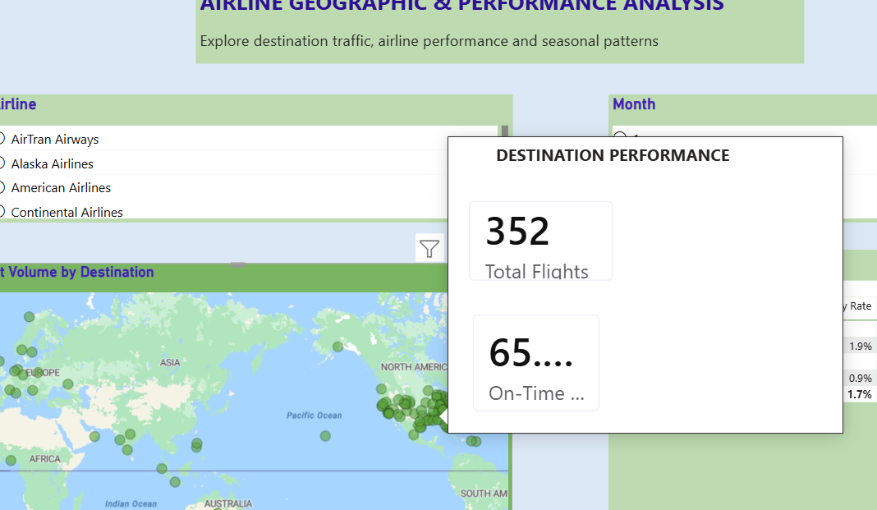
Figure 8: Custom tooltip displayed on hover.

Conclusion
Overall, the dashboard shows that airline operations vary by destination, airline and month. Flight volume is concentrated in certain destinations, while airline performance and delay rates differ between carriers. The interactive drill-through, decomposition tree and tooltip allow users to move from general information to detailed airline analysis and identify areas that may require improvement.

Appendix: Dashboard Pages
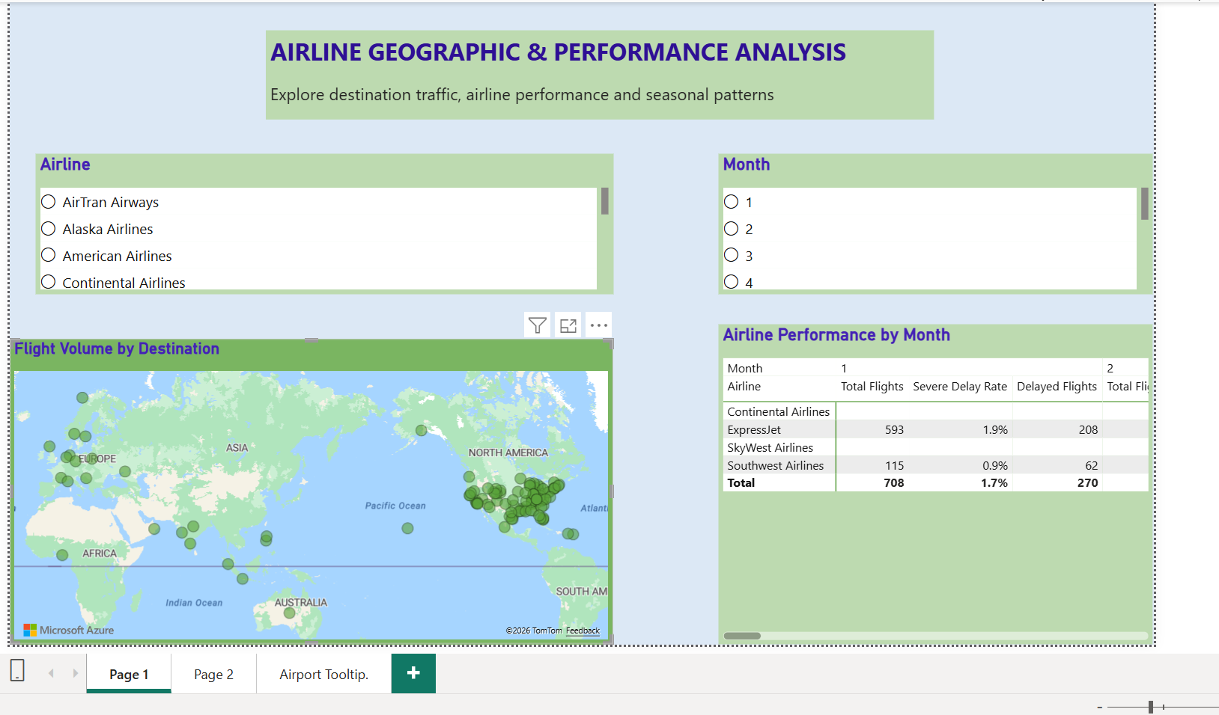
Figure 9: Geographic and Segment Analysis page.
This page presents the geographic distribution of flight activity and allows airline performance to be compared across different months.
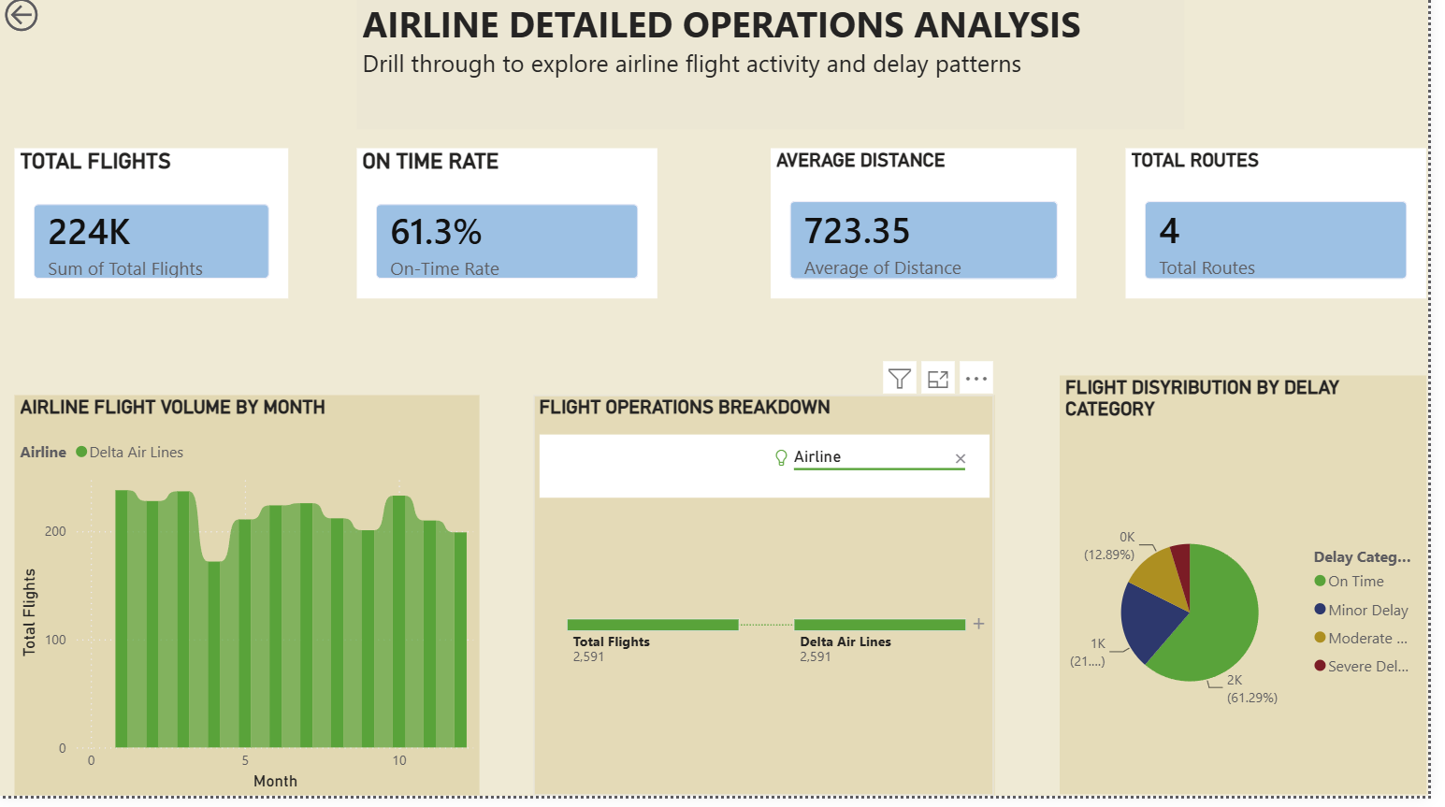
Figure 10: Airline Detailed Operations Analysis page (Page 4).
This page provides detailed information about the selected airline, including total flights, on-time rate, average distance, routes, monthly activity and delay categories.
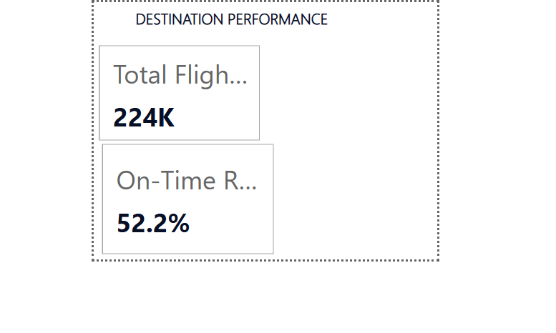
Figure 11: Custom tooltip showing additional destination performance information.

