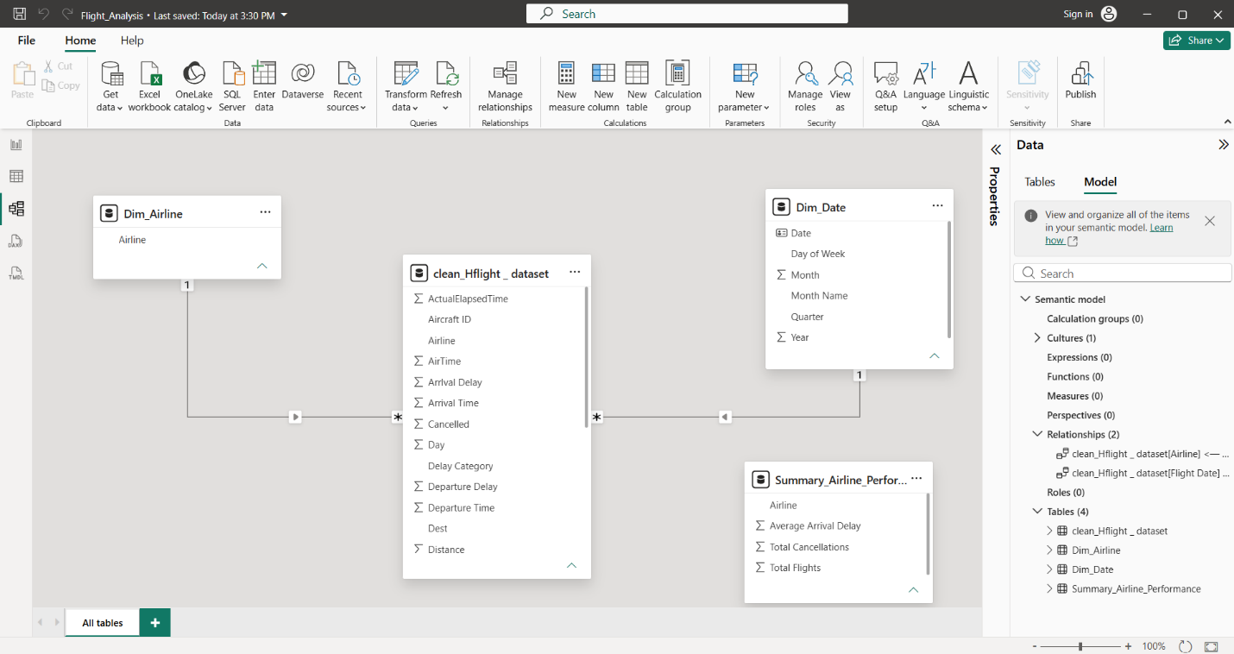

The Power BI data model for the Airline Delay and Operations Dashboard is constructed using a standard Star Schema design pattern. The model separates quantitative transactional data (facts) from descriptive background details (dimensions) to ensure optimal query performance, clear data relationships, and intuitive reporting.
The model consists of four primary tables:
clean_Hflight_dataset (Central Fact Table)
Dim Airline (Dimension Table)
Dim_Date (Dimension Table)
Summary_Airline_Performance (Aggregated Table)
2. Table Classification & Structural Interpretation
A. Central Fact Table: clean_Hflight_dataset
Classification: Fact Table.
Interpretation: This table serves as the primary engine for analysis. It stores individual flight record details and transactional metrics. It contains numerical fields required to calculate Key Performance Indicators (KPIs), such as Arrival Delay, Departure Delay, AirTime, Distance, ActualElapsedTime, and operational flags such as Cancelled.
B. Dimension Tables: Dim_Airline & Dim_Date
- Classification: Dimension Tables (Lookup Tables).
- Interpretation: These tables provide descriptive attributes that allow users to filter, group, and slice the flight metrics stored in the Fact table.
Dim_Airline: Contains distinct airline identifiers (Airline), allowing the dashboard to break down performance, delays, and cancellations by carrier.
Dim_Date: Contains detailed temporal attributes (Date, Day of Week, Month, Month Name, Quarter, Year). This enables trend analysis, identifying peak travel periods, seasonal delay patterns, and month-over-month performance.
C. Standalone Summary Table: Summary_Airline_Performance
Classification: Aggregated Reference Table.
Interpretation: Contains pre-calculated summary metrics (Average Arrival Delay, Total Cancellations, Total Flights) per airline. It acts as an auxiliary table for high-level summary cards or quick verification against detailed DAX measures.
3. Data Relationships and Cardinality
The integrity of the model is maintained through proper database relationships:
- Dim_Airline to clean_Hflight_dataset:
Cardinality: One-to-Many (1:*).
Direction: Single-direction filter flowing from Dim_Airline to clean_Hflight_dataset.
Meaning: A single airline in the dimension table links to multiple flight records in the fact table. Filtering by an airline automatically isolates all relevant flights for that carrier.
- Dim_Date to clean_Hflight_dataset:
Cardinality: One-to-Many (1:*).
Direction: Single-direction filter flowing from Dim_Date to clean_Hflight_dataset.
Meaning: A unique calendar date in the date table connects to multiple flights occurring on that day. Selecting a specific month, quarter, or date range dynamically filters all operational metrics in the fact table.

