

College Of

Computing Technology

BACHELOR OF SCIENCE IN COMPUTER SCIENCE

(Information Technology)

Project Report

**iWasHere**

by

**John-Paul Chirwa**

**2014443**

Supervised by

**Graham Glanville (Dean of School)**

**Dermot Glanville (ICT Faculty Coordinator)**

**April 2018**

# ACKNOWLEDGMENT

Martin Luther King Jr once said “If I cannot do great things, I can do small things in a great way”. This project has been a bridge between my theoretical and working practice, as I have been emancipated with every undertaking of the project I have come to acknowledge the great work and support of those of who saw it from just an idea to a concept of practice as anything worth doing is worth doing right. First of all, I would like to thank the almighty God who has guided me through this academic journey, without his grace this project could not become a reality. I am particularly indebted to my family and friends for all the encouragement throughout the undertaking but most importantly I feel more than obliged to take this opportunity to thank Graham Glanville (School Dean), Dr Muhammed Iqbal, Dermot Glanville, Dr Kyle Goslin and Dr Rory O’Connor including fellow students in the class of 2014 for the support and ideas brought from the beginning to the end of my project. I am extremely grateful for all the support.

JOHN-PAUL CHIRWA

# ABSTRACT

*We live in an era where information is ubiquitous from the substantial pool of data provided by social media and several other media outlets but are we doing enough to make use of this vast availability of data provided to us on impulse. The era of Social media to some is due to last they’re whole life time. We have come to an era where we check our phones approximately 80 times or day or in other terms once every 12 minutes according to certain estimates published by (SWNS, 2017). The majority of this time is spent interacting the biggest social media sites like Instagram, Facebook and Snapchat. The common denominator between these social media platforms available to us is photography. Digital photography and the web as we know it has changed how we take pictures and how we perceive this photography overall.*

*Photography is the art of taking a photo and processing it and the viral use of photography through mobile phones and distributing or sharing a photo has automatically qualified every user to be a photographer by definition. Visual communication has made it clear that the world need less words and more action. Though visual communication has set the bar high on self-explanatory communication it’s still not enough to take a photo and share it without a caption on social media. This project has made an emphasis on what use it is for MR PHOTOGRAPHER with that latest smart phone with an XXXmp camera to take a photo and share the photo without us fully utilizing the data that the digital photo has come available with. The revolution of mobile phone digital photography has made the availability of picture data exploitation beneficial to those that know how to use it to they’re advantage. It is only after careful perusal of this project report that we the “users” of iWasHere will get to understand how a photo literally speaks a thousand volumes.*

*The prime objective of “iWasHere” is to develop a fully-fledged mobile hybrid application with the capacity to capture a picture with accurate location based on API and non API plugins, light intensity, noise levels, temperature levels and general EXIF data based on the user’s mobile phone capabilities and using this data to explore every individuals decision making capacity. Using different criterions “iWasHere” will make it possible for the average user to explore not only a picture but the environment around the picture which has been formatted using different algorithms. As a user visual decision making should go beyond what you see in a picture and what is written about it but include the facts surrounding the picture.*

***Keywords: Hybrid, camera, light, noise,temperature ,EXIF***

# CONCEPT ART

**

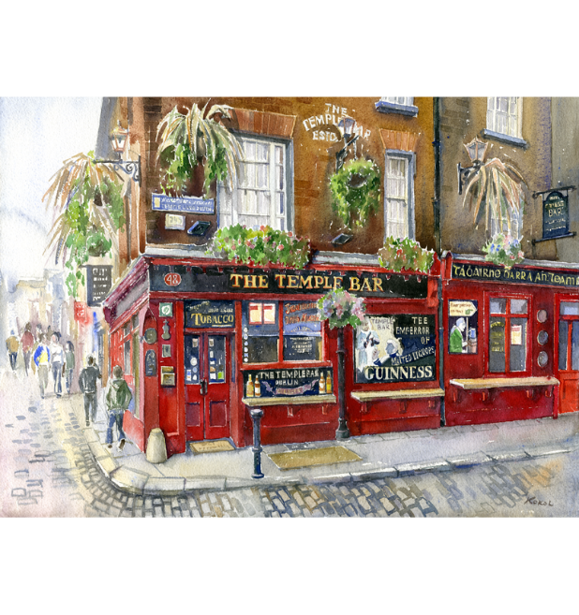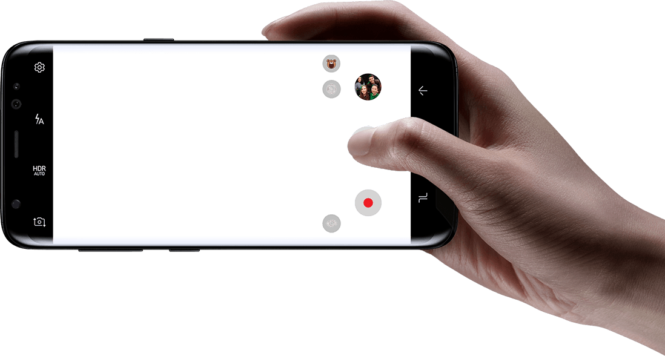

Table of Contents

Acknowledgement 2

ABSTRACT 2

CONCEPT ART 3

INTRODUCTION 5

MISSION 6

PROBLEM AREA OF INNOVATION 6

PROBLEM INVESTIGATION 6

SOLUTION INVESTIGATION 6

AIMS AND OBJECTIVES 7

PROJECT SCHEDULE 9

ASSUMPTIONS & LIMITATIONS 9

ANALYSIS 10

OPPORTUNITIES 12

THREATS 12

COMMERCIALIZATION 13

LITERATURE REVIEW 14

SIMILAR SYSTEMS ANALYSIS 14

SYSTEM DEVELOPMENTMETHODOLOGY 14

PROTOTYPE BUILD 14

WEEK 1 14

WEEK 2 14

WEEK 3 14

WEEK 4 14

WEEK 5 14

WEEK 6 14

WEEK 7 14

WEEK 8 14

WEEK 9 14

WEEK 10 14

SYSTEM SUMMARY 14

PROJECT OUTCOMES VERSUS ORIGINAL PLAN 14

CONCLUSIONS AND FURTHER RECOMMENDATIONS 14

REFERENCE LIST 14

APPENDICES 14

# INTRODUCTION

In a world of technological innovation moving at a rapid pace the idea of fitting this technology on hand held, easy to use devices has brought on a new industry of development with a core objective of targeting mobile applications, camera applications in particular.

Every avenue ranging from social media to IoT is a primary prey for this mega innovation of mobile applications development. These applications are changing the way people communicate through this vast availability of information. The notion behind building iWasHere a mobile hybrid application is to let a user capture a picture in real time and geotag and feed it with as much information readily available to the capacity of their mobile phone for the next registered or better yet anonymous user within a certain proximity for their personal use. The concept behind such a project is to promote not only places and events of surreal interest but all places to the smallest detail to cater for the majority of users that would otherwise disregard the availability of data related to the digital photo captured. The good the bad and the ugly are all forms of events that can benefit majorly from this piece of innovation. From a policing perspective this addresses a problem of substantial evidence gathering and from any online local guide’s perspective the complex world of the unnecessary information gathering and sharing. From a technical angle it fulfills the concept of information gathering like ambience of a room that otherwise would go unnoticed or never used. Believe it or not but the vast majority of users would like to know indirectly or directly about how noisy, warm, cold, dark, light and all sorts of data about a place. In lay man term it simply blends down to this. Deciding between two places? Browse reviews and photos from Mr. and Ms. Anonymous to make a more informed decision. Or even, better, join them and share your favorite places.

In this modern-day technology era it is imperative when developing a mobile application to divert our focus to important aspects like compatibility hence iWasHere mobile application will be compatible with most mobile devices running on both apple (iOS) and android operating systems including several other computer browsers ranging from safari to Firefox. From a business stand point this sort of responsive design for mobile applications demonstrates a bigger goal from that achieved from creating native applications.

This is not a social media application by default, it is merely an affiliation of certain aspects that social media applications have failed to merge in most of the social media applications that exist so far. iWasHere is a piece of application that has the potential of improvising its functionality into certain areas of social media applications. From a criminology aspect of this application it is important to understand that certain legalities can apply and that iWasHere is not a replacement for investigative tools that exist but more of standalone application that would be used towards an investigation.

From planning to implementation this project has not just proved to help the user as an informative platform but a clear undertaking of what the gathering of data can help in predictive analytics over the course of time. For example when we look at the Market Basket analysis which is a modelling technique based on the theory of of buying a certain item you are more than likely to buy another group of items. When we look at this analysis the exponential benefit of this application on a broad scale in the foreseeable future would be targeted marketing of users based on data gathered from the pictures that they have taken.

For a full working mobile application of this caliber to take shape and exist with minimal but functional interaction from a design perspective there was need for a range of resources from a hardware and software perspective which will be spoken about in the chapters to follow.

## MISSION

To help people relay life events for the sake of decision making through pictures for other users by taking pictures and leaving memories. It’s all about tagging it with information you always wish you had. Why this project is good is because by gathering up tools readily available to through different sources I will have managed to put my skills of mobile application building, data analytics and principles of professional practice into practice all at the same time while delivering a project that will benefit most users and hopefully businesses in the foreseeable future.

“A picture is a worth a thousand words but how do I make a choice?”

John-Paul Chirwa

# PROBLEM AREA OF INNOVATION

## PROBLEM INVESTIGATION

We have seen a lot of applications that offer a wide range of options for sharing pictures in a socially available manner with the power lying in the hands of mostly the developer on what information can be shared. A good example is the google maps contributions. This is a local guide platform for location based tagging. You simply contribute to google maps and earn points. By offering a range of benefits rewarded for local guides contribution towards they’re google maps platform they have set a high line towards against they’re competitors. Google allows its local guides to score points through ratings, describe your experience with reviews, share photographs and videos, provide insights with answers, respond to questions about a place, update information with place edits, add missing places, or verify information by checking facts but what it does not do is offer a socially available platform with proximity settings and alternate tagging. A lot of emphasis has been put on data collection for a more dynamic singly system while disregarding the users’ needs. This project aims to tackle the issue of what the user benefits from the system rather then what the system benefits from the user.

## SOLUTION INVESTIGATION

iWasHere tackles this problem of a very limited availability of what the user is looking for specifically. iWasHere will offer not only a platform for local guides but also tackle criminology by advancing the information we already have into a more useful platter. In a nut shell iWasHere is a combination of data availability and the decisions associated with the data from the user’s perspective. This application has a solution to make photographs and videos available in both static 2d and a more sophisticated 3d sort of scenario which is in gif format. This will not only be good for local guides but also good for businesses by cutting down the cost of advertising by more than half. Media marketing should be every businesses main goal in advertising in this innovative world. Media Market describes the set of people that could potentially be exposed to your advertisement and the price you pay for this is the media cost and that’s what this application is trying to cut by offering a way that thriving businesses can come out of the financial and review rabble.

# AIMS AND OBJECTIVES

The main objective of this project is to create a hybrid mobile application with the capability to demonstrate how well data can be used to make formidable decisions based on the fundamental reading of a simple picture. This project aims to make use of unique data that is otherwise discarded by most users of mobile phone technology. Systems and applications have been put in place to gather data but only for the systems purpose, the user has been cut out of the equation. To understand the full scale of the project it is imperative to elaborate a few key aspects in accordance to the actual design of the application. One thing to take key interest is use of the terminology “Native” application.

Hybrid development combines the best (or worst) of both the native and HTML5 worlds. We define hybrid as a web app, primarily built using HTML5 and JavaScript, which is then wrapped inside a thin native container that provides access to native platform features like plugins. Due to the fact that our application is intended for mobile devices it is good to understand that mobile screens are small while apps are big and that’s why we need to be extremely lucid on the difference between a hybrid, an HTML5 and a native application. Native apps are platform specific which has its perks and that is the ability to perform the best while HTML5 just use standard web technologies primarily and typically HTML5, JavaScript and CSS which have the ability for cross platform mobile that work on all sorts of devices but this approach leaves out vital information like access to native device functionality like the camera. It’s for this reason I will be building a Hybrid application. Despite the desirability to have more control of an application in native we have to consider that user experience is an essential part of business, a poor mobile application experience is more likely to discourage a user from using that application again. The approach that I have taken in regards to building my mobile application turns to have a more Minimum viable product approach but can be rapidly spread across platforms while delivering the look and feel of big social players like Instagram and Facebook who are more likely usual suspects of the hybrid market. It remains debatable even on a bigger business scale as to what approach should be taken but that decision is based on the business requirements. The figures below demonstrates the thin lines drawn between these approaches.

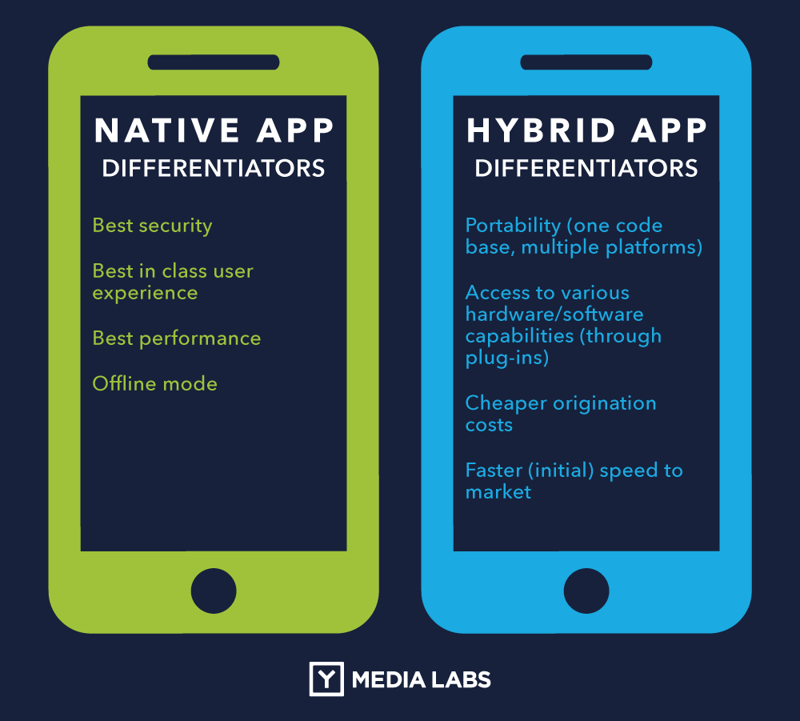

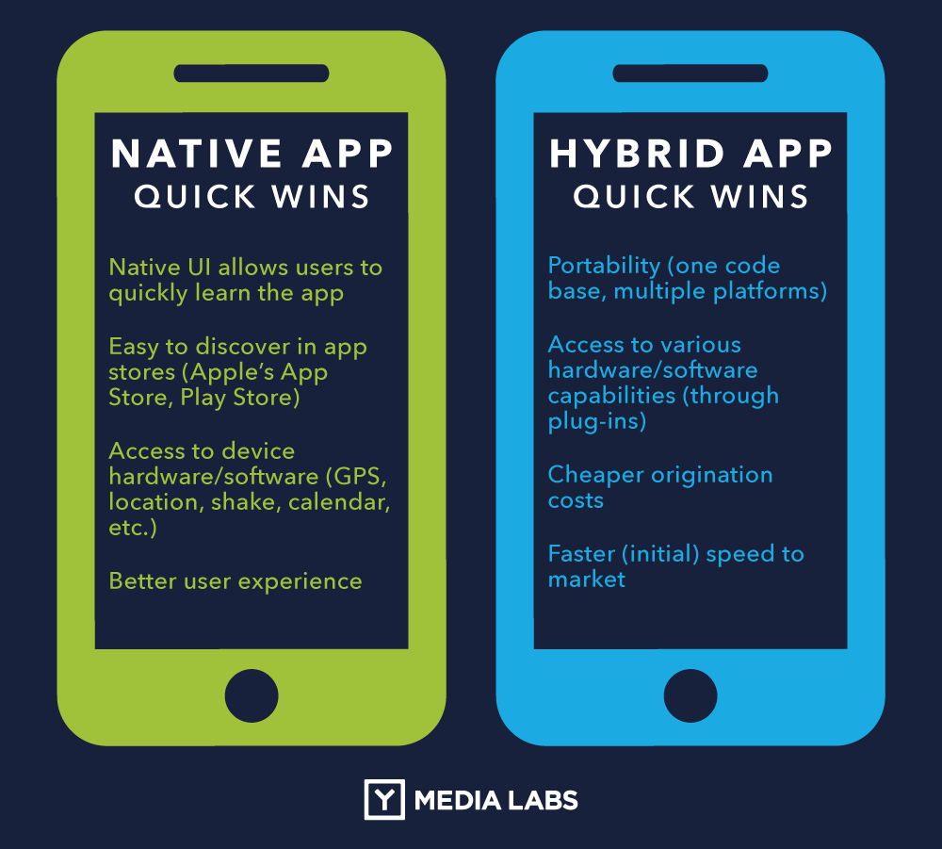

Figure 1: Hybrid VS Native Application approach

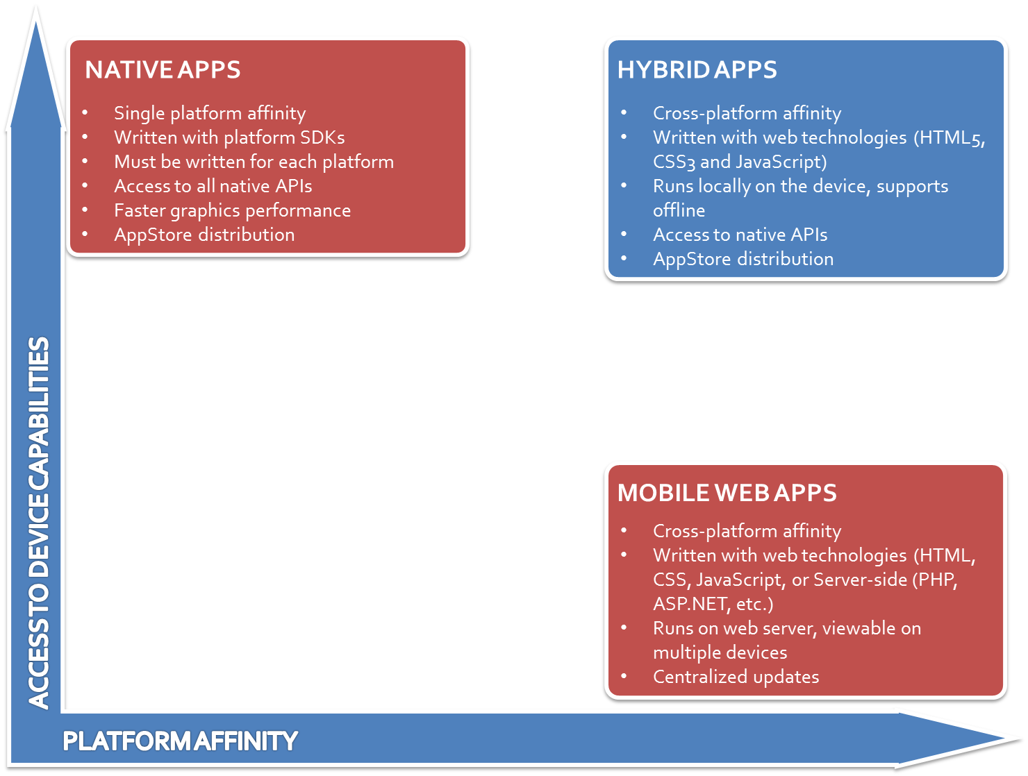

Figure 2 Overview of mobile building approaches

Based on influencing factors including time constraints and platform integration following the requirements of users it makes business sense to build an application over a hybrid platform. To fully appreciate the concept iWasHere tries to deliver to the user a list of aims has been depicted to clearly illustrate the overall application aims.

# PROJECT SCHEDULE

# ASSUMPTIONS & LIMITATIONS

In order to complete this report and application a projected trajectory was put in place as a working schedule throughout the length of the course. As per any other project the delivery corresponding to tasks had to be adjusted accordingly to mitigate problems with project outcomes and deliverables.

This project was limited by the following factors.

1. Limitations in time during exam week and continuous assessment deadlines for the reason that this was the final year in this program.
2. Limited support in the use of the main platform for developing applications which was cordova as most of the plugins that were important to the completion were deprecated or unsupported by specific devices.
3. Due to unforeseen circumstances like bereavement in the family I was left mentally incapable to carry out course work during a crucial time and other unforeseen circumstances including the weather.
4. Restrictions on data following the introduction of the GDPR which most major companies of information that my application would rely on had to adapt to. BY making changes to some of their data protection laws I was left with specific API’s that were considered redundant by the end of the project.
5. General time limitations as this was an ambitious undertaking with a lot of advantages but also functionality
6. As this is a hybrid mobile application a cross device capability is involved but unfortunately access to certain devices like an apple phone for testing was not available.
7. Limitations to similarity in applications as there is no 1 application that addresses a similar issue in one context

For the user experience that is expected to deliver the best results I have made a few assumptions in regards to user and system specific evaluations

1. The user will be using either an android or Apple phone. With an android phone it is expected and assumed that the user uses an android with Android version 7.0.0 or higher with API level 23 or higher. The reason to assume such will be explained in depth in the report.
2. In order to access all the functionalities of the application the end user should have access to the internet from any source like Wi-Fi or 3g as some of the functionality is reliant on an internet connectivity.
3. The user will have accepted permissions to access different device resources embedded onto they’re android device like the camera functionality.
4. The user has an obligation to use the data for a good cause and not to inflict any harm on others
5. The user will have a device that is supported by the application with the ability to access Google play store or App Store

# COMMERCIALIZATION

From a business stand point the concept behind such an application is enough to have every investor reach for their pockets with no hesitation. Social media applications are websites and applications that enable users to create and share content or to participate in social networking and when you include tourism features in this social world you bring 2 big worlds together.

Imagine walking into your local pub and using iWasHere to take not just a picture but a short clip of your surrounding and leaving it on the application for anyone using iWasHere who is within your vicinity to use what you have uploaded to make a choice to either visit the pub or not with an inclusion of comments and reviews of the place or better yet as a business that promotes other businesses through tourism imagine the use of market basket analysis to gather all the data from temperature to noise levels of a restaurant to circumvent the tourists you are targeting. This would not just be fun for the user using the application but a major advertising market opening for the local pub and places. Business owners thrive through advertising and spend billions of euros every year on large scale advertising when a simple advertising platform can be easily used for anyone to use and contribute. These business owners only viable option especially in a striving business is to target an era of social media boom where sharing of pictures on the go plays a major advertising role. Paying for business advertising on the application would not only be cheap but necessary in a competitive scale. The return on investment is nothing compared to the CAPEX and OPEX aspect of this investment for any investor who has any interest in being a part of this innovation too.

In the interest of identifying business needs in the foreseeable future and determining the solutions to my business problems i will apply the MoSCow tool for my software development process in order to reach a common understanding with all interested stakeholders on the important role they place in the delivery of requirements. It stands for Must have, Should have, Could have, and Won't have. iWasHere will be broken down into the following stream. There has been a need of prioritization because of the time and potential funding constraints hence the more agile development approach.

|  |
| --- |
| **MoSCow Analysis** |

|  |  |  |  |
| --- | --- | --- | --- |
| MUST | SHOULD | COULD | WONT/WOULD |
| Integration of camera functionality | Hash tagging of pictures | Voice recognition snapping of photos | User personal details |
| Integration of GPS functionality | Tagging pictures | Voice recognition tagging of photos | User login only by registration |
| Mobile phone user permission functionality | Download of high resolution pictures | iWasHere crime scene category | Gaming functionality |
| Photo and video clip upload | 5 star ratings | View of location or event website | Tutorials |
| Location determining | Android widget | Incentives for local guides | User tracking functionality after use |
| Log in and log out with register and anonymous log in module | Regular spot of the day | Local guide tips | Blog |

## OPPORTUNITIES

From a commercial perspective it is safe to say that opportunities commercial wise are looming. The concept of this project leads to a lucrative enterprise based on the following:

1. Information and communication technology (ICT) developments are permeating every aspect of tourism marketing and that’s what this project is dedicated to.
2. Evidence shows that ICT influences nearly every aspect of services marketing and the main stages in the marketing mix (Middleton, 2001).
3. This project will allow even the most neglected spots rise up the ranks with the right form of online social boost as the Internet provides a completely new medium to communicate to targeted customer groups
4. It will be used as a tool for almost all forms of local advertising through photo content.
5. It can enter a larger market in time as a platform of many aspects of e-commerce like reviewing prices
6. It can be used in the criminal justice system hence enough backing from not just a private commercial aspect but also governmental aspect.
7. Easily get recognized as both a business and as a guide.
8. Having a hyper-local application will help us stand out.
9. Users moving to online travel guidance
10. It’s a great way to retain users

THREATS

Every project has threats that have a feasible ability to break the project down or help it tackle the market a little better then it stated. From iWasHere perspective of the commercial aspect of the application the threats include

1. Big data analytics requires enough funding in order to manipulate and store all the data the application processes.
2. A bad review means bad business and would spark a lot of trouble for some businesses.
3. Indirect competitors entering the field to compete directly.
4. Bigger companies wanting to compete directly.
5. This is an exclusive social media engagement
6. Internet subscription chares to shoot up the roof because of content of the application for big data analytics

# LITERATURE REVIEW & SIMILAR SYSTEM ANAYSIS

Technology has evolved tremendously over the years. Picture this: The sun is sinking below the horizon, and it's going to be one heck of a sunset — one for the gram. As you quickly reach out for your phone to capture those vivid, elephant shaped bubbly skies, but the image simply isn’t as beautiful as it appears in real life. This was a common occurrence in nascent days. The functionality of the mobile phone camera evolved tremendously over time with the first camera phones released in 2000 with the ability to only store just about 20 photos and each with resolution spiraling to just about 0.11 to 0.35 megapixels. As technology seems to progress certain basic functionalities were included like self-timers zoom and flash features and not to forget the 1st iterations of what would become the famous filters that we see on social media apps. One thing that stands out the most of the EXIF data which most mobile phones have the ability to integrate in their camera functionality. Some of the applications that had me think of this idea are:

### Google maps contributions

A true giant in user involvement contributing to google maps by sharing photos and reviews lets a user contribute as a tour guide while earning some points. This application combines phone coordinates through google API’s and phone local plugin for coordinates.

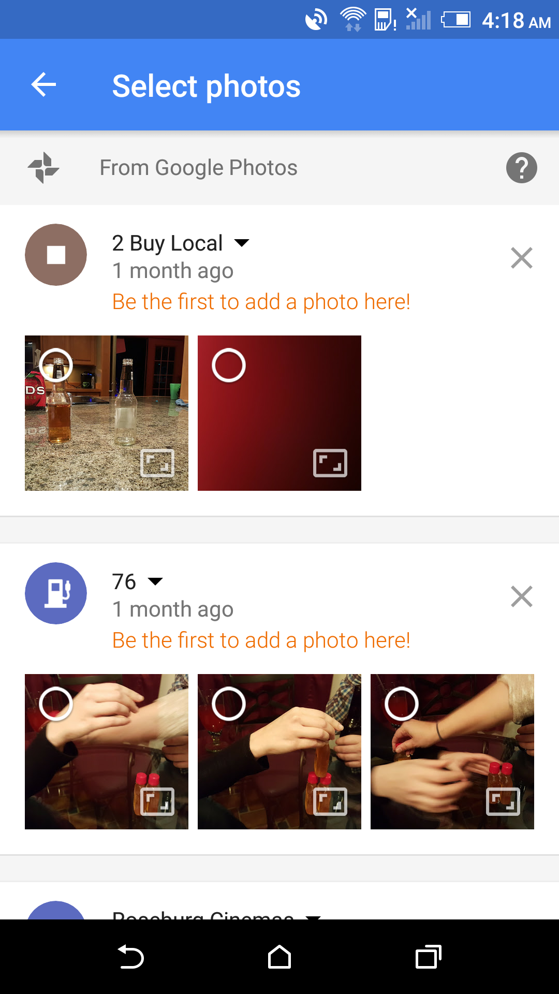

### PhotoMap Gallery

This is a mobile application concentrating on photos, videos and trips. It uses EXIF data in such a way that it’s used not just as a basic Metadata that it is but recalculates EXIF data to include data that a user would find helpful like tracking your trips or your everyday life with the integrated geo tracker. The characteristics of such algorithms are unambiguous.

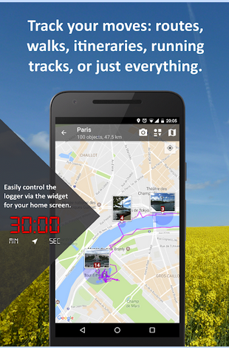

### Photo Forensics

Another great application for analyzing images created by Dafaq Developers for android devices. It combines the informative functionality of image metadata in detail, locations where pictures were taken, the device and software used and color values. This is another application that is used for the best user experience.

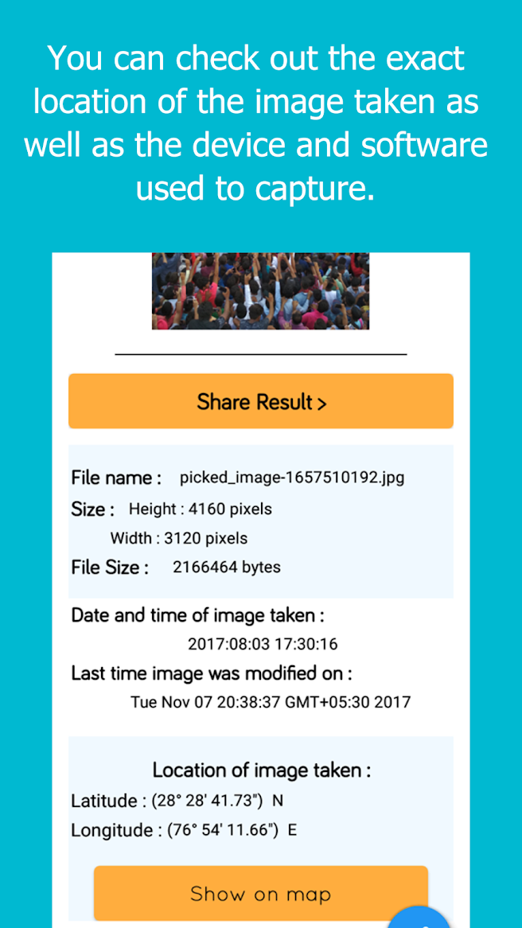

## CONCLUSION

I have carefully analyzed these apps in depth and though these are all informative applications designed for the ultimate user experience they all do just one thing in terms of functionality and the resource they gather that functionality on. They have a primary repository of information which is the EXIF data which is only limited to the phone developers specification. They are missing the element of decision making based on the user’s mobile phone abilities to gather extra information from a larger scale. iWasHere plans to fill out that void where user involvement is of primary consideration by the system through more utilization of the users mobile phone capabilities. The objective is to do more with the functionality that is already available and innovation changes that have added a lot more functionality to device ranges. A lot of mobile applications exist that offer the same concept as iWasHere but to have one mobile application instead of a combination of multiple applications that have to be combined for the ultimate functionality has not existed yet. iWasHere tries to explore the limitations of hardware components available in smart phones.

# TECHNOLOGY

## FRAMEWORKS

### Introduction

To build this flexible mobile hybrid application encompassed the need for a framework. Frameworks make building the application easier based as they act as a template. With new mobile frameworks we are empowered the ability to write and build our application once and run it on different platforms with little less effort. The frameworks that were used include

#### Framework7 & jQuery Mobile

In the interest of a more robust cross platform application the use of Framework7 & jQuery Mobile combined with the power of Cordova/Phonegap offered me the responsive design I was looking for to sit on different platforms ranging from tablets to laptops to mobile phones. Framework7 is more of a free and open source mobile HTML framework used to develop hybrid mobile apps or web apps with iOS & Android native look and feel and that is what I was aiming for.

Both of these frameworks working codependent offer us the power of modern mobile application building technology required.

## LANGUAGE’S

As technology gets better so does ease, flexibility and compatibility. My choice of languages for building this application shifted to a much easier and robust choice that makes the building process somewhat quicker. Initially for native mobile applications the use of JAVA programming as a language was a norm since its open source definition, it is hooked to the Android operating system, it’s independent of platform, and has several uses in the real world, but now with the introduction of other frameworks for mobile application building like PhoneGap it has made it easier and quicker to live the underlying work for example accessing the native phone camera to pre-built open sources readily available. It is for this reason I am also using PhoneGap because a PhoneGap application may only use standards-based Web technologies like HTML, JavaScript, CSS but also make use of network protocols (XmlHTTPRequest, Web Sockets, etc) to easily communicate with backend services written in any language like JAVA. This allows my PhoneGap app to remotely access existing business processes while the device is connected to the Internet which is important to me since this application is gathering geo tagged pictures in real time.

At this stage it’s paramount to know the above languages and how the compare with other languages but just as a recap on the definition and importance of each of the language used during the development of iWasHere:

### JavaScript

This is not primarily a language for mobile app development instead, it is more of a language that is run by different browsers used to develop and control web pages for example the action on click of a basic button on a page. Creating mobile apps with JavaScript is possible but it has to be used with the rest of the other languages stated like CSS, HTML, and AJAX.

The frameworks used to create a professional JavaScript app can be jQuery Mobile and Framework7 which we are all using.

Creating my application in JavaScript was easier because all I have to do is code the app once and it can be released on all the platforms I mentioned which are Android and IOS just to mention a few.

### CSS

Cascading style sheet is a stylesheet language used to describe the presentation of my application. It describes how several components like buttons and text elements should be rendered on screen, on all the devices iWasHere is going to be used on.

### HTML5

This language is primarily used to create content over the internet and is used hand in hand with other languages in order for it to work with JavaScript. My only requirement for building this application is using a powerful framework such as PhoneGap.

## HARDWARE

### Introduction

Mobile devices like Android and apples iPhone come supplied with a lot of hardware features which we can use to develop this application but most importantly we need a computer to develop this app. The following list decibes the hardware components that were used to develop the mobile application

### Computer

My technology choice in computers was a Lenovo y40-70 laptop which encompasses

1. Windows 10 enterprise edition

2. Intel Core i5-4510U 2.0 GHz CPU

3. 8 GB DDR3L of RAM

4. AMD Radeon R9 M275 graphic card

The rational for this choice in a computer is that it has the basic requirement to run Phonegap. Apart from that it holds 8 GB of RAM with an i5 dual core processor which brings speed and efficiency during development of the mobile application.

### MOBILE PHONES

Android or IOS is our primary choice of building platform. Even though this application is somewhat focusing on the two platforms it can be extended to other devices in the future but for now our primary goal is to build it distinctively for Android and IOS platform based mobile phones.

As a developer i find it very important to keep up to date with the latest in technology and that includes the latest version of the android and IOS operating system.

This application supports the latest in both these platforms. Android "Oreo" is the eighth major version of the Android mobile operating system and that will be my test platform. IOS 11.1.2 of the 15B202 build which was released on Nov 16, 2017 is my IOS version of choice for this build.

The reason I chose to build my application on and Android and IOS hosting the very latest in their operating systems on a Phonegap platform is because it addresses several of the bugs that previous versions of the android had. The other rational reason is because I use a SONY Xperia XZ Premium phone which runs on the android OREO operating system which makes testing my application easier if I am not using an emulator. In the interest of compatibility it’s important though to remember that the very latest version of our operating system can support only android and IOS platforms running that new technology and may not work for older versions hence I will be vigilante by testing different versions of the platforms simultaneously.

## SOFTWARE

### Introduction

It’s important to realize that behind all this hardware there is a huge range of software that is available to make iWasHere work. I selected only the most important technology that saw me through the finish of this project in the most efficient manner.

### Phonegap/Cordova

This is one of the most popular tools for mobile hybrid application development. The reason for this choice is that Phonegap is based on Cordova which allows easy integration of a range Java based classes and JavaScript APIs that connect to the device’s native functions such as Camera, Compass, Contacts, and Geolocation all of which were used for my application.With Phonegap there is no need to have a vast professional knowledge for technical native programming languages like one which Android Studio uses but instead the collection of readily available plugins that are ready for any modification with the use of another framework which will either be Framework7 or jQuery mobile making it possible for Rapid Application Development.

Phonegap/Cordova is a very powerful tool for building mobile applications quickly and efficiently but it is not only a framework in its name but also a software or a tool. The core of Apache Cordova applications uses CSS3 and HTML5 for their rendering and JavaScript for their logic. The HTML5 part is a really important part as it provides access to hardware that sits on our mobile phones like the camera for instance. The reason I have chos the use of the Apache Cordova is that it can be extended with native plug-ins, which would allow me to add more functionalities that can be called directly from my JavaScript, making it communicate directly between the native layer and the HTML5 page. These much spoken about plugins allow access to our devices leaning hardware.

The components on my phone that need access using these plugins are

• Camera

• Geolocation

• Compass

• Accelerometer

• Thermometer

• Room Ambiance

The Cordova/PhoneGap desktop application does not only feature the implementation of a framework but also a tool that lets us build a mobile application with ease and the concept of applying already built templates and applying them to your needs. This PhoneGap Desktop applications templates help you build apps quickly with popular features like Push Notifications, Augmented Reality and frameworks like React and Framework7.

I have chosen the use of both PhoneGap desktop app and the PhoneGap CLI because while the desktop app might offer ease by supplying me with a few templates it can only offer just the few templates while the use of the PhoneGap CLI gives me a chance to not only better my skills in Linux commands but also offers flexibility when adding several templates and features of the mobile application am building. Hence to get the PhoneGap CLI working we need additional software namely:

1. Git

2. npm

3. Node.js

4. Android SDK

5. JAVA JDK/JRE

### Genymotion

Genymotion is a fast Android emulator which comes with pre-configured Android (x86 with OpenGL hardware acceleration) images, suitable for my application testing. So instead of using a physical device I will use an emulator for a faster more robust way of testing my application. It also features several Android test operating systems which are hosted on a virtual machine. To get Genymotion to work after installation requires installation of a virtual hypervisor like VirtualBox. This software enables virtualizing Android operating systems. An installed version of 5.0.4 or above and that it runs with no errors.

### Database

Data synchronization and offline capabilities are the bread and butter to successful mobile apps. Choosing the right database is an important part of my application and as such it took me a while to decide what database I want to use but never the less after weighing pros and cons since today’s consumers rely quit a lot on mobile applications which simply put if apps don’t work then people don’t use them. In todays a mobile applications the reliance of an internet connection is almost obsolete due to the fact that their experience could be unpredictable and sluggish so to say. To avoid all this chaos database providers and cloud service provider’s offer this offline and sync capability that enable apps to work offline. These companies include Amazons Cognito and Microsoft Azure mobile Services just to mention a few. This service has allowed mobile applications to store data as need be without relying on backend storage services.

My applications goal is to offer this cloud based offline database that won’t require a client to have an internet connection there and then in order to use other basic services. This simply means my database will be on the cloud but at the same time also maintain a local updated copy of the database which will allow my application to function as normal with or without a network connection. It is for this reason I will use an embeddable database called SQLite for my iWasHere application even though they are a few.

These Embeddable databases are light, self-contained libraries with no server, no administration, and small code print and limited resource requirements. Mobile applications use these to manage and create their own databases with just a few function calls behind the scenes.

SQLite

This is a database option I have chosen simply because SQLite can be a good option to support the storage, security and performance of my mobile application’s data. It is self-contained, highly reliable, embedded, full-featured, public-domain, SQL database engine. SQLite is the most popular database.

# SYSTEM DEVELOPMENT METHODOLOGY

# PROTOTYPE BUILD

## WEEK 1

## WEEK 2

## WEEK 3

## WEEK 4

## WEEK 5

## WEEK 6

## WEEK 7

## WEEK 8

## WEEK 9

## WEEK 10

# SYSTEM SUMMARY

# PROJECT OUTCOMES VERSUS ORIGINAL PLAN

# CONCLUSIONS AND FURTHER RECOMMENDATIONS

# REFERENCE LIST

# APPENDICES