# Name: __Joseph Coker_____

# Netid: _____Jpc496______

1. Correct Design part 1 (40 pts)

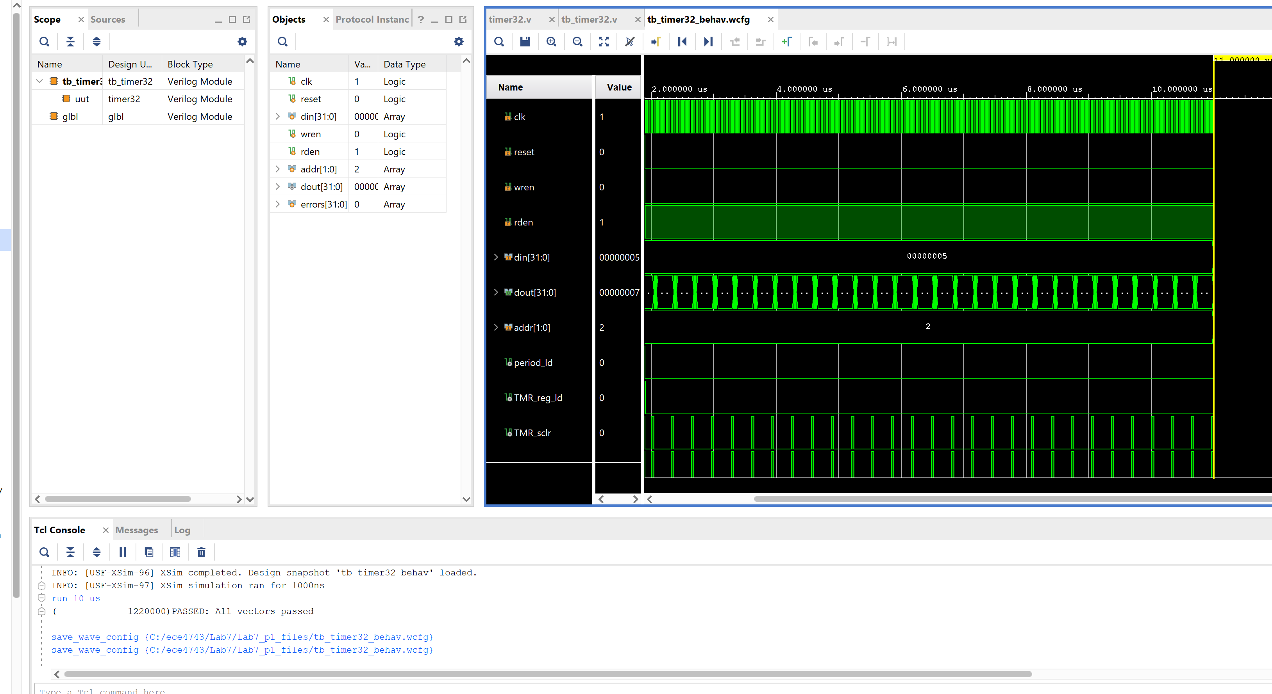

1. Correct Design part 2 (25 pts)

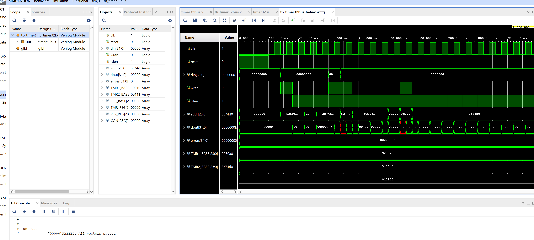

1. Correct Design part 3 (25 pts) with TA checkoff, design resources (Slice Logic, Summary of Registers by Type)
   1. Emailed video to TA. The problem I had in lab time was a much smaller period than what was required, as well as starting with the incorrect project file for the board.
2. (10 pts) Timing Analysis, part 3. Capture a screen shot from the timing analysis of the implemented design that gives the worst slack for Intra-clock paths for our 50 MHz clock (clk_out1_clk_wiz). This design is supposed to run at 50 MHz. Could this design run at 100 MHz based on the slack in the timing report (explain your answer in order to get credit, you cannot just say ‘yes’ or ‘no’).
   1. Yes, it could run at 100 MHz without much change in the timing. The delay is 9.500 NS which is 95 MHz, running at 100 MHz should be okay.

