# Name: __Joseph Coker__

# Netid: _Jpc496____

1. Part 1, Correct Design (50 pts).

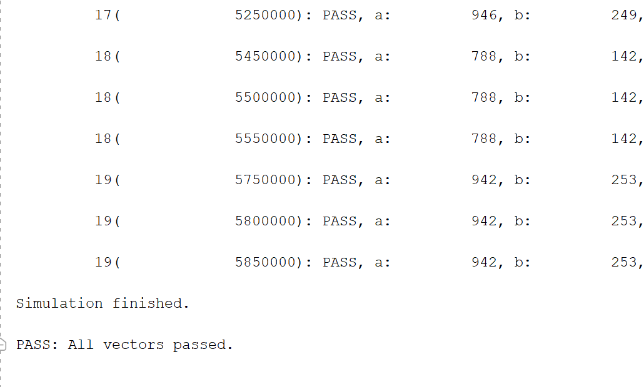

1. Part 1, Resource Tables (Slice Logic, Summary of Registers by Type, DSP) ( 10 pts)

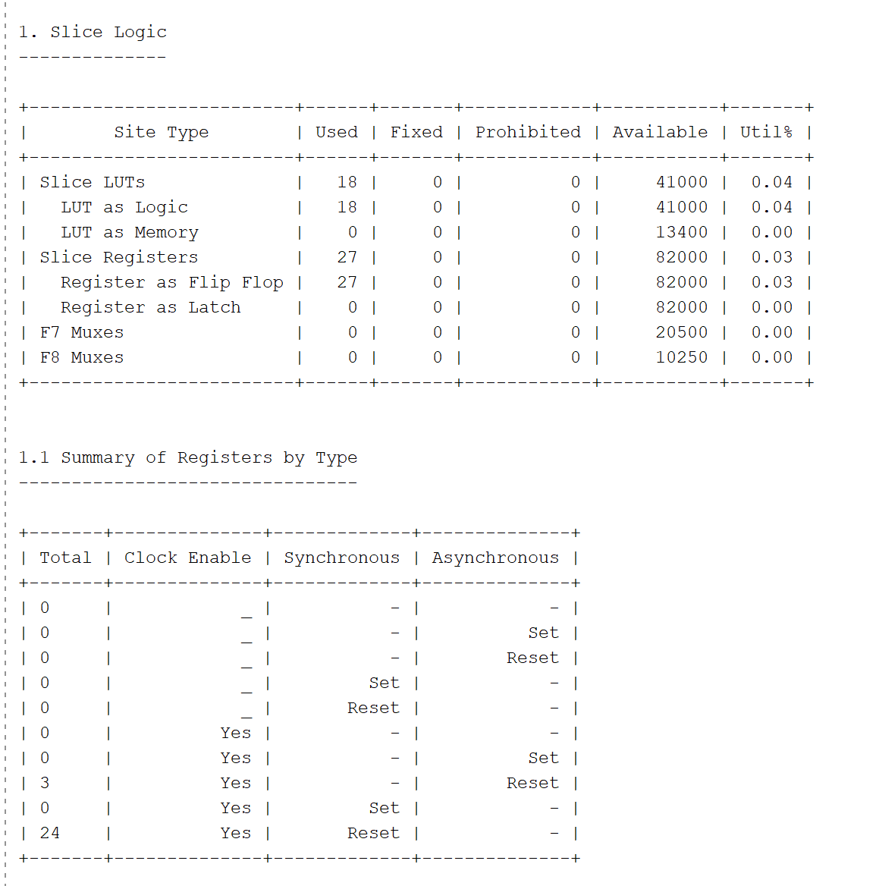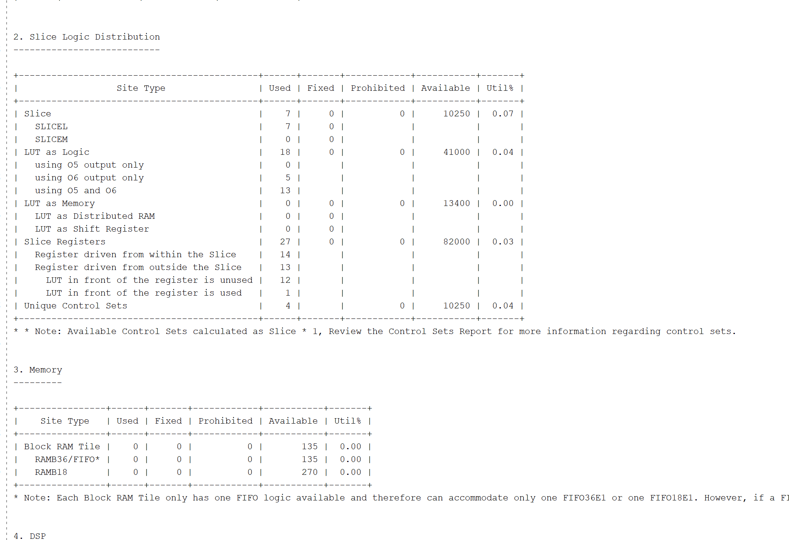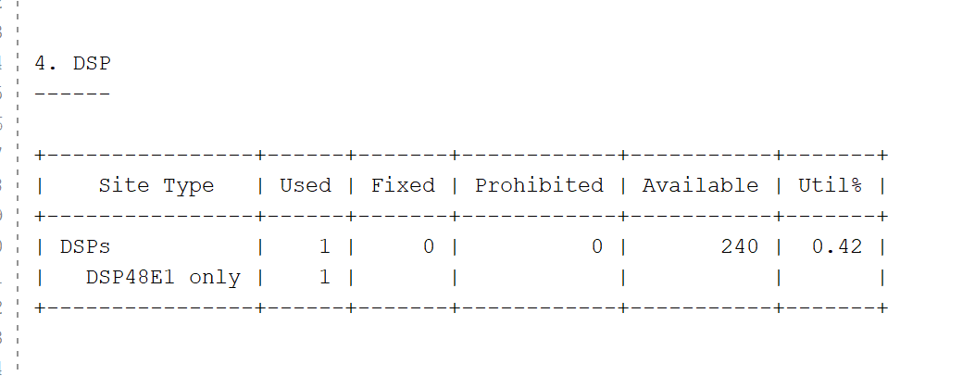

1. Part 2, screenshot of checksum after 100 vectors (Part 2) (10 pts)

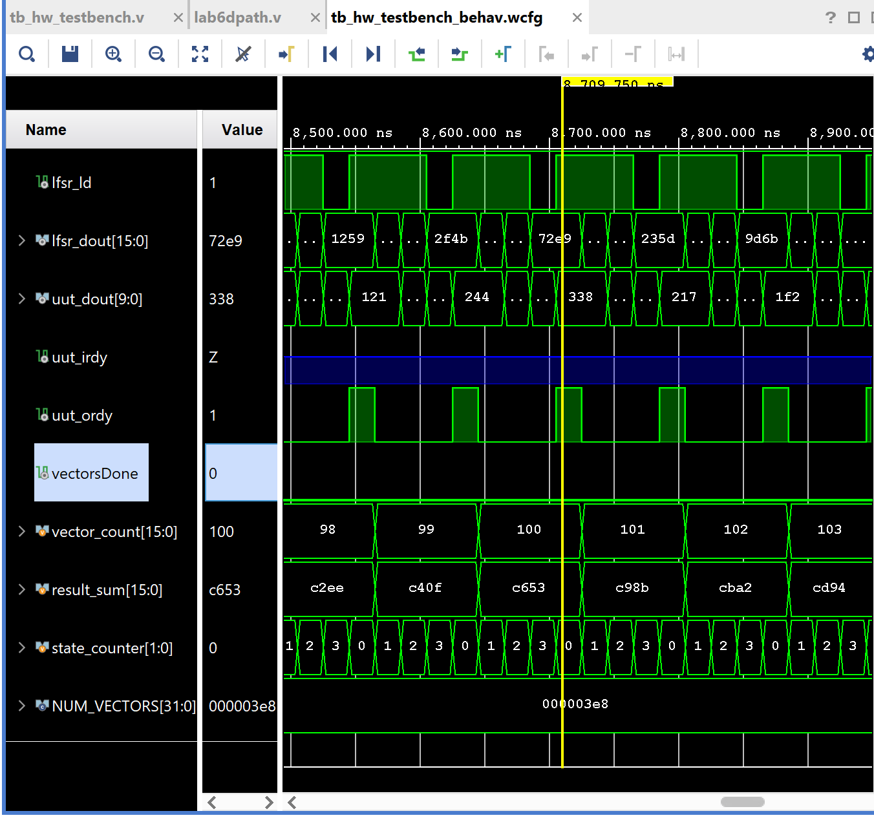

1. Part 2, Downloaded into board and verified by TA (30 pts).

