Status of the lenses in the sample:

Original sample: 21 lenses

Lens we surely drop from the sample
After discussion with Domink, Justin, and Fei decided to drop 3 lenses: 0818 (shorthand for HS0818), 1520, 1600. They are all quite complicated.
- 0818 Complicated environment, never possible to reconstruct it
- 1520 A lot of structure in the line of sight (3 groups including the probable lens and its group in between)
- 1600 SPS really hard (late-type viewed edge-on, a lot of dust) and it gives a really flat stellar mass profile
→ down to 18 lenses

Lenses which are hard to model
Plots of the lenses can be found on the next page. Generally, adding an external mass only changes the time delays significantly but not reconstructed lens.
- 0414 Satellite galaxy
- 0712 Fold lens
- 0911 Satellite galaxy
- 1422 asdf
- 1608 Merger (after discussing it with Prasenjit, model the merging smaller galaxy as a point mass)
- 2045 Cusp lens and satellite galaxy
→ down to 12 lenses without them

My judgement:
- 0414 Not happy with external mass. One of the plots ok like that? Otherwise no idea what to try next.
- 0712 Looks almost ok. Otherwise no idea what to try next.
- 0911 Not happy with external mass. One of the plots ok like that? Otherwise no idea what to try next.
- 1422 Almost there, but I'm a bit worried about the 'lobe'-structure. Fix pixrad (worse with larger pixrad) but maybe higher resolution in the center (9x9) (or ok like that?)
- 1608 Not happy with external mass. Maybe could try a slightly higher pixrad.
- 2045 Very, very hard. I would rather suggest to drop this lens. No idea what to try next.

Lenses which work fine
12 lenses:
- 0047
- 0142
- 0952
- 0957
- 1009
- 1030
- 1104
- 1115
- 1152
- 2016
- 2149
- 2237

Plots of the more problematic lenses

0414
Pixrad 12, shear 0.5, Point mass with mass range: 10⁹-5*10¹⁰
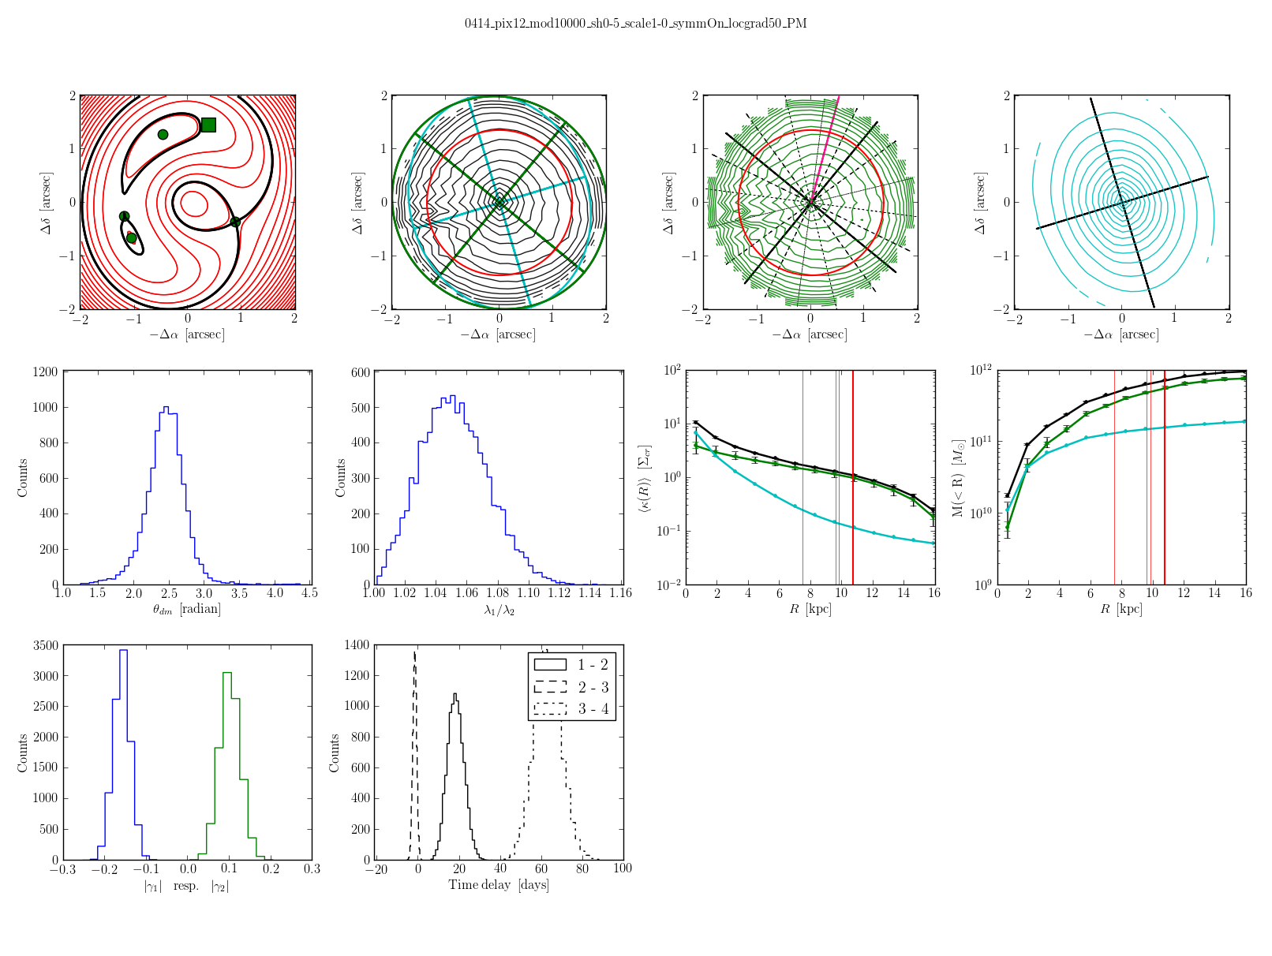
0414
Pixrad 12, shear 0.5, Point mass with mass range 5*10⁸-10¹⁰
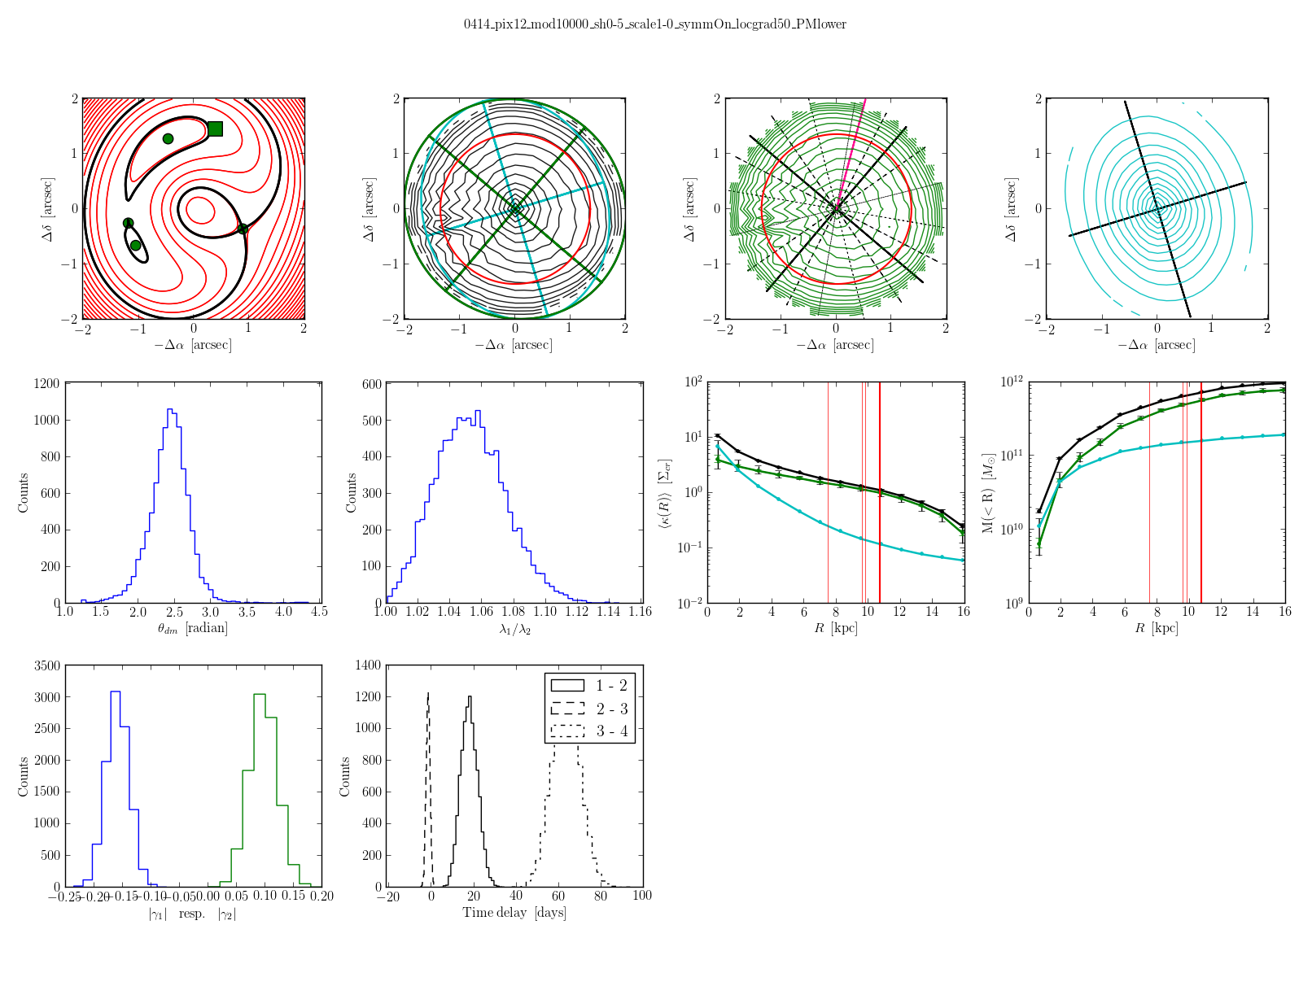
0414
Pixrad 12, shear 0.5, without Point mass
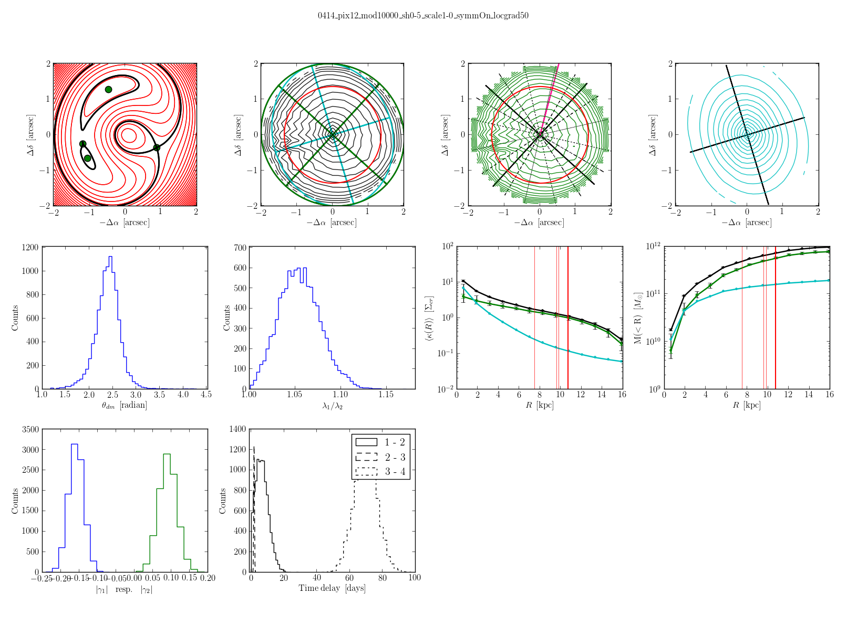
0712
Pixrad 14, shear 0.3
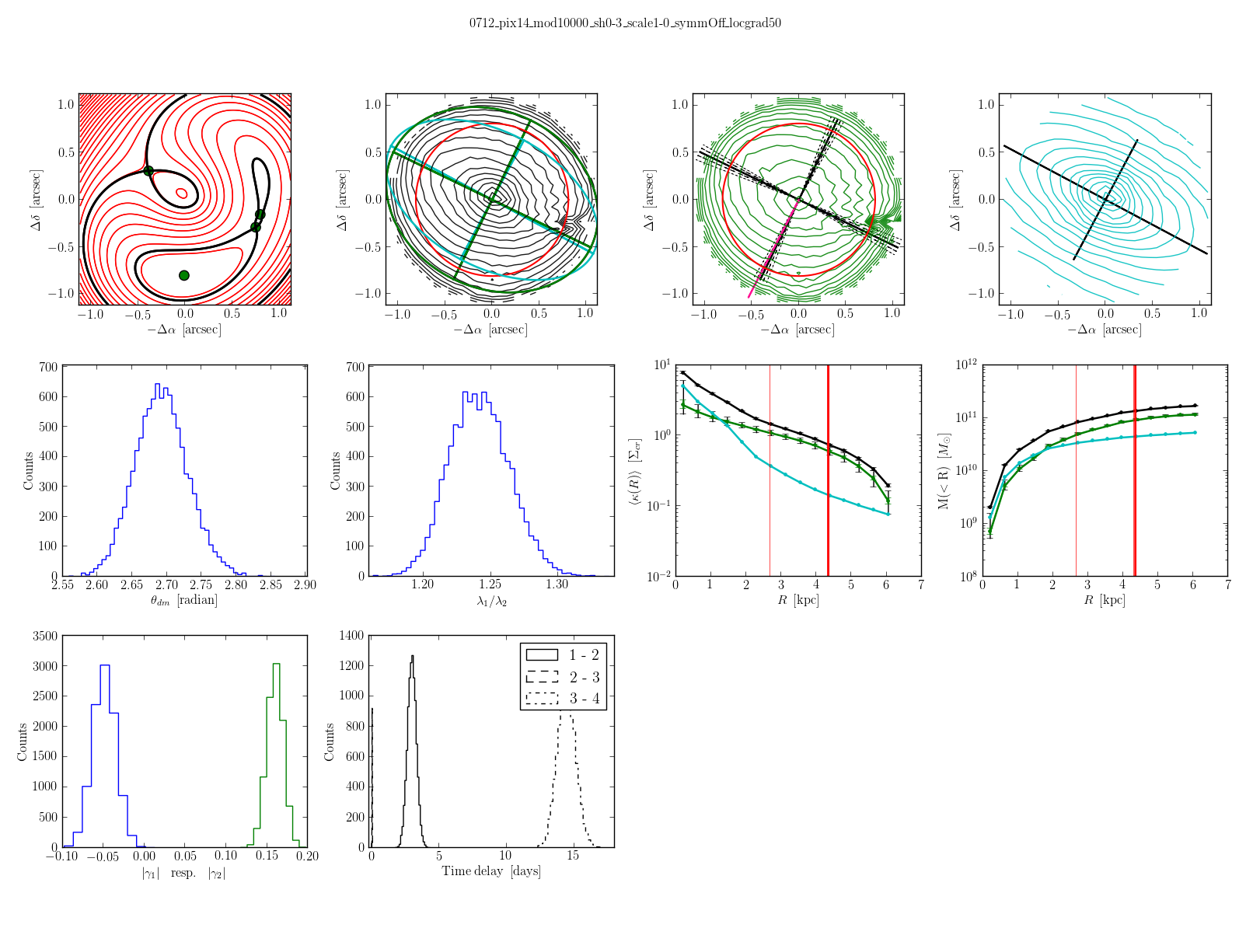
0911
Pixrad 12, shar 0.4, Point mass with mass range 10⁹-5*10¹⁰
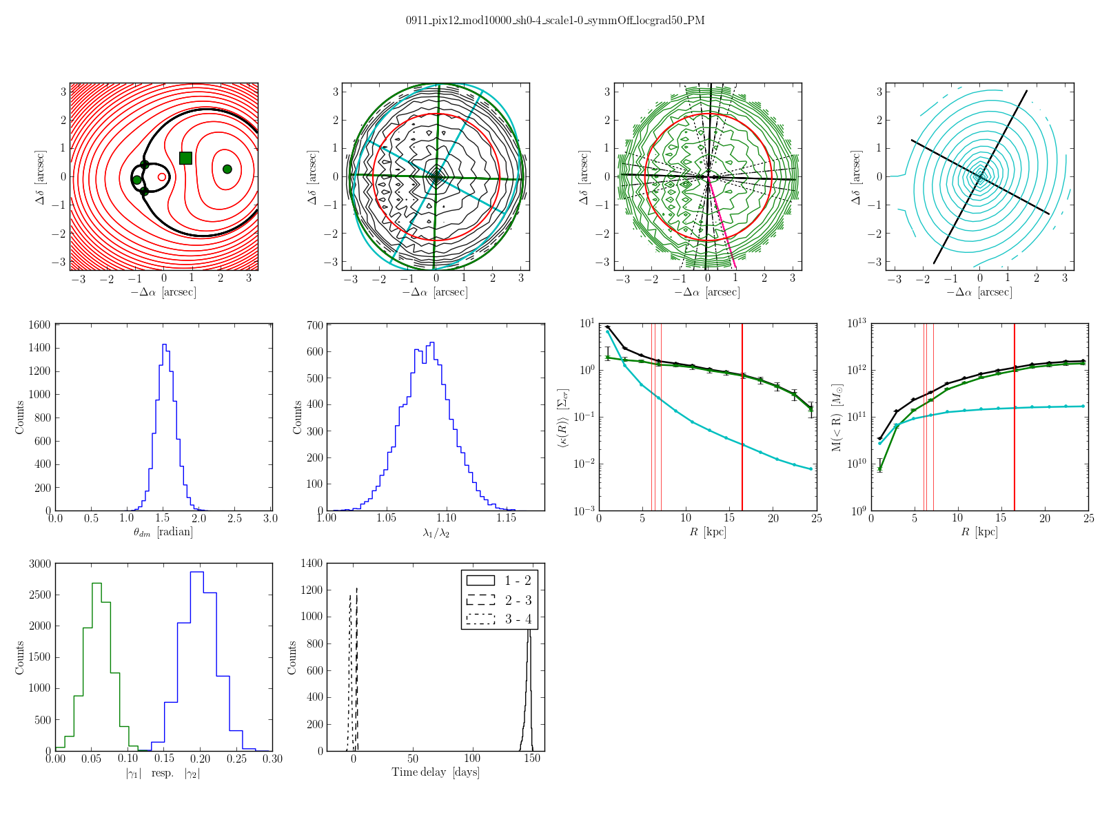
0911
Pixrad 12, shar 0.4, Point mass with mass range 5*10⁸-10¹⁰
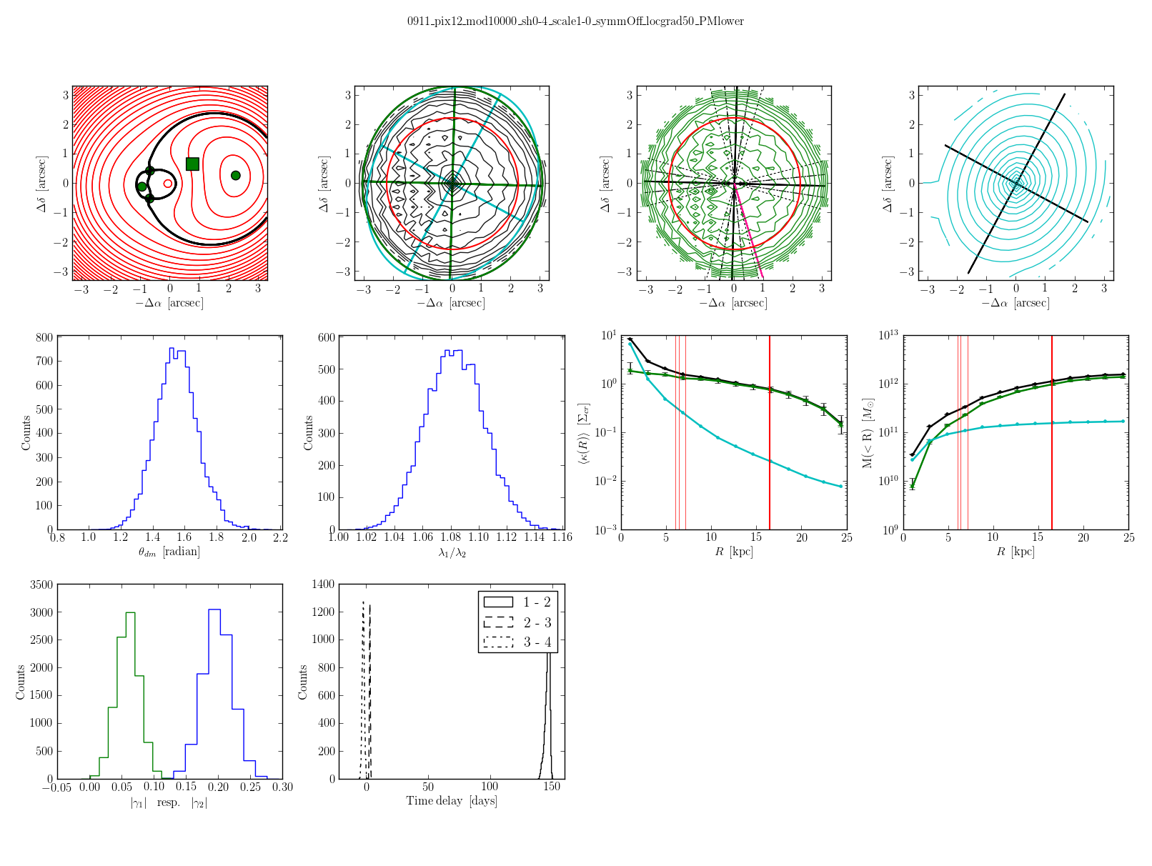
0911
Pixrad 14, shear 0.4, Point mass in mass range 10⁹-5*10¹⁰
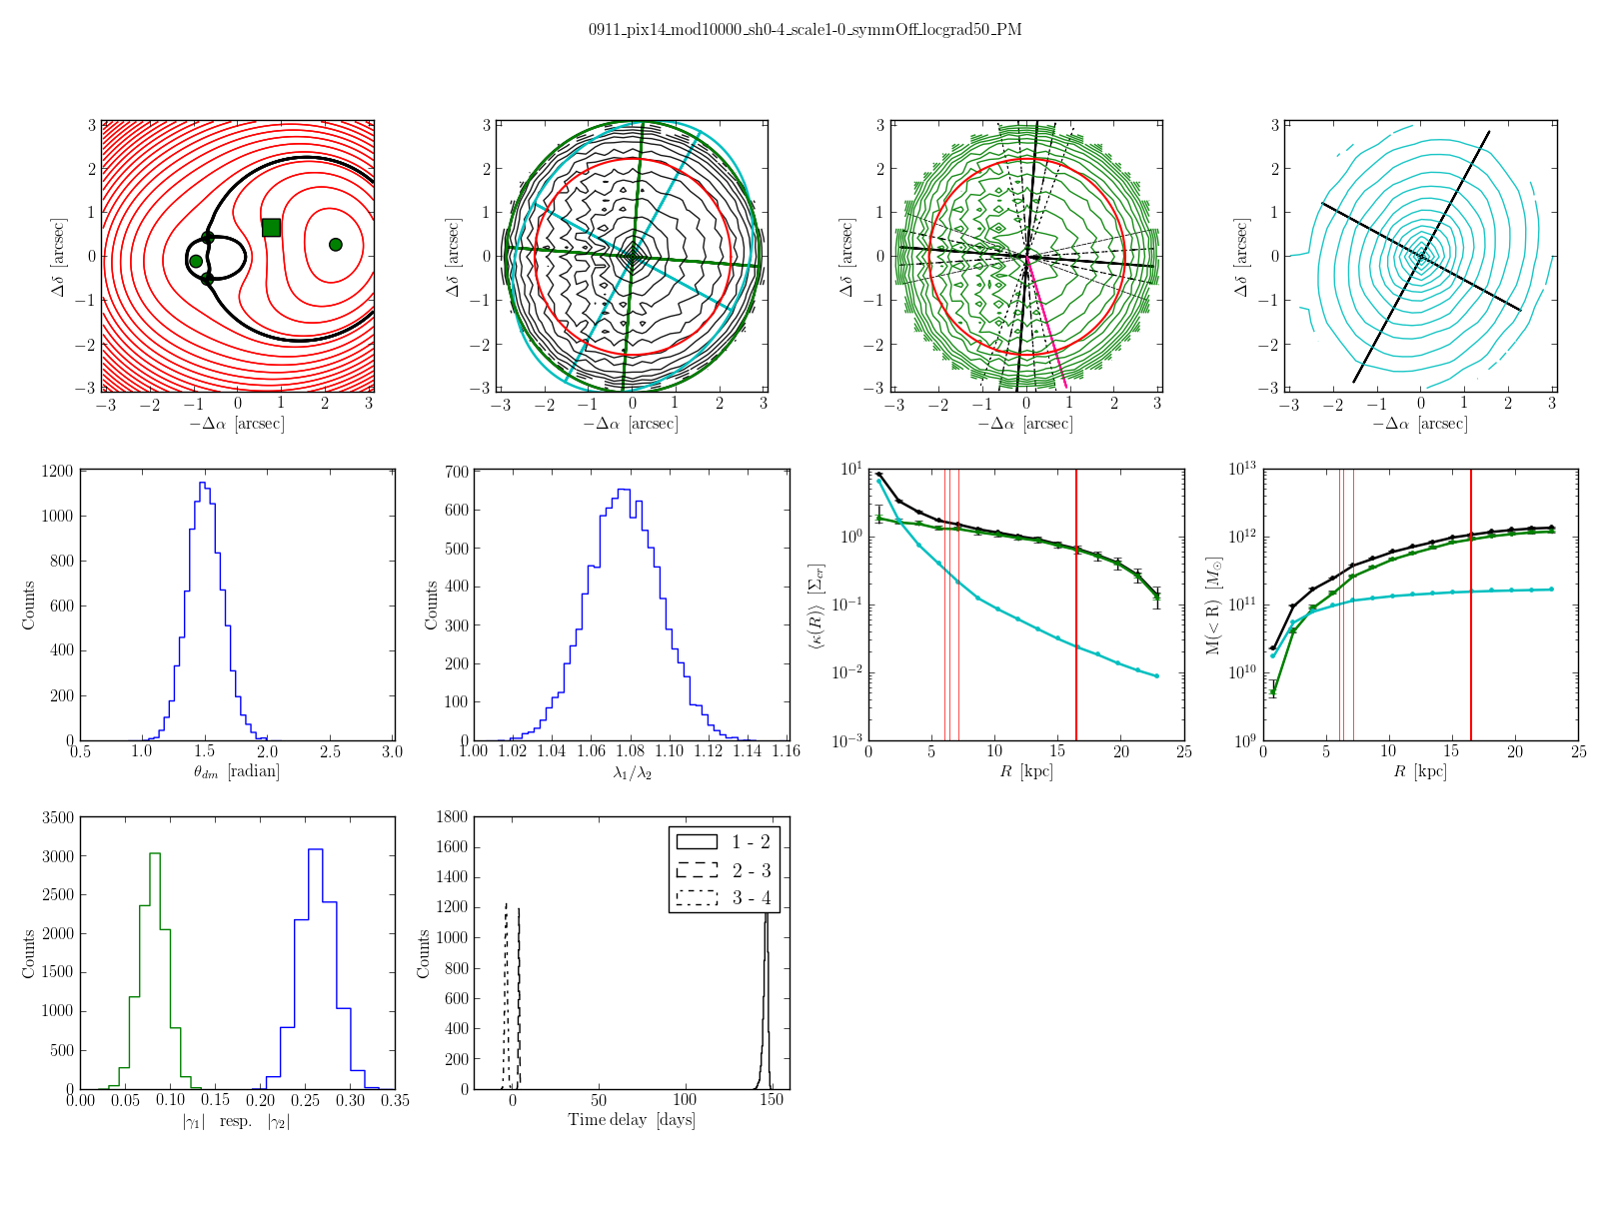
1422
Pixrad 14, shear 0.3, high resolution in the center (central pixel split into 5x5-grid)
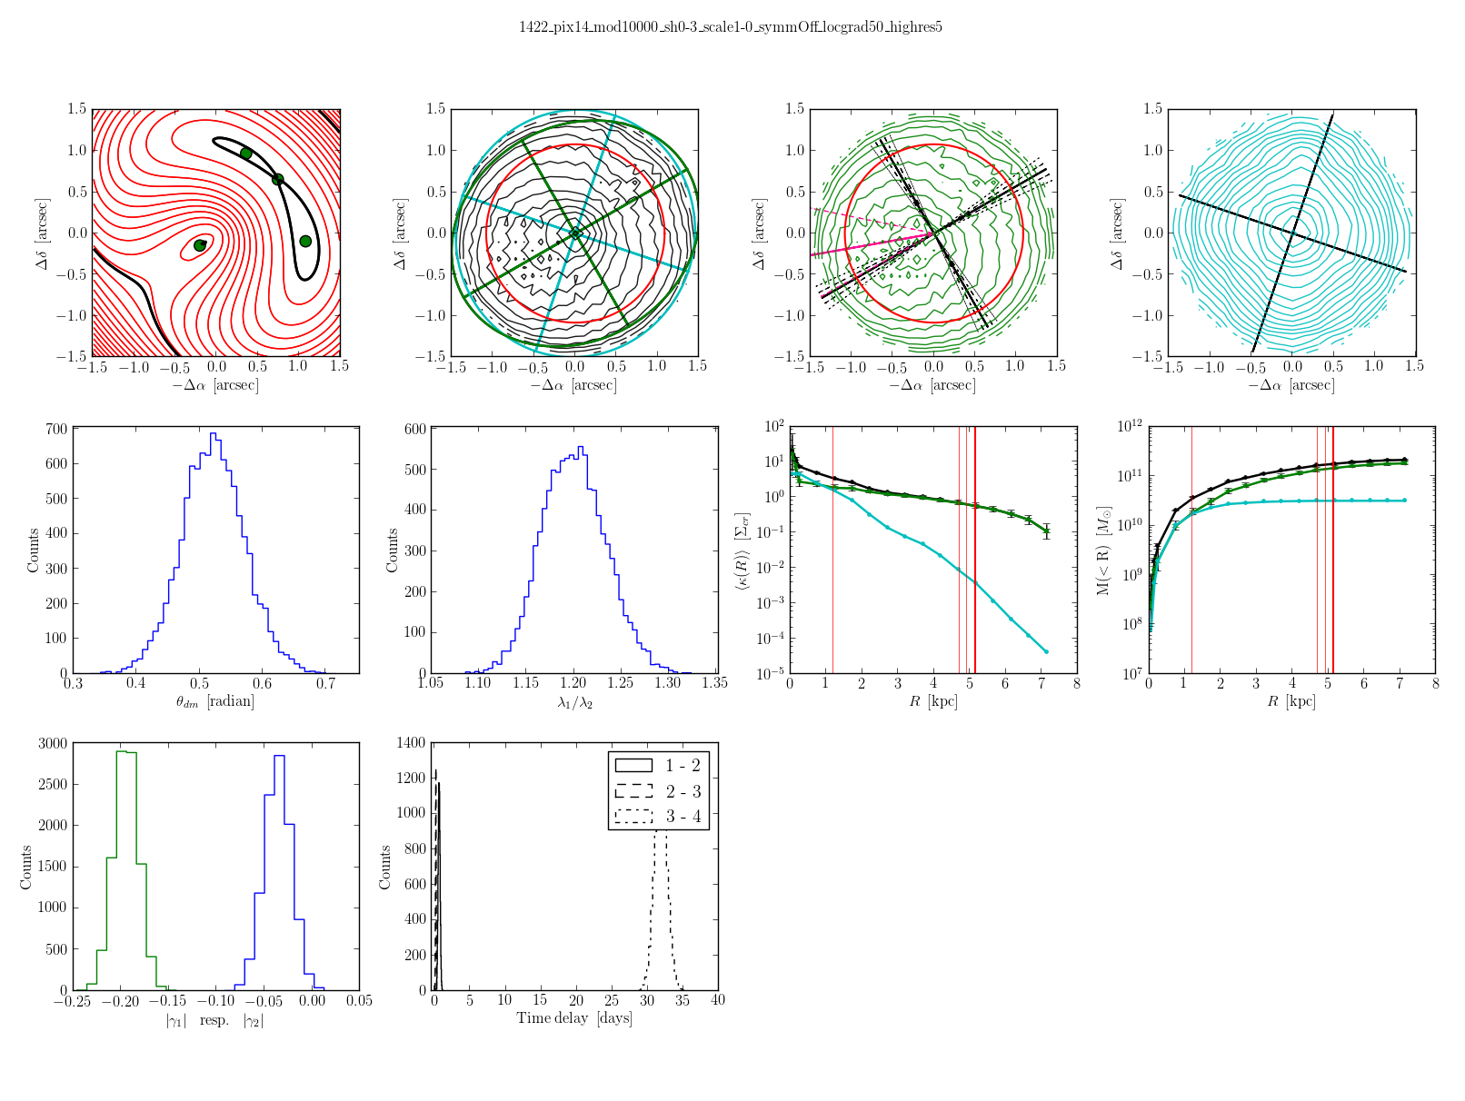
1422
Pixrad 14, shear 0.3, high resolution in the center (central pixel split into 7x7-grid)
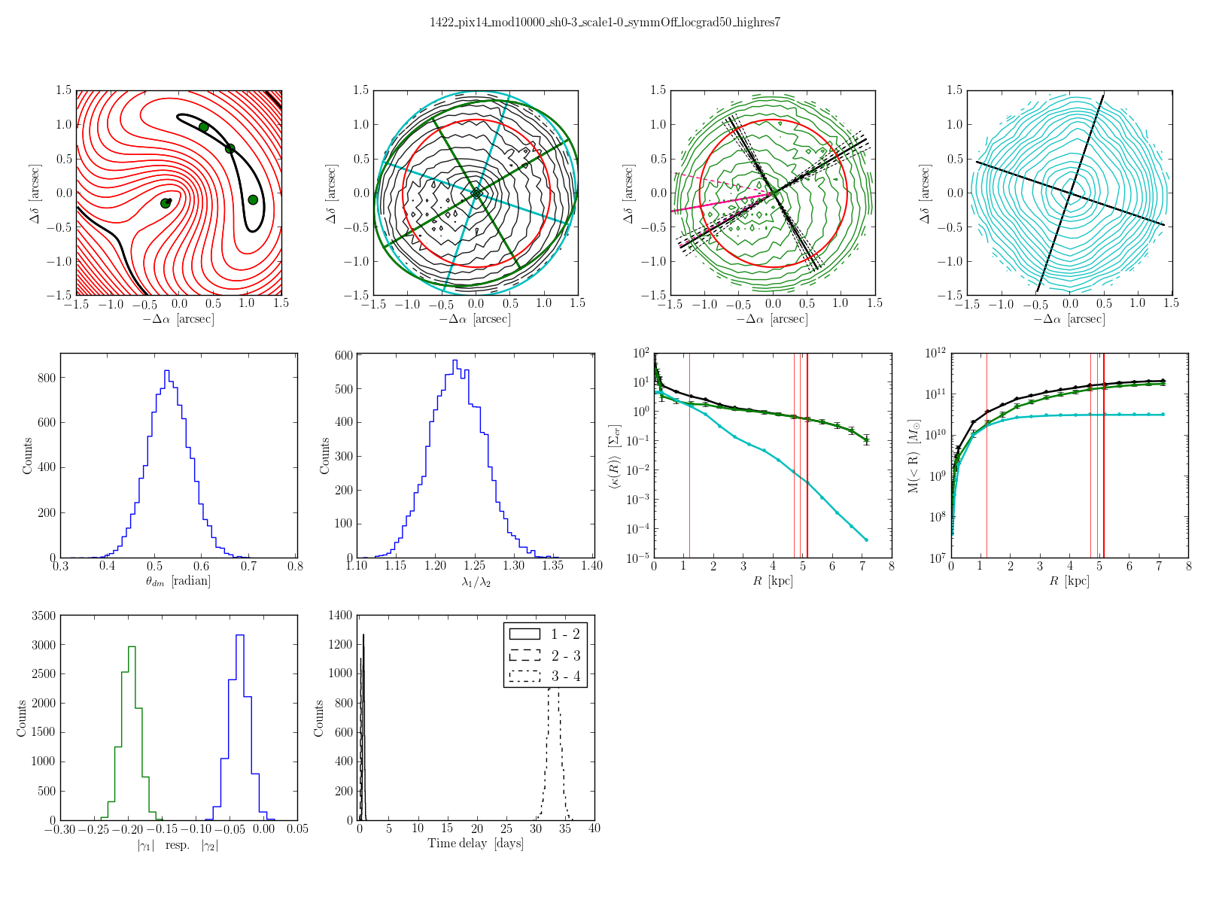
1608
Pixrad 12, shear 0.4, Point mass with mass range 10⁹-5*10¹⁰
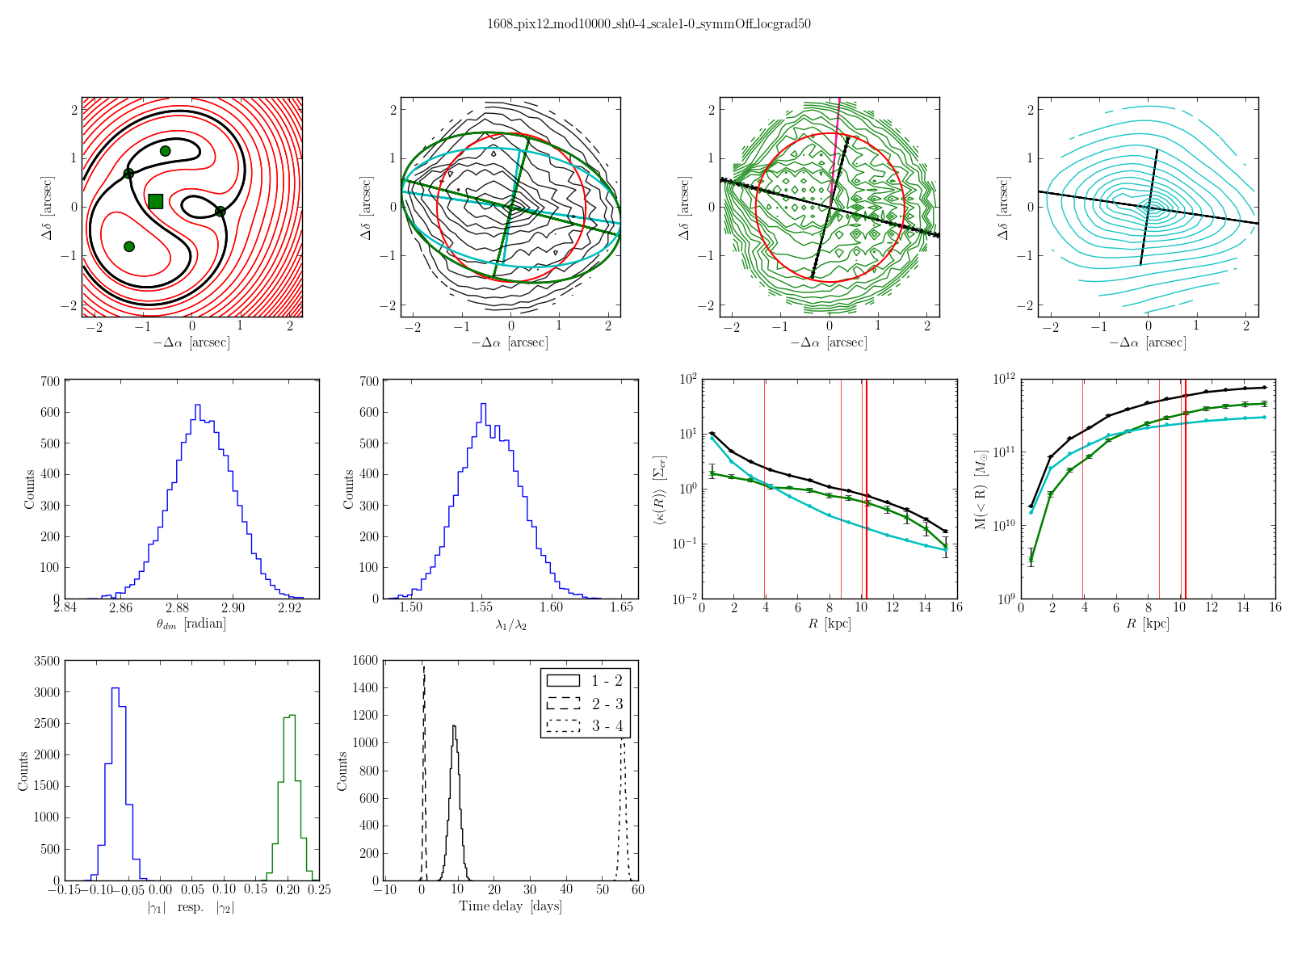
2045
Pixrad 14, shear 0.5, high resolution in the center (central pixel split into 5x5-grid), Point mass in mass range 10⁹-5*10¹⁰


