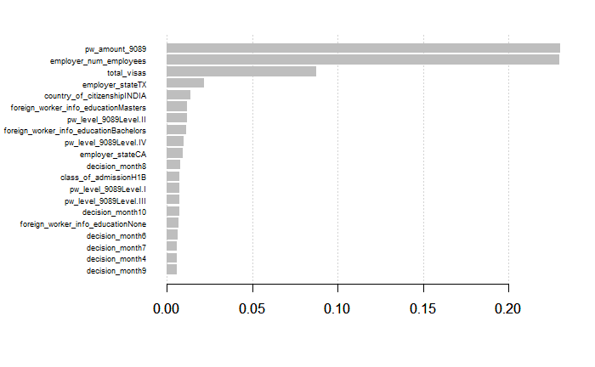

XGBoost 1

Confusion Matrix and Statistics

Reference

Prediction 0 1

0 891 1958

1 1273 43142

Accuracy : 0.9316

95% CI : (0.9293, 0.9339)

No Information Rate : 0.9542

P-Value [Acc > NIR] : 1

Kappa : 0.3201

Mcnemar's Test P-Value : <2e-16

Sensitivity : 0.9566

Specificity : 0.4117

Pos Pred Value : 0.9713

Neg Pred Value : 0.3127

Prevalence : 0.9542

'Positive' Class : 1

XGBoost2

Confusion Matrix and Statistics

Reference

Prediction 0 1

0 891 1958

1 1273 43142

Accuracy : 0.9316

95% CI : (0.9293, 0.9339)

No Information Rate : 0.9542

P-Value [Acc > NIR] : 1

Kappa : 0.3201

Mcnemar's Test P-Value : <2e-16

Sensitivity : 0.9566

Specificity : 0.4117

Pos Pred Value : 0.9713

Neg Pred Value : 0.3127

Prevalence : 0.9542

Detection Rate : 0.9128

Detection Prevalence : 0.9397

Balanced Accuracy : 0.6842

'Positive' Class : 1