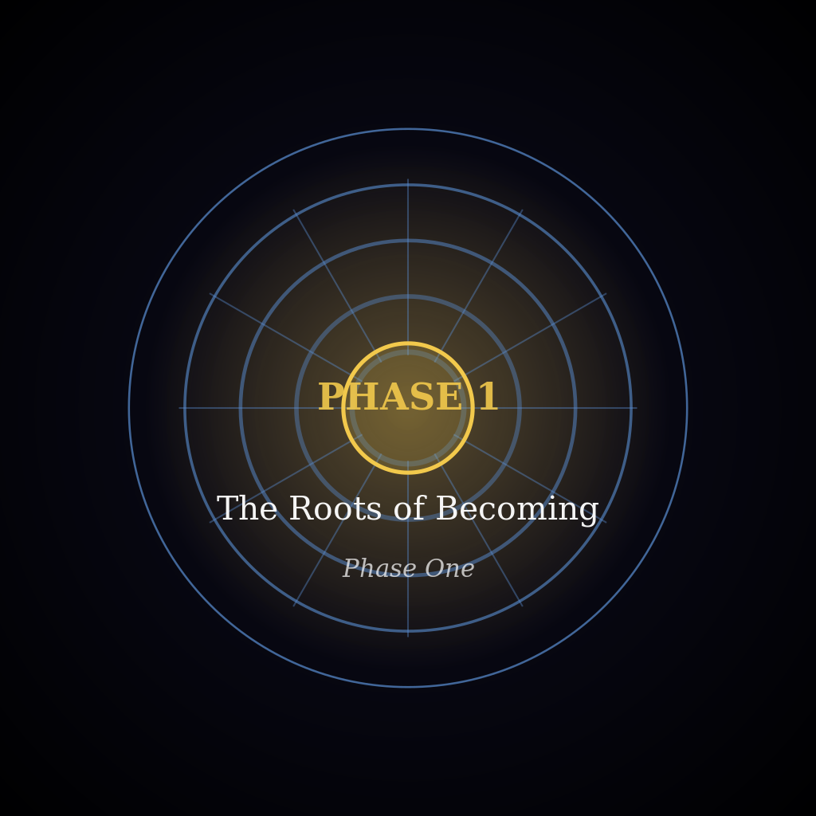
PHASE 1 — THE ROOTS OF BECOMING
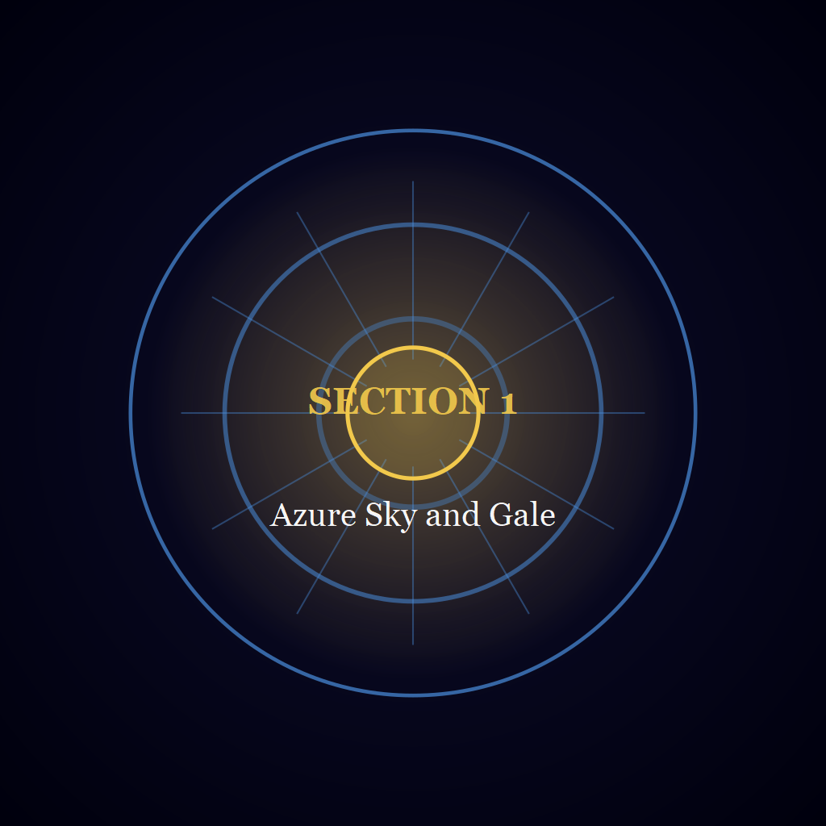
Section 1 — Azure Sky and Gale
Whatever stands in the light was first held in the dark.
Nothing is defended that was not first loved.

STARWARD SAGA
PHASE 1 — THE ROOTS OF BECOMING
SECTION 1 — AZURE SKY AND GALE
PART 1 — The Two Mornings

Chapter 001 — The Capital Waking

Area 1 — The Hour on the West Platform
1.1.1.001.01
Year 1247, Ilovany, Orvil, Day 1
The Windward Range was the far edge of everything, a dark uneven line laid along the north, no blacker than the sky above it but sharper. A few stars hung over it, and the eye could not settle on them. Between the Range and the city lay the Azure Sky Kingdom's plain, quiet to its last field, and across the plain ran the pale thread of the road with a single light moving on it: a lamp, small as a seed. It did not bob as a lamp does in a runner's hand. It slid along smooth, past a field wall, a barn roof, a bend of ditch, and where the road tipped upward it did not slow; no ordinary legs could have done that, only qi, thin and steady, in a body made to carry it. The eye left the lamp for the Range and came back. It crossed the furrows, found no movement in them, and came back again. Wherever the road lost itself in the night the lamp had no way left to go but on, and the eye went on with it.
Frost had silvered the nearer fields and the farther ones were ink. They ran away toward the Range with the grain of the land, as the grain runs along a plank, and the road crossed them at a slant, the one line that went against it.
Somewhere a key was working the wire. Each tap came alone in the still hour, dry and short and done before the next, with a longer gap where a word ended, in a good hand that neither hurried nor stopped. It was the only sound around. Whoever worked it wasted no tap.
Nearer lay the city under the basin's haze, which rose only to the tallest chimneys and let them stand out of it: Azorion, roof stepping down below roof as the ledges of a quarry step, the lanes between them carved as seams of deeper black, a few yellow windows pricked through, the outermost district low where the roofs frayed out into the fields, one wide street climbing from it toward the palace, empty to its last corner. The air coming up carried a trace of coal smoke and, under it, the sharp faint sweetness of the forge quarter's solder. Above the roofs the Royal Palace of Twin Courts rose on its own shoulder of stone, black and wide, its tiers dark from terrace to ridge, each roof set a little higher than the one below, and at its west edge the stone ran out past the last of the terrace into a platform that had no rail.
The platform was a floor of blue-flecked slabs fitted without mortar, flat as a table, ending in air. The flecks held what little light there was, like spilled salt. No other stone in the palace showed the Range, or the road running out toward it. Overhead the Twin Courts Bridge crossed the dark with a flame lit in its span, and on the slab nearest the edge, the one worn a shade paler than the rest, Varys stood, the king, whom the palace behind him and the city below obeyed. On the ladder of qi he held Ruler Level 3 Mid, high enough that his presence, if he let it out, would set an ordinary man's chest aching across the whole of a courtyard.
A hand's width beyond his boots the slab ended, and past that the air dropped away to the nearest roof; no part of the drop moved, so his eyes crossed it as they crossed the stone and went on to what did. Frost whitened the seams between the slabs, and ticked once as the air moved over it. His coat hung open at the throat, heavy cloth that made sounds of its own, the sleeve, the hem, the scabbard's tip tapping a buckle; his feet were set apart, his hands loose, the sword at his hip. The spring air held each breath he let go as a white cloud that thinned and was gone.
The sleeve of his coat had been whispering against the cloth at his side with every breath. As the runner's lamp climbed the slope, the whisper stopped. The key came clearer without it, tap after tap, and he held to it for the full length of the climb, until the rise took it and the night closed behind. Then the sleeve began again.
Out where the dark swallowed it, the road lay bare. The field wall, the barn roof, the bend of ditch had gone back to being parts of the one dark body of the plain, and the key went on below him, a word, a gap, a word. Behind him the palace slept in its tiers: no window lit, no footstep on the terrace, no door. The hour had not yet begun.
He began with the breath: in on a slow draw, out on a slower, in again, until the breathing ran by itself and the rest could be laid on top of it. Then the sword came out of its place and into his hand, the loudest thing that had happened on the platform since he came, and he began his drills. They kept him inside the edges of the slab: a half step, the weight easing back onto the rear heel, the heel turning on the stone with a faint grit; the sword rising and settling; the wrist turning; the point dropping and lifting. The shapes passed through his shoulders and hips one after another, as they had passed through every morning before this one, and the breath carried them.
Below him the key thinned, and then went quiet. The yellow in the span was no longer the only colour there was. The Range, which had been a single line, came apart into ridges, each a different black. The haze lay thinner over the city; roofs showed through it, and chimneys, and from the forge quarter a thread of coal smoke climbed without a bend. In that quarter a bellows drew, and drew again; a spark showed at a window and went out; a hammer rang once on an anvil and was still, and the smell of the solder came up thicker as the fires caught. At the plain's edge a pump handle creaked, stopped, creaked again, and a bucket rang once on a stone rim; farther out a chain ran down a well wheel link by link. In the lower streets a cart went over cobbles. A shutter banged back against a wall. The sky above the plain had not brightened; it had only stopped being black.
Faster as the gloom thinned, then slower, the shapes went on, the breath keeping its place through both. Weight crossed to the front foot and back; the long muscle of the thigh took it; a shoulder blade slid under the coat. A thread of wind came over the edge, lifted the hem of the coat, and let it fall. The slab received each shape as it had received all the others, and he did not leave it. The grit of the heel, the whisper of the sleeve, the knock of the hilt against his palm at each change of grip: these were the sounds he made, and past them the city was beginning to answer, a wheel here, a door there, far down and separate.
Near the end of the hour he stopped. The sword hung low in his right hand, its point near the stone and a little off the line of his body; the left hand hung open at his side. His weight sat even over both feet. He let the breath go out long and slow and left himself open, the whole front of him given to a movement that did not come, no cover across the line from throat to hip but the cloud of his own breath.
Then Open Guard Reading Cut. The sword rose out of its low place and passed through the place where an opening would have been, once, and was done. The cut was under way before he knew of it. His qi ran down the arm and out through the edge for the length of the cut and no longer, a Ruler's qi and nothing past it, and the breath he had let go hung white before him with the edge gone through it, the two halves leaning apart. The sword stopped at the end of its line, the point still. Nothing had been struck. Nothing answered. He set his feet again on the slab, the sword came back to its low place, and the stance settled.
The hour was not over, and he kept the rest of it. His breath returned to its long beat and the drills came back after it, slower, until the shapes were finished and only the breathing remained, and that took no work. The sword went home. The Range stood out clearer against the sky, the last stars going out along its crest, and the flame overhead was a yellow mark on a sky going from black to slate. He let the last of the dark go by. It took its time, and he did not hurry it.
On the highest ridge of the city a single tile went white.
He turned from the edge. The stair ran down along the side of the platform with the slope of roofs open beside it, its steps carved from the same blue-flecked rock as the slabs, the wall beside them dry where the frost did not reach, and he was on it before the next tile caught. His weight went down onto each step as it had onto the last, steady, unbroken.
The light came before anything that made it. It came white, with no gold in it, and the ridge-tiles caught it first, each one a hair of white fire; then the faces of the tiles below took it and gave it back as blue. The blue came down the roofs a tier at a time. It did not spread; it fell, tier on tier, faster than a man could walk, and every roof it reached went from black to a deep blue with a green edge where the glaze had pooled along the lip, the colour coming up out of the clay and not down onto it. The windows flashed next, one after another down the slope. The haze between the chimneys lit from within and turned blue with them, and the coal smoke hung in it, bright. A city that had been one mass of dark came apart into roofs, each with its own edge, each shining, until the slope below the palace showed blue from the highest ridge to the last, and every chimney drew a long shadow down the roof behind it. With the colour came the first loud noise of the morning, shutters going back along every lane. Out on the plain the barn roof came out of the night, and the field wall, and the bend of ditch, and the fields drew apart into their strips. The Range's highest edge drew a thin line of the same white and held it, the one hard line on that whole bright side of the continent. The road lay pale as chalk where the dark had held it.
Above him, along the lip of the platform, the light arrived. It touched the stone, and the slab nearest the edge, the one worn a shade paler than the rest, and found it empty. Overhead, the flame in the bridge went thin against the white. He went on down with the light behind him, and its edge came down the wall at his shoulder and stopped a little way short of him.
Out on the plain the road ran bare toward the Range. He followed it with his eyes as far as it went, to the last of what it showed him, until the stair turned and the wall took it.

