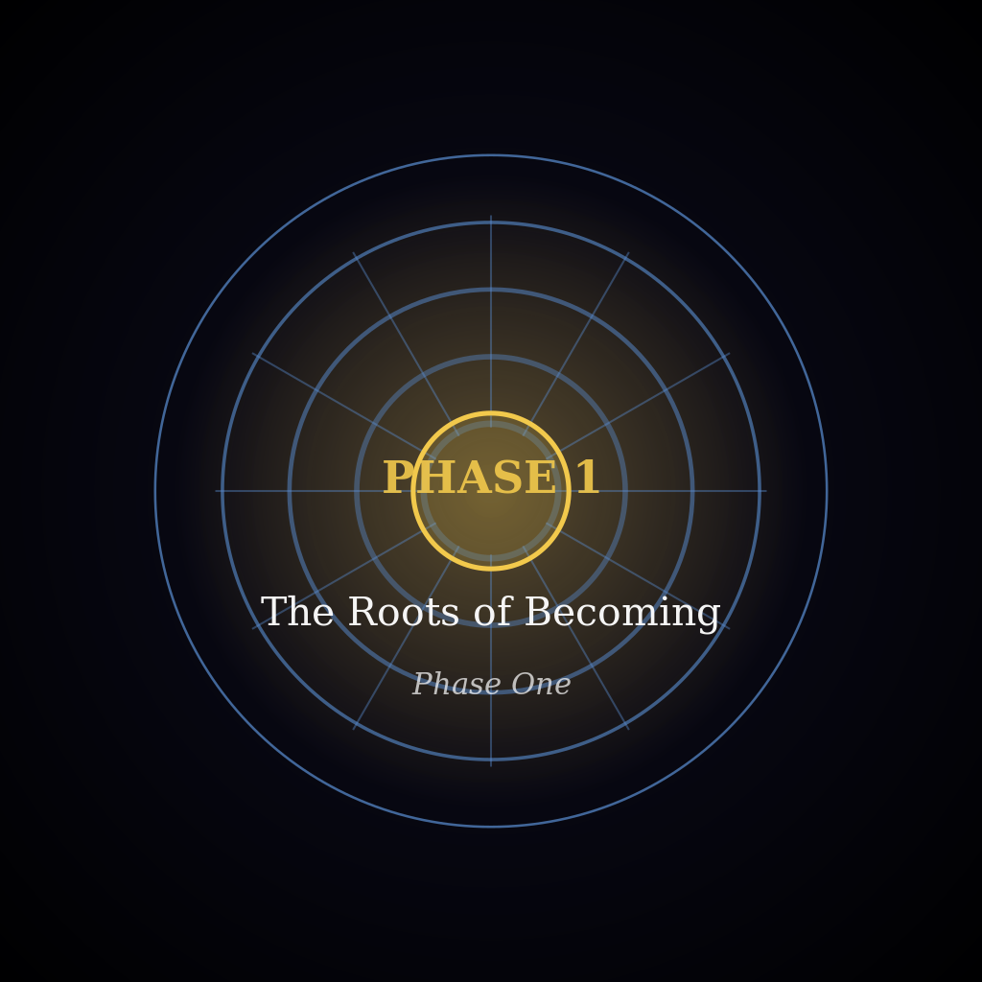
Area 3 — The Palace Wakes Around Him
1.1.1.001.03
Year 1247, Ilovany, Orvil, Day 1
The scrape ended in a knock of wood on stone, and the doors swung inward ahead of his hand. A forearm in a rolled brown sleeve went back behind the nearer door. That was all there was of whoever had lifted the bar. Varys passed through without a pause, and the frost on his boot leather fell away in flakes.
Beyond the doors the passage ran low and stone-floored, and it was as cold as the courtyard had been. Steam made that plain. It rolled from a kitchen doorway on the right, climbed, and hung under the rafters in a grey bank. Daylight reached the bank by stages: through the high windows of the outer wall first, then into the steam itself, then down to the floor, which became the colour of skimmed milk. The windows were narrow, their panes thick and a little green, and the sky behind them was still only grey.
Lids rattled as the pots boiled, and somewhere a lid was lifted and set down crooked. Water went into a trough from a height, a clear pour. Out of sight a broom scuffed over stone, stopped, scuffed again. In the kitchen doorway the ladles still swung on their rack, rocked by a door slapping shut. Tongs lay across a pot. A cook in a sleeveless tunic raised a lid with a folded cloth, and a cloud of steam rose past her red forearms and broke on the rafters. Someone ahead of him half-ran with an armful of cloth and was round the corner before he reached the doorway. His boots kept their pace on the stone. The next doorway showed who did the work. Beside the stove a woman scrubbed a pan with sand in long sweeps, a man stirred a pot with a paddle taller than himself, and a girl set bowls along a board, nudging each bowl a little after she had set it down. Not a head lifted. The door swung shut behind Varys on the draught.
He walked into a bank of steam and out the far side of it. Inside, for a few strides, the corridor was a blur, and the shapes in it were people only because they moved; a shape that stood still was a post or a person, and which it was he could tell only by passing it. The grey thinned. Ahead a side door opened and a tray came out of it, loaded with cups and a covered dish. Whoever carried it stopped in the open doorway. The cups rang against each other and settled. The cover on the dish chattered on its rim and fell quiet. Varys stopped too. For as long as it lasted there was only the steam sliding between them, a lid lifting behind a wall, the tray held steady, the carrier's eyes fixed on its rim. Then the cups shifted. The carrier walked on, and so did he, and they passed each other at the narrowest part of the passage.
By its sounds a house woke in order: lids, water, doors, feet. From that order alone he could have said how far along the house was.
Door bolts shot back along the passage. A door swung on its hinges, and another after it, and each let out a little more of the sound of work and a little more cold. Another opened on shelves of jars stacked to the ceiling, and a hand he did not see shut it again. Folded linen went by, piled to a maid's chin. A spoon knocked on the rim of a pot, and knocked again. Under his boots the stone ended and planks began, and the dry tick of his steps became flat and close. The air cleared behind him and left the smell of porridge. By then the light had reached the floor. It lay across the planks in broad pale patches beneath each high window, and it had not found a direction yet: it came from everywhere together and left every body without a shadow, his own among them. Steam wandered into the patches and became as pale as they were. The walls, grey a little before, grew lighter from the top down. A boy passed with a basket of split wood on his hip, and every grain of the wood showed. Nobody spoke, and the work went on without it. Past the last of the kitchens a broom was working a threshold, its bristles combing the grit.
On his left another passage opened, and he crossed its mouth. Down it, at the far end beneath a window, a door was shut, and a short queue waited along the wall beside it. Varys found the queue by its small motions, for the rest of it did not move. A cap turned in someone's hands and a weight passed from foot to foot. A head tipped forward and came back, and somebody coughed into a sleeve. A man had a cloth wrapped round his hand, and a woman leaned on a stick. They were grown men and women, and they kept to the wall and left the passage clear. Their silence was of another kind from the kitchens', because they were waiting for that door to open. From the window above them came a strip of grey sky, and its light fell on their faces and ended there.
Something crossed the far end faster than any of that, and he knew the walk before he knew anything else about her. Valia. She came from the right with her sleeves already pushed above the elbow, going toward the door at the pace of someone with work behind her and more ahead. He read her qi next: Ruler Level 1 Mid, well under his own, and held so close against her that the people in the queue, hurt as they were, felt nothing but a woman coming. The motion in the queue stopped as she reached it, caps and weight and heads together. At the nearest of them she shortened her stride. In passing she laid her palm on a man's shoulder, warm and flat, as a greeting is given; but it rested there past the greeting's end, and her glance ran down his arm to the wrist and up to his face before the hand moved on. A fine thread of her qi had gone down the arm with the glance and found a small hurt in the wrist, and one sure sweep from the palm had closed it. That was Practised Hand, which spends no more qi than the hurt needs. The man looked at his own wrist as if it had been spoken to, and turned it, and the stiffness was gone. She was through the door, and it shut behind her, and the caps turned again. She had not looked up the passage.
She had been up before the light, then. The queue had not waited for the day. The wall hid the cross-passage, and the planks carried him on.
Beyond the next corner a door stood open. The Peg Room was hardly bigger than a linen cupboard, and it was plainly hers. Pegs ran along the outer wall at a height for someone short, and from a peg near the door hung a cloak much too long for anybody in the room, its hem on the floor. Tools hung from the others at the same low height. Under the high window stood a table and a stool, the stool raised on a box so that whoever sat on it could reach the table. A rag lay at the table's far side, and a jar of oil with a feather standing in it. The air from the room smelled of oil and cold metal.
Varya sat with her back half turned to the door. He looked at her hands before he looked at her: a callus at the root of the thumb, a smear of oil along a forefinger. They were working at something that lay in pieces across the table, small things of metal and pale wood, and of all of them he found only the pieces her fingers were moving. Of the girl herself his sense for qi met nothing, as it met nothing in the stool or the box beneath it; she was eight, and her first awakening was still ahead of her. A piece was lifted, turned toward the window, set against another. Tried together, they were judged wrong and parted. Another was reached for. The hands were small and certain where they were certain and stopped dead where they were not, and between pieces they lay flat on the wood, idle. He crossed the doorway on boards that answered under his weight, and she did not turn. The stool creaked and was quiet. The pieces made their faint sounds against the table, metal on wood and wood on metal, tapping as steadily as rain on a sill. Above her, in the window, hung a pane of sky with the colour not yet in it.
Then the cold reached her, all at once and without warning. The pieces jumped in her hands and fell. Her shoulders rose to her ears; her hands burrowed into her sleeves; her feet found the rung of the stool and hauled themselves up after them. Every part of her was given to the cold, and none was left for the table. She slid down off the box, dragged the cloak from its peg with both arms, and vanished into it. The climb back to the stool was made under the cloak's weight. Her hands found their way out of the folds and back to the pieces, and the tapping picked up its rhythm again.
She had dealt with it herself. Varys went on, and behind him the tapping continued.
After the Peg Room the household thinned. Doors stood open on empty rooms. In the nearest a table was laid with bowls for a meal still to come. The chairs were pushed in, a cloth folded on every seat, and his steps were the loudest thing in the room. Behind him the sounds dropped away one by one, and the passage was left to him alone. At the last window the light was no longer pale. It had weight now, and it lay on the planks like cloth.
The corridor ended at the last door out of the household. It was heavier than the rest, dark oak with an iron latch, and light showed under it and round it in a thin strip. A draught came in beneath and stirred a curl of dust. Through the oak came the day's own sounds, thinner and farther off than the household's: pigeons clattering up from a ledge, a gate groaning open somewhere below, the wide low noise of the city. The papers were in his left hand, the folded notice against his ribs. The latch was grey and simple and worn a little where hands lifted it.
His right hand left his side for the latch, fast. Part of the way there it slowed, and the rest of the distance it crossed at an easy pace. The iron was cold. It lifted without a sound.
The door swung out on a long low note of hinges, and beyond the doorway the light was full on the roofs.

