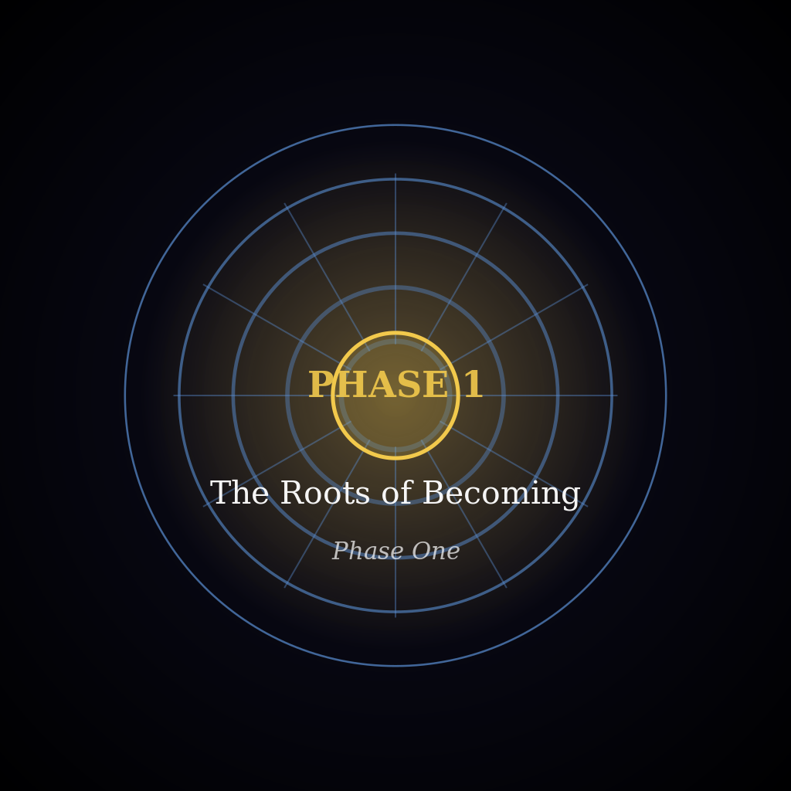
Area 4 — The Long Hall Takes the Morning
1.1.1.001.04
Year 1247, Ilovany, Orvil, Day 1
Varys stopped in the open south door of the Sword Court, the hall where he listened to his people's requests, and looked up its length. At the far end the throne, a tall plain chair, sat empty at the top of wide steps, with a wall of blue stone rising behind it. The two morning bells had rung long ago to open the court, the brass one first and the other right behind it, with a long, bright ring. Now the sun was well up. It shone in from the east, through the tall open pillars on the right-hand side, and lit the side of the throne that faced them. Beyond the pillars the blue roofs of the city fell away down the hill.
Two rows of tall stands lined the path up the middle of the hall. Each had a wide cup at the top where a light burned at night. In the daylight the cups were empty. The path crossed the open floor where the petitioners gathered, the people who had come to ask the king for something. Past them was the long table, empty. Past the table there was only bare stone, up to the steps. The air in the hall was cool.
The petitioners filled the floor near the entrance. They wore plain cloth in blue, grey and undyed wool, and every face was turned toward the door. From where Varys stood it was like a field of grain before the wind comes, every head the same way. Between the pillars the sun made bright patches on the stone, and the people nearest the east side were half in light and half in shade. Most of them had been waiting since the bells. The king was the last to come. None of them moved, and none of them had yet said what they had come to ask.
Over the door, two strips of carving ran one above the other. The top strip was flowing writing. The bottom strip was straight marks and angles, like a builder's plan. Varys greeted the room in the court's way. He raised his right hand, open, toward the top strip, then lowered it toward the bottom one. Last, the shoulders. The left rose and paused at the top. The right rose to meet it. Then both dropped together. Everyone had been waiting for that pause. When it came, the crowd moved all at once, and the waiting was over.
He walked up the path between the rows, with people close on both sides. Past the long table the stone was bare. A folded note from first light was still against his ribs. At the foot of the steps he stopped and turned to face the hall. He stood on the floor, not on the steps, so that he was level with anyone who came to him. The empty throne was at his back, and the way he had come in was a small bright patch at the other end.
The day's work began at the long table. A sheet of paper rose in the hand of the floor clerk, Nessa Pryor, who had been standing there all along with the sheet at her side. Her job was to read out each name and request, and she began with the first name on her sheet. She read in a flat, even voice, the voice of someone who had read many names. It was not loud, and there was no qi under it, only breath and long practice, but it carried down the hall. "Garth Maddock, a miller from the low road past the last roofs, asks about his yard." That was all she said about it. Varys wanted to hear the rest from the man himself.
The clerk lowered her sheet and was still again. At the back of the crowd a man jumped at the sound of his name. He turned his head to find the speaker. The voice had come to him from the far end of the hall as if she were beside him. Then he pushed his way out of the crowd and onto the path.
He was a big man with a heavy walk, the walk of someone used to floors that shake. Flour was worked into his coat, his boots, his hair and his eyebrows, and it was hard to tell how much of the white was flour and how much was age. A dry smell of flour followed him. Where the sun fell across the path he was white from head to foot, and then he was in shadow again.
The hall was longer than any floor he had crossed, and his boots were heavy on the stone. He looked up at the throne, down at the table, and down again at the floor in front of him. With each look his steps got shorter. He never looked at Varys. A man who had lifted sacks all his life should not be out of breath from a walk, but the miller was. His lips were moving as he said something over to himself.
At the end of the table, where the clerk was, he could still have turned back. A few steps past her, he could not. His head dropped, his shoulders stiffened, and he walked the rest of the way like that.
Varys kept his place and let him come, his presence drawn in until it was no more than an ordinary man's, so that the miller crossed the last of the hall with no pain in him but his own nerves. The miller stopped at talking distance and drew himself up. The flour showed in the creases of his face. "Your Majesty!" It was far too loud. It hit the stone behind Varys and came back in pieces. The miller winced and lowered his voice. "Thank you for hearing me." This time he spoke low, hardly louder than a man talking across a table. It carried to the back of the hall. He had spoken to one man, and the people at the back had caught every word.
He searched Varys's face for a nod or a word. He got neither. He swallowed, and then he began. "My mill is on the low road. Behind it I have a yard of packed earth with a fence round it. Every morning at first light the young people from the lane come into it to train. Eight or nine of them come most days. They drill with wooden swords, and some with only their fists. They swing together at the empty air, over and over. By the end their arms shake. They are there before the wheel is started and gone before the sacks come down. I let them, though there is no more qi in me than in the millstone, nor in my wife, Orla, who says she gave her leave before I gave mine."
Varys kept his eyes on the man's face and did not speak. The miller looked up, found no sign there, and his words ran faster. "Three mornings ago a young man called Ruan Fenner, not yet twenty, was drilling in the middle of the yard. He woke his qi only last winter, so he is a Senior now, but the lowest sort there is, with the first thin thread of it and no more. He swung his sword at the empty air, and a cut flew off the end of it. You could not see the cut. You could only see what it did. It split two boards of my fence, and what was left of it knocked against the post of the gate on my mill-race. The gate stuck in its slot, and for most of the morning the water ran wrong. Nobody was hurt. Nobody was in the way."
Varys pictured the yard. The mill was at the back. Along one side ran the mill-race, the stream that turned the wheel, with a wooden gate to hold the water. A cut from a hand so new to qi would not carry far, but the yard was small, and thrown that way it would split the fence and reach the gate post before anyone could move.
Between sentences the miller glanced up, then down at the floor, then up again. "I do not want the young people stopped. I asked Ruan to turn the other way and face the field. But the field beside my yard is planted. He will not cut at young wheat, and I would not ask him to. If he faces the race, he hits the gate. If he faces the lane, he hits the lane. If he faces the wheat, he hits the wheat. I have walked round that yard in my head all week. I had it in order before I came here."
He broke off. His eyes slid away from Varys to the sunlight on the floor, as if the rest might be written on the stones. His mouth worked on a word that did not come. Varys kept his face still. He did not nod or frown, and he did not look at the crowd. Whatever the miller needed to find, he would have to find it himself. At the end of the long table the clerk's sheet did not lift. The crowd had its own requests, still unspoken. The sun crept on across the stones. Then the miller's eyes returned. "I have lost the order," he said. "I will say it as it comes."
"There is an open field behind the lane. There is no crop in it, and no water near it. But it belongs to the farmer, and it is not mine to give. I did not want to go to him and have him think I was sending him my trouble. He would hear it differently from you."
"Ruan sat on my step all that day. He did not say a word, and he would not eat. At harvest he looks after that gate for me, so it was his own work he had broken. Orla put out her own bread beside him, a dark loaf and a pale one. By evening neither had been touched. He has not picked up a sword since. He is not a bad lad." His voice had grown quieter without his noticing, and his eyes no longer ran from Varys.
"So I ask you, Your Majesty. Where may the young people train?"
The miller had finished. Varys looked at him, and then down the long hall at the crowd. Nobody there had spoken. They were waiting for him. Then he answered, in a low, even voice. "You asked where, so I will say where. Your yard has water on one side, the lane on the other and young wheat in front, and a cut that flies has nowhere safe to go. You say the open field behind the lane has no crop and no water near it. I cannot say what the farmer will answer, and the choice is his. If he gives his leave, the young people may train there, clear of the race and the planted ground. Take this to him as the crown's word. And tell the young man to eat."
The miller did not move. He had expected a long wait, or a no, and the last words were slow to sink in. Then a smile broke through the flour on his face. "Thank you, Your Majesty. I will take it to him today. And I will tell Ruan to eat."
The clerk lifted her sheet and read the next name. The noise of the city drifted in through the open pillars. A seller in the street below called the same words over and over, and hooves clattered past. The crowd made room for the miller, and he walked back down the long hall. His steps were even, and his shoulders were loose.

