Cobre · Transaction Corridor Analysis
L2 Business Architect Assessment · Candidate submission · Data: 50,000 transactions and 5,000 users, Jul–Dec 2025
One-page summary
Transactions | Value processed | Success rate | USD→MXN failure | Recoverable / month
50,000 | US$281.5M | 90.4% | 18.3% | US$500K

Key findings
- USD→MXN is the largest corridor (35% of transactions, 45% of value) and the only one growing.
- But it fails 18.3% vs 4.9% in the other corridors, and concentrates 66% of all Cobre failures.
- The failure belongs to the corridor: every segment and amount fails 3-4× more, and it gets worse for payments above US$10K. The day of the week has no effect.
- Mexican and Colombian users behave the same, and total volume is flat (~273 tx/day for six months).
- Bringing failures down to 5% is worth US$500K/month. 2026 recommendation: prioritize USD→MXN.
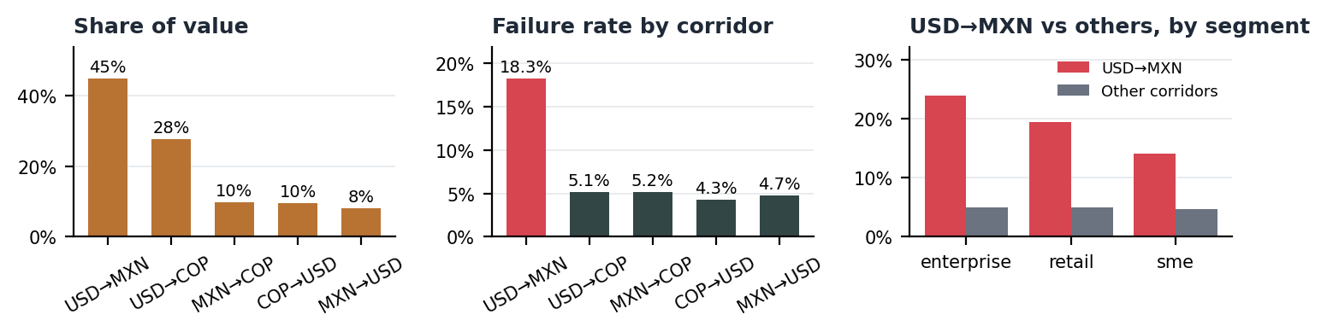
Recommendation: prioritize USD→MXN in 2026
Fix first, then grow. Its success rate is only 81.7%. Bringing failures to 5% unlocks ~US$500K/month without acquiring a single new customer; no other corridor has more than US$2K/month to recover.
- Q1 · Stabilize: Daily dashboard of rejections by code, segment and amount; CLABE and name validation at checkout (retail).
- Q1–Q2 · Unblock large payments: KYB/AML pre-approval and agreed limits with the payout bank for payments >US$10K; automatic splitting where allowed.
- Q2 · Redundancy: Second MXN payout provider with smart routing based on success rate.
- H2 · Grow: Once success is ≥95%, commercial push to US enterprise and SME exporters.
Expected impact: Failure rate from 18.3% to 5%: +US$500K/month (~US$6.0M/year) in recovered revenue, plus retention of enterprise clients who today see 1 in 4 payments fail.

Part 1 · Data analysis
Every answer below is computed in Python; tables and charts are in Cobre_Dashboard.xlsx and Part1_Data_Analysis.xlsx.
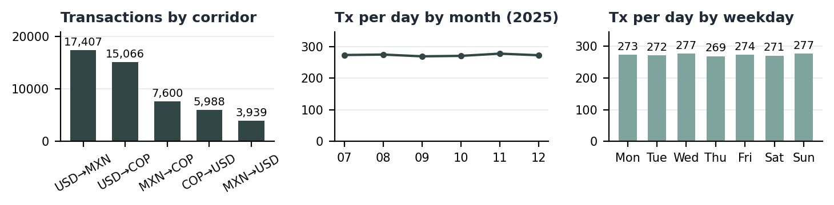
Question | Answer
1.1 Corridor performance
1.1a What are the top 5 payment corridors by transaction volume? | 1. USD→MXN (34.8%) · 2. USD→COP (30.1%) · 3. MXN→COP (15.2%) · 4. COP→USD (12.0%) · 5. MXN→USD (7.9%). There are only 5 corridors, so the top 5 is the full set; the first two account for 65% of transactions.
1.1b What are the top 5 corridors by transaction value (total USD)? | 1. USD→MXN (US$126.6M) · 2. USD→COP (US$77.8M) · 3. MXN→COP (US$27.5M) · 4. COP→USD (US$26.9M) · 5. MXN→USD (US$22.6M). USD→MXN concentrates 45.0% of value with 34.8% of transactions.
1.1c Which corridors have the highest success rates? | COP→USD leads with 95.7%. All corridors are around 95% except USD→MXN, which drops to 81.7%: it is the only reliability problem.
1.1d What is the average transaction size by corridor? | USD→MXN US$7,271 · MXN→USD US$5,750 · USD→COP US$5,165 · COP→USD US$4,495 · MXN→COP US$3,621. The mean is ~1.8× the median in every corridor: a few large enterprise payments pull the average up.
1.2 User behavior
1.2a What's the average number of transactions per user? | 10.0 transactions per user (median 10, max 21). All 5,000 registered users transacted at least once.
1.2b Who are the top 10 users by transaction volume? | The leader is USR_4714 with 21 transactions; the top 10 make between 20 and 21, only 2× the average. No user concentrates volume.
1.2c How does user behavior differ between Mexico and Colombia? | Mexico accounts for 59.1% of transactions because it has more users, but per user they behave the same: 10.0 vs 10.0 tx/user, ticket US$5,595 vs US$5,679, success 90.4% vs 90.5%, same corridor and segment mix. The real difference is the destination: money arriving in Mexico fails 18.3% vs 5.1% for money arriving in Colombia.
1.3 Time patterns
1.3a What days of the week have the highest transaction volume? | Sunday has the highest daily average and Thursday the lowest, but the gap between them is only 2.8%: there is no dominant day; volume is even across the week.
1.3b Are there any notable hourly patterns? | All activity happens between 8:00 and 19:59 (banking hours), with no overnight transactions. The peak is at 10:00, but the variation across hours is 4.8%: within the window volume is flat.
1.3c Has transaction volume been growing or declining over the 6-month period? | It is flat. 274 tx/day in July vs 273 in December (-0.3%); the linear trend is 0.08% per month. Only USD→MXN is growing in value (+4.2% Q4 vs Q3).

Part 2 · Why does USD→MXN fail? Root cause and impact
Write-up · 267 words
Diagnosis. USD→MXN fails 18.3% of transactions (19.8% of value), 3.7× the other corridors (4.9%), and drives 66% of all Cobre failures. The data shows a higher rate than the 15% stated in the brief.
Patterns. (1) Every segment fails more than in other corridors, with a gradient: enterprise 23.9%, retail 19.5% and SME 14.1%; retail drives 52% of failures by volume. (2) Amount matters: payments >US$10K fail 23.4% and, within SME, the rate jumps from 13.7% to 20.1% when crossing US$10K. (3) The day does not matter: Fridays fail 18.4% and the weekly range is 17.0%–18.9% (chi², p=0.53); neither do hour or month. Failures are spread across 2,341 users: this is not a single customer.
Three possible root causes. H1: a compliance/AML rule or payout-bank limit on payments >US$10K. H2: invalid beneficiary data (CLABE, name) in retail. H3: a structural issue with the MXN provider or settlement route that raises the baseline failure rate across the whole corridor.
Validation. Analyze rejection codes by segment and amount; compare failure rates by provider/payout bank; pilot CLABE validation at checkout and pre-approval of payments >US$10K with an A/B test.
Impact. At a 0.5% fee, the sample loses US$21K/month; scaled to Cobre's US$1.5B/month that is US$669K/month. Cutting failures to 5% recovers US$500K/month (US$6.0M/year); under the brief's assumptions (35%, 15%) it would be US$262K/month.
Recommendation. Attack H1 and H3 first, since they concentrate the lost value: agree limits and pre-approval for large payments with the payout bank, and test a second MXN provider. In parallel, add CLABE validation for retail (H2) and track the failure rate weekly by segment and amount band.
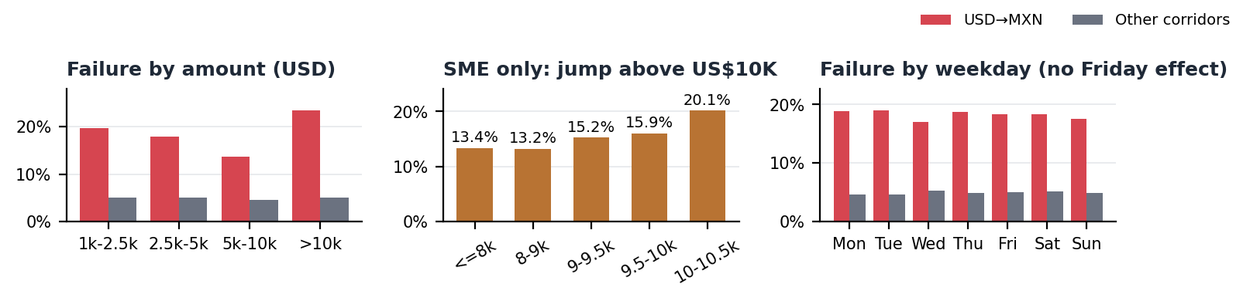
Revenue impact (fee 0.5%; gain = (failed value % − 5%) × corridor value × fee)
Scenario | Monthly value | Failed value % | Revenue lost / month | Gain at 5% / month | Annual gain
Sample (data as is) | US$21,094,515 | 19.8% | US$20,921 | US$15,647 | US$187,768
Scaled to US$1.5B/month | US$674,500,531 | 19.8% | US$668,952 | US$500,327 | US$6,003,927
Brief scenario (35%, 15%) | US$525,000,000 | 15.0% | US$393,750 | US$262,500 | US$3,150,000

Part 3 · Strategic recommendation memo
256 words
To: Management · From: Business Analyst · Subject: Corridor to prioritize in 2026
Prioritize USD→MXN.
Why this corridor
- Scale: It moves 45% of processed value; scaled to Cobre's volume it generates ~US$2.7M/month in fees, 1.4× USD→COP.
- Growth: It is the only large corridor that is growing: +4.2% in daily value in Q4 vs Q3, while USD→COP fell 1.3%.
- Hidden upside: Its success rate is only 81.7%. Bringing failures to 5% unlocks ~US$500K/month without acquiring a single new customer; no other corridor has more than US$2K/month to recover.
- Market: US→Mexico is the world's largest remittance corridor and the region's main B2B flow, with mature payment rails (SPEI).
Decision matrix: Weighting revenue (30%), growth (15%), reliability (15%), recoverable revenue (20%), market (10%), simplicity (10%), USD→MXN scores 0.85 vs 0.53 for USD→COP. The result is robust: it still wins when any single criterion is removed.
Recommended actions
- Q1 · Stabilize: Daily dashboard of rejections by code, segment and amount; CLABE and name validation at checkout (retail).
- Q1–Q2 · Unblock large payments: KYB/AML pre-approval and agreed limits with the payout bank for payments >US$10K; automatic splitting where allowed.
- Q2 · Redundancy: Second MXN payout provider with smart routing based on success rate.
- H2 · Grow: Once success is ≥95%, commercial push to US enterprise and SME exporters.
Expected impact: Failure rate from 18.3% to 5%: +US$500K/month (~US$6.0M/year) in recovered revenue, plus retention of enterprise clients who today see 1 in 4 payments fail.
Risks: Root causes remain hypotheses until rejection codes are reviewed; market and simplicity scores are qualitative judgments.
Decision matrix (min-max normalized, weighted)
Corridor | % of value | Monthly revenue (scaled) | Growth Q4 vs Q3 | Success rate | Recoverable / month | Market (1-5) | Simplicity (1-5) | Score
USD_MXN | 45.0% | US$2,703,550 | 4.2% | 81.7% | US$500,327 | 5 | 4 | 0.85
USD_COP | 27.6% | US$1,968,009 | -1.3% | 94.9% | US$1,871 | 4 | 4 | 0.53
MXN_USD | 8.0% | US$572,738 | 1.4% | 95.3% | US$562 | 3 | 3 | 0.31
COP_USD | 9.6% | US$687,278 | 1.3% | 95.7% | US$0 | 2 | 2 | 0.25
MXN_COP | 9.8% | US$695,812 | -2.4% | 94.8% | US$824 | 3 | 2 | 0.19

Appendix · Use of AI, data quality and deliverables
Use of AI tools
- Claude (Anthropic) was used to refactor the initial scripts into a modular package with a single metrics function (summarize) instead of five duplicated groupby blocks, to suggest the root-cause cuts and the chi² test to rule out the day-of-week effect, and to draft the write-up and memo.
- Own validation: the patterns stated in the brief were checked against the data. Two do not hold: Friday failures (18%) match every other day, and the segment with the highest failure rate is enterprise, not retail (retail does drive more failures by volume). A US$10K threshold test within SME was added to separate the amount effect from the segment effect.
- Python is the single source of truth: every figure and text is generated by python main.py; the Excel workbook and this document only load and display those results.
Data quality and assumptions
- Clean data: no empty cells, no duplicates, no orphan users, and corridors consistent with origin/destination.
- The segment in transactions.csv differs from users.csv in 61% of rows and 4,970 users appear with more than one segment. The transaction segment is used (it is the one the brief describes) and the mismatch is flagged as a data-governance task.
- Data ends on 2025-12-30: monthly metrics are computed per day with data.
- Assumptions: 0.5% fee on successful payments; Cobre's real volume of US$1.5B/month with the same mix as the sample; target failure rate 5%.
- Qualitative scores (Part 3): market 5 = largest remittance corridor (USD→MXN); simplicity 4 = mature SPEI/ACH rails; 2 = intra-LatAm double conversion or FX outflows subject to exchange controls.
Deliverables
File | Content
Cobre_Assessment_Deliverable.docx / .pdf | This document: summary, write-up, memo, AI note.
Cobre_Dashboard.xlsx | Dashboard and one sheet per part: each question, answer, table and chart.
Part1/2/3 workbooks | Every analysis table, one sheet per table (data quality checks in Part 1).
python/ (code) | Single source of truth. Run: python main.py → build_excel.py → build_document.py.

