FRVA - User Manual

Version 1.1

16. Jan. 2018

**Table of Contents**

1. Introduction 3

2. Limitations 3

3. License 3

4. GUI - Elements 4

4.1. Library View 4

4.2. Live View 5

4.3. Console 6

5. Library 7

5.1. First start 7

5.2. Importing data 7

5.3. Selecting data 8

5.4. Deleting data 8

5.5. Exporting data 8

5.6. Zoom 8

5.7. Infobox 9

5.8. Tabs 9

5.9. View Measurements 9

5.10. Settings Button 9

6. Live View 10

6.1. Establish connection to Rox 10

6.2. Save Captured Data 10

6.3. Disconnect from Rox 10

6.4. Show Measurement 10

6.5. Switch View 10

6.6. Capture Manual Measurements 11

6.7. Set Integration Time 11

6.8. Set Interval Between Measurements 11

6.9. Set System Time 11

7. Console 12

7.1. Pause the Output 12

7.2. Send Command (expert mode) 12

Appendix A - List of Comands 13

# Introduction

FRVA - Flox-Rox Visualizing Application.

This software provides the tools to display and manage data captured with RoX from JB-HyperSpectral.

Additionally it provide the possibility to connect to a RoX over Bluetooth and operate the device remote. The data captured remote are displayed in the application.

The software has been created in a student-project on FHNW in Switzerland.

<https://www.fhnw.ch/>

The software is open source and licensed under LGPL.

The software is available on the github repository: <https://github.com/jpduloch/frva>

# Limitations

The software is optimized for a certain format of the data-files created by the device.

**Minimal RoX - Software Version: RoX V1.0**

The application is written in Java. To execute **Java Runtime 1.8 or higher** is required. <http://www.oracle.com/technetwork/java/javase/downloads/jre8-downloads-2133155.html>

The application is developed for Linux systems, but has successfully been tested on Mac and Windows systems.

# License

Copyright 2018 Andreas Hüni

FRVA is free software: you can redistribute it and/or modify it under the terms of the GNU General Lesser Public License as published by the Free Software Foundation, either version 3 of the License, or (at your option) any later version.

FRVA is distributed in the hope that it will be useful, but WITHOUT ANY WARRANTY; without even the implied warranty of MERCHANTABILITY or FITNESS FOR A PARTICULAR PURPOSE. See the GNU Lesser General Public License for more details.

You should have received a copy of the GNU LesserGeneral Public License along with FRVA. If not, see <<http://www.gnu.org/licenses/>>.

# GUI - Elements

## Library View

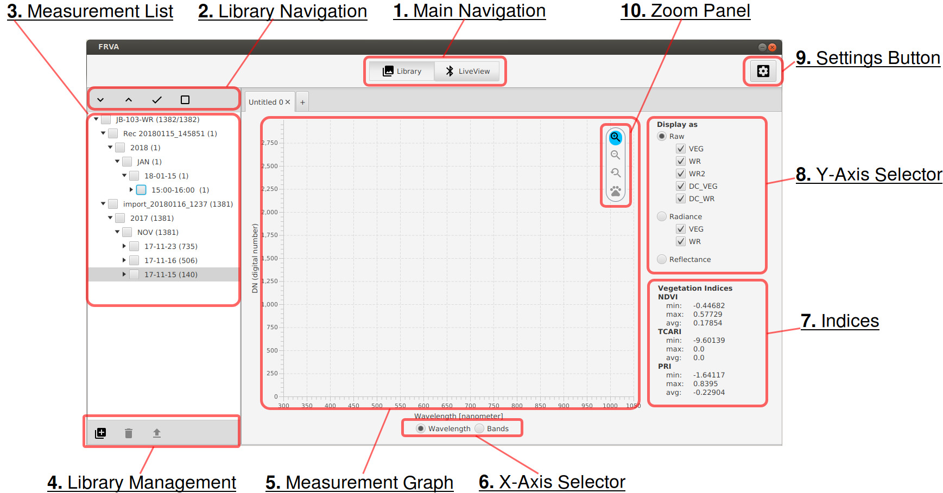

1. Main Navigation

Library-View Button switches view to Library View

Live-View Button indicates the current view is Live-View

1. Library Navigation

Expand all Button

Retract all Button

Select all Button

Deselect all Button

1. Measurement List

Shows all Measurements in the Library

1. Library Management

Import Button

Delete Selected Button

Export Button

1. Measurement Graph
2. X-Axis Selector

Selector for Bandwidth or Bands

1. Indices

Area where Indices (NDVI, TCARI, PRI) are displayed

1. Y-Axis Selector

Selector for Raw, Radiance or Reflectance.

Additional Selectors to display specificLines.

1. Settings Button

Starts Wizard to define Library Path

1. Zoom Panel

## Live View

1. Main Navigation

Library-View Button switches view to Library View

Live-View Button indicates the current view is Live-View

1. Measurement List  
    List all captured measurements in the current connection
2. Measurement Graphs   
    Two graphs representing the received data from the selected measurement.
3. Settings Button
4. Disconnect Button  
    Interrupts the current connection and starts dialog to establish a new connection
5. Connection Information  
    Displays information to the current connection, read from the connected device.

Includes display of command in execution.

1. Command Buttons  
    Manual Mode Button  
    Auto Mode Button  
    Manual Measurement Button  
    Manual Measurement Count  
    Manual Measurement Optimisation Checkbox  
    Set Integration Time Button  
    Set Interval Between MS Button  
    Set Time Button

## Console

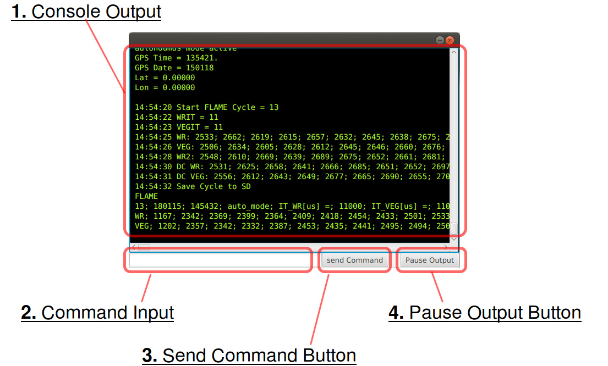

1. Console Output   
    Displays the Output sent from the connected device
2. Command Input Field  
    Textfield to enter Commands
3. Send Command Button  
    Sends Commands entered in the Command Input Field to the connected device
4. Pause/Resume Output Button

Stops the Console Output, incoming information is cached until output is resumed

# Library

## First start

When you start the application for the first time the library is created under “USERHOME/FRVA”.

You can change this path at any time.

## Importing data

A valid dataset contains a valid calibration file (cal.csv) and at least one folder with at least one datafile with comma-separated-values (.csv).

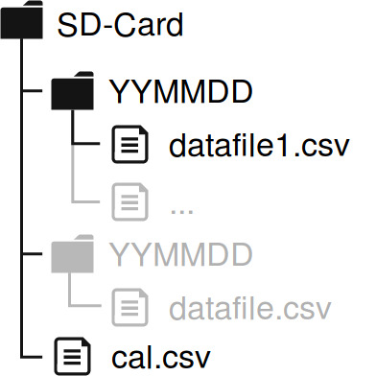

Only one SD-Card can be imported at the time.

1. Click the button on the left bottom corner in the Library-View and chose the folder you want to import. Even if you want to import only a single measurement, you need to chose the full folder. You are able to specify which measurements you want to import later in the process.
2. Click “Next” and optionally type a name for the data you want to import. Click next. Depending on the amount of data you are importing, this might take some time, as data is now analyzed.
3. In the next step you are able to select if you want to import all measurements.
4. Click “Finish” to import the selected measurements. Depending on the amount of measurements, this might take a while.

**Consider:** It is recommended to use the import-scenario for adding data to the library. Nevertheless dragging data manually to the library is possible as the application reads unmodified data.

**Consider:** To minimize loading time, a file named db.csv containing only the metadata for every measurement is written for every SD-card either on import. If you added data manually into the library, this file is written on start of the application. This process might take some time, depending on the amount of data, that you added.

**Consider:** If data has been changed inside the library manually, the corresponding db.csv file must be deleted. Otherwise the application might not work properly anymore. If a db.csv file is missing, FRVA will automatically recreate it on a restart.

**Consider:** The application is able to import up to 200’000 measurements at once. At a library size of over 500’000 the application struggles to start. Consider having multiple libraries and change them via the settings button.

## Selecting data

Over the TreeView on the left side of the user interface you can select one or multiple measurements. Measurements are sorted by device -> year -> month -> day -> hour.  
You can use the “Expand-All” and “Collapse-All”-Button in the bar above the TreeView.   
Selecting measurements can be achieved by clicking on a measurement. If the hook in front of the entry is shown, the measurement is selected. If a parent-element of a measurement is selected, all containing measurements are selected. You can also use the “Select All” and “Select None”-button in the bar above the TreeView.Ticked measurements are automatically plotted on the right side of the user-interface.

It is possible to use the **Shift**-modifier key to **select multiple measurements**. If multiple measurements are selected the “Select-None”-button first unticks the selected items.

To avoid accidental plotting of a large amount of measurements, FRVA will plot only automatically up to 40 measurements. If more than 40 measurements are selected, the application will ask for confirmation before plotting.

Be aware: on expanding the data will be loaded into memory. This means, that if you eg. click Expand-All with a massive library, the application might take a long time to

## Deleting data

Selected measurements can be deleted by clicking the bin icon in the bar below the TreeView.

**Consider:** This action deletes the the measurements not only from the treeview, but also from the .csv-file.

## Exporting data

Selected measurements can be exported by clicking the “Export”-button in the bar below the TreeView. After selecting a path, the selected measurements are exported.

**Consider:** If you chose measurements from more than one SD-Card, multiple folders will be created, as every measurement is linked to a unique calibration-File.

## Zoom

The plotted measurement can be zoomed. By default the zoom-in function is active. When you click and hold anywhere in the plot, a rectangle appears. If the zoomed area is ok, the rectangle will turn green. Release the mouse-button and the area will be zoomed in. Alternatively you can also zoom by using the mousewheel. If you change the setting to zoom out, you can click anywhere to zoom out. The reset-button resets the zoom to the default zoom level. The “drag”-button lets you drag around any zoomed in area. These three buttons (zoom out, reset and drag) can only be used if you are not fully zoomed out.

## Infobox

If hovering over a line, a infobox will appear, showing additional information about this plotted line. (Location, ID, device, type of line and exact value)

## Tabs

You can have multiple tabs open at one time. Every tab maintains its own list of selected measurements. Therefore you can have different selections and view settings on each tab.

To create a new tab press the plus “**+**” sign in the tab navigation.

To close a tab press the “**x**” sign on the corresponding tab.

To rename a tab, doubleclick its name, enter a new name and confirm with the enter-key.

**Consider:** Tabs are not saved; the application always starts with one untitled tab.

## View Measurements

The measurement graph can be adapted to display different calculations on different relations.

On the x-axis the values can be shown as bands (0 - n) or as wavelength of the corresponding data.

On the y-axis it is possible to display the data as Raw, as Radiance and as Reflectance. The Radio buttons have to be used to change the displayed data. To hide or show a specific type (line) on the graph, the checkboxes of the currently selected calculation can be used.

**Consider:** The indices (NDVI, TCARI, PRI) are only shown when the reflectance is displayed.

## Settings Button

The settings-button on the upper right corner of the application can be used for changing the library-path. By default this library path will be set on the first start of the application to “USERHOME/FRVA”. You can change this preset.

**Consider:** You need to restart the application to apply the changes.

**Consider:** Changing the library path does not move any files from the existing to the new path. You can use this functionality to switch between different libraries.   
Make sure you choose an existing library, or an empty folder. If the folder contains non related data, it might be deleted.

# Live View

The Live-View provides a possibility to connect to RoX device. A serial connection with the device will be established over Bluetooth.

## Establish connection to Rox

Make sure bluetooth is activated on your device. The connection process is fully covered from within the FRVA-Application. You do NOT need to connect to the RoX via system settings.

1. In the Main-Navigation click on the “LiveView”-Button. The application looks for available RoX devices. If one or multiple devices have been discovered, a list of these will be shown. RoX devices usually have a JB prefix in their name.
2. Chose the device you want to connect and click connect. Wait until the connection process is finished and the status-box disappears.
3. If the connection has been successful, the console window will open, where you can see the exchanged data between your device and the RoX-Spectrometer.

## Save Captured Data

The captured data is saved automatically. A new SD-Card is added to the current library as soon as the first measurement is finished.

The SD-Card appears in the Library-View under the given device as:

“Rec YYYYMMDD_HHMMSS”

## Disconnect from Rox

If a connection has been established you will be able to click the “Disconnect”-Button in the upper right corner. Click this button, and the connection will be closed.

## Show Measurement

On the left side you see all measurements captured in the current session. Click on a measurement to plot this measurement to the graph. Incoming measurements will be added automatically to the list of measurements.

## Switch View

You are able to switch from the Live-View mode to the Library mode without losing the connection to a RoX-device. On changing, all measurements from the Live-View will be added to the Library, so you can do further analysis of measurements.

## Capture Manual Measurements

Usually the RoX is in Auto-Mode. You can change to Manual Mode by clicking the Manual Mode Button on the right side of the user interface. RoX will change to manual mode after the current measurement has been finished. Once the RoX is in manual mode, the button “Manual Measurement” becomes active. Via the text-field you can choose how many manual measurements you want to execute. Click “Manual Measurement” to start the measurement process.

## Set Integration Time

To set the integration time on the device:

1. Click the Set Integration Time Button
2. Enter a duration in [ms]
3. Click OK

**Consider:** The integration time is used as default when a measurement is made without optimisation. This is not the maximal integration time.

**Consider:** This command can only be executed in manual mode.

## Set Interval Between Measurements

To set the interval between measurement on the device:

1. Click the Set Interval Button
2. Enter a duration in [s]
3. Click OK
4. The Interval is set

**Consider:** This command can only be executed in manual mode.

## Set System Time

The time on the devices can be synchronized with the local time on the computer connected.

To synchronize the time click the Set Time Button. Click Ok in the appearing dialog.

**Consider:** This command can only be executed in manual mode.

# Console

The Console is intended to give a advanced sight on what the device is doing. Also it gives the possibility to send any commands the the connected device.

The console is opened on a successful connection. Closing the console does not affect an open connection. Once closed, the console window cannot be reopened for the same connection. A new successful connection reopens the console-windowText can be copied from the console window. After the end of a connection, the console window stays open..

## Pause the Output

The output can be paused with the “Pause/Resume Output” button. The incoming input from the device is cached during the pause and is displayed in the console when the output is resumed.

## Send Command (expert mode)

**Attention!** Measurements will not be shown in the GUI if you trigger measurements directly over the console as this feature (as any other direct command) may leave the device in an unmanaged state. When this happens you must restart the device and reconnect.

1. Enter the command (e.g. “IM 1000”) into the Command Input Field
2. Click the Send Command Button

# Appendix A - List of Comands

This list shows the commands to steer the RoX device over the serial connection (Bluetooth). It represents the comandset for v1.0. The actual list can be triggered with the command “C”.

The x stands for a numeric value.

|  |  |
| --- | --- |
| Command | Description |
| B | Connect App |
| fc | send calibration file |
| f1 | transfers the current raw file QE |
| f2 | transfers the current raw file FLAME |
| A | go back to automatic mode |
| O | Optimise |
| M | measure without Optimisation |
| m | measure with Optimisation |
| I x | set integration time to x ms(eg. I 500) |
| IM x | set maximum integration time to x ms (eg. IM 1000 |
| i x | set the interval between measurements to x s (eg. i 60) |
| iL x | sets the cycles between FLED to x cycles, 0=off |
| S x | sets the resolution of sent bytes to x |
| a1 x | set the QE averages to x (eg. a1 3) |
| a2 x | set the FLAME averages to x (eg. a2 3) |
| G | Show GPS position |
| c | Read in config.txt |
| T | to set date+time |
| ss | toggle serial stream |
| st | toggle serial data transfer |
| C | get CommandList |