Preserving Antebellum Print Culture
Jason Peak

Abstract

[Sorry. Ignored \begin{singlespace} ... \end{singlespace}]

1 Core Goals and Requirements
For the editions of the magazines that Poe edited, the page count is about 4,000. The primary project goal is the establishment of a digital repository containing the text and scanned image of each of these pages. In addition to making each page image available,the text should be fully searchable. Providing access to page images and text search tools implies an access-controlled, web-based interface. Maintaining the integrity of complex, mixed-media, multi-page document records requires sturdy archival frameworks and flexible metadata standards.

1.1 Additional Opportunities
With core foundation blocks laid, the team will build up enhanced access services, including annotation, semantic search, and the infrastructure to expose the repository as linked open data.
Annotation consists of moderated user annotations to the elements of the repository. These annotations may become part of the archival record.
Search entails semantic markup. The team will identify or develop an appropriate ontology with which to describe semantic relationships amongst repository elements at the sub-document level. Initial candidates for such markup include people, places, corporate bodies captured with EAC-CPF.
Linked Open Data Client webservices will be developed to allow others to reuse the archive as a dataset for their own purposes.
Access to the contents of the repository is a key driver of this effort. While our core goals will lead us to a stable and sustainable repository, opening the contents of that repository to outside research is where the project gains traction, value, and the sustainable funding required for permanence. In the following sections, we will explore the issues associated with both the core and stretch goals and recommend tools, standards and workflows for achieving them.

2 Current Infrastructure
Currently, the project uses the popular Omeka publishing platform as repository, content ingest and administration interface, and dissemination portal. The application relies on a relational database to maintain application state and configuration, to control user access, for persistent records and metadata storage, and for RDF-like inter-record relationship data.
Besides offering a one-stop solution to the needs of a small repository, Omeka is freely available and open source from top to bottom. It is written in PHP and based on the industry standard Zend PHP framework. It can be fitted to a number of databases, including PostgreSQL and MySQL, which are also free and open source. Rounding out the Omeka architecture is the Apache webserver running on linux. Using open source software allows the team great flexibility in customizing the software, and independence in resolving technical issues. As the project goals outgrow the capabilities of Omeka, finding a similarly open replacement will be in keeping with archival best practices [citation]

2.1 Constraints
While Omeka has served the project well, achieving the core project goals within its current framework presents significant challenges and forces some awkward compromises with respect to the internal representation of data. Specifically, Omeka is not well-suited to multi-page records or sub-document references.
Omeka operates on items. Each item is defined by its Dublin Core metadata, and files, such as images, can be attached to item records. This model fits a collection of paintings, photographs, or museum objects very well; these can be gathered into an Omeka collection and presented as an exhibit. Approximating a magazine, consisting of succeeding pages would require distinct items for each page, using the page number as the title, perhaps, attaching the appropriate page scan to the appropriate item, and then assembling all of the pages into a collection or exhibit. Assuming that the page order can be defined for the exhibit, the structure that it represents is an attribute of the exhibit, not of the item itself.
There are well-known XML dialects that are designed to describe such multi-page documents, but put simply, Omeka does not speak XML. Certainly, this team has written custom plugins to give Omeka the ability to parse XML, specifically TEI, documents, but because Omeka was not designed to operate on XML data, this approach is not sustainable in terms of long-term preservation or the extended goals this project aims to achieve. Trustworthy digital repositories are composed of standards-based frameworks built to operate on standards-based records and to enforce standards-based archival policies; most of these are expressed as XML. Replacing the current infrastructure with such a system increases complexity and potential cost but offers a commensureate increase in long-term stability, sustainability and interoperability.

3 Required Infrastructure
At the base, there must be a robust and trusted repository in which born-digital artifacts are deposited. The time and expense required to capture this corpus deserves no less, and we imagine that generations of future scholars and students will benefit from our efforts, provided that the materials are well-preserved in accordance with the best practices currently known to the archives community.

3.1 TDR
A sustainable, trustworthy, well-supported, and well-managed digital repository needs hardware, software, policies, processes, services, and people to assure long-term retention and, perhaps, access to its content and metadata.[6]
The term Trusted Digital Repository is loaded with implications, most importantly, that some digital repositories are not trusted. Dow prefers to use Trustworthy Digital Repository, and gives its meaning as an overall commitment to the stewardship of digital materials[6]. As a purely digital project, achieving the core goals and assuring the long-term success of Poe’s Magazine World is bound to making this commitment.

3.1.1 TDR Specifications

OAIS
There are several models used in building trusted digital repositories, but by far the most common is based on the Open Archives Information System (OAIS) model, ISO 14721:2003. OAIS is a high-level model, and the details of implementation are determined locally. Using the model helps organizations plan sustainable repositories[8] The model defines six functions that a conforming repository must implement: Ingest, Archival, Data Management, Administration, Access, Preservation Planning.

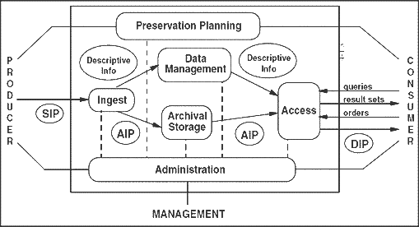
Figure 1: OAIS reference model[12]12

TRAC and DRAMBORA
Because the OAIS model is loosely defined, there is no single correct implementation, and while there is no official definition[6] of TDR, there is general agreement of its components and better, tools for determining trustworthiness. The requirements defined by these documents are the de facto specification of the term, TDR. Most prominent of these tools are the Digital Repository Audit Method Based on Risk Assessment (DRAMBORA)[3] and the Trustworthy Repositories Audit & Certification: Criteria and Checklist (TRAC)[4]. TRAC became ISO standard 16363 in 2012[7]. TRAC is designed for institutions to audit a repository provider; unless the project elects to pay an external service provider, it is not directly applicable.
DRAMBORA, a self-audit tool, takes a risk-management approach to repository audit. DRAMBORA is designed to identify weakness in the organization and its infrastructure. As an exercise, applying the DRAMBORA toolkit to the project’s repository will not only identify risk-management opportunities, but will help generate formal planning and policy specifications that can guide the repository’s daily operations. Sample DRAMBORA checklist items include:
1. T3: List your repositoryâ€™s strategic planning documents
2. T7: Identify your repositoryâ€™s activities, assets and their owners

3.1.2 TDR Options
Poe’s Magazine World has options with respect to adopting a TDR: use the LSU libraries existing infrastructure, wait for a forthcoming institutional repository, or build and self-host. Each offers benefits; each has constraints. Initially, we should consider a hybrid approach.

Louisiana Digital Library
It is likely that the Hill Memorial Library Digital Imaging staff will be providing scans + dirty OCR for each page in the collection. If that happens, they have also agreed to add each item to the Louisiana Digital Library (LDL), which will be maintained in perpetuity. The LDL is well-established and actively maintained. Depositing the Poe’s Magazine World artifacts there gives permanence to the collection at low cost and requires no effort from the project staff. This step almost fully accomplishes the baseline project goals.
On the other hand, the materials on deposit with LDL will be rough: raw scans and dirty OCR text. The extended goals of the project will require the preservation of clean and carefully marked text, something that the LDL is not currently offering. Further, there is uncertainty over the availability of the digital objects once they have been ingested into the LDL repository system (ContentDM); specifically, the extended project goals require a rich set of APIs for dissemination, including LOD access and HPC Visualization.

Institutional Repository
By the time the project begins in Summer of 2014, there is a high probability that LSU will have established an institutional repository to manage and maintain its research data sets. The dataset which comprises this collection will afford local and distributed research, and so it follows that Poe’s Magazine World will have no problem gaining acceptance into the IR. In this case, the data preservation infrastructure is part of the local technology environment and does not require significant time or expertise from project team members.
The glaring issue with this option is the fact that it has not yet been deployed or even publicly announced.

TDR Provider
For-pay repository services are available, however, given the available institutional resources, a vended solution should be considered a last resort.

Homegrown TDR
If a local institutional repository is not announced soon, the team should consider building its own TDR. Besides ownership, this option affords the greatest flexibility in terms of data structure, policies and their enforcement, access control, dissemination and customization. Of course, taking this route complicates planning and logistics and requires a sustainable funding source for staff and ongoing infrastructure maintenance.

3.1.3 The Poe’s Magazine World TDR
With long-term preservation of the digitized originals managed in the archive, the OAIS model, and the core project goals require that the digital objects be made available for use by the repository’s designated community. At a minimum, the project goals require that users should be able to retrieve the page images and text. Further, the text must be searchable. In addition to assuring long-term preservation, the repository services provided by the Louisiana Digital Library will make the page scans and OCR text available through their public portal. While this comes close to satisfying the core goals, because the OCR text will be dirty, the legibility of the text is not expected to be suitable for accurate full-text search. Furthermore, while we plan to manually clean this text, our agreement with LDL does not include a continuing trickle of item updates. Therefore, our obligations to provide full-text search access to the text, coupled with our extended goals, requires that we seek a more flexible repository arrangement.

LDL as Dark Archive
A hybrid approach could treat the LDL collection as the dark, permanent archive while the active access-focused archive resides in another system. Unfortunately, this breaks the OAIS model in that there is no ongoing system-level integration available between the LDL archive and the active archive. Even if it were organizationally possible, the complexity required to keep two wholly disparate systems in sync as a cohesive system is unmanageable.

Institutional Repository
A managed Institutional Repository is the most expedient possibility for achieving core project goals, provided that its data model is flexible, that it provides reasonable access APIs, and that there is provision for long-term preservation.

Build
Fortunately, we would not be starting from scratch. The technology landscape at LSU is such that existing systems may leveraged to satisfy many of the most daunting requirements of a TDR, specifically, secure data centers, disaster recovery systems, and distributed backup systems. A brief sketch might look like this: The repository and its peripheral systems (administration, ingest, dissemination portals) run on virtual servers housed in a secure data center on campus. Each server image is backed up each night; this serves as a hot backup in case of local (in terms of the server operating system) failure, corruption, human error. For each of these servers, key file systems are identified for nightly incremental backup via LSU’s Tivoli Storage Manager which makes geographically distributed tape-based backups which can be used for recovery from local disaster. For a TDR, these key file systems include the dark archive, the active archive, the repository management system itself, and any public-facing dissemination portals.
This sketch assumes the existence of repository software, administration and dissemination software tools, and human resources. The staff required include systems administrators to maintain the repository systems, programmers to create and integrate custom tools and dissemination applications (web portal, LOD services, etc), and archivists to plan preservation, curate content and manage the archive and enforce its policies. Finding sustainable funding to maintain these human-machine systems over the long term will prove the greatest challenge.

3.2 Tools

3.2.1 Repository Software
Software packages and cloud services exist that provide some or all of the functions required of a digital repository. Off the shelf, a number of candidates present themselves. Fedora, Archivematica, DAITSS and ContentDM are the most prominent.

ContentDM
Because ContentDM is a closed-source product, we will not consider it a viable option.

FEDORA
The Flexible Extensible Digital Object Repository Architecture is a back-end system that manages ingest, content, and policies. Fedora offers flexible data models that let repositories represent arbitrarily complex objects consisting of a range of media types. At the core of this model is extensive use of the METS metadata standard format to encapsulate structural, administrative, representational, and descriptive metadata[11].

Islandora
is a Drupal-based front-end for Fedora. Drupal is a popular, widely-used, community-developed, open source web platform used for the rapid development of web applications. While there is an online sandbox[9] for evaluation purposes, any local investigation into the use of Fedora should include an Islandora front-end.

DAITSS
Dark Archive in the Sunshine State is designed for long-term preservation[2] and, as its name suggests, places great emphasis on the integrity of the dark archive. Having recently released their 2.0 version touting RESTful web services and multiple tenancy, DAITSS should be included on the short list for further investigation.

Archivematica
is new, and is poised for its 1.0 release. Archivematica claim OAIS compliance[1] and ingest-to-access workflow based on a microservices architecture.

3.2.2 Access Software
In addition to building custom portals and visualizations based on the content of the repository, a number of ready-made applications exist to present the repository to end-users. A number of web front-ends have been written and published for Fedora[5]. For example, the Scholar’s Lab has published their Fedora Connector for Omeka, which lets Omeka users populate exhibits and collections from the content of the Fedora repository. It does not, like Islandora, offer repository management functionality[10].

4 Migration
To date, a great deal of content has been located in collections, scanned and stored in the Omeka repository. Because Omeka is open source, developing a migration path for existing records will require careful execution, but little difficulty or uncertainty. Further, there is no technical or economic reason that this will need to be done in haste, as may be the case in a hosted environment where each megabyte incurs a certain cost per hosted minute.

4.1 Transition
Once an alternative platform is chosen, selected and thoroughly tested, the Omeka site can be put into a read-only state such that no further modifications to its records database can occur. With the database frozen, a full database backup, using mysqldump, will create a fixed-point snapshot of the database state, a restoration point.

4.2 Translation
Using knowledge gained in the course of developing custom Omeka plugins, data translation scripts will marshal complete records from the Omeka database tables and render each as a SIP ingestible by the new system. With all of its records safely ingested in the new system, the old system will remain in read-only state as a reference for as long as the team deems useful (probably a year).

5 Ingest Workflow
Workflow is loosely defined here. Inevitably, refinements will be made as issues are discovered and resolved. The acquisition process, from capture to ingest, can be imagined as a pipeline starting from the physical original and ending with an archival Submission Information Package (SIP). Stages in this pipeline include: page scanning, OCR text extraction, OCR cleanup, baseline TEI encoding and Submission Information Packaging (SIP).
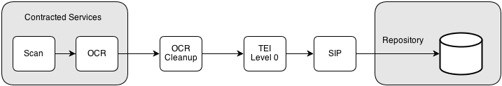
Figure 2: from capture to ingest
While each stage will require human intervention and oversight, the OCR correction stage is expected to incur the most significant outlay of human resources.

5.1 Contracted Services
The raw scans and text will be provided by Hill Memorial Library as a contracted service. Details of this process will be handled by library staff, and the end product will be delivered to the project team for further pre-ingest processing. As noted elsewhere, Hill will retain a copy of this corpus in perpetuity.

5.2 Data Structure

5.2.1 Image + Text
The atomic elements of the repository are garden variety TIFF images and lightly-encoded[13] TEI text files. The most basic use-case for repository records is that of an end-user browsing one of the issues of The Broadway Journal, for example. In this scenario, the user expects to view the page image, but also to have the ability to search the text for keywords, for example, all occurrences of the word election occurring in the current, say, June 1844 issue. A list of search results comes back, the user chooses one to follow.
The collection is comprised of a subset of all the issues of four periodicals. Each issue contains pages; each page contains text, possibly a heterogeneous concatenation of text from two or more adjacent pieces, advertisements, and graphics. This is a complex, but neatly hierarchical, structure that should be represented in a suitable data structure.

5.2.2 METS Records
METS is an XML format for describing the structure of archival digital objects. METS records are used to describe books, for example, where a single METS record represents the book, and nested within this record is a METS record for each page. Each of these page records contains, at a minimum, a reference to the TIFF image of the page and the TEI markup of the text. In addition to describing structure, METS is a container format for other metadata formats. Commonly including in a mets:mdwrap element are RDF elements for semantic mappings, MODS records for bibliographic and library catalog information, EAD finding aids, and so on. It enjoys widespread use and the endorsement of leading archival institutions, including the Library of Congress.

5.3 TEI, Level 1
TEI SIG’s Best Practices of TEI in Libraries enumerates five levels of TEI encoding that describe increasingly complex markup. The baseline text for each page will have the characteristics of this Level 1 TEI and will serve as the base upon which enhanced readings are built.
[Sorry. Ignored \begin{singlespace} ... \end{singlespace}]

5.4 OCR Cleanup and TEI
Cleaning dirty OCR is an intensely human process. Each word in each page must be compared to the original for fidelity; errors will be corrected in standard text-editing software. Dual monitors will be necessary for the staff performing this work. In addition, spell-checking utilities will identify gross errors introduced by the OCR process. While we will aim for perfection, errors will remain. The repository should plan for these future text updates and determine utilities for propogating revisions to derivative versions. The process of manually correcting OCR text is a prerequisite for the intermediate TEI levels three and four. In the scope of the initial project phase, described here, it is likely that TEI levels above three will be used only for a few proof of concept and highlight cases. Level 2 does not require corrected text and still treats the text as subordinate to the page image while making some additional structural markup. Level three TEI is most fitting at this stage, and the TEI SIG describes it as follows:
[Sorry. Ignored \begin{singlespace} ... \end{singlespace}]

5.5 Conclusion
In a recent CLIR report, warns against insularity in planning Digital Humanities projects and validates this project’s aims towards linked data.
The silo-like nature of current centers is creating untethered digital production that is detrimental to the needs of humanities scholarship. Todayâ€™s centers favor individual projects that address specialized research interests. These projects are rarely integrated into larger digital resources that would make them more widely known and available for the research community. As a result, they receive little exposure outside their center and are at greater risk of being orphaned over time.[14]
Given raw images and dirty OCR as a starting point, core project goals may be achieved by identifying a suitable Trustworthy Digital Repository, by coercing the text to TEI Level 3, and by binding page image + text in a suitable format such that each issue of each magazine is available to modern readers much as it was to contemporary readers. Selection of and strict adherence to appropriate standards will ensure that the repository is sustainable for the long-term, that it can serve as a fertile base for deeper investigation, and that it may become part or an increasing community of repositories that have opened their data to use and reuse by others.

6 unwritten...
1. RDF/CIDOC/Ontology in Fedora, in TEI, in METS, etc
2. METS, TEI levels examples
3. LOD how
4. ...

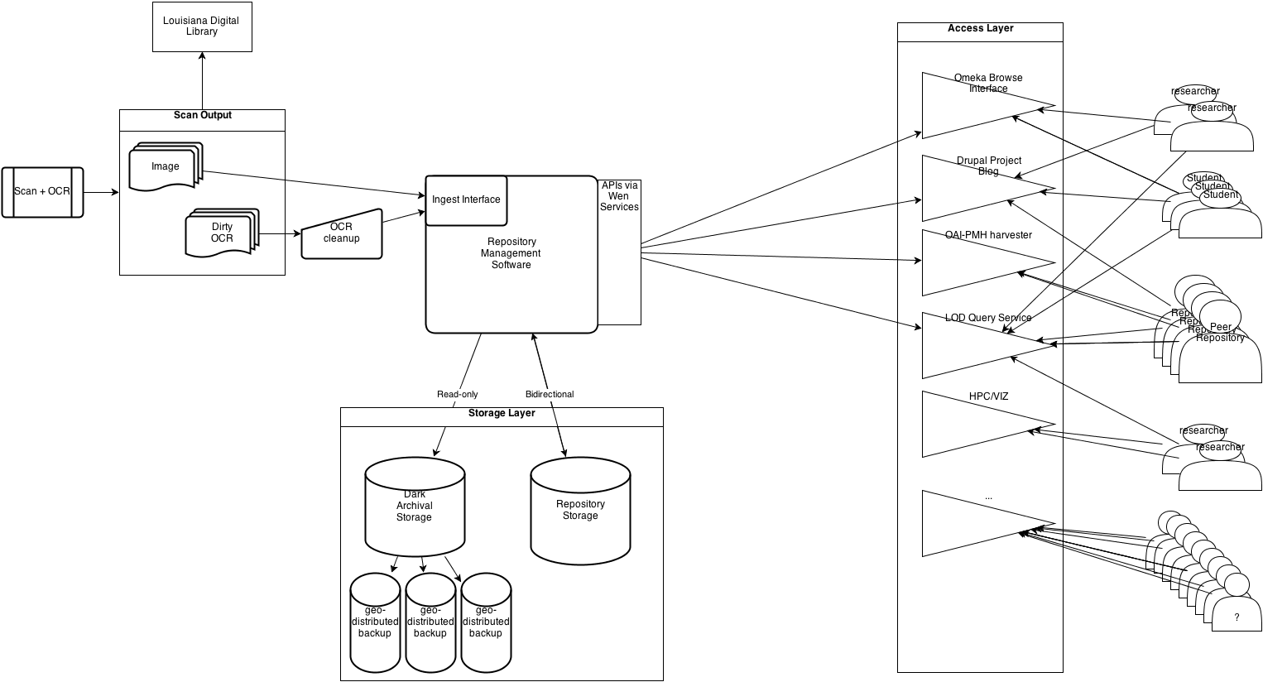
References
[1] Archivematica. Archivematica wiki homepage.
[2] Priscilla Caplan. Daitss, an oais-based preservation repository.
[3] Digital Curation Center. Drambora: About, May 2013.
[4] CRL, The Center for Research Libraries and OCLC Online Computer Library Center, Inc. Trustworthy Repositories Audit & Certification: Criteria and Checklist, 2007.
[5] Daniel Davis. Web ui / front end applications.
[6] Elizabeth H. Dow. Electronic Records in the Manuscript Repository. Scarecrow Press, Inc., 2009.
[7] Center for Research Libraries. Iso 16363 / tdr, May 2013.
[8] Ross Harvey. Digital Curation, A How-To-Do-It Manual. Neal-Schuman, 2010.
[9] Islandora. Islandora sandbox.
[10] Scholar’s Lab. Omeka fedora connector.
[11] Eric Peters. Fedora metadata storage philosophy.
[12] poppen. Oais-.gif, May 2013.
[13] TEI SIG on Libraries. Best practices for TEI in libraries. http://www.tei-c.org/SIG/Libraries/teiinlibraries/main-driver.html, October 2011.
[14] Diane Zorich. A survey of digital humanities centers in the united states, 2008.

