CSC 7135 Activity Diagrams
Jason Peak, Wyatt Clements, Gurmindar Kaur, Simron Thapa, Rama Indugula, and Job Champagn

e

Use Case: Order Journal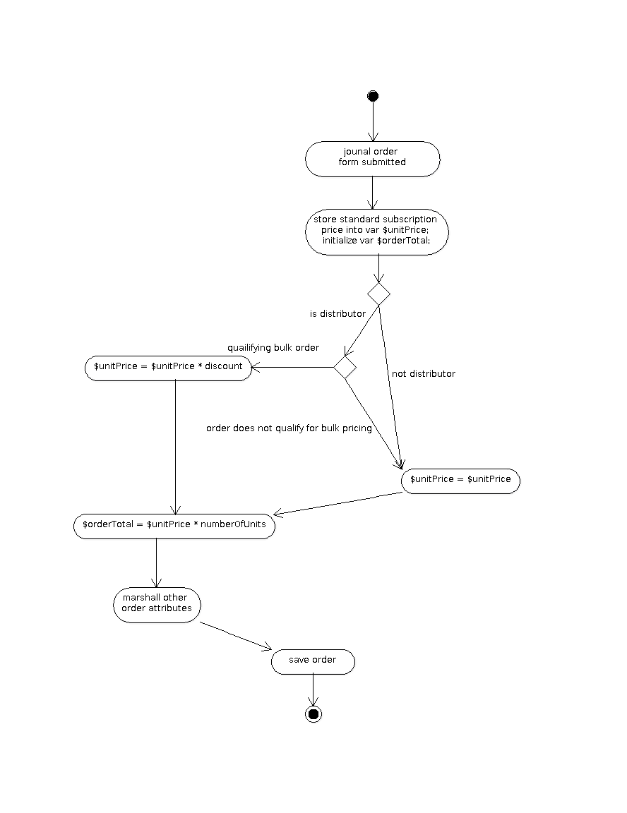

Use Case: Sends Renewal Notice
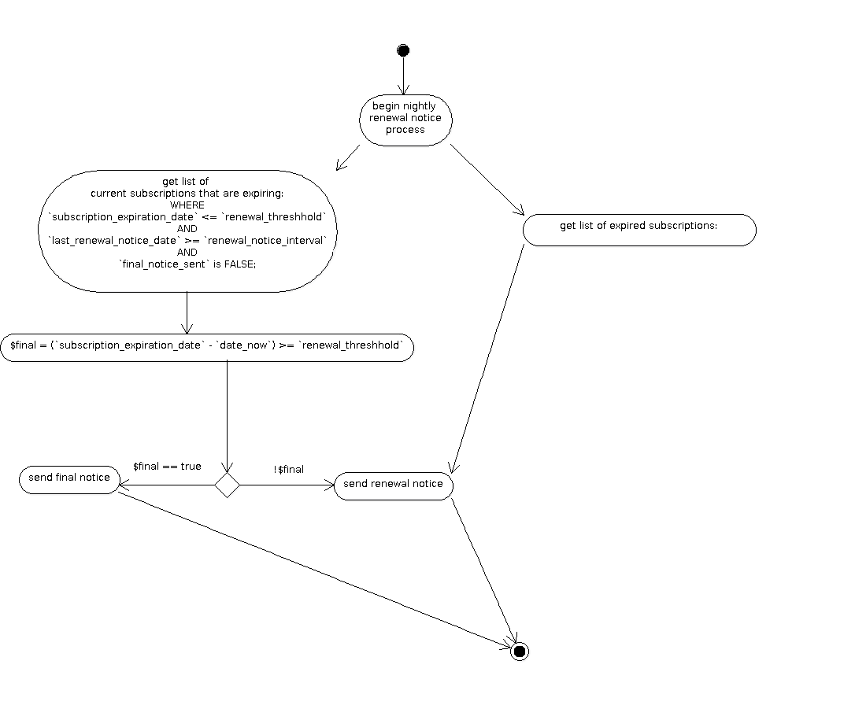

Use Case: Receive Discount
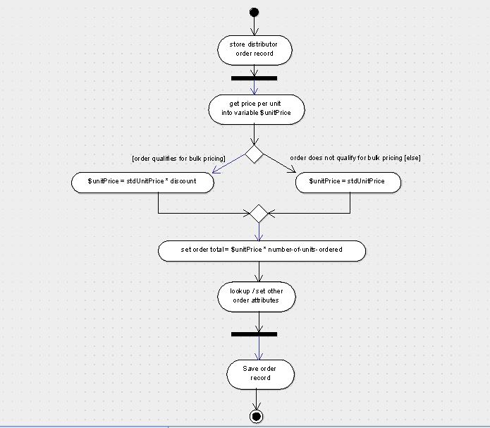

Use Case: Supply name and address of Subscribers
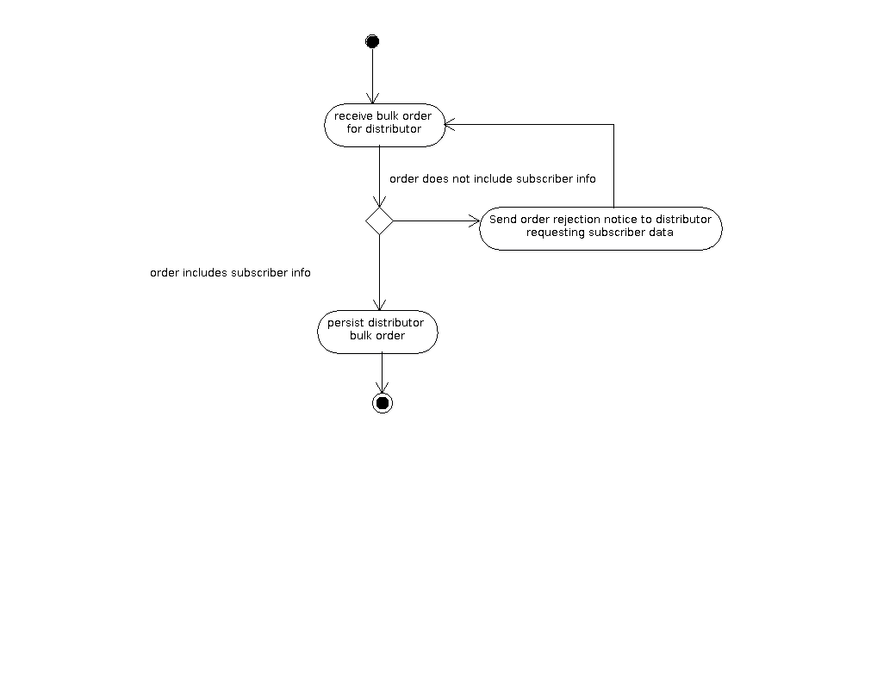

Use Case: Receive Free Subscription
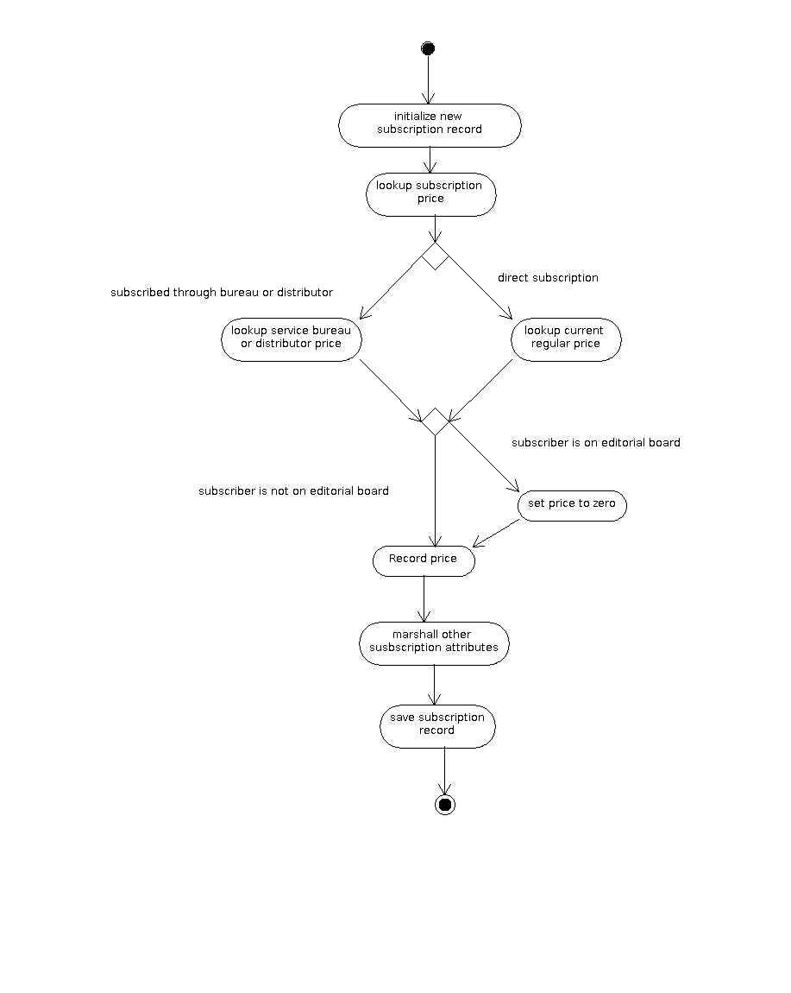

Use Case: Publish Journal
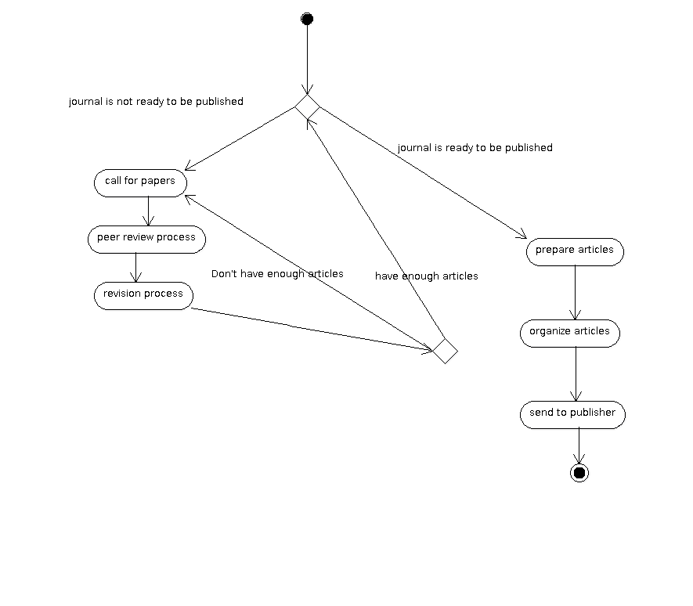

Use Case: Plan future topics and potential Authors
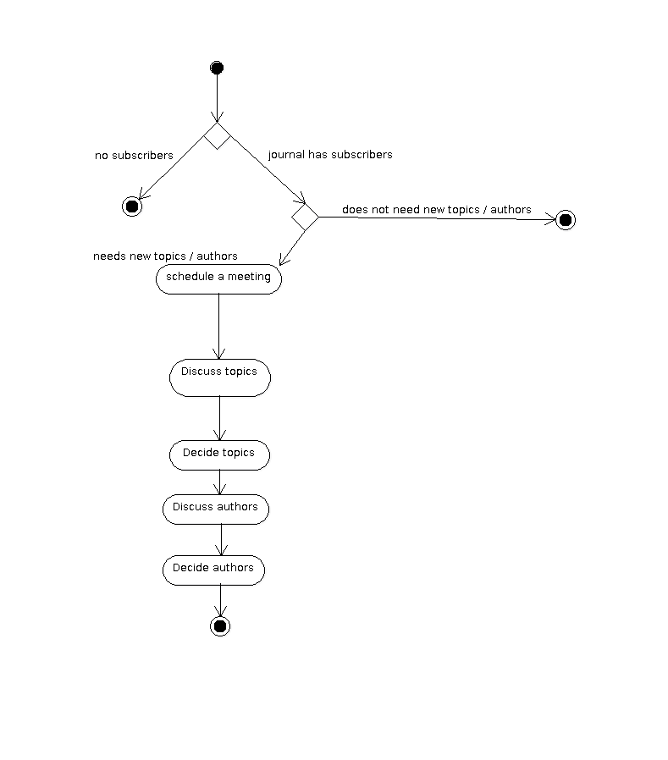

Use Case: Distribute and Market Journal