

**============================================================**

**DOOR SCRIPT – FREE**

**DOCUMENTATION**

**============================================================**

**INDEX**

**============================================================**

**1. INTRODUCTION**

**2. SETUP GUIDE**

**2.1. WHAT’S IN THE BOX (AND WHAT’S NOT)**

**2.2. STEP-BY-STEP GUIDE**

**2.3. TROUBLESHOOTING AND KNOWN BUGS**

**3. OVERVIEW SCRIPT**

**3.1. DETECTION SCRIPT**

**3.1.1. DETECTION SETTINGS**

**3.1.2. DEBUG SETTINGS**

**3.2. DOOR SCRIPT**

**3.2.1. DOOR SETTINGS**

**3.3. DEBUGGER**

**4. COPYRIGHT AND CONTACT**

**============================================================**

**=========================================================================**

**1. INTRODUCTION**

**=========================================================================**

Hey, this is the documentation file for the ‘Door Script – FREE’ Unity3D asset.

I hope all of your questions get answered in here, if you have any further questions,

Contact me by using one of the methods listed below (see 4. COPYRIGHT AND CONTACT)

**=========================================================================**

**=========================================================================**

**2. SETUP GUIDE**

**=========================================================================**

**2.1. WHAT’S IN THE BOX (AND WHAT’S NOT)**

**===================================================================**

**Included in this asset:**

* An example scene to show you what the asset is able to do
* A test scene for you to experiment with the asset
* A ‘Detection’ script to detect moveable objects in your game
* A ‘Door’ script to move the detected objects
* A ‘MouseLook’ and ‘PlayerMovement’ script
* A debugging tool

**Not included in this asset (you need this):**

* A character that is able to move/look around in the game world
* 3D objects in your scene that you want to use as doors/windows

**===================================================================**

**===================================================================**

**2.2. STEP-BY-STEP GUIDE**

**===================================================================**

**1)** Import the asset

**2)** Create and assign the tag ‘Door’ to all of the objects you want to use as doors

in your scene.

🡪 You can create a new tag by clicking on the door, going to the tag menu and

clicking 'Add tag ...' on the drop-down menu

🡪 If you want to use another tag to identify doors, you can set this

in the 'Detection’ script

**3)** Click and drag the ‘Detection’ script onto your character

**4)** Click and drag the 'Door' script onto ALL of your doors

**5)** Have fun with the settings!

**===================================================================**

**2.3. TROUBLESHOOTING AND KNOWN BUGS**

**===================================================================**

The only known ‘bug’ is that when a door rotates, it will always pick the shortest

way between StartAngle and EndAngle, and this might not always be what you

would expect.

Also make sure your door has a collider component attached to it, otherwise the

script won’t be able to detect the presence of a door.

**===================================================================**

**=========================================================================**

**3. OVERVIEW SCRIPT**

**=========================================================================**

**3.1. DETECTION SCRIPT**

**===================================================================**

**3.1.1. DETECTION SETTINGS**

**============================================================**

http://i.imgur.com/Nb8F6wP.png

|  |  |
| --- | --- |
| **Reach** | Within this radius is the player able to open the door/window. Equals the length of the raycast. |
| **Trigger Tag** | The tag that triggers the door/window to be openable. All the objects with the tag ‘Door’ in your game will be openable/closeable by the script. |

**Example Reach:**

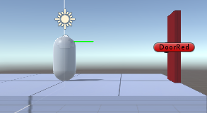 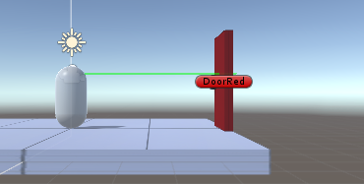

Reach = 1 Reach = 5

**Example Trigger Tag:**

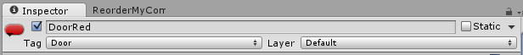

**🡪** ‘DoorRed’ is detected by the ‘Detection’ script as openable/closeable

Because the tag is the same as the ‘TriggerTag’ variable.

**============================================================**

**============================================================**

**3.1.2. DEBUG SETTINGS**

**============================================================**

http://i.imgur.com/1dex13v.png

|  |  |
| --- | --- |
| **Debug Ray Color** | The color of the ray that visually represents the raycast in the scene view. (Debugging purposes) |

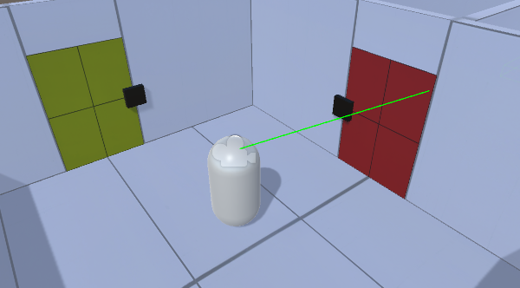

**In Game Debugger:** Toggle for an in-game debugging GUI

(See 3.3.DEBUGGER)

**============================================================**

**===================================================================**

**3.2. DOOR SCRIPT**

**===================================================================**

**3.2.1. DOOR SETTINGS**

**============================================================**

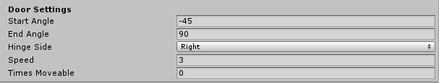

|  |  |
| --- | --- |
| **Start Angle** | The start angle of the door, is based on the original position of the door before you click ‘play’. |
| **End Angle** | The end angle of the door, is based on the original position of the door before you click ‘play’. |
| **Hinge Side** | The hinge side determines around which side of the door/window the door/window opens, left or right. |
| **Speed** | Determines how fast the door opens/closes. |
| **Times Moveable** | Determines how many times the player is able to move the door, if set to zero, the player will be able to open the door an infinite number of times. |

**Example:**

**Door Settings**

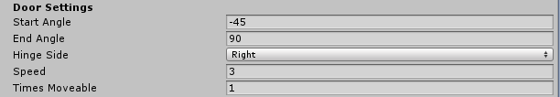

|  |  |
| --- | --- |
| **Before I clicked ‘play’** | http://i.imgur.com/smeSjZE.png |
| **After I clicked ‘play’, before I opened the door (the hinge, positioned right, rotated -45 degrees, based on the original 0 degrees rotation)** | http://i.imgur.com/XCpopZV.png |
| **After I opened the door (the hinge, positioned right, rotated +90 degrees, based on the original 0 degrees rotation)** | http://i.imgur.com/U1CHtop.png |

**===================================================================**

**3.3. DEBUGGER**

**===================================================================**

The debugging tool created by Viktor Yurov is a great way to get more information

about the doors in your scene. When toggled under the ‘Detection’ script

http://i.imgur.com/rjRIneO.png

there will be a GUI visible in-game when you hit play.

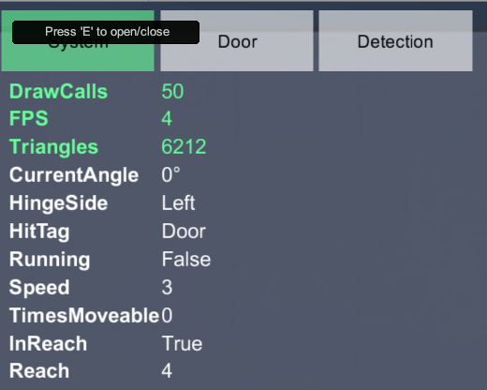

This panel will show tons of variables whenever the ‘Detection’ script detects

an openable door.

You can also check all the debugging info by doing this:

*Window>Debug Panel*

**Check the ‘ReadMe’ pdf file found in the ‘Debugger’ folder included in the asset.**

**=========================================================================**

**4. COPYRIGHT AND CONTACT**

**=========================================================================**

**Copyright:**

All the scripts, scenes, 3D objects, textures and materials in this asset are created by me

except for these:

* The ‘MouseLook’ script
* The ‘PlayerMovement’ script
* The ‘Debug Panel’ tool

The first two scripts are from this website:

<http://wiki.unity3d.com/index.php/Scripts>

The contents of this website are available

under 'Creative Commons Attribution Share Alike'.

The debugging script is a great tool developed by developer Yurov Viktor:

<https://www.assetstore.unity3d.com/en/#!/content/30739>

<https://www.assetstore.unity3d.com/en/#!/search/page=1/sortby=popularity/query=publisher:11008>

These scripts are included in the asset for example purposes only. Thanks to the developers!

You are free to use this script in any free/paid game that you want, but it would be awesome if

you notify me when you published a game that uses my asset!

**Contact:**

For assistance, feedback, suggestions, comments and other stuff:

**Email:** alexanderameye@gmail.com