Problem Set 1

Jonathan A. Pedroza, PhD

2022-02-01

1. What type of distribution is below?

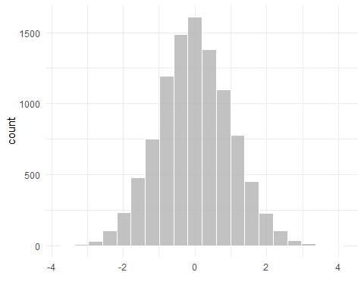

**Answer:**

1. What type of distribution is below?

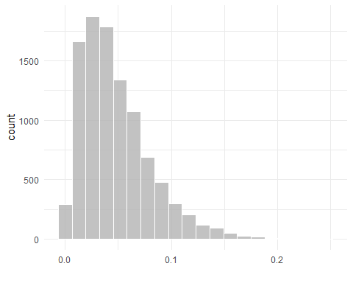

**Answer:**

1. What type of distribution is below?

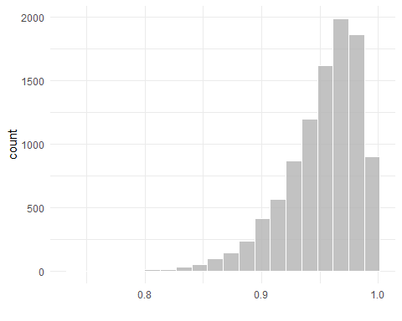

**Answer:**

1. Describe what a bimodal distribution is in your own words.

**Answer:**

1. What is the term for the formula below?

$$=\frac{f}{N}$$

**Answer:**

1. Calculate the relative frequency for each category. The following data will be for numbers 6-8. **If using R/RStudio, you can copy+paste from the *word categories to the word categories below it* and run that in R/RStudio to see the values.**

categories <- c('d', 'e', 'a', 'e', 'e', 'e',  
 'b', 'd', 'e', 'c', 'a', 'e',  
 'a', 'd', 'e', 'd', 'e', 'c',  
 'a', 'b', 'e', 'a', 'b', 'd',  
 'd', 'd', 'd', 'e', 'e', 'e')  
categories

## [1] "d" "e" "a" "e" "e" "e" "b" "d" "e" "c" "a" "e" "a" "d" "e" "d" "e" "c" "a"  
## [20] "b" "e" "a" "b" "d" "d" "d" "d" "e" "e" "e"

**Answer:**

1. Get the **proportions** & **percentages** of each category.

**Answer:**

/30 A

/30 B

/30 C

/30 D

/30 E

1. Calculate the cumulative frequency of categories D and E combined.

**Answer:**

9.Calculate the median for the following values. The following data will be for numbers 9 & 10. **If using R/RStudio, you can copy+paste from the *word numbers to the word numbers below it* and run that in R/RStudio to see the values.**

numbers <- c(3, 5, 7, 6, 4, 9, 1, 8, 4, 6, 6, 4, 5, 2, 3)  
numbers

## [1] 3 5 7 6 4 9 1 8 4 6 6 4 5 2 3

**Answer:**

1. Calculate the mean for the following values.

**Answer:**