

940 South Coast Drive Ste. 225 Costa Mesa, CA 92626 Phone: (949) 743-1457 Fax: (949) 274-8299

**Name**: NA

**DOB**: NA

**DATE(S) OF EVALUATION**: NA (Interview) and NA (Testing)

EXAMINERS: NA, NA, and NA

The following neuropsychological assessment report is CONFIDENTIAL and is intended as a communication between professionals. In its present form it is not to be released to the patient, the patient’s family or other representative, or any other practitioner without expressed written consent of the patient and the examiner. All requests for copies of this report should be sent to the examiner. The test data herein can only be interpreted by appropriately trained healthcare providers; should questions arise about the contents of this report, please contact the neuropsychologist.

REFERRAL SOURCE:

NA NA is a NA-year-old, NA-handed, NA, NA, NA with NA years of education.

BACKGROUND AND HISTORY:

History of presenting complaints: Historical information was obtained from a thorough clinical interview via telehealth with NA NA. The patient, whose medical history is significant for NA, presented with complaints of longstanding difficulties with NA since NA.

NA

NA

NA

NA

NA

NA

Current Functioning: NA NA NA

Medical History: The patient’s medical history is significant for NA. NA

Current Medications: Per NA NA’s report, NA is NA. NA mentioned a previous prescription of NA.

Family History: NA

Psychiatric History and Substance Use: NA

NA

Developmental, Educational, Social, and Occupational History: r

**BEHAVIORAL OBSERVATIONS:**

NA

**TESTS ADMINISTERED:**

NA

**TEST RESULTS:**

Validity: Consistent with behavioral observations, NA NA’s level of effort and engagement was deemed to be appropriate based on independent and embedded measures of performance validity. As such, the following results are believed to be a valid estimate of the patient’s current cogntive functioning.

Intellectual Functioning: NA

Attention/Concentration: NA

Processing Speed: NA

Executive (Frontal Systems) Functions: NA

Language Skills: NA

Visual-Spatial Skills: NA

Memory: NA

Mood and Personality Functioning: NA

For greater detail of test results, please see Neuropsychological Summary Score Sheet.

**SUMMARY & IMPRESSIONS:**

NA NA is a NA-year-old, NA-handed, NA, NA, NA with NA years of education. NA

**RECOMMENDATIONS:**

* The patient would benefit from feedback with our team regarding the nature of NA neurocognitive profile. This knowledge will allow NA to gain a better understanding of NA level of abilities and capitalize on cognitive strengths. Education in the definition and implications of Attention-Deficit/Hyperactivity Disorder will be an important part of feedback.
* NA NA may benefit from connecting with a psychiatrist to undergo a psychiatric medication evaluation in light of the recent results and diagnosis of ADHD.
* NA NA may benefit from utilization of cognitive rehabilitation therapy to gain learning strategies that support NA symptoms of ADHD.
* The patient may benefit from accessing resources to gain skills to support her attentional difficulties using several workbooks for self-paced training. Some examples of resources are listed below.
  + Managing ADHD Workbook for Women: Exercises and Strategies to Improve Focus, Motivation, and Confidence by Christy Duan, M.D., Kathleen Fentress Tripp PMHNP-BC, and Beata Lewis, M.D.
  + Executive Functioning Workbook for Adults: Exercises to Help You Get Organized, Stay Focused, and Achieve Your Goals by Blythe Grossberg, Psy.D.
  + The ADHD Workbook: Skills, Techniques, and Exercises to Manage Time, Emotions, Depression, and Hyperactivity with CBT Worksheets by Beatrice W. Hanlon
  + My Brain Has Too Many Tabs Open Daily Planner: Everyday Planner for ADHD, ASD, Autism and the Chronically Disorganized by Paperclip Press
  + ADHD Workbook for Adults: Proven Techniques and Exercises to Succeed in Private and Professional Life (podcast) by Tara Wilson
  + Adult Women Navigating ADHD: Techniques and Skills to Positively Transform Your Life and Take Charge of Adult ADHD (audiobook) by Lillian Clem
  + Mindful Parenting for ADHD: A Guide to Cultivating Calm, Reducing Stress, & Helping Children Thrive by Mark Bertin, M.D.
  + The Smart but Scattered Guide to Success: How to Use Your Brain’s Executive Skills to Keep Up, Stay Calm, and Get Organized at Work and at Home by Peg Dawson, Ed.D. and Richard Guare, Ph.D.
  + Smart but Scattered Kids Website (for your daughter): https://www.smartbutscatteredkids.com/
* The patient will benefit from the utilization of compensatory strategies to address NA cognitive weaknesses. To address NA simple/sustained attention and executive functioning difficulties, NA NA should increase the structure in NA daily routine, focus on completing one task at a time rather than attempting to multi-task, and decrease distractions in the environment when attempting to learn new information. Given NA strengths and interest in language and physical activity, it is recommended that NA utilizes strategies that capitalize on these areas to strengthen NA attention, concentration, time management, and organization (e.g., using pneumonic or chunking/categorization verbal strategies and/or contextual stories to remember household and occupational tasks; taking breaks to become physically active while working at home; using a standing desk for work).
* Given NA ADHD diagnosis, NA NA is a good candiate for receiving academic accommodations if NA descides to pursue higher education. Recommendations are as follows, but are not necessarily limited to:
  + Ability to record lectures
  + Note-taker assistance
  + Lecture videos with subtitles
  + Quiet, distraction-free environment for test taking
  + Extra time for completing exams, projects, and/or assignments
  + Reduced course load
  + Availability of digital and/or physical copies of materials
  + Opportunities for movement and tactile input (e.g., fidget spinners) especially for longer lectures and exams
  + Online exam options
  + Clear and specific written instructions
* NA NA may benefit from mindful-based stress reduction techniques to build self-awareness, decrease frustration and irritability, and strengthen inhibitory responses to impulsive urges (e.g., using deep diaphragmatic breathing when experiencing distress; using the STOP technique to increase self-awareness of long-term outcomes prior to engaging in an impulsive act). Additionally, use of mindful-based stress reduction techniques can support simple attention, concentration, focus, and memory.
* Due to NA history of anxiety, depression, and trauma, it is recommended that NA continue to monitor NA symptoms, especially given that in the context of mood disturbance, mild fronto-subcortical dysfunction may manifest in reduced cognitive efficiency and disruptions in executive control during daily life. Further, attention and short- and long-term memory can be negatively impacted in those with high stress, anxiety, depression, and posttraumatic stress disorder. NA NA may benefit from ongoing mental health treatment to monitor NA symptoms and sustain optimal cognitive functioning.
* NA is encouraged to practice heart-healthy behaviors including routine physical exercise within NA physical capabilities and adhering to a balanced diet. The MIND diet and Mediterranean diet are recommended for cardiovascular and brain health. These practices may also promote improved emotional functioning.
* To aid in alleviating attentional/executive functioning challenges, the following recommendations may help maximize NA NA’s cognitive functioning:
  + Increase structure in NA environment.
  + Breaking lengthier and more time-consuming tasks into smaller segments, completing each one before moving onto the next.
  + Minimizing competing stimuli/distractions to maximize NA attentional capacity.
  + Write down and organize information to-be-remembered.
  + Utilize a daily planner/calendar as well as alarms/reminders.
  + Ask for repetition of important information and repeat it back to ensure completeness and accuracy.
  + Try to avoid making decisions on-the-spot or when under stress.
  + Periodically review and rehearse information over time to ensure retention.
  + Ensure that tasks are performed in a more mindful, aware state rather than on “autopilot” in order to strengthen memory traces.
  + Slow down to reduce errors.
  + Receive information in written form.
* The current results will serve as a useful baseline of cognitive functioning. While ongoing monitoring of the patient’s cognitive functioning is not necessarily indicated, NA NA may be retested in no sooner than 12 months if NA notices any significant declines in cognition and/or if attentional concerns persist after medical treatment of ADHD.

Thank you for the opportunity to assist in NA NA’s care. Case seen by NA, NA, under the supervision of NA, attending NA.

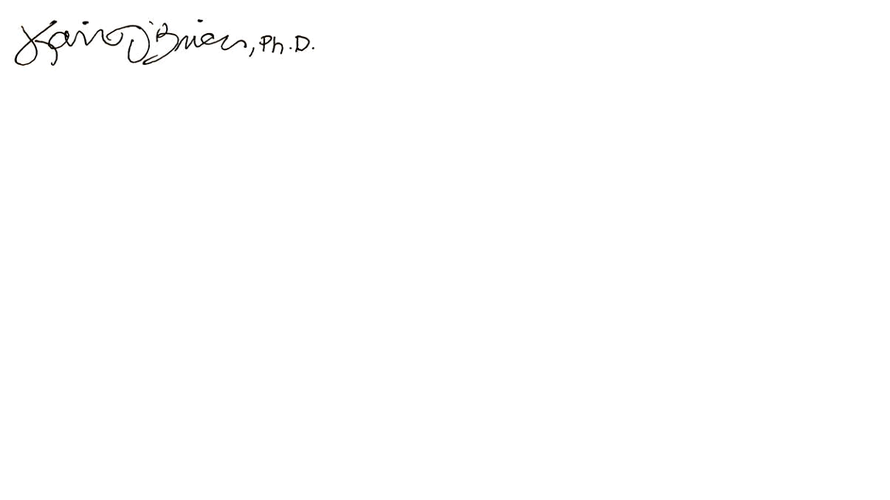 _________________________________ NA NA NA

NA NA NA

# NEUROPSYCHOLOGICAL SUMMARY SCORE SHEET

Table 1: Premorbid Functioning

| Test | Raw | Standard Score | Percentile |
| --- | --- | --- | --- |
| TOPF | NA | NA | NA |

Table 1: Performance Validity

| Test | Score | Total |
| --- | --- | --- |
| CVLT-II FC | NA | NA |
| RDS | NA |  |
| TOMM Trial 1 | NA |  |
| TOMM Trial 2 | NA |  |

Table 1: General Intellectual Functioning (WAIS-IV)

| Test | Raw | ACSS | Percentile | Test | Raw | Standard Score | Percentile |
| --- | --- | --- | --- | --- | --- | --- | --- |
| Similarities (SI) | NA | NA | NA | WAIS-IV VCI | NA | NA | NA |
| Information (IN) | NA | NA | NA | WAIS-IV PRI | NA | NA | NA |
| Vocabulary (VC) | NA | NA | NA | WAIS-IV GAI | NA | NA | NA |
| Block Design (BD) | NA | NA | NA | WAIS-IV WMI | NA | NA | NA |
| Matrix Reasoning (MR) | NA | NA | NA | WAIS-IV PSI | NA | NA | NA |
| Visual Puzzles (VP) | NA | NA | NA | WAIS-IV FSIQ | NA | NA | NA |
| Digit Span (DS) | NA | NA | NA |  |  |  |  |
| Arithmetic (AR) | NA | NA | NA |  |  |  |  |
| Symbol S (SS) | NA | NA | NA |  |  |  |  |
| Coding (CO) | NA | NA | NA |  |  |  |  |

Table 1: Attention & Information Processing Speed

| Test | Raw | ACSS | Percentile | Test | Raw | ACSS | Percentile | Errors |
| --- | --- | --- | --- | --- | --- | --- | --- | --- |
| WAIS-IV DS | NA | NA | NA | WAIS-IV SS | NA | NA | NA |  |
| DS Fwd | NA | NA | NA | WAIS-IV CO | NA | NA | NA |  |
| DS Bwd | NA | NA | NA | Stroop (Word) | NA | NA | NA | NA |
| DS Seq | NA | NA | NA | Stroop (Color) | NA | NA | NA | NA |
| Longest Digit: | NA FwdNA BwdNA Seq |  |  | Trails A | NA | NA | NA | NA |
|  |  |  |  |  |  |  |  |  |
| Conners CPT-3 |  |  |  |  |  |  |  |  |
| d' |  | t = NA | NA | HRT | NA | NA | NA |  |
| Omissions |  | t = NA | NA | HRT SD | NA | NA | NA |  |
| Commissions |  | t = NA | NA | Variability | NA | NA | NA |  |
| Perseverations |  | t = NA | NA | HRT Block Change | NA | NA | NA |  |
|  |  |  |  | HRT ISI Change | NA | NA | NA |  |

Table 1: Executive Functions (Frontal Systems)

| Test | Raw | Percentile | Test | Raw | ACSS | Percentile |
| --- | --- | --- | --- | --- | --- | --- |
| WCST-64 Categories | NA | NA | WAIS-IV SI | NA | NA | NA |
| WCST P. Errors | NA | NA | WAIS-IV MR | NA | NA | NA |
| WCST CLR | NA | NA | WAIS-IV WMI | NA | NA | NA |
| WCST FMS | NA | NA | Trails B | NA | NA | NA |
|  |  |  | Stroop (CW) | NA | NA | NA |
|  |  |  | FAS | NA | NA | NA |

Table 1: Language

| Test | Raw | Z-score | Percentile |
| --- | --- | --- | --- |
| FAS | NA | NA | NA |
| Animals | NA | NA | NA |
| WAIS-IV VC | NA | NA | NA |

Table 1: Visuospatial

| Test | Raw | ACSS | Percentile |
| --- | --- | --- | --- |
| WAIS-IV BD | NA | NA | NA |
| WAIS-IV MR | NA | NA | NA |
| WAIS-IV VP | NA | NA | NA |
| RCFT Copy | NA | NA | NA |

Table 1: Verbal Memory

| Test | Raw | ACSS | Percentile |
| --- | --- | --- | --- |
| CVLT-3 | NA | NA | NA |
| Trials 1-5 | NA | NA | NA |
| List B | NA | NA | NA |
| SD Free | NA | NA | NA |
| SD Cued | NA | NA | NA |
| LD Free | NA | NA | NA |
| LD Cued | NA | NA | NA |
| Repetitions | NA | NA | NA |
| Intrusions | NA | NA | NA |
| Recog Hits | NA | NA | NA |
| False Positives | NA | NA | NA |
| LD Recog Accuracy | NA | NA | NA |
| WMS-IV | NA | NA | NA |
| LM I | NA | NA | NA |
| LM II | NA | NA | NA |
| Recognition | NA | NA | NA |

Table 1: Non-verbal (Visual) Memory

| Test | Raw | ACSS | Percentile |
| --- | --- | --- | --- |
| RCFt 3" delay | NA | NA | NA |
| RCFT 30" delay | NA | NA | NA |
| RCFT Total Recog | NA | NA | NA |

Table 1: Mood/Questionnaires

| Test | Score | Total | Interpretation |
| --- | --- | --- | --- |
| BDI-II | NA | 63 | NA Depression |
| BAI | NA | 63 | NA Anxiety |
| CAARS-Self-Report Long Version (CAARS-S:L) |  |  |  |
| Inattention/Memory Problems | T = NA |  |  |
| Hyperactivity/Restlessness | T = NA |  |  |
| Impulsivity/Emotional Lability | T = NA |  |  |
| Problems with Self-Concept | T = NA |  |  |
| DSM-IV Inattentive Symptoms | T = NA |  |  |
| DSM-IV Hyperactive-Impulsive Symptoms | T = NA |  |  |
| DSM-IV ADHD Symptoms Total | T = NA |  |  |
| ADHD Index | T = NA |  |  |