Homework 3_4

JP

11/12/2020

# Homework 3

psych::describe(hw, na.rm = TRUE)

## vars n mean sd median trimmed mad min max range skew  
## study_id 1 273 137.00 78.95 137.00 137.00 100.82 1.00 273 272.00 0.00  
## girl 2 272 0.48 0.50 0.00 0.47 0.00 0.00 1 1.00 0.09  
## efficacy 3 267 5.72 2.41 5.67 5.73 2.83 1.00 10 9.00 -0.06  
## bullying 4 271 5.07 2.85 5.00 5.06 3.96 0.67 10 9.33 0.01  
## achieve_t 5 270 63.74 7.87 62.00 63.35 8.90 50.00 81 31.00 0.40  
## kurtosis se  
## study_id -1.21 4.78  
## girl -2.00 0.03  
## efficacy -1.02 0.15  
## bullying -1.36 0.17  
## achieve_t -0.87 0.48

hw2 <- hw %>%   
 mutate(efficacy_z = scale(efficacy, center = TRUE, scale = TRUE),  
 bullying_z = scale(bullying, center = TRUE, scale = TRUE),  
 eff_x_bull = efficacy_z*bullying_z,  
 bully_minus = bullying_z - 1,  
 bully_plus = bullying_z + 1)  
  
model <- lm(achieve_t ~ efficacy_z*bullying_z + girl, data = hw2)  
summary(model)

##   
## Call:  
## lm(formula = achieve_t ~ efficacy_z * bullying_z + girl, data = hw2)  
##   
## Residuals:  
## Min 1Q Median 3Q Max   
## -14.9410 -4.1893 -0.3146 3.9260 16.9109   
##   
## Coefficients:  
## Estimate Std. Error t value Pr(>|t|)   
## (Intercept) 63.0203 0.5099 123.586 < 2e-16 ***  
## efficacy_z 3.1444 0.3751 8.383 3.48e-15 ***  
## bullying_z -3.3765 0.3725 -9.064 < 2e-16 ***  
## girl 1.2047 0.7314 1.647 0.101   
## efficacy_z:bullying_z -1.8713 0.3627 -5.159 4.98e-07 ***  
## ---  
## Signif. codes: 0 '***' 0.001 '**' 0.01 '*' 0.05 '.' 0.1 ' ' 1  
##   
## Residual standard error: 5.856 on 256 degrees of freedom  
## (12 observations deleted due to missingness)  
## Multiple R-squared: 0.4488, Adjusted R-squared: 0.4402   
## F-statistic: 52.12 on 4 and 256 DF, p-value: < 2.2e-16

minus <- lm(achieve_t ~ efficacy_z*bully_minus + girl, data = hw2)  
summary(minus)

##   
## Call:  
## lm(formula = achieve_t ~ efficacy_z * bully_minus + girl, data = hw2)  
##   
## Residuals:  
## Min 1Q Median 3Q Max   
## -14.9410 -4.1893 -0.3146 3.9260 16.9109   
##   
## Coefficients:  
## Estimate Std. Error t value Pr(>|t|)   
## (Intercept) 59.6438 0.6469 92.195 < 2e-16 ***  
## efficacy_z 1.2732 0.4801 2.652 0.00851 **   
## bully_minus -3.3765 0.3725 -9.064 < 2e-16 ***  
## girl 1.2047 0.7314 1.647 0.10076   
## efficacy_z:bully_minus -1.8713 0.3627 -5.159 4.98e-07 ***  
## ---  
## Signif. codes: 0 '***' 0.001 '**' 0.01 '*' 0.05 '.' 0.1 ' ' 1  
##   
## Residual standard error: 5.856 on 256 degrees of freedom  
## (12 observations deleted due to missingness)  
## Multiple R-squared: 0.4488, Adjusted R-squared: 0.4402   
## F-statistic: 52.12 on 4 and 256 DF, p-value: < 2.2e-16

plus <- lm(achieve_t ~ efficacy_z*bully_plus + girl, data = hw2)  
summary(plus)

##   
## Call:  
## lm(formula = achieve_t ~ efficacy_z * bully_plus + girl, data = hw2)  
##   
## Residuals:  
## Min 1Q Median 3Q Max   
## -14.9410 -4.1893 -0.3146 3.9260 16.9109   
##   
## Coefficients:  
## Estimate Std. Error t value Pr(>|t|)   
## (Intercept) 66.3968 0.6157 107.841 < 2e-16 ***  
## efficacy_z 5.0157 0.5604 8.951 < 2e-16 ***  
## bully_plus -3.3765 0.3725 -9.064 < 2e-16 ***  
## girl 1.2047 0.7314 1.647 0.101   
## efficacy_z:bully_plus -1.8713 0.3627 -5.159 4.98e-07 ***  
## ---  
## Signif. codes: 0 '***' 0.001 '**' 0.01 '*' 0.05 '.' 0.1 ' ' 1  
##   
## Residual standard error: 5.856 on 256 degrees of freedom  
## (12 observations deleted due to missingness)  
## Multiple R-squared: 0.4488, Adjusted R-squared: 0.4402   
## F-statistic: 52.12 on 4 and 256 DF, p-value: < 2.2e-16

lav_mod <- '  
# regression  
achieve_t ~ efficacy_z + bullying_z + eff_x_bull + girl  
'  
  
lav_fit <- sem(lav_mod, data = hw2)  
summary(lav_fit, standardized = TRUE)

## lavaan 0.6-7 ended normally after 36 iterations  
##   
## Estimator ML  
## Optimization method NLMINB  
## Number of free parameters 5  
##   
## Used Total  
## Number of observations 261 273  
##   
## Model Test User Model:  
##   
## Test statistic 0.000  
## Degrees of freedom 0  
##   
## Parameter Estimates:  
##   
## Standard errors Standard  
## Information Expected  
## Information saturated (h1) model Structured  
##   
## Regressions:  
## Estimate Std.Err z-value P(>|z|) Std.lv Std.all  
## achieve_t ~   
## efficacy_z 3.144 0.371 8.464 0.000 3.144 0.400  
## bullying_z -3.376 0.369 -9.152 0.000 -3.376 -0.429  
## eff_x_bull -1.871 0.359 -5.209 0.000 -1.871 -0.243  
## girl 1.205 0.724 1.663 0.096 1.205 0.077  
##   
## Variances:  
## Estimate Std.Err z-value P(>|z|) Std.lv Std.all  
## .achieve_t 33.631 2.944 11.424 0.000 33.631 0.551

# minus_eff <- minus[['coefficients']]['efficacy_z']  
# avg_eff <- model[['coefficients']]['efficacy_z']  
# plus_eff <- plus[['coefficients']]['efficacy_z']  
  
# hw2 %>%   
# ggplot(aes(efficacy_z, achieve_t)) +  
# geom_point(alpha = .8, color = 'powderblue') +  
# geom_abline(aes(linetype = '+ 1 SD', slope = minus_eff, intercept = 59.64), size = 1) +  
# geom_abline(aes(linetype = 'Average', slope = avg_eff, intercept = 63.02), size = 1) +  
# geom_abline(aes(linetype = '- 1 SD', slope = plus_eff, intercept = 66.40), size = 1) +  
# xlim(-2, 2) +   
# theme_minimal()

# install.packages(c('rockchalk', 'probemod'))  
# install.packages('interactions', 'sandwich')  
  
library(probemod)  
  
interactions::probe_interaction(model = model, pred = efficacy_z, modx = bullying_z)

## JOHNSON-NEYMAN INTERVAL   
##   
## When bullying_z is OUTSIDE the interval [1.14, 2.74], the slope of  
## efficacy_z is p < .05.  
##   
## Note: The range of observed values of bullying_z is [-1.55, 1.73]  
##   
## SIMPLE SLOPES ANALYSIS   
##   
## Slope of efficacy_z when bullying_z = -1.00 (- 1 SD):   
##   
## Est. S.E. t val. p  
## ------ ------ -------- ------  
## 5.02 0.56 8.95 0.00  
##   
## Slope of efficacy_z when bullying_z = -0.01 (Mean):   
##   
## Est. S.E. t val. p  
## ------ ------ -------- ------  
## 3.16 0.38 8.42 0.00  
##   
## Slope of efficacy_z when bullying_z = 0.98 (+ 1 SD):   
##   
## Est. S.E. t val. p  
## ------ ------ -------- ------  
## 1.30 0.48 2.74 0.01

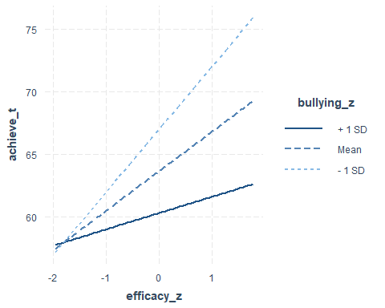

jnresults <- jn(model, dv = 'achieve_t', iv = 'efficacy_z', mod = 'bullying_z', alpha = .05)  
  
jnresults

## Call:  
## jn(model = model, dv = "achieve_t", iv = "efficacy_z", mod = "bullying_z",   
## alpha = 0.05)  
##   
## Conditional effects of efficacy_z on achieve_t at values of bullying_z   
## bullying_z Effect se t p llci ulci  
## 1 1.2732 0.4801 2.6517 0.0085 0.3276 2.2187  
## 2 -0.5981 0.7639 -0.7830 0.4344 -2.1024 0.9062  
## 3 -2.4694 1.0953 -2.2546 0.0250 -4.6263 -0.3124  
## 4 -4.3407 1.4418 -3.0105 0.0029 -7.1801 -1.5012

plot(jnresults)

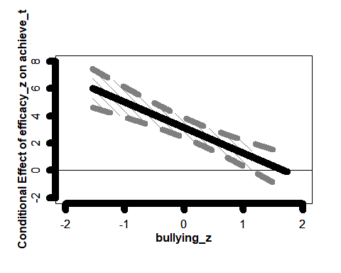

## Values of bullying_z indicated by the shaded region  
## x y se t p llci  
## Lower Bound: 1.139631 1.011873 0.5138209 1.969311 0.05 6.661338e-16  
## Upper Bound: 2.740264 -1.983355 1.0071314 -1.969311 0.05 -3.966709e+00  
## ulci  
## Lower Bound: 2.023746e+00  
## Upper Bound: 2.220446e-16

My hypothesis is:

Higher levels of school bullying will moderate the impact of self-efficacy on achievement. Such that, higher levels of bullying will erode the beneficial effect of efficacy on achievement.

Answer:

The hypothesis was supported as bullying moderated the association between efficacy and achievement (b = -1.87, p < .001). The simple slopes showed that at all levels of bullying, the association between efficacy and achievement was significant. At one SD under the average level of bullying, self-efficacy was significantly associated with achievement (b = 5.02, p < .01). At one SD over the average level of bullying, self-efficacy was significantly associated with achievement (p < .001). The association was strongest for those that had one SD lower levels of bullying. The regions of significance was within a lower bound of (6.66e-16, 2.02) and an upper bound of (-3.97, 2.20e-16).