深度学习实践 b站 第12讲RNN基础篇

Pytorch for RNN

B站 刘二大人 ，传送门PyTorch深度学习实践——循环神经网络(基础篇)

来源：https://www.bilibili.com/video/BV1Y7411d7Ys?p=12

# How to use RNNCell

注意几个参数

* 输入和隐层（输出）维度
* 序列长度
* 批处理大小

注 调用RNNCell这个需要循环，循环长度就是序列长度

|  |
| --- |
| import torch  batch_size = 1 # 批处理大小  seq_len = 3 # 序列长度  input_size = 4 # 输入维度  hidden_size = 2 # 隐层维度  cell = torch.nn.RNNCell(input_size=input_size, hidden_size=hidden_size)  # (seq, batch, features)  dataset = torch.randn(seq_len, batch_size, input_size)  hidden = torch.zeros(batch_size, hidden_size)  # 这个循环就是处理seq_len长度的数据  for idx, data in enumerate(dataset):  print('=' * 20, idx, '=' * 20)  print('Input size:', data.shape, data)  hidden = cell(data, hidden)  print('hidden size:', hidden.shape, hidden)  print(hidden) |

输出结果

|  |
| --- |
| ==================== 0 ====================  Input size: torch.Size([1, 4]) tensor([[ 1.9129, -0.7440, 0.2329, 1.3065]])  hidden size: torch.Size([1, 2]) tensor([[-0.0790, -0.8957]], grad_fn=<TanhBackward>)  tensor([[-0.0790, -0.8957]], grad_fn=<TanhBackward>)  ==================== 1 ====================  Input size: torch.Size([1, 4]) tensor([[-0.6290, -0.2338, -0.2949, 0.3956]])  hidden size: torch.Size([1, 2]) tensor([[ 0.0170, -0.0005]], grad_fn=<TanhBackward>)  tensor([[ 0.0170, -0.0005]], grad_fn=<TanhBackward>)  ==================== 2 ====================  Input size: torch.Size([1, 4]) tensor([[-0.6959, 1.0590, -0.6798, 0.6989]])  hidden size: torch.Size([1, 2]) tensor([[0.4216, 0.6813]], grad_fn=<TanhBackward>)  tensor([[0.4216, 0.6813]], grad_fn=<TanhBackward>) |

# How to use RNN

确定几个参数

* input_size和hidden_size: 输入维度和隐层维度
* batch_size: 批处理大小
* seq_len: 序列长度
* num_layers: 隐层数目

注 直接调用RNN这个不用循环

注：如果使用batch_first: if True, the input and output tensors are provided as:(batch_size, seq_len, input_size)

|  |
| --- |
| import torch  batch_size = 1  seq_len = 3  input_size = 4  hidden_size = 2  num_layers = 1  cell = torch.nn.RNN(input_size=input_size, hidden_size=hidden_size, num_layers=num_layers)  # (seqLen, batchSize, inputSize)  inputs = torch.randn(seq_len, batch_size, input_size)  hidden = torch.zeros(num_layers, batch_size, hidden_size)  out, hidden = cell(inputs, hidden)  print('Output size:', out.shape) # (seq_len, batch_size, hidden_size)  print('Output:', out)  print('Hidden size:', hidden.shape) # (num_layers, batch_size, hidden_size)  print('Hidden:', hidden) |

输出结果

|  |
| --- |
| Output size: torch.Size([3, 1, 2])  Output: tensor([[[ 0.3689, 0.5982]],  [[ 0.1233, 0.2617]],  [[-0.3517, -0.7246]]], grad_fn=<StackBackward>)  Hidden size: torch.Size([1, 1, 2])  Hidden: tensor([[[-0.3517, -0.7246]]], grad_fn=<StackBackward>) |

# Example: Using RNNCell

Hello --> ohlol

首先需要将输入的单词转成向量one-hot vector

注意input_size，如下图

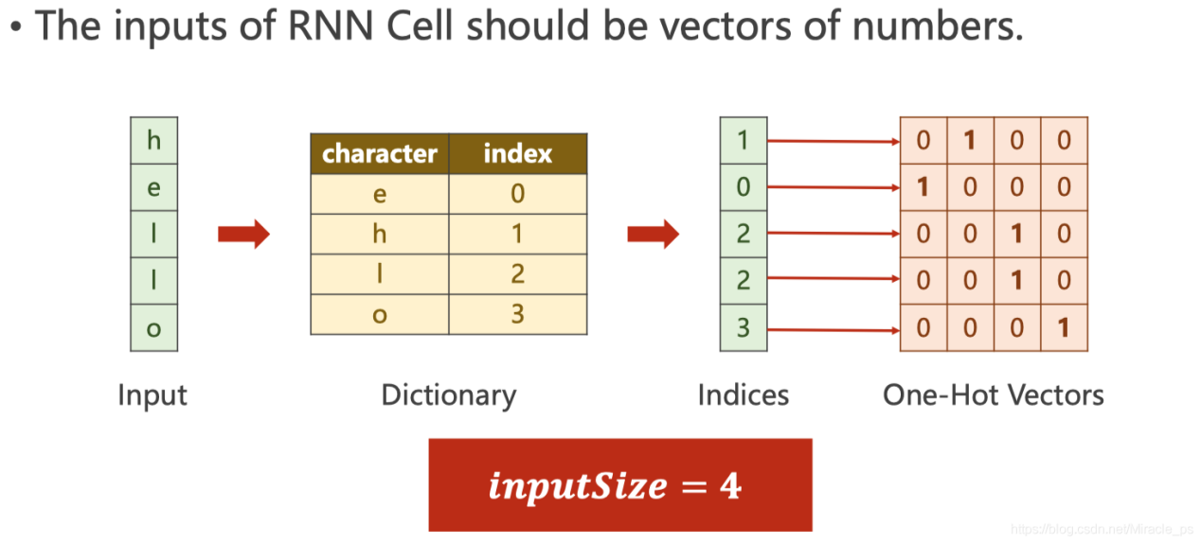

注意交叉熵在计算loss的时候维度关系

这里的hidden是([1, 4]), label是 ([1])

源代码

数据准备

|  |
| --- |
| import torch  input_size = 4  hidden_size = 4  batch_size = 1  idx2char = ['e', 'h', 'l', 'o']  x_data = [1, 0, 2, 3, 3] # hello中各个字符的下标  y_data = [3, 1, 2, 3, 2] # ohlol中各个字符的下标  one_hot_lookup = [[1, 0, 0, 0],  [0, 1, 0, 0],  [0, 0, 1, 0],  [0, 0, 0, 1]]  x_one_hot = [one_hot_lookup[x] for x in x_data] # (seqLen, inputSize)  inputs = torch.Tensor(x_one_hot).view(-1, batch_size, input_size)  labels = torch.LongTensor(y_data).view(-1, 1) # torch.Tensor默认是torch.FloatTensor是32位浮点类型数据，torch.LongTensor是64位整型  print(inputs.shape, labels.shape) |

输出结果：

|  |
| --- |
| torch.Size([5, 1, 4]) torch.Size([5, 1]) |

构建模型

|  |
| --- |
| import torch.nn as nn  class Model(nn.Module):  def __init__(self, input_size, hidden_size, batch_size):  super(Model, self).__init__()  self.batch_size = batch_size  self.input_size = input_size  self.hidden_size = hidden_size  self.rnncell = nn.RNNCell(input_size=self.input_size, hidden_size=self.hidden_size)  def forward(self, inputs, hidden):  hidden = self.rnncell(inputs, hidden) # (batch_size, hidden_size)  return hidden  def init_hidden(self):  return torch.zeros(self.batch_size, self.hidden_size)  net = Model(input_size, hidden_size, batch_size)  criterion = torch.nn.CrossEntropyLoss()  optimizer = torch.optim.Adam(net.parameters(), lr=0.1) |

训练

|  |
| --- |
| epochs = 15  for epoch in range(epochs):  loss = 0  optimizer.zero_grad()  hidden = net.init_hidden()  print('Predicted string:', end='')  for input, label in zip(inputs, labels):  hidden = net(input, hidden)  # 注意交叉熵在计算loss的时候维度关系，这里的hidden是([1, 4]), label是 ([1])  loss += criterion(hidden, label)  _, idx = hidden.max(dim = 1)  print(idx2char[idx.item()], end='')  loss.backward()  optimizer.step()  print(', Epoch [%d/15] loss=%.4f' % (epoch+1, loss.item())) |

输出结果

|  |
| --- |
| Predicted string:lhlhh, Epoch [1/15] loss=6.8407  Predicted string:lllll, Epoch [2/15] loss=5.2957  Predicted string:lllol, Epoch [3/15] loss=4.9344  Predicted string:lllol, Epoch [4/15] loss=4.7035  Predicted string:oolol, Epoch [5/15] loss=4.4781  Predicted string:oolol, Epoch [6/15] loss=4.2419  Predicted string:ohlol, Epoch [7/15] loss=3.9733  Predicted string:ohlol, Epoch [8/15] loss=3.6942  Predicted string:ohlol, Epoch [9/15] loss=3.4917  Predicted string:ohloo, Epoch [10/15] loss=3.3837  Predicted string:ohloo, Epoch [11/15] loss=3.2953  Predicted string:ohlol, Epoch [12/15] loss=3.1331  Predicted string:ohlol, Epoch [13/15] loss=2.9294  Predicted string:ohlol, Epoch [14/15] loss=2.7344  Predicted string:ohlol, Epoch [15/15] loss=2.5680 |

# Example: Using RNN

注意inputs和labels的维度

inputs维度是: (seqLen, batch_size, input_size)

labels维度是: (seqLen * batch_size)

注意outputs维度，对应和labels做交叉熵的维度

outputs维度是: (seqLen, batch_size, hidden_size)

为了能和labels做交叉熵，需要reshape一下: outputs.view(-1, hidden_size)

源代码

数据准备

|  |
| --- |
| import torch  input_size = 4  hidden_size = 4  batch_size = 1  seq_len = 5  num_layers = 1  idx2char = ['e', 'h', 'l', 'o']  x_data = [1, 0, 2, 3, 3] # hello中各个字符的下标  y_data = [3, 1, 2, 3, 2] # ohlol中各个字符的下标  one_hot_lookup = [[1, 0, 0, 0],  [0, 1, 0, 0],  [0, 0, 1, 0],  [0, 0, 0, 1]]  x_one_hot = [one_hot_lookup[x] for x in x_data] # (seqLen, inputSize)  inputs = torch.Tensor(x_one_hot).view(seq_len, batch_size, input_size)  labels = torch.LongTensor(y_data)  print(inputs.shape, labels.shape) |

输出结果

|  |
| --- |
| torch.Size([5, 1, 4]) torch.Size([5]) |

构建模型

|  |
| --- |
| import torch.nn as nn  class Model(nn.Module):  def __init__(self, input_size, hidden_size, batch_size, num_layers=1):  super(Model, self).__init__()  self.num_layers = num_layers  self.batch_size = batch_size  self.input_size = input_size  self.hidden_size = hidden_size  self.rnn = nn.RNN(input_size=self.input_size, hidden_size=self.hidden_size, )  def forward(self, inputs):  hidden = torch.zeros(self.num_layers, self.batch_size, self.hidden_size)  out, _ = self.rnn(inputs, hidden) # 注意维度是(seqLen, batch_size, hidden_size)  return out.view(-1, self.hidden_size) # 为了容易计算交叉熵这里调整维度为(seqLen * batch_size, hidden_size)  net = Model(input_size, hidden_size, batch_size)  criterion = torch.nn.CrossEntropyLoss()  optimizer = torch.optim.Adam(net.parameters(), lr=0.1) |

训练模型

|  |
| --- |
| epochs = 15  for epoch in range(epochs):  optimizer.zero_grad()  outputs = net(inputs)  # print(outputs.shape, labels.shape)  # 这里的outputs维度是([seqLen * batch_size, hidden]), labels维度是([seqLen])  loss = criterion(outputs, labels)  loss.backward()  optimizer.step()  _, idx = outputs.max(dim=1)  idx = idx.data.numpy()  print('Predicted: ', ''.join([idx2char[x] for x in idx]), end='')  print(', Epoch [%d/15] loss = %.3f' % (epoch + 1, loss.item())) |

输出结果

|  |
| --- |
| Predicted: ololl, Epoch [1/15] loss = 1.189  Predicted: ollll, Epoch [2/15] loss = 1.070  Predicted: ollll, Epoch [3/15] loss = 0.976  Predicted: ohlll, Epoch [4/15] loss = 0.883  Predicted: ohlol, Epoch [5/15] loss = 0.788  Predicted: ohlol, Epoch [6/15] loss = 0.715  Predicted: ohlol, Epoch [7/15] loss = 0.652  Predicted: ohlol, Epoch [8/15] loss = 0.603  Predicted: ohlol, Epoch [9/15] loss = 0.570  Predicted: ohlol, Epoch [10/15] loss = 0.548  Predicted: ohlol, Epoch [11/15] loss = 0.530  Predicted: ohlol, Epoch [12/15] loss = 0.511  Predicted: ohlol, Epoch [13/15] loss = 0.488  Predicted: ohlol, Epoch [14/15] loss = 0.462  Predicted: ohlol, Epoch [15/15] loss = 0.439 |

# 将一个单词变成vector

One-hot encoding of words and characters

one-hot vectors high-dimension --> lower-dimension

one-hot vectors sparse --> dense

one-hot vectors hardcoded --> learn from data

Embedding

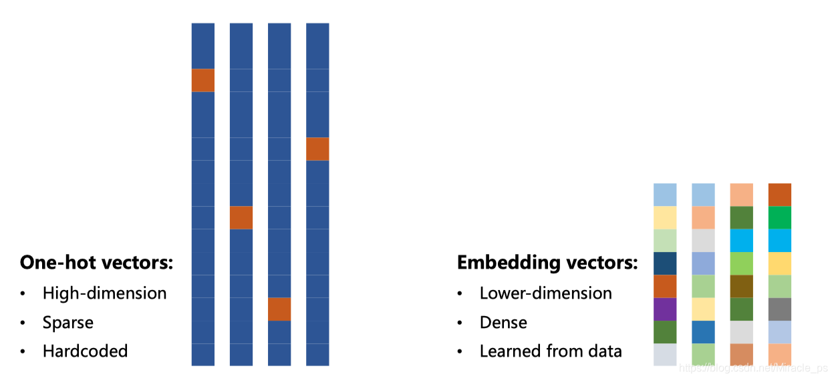

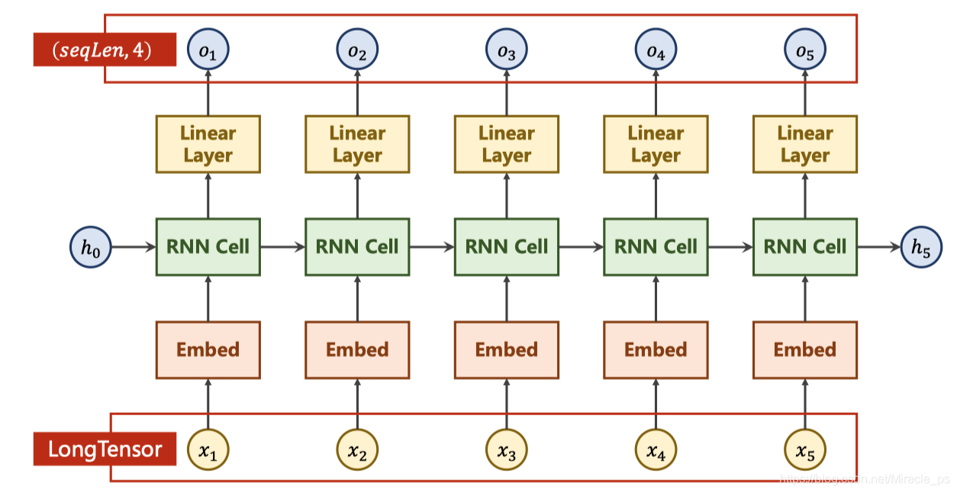

源代码

构建模型

|  |
| --- |
| import torch.nn as nn  # parameters  num_class = 4  input_size = 4  hidden_size = 8  embedding_size = 10  num_layers = 2  batch_size = 1  seq_len = 5  class Model(nn.Module):  def __init__(self):  super(Model, self).__init__()  self.emb = torch.nn.Embedding(input_size, embedding_size)  self.rnn = nn.RNN(input_size=embedding_size, hidden_size=hidden_size, num_layers=num_layers, batch_first=True)  self.fc = nn.Linear(hidden_size, num_class)  def forward(self, x):  hidden = torch.zeros(num_layers, x.size(0), hidden_size)  x = self.emb(x) # (batch, seqLen, embeddingSize)  x, _ = self.rnn(x, hidden) # 输出(𝒃𝒂𝒕𝒄𝒉𝑺𝒊𝒛𝒆, 𝒔𝒆𝒒𝑳𝒆𝒏, hidden_size)  x = self.fc(x) # 输出(𝒃𝒂𝒕𝒄𝒉𝑺𝒊𝒛𝒆, 𝒔𝒆𝒒𝑳𝒆𝒏, 𝒏𝒖𝒎𝑪𝒍𝒂𝒔𝒔)  return x.view(-1, num_class) # reshape to use Cross Entropy: (𝒃𝒂𝒕𝒄𝒉𝑺𝒊𝒛𝒆×𝒔𝒆𝒒𝑳𝒆𝒏, 𝒏𝒖𝒎𝑪𝒍𝒂𝒔𝒔)    net = Model()  criterion = torch.nn.CrossEntropyLoss()  optimizer = torch.optim.Adam(net.parameters(), lr=0.05) |

准备数据并训练

|  |
| --- |
| idx2char = ['e', 'h', 'l', 'o']  x_data = [[1, 0, 2, 2, 3]] # (batch, seq_len)  y_data = [3, 1, 2, 3, 2] # (batch * seq_len)  inputs = torch.LongTensor(x_data) # Input should be LongTensor: (batchSize, seqLen)  labels = torch.LongTensor(y_data) # Target should be LongTensor: (batchSize * seqLen)  epochs = 15  for epoch in range(epochs):  optimizer.zero_grad()  outputs = net(inputs)  loss = criterion(outputs, labels)  loss.backward()  optimizer.step()  _, idx = outputs.max(dim=1)  idx = idx.data.numpy()  print('Predicted: ', ''.join([idx2char[x] for x in idx]), end='')  print(', Epoch [%d/15] loss = %.3f' % (epoch + 1, loss.item())) |

输出结果

|  |
| --- |
| Predicted: ollll, Epoch [1/15] loss = 1.290  Predicted: olooo, Epoch [2/15] loss = 1.071  Predicted: ollol, Epoch [3/15] loss = 0.913  Predicted: ollol, Epoch [4/15] loss = 0.785  Predicted: ollol, Epoch [5/15] loss = 0.660  Predicted: ohlol, Epoch [6/15] loss = 0.541  Predicted: ohlol, Epoch [7/15] loss = 0.435  Predicted: ohlol, Epoch [8/15] loss = 0.343  Predicted: ohlol, Epoch [9/15] loss = 0.251  Predicted: ohlol, Epoch [10/15] loss = 0.171  Predicted: ohlol, Epoch [11/15] loss = 0.121  Predicted: ohlol, Epoch [12/15] loss = 0.081  Predicted: ohlol, Epoch [13/15] loss = 0.052  Predicted: ohlol, Epoch [14/15] loss = 0.036  Predicted: ohlol, Epoch [15/15] loss = 0.025 |

说明

可以看到使用embedding之后收敛的更快了，说明模型的学习能力变强了

————————————————

版权声明：本文为CSDN博主「一荤配一素」的原创文章，遵循CC 4.0 BY-SA版权协议，转载请附上原文出处链接及本声明。

原文链接：https://blog.csdn.net/Miracle_ps/article/details/114493682