【PyTorch】深度学习实践 b站 第13讲RNN高级篇

# RNN_Classifier model

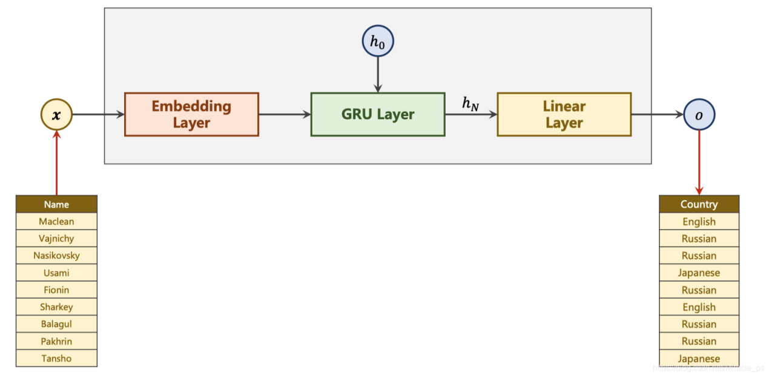

# 1. 准备数据

对于每个名字需要得到一个向量

通过ASCII对于每个名字的每个字符都得到一个one-hot vector

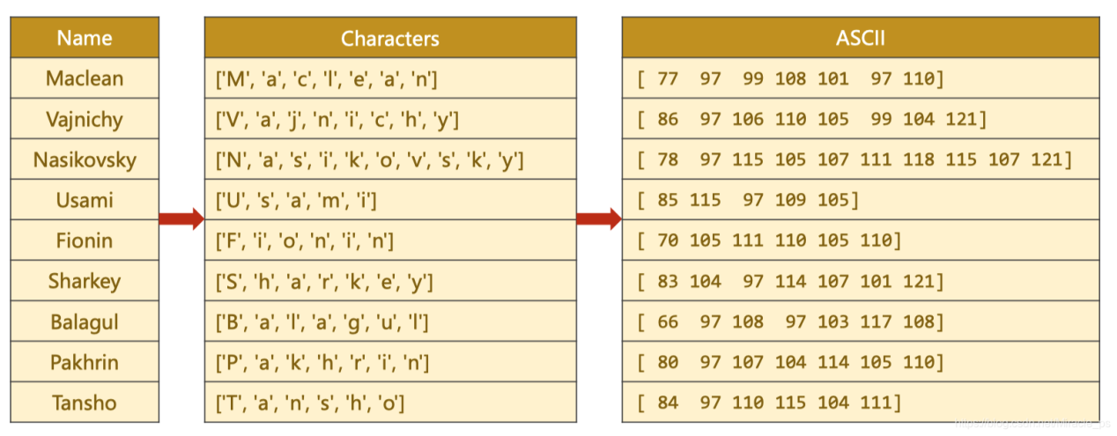

由于输入是矩阵所以需要padding

|  |
| --- |
| import torch  from torch.utils.data import Dataset  from torch.utils.data import DataLoader  import gzip  import csv  class NameDataset(Dataset):  def __init__(self, is_train_set):  filename = './names_train.csv.gz' if is_train_set else './names_test.csv.gz'  with gzip.open(filename, 'rt') as f: # r表示只读，从文件头开始 t表示文本模式  reader = csv.reader(f)  rows = list(reader)  self.names = [row[0] for row in rows]  self.len = len(self.names)  self.countries = [row[1] for row in rows]  self.country_list = list(sorted(set(self.countries)))  self.country_dict = self.getCountryDict()  self.country_num = len(self.country_list)  def __getitem__(self, index): # 根据索引拿到的是 名字，国家的索引  return self.names[index], self.country_dict[self.countries[index]]  def __len__(self):  return self.len  def getCountryDict(self):  country_dict = dict()  for idx, country_name in enumerate(self.country_list, 0):  country_dict[country_name] = idx  return country_dict  def idx2country(self, index):  return self.country_list[index]  def getCountriesNum(self):  return self.country_num  HIDDEN_SIZE = 100  BATCH_SIZE = 256  N_LAYER = 2  N_EPOCHS = 50  N_CHARS = 128 # 这个是为了构造嵌入层  trainSet = NameDataset(is_train_set=True)  trainLoader = DataLoader(trainSet, batch_size=BATCH_SIZE, shuffle=True)  testSet = NameDataset(is_train_set=False)  testLoader = DataLoader(testSet, batch_size=BATCH_SIZE, shuffle=False)  N_COUNTRY = trainSet.getCountriesNum() |

# 2. 构建模型

GRU的维度

输入维度

𝑖𝑛𝑝𝑢𝑡: (𝑠𝑒𝑞𝐿𝑒𝑛, 𝑏𝑎𝑡𝑐ℎ𝑆𝑖𝑧𝑒, ℎ𝑖𝑑𝑑𝑒𝑛𝑆𝑖𝑧𝑒)

hidden: (nLayers * nDirections, batchSize, hiddenSize)

输出维度

output: (seqLen, batchSize, hiddenSize * nDirections)

hidden: (nLayers * nDirections, batchSize, hiddenSize)

示意图

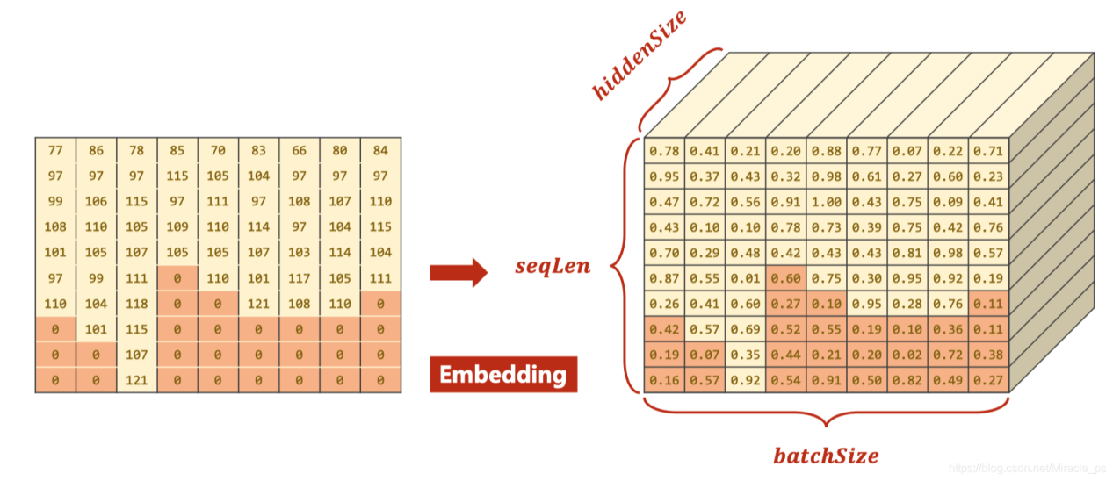

GRU处理时可以使用pack_padded_sequence提高效率

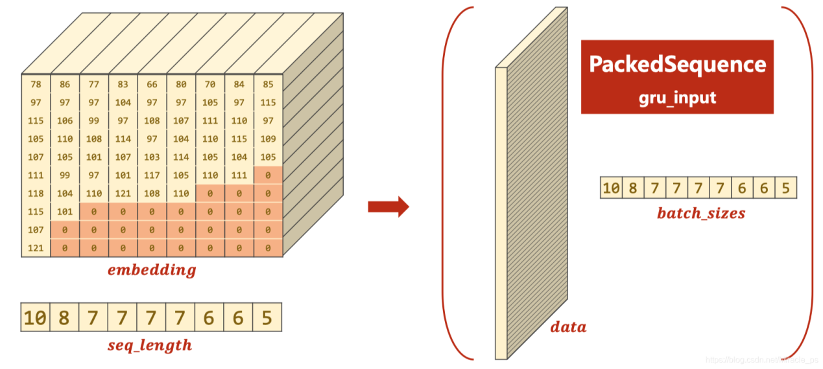

|  |
| --- |
| class RNNClassifier(torch.nn.Module):  def __init__(self, input_size, hidden_size, output_size, n_layers=1, bidirectional=True):  super(RNNClassifier, self).__init__()  self.hidden_size = hidden_size  self.n_layers = n_layers  self.n_directions = 2 if bidirectional else 1 # 使用双向的GRU    # 嵌入层（𝑠𝑒𝑞𝐿𝑒𝑛, 𝑏𝑎𝑡𝑐ℎ𝑆𝑖𝑧𝑒） --> (𝑠𝑒𝑞𝐿𝑒𝑛, 𝑏𝑎𝑡𝑐ℎ𝑆𝑖𝑧𝑒, hidden_size)  self.embedding = torch.nn.Embedding(input_size, hidden_size)  self.gru = torch.nn.GRU(hidden_size, hidden_size, n_layers, bidirectional=bidirectional)  self.fc = torch.nn.Linear(hidden_size * self.n_directions, output_size)  def _init_hidden(self, batch_size):  hidden = torch.zeros(self.n_layers * self.n_directions, batch_size, self.hidden_size)  return hidden  def forward(self, input, seq_lengths):  # input shape : B x S -> S x B  input = input.t()  batch_size = input.size(1)  hidden = self._init_hidden(batch_size)  embedding = self.embedding(input)  # pack them up  gru_input = torch.nn.utils.rnn.pack_padded_sequence(embedding, seq_lengths)  output, hidden = self.gru(gru_input, hidden)  if self.n_directions == 2:  hidden_cat = torch.cat([hidden[-1], hidden[-2]], dim=1)  else:  hidden_cat = hidden[-1]  fc_output = self.fc(hidden_cat)  return fc_output |

# 3. 数据转化成Tensor

|  |
| --- |
| def name2list(name):  arr = [ord(c) for c in name]  return arr, len(arr)  def make_tensors(names, countries):  sequences_and_lengths = [name2list(name) for name in names]  name_sequences = [s1[0] for s1 in sequences_and_lengths]  seq_lengths = torch.LongTensor([s1[1] for s1 in sequences_and_lengths])  countries = countries.long()  # make tensor of name, BatchSize * seqLen  # 他这里补零的方式先将所有的0 Tensor给初始化出来，然后在每行前面填充每个名字  seq_tensor = torch.zeros(len(name_sequences), seq_lengths.max()).long()  # print("seq_lengths.max:", seq_lengths.max())  for idx, (seq, seq_len) in enumerate(zip(name_sequences, seq_lengths), 0):  seq_tensor[idx, :seq_len] = torch.LongTensor(seq)  # sort by length to use pack_padded_sequence  # 将名字长度降序排列，并且返回降序之后的长度在原tensor中的小标perm_idx  seq_lengths, perm_idx = seq_lengths.sort(dim=0, descending=True)  # 这个Tensor中的类似于列表中切片的方法神奇啊，直接返回下标对应的元素，相等于排序了  seq_tensor = seq_tensor[perm_idx]  countries = countries[perm_idx]  # 返回排序之后名字Tensor，排序之后的名字长度Tensor，排序之后的国家名字Tensor  return seq_tensor, seq_lengths, countries |

# 4. 训练数据

|  |
| --- |
| classifier = RNNClassifier(N_CHARS, HIDDEN_SIZE, N_COUNTRY, N_LAYER)  criterion = torch.nn.CrossEntropyLoss()  optimizer = torch.optim.Adam(classifier.parameters(), lr=0.001)  import time  import math  def trainModel():  def time_since(since):  s = time.time() - since  m = math.floor(s / 60)  s -= m * 60  return '%dm %ds' % (m, s)  total_loss = 0  for i, (names, countries) in enumerate(trainLoader, 1):  # print(type(names), type(countries))  # print(len(names), countries.shape)  inputs, seq_lengths, target = make_tensors(names, countries)    output = classifier(inputs, seq_lengths)  # print("Shape:", output.shape, target.shape)  # 注意输出和目标的维度：Shape: torch.Size([256, 18]) torch.Size([256])  loss = criterion(output, target)  optimizer.zero_grad()  loss.backward()  optimizer.step()  total_loss += loss.item()  if i % 10 == 0:  print(f'[{time_since(start)}] Epoch {epoch} ', end='')  print(f'[{i * len(inputs)}/{len(trainSet)}] ', end='')  print(f'loss={total_loss / (i * len(inputs))}')  return total_loss  def testModel():  correct = 0  total = len(testSet)  print("evaluating trained model ... ")  with torch.no_grad():  for i, (names, countries) in enumerate(testLoader):  inputs, seq_lengths, target = make_tensors(names, countries)  output = classifier(inputs, seq_lengths)  # 注意这个keepdim的使用，为了直接和target计算loss  pred = output.max(dim=1, keepdim=True)[1]  # 注意这个view_as 和 eq  correct += pred.eq(target.view_as(pred)).sum().item()    percent = '%.2f' % (100 * correct / total)  print(f'Test set: Accuracy {correct}/{total} {percent}%')  return correct / total    N_EPOCHS = 50  start = time.time()  print("Training for %d epochs..." % N_EPOCHS)  acc_list = []  for epoch in range(1, N_EPOCHS + 1):  # Train cycle  trainModel()  acc = testModel()  acc_list.append(acc) |

训练结果

|  |
| --- |
| Training for 50 epochs...  [0m 2s] Epoch 1 [2560/13374] loss=0.00895661092363298  [0m 4s] Epoch 1 [5120/13374] loss=0.007739758561365306  [0m 6s] Epoch 1 [7680/13374] loss=0.0069853457777450485  [0m 8s] Epoch 1 [10240/13374] loss=0.006530495395418256  [0m 11s] Epoch 1 [12800/13374] loss=0.006135637713596225  evaluating trained model ...  Test set: Accuracy 4535/6700 67.69%  [0m 15s] Epoch 2 [2560/13374] loss=0.004228085093200207  [0m 17s] Epoch 2 [5120/13374] loss=0.0041014277492649855  [0m 19s] Epoch 2 [7680/13374] loss=0.004011582878107826  [0m 22s] Epoch 2 [10240/13374] loss=0.0038964587613008915  [0m 24s] Epoch 2 [12800/13374] loss=0.0038181920163333416  evaluating trained model ...  ......（中间省略若干）  [12m 46s] Epoch 49 [2560/13374] loss=0.00016357196727767587  [12m 49s] Epoch 49 [5120/13374] loss=0.0001682748734310735  [12m 51s] Epoch 49 [7680/13374] loss=0.00017566338913942067  [12m 54s] Epoch 49 [10240/13374] loss=0.0001776946208337904  [12m 57s] Epoch 49 [12800/13374] loss=0.00018831568930181676  evaluating trained model ...  Test set: Accuracy 5627/6700 83.99%  [13m 2s] Epoch 50 [2560/13374] loss=0.00016892087151063607  [13m 5s] Epoch 50 [5120/13374] loss=0.00015529338124906645  [13m 7s] Epoch 50 [7680/13374] loss=0.00017500294488854707  [13m 11s] Epoch 50 [10240/13374] loss=0.00017692927776806754  [13m 14s] Epoch 50 [12800/13374] loss=0.00018558732335804962  evaluating trained model ...  Test set: Accuracy 5613/6700 83.78% |

# 5. 可视化

|  |
| --- |
| import matplotlib.pyplot as plt  import numpy as np  epoch = np.arange(1, len(acc_list) + 1)  acc_list = np.array(acc_list)  plt.plot(epoch, acc_list)  plt.xlabel('Epoch')  plt.ylabel('Accuracy')  plt.grid()  plt.show() |

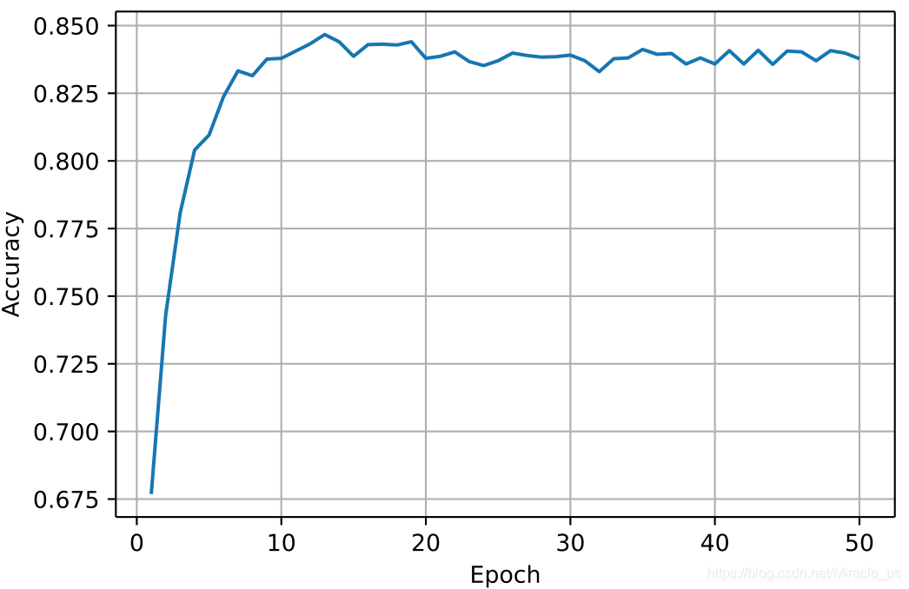

————————————————

版权声明：本文为CSDN博主「一荤配一素」的原创文章，遵循CC 4.0 BY-SA版权协议，转载请附上原文出处链接及本声明。

原文链接：https://blog.csdn.net/Miracle_ps/article/details/114537615