[Company name]
[Document title]
[Document subtitle]

Confidentiality Statement
This document contains confidential and proprietary information of SettleMint. By reading this document, you agree not to disclose the confidential information contained herein to any third party without the prior written consent of SettleMint, except to those agents, principals, representatives, or consultants who require access for the purpose of evaluating this document. You further agree to inform such persons of the confidential nature of this document and to obtain their agreement to preserve its confidentiality to the same extent as yours.
This confidentiality statement shall remain binding on the parties for a period of five (5) years from the date stated on the front cover, unless superseded by confidentiality provisions detailed in a subsequent agreement.
Terms and Conditions
This proposal is valid until [DD Month YYYY]. In the absence of confirmation to proceed, SettleMint and [the Company] acknowledge and agree to abide by the Mutual NDA as the governing agreement.
SettleMint reserves the right to vary the terms of this proposal in response to changes in specifications or information made available at a later date. Submission of this proposal does not convey any right, title, interest, or license in any intellectual property rights (including, but not limited to, patents, copyrights, trade secrets, or trademarks) contained herein.
All rights are reserved. This proposal and the information contained within it are provided on an “as is” basis, without any warranties of any kind, express or implied.
All contracts with SettleMint will be governed by Belgian Law and subject to the exclusive jurisdiction of Belgian courts.
Contact Details
For any enquiries regarding this document, please contact:
[Full Name]
[Job Title]
Email: [email@example.com]
Phone: [Country Code - Number]

Table of Contents

Table of Contents 3
Executive Summary 4
Investment Rationale 5
Cost of Current Approach 6
DALP Value Drivers 7
ROI Framework 8
Licensing Model 9
Philosophy 10
Tier Recommendation 11
Deployment Options and Pricing 12
Recommended: Sovereign On-Premises (Dual EU Data Centers) 13
Support and SLA Framework 14
Enterprise Support (Required for Systemic FMI) 15
Severity Definitions 16
Implementation Investment 17
Total Cost of Ownership 18
Three-Year TCO 19
Build vs. DALP 20
Commercial Terms 21
Contract Structure 22
Payment Schedule 23
Eurosystem Extension 24
IP and Data 25
Exit 26
Reference Clients 27
Next Steps 28

Prepared for: European Central Bank
Document Title: Commercial Proposal: Digital Euro Wholesale Settlement Infrastructure
RFP Reference: EUROPEANCENTRALBANK-RFP-202603
Submission Date: March 2026
Version: 1.0 Draft
Classification: SettleMint Confidential

  - Table of Contents
- Executive Summary
- Investment Rationale
- Licensing Model
- Deployment Options and Pricing
- Support and SLA Framework
- Implementation Investment
- Total Cost of Ownership
- Commercial Terms
- Reference Clients
- Next Steps

  - Executive Summary
The European Central Bank's wholesale digital euro settlement programme requires infrastructure where settlement finality is legally irrevocable, DvP atomicity is guaranteed under all operating conditions, and the Eurosystem governance model is enforced at the technical level. As the monetary authority for the eurozone, the ECB cannot operate settlement infrastructure that creates uncertainty about whether a transaction has achieved finality, who authorized it, or under what policy constraints it executed.
The commercial decision facing the ECB is whether to build the wholesale settlement engine, consensus finality mechanism, TARGET2 integration, and Eurosystem governance enforcement from scratch (estimated at EUR 25-45M over 36-48 months), assemble these capabilities from multiple vendors (with fragmented accountability across a systemically important FMI), or adopt a platform with production-proven settlement finality at comparable institutional scale.
DALP addresses the ECB's requirements through a sovereign deployment model where the ECB retains full infrastructure control, the Eurosystem governance hierarchy is enforced at the smart contract level, and settlement finality is delivered through IBFT 2.0 consensus with 7+ years of production validation.
Recommended commercial profile:
- License tier: Sovereign (systemic FMI governance; Eurosystem multi-entity extension; CPMI-IOSCO PFMI alignment)
- Deployment: Sovereign on-premises across two EU data centers under ECB control
- Implementation: Fixed-price, 32-week delivery including TARGET2 integration and parallel run
- Support: Enterprise (24/7, DORA/CPMI-IOSCO aligned, dedicated SRE team)
Indicative 3-year investment: EUR [CLIENT-SPECIFIC: ~8M-14M] total. Internal build estimate: EUR 25-45M+ over 36-48 months.
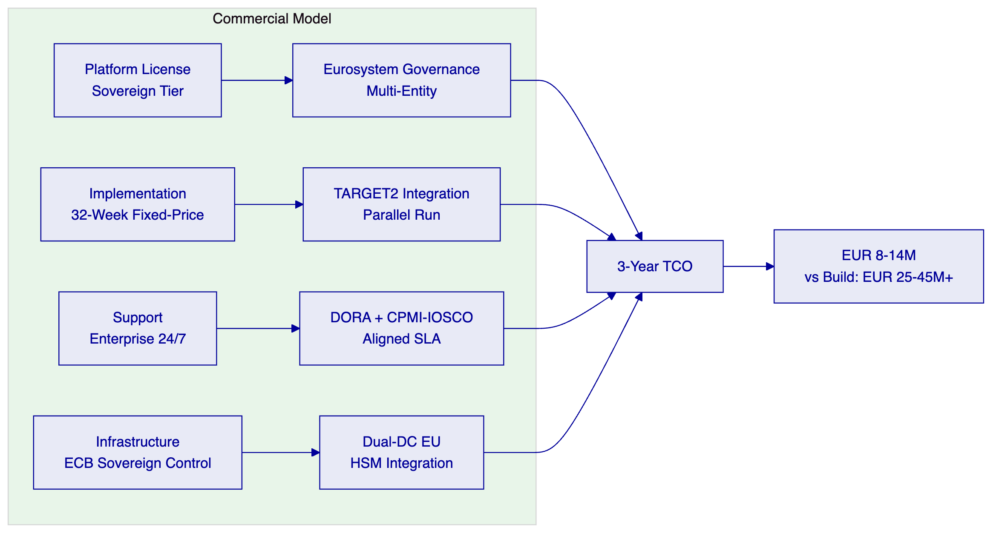

  - Investment Rationale
    - Cost of Current Approach
Internal build estimate: EUR 25-45M+ over 36-48 months.
Capability Domain | Estimated FTE | Duration | Estimated Cost
XvP atomic DvP settlement engine | 8-12 FTE | 24-30 months | EUR 6-10M
IBFT 2.0 finality layer and consensus engineering | 5-8 FTE | 18-24 months | EUR 4-7M
TARGET2 integration and cash leg coordination | 5-7 FTE | 18-24 months | EUR 3-5M
Eurosystem governance enforcement layer | 4-6 FTE | 15-18 months | EUR 2.5-4M
Wholesale digital euro token with compliance modules | 3-5 FTE | 12-15 months | EUR 2-3.5M
Dual-DC sovereign deployment with DR | 4-6 FTE | 12-18 months | EUR 2.5-4.5M
DORA/CPMI-IOSCO/NIS2 compliance documentation | 3-4 FTE | 12-15 months | EUR 1.5-2.5M
Observability and supervisory reporting | 3-4 FTE | 9-12 months | EUR 1.5-2.5M

Critical build risk: Settlement finality for a systemically important FMI is not achieved through engineering effort alone. It requires a consensus mechanism proven in production across infrastructure failures, network partitions, Byzantine fault scenarios, and peak load conditions. Building and validating this from scratch for a systemic FMI requires operational experience that cannot be compressed into a development timeline. The ECB would launch the wholesale digital euro on untested settlement infrastructure.
    - DALP Value Drivers
Capability | Internal Build Cost | DALP
XvP atomic DvP settlement | EUR 6-10M | Included
IBFT 2.0 finality mechanism | EUR 4-7M | Included, 7+ years production validated
Eurosystem governance enforcement | EUR 2.5-4M | AccessManager with 26-role taxonomy
TARGET2 integration framework | EUR 3-5M | REST API + adapter pattern
Wholesale CBDC token with compliance | EUR 2-3.5M | Configurable DALPAsset
DORA/CPMI-IOSCO documentation | EUR 1.5-2.5M | Pre-documented

    - ROI Framework
Value Driver | Basis
Build cost avoidance | EUR 25-45M over 36-48 months
Time-to-production | 32 weeks vs. 36-48 months
Settlement finality validation | 7+ years production history vs. zero at launch
Eurosystem extension | Same platform for NCB deployments at marginal cost
Operational risk reduction | Production-proven infrastructure vs. untested build

  - Licensing Model
    - Philosophy
Sovereign platform license. The ECB's wholesale digital euro settlement generates compliance events, settlement evidence, and governance audit records on every transaction. A per-event pricing model would penalize the ECB for maintaining the evidentiary discipline that CPMI-IOSCO PFMI Principle 23 and DORA require. The annual subscription covers all settlement instructions, compliance events, governance actions, and audit records.
    - Tier Recommendation
Capability | Foundation | Enterprise | Sovereign (Recommended)
XvP settlement | Included | Included | Included
Eurosystem governance enforcement | Basic roles | Multi-tier roles | Full Eurosystem hierarchy
Multi-entity extension (NCBs) | Not included | Optional | Included
CPMI-IOSCO PFMI documentation | Standard | Enhanced | Full
Dedicated SRE team | Shared | Designated | Named team
Custom compliance modules | Not included | Standard | Included
Annual license (indicative) | EUR [CLIENT-SPECIFIC: ~800K-1.2M] | EUR [CLIENT-SPECIFIC: ~1.5M-2.2M] | EUR [CLIENT-SPECIFIC: ~2.5M-4M]

Recommended: Sovereign. The ECB's systemic importance, CPMI-IOSCO obligations, multi-entity Eurosystem governance requirements, and the need for dedicated SRE engagement justify the Sovereign tier. The NCB extension path is included within the Sovereign tier without requiring new license negotiation.

  - Deployment Options and Pricing
    - Recommended: Sovereign On-Premises (Dual EU Data Centers)
ECB-controlled infrastructure across two EU data centers. Full sovereign control over all settlement data, cryptographic keys, and operational procedures.
Infrastructure cost (ECB-borne, indicative):
Component | Monthly Estimate
Kubernetes clusters (2 DCs, 3-AZ each) | EUR 8,000-16,000
Besu validator nodes (6) | EUR 4,000-8,000
PostgreSQL Multi-AZ + replica | EUR 3,000-6,000
HSM infrastructure (2 DCs) | EUR 5,000-10,000
Redis, object storage, networking | EUR 2,000-4,000
Observability stack | EUR 1,000-2,000
Total infrastructure | EUR 23,000-46,000/month

  - Support and SLA Framework
    - Enterprise Support (Required for Systemic FMI)
Capability | Detail
Coverage | 24/7/365
P1 response | 15 minutes
P1 resolution target | 2 hours
P2 response | 1 hour
Uptime SLA | 99.99%
Dedicated SRE | Named team
CPMI-IOSCO alignment | PFMI Principle 17 operational risk management
DORA alignment | Full incident classification and notification

    - Severity Definitions
Level | Definition | Response | Resolution Target
P1 Critical | Settlement blocked; XvP unavailable; consensus failure; finality engine down | 15 min | 2 hours
P2 High | Major function impaired; settlement continues with workaround | 1 hour | 4 hours
P3 Medium | Non-critical function impacted | 4 hours | 2 business days
P4 Low | General inquiry | 1 business day | Next cycle

  - Implementation Investment
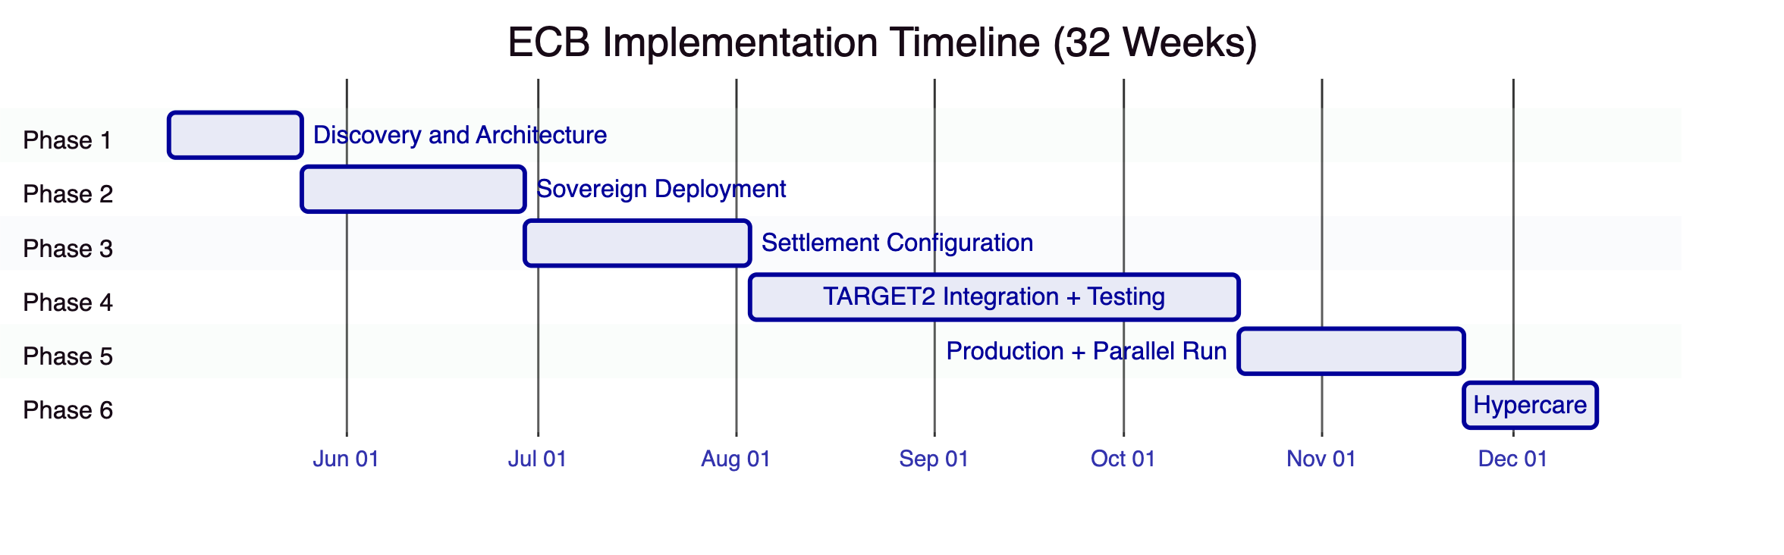
Phase | Duration | Investment
Discovery and Architecture | 3 weeks | EUR [CLIENT-SPECIFIC: ~200K-350K]
Sovereign Deployment | 5 weeks | EUR [CLIENT-SPECIFIC: ~300K-500K]
Settlement Configuration | 5 weeks | EUR [CLIENT-SPECIFIC: ~300K-480K]
TARGET2 Integration and Testing | 11 weeks | EUR [CLIENT-SPECIFIC: ~550K-900K]
Production and Parallel Run | 5 weeks | EUR [CLIENT-SPECIFIC: ~250K-400K]
Hypercare | 3 weeks | EUR [CLIENT-SPECIFIC: ~150K-250K]
Total | 32 weeks | EUR [CLIENT-SPECIFIC: ~1.75M-2.9M]

  - Total Cost of Ownership
    - Three-Year TCO
Year | License | Implementation | Support | Infrastructure | Total
Year 1 | EUR [CLIENT-SPECIFIC: ~3.2M] | EUR [CLIENT-SPECIFIC: ~2.3M] | EUR [CLIENT-SPECIFIC: ~600K] | EUR [CLIENT-SPECIFIC: ~400K] | EUR [CLIENT-SPECIFIC: ~6.5M]
Year 2 | EUR [CLIENT-SPECIFIC: ~3.2M] | 0 | EUR [CLIENT-SPECIFIC: ~600K] | EUR [CLIENT-SPECIFIC: ~450K] | EUR [CLIENT-SPECIFIC: ~4.25M]
Year 3 | EUR [CLIENT-SPECIFIC: ~3.2M] | 0 | EUR [CLIENT-SPECIFIC: ~600K] | EUR [CLIENT-SPECIFIC: ~450K] | EUR [CLIENT-SPECIFIC: ~4.25M]
3-Year Total |  |  |  |  | EUR [CLIENT-SPECIFIC: ~15M]

    - Build vs. DALP
Criterion | DALP (Sovereign) | Internal Build
3-year cost | EUR ~15M | EUR 30-55M+
Time to production | 32 weeks | 36-48 months
Settlement finality validation | 7+ years production | None at launch
TARGET2 integration | REST API framework | Custom build
CPMI-IOSCO readiness at launch | Pre-documented | Must be developed
Eurosystem extension | Marginal cost per NCB | Near-full rebuild

  - Commercial Terms
    - Contract Structure
Sovereign Platform License Agreement (3-year initial term with Eurosystem extension option), Fixed-Price Implementation Agreement (parallel run as contractual acceptance criterion), Enterprise Support Agreement (co-terminus, DORA-aligned).
    - Payment Schedule
Implementation: 20% at signing, 15% per phase gate, 10% at production acceptance. License and support: Annual in advance.
    - Eurosystem Extension
The Sovereign tier includes a pre-negotiated extension path for national central bank deployments within the Eurosystem at reduced incremental license cost per entity.
    - IP and Data
DALP platform IP: SettleMint. Settlement records, participant data, monetary policy parameters, positions: ECB. TARGET2 integration adapter: ECB on delivery. Configurations: ECB.
    - Exit
120-day transition assistance. Full data export. CPMI-IOSCO record preservation (minimum 10 years for settlement records). On-chain state on ECB's Besu network accessible independently. Eurosystem notification provisions.

  - Reference Clients
Client | Geography | Use Case | Scale | Relevance
Bank of England | UK | Wholesale CBDC pilot | Central bank FMI | Most comparable: central bank CBDC; settlement finality; FMI governance
Clearstream | Luxembourg | Tokenized collateral (XvP) | International CSD | XvP settlement; CSDR alignment; post-trade scale
Central Bank of UAE | UAE | CBDC digital dirham | Central bank | Central bank digital currency; sovereign infrastructure
Deutsche Borse | Germany | Digital asset trading venue | Exchange/FMI | BaFin-regulated; MiCA alignment

  - Next Steps
Step | Timing
Commercial Q and A | Within 2 weeks
Settlement architecture scoping workshop | Week 3-4
TARGET2 integration design session | Week 4-5
Eurosystem governance mapping | Week 4-5
Technical due diligence | Week 4-6
CPMI-IOSCO gap analysis | Week 5-6
Firm commercial proposal | Week 6-8
NCB extension discussion | Week 7-9
Contract negotiation | Week 9-14

Document Classification: SettleMint Confidential
Version 1.0 Draft, March 2026

