[Company name]
[Document title]
[Document subtitle]

Confidentiality Statement
This document contains confidential and proprietary information of SettleMint. By reading this document, you agree not to disclose the confidential information contained herein to any third party without the prior written consent of SettleMint, except to those agents, principals, representatives, or consultants who require access for the purpose of evaluating this document. You further agree to inform such persons of the confidential nature of this document and to obtain their agreement to preserve its confidentiality to the same extent as yours.
This confidentiality statement shall remain binding on the parties for a period of five (5) years from the date stated on the front cover, unless superseded by confidentiality provisions detailed in a subsequent agreement.
Terms and Conditions
This proposal is valid until [DD Month YYYY]. In the absence of confirmation to proceed, SettleMint and [the Company] acknowledge and agree to abide by the Mutual NDA as the governing agreement.
SettleMint reserves the right to vary the terms of this proposal in response to changes in specifications or information made available at a later date. Submission of this proposal does not convey any right, title, interest, or license in any intellectual property rights (including, but not limited to, patents, copyrights, trade secrets, or trademarks) contained herein.
All rights are reserved. This proposal and the information contained within it are provided on an “as is” basis, without any warranties of any kind, express or implied.
All contracts with SettleMint will be governed by Belgian Law and subject to the exclusive jurisdiction of Belgian courts.
Contact Details
For any enquiries regarding this document, please contact:
[Full Name]
[Job Title]
Email: [email@example.com]
Phone: [Country Code - Number]

Table of Contents

Table of Contents
Executive Summary
About SettleMint
Company Overview
Relevance to Absa Group
About DALP
Trade Finance Lifecycle
Core Capabilities for Trade Finance
Customer References
Trade Finance References
Expanded: RBI Innovation Hub — Trade Finance
Proposed Solution
Solution Overview
Receivable Token Configuration
Trade Finance Workflow
Functional Fit Matrix
Technical Architecture
Four-Layer Stack
Security: 5-Layer Defense-in-Depth
Implementation (19 Weeks)
Deployment
Support: Premium
Risk Register
Appendices
Glossary

Field | Value
Proposal title | Technical Proposal — Tokenized Trade Finance Workflow and Receivables Digitization
Client | Absa Group
Submitted by | SettleMint NV
Date | March 2026
Version | v1.0
Confidentiality | Restricted
RFP Reference | ABSA-GROUP-RFP-TOKENIZED-TRADE-FINANCE-202603
Primary contact | Adam Popat, CEO

  - Table of Contents
- Executive Summary
- About SettleMint
- About DALP
- Understanding Absa's Programme Objectives
- Customer References
- Proposed Solution and Functional Capabilities
- Technical Architecture
- Smart Contract Architecture for Trade Finance
- Identity, Compliance, and Regulatory Controls
- Settlement, Servicing, and Lifecycle Management
- Integration Architecture
- Security, Resilience, and Operational Assurance
- Implementation Approach and Delivery Phases
- Deployment Model
- Training and Knowledge Transfer
- Support and SLA
- Risk Management
- Compliance Matrix
- Appendices

  - Executive Summary
Absa Group has identified tokenized trade finance workflow and receivables digitization as a business-critical capability requiring production-grade discipline. This procurement seeks a platform that can support trade finance operations within South Africa's regulatory environment — including SARB prudential controls, FSCA financial sector regulations, and the practical considerations of cross-border African trade.
SettleMint's Digital Asset Lifecycle Platform (DALP) addresses this requirement through its durable workflow engine and configurable token architecture. DALP provides production-ready infrastructure for tokenizing trade finance instruments (letters of credit, bills of exchange, receivables), orchestrating multi-party approval workflows, enforcing compliance at the smart contract level, and settling through atomic delivery-versus-payment.
Why DALP fits Absa Group's requirements:
- Trade finance workflow capability. DALP's durable execution engine handles multi-step trade finance workflows — document presentation, counterparty verification, milestone approvals, limit checks, and conditional settlement — with deterministic completion guarantees. Each workflow step produces auditable evidence, and failure at any point triggers defined recovery paths. The Reserve Bank of India Innovation Hub engagement — multi-bank, multi-node, multi-cloud blockchain for fraud-proof trade finance (letters of credit) — directly demonstrates this capability.
- Receivables digitization. DALPAsset's configurable architecture supports tokenization of trade receivables with document metadata linking, counterparty identity verification, transfer restrictions to nominated parties, and milestone-based liquidity release. Receivable tokens can be transferred (sold, discounted, pledged) with full compliance enforcement.
- African market understanding. SettleMint's Standard Chartered engagement spans Asia, Africa, and the Middle East. The South African Reserve Bank's Project Khokha (wholesale CBDC pilot) and JSE digital asset initiatives demonstrate the market's trajectory. DALP's configurable compliance engine accommodates SARB and FSCA requirements through module composition.
- Production credentials. 14 institutional deployments including Standard Chartered, Commerzbank (EUR 7M/year savings), OCBC, SBI, Islamic Development Bank. ISO 27001 and SOC 2 Type II certified.
- Enterprise integration. REST API v2, GraphQL, webhooks, SDK, CLI (301 commands). Connects to core banking, trade finance back-office, SWIFT, KYC/AML, and regulatory reporting.
The proposed implementation follows a 19-week phase-gated methodology with five formal gate reviews.
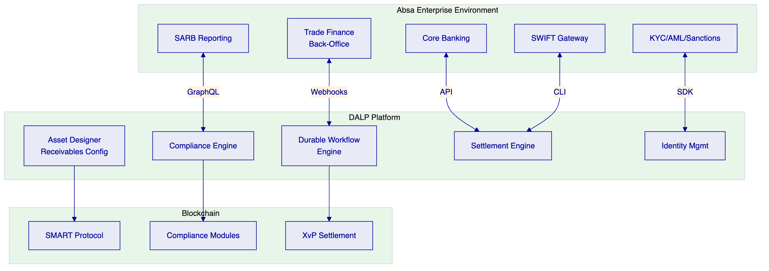

  - About SettleMint
    - Company Overview
SettleMint: production-grade digital asset lifecycle management for regulated markets. Founded 2016, Leuven, Belgium. 10 years continuous operation, 7+ years production deployments at regulated banks. ISO 27001, SOC 2 Type II.
    - Relevance to Absa Group
Credential | Evidence
Trade finance experience | RBI Innovation Hub: multi-bank LC processing
African market exposure | Standard Chartered: Asia, Africa, ME
Institutional deployments | 14 engagements at regulated institutions
Cross-border capability | Maybank Project Photon: atomic cross-border settlement
South Africa context | Awareness of Project Khokha, SARB framework, FSCA requirements

  - About DALP
    - Trade Finance Lifecycle
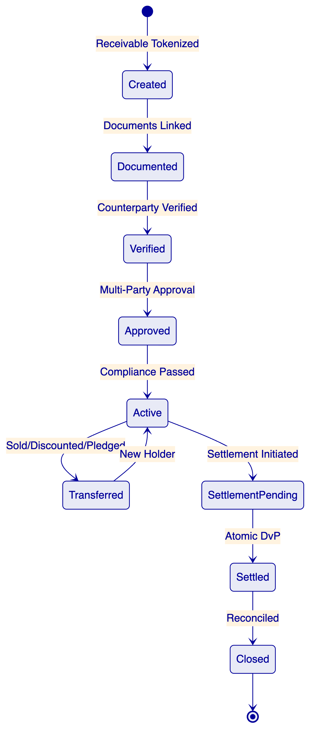
    - Core Capabilities for Trade Finance
Durable Workflow Engine. Multi-step trade finance workflows execute with deterministic completion guarantees. State persists to PostgreSQL — surviving restarts, network partitions, and partner outages. Configurable timeouts and escalation paths for long-running approval processes.
Configurable Token Architecture. DALPAsset supports trade finance instrument configuration: document reference metadata, milestone definitions, counterparty restrictions, holding period enforcement, and multi-party approval workflows.
On-chain Compliance. 18 compliance module types enforce transfer rules before execution. Identity verification, address allow lists (nominated counterparties), transfer approvals (maker-checker), and timelocks (holding periods) compose into instrument-specific compliance configurations.
Atomic Settlement. XvP settlement provides atomic DvP — both legs in a single transaction, zero counterparty exposure, deterministic finality (median 2.3s under IBFT 2.0).

  - Customer References
    - Trade Finance References
Client | Relevance | Geography
RBI Innovation Hub | Multi-bank LC processing | India
Standard Chartered | Institutional trading, Africa exposure | Asia, Africa, ME
Commerzbank | Regulated settlement, EUR 7M/year savings | Germany
IsDB | Multi-country distribution (57 nations) | Global
Maybank Photon | Cross-border atomic settlement | Malaysia
    - Expanded: RBI Innovation Hub — Trade Finance
Context. The RBI Innovation Hub required multi-bank, multi-node, multi-cloud blockchain for fraud-proof trade finance — specifically letters of credit processing across multiple banks.
Solution. DALP powers blockchain and trade finance workflow: document verification, milestone tracking, multi-party approvals, settlement across banks. Multi-cloud deployment for resilience.
Outcomes. Fraud-proof LC workflows operational. Multi-bank participation. Multi-cloud resilience demonstrated.
Transferability. Directly maps to Absa's requirements: multi-party trade workflows, document-linked operations, counterparty verification, milestone-based settlement.

  - Proposed Solution
    - Solution Overview
DALP deploys as Absa's trade finance digitization platform covering:
- Receivable Tokenization: Trade receivables represented as on-chain tokens with document metadata, counterparty identity, and compliance rules
- Workflow Orchestration: Multi-step trade finance workflows with durable execution, milestone tracking, and audit evidence
- Settlement: Atomic DvP for receivable transfers (sale, discount, pledge) and maturity settlement
    - Receivable Token Configuration
Features:
- Historical balances — trade history and audit
- Timelock — holding period enforcement
Compliance modules:
- Identity verification — counterparty identity required
- Address allow list — nominated counterparties only
- Transfer approval — multi-party with configurable expiry
- Timelock — minimum holding period (FIFO tracking)
    - Trade Finance Workflow
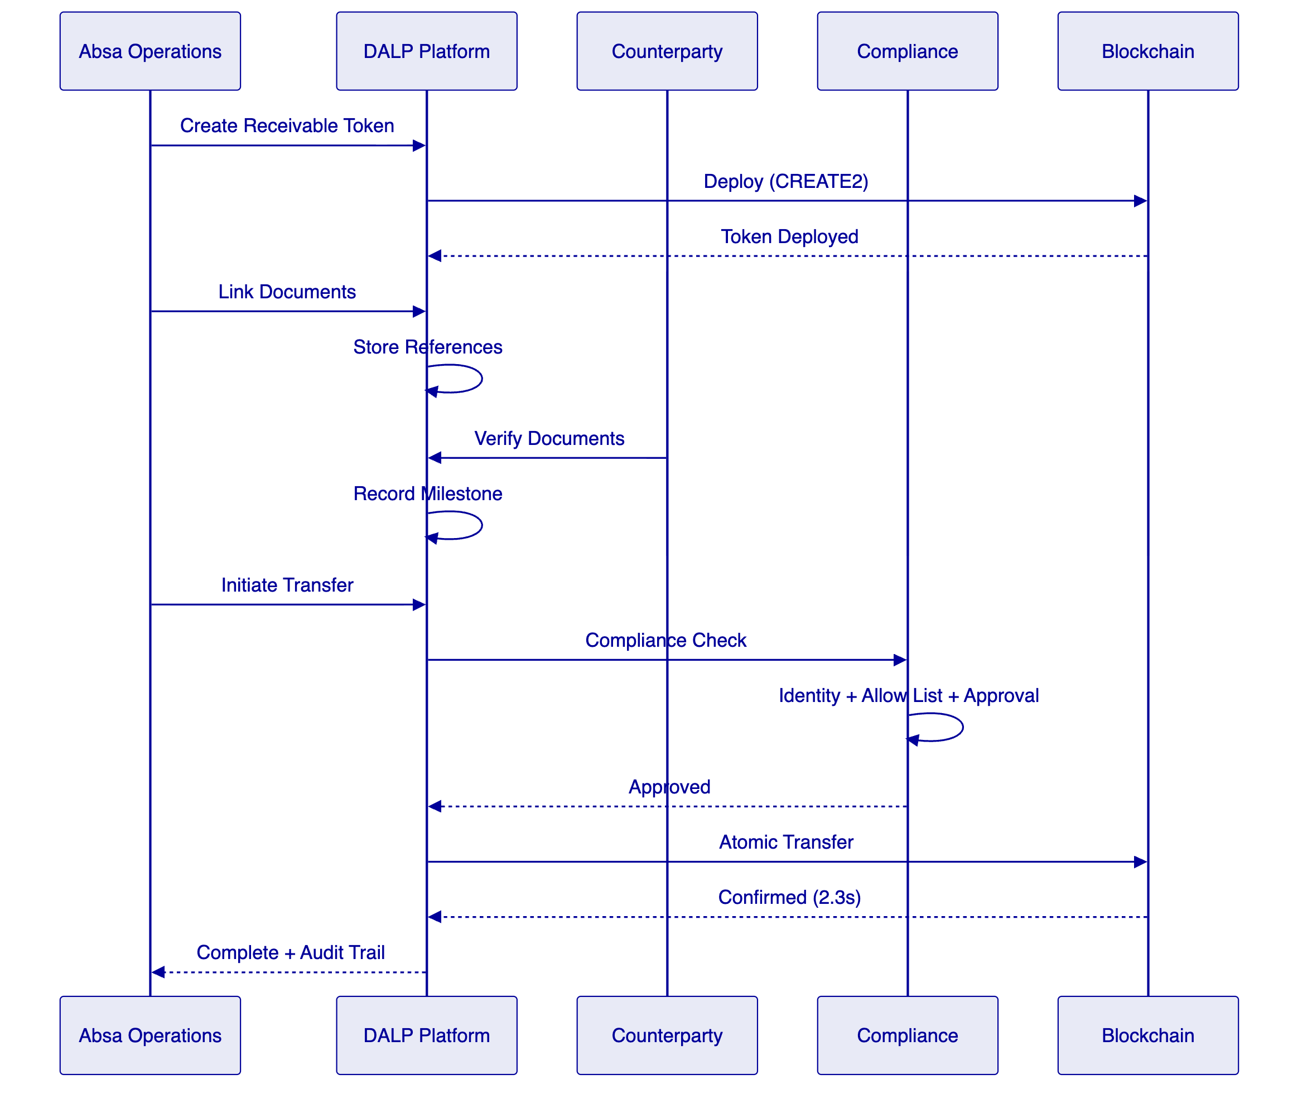
    - Functional Fit Matrix
Req | Summary | Status | Response
REQ-01 | Segregated environments | Full | Independent instances
REQ-02 | API-first interfaces | Full | DAPI, SDK, CLI, webhooks
REQ-03 | RBAC, maker-checker | Full | 26 roles, wallet verification
REQ-04 | Configurable lifecycle | Full | DALPAsset runtime config
REQ-05 | Dependency disclosure | Full | Register provided
REQ-06 | Resilience, monitoring | Full | Multi-AZ, Grafana
REQ-07 | Phased implementation | Full | 19-week methodology
REQ-08 | Audit evidence | Full | On-chain + off-chain
REQ-09 | Document-linked workflows | Full | Durable engine + metadata
REQ-10 | Core books reconciliation | Configurable | API integration Phase 4
REQ-11 | Multi-entity limits | Configurable | Compliance modules + API

  - Technical Architecture
    - Four-Layer Stack
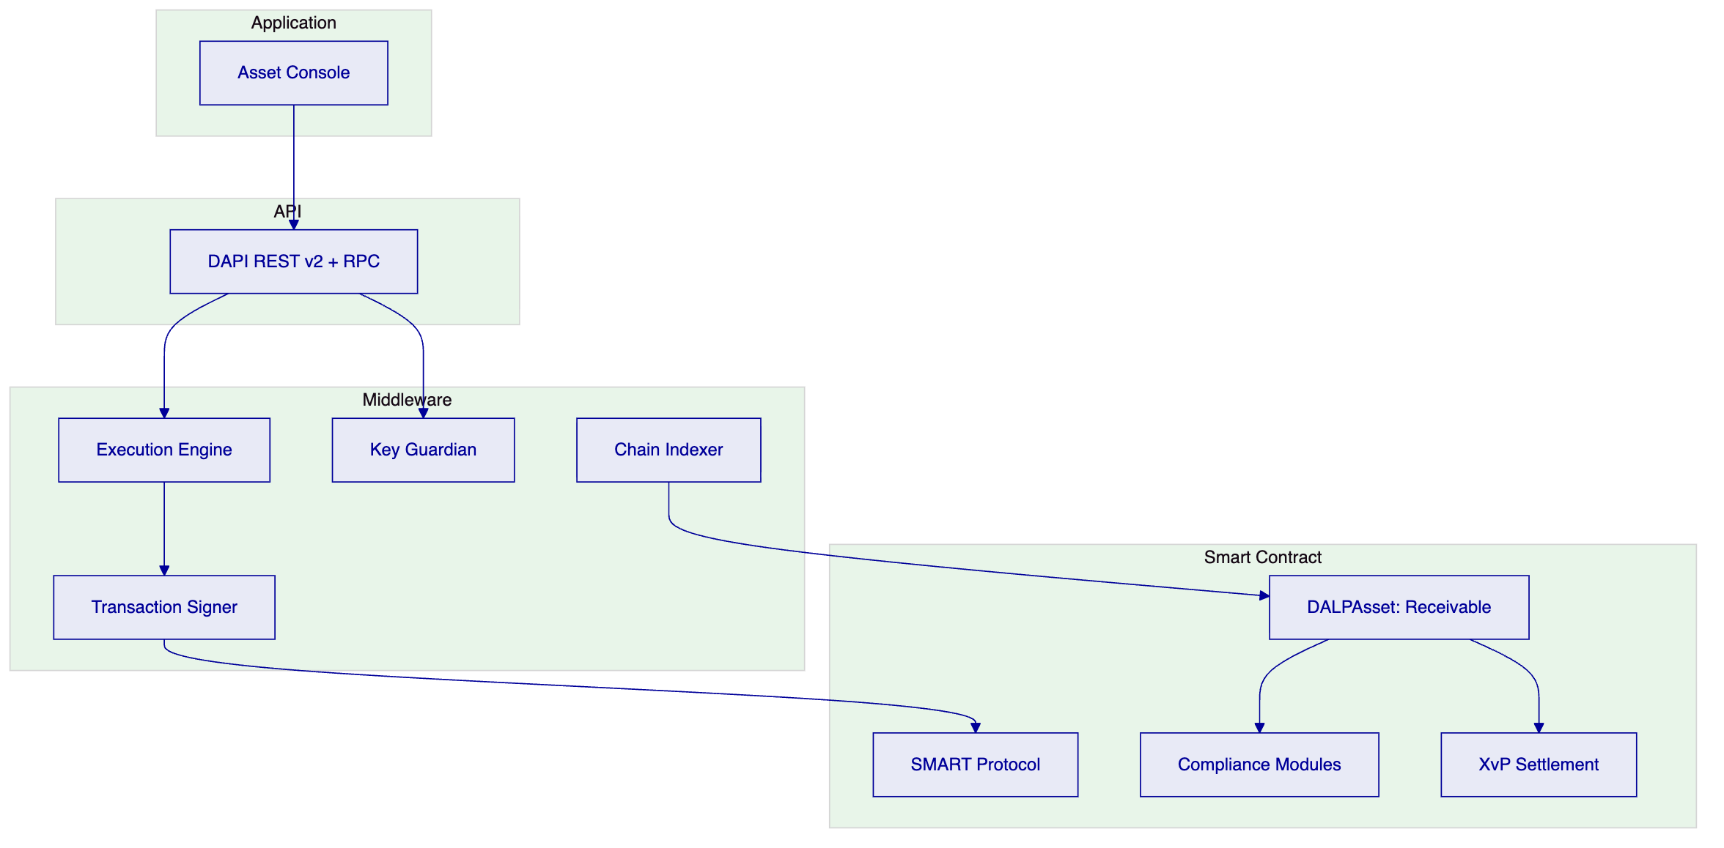
    - Security: 5-Layer Defense-in-Depth
- Authentication (passkeys, LDAP, OAuth)
- Authorization (26 roles, RBAC)
- Wallet verification (step-up auth)
- Compliance (18 modules, fail-closed)
- Custody policy (DFNS/Fireblocks)
ISO 27001, SOC 2 Type II certified.

  - Implementation (19 Weeks)
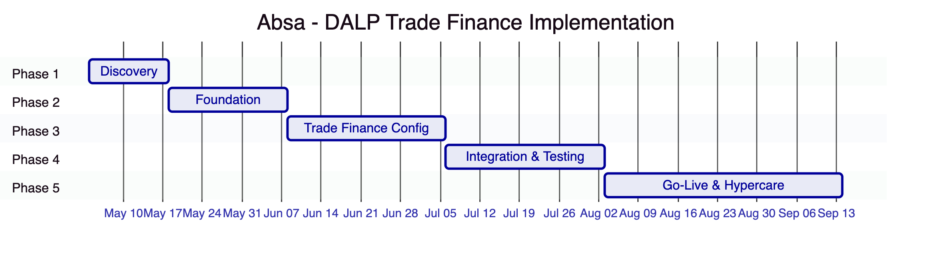
Estimated Absa effort: 75 person-days

  - Deployment
Aspect | Configuration
Model | Dedicated cloud
Region | AWS Cape Town or Azure South Africa
Data residency | South Africa compliant
Blockchain | 4-node Besu (IBFT 2.0)

  - Support: Premium
Aspect | Configuration
Coverage | 16×5
P1 response | 2 hours
Uptime SLA | 99.95%
Dedicated engineer | Yes

  - Risk Register
ID | Risk | Mitigation
R1 | SARB/FSCA regulatory changes | Configurable compliance
R2 | Trade finance system complexity | Phase 1 deep discovery
R3 | Cross-border integration | Phased approach
R4 | Security review timeline | Pre-share certifications

  - Appendices
    - Glossary
Term | Definition
DALP | Digital Asset Lifecycle Platform
SMART Protocol | ERC-3643 implementation
DALPAsset | Configurable token contract
OnchainID | On-chain identity (ERC-734/735)
XvP | Atomic settlement addon

