[Company name]
[Document title]
[Document subtitle]

Confidentiality Statement
This document contains confidential and proprietary information of SettleMint. By reading this document, you agree not to disclose the confidential information contained herein to any third party without the prior written consent of SettleMint, except to those agents, principals, representatives, or consultants who require access for the purpose of evaluating this document. You further agree to inform such persons of the confidential nature of this document and to obtain their agreement to preserve its confidentiality to the same extent as yours.
This confidentiality statement shall remain binding on the parties for a period of five (5) years from the date stated on the front cover, unless superseded by confidentiality provisions detailed in a subsequent agreement.
Terms and Conditions
This proposal is valid until [DD Month YYYY]. In the absence of confirmation to proceed, SettleMint and [the Company] acknowledge and agree to abide by the Mutual NDA as the governing agreement.
SettleMint reserves the right to vary the terms of this proposal in response to changes in specifications or information made available at a later date. Submission of this proposal does not convey any right, title, interest, or license in any intellectual property rights (including, but not limited to, patents, copyrights, trade secrets, or trademarks) contained herein.
All rights are reserved. This proposal and the information contained within it are provided on an “as is” basis, without any warranties of any kind, express or implied.
All contracts with SettleMint will be governed by Belgian Law and subject to the exclusive jurisdiction of Belgian courts.
Contact Details
For any enquiries regarding this document, please contact:
[Full Name]
[Job Title]
Email: [email@example.com]
Phone: [Country Code - Number]

Table of Contents

Table of Contents
Executive Summary
Understanding Al Rajhi Bank's Programme Objectives
The Challenge: Production-Grade Islamic Finance Tokenization
Regulatory Context: KSA Market Realities
Proposed DALP Operating Model for Sharia-Compliant Tokenized Products
Operating Model Overview
Product Lifecycle for Sharia-Compliant Instruments
Technical Architecture and Integration Boundaries
Four-Layer Architecture
Enterprise Integration Architecture for Al Rajhi Bank
Deployment Architecture
Smart Contract Architecture for Islamic Finance
DALPAsset Configuration for Sharia Products
UUPS Proxy Upgrade Pattern
Identity, Compliance, and Sharia Governance Controls
Identity Management with OnchainID
Role-Based Access Control and Maker-Checker (REQ-03)
Compliance Engine: Fail-Closed Design
Settlement, Servicing, and Lifecycle Management
Settlement Architecture
Profit Distribution Workflow
Reconciliation Framework (REQ-04)
Security, Resilience, and Operational Assurance
Security Architecture Overview
Certifications and Assurance (REQ-06)
Operational Resilience
Implementation Approach and Delivery Phases
19-Week Implementation Plan
Phase-by-Phase Detail
Client Responsibilities
Current Coverage, Dependencies, and Qualified Gaps
Requirements Coverage Matrix
Qualified Gaps and Mitigations
Dependency Register
Relevant Delivery Evidence
Reference Deployments
Islamic Development Bank — Sharia-Compliant at Sovereign Scale
Saudi Arabia RER — Production in KSA
Appendices
Appendix A: Response Matrix
Appendix B: Glossary
Appendix C: IP and Confidentiality Statement

Field | Value
Proposal title | Technical Proposal — Sharia-Compliant Tokenized Savings and Investment Products
Client | Al Rajhi Bank
Submitted by | SettleMint NV
Date | March 2026
Version | v1.0
Confidentiality | Restricted
RFP Reference | AL-RAJHI-BANK-RFP-SHARIA-TOKENIZED-PRODUCTS-202603
Primary contact | Adam Popat, CEO

  - Table of Contents
- Executive Summary
- Understanding Al Rajhi Bank's Programme Objectives
- Proposed DALP Operating Model for Sharia-Compliant Tokenized Products
- Technical Architecture and Integration Boundaries
- Smart Contract Architecture for Islamic Finance
- Identity, Compliance, and Sharia Governance Controls
- Settlement, Servicing, and Lifecycle Management
- Security, Resilience, and Operational Assurance
- Implementation Approach and Delivery Phases
- Current Coverage, Dependencies, and Qualified Gaps
- Relevant Delivery Evidence
- Appendices

  - Executive Summary
Al Rajhi Bank has identified Sharia-compliant tokenized savings and investment products as a business-critical capability requiring the same discipline applied to core regulated systems. This is not an innovation exercise — it is a procurement intended to determine whether the market can supply a dependable platform and implementation model for production-grade tokenized Islamic finance products that operate within SAMA regulatory expectations, CMA capital markets rules, AAOIFI governance standards, and the bank's internal control environment.
SettleMint's Digital Asset Lifecycle Platform (DALP) addresses this requirement directly. DALP provides production-ready infrastructure for designing, issuing, servicing, and retiring tokenized financial instruments — with compliance enforcement, identity verification, and governance controls embedded at the smart contract level rather than bolted on as application-layer overlays.
Why DALP fits Al Rajhi Bank's requirements:
- Sharia-compliant product configuration. DALP's configurable token architecture allows the bank to define Sharia-compliant product rules — profit-sharing ratios, Mudarabah and Murabaha structures, maturity schedules, and distribution mechanics — through platform configuration rather than custom smart contract development. The compliance engine enforces eligibility checks, investor accreditation, and transfer restrictions at the contract level, ensuring that Sharia governance rules travel with the token throughout its lifecycle.
- Production-proven at institutional scale. DALP processes digital assets across production deployments with regulated institutions including Standard Chartered Bank, State Bank of India, Commerzbank, OCBC Bank, and the Islamic Development Bank. The Islamic Development Bank engagement — covering Sharia-compliant subsidy distribution across 57 member countries serving 1.7 billion people — directly demonstrates DALP's fitness for Islamic finance use cases at sovereign scale.
- Enterprise integration, not isolation. DALP connects to identity services, core banking ledgers, sanctions and AML tooling, reporting environments, and observability stacks through a comprehensive API surface (REST, GraphQL, webhooks, SDK, CLI). The platform does not create an isolated digital-asset island; it sits inside institutional plumbing with defined integration boundaries and reconciliation points.
- Control integrity from day one. Every operation — issuance, transfer, corporate action, distribution — produces a complete audit trail with initiator identity, policy checks applied, approval chain, and resulting state. Role-based access control with maker-checker workflows, segregation of duties, and Sharia board approval lineage are native to the platform.
Under tested conditions (500 concurrent settlement instructions on a 4-node IBFT validator network), DALP achieves median settlement latency of 2.3 seconds with P99 at 4.1 seconds — providing deterministic T+0 finality that eliminates the confirmation-depth waiting required by probabilistic consensus mechanisms.
The proposed implementation follows SettleMint's phase-gated methodology: 19 weeks from kickoff to hypercare completion, with five delivery phases, formal gate reviews, and clearly defined client responsibilities at each stage. The first production asset class can be live within 13 weeks of kickoff.
This proposal responds to every requirement in the RFP with explicit status, evidence references, and honest qualification of gaps. Where a capability is partial or planned, the gap, mitigation, and timeline are stated directly. SettleMint's position is that operational honesty earns more trust than an over-optimistic response — and we believe Al Rajhi Bank's evaluation team shares that view.
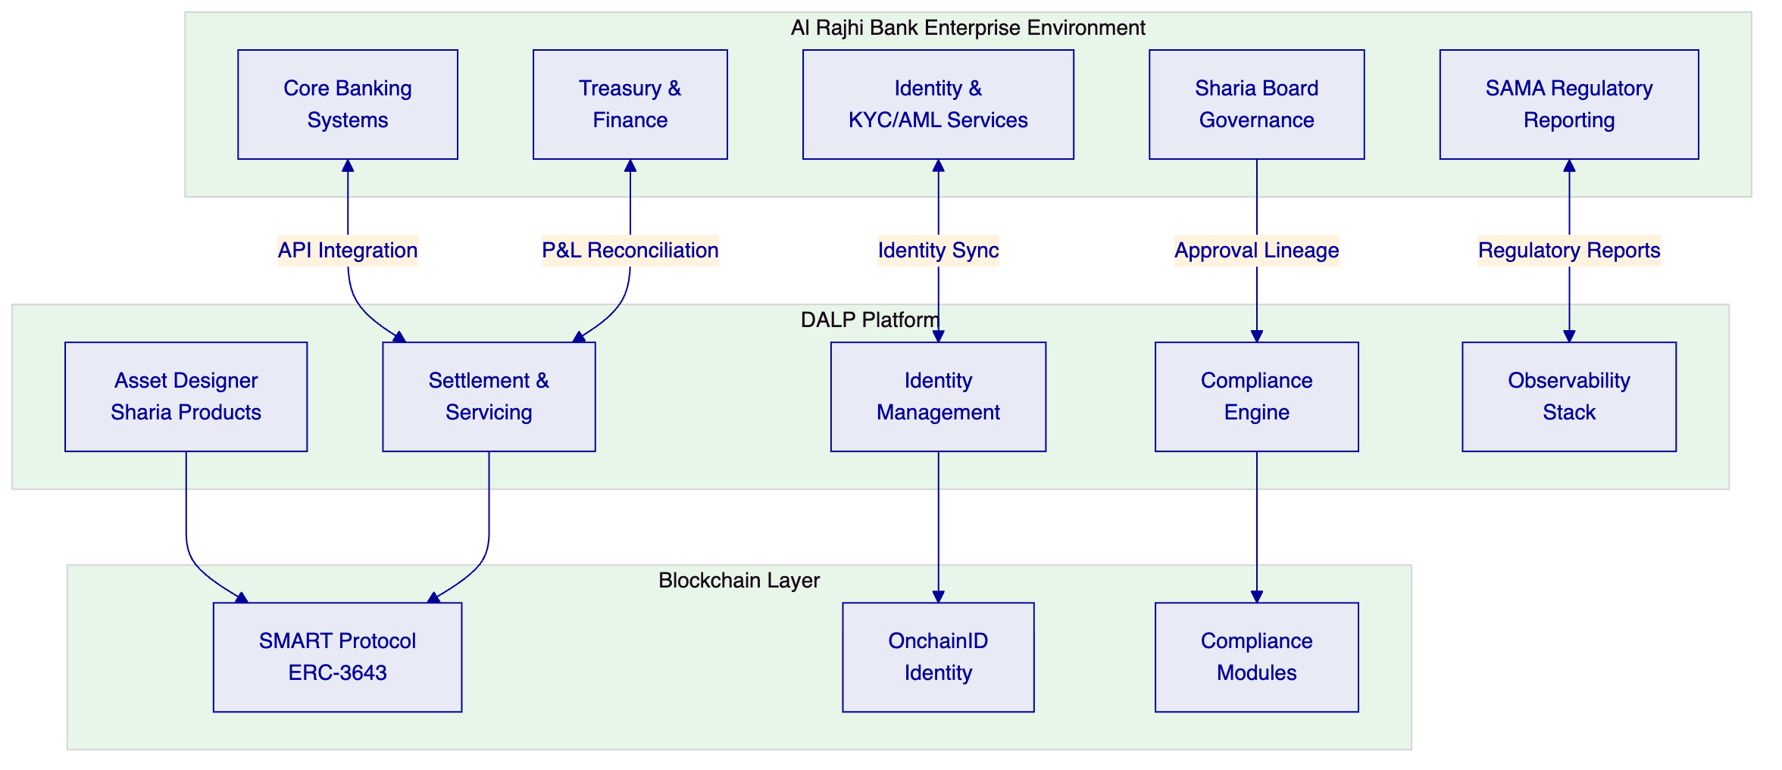

  - Understanding Al Rajhi Bank's Programme Objectives
    - The Challenge: Production-Grade Islamic Finance Tokenization
Al Rajhi Bank's procurement is grounded in three specific challenges that we address directly:
First, control integrity. The bank must be able to identify who initiated a change or transaction, which policy checks applied, who approved the event, and how the resulting state can be reconstructed later. For Sharia-compliant products, this extends to Sharia board approval lineage, fatwa references, and evidence that profit-sharing mechanics operate as certified.
Second, enterprise coexistence. The selected solution cannot become a reconciliation sinkhole. It must integrate with existing core banking, identity, compliance, treasury, and reporting systems without creating hidden operational debt or unowned responsibilities.
Third, phased scalability. Al Rajhi Bank wants to move from initial product launch to broader adoption — additional asset classes, investor segments, and distribution channels — without a platform reset.
DALP addresses all three challenges through its architecture:
- Control integrity is structural, not bolted on. Every transaction flows through the compliance engine, identity registry, and approval workflow before execution. Audit trails are immutable and queryable.
- Enterprise integration is the platform's default mode. DALP exposes 301 CLI commands across 26 command groups, a REST API (v2), GraphQL via subgraph, event webhooks, and a TypeScript SDK — providing multiple integration patterns for different enterprise system categories.
- Scalability is configuration-driven. New asset classes use the same DALPAsset configurable contract with different feature and compliance module compositions. No redeployment, no re-audit, no platform reset.
    - Regulatory Context: KSA Market Realities
We anchor this response in the actual regulatory and market infrastructure realities of the Kingdom:
- SAMA expectations for digital asset platforms, including prudential controls, operational resilience, and outsourcing governance
- CMA capital markets rules governing tokenized investment products, investor eligibility, and market conduct
- AAOIFI standards for Islamic finance product governance, profit distribution, and Sharia compliance documentation
- Saudi cybersecurity controls (NCA) for critical infrastructure and data protection requirements
- Project Aber and Digital Dirham learnings relevant to cross-border settlement architecture, though not treated as substitutes for explicit control design
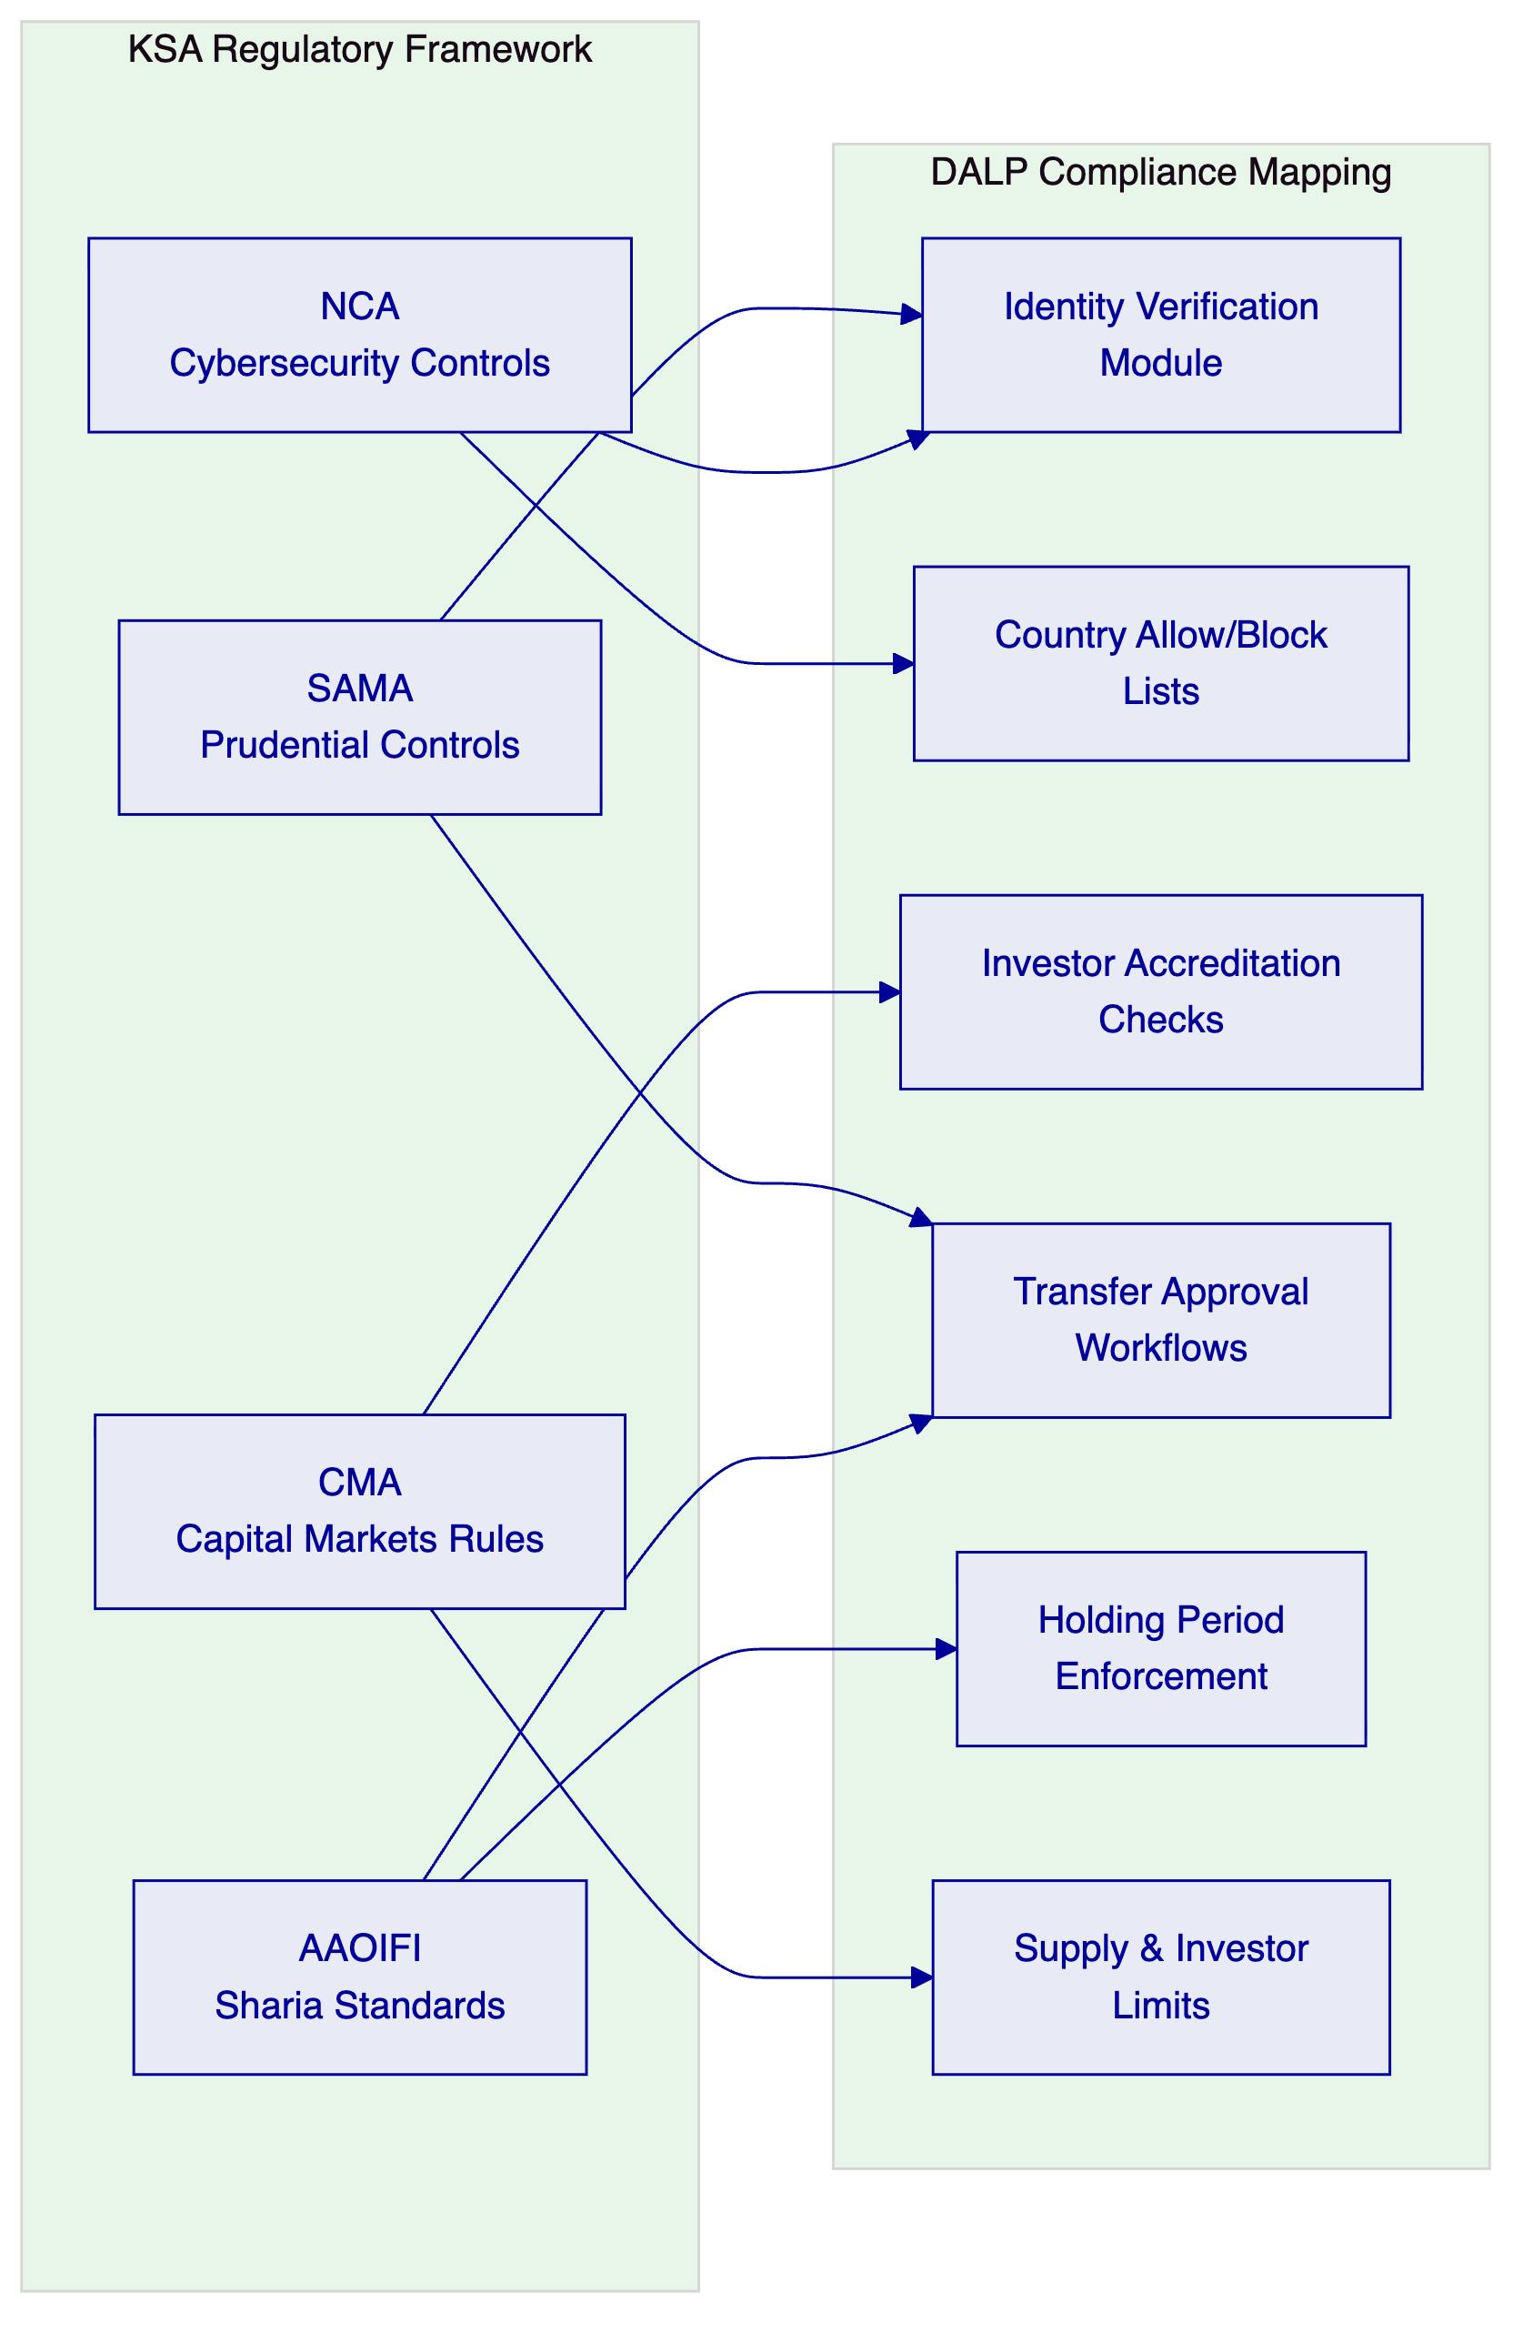

  - Proposed DALP Operating Model for Sharia-Compliant Tokenized Products
    - Operating Model Overview
The proposed operating model maps DALP's capabilities directly to Al Rajhi Bank's five workstreams. Each workstream is addressed with specific deliverables, responsibilities, and milestone gates — not generic methodology statements.
Workstream | DALP Capability | Al Rajhi Bank Responsibility | Integration Point
WS-01: Mobilisation | Environment provisioning, governance framework | Steering committee, design authority | Joint RAID management
WS-02: Product Configuration | Asset Designer, compliance modules, lifecycle rules | Sharia board approval, product policy decisions | Business rules validation
WS-03: Integration | API surface, webhooks, event system | Core banking, identity, AML system readiness | Defined API contracts
WS-04: Testing | Platform test environments, security testing | UAT execution, business acceptance | Joint defect triage
WS-05: Operations | Observability stack, runbooks, SLA framework | Service desk staffing, management reporting | Support handoff protocol
    - Product Lifecycle for Sharia-Compliant Instruments
DALP supports the full lifecycle of Sharia-compliant tokenized products through its configurable architecture:
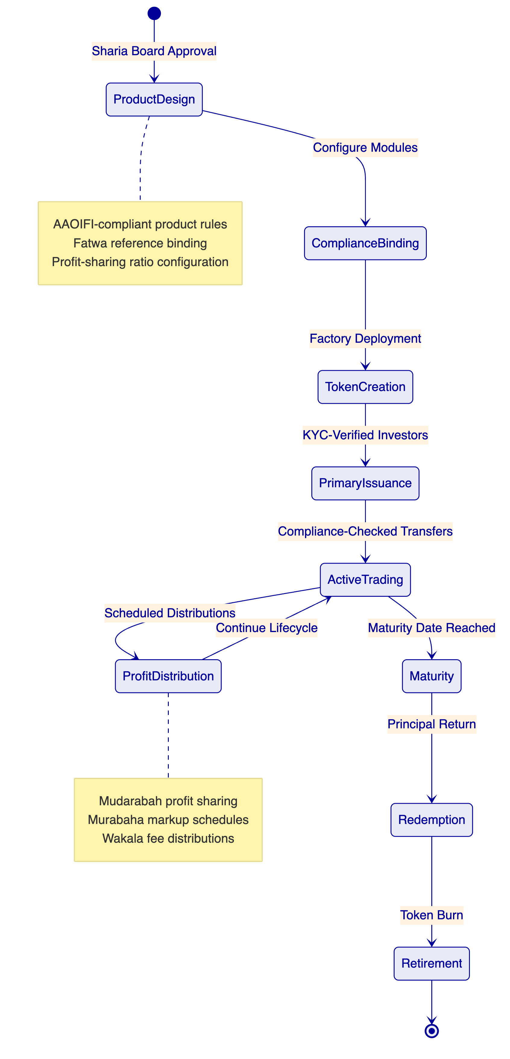
Product Design and Configuration. The Asset Designer wizard guides operators through Sharia-compliant product configuration. For each product type:
- Mudarabah savings products: Configure profit-sharing ratios, expected return ranges, distribution frequency, and loss-sharing mechanics. The platform enforces that profit distribution follows the contractually defined ratio, not a fixed interest rate.
- Murabaha investment products: Configure cost-plus-markup structures, deferred payment schedules, and ownership transfer mechanics. The compliance engine ensures the underlying asset transfer occurs before markup application.
- Wakala investment products: Configure agency fee structures, investment mandate parameters, and performance-based distribution rules.
- Sukuk instruments: Configure underlying asset references, periodic distribution schedules, dissolution mechanics, and Sharia board attestation requirements.
Each product configuration binds specific compliance modules that enforce Sharia governance rules at the smart contract level:
Compliance Module | Sharia Application | Enforcement Level
Identity Verification | Investor KYC/AML, Saudi national ID integration | On-chain (pre-transfer)
Country Allow List | KSA-only or GCC-permitted investor base | On-chain (pre-transfer)
Investor Count Limit | Regulatory caps on participant numbers | On-chain (pre-mint)
Transfer Approval | Sharia board sign-off on secondary transfers | On-chain (pre-transfer)
Holding Period (Time Lock) | Minimum holding periods per AAOIFI guidance | On-chain (pre-transfer)
Collateral Requirement | Asset-backing verification for Sukuk | On-chain (pre-mint)

  - Technical Architecture and Integration Boundaries
    - Four-Layer Architecture
DALP is built as a four-layer stack where each layer has a distinct responsibility boundary and layers communicate through well-defined interfaces:
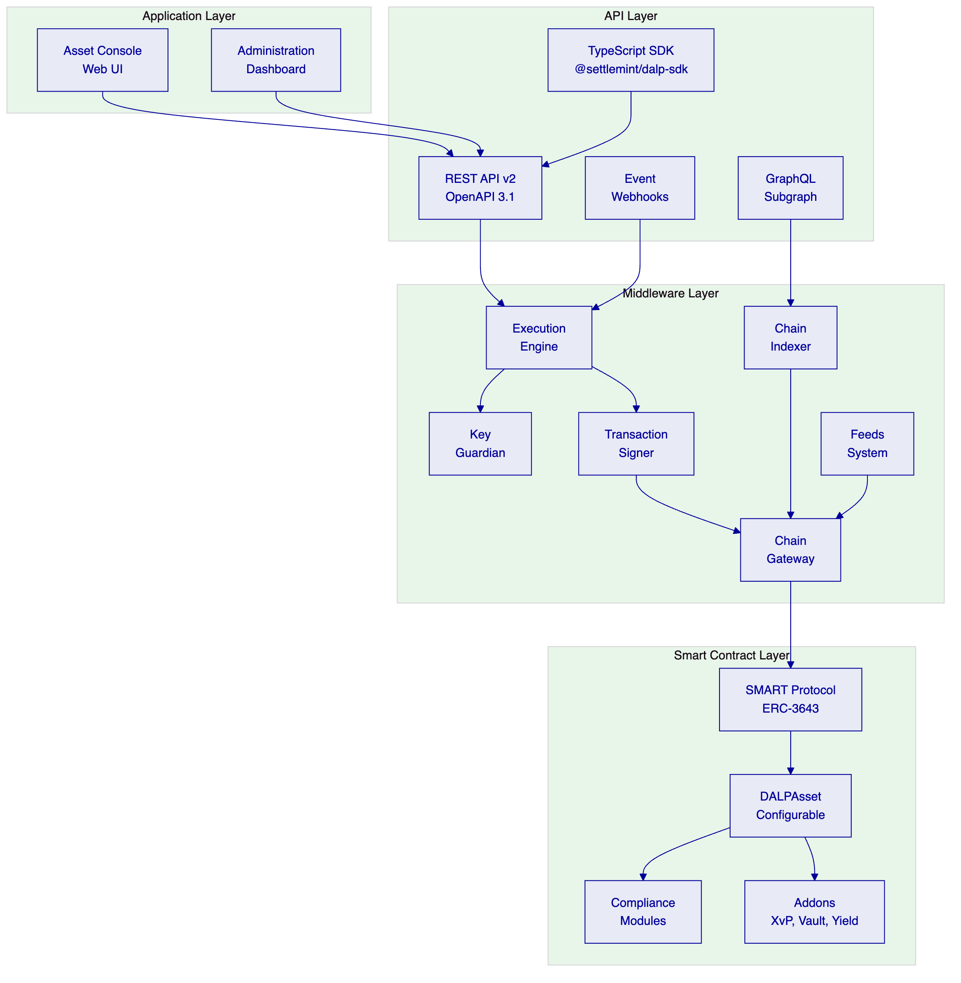
Requests flow top-down through these layers. A user action in the Asset Console triggers an API call, which the middleware orchestrates into one or more blockchain transactions, which the smart contract layer validates and executes on-chain. Each layer independently enforces its own security controls, so no single-layer failure grants unauthorized access.
    - Enterprise Integration Architecture for Al Rajhi Bank
The following diagram shows how DALP integrates with Al Rajhi Bank's enterprise systems, addressing the RFP's requirement that the solution fit into the broader enterprise stack without creating hidden operational debt:
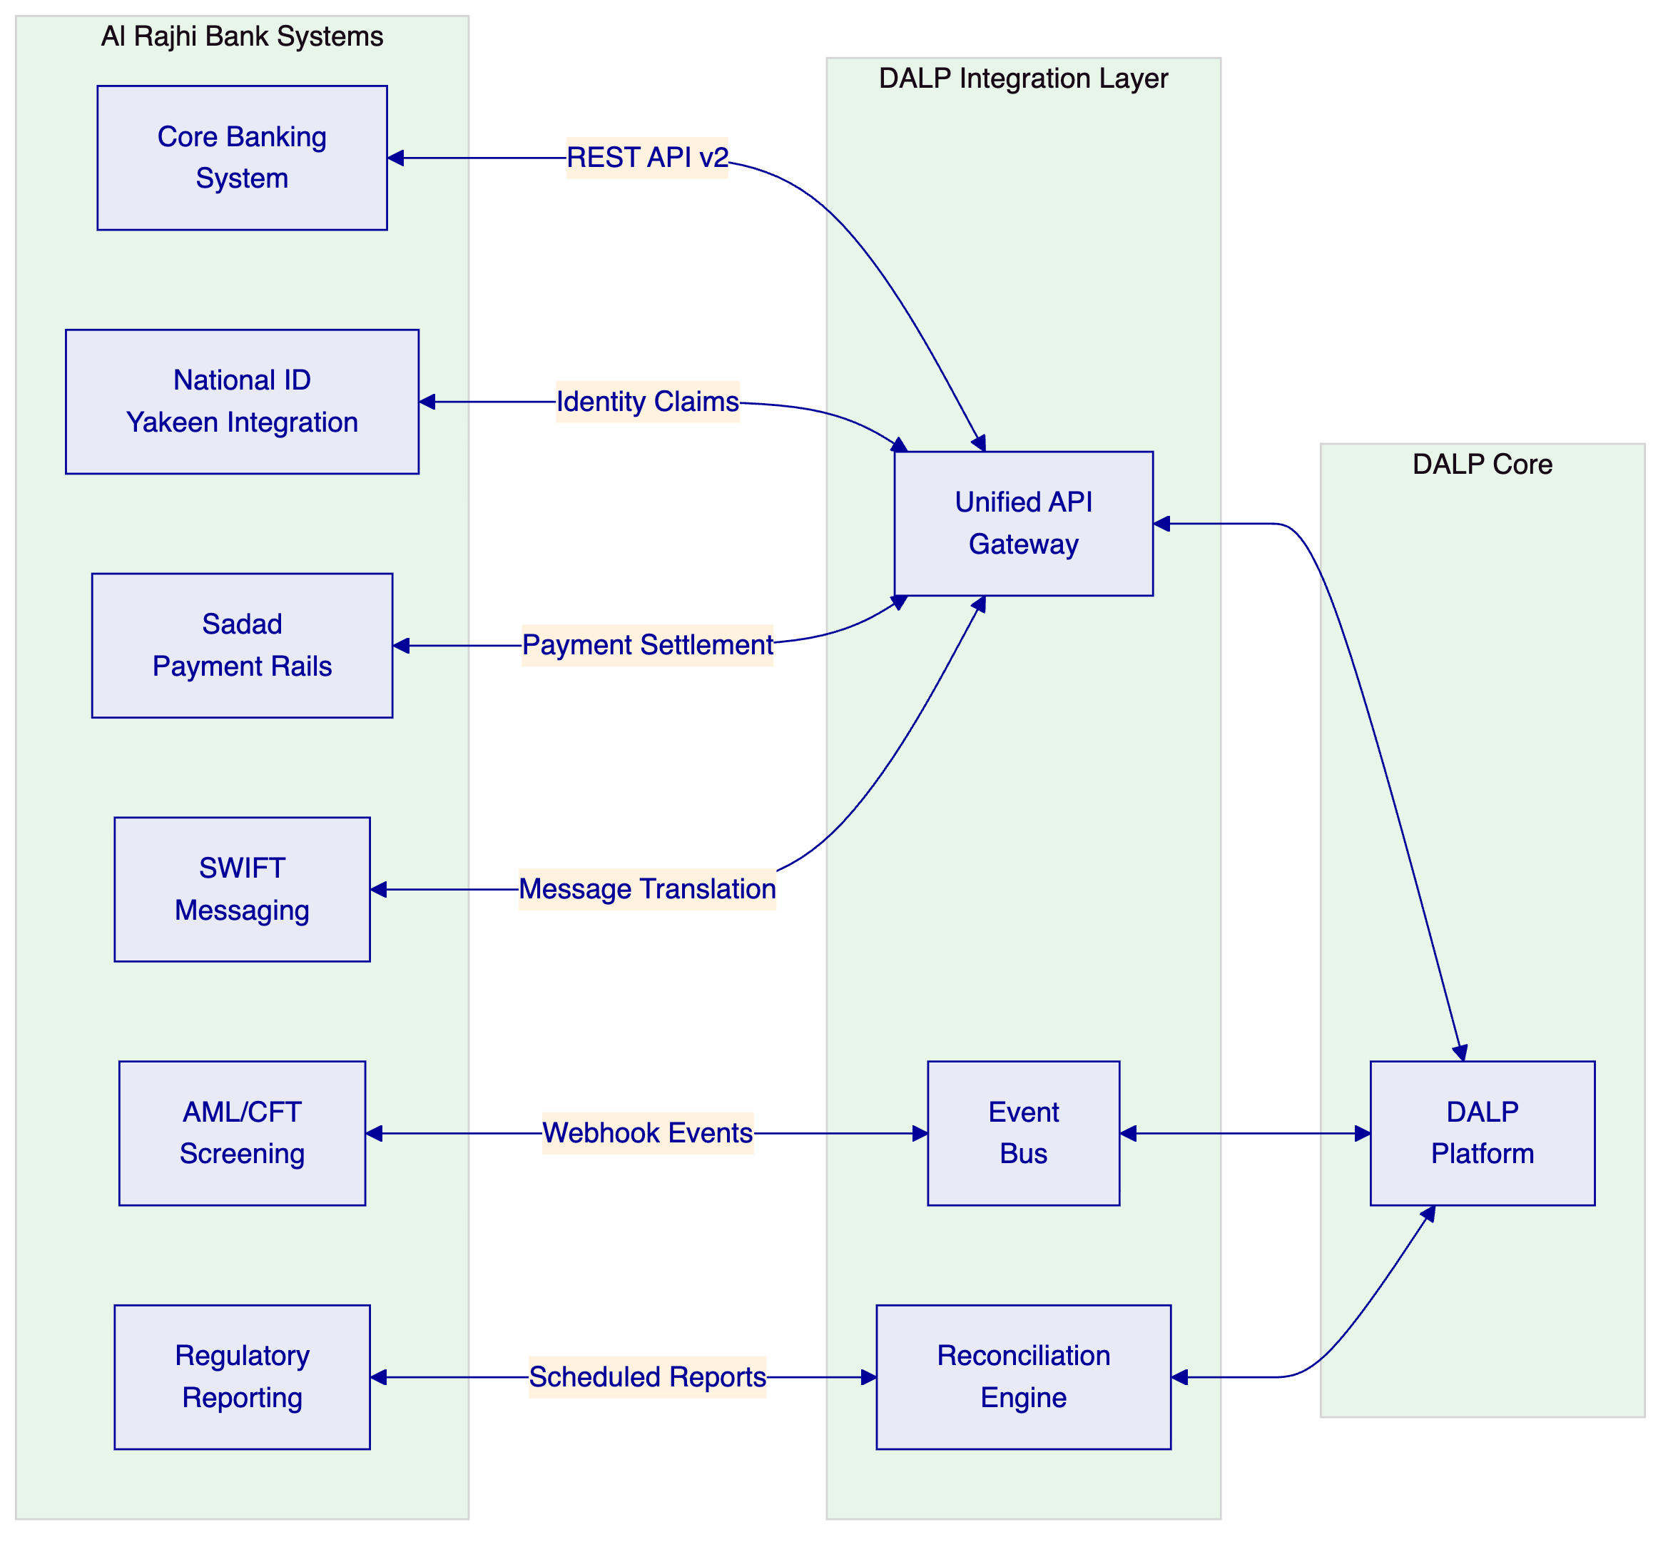
Integration patterns by system category:
Enterprise System | Integration Pattern | Data Flow | Frequency
Core Banking | REST API v2, bidirectional | Position sync, P&L booking | Real-time + batch reconciliation
AML/CFT Screening | Webhook events + API | Transaction alerts, case referrals | Real-time per transaction
National Identity (Yakeen) | Identity claims via API | KYC verification, identity attestation | On investor onboarding
Regulatory Reporting | Scheduled API extracts | SAMA reports, CMA filings | Daily/monthly per requirement
Sadad Payment Rails | Payment API integration | Fiat settlement instructions | Per settlement event
SWIFT Messaging | Message translation middleware | Cross-border instructions | Per cross-border transaction
    - Deployment Architecture
DALP supports three deployment models. For Al Rajhi Bank, we recommend a dedicated cloud deployment within KSA-resident infrastructure to satisfy data residency requirements:
Environment | Purpose | Configuration
Development | Feature development, API testing | Shared infrastructure, reduced compute
UAT/Staging | Business acceptance, integration testing | Production-mirror configuration
DR | Disaster recovery, failover testing | Geo-separated within KSA
Production | Live operations | Full HA, dedicated compute, KSA data center
REQ-01 (segregated environments) is fully supported. All environments are isolated at the network, compute, and data levels with separate access controls.

  - Smart Contract Architecture for Islamic Finance
Having established in the preceding section how DALP's four-layer architecture provides the structural foundation for Al Rajhi Bank's enterprise integration, we now turn to how the smart contract layer specifically addresses the Sharia compliance requirements that distinguish this programme from conventional tokenization.
    - DALPAsset Configuration for Sharia Products
All Sharia-compliant products use the DALPAsset configurable contract, which extends the SMART Protocol (ERC-3643) with runtime-pluggable features and compliance modules. This design means Al Rajhi Bank does not need separate smart contract development for each product type:
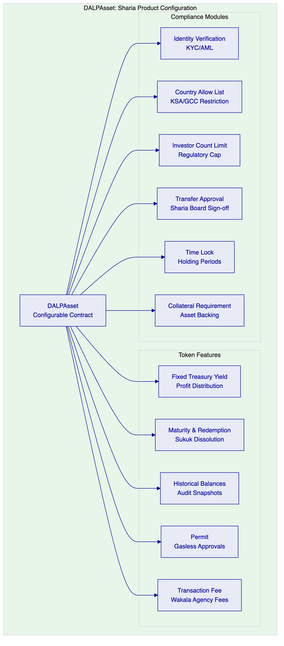
Key Sharia compliance considerations in the smart contract design:
- Profit vs. interest segregation (REQ-13). The Fixed Treasury Yield feature is configured to distribute profits based on the contractually defined profit-sharing ratio, not a fixed interest rate. The distribution calculation references the actual investment pool performance, and the smart contract enforces that distributions are labelled and calculated as profit shares rather than interest payments. This distinction is enforced at the contract level and visible in all audit trails.
- Sharia board workflow integration (REQ-12). The Transfer Approval compliance module supports multi-level approval workflows. For Sharia governance, this can be configured to require Sharia board representative approval for product launches, secondary market enablement, and distribution parameter changes. Each approval is recorded on-chain with the approver's verified identity, timestamp, and reference to the relevant fatwa or board resolution.
- AAOIFI documentation treatment. Product configurations can reference specific AAOIFI standards (e.g., FAS 4 for Murabaha, FAS 3 for Mudarabah) in metadata fields that travel with the token throughout its lifecycle. These references are queryable via the API and included in regulatory reporting extracts.
    - UUPS Proxy Upgrade Pattern
DALPAsset contracts are deployed using the UUPS (Universal Upgradeable Proxy Standard) pattern, which preserves all on-chain state during upgrades while allowing the implementation logic to evolve:
- The proxy contract holds the state (token balances, compliance configuration, identity data)
- Upgrade logic lives in the implementation contract, requiring explicit authorization via GOVERNANCE_ROLE
- Token addresses remain stable across upgrades — no migration required
- Immutable deployment is available for regulatory frameworks requiring compile-time guarantees
For Al Rajhi Bank, we recommend upgradeable deployment for development and UAT environments, with the option to deploy immutable contracts in production if required by SAMA or the bank's internal governance framework.

  - Identity, Compliance, and Sharia Governance Controls
    - Identity Management with OnchainID
DALP manages investor and participant identities through OnchainID (ERC-734/735), providing on-chain identity verification as a prerequisite for all asset operations:
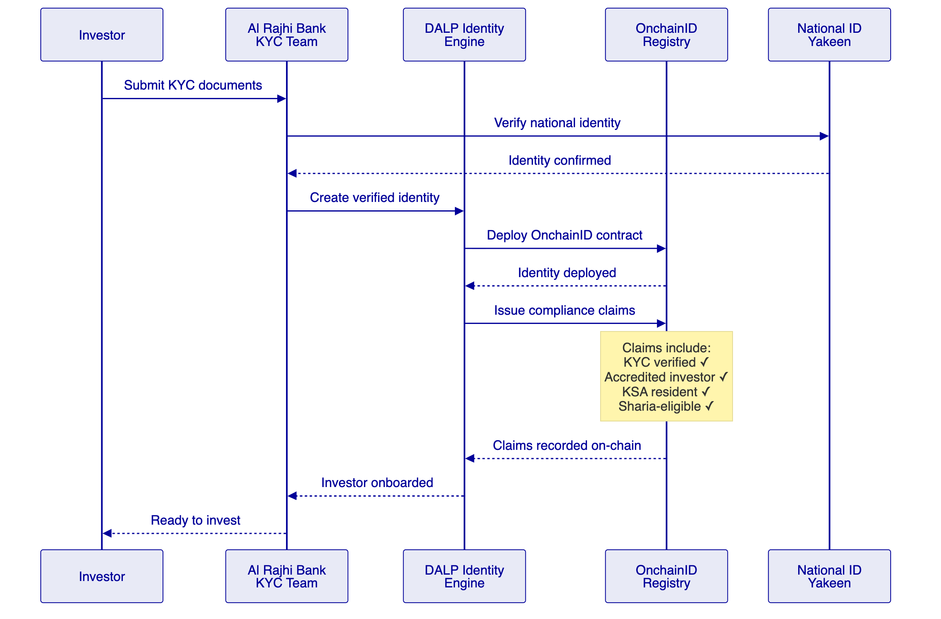
    - Role-Based Access Control and Maker-Checker (REQ-03)
DALP implements granular RBAC with segregation of duties across all operations:
Role | Permissions | Maker-Checker Scope
Product Manager | Asset design, configuration | Creates product → requires Sharia Board approval
Compliance Officer | Compliance module configuration, claim management | Configures rules → requires Head of Compliance approval
Operations Manager | Issuance execution, distribution processing | Initiates operations → requires Treasury approval
Sharia Board Representative | Product certification, distribution approval | Reviews and certifies → recorded on-chain
Treasury Manager | Settlement authorization, reconciliation sign-off | Approves settlements → requires dual authorization
Platform Administrator | User management, environment configuration | System changes → requires CISO approval
Auditor (read-only) | Full audit trail access, report generation | No write access; complete read visibility
Every action by every role produces an immutable audit log entry containing: user identity, timestamp, action performed, parameters, approval chain, and resulting state change.
    - Compliance Engine: Fail-Closed Design
DALP's compliance engine evaluates a configurable set of transfer rules before each transaction. Modules evaluate in sequence, and a single module veto blocks the transfer. This is a fail-closed design: the default is denial unless all modules explicitly approve.
For Al Rajhi Bank's Sharia-compliant products, the compliance evaluation sequence is:
- Identity Verification — Does the investor have a verified OnchainID with valid KYC claims?
- Country Allow List — Is the investor's jurisdiction in the permitted list (KSA, or GCC if configured)?
- Investor Accreditation — Does the investor meet the accreditation requirements for this product?
- Sharia Eligibility — Does the investor have a valid Sharia-eligibility claim?
- Transfer Approval — Has the required approval (Sharia board, compliance, or treasury) been granted?
- Holding Period — Has the minimum holding period elapsed for FIFO-tracked token batches?
- Investor Count Limit — Would this transfer exceed the regulatory cap on unique holders?
If any module denies the transfer, the transaction reverts with a specific error code identifying which compliance check failed. This provides Al Rajhi Bank's operations team with immediate visibility into why a transaction was blocked, supporting exception management and regulatory evidence requirements.

  - Settlement, Servicing, and Lifecycle Management
    - Settlement Architecture
DALP supports atomic Delivery versus Payment (DvP) settlement through the XvP Settlement addon, which ensures that asset delivery and payment occur simultaneously or not at all:
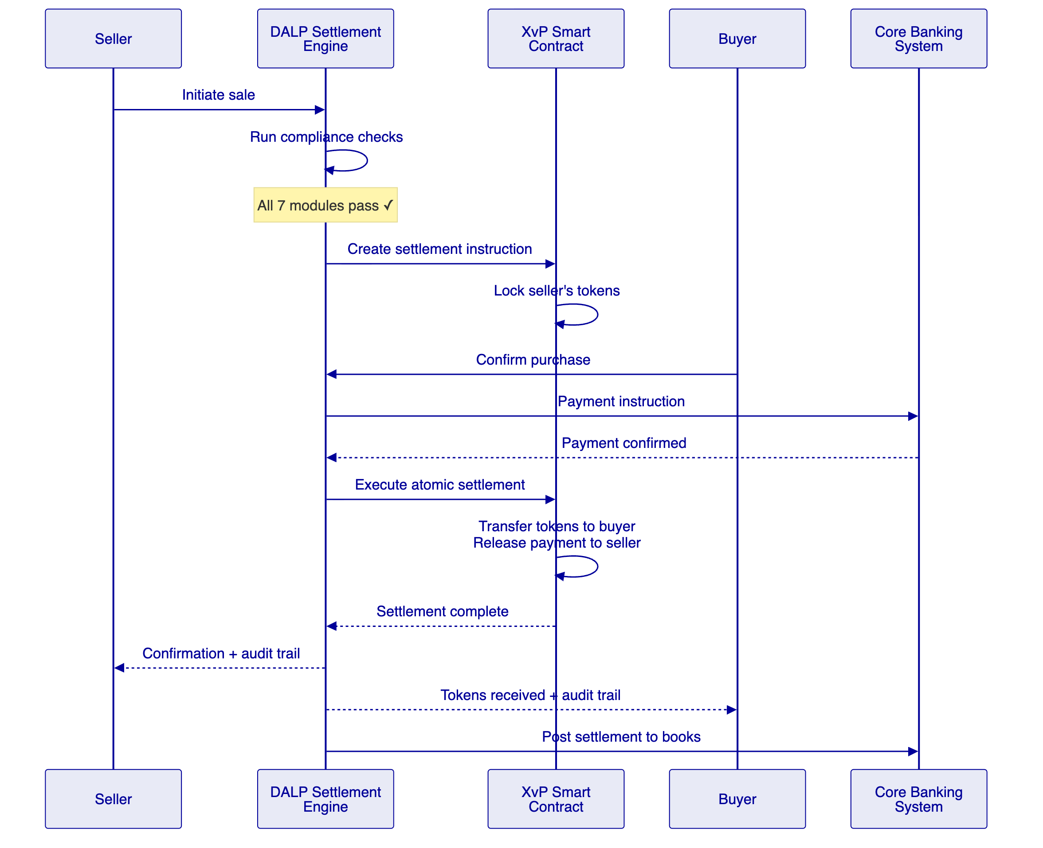
    - Profit Distribution Workflow
For Sharia-compliant products, profit distributions follow a distinct workflow that ensures compliance with AAOIFI standards:
Distribution Type | Mechanism | Compliance Control
Mudarabah profit share | Calculated from investment pool performance × agreed ratio | Enforced at contract level; cannot default to fixed rate
Murabaha markup payment | Scheduled payments per deferred sale agreement | Payment schedule locked at issuance; visible in audit trail
Wakala performance fee | Agent fee calculated on actual returns | Fee cap enforced at contract level
Sukuk periodic distribution | Rental income or profit from underlying asset | Distribution linked to verified asset performance data
    - Reconciliation Framework (REQ-04)
DALP provides comprehensive reconciliation capabilities between on-chain state and Al Rajhi Bank's books-and-records:
- Real-time position sync via API — on-chain balances queryable at any point in time using historical balance snapshots
- Event-driven notifications — every state change (mint, burn, transfer, distribution) triggers webhook events to downstream systems
- Reconciliation extracts — scheduled API exports in formats compatible with core banking reconciliation tools
- Break identification — discrepancies between on-chain state and expected positions surface through the observability dashboard
- Audit trail correlation — every on-chain transaction can be correlated with the initiating API call, approval chain, and downstream booking

  - Security, Resilience, and Operational Assurance
    - Security Architecture Overview
DALP implements defense-in-depth across five independent control layers:
[Diagram 9 — render failed, see markdown source]
    - Certifications and Assurance (REQ-06)
Certification | Status | Relevance
ISO 27001 | Current | Information security management system
SOC 2 Type II | Current | Security, availability, confidentiality controls
Smart contract audits | Completed per release | Independent security review of all on-chain code
Penetration testing | Annual + per major release | External assessment of platform security posture
    - Operational Resilience
Capability | Implementation | Evidence
Recovery Point Objective (RPO) | < 1 hour | Continuous database replication, blockchain state is inherently replicated
Recovery Time Objective (RTO) | < 4 hours | Automated failover procedures, tested quarterly
Backup integrity | Daily automated backups with integrity verification | Tested restore procedures documented
Incident management | Structured escalation with defined severity levels | SLA-bound response times per severity
Monitoring | Three-pillar observability (metrics, logs, traces) | Pre-built Grafana dashboards, automated alerting

  - Implementation Approach and Delivery Phases
    - 19-Week Implementation Plan
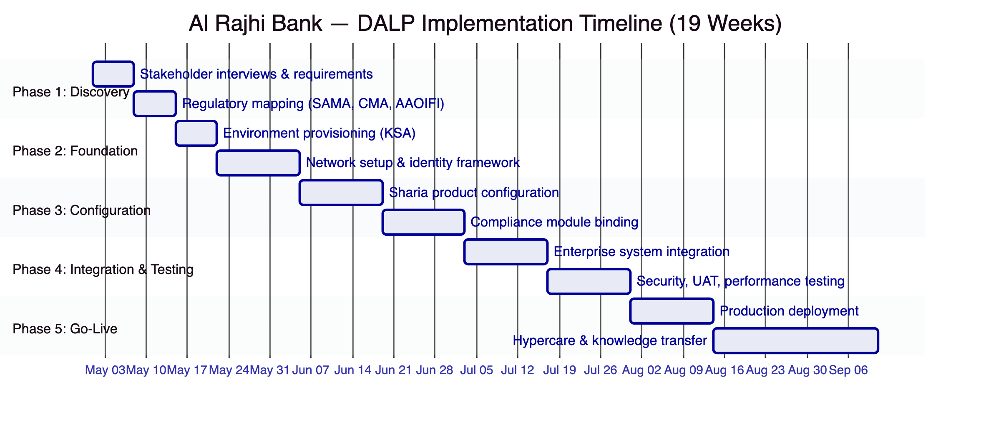
    - Phase-by-Phase Detail
Phase 1: Discovery and Requirements (Weeks 1–2)
- Stakeholder interviews with business, technology, compliance, risk, Sharia board, and operations
- Regulatory mapping: SAMA, CMA, AAOIFI standards to specific DALP compliance modules
- Current-state assessment of core banking, identity, and compliance systems
- Architecture design for KSA-resident deployment
- Gate deliverable: Validated requirements document, target architecture, implementation roadmap
Phase 2: Foundation and Setup (Weeks 3–5)
- Environment provisioning: Dev, UAT, DR, and Production environments within KSA
- Blockchain network setup (permissioned Hyperledger Besu recommended for regulatory control)
- Identity framework deployment and Yakeen integration design
- Custody integration model selection (DFNS or Fireblocks)
- Gate deliverable: Functional platform environments ready for configuration
Phase 3: Configuration and Compliance (Weeks 6–9)
- Sharia product configuration: Mudarabah, Murabaha, Sukuk product templates
- Compliance module binding per product type (identity, jurisdiction, holding periods, approvals)
- Profit distribution schedule configuration
- Sharia board approval workflow setup
- Gate deliverable: Configured platform matching business and Sharia governance requirements
Phase 4: Integration and Testing (Weeks 10–13)
- Core banking integration (position sync, settlement booking)
- AML/CFT system integration (transaction monitoring, alert routing)
- Functional testing, security testing, performance testing, UAT
- Regulatory reporting validation
- Gate deliverable: Validated, integrated system with formal go-live readiness
Phase 5: Go-Live and Hypercare (Weeks 14–19)
- Production deployment (2 weeks)
- Knowledge transfer to operations team
- Hypercare: intensive post-go-live support (4 weeks)
- Service desk handoff and SLA activation
- Gate deliverable: Production system with operational readiness confirmed
    - Client Responsibilities
Al Rajhi Bank's responsibilities during implementation include:
- Steering committee and design authority participation
- Sharia board availability for product certification
- Core banking and identity system API readiness
- UAT execution and business acceptance
- Operational staffing for post-go-live service desk
- Network and infrastructure provisioning (if on-premises deployment selected)

  - Current Coverage, Dependencies, and Qualified Gaps
    - Requirements Coverage Matrix
Req ID | Requirement | Status | Evidence Reference
REQ-01 | Segregated environments | Full | Section: Deployment Architecture
REQ-02 | API-first interfaces, eventing, version governance | Full | Section: Technical Architecture
REQ-03 | RBAC, segregation of duties, maker-checker, audit logs | Full | Section: Identity, Compliance, and Sharia Governance
REQ-04 | Configurable lifecycle states, policy controls, limits, reconciliation | Full | Section: Settlement, Servicing, and Lifecycle Management
REQ-05 | Third-party dependency disclosure | Full | See Dependency Register below
REQ-06 | Resilience, recovery, monitoring, incident management | Full | Section: Security, Resilience, and Operational Assurance
REQ-07 | Delivery method, client effort, phased plan | Full | Section: Implementation Approach
REQ-08 | Audit evidence extraction, supervisory review, board reporting | Full | Section: Identity, Compliance, and Sharia Governance
REQ-12 | Sharia board workflows, fatwa references, AAOIFI documentation | Partial | Section: Smart Contract Architecture for Islamic Finance
REQ-13 | Profit vs. interest segregation | Full | Section: Smart Contract Architecture for Islamic Finance
    - Qualified Gaps and Mitigations
REQ-12: Sharia board workflows — Partial.
DALP's Transfer Approval compliance module supports multi-level approval workflows that can be configured for Sharia board sign-off requirements. Fatwa references can be stored as metadata attached to product configurations and are included in audit trail extracts.
However, DALP does not currently provide a dedicated Sharia board portal with specialized UI for fatwa management, board resolution tracking, or AAOIFI standard compliance dashboards. These capabilities are achievable through:
- Configuration of existing approval workflows (available now) — Sharia board representatives are assigned the GOVERNANCE_ROLE with approval permissions on product configuration and distribution events
- Custom dashboard development (implementation phase, estimated 2 weeks additional effort) — A dedicated Sharia governance view can be built using DALP's API and the existing observability stack
- AAOIFI reporting templates (Q3 2026 roadmap) — Structured reporting templates aligned to specific AAOIFI Financial Accounting Standards are in development
Mitigation timeline: Core Sharia governance workflows are functional from day one through existing approval mechanisms. The dedicated Sharia board dashboard is deliverable during the implementation phase. AAOIFI reporting templates are targeted for Q3 2026 and will be delivered as a platform update within the license term.
    - Dependency Register
Dependency | Type | Owner | Risk
KSA-resident cloud infrastructure | Infrastructure | Al Rajhi Bank / Cloud provider | Medium — requires provisioning lead time
Core banking API readiness | Integration | Al Rajhi Bank | High — critical path for settlement booking
Yakeen national identity integration | Integration | Al Rajhi Bank / NIC | Medium — required for investor onboarding
Sharia board availability | Business | Al Rajhi Bank | Medium — required for product certification gates
SAMA regulatory guidance on tokenized products | Regulatory | SAMA | Low — current framework sufficient for initial scope
Custody provider selection | Technical | Joint decision | Medium — affects key management architecture

  - Relevant Delivery Evidence
    - Reference Deployments
Client | Region | Asset Class | Relevance to Al Rajhi Bank
Islamic Development Bank | Multi-region (57 countries) | Subsidy tokens, Sharia-compliant | Direct — Sharia-compliant tokenization at sovereign scale
Saudi Arabia RER | KSA | Real estate | Direct — KSA production deployment, national-scale
Standard Chartered Bank | Asia, Africa, Middle East | Securities | Direct — multi-jurisdiction bank deployment
State Bank of India | South Asia | CBDC | Relevant — national-scale institutional deployment
OCBC Bank | Southeast Asia | Securities, bonds, real estate | Relevant — regulated bank, multi-asset
Commerzbank | Europe | Exchange-traded products | Relevant — hybrid on/off-chain, regulated exchange
    - Islamic Development Bank — Sharia-Compliant at Sovereign Scale
The Islamic Development Bank engagement is the most directly relevant reference for Al Rajhi Bank. SettleMint delivered a Sharia-compliant blockchain-based subsidy distribution system serving 57 member countries and 1.7 billion people. The system:
- Operates under Islamic finance principles with peer-to-peer fund delivery
- Handles multi-country distribution with jurisdiction-specific compliance rules
- Provides complete audit trails for Sharia governance review
- Demonstrates DALP's capability to operate at sovereign scale within Islamic finance frameworks
    - Saudi Arabia RER — Production in KSA
SettleMint serves as the delivery partner for Saudi Arabia's national-scale Real Estate Registry blockchain. This project demonstrates:
- Production deployment within KSA
- Integration with national identity (Yakeen) and payment rails (Sadad)
- Multi-stakeholder governance (PropTechs, banks, government agencies)
- Live production transactions since January 2026

  - Appendices
    - Appendix A: Response Matrix
A detailed response matrix mapping every RFP requirement (REQ-01 through REQ-13, RC-01 through RC-06) to specific proposal sections, compliance status, and evidence references is provided as a separate document.
    - Appendix B: Glossary
Term | Definition
DALP | Digital Asset Lifecycle Platform — SettleMint's production-grade tokenization platform
SMART Protocol | SettleMint Adaptable Regulated Token — ERC-3643 implementation for compliant security tokens
DALPAsset | Configurable token contract supporting runtime feature and compliance module composition
OnchainID | On-chain identity standard (ERC-734/735) for verifiable KYC/AML claims
XvP Settlement | Exchange versus Payment — atomic settlement ensuring simultaneous asset and payment transfer
AAOIFI | Accounting and Auditing Organization for Islamic Financial Institutions
Mudarabah | Islamic profit-sharing partnership where one party provides capital, the other provides management
Murabaha | Islamic cost-plus financing where the bank purchases an asset and resells at an agreed markup
Wakala | Islamic agency contract where one party acts as agent for investment on behalf of the principal
Sukuk | Islamic equivalent of bonds — certificates representing ownership in an underlying asset
SAMA | Saudi Arabian Monetary Authority (now Saudi Central Bank)
CMA | Capital Market Authority of Saudi Arabia
    - Appendix C: IP and Confidentiality Statement
This proposal contains no internal tool names, code snippets, file paths, or internal project references. All technical descriptions use client-facing terminology appropriate for external communication. Document metadata has been reviewed to ensure no internal information leakage.

