[Company name]
[Document title]
[Document subtitle]

Confidentiality Statement
This document contains confidential and proprietary information of SettleMint. By reading this document, you agree not to disclose the confidential information contained herein to any third party without the prior written consent of SettleMint, except to those agents, principals, representatives, or consultants who require access for the purpose of evaluating this document. You further agree to inform such persons of the confidential nature of this document and to obtain their agreement to preserve its confidentiality to the same extent as yours.
This confidentiality statement shall remain binding on the parties for a period of five (5) years from the date stated on the front cover, unless superseded by confidentiality provisions detailed in a subsequent agreement.
Terms and Conditions
This proposal is valid until [DD Month YYYY]. In the absence of confirmation to proceed, SettleMint and [the Company] acknowledge and agree to abide by the Mutual NDA as the governing agreement.
SettleMint reserves the right to vary the terms of this proposal in response to changes in specifications or information made available at a later date. Submission of this proposal does not convey any right, title, interest, or license in any intellectual property rights (including, but not limited to, patents, copyrights, trade secrets, or trademarks) contained herein.
All rights are reserved. This proposal and the information contained within it are provided on an “as is” basis, without any warranties of any kind, express or implied.
All contracts with SettleMint will be governed by Belgian Law and subject to the exclusive jurisdiction of Belgian courts.
Contact Details
For any enquiries regarding this document, please contact:
[Full Name]
[Job Title]
Email: [email@example.com]
Phone: [Country Code - Number]

Table of Contents

Table of Contents 3
Executive Summary 4
About SettleMint 5
Relevance to Attijariwafa Bank 6
About DALP 7
Supply-Chain Document Digitization 8
Core Capabilities 9
Understanding Attijariwafa's Programme Objectives 10
Client Context 11
Regulatory Context: Morocco 12
Customer References 13
Proposed Solution 14
Trade Finance Instrument Configuration 15
Supply-Chain Workflow 16
Functional Fit Matrix 17
Technical Architecture 18
Security: 5-Layer Defense-in-Depth 19
Implementation (19 Weeks) 20
Deployment 21
Support: Premium 22
Risk Register 23
Appendices 24
Glossary 25

Field | Value
Proposal title | Technical Proposal — Tokenized Trade Finance and Supply-Chain Document Digitization
Client | Attijariwafa Bank
Submitted by | SettleMint NV
Date | March 2026
Version | v1.0
Confidentiality | Restricted
RFP Reference | ATTIJARIWAFA-BANK-RFP-TOKENIZED-TRADE-FINANCE-MOROCCO-202603
Primary contact | Adam Popat, CEO

  - Table of Contents
- Executive Summary
- About SettleMint
- About DALP
- Understanding Attijariwafa's Programme Objectives
- Customer References
- Proposed Solution and Functional Capabilities
- Technical Architecture
- Smart Contract Architecture for Trade Finance
- Identity, Compliance, and Regulatory Controls
- Settlement, Servicing, and Lifecycle Management
- Integration Architecture
- Security, Resilience, and Operational Assurance
- Implementation Approach and Delivery Phases
- Deployment Model
- Training and Knowledge Transfer
- Support and SLA
- Risk Management
- Compliance Matrix
- Appendices

  - Executive Summary
Attijariwafa Bank has identified tokenized trade finance and supply-chain document digitization as a business-critical capability. As Morocco's largest banking group with significant pan-African operations, Attijariwafa requires a platform that operates within Bank Al-Maghrib regulatory expectations, AMMC capital markets rules, and supports the cross-border trade finance requirements of its pan-African network spanning 25+ countries.
SettleMint's Digital Asset Lifecycle Platform (DALP) addresses this through its durable workflow engine and configurable token architecture. DALP provides production-ready infrastructure for tokenizing trade finance instruments, digitizing supply-chain documents with on-chain evidence, orchestrating multi-party approval workflows, and settling through atomic delivery-versus-payment.
Why DALP fits Attijariwafa Bank's requirements:
- Trade finance workflow expertise. The RBI Innovation Hub engagement — multi-bank, multi-node, multi-cloud blockchain for fraud-proof letters of credit — directly demonstrates DALP's capability for the document-linked, multi-party trade workflows that Attijariwafa requires.
- Supply-chain document digitization. DALP's metadata linking, durable workflow engine, and compliance modules support the digitization of supply-chain documents with on-chain evidence of document presentation, verification, and approval. Document references (hashes, identifiers) are stored immutably on-chain while document content remains in Attijariwafa's document management systems.
- Cross-border African trade. Standard Chartered's engagement spans Africa. The Islamic Development Bank program operates across 57 countries including multiple African nations. DALP's configurable compliance engine accommodates multi-jurisdiction requirements through per-token compliance module composition.
- Production credentials. 14 institutional deployments. Commerzbank: EUR 7M/year savings. ISO 27001, SOC 2 Type II.
- Enterprise integration. REST API v2, GraphQL, webhooks, SDK, CLI (301 commands). Connects to core banking, trade finance systems, SWIFT, KYC/AML.
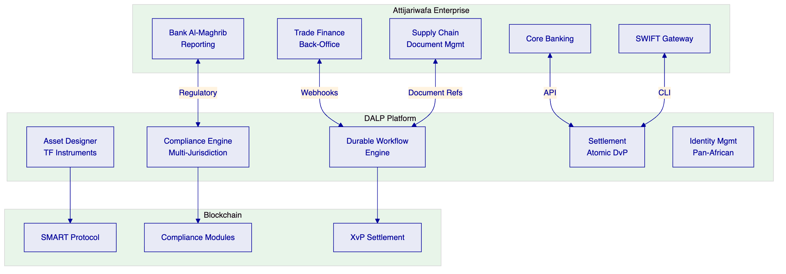

  - About SettleMint
    - Relevance to Attijariwafa Bank
Credential | Evidence
Trade finance | RBI Innovation Hub: multi-bank LC processing
African market | Standard Chartered: Africa exposure; IsDB: African nations
Islamic finance | IsDB: Sharia-compliant distribution across 57 countries
Institutional scale | 14 deployments, 7+ years production
Certifications | ISO 27001, SOC 2 Type II

  - About DALP
    - Supply-Chain Document Digitization
DALP's document digitization capability for trade finance:
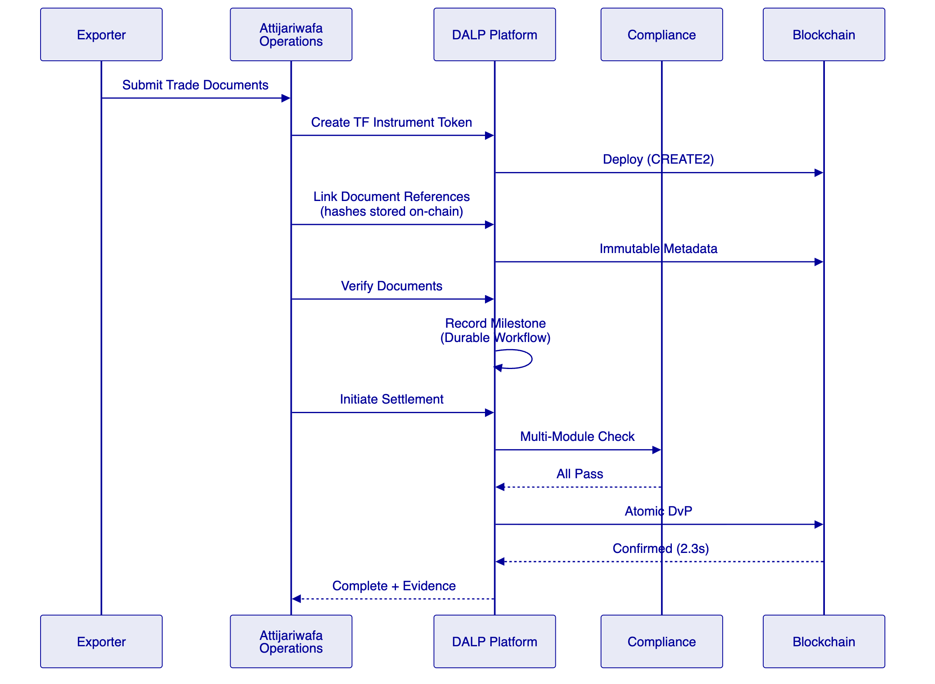
Document reference model:
- Document hashes stored on-chain as immutable metadata
- Document content remains in Attijariwafa's document management system
- Verification status recorded as workflow milestone with approver identity
- Any change to references produces an audit event
- Full lifecycle evidence preserved for regulatory examination
    - Core Capabilities
Durable Workflow Engine: Multi-step supply-chain workflows with deterministic completion, state persistence, timeout management, and escalation paths.
Configurable Tokens: DALPAsset with document metadata, counterparty restrictions, multi-party approvals, holding period enforcement.
On-chain Compliance: 18 modules. Identity verification, address allow lists, transfer approvals, timelocks. Fail-closed logic.
Atomic Settlement: XvP — both legs in single transaction, deterministic finality (2.3s median, 4.1s P99 under IBFT 2.0).

  - Understanding Attijariwafa's Programme Objectives
    - Client Context
Challenge 1: Pan-African trade complexity. Attijariwafa operates across 25+ African countries with different regulatory frameworks. The platform must support multi-jurisdiction compliance through configurable per-token module composition.
Challenge 2: Supply-chain document integrity. Paper-based trade documents create fraud risk, processing delays, and audit challenges. On-chain document references with immutable verification timestamps address these concerns.
Challenge 3: Cross-border settlement efficiency. Current cross-border trade settlement involves multiple intermediaries and T+3 to T+5 delays. Atomic DvP reduces this to under 3 seconds.
    - Regulatory Context: Morocco
Regulator | Requirements | DALP Coverage
Bank Al-Maghrib | Prudential controls, operational resilience | Multi-AZ, defense-in-depth
AMMC | Capital markets, financial instruments | Compliance modules, OnchainID
Morocco AML/CFT | Anti-money laundering | OnchainID with KYC claims
Morocco data protection | Data residency, privacy | Configurable deployment location

  - Customer References
Client | Trade Finance Relevance
RBI Innovation Hub | Multi-bank LC processing — direct match
Standard Chartered | Africa market exposure
IsDB | Pan-African, Sharia-compliant operations
Commerzbank | Regulated settlement, EUR 7M/year savings
Maybank Photon | Cross-border atomic settlement

  - Proposed Solution
    - Trade Finance Instrument Configuration
Features: Historical balances, timelock
Compliance modules: Identity verification, address allow list, transfer approval, timelock
    - Supply-Chain Workflow
Stage | DALP Component | Evidence
Document creation | Metadata linking | Hash on-chain
Document verification | Workflow milestone | Approver + timestamp
Counterparty approval | Transfer approval module | Multi-party
Compliance check | Compliance engine | 18 modules
Settlement | XvP | Atomic, 2.3s
Reconciliation | API integration | Webhook-driven

    - Functional Fit Matrix
Req | Summary | Status
REQ-01 | Segregated environments | Full
REQ-02 | API-first interfaces | Full
REQ-03 | RBAC, maker-checker | Full
REQ-04 | Configurable lifecycle | Full
REQ-05 | Dependency disclosure | Full
REQ-06 | Resilience, monitoring | Full
REQ-07 | Phased implementation | Full
REQ-08 | Audit evidence | Full
REQ-09 | Document-linked workflows | Full
REQ-10 | Core books reconciliation | Configurable
REQ-11 | Multi-entity limits | Configurable

  - Technical Architecture
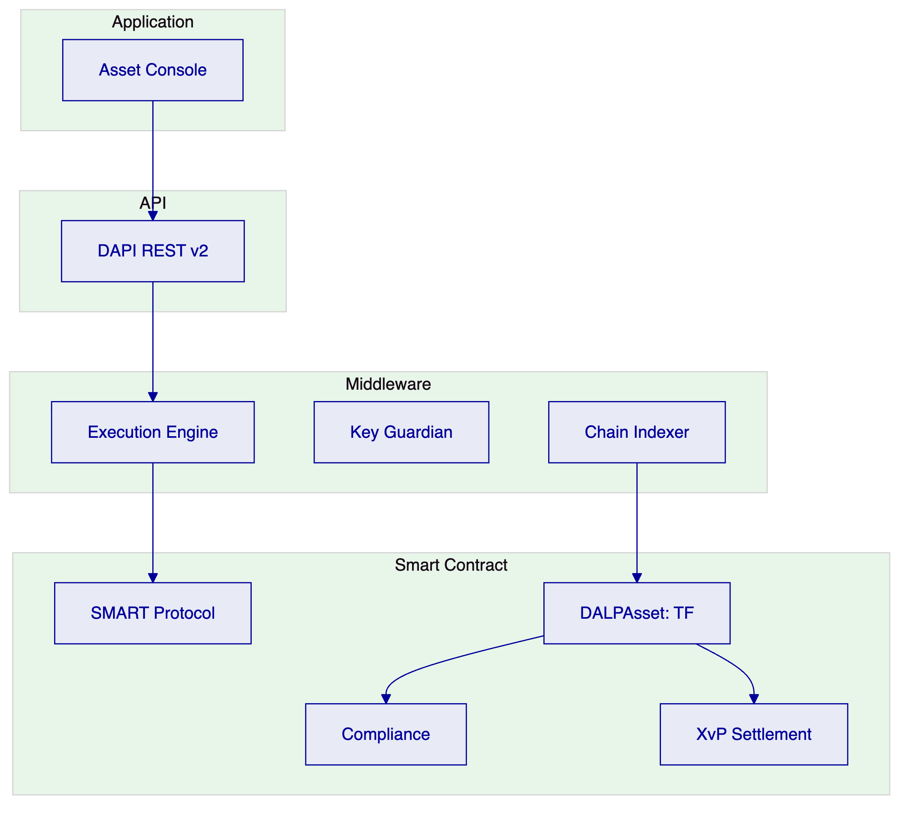
    - Security: 5-Layer Defense-in-Depth
- Authentication (passkeys, LDAP, OAuth)
- Authorization (26 roles)
- Wallet verification
- Compliance (18 modules)
- Custody policy
ISO 27001, SOC 2 Type II.

  - Implementation (19 Weeks)
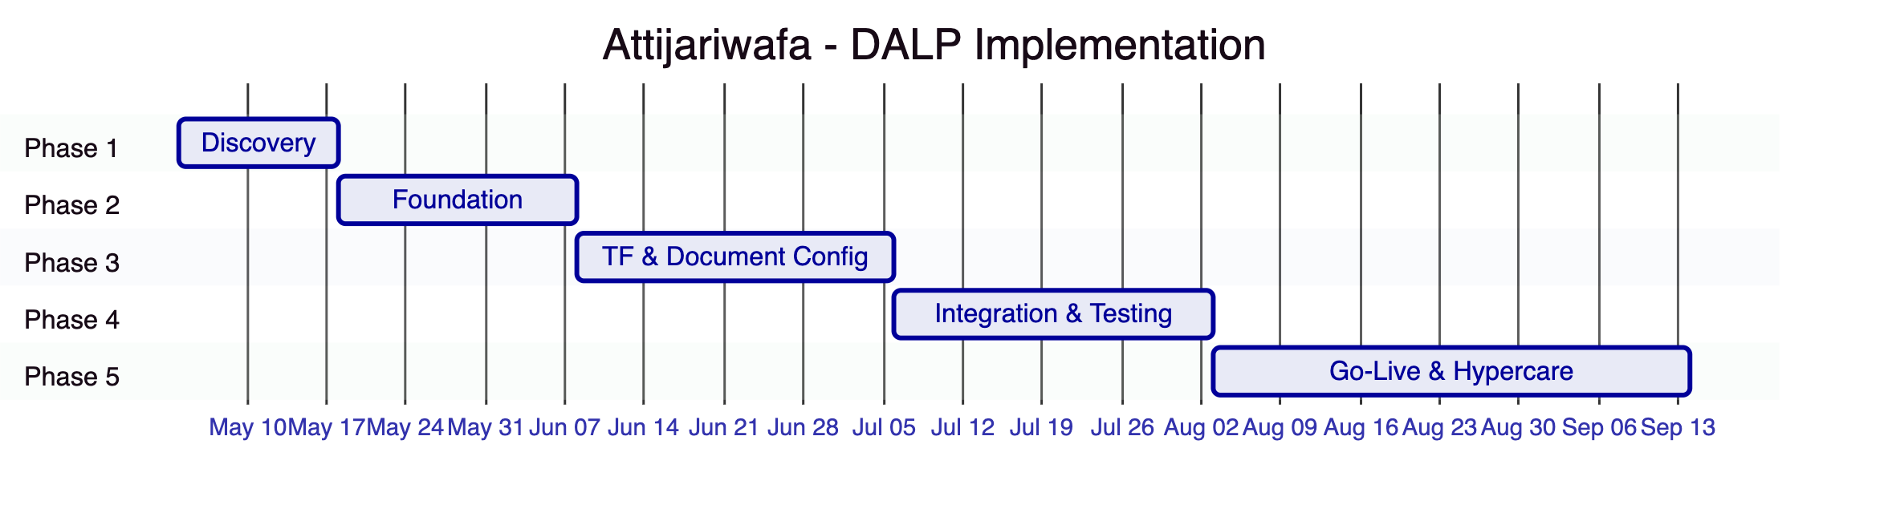
Estimated client effort: 75 person-days

  - Deployment
Aspect | Configuration
Model | Dedicated cloud
Region | AWS Europe (Paris) or Azure France
Data residency | Morocco/EU compliant
Blockchain | 4-node Besu (IBFT 2.0)

  - Support: Premium
Aspect | Configuration
Coverage | 16×5
P1 response | 2 hours
Uptime SLA | 99.95%

  - Risk Register
ID | Risk | Mitigation
R1 | BAM regulatory changes | Configurable compliance
R2 | Pan-African integration complexity | Phased rollout by country
R3 | Document management integration | Phase 1 discovery
R4 | Cross-border data residency | Configurable deployment

  - Appendices
    - Glossary
Term | Definition
DALP | Digital Asset Lifecycle Platform
SMART Protocol | ERC-3643 implementation
DALPAsset | Configurable token contract
OnchainID | On-chain identity (ERC-734/735)
XvP | Atomic settlement addon

