[Company name]
[Document title]
[Document subtitle]

Confidentiality Statement
This document contains confidential and proprietary information of SettleMint. By reading this document, you agree not to disclose the confidential information contained herein to any third party without the prior written consent of SettleMint, except to those agents, principals, representatives, or consultants who require access for the purpose of evaluating this document. You further agree to inform such persons of the confidential nature of this document and to obtain their agreement to preserve its confidentiality to the same extent as yours.
This confidentiality statement shall remain binding on the parties for a period of five (5) years from the date stated on the front cover, unless superseded by confidentiality provisions detailed in a subsequent agreement.
Terms and Conditions
This proposal is valid until [DD Month YYYY]. In the absence of confirmation to proceed, SettleMint and [the Company] acknowledge and agree to abide by the Mutual NDA as the governing agreement.
SettleMint reserves the right to vary the terms of this proposal in response to changes in specifications or information made available at a later date. Submission of this proposal does not convey any right, title, interest, or license in any intellectual property rights (including, but not limited to, patents, copyrights, trade secrets, or trademarks) contained herein.
All rights are reserved. This proposal and the information contained within it are provided on an “as is” basis, without any warranties of any kind, express or implied.
All contracts with SettleMint will be governed by Belgian Law and subject to the exclusive jurisdiction of Belgian courts.
Contact Details
For any enquiries regarding this document, please contact:
[Full Name]
[Job Title]
Email: [email@example.com]
Phone: [Country Code - Number]

Table of Contents

Table of Contents
Executive Summary
Understanding BNP Paribas's Programme Objectives
The Fund Distribution Challenge
Proposed DALP Operating Model for Tokenized Funds
Fund Lifecycle Coverage
Fund Configuration Parameters
Technical Architecture and Integration Boundaries
Enterprise Integration for BNP Paribas
NAV Feed Integration
Identity, Compliance, and MiCA/UCITS Controls
Multi-Jurisdiction Fund Compliance
Investor Classification
Distribution, NAV Processing, and Lifecycle Management
Subscription and Redemption Workflow
Distribution Processing
Security, Resilience, and Operational Assurance
Implementation Approach and Delivery Phases
19-Week Implementation
Current Coverage, Dependencies, and Qualified Gaps
Coverage Summary
Qualified Gaps
Relevant Delivery Evidence
KBC Securities — Fund-Like Operations
Appendices
Appendix A: Glossary

Field | Value
Proposal title | Technical Proposal — Tokenized Funds Distribution Platform
Client | BNP Paribas
Submitted by | SettleMint NV
Date | March 2026
Version | v1.0
Confidentiality | Restricted
RFP Reference | BNP-PARIBAS-RFP-TOKENIZED-FUNDS-202603
Primary contact | Adam Popat, CEO

  - Table of Contents
- Executive Summary
- Understanding BNP Paribas's Programme Objectives
- Proposed DALP Operating Model for Tokenized Funds
- Technical Architecture and Integration Boundaries
- Fund-Specific Smart Contract Architecture
- Identity, Compliance, and MiCA/UCITS Controls
- Distribution, NAV Processing, and Lifecycle Management
- Security, Resilience, and Operational Assurance
- Implementation Approach and Delivery Phases
- Current Coverage, Dependencies, and Qualified Gaps
- Relevant Delivery Evidence
- Appendices

  - Executive Summary
BNP Paribas has identified tokenized fund distribution as a strategic capability for transforming its asset servicing and fund administration operations. As the world's largest custodian by assets under custody and a leading fund administrator, BNP Paribas is uniquely positioned to define how tokenized funds are distributed, settled, and serviced across European and global markets.
SettleMint's Digital Asset Lifecycle Platform (DALP) provides the infrastructure for the complete fund tokenization lifecycle — from fund unit creation and distribution through NAV-based subscription and redemption, transfer agent automation, and regulatory reporting — with MiCA compliance and UCITS/AIFMD fund governance controls embedded at the smart contract level.
Why DALP fits BNP Paribas's requirements:
- Full fund lifecycle coverage. DALP manages fund unit issuance, subscription processing, redemption handling, distribution payments, corporate actions, and fund closure through configurable smart contracts. The Fund asset class in DALPAsset supports NAV-based pricing, subscription windows, redemption queues, and transfer restrictions — all configurable without custom development.
- Transfer agent automation. DALP's configurable compliance modules and approval workflows can automate core transfer agent functions: investor eligibility verification, subscription/redemption processing, register maintenance, and distribution calculations. This reduces manual processing while maintaining the audit trails required by fund administrators.
- MiCA and UCITS compliance. DALP's compliance engine supports MiCA token classification, UCITS distribution rules, AIFMD investor eligibility restrictions, and cross-border fund passport requirements. Compliance modules enforce these rules at the smart contract level, ensuring that every fund unit transfer complies with the applicable regulatory framework.
- Production reference in fund operations. KBC Securities (Bolero Crowdfunding) deployed DALP for equity crowdfunding with corporate actions, lifecycle events, and fiat-backed token settlement — demonstrating DALP's capability to handle fund-like operations including subscription, distribution, and redemption workflows.
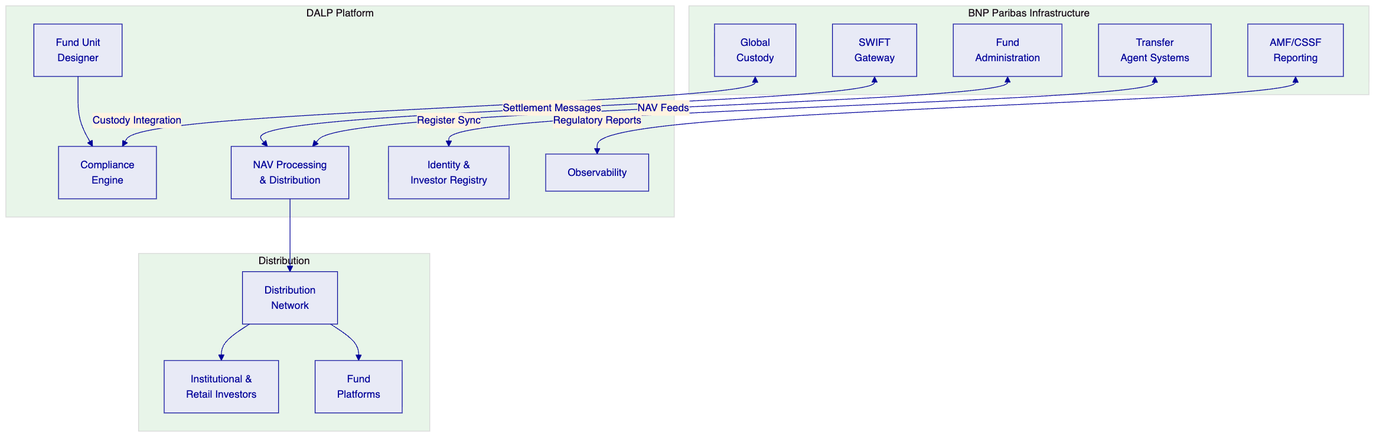

  - Understanding BNP Paribas's Programme Objectives
    - The Fund Distribution Challenge
Traditional fund distribution involves multiple intermediaries — transfer agents, fund administrators, distributors, custodians, and settlement systems — each maintaining separate records that require constant reconciliation. A single subscription or redemption can take T+1 to T+3 to settle, with manual processing at multiple points in the chain.
Tokenized fund distribution collapses this intermediary chain. Fund units represented as tokens on a single ledger eliminate the reconciliation burden, enable T+0 or T+1 settlement, and provide real-time visibility into the investor register for all authorized parties.
BNP Paribas's programme objectives:
First, distribution efficiency. Reduce the cost and time of fund distribution by automating subscription, redemption, and transfer processing through smart contracts while maintaining regulatory compliance across jurisdictions.
Second, register accuracy. Provide a single source of truth for fund unit ownership, eliminating reconciliation between transfer agents, custodians, and distributors.
Third, cross-border scalability. Support fund distribution across multiple EU jurisdictions under MiCA, UCITS, and AIFMD frameworks, with the ability to extend to non-EU markets.
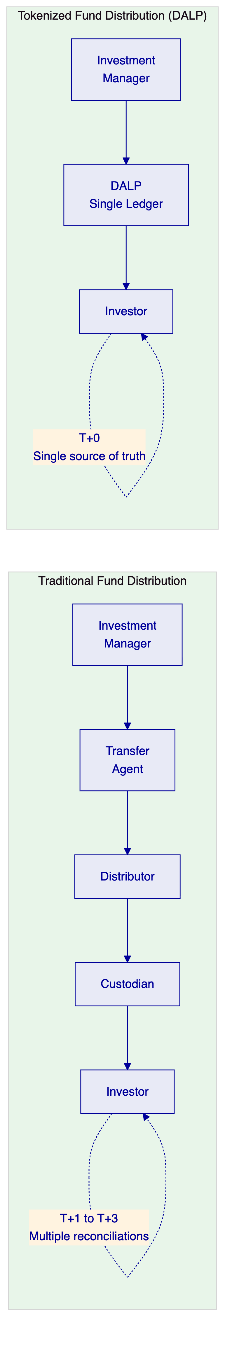

  - Proposed DALP Operating Model for Tokenized Funds
    - Fund Lifecycle Coverage
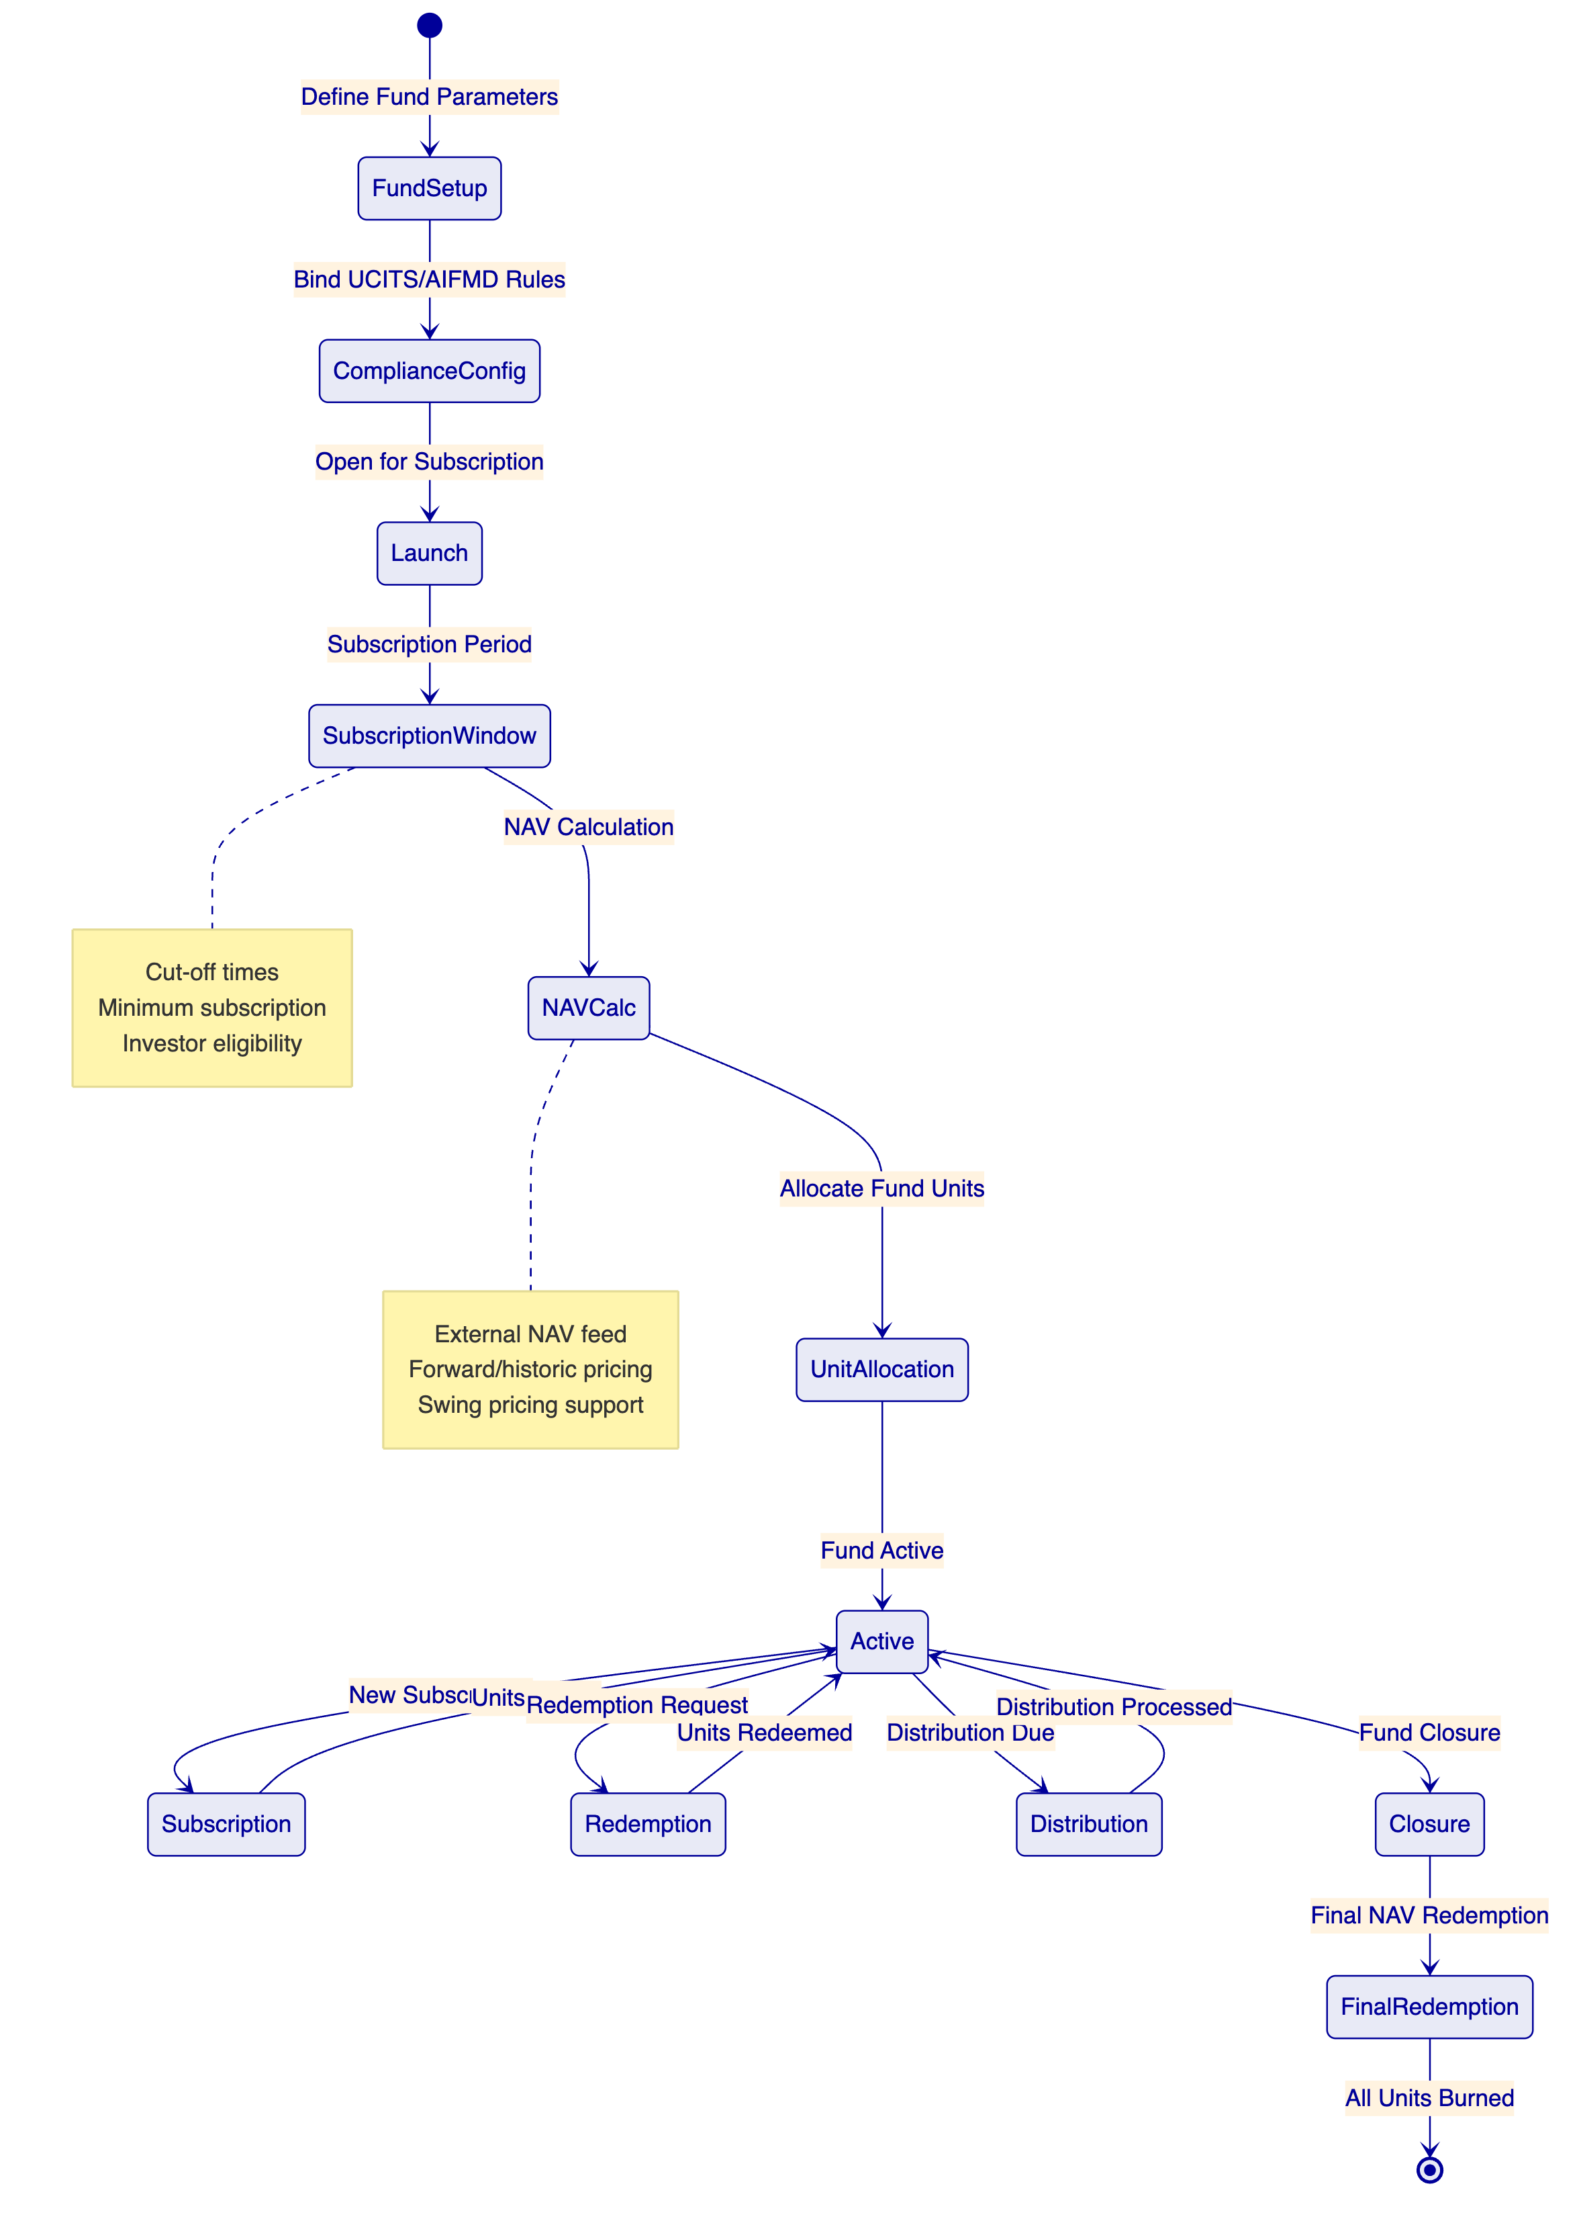
    - Fund Configuration Parameters
Parameter | Description | DALP Configuration
Fund type | UCITS, AIFM, money market, ETF | Compliance module binding
NAV pricing | Forward, historic, dual pricing | Feeds System integration
Subscription cut-off | Daily, weekly, monthly | Configurable schedule
Redemption notice | T+0 to T+5 | Time Lock module
Minimum subscription | Per investor class | Supply limit module
Distribution policy | Accumulating or distributing | Yield feature
Swing pricing | Anti-dilution mechanism | Fee feature configuration
Transfer restrictions | Lock-up periods, qualified investor only | Compliance modules

  - Technical Architecture and Integration Boundaries
    - Enterprise Integration for BNP Paribas
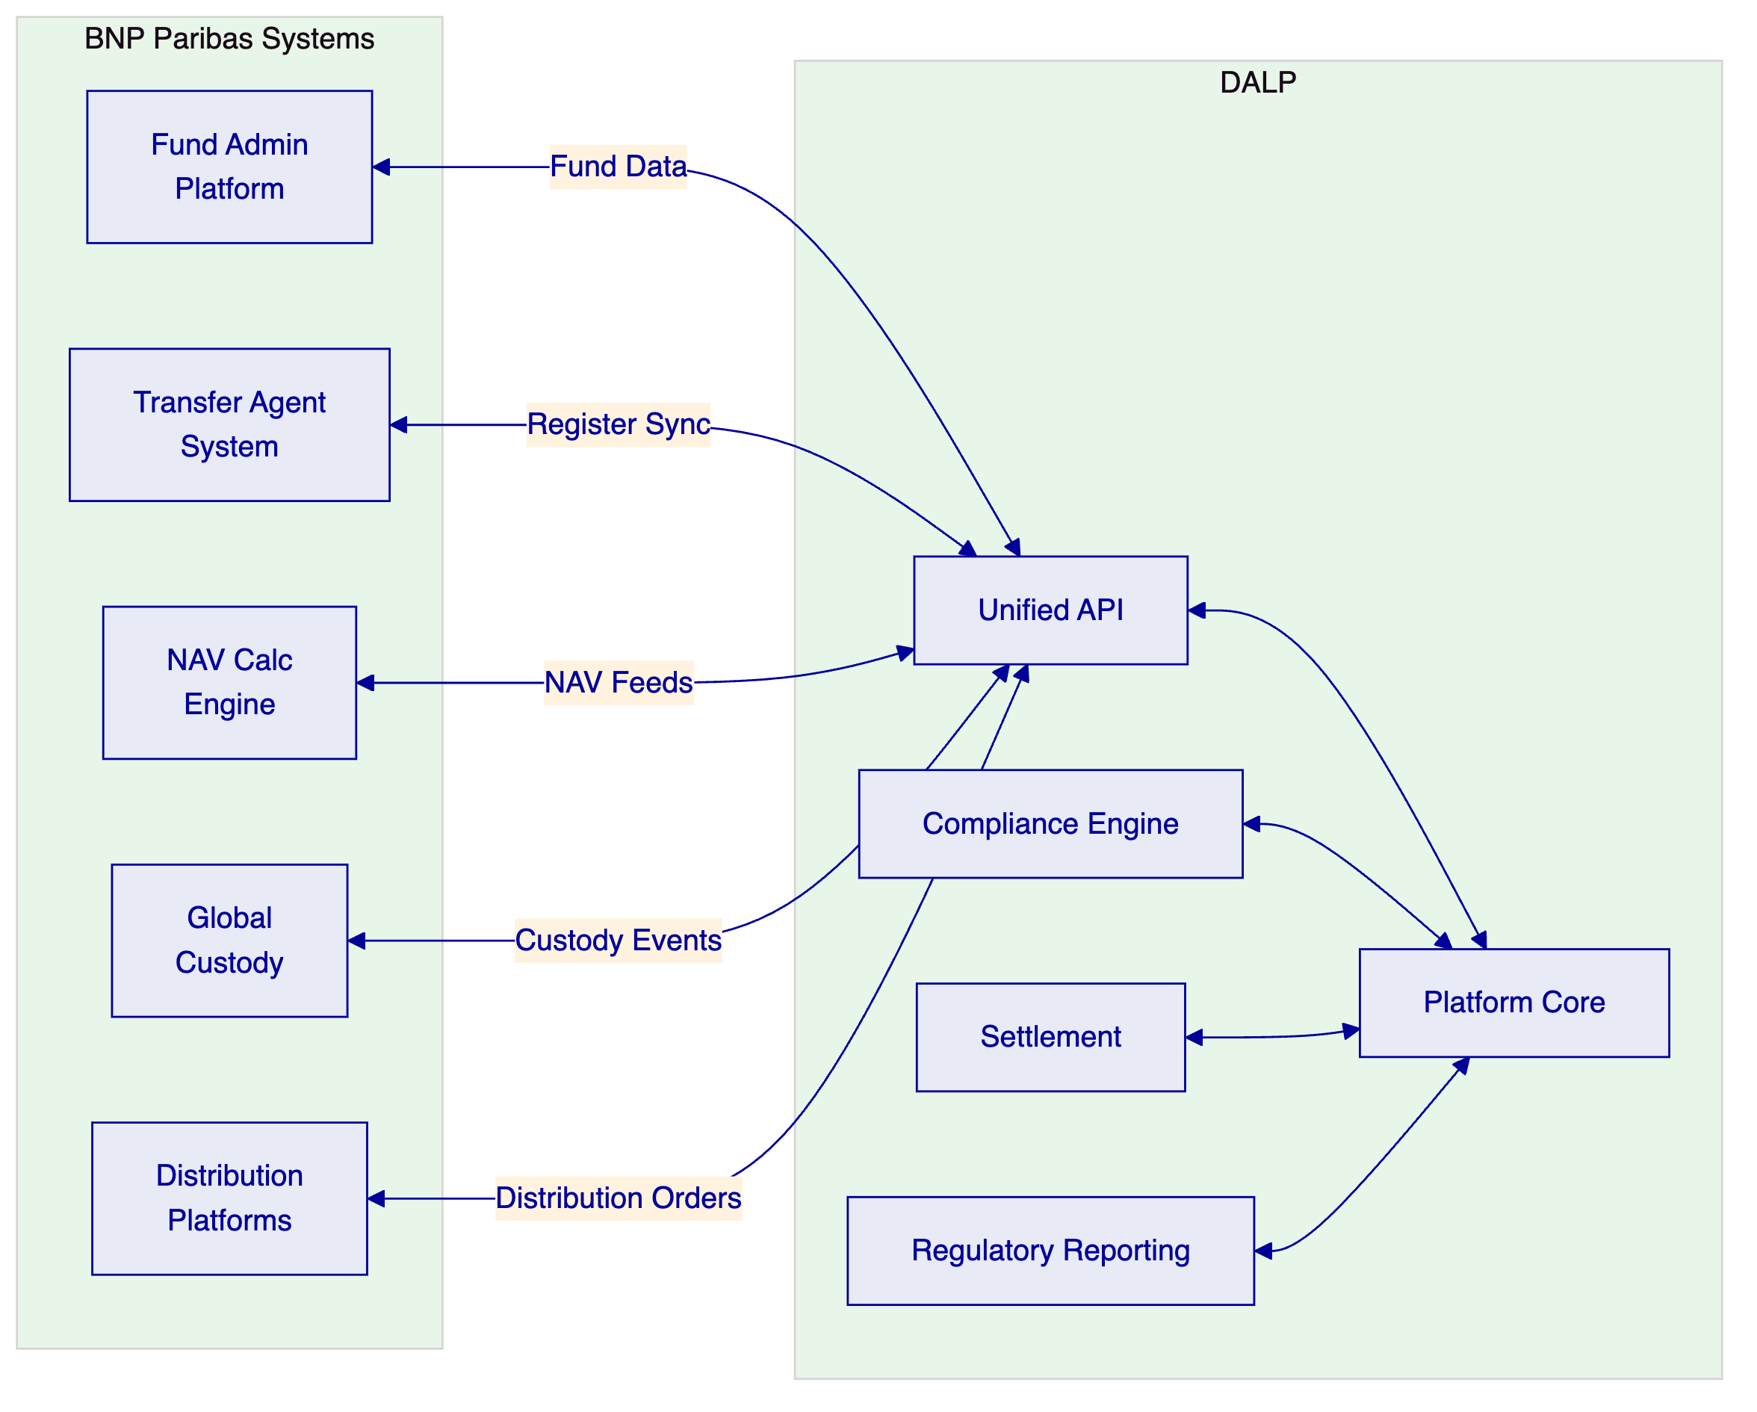
    - NAV Feed Integration
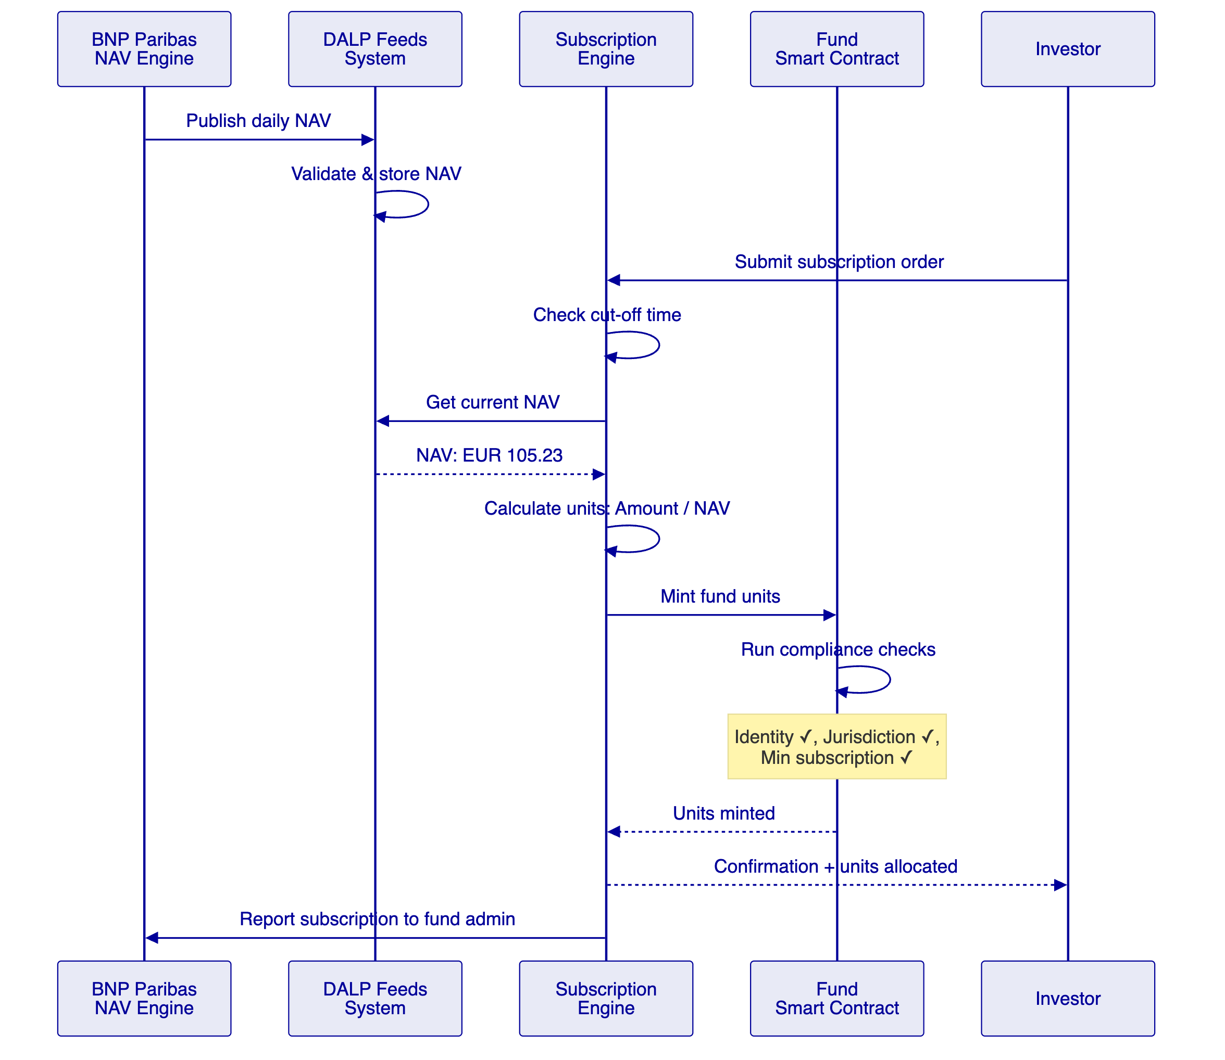

  - Identity, Compliance, and MiCA/UCITS Controls
    - Multi-Jurisdiction Fund Compliance
Framework | Requirement | DALP Module
UCITS | Investor eligibility per share class | Investor Accreditation + Country Allow List
AIFMD | Professional investor restriction | Investor Accreditation module
MiCA | Token classification, disclosure | Asset metadata + compliance modules
MiFID II | Distribution suitability | Transfer Approval (distributor attestation)
GDPR | Investor data protection | On-chain pseudonymity + off-chain PII
PRIIPS | KID documentation | Metadata fields with document references
    - Investor Classification
Investor Class | UCITS | AIFM | Compliance Module
Retail | Permitted | Restricted | Identity Verification + Country Allow List
Professional | Permitted | Permitted | Investor Accreditation
Institutional | Permitted | Permitted | Investor Accreditation + enhanced KYC
Qualified | Permitted | Permitted | Full accreditation + Transfer Approval

  - Distribution, NAV Processing, and Lifecycle Management
    - Subscription and Redemption Workflow
DALP automates subscription and redemption processing:
- Subscription: Investor submits order → cut-off check → NAV feed → unit calculation → compliance verification → mint units → confirmation
- Redemption: Investor submits request → notice period check → NAV feed → unit calculation → compliance check → burn units → payment instruction → confirmation
    - Distribution Processing
Distribution Type | Mechanism | DALP Feature
Income distribution | Proportional to holdings at record date | Yield feature + historical balance snapshots
Capital gains | Per fund accounting rules | Configurable distribution calculation
Reinvestment | Automatic subscription at NAV | Minting at distribution NAV
Accumulation | NAV adjustment (no distribution) | Metadata update only

  - Security, Resilience, and Operational Assurance
Control | Implementation
Certifications | ISO 27001, SOC 2 Type II
Authentication | MFA, passkeys, LDAP/AD, OAuth 2.0
Key management | HSM integration, multi-signature
RPO / RTO | < 1 hour / < 4 hours
Monitoring | Three-pillar observability
GDPR compliance | EU-resident deployment, data minimization

  - Implementation Approach and Delivery Phases
    - 19-Week Implementation
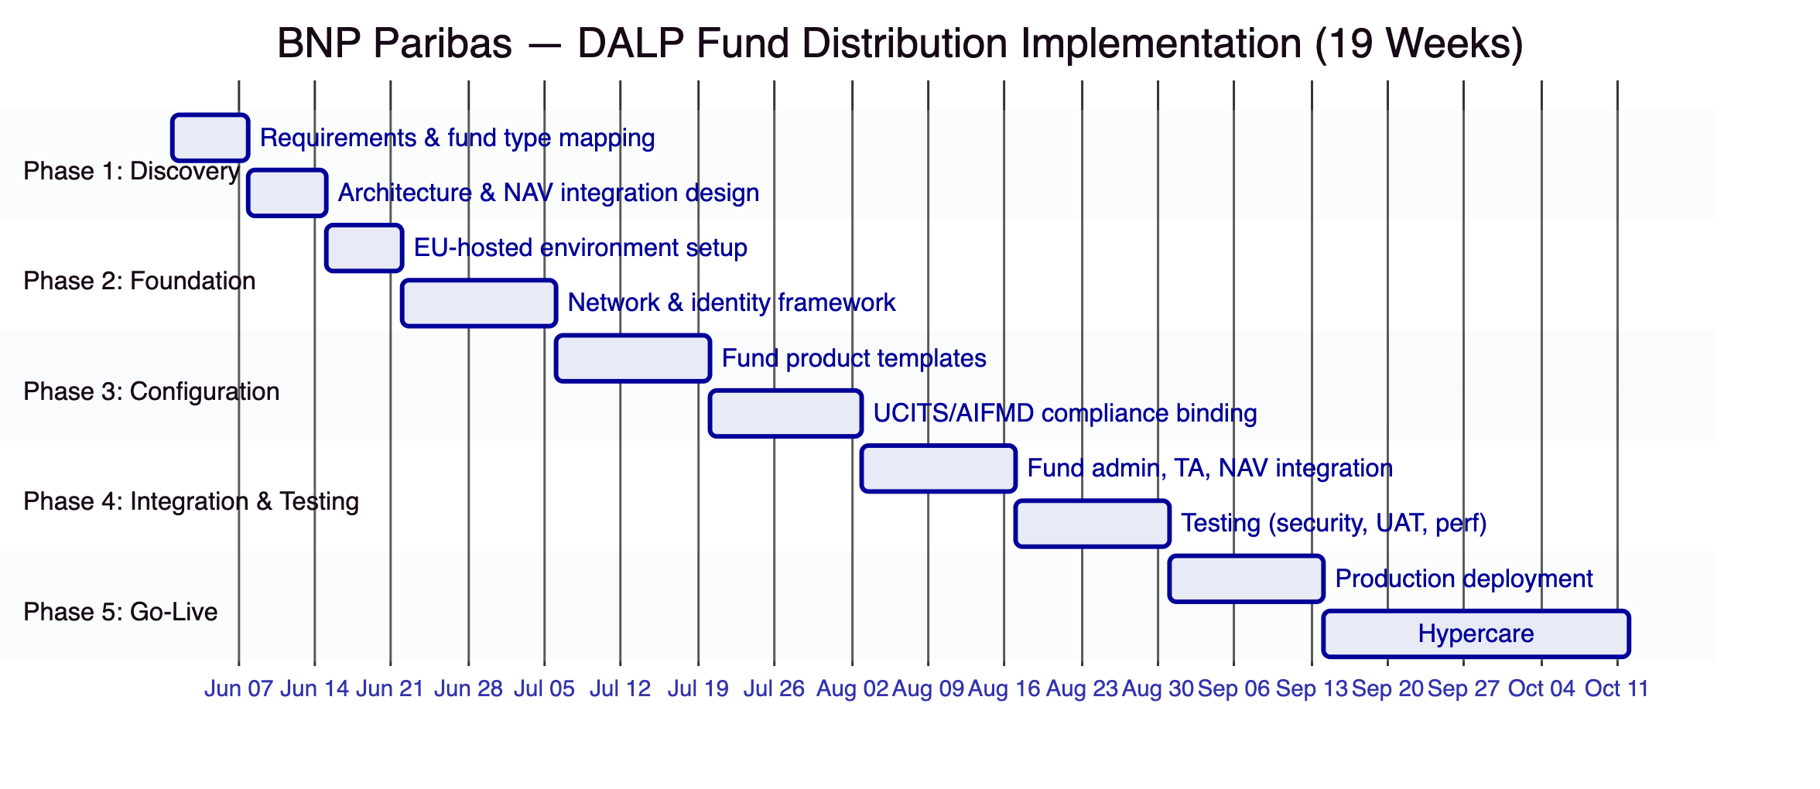

  - Current Coverage, Dependencies, and Qualified Gaps
    - Coverage Summary
Requirement | Status | Notes
Fund unit tokenization | Full | Fund asset class in DALPAsset
Subscription/redemption | Full | Configurable workflows
NAV-based pricing | Full | Feeds System integration
Distribution processing | Full | Yield feature + historical snapshots
Transfer restrictions | Full | Compliance modules
UCITS compliance | Full | Investor eligibility, jurisdiction controls
MiCA compliance | Full | Token classification, disclosure
Transfer agent automation | Partial | Core TA functions automated; full TA replacement requires additional configuration
Swing pricing | Partial | Fee feature supports anti-dilution; specific swing pricing formula requires configuration
FundSettle/Euroclear integration | Planned | Integration architecture defined; requires joint development
    - Qualified Gaps
Full transfer agent replacement — Partial. DALP automates core TA functions (register maintenance, subscription/redemption processing, distribution calculations). Complete TA replacement including regulatory reporting, tax reclaim processing, and multi-currency settlement requires additional configuration and integration work estimated at 4 weeks beyond standard implementation.
FundSettle/Euroclear integration — Planned. Direct integration with Euroclear's FundSettle platform requires joint development. DALP provides the API surface and settlement instruction format; FundSettle connectivity requires BNP Paribas's existing CSD relationship and technical coordination. Timeline: achievable during implementation Phase 4.

  - Relevant Delivery Evidence
Client | Region | Relevance
KBC Securities (Bolero) | Belgium | Direct — equity crowdfunding, corporate actions, fiat-backed tokens
OCBC Bank | Singapore | Securities tokenization, wealth products
Commerzbank | Germany | Hybrid on/off-chain issuance, exchange listing
Standard Chartered Bank | Multi-region | Multi-jurisdiction securities
SIX Digital Exchange | Switzerland | Tokenized fund distribution reference
    - KBC Securities — Fund-Like Operations
KBC Securities deployed DALP for Bolero Crowdfunding:
- Equity and SME loan tokenization
- Corporate actions processing (dividends, lifecycle events)
- Fiat-backed stable token for settlement
- Complete lifecycle from issuance through redemption
- Regulatory-compliant under Belgian securities law
- Demonstrates subscription, distribution, and redemption workflows

  - Appendices
    - Appendix A: Glossary
Term | Definition
DALP | Digital Asset Lifecycle Platform
UCITS | Undertakings for Collective Investment in Transferable Securities
AIFMD | Alternative Investment Fund Managers Directive
MiCA | Markets in Crypto-Assets Regulation
MiFID II | Markets in Financial Instruments Directive II
NAV | Net Asset Value
KID | Key Information Document (PRIIPS)
TA | Transfer Agent
DALPAsset | Configurable token contract
OnchainID | On-chain identity standard (ERC-734/735)
XvP | Exchange versus Payment
AMF | Autorité des marchés financiers (France)
CSSF | Commission de Surveillance du Secteur Financier (Luxembourg)

