[Company name]
[Document title]
[Document subtitle]

Confidentiality Statement
This document contains confidential and proprietary information of SettleMint. By reading this document, you agree not to disclose the confidential information contained herein to any third party without the prior written consent of SettleMint, except to those agents, principals, representatives, or consultants who require access for the purpose of evaluating this document. You further agree to inform such persons of the confidential nature of this document and to obtain their agreement to preserve its confidentiality to the same extent as yours.
This confidentiality statement shall remain binding on the parties for a period of five (5) years from the date stated on the front cover, unless superseded by confidentiality provisions detailed in a subsequent agreement.
Terms and Conditions
This proposal is valid until [DD Month YYYY]. In the absence of confirmation to proceed, SettleMint and [the Company] acknowledge and agree to abide by the Mutual NDA as the governing agreement.
SettleMint reserves the right to vary the terms of this proposal in response to changes in specifications or information made available at a later date. Submission of this proposal does not convey any right, title, interest, or license in any intellectual property rights (including, but not limited to, patents, copyrights, trade secrets, or trademarks) contained herein.
All rights are reserved. This proposal and the information contained within it are provided on an “as is” basis, without any warranties of any kind, express or implied.
All contracts with SettleMint will be governed by Belgian Law and subject to the exclusive jurisdiction of Belgian courts.
Contact Details
For any enquiries regarding this document, please contact:
[Full Name]
[Job Title]
Email: [email@example.com]
Phone: [Country Code - Number]

Table of Contents

Table of Contents
Executive Summary
Understanding the Central Bank of UAE's Programme Objectives
The Digital Dirham Vision
Sovereign-Grade Requirements
Technical Architecture for CBDC Operations
Four-Layer Architecture Adapted for CBDC
Network Architecture
Deployment for UAE
Token Architecture for Digital Dirham
Digital Dirham Token Design
Two-Tier Distribution Model
Identity, Compliance, and Regulatory Controls
Multi-Tier Identity Model
AML/CFT Integration
Distribution, Settlement, and Interoperability
Cross-Border Settlement
Wholesale Settlement
Security, Resilience, and Sovereign-Grade Assurance
Security for Sovereign Infrastructure
Operational Resilience
Implementation Approach and Delivery Phases
Phased Implementation
Current Coverage, Dependencies, and Qualified Gaps
Coverage Summary
Qualified Gaps
Relevant Delivery Evidence
State Bank of India — CBDC at National Scale
Appendices
Appendix A: Glossary

Field | Value
Proposal title | Technical Proposal — CBDC and Digital Dirham Enabling Infrastructure
Client | Central Bank of UAE
Submitted by | SettleMint NV
Date | March 2026
Version | v1.0
Confidentiality | Restricted
RFP Reference | CENTRAL-BANK-OF-UAE-RFP-CBDC-DIGITAL-DIRHAM-INFRASTRUCTURE-202603
Primary contact | Adam Popat, CEO

  - Table of Contents
- Executive Summary
- Understanding the Central Bank of UAE's Programme Objectives
- Proposed DALP Operating Model for Digital Dirham Infrastructure
- Technical Architecture for CBDC Operations
- Token Architecture for Digital Dirham
- Identity, Compliance, and Regulatory Controls
- Distribution, Settlement, and Interoperability
- Security, Resilience, and Sovereign-Grade Assurance
- Implementation Approach and Delivery Phases
- Current Coverage, Dependencies, and Qualified Gaps
- Relevant Delivery Evidence
- Appendices

  - Executive Summary
The Central Bank of UAE (CBUAE) has identified CBDC and Digital Dirham enabling infrastructure as a sovereign-critical capability. This procurement will determine whether the market can supply a platform and implementation model capable of supporting a national digital currency at the transaction volumes, security requirements, and governance standards expected of sovereign monetary infrastructure.
SettleMint's Digital Asset Lifecycle Platform (DALP) directly addresses this requirement. DALP provides the token issuance, distribution, compliance enforcement, and lifecycle management infrastructure required for a production-grade CBDC — with the identity controls, regulatory transparency, and operational resilience that sovereign implementations demand.
Why DALP is suited for the Digital Dirham programme:
- Proven CBDC delivery. DALP powers the State Bank of India's e-Rupee (eR) CBDC infrastructure — designed for over one billion projected daily transactions. The pilot phase is complete and production deployment is underway. This is the most directly relevant reference for the CBUAE's Digital Dirham programme.
- Sovereign-scale architecture. DALP's four-layer architecture separates the token logic, compliance enforcement, middleware orchestration, and application interfaces into independently scalable layers. The platform has been deployed at country scale for Saudi Arabia's Real Estate Registry, processing live production transactions since January 2026.
- Compliance-embedded design. DALP's compliance engine enforces KYC/AML verification, jurisdiction controls, transaction limits, and regulatory reporting at the smart contract level. For a CBDC, this means every digital dirham transaction carries its compliance context — identity verification, sanctions screening integration, and transaction monitoring hooks — as structural properties of the currency, not application-layer overlays.
- Cross-border interoperability. DALP supports multi-network deployment and cross-chain settlement. For the CBUAE's cross-border ambitions — building on Project Aber with Saudi Arabia and mBridge with HKMA, BIS, and others — the platform provides the interoperability layer required for cross-border CBDC settlement.
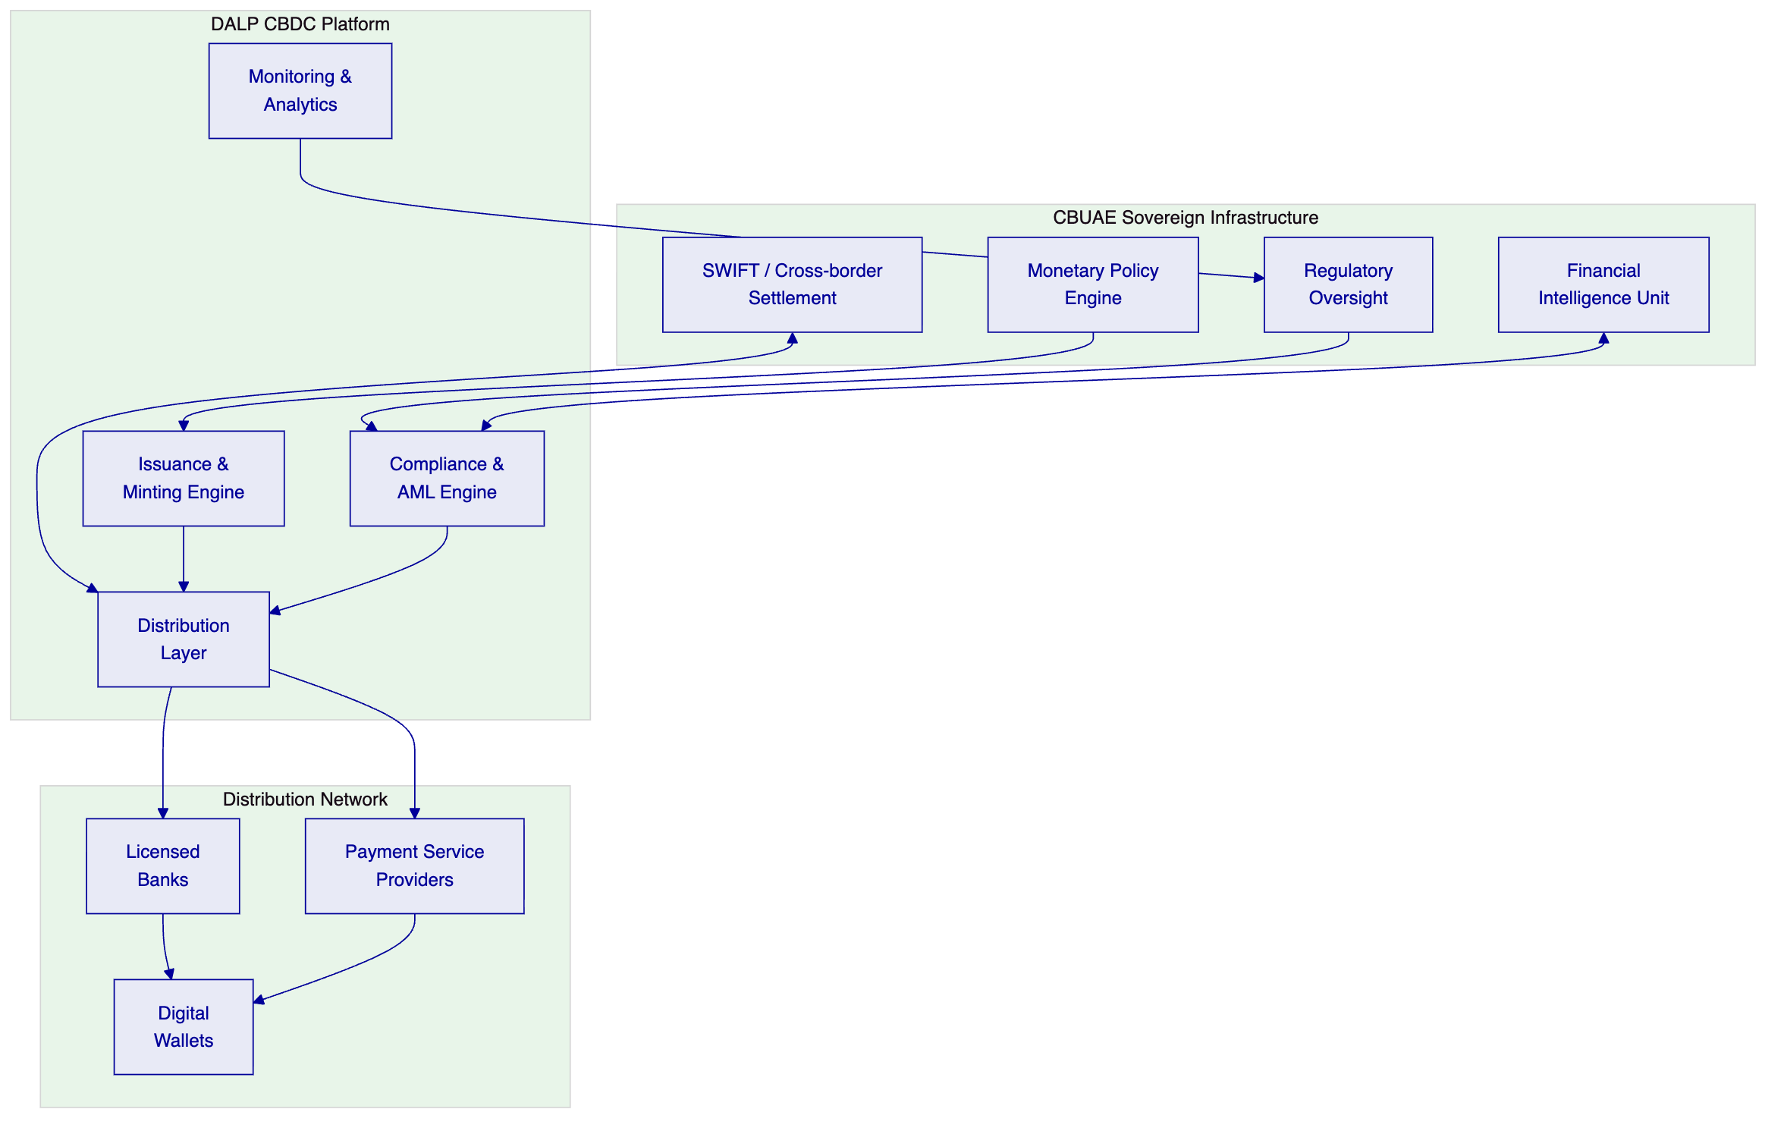

  - Understanding the Central Bank of UAE's Programme Objectives
    - The Digital Dirham Vision
The CBUAE's Digital Dirham programme represents the UAE's commitment to sovereign digital currency infrastructure. Building on Project Aber (cross-border CBDC with Saudi Arabia) and participation in mBridge (multi-CBDC platform with HKMA, Bank of Thailand, and People's Bank of China via BIS), the CBUAE requires infrastructure that supports:
- Wholesale CBDC for interbank settlement with deterministic finality
- Retail CBDC for consumer and merchant payments with offline capability considerations
- Cross-border settlement building on Project Aber and mBridge architecture
- Programmable money for government disbursements, subsidy distribution, and conditional payments
    - Sovereign-Grade Requirements
A CBDC platform for the CBUAE must meet requirements fundamentally different from commercial tokenization:
- Monetary sovereignty: The CBUAE must retain absolute control over issuance, supply management, and monetary policy enforcement
- Universal accessibility: The infrastructure must support the entire UAE financial ecosystem — banks, payment providers, merchants, and consumers
- Regulatory transparency: Every transaction must be available for regulatory review while preserving appropriate privacy boundaries
- Resilience at national scale: The platform must operate with the same availability expectations as core national payment infrastructure
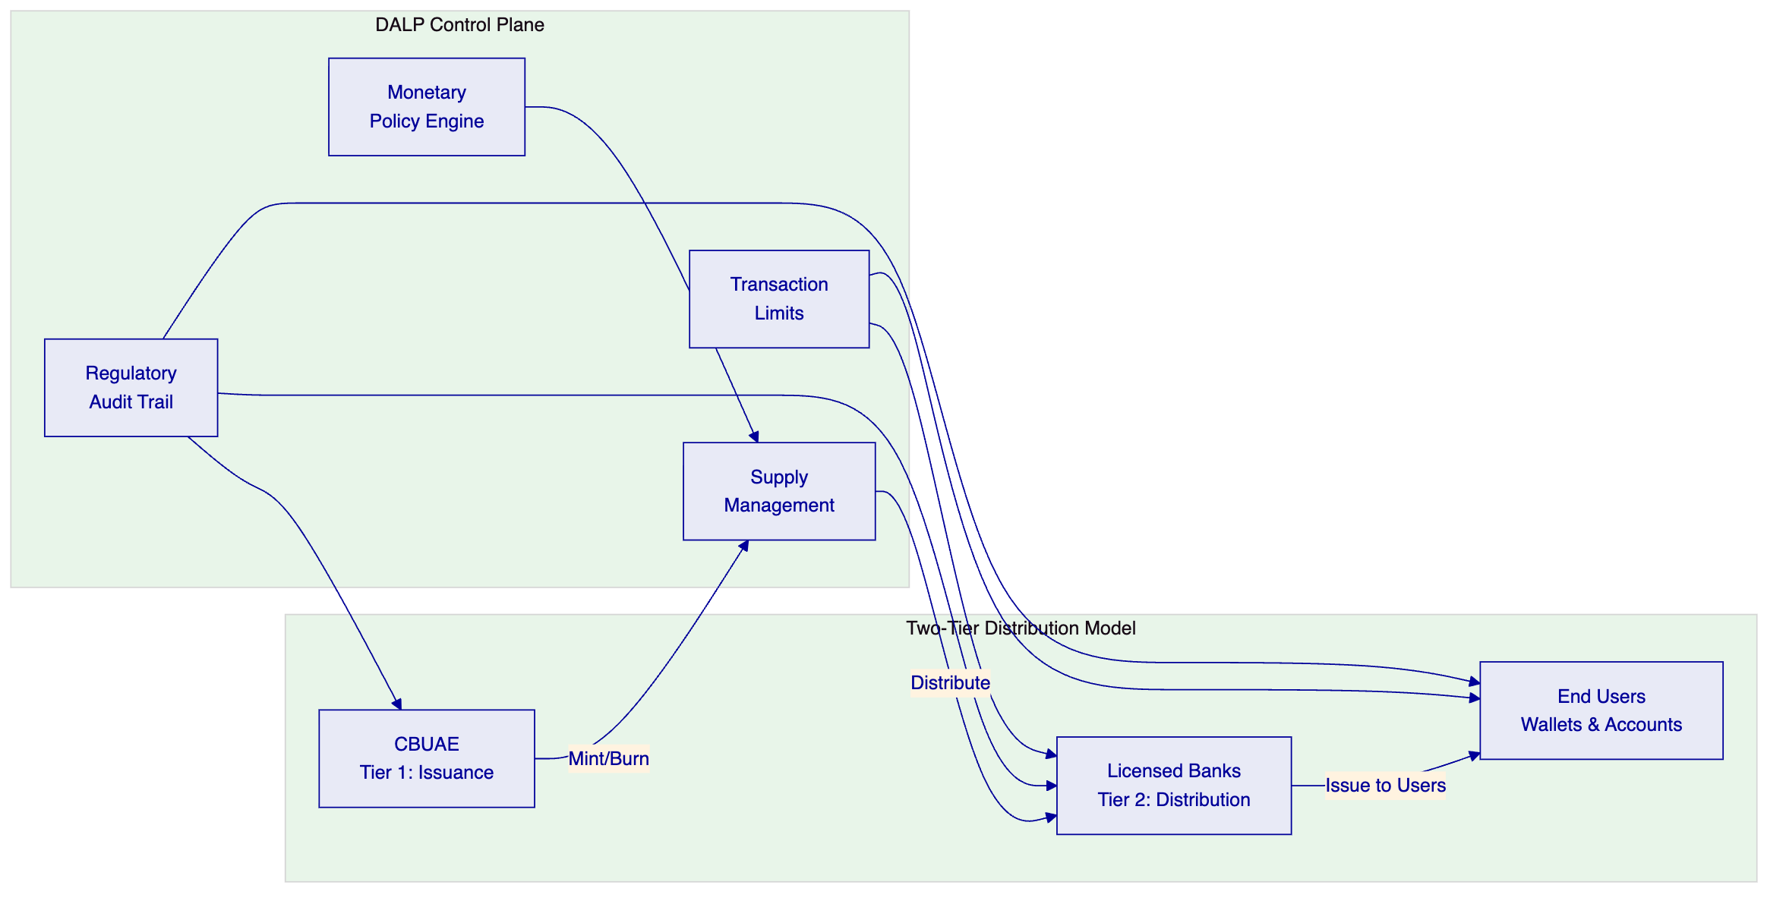

  - Technical Architecture for CBDC Operations
    - Four-Layer Architecture Adapted for CBDC
DALP's architecture is adapted for CBDC requirements with emphasis on sovereign control, high-throughput transaction processing, and multi-tier distribution:
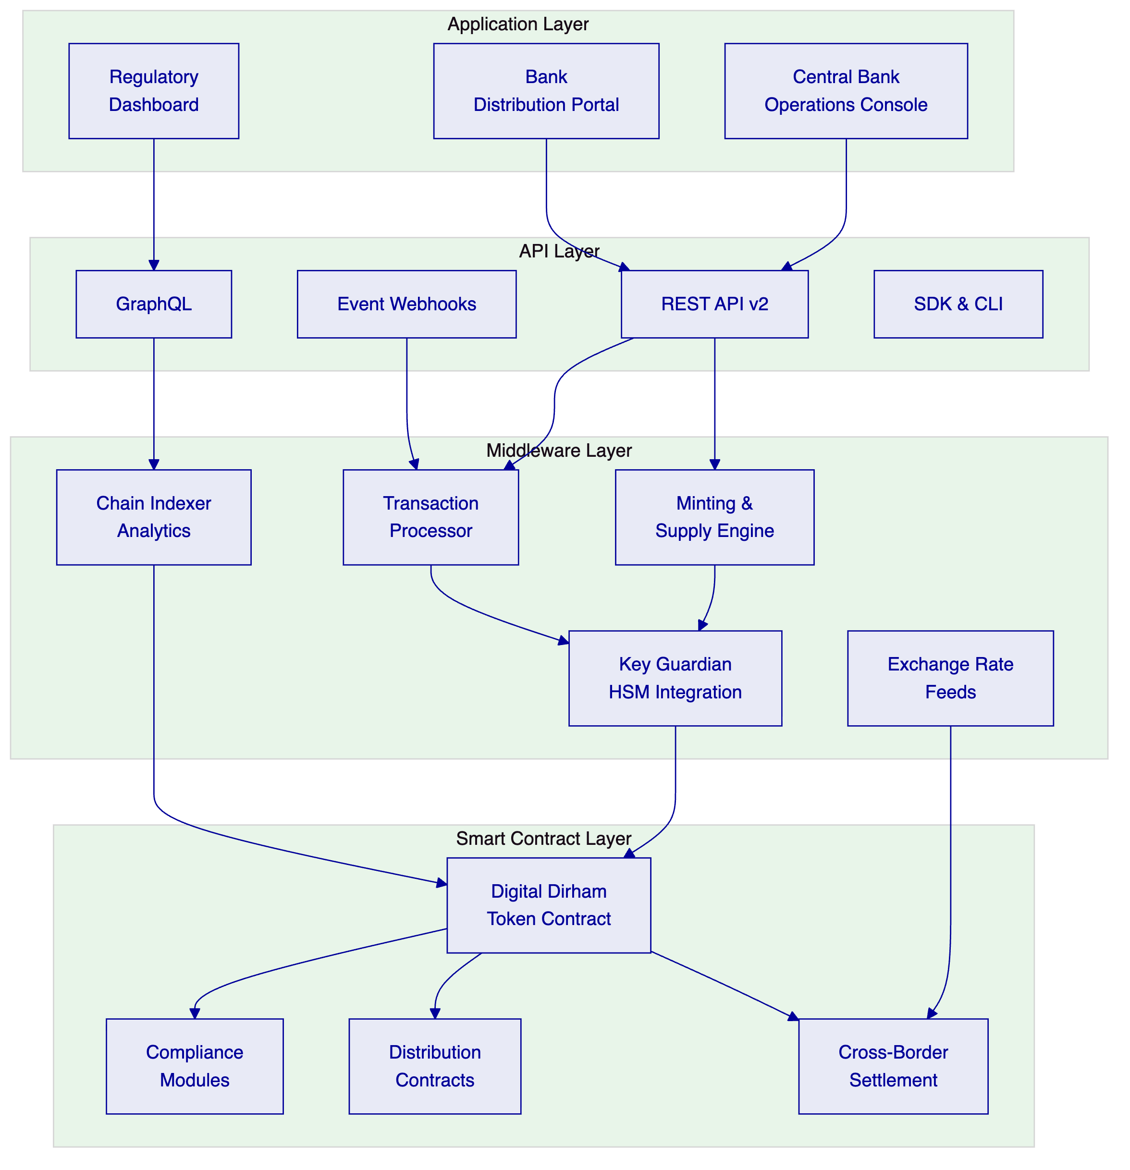
    - Network Architecture
For the CBUAE, we recommend a permissioned Hyperledger Besu network with IBFT 2.0 consensus:
Component | Configuration | Rationale
Consensus | IBFT 2.0 (Istanbul BFT) | Deterministic finality, regulatory-compliant
Validator nodes | Operated by CBUAE + selected licensed banks | Sovereign control over network governance
Transaction privacy | Private transaction groups per Besu privacy | Selective disclosure for regulatory vs. commercial data
Network throughput | Tested at 500+ concurrent settlement instructions | Scalable to CBDC transaction volumes
Finality | Under 3 seconds median, 4.1 seconds P99 | Deterministic, not probabilistic
    - Deployment for UAE
Environment | Purpose
Development | Feature development, API integration testing
UAT / Staging | Bank integration testing, regulatory review
Disaster Recovery | Geo-separated within UAE
Production | Full HA configuration, UAE-resident data centers
Sandbox | External developer testing environment

  - Token Architecture for Digital Dirham
    - Digital Dirham Token Design
The Digital Dirham is configured as a DALPAsset with CBDC-specific features:
Feature | Configuration | Purpose
Supply management | Central bank-exclusive minting/burning authority | Monetary sovereignty
Transaction limits | Configurable per wallet tier (individual, merchant, bank) | AML/CFT and monetary policy
Identity verification | Mandatory OnchainID for all wallet holders | KYC/AML compliance
Country restrictions | UAE-resident wallets, with cross-border corridors | Jurisdictional control
Programmable conditions | Conditional transfers for government disbursements | Targeted monetary policy
Historical balances | Snapshot-based audit trail | Regulatory examination
    - Two-Tier Distribution Model
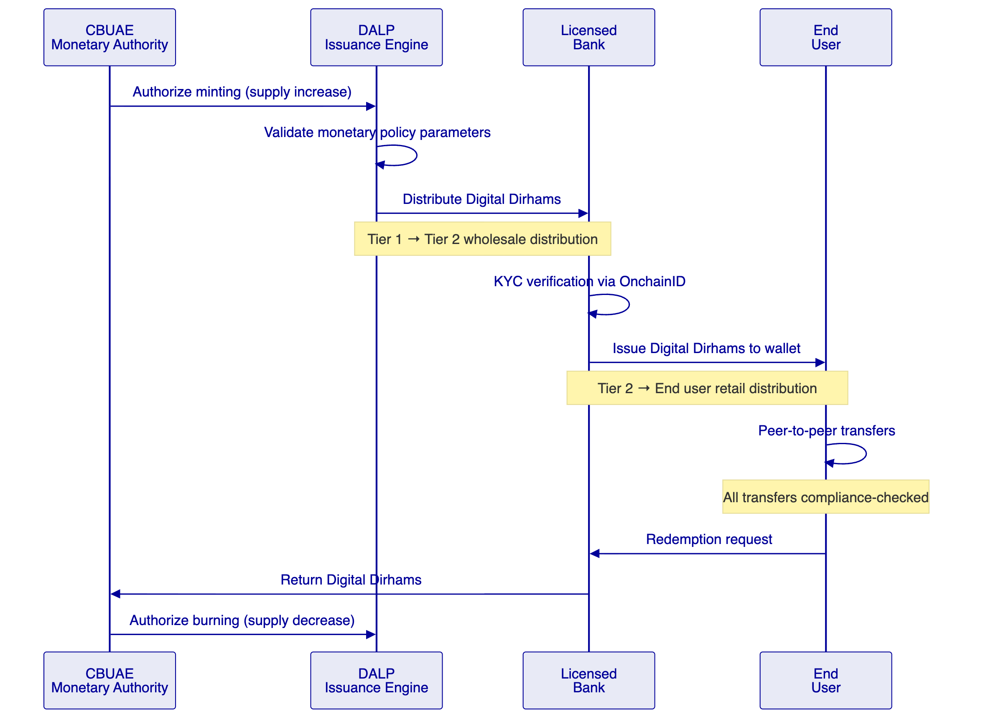

  - Identity, Compliance, and Regulatory Controls
    - Multi-Tier Identity Model
Tier | Wallet Type | KYC Level | Transaction Limits | Identity Method
Tier 0 | Interbank (wholesale) | Full institutional KYC | Unlimited | Institutional OnchainID
Tier 1 | Licensed bank | Full institutional KYC | Per monetary policy | Institutional OnchainID
Tier 2 | Corporate | Enhanced KYC | Per regulatory limits | Corporate OnchainID
Tier 3 | Individual (verified) | Standard KYC | Per individual limits | Personal OnchainID
Tier 4 | Individual (basic) | Simplified KYC | Low-value limits | Simplified OnchainID
    - AML/CFT Integration
DALP integrates with the CBUAE's Financial Intelligence Unit through:
- Real-time transaction monitoring webhook events
- Suspicious transaction report (STR) data extracts
- Sanctions screening integration via API
- Transaction pattern analytics via the observability stack
- Complete audit trail for regulatory examination

  - Distribution, Settlement, and Interoperability
    - Cross-Border Settlement
Building on Project Aber and mBridge architecture, DALP supports cross-border CBDC settlement through:
- Multi-network deployment capability — separate chains per jurisdiction
- Atomic cross-chain settlement via bridge contracts
- Exchange rate feed integration for multi-currency settlement
- Regulatory reporting per jurisdiction
    - Wholesale Settlement
For interbank settlement, DALP provides:
- Deterministic finality in under 3 seconds (IBFT 2.0 consensus)
- Atomic DvP via XvP Settlement addon
- Real-time gross settlement (RTGS) compatibility through API integration
- Netting and batch settlement support

  - Security, Resilience, and Sovereign-Grade Assurance
    - Security for Sovereign Infrastructure
Control | Implementation
Key management | HSM integration for central bank signing keys
Network security | Permissioned network — no public access to validator layer
Encryption | AES-256 at rest, TLS 1.3 in transit
Access control | Multi-factor authentication, hardware security keys
Audit | Complete immutable transaction log, queryable API
Certifications | ISO 27001, SOC 2 Type II
    - Operational Resilience
Target | Value
Availability | 99.99% (sovereign-grade)
RPO | < 15 minutes
RTO | < 1 hour
DR testing | Quarterly with documented results
Incident response | 24×7 for P1 events

  - Implementation Approach and Delivery Phases
    - Phased Implementation
Given the sovereign nature of CBDC infrastructure, we recommend a phased approach:
Phase A: Wholesale CBDC (Months 1–6)
- Interbank settlement infrastructure
- Central bank operations console
- Integration with existing RTGS and payment systems
- Validator network setup with CBUAE and selected banks
Phase B: Retail CBDC Pilot (Months 7–12)
- Two-tier distribution model
- Bank distribution portal
- Consumer wallet infrastructure
- Limited geographic/participant pilot
Phase C: Full Retail Deployment (Months 13–18)
- Nationwide rollout
- Merchant payment integration
- Government disbursement channels
- Cross-border corridors (building on Project Aber/mBridge)
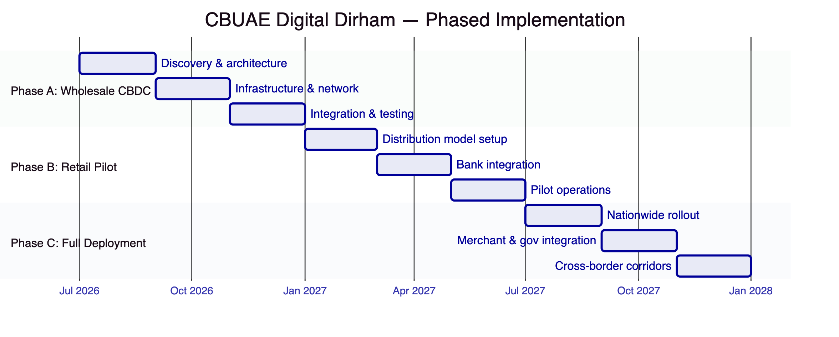

  - Current Coverage, Dependencies, and Qualified Gaps
    - Coverage Summary
Requirement Area | Status | Notes
Token issuance & supply management | Full | Central bank-exclusive minting/burning
Two-tier distribution | Full | Configurable distribution contracts
AML/CFT integration | Full | Webhook events, API integration
Transaction limits | Full | Per-tier configurable limits
Audit trail | Full | Complete immutable log
Cross-border settlement | Partial | Multi-network support available; specific corridor configuration required
Offline capability | Planned | Under evaluation — hardware wallet integration pathway
Privacy-preserving transactions | Partial | Besu private transactions available; zero-knowledge proof integration on roadmap
    - Qualified Gaps
Offline capability — Planned. Retail CBDC offline payments require hardware-based solutions. DALP does not currently provide native offline payment capability. Mitigation: partnership with hardware wallet providers for offline-capable devices, with on-chain reconciliation when connectivity restores. Timeline: evaluated during Phase B design.
Privacy-preserving transactions — Partial. Besu private transaction groups provide selective disclosure. Full zero-knowledge proof-based privacy for retail transactions is on the platform roadmap (2027). Mitigation: tiered privacy model using Besu private groups for wholesale and standard pseudonymous transactions for retail with regulatory access.

  - Relevant Delivery Evidence
Client | Region | Relevance
State Bank of India (e-Rupee) | India | Direct — CBDC infrastructure at national scale
Saudi Arabia RER | KSA | Direct — sovereign-scale blockchain, UAE neighbor
Islamic Development Bank | 57 countries | Sovereign-scale distribution system
Maybank (Project Photon) | Malaysia | Cross-border FX settlement
Standard Chartered Bank | Multi-region | Multi-jurisdiction bank infrastructure
    - State Bank of India — CBDC at National Scale
The SBI e-Rupee engagement is the most directly relevant reference:
- CBDC infrastructure for India's national digital currency
- Designed for one billion+ projected daily transactions
- Pilot completed, production deployment underway
- Integration with existing banking infrastructure
- National-scale identity verification
- Cross-border settlement use cases

  - Appendices
    - Appendix A: Glossary
Term | Definition
CBDC | Central Bank Digital Currency
DALP | Digital Asset Lifecycle Platform
Digital Dirham | CBUAE's proposed central bank digital currency
IBFT 2.0 | Istanbul Byzantine Fault Tolerance — consensus mechanism for permissioned networks
OnchainID | On-chain identity standard (ERC-734/735)
Project Aber | Joint CBDC project between CBUAE and Saudi Central Bank
mBridge | Multi-CBDC platform involving HKMA, BIS, BOT, PBC
DvP | Delivery versus Payment
RTGS | Real-Time Gross Settlement
HSM | Hardware Security Module

