[Company name]
[Document title]
[Document subtitle]

Confidentiality Statement
This document contains confidential and proprietary information of SettleMint. By reading this document, you agree not to disclose the confidential information contained herein to any third party without the prior written consent of SettleMint, except to those agents, principals, representatives, or consultants who require access for the purpose of evaluating this document. You further agree to inform such persons of the confidential nature of this document and to obtain their agreement to preserve its confidentiality to the same extent as yours.
This confidentiality statement shall remain binding on the parties for a period of five (5) years from the date stated on the front cover, unless superseded by confidentiality provisions detailed in a subsequent agreement.
Terms and Conditions
This proposal is valid until [DD Month YYYY]. In the absence of confirmation to proceed, SettleMint and [the Company] acknowledge and agree to abide by the Mutual NDA as the governing agreement.
SettleMint reserves the right to vary the terms of this proposal in response to changes in specifications or information made available at a later date. Submission of this proposal does not convey any right, title, interest, or license in any intellectual property rights (including, but not limited to, patents, copyrights, trade secrets, or trademarks) contained herein.
All rights are reserved. This proposal and the information contained within it are provided on an “as is” basis, without any warranties of any kind, express or implied.
All contracts with SettleMint will be governed by Belgian Law and subject to the exclusive jurisdiction of Belgian courts.
Contact Details
For any enquiries regarding this document, please contact:
[Full Name]
[Job Title]
Email: [email@example.com]
Phone: [Country Code - Number]

Table of Contents

Table of Contents
Executive Summary
Understanding Deutsche Bank's Programme Objectives
The German Digital Securities Landscape
Proposed DALP Operating Model for Digital Bonds
Bond Lifecycle Coverage
Bond Configuration Parameters
Technical Architecture and Integration Boundaries
Enterprise Integration for Deutsche Bank
ISO 20022 Messaging
Settlement, Servicing, and Corporate Actions
T+0 Settlement
Coupon Processing
Corporate Actions
Security, Resilience, and Operational Assurance
G-SIB Grade Security
Operational Resilience
Implementation Approach and Delivery Phases
19-Week Implementation
Current Coverage, Dependencies, and Qualified Gaps
Requirements Coverage
Qualified Gaps
Relevant Delivery Evidence
Commerzbank — German Bank, Production Digital Securities
Appendices
Appendix A: Glossary

Field | Value
Proposal title | Technical Proposal — Digital Bonds Issuance Platform
Client | Deutsche Bank
Submitted by | SettleMint NV
Date | March 2026
Version | v1.0
Confidentiality | Restricted
RFP Reference | DEUTSCHE-BANK-RFP-DIGITAL-BONDS-202603
Primary contact | Adam Popat, CEO

  - Table of Contents
- Executive Summary
- Understanding Deutsche Bank's Programme Objectives
- Proposed DALP Operating Model for Digital Bonds
- Technical Architecture and Integration Boundaries
- Bond-Specific Smart Contract Architecture
- Identity, Compliance, and MiCA/eWpG Controls
- Settlement, Servicing, and Corporate Actions
- Security, Resilience, and Operational Assurance
- Implementation Approach and Delivery Phases
- Current Coverage, Dependencies, and Qualified Gaps
- Relevant Delivery Evidence
- Appendices

  - Executive Summary
Deutsche Bank has identified digital bonds issuance as a strategic capability for modernizing its fixed-income operations. The German Electronic Securities Act (eWpG) and the EU Markets in Crypto-Assets Regulation (MiCA) have created the regulatory framework for digital securities issuance in Germany and across the European Union. The challenge is no longer regulatory permission — it is production-grade execution: building infrastructure that can issue, settle, service, and retire digital bonds at institutional scale within the control environment expected of a Global Systemically Important Bank (G-SIB).
SettleMint's Digital Asset Lifecycle Platform (DALP) addresses this directly. DALP provides the full bond lifecycle — from structuring and issuance through coupon processing, corporate actions, and redemption at maturity — with compliance enforcement embedded at the smart contract level and enterprise integration designed for G-SIB control requirements.
Why DALP fits Deutsche Bank's requirements:
- Production-proven bond infrastructure. DALP powers Commerzbank's hybrid Exchange-Traded Product (ETP) issuance programme — listed on Boerse Stuttgart with settlement in under 10 seconds and projected annual savings of EUR 7 million. This is the most directly relevant reference for Deutsche Bank's digital bonds programme.
- MiCA and eWpG compliance readiness. DALP's compliance engine supports jurisdiction-specific regulatory configurations including MiFID II reporting (RTS 25), eWpG crypto securities register requirements, and MiCA prudential controls. Compliance modules enforce investor eligibility, jurisdiction restrictions, and transfer restrictions at the smart contract level.
- G-SIB integration architecture. DALP integrates with core banking systems, custody providers (including sub-custody arrangements), SWIFT messaging, TARGET2-Securities (T2S), and regulatory reporting through a comprehensive API surface. The platform is designed to sit inside Deutsche Bank's enterprise architecture without creating reconciliation sinkholes or unowned integration points.
- Deterministic settlement. Under tested conditions (500 concurrent settlement instructions, 4-node validator network), DALP achieves median settlement latency of 2.3 seconds with P99 at 4.1 seconds using IBFT consensus. This provides T+0 settlement with deterministic finality — eliminating the confirmation-depth waiting required by probabilistic consensus mechanisms.
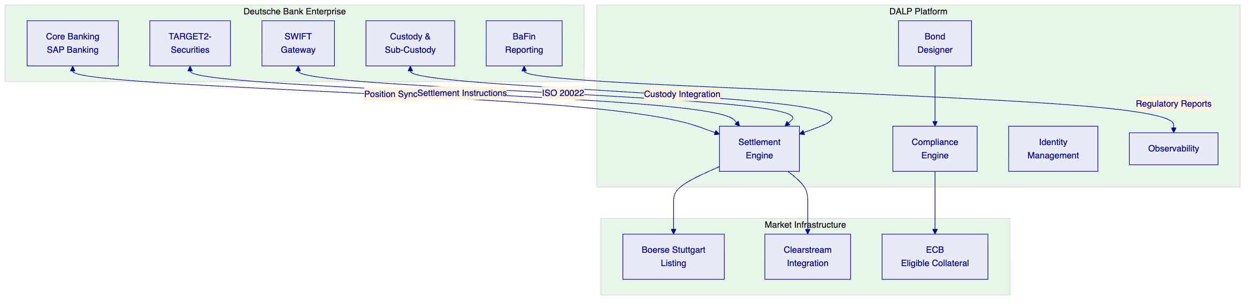

  - Understanding Deutsche Bank's Programme Objectives
    - The German Digital Securities Landscape
Germany's eWpG (Electronic Securities Act, effective June 2021) permits the issuance of electronic securities on distributed ledger technology, creating a regulated pathway for digital bonds. Combined with MiCA (effective June 2023 for asset-referenced tokens, December 2024 for full scope), the regulatory framework for digital bond issuance in Germany and across the EU is now established.
Deutsche Bank's programme objectives center on three requirements:
First, institutional-grade issuance infrastructure. The platform must support the full bond lifecycle — structuring, primary issuance, secondary market settlement, coupon processing, corporate actions, and redemption — with the same control environment applied to traditional fixed-income operations.
Second, regulatory compliance across jurisdictions. Digital bonds issued under eWpG must comply with German securities law, BaFin supervision, MiCA requirements, and potentially MiFID II obligations for distribution across EU member states. The platform must support multi-jurisdictional compliance without requiring separate implementations per jurisdiction.
Third, hybrid on-chain/off-chain coexistence. Deutsche Bank's digital bonds programme will initially coexist with traditional fixed-income infrastructure. The platform must integrate with TARGET2-Securities, Clearstream, SWIFT, and existing core banking systems — operating as a component within the broader settlement ecosystem, not as a replacement for it.
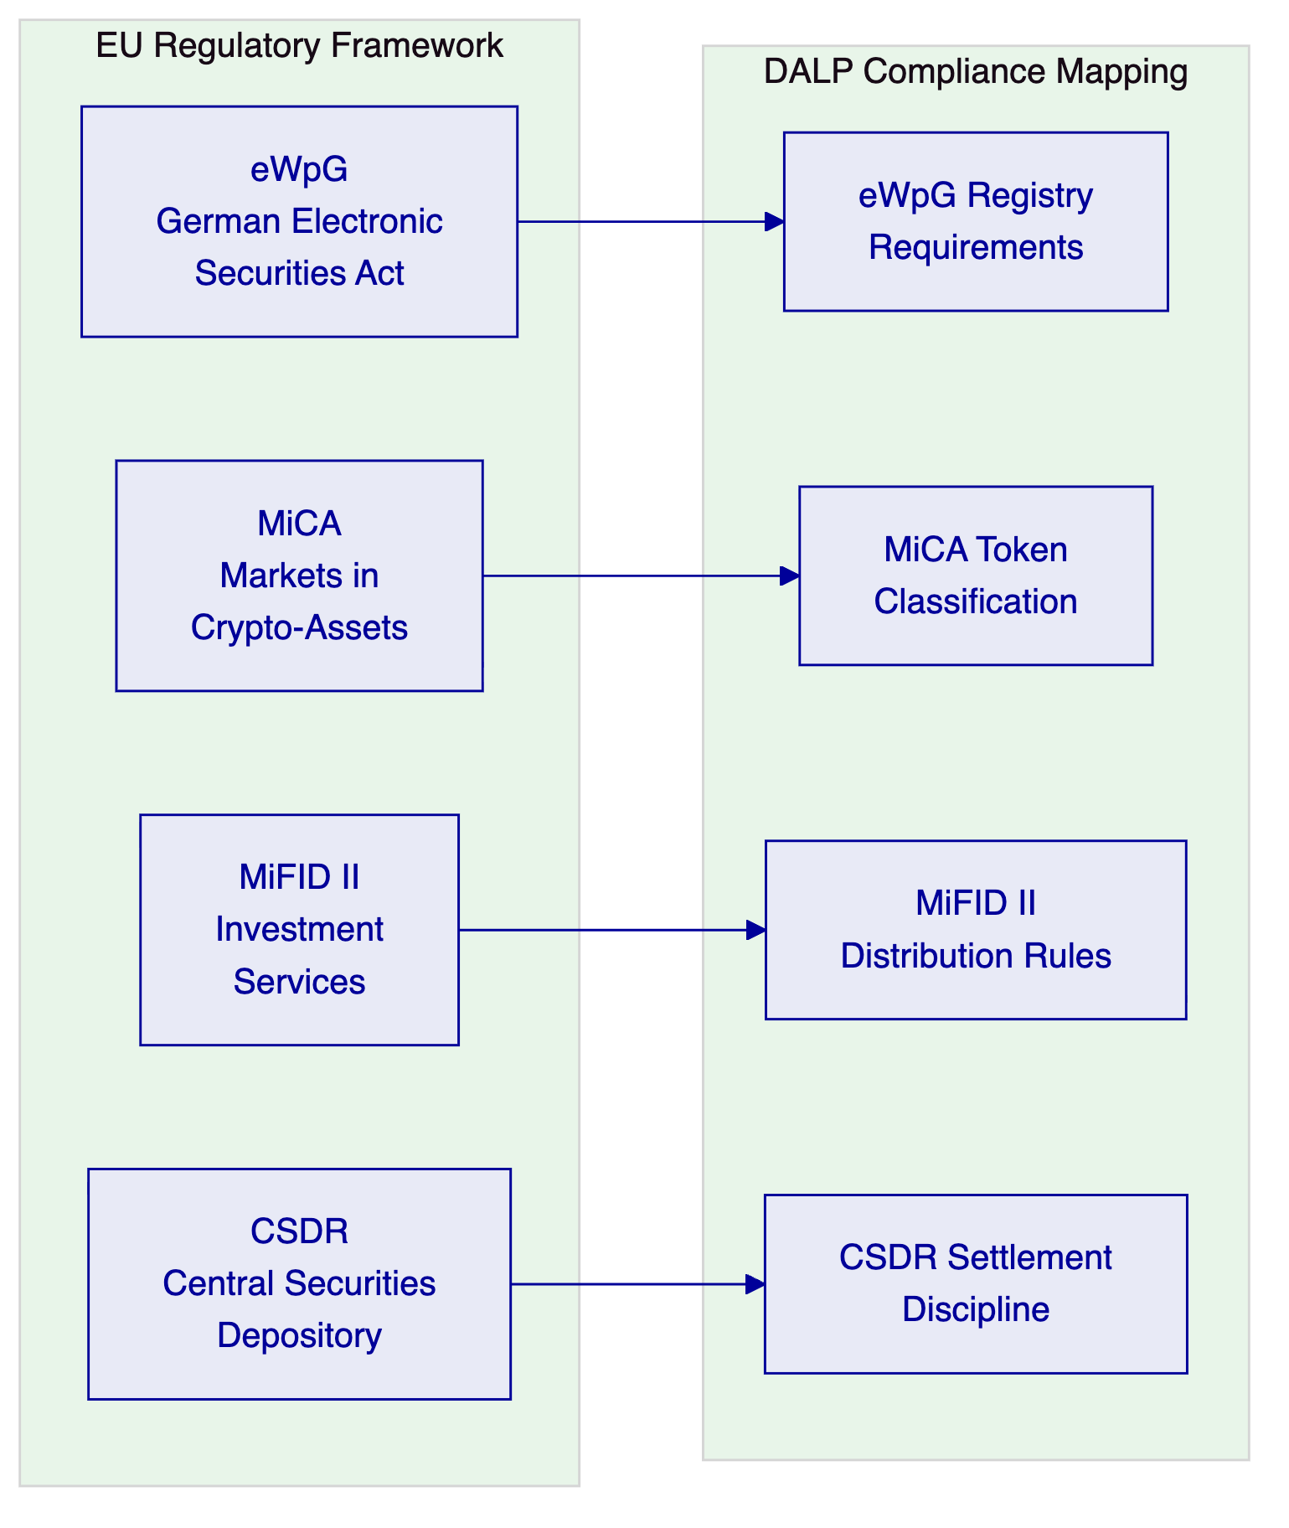

  - Proposed DALP Operating Model for Digital Bonds
    - Bond Lifecycle Coverage
DALP manages the complete bond lifecycle through configurable DALPAsset contracts:
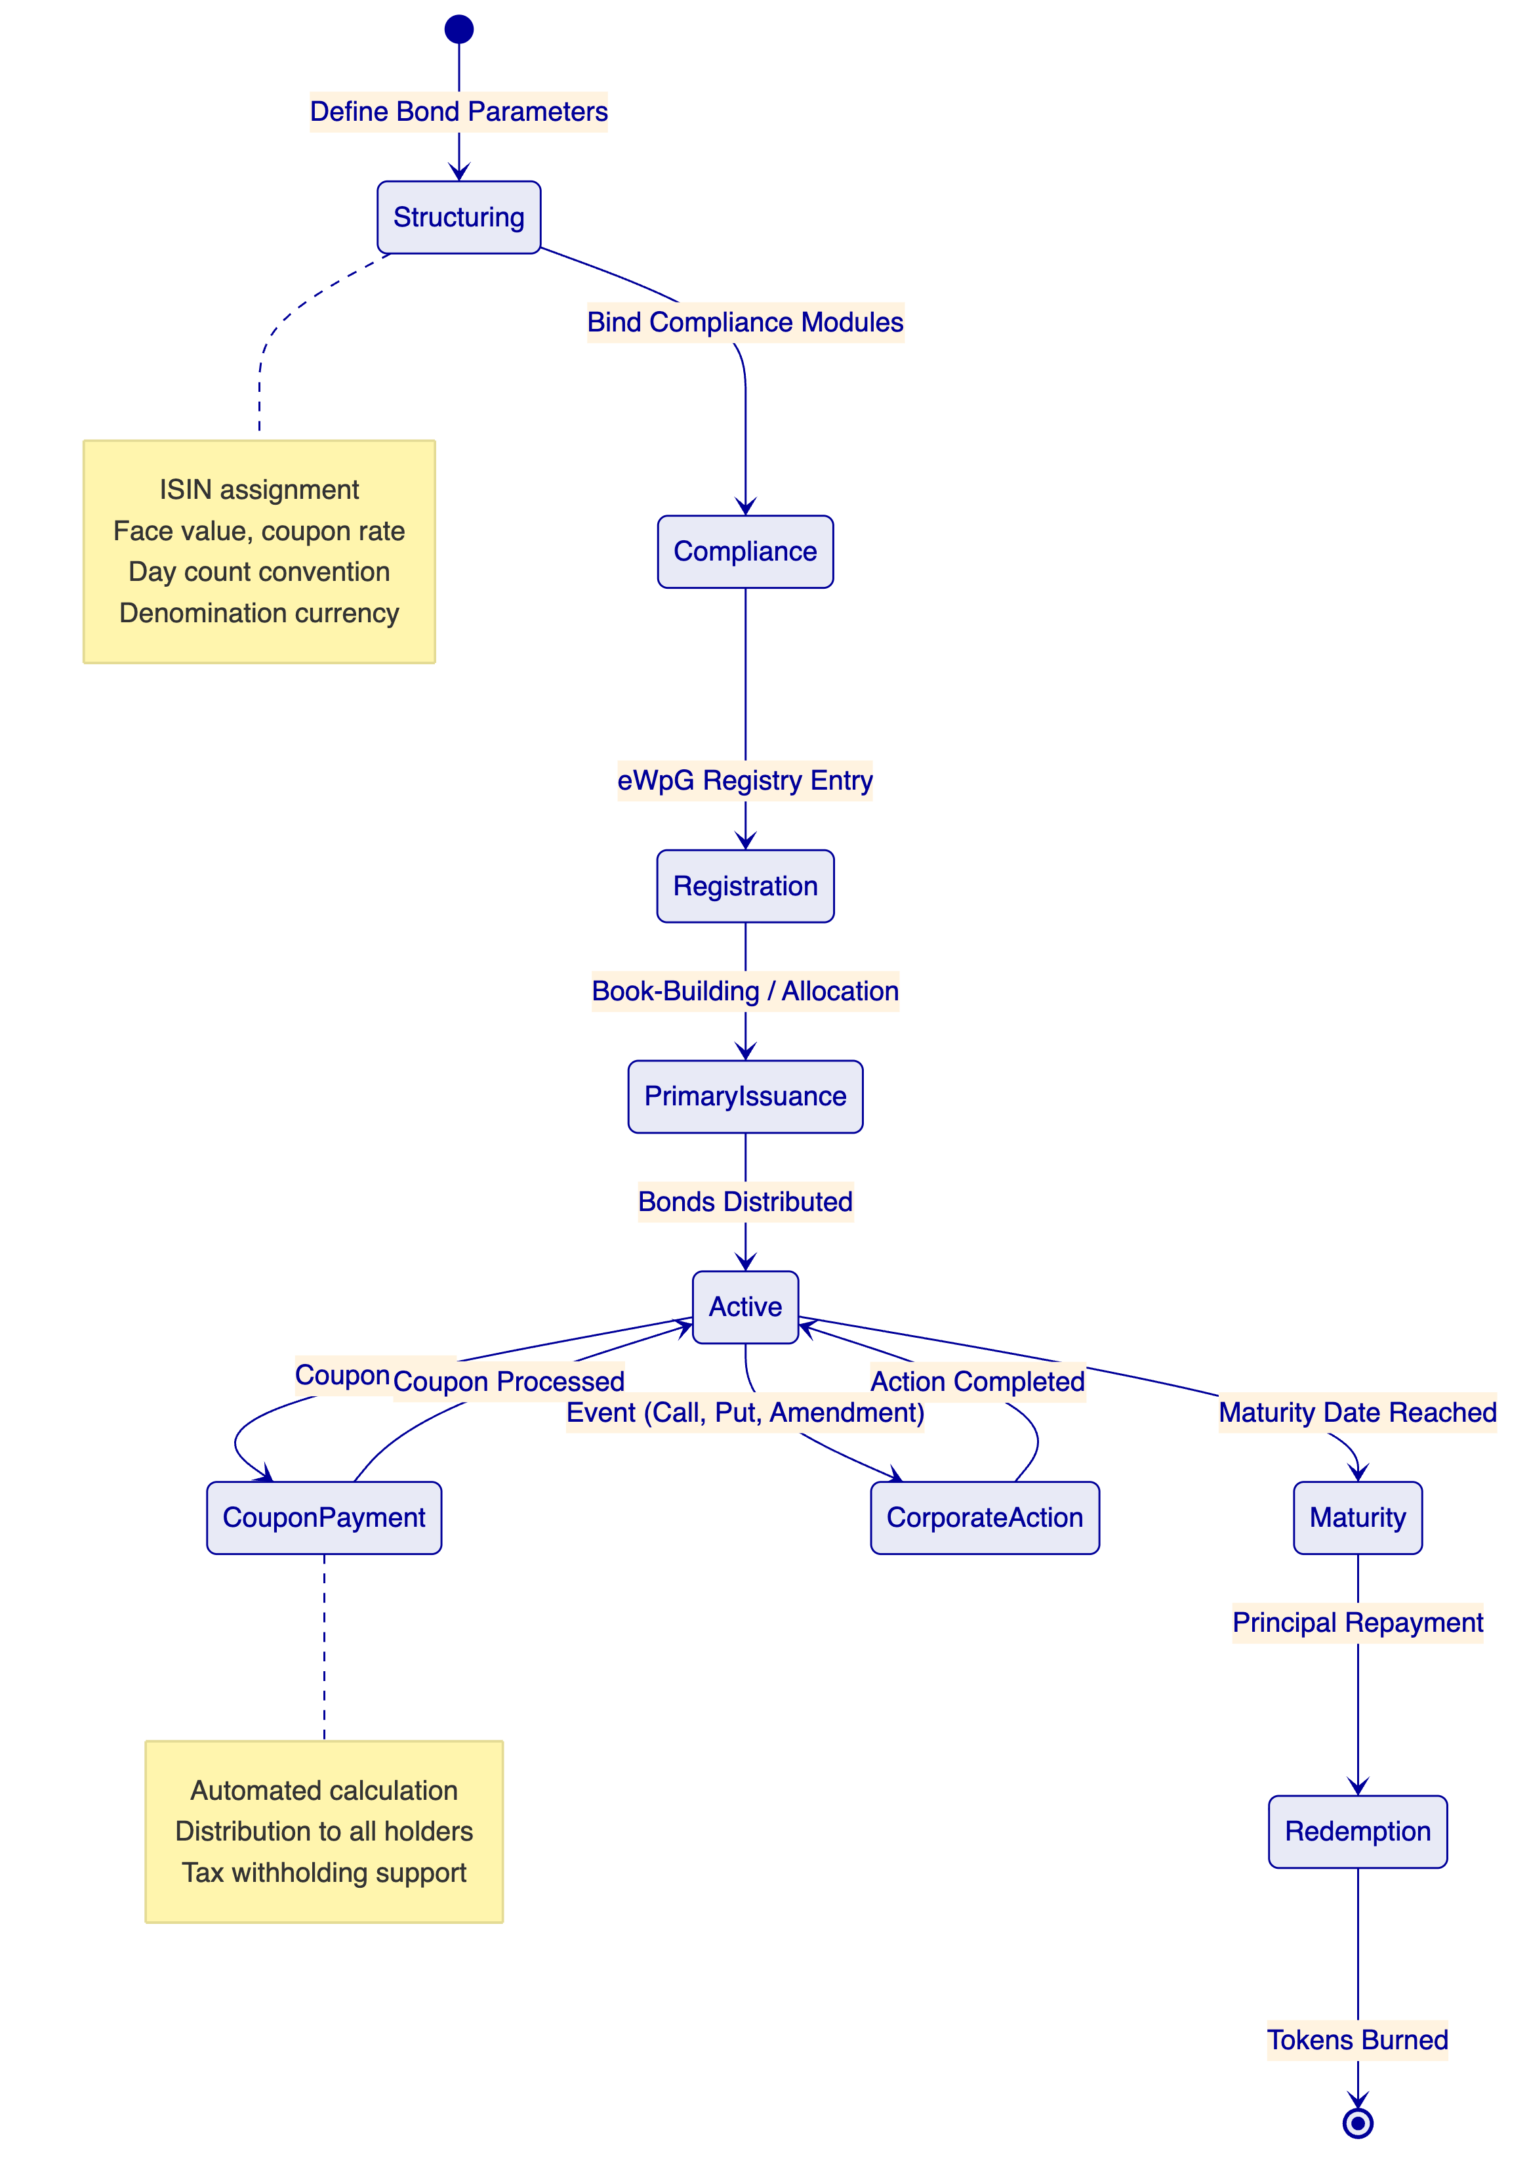
    - Bond Configuration Parameters
Parameter | Description | DALP Configuration
ISIN | International Securities Identification Number | Validated per ISO 6166 at creation
Face value | Par value per bond | Token denomination parameter
Coupon rate | Fixed or floating rate | Yield feature configuration
Coupon frequency | Annual, semi-annual, quarterly | Distribution schedule
Day count convention | 30/360, ACT/360, ACT/365 | Calculation engine parameter
Maturity date | Bond expiry date | Maturity & Redemption feature
Call/put provisions | Early redemption rights | Configurable lifecycle events
Currency | Denomination and settlement currency | DALPAsset currency parameter
Jurisdiction | Governing law and regulatory framework | Compliance module binding

  - Technical Architecture and Integration Boundaries
    - Enterprise Integration for Deutsche Bank
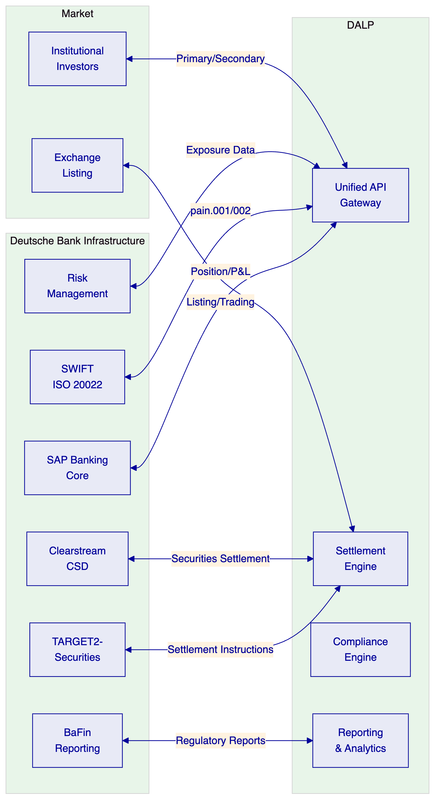
    - ISO 20022 Messaging
DALP supports integration with SWIFT and TARGET2-Securities through ISO 20022 message types:
Message Type | Purpose | Integration
pain.001 | Payment initiation | Settlement instruction creation
pain.002 | Payment status | Settlement confirmation
semt.002 | Securities balance | Position reconciliation
sese.023 | Settlement instruction | DVP settlement
sese.025 | Settlement confirmation | Post-settlement reporting
Current status: DALP generates settlement instructions in its standard format. Native ISO 20022 message generation is in development, targeted for Q3 2026. In the interim, a documented middleware translation layer is available, successfully deployed by two existing clients.

  - Settlement, Servicing, and Corporate Actions
    - T+0 Settlement
DALP enables T+0 settlement for digital bonds through atomic DvP:
- Settlement finality in under 3 seconds (median) using IBFT consensus
- Deterministic finality — no confirmation-depth waiting
- Atomic DvP via XvP Settlement addon
- Integration with T2S for hybrid settlement scenarios
    - Coupon Processing
Automated coupon processing for all holders:
- Calculation based on configured day count convention and coupon rate
- Distribution to all verified holders based on historical balance snapshot
- Tax withholding support (configurable per jurisdiction)
- Complete audit trail of calculation basis, distribution amounts, and timestamps
    - Corporate Actions
Action | Support | Mechanism
Coupon payment | Full | Automated calculation and distribution
Maturity redemption | Full | Maturity & Redemption feature
Early call | Full | Configurable call provisions
Put option | Full | Investor-initiated redemption
Amendment | Partial | Governance-approved parameter changes
Default event | Configuration | Configurable trigger and workflow

  - Security, Resilience, and Operational Assurance
    - G-SIB Grade Security
Control | Implementation
Authentication | Multi-factor, passkeys (WebAuthn), LDAP/AD, OAuth 2.0/OIDC
Key management | HSM integration, multi-signature governance controls
Smart contract security | Independent audits per release, UUPS upgrade pattern
Network security | Permissioned Besu, encrypted node communication
Data protection | AES-256 at rest, TLS 1.3 in transit, GDPR-compliant
Certifications | ISO 27001, SOC 2 Type II
    - Operational Resilience
Target | Configuration
RPO | < 1 hour
RTO | < 4 hours
Availability | 99.95%
DR | Geo-separated within EU
Monitoring | Three-pillar observability
Penetration testing | Annual + per major release

  - Implementation Approach and Delivery Phases
    - 19-Week Implementation
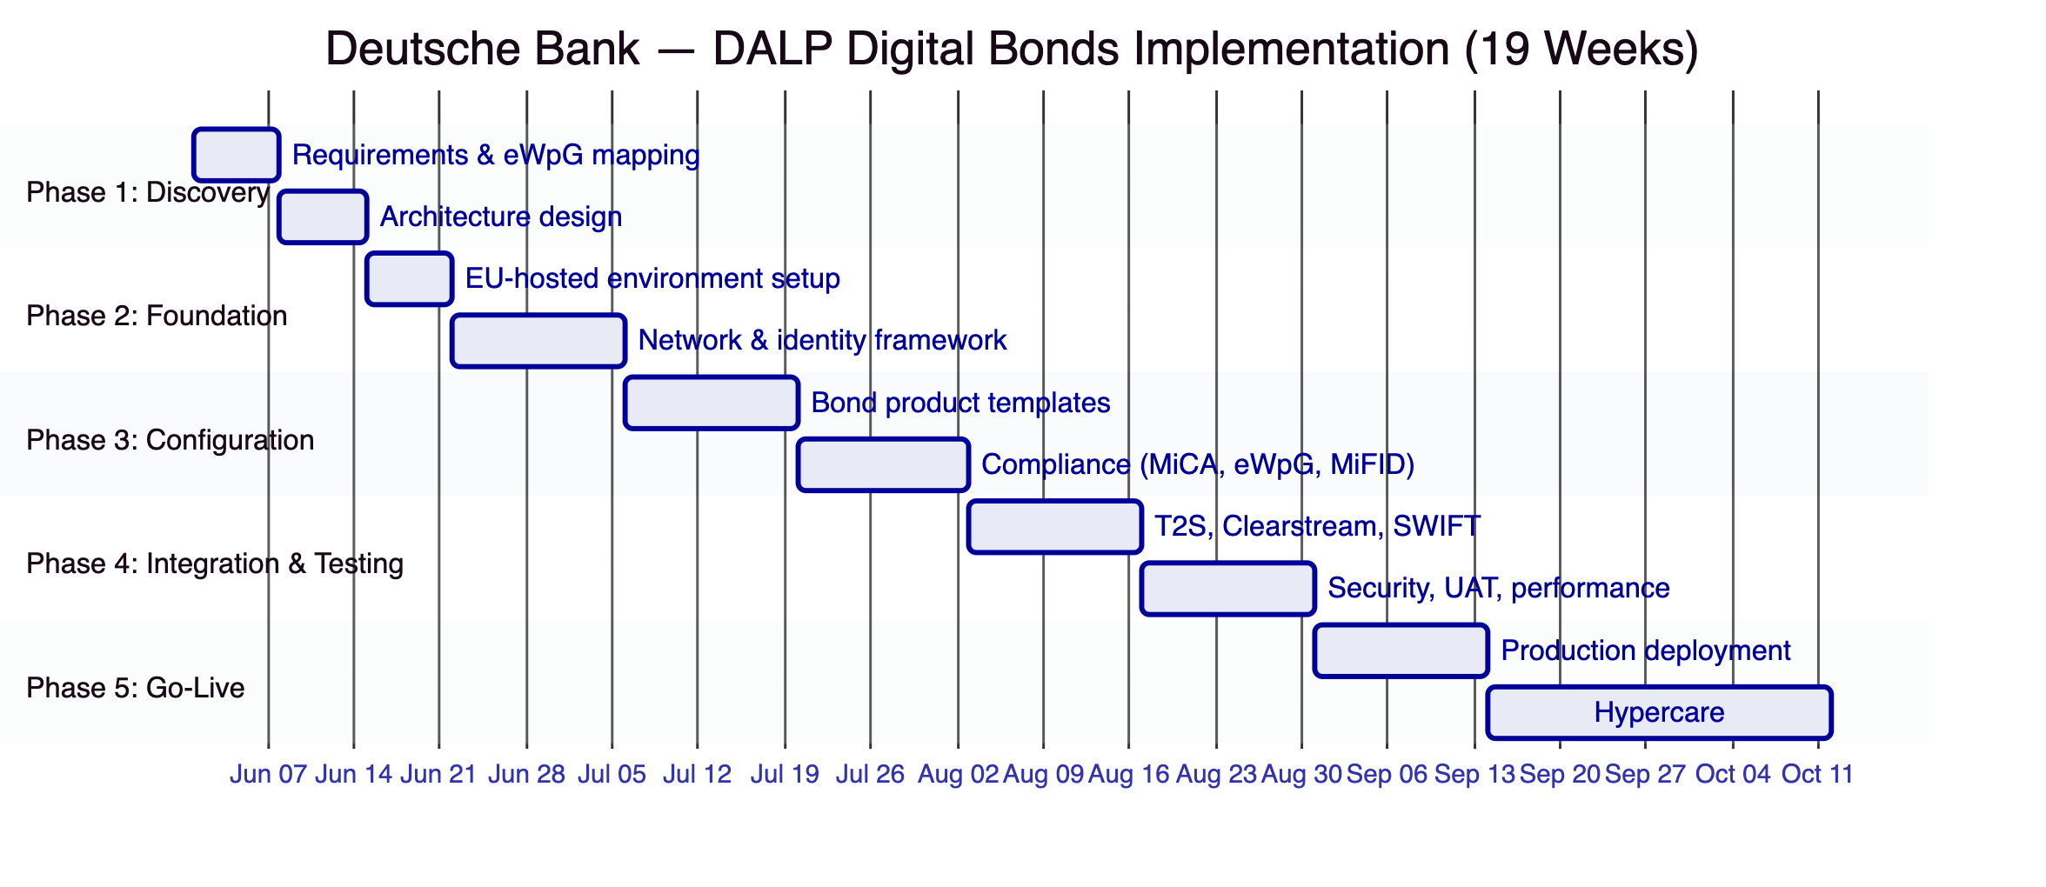

  - Current Coverage, Dependencies, and Qualified Gaps
    - Requirements Coverage
Req Area | Status | Notes
Bond lifecycle | Full | Issuance through redemption
eWpG registry | Full | Crypto securities register requirements
MiCA compliance | Full | Token classification, prudential controls
T2S integration | Partial | API integration available; native SWIFT ISO 20022 in Q3 2026
Clearstream CSD | Partial | Integration architecture defined; requires joint development
Coupon processing | Full | Automated with day count convention support
Corporate actions | Full | Coupon, call, put, maturity redemption
BaFin reporting | Full | Configurable regulatory report templates
RBAC & audit | Full | G-SIB grade controls
    - Qualified Gaps
Native ISO 20022 messaging — Q3 2026. DALP does not currently generate native ISO 20022 messages. A documented middleware translation layer is available and deployed by two existing clients. Native support targeted for Q3 2026. This does not block implementation — the middleware approach is production-proven.
Clearstream CSD integration — Joint development required. Direct integration with Clearstream's settlement infrastructure requires joint development during the implementation phase. DALP provides the API surface and settlement instruction format; Clearstream connectivity requires Deutsche Bank's existing CSD relationship and technical coordination.

  - Relevant Delivery Evidence
Client | Region | Relevance
Commerzbank | Germany | Direct — hybrid ETP issuance, Boerse Stuttgart, EUR 7M savings
OCBC Bank | Singapore | Regulated bank, multi-asset securities tokenization
KBC Securities | Belgium | Equity crowdfunding, corporate actions, fiat-backed tokens
Standard Chartered Bank | Multi-region | Multi-jurisdiction securities
Saudi Arabia RER | KSA | National-scale blockchain production
    - Commerzbank — German Bank, Production Digital Securities
The Commerzbank ETP engagement is the most directly relevant reference:
- German bank, regulated under BaFin
- Hybrid on-chain/off-chain issuance model
- Listed on Boerse Stuttgart
- Settlement under 10 seconds
- Projected EUR 7 million annual savings
- Demonstrates coexistence with established exchange infrastructure

  - Appendices
    - Appendix A: Glossary
Term | Definition
DALP | Digital Asset Lifecycle Platform
eWpG | Elektronische Wertpapiergesetz (German Electronic Securities Act)
MiCA | Markets in Crypto-Assets Regulation (EU)
MiFID II | Markets in Financial Instruments Directive II
CSDR | Central Securities Depository Regulation
T2S | TARGET2-Securities (Eurosystem settlement platform)
G-SIB | Global Systemically Important Bank
DvP | Delivery versus Payment
ISIN | International Securities Identification Number
DALPAsset | Configurable token contract
IBFT | Istanbul Byzantine Fault Tolerance consensus
ISO 20022 | International standard for financial messaging

