[Company name]
[Document title]
[Document subtitle]

Confidentiality Statement
This document contains confidential and proprietary information of SettleMint. By reading this document, you agree not to disclose the confidential information contained herein to any third party without the prior written consent of SettleMint, except to those agents, principals, representatives, or consultants who require access for the purpose of evaluating this document. You further agree to inform such persons of the confidential nature of this document and to obtain their agreement to preserve its confidentiality to the same extent as yours.
This confidentiality statement shall remain binding on the parties for a period of five (5) years from the date stated on the front cover, unless superseded by confidentiality provisions detailed in a subsequent agreement.
Terms and Conditions
This proposal is valid until [DD Month YYYY]. In the absence of confirmation to proceed, SettleMint and [the Company] acknowledge and agree to abide by the Mutual NDA as the governing agreement.
SettleMint reserves the right to vary the terms of this proposal in response to changes in specifications or information made available at a later date. Submission of this proposal does not convey any right, title, interest, or license in any intellectual property rights (including, but not limited to, patents, copyrights, trade secrets, or trademarks) contained herein.
All rights are reserved. This proposal and the information contained within it are provided on an “as is” basis, without any warranties of any kind, express or implied.
All contracts with SettleMint will be governed by Belgian Law and subject to the exclusive jurisdiction of Belgian courts.
Contact Details
For any enquiries regarding this document, please contact:
[Full Name]
[Job Title]
Email: [email@example.com]
Phone: [Country Code - Number]

Table of Contents

Executive Summary 3
Context and Strategic Drivers 4
Why This Programme Is Hard 5
Proposed Response 6
Why SettleMint 7
Why DALP 8
Reference Fit Snapshot 9
About SettleMint 10
Company Overview 11
Production Credentials 12
Regulatory Readiness 13
About DALP 14
Platform Overview 15
Core Lifecycle Pillars 16
Issuance 17
Compliance 18
Custody 19
Settlement 20
Servicing 21
Platform Foundations 22
Identity and Access Management 23
Integration and Interoperability 24
Observability and Operations 25
Customer References 26
Summary Table 27
Expanded Reference: Maybank (Project Photon) 28
Expanded Reference: Commerzbank 29
Understanding of Requirements 30
Requirement Domains 31
Proposed Solution and Functional Capabilities 32
Solution Overview 33
Deposit and Stablecoin Configuration 34
Compliance Enforcement 35
Settlement and Payment Integration 36
Functional Fit Matrix 37
Technical Architecture 38
Layered Architecture 39
Data Architecture 40
Transaction Pipeline 41
Security 42
Project Implementation and Delivery 43
Phase Plan 44
Risks 45
Deployment 46
Training and Knowledge Transfer 47
Support and SLA 48
Compliance Matrix 49
Support Appendix 50

Field | Value
Proposal title | Technical Proposal: Digital Asset-Enabled Payment Rails for Treasury and Merchant Corridors
Client | Mashreq Bank (UAE)
Submitted by | SettleMint NV
Date | March 2026
Version | v1.0
Confidentiality | Restricted
RFP Reference | MASHREQ-BANK-RFP-DIGITAL-ASSET-PAYMENT-RAILS-202603
Contact | SettleMint NV, Kempische Steenweg 311/4.01, 3500 Hasselt, Belgium
Valid until | June 2026

- Executive Summary
  - Context and Strategic Drivers
Mashreq Bank is procuring digital asset-enabled payment rails for treasury and merchant corridors as a business-critical capability that must operate within its existing control environment under the Central Bank of the UAE (CBUAE) supervisory framework. The UAE's Digital Dirham programme, CBUAE regulatory developments, and the Dubai International Financial Centre (DIFC) digital asset framework create a regulatory environment that requires platforms to demonstrate production-grade compliance, auditability, and integration with established payment infrastructure.
Mashreq Bank's procurement targets a platform that can enable tokenized deposits, stablecoin settlement, and digital asset-enabled treasury operations while integrating with existing payment rails, correspondent banking relationships, and merchant settlement processes. DALP delivers deterministic settlement finality in under 3 seconds with compliance enforcement built into every transaction.
  - Why This Programme Is Hard
Payment rail infrastructure operates at the intersection of multiple regulatory regimes (CBUAE, DFSA for DIFC operations, international correspondent banking standards), requires real-time settlement with zero tolerance for reconciliation failures, must integrate with SWIFT, RTGS, and local payment systems, and demands the highest levels of operational resilience and security. The merchant corridor dimension adds complexity through high-volume, low-latency requirements and multi-currency considerations.
  - Proposed Response
SettleMint proposes DALP as the lifecycle platform for Mashreq Bank's digital payment rails programme. The deployment uses dedicated cloud infrastructure within UAE-resident data centres, ensuring compliance with CBUAE data localization requirements.
DALP addresses the payment rails use case through its deposit and stablecoin asset templates with programmable interest and withdrawal rules, atomic DvP/XvP settlement for treasury operations, ISO 20022 integration for SWIFT, SEPA, and RTGS connectivity, bridge functionality for cross-network settlement, and ex-ante compliance enforcement with 18 configurable module types.
  - Why SettleMint
Nearly a decade of production experience with regulated banks and sovereign entities. Particular relevance: Maybank's Project Photon for FX tokenization and cross-border settlement using atomic XvP, the Saudi RER programme for national-scale integration, and the Central Bank of UAE engagement context through the broader Middle East operations.
  - Why DALP
DALP provides the lifecycle control plane for tokenized deposits and stablecoins with built-in payment rail connectivity. ISO 20022 integration connects to SWIFT, SEPA, and RTGS. The deposit template includes programmable interest, maturity, withdrawal rules, and bridge functionality for external network connectivity. The stablecoin template includes reserve monitoring, attestation integration, and multi-currency support.
  - Reference Fit Snapshot
- Maybank (Project Photon): FX tokenization and cross-border settlement with atomic XvP, tokenized Malaysian Ringgit (MYRT)
- Commerzbank: Settlement under 10 seconds with EUR 7M annual savings, demonstrating payment efficiency at institutional scale
- Saudi RER: National-scale programme with deep enterprise integration, demonstrating UAE-region delivery capability

- About SettleMint
  - Company Overview
SettleMint is the production-grade digital asset lifecycle management company for regulated financial markets and sovereign use cases, with nearly a decade of focused experience and 7+ years of continuous production deployments at regulated banks.
  - Production Credentials
Category | Evidence
Market Validation | Nearly 10 years; 7+ years production at regulated banks
Operational Maturity | Live across bonds, equities, deposits, stablecoins, real estate, funds
Sovereign Credibility | National-scale Middle East programmes
Team Depth | 200+ years combined banking and blockchain experience

  - Regulatory Readiness
Jurisdiction | Framework | DALP Support
UAE | CBUAE requirements, DFSA framework | Platform controls mapped; buyer retains interpretation
GCC | Regional frameworks | Supported
EU | MiCA, GDPR | Native compliance templates
Singapore | MAS | Compliance modules

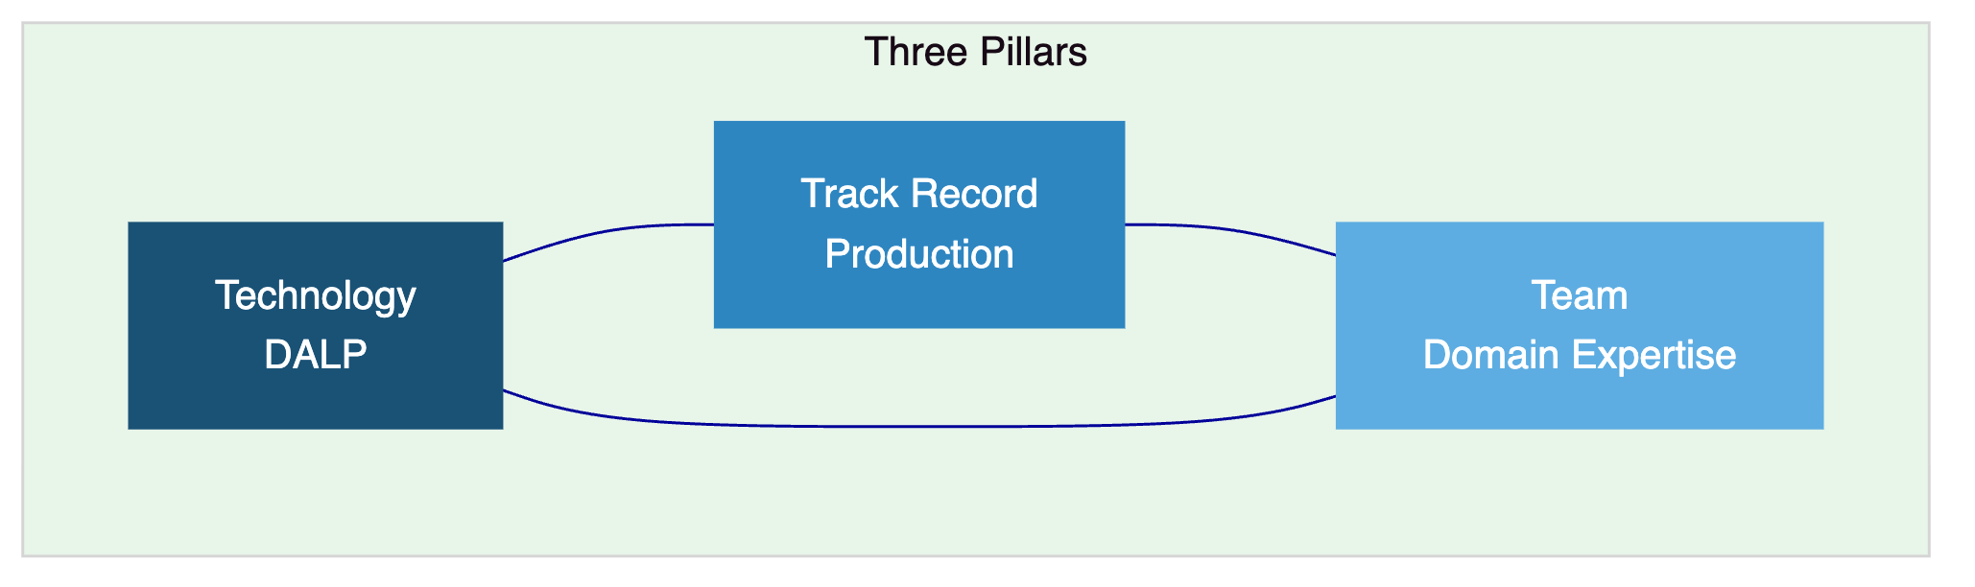

- About DALP
  - Platform Overview
DALP provides the full digital asset lifecycle from design through retirement. For Mashreq Bank's payment rails programme, DALP serves as the control plane for tokenized deposits, stablecoin operations, and treasury settlement, sitting between existing core systems and blockchain networks.
  - Core Lifecycle Pillars
    - Issuance
Deposit template with programmable interest, maturity, and withdrawal rules. Stablecoin template with reserve monitoring, attestation integration, and multi-currency support. Bridge functionality for external network connectivity. Deterministic orchestration with paused-by-default governance.
    - Compliance
18 compliance module types with ex-ante enforcement. CBUAE and GCC framework alignment. ERC-3643 with OnchainID for verifiable investor identities. Two-layer policy model.
    - Custody
Key Guardian with Fireblocks and DFNS integration. Maker-checker workflows. Provider-delegated transaction broadcast.
    - Settlement
Atomic DvP/XvP where both legs complete or revert. ISO 20022 for SWIFT, SEPA, RTGS. HTLC cross-chain settlement for cross-border corridors. T+0 finality with compliance enforcement.
    - Servicing
Automated interest distribution, withdrawal processing, and lifecycle management. Corporate actions, reserve attestation reporting, and audit trail generation.
[Diagram 3 — render failed, see markdown source]
  - Platform Foundations
    - Identity and Access Management
OnchainID, Identity Registry, 5-role RBAC, KYC/KYB workflows, invitation-linked onboarding, wallet verification, identity recovery.
    - Integration and Interoperability
REST, GraphQL, webhooks, oRPC, typed SDK, CLI with 301 commands, ISO 20022 payment connectivity, bring-your-own-custodian, multi-chain EVM support.
    - Observability and Operations
Grafana dashboards, three-pillar observability (VictoriaMetrics, Loki, Tempo), automated alerting, 11-state async transaction pipeline, 534 structured error codes.

- Customer References
  - Summary Table
Client | Use Case | Geography | Relevance
Maybank (Project Photon) | FX tokenization, XvP settlement | Malaysia | Cross-border payment rails
Commerzbank | ETP issuance, settlement under 10s | Germany | Payment efficiency
Saudi RER | Country-scale tokenization | KSA | UAE-region delivery
IsDB (Subsidy) | Multi-country distribution | 57 countries | Multi-jurisdictional payments
Sony Bank | Stablecoin with identity | Japan | Stablecoin capability
Standard Chartered | Digital exchange | Asia, Africa, ME | UAE market presence
OCBC Bank | Security token engine | Singapore | Tier-1 bank platform
SBI | CBDC infrastructure | India | Digital currency operations

  - Expanded Reference: Maybank (Project Photon)
Maybank deployed the MYRT token (tokenized Malaysian Ringgit) for FX tokenization and cross-border settlement using DALP's Exchange-versus-Payment (XvP) model. The solution enables atomic cross-currency swaps with simultaneous settlement of both legs, reducing counterparty and settlement risk. Implemented in alignment with Bank Negara Malaysia's Digital Asset Innovation Hub, the programme provides a scalable foundation for production deployment across broader tokenized deposit and cross-border settlement use cases. This reference directly parallels Mashreq Bank's requirement for digital asset-enabled payment corridors.
  - Expanded Reference: Commerzbank
Settlement in under 10 seconds with EUR 7 million annual savings potential through reduced counterparty risk and eliminated listing inefficiencies. The hybrid on/off-chain ETP solution demonstrates production-grade payment and settlement efficiency in a European banking environment.

- Understanding of Requirements
  - Requirement Domains
Domain | Mashreq Requirements | DALP Coverage
Product Scope | Tokenized deposits, stablecoin settlement, treasury operations | Deposit and stablecoin templates, treasury features
Compliance | CBUAE requirements, AML/CFT, cross-border controls | 18 modules, ex-ante enforcement
Settlement | Real-time, multi-currency, merchant corridors | Atomic DvP/XvP, ISO 20022
Integration | Core banking, SWIFT, RTGS, merchant systems | REST, GraphQL, webhooks, ISO 20022
Operations | High-volume, low-latency, resilience | Async pipeline, 3-pillar observability

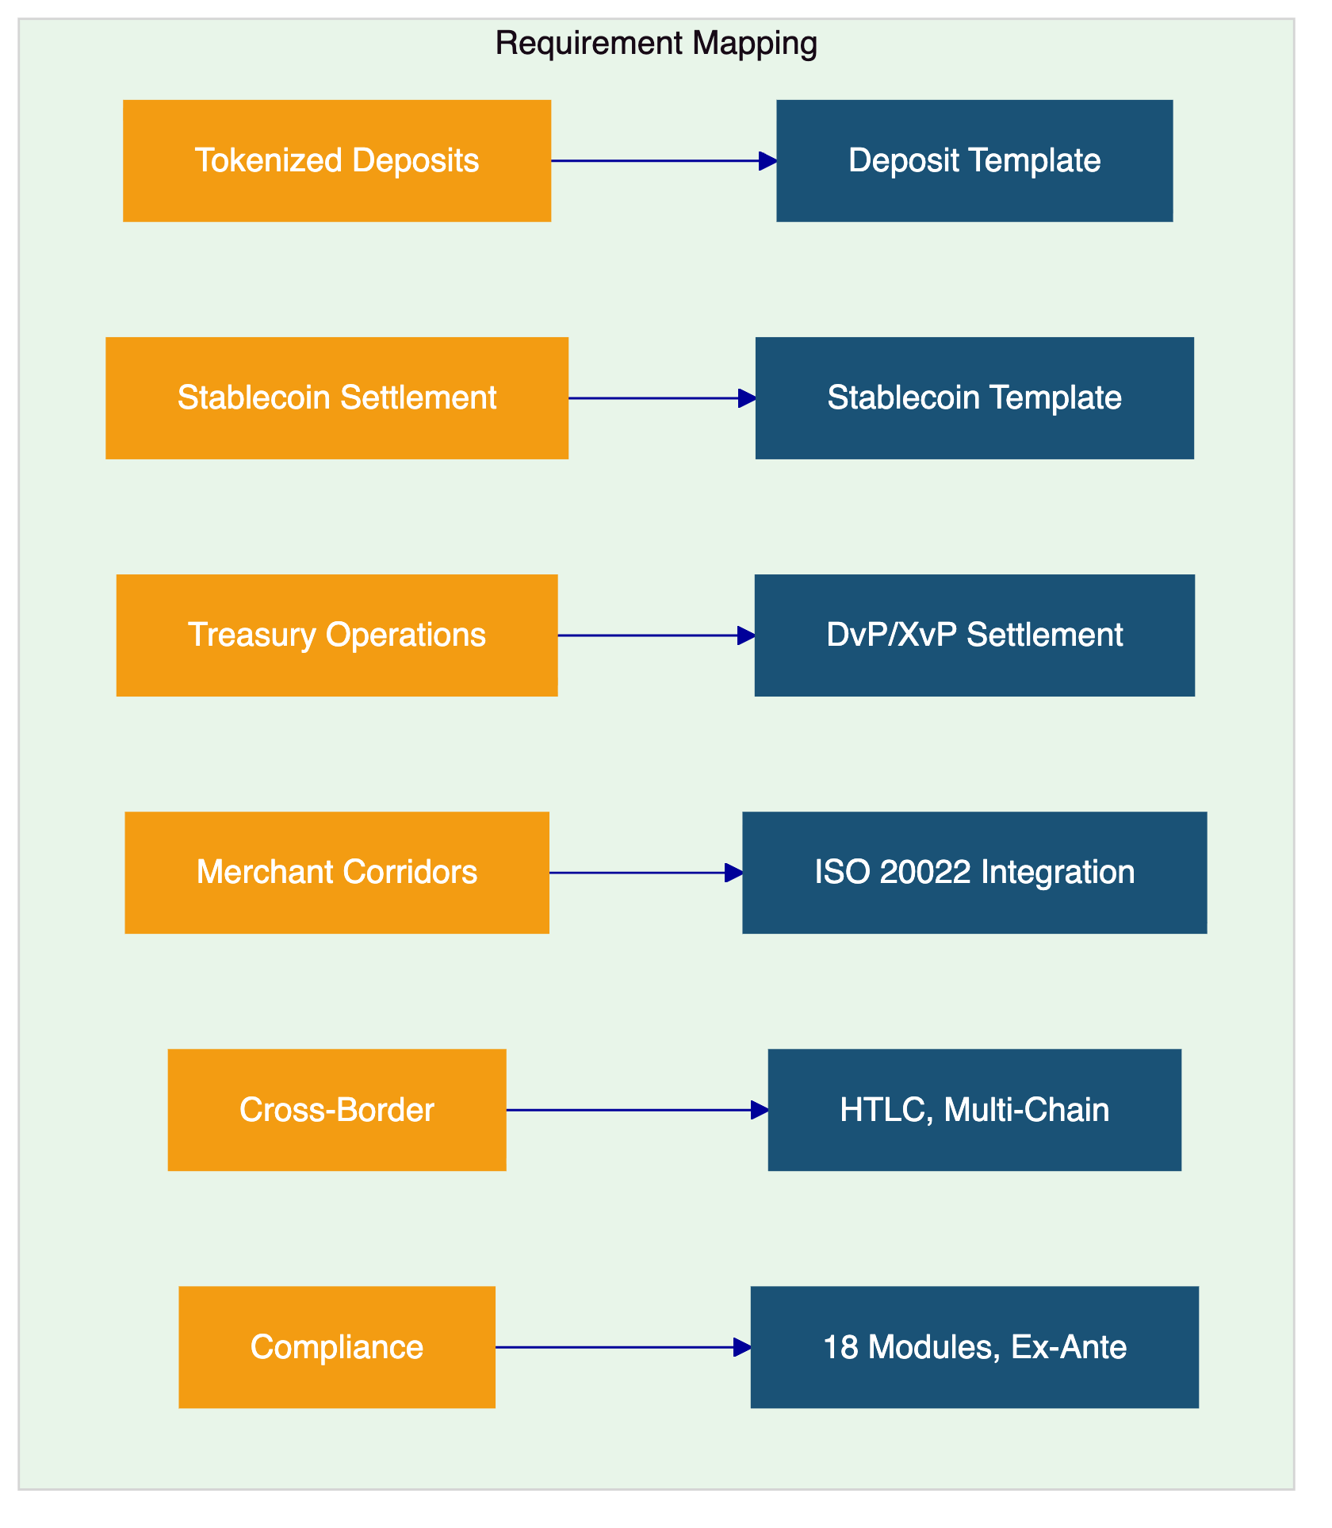

- Proposed Solution and Functional Capabilities
  - Solution Overview
DALP deploys as the payment rails lifecycle platform within Mashreq Bank's enterprise environment. The solution encompasses tokenized deposit configuration, stablecoin management, treasury settlement operations, merchant corridor settlement, cross-border payment orchestration, and operational monitoring.
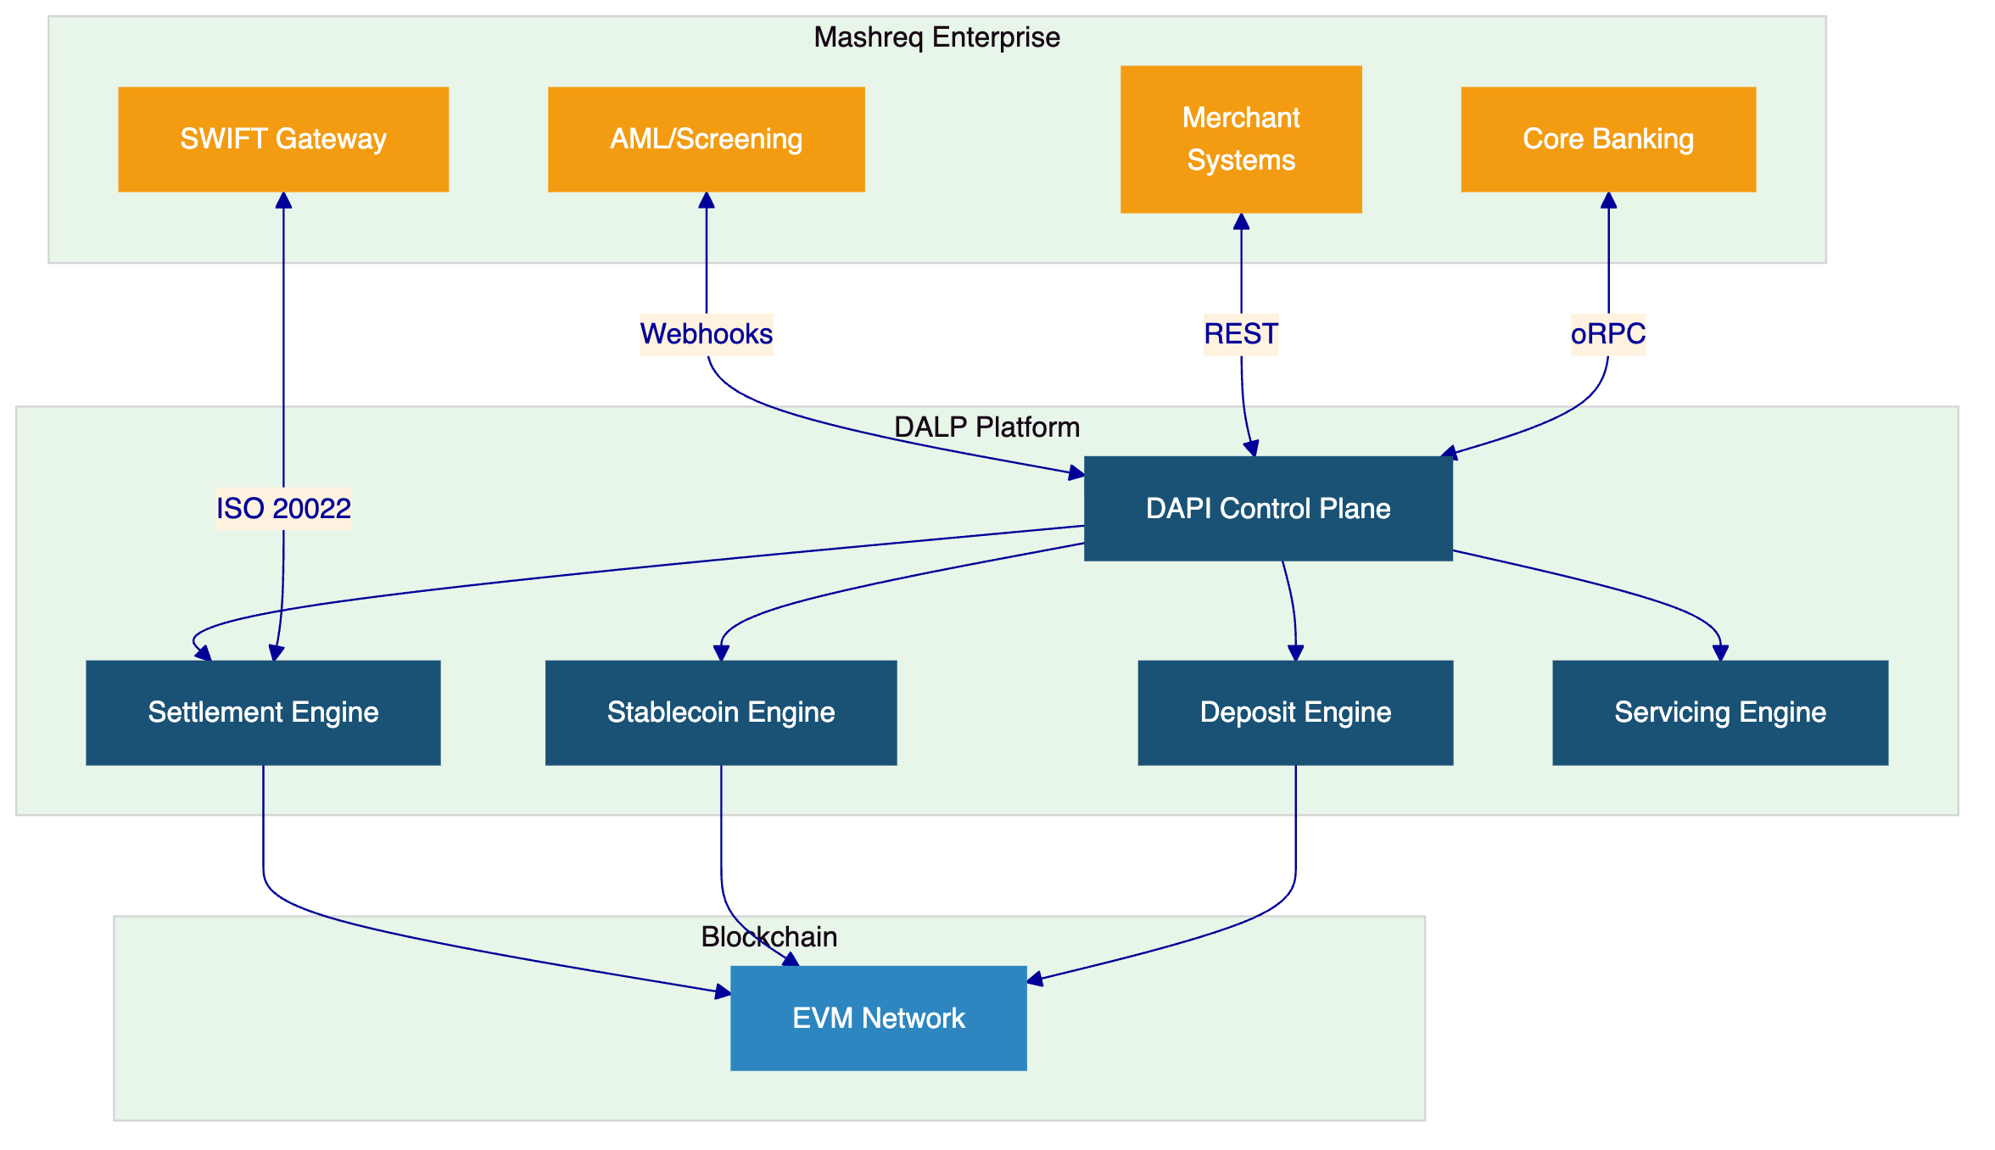
  - Deposit and Stablecoin Configuration
DALP's deposit template provides programmable interest, maturity, and withdrawal rules for tokenized deposits. The stablecoin template includes reserve monitoring, attestation integration, multi-currency support, and regulatory reporting capabilities. Bridge functionality enables interoperability with external networks, supporting Mashreq Bank's cross-border corridor requirements.
  - Compliance Enforcement
The 18 compliance module types enforce CBUAE requirements, AML/CFT controls, and cross-border transfer restrictions ex-ante. Every payment transaction is validated against applicable compliance rules before execution. The audit trail records which checks were evaluated, what data was used, and the result, providing the evidence base CBUAE supervisory review requires.
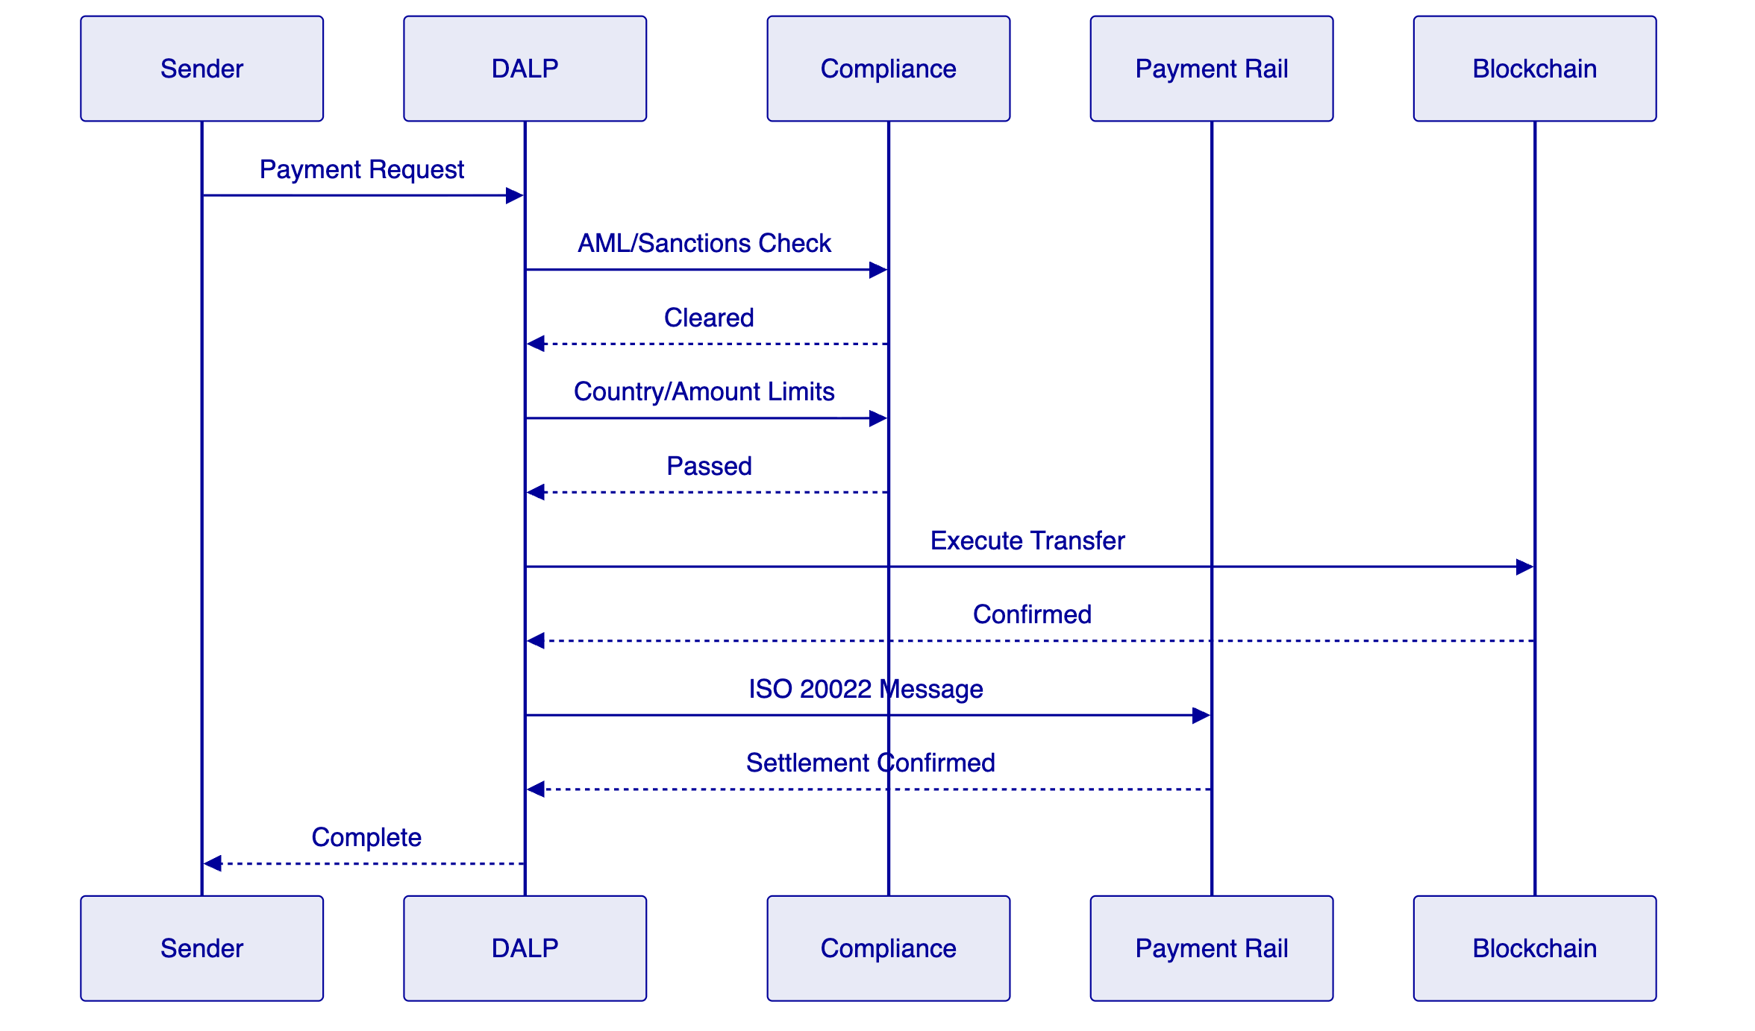
  - Settlement and Payment Integration
Atomic DvP/XvP settlement with ISO 20022 connectivity to SWIFT, RTGS, and local payment systems. For merchant corridors, DALP provides high-throughput settlement with the same compliance and audit controls applied to treasury operations. The XvP extension coordinates multi-currency exchanges for cross-border corridors with simultaneous settlement of all legs.
  - Functional Fit Matrix
Requirement | DALP Capability | Status
Tokenized deposits | Deposit template with programmable rules | Full
Stablecoin settlement | Stablecoin template with reserve monitoring | Full
Treasury operations | DvP/XvP, multi-currency settlement | Full
Merchant corridors | High-throughput settlement, REST APIs | Full
Cross-border payment | HTLC cross-chain, ISO 20022 | Full
CBUAE compliance | 18 modules, ex-ante enforcement | Full
AML/CFT integration | Webhook screening integration | Full
RBAC and audit | 5 roles, maker-checker, immutable trail | Full
Environment segregation | Dev, staging, UAT, DR, production | Full
Resilience and DR | HA, backup, 3-pillar observability | Full

- Technical Architecture
  - Layered Architecture
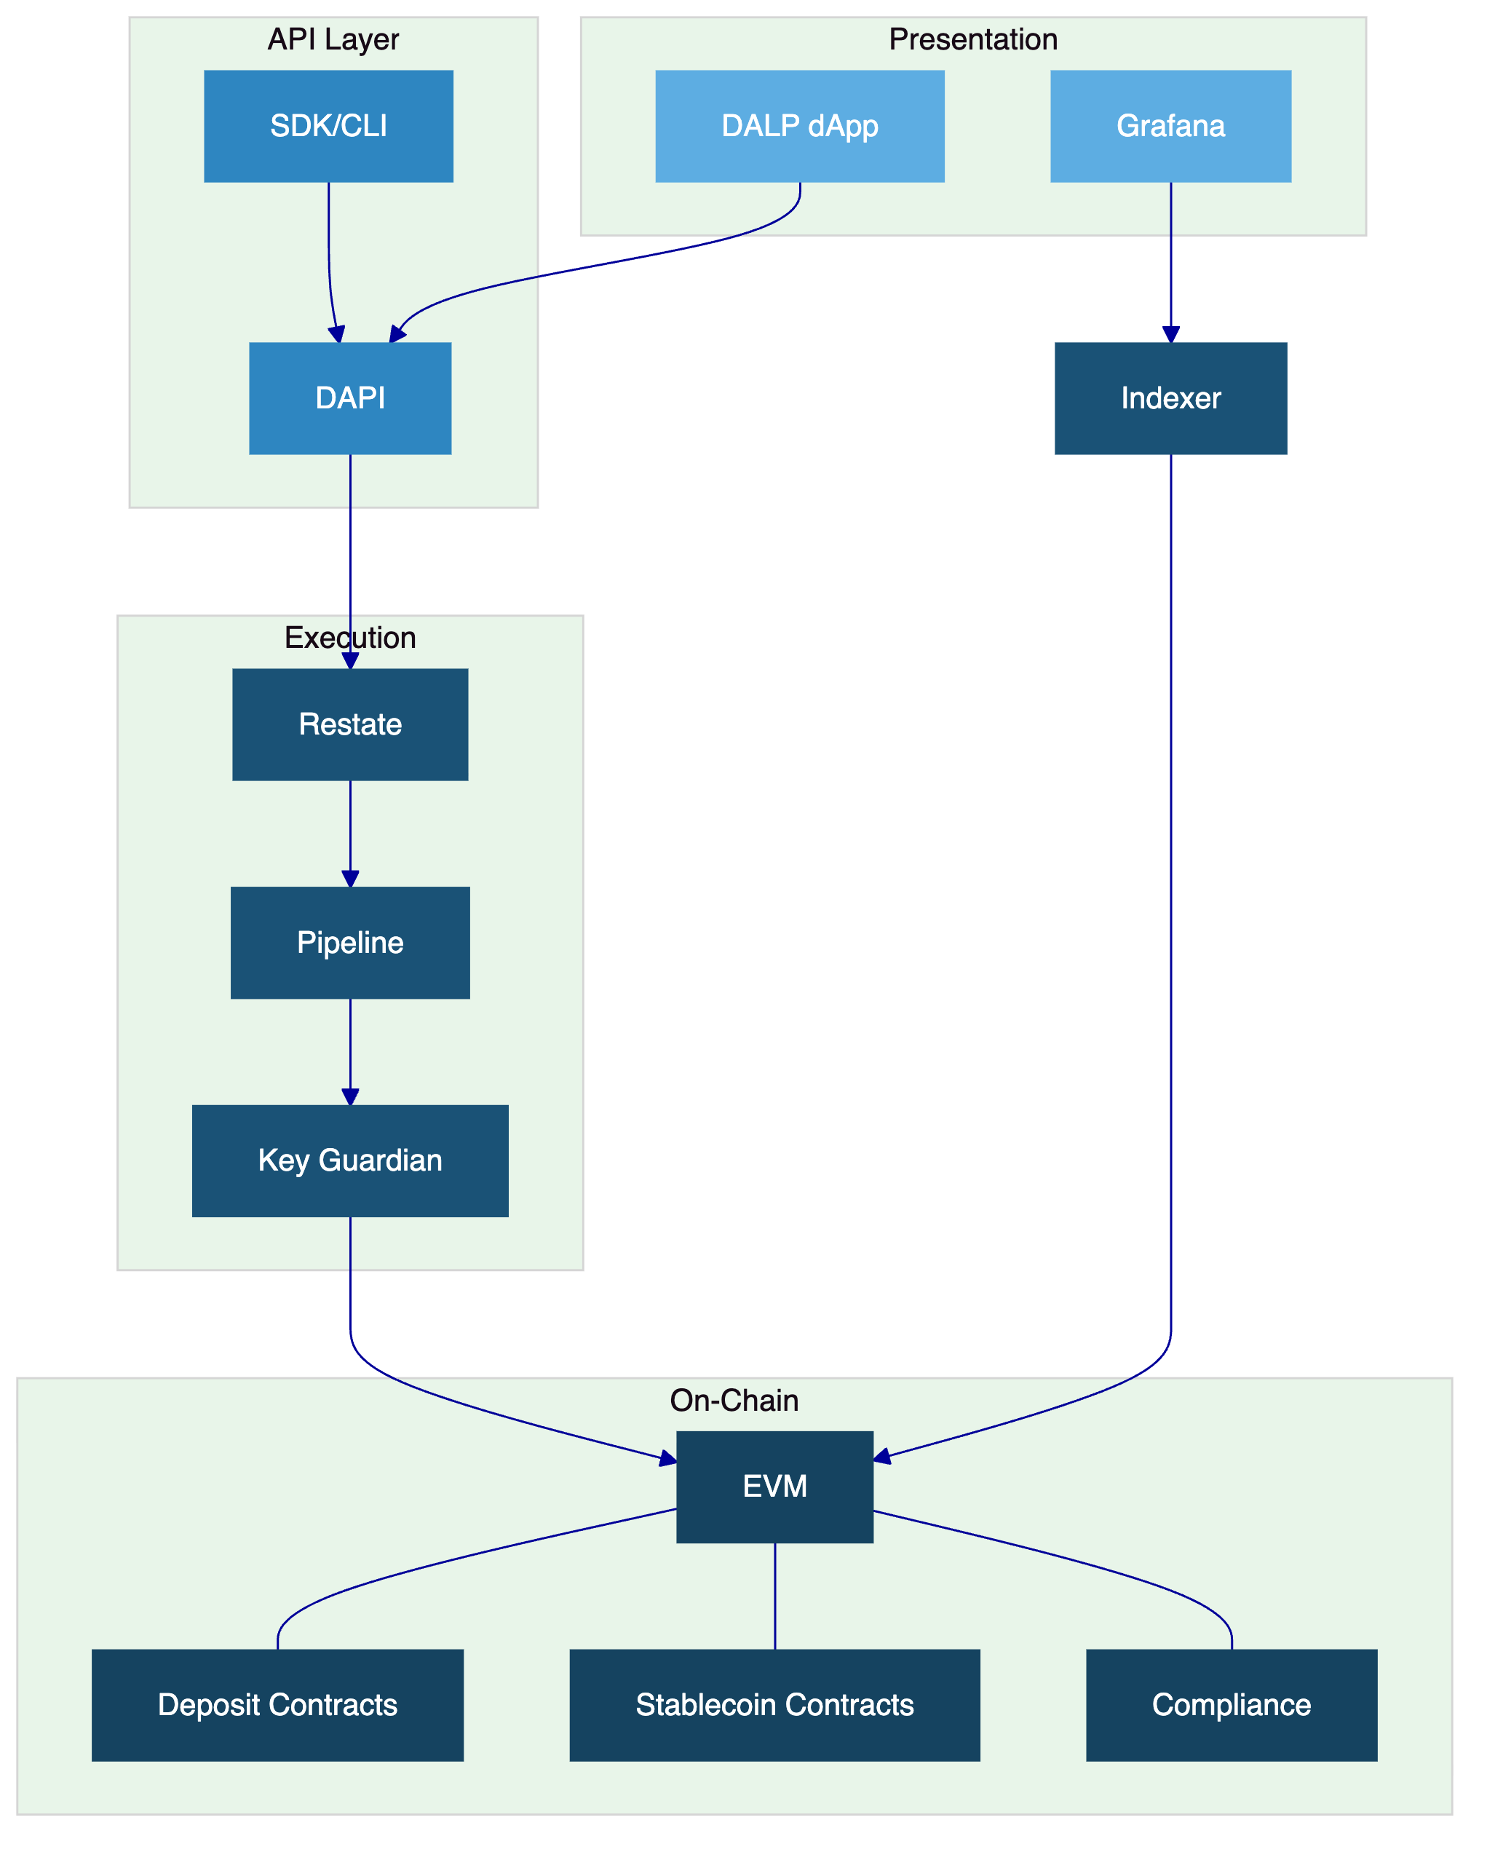
  - Data Architecture
Chain state (authoritative records), application state (PostgreSQL with zero-downtime schema), indexed state (read-optimized views for dashboards and reporting). The async transaction pipeline provides 11-state lifecycle management with idempotency, dead-letter rescue, and public status polling.
  - Transaction Pipeline
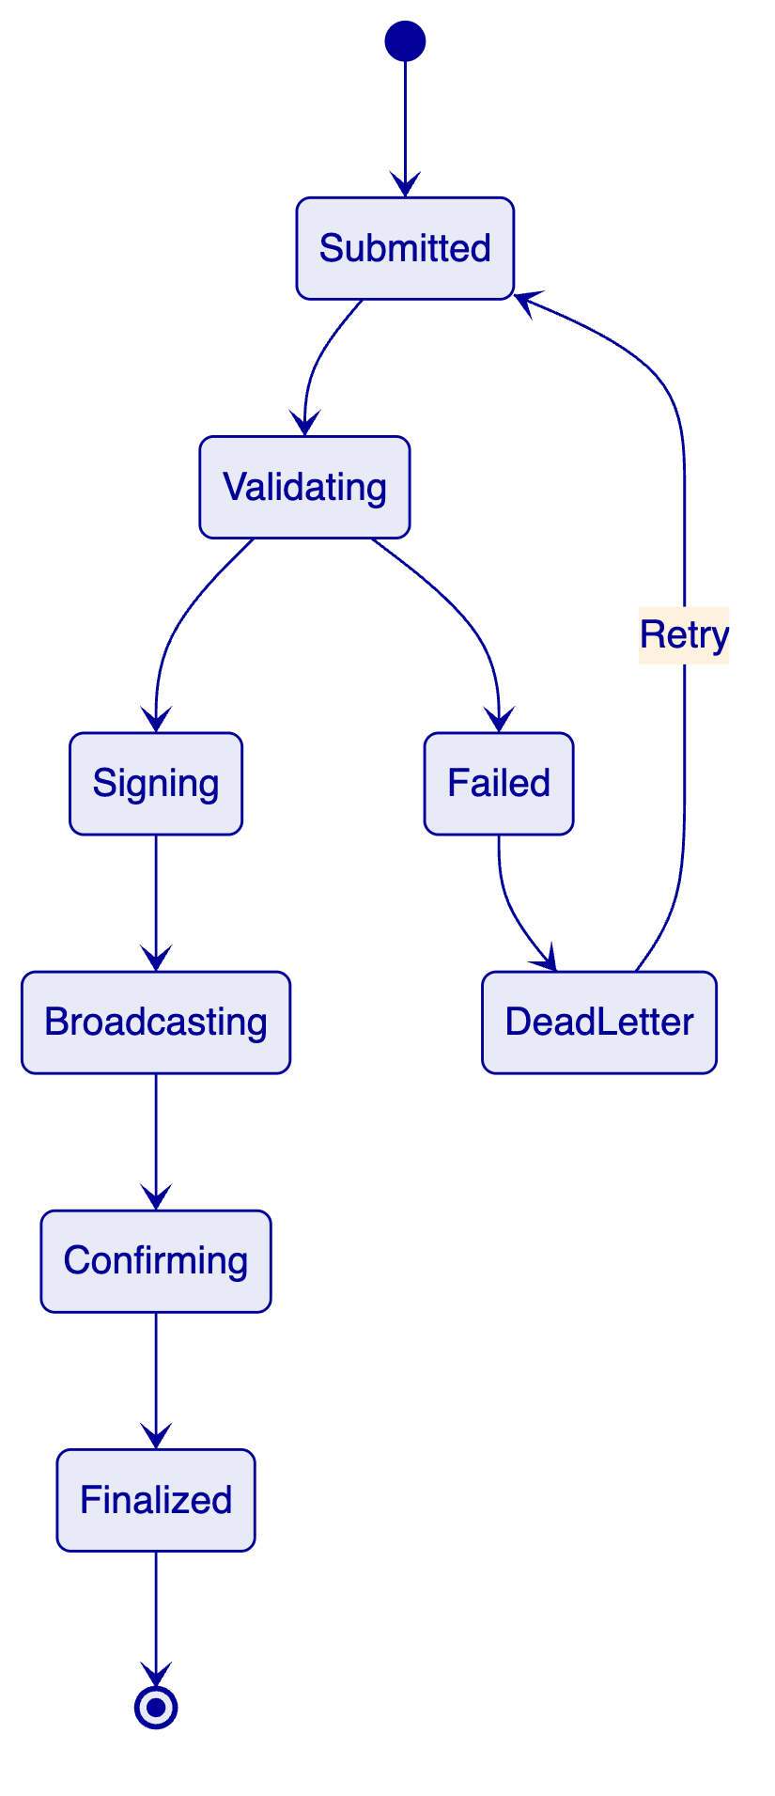

- Security
Three-domain trust model with defense-in-depth. Two-endpoint authentication. Five-role RBAC. Key Guardian with Tier 4 custody (Fireblocks/DFNS) for production. Maker-checker workflows. Emergency pause capability. Encrypted data at rest and in transit. 534 structured error codes for auditability. Security testing as part of Phase 4.
Control Area | SettleMint | Mashreq Bank
Platform security | Owner | Reviewer
Key management | Shared | Owner
Access control config | Advisor | Owner
Compliance rules | Advisor | Owner

- Project Implementation and Delivery
  - Phase Plan
Phase | Weeks | Objective
Discovery | 1 to 3 | Requirements, CBUAE mapping, architecture
Foundation | 4 to 7 | Environments, deposit/stablecoin config, compliance
Integration | 8 to 11 | Core banking, SWIFT, merchant systems, AML
Testing | 12 to 15 | Functional, NFR, security, UAT
Go-Live | 16 to 17 | Controlled cutover
Hypercare | 18 to 21 | Monitoring and handover

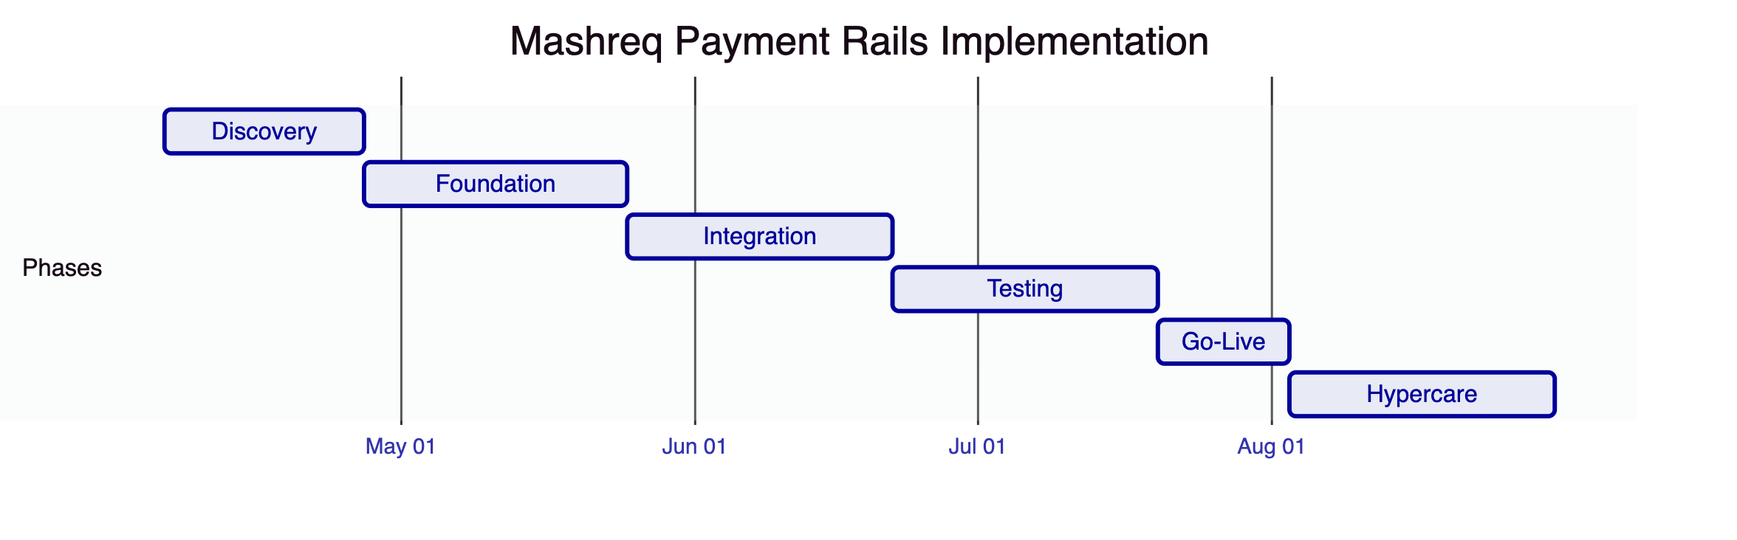
  - Risks
Risk | Likelihood | Impact | Mitigation
CBUAE regulatory timing | Medium | High | Early engagement in Discovery
SWIFT integration complexity | Medium | Medium | ISO 20022 standard patterns
Merchant system diversity | Medium | Medium | Phased integration approach
Custody provider onboarding | Low | Medium | Parallel setup track

- Deployment
Dedicated cloud, UAE-resident infrastructure. Multi-zone HA. All models deliver identical capabilities.
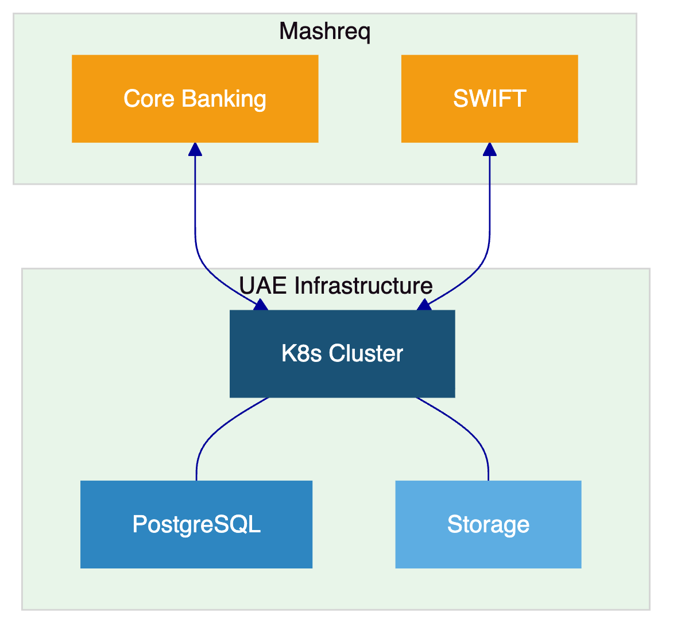

- Training and Knowledge Transfer
Administrator track (platform ops), Developer track (APIs, SDK), Operations track (payment workflows, monitoring). Knowledge transfer through labs, shadowing, and runbooks.

- Support and SLA
Premium recommended. 99.95% uptime, 2-hour P1 response, dedicated engineer, monthly releases.

- Compliance Matrix
Requirement | Status | DALP Response
Tokenized deposits | Full | Deposit template
Stablecoin operations | Full | Stablecoin template
Treasury settlement | Full | DvP/XvP, ISO 20022
Merchant settlement | Full | REST APIs, high-throughput
Cross-border corridors | Full | HTLC, bridge functionality
CBUAE compliance | Configurable | Modules mapped; buyer interprets
AML/CFT | Full | Webhook integration
RBAC and audit | Full | 5 roles, immutable trail
Environment segregation | Full | Full environment set
Resilience and DR | Full | HA, 3-pillar observability

- Support Appendix
Dedicated engineer maintaining knowledge of Mashreq's deployment. Monthly service reports. 72-hour maintenance notice; 24-hour for critical security patches.

