[Company name]
[Document title]
[Document subtitle]

Confidentiality Statement
This document contains confidential and proprietary information of SettleMint. By reading this document, you agree not to disclose the confidential information contained herein to any third party without the prior written consent of SettleMint, except to those agents, principals, representatives, or consultants who require access for the purpose of evaluating this document. You further agree to inform such persons of the confidential nature of this document and to obtain their agreement to preserve its confidentiality to the same extent as yours.
This confidentiality statement shall remain binding on the parties for a period of five (5) years from the date stated on the front cover, unless superseded by confidentiality provisions detailed in a subsequent agreement.
Terms and Conditions
This proposal is valid until [DD Month YYYY]. In the absence of confirmation to proceed, SettleMint and [the Company] acknowledge and agree to abide by the Mutual NDA as the governing agreement.
SettleMint reserves the right to vary the terms of this proposal in response to changes in specifications or information made available at a later date. Submission of this proposal does not convey any right, title, interest, or license in any intellectual property rights (including, but not limited to, patents, copyrights, trade secrets, or trademarks) contained herein.
All rights are reserved. This proposal and the information contained within it are provided on an “as is” basis, without any warranties of any kind, express or implied.
All contracts with SettleMint will be governed by Belgian Law and subject to the exclusive jurisdiction of Belgian courts.
Contact Details
For any enquiries regarding this document, please contact:
[Full Name]
[Job Title]
Email: [email@example.com]
Phone: [Country Code - Number]

Table of Contents

Executive Summary 3
Context and Strategic Drivers 4
Why This Programme Is Hard 5
Proposed Response 6
Why SettleMint 7
Why DALP 8
Reference Fit Snapshot 9
About SettleMint 10
Company Overview 11
Production Credentials 12
Regulatory Readiness 13
About DALP 14
Platform Overview 15
Core Lifecycle Pillars 16
Issuance 17
Compliance 18
Custody 19
Settlement 20
Servicing 21
Platform Foundations 22
Customer References 23
Expanded Reference: OCBC Bank 24
Expanded Reference: Saudi RER 25
Understanding of Requirements 26
Requirement Domains 27
Proposed Solution 28
Solution Overview 29
Functional Fit Matrix 30
Technical Architecture 31
Layered Architecture 32
Transaction Pipeline 33
Security 34
Implementation 35
Deployment 36
Training, Support, and SLA 37
Compliance Matrix 38

Field | Value
Proposal title | Technical Proposal: Digital Asset Core Infrastructure for Regulated Institutional Products
Client | National Bank of Egypt (Egypt)
Submitted by | SettleMint NV
Date | March 2026
Version | v1.0
Confidentiality | Restricted
RFP Reference | NATIONAL-BANK-OF-EGYPT-RFP-DIGITAL-ASSET-INFRASTRUCTURE-202603
Contact | SettleMint NV, Kempische Steenweg 311/4.01, 3500 Hasselt, Belgium
Valid until | June 2026

- Executive Summary
  - Context and Strategic Drivers
National Bank of Egypt (NBE) is procuring digital asset core infrastructure for regulated institutional products as a business-critical capability operating within a control environment shaped by the Central Bank of Egypt (CBE) and Financial Regulatory Authority (FRA) supervisory frameworks. As Egypt's largest and oldest commercial bank, NBE requires production-grade infrastructure that can support multiple digital asset product types across institutional and potentially retail segments, with the governance, compliance, and operational reliability that regulatory oversight demands.
DALP delivers deterministic settlement finality in under 3 seconds with compliance enforcement built into every transaction, providing the performance and control characteristics that institutional digital asset products require.
  - Why This Programme Is Hard
Digital asset core infrastructure for a bank of NBE's scale must support multiple asset classes simultaneously, from bonds and deposits through to potentially equities and structured products. The platform must integrate with NBE's extensive branch network systems, core banking infrastructure, identity and KYC processes, and regulatory reporting. Egypt's evolving digital asset regulatory framework requires a platform that can adapt compliance controls as CBE and FRA guidance matures.
The "core infrastructure" designation means this is not a single-product deployment; it is the foundation on which multiple digital asset products will be built over time. This demands architectural flexibility, multi-asset lifecycle management, and the ability to add new product types without replacing or substantially modifying the underlying platform.
  - Proposed Response
SettleMint proposes DALP as the core digital asset infrastructure for NBE's regulated institutional products. DALP's multi-asset architecture, covering bonds, equities, funds, deposits, stablecoins, real estate, and precious metals through purpose-built templates, plus a configurable token for novel asset classes, provides the product breadth NBE requires. The deployment model uses dedicated cloud with Egypt-resident infrastructure.
  - Why SettleMint
Nearly a decade of production experience. Sovereign-scale Middle East programmes (Saudi RER, IsDB). Multi-year regulated bank deployments (OCBC, Standard Chartered, SBI). Bond-specific credentials (Commerzbank, Mizuho). Multi-asset platform capability proven across 7 asset classes in production.
  - Why DALP
DALP uniquely provides multi-asset lifecycle coverage through a single platform. The 7 pre-built asset templates plus configurable token mean NBE can launch bonds first, then add deposits, equities, or funds using the same compliance engine, governance model, and operational tooling. This eliminates the need to procure separate platforms for each product type and ensures consistent compliance enforcement across all digital asset products.
  - Reference Fit Snapshot
- Saudi RER: National-scale tokenization with deep government system integration, relevant to NBE's Egyptian public-sector context
- IsDB: Multi-country financial infrastructure serving 57 member countries, demonstrating scale and multi-jurisdictional governance
- OCBC Bank: Multi-asset security token engine for institutional distribution, demonstrating the core infrastructure use case

- About SettleMint
  - Company Overview
Production-grade digital asset lifecycle management company with nearly 10 years of focus and 7+ years of continuous production at regulated banks. Multi-year deployments across bonds, equities, deposits, stablecoins, real estate, and funds.
  - Production Credentials
Category | Evidence
Market Validation | Nearly 10 years; 7+ years production
Operational Maturity | 7 asset classes in production
Sovereign Credibility | National-scale Middle East programmes
Team Depth | 200+ years combined experience

  - Regulatory Readiness
Jurisdiction | DALP Support
Egypt (CBE, FRA) | Controls mapped; buyer interprets
EU (MiCA) | Native templates
GCC | Supported
Singapore (MAS) | Modules available

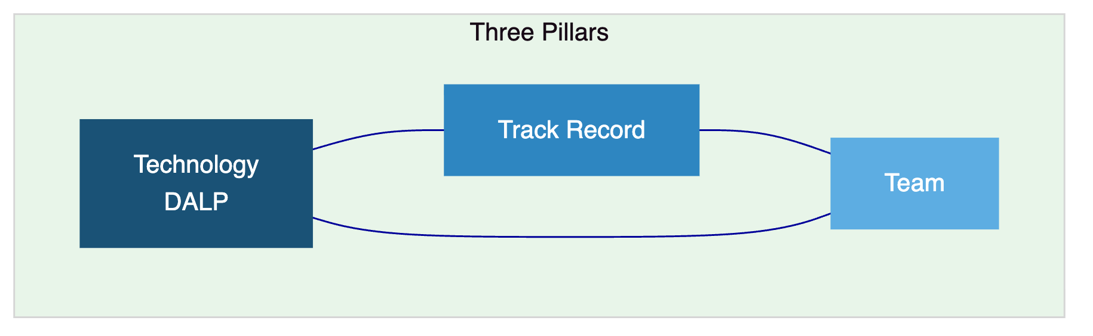

- About DALP
  - Platform Overview
Full digital asset lifecycle from design through retirement. Multi-asset platform supporting 7 asset classes plus configurable tokens. For NBE, DALP provides the foundational infrastructure on which multiple digital asset products can be launched and operated under a single governance model.
  - Core Lifecycle Pillars
    - Issuance
7 purpose-built asset templates (bonds, equities, funds, deposits, stablecoins, real estate, precious metals) plus configurable token with up to 32 pluggable features. Asset Designer wizard. Deterministic orchestration with paused-by-default governance.
    - Compliance
18 compliance module types with ex-ante enforcement. ERC-3643 (T-REX) with OnchainID. Multi-jurisdictional support for CBE, FRA, and international frameworks.
    - Custody
Key Guardian with Fireblocks and DFNS. Maker-checker workflows. Provider-delegated transaction broadcast.
    - Settlement
Atomic DvP/XvP with T+0 finality. ISO 20022 for SWIFT, SEPA, RTGS. HTLC cross-chain settlement.
    - Servicing
Automated coupons, dividends, interest, maturity, corporate actions. Complete audit trail for every lifecycle event.
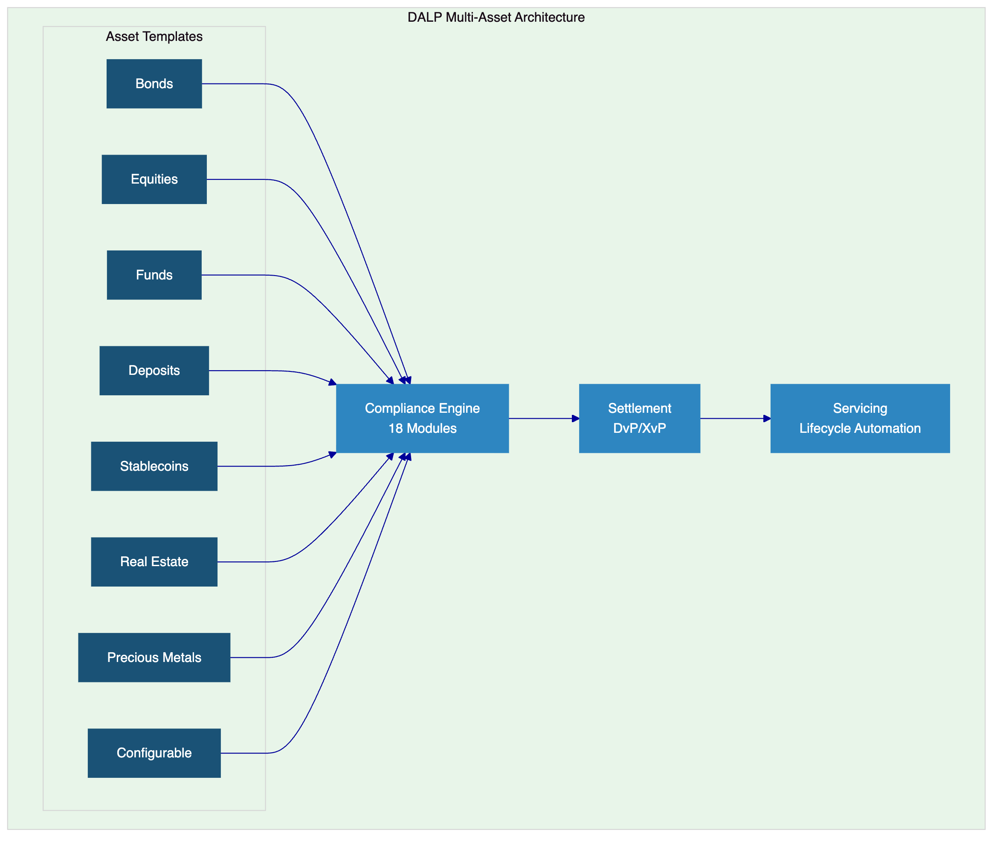
  - Platform Foundations
Identity and access (OnchainID, 5-role RBAC, KYC/KYB), integration (REST, GraphQL, webhooks, oRPC, SDK, CLI, ISO 20022), observability (Grafana, VictoriaMetrics, Loki, Tempo, 534 error codes).

- Customer References
Client | Use Case | Geography | Relevance
OCBC Bank | Multi-asset security tokens | Singapore | Core infrastructure use case
Saudi RER | Country-scale tokenization | KSA | National-scale, Egyptian context
IsDB | Subsidy distribution, 57 countries | Multi-region | Multi-jurisdictional
Commerzbank | ETP issuance | Germany | Fixed income
Standard Chartered | Digital exchange | Asia, Africa, ME | Multi-asset institutional
SBI | CBDC infrastructure | India | National digital currency
Mizuho | Bond tokenization | Japan | Fixed income
Maybank | FX tokenization | Malaysia | Cross-border
Sony Bank | Stablecoin | Japan | Deposit/stablecoin
KBC Securities | Equity crowdfunding | Belgium | Multi-asset lifecycle

  - Expanded Reference: OCBC Bank
OCBC Bank deployed SettleMint's security token engine for securitization, tokenization, and fractionalization of off-chain assets targeting HNWIs and HENRYs. The solution spans bonds, SPVs, stocks, and real estate with a secure end-user interface, order book management, and cash position tracking. This reference demonstrates the "core infrastructure" model NBE is seeking: a single platform supporting multiple asset types for institutional distribution.
  - Expanded Reference: Saudi RER
Country-scale blockchain infrastructure for real estate registration, fractionalization, and marketplace. Deep integration with government registry, billing, escrow, and administrative systems. Demonstrates national-scale delivery discipline relevant to NBE's position as Egypt's leading public-sector bank.

- Understanding of Requirements
  - Requirement Domains
Domain | NBE Requirements | DALP Coverage
Multi-Asset Scope | Core infrastructure for multiple product types | 7 templates + configurable token
Identity | Integration with NBE identity systems | OnchainID, Identity Registry
Compliance | CBE/FRA requirements, multi-product controls | 18 modules, ex-ante enforcement
Settlement | Multi-asset settlement, payment integration | DvP/XvP, ISO 20022
Integration | Core banking, branch systems, reporting | REST, GraphQL, webhooks, SDK, CLI
Scalability | Foundation for future product expansion | Same platform, new configuration

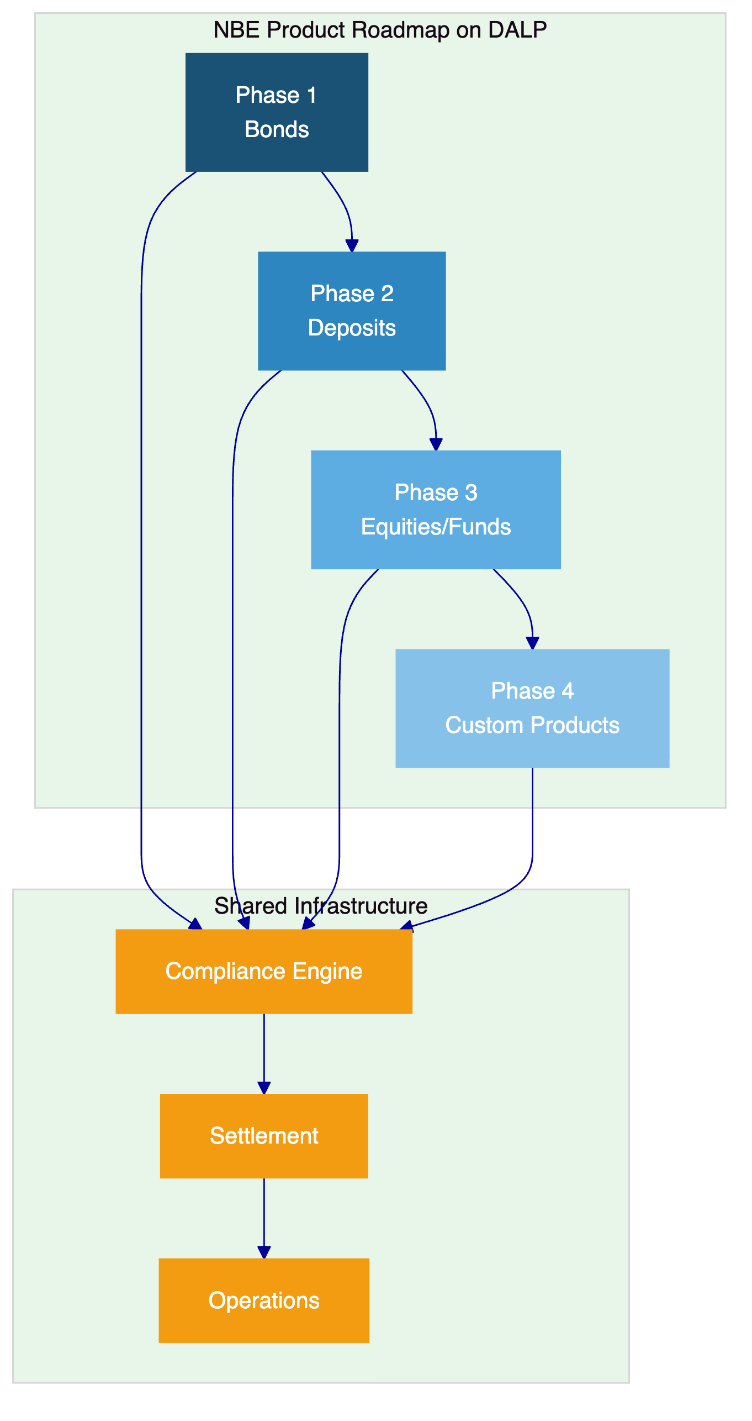

- Proposed Solution
  - Solution Overview
DALP deploys as the core digital asset infrastructure within NBE's enterprise environment. Phase 1 focuses on bonds, with the architecture designed to support phased expansion into deposits, equities, funds, and custom products using the same platform, compliance engine, and governance model.
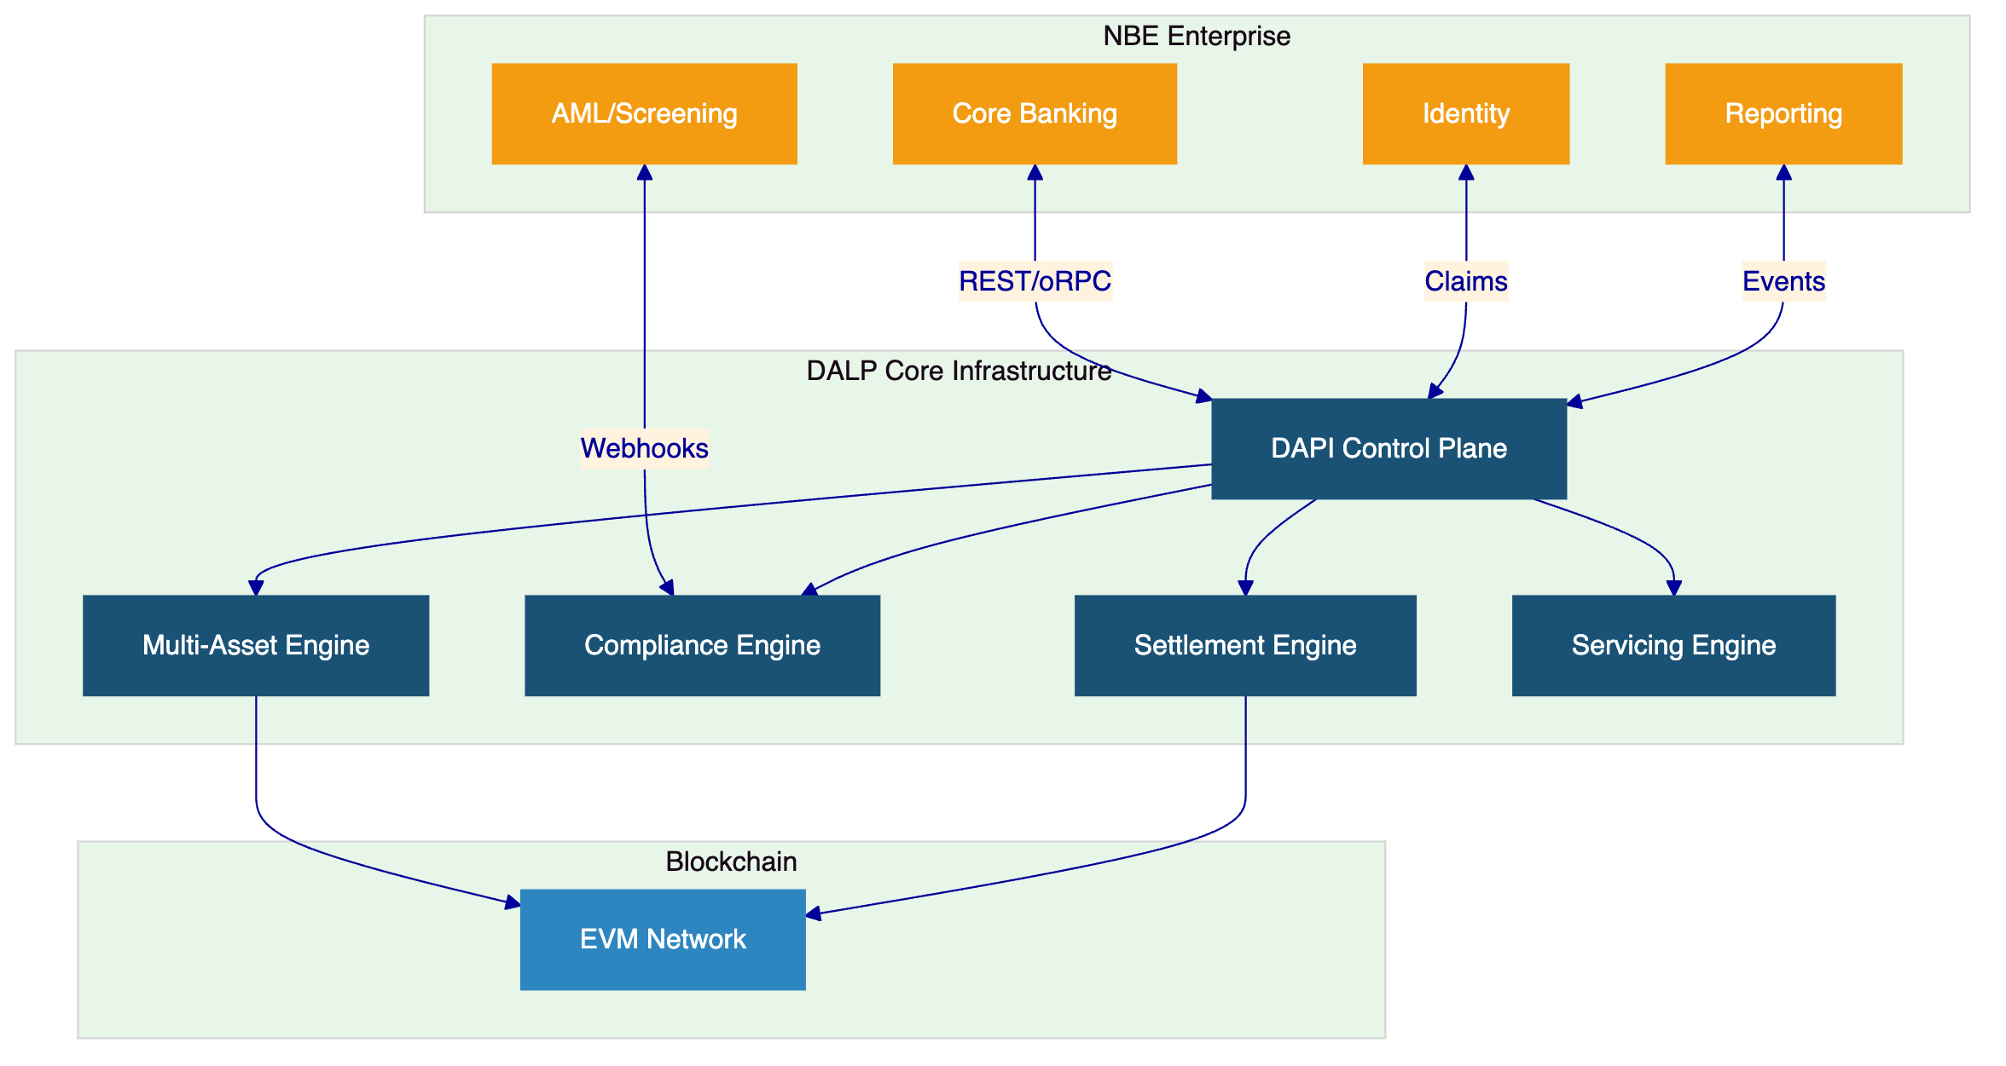
  - Functional Fit Matrix
Requirement | DALP Capability | Status
Multi-asset support | 7 templates + configurable token | Full
Environment segregation | Dev, staging, UAT, DR, production | Full
API-first integration | REST, GraphQL, webhooks, oRPC, SDK, CLI | Full
RBAC and audit | 5 roles, maker-checker, immutable trail | Full
Lifecycle management | Templates, policies, governance gates | Full
Compliance enforcement | 18 modules, ex-ante, ERC-3643 | Full
Settlement | Atomic DvP/XvP, ISO 20022 | Full
Servicing | Automated coupons, maturity, distributions | Full
Resilience | HA, DR, 3-pillar observability | Full
Evidence for audit | 534 error codes, compliance records | Full

- Technical Architecture
  - Layered Architecture
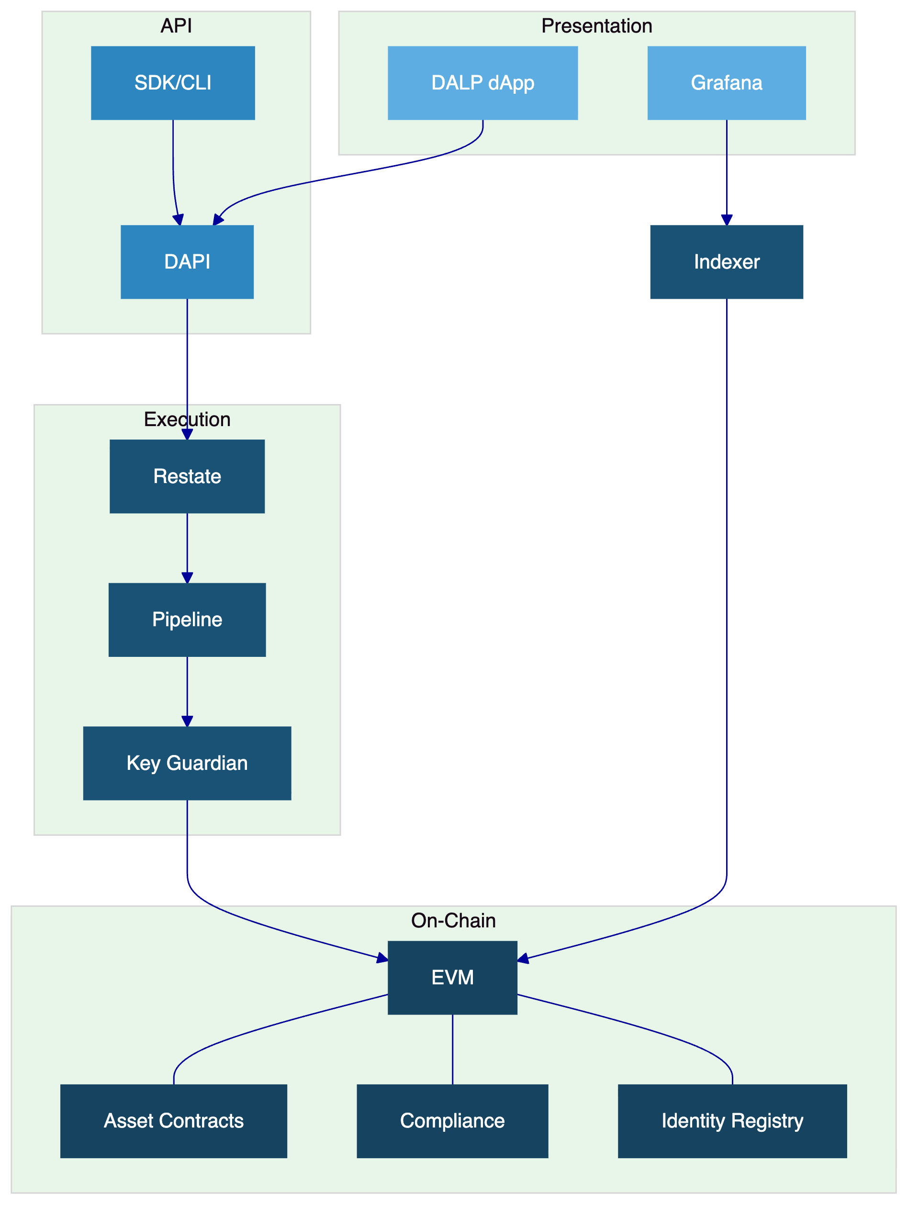
  - Transaction Pipeline
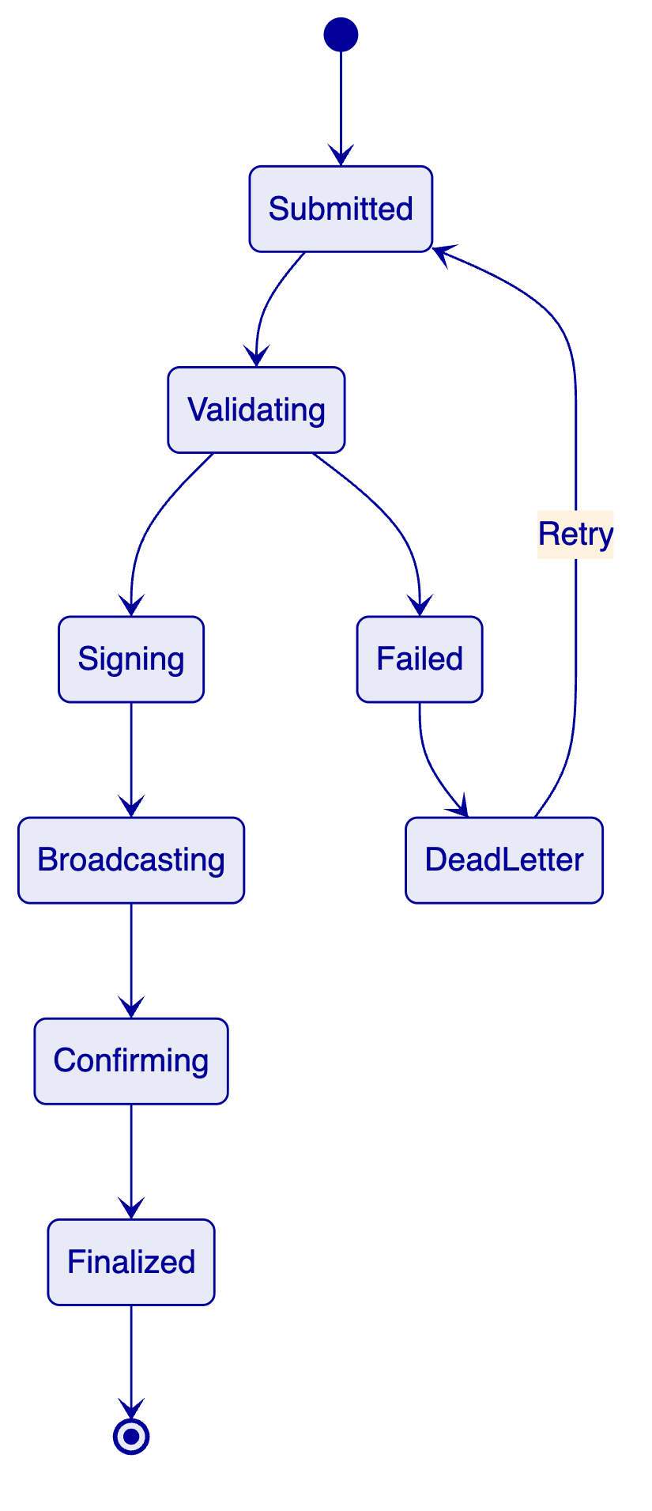

- Security
Three-domain trust model. Defense-in-depth. Two-endpoint authentication. 5-role RBAC. Key Guardian Tier 4 for production. Maker-checker. Emergency pause. Encrypted at rest and in transit. 534 error codes. Security testing in Phase 4.

- Implementation
Phase | Weeks | Objective
Discovery | 1 to 3 | Requirements, CBE/FRA mapping, multi-asset architecture
Foundation | 4 to 7 | Environments, Phase 1 asset config, compliance
Integration | 8 to 11 | Core banking, identity, AML, reporting
Testing | 12 to 15 | Functional, NFR, security, UAT
Go-Live | 16 to 17 | Controlled cutover
Hypercare | 18 to 21 | Monitoring and handover

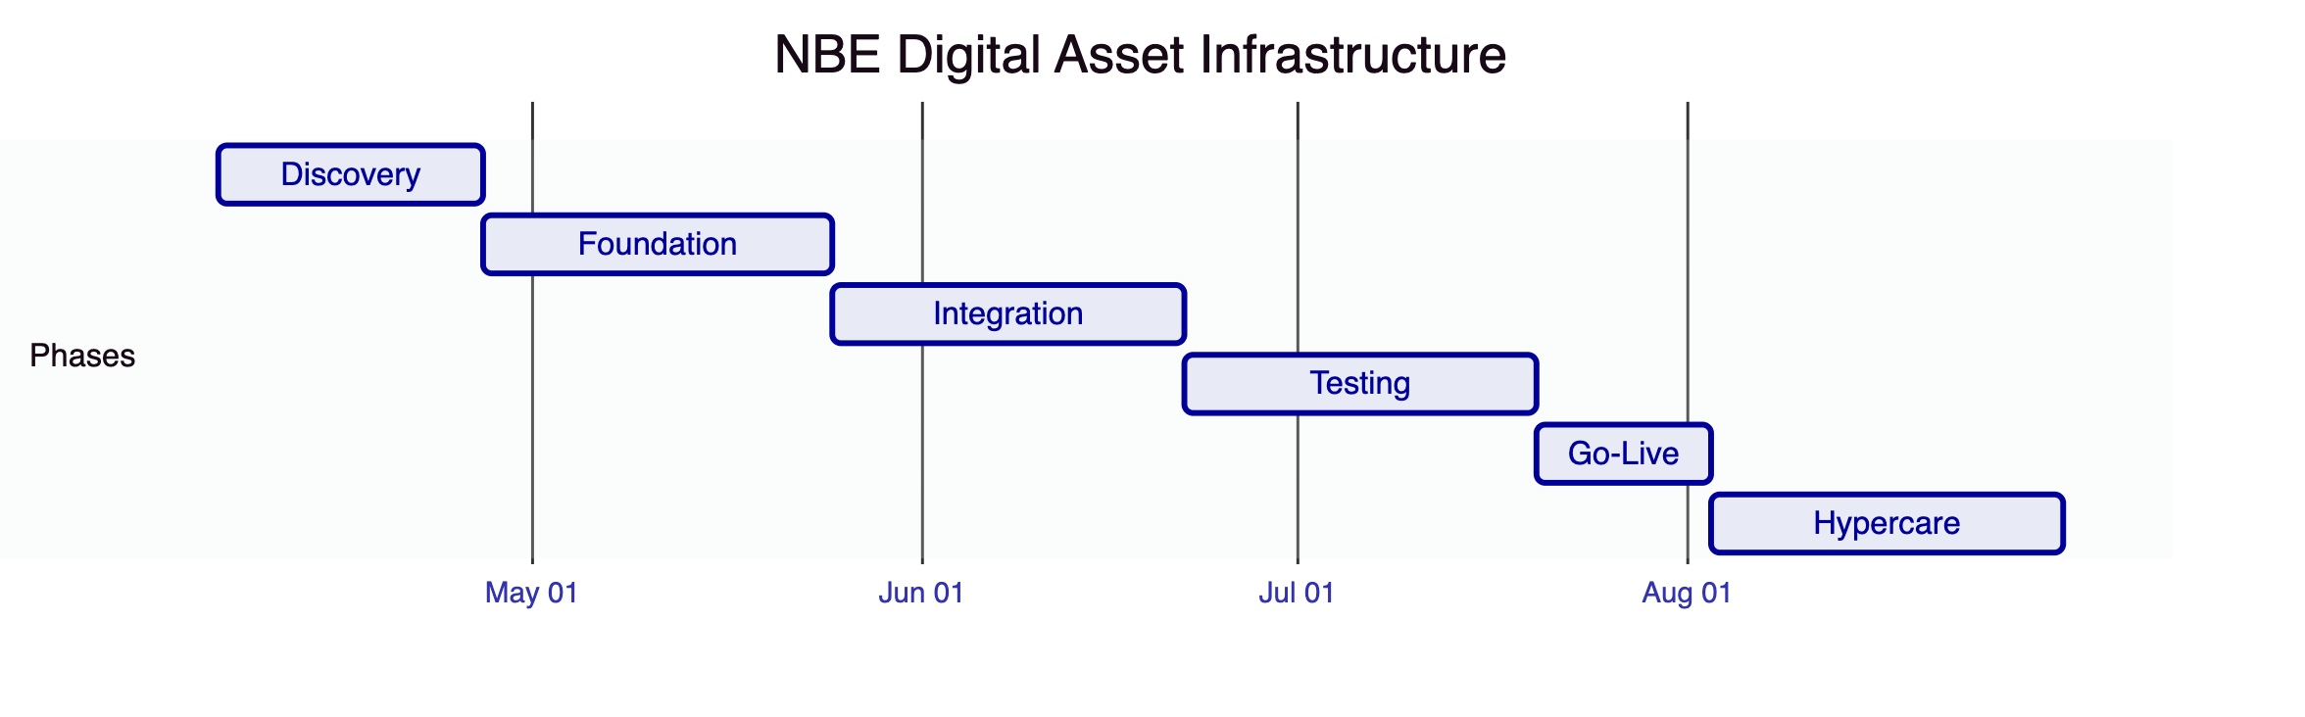

- Deployment
Dedicated cloud, Egypt-resident. Multi-zone HA. All models deliver identical capabilities.

- Training, Support, and SLA
Premium support recommended. Three training tracks. 99.95% uptime, 2-hour P1 response, dedicated engineer.

- Compliance Matrix
Requirement | Status | DALP Response
Multi-asset infrastructure | Full | 7 templates + configurable
Environment segregation | Full | Full environment set
API-first | Full | REST, GraphQL, webhooks, oRPC
RBAC and audit | Full | 5 roles, immutable trail
Lifecycle management | Full | Templates, governance gates
Compliance | Full | 18 modules, ex-ante
Settlement | Full | DvP/XvP, ISO 20022
Resilience | Full | HA, 3-pillar observability
Regulatory mapping | Configurable | Modules mapped; buyer interprets

