[Company name]
[Document title]
[Document subtitle]

Confidentiality Statement
This document contains confidential and proprietary information of SettleMint. By reading this document, you agree not to disclose the confidential information contained herein to any third party without the prior written consent of SettleMint, except to those agents, principals, representatives, or consultants who require access for the purpose of evaluating this document. You further agree to inform such persons of the confidential nature of this document and to obtain their agreement to preserve its confidentiality to the same extent as yours.
This confidentiality statement shall remain binding on the parties for a period of five (5) years from the date stated on the front cover, unless superseded by confidentiality provisions detailed in a subsequent agreement.
Terms and Conditions
This proposal is valid until [DD Month YYYY]. In the absence of confirmation to proceed, SettleMint and [the Company] acknowledge and agree to abide by the Mutual NDA as the governing agreement.
SettleMint reserves the right to vary the terms of this proposal in response to changes in specifications or information made available at a later date. Submission of this proposal does not convey any right, title, interest, or license in any intellectual property rights (including, but not limited to, patents, copyrights, trade secrets, or trademarks) contained herein.
All rights are reserved. This proposal and the information contained within it are provided on an “as is” basis, without any warranties of any kind, express or implied.
All contracts with SettleMint will be governed by Belgian Law and subject to the exclusive jurisdiction of Belgian courts.
Contact Details
For any enquiries regarding this document, please contact:
[Full Name]
[Job Title]
Email: [email@example.com]
Phone: [Country Code - Number]

Table of Contents

Table of Contents
Executive Summary
Understanding QNB's Programme Objectives
The Sukuk Market Opportunity
Three Critical Challenges
Proposed DALP Operating Model for Tokenized Sukuk
Sukuk Product Configuration
Operating Model Mapping to QNB Workstreams
Technical Architecture and Integration Boundaries
Four-Layer Architecture
Enterprise Integration for QNB
Sukuk-Specific Smart Contract Architecture
DALPAsset Sukuk Configuration
Sukuk Distribution Flow
Identity, Compliance, and Sharia Governance
Compliance Engine Configuration for Sukuk
Role-Based Access Control
Settlement, Distribution, and Lifecycle Management
Atomic DvP Settlement
Distribution Types
Dissolution Mechanics
Security, Resilience, and Operational Assurance
Security Certifications
Operational Resilience
Implementation Approach and Delivery Phases
19-Week Implementation
Current Coverage, Dependencies, and Qualified Gaps
Requirements Coverage
Qualified Gap: REQ-12
Relevant Delivery Evidence
Appendices
Appendix A: Glossary

Field | Value
Proposal title | Technical Proposal — Tokenized Sukuk Issuance and Servicing Platform
Client | Qatar National Bank
Submitted by | SettleMint NV
Date | March 2026
Version | v1.0
Confidentiality | Restricted
RFP Reference | QATAR-NATIONAL-BANK-RFP-TOKENIZED-SUKUK-202603
Primary contact | Adam Popat, CEO

  - Table of Contents
- Executive Summary
- Understanding QNB's Programme Objectives
- Proposed DALP Operating Model for Tokenized Sukuk
- Technical Architecture and Integration Boundaries
- Sukuk-Specific Smart Contract Architecture
- Identity, Compliance, and Sharia Governance
- Settlement, Distribution, and Lifecycle Management
- Security, Resilience, and Operational Assurance
- Implementation Approach and Delivery Phases
- Current Coverage, Dependencies, and Qualified Gaps
- Relevant Delivery Evidence
- Appendices

  - Executive Summary
Qatar National Bank has identified tokenized sukuk issuance and servicing as a business-critical capability. This procurement tests whether the market can supply a dependable platform and implementation model for production-grade tokenized sukuk that operates within QCB regulatory expectations, QFC Authority capital markets rules, AAOIFI standards, and QNB's internal control environment.
SettleMint's Digital Asset Lifecycle Platform (DALP) provides production-ready infrastructure for the entire sukuk lifecycle — from structuring and issuance through periodic distribution, corporate actions, and dissolution — with Sharia compliance enforcement embedded at the smart contract level.
Why DALP fits QNB's sukuk programme:
- Full sukuk lifecycle coverage. DALP manages the complete sukuk lifecycle through configurable smart contracts: underlying asset referencing, certificate issuance, periodic rental or profit distributions, corporate actions, and dissolution with principal return. The Asset Designer wizard supports sukuk-specific parameters including underlying asset class, distribution frequency, dissolution triggers, and Sharia board attestation requirements.
- Sharia compliance at the contract layer. Every sukuk transfer passes through DALP's compliance engine, which enforces investor eligibility, jurisdiction restrictions, holding periods, and Sharia governance approvals at the smart contract level. Compliance rules travel with the token — they cannot be circumvented by application-layer workarounds.
- Production-proven Islamic finance capability. DALP powers the Islamic Development Bank's Sharia-compliant subsidy distribution system serving 57 member countries. The Saudi Arabia Real Estate Registry — a national-scale blockchain for property registration and fractionalization — runs on DALP in production since January 2026.
- Enterprise integration readiness. DALP integrates with core banking systems, custody providers, AML/CFT tooling, and regulatory reporting through a comprehensive API surface (REST, GraphQL, webhooks, SDK, CLI with 301 commands across 26 groups).
The proposed implementation spans 19 weeks from kickoff to hypercare completion, following SettleMint's phase-gated methodology with formal gate reviews at each stage.
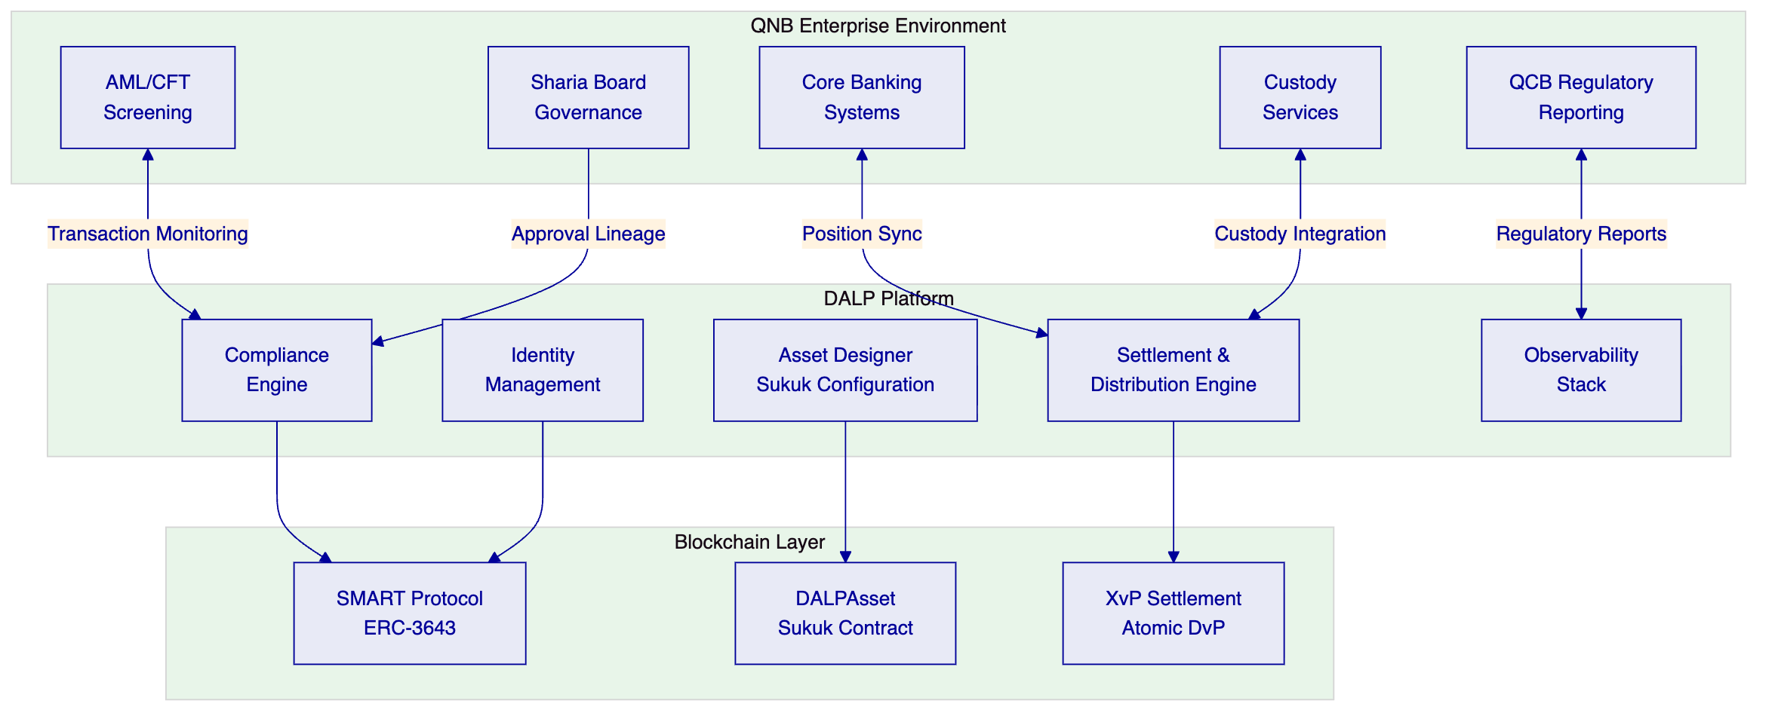

  - Understanding QNB's Programme Objectives
    - The Sukuk Market Opportunity
Qatar's sukuk market represents one of the fastest-growing segments of Islamic capital markets. QNB, as the largest financial institution in the Middle East and Africa by assets, is positioned to lead the digital transformation of sukuk issuance. The challenge is not whether to tokenize sukuk — it is whether the platform can handle the operational complexity of production-grade sukuk servicing: periodic distributions tied to underlying asset performance, dissolution mechanics, Sharia board governance, multi-party settlement, and regulatory reporting across jurisdictions.
    - Three Critical Challenges
Asset-backed integrity. Every sukuk certificate must reference a verifiable underlying asset. The platform must enforce that distributions are derived from actual asset performance, not simulated returns. This requires integration with asset valuation feeds and on-chain verification of collateral adequacy.
Distribution complexity. Sukuk distributions are not simple coupon payments. They may represent rental income (Ijarah), profit shares (Mudarabah), or sale proceeds (Murabaha). Each structure has different calculation mechanics, timing requirements, and Sharia governance implications. The platform must support configurable distribution logic without requiring custom smart contract development per sukuk issuance.
Lifecycle governance. From issuance through dissolution, sukuk require multi-party governance involving the issuer, Sharia board, trustee, and regulator. The platform must provide complete audit trails showing who approved each lifecycle event, which compliance checks were applied, and how the resulting state can be reconstructed for regulatory examination.
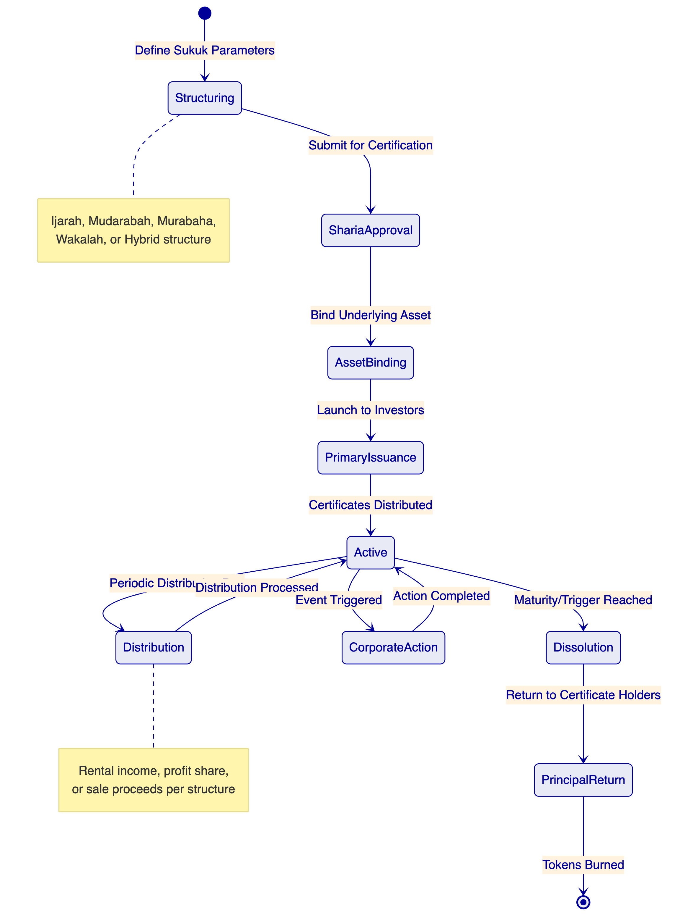

  - Proposed DALP Operating Model for Tokenized Sukuk
    - Sukuk Product Configuration
DALP's configurable token architecture supports all major sukuk structures without custom smart contract development:
Sukuk Type | Underlying Asset | Distribution Mechanism | DALP Configuration
Ijarah Sukuk | Real estate, equipment, infrastructure | Rental income pass-through | Fixed Treasury Yield feature + Collateral Requirement module
Mudarabah Sukuk | Investment portfolio | Profit-sharing per agreed ratio | Yield feature + configurable ratio parameters
Murabaha Sukuk | Trade receivables | Deferred sale markup payments | Maturity & Redemption feature + scheduled distributions
Wakalah Sukuk | Mixed asset pool | Agency fee + investment returns | Transaction Fee feature + Yield configuration
Hybrid Sukuk | Combined asset classes | Blended distribution mechanics | Multiple features composed on single DALPAsset
    - Operating Model Mapping to QNB Workstreams
Workstream | DALP Capability | QNB Responsibility
WS-01: Mobilisation | Environment provisioning, governance framework | Steering committee, design authority
WS-02: Product Configuration | Sukuk templates, compliance modules, distribution rules | Sharia board certification, product policy
WS-03: Integration | API surface, custody integration, payment rails | Core banking readiness, custody provider selection
WS-04: Testing | Platform test environments, security testing | UAT execution, business acceptance
WS-05: Operations | Observability, runbooks, SLA framework | Service desk staffing, management reporting

  - Technical Architecture and Integration Boundaries
    - Four-Layer Architecture
DALP operates as a four-layer stack with distinct responsibility boundaries:
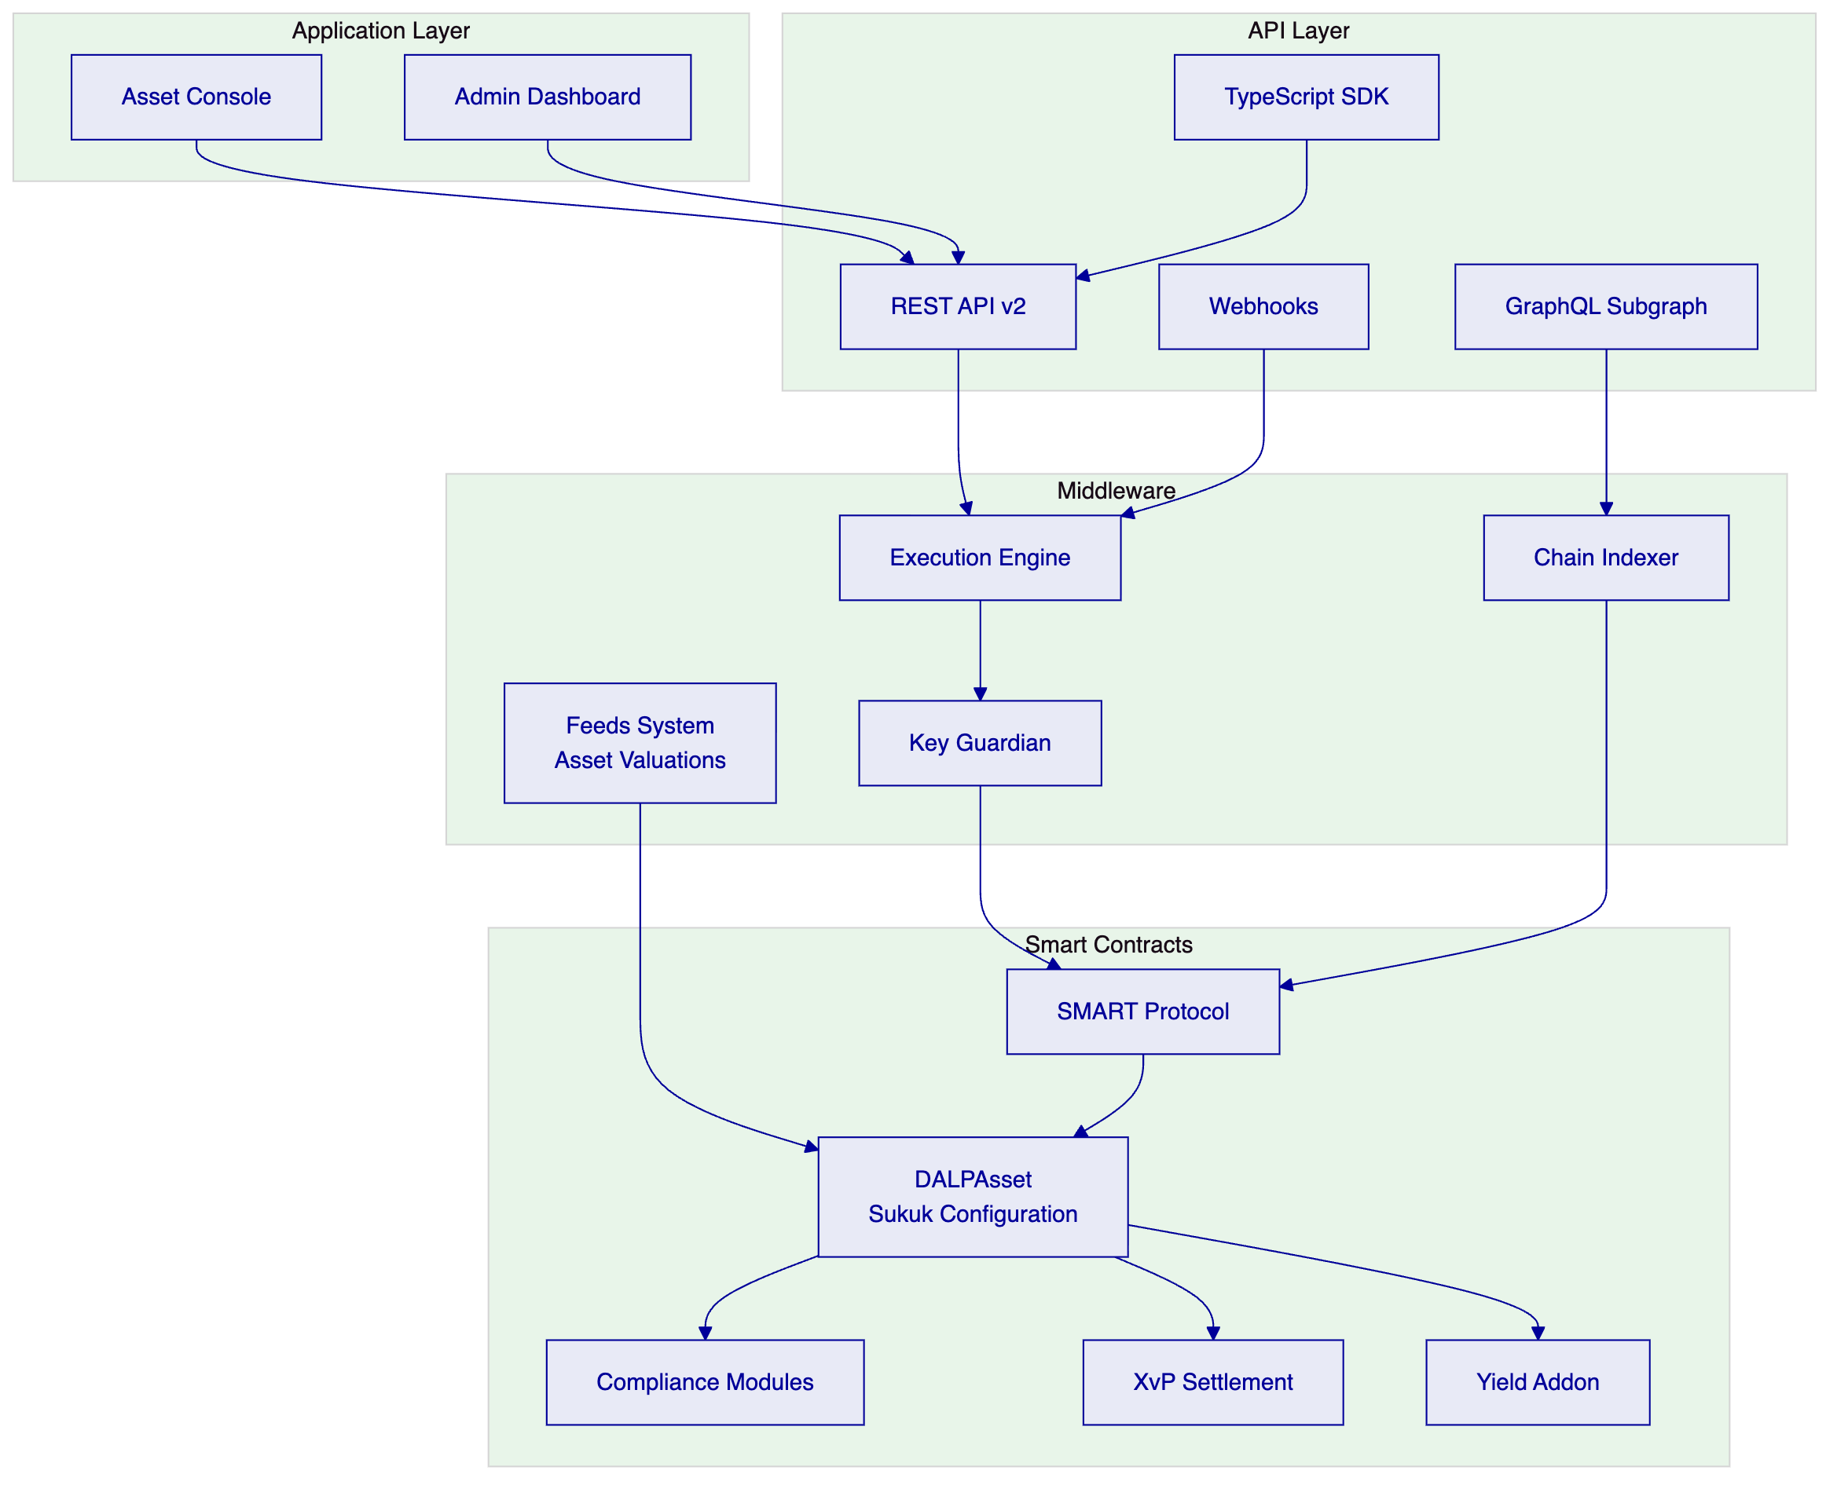
    - Enterprise Integration for QNB
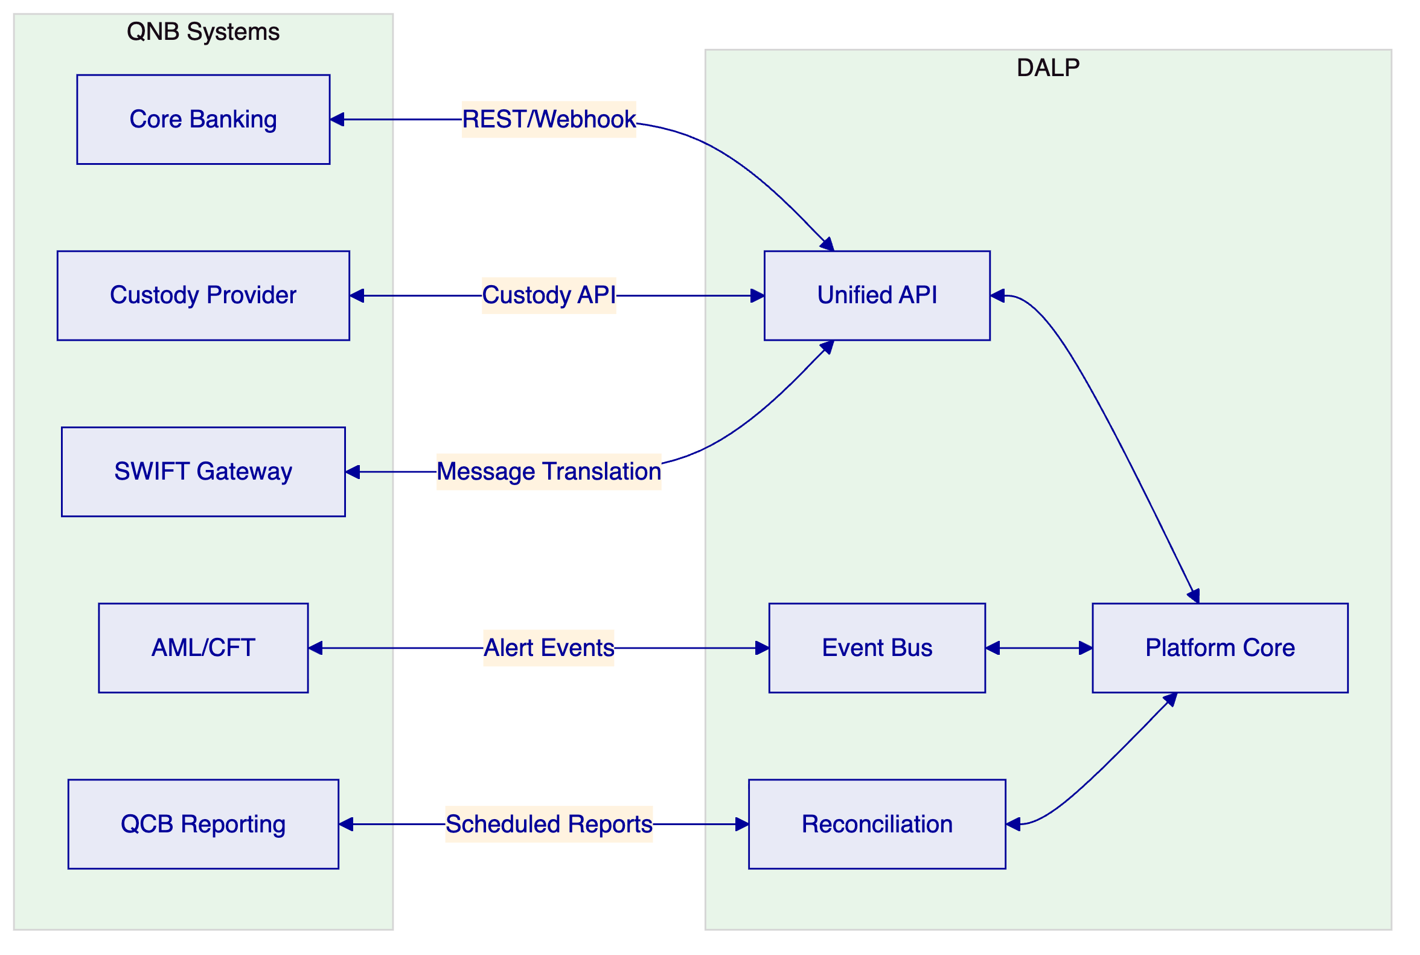

  - Sukuk-Specific Smart Contract Architecture
    - DALPAsset Sukuk Configuration
Each sukuk issuance is configured as a DALPAsset with the following composition:
Token features (runtime-pluggable):
- Fixed Treasury Yield — for periodic distribution calculations
- Maturity and Redemption — for dissolution mechanics and principal return
- Historical Balances — for audit snapshots at any point in time
- Permit — for gasless approval operations
- Transaction Fee — for agency fees in Wakalah structures
Compliance modules (fail-closed evaluation):
- Identity Verification — verified OnchainID with KYC claims
- Country Allow List — Qatar and permitted jurisdictions
- Investor Accreditation — qualified investor checks per QFC rules
- Transfer Approval — Sharia board and trustee sign-off workflows
- Holding Period (Time Lock) — minimum holding enforcement with FIFO tracking
- Collateral Requirement — on-chain verification of underlying asset adequacy
    - Sukuk Distribution Flow
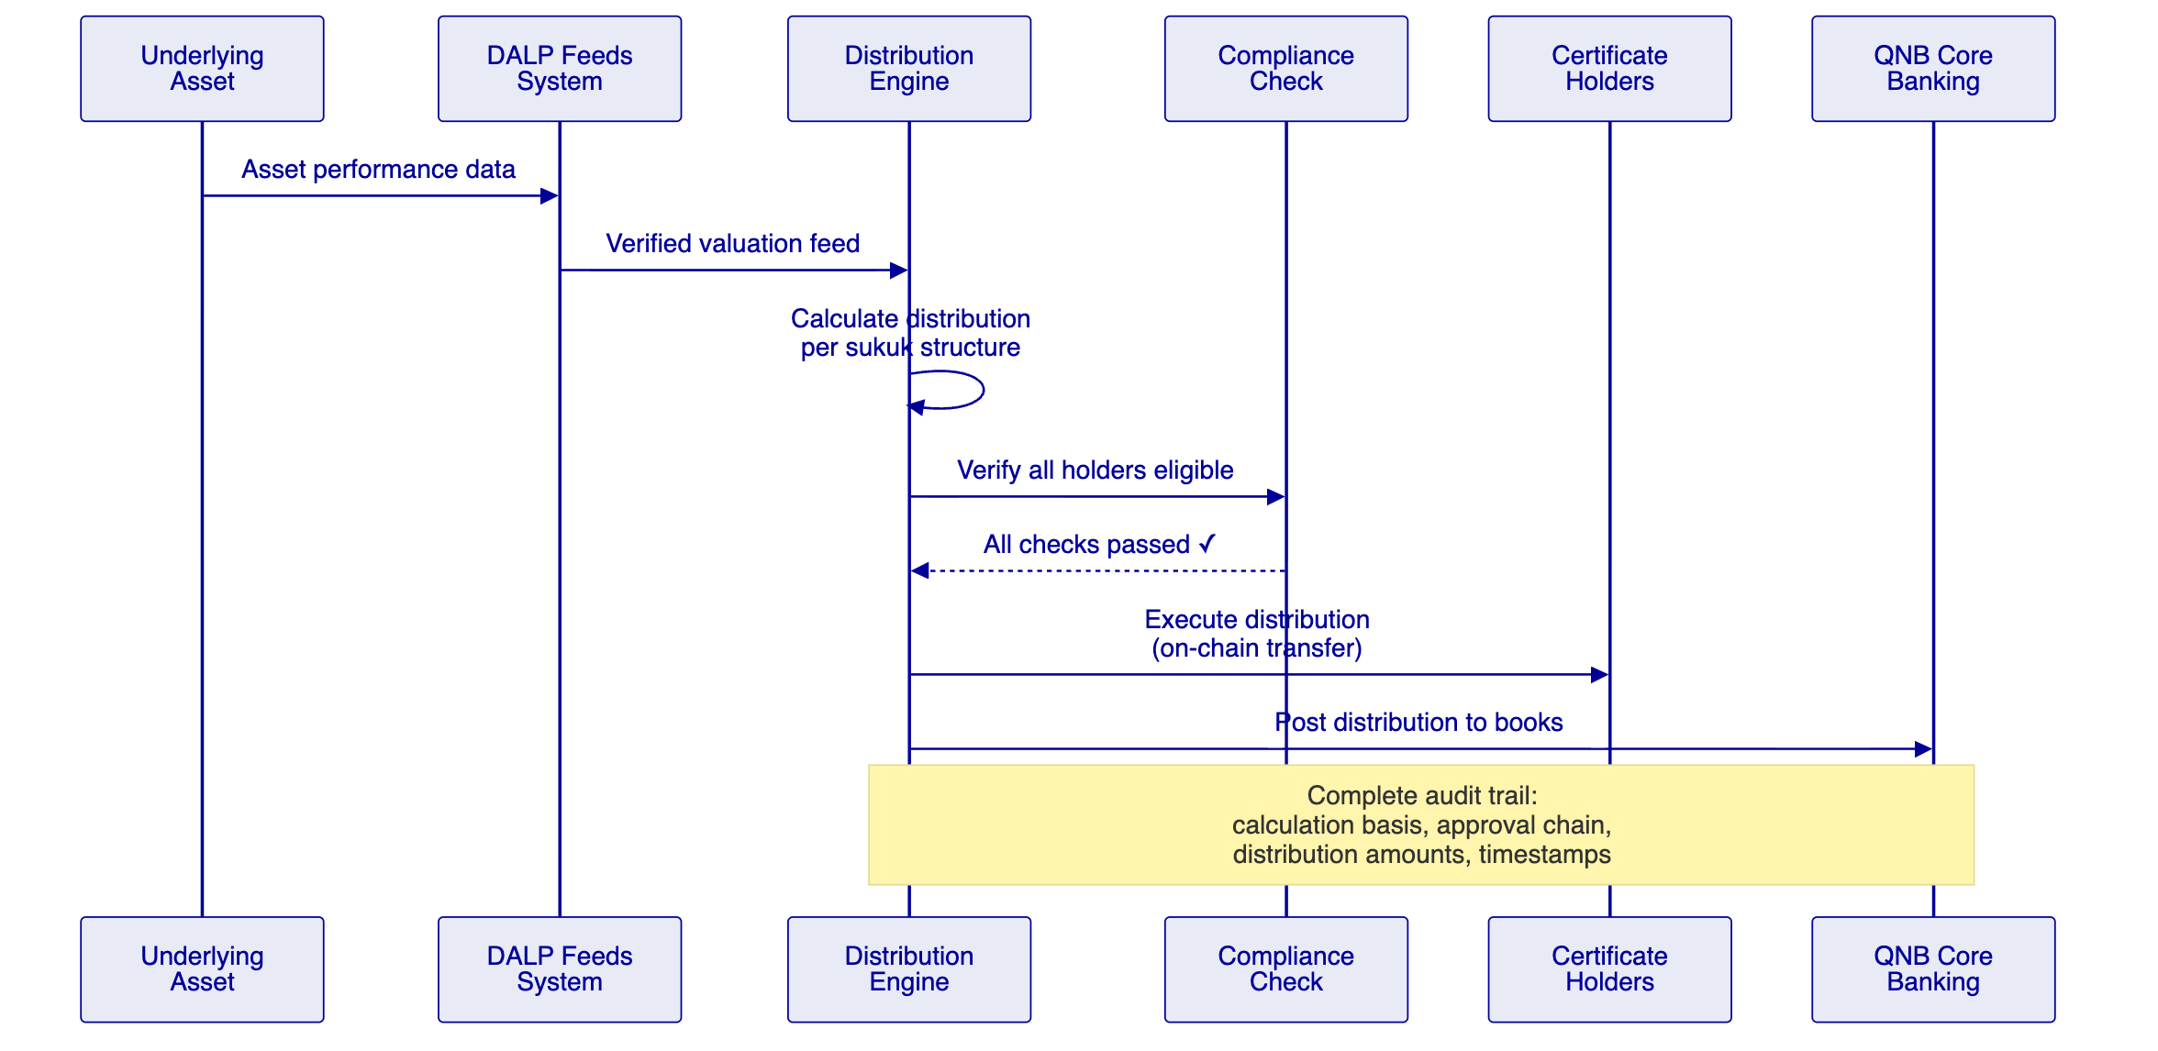

  - Identity, Compliance, and Sharia Governance
    - Compliance Engine Configuration for Sukuk
DALP's compliance engine operates in fail-closed mode: every transfer must pass all bound compliance modules. For QNB's sukuk programme:
Module | Purpose | Configuration
Identity Verification | KYC/AML verified OnchainID | Required for all certificate holders
Country Allow List | Jurisdiction restrictions | Qatar + approved jurisdictions
Investor Accreditation | Qualified investor checks | Per QFC Authority requirements
Transfer Approval | Multi-party governance | Sharia board + trustee approval for secondary transfers
Time Lock | Minimum holding period | AAOIFI-guided holding periods per sukuk type
Collateral Requirement | Asset-backing verification | On-chain proof of underlying asset adequacy
    - Role-Based Access Control
Role | Scope | Maker-Checker
Sukuk Structurer | Product design, parameter configuration | Creates structure → Sharia board approval required
Compliance Officer | Compliance module management | Configures rules → Head of Compliance approval
Trustee | Asset custody oversight, distribution approval | Reviews → recorded on-chain
Sharia Board Rep | Product certification, structure approval | Certifies → immutable on-chain record
Treasury Manager | Settlement authorization | Approves → dual authorization required
Auditor | Full read-only access | No write access; complete visibility

  - Settlement, Distribution, and Lifecycle Management
    - Atomic DvP Settlement
DALP supports atomic Delivery versus Payment through the XvP Settlement addon. For sukuk primary issuance and secondary market transfers, this ensures that certificate delivery and payment occur simultaneously or not at all, eliminating settlement risk.
    - Distribution Types
Distribution | Calculation | Frequency | DALP Feature
Ijarah rental | Fixed rental amount per certificate | Monthly/quarterly | Fixed Treasury Yield
Mudarabah profit | Pool performance × agreed ratio | Quarterly/semi-annual | Yield addon with configurable ratio
Murabaha markup | Scheduled payment amounts | Per sale agreement schedule | Maturity & Redemption
Wakalah return | Investment return − agency fee | Per mandate period | Yield + Transaction Fee
    - Dissolution Mechanics
At maturity or upon a dissolution trigger event, DALP executes the dissolution workflow:
- Calculate final distribution amount per certificate holder
- Execute distribution via on-chain transfer
- Return principal to certificate holders
- Burn sukuk tokens (permanent retirement)
- Record complete dissolution audit trail

  - Security, Resilience, and Operational Assurance
    - Security Certifications
Certification | Status
ISO 27001 | Current
SOC 2 Type II | Current
Smart contract audits | Per release
Penetration testing | Annual + per major release
    - Operational Resilience
Capability | Target
RPO | < 1 hour
RTO | < 4 hours
Backup frequency | Daily with integrity verification
Monitoring | Three-pillar observability (metrics, logs, traces)

  - Implementation Approach and Delivery Phases
    - 19-Week Implementation
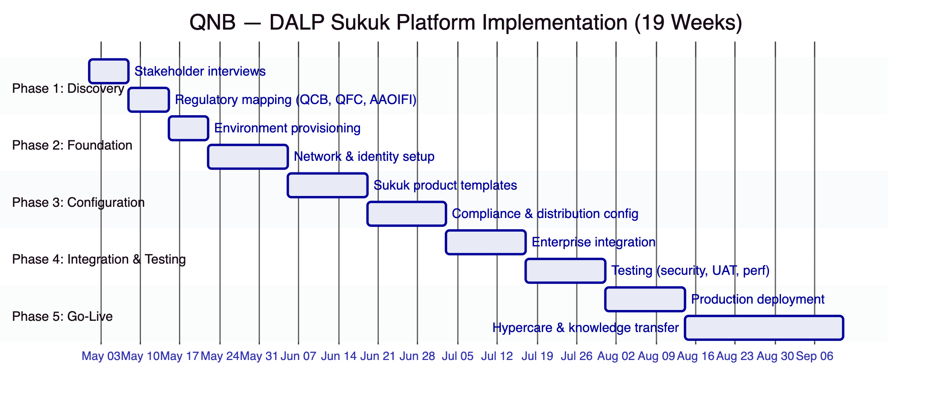

  - Current Coverage, Dependencies, and Qualified Gaps
    - Requirements Coverage
Req ID | Requirement | Status | Notes
REQ-01 | Segregated environments | Full | Dev, UAT, DR, Production
REQ-02 | API-first interfaces | Full | REST v2, GraphQL, webhooks, SDK
REQ-03 | RBAC, maker-checker, audit | Full | Native platform capability
REQ-04 | Configurable lifecycle | Full | DALPAsset with runtime features
REQ-05 | Dependency disclosure | Full | See dependency register
REQ-06 | Resilience & monitoring | Full | ISO 27001, SOC 2, three-pillar observability
REQ-07 | Implementation plan | Full | 19-week phase-gated methodology
REQ-08 | Audit evidence extraction | Full | Complete audit trail, queryable API
REQ-12 | Sharia board workflows | Partial | Approval workflows available; dedicated Sharia portal in Q3 2026
REQ-13 | Profit vs. interest segregation | Full | Enforced at smart contract level
    - Qualified Gap: REQ-12
DALP supports Sharia board approval workflows through the Transfer Approval compliance module and GOVERNANCE_ROLE assignment. Fatwa references stored as token metadata. A dedicated Sharia board dashboard with AAOIFI reporting templates is targeted for Q3 2026. Mitigation: core governance workflows operational from day one; dedicated dashboard deliverable during implementation (estimated 2 weeks additional).

  - Relevant Delivery Evidence
Client | Region | Relevance
Islamic Development Bank | 57 countries | Sharia-compliant tokenization at sovereign scale
Saudi Arabia RER | KSA | National-scale production, property tokenization
Standard Chartered Bank | Asia, ME, Africa | Multi-jurisdiction securities
Commerzbank | Germany | Hybrid on/off-chain ETP issuance
OCBC Bank | Singapore | Regulated bank, multi-asset securities
Maybank (Project Photon) | Malaysia | FX tokenization, cross-border settlement

  - Appendices
    - Appendix A: Glossary
Term | Definition
DALP | Digital Asset Lifecycle Platform
Sukuk | Islamic certificates representing ownership in underlying assets
Ijarah | Lease-based sukuk structure
Mudarabah | Profit-sharing sukuk structure
Murabaha | Cost-plus financing sukuk structure
Wakalah | Agency-based sukuk structure
DALPAsset | Configurable token contract
OnchainID | On-chain identity standard (ERC-734/735)
XvP | Exchange versus Payment — atomic settlement
AAOIFI | Accounting and Auditing Organization for Islamic Financial Institutions
QCB | Qatar Central Bank
QFC | Qatar Financial Centre

