[Company name]
[Document title]
[Document subtitle]

Confidentiality Statement
This document contains confidential and proprietary information of SettleMint. By reading this document, you agree not to disclose the confidential information contained herein to any third party without the prior written consent of SettleMint, except to those agents, principals, representatives, or consultants who require access for the purpose of evaluating this document. You further agree to inform such persons of the confidential nature of this document and to obtain their agreement to preserve its confidentiality to the same extent as yours.
This confidentiality statement shall remain binding on the parties for a period of five (5) years from the date stated on the front cover, unless superseded by confidentiality provisions detailed in a subsequent agreement.
Terms and Conditions
This proposal is valid until [DD Month YYYY]. In the absence of confirmation to proceed, SettleMint and [the Company] acknowledge and agree to abide by the Mutual NDA as the governing agreement.
SettleMint reserves the right to vary the terms of this proposal in response to changes in specifications or information made available at a later date. Submission of this proposal does not convey any right, title, interest, or license in any intellectual property rights (including, but not limited to, patents, copyrights, trade secrets, or trademarks) contained herein.
All rights are reserved. This proposal and the information contained within it are provided on an “as is” basis, without any warranties of any kind, express or implied.
All contracts with SettleMint will be governed by Belgian Law and subject to the exclusive jurisdiction of Belgian courts.
Contact Details
For any enquiries regarding this document, please contact:
[Full Name]
[Job Title]
Email: [email@example.com]
Phone: [Country Code - Number]

Table of Contents

Table of Contents 3
Executive Summary 4
About SettleMint 5
Company Overview 6
Production Credentials 7
Relevance to SNB 8
About DALP 9
Platform Overview 10
Core Lifecycle Pillars 11
Fixed Income Specific Capabilities 12
Customer References 13
Summary Table 14
Expanded Reference: Commerzbank — Exchange-Traded Products 15
Expanded Reference: Mizuho Bank — Bond Tokenization 16
Proposed Solution and Functional Capabilities 17
Fixed Income Origination Model 18
Coupon and Distribution Automation 19
Investor Onboarding and Eligibility 20
Integration with Treasury and Capital Markets 21
Technical Architecture 22
Layered Architecture 23
Data Architecture 24
Operational Architecture 25
Security, Resilience, and Operational Assurance 26
Security Model 27
Key Management 28
Compliance Controls 29
Security Responsibility Matrix 30
Implementation Approach and Delivery Phases 31
Implementation Timeline 32
Deployment Model 33
Recommended: Dedicated Cloud, KSA-Resident 34
Support and SLA 35
Recommended: Premium Support 36
Risk Management 37
Current Coverage, Dependencies, and Qualified Gaps 38
Compliance Matrix 39
Qualified Gap: Paying Agent/Registrar Integration (REQ-10) 40
Appendices 41
Appendix A: Standards Reference 42

Field | Value
Proposal title | Technical Proposal — Tokenized Fixed Income Origination and Investor Servicing
Client | Saudi National Bank
Submitted by | SettleMint NV
Date | March 2026
Version | v1.0
Confidentiality | Restricted
RFP Reference | SAUDI-NATIONAL-BANK-RFP-TOKENIZED-FIXED-INCOME-202603
Primary contact | Adam Popat, CEO

  - Table of Contents
- Executive Summary
- About SettleMint
- About DALP
- Understanding SNB's Programme Objectives
- Customer References
- Proposed Solution and Functional Capabilities
- Technical Architecture
- Smart Contract Architecture for Fixed Income
- Identity, Compliance, and Regulatory Controls
- Settlement, Servicing, and Lifecycle Management
- Integration Architecture
- Security, Resilience, and Operational Assurance
- Implementation Approach and Delivery Phases
- Deployment Model
- Training and Knowledge Transfer
- Support and SLA
- Risk Management
- Current Coverage, Dependencies, and Qualified Gaps
- Compliance Matrix
- Appendices

  - Executive Summary
Saudi National Bank has identified tokenized fixed income origination and investor servicing as a business-critical capability requiring production-grade discipline. This procurement tests whether the market can supply a platform that handles the full fixed income lifecycle — origination, issuance, investor onboarding, coupon servicing, maturity redemption, and corporate actions — inside SNB's control environment with the governance expected of core regulated systems.
SettleMint's Digital Asset Lifecycle Platform (DALP) addresses this requirement directly. DALP provides production-ready infrastructure for designing, issuing, servicing, and retiring tokenized financial instruments with compliance enforcement, identity verification, and governance controls embedded at the smart contract level.
Why DALP fits SNB's fixed income requirements:
- Purpose-built fixed income lifecycle. DALP's bond asset class provides automated coupon schedules, maturity logic, and secondary market connectivity as native platform capabilities. Issuance calendars, allocation workflows, and investor entitlement tracking operate through platform configuration rather than custom development. The compliance engine enforces investor eligibility, transfer restrictions, and holding limits at the smart contract level, ensuring governance rules travel with every instrument through its entire lifecycle.
- Sharia-compliant sukuk support. Through DALP's configurable token architecture, sukuk-style instruments can be modelled with profit-sharing distribution mechanics, Sharia board approval lineage, and AAOIFI-aligned governance controls. The Islamic Development Bank engagement — covering Sharia-compliant subsidy distribution across 57 member countries — directly demonstrates DALP's fitness for Islamic finance use cases at sovereign scale.
- Production-proven at institutional scale. DALP processes digital assets across production deployments including Commerzbank (exchange-traded products on Boerse Stuttgart with settlement under 10 seconds and EUR 7M annual savings potential), Mizuho Bank (bond tokenization and trade finance, PoC completed late 2025 with production planning underway), Standard Chartered Bank (Digital Virtual Exchange for institutional investors across Asia, Africa, and the Middle East), and OCBC Bank (security token engine for securitization).
- KSA market presence and regulatory alignment. SettleMint has active programmes in the Gulf region including the Saudi Arabia Real Estate Registry (country-scale real estate tokenization under REGA/Vision 2030). The platform supports SAMA regulatory expectations, CMA capital markets rules, Saudi cybersecurity and data controls, and Sharia governance through configurable compliance modules and jurisdiction-aware policy templates.
- Enterprise integration, not isolation. DALP connects to treasury and capital-markets books, Tadawul-linked workflows, KYC/AML tooling, corporate and wealth channels, and reporting environments through a comprehensive API surface (REST API v2 with OpenAPI 3.1, GraphQL, event webhooks, TypeScript SDK, CLI with 301 commands across 26 command groups).
The proposed implementation follows SettleMint's phase-gated methodology: 19 weeks from kickoff to hypercare completion. The first production fixed income instrument can be live within 13 weeks of kickoff.
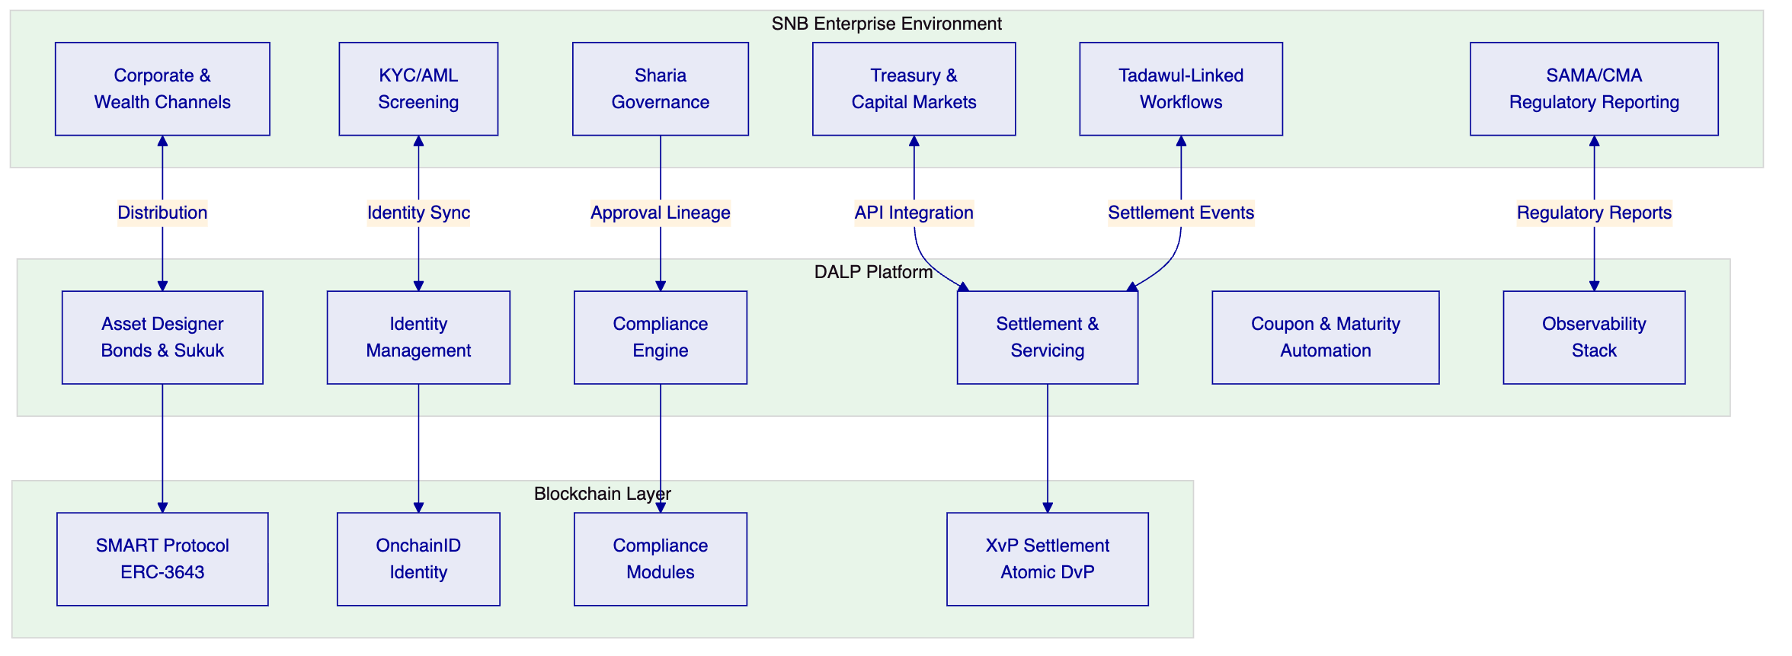

  - About SettleMint
    - Company Overview
SettleMint is the production-grade digital asset lifecycle management company for regulated financial markets and sovereign use cases. Founded in 2016 with 10 years of continuous operation and 7+ years of continuous production deployments at regulated banks.
    - Production Credentials
Credential | Evidence
Continuous operation | Since 2016, 10 years
Production deployments | 7+ years with regulated banks
Asset classes in production | Bonds, equities, deposits, stablecoins, real estate, funds, precious metals
Geographic coverage | Europe, Middle East, Asia-Pacific
Sovereign programs | Saudi Arabia RER, SBI CBDC
Certifications | ISO 27001, SOC 2 Type II

    - Relevance to SNB
- KSA sovereign programme: Saudi Arabia RER — country-scale real estate tokenization under REGA/Vision 2030
- Fixed income experience: Mizuho Bank (bond tokenization PoC, production planning), Commerzbank (exchange-traded products with <10s settlement)
- Islamic finance: Islamic Development Bank — Sharia-compliant subsidy distribution across 57 member countries
- Tier-1 bank experience: Standard Chartered, Commerzbank, OCBC, SBI — comparable regulatory complexity

  - About DALP
    - Platform Overview
DALP provides production-ready infrastructure for the full digital asset lifecycle. For fixed income, this means origination, primary issuance, compliance enforcement, investor onboarding, coupon servicing, maturity redemption, and corporate actions in a single governed platform.
    - Core Lifecycle Pillars
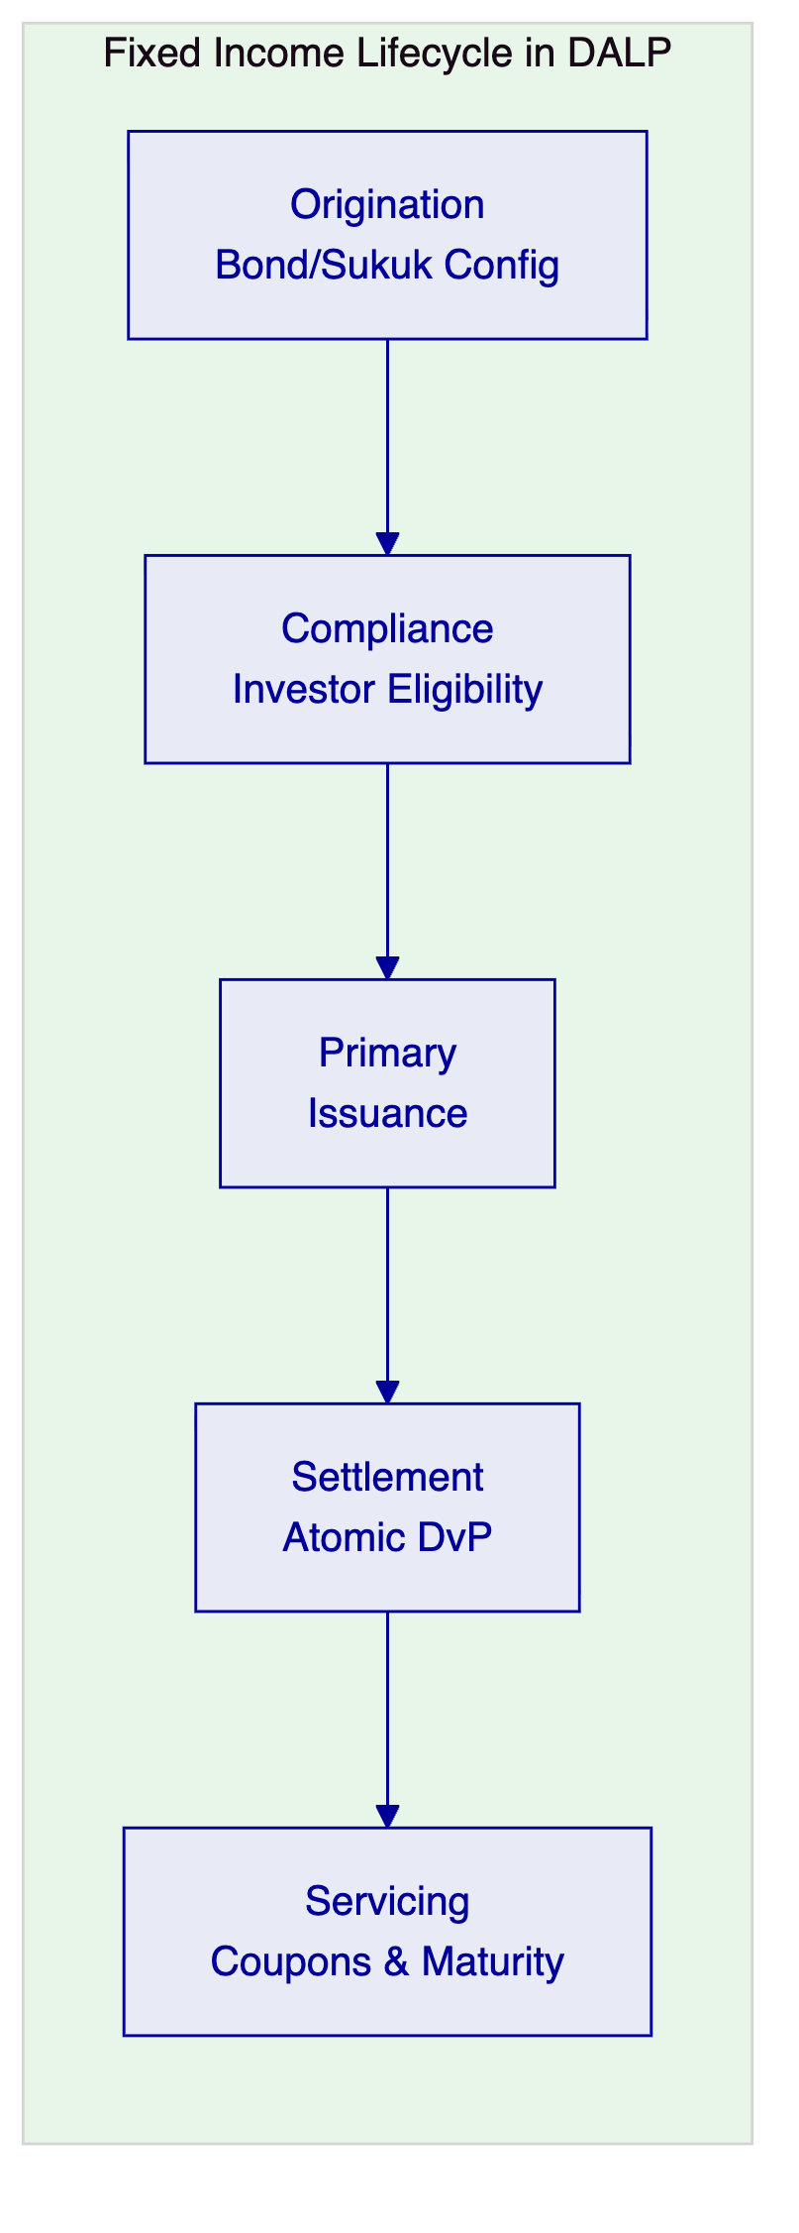
Origination and Issuance. DALP's Asset Designer provides a guided wizard for configuring bond and sukuk instruments with coupon schedules, maturity parameters, denomination structures, and compliance rules. DALPAsset supports runtime attachment of compliance modules for investor eligibility enforcement.
Compliance. Eighteen compliance module types enforce investor eligibility, country restrictions, accreditation requirements, holding limits, and transfer controls before every transaction executes. Sharia governance controls capture board approval lineage and product rule compliance.
Settlement. XvP atomic delivery-versus-payment eliminates counterparty risk. Both asset and cash legs complete together or revert together. Settlement finality is deterministic under IBFT consensus.
Servicing. Automated coupon distribution (fixed treasury yield), maturity redemption with treasury payout abstraction, and corporate action processing. All servicing operations maintain compliance integrity throughout the instrument's lifecycle.
    - Fixed Income Specific Capabilities
Capability | DALP Implementation
Coupon schedules | Fixed treasury yield feature with configurable frequency
Maturity redemption | Automated with treasury payout abstraction
Investor eligibility | 18 compliance modules, ex-ante enforcement
Transfer restrictions | On-chain enforcement, configurable at runtime
Corporate actions | Controlled mint/burn, governance events
Issuance calendar | Asset Designer configuration
Allocation workflows | Identity-linked distribution
Portfolio reporting | Event webhooks, GraphQL queries, dashboards

  - Customer References
    - Summary Table
Client | Use Case | Geography | Relevance to SNB
Commerzbank | Exchange-Traded Products | Germany | Regulated exchange, <10s settlement, EUR 7M savings
Mizuho Bank | Bond Tokenization | Japan | Fixed income lifecycle, production planning
Standard Chartered | Digital Virtual Exchange | Asia, Africa, ME | Institutional distribution
OCBC Bank | Security Token Engine | Singapore | Securitization, investor products
Islamic Development Bank | Subsidy Distribution | 57 countries | Sharia-compliant, sovereign scale
Saudi Arabia RER | Real Estate Registry | KSA | Country-scale sovereign, Vision 2030
State Bank of India | CBDC Infrastructure | India | National-scale payment infrastructure
Maybank | FX Tokenization | Malaysia | Atomic cross-border settlement
ADI Finstreet | Equity Tokenization | Abu Dhabi | GCC market, institutional custody
Sony Bank | Stablecoin Issuance | Japan | Regulated digital instruments
KBC Securities | Crowdfunding | Belgium | Issuance, lifecycle, corporate actions

    - Expanded Reference: Commerzbank — Exchange-Traded Products
Context. Commerzbank needed to issue exchange-traded products with listing on Boerse Stuttgart, requiring settlement that meets exchange-grade performance requirements.
Solution. DALP provides hybrid on/off-chain ETP issuance with settlement under 10 seconds. The platform handles the full issuance lifecycle while meeting regulatory and performance requirements.
Outcome. Settlement under 10 seconds. Listed on Boerse Stuttgart. Projected savings of EUR 7M per year. Reduced counterparty risk through near-real-time clearing.
Transferability. Demonstrates DALP's fitness for regulated fixed income instruments with strict settlement requirements. The EUR 7M savings model provides SNB with a reference for building its business case.
    - Expanded Reference: Mizuho Bank — Bond Tokenization
Context. Mizuho Bank sought bond tokenization and trade finance capabilities with emphasis on standard platform capabilities rather than custom development — enabling Mizuho's internal team to operate independently.
Solution. DALP powers the bond tokenization layer with standard lifecycle capabilities: issuance, compliance, servicing, and settlement.
Outcome. Proof of concept completed late 2025; production planning stage. Demonstrates that fixed income lifecycle management can operate through platform configuration.
Transferability. Directly applicable: bond tokenization at a major bank with emphasis on operational independence and standard platform capabilities.

  - Proposed Solution and Functional Capabilities
    - Fixed Income Origination Model
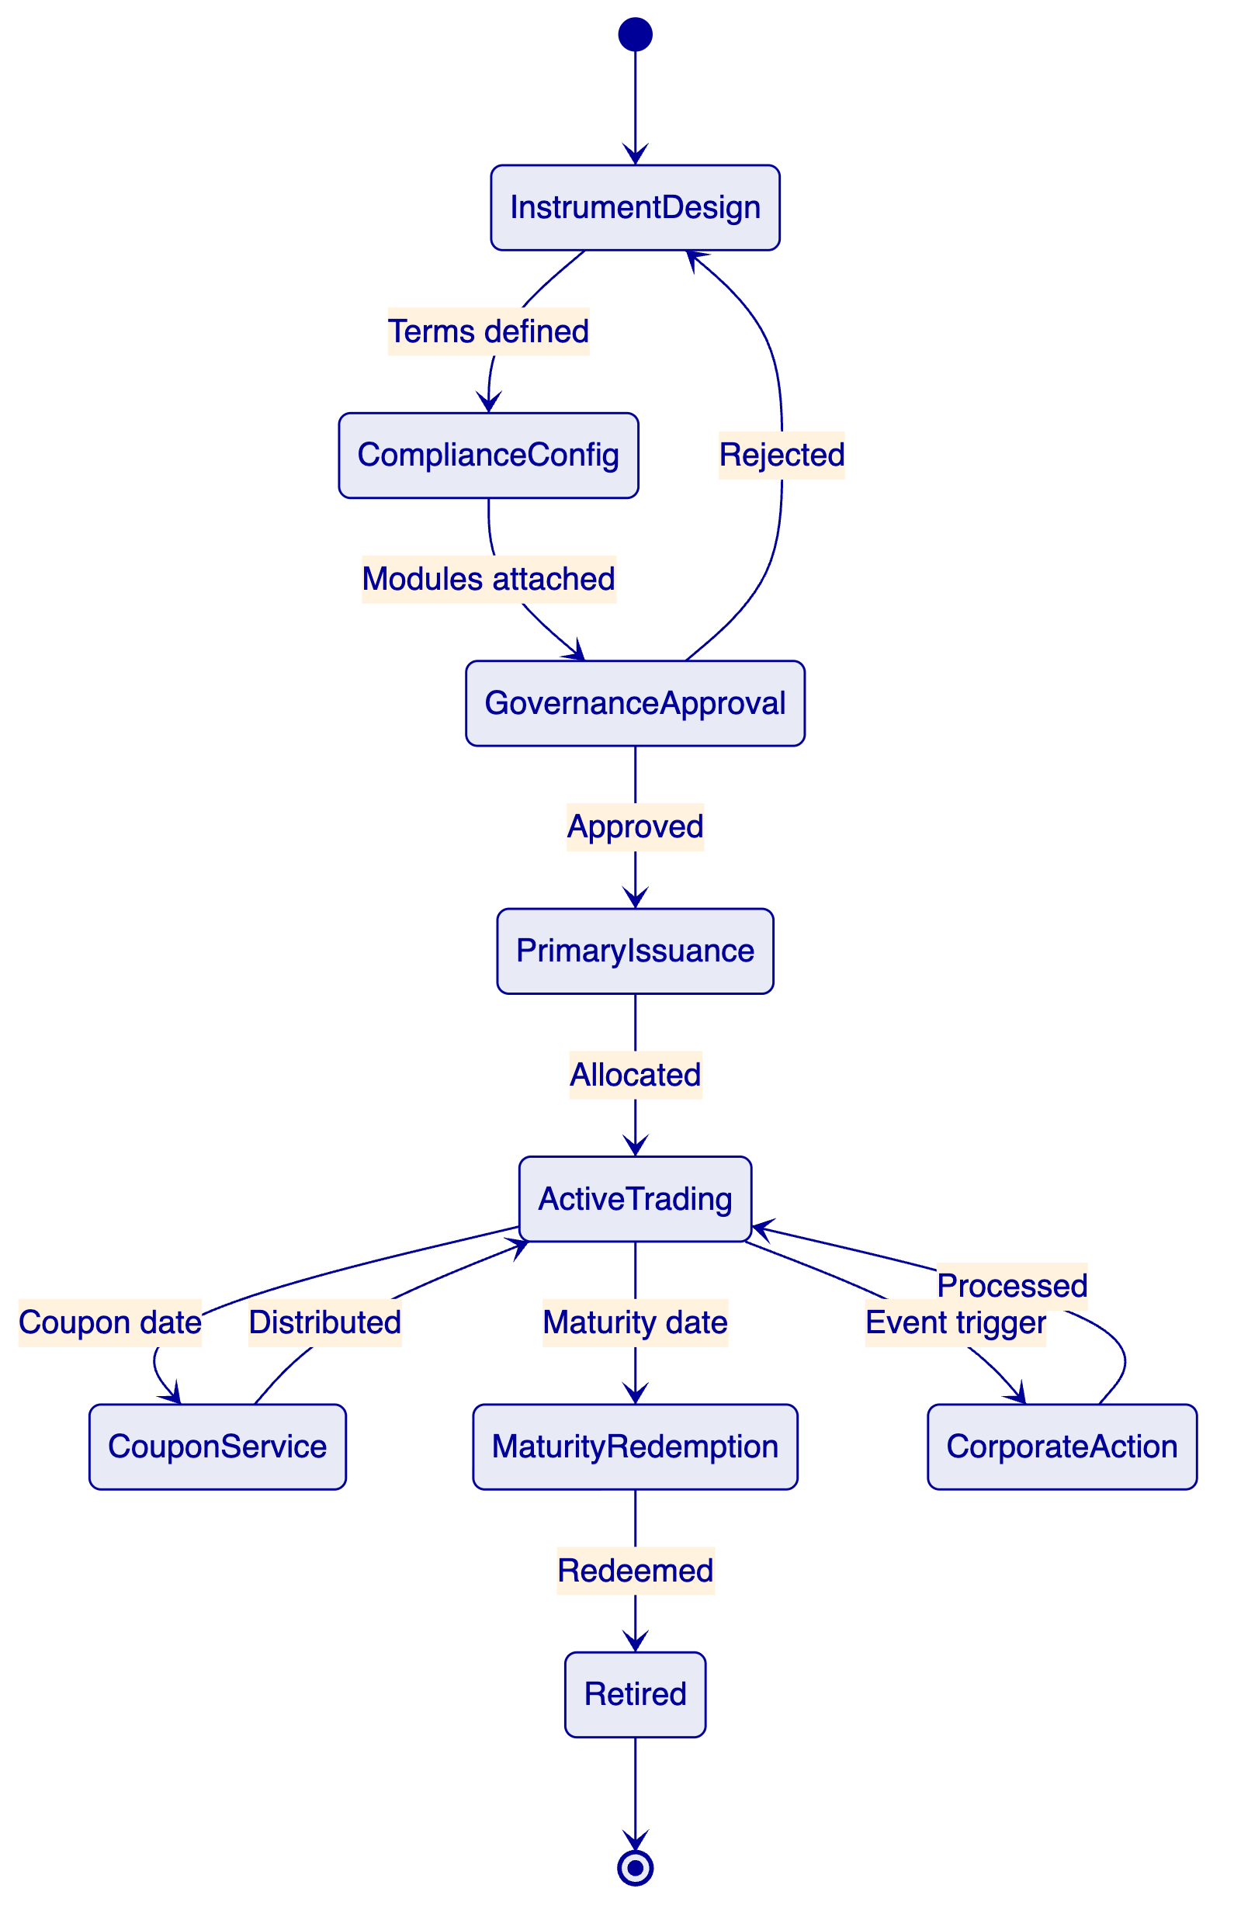
The origination model follows a governed sequence: instrument design (terms, coupon schedule, maturity parameters), compliance configuration (investor eligibility modules, transfer restrictions), governance approval (Sharia board if applicable, internal approvals), primary issuance and allocation, active trading with compliance enforcement, automated coupon servicing, and maturity redemption.
    - Coupon and Distribution Automation
DALP's fixed treasury yield feature automates coupon distribution based on configurable schedules. The distribution engine calculates entitlements based on token holdings at the record date, routes payments through the treasury payout abstraction (supporting both EOA and contract-based treasuries), and produces an auditable record of every distribution event. For sukuk-style instruments, profit-sharing distributions follow the same automated pattern with Sharia-compliant calculation logic.
    - Investor Onboarding and Eligibility
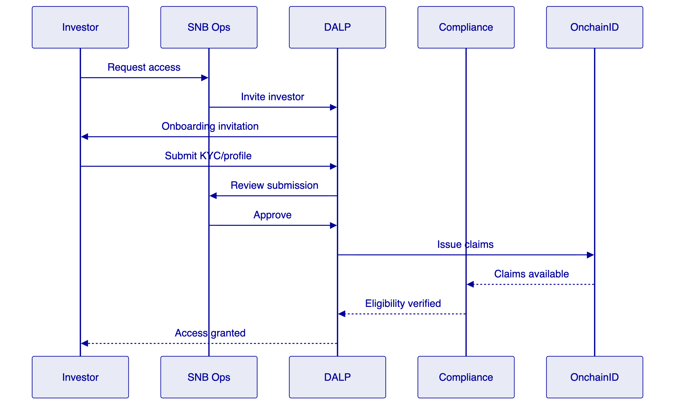
    - Integration with Treasury and Capital Markets
DALP integrates with SNB's treasury and capital markets systems through REST API v2, event webhooks, and server-sent events. Coupon payment events, maturity events, and settlement confirmations are streamed in real time to downstream books. Reconciliation identifiers remain stable across APIs, ledgers, workflow queues, and reports, enabling SNB to match platform records to internal books without ambiguity.

  - Technical Architecture
    - Layered Architecture
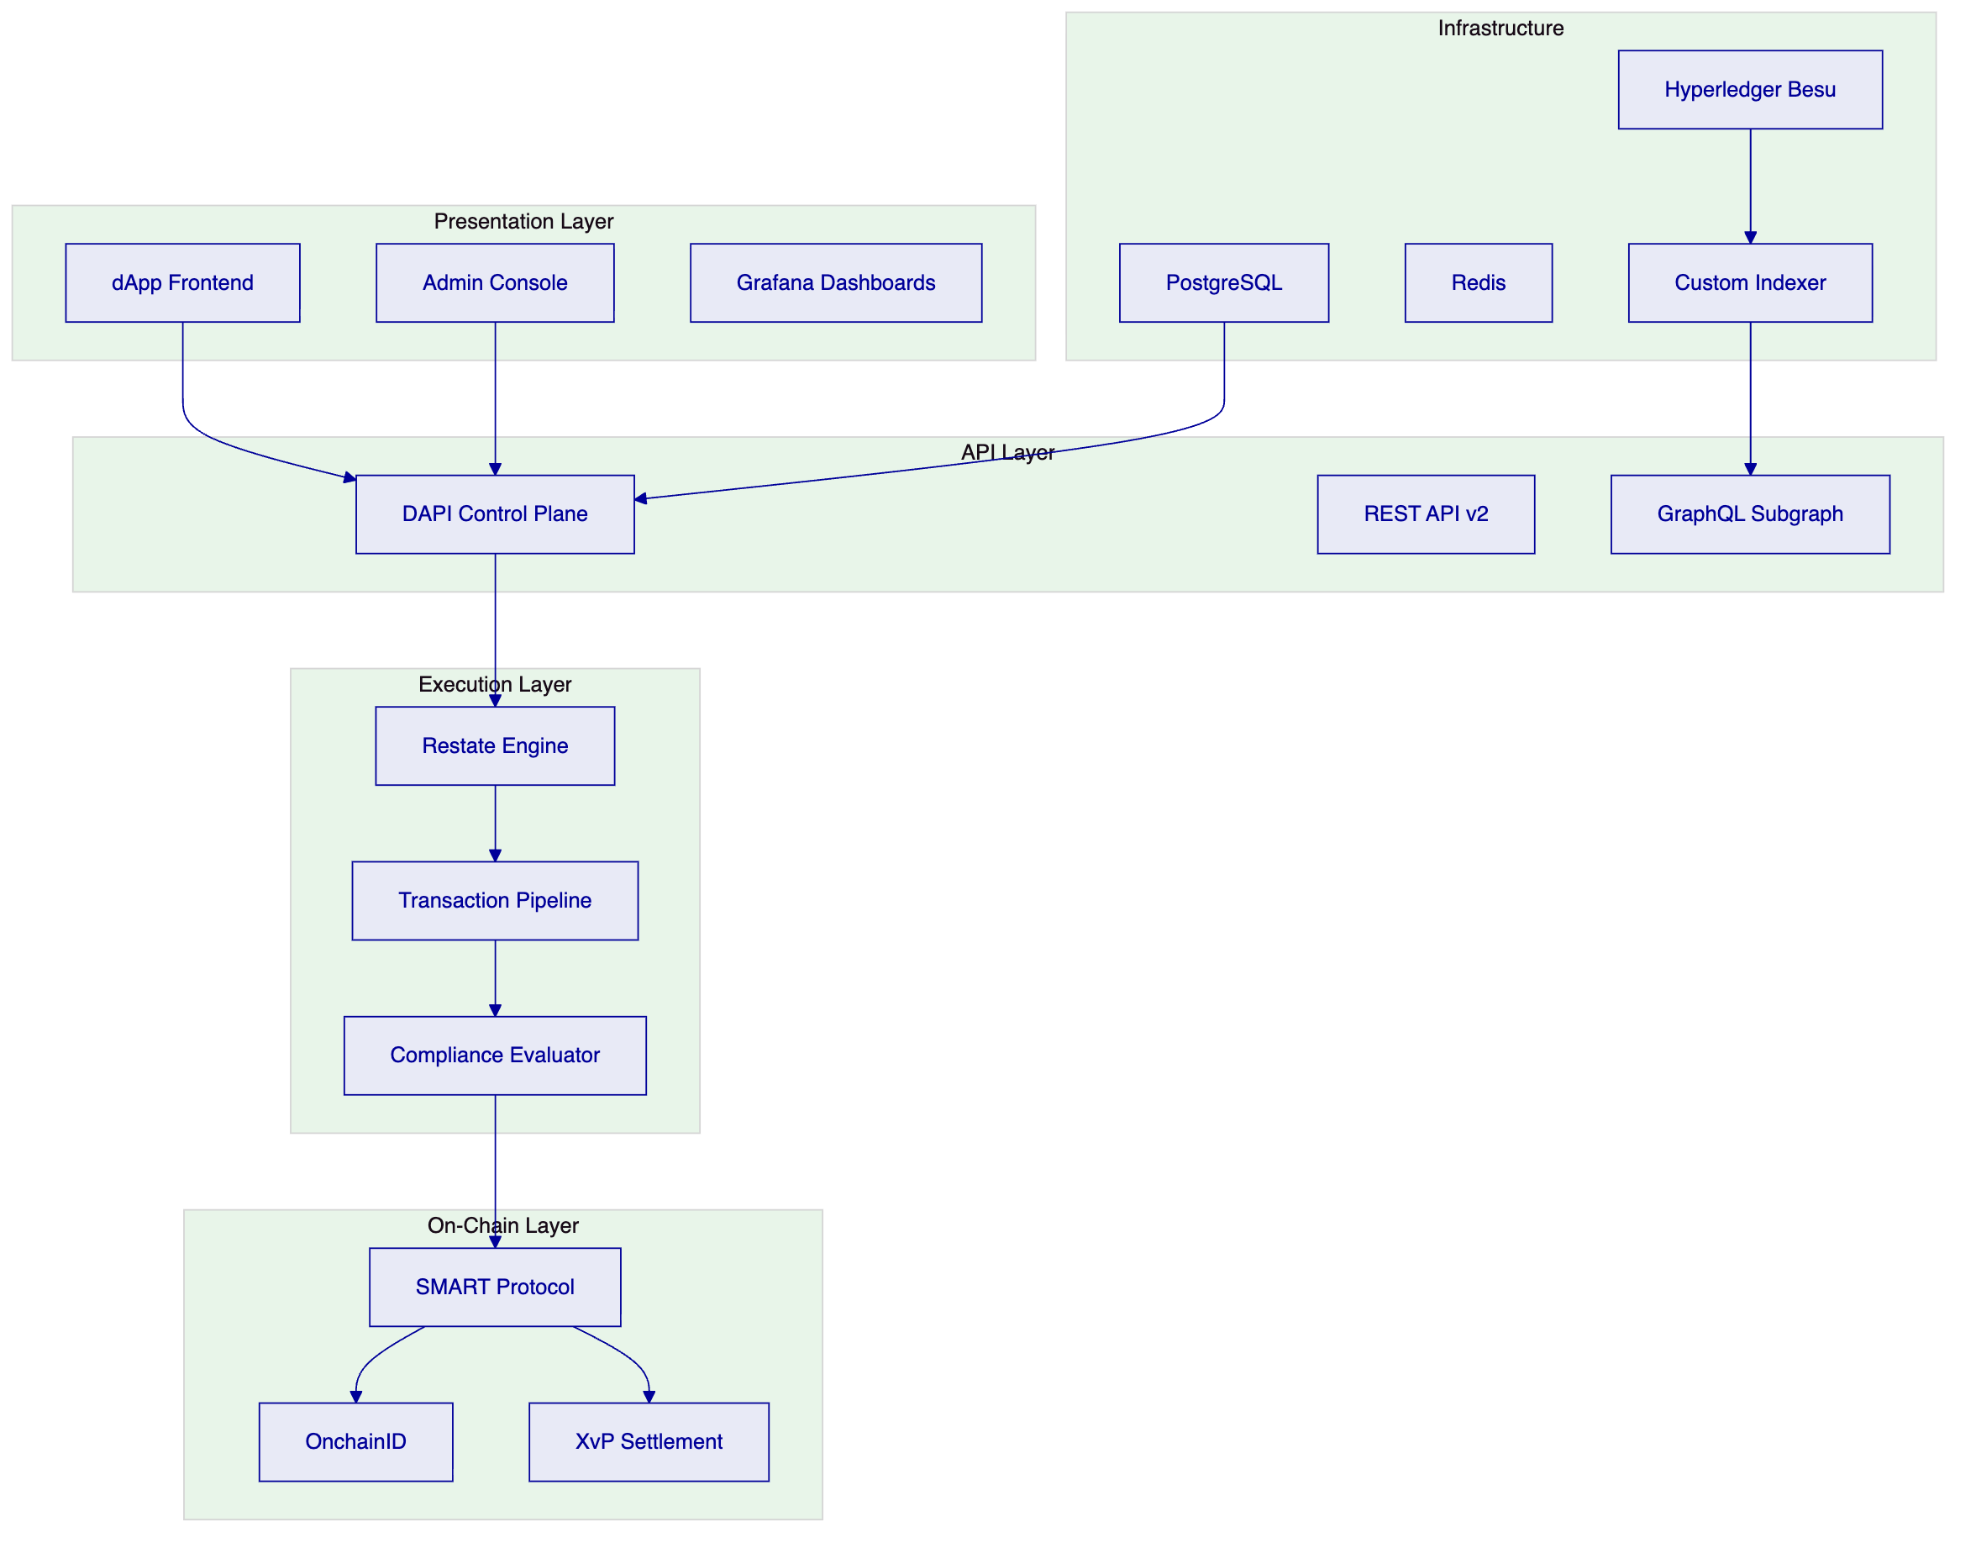
    - Data Architecture
Three state categories: chain state (immutable ownership, compliance configurations), application state (PostgreSQL — workflows, transaction pipeline, profiles), and indexed state (custom indexer with zero-downtime schema lifecycle for analytics and reporting).
    - Operational Architecture
The durable execution engine (Restate) ensures multi-step fixed income workflows — coupon calculation, distribution, settlement confirmation — survive process restarts and infrastructure failures. The async transaction pipeline manages the 11-state lifecycle with idempotency, retry semantics, and dead-letter rescue.

  - Security, Resilience, and Operational Assurance
    - Security Model
Defense-in-depth across application, blockchain, and custody layers. Two-endpoint authentication separates session and API-key access. RBAC with five roles and nine permission levels. Maker-checker workflows enforce separation of duties.
    - Key Management
Key Guardian with DFNS/Fireblocks integration. Provider-delegated transaction broadcast separates governance (DALP) from execution (custody provider). HSM and cloud secret manager options for KSA-specific requirements.
    - Compliance Controls
Immutable audit trail for every operation. 534 structured error codes. Exportable evidence packs for SAMA, CMA, Sharia board, and internal audit review.
    - Security Responsibility Matrix
Control Area | SettleMint | SNB
Platform security | Application security, smart contract audits | Enterprise policies, network perimeter
Key management | Orchestration, custody integration | Provider selection, key ceremonies
Access control | RBAC enforcement | User provisioning, recertification
Data protection | Encryption at rest/transit | Data classification, retention
Incident management | Platform detection, forensic support | Enterprise incident management

  - Implementation Approach and Delivery Phases
    - Implementation Timeline
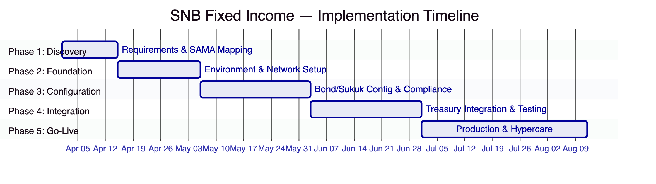
Phase 1 (Weeks 1-2): Discovery, SAMA/CMA regulatory mapping, Sharia governance requirements, architecture design.
Phase 2 (Weeks 3-5): Environment provisioning, network configuration, identity framework, custody provider integration.
Phase 3 (Weeks 6-9): Bond/sukuk configuration, compliance modules, coupon schedule setup, governance workflows.
Phase 4 (Weeks 10-13): Treasury system integration, Tadawul-linked workflows, security testing, UAT.
Phase 5 (Weeks 14-19): Production deployment, knowledge transfer, 6-week hypercare.

  - Deployment Model
    - Recommended: Dedicated Cloud, KSA-Resident
Dedicated cloud infrastructure within KSA-resident data centers. DALP deploys on Kubernetes with PostgreSQL, Redis, and object storage via Helm charts. All deployment models deliver the same platform capabilities.

  - Support and SLA
    - Recommended: Premium Support
Aspect | Premium
Coverage | 16x5 (Sunday-Thursday for KSA)
P1 response | 2 hours
P2 response | 4 hours
Dedicated engineer | Yes
Business reviews | Quarterly

  - Risk Management
ID | Risk | Likelihood | Impact | Mitigation | Owner
R-01 | SAMA/CMA regulatory interpretation | Medium | High | Phase 1 regulatory mapping workshop | SNB
R-02 | Sharia board certification timeline | Medium | High | Early engagement, parallel approval tracks | SNB
R-03 | Treasury system API readiness | Medium | High | API specification in Phase 1, integration sandbox | SNB
R-04 | Tadawul integration complexity | Medium | Medium | Phased approach, standard API patterns | Joint
R-05 | Local hosting requirements | Low | Medium | KSA-resident dedicated cloud | Joint
R-06 | Multi-instrument scaling | Low | Medium | Configurable token architecture | SettleMint

  - Current Coverage, Dependencies, and Qualified Gaps
    - Compliance Matrix
Req ID | Requirement | Status | Response
REQ-01 | Segregated environments | Full | Kubernetes-based isolation
REQ-02 | API-first interfaces | Full | REST, GraphQL, webhooks, SDK, CLI
REQ-03 | RBAC and audit | Full | 5 roles, maker-checker, immutable trail
REQ-04 | Configurable lifecycle | Full | DALPAsset runtime configuration
REQ-05 | Third-party disclosure | Full | All providers documented
REQ-06 | Resilience and recovery | Full | HA, backup, monitoring, alerting
REQ-07 | Delivery method | Full | 19-week phase-gated plan
REQ-08 | Evidence extraction | Full | Structured logs, audit packs
REQ-09 | Issuance calendars, coupons, maturity | Full | Asset Designer, fixed treasury yield, maturity redemption
REQ-10 | Paying agent, registrar, depository | Partial | Platform provides settlement; external paying agent/registrar integration during Phase 4
REQ-11 | Transfer restrictions, eligibility | Full | 18 compliance modules, ex-ante enforcement
RC-01 | Regulatory mapping | Full | Configurable modules, SAMA/CMA alignment
RC-02 | AML/CFT | Full | Sanctions screening integration
RC-03 | Data governance | Full | Encryption, KSA residency, retention
RC-04 | Operational resilience | Full | HA, DR, monitoring
RC-05 | Outsourcing | Full | Cloud and custody disclosed
RC-06 | Assurance and audit | Full | Logs, reports, attestations

    - Qualified Gap: Paying Agent/Registrar Integration (REQ-10)
DALP handles settlement, coupon distribution, and maturity redemption natively. Integration with external paying agents, registrars, and depository processes requires configuration during Phase 4 to map DALP events to SNB's existing market infrastructure workflows. The platform provides all necessary identifiers, event streams, and batch capabilities to support this integration.

  - Appendices
    - Appendix A: Standards Reference
Standard | Application
ERC-3643 (T-REX) | Core token framework
ERC-734/735 | OnchainID identity
ERC-20 | Token interface compatibility
ERC-5805 | Voting and governance
ISO 20022 | Payment message integration
OpenAPI 3.1 | REST API specification

