[Company name]
[Document title]
[Document subtitle]

Confidentiality Statement
This document contains confidential and proprietary information of SettleMint. By reading this document, you agree not to disclose the confidential information contained herein to any third party without the prior written consent of SettleMint, except to those agents, principals, representatives, or consultants who require access for the purpose of evaluating this document. You further agree to inform such persons of the confidential nature of this document and to obtain their agreement to preserve its confidentiality to the same extent as yours.
This confidentiality statement shall remain binding on the parties for a period of five (5) years from the date stated on the front cover, unless superseded by confidentiality provisions detailed in a subsequent agreement.
Terms and Conditions
This proposal is valid until [DD Month YYYY]. In the absence of confirmation to proceed, SettleMint and [the Company] acknowledge and agree to abide by the Mutual NDA as the governing agreement.
SettleMint reserves the right to vary the terms of this proposal in response to changes in specifications or information made available at a later date. Submission of this proposal does not convey any right, title, interest, or license in any intellectual property rights (including, but not limited to, patents, copyrights, trade secrets, or trademarks) contained herein.
All rights are reserved. This proposal and the information contained within it are provided on an “as is” basis, without any warranties of any kind, express or implied.
All contracts with SettleMint will be governed by Belgian Law and subject to the exclusive jurisdiction of Belgian courts.
Contact Details
For any enquiries regarding this document, please contact:
[Full Name]
[Job Title]
Email: [email@example.com]
Phone: [Country Code - Number]

Table of Contents

Table of Contents
Executive Summary
About SettleMint
Company Overview and KSA Credentials
About DALP
Fixed Income Lifecycle
Understanding SNB's Programme Objectives
Client Context
Regulatory Context: KSA
Customer References
Fixed Income Reference Fit
Expanded Reference: Commerzbank ETP
Proposed Solution and Functional Capabilities
Bond Configuration
Token Configuration for SNB Bonds
Investor Servicing
Compliance Enforcement
Settlement Architecture
Functional Fit Matrix
Technical Architecture
Four-Layer Stack
Network: Permissioned Hyperledger Besu
Security: 5-Layer Defense-in-Depth
Implementation (19 Weeks)
Deployment
Support: Premium
Risk Register
Gaps
Appendices
Glossary

Field | Value
Proposal title | Technical Proposal — Tokenized Fixed Income Origination and Investor Servicing
Client | Saudi National Bank
Submitted by | SettleMint NV
Date | March 2026
Version | v1.0
Confidentiality | Restricted
RFP Reference | SAUDI-NATIONAL-BANK-RFP-TOKENIZED-FIXED-INCOME-202603
Primary contact | Adam Popat, CEO

  - Table of Contents
- Executive Summary
- About SettleMint
- About DALP
- Understanding SNB's Programme Objectives
- Customer References
- Proposed Solution and Functional Capabilities
- Technical Architecture
- Smart Contract Architecture for Fixed Income
- Identity, Compliance, and Regulatory Controls
- Settlement, Servicing, and Lifecycle Management
- Integration Architecture
- Security, Resilience, and Operational Assurance
- Implementation Approach and Delivery Phases
- Deployment Model
- Training and Knowledge Transfer
- Support and SLA
- Risk Management
- Current Coverage, Dependencies, and Qualified Gaps
- Compliance Matrix
- Appendices

  - Executive Summary
Saudi National Bank has identified tokenized fixed income origination and investor servicing as a business-critical capability requiring production-grade discipline. This is a procurement to assess whether the market can supply a dependable platform for designing, issuing, servicing, and distributing tokenized bonds and sukuk within SAMA regulatory expectations, CMA capital markets rules, and the bank's internal control environment.
SettleMint's Digital Asset Lifecycle Platform (DALP) addresses this requirement directly. DALP provides production-ready infrastructure for the full fixed income lifecycle — from instrument design and issuance through coupon distribution, corporate actions, maturity processing, and retirement — with compliance enforcement, identity verification, and governance controls embedded at the smart contract level.
Why DALP fits Saudi National Bank's requirements:
- Native fixed income architecture. DALP's Asset Designer supports bonds as a primary asset class with configurable parameters: ISIN, maturity date, face value, denomination asset linking, coupon structure, and compliance rules. The fixed treasury yield feature automates interest accrual and distribution. The maturity and redemption feature handles automated processing at maturity. XvP settlement provides atomic delivery-versus-payment for primary issuance and secondary trading.
- Saudi Arabia market presence. SettleMint's deepest Gulf engagement is the Saudi Arabia Real Estate Registry (RER) — the first country in the world to deploy a national-scale property blockchain under REGA and Vision 2030. This sovereign-scale program demonstrates DALP's ability to operate within KSA's regulatory framework, integrate with national infrastructure (Yakeen identity, Sadad payments), and meet the governance expectations of Saudi government institutions.
- Institutional-scale production track record. Production deployments include Commerzbank (exchange-traded products with settlement under 10 seconds, projected EUR 7M/year savings), Standard Chartered Bank (Digital Virtual Exchange), OCBC Bank (security token engine), State Bank of India (CBDC infrastructure), and the Islamic Development Bank (Sharia-compliant subsidy distribution across 57 countries serving 1.7 billion people).
- Enterprise integration. DALP connects to core banking, treasury systems, investor registry, regulatory reporting, and market infrastructure through REST API v2 (OpenAPI 3.1), GraphQL, webhooks, TypeScript SDK, and CLI (301 commands across 26 command groups).
- Control integrity. Every operation produces a complete audit trail. Role-based access control with 26 roles, maker-checker workflows, wallet verification step-up authentication, and on-chain compliance enforcement with 18 module types.
The proposed implementation follows a 19-week phase-gated methodology. The first fixed income product can be live within 13 weeks of kickoff.
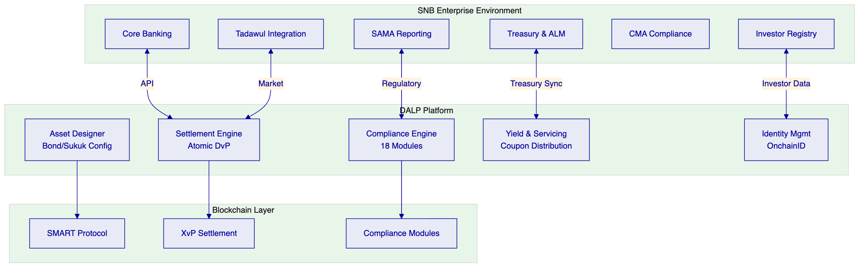

  - About SettleMint
    - Company Overview and KSA Credentials
SettleMint is the production-grade digital asset lifecycle management company for regulated financial markets. Founded 2016, headquartered in Leuven, Belgium. 10 years of continuous operation, 7+ years of production deployments at regulated banks.
KSA-specific credentials:
Credential | Evidence
Saudi RER | Country-scale real estate blockchain under REGA/Vision 2030
Islamic Development Bank | Sharia-compliant subsidy distribution, 57 countries
Al Rajhi Bank engagement | DALP proposal for Sharia-compliant tokenized products
Regional office | Active Middle East operations
Certifications | ISO 27001, SOC 2 Type II

  - About DALP
    - Fixed Income Lifecycle
DALP covers every stage of the fixed income lifecycle:
Design: Asset Designer wizard captures bond-specific parameters — ISIN, maturity date, face value, denomination asset, coupon frequency, compliance modules. No custom smart contract development required.
Issuance: Factory pattern deployment with CREATE2 deterministic addressing. Atomic deployment: identity registration, compliance binding, and role assignment in a single transaction.
Primary Distribution: XvP settlement addon provides atomic DvP for primary market placement. Both legs — bond token delivery and payment — execute in a single atomic transaction.
Secondary Trading: Compliance engine enforces eligibility on every transfer. Transfer approval module enables maker-checker for secondary trades. Timelock module enforces holding period restrictions where applicable.
Servicing: Fixed treasury yield automates coupon distribution. Historical balances feature enables ex-date/record-date snapshot capability. Corporate actions via SMART Protocol governance.
Maturity: Maturity and redemption feature triggers automatic processing at maturity date. Redemption via atomic DvP (bond tokens burned, denomination tokens transferred).
Retirement: Token burn after redemption with full lifecycle evidence preserved on-chain.

  - Understanding SNB's Programme Objectives
    - Client Context
Saudi National Bank's procurement addresses three challenges:
First, fixed income origination efficiency. Traditional bond issuance involves multiple intermediaries, manual processes, and settlement cycles measured in days. SNB requires a platform that enables configuration-driven origination with same-day settlement.
Second, investor servicing automation. Coupon distribution, corporate actions, and maturity processing must be automated with full audit trails — not dependent on manual operational processes.
Third, regulatory compliance. SAMA expectations, CMA capital markets rules, and Saudi cybersecurity controls (NCA) must be addressed natively by the platform.
    - Regulatory Context: KSA
Regulator | Relevant Requirements | DALP Coverage
SAMA | Prudential controls, operational resilience | Multi-AZ deployment, defense-in-depth
CMA | Capital markets, investor eligibility | Compliance modules, OnchainID claims
NCA | Cybersecurity, critical infrastructure | ISO 27001, SOC 2 Type II, encryption
Tadawul | Market infrastructure integration | API integration capability
Vision 2030 | Digital transformation objectives | Saudi RER demonstrates alignment

  - Customer References
    - Fixed Income Reference Fit
Client | Fixed Income Relevance | Evidence
Commerzbank | ETP issuance on Boerse Stuttgart | Settlement <10s, EUR 7M/year savings
KBC Securities | Equity/SME loan crowdfunding with fiat stable token | Bond-adjacent lifecycle
OCBC Bank | Security token securitization | Multi-asset tokenization
Saudi RER | KSA sovereign-scale deployment | Same jurisdiction, same governance
Mizuho Bank | Bond tokenization PoC (Japan/Singapore) | Direct bond use case
Islamic Development Bank | Sharia-compliant instrument distribution | Islamic finance fixed income
    - Expanded Reference: Commerzbank ETP
Context. Commerzbank needed exchange-traded product issuance with listing on Boerse Stuttgart, requiring settlement meeting exchange-grade performance.
Solution. DALP provides hybrid on/off-chain ETP issuance. Settlement under 10 seconds. Full regulatory compliance for German financial market requirements (BaFin oversight).
Outcomes. Settlement under 10 seconds. Boerse Stuttgart listing. Projected EUR 7M/year savings.
Transferability. Demonstrates DALP's fitness for regulated fixed income issuance with measurable cost savings. The settlement performance and regulatory compliance pattern transfers directly to SNB's requirements.

  - Proposed Solution and Functional Capabilities
    - Bond Configuration
DALP's Asset Designer configures fixed income instruments:
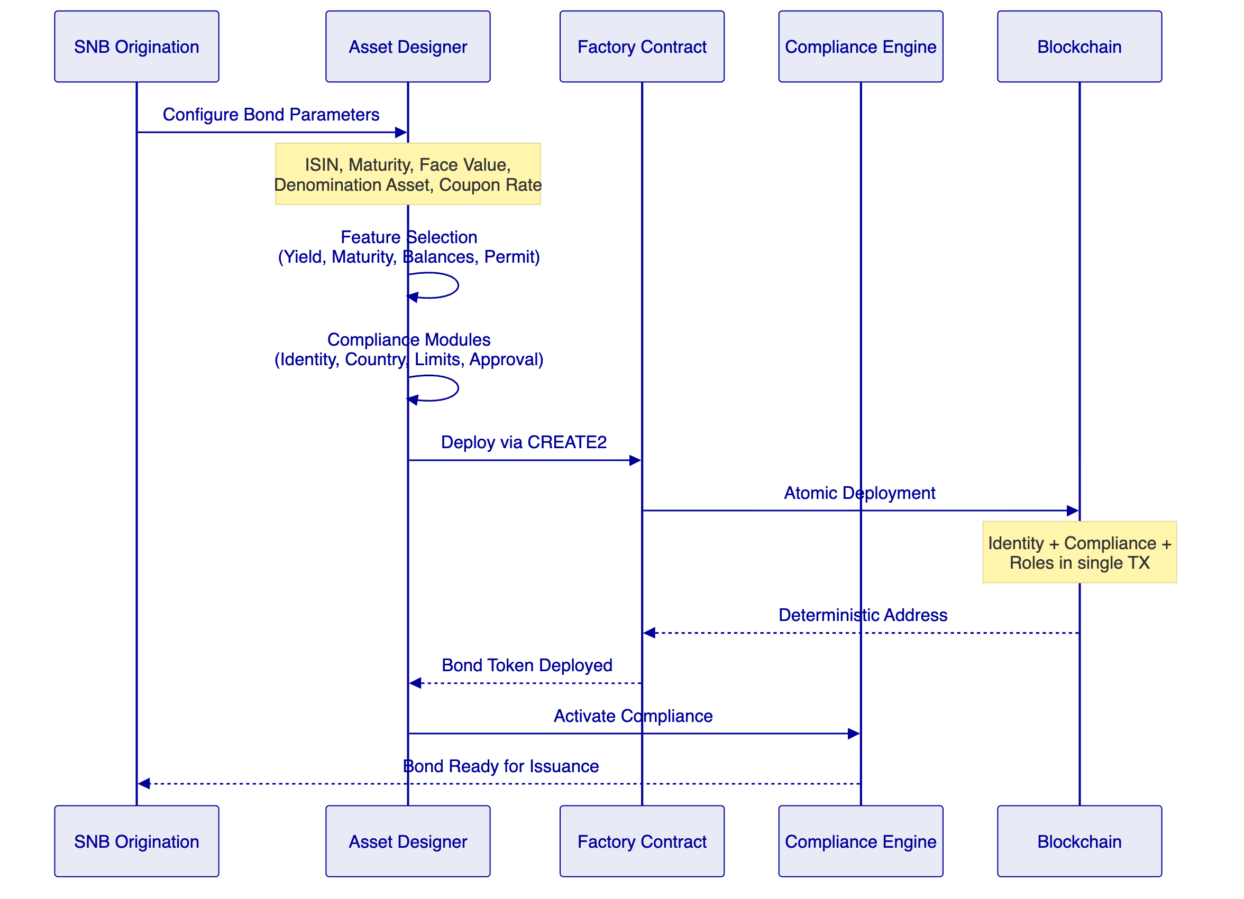
    - Token Configuration for SNB Bonds
Features:
- Historical balances — ex-date/record-date snapshots
- Fixed treasury yield — automated coupon distribution
- Maturity and redemption — automated maturity processing
- Transaction fee accounting — fee tracking
- Permit (EIP-2612) — gasless approvals
Compliance modules:
- Identity verification — mandatory
- Country allow list — KSA and approved jurisdictions
- Investor count limit — regulatory cap
- Transfer approval — maker-checker for secondary trades
    - Investor Servicing
Event | DALP Component | Automation
Coupon distribution | Fixed treasury yield + yield addon | Automated, configurable frequency
Ex-date snapshot | Historical balances feature | Automatic at configured date
Record date capture | On-chain balance query | Real-time
Payment processing | XvP settlement | Atomic DvP
Corporate actions | SMART Protocol governance | Configurable
Maturity redemption | Maturity feature | Automated at date
Early redemption | Burn + compliance + approval | Semi-automated
    - Compliance Enforcement
The compliance engine evaluates transfer rules before execution:
Module | Purpose | Bond Application
Identity verification | Verified OnchainID required | All transfers
Country allow list | Jurisdiction restriction | KSA + approved
Investor count limit | Holder cap | Regulatory compliance
Transfer approval | Maker-checker | Secondary trades above threshold
Timelock | Holding period | Where regulatory required
    - Settlement Architecture
XvP atomic DvP for both primary distribution and secondary trading:
- Both legs (bond delivery + payment) in single atomic transaction
- Deterministic finality under IBFT 2.0 (median 2.3s, P99 4.1s)
- Zero counterparty exposure window
- Failed settlements revert completely with diagnostic logging
    - Functional Fit Matrix
Req | Summary | Status | Response
REQ-01 | Segregated environments | Full | Independent instances
REQ-02 | API-first interfaces | Full | DAPI, SDK, CLI, webhooks
REQ-03 | RBAC, maker-checker, audit | Full | 26 roles, wallet verification
REQ-04 | Configurable lifecycle | Full | DALPAsset runtime config
REQ-05 | Dependency disclosure | Full | Register provided
REQ-06 | Resilience, monitoring | Full | Multi-AZ, Grafana
REQ-07 | Phased implementation | Full | 19-week methodology
REQ-08 | Audit evidence | Full | On-chain + off-chain
REQ-09 | Bond origination workflow | Full | Asset Designer + factory
REQ-10 | Coupon distribution | Full | Fixed treasury yield
REQ-11 | Maturity processing | Full | Maturity/redemption feature

  - Technical Architecture
    - Four-Layer Stack
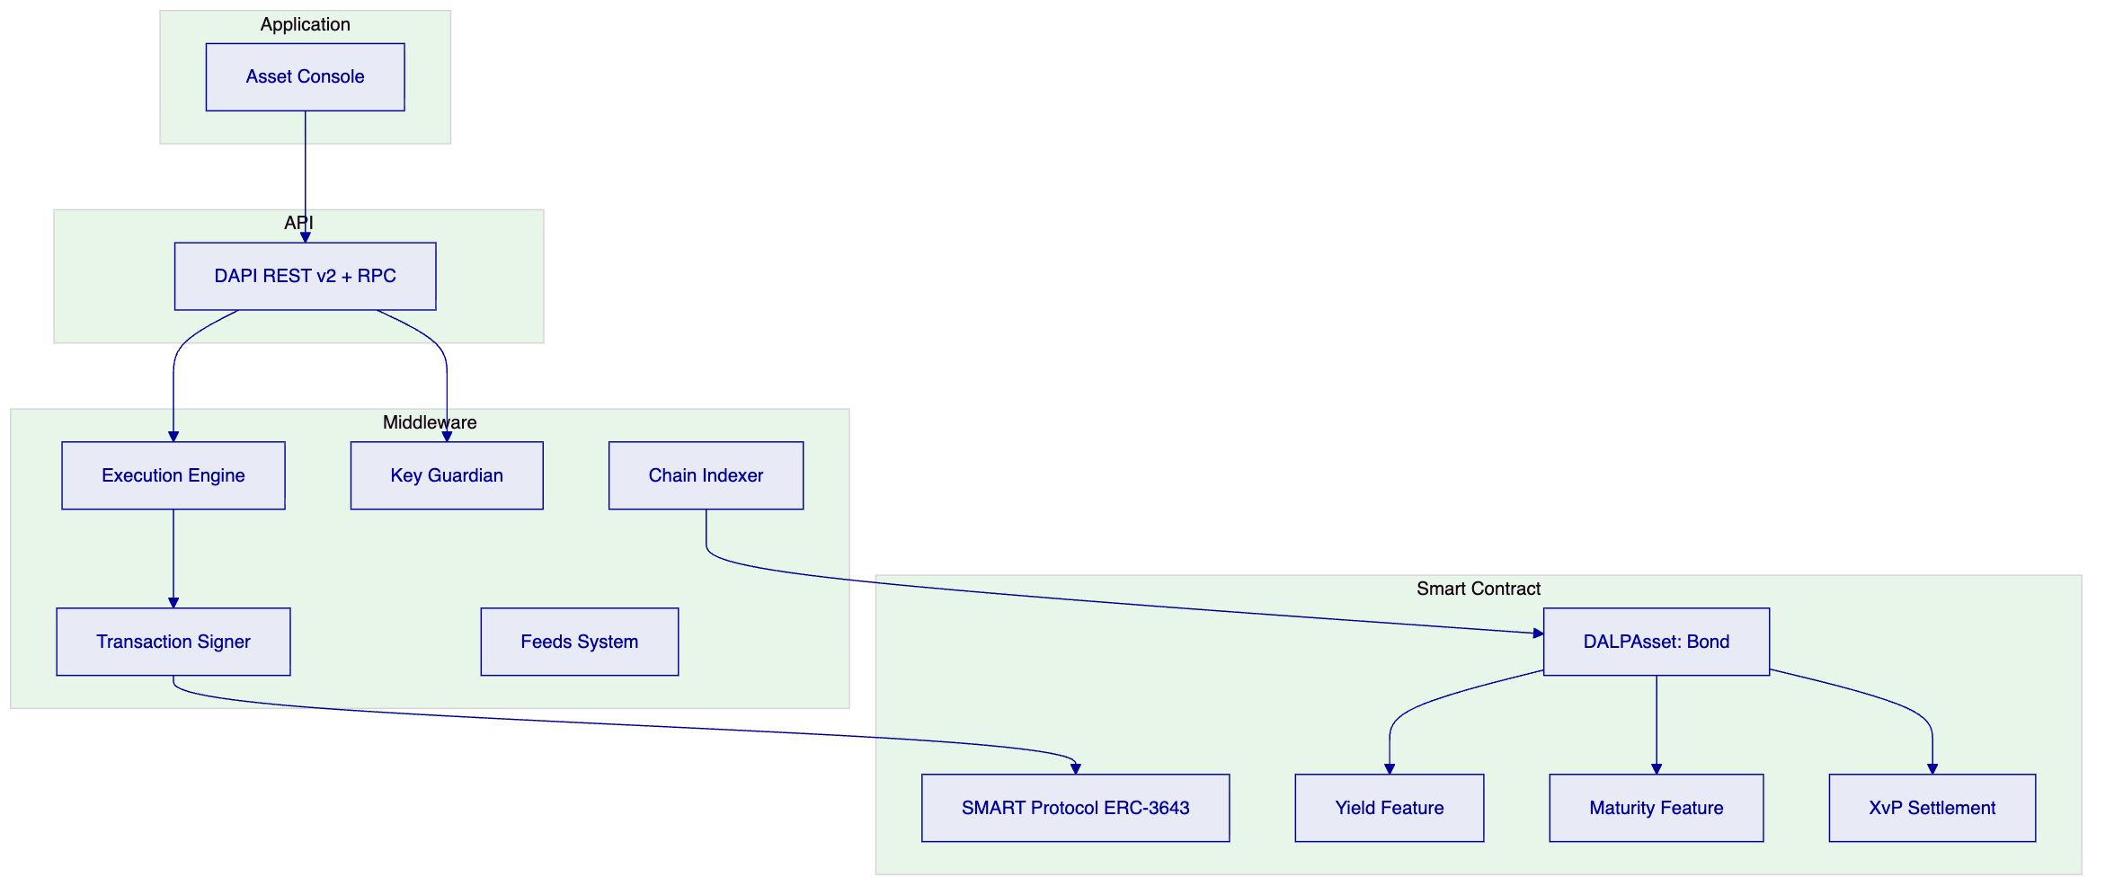
    - Network: Permissioned Hyperledger Besu
Aspect | Configuration
Consensus | IBFT 2.0
Validators | 4 nodes
Block time | 2 seconds
Finality | Deterministic
Privacy | Permissioned (SNB-controlled)
    - Security: 5-Layer Defense-in-Depth
- Authentication (email/password, passkeys, LDAP, OAuth, SAML)
- Authorization (26 roles, 4 layers, RBAC)
- Wallet verification (PIN, TOTP, passkey, backup codes)
- Compliance (18 modules, fail-closed)
- Custody policy (DFNS/Fireblocks TAP)
Certifications: ISO 27001, SOC 2 Type II

  - Implementation (19 Weeks)
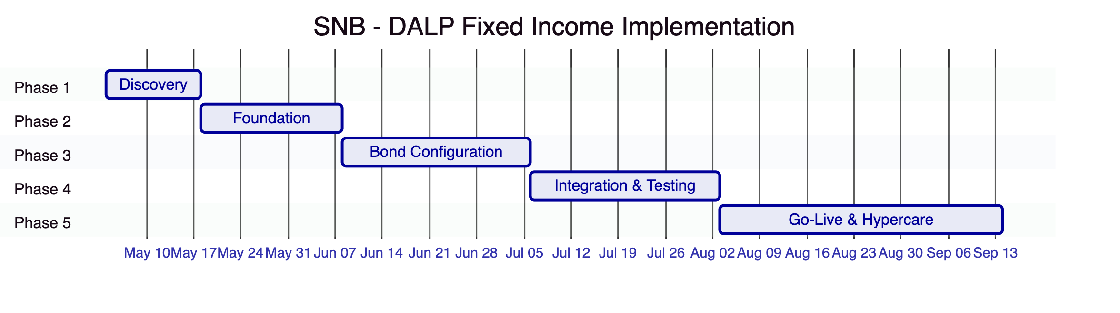
Estimated SNB effort: 75 person-days

  - Deployment
Aspect | Configuration
Model | Dedicated cloud
Region | AWS Bahrain / Azure
Data residency | KSA / GCC compliant
Blockchain | 4-node Besu (IBFT 2.0)
Custody | DFNS or Fireblocks

  - Support: Premium
Aspect | Configuration
Coverage | 16×5 (Sunday–Thursday)
P1 response | 2 hours
Uptime SLA | 99.95% monthly
Dedicated engineer | Yes

  - Risk Register
ID | Risk | Mitigation
R1 | SAMA/CMA regulatory changes | Configurable compliance modules
R2 | Tadawul integration complexity | Phase 1 deep discovery
R3 | Treasury system API delays | Early engagement, mock APIs
R4 | Security review timeline | Pre-share certifications
R5 | Custody provider onboarding | Platform signer fallback

  - Gaps
Gap | State | Mitigation | Timeline
SWIFT ISO 20022 | Middleware available | Two clients deployed | Native Q3 2026
Tadawul-specific integration | API available | Phase 4 integration | Implementation
CMA reporting templates | Configurable engine | Created Phase 3 | Implementation

  - Appendices
    - Glossary
Term | Definition
DALP | Digital Asset Lifecycle Platform
SMART Protocol | ERC-3643 implementation
DALPAsset | Configurable token contract
OnchainID | On-chain identity (ERC-734/735)
XvP | Atomic settlement addon
IBFT | Istanbul BFT consensus

