Gyan
Settlement Configurable Token for Financial Institutions
Technical Proposal | Falcon

Confidentiality Statement
This document contains confidential and proprietary information of SettleMint. By reading this document, you agree not to disclose the confidential information contained herein to any third party without the prior written consent of SettleMint, except to those agents, principals, representatives, or consultants who require access for the purpose of evaluating this document. You further agree to inform such persons of the confidential nature of this document and to obtain their agreement to preserve its confidentiality to the same extent as yours.
This confidentiality statement shall remain binding on the parties for a period of five (5) years from the date stated on the front cover, unless superseded by confidentiality provisions detailed in a subsequent agreement.
Terms and Conditions
This proposal is valid until 15 March 2026. In the absence of confirmation to proceed, SettleMint and Gyan acknowledge and agree to abide by the Mutual NDA as the governing agreement.
SettleMint reserves the right to vary the terms of this proposal in response to changes in specifications or information made available at a later date. Submission of this proposal does not convey any right, title, interest, or license in any intellectual property rights (including, but not limited to, patents, copyrights, trade secrets, or trademarks) contained herein.
All rights are reserved. This proposal and the information contained within it are provided on an “as is” basis, without any warranties of any kind, express or implied.
All contracts with SettleMint will be governed by Belgian Law and subject to the exclusive jurisdiction of Belgian courts.
Contact Details
For any enquiries regarding this document, please contact:
SettleMint Team
Digital Asset Solutions
Email: contact@settlemint.com
Phone: +32 2 000 00 00

Table of Contents

Executive Summary 3
The Institutional Problem 4
Proposed Solution 5
Configurable Settlement Token Model 6
Settlement Workflows and Controls 7
Compliance and Identity Controls 8
Lifecycle and Servicing Model 9
Interoperability and Integration Considerations 10
Governance, Auditability, and Operational Readiness 11
Reference Architecture Considerations 12
Phased Implementation Approach 13
Phase One, Design and Control Definition 14
Phase Two, Foundation and Platform Setup 15
Phase Three, Token Configuration and Workflow Design 16
Phase Four, Integration, Testing, and Readiness 17
Phase Five, Production Rollout and Hypercare 18
Why DALP Instead of Generic Tokenization 19
Conclusion 20

- Executive Summary
Financial institutions evaluating tokenized settlement infrastructure face a problem that generic tokenization stacks do not solve. Creating a token is straightforward. Operating a settlement instrument under institutional controls is not. A settlement token must enforce participant eligibility before value moves, integrate with identity and custody controls, support governed issuance and redemption, preserve a defensible audit trail, and fit into treasury, payments, and post-trade operating models without creating new reconciliation risk.
SettleMint proposes DALP, the Digital Asset Lifecycle Platform, as the foundation for a configurable settlement token operating model for banks and other regulated financial institutions. DALP provides a configuration-driven framework for tokenized deposits, stable-value instruments, and regulated transfer workflows on EVM-compatible networks. The platform combines ERC-3643 based compliance enforcement, OnchainID identity controls, role-based governance, atomic settlement patterns, lifecycle servicing, and enterprise integration surfaces in one platform.
This proposal outlines how a financial institution can use DALP to deploy and operate a configurable settlement token with strong controls from day one. The proposed model focuses on six institutional priorities: configurable token design, settlement workflow control, compliance and identity enforcement, lifecycle and servicing operations, interoperability with existing systems, and operational readiness under audit and governance scrutiny.
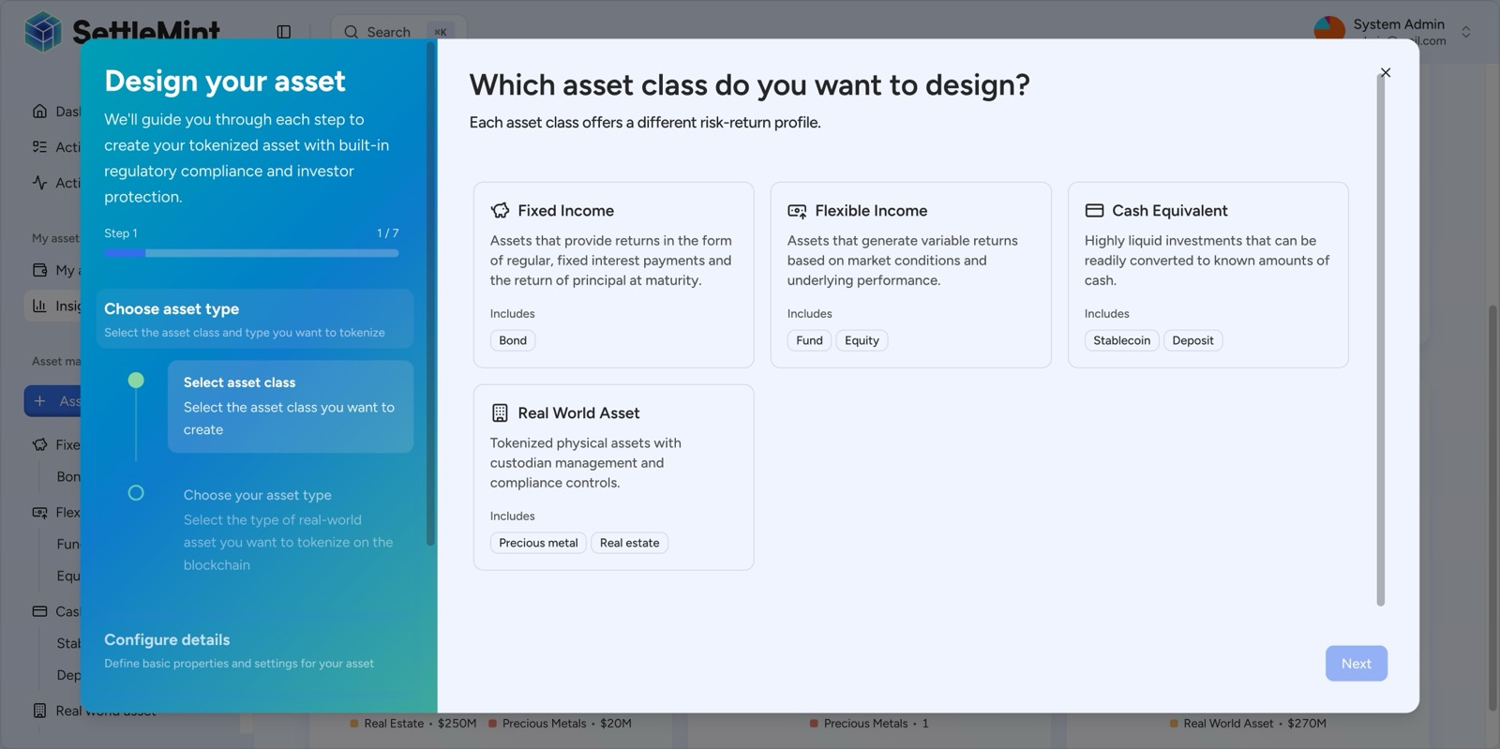
DALP's Asset Designer configures regulated digital assets through a guided workflow, allowing institutions to set token parameters, compliance rules, and operating controls before deployment.

- The Institutional Problem
Settlement tokens used by financial institutions carry a different burden from retail payment tokens or general-purpose digital assets. The institution is not only moving value. It is operating a liability or cash-equivalent instrument inside a controlled environment that must satisfy treasury policy, compliance requirements, segregation of duties, eligibility rules, audit review, and operational resilience expectations.
Generic tokenization approaches usually stop at ledger representation. They can mint, transfer, and burn. They do not natively answer the questions that matter in regulated settlement flows. Who is allowed to receive the token. Which legal entity issued the required identity claim. Whether the recipient remains eligible at the moment of transfer. Whether a treasury or operations team has the right role to approve issuance. Whether the instrument can be paused, frozen, or forcibly moved under exceptional legal or security conditions. How the institution reconciles blockchain finality with internal books, custody policy, and payment operations.
Institutional settlement therefore requires a platform built around control, not only token mechanics. That is the complexity of doing it right. DALP addresses that complexity through configurable asset design, ex-ante compliance, enterprise key management, role-scoped operations, and integration surfaces that fit existing banking architecture.

- Proposed Solution
SettleMint proposes a configurable settlement token model implemented on DALP. The solution uses DALP's cash-equivalent asset capabilities, identity and compliance stack, and operational tooling to establish a settlement instrument that can support controlled issuance, transfer, redemption, and integration into broader settlement workflows.
At a high level, the institution defines the settlement token's legal and operational parameters, including denomination, jurisdiction, participant eligibility rules, supply controls, issuance authority, and servicing model. DALP then deploys the token through its factory-based workflow, binds it to the platform identity and compliance infrastructure, and exposes the resulting asset through API, UI, and operational monitoring interfaces.
The result is not a one-off smart contract. It is an operating environment for a regulated settlement instrument.
Design Objective | DALP Response
Configurable token structure | Asset Designer and API-based token creation with asset-specific parameters and feature selection
Controlled settlement flows | Compliance-checked transfers, atomic DvP/XvP support, pause, freeze, and forced transfer controls
Verified counterparties | OnchainID identity registry with trusted issuer claims and transfer-time eligibility enforcement
Lifecycle servicing | Mint, burn, redemption, supply control, role management, recovery, and audit logging
Enterprise integration | REST API, TypeScript SDK, CLI, event indexing, monitoring, and ISO 20022-aligned payment integration patterns
Governance readiness | Five-role per-asset operating model, maker-checker compatible custody patterns, durable transaction history

- Configurable Settlement Token Model
The proposed settlement token should be treated as a configurable institutional cash instrument, not as a generic ERC-20. DALP supports cash-equivalent token classes including tokenized deposits and stablecoins, with asset configuration performed through the same production workflow used for other regulated instruments on the platform. This allows the institution to define the token's denomination, metadata, compliance profile, governance assignments, and settlement behavior without commissioning a new smart contract for each product variant.
That configurability matters because settlement instruments are rarely uniform across institutions or jurisdictions. One programme may require issuer-controlled minting against treasury processes. Another may require corridor-specific participant allowlists. Another may require a tokenized deposit model tied to internal liability controls. DALP's model allows those operating rules to be expressed through configuration of asset parameters, compliance modules, identity claims, and roles, rather than through ad hoc contract rewrites.
A settlement configurable token on DALP can therefore be tailored around institutional policy while still relying on a standardized, production-grade contract and lifecycle framework.
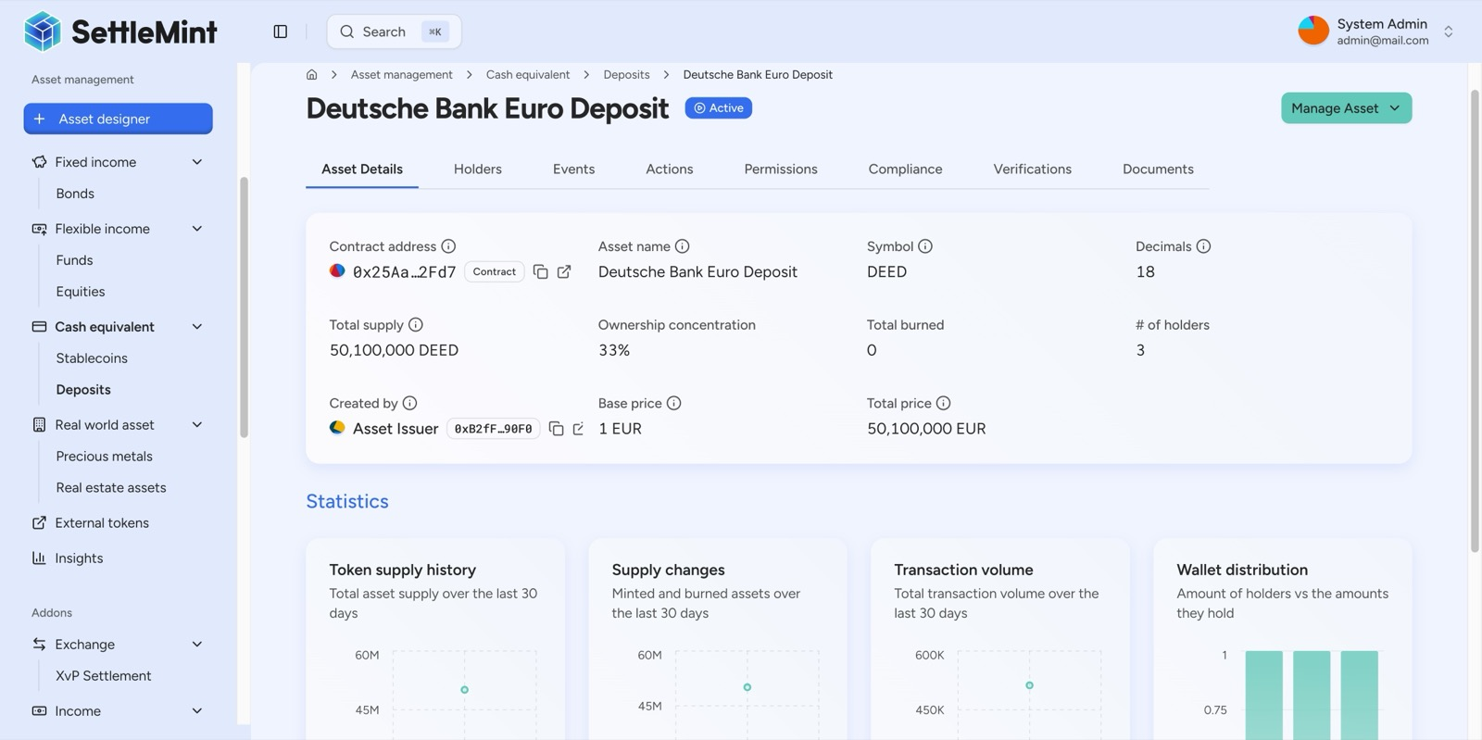
DALP's deposit tokenization flow establishes institutional cash-equivalent assets that can act as on-chain settlement instruments within a governed operating model.

- Settlement Workflows and Controls
A settlement token is only useful if the movement of value happens under deterministic control. DALP enforces this through a transfer pipeline that resolves sender and recipient identities, evaluates all active compliance modules, applies any relevant token feature checks, and only then allows the balance update to execute. If any required condition fails, the transaction reverts. There is no state in which a non-compliant transfer settles and is reviewed later.
For bilateral or multi-party settlement workflows, DALP provides atomic settlement patterns through its XvP module. This supports delivery-versus-payment and payment-versus-payment flows where all legs execute together or the full operation reverts. That matters for institutional settlement because it removes the operational gap between asset movement and cash movement that otherwise creates counterparty and reconciliation risk.
The platform also includes the operational controls expected in financial institution workflows. Tokens can be paused during an incident. Specific addresses or balances can be frozen. Custodian-authorized forced transfers can be used under exceptional legal or operational circumstances. Supply managers can mint and burn under role control. These are not optional extras. They are part of what makes a settlement instrument governable under real-world conditions.
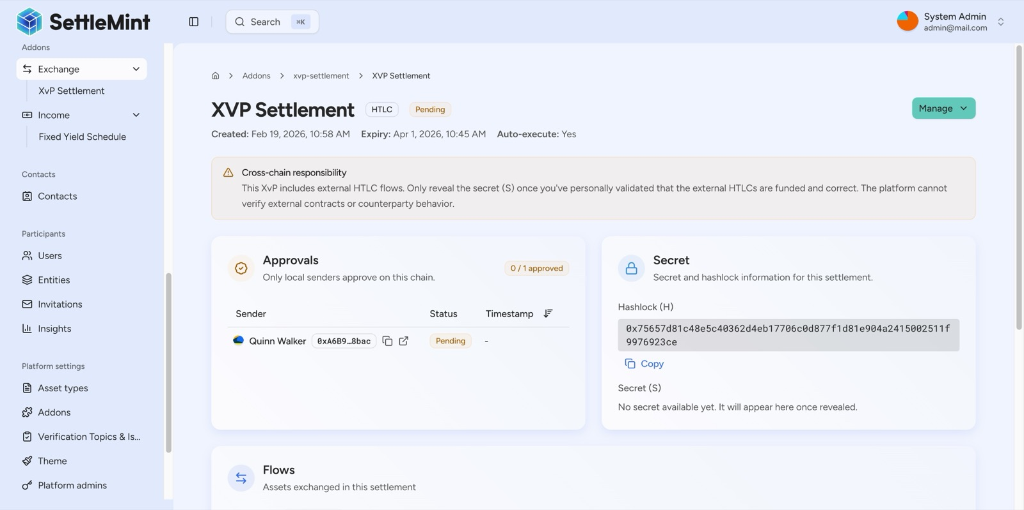
DALP's XvP workflow coordinates multi-leg settlement with explicit approval state, expiry management, and atomic execution logic.

- Compliance and Identity Controls
Institutional settlement requires participant eligibility to be enforced before execution. DALP does this through its ERC-3643 based compliance architecture and OnchainID identity system. Every token holder is represented by a registered on-chain identity contract. Claims such as KYC status, AML status, accreditation, jurisdiction, or institution-specific eligibility are issued by trusted parties and validated at transfer time.
This architecture shifts compliance from manual review and after-the-fact investigation into programmable enforcement. If the required claim has expired, if the claimant is not trusted for that topic, or if the transfer violates a country restriction, investor count rule, approval workflow, or time-based policy, the transfer fails immediately. This is the correct operating posture for regulated settlement, because compliance must be embedded into execution, not treated as a separate supervisory process.
DALP's compliance library supports jurisdiction restrictions, identity verification logic, investor limits, transfer approval, holding period logic, supply limits, and collateral requirements. These modules can be combined into institution-specific policy templates so that a settlement token programme can reflect local regulatory requirements and internal control policy without custom contract development.
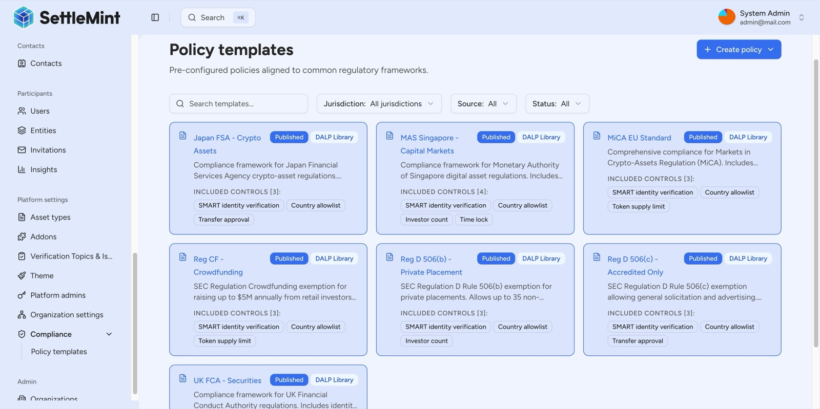
DALP's compliance policy framework allows institutions to configure enforceable transfer rules, jurisdiction restrictions, and identity requirements at the token level.

- Lifecycle and Servicing Model
A settlement token programme does not end at issuance. It requires ongoing servicing and predictable lifecycle control. DALP covers this through its asset lifecycle management capabilities. Once a token is deployed, authorized operators can mint supply, redeem or burn units, manage freezes, pause and unpause the asset, assign and revoke roles, and recover operations under governed emergency procedures.
This lifecycle coverage is particularly important for financial institutions because settlement instruments live inside treasury, cash management, and operational support processes. A token may need to be issued against funds movement, redeemed at end of day, suspended during an exception event, or transferred under legal instruction. DALP provides the operational primitives for those actions while preserving role-based controls and a full event trail.
Where the institution needs distribution schedules, asset servicing, or maturity-driven mechanics for adjacent instruments, the same DALP platform extends into those workflows as well. That gives the institution room to use one operating platform across broader digital asset initiatives rather than creating an isolated settlement stack that cannot evolve.

- Interoperability and Integration Considerations
Institutional settlement infrastructure succeeds when it connects cleanly to existing systems. DALP is designed as an API-first platform with a unified REST surface, OpenAPI specification, TypeScript SDK, CLI, analytics views, and real-time monitoring streams. This allows the settlement token programme to integrate with treasury systems, core banking, KYC providers, payment workflows, reconciliation tooling, custody services, and reporting environments.
DALP also supports payment-rail integration patterns aligned with ISO 20022 and provides exchange-rate and data-feed capabilities for cases where settlement or valuation logic requires external data inputs. For custody, the platform supports a bring-your-own-custodian approach with integrations such as DFNS and Fireblocks, allowing the institution to preserve its preferred key management and approval environment rather than replacing it.
This interoperability matters because tokenized settlement does not exist in isolation. It must coexist with internal books and records, payment controls, identity services, and enterprise observability. DALP is built to sit within that operating landscape rather than outside it.

- Governance, Auditability, and Operational Readiness
A settlement token for financial institutions must remain governable under scrutiny from control functions, auditors, and risk committees. DALP supports this through a multi-layer permission model, durable transaction lifecycle tracking, full event indexing, and operational monitoring across API, blockchain, and workflow health.
At the asset level, DALP separates responsibilities across core operational roles including admin, governance, supply management, custodian, and emergency. This allows the institution to reflect its own segregation-of-duties model across issuance, policy changes, emergency intervention, and custody actions. At the system level, broader roles govern identity, compliance configuration, system management, and feeds.
Operationally, the platform exposes real-time monitoring, request logs, transaction status, and indexed event history. Every material action leaves evidence. That includes identity events, role changes, mints, burns, freezes, transfers, and settlement lifecycle transitions. For financial institutions, this is essential. A settlement platform must do more than execute. It must prove what happened, who authorized it, and which controls were active at the time.
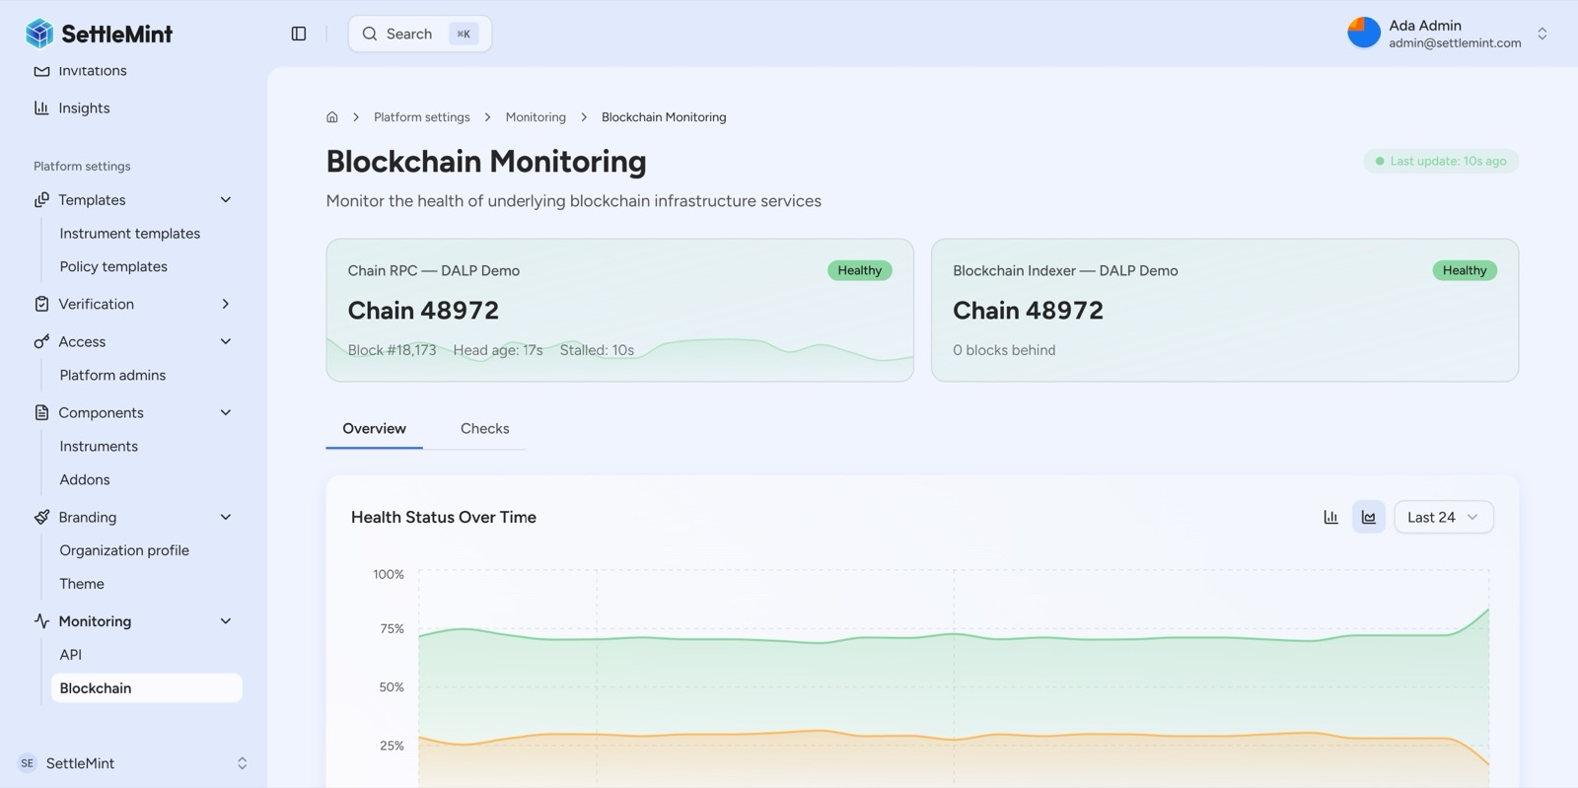
DALP provides real-time blockchain and platform monitoring so operations teams can supervise transaction health, indexer status, and infrastructure behavior in production.

- Reference Architecture Considerations
The recommended deployment model for a financial institution is private cloud or on-premises, depending on data residency, infrastructure policy, and operational preference. DALP supports both models with the same core platform capabilities. A standard deployment includes the DALP application layer, DAPI service, chain indexer, signer integration, database, object storage, and observability stack.
Within that topology, the settlement token programme typically connects to four institutional domains. First, identity and KYC infrastructure, which provides the underlying verification evidence used to issue trusted claims. Second, custody and signing infrastructure, which governs how transactions are approved and signed. Third, treasury and payment systems, which coordinate issuance, redemption, and settlement cash flows. Fourth, reporting and monitoring systems, which consume events, analytics, and operational telemetry.
The architectural objective is clear. DALP should serve as the governed digital asset lifecycle and execution layer, while the institution retains control of its surrounding enterprise systems.

- Phased Implementation Approach
SettleMint recommends a phased implementation approach for a settlement configurable token programme. This reduces delivery risk, aligns control design with operational readiness, and allows the institution to validate governance and compliance assumptions before expanding scope.
  - Phase One, Design and Control Definition
The first phase establishes the target operating model. This includes confirming the legal and product framing of the settlement token, identifying participant types, mapping identity and compliance requirements, selecting deployment topology, and defining the control matrix across issuance, transfer, redemption, and exception handling. The output is a validated architecture and policy blueprint rather than a speculative build.
  - Phase Two, Foundation and Platform Setup
The second phase provisions the DALP environments, configures network and custody connectivity, establishes identity and role structures, and prepares the observability and transaction execution layers. At the end of this phase, the institution has a working platform foundation ready for token configuration and integration.
  - Phase Three, Token Configuration and Workflow Design
The third phase configures the settlement token itself. Asset parameters, compliance templates, claim topics, role assignments, and settlement workflow patterns are implemented and tested in a non-production environment. Integration contracts with KYC, treasury, and payment functions are validated in parallel.
  - Phase Four, Integration, Testing, and Readiness
The fourth phase connects DALP to the institution's surrounding systems and validates end-to-end behavior through functional, security, performance, and operational testing. This includes both pass and fail scenarios for compliance logic, controlled settlement execution, and evidence generation for audit and support teams.
  - Phase Five, Production Rollout and Hypercare
The final phase executes production deployment, controlled go-live, and hypercare. The institution's operations team is supported through early production activity while support runbooks, escalation flows, monitoring thresholds, and operating ownership are finalized.
This phased model is important because institutional settlement programmes fail when policy, operations, and technology are compressed into one deployment event. A controlled rollout is the better path.

- Why DALP Instead of Generic Tokenization
Generic tokenization is insufficient for institutional settlement because it treats the token as the product. In practice, the token is only one part of the operating model. Institutions need identity-linked participation, pre-execution compliance, controlled issuance and redemption, atomic settlement options, integration with custody and payment infrastructure, and operational evidence that survives internal and external review.
DALP addresses these requirements as platform capabilities, not as custom side projects. The institution gets a configurable digital asset lifecycle platform that already includes the control framework needed for regulated operation. That shortens implementation time, reduces architectural risk, and avoids the pattern of assembling multiple partial tools that leave governance and lifecycle gaps between them.
The core differentiator is not that DALP can mint a token. Many tools can. The differentiator is that DALP is built around the complexity of doing it right in institutional environments.

- Conclusion
A configurable settlement token for financial institutions must operate as more than a blockchain asset. It must function as a governed settlement instrument with identity-linked participation, deterministic controls, lifecycle servicing, auditability, and clean integration into existing institutional architecture.
DALP provides the building blocks for that outcome. Its configurable asset model, ERC-3643 compliance stack, identity infrastructure, settlement workflow controls, lifecycle operations, and enterprise integration surfaces make it a strong fit for institutions that need production-grade tokenized settlement capability without compromising on governance or operational readiness.
SettleMint therefore recommends DALP as the platform foundation for a settlement configurable token programme, delivered through a phased implementation path that aligns policy, technology, and operations from the outset.

