[Company name]
[Document title]
[Document subtitle]

Confidentiality Statement
This document contains confidential and proprietary information of SettleMint. By reading this document, you agree not to disclose the confidential information contained herein to any third party without the prior written consent of SettleMint, except to those agents, principals, representatives, or consultants who require access for the purpose of evaluating this document. You further agree to inform such persons of the confidential nature of this document and to obtain their agreement to preserve its confidentiality to the same extent as yours.
This confidentiality statement shall remain binding on the parties for a period of five (5) years from the date stated on the front cover, unless superseded by confidentiality provisions detailed in a subsequent agreement.
Terms and Conditions
This proposal is valid until [DD Month YYYY]. In the absence of confirmation to proceed, SettleMint and [the Company] acknowledge and agree to abide by the Mutual NDA as the governing agreement.
SettleMint reserves the right to vary the terms of this proposal in response to changes in specifications or information made available at a later date. Submission of this proposal does not convey any right, title, interest, or license in any intellectual property rights (including, but not limited to, patents, copyrights, trade secrets, or trademarks) contained herein.
All rights are reserved. This proposal and the information contained within it are provided on an “as is” basis, without any warranties of any kind, express or implied.
All contracts with SettleMint will be governed by Belgian Law and subject to the exclusive jurisdiction of Belgian courts.
Contact Details
For any enquiries regarding this document, please contact:
[Full Name]
[Job Title]
Email: [email@example.com]
Phone: [Country Code - Number]

Table of Contents

Executive Summary 3
Context and Strategic Drivers 4
Why This Programme Is Hard 5
Proposed Response 6
Why SettleMint 7
Why DALP 8
Reference Fit Snapshot 9
About SettleMint 10
Production Credentials 11
Regulatory Readiness 12
About DALP 13
Core Lifecycle Pillars 14
Issuance 15
Compliance 16
Custody 17
Settlement 18
Servicing 19
Customer References 20
Expanded Reference: Standard Chartered Bank 21
Expanded Reference: ADI Finstreet 22
Understanding of Requirements 23
Proposed Solution 24
Solution Overview 25
Compliance Enforcement 26
Functional Fit Matrix 27
Technical Architecture 28
Security, Implementation, Deployment, Training, Support 29
Security 30
Implementation (19 Weeks) 31
Deployment 32
Support 33
Compliance Matrix 34

Field | Value
Proposal title | Technical Proposal: Tokenized Securities Issuance and Settlement Platform
Client | Standard Bank (South Africa)
Submitted by | SettleMint NV
Date | March 2026
Version | v1.0
Confidentiality | Restricted
RFP Reference | STANDARD-BANK-RFP-TOKENIZED-SECURITIES-202603
Contact | SettleMint NV, Kempische Steenweg 311/4.01, 3500 Hasselt, Belgium
Valid until | June 2026

- Executive Summary
  - Context and Strategic Drivers
Standard Bank is procuring a tokenized securities issuance and settlement platform as a business-critical capability operating within its control environment under the South African Reserve Bank (SARB), Financial Sector Conduct Authority (FSCA), and Johannesburg Stock Exchange (JSE) regulatory oversight. As Africa's largest bank by assets, Standard Bank's platform selection carries strategic significance for the broader development of digital securities infrastructure across the continent.
South Africa's capital markets regulatory environment is maturing rapidly. SARB's Project Khokha demonstrated blockchain-based settlement feasibility, and the JSE is actively developing digital asset market infrastructure. Standard Bank requires a platform that delivers deterministic settlement finality in under 3 seconds, supports multi-asset securities across bonds and equities, and provides the compliance, governance, and auditability expected of a systemically important financial institution.
  - Why This Programme Is Hard
Tokenized securities issuance and settlement spans multiple asset classes (bonds and equities at minimum), requires integration with JSE market infrastructure, Strate CSD processes, and SARB payment systems, and must support both primary issuance and secondary market settlement. The compliance burden is substantial: SARB prudential requirements, FSCA conduct standards, FIC AML/CFT obligations, and international investor distribution rules create a multi-layered regulatory environment.
Standard Bank's scale and pan-African presence add complexity. A platform that works for South Africa alone may not scale to support Standard Bank's operations across 20 African markets. The architecture must support multi-jurisdictional compliance and cross-border distribution from day one.
  - Proposed Response
SettleMint proposes DALP as the tokenized securities lifecycle platform. DALP's multi-asset architecture supports bonds and equities through purpose-built templates with asset-specific lifecycle logic, with expansion capability to funds, deposits, and additional asset classes. The deployment uses dedicated cloud with South Africa-resident infrastructure.
  - Why SettleMint
SettleMint's Standard Chartered Bank reference directly demonstrates institutional securities trading capability across Asia, Africa, and the Middle East. The Commerzbank reference shows fixed income settlement under 10 seconds. The Saudi RER reference demonstrates national-scale deployment discipline. Multi-year production experience with regulated banks across multiple jurisdictions provides the credibility Standard Bank requires.
  - Why DALP
DALP provides multi-asset lifecycle management (bonds and equities with expansion to funds and deposits), ex-ante compliance enforcement across 18 module types, atomic DvP settlement with T+0 finality, automated corporate actions (dividends, coupons, stock splits, voting), and ISO 20022 payment rail connectivity. The configurable token extends coverage beyond pre-built asset classes for future innovation.
  - Reference Fit Snapshot
- Standard Chartered Bank: Institutional securities trading across Africa and the Middle East, directly relevant to Standard Bank's market context
- Commerzbank: Fixed income settlement under 10 seconds, EUR 7M savings
- ADI Finstreet: Tokenized equity with corporate actions on Abu Dhabi mainnet, demonstrating equity-specific capability

- About SettleMint
  - Production Credentials
Category | Evidence
Market Validation | Nearly 10 years; 7+ years production
Operational Maturity | 7 asset classes in production
Sovereign Credibility | National-scale Middle East programmes
African Market Presence | Standard Chartered engagement across Africa

  - Regulatory Readiness
Jurisdiction | DALP Support
South Africa (SARB, FSCA, FIC) | Controls mapped; buyer interprets
Pan-African markets | Configurable compliance per jurisdiction
EU (MiCA) | Native templates
GCC | Supported

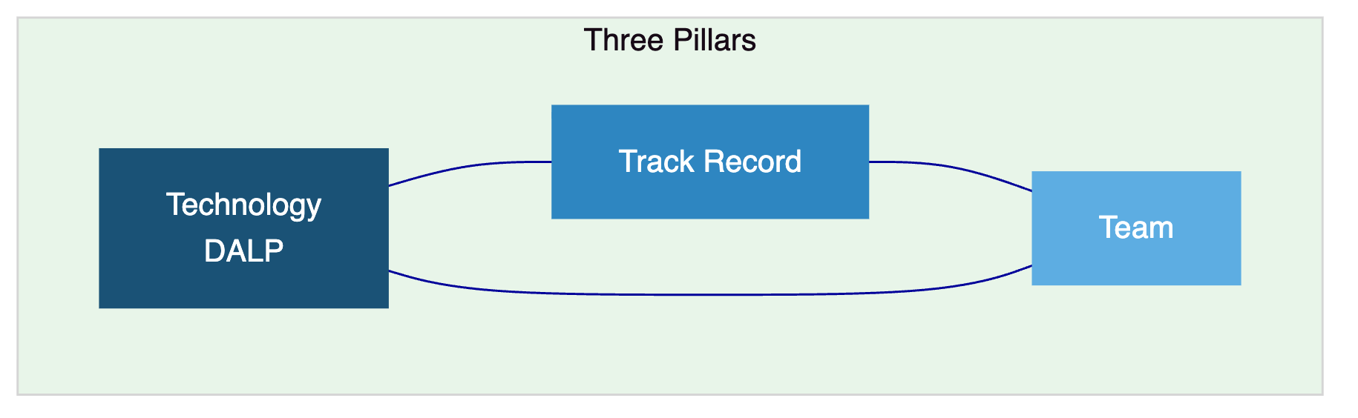

- About DALP
  - Core Lifecycle Pillars
    - Issuance
Bond templates (coupon schedules, maturity, call/put), equity templates (dividend distribution, voting rights, corporate actions), plus 5 additional asset class templates and configurable token. Deterministic orchestration with paused-by-default governance.
    - Compliance
18 compliance module types with ex-ante enforcement. Multi-jurisdictional support for SARB, FSCA, FIC, and pan-African requirements. ERC-3643 with OnchainID.
    - Custody
Key Guardian with institutional custody (Fireblocks, DFNS). Maker-checker workflows.
    - Settlement
Atomic DvP/XvP with T+0 finality. ISO 20022 for SARB RTGS, JSE settlement, SWIFT. HTLC for cross-border.
    - Servicing
Automated dividends, coupons, stock splits, maturity, corporate actions. Voting rights through ERC-5805. Complete audit trail.
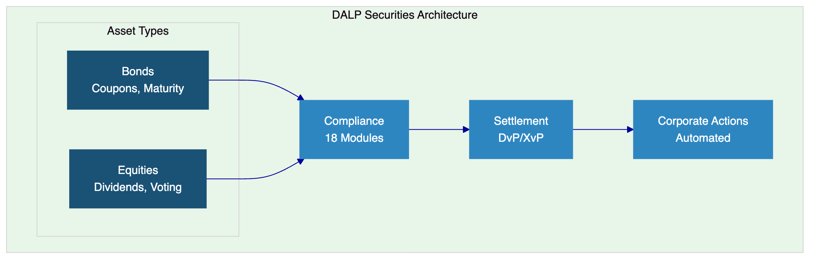

- Customer References
Client | Use Case | Geography | Relevance
Standard Chartered | Institutional securities trading | Asia, Africa, ME | African market, securities
Commerzbank | ETP issuance, settlement | Germany | Fixed income, EUR 7M savings
ADI Finstreet | Tokenized equity, corporate actions | UAE | Equity capability
OCBC Bank | Multi-asset security tokens | Singapore | Securities platform
Saudi RER | Country-scale tokenization | KSA | National-scale integration
KBC Securities | Equity crowdfunding | Belgium | Equity lifecycle
Maybank | FX tokenization, XvP | Malaysia | Atomic settlement
IsDB | Multi-country distribution | 57 countries | Pan-African relevance

  - Expanded Reference: Standard Chartered Bank
Standard Chartered's Digital Virtual Exchange supports fractional tokenization of securities across Asia, Africa, and the Middle East. Ownership changes are recorded instantly on the blockchain, eliminating custody intermediaries and reducing settlement times. This reference directly demonstrates institutional securities capability in Standard Bank's geographic operating context.
  - Expanded Reference: ADI Finstreet
Tokenized equity issuance on Abu Dhabi's mainnet with embedded corporate action functionality, including stock splits and consolidations via controlled mint and burn, and on-chain voting using ERC20Votes. Demonstrates DALP's equity-specific lifecycle management with institutional custody integration (DFNS, Fireblocks path).

- Understanding of Requirements
Domain | Standard Bank Requirements | DALP Coverage
Securities scope | Bonds and equities, secondary market | Bond and equity templates
Compliance | SARB, FSCA, FIC, pan-African | 18 modules, multi-jurisdictional
Settlement | JSE integration, SARB RTGS | DvP/XvP, ISO 20022
Corporate actions | Dividends, coupons, splits, voting | Automated lifecycle servicing
Integration | Core banking, Strate CSD, JSE | REST, GraphQL, ISO 20022

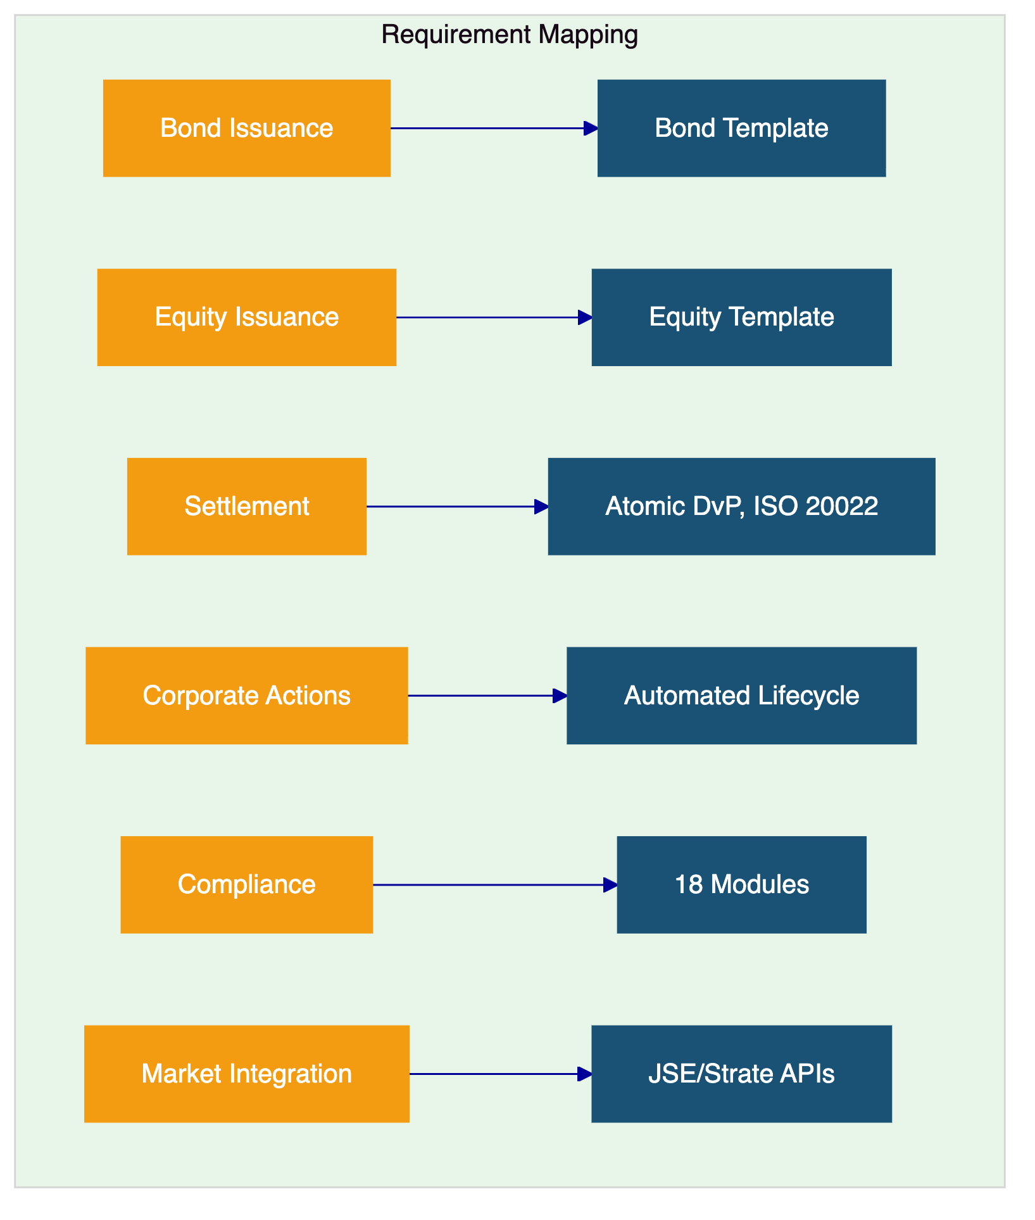

- Proposed Solution
  - Solution Overview
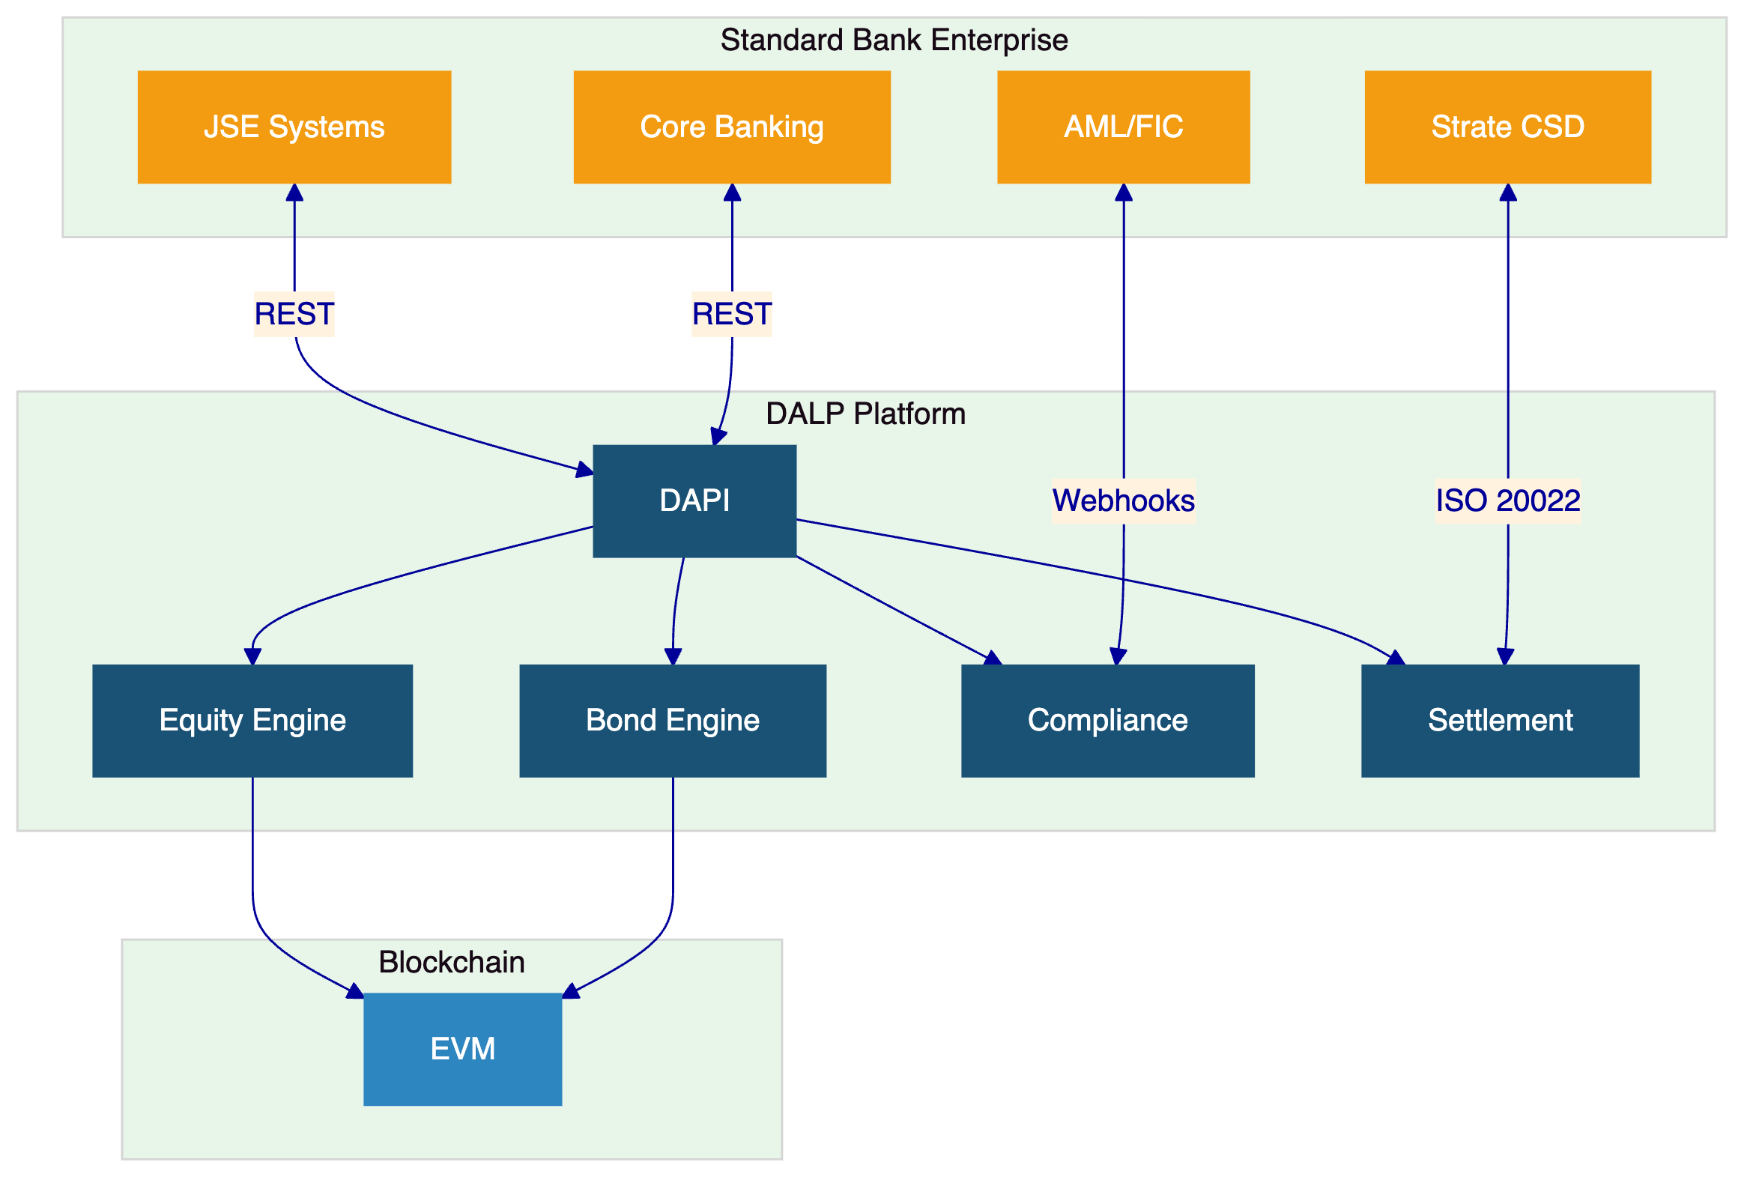
  - Compliance Enforcement
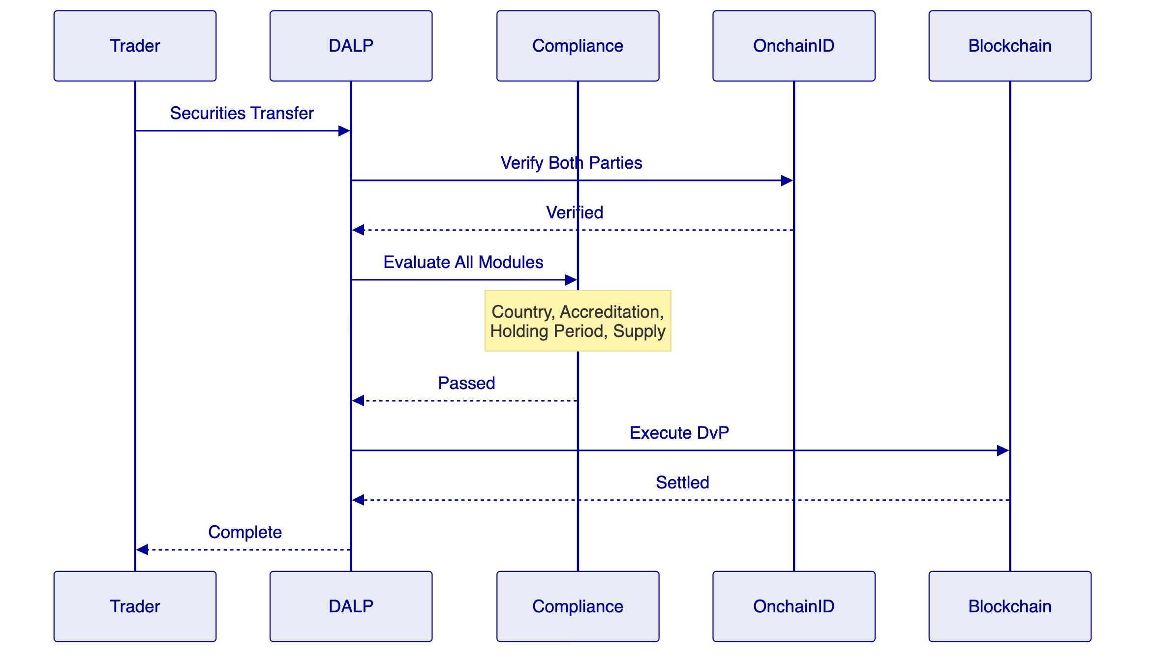
  - Functional Fit Matrix
Requirement | Status | DALP Capability
Bond issuance | Full | Bond template with lifecycle
Equity issuance | Full | Equity template with corporate actions
Settlement (JSE/Strate) | Full | DvP/XvP, ISO 20022
Corporate actions | Full | Automated dividends, coupons, splits
Voting rights | Full | ERC-5805
RBAC and audit | Full | 5 roles, immutable trail
Compliance | Full | 18 modules, ex-ante
Environment segregation | Full | Full set
Resilience | Full | HA, 3-pillar observability

- Technical Architecture
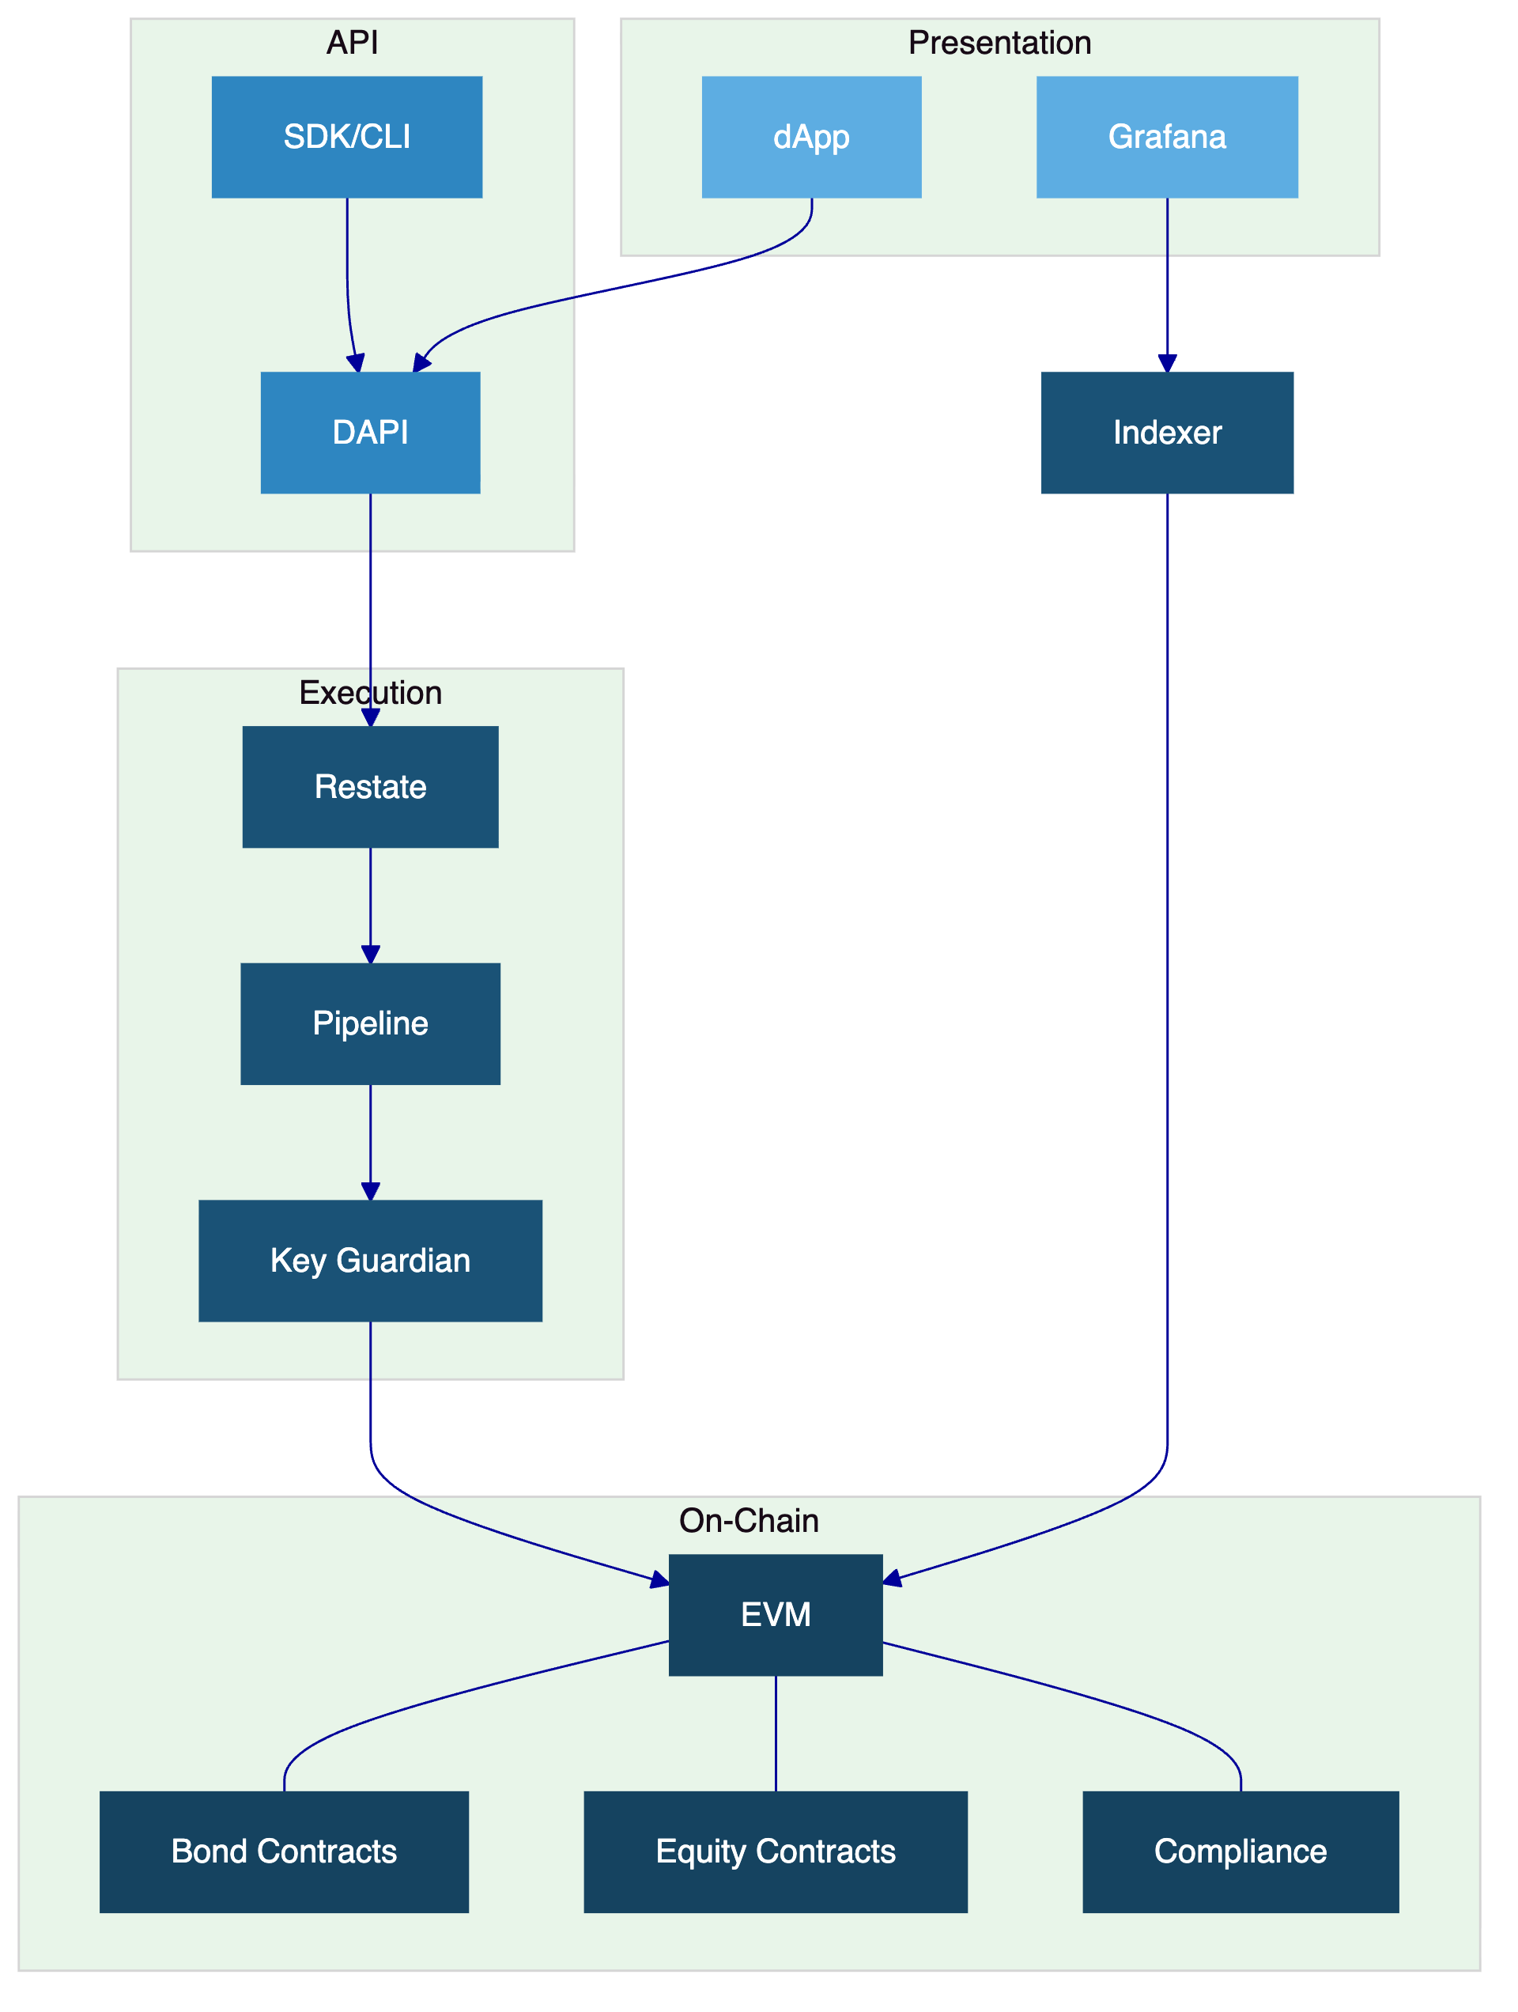

- Security, Implementation, Deployment, Training, Support
  - Security
Three-domain trust model. Defense-in-depth. Two-endpoint auth. 5-role RBAC. Key Guardian Tier 4. Maker-checker. Emergency pause.
  - Implementation (19 Weeks)
Phase | Weeks | Objective
Discovery | 1 to 3 | Requirements, SARB/FSCA mapping, JSE integration design
Foundation | 4 to 7 | Environments, bond and equity config, compliance
Integration | 8 to 11 | Core banking, Strate, JSE, FIC
Testing | 12 to 15 | Functional, NFR, security, UAT
Go-Live | 16 to 17 | Controlled cutover
Hypercare | 18 to 21 | Monitoring and handover

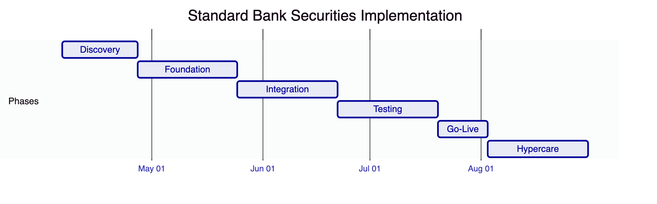
  - Deployment
Dedicated cloud, South Africa-resident. Multi-zone HA.
  - Support
Premium recommended. 99.95% uptime. 2-hour P1 response. Dedicated engineer.

- Compliance Matrix
Requirement | Status
Bond issuance and lifecycle | Full
Equity issuance and corporate actions | Full
Settlement (JSE/Strate integration) | Full
Multi-jurisdictional compliance | Full
RBAC and audit | Full
Environment segregation | Full
Resilience and DR | Full
Regulatory mapping (SARB/FSCA) | Configurable

