[Company name]
[Document title]
[Document subtitle]

Confidentiality Statement
This document contains confidential and proprietary information of SettleMint. By reading this document, you agree not to disclose the confidential information contained herein to any third party without the prior written consent of SettleMint, except to those agents, principals, representatives, or consultants who require access for the purpose of evaluating this document. You further agree to inform such persons of the confidential nature of this document and to obtain their agreement to preserve its confidentiality to the same extent as yours.
This confidentiality statement shall remain binding on the parties for a period of five (5) years from the date stated on the front cover, unless superseded by confidentiality provisions detailed in a subsequent agreement.
Terms and Conditions
This proposal is valid until [DD Month YYYY]. In the absence of confirmation to proceed, SettleMint and [the Company] acknowledge and agree to abide by the Mutual NDA as the governing agreement.
SettleMint reserves the right to vary the terms of this proposal in response to changes in specifications or information made available at a later date. Submission of this proposal does not convey any right, title, interest, or license in any intellectual property rights (including, but not limited to, patents, copyrights, trade secrets, or trademarks) contained herein.
All rights are reserved. This proposal and the information contained within it are provided on an “as is” basis, without any warranties of any kind, express or implied.
All contracts with SettleMint will be governed by Belgian Law and subject to the exclusive jurisdiction of Belgian courts.
Contact Details
For any enquiries regarding this document, please contact:
[Full Name]
[Job Title]
Email: [email@example.com]
Phone: [Country Code - Number]

Table of Contents

Table of Contents 3
1. Cover Page 4
2. Executive Summary 5
2.1 Context 6
2.2 Why This Programme Is Hard 7
2.3 Proposed Response 8
2.4 Why SettleMint 9
2.5 Document Map 10
3. About SettleMint 11
3.1 Company Overview 12
3.2 Mission and Market Position 13
3.3 Asia-Pacific Presence and Credentials 14
3.4 Technology Certifications and Standards 15
3.5 Team Depth 16
4. Platform Overview: DALP 17
4.1 What DALP Is 18
4.2 Core Lifecycle Pillars 19
4.3 Platform Foundations 20
4.4 Differentiation from Custom Development 21
5. Solution Architecture 22
5.1 Four-Layer Technical Stack 23
5.2 ERC-3643 and SMART Protocol 24
5.3 DALPAsset: The Configurable Contract 25
5.4 Factory Pattern and Deterministic Deployment 26
6. Asset Lifecycle Coverage 27
6.1 Tokenized Deposits: Full Lifecycle 28
6.2 Trade Finance Instruments: Configurable Token Architecture 29
6.3 Corporate Actions and Servicing Operations 30
7. Compliance Architecture 31
7.1 Ex-Ante Enforcement Model 32
7.2 MAS Singapore Compliance Template 33
7.3 Payment Services Act Alignment 34
7.4 MAS Technology Risk Management Guidelines 35
7.5 Eighteen Compliance Module Types 36
7.6 Custom Compliance Expression Builder 37
8. Integration Architecture 38
8.1 API-First Design 39
8.2 Integration Methods 40
8.3 Enterprise System Integration Patterns 41
8.4 TradeTrust Integration 42
8.5 Project Guardian Interoperability 43
8.6 Protocol Choices and Technical Controls 44
9. Custody and Key Management 45
9.1 Key Guardian Architecture 46
9.2 Key Lifecycle Management 47
9.3 MPC Custody Integration: Fireblocks 48
9.4 Privileged Access Controls 49
10. Settlement and Operations 50
10.1 Atomic DvP with XvP Settlement 51
10.2 Cross-Chain Settlement via HTLC 52
10.3 Operational Dashboards 53
10.4 Reconciliation Architecture 54
10.5 Case Management and Exception Handling 55
11. Security Architecture 56
11.1 Defense-in-Depth: Five Independent Layers 57
11.2 Certifications 58
11.3 Smart Contract Security 59
11.4 Network Security and Data Protection 60
11.5 Operational Security and Incident Response 61
12. Deployment Options 62
12.1 Recommended Deployment: AWS Singapore (ap-southeast-1) 63
12.2 Alternative: On-Premises Deployment 64
12.3 Hybrid Configuration 65
12.4 Environment Separation 66
13. Implementation Approach 67
13.1 Delivery Methodology 68
13.2 Phase 1: Discovery and Requirements (Weeks 1-3) 69
13.3 Phase 2: Configuration and Setup (Weeks 4-7) 70
13.4 Phase 3: Integration Development (Weeks 8-11) 71
13.5 Phase 4: Testing and UAT (Weeks 12-14) 72
13.6 Phase 5: Go-Live (Week 15) 73
13.7 Phase 6: Hypercare and Optimization (Weeks 16-19) 74
13.8 Staffing Model 75
13.9 RAID Summary 76
14. Support and SLA 77
14.1 Support Tier Recommendation 78
14.2 Enterprise Support: Coverage and Commitments 79
14.3 Incident Response Targets 80
14.4 SLA Credits 81
14.5 Escalation Path 82
15. Reference Projects 83
15.1 Complete Reference Table 84
15.2 OCBC Bank: Singapore Security Token Engine (Detailed Case Study) 85
15.3 Maybank Project Photon: XvP Settlement (Detailed Case Study) 86
15.4 Reserve Bank of India: Trade Finance Infrastructure (Detailed Case Study) 87
16. Regulatory Alignment 88
16.1 MAS Digital Asset Framework 89
16.2 Control Mapping Table: MAS, PSA, TRM Guidelines 90
16.3 Data Residency and Privacy 91
16.4 Records Retention and Evidentiary Integrity 92
17. Response Matrix 93
14a. Target Operating Model (Business-as-Usual Run State) 94
14a.1 Operational Ownership Model 95
14a.2 Daily Operational Procedures 96
14a.3 Reconciliation Procedures 97
14a.4 Change Management Procedures 98
14a.5 Knowledge Continuity 99
14b. Scenario Responses 100
Scenario 1: Normal Day at Standard Volume 101
Scenario 2: Peak Day at Elevated Volume 102
Scenario 3: Control Event — Sanctions Alert and Failed Settlement 103
14c. Singapore Domestic Payment Rail Integration 104
14c.1 MAS SORA (SGD RTGS) Connectivity 105
14c.2 PayNow and FAST Integration 106
14c.3 Data Residency for Payment Rail Integration 107
18. Appendix A: Risk Register 108
Assumptions Log 109
Dependency Log 110
19. Appendix B: Compliance Module Catalog 111
Category 1: Eligibility Modules 112
Category 2: Restriction Modules 113
Category 3: Transfer Control Modules 114
Category 4: Issuance and Supply Modules 115
Category 5: Time-Based Modules 116
Category 6: Settlement and Collateral Modules 117

Prepared for: DBS Bank Ltd
Date: 20 March 2026
Version: 1.0 Draft
Classification: SettleMint Confidential — Invited Bidders Only
Reference: DBS-BANK-RFP-202603

  - Table of Contents
- Cover Page
- Executive Summary
- About SettleMint
- Platform Overview: DALP
- Solution Architecture
- Asset Lifecycle Coverage
- Compliance Architecture
- Integration Architecture
- Custody and Key Management
- Settlement and Operations
- Security Architecture
- Deployment Options
- Implementation Approach
- Support and SLA
- Reference Projects
- Regulatory Alignment
- Response Matrix
- Appendix A: Risk Register
- Appendix B: Compliance Module Catalog

  - 1. Cover Page
Document Title: Technical Proposal: Tokenized Deposits and Trade Finance Platform
Client: DBS Bank Ltd, Singapore
Date: 20 March 2026
Version: 1.0 Draft
Prepared by: SettleMint NV
Classification: SettleMint Confidential
This document contains proprietary and confidential information belonging to SettleMint NV. It is submitted exclusively in response to DBS-BANK-RFP-202603 and may not be reproduced, disclosed, or distributed without prior written consent from SettleMint NV.

  - 2. Executive Summary
    - 2.1 Context
DBS Bank is moving digital asset operations from controlled exploration to institutional deployment. The institution's direct involvement in DBS Digital Exchange, Singapore's publicly visible participation in Project Guardian, and the progressive maturation of trade finance digitalization initiatives under TradeTrust collectively create a set of demands that this programme must now satisfy — not in a proof-of-concept sandbox, but in a production environment that operates under MAS regulatory oversight, survives internal audit, and integrates into DBS Bank's existing enterprise infrastructure. Those expectations are not limited to technology; they extend to governance, auditability, operational sustainability, and the ability to withstand scrutiny from MAS, internal audit, risk committees, and senior management simultaneously.
This proposal responds directly to that context. SettleMint does not approach this as a pilot opportunity or a technology demonstration. DBS Bank has signalled clearly that it is procuring a production platform with a reusable operating model, not another proof of concept. The institution's strategic objectives, as articulated in this RFP, require a controlled and reusable infrastructure that can support tokenized deposits and trade finance workflows from initial controlled scope through phased expansion across products, legal entities, and approved jurisdictions — without re-platforming.
SettleMint's Digital Asset Lifecycle Platform, DALP, is designed precisely for this category of requirement. Built through nearly a decade of production deployments with regulated banks, market infrastructure providers, and sovereign entities, DALP provides the governance, compliance, and operational infrastructure that regulated environments demand. This proposal maps those capabilities directly to DBS Bank's stated objectives and requirement set.
    - 2.2 Why This Programme Is Hard
Institutions that have attempted tokenization programmes at production scale consistently encounter the same failure modes: compliance enforcement that works in demos but breaks under real transfer conditions; key management that satisfies security theatre but creates operational brittleness; integration architectures that assume clean-room conditions and accumulate invisible debt when they meet legacy systems; and reporting capabilities that are improvised after the fact, making audits painful and regulatory inquiries reactive rather than confident.
For DBS Bank specifically, the complexity is compounded by several institutional realities. First, Singapore's regulatory environment under MAS, the Payment Services Act, and the TRM Guidelines creates a compliance control surface that extends well beyond standard token transfer logic. Controls must operate across identity, jurisdiction, transaction monitoring, reporting, and change governance simultaneously. Second, DBS Bank's integration landscape is not a greenfield: it includes existing treasury systems, payment rails, risk platforms, data infrastructure, and operational workflows that the tokenized deposits and trade finance programme must fit into rather than replace. Third, the institution's involvement in Project Guardian and TradeTrust means that the architecture must be interoperable by design, not as an afterthought.
The hardest part is not creating tokenized deposits or digitizing trade finance instruments. The hard part is ensuring that every transfer is validated against the correct identity and eligibility rules before execution; that every governance decision leaves a defensible evidence trail; that every integration handles partial failures, duplicates, and reconciliation breaks gracefully; and that the entire system can be operated, audited, and explained by DBS Bank's own teams without permanent vendor dependency. These are the problems DALP was built to solve.
    - 2.3 Proposed Response
SettleMint proposes the deployment of DALP as the governed infrastructure layer for DBS Bank's tokenized deposits and trade finance programme. The proposal covers the complete scope defined in this RFP, including:
Tokenized Deposits: DALP's deposit token module enables DBS Bank to issue tokenized deposit instruments on-chain with full lifecycle support: issuance, transfer with ex-ante compliance enforcement, yield calculation and distribution, redemption, and retirement. The deposit token serves as both a financial instrument and the cash leg for atomic Delivery-versus-Payment settlement in trade finance workflows. Regulatory controls for MAS PSA compliance, including investor eligibility verification, jurisdiction restrictions, and transfer limits, are enforced at the smart contract layer, not at the application layer where they can be bypassed.
Trade Finance: DALP's configurable token architecture supports the digitization of trade finance instruments including letters of credit, bills of lading, invoices, and receivables. Each instrument is represented as a configurable token with appropriate lifecycle logic, metadata schemas for trade document attributes, and compliance rules reflecting the risk profile and regulatory requirements of the specific instrument type. The XvP (Exchange versus Payment) settlement module supports atomic DvP settlement, enabling simultaneous exchange of trade finance instruments and deposit tokens without counterparty risk.
Integration: DALP's API-first architecture, supporting REST, TypeScript SDK, and event webhooks, provides the connectivity required for DBS Bank's enterprise integration landscape, including core banking, treasury systems, sanctions screening, AML case management, data warehouses, and reporting infrastructure. The platform is designed as an integration peer, not a replacement for existing institutional systems.
Governance and Compliance: DALP's role-based access control model, maker-checker approval workflows, and on-chain audit trail provide the governance infrastructure required for MAS TRM Guidelines compliance, internal audit, and regulatory examination. The platform's 18 compliance module types cover the full range of MAS regulatory requirements without custom development.
Deployment: SettleMint proposes deployment in a dedicated cloud environment within AWS Singapore (ap-southeast-1) to satisfy MAS data residency requirements, with on-premises deployment available as an alternative for institutions requiring full infrastructure control.
    - 2.4 Why SettleMint
The evaluation criteria for this RFP place substantial weight on production realism, control maturity, and delivery evidence rather than headline marketing claims. SettleMint's case for selection rests on three verifiable pillars.
First, proven production deployments in directly comparable environments. SettleMint has operated DALP in production with OCBC Bank in Singapore for a security token engine covering securitization, tokenization, and fractionalization of off-chain assets for HNWI investment products — the same regulatory environment, the same institutional control expectations, and the same MAS compliance framework that governs this procurement. The OCBC deployment demonstrates that DALP's compliance architecture satisfies Singapore's regulatory requirements in production, not just in sandbox conditions. For DBS Bank's evaluation committee, this is the most directly relevant production reference in the market: same regulator, same jurisdiction, same compliance framework, multi-year live operation. SettleMint is not proposing to build a Singapore-compliant digital asset platform for the first time; it is proposing to extend a proven deployment pattern to DBS Bank's programme. Additional APAC references include Standard Chartered Bank's Digital Virtual Exchange for fractional tokenization of securities across Asia, and Maybank's Project Photon for FX tokenization and cross-border XvP settlement aligned with Bank Negara Malaysia's Digital Asset Innovation Hub.
Second, a compliance architecture that enforces controls before execution, not after review. DALP's implementation of ERC-3643 (T-REX) with the SMART Protocol means that every token transfer is validated against identity, jurisdiction, eligibility, and policy rules at the smart contract layer. There is no application-layer compliance that can be bypassed by a direct contract call. This is the enforcement model that MAS expects and that internal audit will examine. SettleMint can demonstrate this in production, not just in documentation.
Third, a delivery model built around the realities of institutional implementation. SettleMint's phase-gated methodology, refined through production deployments with regulated banks across Singapore, Europe, and the Middle East, addresses the specific failure modes that institutional programmes encounter: unresolved governance ownership, integration debt, compliance gaps discovered during testing, and operational knowledge concentrated in vendor specialists. The methodology is designed to transfer operating capability to DBS Bank's teams, not to create permanent dependency.
    - 2.5 Document Map
This proposal is structured to respond directly to the DBS Bank RFP, organized as follows:
- Section 3: About SettleMint — company background, track record, and market position
- Section 4: Platform Overview — DALP architecture, capabilities, and differentiators
- Section 5: Solution Architecture — four-layer technical stack and deployment design
- Section 6: Asset Lifecycle Coverage — tokenized deposits and trade finance lifecycle detail
- Section 7: Compliance Architecture — MAS, PSA, and TRM Guidelines alignment
- Section 8: Integration Architecture — enterprise connectivity and API design
- Section 9: Custody and Key Management — key security operating model
- Section 10: Settlement and Operations — XvP/DvP atomic settlement and operational tooling
- Section 11: Security Architecture — defense-in-depth, ISO 27001, SOC 2 Type II
- Section 12: Deployment Options — Singapore cloud, on-premises, and hybrid patterns
- Section 13: Implementation Approach — phased delivery, RAID, and staffing
- Section 14: Support and SLA — tiered support with quantified SLA commitments
- Section 15: Reference Projects — 14 production references with APAC case studies
- Section 16: Regulatory Alignment — control mapping to MAS, PSA, TRM Guidelines
- Section 17: Response Matrix — requirement-by-requirement responses (TR-01 to TR-20)
- Appendix A: Risk Register — programme RAID tailored to this procurement
- Appendix B: Compliance Module Catalog — full catalog of 18 DALP compliance modules

  - 3. About SettleMint
    - 3.1 Company Overview
SettleMint is the digital asset lifecycle platform company for regulated financial markets and sovereign use cases. Founded nearly a decade ago, SettleMint has grown from an early enterprise blockchain infrastructure provider into the category-defining platform company enabling financial institutions, market infrastructure providers, and sovereign entities to move real-world value on-chain with compliance, security, and operational reliability.
SettleMint exists to solve the complexity of doing digital assets right. Tokenization technology is increasingly accessible, but the hard problems — regulatory compliance, key management, asset lifecycle operations, settlement logic, auditability — remain genuinely difficult to get right in production. Most institutions underestimate this complexity until they are deep in implementation. As regulatory frameworks mature and expectations shift from innovation exploration to operational reality, most organizations remain stuck in pilot mode: isolated internal experiments, underestimated operational complexity, and architectures that do not scale or withstand regulatory scrutiny. SettleMint's mission is to enable regulated institutions to move from slides to balance sheets, absorbing infrastructure complexity so they can focus on their business.
    - 3.2 Mission and Market Position
SettleMint makes regulated digital asset tokenization compliant, secure, and scalable for financial institutions, market infrastructure providers, and governments. Through DALP, SettleMint enables institutions to design, launch, and operate digital asset solutions across major asset classes and blockchain networks — with the governance, compliance, and reliability required for real-world deployment.
SettleMint is not a new entrant reacting to the latest tokenization wave. The company has nearly a decade of focused experience building blockchain infrastructure for enterprises and regulated institutions. This sustained investment in technology and institutional relationships has produced a depth of expertise and operational maturity that cannot be replicated quickly.
The company's evolution reflects the broader maturation of the digital asset market:
Early enterprise blockchain era: SettleMint built foundational distributed ledger infrastructure for some of the world's most demanding enterprise environments, spanning financial services, supply chains, telecoms, and government entities.
Institutional adoption phase: As financial institutions moved beyond proof-of-concept, SettleMint deepened its focus on the regulatory, governance, and operational requirements that separate pilot projects from production infrastructure. Multi-year continuous production deployments with regulated banks in Asia and Europe established SettleMint's credentials in compliance-heavy environments.
Digital asset lifecycle era: Recognizing that the market needed more than issuance tools or custody solutions, SettleMint consolidated years of production experience into DALP, providing end-to-end coverage from asset design through issuance, compliance, custody integration, settlement, servicing, and retirement.
    - 3.3 Asia-Pacific Presence and Credentials
SettleMint's Asia-Pacific credentials are directly relevant to this procurement. The OCBC Bank deployment in Singapore represents a multi-year production engagement operating under the same MAS regulatory framework that governs DBS Bank's tokenized deposits and trade finance programme. OCBC's security token engine, built on DALP, handles securitization, tokenization, and fractionalization of off-chain assets for HNWI investment products — a use case with compliance complexity comparable to this procurement.
Standard Chartered Bank's Digital Virtual Exchange, implemented with SettleMint support, supports fractional tokenization of securities across Asia, Africa, and the Middle East, with instant ownership recording on-chain eliminating the need for custody intermediaries. Maybank's Project Photon, using DALP's XvP settlement capability, enables atomic cross-currency swaps of tokenized Malaysian Ringgit with alignment to Bank Negara Malaysia's Digital Asset Innovation Hub framework.
Mizuho Bank's bond tokenization and trade finance proof of concept, completed in late 2025, demonstrates DALP's capability in the Japanese regulatory environment, with production planning underway.
    - 3.4 Technology Certifications and Standards
SettleMint maintains ISO 27001 and SOC 2 Type II certifications, confirming that security controls are independently audited and continuously maintained. The platform undergoes regular penetration testing, security assessments by independent third parties, and smart contract security audits by specialized blockchain security firms.
    - 3.5 Team Depth
The team behind SettleMint combines deep expertise across blockchain engineering, financial markets, and enterprise delivery. The core team brings together over 200 years of combined banking and blockchain experience, combining technical depth, financial domain knowledge, and enterprise delivery expertise. Dedicated solution architects, delivery leads, and customer success teams have implemented tokenization solutions in multiple jurisdictions and navigated internal processes including security review, vendor onboarding, and change control with large institutions including MAS-regulated banks.

  - 4. Platform Overview: DALP
    - 4.1 What DALP Is
DALP, the Digital Asset Lifecycle Platform, provides the infrastructure institutions need to design, launch, and operate digital assets at production scale — with the governance, compliance, and reliability that regulated environments demand. It is a platform, not a consulting engagement. Institutions configure and operate it themselves, using the same software that powers production deployments across Europe, the Middle East, and Asia Pacific.
DALP sits between existing core financial systems and multiple blockchain networks, providing the governance and orchestration layer that enables institutions to build, deploy, and operate compliant digital asset solutions in production. The platform abstracts blockchain complexity and embeds compliance and governance directly into the platform architecture, enabling institutions to move from exploration to execution materially faster than custom development approaches.
Unlike point solutions that address only issuance, only custody, or only trading, DALP provides a unified platform covering the full digital asset lifecycle: from asset design through issuance, compliance enforcement, custody integration, settlement, servicing, and retirement — treated as one continuous lifecycle under a single governance model, security posture, and operating framework.
    - 4.2 Core Lifecycle Pillars
DALP is structured around five integrated core-lifecycle modules:
Issuance: Rapid deployment of tokenized assets across seven asset classes — bonds, equities, funds, deposits, stablecoins, real estate, and precious metals — each with purpose-built lifecycle logic. Assets are deployed through a configuration-driven Asset Designer wizard, not custom smart contract development, which means every component is pre-audited and security guarantees are inherited, not re-engineered.
Compliance: Ex-ante enforcement ensures every transfer is validated before execution, not reviewed after. DALP's compliance architecture includes 18 compliance module types covering country restrictions, investor accreditation, supply limits, holding periods, collateral backing, transfer controls, and more. Multi-jurisdictional support covers Singapore MAS, EU MiCA, UK FCA, Japan FSA, US Reg D/S/CF, and GCC frameworks. The ERC-3643 regulated token standard is the actual open standard DALP implements, providing a compliance enforcement mechanism that operates at the smart contract layer and cannot be bypassed by application-layer logic.
Custody: Key management workflows with bring-your-own-custodian integrations. DALP's Key Guardian manages cryptographic key material through multiple storage backends at escalating security levels. Third-party custody providers Fireblocks and DFNS are supported through a unified signer abstraction, making custody providers interchangeable through configuration rather than code changes.
Settlement: Atomic Delivery-versus-Payment and Exchange-versus-Payment settlement where both legs complete together or revert together, eliminating counterparty risk and reconciliation gaps. Both local (same-chain) and HTLC (cross-chain) settlement modes are supported with compliance enforcement across all settlement legs.
Servicing: Automated lifecycle operations — coupon payments, yield distribution, dividend processing, redemptions, maturity handling — executed programmatically across every asset type. This is the operational capability most tokenization platforms lack: managing assets from issuance through every event in their lifecycle to retirement.
    - 4.3 Platform Foundations
Beneath the five lifecycle pillars, DALP provides three cross-cutting foundations:
Identity and Access Management: OnchainID provides verifiable on-chain investor identities. The Identity Registry manages verified profiles with claim-based verification reusable across all assets. Role-based access control governs every action with roles from token issuance to transfer approval.
Integration and Interoperability: Comprehensive APIs — REST, event webhooks, and TypeScript SDK — provide programmatic access to every platform capability. Payment rail connectivity supports ISO 20022 standards (SWIFT, SEPA, RTGS). Bring-your-own-custodian integrations support Fireblocks and DFNS. The platform deploys on public or private EVM-compatible networks without code changes.
Observability and Operations: Pre-built Grafana dashboards cover operations overview, transaction monitoring, compliance activity, and security events. Three-pillar observability: metrics (VictoriaMetrics), logs (Loki), traces (Tempo and OpenTelemetry). Distributed tracing spans the full transaction lifecycle. Automated alerting with structured notification templates for firing and resolved states. An async transaction pipeline with 11-state lifecycle management, idempotency, retry semantics, and dead-letter rescue provides operational resilience by design.
    - 4.4 Differentiation from Custom Development
The real challenge for financial institutions is not tokenization itself — it is doing tokenization correctly at production scale. Building digital asset infrastructure from scratch requires assembling and integrating multiple point solutions: issuance tools, custody integrations, compliance engines, settlement protocols, and operational monitoring. This creates coordination overhead where every change requires cross-vendor coordination; extended timelines of 18 to 24 months of custom development; compliance gaps where compliance is treated as an afterthought rather than embedded from day one; and operational risk with no unified registry, no atomic operations, and no comprehensive observability.
DALP eliminates these challenges through one platform covering the full lifecycle with a unified registry and control plane; pre-built compliance with 18 module types and jurisdictional templates enforced ex-ante; atomic settlement ensuring both legs complete or both revert; full operational tooling including monitoring, alerting, distributed tracing, and structured error handling; and proven deployment patterns validated through multi-year production at regulated banks and sovereign entities.

  - 5. Solution Architecture
    - 5.1 Four-Layer Technical Stack
DALP's architecture is a four-layer stack with distinct responsibility boundaries at each level. Lower layers enforce stricter invariants; upper layers provide flexibility and user-facing abstraction.
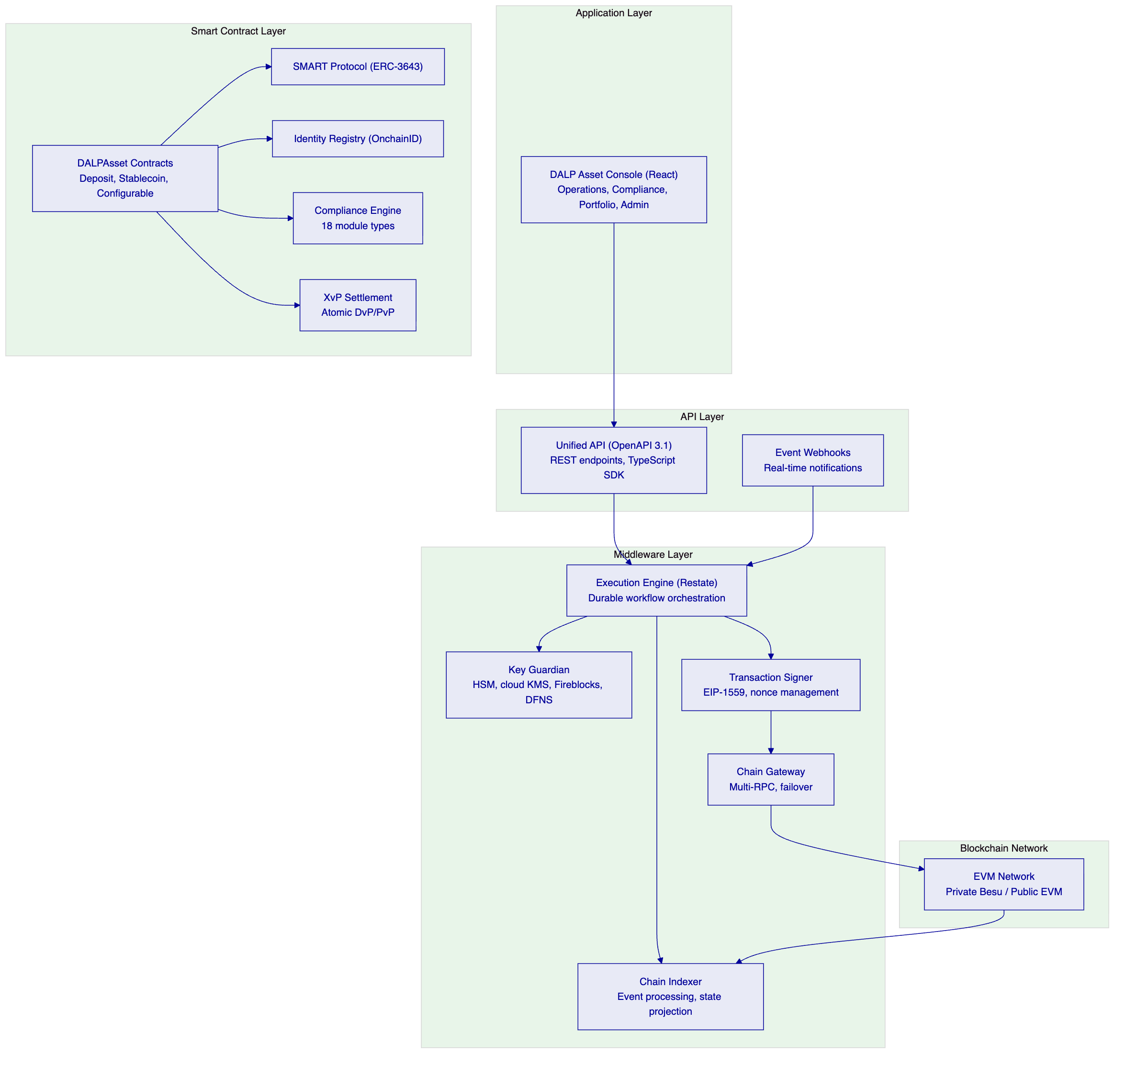
Application Layer: The DALP Asset Console provides the operational interface for asset lifecycle management, compliance workflows, portfolio views, system monitoring, and the Asset Designer wizard. It supports internationalization including Japanese (ja-JP) for regional deployments and uses arbitrary-precision arithmetic for all financial calculations.
API Layer: The Unified API exposes all platform capabilities through a type-safe interface with OpenAPI 3.1 specifications. A dual-endpoint architecture separates browser sessions from programmatic access, creating a hardened security boundary. The TypeScript SDK (@settlemint/dalp-sdk) provides the recommended programmatic integration surface for DBS Bank's engineering teams.
Middleware Layer: The Execution Engine (Restate) provides durable workflow orchestration with persistent state and exactly-once semantics. Key Guardian manages cryptographic key storage with HSM and cloud KMS integration. The Transaction Signer handles EIP-1559 gas pricing and meta-transactions. The Chain Indexer processes blockchain events into a queryable state projection.
Smart Contract Layer: All contracts build on the SMART Protocol (ERC-3643 / T-REX) with a five-layer on-chain architecture: SMART Protocol foundation, global infrastructure, system-level identity and compliance, asset contracts (DALPAsset, deposit, stablecoin), and addon contracts for settlement, distribution, and treasury operations.
    - 5.2 ERC-3643 and SMART Protocol
All DALP smart contracts implement the ERC-3643 standard (also known as T-REX: Token for Regulated EXchanges), the open Ethereum standard designed specifically for regulated securities markets. ERC-3643 mandates four critical additions to standard token contracts:
- An Identity Registry where every holder must have a verified on-chain identity
- A Compliance Engine that evaluates modular rules before each transfer
- Trusted Issuers who are the only entities authorized to attest to identity claims
- Transfer Restrictions that go beyond simple balance checks
DALP implements ERC-3643 through the SMART Protocol (SettleMint Asset Regulatory Technology), a production-hardened framework that adds upgradeable compliance modules, multi-jurisdictional regulatory templates, and richer claim-expression logic than standard implementations.
For DBS Bank's tokenized deposits, this means that every deposit token transfer is validated against the Identity Registry (confirming both sender and recipient have verified on-chain identities with current, non-expired claims), the Compliance Engine (enforcing MAS-aligned controls), and token-level features, all before any balance changes occur. There is no application-layer bypass. The enforcement is at the protocol level.
    - 5.3 DALPAsset: The Configurable Contract
DALPAsset is the recommended contract type for all new tokenization projects including DBS Bank's tokenized deposits and trade finance instruments. It extends the SMART Protocol with the SMARTConfigurable extension, allowing token features and compliance modules to be attached and reconfigured at runtime after deployment.
This design eliminates the need to commit to a specialized contract type at deployment time. A DBS Bank deposit token can start as a simple instrument, then have yield calculation added, then have transfer approval workflows enabled for specific counterparties, all without redeploying the contract or migrating balances. For trade finance instruments, the metadata schema captures document attributes (letter of credit reference, bill of lading number, trade counterparty identifiers), and the configurable compliance engine enforces the appropriate eligibility and transfer rules.
Runtime-pluggable token features available include:
- Historical balances (for yield calculation snapshots)
- Voting power (for governance-enabled instruments)
- Permit (gasless approvals for meta-transactions)
- AUM fee (for deposit instruments with management charges)
- Maturity and redemption (for term deposits and trade finance instruments with defined maturity)
- Fixed treasury yield (for deposit interest calculation and distribution)
- Transaction fee (with multiple variants for accounting and external fee routing)
    - 5.4 Factory Pattern and Deterministic Deployment
All asset contracts are deployed through a factory pattern using CREATE2 deterministic addressing. This provides predictable contract addresses that can be configured in external systems before deployment; atomic deployment that wraps proxy deployment, identity registration, compliance initialization, and role assignment into a single transaction; and system registration that automatically registers new assets with the system's identity registry, compliance orchestration, and access manager.
The deployment workflow is orchestrated through Restate (DALP's durable execution engine) as an idempotent workflow: if any step fails, deployment resumes from the last successful step without creating orphaned contracts. This is not best-effort scripting; it is durable execution with persistent state.

  - 6. Asset Lifecycle Coverage
    - 6.1 Tokenized Deposits: Full Lifecycle
DALP provides complete lifecycle coverage for tokenized bank deposits, from initial design through issuance, servicing, and retirement. This section describes the full lifecycle in the context of DBS Bank's programme.
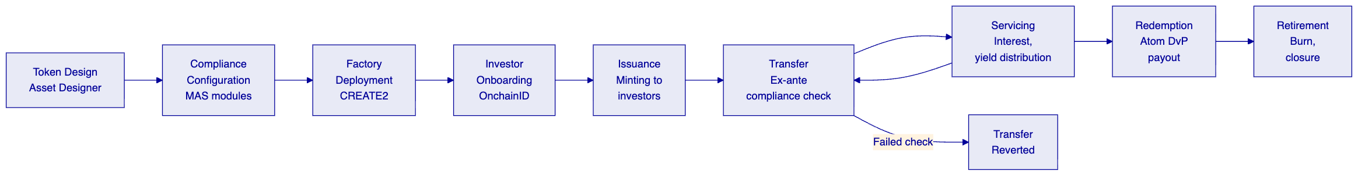
Token Design: The Asset Designer wizard guides DBS Bank's operations teams through deposit token configuration: denomination currency (SGD), decimal precision, supply parameters, ISIN or reference identifier, and jurisdiction assignment. For trade finance instruments, the wizard captures document-type identifiers, counterparty metadata schemas, and lifecycle parameters.
Compliance Configuration: Step 6 of the wizard binds compliance modules from DALP's pre-built library. For MAS-aligned deposits, the relevant modules include SMART identity verification (requiring verified OnchainID for all transfers), country allowlisting (restricting to MAS-permitted jurisdictions), investor count limits (configurable per MAS guidelines), and time-locked holding periods where applicable. The MAS Singapore compliance template is pre-built and immediately available.
Factory Deployment: The factory deploys the token contract with deterministic addressing, initializes the compliance engine, binds to the Identity Registry, issues classification claims, assigns roles, and registers the asset in the platform registry — all in a single atomic transaction. The token starts in a paused state, giving DBS Bank's compliance team time to verify configuration before the token goes live.
Investor Onboarding: Before an investor can receive or transfer deposit tokens, they must have a registered on-chain identity (OnchainID) with verified claims from trusted issuers. The OnchainID framework supports integration with DBS Bank's existing KYC/AML infrastructure: claims issued by DBS Bank's trusted issuer role are cryptographically attested and stored on-chain, reusable across all tokens in the system without per-token re-verification.
Issuance: Once the token is unpaused and roles are assigned, DBS Bank's supply managers can mint deposit tokens to verified investor wallets. DALP validates each mint operation: confirms supply management role, verifies wallet through PIN or TOTP, checks recipient compliance status, validates supply cap, and executes the mint. Batch minting supports up to 100 recipients per call for efficient initial distribution.
Transfer: Every transfer follows the deterministic compliance path: Identity Registry resolution, compliance module evaluation (all configured modules must pass), feature pre-checks, then atomic balance update. This is ex-ante enforcement. A transfer to an investor with expired KYC claims reverts immediately. A transfer exceeding country concentration limits reverts. A transfer outside the configured holding period reverts. The non-compliant state never exists on-chain.
Servicing: DALP automates deposit interest distribution through the Fixed Treasury Yield feature. DBS Bank configures payment intervals (monthly, quarterly, annual), yield rates, and denomination asset (SGD stablecoin or deposit token). The distribution is pull-based: investors or their custodians claim accrued yield, avoiding gas cost and block gas limit issues of push-based distribution to many holders. Historical Balance snapshots determine each investor's proportional share at each accrual period.
Redemption: For term deposits, the Maturity Redemption feature implements the complete lifecycle endpoint. After the configured maturity date, the token blocks all transfers. Holders redeem tokens for the denomination asset at face value in a single atomic transaction: tokens burn and the denomination asset transfers from the treasury simultaneously. No partial redemptions occur. If the treasury is insufficient, the redemption reverts.
Retirement: DALP supports controlled retirement of deposit tokens through the burn mechanism. The supply management role executes burns against holder balances. For compliance-related burns (regulatory enforcement, account remediation), the custodian role can execute forced burns with full on-chain audit trail.
    - 6.2 Trade Finance Instruments: Configurable Token Architecture
Trade finance instruments — letters of credit, bills of lading, invoice financing instruments, receivables — have highly varied lifecycle requirements that do not map neatly to standard bond or equity templates. DALP's configurable token (DALPAsset) architecture addresses this.
Each trade finance instrument type is represented as a DALPAsset with a custom instrument template defining the metadata schema. A letter of credit token might carry: issuing bank identifier, applicant and beneficiary identifiers, credit amount, expiry date, terms and conditions reference, document requirements hash, and compliance status. A bill of lading token carries: vessel, port of loading, port of discharge, consignee, commodity description, and delivery terms.
The compliance engine enforces instrument-specific rules: letters of credit require verified counterparty identities on both sides; transfer approval workflows enforce documentary conditions before transfer; collateral requirements verify on-chain proof of reserves for receivables financing; time locks enforce settlement windows.
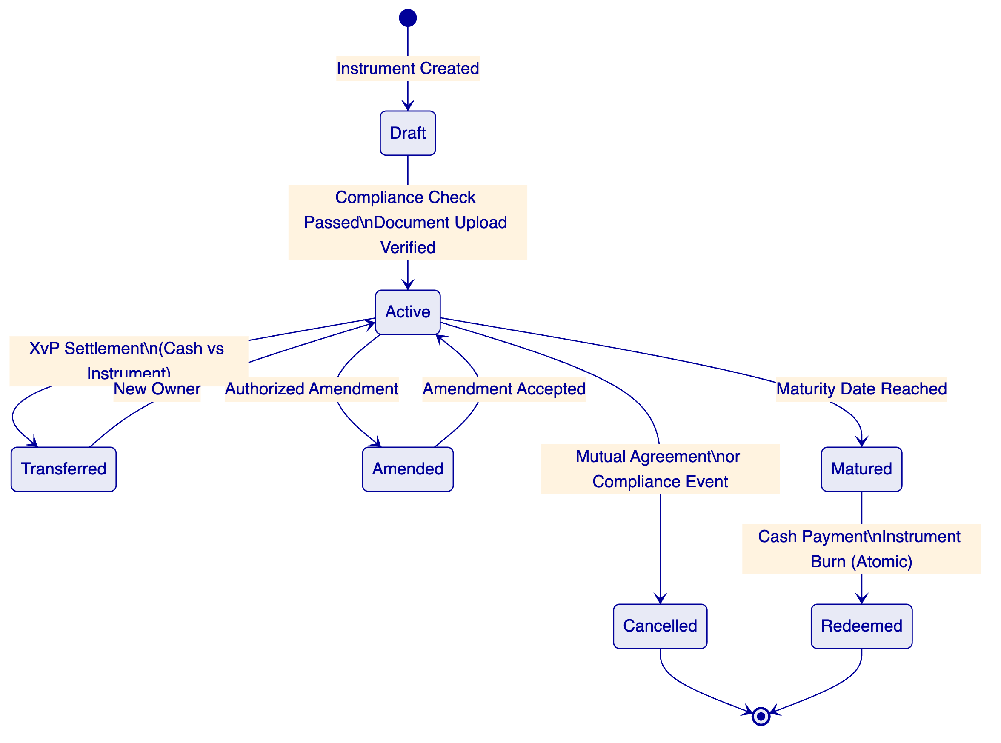
    - 6.3 Corporate Actions and Servicing Operations
Yield Distribution: Automated through the Yield Schedule addon with snapshot-based balance capture, flexible schedules (one-time, recurring, custom), pro-rata calculation, and distribution in the same asset or a different payment token. For deposit instruments, this handles interest crediting with full on-chain evidence of each distribution event.
Freeze and Unfreeze: The custodian role freezes individual investor wallets, preventing all transfers while maintaining the frozen balance on record. Both full address freezes and partial amount freezes are supported. This is the on-chain mechanism for sanctions holds, AML investigation freezes, and regulatory enforcement actions.
Pause and Unpause: The emergency role provides circuit-breaker capability: all operations on a token are halted while read-only operations continue. This is DBS Bank's control mechanism for security incidents, regulatory emergency orders, or market disruption events requiring immediate suspension.
Role Management: Asset-level roles (admin, custodian, emergency, governance, supply management) can be granted and revoked by the admin role holder through the API and console. Role changes take effect at the smart contract level, with full on-chain audit trail. Batch role operations allow efficient onboarding of multiple authorized operators.

  - 7. Compliance Architecture
    - 7.1 Ex-Ante Enforcement Model
The most critical design decision in DALP's compliance model is where enforcement happens: before execution, not after. Every token transfer, every minting operation, and every investor onboarding event passes through a deterministic policy evaluation engine that validates eligibility, identity claims, and jurisdictional constraints at the smart contract layer. If a transfer would violate any configured rule, it reverts atomically. There is never a state where non-compliant tokens exist in an unauthorized wallet.
This matters for DBS Bank for two specific reasons. First, MAS's supervisory approach to digital assets places significant weight on ex-ante controls rather than post-trade remediation. A compliance architecture that generates exceptions for review after non-compliant transfers have occurred is not aligned with MAS expectations. Second, DBS Bank's internal audit and risk functions will scrutinize whether compliance controls are deterministic and testable. DALP's on-chain compliance engine is both: the control logic is visible in smart contract code, independently auditable, and produces consistent outcomes across all execution environments.
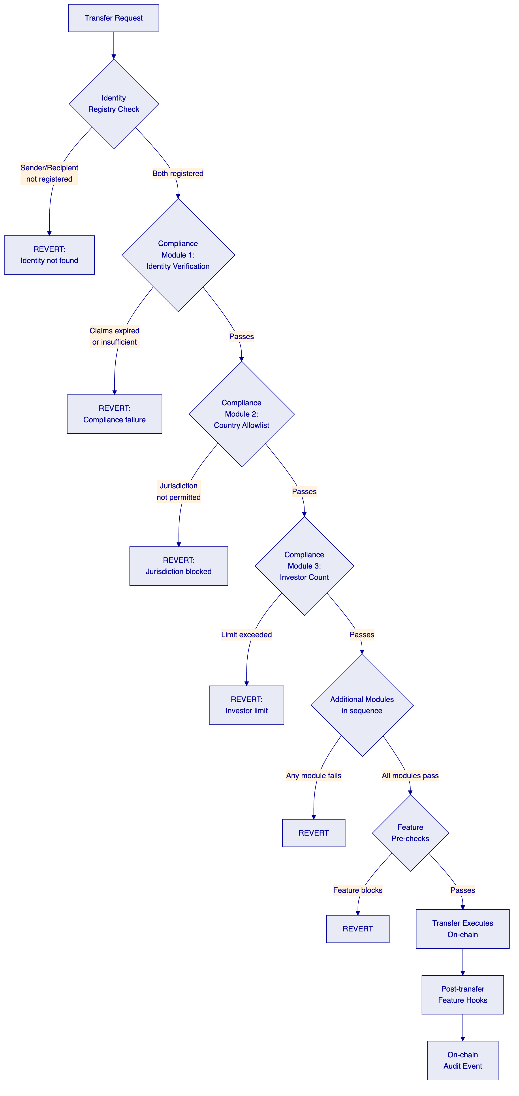
    - 7.2 MAS Singapore Compliance Template
DALP ships a pre-built MAS Singapore compliance template that enforces the core controls required under the MAS digital asset framework simultaneously. The template enforces:
- SMART Identity Verification: All transfer parties must have verified OnchainID contracts with current, non-expired KYC/AML claims from trusted issuers. Claims are checked at execution time, not only at onboarding: an expired claim fails. A claim from an issuer who lost trust status fails. This is continuous compliance, not a one-time onboarding checkbox.
- Country Allowlist: The jurisdiction of each investor is verified against the configured country allowlist. For MAS-regulated instruments, the allowlist includes only permitted jurisdictions. Transfers involving investors in restricted jurisdictions revert before execution.
- Investor Count Limits: Configurable maximum holder counts enforce MAS instrument-specific offering limits. Per-country limits are independently configurable from global limits, enabling precise regulatory compliance per jurisdiction.
- Time-Locked Holding Periods: Configurable minimum holding period enforcement using FIFO batch tracking. For instruments with post-issuance lock-up requirements, the time lock module ensures holders cannot transfer until the minimum period has elapsed.
    - 7.3 Payment Services Act Alignment
The Payment Services Act (PSA) governs digital payment tokens in Singapore and has direct implications for tokenized deposit programmes. DALP's compliance architecture supports PSA compliance through several mechanisms:
Supply Controls: DALP's supply cap compliance module enforces hard maximum token supply at the smart contract level, supporting PSA restrictions on total issuance volume for specific instrument types. The module tracks live circulating supply and prevents any minting beyond the regulatory limit.
Transfer Restrictions: The transfer approval workflow module requires explicit authorization before transfers execute. For PSA-regulated instruments, this ensures that each transfer receives appropriate review before settlement. The approval queue is fully auditable, with timestamps, approver identity, and decision rationale recorded on-chain.
Collateral Verification: For deposit tokens requiring collateral backing, the collateral requirement module enforces on-chain proof of reserves before minting. This directly supports PSA reserve requirements for digital payment tokens.
Transaction Monitoring Integration: DALP's API architecture supports real-time integration with DBS Bank's transaction monitoring and sanctions screening infrastructure. Every transfer event generates an on-chain event that can be consumed by webhooks or API polling, enabling simultaneous screening of transfer details before settlement confirmation is communicated downstream.
    - 7.4 MAS Technology Risk Management Guidelines
The MAS TRM Guidelines create specific control requirements for technology risk management in financial institutions. DALP's architecture addresses the TRM Guidelines control framework:
Change Management: DALP's governance roles separate ordinary configuration from privileged configuration and from code changes. Per-asset governance roles control compliance module reconfiguration. System-level roles control smart contract upgrades. The UUPS proxy upgrade pattern requires explicit governance role authorization for any contract upgrade. All configuration changes emit on-chain events with the operator identity, timestamp, and before/after state, creating a tamper-evident change log.
Access Controls: The dual-layer permission model (off-chain platform roles and on-chain smart contract roles) enforces segregation of duties at both the application and protocol layers. 26 distinct roles across four layers ensure that no single operator has unilateral authority over the complete system.
Audit Trails: Every action in DALP generates a permanent, tamper-evident on-chain record: identity verification, role grants, asset creation, compliance events, transfers, yield distributions, and system configuration changes. These events are indexed by DALP's Chain Indexer and surfaced through the operational dashboard and API for audit access.
Incident Management: The emergency role provides immediate circuit-breaker capability without requiring broader administrative access. The pause mechanism halts all on-chain operations while preserving read access and role management capability. Recovery procedures are documented in operational runbooks and tested as part of the DR testing programme.
    - 7.5 Eighteen Compliance Module Types
DALP provides 18 compliance module types across six categories. Every compliance requirement in this RFP maps to one or more of these modules:
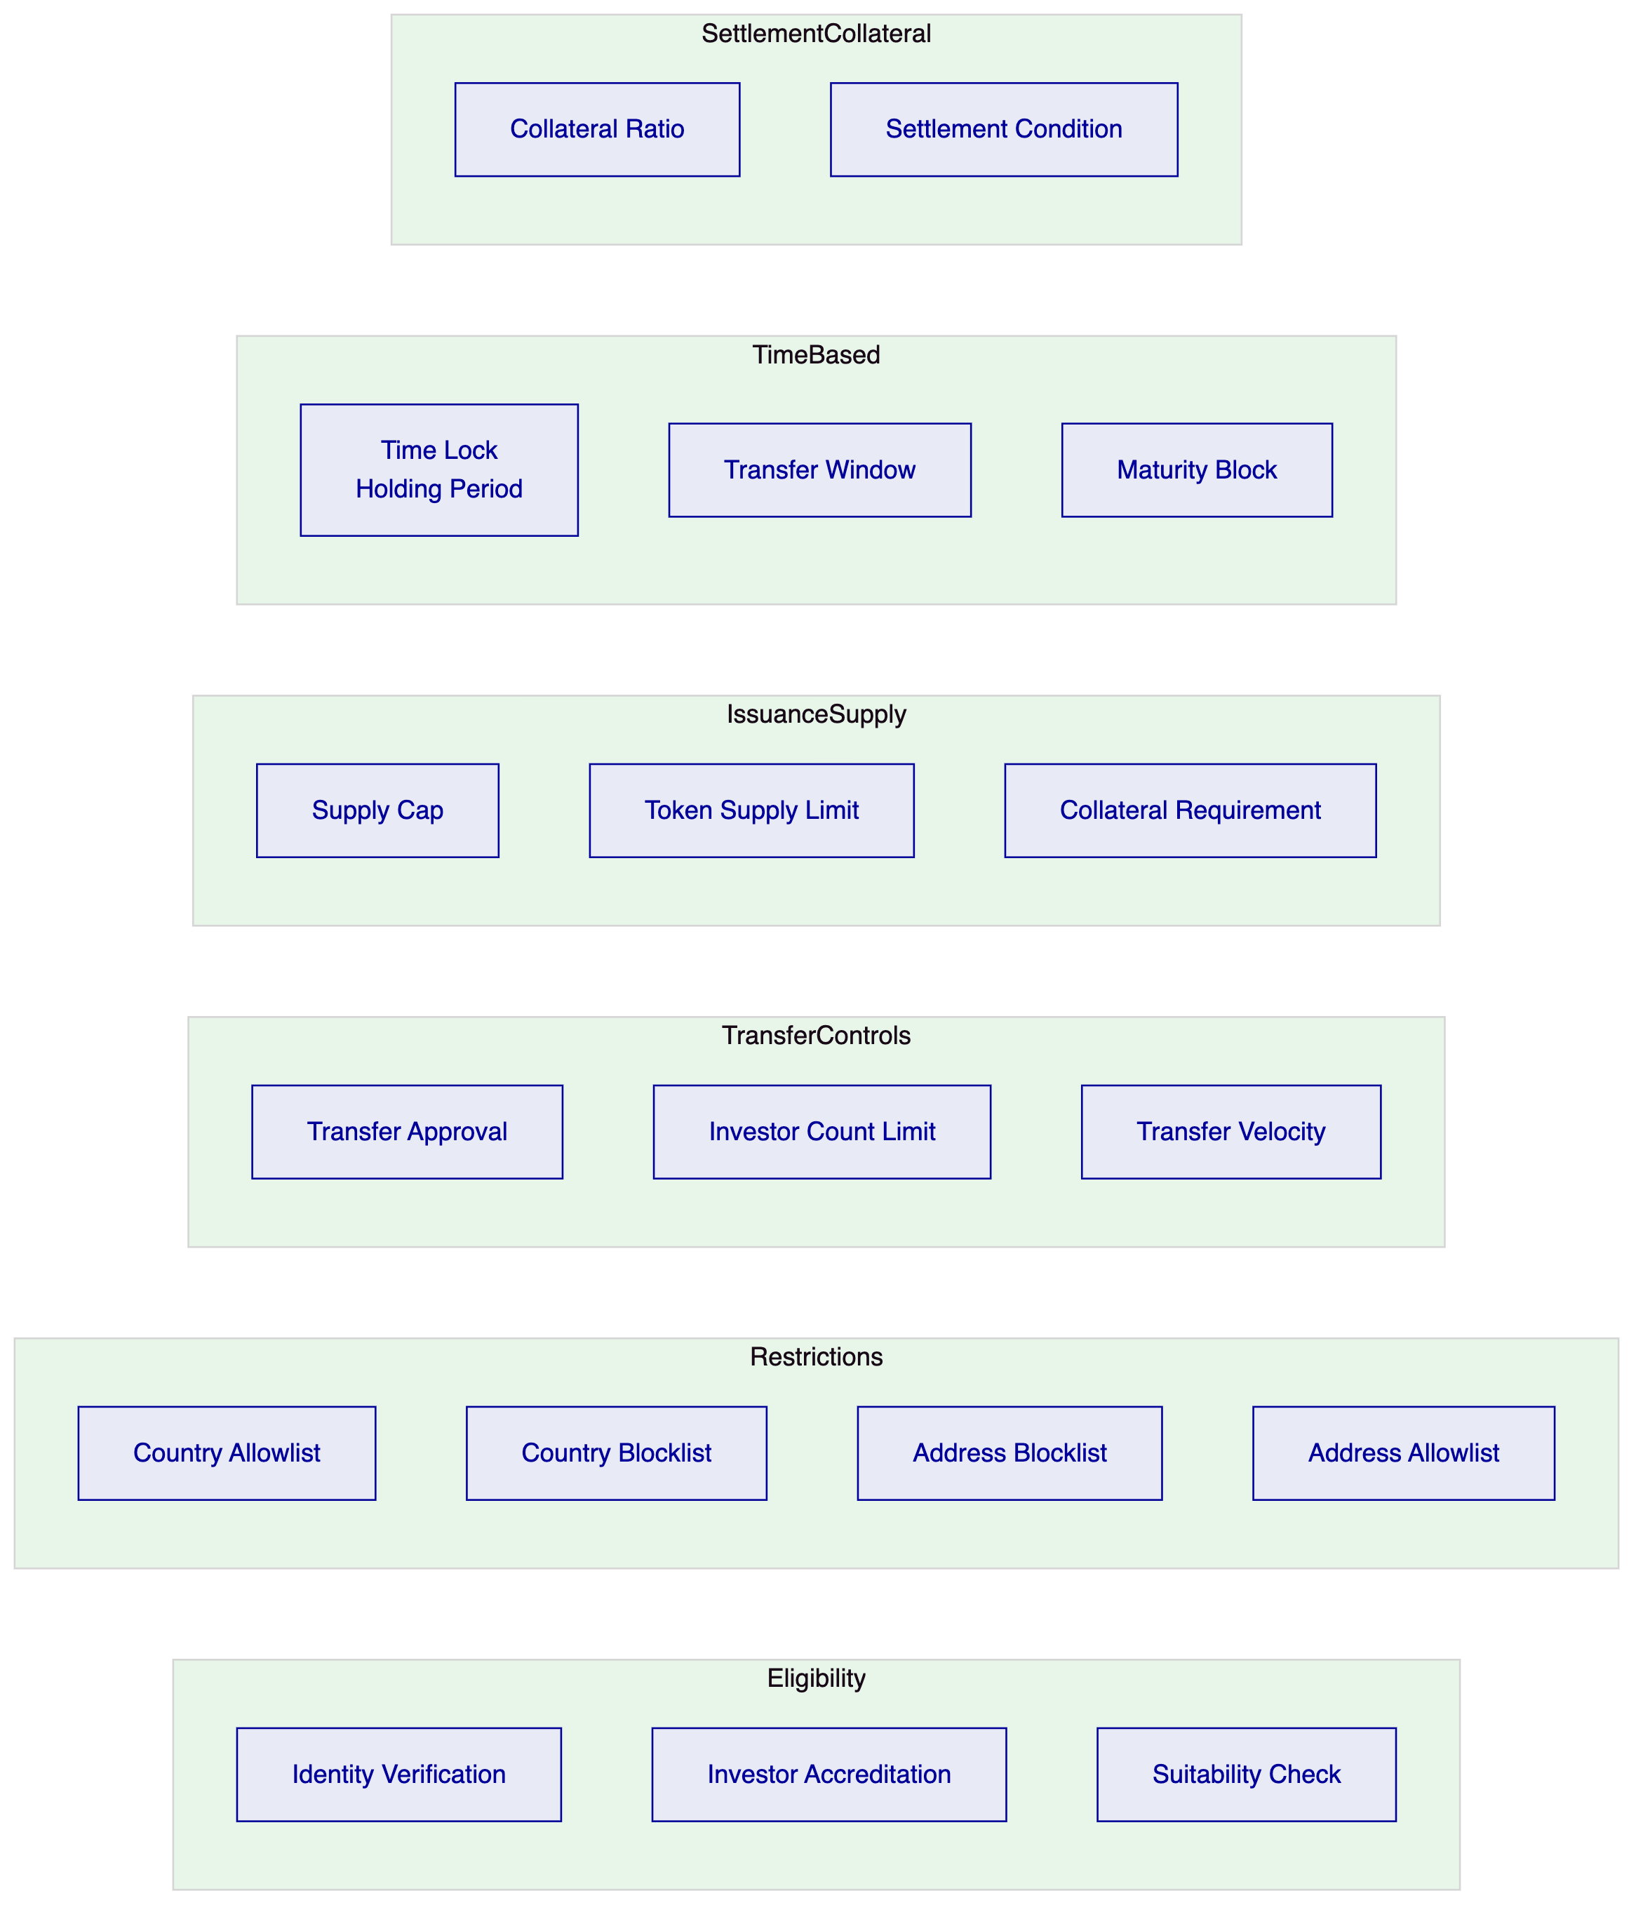
Full module specifications are provided in Appendix B.
    - 7.6 Custom Compliance Expression Builder
Beyond the pre-built module library, DALP provides a visual expression builder where compliance teams construct investor eligibility rules using boolean logic. A simple expression such as "KYC AND Accredited Investor" creates a gated eligibility requirement. Complex expressions can chain nine or more conditions, combining KYC, AML, accredited investor status, collateral verification, and MAS-specific claims into a single enforced eligibility gate.
For DBS Bank, this enables the compliance team to define institution-specific eligibility requirements without requiring smart contract development. The expression builder provides real-time validation ensuring every expression is syntactically and logically complete before deployment. Expression changes require the governance role and are recorded permanently on-chain.

  - 8. Integration Architecture
    - 8.1 API-First Design
DALP is designed as an API-first platform. Every capability available through the console is accessible programmatically through the Unified API. This is a strict design principle, not a marketing claim: the console itself is built on the same API that external systems consume, ensuring no capability gap between the UI and the programmatic interface.
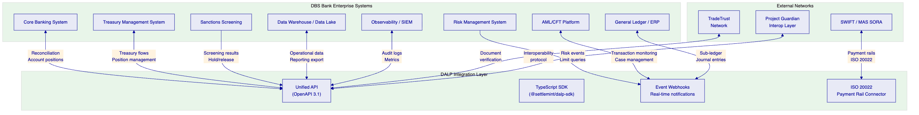
    - 8.2 Integration Methods
DALP provides three primary integration methods, each suited to different connectivity requirements:
REST API (OpenAPI 3.1): The primary integration surface for system-to-system connectivity. All platform capabilities are exposed through documented REST endpoints. API keys follow the "smatk" prefix format and are rate-limited to 10,000 requests per 60-second window per key. Interactive API exploration is available through Swagger UI. The OpenAPI 3.1 specification is generated directly from procedure definitions, ensuring documentation stays synchronized with implementation.
TypeScript SDK (@settlemint/dalp-sdk): The recommended integration path for DBS Bank's Node.js-based services. The SDK provides a typed client factory with automatic serialization of blockchain value types, supporting all API namespaces including token, user, account, contact, asset, and system. The SDK enforces API key presence, validates base URLs, and applies security headers.
Event Webhooks: Event-driven notifications for transaction confirmations, compliance state changes, and asset lifecycle events. Webhooks enable real-time integration with DBS Bank's core banking systems, AML platforms, and reporting infrastructure. Webhook payloads include full event context, correlation identifiers for distributed tracing, and timestamp data for time-synchronization.
    - 8.3 Enterprise System Integration Patterns
Core Banking Integration: DALP integrates with DBS Bank's core banking system through a combination of REST API calls for operational commands and webhooks for event-driven reconciliation. The integration model is designed around the principle that DALP is the digital asset ledger of record, while the core banking system maintains the fiat position record. Reconciliation between the two is driven by DALP events, with the CBS consuming token transfer events and adjusting fiat positions accordingly.
AML/CFT Platform Integration: DALP's webhook system delivers real-time transaction notifications to DBS Bank's AML platform immediately upon transfer event confirmation on-chain. The webhook payload includes sender, recipient, amount, token identifier, jurisdiction codes, and the full compliance check log showing which modules were evaluated and their results. For transactions triggering AML holds, the AML platform calls DALP's freeze API to place an immediate hold on the relevant wallet, preventing further transfers while the investigation proceeds.
Sanctions Screening Integration: Pre-transfer screening is supported through the Transfer Approval compliance module. Before a transfer executes, the module routes the transfer details to DBS Bank's sanctions screening service via API. If the screening service approves, the on-chain transfer executes. If screening returns a hold or reject status, the transfer approval is denied and the on-chain event records the denial with the screening reference. This creates an auditable record of every screening decision for each transfer.
General Ledger Integration: DALP generates structured accounting events for every material transaction: issuance (new asset created), mint (supply increase), transfer (ownership change), yield distribution (income recognition), redemption (supply decrease), and burn (asset retirement). These events, delivered via webhook with configurable payload format, drive automated journal entries in DBS Bank's ERP and sub-ledger systems. The event payload includes sufficient context for automated double-entry bookkeeping: instrument identifier, amount, counterparties, timestamp, and transaction reference.
Data Warehouse Integration: The DALP API supports bulk data export for analytics and reporting. Time-windowed queries against the events API enable DBS Bank's data warehouse to maintain a complete copy of all digital asset activity for regulatory reporting, management information, and risk analysis. The event schema is stable and versioned, with breaking changes communicated through the standard release management process.
    - 8.4 TradeTrust Integration
TradeTrust is Singapore's cross-border digital trade document framework, enabling the digitization and legal recognition of trade documents. DALP's integration with TradeTrust frameworks supports DBS Bank's trade finance digitalization objectives in the following ways:
The configurable token architecture supports the representation of TradeTrust-compatible eBL (electronic Bills of Lading) and eNegotiable instruments as on-chain tokens. Metadata schemas capture TradeTrust document identifiers, issuer certificates, and document hashes. The compliance engine enforces transfer conditions aligned with TradeTrust framework requirements, including endorsement chain validation and transferee eligibility.
DALP's API architecture supports integration with TradeTrust's underlying infrastructure for document verification. When a trade finance instrument token is transferred, the integration layer can validate the corresponding TradeTrust document status before the on-chain transfer executes, maintaining consistency between the digital asset ledger and the trade document registry.
    - 8.5 Project Guardian Interoperability
Project Guardian, MAS's initiative for wholesale digital markets, has established several key design principles that influence DBS Bank's architecture choices: open and interoperable networks, programmable instruments, and common infrastructure for policy enforcement. DALP's design is aligned with these principles:
DALP operates on EVM-compatible blockchain networks, the standard substrate for Project Guardian participants. The ERC-3643 compliance standard provides a common token interface that other Project Guardian participants can verify and interact with. The DALP identity framework (OnchainID) supports integration with other Project Guardian identity schemes through the trusted issuer model: claims issued by one Project Guardian participant's trusted issuer are recognizable by another participant's compliance engine if their issuer is included in the trusted issuer registry.
The XvP settlement module provides the atomic cross-party settlement primitive referenced in Project Guardian's settlement architecture work. For DBS Bank's tokenized deposits, this means that settlement of tokenized deposit transfers against Project Guardian-compatible instruments on participating networks can be structured as atomic HTLC settlements, eliminating counterparty risk across network boundaries.
    - 8.6 Protocol Choices and Technical Controls
Authentication: All API integration uses API keys scoped to specific procedure namespaces. Keys are transmitted over TLS 1.2 or higher and stored as hashed values after creation. Keys are rate-limited and can be revoked immediately through the console or API.
Idempotency: API mutations support idempotency keys, enabling DBS Bank's integration layer to safely retry failed requests without creating duplicate transactions. The platform detects duplicate submissions with the same idempotency key and returns the original response without re-executing.
Error Classification: 534 structured error codes with full metadata, i18n translations in four locales, and SDK mirror provide programmatic error handling for all failure scenarios. Error responses include code, message, context data, and correlation identifier for distributed tracing.
Retry Logic: The async transaction pipeline manages retry semantics with configurable backoff. The dead-letter rescue system captures transactions that exhaust retry attempts for operator review, preventing silent failures.
Reconciliation: Every on-chain transaction generates a deterministic event with block number, transaction hash, log index, and timestamp. These identifiers provide the anchors for reconciliation between DALP's event log and downstream systems. Where reconciliation breaks occur, the break is surfaced through the operational dashboard with a detailed audit trail of the events contributing to the discrepancy.

  - 9. Custody and Key Management
    - 9.1 Key Guardian Architecture
The Key Guardian service is DALP's cryptographic key management component. It manages key material through defense-in-depth with multiple storage backends at escalating security levels. Keys never leave secure boundaries in plaintext.
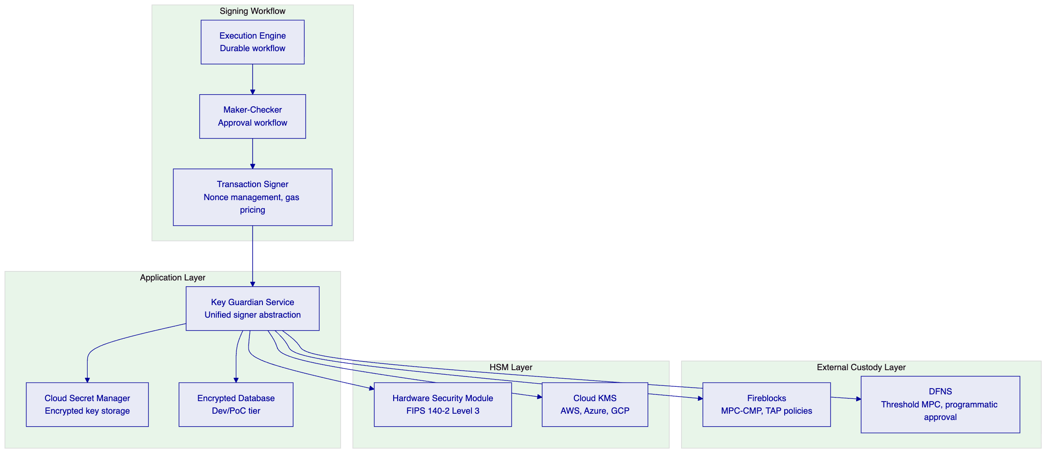
Storage tiers by security level:
Tier | Protection | Use Case for DBS Bank
Encrypted database | Application-level encryption | Development and testing environments
Cloud secret manager | Platform-managed encryption (AWS Secrets Manager) | Standard production operations
Hardware security module | FIPS 140-2 Level 3 | Treasury and high-value operations
Fireblocks MPC-CMP | Institutional MPC, no static key shares | Highest security institutional operations
DFNS threshold MPC | Distributed key shards, programmatic approval | Alternative institutional custody

For DBS Bank's production deployment, SettleMint recommends an HSM-backed configuration for treasury operations combined with Fireblocks or DFNS MPC custody for institutional-grade signing, with the cloud secret manager for automated operational processes. The Key Guardian's unified signer abstraction makes custody providers interchangeable through configuration, allowing DBS Bank to adjust the custody model as requirements evolve.
    - 9.2 Key Lifecycle Management
Generation: HSM-backed keys are generated entirely within hardware and never exposed to application-layer processes. Cloud KMS keys use provider-native generation with immediate encryption before any memory operations. Software keys (for non-production environments) use cryptographically secure random sources.
Rotation: Active signing keys are replaced while maintaining historical keys for verification of past transactions. Key rotation coordinates with blockchain address registry updates and downstream system notifications. The rotation process is a durable workflow orchestrated through Restate, ensuring consistency even across infrastructure failures.
Emergency Access: DALP defines a formal break-glass procedure for emergency access scenarios. Emergency access requires authorization from multiple designated holders, generates an on-chain emergency event record, triggers immediate alert notifications, and initiates an automatic review process. The procedure is documented in operational runbooks and tested as part of the quarterly DR programme.
Recovery: Enterprise deployments support key recovery through sharded backup schemes with threshold signature requirements. Recovery workflows are implemented as durable, phase-tracked processes in Restate: preview (assess impact), execution (cryptographic recovery), credential reset, and per-token balance migration if required. All recovery operations are idempotent and keyed by user identifier to prevent concurrent duplicate recovery operations.
    - 9.3 MPC Custody Integration: Fireblocks
Fireblocks MPC-CMP provides continuous key refresh, eliminating static key shares. No single server ever holds a complete private key, and the distributed key shares continuously refresh, making historical compromise attempts invalid.
DALP's Fireblocks integration supports the full Transaction Authorization Policy (TAP) framework:
- Amount thresholds: transactions above configured limits require additional approval
- Whitelisted destinations: transfers only to pre-approved wallet addresses execute without additional review
- Velocity limits: aggregate transfer volumes within time windows trigger automatic holds
- Multi-approver requirements: high-value or sensitive transactions require M-of-N approver confirmation
DALP owns permissioning, wallet verification, queueing, and workflow state transitions. Fireblocks owns nonce allocation, gas handling, signing, and broadcast. This separation ensures that DALP's governance model remains the authoritative control surface while Fireblocks provides the cryptographic security guarantees.
    - 9.4 Privileged Access Controls
Administrative actions in DALP require step-up authentication beyond the standard session. All blockchain write operations require wallet verification through PIN, TOTP, or hardware passkey. There is no administrative override that bypasses wallet verification. Recovery requires backup codes or credential re-enrollment, creating a deliberate friction that prevents unauthorized use of compromised sessions.
Privileged access events — role assignments, compliance module changes, governance configuration updates, emergency access — are logged with full context: operator identity, timestamp, action type, parameters, and the on-chain transaction reference. This log is immutable and accessible for audit review.

  - 10. Settlement and Operations
    - 10.1 Atomic DvP with XvP Settlement
DBS Bank's tokenized deposits and trade finance programme requires settlement finality without counterparty risk. Traditional T+2 clearing cycles introduce a window of counterparty risk between trade agreement and settlement. DALP's atomic Delivery-versus-Payment settlement eliminates this window: asset and cash transfer simultaneously or both revert. There is no state where DBS Bank has delivered an instrument but not received payment.
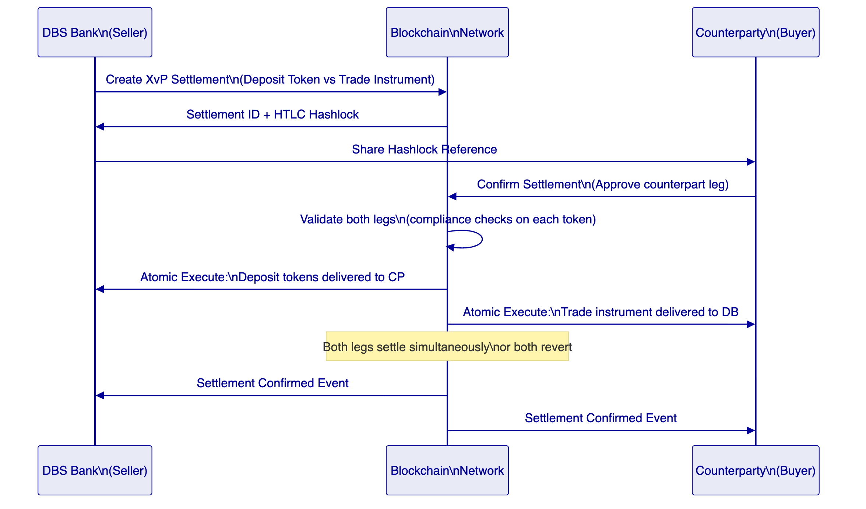
The XvP (Exchange versus Payment) settlement module extends atomic DvP to multi-party, multi-asset settlements. For trade finance, a single settlement can atomically coordinate: transfer of the trade finance instrument (letter of credit, bill of lading) from seller to buyer; transfer of the deposit token payment from buyer to seller; notification events to downstream systems (core banking, treasury, AML) simultaneously.
    - 10.2 Cross-Chain Settlement via HTLC
For settlements involving counterparties on different blockchain networks (relevant for Project Guardian interoperability scenarios), DALP's HTLC (Hash Time-Locked Contract) mechanism provides cryptographic atomicity across networks:
- DBS Bank creates the settlement on Network A with a hashlock (H = SHA256(secret))
- The counterparty creates the corresponding settlement on Network B using the same hashlock
- DBS Bank reveals the secret to claim the counterparty's asset on Network B
- The same secret reveals on Network A, allowing the counterparty to claim DBS Bank's asset
- If either party fails to act before expiry, both legs expire and assets return to their owners
All compliance checks run on each token independently. If any compliance check fails on any leg, that settlement cannot proceed.
    - 10.3 Operational Dashboards
DALP provides operational dashboards that give DBS Bank's first-line operations, second-line risk, and third-line audit functions the visibility they need:
Operations Dashboard: Real-time view of active settlements, pending transactions, approval queues, and failed events. Configurable alert thresholds trigger notifications when conditions require operator attention: pending items exceeding configured age, failed transaction rates, reconciliation breaks.
Compliance Activity Dashboard: Volume of compliance verifications, approval rates, failed transfer attempts with reason codes, identity verification status, and trusted issuer activity. Compliance officers can drill into specific events for detailed examination without requiring engineering support.
Security Dashboard: Authentication events, access pattern analysis, privileged action log, API key usage, and alert history. The security overview surfaces anomalous patterns for investigation.
Transaction Monitor: Pending and failed transactions, gas usage, confirmation times, and the async transaction pipeline state. The 11-state transaction lifecycle (submitted, pending, confirmed, failed, dead-letter, etc.) is fully visible, enabling operations teams to distinguish between transient failures and permanent errors requiring intervention.
    - 10.4 Reconciliation Architecture
Financial reconciliation is a first-class concern in DALP's architecture, not an afterthought.
On-chain as the source of truth: DALP's Chain Indexer continuously processes blockchain events into a queryable state projection. The indexer state is always derivable from the on-chain record — if the indexer is behind or corrupted, it can be rebuilt by replaying the chain. This makes the on-chain record the authoritative ledger, with the indexed state as a queryable cache.
Event-driven reconciliation: Every material event generates a structured webhook notification with the complete event context. DBS Bank's reconciliation systems consume these webhooks to maintain a synchronized state. Where reconciliation breaks occur (event missing, amount mismatch, timestamp discrepancy), the break is surfaced through the reconciliation API with full event trace.
Sub-ledger alignment: The event payload format is designed for automated journal entry generation. Every transfer event includes sender, recipient, amount, instrument identifier, timestamp, and transaction reference. Every yield distribution event includes the distribution total, holder count, per-holder amounts, calculation basis, and treasury funding transaction reference. These payloads drive automated sub-ledger updates without manual intervention.
Nostro/vostro reconciliation for trade finance: For trade finance instruments involving correspondent banking relationships, DALP's event log provides the digital asset leg of the reconciliation. The integration layer correlates DALP events with SWIFT MT/MX messages and internal position records to maintain a complete reconciliation view across on-chain and off-chain positions.
    - 10.5 Case Management and Exception Handling
Approval Queue Management: The transfer approval compliance module creates an approval queue for transactions requiring human review. Operations teams see pending items with full context — initiator, amount, counterparties, compliance check results, and time in queue. Items approaching configured SLA thresholds trigger escalation alerts. Approval decisions are recorded on-chain with approver identity, timestamp, and decision reference.
Exception Workflow: Failed transactions, compliance rejections, and reconciliation breaks generate structured exception records accessible through the operational API. Each exception includes event context, failure reason, contributing compliance module results, and suggested remediation steps. Exception records are retained for the full regulatory retention period.
Regulatory Reporting Support: DALP's event log provides the underlying data for regulatory reporting obligations. The time-windowed event query API supports extraction of all transaction activity within a reporting period, including failed and reverted transactions. Report reproduction is deterministic: the same query against the same time window always returns the same result, supporting regulator-facing evidence generation.

  - 11. Security Architecture
    - 11.1 Defense-in-Depth: Five Independent Layers
DALP enforces security through five independent control layers. No single-layer failure grants unauthorized access to digital assets. Each layer operates independently, so a compromised session is blocked by wallet verification; a bypassed API authorization is blocked by on-chain compliance; a compromised application server cannot sign transactions without custody provider approval.
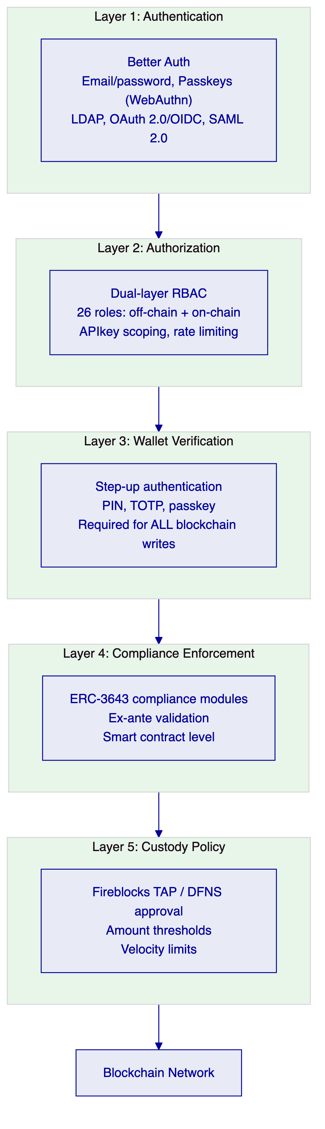
Layer 1: Authentication. Better Auth with support for email/password, passkeys (WebAuthn), LDAP/Active Directory (for corporate directory integration), OAuth 2.0/OIDC (Okta, Auth0, Azure AD), and SAML 2.0 for legacy enterprise SSO. Sessions use HTTP-only cookies with SameSite protection and 7-day expiry with 24-hour refresh windows. Every authentication event is logged.
Layer 2: Authorization. A dual-layer permission model where off-chain platform roles and on-chain roles must both pass for any blockchain write operation. 26 distinct roles across four layers (platform, system people, per-asset, system module) enforce granular separation of duties. API keys are scoped to specific procedure namespaces. Rate limiting at 10,000 requests per 60-second window per key prevents abuse.
Layer 3: Wallet Verification. Step-up authentication for all blockchain write operations via PIN, TOTP, or backup codes. Even with a valid authenticated session, no on-chain transaction executes without wallet verification. There is no administrative override that skips this layer. This is the control that protects against session hijacking and insider threats that have a valid session.
Layer 4: Compliance Enforcement. ERC-3643 compliance modules validate every transfer against identity, jurisdiction, and policy rules at the smart contract layer. The compliance check runs on-chain and cannot be bypassed by application-layer code. A direct contract call that bypasses the DALP application still hits the on-chain compliance engine.
Layer 5: Custody Policy. External custody providers (Fireblocks, DFNS) impose additional approval gates for custody-backed signing flows. Transaction Authorization Policies enforce amount thresholds, destination whitelisting, velocity limits, and multi-approver requirements. A compromised application server cannot execute custody-signed transactions that violate TAP rules.
    - 11.2 Certifications
SettleMint maintains ISO 27001 certification covering the information security management system governing DALP development, operations, and customer data. The certification confirms that risk assessment, security controls, organizational policies, and continuous improvement processes meet the international standard.
SettleMint holds SOC 2 Type II certification, verifying that security controls operate effectively over an extended audit period, not just at a point-in-time assessment. The Type II report provides DBS Bank with assurance that access controls, change management, and incident response procedures are consistently followed in production operations.
Both certificates are available for review as part of the vendor risk assessment process.
    - 11.3 Smart Contract Security
All DALP smart contracts are built on the SMART Protocol (ERC-3643), an independently audited open standard. The UUPS (Universal Upgradeable Proxy Standard) upgrade pattern ensures that the proxy contract holds state while the implementation contract explicitly authorizes upgrades, preventing unauthorized contract replacement. DALPAsset contracts used for DBS Bank's deployment are upgradeable under governance control, allowing security patches and compliance updates without token migration.
The smart contract layer enforces the principle of separation: the custodian role can execute forced transfers in compliance-bypass scenarios, but cannot alter compliance configuration. The governance role can reconfigure compliance modules, but cannot execute transfers. The emergency role can pause all operations, but cannot execute transactions or alter configuration. This separation ensures that no single role can both alter the rules and execute transactions.
    - 11.4 Network Security and Data Protection
All API communication uses TLS 1.2 or higher. Session cookies are HTTP-only, Secure-flagged, and SameSite-protected. Kubernetes network policies restrict pod-to-pod communication to required service dependencies. The ingress controller manages external access points with rate limiting and DDoS protection.
Data at rest is encrypted using provider-native encryption for cloud deployments. The Key Guardian's multiple encryption tiers ensure that sensitive key material is protected at all levels. Tenant data isolation is enforced at the database query level: every API request is scoped to the active organization, preventing cross-tenant data access.
    - 11.5 Operational Security and Incident Response
The observability stack provides the tooling for incident response: correlation identifiers link logs, metrics, and traces for affected operations; timeline reconstruction via log search reveals event sequences; impact assessment via metrics dashboards quantifies affected users and operations; trace visualization identifies failing components.
For DBS Bank's deployment, SettleMint recommends integration with DBS Bank's SIEM platform through structured log forwarding from DALP's Loki log aggregation system. All audit events, security events, and compliance events are emitted as structured JSON logs with consistent field schemas, enabling SIEM rule creation and alert correlation.

  - 12. Deployment Options
    - 12.1 Recommended Deployment: AWS Singapore (ap-southeast-1)
For DBS Bank's tokenized deposits and trade finance programme, SettleMint recommends a Managed Private Cloud deployment within AWS Singapore (ap-southeast-1). This configuration satisfies MAS data residency requirements by ensuring all data remains within Singapore jurisdiction, while providing the operational flexibility and managed infrastructure support appropriate for this programme's initial phase.
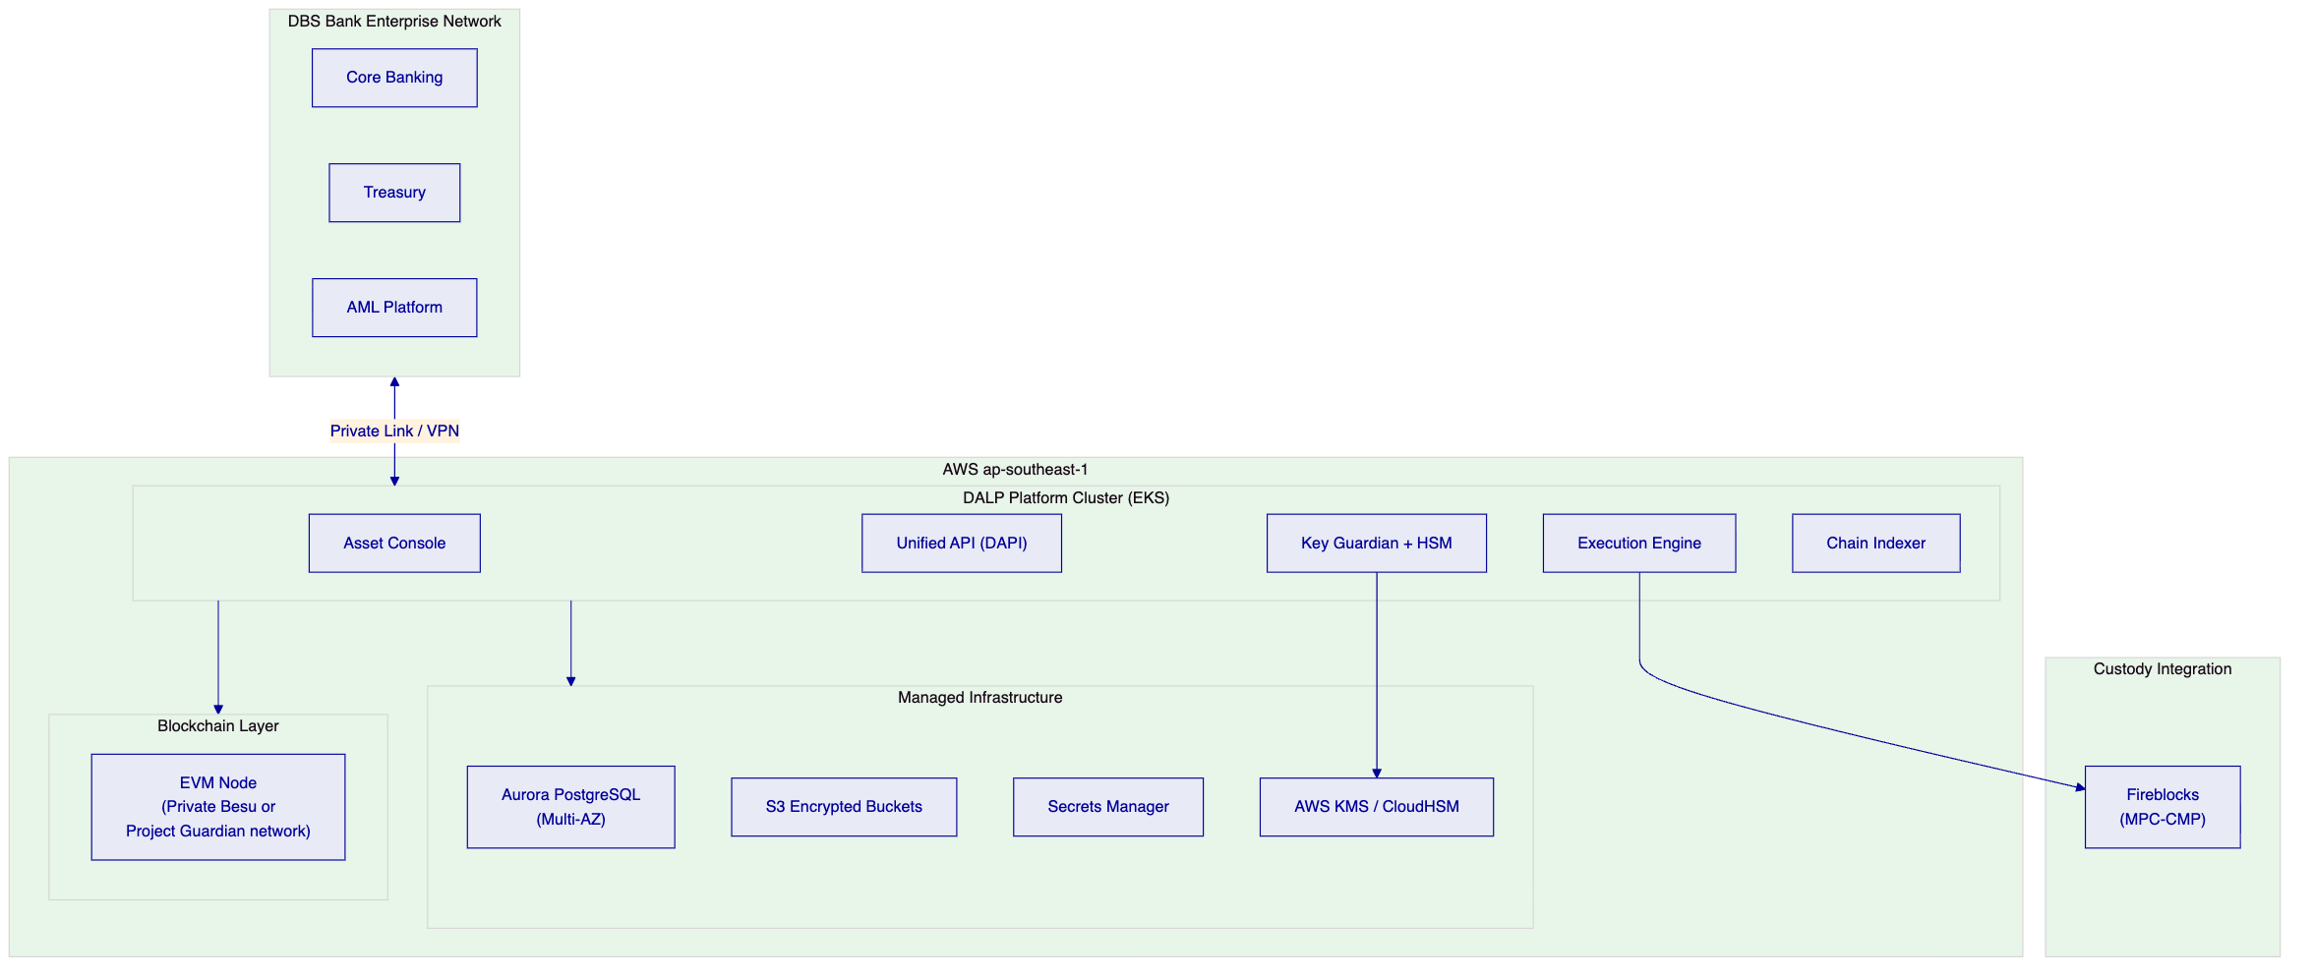
Infrastructure configuration:
- EKS managed Kubernetes cluster with multi-AZ node groups for high availability
- Aurora PostgreSQL with Multi-AZ deployment and automated backups
- S3 with server-side encryption and versioning for document storage
- AWS Secrets Manager for key material (with CloudHSM option for FIPS 140-2 Level 3 requirements)
- CloudFront for console delivery with Singapore origin
- AWS PrivateLink for secure connectivity from DBS Bank's network to DALP API endpoints
Data residency: All platform data including transaction records, identity data, key material, and audit logs resides within AWS ap-southeast-1. No data leaves Singapore jurisdiction through DALP platform operations.
    - 12.2 Alternative: On-Premises Deployment
For DBS Bank teams that require full infrastructure control, DALP supports on-premises deployment on DBS Bank's own Kubernetes infrastructure. This configuration requires a DBS Bank-operated Kubernetes cluster (v1.25+), PostgreSQL database (v15+), object storage (MinIO or S3-compatible), HSM or cloud-based secrets management, and operational team with Kubernetes administration capability.
On-premises deployment provides air-gap capability for environments requiring complete network isolation. SettleMint provides Helm charts for full deployment, infrastructure sizing guidance, and deployment validation procedures. Platform support remains available through secure channels.
    - 12.3 Hybrid Configuration
A hybrid deployment pattern is available for DBS Bank organizations with specific requirements around sensitive component isolation: application and API layers in the managed cloud; HSM and key management on-premises; optional primary on-premises with cloud disaster recovery.
    - 12.4 Environment Separation
Production, staging, and development environments are deployed as separate DALP instances with isolated infrastructure, separate API keys, and distinct configuration. Secrets differ by environment. Configuration promotion follows a controlled process: changes are validated in development, tested in staging, and promoted to production through a documented change management workflow with approvals and rollback procedures.

  - 13. Implementation Approach
    - 13.1 Delivery Methodology
SettleMint follows a structured, phase-gated implementation methodology refined through production deployments with regulated banks. The methodology addresses the specific failure modes that institutional programmes encounter: unresolved governance ownership, integration debt, compliance gaps discovered during testing, and operational knowledge concentrated in vendor specialists.
The standard implementation for DBS Bank's tokenized deposits and trade finance programme spans approximately 19 weeks from kickoff to end of hypercare, organized into six phases:
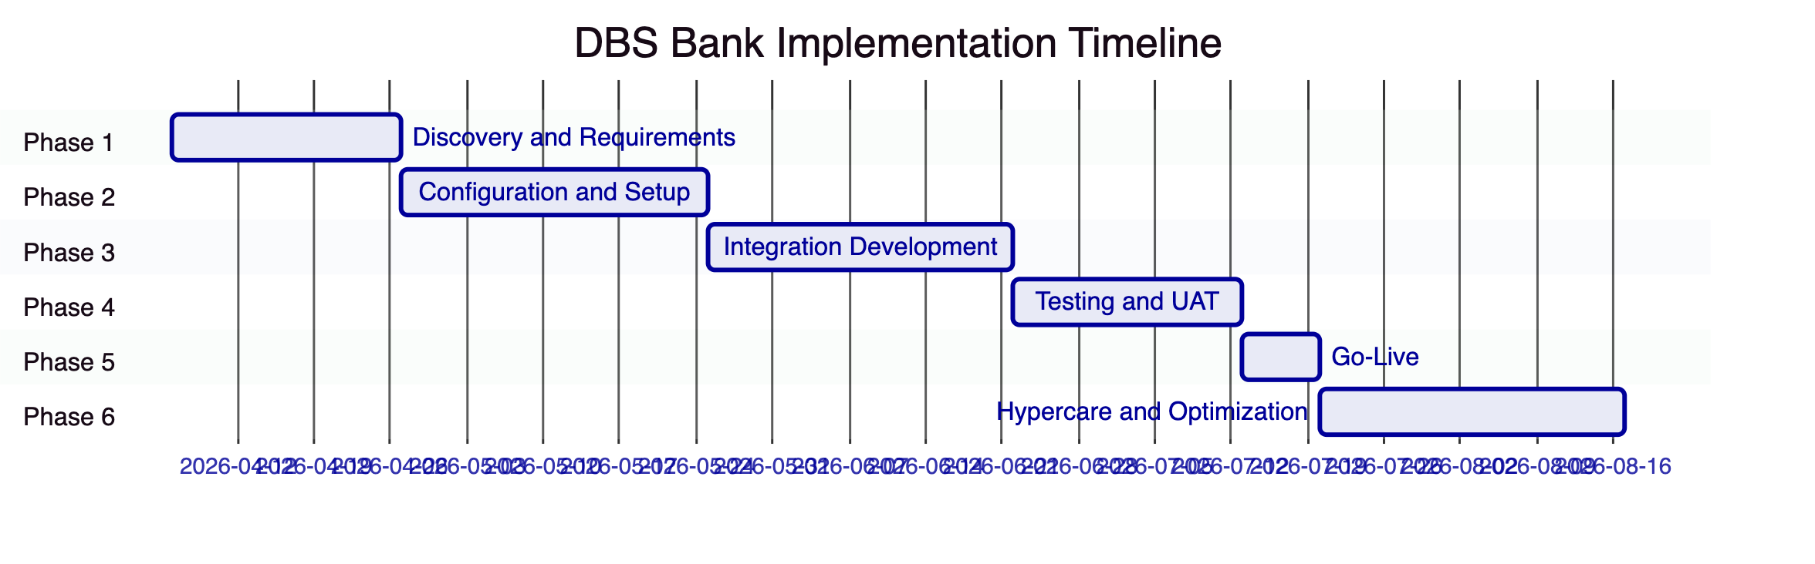
    - 13.2 Phase 1: Discovery and Requirements (Weeks 1-3)
Objective: Establish comprehensive understanding of DBS Bank's business objectives, technical landscape, regulatory environment, and operational requirements.
Activities:
- Structured stakeholder interviews with institutional banking, treasury and markets, technology, compliance, risk, and operations teams
- Current-state assessment of relevant workflows, approval chains, reconciliation pain points, and reporting obligations
- Regulatory and compliance mapping: MAS, PSA, TRM Guidelines requirements mapped to DALP compliance modules
- Asset class scoping: tokenized deposits and trade finance instrument types, lifecycle events, and business rules
- Architecture design: deployment topology (AWS Singapore), network selection (private Besu or Project Guardian network), custody integration model (Fireblocks recommended), identity provider integration, and external system connectivity
- RAID assessment: identification of implementation risks, dependencies, and mitigation strategies
Deliverables: Business Requirements Document; Regulatory and Compliance Matrix; Target Architecture Document; Implementation Roadmap; RACI Matrix
DBS Bank Responsibilities: Project sponsor and PM designation; stakeholder availability; systems documentation; architecture sign-off
    - 13.3 Phase 2: Configuration and Setup (Weeks 4-7)
Objective: Provision DALP environment, configure asset types and compliance modules, establish identity and access framework, prepare integration layer.
Activities:
- Environment provisioning in AWS ap-southeast-1 (development, staging, production)
- Blockchain network setup (private Besu or connection to Project Guardian network)
- Deposit token and trade finance instrument configuration using DALP's asset templates
- MAS Singapore compliance template deployment and customization
- OnchainID identity framework configuration and KYC/AML provider integration planning
- Key Guardian configuration with AWS KMS and CloudHSM (or Fireblocks integration)
- Integration layer design: API authentication, webhook configuration, retry and idempotency patterns
Deliverables: Provisioned environments; Asset configuration documentation; Compliance module configuration; Identity and access design; Integration design document
    - 13.4 Phase 3: Integration Development (Weeks 8-11)
Objective: Connect DALP to DBS Bank's existing systems, delivering end-to-end operational workflows.
Activities:
- Core banking system integration: position reconciliation, account management connectivity
- AML/CFT platform integration: real-time webhook delivery, freeze/unfreeze API connectivity
- Sanctions screening integration: pre-transfer screening API, approval workflow binding
- Treasury system integration: cash position management, yield distribution notifications
- General ledger integration: automated journal entry generation from DALP events
- Data warehouse integration: event stream configuration, bulk export API setup
- TradeTrust and Project Guardian integration connectivity
- SWIFT/MAS payment rail connectivity via ISO 20022 adapter
Deliverables: Integrated system landscape; API integration documentation; End-to-end workflow documentation; Integration test results; Draft runbooks
    - 13.5 Phase 4: Testing and UAT (Weeks 12-14)
Objective: Validate the complete deployment against all functional, security, performance, and compliance requirements.
Testing scope:
- Functional: all asset lifecycle events, compliance rules, custody workflows, settlement logic, reporting
- Security: penetration testing, access control validation, key management audit, smart contract review
- Performance: load testing at expected DBS Bank transaction volumes plus 3x headroom
- Compliance: ex-ante enforcement validation — confirming non-compliant transfers revert correctly in all scenarios including expired claims, blocked jurisdictions, exceeded limits, and failed screening
- UAT: business-scenario test scripts with DBS Bank operations, compliance, treasury, and risk teams
- Disaster recovery: backup, failover, and recovery procedure validation
- Cyber tabletop: sanctions alert, failed settlement, wallet compromise, and emergency suspension scenarios
Deliverables: Test plan and cases; Functional test report; Security assessment report; Performance test report; UAT sign-off; Go-live readiness assessment
    - 13.6 Phase 5: Go-Live (Week 15)
Objective: Controlled production deployment with immediate support coverage.
Activities:
- Production deployment execution per runbook
- Data seeding: legal entities, roles, products, investor registry, standing settlement instructions
- Smoke testing in production: platform health, integration connectivity, compliance enforcement, observability
- Cutover coordination with DBS Bank operations teams
- Dedicated go-live support team on-site or dedicated remote
Go/No-Go Criteria:
- All UAT test cases passed with no critical defects open
- Security assessment findings remediated or accepted with documented risk treatment
- Performance test results meet SLA targets
- Compliance enforcement validated for all MAS-required scenarios
- DBS Bank operations team sign-off on readiness
- Incident escalation contacts confirmed and tested
    - 13.7 Phase 6: Hypercare and Optimization (Weeks 16-19)
Objective: Intensive post-go-live support, performance optimization, and knowledge transfer completion.
Activities:
- Dedicated monitoring of platform health, transaction volumes, compliance enforcement, integration stability
- Priority resolution of production issues with accelerated response times
- Performance optimization based on real workload patterns
- Knowledge transfer completion: platform administration, monitoring, troubleshooting, compliance module management
- Formal operational readiness assessment: confirmation that DBS Bank teams can independently manage day-to-day operations
- Managed transition to contracted support tier
Hypercare Exit Criteria:
- No P1 incidents open for 5 consecutive business days
- Reconciliation accuracy at 99.99% or above
- Operations team successfully completing all standard operational tasks independently
- All runbooks validated through observed execution
- Knowledge transfer completion certificate signed
    - 13.8 Staffing Model
SettleMint Team:
Role | Phase 1 | Phase 2 | Phase 3 | Phase 4 | Phase 5 | Phase 6
Delivery Lead | Full | Full | Full | Full | Full | Partial
Solution Architect | Full | Full | Partial | Partial | On-call | On-call
Platform Engineer | — | Full | Full | Full | Full | Partial
Integration Engineer | — | Partial | Full | Partial | On-call | On-call
QA / Test Lead | — | — | Partial | Full | Partial | —
Security Engineer | — | Partial | Partial | Full | On-call | —
Support Engineer | — | — | — | — | Full | Full

DBS Bank Team Requirements:
Role | Involvement
Project Sponsor | Gate reviews, escalations, sign-offs
Project Manager | Full engagement across all phases
Technical Lead / Architect | Phases 1-4 (architecture, integration, testing)
Infrastructure / DevOps | Phases 2-5 (environment provisioning, deployment)
Business / Operations SMEs | Phases 1, 4, 6 (requirements, UAT, knowledge transfer)
Compliance / Risk | Phases 1, 2, 4 (regulatory mapping, compliance validation)
Security / InfoSec | Phases 2, 4 (security review, penetration testing)
AML / Sanctions | Phase 4 (scenario testing, workflow validation)

    - 13.9 RAID Summary
Key risks for DBS Bank's programme are detailed in Appendix A. Critical risks and their mitigations include:
Regulatory interpretation risk: MAS guidance on specific tokenized deposit instrument classifications may require compliance configuration adjustments. Mitigation: Early engagement with legal and compliance teams in Phase 1 to confirm regulatory interpretation before configuration begins; modular compliance architecture enables rapid adjustment without redeployment.
Integration complexity: DBS Bank's core banking, AML, and treasury systems represent significant integration scope. Mitigation: Detailed integration assessment in Phase 1 with capacity buffer in Phase 3; DALP's comprehensive API layer reduces custom development; mock integration patterns allow DALP configuration to proceed in parallel with integration development.
TradeTrust and Project Guardian interoperability: Interoperability requirements with external market infrastructure may introduce dependencies outside DBS Bank's control. Mitigation: Early identification of interoperability requirements and external stakeholders in Phase 1; DALP's ERC-3643 foundation provides the standard interface; contingency design for phased interoperability.

  - 14. Support and SLA
    - 14.1 Support Tier Recommendation
For DBS Bank's tokenized deposits and trade finance programme, SettleMint recommends the Enterprise Support tier, reflecting the mission-critical nature of a programme operating under MAS regulatory oversight with direct impact on financial operations.
    - 14.2 Enterprise Support: Coverage and Commitments
Attribute | Commitment
Coverage | 24/7/365
Support Channels | Email, support portal, dedicated Slack channel, phone, video escalation
Uptime SLA | 99.99% monthly (approximately 4.3 minutes maximum downtime)
Named Support Team | Dedicated team with deep familiarity of DBS Bank's deployment
Solution Architect Access | Quarterly architecture reviews and optimization recommendations
Customer Success Manager | Named CSM, bi-weekly operational review
Platform Updates | Continuous delivery, staged rollouts, client approval gate before production

    - 14.3 Incident Response Targets
Severity | Classification | Response Target | Resolution Target
P1 Critical | Production down, compliance failure, settlement failure | 15 minutes | 2 hours
P2 High | Major degradation, no workaround | 1 hour | 4 hours
P3 Medium | Workaround available | 4 hours | 2 business days
P4 Low | Minor, cosmetic | 1 business day | 3 business days

P1 triggers: DALP dApp or DAPI unresponsive; compliance module bypass allowing non-compliant transfers; atomic DvP settlement failure in production; Key Guardian signing failure; unplanned data loss or corruption.
    - 14.4 SLA Credits
Uptime Achieved | Credit
Below SLA but ≥ 99.0% | 10% of monthly support fees
Below 99.0% but ≥ 98.0% | 25% of monthly support fees
Below 98.0% | 50% of monthly support fees

    - 14.5 Escalation Path
- Designated Support Engineer (or named support team)
- Support Engineering Manager
- VP Engineering / Head of Customer Success
- SettleMint Executive Management
Automatic escalation: P1 incidents not acknowledged within 15 minutes escalate to Support Engineering Manager; P1 incidents not resolved within 2 hours escalate to VP Engineering and client notification. Three P1/P2 incidents within 30 days trigger a Root Cause Review with the Solution Architect and a client briefing.

  - 15. Reference Projects
    - 15.1 Complete Reference Table
Institution | Region | Use Case | Status
OCBC Bank | Singapore | Security token engine: securitization, tokenization, fractionalization; HNWI/HENRY investment products; order book, wallet, cash positions | Production
KBC Securities (Bolero) | Belgium | Equity crowdfunding + SME loans; smart contracts for issuance, lifecycle, corporate actions, redemption | Production
KBC Insurance | Belgium | NFT product passports for insured assets; valuation and claims processing | Production
Standard Chartered Bank | Asia/MENA | Digital Virtual Exchange; fractional tokenization of securities; institutional trading; instant ownership recording | Production
Reserve Bank of India Innovation Hub | India | Multi-bank letter of credit trade finance; multi-node multi-cloud blockchain; fraud-proof trade finance workflows | Production
Sony Bank (Sony Group) | Japan | Stablecoin issuance and management; integrated digital identity; KYC-enabled Web3 banking | Phase 1 Production
State Bank of India | India | CBDC infrastructure; secure scalable digital currency; financial inclusion | Pilot complete, production in progress
Islamic Development Bank | Multilateral | Sharia-compliant subsidy distribution; 57 member countries; P2P distribution | Production
Mizuho Bank | Japan | Bond tokenization and trade finance; standard platform capabilities | PoC complete, production planning
Islamic Development Bank (market stabilization) | Multilateral | Automated market stabilization; sharia-compliant collateral volatility reduction 30-50% | Production
Maybank (Project Photon) | Malaysia | FX tokenization; cross-border XvP settlement; MYRT token; DAIH alignment | Production
ADI Finstreet | UAE | Tokenized equity on Abu Dhabi mainnet; corporate actions; DFNS/Fireblocks custody | Production
Commerzbank | Germany | Hybrid on/off-chain ETP issuance; Boerse Stuttgart; settlement under 10 seconds; EUR 7M annual savings | Production
Saudi RER | Saudi Arabia | Country-scale real estate tokenization; registry-as-truth model; government system integration | Production

    - 15.2 OCBC Bank: Singapore Security Token Engine (Detailed Case Study)
Relevance: Direct comparator. OCBC Bank operates under the same MAS regulatory framework as DBS Bank, in the same Singapore jurisdiction, with comparable institutional governance and compliance requirements. This deployment demonstrates that DALP's compliance architecture satisfies MAS requirements in production.
Scope: SettleMint implemented a security token engine for OCBC Bank that enhanced liquidity for illiquid assets and expanded investment opportunities for HNWIs and HENRYs (High Earners Not Rich Yet). The solution covered securitization, tokenization, and fractionalization of off-chain assets including bonds, SPVs, stocks, and real estate.
Technical architecture: The platform included a complete end-user interface for tokenization, wallet management, and cash position visibility, plus a backend with order book management and APIs to integrate with OCBC Bank's off-chain securities and cash systems. SettleMint's compliance architecture enforced MAS eligibility requirements, investor count limits, and transfer restrictions as configured in the DALP compliance templates.
Governance: The deployment included maker-checker approval workflows, role-based access control aligned with OCBC Bank's operational governance model, and integration with OCBC Bank's identity and KYC infrastructure for on-chain claim issuance.
Outcome: OCBC Bank operates a scalable digital asset exchange platform that is administrator-managed and has demonstrated the ability to expand to new asset classes and investor segments using the same platform configuration, not through re-platforming or custom development.
Transfer to DBS Bank programme: The governance model, compliance configuration patterns, MAS template deployment, and Singapore-specific integration patterns from the OCBC deployment are directly reusable for DBS Bank's programme. SettleMint's institutional knowledge of operating DALP under MAS regulation reduces the compliance mapping and configuration risk in Phases 1 and 2.
    - 15.3 Maybank Project Photon: XvP Settlement (Detailed Case Study)
Relevance: Directly demonstrates DALP's XvP settlement capability for tokenized deposits and trade finance. Project Photon's focus on atomic cross-currency settlement with alignment to central bank digital asset frameworks parallels DBS Bank's trade finance settlement requirements.
Scope: Maybank's Project Photon implemented the MYRT token (tokenized Malaysian Ringgit) in a controlled environment, fully backed by fiat balances, enabling atomic cross-currency swaps with simultaneous settlement of both legs of FX transactions. The project aligned with Bank Negara Malaysia's Digital Asset Innovation Hub (DAIH) framework.
Technical architecture: The XvP module coordinated two-leg settlements with HTLC cryptographic locking, ensuring that both the SGD/MYR leg and the corresponding asset leg completed atomically or both reverted. Compliance enforcement ran on both token types independently, ensuring that no non-compliant state could exist on either leg.
Transfer to DBS Bank programme: The XvP settlement pattern directly applies to DBS Bank's trade finance settlement requirements. The MYRT token architecture (deposit token backed by fiat) mirrors DBS Bank's tokenized deposit design. The alignment with central bank digital asset frameworks (DAIH) demonstrates DALP's suitability for Project Guardian-aligned programmes.
    - 15.4 Reserve Bank of India: Trade Finance Infrastructure (Detailed Case Study)
Relevance: Demonstrates DALP's capability in multi-party, multi-institution trade finance workflows, directly relevant to DBS Bank's trade finance digitalization objectives.
Scope: The Reserve Bank of India Innovation Hub deployed a multi-bank letter of credit trade finance solution using SettleMint's platform. The solution involved multiple banks running their own nodes on a shared network, with blockchain infrastructure deployed using SettleMint's platform. The architecture included chain-code for user management, a transaction explorer, and document uploads, with secure UI deployments for both banks and corporates.
Technical architecture: The multi-node, multi-cloud blockchain infrastructure enabled each participating bank to maintain its own node while participating in a shared transaction network. The fraud-proof, tamper-proof workflow used smart contract logic to enforce documentary compliance: letters of credit, bills of lading, and commercial invoices were verified at the smart contract layer before fund transfer occurred.
Transfer to DBS Bank programme: The multi-bank trade finance pattern demonstrates that DALP's platform can support the multi-party workflows inherent in international trade finance, including documentary verification, counterparty identity management, and settlement coordination. For DBS Bank's TradeTrust integration requirements, this reference demonstrates SettleMint's experience with trade document digitalization at an institutional scale.

  - 16. Regulatory Alignment
    - 16.1 MAS Digital Asset Framework
The Monetary Authority of Singapore has established a comprehensive regulatory framework for digital assets encompassing the Payment Services Act, securities laws, and the Technology Risk Management Guidelines. This section maps DALP's architecture to the key control requirements of each framework component.
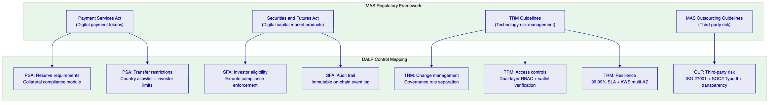
    - 16.2 Control Mapping Table: MAS, PSA, TRM Guidelines
Regulatory Requirement | Requirement Description | DALP Control | Evidence
PSA Section 29: Reserve Backing | Digital payment tokens must maintain adequate reserve backing | Collateral requirement module enforces on-chain proof of reserves before minting; collateral ratio tracked continuously | On-chain compliance module configuration; collateral event log
PSA Section 30: Transfer Restrictions | Restrictions on transfer to unauthorized recipients | Country allowlist + Identity Verification compliance modules enforce ex-ante | Compliance module configuration; on-chain transfer revert events
PSA: AML/CFT | Anti-money laundering and counter-terrorist financing obligations | Integration with DBS Bank's AML platform via webhooks; wallet freeze API for enforcement | Webhook configuration; freeze/unfreeze event log
TRM Guideline 5.1: Access Control | Appropriate access controls for systems managing customer data | Dual-layer RBAC; 26 roles; wallet verification for all writes; API key scoping | Role configuration; access event log; security dashboard
TRM Guideline 5.3: Change Management | Controlled changes to technology systems | Governance role separation; UUPS proxy upgrade with on-chain authorization; configuration change log | Change event log; role assignment records
TRM Guideline 7.1: System Resilience | Systems must meet defined resilience objectives | 99.99% uptime SLA; AWS Multi-AZ; RTO 2-15 minutes; RPO seconds to 1 minute | SLA commitment; architecture documentation; DR test results
TRM Guideline 9.1: Third-Party Risk | Management of risks from third-party technology providers | ISO 27001 and SOC 2 Type II certifications; transparency on all subcontractor dependencies; defined control boundary | Certificates available; third-party dependency register
MAS Notice on Cyber Hygiene | Regular penetration testing and vulnerability management | Regular penetration testing (at least annually); vulnerability scanning; patching cadence | Penetration test reports; vulnerability management programme documentation
Outsourcing Guidelines: Data Residency | Customer data must remain within Singapore for licensed institutions | AWS ap-southeast-1 deployment; no data transfer outside Singapore jurisdiction; data residency attestation | Deployment architecture; data flow diagrams; AWS region configuration
Outsourcing Guidelines: Audit Rights | Institutions must retain audit rights over outsourced service providers | Full audit access to platform logs, configurations, and change records; SettleMint provides regulator-facing evidence packs | Audit access procedures; evidence export API
Project Guardian: Interoperability | Support for MAS-endorsed cross-network interoperability frameworks | ERC-3643 standard token interface; OnchainID identity interoperability; XvP HTLC cross-chain settlement | ERC-3643 implementation; cross-chain settlement documentation
TradeTrust: Document Integrity | Trade documents must be verifiable and transferable under MLETR | Configurable token metadata schema for trade document attributes; integration API for TradeTrust verification | Integration architecture; metadata schema documentation

    - 16.3 Data Residency and Privacy
All DALP platform data for DBS Bank's deployment resides in AWS ap-southeast-1 (Singapore). This covers transaction records, identity data, key material (in AWS KMS/CloudHSM), audit logs, and configuration data. No data leaves Singapore jurisdiction through DALP platform operations.
For personal data subject to Singapore's Personal Data Protection Act (PDPA), DALP's data model separates on-chain data (which is immutable and pseudonymous — blockchain addresses, not personal identifiers) from off-chain data (which includes personal details subject to PDPA). The on-chain identity contracts store claim types and their validity status, not the underlying personal data. The personal data is held by the trusted issuer (DBS Bank's KYC infrastructure) and referenced through the OnchainID claim mechanism.
    - 16.4 Records Retention and Evidentiary Integrity
DALP's audit trail is inherently tamper-evident: on-chain events cannot be deleted or modified after they are written to the blockchain. For regulatory evidence purposes, the event log is exportable through the API with full event context, block reference, transaction hash, and timestamp. Event log queries are deterministic and reproducible: the same query against the same time window always returns the same result.
DALP's off-chain indexed data (the query layer over on-chain events) supports configurable retention policies for regulatory compliance, including legal-hold capabilities and deletion controls for personal data under PDPA. The separation between immutable on-chain data and configurable off-chain indexed data allows DBS Bank to satisfy both blockchain immutability requirements and PDPA deletion rights within the same architecture.

  - 17. Response Matrix
Req ID | Requirement | Compliance Status | DALP Response | Evidence
TR-01 | End-to-end lifecycle: initiation, approval, issuance, servicing, reporting, exception handling, closure | Supported | DALP provides complete lifecycle coverage for tokenized deposits and trade finance. Asset Designer covers creation; compliance modules cover approval; servicing covers yield, freeze, redemption; operational dashboards cover reporting; exception queues cover break management; burn and maturity redemption cover closure | Asset lifecycle documentation; OCBC Bank production reference
TR-02 | Maker-checker controls, delegated authority, segregation of duties, evidential approval logs | Supported | Transfer approval compliance module implements configurable maker-checker workflows with role-bound approval authority. 26 roles across four layers enforce separation of duties. All approval decisions recorded on-chain with approver identity, timestamp, and decision reference | Role configuration documentation; on-chain event log
TR-03 | Documented APIs, events, batch interfaces, message standards | Supported | OpenAPI 3.1 specification; TypeScript SDK; event webhooks; ISO 20022 payment rail support. All endpoints documented with response schemas, error codes, and authentication requirements | API documentation; OpenAPI specification
TR-04 | MAS regulatory alignment, PSA, TRM Guidelines, audit evidence, control mapping | Supported | Section 16 provides detailed control mapping to MAS, PSA, and TRM Guidelines. ISO 27001 and SOC 2 Type II certifications. MAS Singapore compliance template pre-built and deployed | Control mapping table; Section 16; certification evidence
TR-05 | Identity, wallet, participant onboarding, KYC/KYB, jurisdictional eligibility | Supported | OnchainID identity framework with claim-based verification. Identity Verification compliance module requires verified claims for all transfers. Country allowlist enforces jurisdictional eligibility. KYC/AML integration through trusted issuer API | Identity framework documentation; OCBC Bank reference
TR-06 | Key management, HSM/KMS, signing policy, break-glass, wallet administration | Supported | Key Guardian with HSM/CloudHSM support. Fireblocks MPC-CMP integration. Break-glass procedure documented. Wallet verification required for all writes. Emergency access logged and reviewed | Key management documentation; Section 9
TR-07 | Reconciliation across digital asset events, cash movement, GL, sub-ledgers, external confirmations | Supported | On-chain as source of truth with indexer query layer. Structured webhook payloads designed for automated journal entry generation. Reconciliation break surfacing through operational API. Deterministic event replay for reconciliation validation | Integration architecture; Section 10.4
TR-08 | Operational dashboards, alerting, case management, evidence export | Supported | DALP operational dashboards (operations, compliance, security, transactions). Configurable alerting via Grafana. Exception queue with SLA tracking. Evidence export API for audit and regulatory inspection | Dashboard documentation; Section 10.3
TR-09 | Deployment flexibility: cloud, private cloud, on-premises; data residency | Supported | Full deployment flexibility: managed cloud (AWS Singapore recommended), private cloud (client cloud), on-premises (Kubernetes). Data residency controlled per deployment model | Section 12; deployment documentation
TR-10 | Reference delivery experience with regulated financial institutions in APAC | Supported | OCBC Bank (Singapore, MAS-regulated, production); Standard Chartered (APAC); Maybank Project Photon (Malaysia, central bank aligned); Reserve Bank of India trade finance; Mizuho Bank (production planning) | Section 15; reference letters available
TR-11 | Programmable controls: entitlement rules, transfer restrictions, pricing triggers, settlement conditions | Supported | 18 compliance module types covering full range of programmable controls. Expression builder for custom eligibility rules. XvP settlement with configurable conditions. Governance role required for all control changes | Compliance module catalog (Appendix B)
TR-12 | Testing strategy: SIT, UAT, performance, failover, cyber tabletop, data migration, cutover | Supported | Section 13.5 details comprehensive test programme including all named categories. Test plan and evidence provided as standard deliverables | Implementation methodology; Section 13.5
TR-13 | Integration with ERP/GL, treasury, CRM, case management, observability, domestic payment infrastructure | Supported | Section 8 details integration architecture for all named system categories. SWIFT/MAS SORA connectivity via ISO 20022 adapter | Integration architecture; Section 8
TR-14 | Data model extensibility: legal entity, branch, product, counterparty, collateral, jurisdiction | Supported | Configurable token instrument templates with custom metadata schemas. Per-asset compliance module configuration. Multi-entity setup through DALP's organization model. No custom code required for new product variants | Asset configuration documentation; instrument template system
TR-15 | Records retention, evidentiary integrity, exportability | Supported | On-chain tamper-evident audit trail. Time-windowed event query API for deterministic evidence export. Configurable retention policies for off-chain indexed data. Legal-hold capability | Section 16.4; audit export documentation
TR-16 | Third-party risk transparency: custodians, node operators, cloud, analytics, managed security | Supported | Full subcontractor transparency provided. Third-party dependency register covers Fireblocks (custody), AWS (infrastructure), Restate (workflow engine). ISO 27001 and SOC 2 Type II for SettleMint. Cloud shared responsibility model documented | Third-party dependency register; Section 11.2
TR-17 | Business continuity: RTO/RPO, region failover, backup restore, crisis governance | Supported | RTO 2-15 minutes (cloud-native); RPO seconds to 1 minute. AWS Multi-AZ deployment. Velero backup with CloudNativePG WAL archival. Quarterly DR testing. Crisis governance procedures documented | Section 11.5; Section 12; DR documentation
TR-18 | Commercial scaling for entities, jurisdictions, products, volumes without re-platform | Supported | Platform licensing model scales through environment addition. Configurable compliance templates enable jurisdiction expansion without custom development. Multi-entity organization model supports legal entity separation | Section 17 (commercial proposal); pricing schedule
TR-19 | Release management, regression testing, policy change approvals, smart contract change governance | Supported | UUPS proxy upgrade pattern with governance role authorization. Configuration change events logged on-chain. Staging environment for pre-production validation. Staged production rollouts for Enterprise tier | Change management documentation; Section 13
TR-20 | Future-state roadmap aligned to DBS Bank strategy, with live/roadmap distinction | Supported with narrative | This proposal clearly distinguishes live capabilities (marked Supported) from integration-dependent capabilities (marked accordingly). Roadmap items are tagged [ROADMAP] where included. SettleMint's product roadmap is shared with clients under NDA through the Customer Success Manager | Product roadmap (available under NDA)

  - 14a. Target Operating Model (Business-as-Usual Run State)
    - 14a.1 Operational Ownership Model
After the hypercare period concludes, DALP operates under DBS Bank's day-to-day management with SettleMint providing platform support per the Enterprise Support SLA. The run-state model distributes responsibility clearly between DBS Bank operational teams and SettleMint.
DBS Bank First-Line Operations Team owns:
- Daily start-of-day and end-of-day reconciliation checks
- Approval queue management for pending transfers and issuance requests
- Exception triage and routing to second-line functions
- Monitoring dashboard review and alert response
- Investor onboarding coordination (claim issuance workflow)
- Routine reporting pack production from DALP event exports
DBS Bank Second-Line Risk and Compliance owns:
- Review of compliance exception reports
- AML/CFT case management triggered by DALP events
- Policy change approval for compliance module reconfiguration
- Regulatory reporting sign-off
- Periodic review of trusted issuer status
DBS Bank Technology Team owns:
- Platform infrastructure monitoring (in shared responsibility with SettleMint for managed cloud)
- Integration health monitoring across enterprise system connectors
- Release management coordination with SettleMint for platform updates
- Security patch review and approval
SettleMint Support Team owns:
- Platform-level incident response per Enterprise SLA
- Platform software updates and patch management
- Root cause analysis for P1/P2 incidents
- Quarterly architecture reviews and optimization recommendations
    - 14a.2 Daily Operational Procedures
Start-of-Day Checks (08:00-09:00 SGT):
- Review DALP operations dashboard for overnight events: failed transactions, expired settlements, reconciliation breaks
- Confirm Chain Indexer health: block height, head age, indexer lag
- Review approval queue: pending transfers, pending issuance requests, transfers approaching SLA
- Confirm AML integration health: webhook delivery success rate from overnight batch
- Review settlement queue: any XvP settlements approaching expiry requiring counterparty action
- Confirm blockchain network health: node connectivity, gas pricing within normal range
Intraday Monitoring:
- Approval queue review every 2 hours during business hours
- Reconciliation mismatch alerts acted upon within 30 minutes of alert generation
- Failed transaction investigation: distinguish transient (network, gas) from permanent (compliance, policy) failures
- Sanctions screening hold review: immediate escalation to compliance team for new holds
End-of-Day Checks (17:30-18:30 SGT):
- Reconciliation sign-off: confirm digital asset positions align with core banking sub-ledger
- Settlement close: confirm all intraday XvP settlements reached final state (executed or cancelled)
- Yield schedule review: confirm any scheduled distributions completed successfully
- Exception log review: categorize and route any unresolved exceptions
- Daily reporting pack: generate event export for management information and regulatory reporting systems
    - 14a.3 Reconciliation Procedures
The reconciliation framework operates in three layers:
Layer 1 — Real-time event reconciliation: DALP webhooks deliver events to DBS Bank's core banking system and sub-ledger in real time. The reconciliation engine in the core banking system matches DALP events to internal position records and flags mismatches immediately.
Layer 2 — End-of-day position reconciliation: DBS Bank's operations team compares DALP's aggregated position (total supply, holder distribution, pending events) against the internal sub-ledger closing balance. DALP's API provides deterministic balance queries at any block height, enabling precise point-in-time reconciliation.
Layer 3 — Period-end reporting reconciliation: For regulatory reporting periods, DALP's event export API provides a complete event log for the reporting period. The report is reproducible: the same query at the same block height range always produces the same output, supporting auditor verification.
Break Investigation Procedure:
If a reconciliation break is identified:
- Operations team identifies the break category (timing, amount, instrument, counterparty mismatch)
- DALP event API queried for the relevant transaction with full context
- Break cause identified: network delay, failed webhook delivery, duplicate event, or genuine discrepancy
- Resolution: replay webhook manually, adjust internal record, or escalate to SettleMint support for investigation
- Break resolution documented with root cause, resolution, and preventive action
- All break investigations retained for audit access
    - 14a.4 Change Management Procedures
Routine Configuration Changes (Compliance Module Updates, Role Assignments):
- Change request submitted through DBS Bank's internal change management process
- SettleMint provides impact assessment within 2 business days
- Change validated in staging environment before production deployment
- Production deployment within approved change window (Saturday 02:00-06:00 SGT)
- Post-change validation by DBS Bank operations team
Emergency Configuration Changes (Sanctions Hold, Regulatory Order):
- Compliance team raises emergency change request with DBS Bank's change authority
- SettleMint support escalated to Enterprise tier response (15-minute response)
- Emergency change executed in production with simultaneous documentation
- Post-emergency review within 5 business days
Platform Updates (SettleMint-Initiated):
- SettleMint notifies DBS Bank of upcoming updates with minimum 10 business days advance notice for major updates
- DBS Bank reviews update in staging environment (provided by SettleMint's staged rollout process)
- DBS Bank approves production deployment (Enterprise tier: approval gate before production)
- Post-update validation by DBS Bank technology team
    - 14a.5 Knowledge Continuity
The operational model is designed to survive personnel turnover without creating knowledge dependency on specific individuals:
Documentation Set (maintained by SettleMint and DBS Bank jointly):
- Platform administration guide (SettleMint-maintained, version-controlled)
- Integration runbooks (DBS Bank-maintained, reviewed quarterly)
- Compliance configuration register (DBS Bank-maintained, approved by Compliance team)
- Incident response playbooks (jointly maintained, tested quarterly via tabletop exercises)
- Role and permission register (DBS Bank-maintained, reviewed at each personnel change)
Training Programme:
- New operations team members: 2-day platform onboarding covering dashboard navigation, approval workflows, reconciliation procedures, and exception handling
- New compliance team members: 1-day compliance module training covering ex-ante enforcement, module configuration, and audit evidence generation
- Annual refresher: 1-day tabletop exercise covering control event scenarios (sanctions alert, settlement failure, key rotation, network outage)
Support Continuity: The SettleMint Enterprise Support team maintains familiarity with DBS Bank's deployment through bi-weekly operational reviews and quarterly architecture reviews. DBS Bank does not depend on a single named SettleMint contact; the entire named support team shares institutional knowledge of the deployment configuration and integration patterns.

  - 14b. Scenario Responses
    - Scenario 1: Normal Day at Standard Volume
A standard business day for DBS Bank's tokenized deposits and trade finance programme involves the following workflow:
DBS Bank's operations team begins with the start-of-day checklist at 08:00 SGT, confirming overnight event status and approval queue state. During the morning, a batch of tokenized deposit minting requests arrives from DBS Bank's treasury team for a new tranche issuance. The supply manager role holder executes the minting through the DALP console: each recipient's OnchainID is validated automatically, compliance checks confirm all recipients are within the MAS allowlisted jurisdictions with current KYC claims, and the mint transactions execute. The operations team confirms the minting events appear in the webhook feed to the core banking system and reconciles the new token supply against the treasury record.
During the afternoon, several secondary market transfers process between institutional counterparties. Each transfer triggers the compliance engine: identity check passes, country allowlist check passes, investor count remains within limits, and the XvP settlement for a deposit-versus-trade-finance instrument exchange executes atomically. The operations team monitors the settlement queue through the DALP console, confirming all settlements reach the executed state before end-of-day.
At 17:30, end-of-day reconciliation confirms digital asset positions match the core banking sub-ledger to the unit level. The daily reporting extract is generated from the DALP events API and delivered to DBS Bank's data warehouse for management information processing.
    - Scenario 2: Peak Day at Elevated Volume
On a peak day following a market event, transfer volumes are three to five times the normal level. The following differences apply:
The approval queue for discretionary transfers accumulates faster. DBS Bank's operations team receives automatic alerts from the DALP monitoring dashboard when queue age exceeds configured thresholds. Additional approvers are activated using their pre-configured approver roles, processing the queue in parallel without any system changes or emergency configuration.
AML webhook delivery volume increases proportionally. DALP's async transaction pipeline maintains webhook delivery reliability at elevated volumes through its configurable retry logic and dead-letter rescue system. The AML platform's processing latency may increase, but DALP's transfer approval module ensures that transfers requiring screening hold remain in the approval queue until the screening response is received, regardless of volume.
Settlement processing volume increase is absorbed transparently: DALP's Kubernetes deployment scales automatically (managed cloud) or within the pre-provisioned capacity headroom (private cloud). The Chain Gateway's multi-RPC provider configuration ensures blockchain connectivity remains stable even under elevated transaction submission volumes.
End-of-day reconciliation may take longer due to increased event volume, but the deterministic nature of DALP's event log ensures reconciliation accuracy is not affected by volume.
    - Scenario 3: Control Event — Sanctions Alert and Failed Settlement
Scenario: At 14:30 SGT, DBS Bank's sanctions screening platform identifies a potential sanctions match on an investor wallet that holds tokenized deposit tokens. Simultaneously, an XvP settlement for a trade finance instrument transfer fails due to the counterparty not confirming their leg before expiry.
Sanctions Alert Response:
- The sanctions screening platform calls DALP's freeze API for the identified wallet address
- DALP immediately freezes the wallet: the investor's unfrozen balance drops to zero, preventing any outbound transfers
- The compliance dashboard surfaces the freeze event with the wallet address, frozen amount, and the timestamp
- DBS Bank's AML/Compliance team reviews the screening match: if confirmed, the freeze is maintained and the matter is escalated per DBS Bank's AML procedures; if cleared, the compliance team calls DALP's unfreeze API with a documented clearance reference
- All freeze and unfreeze events are recorded permanently on-chain with the operator identity, timestamp, and action reference — auditable evidence regardless of outcome
- The entire workflow from alert to freeze executes in under 5 minutes. No engineering intervention required.
Failed Settlement Response:
- The expired XvP settlement appears in the DALP settlement queue as "Expired"
- DALP's HTLC mechanism returns both parties' assets automatically: neither party loses their asset due to the other's failure to confirm
- The operations team is notified via the monitoring dashboard and webhook alert
- DBS Bank's operations team contacts the counterparty to understand the reason for non-confirmation
- If the counterparty is ready to re-settle, a new XvP settlement is created through the DALP console with a new hashlock and expiry date
- All events — original settlement creation, expiry, asset return, new settlement — are recorded on-chain with complete context for post-event review

  - 14c. Singapore Domestic Payment Rail Integration
    - 14c.1 MAS SORA (SGD RTGS) Connectivity
Singapore's SORA (Scrips and Securities Operations Centre) system serves as the SGD high-value payment settlement infrastructure. For DBS Bank's tokenized deposits programme, the integration pattern between DALP and SORA supports the cash leg of deposit token operations:
Cash leg for deposit issuance: When DBS Bank issues tokenized deposits against SGD fiat funding, the SGD funding transfer through SORA generates a payment confirmation that triggers the token minting workflow. DALP's Transfer Approval module can be configured to require the SORA payment confirmation event (delivered via DBS Bank's treasury system webhook) before the token minting executes. This ensures that SGD funding and token issuance are operationally coordinated, even though they occur on different rails.
Cash leg for deposit redemption: At maturity redemption, the atomic DvP mechanism burns the deposit tokens and transfers the denomination asset (on-chain SGD stablecoin or deposit token) to the redeeming investor simultaneously. The off-chain SGD cash payment through SORA is orchestrated by DBS Bank's treasury system, triggered by the on-chain redemption event webhook. The reconciliation framework confirms that the on-chain and off-chain legs are both completed before the redemption is considered settled.
    - 14c.2 PayNow and FAST Integration
For retail or SME investor segments that may require faster SGD settlement, DALP's webhook architecture supports integration with PayNow and FAST (Fast and Secure Transfers):
Investor onboarding funding: PayNow can serve as the funding channel for retail investors purchasing tokenized deposit products. The PayNow payment confirmation, delivered via DBS Bank's core banking system, triggers the investor onboarding workflow in DALP: the investor's OnchainID is activated and the initial token allocation is minted. This end-to-end flow (PayNow payment to token allocation) can complete within minutes.
Distribution payments: For yield distributions to individual investors, DALP's pull-based yield claim mechanism generates a claim event. DBS Bank's treasury system can consume this event and initiate PayNow or FAST payment to the investor's registered bank account, creating an automated distribution workflow from on-chain yield event to off-chain SGD credit.
    - 14c.3 Data Residency for Payment Rail Integration
All payment rail integration data (payment references, transaction amounts, timestamps, counterparty identifiers) remains within Singapore infrastructure. The integration pattern uses DBS Bank's internal messaging bus as the intermediary between DALP and external payment rails, ensuring no payment data transits outside DBS Bank's network perimeter.

  - 18. Appendix A: Risk Register
Risk ID | Category | Description | Likelihood | Impact | Mitigation
R-001 | Regulatory | MAS guidance on specific tokenized deposit classifications requires compliance configuration adjustment after initial deployment | Medium | High | Early engagement with legal/compliance in Phase 1; modular compliance architecture enables rapid module reconfiguration without token redeployment
R-002 | Integration | DBS Bank core banking system integration complexity exceeds initial estimates | Medium | High | Detailed integration assessment in Phase 1 with 2-week contingency buffer in Phase 3; DALP comprehensive API reduces custom development; mock integrations allow parallel progress
R-003 | Integration | AML/CFT platform real-time webhook delivery latency conflicts with settlement SLA requirements | Low | High | Performance test webhook delivery latency in Phase 4; configurable transfer approval workflow allows compliance hold before on-chain execution if needed
R-004 | Technical | Project Guardian interoperability requirements with external network participants introduce external dependencies | Medium | Medium | Early identification of interoperability requirements in Phase 1; ERC-3643 standard interface provides baseline interoperability; phased interoperability with contingency for deferred implementation
R-005 | Technical | TradeTrust document verification service availability affects trade finance instrument transfer workflow | Medium | Medium | Transfer approval module allows transfer hold if TradeTrust verification unavailable; operational procedures for graceful degradation documented in runbooks
R-006 | Operational | DBS Bank operations team knowledge transfer insufficient for independent BAU operations | Low | High | Structured knowledge transfer programme in Phase 6; role-based training; runbook validation; tabletop exercises; operational readiness sign-off before hypercare exit
R-007 | Security | Custody provider (Fireblocks) service availability affects transaction signing | Low | High | Key Guardian supports multiple custody backends; local HSM fallback path configured for emergency operations; Fireblocks 99.99% SLA contractually guaranteed
R-008 | Commercial | Scope expansion during implementation creates uncontrolled cost and timeline growth | High | Medium | Formal change control process from Phase 1; scope locked at Phase 1 gate with defined change request procedures; impact assessment required for all scope changes
R-009 | Data | Investor identity data quality from existing DBS Bank systems insufficient for on-chain claim issuance | Medium | Medium | Data quality assessment in Phase 1; remediation plan agreed before Phase 2; data seeding validation as Phase 5 go-live criterion
R-010 | Regulatory | PSA regulatory interpretation of tokenized deposits requires licensing or approval not currently held by DBS Bank | Low | Critical | Legal review of instrument classification in Phase 1 before any development commitment; platform configuration does not predetermine regulatory characterization

RAID Log Ownership: Delivery Lead owns the RAID log. Weekly RAID review in programme status meeting. Monthly RAID review at Steering Committee. Issues escalated above agreed thresholds immediately to Programme Sponsor. Risk register reviewed and updated at each phase gate.
    - Assumptions Log
Assumption ID | Category | Assumption | Owner | Invalidation Action
A-001 | Regulatory | Tokenized deposits are classified as deposits (not capital market instruments) under PSA for the instrument structures proposed | DBS Bank Legal | Re-scope compliance template if classification differs
A-002 | Technical | DBS Bank operates or has access to an EVM-compatible blockchain network (private Besu or Project Guardian network) | DBS Bank Technology | Evaluate alternative network options in Phase 1
A-003 | Integration | DBS Bank's AML platform supports real-time webhook consumption with sub-5-second processing latency | DBS Bank Technology | Adjust transfer approval module configuration to accommodate AML processing latency
A-004 | Integration | DBS Bank's core banking system has an available API for position reconciliation and sub-ledger event consumption | DBS Bank Technology | Define alternative reconciliation approach (file-based batch) if API is not available
A-005 | Integration | DBS Bank's KYC/AML infrastructure can act as a Trusted Issuer for OnchainID claims with a programmatic claim issuance API | DBS Bank Operations | Alternative: SettleMint provides managed Trusted Issuer service during initial phase
A-006 | Security | DBS Bank's InfoSec team can accommodate cloud deployment within AWS ap-southeast-1 for this programme | DBS Bank InfoSec | Evaluate on-premises deployment if cloud is not approved
A-007 | Delivery | DBS Bank project team is available full-time for the specified roles during the 19-week implementation | DBS Bank Programme | Re-scope timeline if team availability is constrained
A-008 | Commercial | Contract is denominated in EUR with annual upfront payment; no requirement for SGD denomination or monthly billing | DBS Bank Finance | Arrange currency hedging and payment structure alignment at contract execution
A-009 | Technical | Private blockchain network for DBS Bank's deployment does not require MAS network registration or licensing | DBS Bank Legal | Engage MAS on network regulatory status if required
A-010 | Scope | Initial programme scope is Singapore-only (no multi-jurisdiction deployment in Year 1) | DBS Bank Programme | Scope multi-jurisdiction expansion as a Year 2 configuration exercise

    - Dependency Log
Dependency ID | External Dependency | Owner | Required By | Risk if Delayed
D-001 | Fireblocks enterprise agreement (if selected as custody provider) | DBS Bank Procurement | Phase 2 start | Delay in Key Guardian configuration; fallback to AWS KMS temporarily
D-002 | MAS guidance confirmation on tokenized deposit instrument classification | DBS Bank Legal | Phase 1 completion | Risk of compliance reconfiguration if guidance arrives after Phase 2
D-003 | DBS Bank InfoSec approval for AWS ap-southeast-1 deployment | DBS Bank InfoSec | Phase 2 start | Deployment model change; timeline impact
D-004 | DBS Bank core banking system API specification and sandbox access | DBS Bank Technology | Phase 3 start | Integration development cannot commence without API documentation
D-005 | DBS Bank AML platform API or webhook endpoint for DALP event consumption | DBS Bank Technology | Phase 3 start | AML integration delayed; manual compliance workflow as interim
D-006 | Project Guardian network access credentials (if applicable) | DBS Bank / MAS | Phase 3 | Cross-network interoperability deferred to Phase 2 of programme
D-007 | DBS Bank security review completion and penetration test scheduling | DBS Bank InfoSec | Phase 4 start | Testing phase delay; overall go-live risk
D-008 | TradeTrust framework API access and documentation (if TradeTrust integration in scope) | TradeTrust programme | Phase 3 | Optional work package deferred if access not available in time

  - 19. Appendix B: Compliance Module Catalog
DALP provides 18 compliance module types organized across six categories. All modules operate through the ERC-3643 compliance engine, evaluating before each transfer. Modules are composable: any combination can be applied to a single token.
    - Category 1: Eligibility Modules
Module 1: Identity Verification (SMART Identity)
- Description: Requires all transfer parties to have a registered OnchainID with active, non-expired claims from trusted issuers
- MAS Application: Core KYC requirement for all digital asset transfers
- Configuration: Claim type requirements (KYC, AML, accredited investor status); minimum claim freshness period; trusted issuer list
- Behavior: Transfer reverts if sender or recipient lacks required claims, has expired claims, or has claims from an issuer no longer in the trusted registry
Module 2: Investor Accreditation
- Description: Requires investors to hold a specific accreditation claim (accredited investor, qualified investor, institutional investor)
- MAS Application: Suitability requirements for specific instrument categories
- Configuration: Accreditation claim type; accepted issuer list
- Behavior: Transfer to non-accredited investors reverts; minting to non-accredited investors reverts
Module 3: Suitability Verification
- Description: Requires investors to hold a suitability attestation claim for the specific instrument type
- MAS Application: Product suitability obligations under the MAS notice on sale of investment products
- Configuration: Suitability claim type; instrument category code
- Behavior: Transfer to investors without current suitability attestation reverts
    - Category 2: Restriction Modules
Module 4: Country Allowlist
- Description: Restricts transfers to investors in approved jurisdictions
- MAS Application: Jurisdictional distribution restrictions; PSA transfer restrictions
- Configuration: List of permitted ISO 3166-1 country codes; separate lists for issuance and secondary transfer
- Behavior: Transfer involving an investor whose registered country is not in the allowlist reverts; country claim is sourced from OnchainID
Module 5: Country Blocklist
- Description: Blocks transfers involving investors in prohibited jurisdictions
- MAS Application: Sanctions implementation; OFAC/UN sanctions list enforcement
- Configuration: List of prohibited country codes; enforcement scope (sender, recipient, or both)
- Behavior: Transfer involving investor from a blocked country reverts regardless of other checks
Module 6: Address Blocklist
- Description: Blocks transfers to or from specifically identified wallet addresses
- MAS Application: Targeted sanctions enforcement; AML freeze enforcement at the protocol layer
- Configuration: List of blocked wallet addresses; enforcement scope
- Behavior: Transfer involving a blocked address reverts; addresses added to blocklist take effect immediately
Module 7: Address Allowlist
- Description: Restricts transfers to a specified list of pre-approved wallet addresses
- MAS Application: Controlled distribution to specific counterparties; inter-entity transfer restrictions
- Configuration: List of allowed wallet addresses; maintenance process for list updates
- Behavior: Transfers only execute between addresses on the allowlist
    - Category 3: Transfer Control Modules
Module 8: Transfer Approval
- Description: Requires explicit human approval before transfer execution
- MAS Application: Documentary compliance in trade finance; high-value transfer controls; pre-trade screening integration
- Configuration: Approval queue configuration; approver roles; SLA thresholds; escalation rules
- Behavior: Transfer request enters approval queue; on-chain execution is held until approval is granted; approval record includes approver identity, timestamp, and decision reference
Module 9: Investor Count Limit
- Description: Enforces maximum number of unique token holders
- MAS Application: MAS offering limits; PSA restrictions on holder count for specific instrument categories
- Configuration: Global holder limit; per-country holder limits (independently configurable)
- Behavior: Transfer that would increase holder count beyond the limit reverts; applies independently to global and per-country limits
Module 10: Transfer Velocity
- Description: Limits the total transfer volume within a specified time window
- MAS Application: Transaction monitoring support; concentration limits
- Configuration: Volume limit; time window (rolling); scope (per-address or global)
- Behavior: Transfer that would exceed the velocity limit within the current window reverts
    - Category 4: Issuance and Supply Modules
Module 11: Supply Cap
- Description: Enforces a hard maximum on total circulating supply
- MAS Application: PSA issuance restrictions; MiCA-style supply caps
- Configuration: Maximum supply in token units
- Behavior: Minting beyond the configured cap reverts; cap tracks live circulating supply (burn decreases the used cap)
Module 12: Token Supply Limit (Rolling Window)
- Description: Enforces a maximum issuance volume within a rolling time window
- MAS Application: Periodic issuance restrictions; time-windowed offering caps
- Configuration: Maximum issuance amount; window duration (in days); base price conversion for currency-denominated caps
- Behavior: Minting that would exceed the rolling window limit reverts; window rolls forward with each new issuance
Module 13: Collateral Requirement
- Description: Requires on-chain proof of collateral backing before minting
- MAS Application: PSA reserve requirements for digital payment tokens; collateral-backed deposit token requirements
- Configuration: Required collateral ratio; collateral token address; acceptable collateral types
- Behavior: Minting reverts if on-chain collateral balance is insufficient for the requested mint at the required ratio
    - Category 5: Time-Based Modules
Module 14: Time Lock (Holding Period)
- Description: Enforces a minimum holding period before tokens can be transferred
- MAS Application: Lock-up requirements post-issuance; investment product holding period enforcement
- Configuration: Minimum holding period (in days); FIFO batch tracking for partial transfers
- Behavior: Transfer of tokens within the holding period reverts; FIFO batch tracking ensures that older tokens (past the holding period) transfer first
Module 15: Transfer Window
- Description: Restricts transfers to specified time windows (e.g., business hours, settlement windows)
- MAS Application: Settlement window enforcement; operational control over transfer timing
- Configuration: Allowed time ranges (day of week and hour); timezone setting
- Behavior: Transfer outside the configured time window reverts
Module 16: Maturity Block
- Description: Blocks all standard transfers after the maturity date, enabling only redemption operations
- MAS Application: Fixed-term instrument maturity enforcement; ensuring holders can only exit through redemption
- Configuration: Maturity date (set at token creation, immutable after deployment)
- Behavior: All standard transfers revert after maturity date; redemption (atomic burn-and-payout) remains available to holders
    - Category 6: Settlement and Collateral Modules
Module 17: Collateral Ratio
- Description: Continuously monitors collateral coverage ratio and blocks minting when coverage falls below threshold
- MAS Application: Ongoing collateral monitoring for backed instruments; dynamic collateral enforcement
- Configuration: Minimum coverage ratio; monitoring frequency; alert thresholds
- Behavior: Minting blocked when live collateral ratio falls below the minimum; existing token holders not affected
Module 18: Settlement Condition
- Description: Requires specific on-chain conditions to be met before transfer executes
- MAS Application: Conditional settlement enforcement; documentary conditions for trade finance
- Configuration: Condition contract address; required condition state; timeout behavior
- Behavior: Transfer reverts if the condition contract reports the condition is not met; enables programmable settlement logic without modifying the token contract

End of Technical Proposal: DBS Bank — Tokenized Deposits and Trade Finance Platform
Document version: 1.0 Draft | Prepared: 20 March 2026 | SettleMint Confidential

