[Company name]
[Document title]
[Document subtitle]

Confidentiality Statement
This document contains confidential and proprietary information of SettleMint. By reading this document, you agree not to disclose the confidential information contained herein to any third party without the prior written consent of SettleMint, except to those agents, principals, representatives, or consultants who require access for the purpose of evaluating this document. You further agree to inform such persons of the confidential nature of this document and to obtain their agreement to preserve its confidentiality to the same extent as yours.
This confidentiality statement shall remain binding on the parties for a period of five (5) years from the date stated on the front cover, unless superseded by confidentiality provisions detailed in a subsequent agreement.
Terms and Conditions
This proposal is valid until [DD Month YYYY]. In the absence of confirmation to proceed, SettleMint and [the Company] acknowledge and agree to abide by the Mutual NDA as the governing agreement.
SettleMint reserves the right to vary the terms of this proposal in response to changes in specifications or information made available at a later date. Submission of this proposal does not convey any right, title, interest, or license in any intellectual property rights (including, but not limited to, patents, copyrights, trade secrets, or trademarks) contained herein.
All rights are reserved. This proposal and the information contained within it are provided on an “as is” basis, without any warranties of any kind, express or implied.
All contracts with SettleMint will be governed by Belgian Law and subject to the exclusive jurisdiction of Belgian courts.
Contact Details
For any enquiries regarding this document, please contact:
[Full Name]
[Job Title]
Email: [email@example.com]
Phone: [Country Code - Number]

Table of Contents

Table of Contents 3
1. Executive Summary 4
1.1 Context and Strategic Drivers 5
1.2 Why This Programme Is Hard 6
Lifecycle Complexity 7
Governance and Compliance Burden 8
Operationalization Gap 9
Integration Burden 10
1.3 Proposed Response 11
Deployment Model 12
Target Asset Scope 13
Compliance Approach 14
Custody Model 15
Integration Perimeter 16
Phased Delivery Summary 17
1.4 Why SettleMint 18
1.5 Why DALP 19
1.6 Reference Fit Snapshot 20
2. About SettleMint 21
2.1 Company Overview 22
2.2 History and Market Position 23
2.3 Production Credentials 24
2.4 Regulatory Readiness 25
2.5 Team and Delivery Capability 26
2.6 Ecosystem and Partnerships 27
3. About DALP — Digital Asset Lifecycle Platform 28
3.1 Platform Overview 29
3.2 Core Lifecycle Pillars 30
3.2.1 Issuance 31
3.2.2 Compliance 32
3.2.3 Custody 33
3.2.4 Settlement 34
3.2.5 Servicing 35
3.3 Platform Foundations 36
3.3.1 Identity and Access Management 37
3.3.2 Integration and Interoperability 38
3.3.3 Observability and Operations 39
3.4 Supported Asset Classes 40
3.5 Standards and Protocols 41
4. Customer References 42
4.1 Summary Table 43
4.2 Expanded Reference: Commerzbank (Germany) 44
4.3 Expanded Reference: Standard Chartered Bank 45
5. Understanding of Requirements 46
5.1 KfW Context 47
Institution Mandate 48
Transformation Drivers 49
5.2 Requirement Domains 50
5.3 Key Challenges Identified 51
Challenge 1: Regulatory Complexity 52
Challenge 2: Integration with Existing Infrastructure 53
Challenge 3: Governance and Control 54
Challenge 4: Operational Transition 55
Challenge 5: Long-Term Supportability 56
5.4 Requirement Prioritization 57
5.5 Response Principles 58
6. Proposed Solution and Functional Capabilities 59
6.1 Solution Overview 60
6.2 Issuance and Asset Configuration 61
6.3 Identity and Eligibility 62
6.4 Compliance Enforcement 63
6.5 Transfer, Settlement, and Cash-Leg Coordination 64
6.6 Lifecycle Servicing and Corporate Actions 65
Coupon Distribution 66
Maturity Handling 67
Redemption Mechanics 68
7. Technical Architecture 69
7.1 Architectural Principles 70
7.2 Layered Architecture 71
7.3 Data Architecture 72
7.4 Network and Chain Topology 73
7.5 Multi-Tenancy and Environment Segregation 74
7.6 Operational Architecture 75
8. Security 76
8.1 Security Model Overview 77
8.2 Authentication and Access Control 78
8.3 Key Management and Custody Integration 79
8.4 Data Protection and Encryption 80
8.5 Compliance Controls and Auditability 81
8.6 Testing and Assurance 82
8.7 Security Responsibility Matrix 83
9. Project Implementation & Delivery 84
9.1 Delivery Overview 85
9.2 Phase Plan 86
Phase 1: Discovery and Requirements (4 weeks) 87
Phase 2: Foundation and Setup (6 weeks) 88
Phase 3: Configuration and Compliance (8 weeks) 89
Phase 4: Integration and Testing (8 weeks) 90
Phase 5: Go-Live (2 weeks) 91
Phase 6: Hypercare (4 weeks) 92
9.3 Governance and Decision Structure 93
9.4 Resource Model 94
10. Deployment 95
10.1 Deployment Principles 96
10.2 Recommended Deployment Model 97
10.3 Deployment Options Comparison 98
10.4 Infrastructure Requirements 99
10.5 Availability, Resilience, and DR Approach 100
10.6 Data Residency and Sovereignty 101
11. Training and Knowledge Transfer 102
11.1 Training Strategy 103
11.2 Administrator Track 104
11.3 Developer / Integration Track 105
11.4 End-User / Operations Track 106
11.5 Knowledge Transfer Method 107
12. Support & SLA 108
12.1 Support Model Overview 109
12.2 Support Tiers 110
12.3 Severity and Response Matrix 111
12.4 Escalation and Incident Management 112
12.5 Maintenance and Update Policy 113
12.6 Service Reporting 114
13. Risk Management 115
13.1 Risk Management Approach 116
13.2 Risk Register 117
13.3 Governance of Risks 118
14. Compliance Matrix 119
14.1 Usage Instructions 120
14.2 Detailed Matrix 121
Additional Technical Diagrams 122
Transaction Processing Flow 123
Integration Architecture 124
Deployment Topology 125
Security Architecture 126
Support Escalation Process 127
Implementation Timeline 128
Data Flow Architecture 129

Document Reference: KFW-TECH-2026-001
Version: 1.0 Draft
Submission Date: March 2026
Classification: Confidential
Prepared for: KfW Digital Assets Procurement Team

  - Table of Contents
- Executive Summary
- About SettleMint
- About DALP — Digital Asset Lifecycle Platform
- Customer References
- Understanding of Requirements
- Proposed Solution and Functional Capabilities
- Technical Architecture
- Security
- Project Implementation & Delivery
- Deployment
- Training and Knowledge Transfer
- Support & SLA
- Risk Management
- Compliance Matrix

- 1. Executive Summary
  - 1.1 Context and Strategic Drivers
KfW is undertaking this procurement to establish a controlled, production-grade platform for digital development bonds aligned to its development finance mandate and public-sector auditability requirements. The institution operates with a conservative risk appetite and demands high transparency across all operations. This procurement seeks a solution that supports regulated business growth while preserving strong governance, operational resilience, and clear accountability across front-office, operations, risk, compliance, information security, architecture, and procurement stakeholders.
The strategic drivers for this procurement reflect KfW's position as a leading development finance institution:
- Digital transformation of development bonds: Supporting digitally native development bond issuance with strong public-sector governance and transparency mechanisms that meet German and EU regulatory standards.
- Reporting integrity: Improving reporting integrity for funded programmes and investor disclosures through immutable audit trails and real-time visibility.
- Infrastructure tokenization evaluation: Evaluating infrastructure tokenization patterns that could support future development finance structures across multiple jurisdictions.
KfW has been a flagship issuer in digitally native and blockchain-based bond experimentation in Germany, working with Deutsche Börse / Clearstream ecosystem components and Bundesbank trigger-solution style settlement experiments. This proposal addresses the specific requirements of a conservative, public-interest-driven institution heavily focused on legal certainty, transparency, sovereign-grade issuance controls, and reproducible post-trade reporting.
  - 1.2 Why This Programme Is Hard
The deployment of a digital development bonds platform presents significant challenges that distinguish it from conventional technology implementations:
    - Lifecycle Complexity
Digital development bonds require end-to-end lifecycle management spanning origination, onboarding, issuance, servicing, transfer, redemption, and archival record retention. Each stage involves multiple stakeholders, approval workflows, and regulatory compliance checks. The platform must support the complete journey from bond design through maturity, including corporate actions, coupon payments, and final redemption — all with full auditability.
    - Governance and Compliance Burden
As a German public-sector development bank, KfW operates under stringent regulatory requirements including MiCA, MiFID II, German eWpG, public procurement and public-sector audit requirements, DORA, GDPR, and BaFin guidance. The solution must demonstrate clear control evidence, regulatory alignment, and the ability to generate supervisor-ready reporting without requiring extensive manual intervention.
    - Operationalization Gap
Many digital asset platforms demonstrate compelling pilot functionality but fail to transition to production-ready operation. The gap between proof-of-concept and sustainable production involves addressing operational monitoring, exception handling, reconciliation processes, disaster recovery, and support models that meet institutional standards. This proposal addresses the complete operationalization requirement, not merely the functional capability.
    - Integration Burden
The platform must integrate with existing institutional infrastructure including bond issuance and paying-agent processes, treasury systems, investor communications, settlement and CSD connectivity, accounting, reporting, and public-sector governance workflows. The digital asset layer cannot become a sidecar disconnected from existing books and records, operations controls, or regulator-facing reporting.
  - 1.3 Proposed Response
SettleMint proposes the deployment of DALP (Digital Asset Lifecycle Platform) configured specifically for KfW's digital development bonds requirements. Our response addresses the complete scope defined in the RFP.
    - Deployment Model
We recommend a Private Cloud / Dedicated Deployment model for KfW, hosted within German data centres to ensure full data residency compliance and alignment with BaFin outsourcing requirements. This deployment model provides complete logical isolation from other tenants, data residency in Germany/EU, direct connectivity to KfW's existing infrastructure, and full operational control while retaining platform capabilities.
    - Target Asset Scope
The initial deployment will support bond tokenization with automated coupon schedules, maturity handling, and redemption mechanics; fixed-income instruments configuration for various bond structures; and expansion readiness through architecture supporting future extension to additional asset classes.
    - Compliance Approach
DALP provides ex-ante compliance enforcement through its modular compliance engine built on ERC-3643 (T-REX) standards. Every transfer passes through configurable compliance modules before execution, ensuring regulatory requirements are enforced at the point of transaction rather than reviewed retrospectively.
    - Custody Model
The platform supports KfW's preferred custody arrangements through its custody orchestration layer. DALP integrates with institutional custody providers including Fireblocks and DFNS, enabling KfW to leverage existing custodian relationships while maintaining unified operational control.
    - Integration Perimeter
The platform provides comprehensive API coverage for integration with core banking and treasury management systems, custody and depository connections, payment rails, regulatory reporting systems, investor onboarding platforms, and financial accounting systems.
    - Phased Delivery Summary
Phase | Duration | Focus
Discovery & Requirements | 4 weeks | Scope definition, control mapping, integration design
Foundation & Setup | 6 weeks | Environment provisioning, platform deployment, identity setup
Configuration & Compliance | 8 weeks | Asset configuration, compliance modules, workflow design
Integration & Testing | 8 weeks | System integration, testing, user acceptance
Go-Live | 2 weeks | Cutover, smoke tests, production validation
Hypercare | 4 weeks | Production support, optimization, knowledge transfer

Total estimated timeline: 32 weeks
  - 1.4 Why SettleMint
SettleMint brings unique credentials relevant to KfW's requirements including market tenure since 2017, production record with active deployments at regulated institutions across Europe and Asia, regulated delivery experience with BaFin, FCA, MAS engagement, and relevant reference implementations including Commerzbank in Germany.
  - 1.5 Why DALP
DALP provides the comprehensive platform capability that KfW requires through platform breadth covering the complete digital asset lifecycle, lifecycle model treating assets as continuous process under unified governance, control plane positioning between core financial systems and blockchain networks, and interoperability designed for institutional integration.
  - 1.6 Reference Fit Snapshot
Reference | Relevance to KfW
Commerzbank | German bank, ETP/bond tokenization, production deployment with Boerse Stuttgart
Standard Chartered Bank | Institutional trading, digital asset exchange, custody integration
Sony Bank (Japan) | Stablecoin issuance, regulatory alignment, production-ready positioning

- 2. About SettleMint
  - 2.1 Company Overview
SettleMint is a leading provider of enterprise-grade digital asset platform solutions, headquartered in Brussels, Belgium. Our mission is to enable financial institutions to design, launch, and operate tokenized assets with the same confidence they apply to traditional financial instruments. We focus exclusively on regulated financial institutions, sovereign entities, and market infrastructure providers.
  - 2.2 History and Market Position
Founded in 2017, SettleMint has grown to become a recognized leader in the digital asset platform market. Key milestones include first production deployment at a regulated European bank in 2019, launch of DALP in 2021, expansion into Asian markets in 2022, ISO 27001 certification in 2023, strategic reference wins in 2024, and Mizuho Bank PoC completion in 2025.
  - 2.3 Production Credentials
Credential | Detail
ISO 27001 | Certified Information Security Management System
SOC 2 Type II | Security, availability, and confidentiality controls attested
Regulatory Alignment | Active engagement with BaFin, FCA, MAS, SEC, JFSA
Production Deployments | 14+ named customer references across banking, sovereign, and market infrastructure
Asset Classes Supported | 7+ asset classes including bonds, equities, funds, deposits, stablecoins, real estate

  - 2.4 Regulatory Readiness
DALP is designed to support compliance with EU MiCA, MiFID II, German eWpG, DORA, GDPR, BaFin Guidance, UK FCA, and Singapore MAS regulations.
  - 2.5 Team and Delivery Capability
SettleMint maintains a team of 80+ engineers specializing in distributed systems architecture, blockchain and smart contract development, financial instrument engineering, enterprise integration, and security and cryptography.
  - 2.6 Ecosystem and Partnerships
SettleMint maintains partnerships with Fireblocks and DFNS for custody integration, cloud providers (AWS, Azure, GCP) with dedicated deployment patterns, and HSM providers (Thales, Utimaco).

- 3. About DALP — Digital Asset Lifecycle Platform
  - 3.1 Platform Overview
DALP is SettleMint's production-grade platform for designing, launching, and operating tokenized assets across financial instruments and real-world assets. It provides production-ready infrastructure from day one, enabling institutions to deploy digital assets without building blockchain expertise internally.
DALP sits between existing core financial systems and blockchain networks, providing the governance and orchestration layer that enables institutions to build, deploy, and operate compliant digital asset solutions in production.
  - 3.2 Core Lifecycle Pillars
    - 3.2.1 Issuance
Rapid deployment of tokenized assets across seven asset classes — bonds, equities, funds, deposits, stablecoins, real estate, and precious metals — each with purpose-built lifecycle logic. Key capabilities include configurable business rules, Asset Designer wizard, deterministic issuance orchestration, and paused-by-default behaviour with explicit unpause control.
    - 3.2.2 Compliance
Ex-ante enforcement ensures every transfer is validated before execution. DALP provides 18 compliance module types, multi-jurisdictional support, ERC-3643 (T-REX) implementation, and OnchainID for verifiable on-chain investor identities.
    - 3.2.3 Custody
Enterprise-grade key management workflows with bring-your-own-custodian integrations. Key Guardian supports multiple storage backends, maker-checker approval workflows, RBAC with 5 defined roles, and emergency pause capability.
    - 3.2.4 Settlement
Atomic Delivery-versus-Payment (DvP) and Exchange-versus-Payment (XvP) settlement — both complete together or revert together. Supports local and HTLC cross-chain settlement models with ISO 20022 integration.
    - 3.2.5 Servicing
Automated lifecycle operations executed programmatically across every asset type including automated corporate actions, fixed treasury yield, AUM fee features, and maturity redemption.
  - 3.3 Platform Foundations
    - 3.3.1 Identity and Access Management
OnchainID provides verifiable on-chain investor identities, Identity Registry manages verified profiles, RBAC governs every action with 5 defined roles, and wallet verification with multi-factor gates protects privileged transactions.
    - 3.3.2 Integration and Interoperability
Comprehensive APIs include REST, GraphQL, event webhooks, and oRPC. The platform provides a typed TypeScript SDK, CLI with 301 commands, and payment rail connectivity supporting ISO 20022 standards.
    - 3.3.3 Observability and Operations
Pre-built dashboards cover operations, transactions, compliance, and security. Three-pillar observability includes metrics, logs, and traces with distributed tracing across full transaction lifecycle.
  - 3.4 Supported Asset Classes
Asset Class | Typical Instruments | Lifecycle Support
Fixed Income | Corporate bonds, government bonds, structured notes | Coupon schedules, maturity, redemption
Flexible Income | Common stock, preferred shares, investment fund units | Dividends, voting, corporate actions
Cash Equivalent | Fiat-pegged stablecoins, tokenized bank deposits | Interest, withdrawal rules
Real World Assets | Fractional property ownership, gold-backed tokens | Provenance, chain-of-custody

  - 3.5 Standards and Protocols
Category | Standards Supported
Token Standards | ERC-20, ERC-721, ERC-1400, ERC-3643 (T-REX), ERC-5805, EIP-2612
Identity | OnchainID (ERC-734/735), claim-based verification
Account Abstraction | ERC-4337, ERC-7579
Compliance | 18 module types
Settlement | Atomic DvP/XvP, HTLC cross-chain
Payment Rails | ISO 20022 (SWIFT, SEPA, RTGS)

- 4. Customer References
  - 4.1 Summary Table
Client | Geography | Use Case | Relevance to KfW
Commerzbank | Germany | Hybrid on/off-chain ETP issuance | German bank, bond tokenization
Standard Chartered Bank | UK/Asia | Digital asset exchange | Institutional trading
Sony Bank | Japan | Stablecoin issuance | Regulatory alignment
OCBC Bank | Singapore | Security token engine | Bond/equity tokenization
Saudi RER | Saudi Arabia | Real estate registry | Sovereign-grade
Mizuho Bank | Japan | Bond tokenization | Production planning
ADI Finstreet | UAE | Tokenized equity | Regulatory environment

  - 4.2 Expanded Reference: Commerzbank (Germany)
Commerzbank, one of Germany's leading commercial banks, required a solution for issuing and managing exchange-traded products (ETPs) using a hybrid on/off-chain approach. SettleMint implemented a hybrid solution integrating with Boerse Stuttgart's listing service, achieving settlement in under 10 seconds, reduced counterparty risk, and identified potential annual savings of €7M. This reference directly demonstrates SettleMint's ability to deliver production-grade bond tokenization within the German regulatory framework.
  - 4.3 Expanded Reference: Standard Chartered Bank
Standard Chartered Bank sought to improve trading efficiency for institutional investors through digital asset tokenization. The solution supported fractional tokenization of securities with instant and immutable ownership recording, elimination of custody intermediaries, and faster settlement times. This demonstrates institutional-grade trading and custody integration capabilities.

- 5. Understanding of Requirements
  - 5.1 KfW Context
KfW is Germany's leading development bank, operating under public mandate with strict accountability requirements. The institution has been at the forefront of digitally native bond experimentation in Germany, working with Deutsche Börse / Clearstream ecosystem components.
    - Institution Mandate
KfW's development finance mandate requires absolute transparency in fund deployment, robust public-sector audit compliance, strong governance across all operations, and alignment with German and EU regulatory frameworks.
    - Transformation Drivers
The procurement addresses modernization of development bond issuance processes, enhancement of investor reporting and transparency, evaluation of infrastructure tokenization for future structures, and operational efficiency through digital transformation.
  - 5.2 Requirement Domains
Domain | KfW Priority | DALP Alignment
Product / Asset Scope | Bond-focused | Full bond lifecycle support
Identity / Onboarding | Institutional KYC/AML | OnchainID with claim-based verification
Compliance / Control | German/EU, BaFin | 18 compliance modules, ERC-3643
Settlement / Cash Leg | CSD integration | DvP/XvP, ISO 20022
Integration / Reporting | Treasury, accounting | Comprehensive APIs
Infrastructure / Operations | Production-grade | Durable execution, HA/DR

  - 5.3 Key Challenges Identified
    - Challenge 1: Regulatory Complexity
Compliance with MiCA, MiFID II, German eWpG, BaFin guidance, DORA, and GDPR simultaneously requires supporting different compliance rules for different investor jurisdictions while maintaining a coherent control framework.
    - Challenge 2: Integration with Existing Infrastructure
The digital asset platform cannot operate as an isolated system. It must maintain golden-source synchronization with existing books and records while providing unified operational control.
    - Challenge 3: Governance and Control
The platform must support comprehensive approval workflows, maker-checker patterns, and generate evidence suitable for internal audit and external supervisor review.
    - Challenge 4: Operational Transition
Phased rollout by product and jurisdiction, coexistence with legacy systems, and clear rollback paths are required.
    - Challenge 5: Long-Term Supportability
Internal engineering and operations teams must own the platform day-to-day without permanent vendor dependency.
  - 5.4 Requirement Prioritization
Priority | Requirements
Must Have | TR-01, TR-02, TR-03, TR-05, TR-06, SR-01, SR-02, SR-03, SR-04
Should Have | TR-04, TR-07, TR-08, TR-09, SR-05, SR-06
Could Have | TR-10

All mandatory requirements will be fully addressed in the base implementation.
  - 5.5 Response Principles
Control Before Speed: Every design decision prioritizes control and compliance over processing speed.
Reuse Before Fragmentation: The solution leverages existing DALP components rather than creating bespoke solutions.
Phased Delivery: Implementation proceeds through defined phases with clear acceptance gates.
Evidence-Led Compliance: Every compliance-relevant action generates immutable evidence.
Institutional Ownership: The solution is designed for KfW to operate independently.

- 6. Proposed Solution and Functional Capabilities
  - 6.1 Solution Overview
DALP provides the complete digital asset lifecycle platform for KfW's digital development bonds encompassing DALP core platform, Asset Designer, Asset Console, REST API, SDK, CLI, and observability stack.
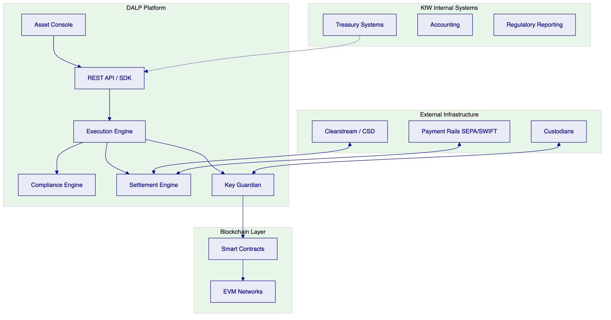
  - 6.2 Issuance and Asset Configuration
DALP provides comprehensive asset configuration including asset type selection for bonds with predefined lifecycle logic, term structure configuration for face value, maturity date, coupon rate, coupon frequency, and denomination. All assets deploy through the Asset Factory with deterministic addressing and paused-by-default activation requiring explicit governance approval before go-live.
  - 6.3 Identity and Eligibility
DALP integrates OnchainID (ERC-734/735) for on-chain identity management with identity contracts for every investor, claims model for verified credentials, issuer trust model for KfW designations, and reusability across all tokens.
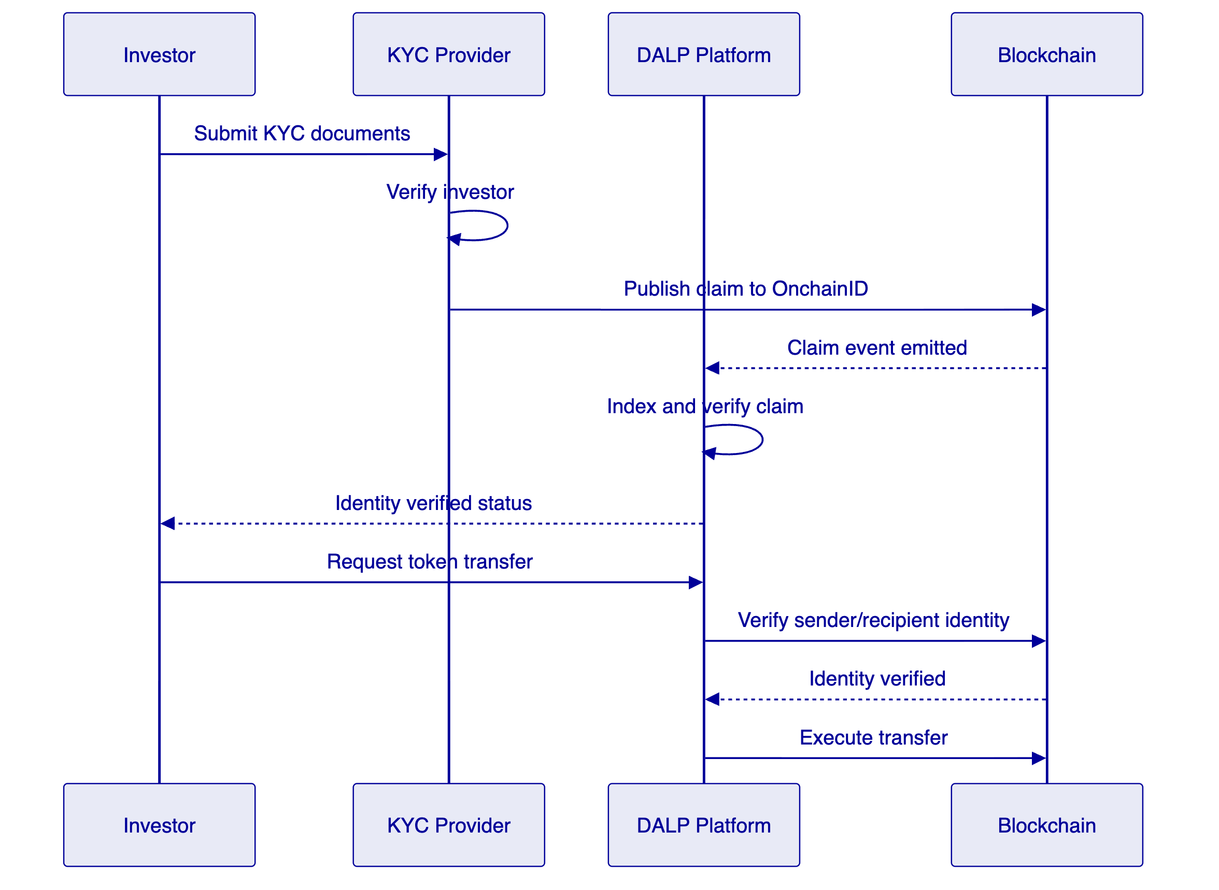
  - 6.4 Compliance Enforcement
Every transfer passes through the compliance engine before execution: identity resolution, module evaluation in sequence, feature pre-check, and atomic execution only if all checks pass.
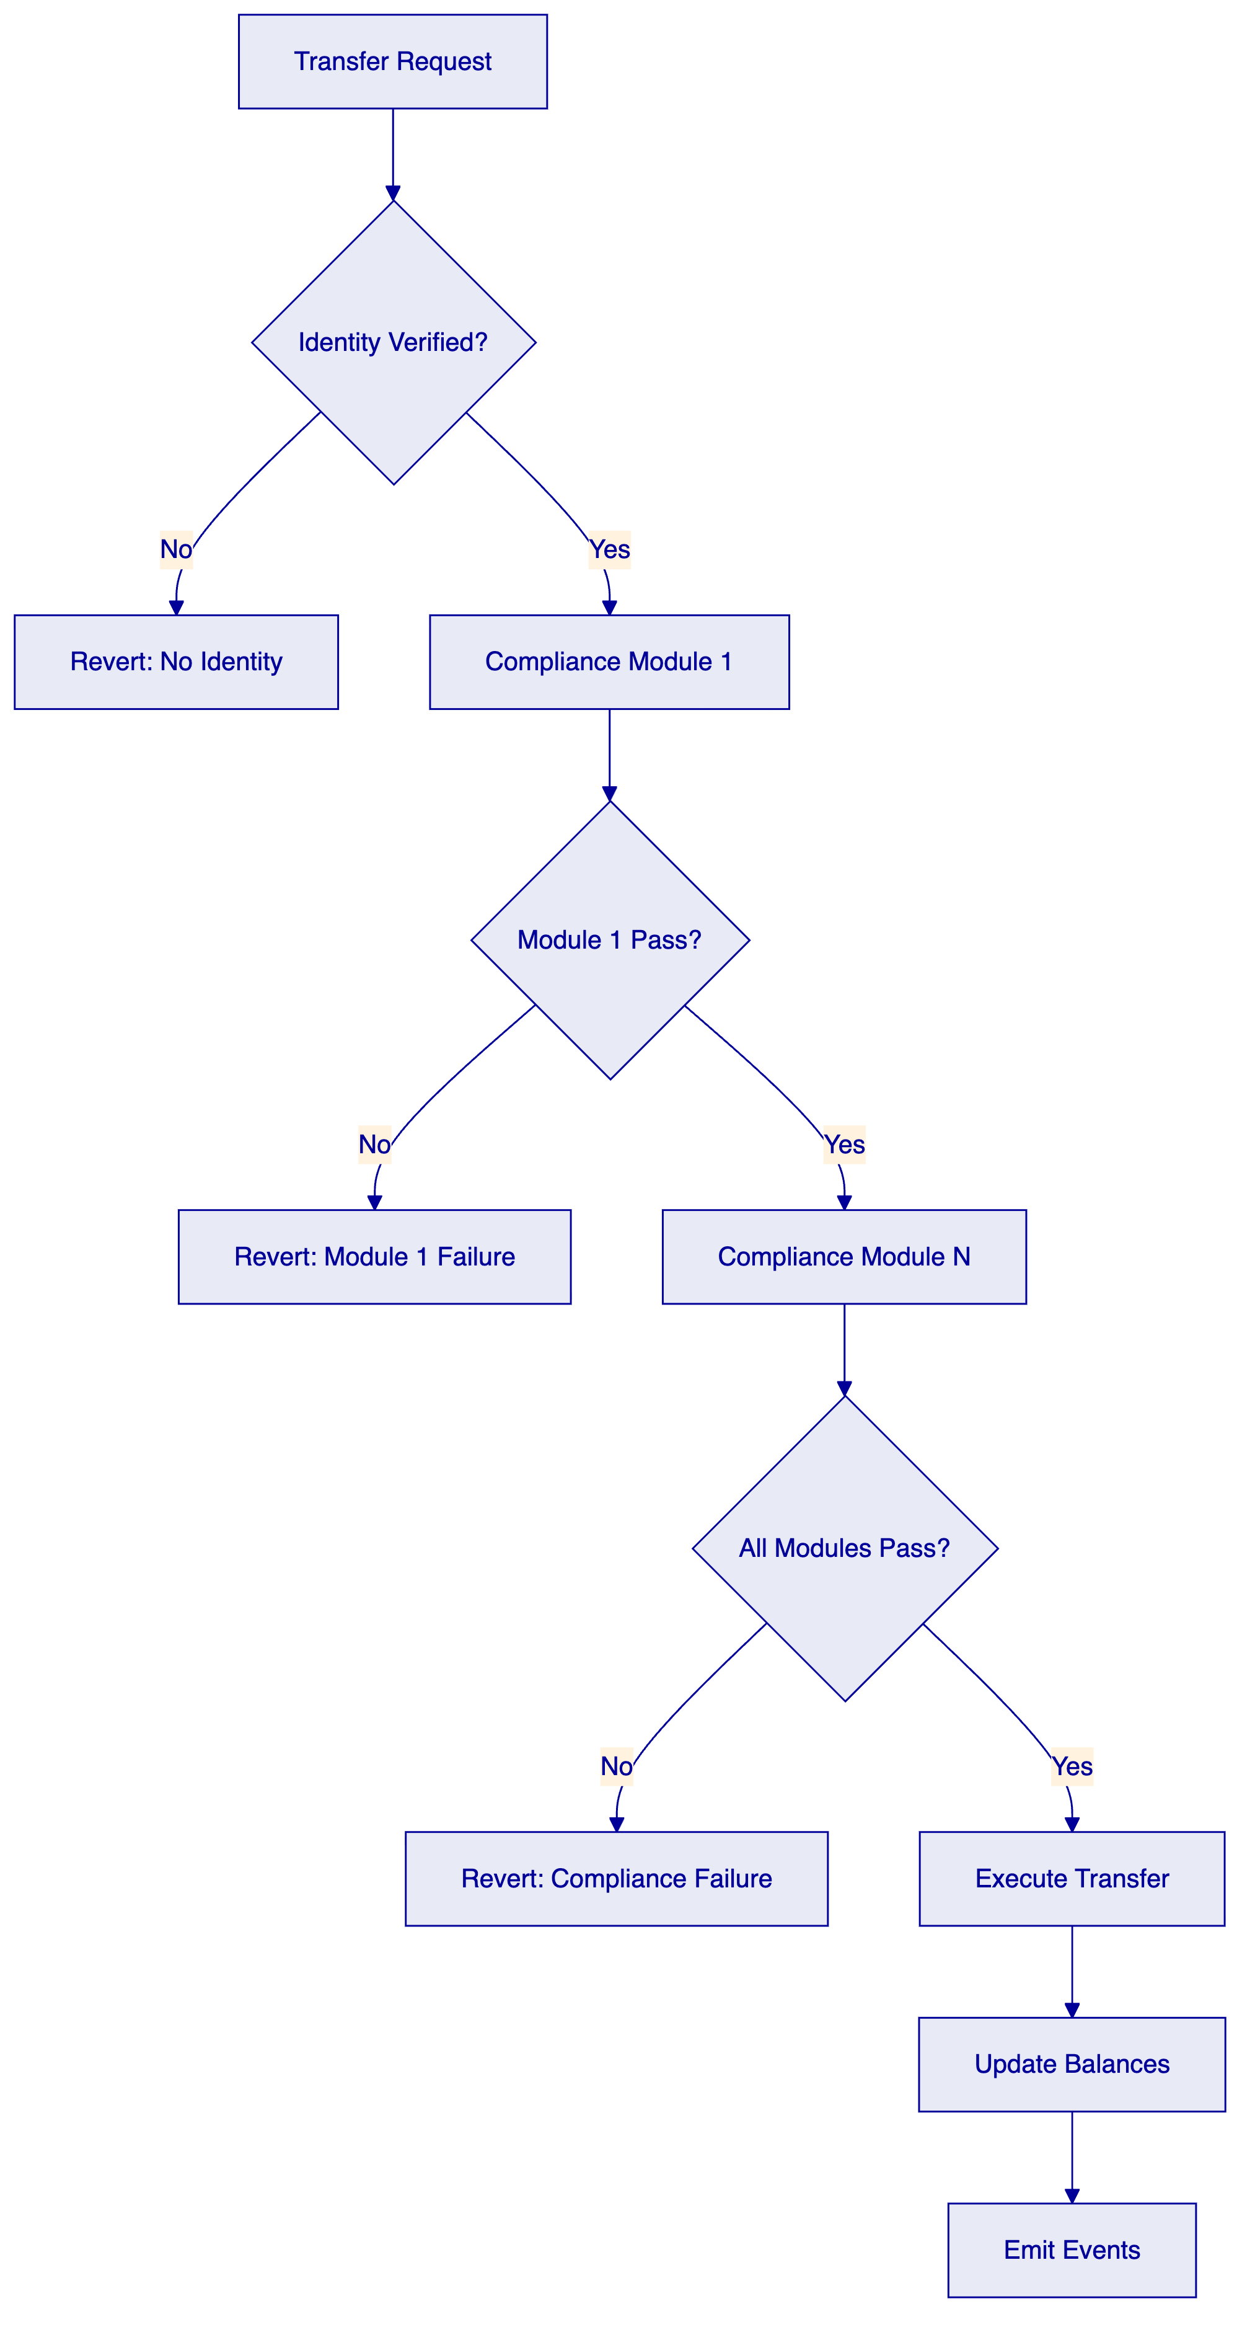
For KfW's requirements, recommended modules include Identity Verification, Country Allow List, Investor Count Limit, Transfer Approval, and Time Lock.
  - 6.5 Transfer, Settlement, and Cash-Leg Coordination
DALP supports DvP (Delivery vs Payment) for atomic exchange of token for payment, XvP (Exchange vs Payment) for multi-leg atomic exchange, and settlement finality with deterministic closure. The platform handles settlement failures with atomic guarantee where if any leg fails, all legs revert.
  - 6.6 Lifecycle Servicing and Corporate Actions
    - Coupon Distribution
The platform supports automated coupon payments through Fixed Treasury Yield for pull-based claim systems and Yield Schedule for automated distribution.
    - Maturity Handling
Maturity Redemption feature implements the complete fixed-income lifecycle endpoint. After maturity date, the token blocks all transfers and holders redeem for denomination asset atomically.
    - Redemption Mechanics
The platform supports bullet redemption, sinking fund redemption, and callable redemption with configurable terms.

- 7. Technical Architecture
  - 7.1 Architectural Principles
DALP follows five architectural principles: lifecycle-first where the platform treats assets as continuous processes; durable execution ensuring workflows survive infrastructure failures; defense-in-depth with security across all layers; separation of concerns between components; and provider abstraction enabling multi-custody and multi-network operation.
  - 7.2 Layered Architecture
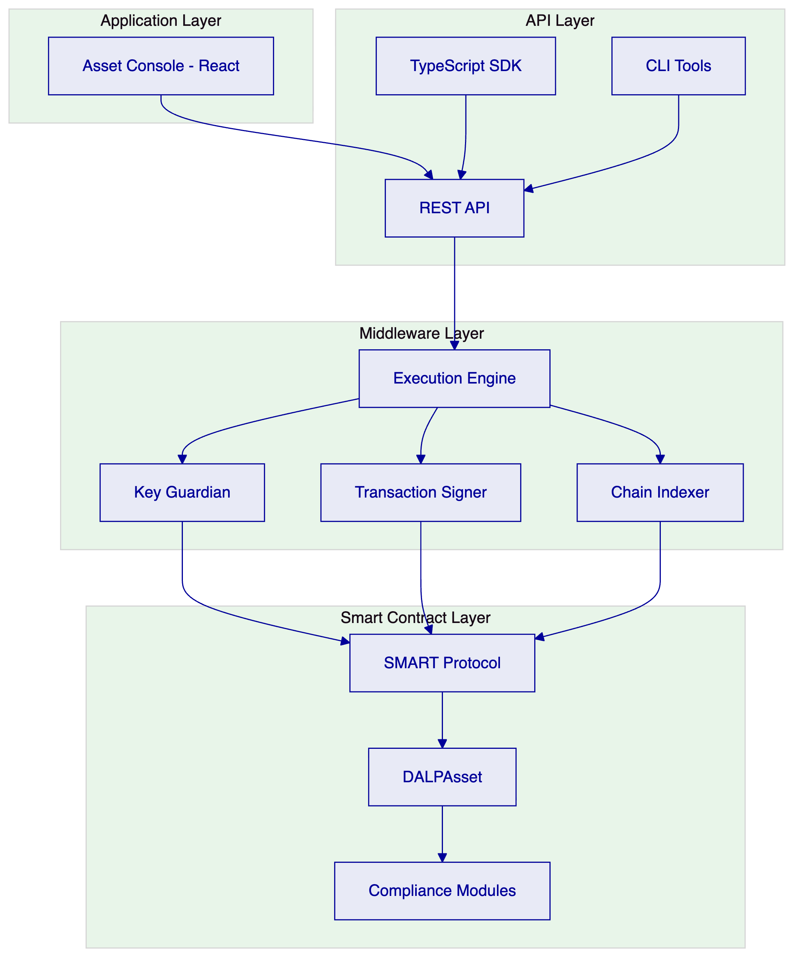
  - 7.3 Data Architecture
The platform maintains chain state on EVM networks, application state in PostgreSQL, indexed state for query optimization, and audit evidence with immutable event storage.
  - 7.4 Network and Chain Topology
DALP operates on any EVM-compatible blockchain. For KfW, we recommend deployment on a private/consortium network (Hyperledger Besu with IBFT 2.0) for production, with public testnet for development and testing.
  - 7.5 Multi-Tenancy and Environment Segregation
The platform supports tenant isolation through separate database schemas, environment separation for dev/test/staging/production/DR, and governance boundaries between organizational units.
  - 7.6 Operational Architecture
The Execution Engine provides reliable workflow orchestration with persistent state. Transaction management includes nonce coordination, gas estimation, and confirmation tracking. The Chain Indexer processes blockchain events for queryable state projection.

- 8. Security
  - 8.1 Security Model Overview
DALP implements a defense-in-depth security model across three domains: perimeter security (network, firewall, DDoS protection), application security (authentication, authorization, input validation), and data security (encryption at rest and in transit).
  - 8.2 Authentication and Access Control
Control | Implementation
Session Auth | Better Auth with secure session management
API Keys | Organization-scoped with optional read-only enforcement
RBAC | 5 defined roles: admin, governance, supply management, custodian, emergency
MFA | PIN, TOTP, or backup codes for privileged operations
Separation of Duties | Role combinations restricted by policy

  - 8.3 Key Management and Custody Integration
Key Guardian provides HSM integration (Thales, Utimaco, cloud KMS), maker-checker workflows with configurable quorum, emergency recovery procedures, and Fireblocks/DFNS integration for institutional custody.
  - 8.4 Data Protection and Encryption
Data State | Protection
In Transit | TLS 1.3
At Rest | AES-256
Secrets | HashiCorp Vault or cloud KMS
Field-Level | Sensitive fields encrypted individually

  - 8.5 Compliance Controls and Auditability
Every action generates immutable audit events, SIEM integration exports standard formats, and reporting supports regulatory requirements.
  - 8.6 Testing and Assurance
SettleMint conducts annual penetration testing by independent firms, maintains vulnerability management with regular scanning, and provides remediation governance with defined SLAs.
  - 8.7 Security Responsibility Matrix
Control Area | SettleMint | Client
Platform Security | Primary | Secondary
Network Security | Primary | Monitoring
Key Management | Shared | Custody Choices
Access Management | Primary | User Provisioning
Incident Response | Primary | Notification

- 9. Project Implementation & Delivery
  - 9.1 Delivery Overview
SettleMint employs a phased delivery methodology with stage-gate approvals ensuring governance alignment and risk management throughout the implementation.
  - 9.2 Phase Plan
    - Phase 1: Discovery and Requirements (4 weeks)
Objective: Define scope, establish baselines, and create detailed design.
Key Activities: Requirements workshop, systems landscape analysis, regulatory requirements mapping, integration design sessions, and success criteria definition.
Outputs: Requirements document, integration specifications, control mapping, and project plan.
Dependencies: KfW stakeholder availability, access to current system documentation.
    - Phase 2: Foundation and Setup (6 weeks)
Objective: Deploy platform infrastructure and establish operational foundations.
Key Activities: Environment provisioning, platform deployment, identity system setup, network configuration, and security hardening.
Outputs: Deployed platform in non-production environments, operational runbooks.
Dependencies: Phase 1 completion, infrastructure access.
    - Phase 3: Configuration and Compliance (8 weeks)
Objective: Configure assets, compliance modules, and workflows.
Key Activities: Asset type configuration, compliance module setup, workflow design, role configuration, and integration mock development.
Outputs: Configured platform, compliance evidence package, workflow documentation.
Dependencies: Phase 2 completion, compliance requirements finalization.
    - Phase 4: Integration and Testing (8 weeks)
Objective: Complete system integration and validate functionality.
Key Activities: System integration, SIT execution, UAT support, performance testing, and security testing.
Outputs: Integration test results, UAT sign-off, security assessment report.
Dependencies: Phase 3 completion, external system readiness.
    - Phase 5: Go-Live (2 weeks)
Objective: Transition to production operation.
Key Activities: Production deployment, smoke testing, cutover execution, and production validation.
Outputs: Production environment, go-live sign-off.
Dependencies: Phase 4 completion, acceptance criteria met.
    - Phase 6: Hypercare (4 weeks)
Objective: Stabilize production operations and transfer knowledge.
Key Activities: Production support, issue resolution, optimization, and knowledge transfer.
Outputs: Stable production operation, trained operations team.
Dependencies: Phase 5 completion.
  - 9.3 Governance and Decision Structure
Gate | Approver | Criteria
Design Review | Architecture Committee | Technical design meets requirements
Security Review | CISO | Security controls adequate
Compliance Review | Compliance | Regulatory alignment confirmed
UAT Sign-off | Business | Functional requirements met
Go-Live Approval | Steering Committee | All gates passed

  - 9.4 Resource Model
Role | Phase 1-2 | Phase 3-4 | Phase 5-6
Project Manager | 1.0 | 1.0 | 1.0
Solution Architect | 0.5 | 0.5 | 0.25
Integration Lead | 0.5 | 1.0 | 0.5
Technical Lead | 1.0 | 2.0 | 1.0
Developers | 2.0 | 4.0 | 1.0
QA Engineer | 0.5 | 2.0 | 1.0
Security Engineer | 0.25 | 0.5 | 0.25

- 10. Deployment
  - 10.1 Deployment Principles
DALP supports portability across deployment models with consistent platform capabilities, security and residency alignment to requirements, and operational control for institutional users.
  - 10.2 Recommended Deployment Model
For KfW, we recommend Private Cloud / Dedicated Deployment with the following characteristics:
Characteristic | Configuration
Location | Germany (EU)
Cloud Provider | Customer choice (AWS, Azure, GCP)
Isolation | Dedicated cluster
Data Residency | EU only
Management | Shared responsibility

  - 10.3 Deployment Options Comparison
Model | Management | Residency | Connectivity | Best For
Managed SaaS | SettleMint | EU/US | Public | Speed to market
Private Cloud | Shared | Customer region | Private link | Control + efficiency
On-Premises | Customer | On-site | Internal | Maximum control

  - 10.4 Infrastructure Requirements
Component | Specification
Compute | Kubernetes (K8s) cluster
Database | PostgreSQL 14+
Cache | Redis 7+
Storage | S3-compatible object storage
Networking | Load balancer, WAF

  - 10.5 Availability, Resilience, and DR Approach
Metric | Target
Availability | 99.9% (excluding planned maintenance)
RTO | 4 hours
RPO | 1 hour
Recovery | Automated failover to DR site

  - 10.6 Data Residency and Sovereignty
All customer data remains in the specified region. No data leaves the designated geographic boundary without explicit configuration. Backup storage maintains the same residency requirements.

- 11. Training and Knowledge Transfer
  - 11.1 Training Strategy
Training is delivered through a combination of instructor-led sessions, hands-on labs, documentation, and shadowing periods. All training is role-specific.
  - 11.2 Administrator Track
Duration: 5 days
Topics: Platform architecture, system configuration, user management, compliance configuration, monitoring, troubleshooting, and backup/restore procedures.
  - 11.3 Developer / Integration Track
Duration: 3 days
Topics: API usage, SDK integration, event handling, custom integration patterns, and debugging techniques.
  - 11.4 End-User / Operations Track
Duration: 2 days
Topics: Asset Console navigation, asset issuance, transfer processing, compliance monitoring, reporting, and daily operations procedures.
  - 11.5 Knowledge Transfer Method
Knowledge transfer includes production shadowing periods where KfW staff observe operations, guided labs with hands-on exercises, comprehensive runbooks for all procedures, and operational readiness assessment before go-live.

- 12. Support & SLA
  - 12.1 Support Model Overview
SettleMint provides tiered support aligned to deployment criticality with defined channels, response times, and escalation paths.
  - 12.2 Support Tiers
Tier | Coverage | Hours | Response Time
Standard | Business hours | 8x5 | 8 hours
Premium | Extended hours | 16x5 | 4 hours
Enterprise | 24x7 | 24x7 | 1 hour

For KfW, we recommend Enterprise tier given the production criticality and regulatory requirements.
  - 12.3 Severity and Response Matrix
Severity | Definition | Response Time | Resolution Target
P1 - Critical | Production down, no workaround | 1 hour | 4 hours
P2 - High | Major functionality impaired | 4 hours | 8 hours
P3 - Medium | Minor functionality affected | 8 hours | 3 business days
P4 - Low | General inquiries, minor issues | 1 business day | Next release

  - 12.4 Escalation and Incident Management
Level | Contact | Escalation Time
L1 | Support Team | Immediate
L2 | Technical Lead | 4 hours
L3 | Engineering Manager | 8 hours
L4 | VP Engineering | 24 hours

  - 12.5 Maintenance and Update Policy
Scheduled maintenance occurs monthly during agreed windows with 5 business days notice. Emergency security patches may be applied with notification. All changes follow change management process.
  - 12.6 Service Reporting
Monthly service reports include uptime metrics, incident summary, and performance indicators. Quarterly business reviews cover roadmap updates and optimization recommendations.

- 13. Risk Management
  - 13.1 Risk Management Approach
Risks are identified, assessed, and managed throughout the project lifecycle with regular review at steering committee meetings.
  - 13.2 Risk Register
ID | Risk | Likelihood | Impact | Mitigation | Owner
R1 | Regulatory change during implementation | Medium | High | Modular compliance design, regular regulatory monitoring | SettleMint
R2 | Integration complexity exceeds estimates | Medium | Medium | Early integration prototyping, buffer in timeline | Shared
R3 | Client resource availability delays | Medium | Medium | Clear dependency tracking, executive sponsorship | KfW
R4 | Third-party security review delays | Low | Medium | Early engagement, parallel workstreams | Shared
R5 | Custodian integration challenges | Medium | Medium | Fireblocks/DFNS experience, fallback options | SettleMint

  - 13.3 Governance of Risks
Risk status is reviewed weekly in project meetings and monthly in steering committee. Triggers and contingency actions are defined for each major risk.

- 14. Compliance Matrix
  - 14.1 Usage Instructions
The following matrix maps KfW's requirements to DALP capabilities. Status codes: Full (F), Partial (P), Configurable (C), Assumption (A), Out of Scope (O).
  - 14.2 Detailed Matrix
Req ID | Requirement | Status | DALP Response | Source
TR-01 | End-to-end lifecycle management | F | Full lifecycle from issuance through retirement | Architecture, Asset Lifecycle docs
TR-02 | Documented APIs and event interfaces | F | REST API, Webhooks, SDK, CLI | API documentation
TR-03 | RBAC, dual control, approval workflows | F | 5 roles, maker-checker, workflow engine | Security documentation
TR-04 | Configurable smart-instrument templates | F | DALPAsset with 32 pluggable features | Asset Lifecycle docs
TR-05 | Immutable audit trails | F | On-chain events, off-chain logging | Architecture documentation
TR-06 | Resilient deployment across environments | F | Dev, test, pre-prod, DR, prod | Deployment documentation
TR-07 | Interoperability with external networks | F | Fireblocks, DFNS, payment rails | Integration documentation
TR-08 | Configurable dashboards and reports | F | Grafana dashboards, custom reports | Observability documentation
TR-09 | Data export, regulator-ready reporting | F | Event export, regulatory templates | Reporting documentation
TR-10 | Advanced analytics and simulation | P | Roadmap capability | Product roadmap
SR-01 | ISO 27001 or equivalent | F | Certified | Security credentials
SR-02 | Encryption in transit and at rest | F | TLS 1.3, AES-256 | Security documentation
SR-03 | Privileged access management | F | Vault integration, break-glass controls | Security documentation
SR-04 | Vulnerability management | F | Annual pen testing, regular scanning | Security documentation
SR-05 | Data residency options | F | EU, regional deployments | Deployment options
SR-06 | SIEM integration | F | Syslog, JSON event export | Integration documentation

  - Additional Technical Diagrams
    - Transaction Processing Flow
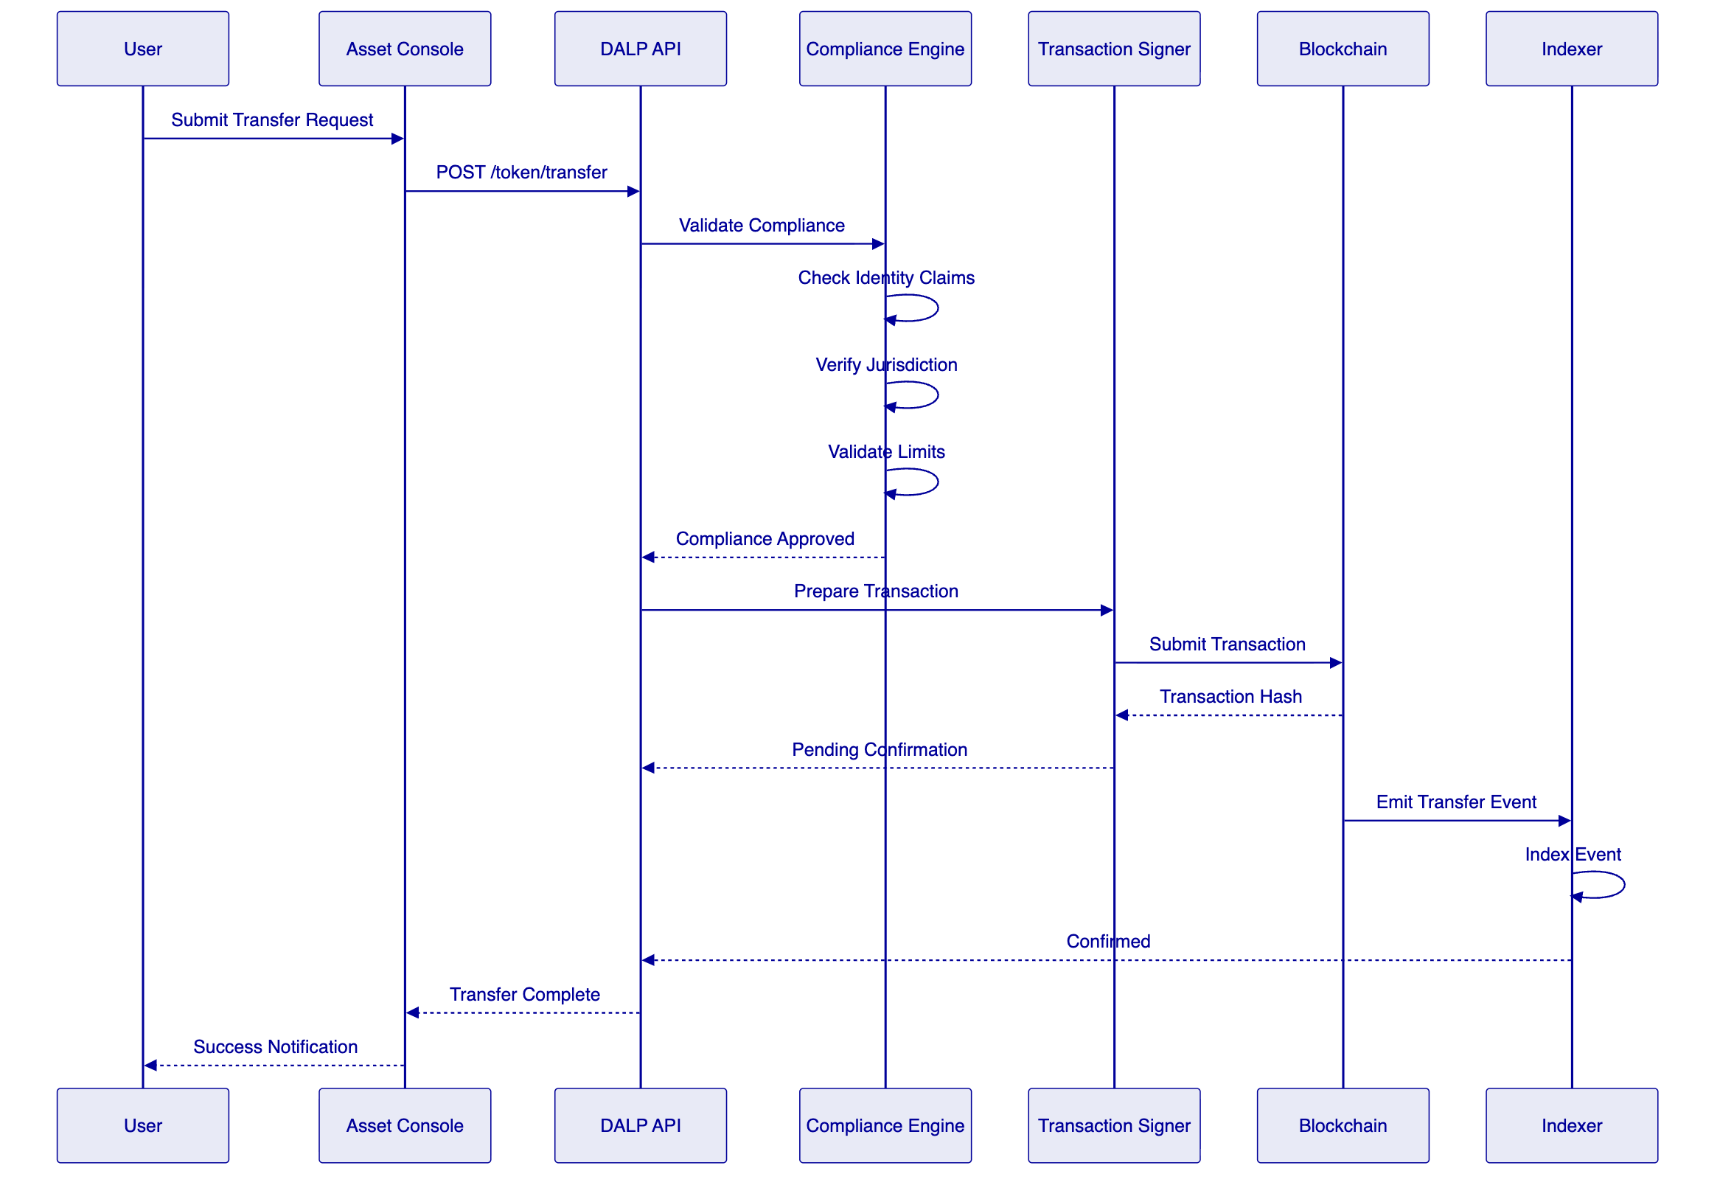
    - Integration Architecture
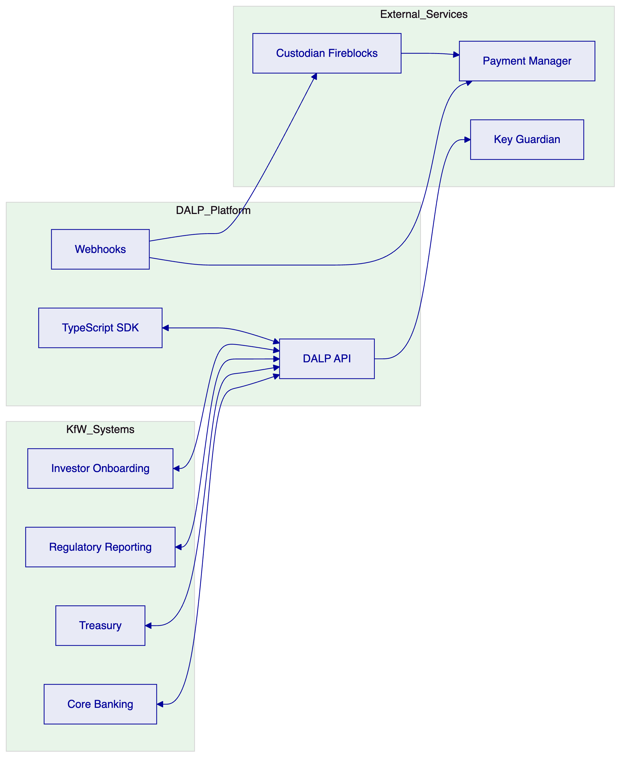
    - Deployment Topology
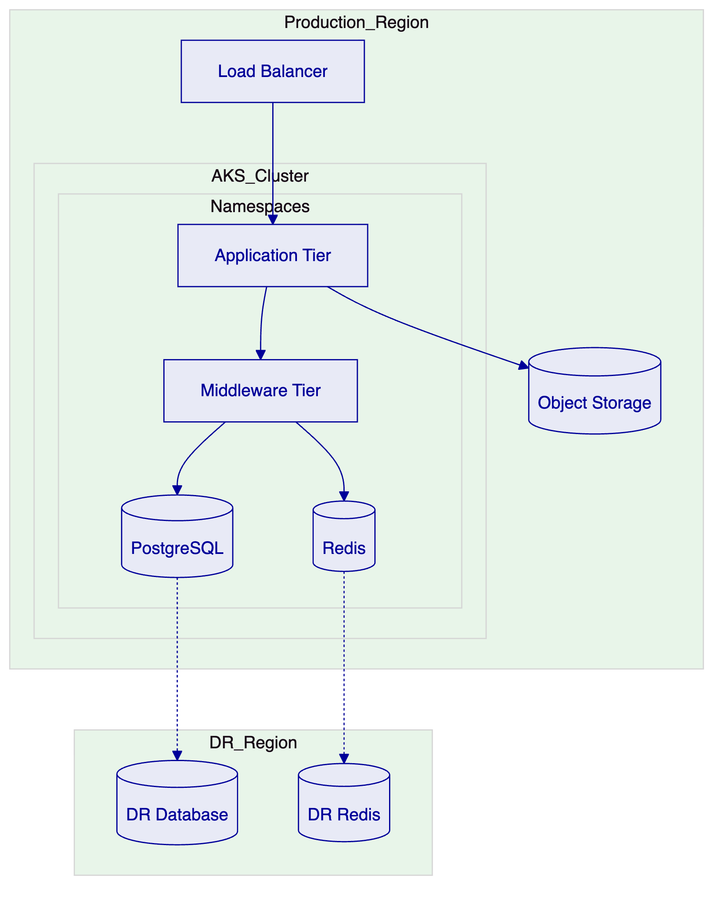
    - Security Architecture
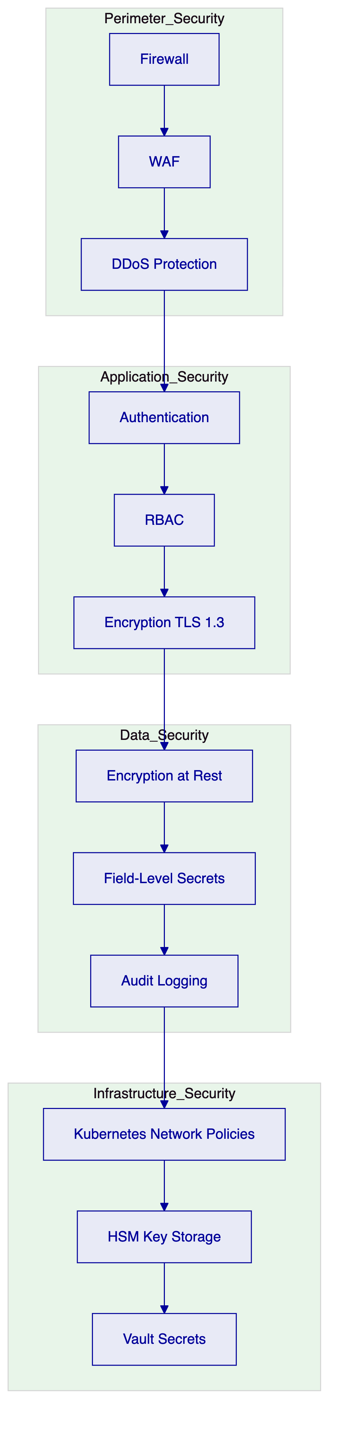
    - Support Escalation Process
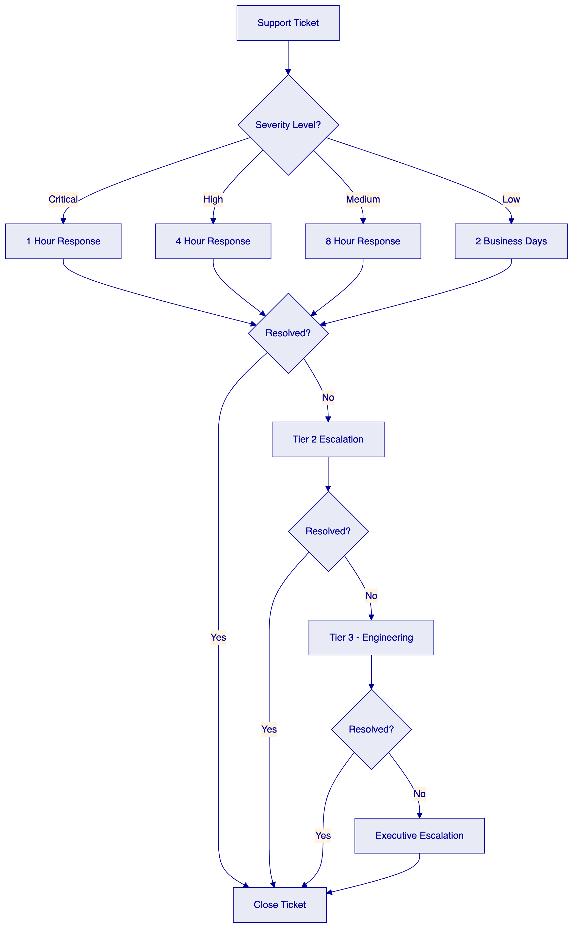
    - Implementation Timeline
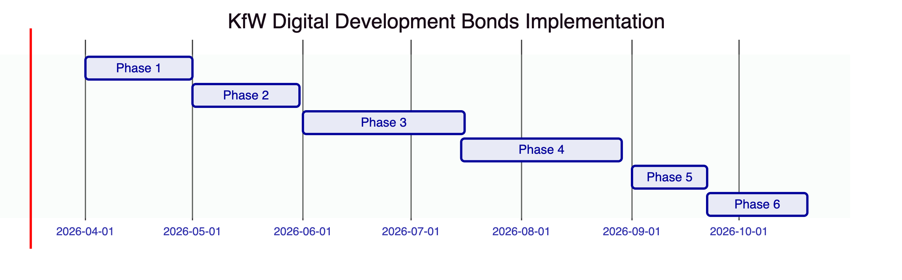
    - Data Flow Architecture
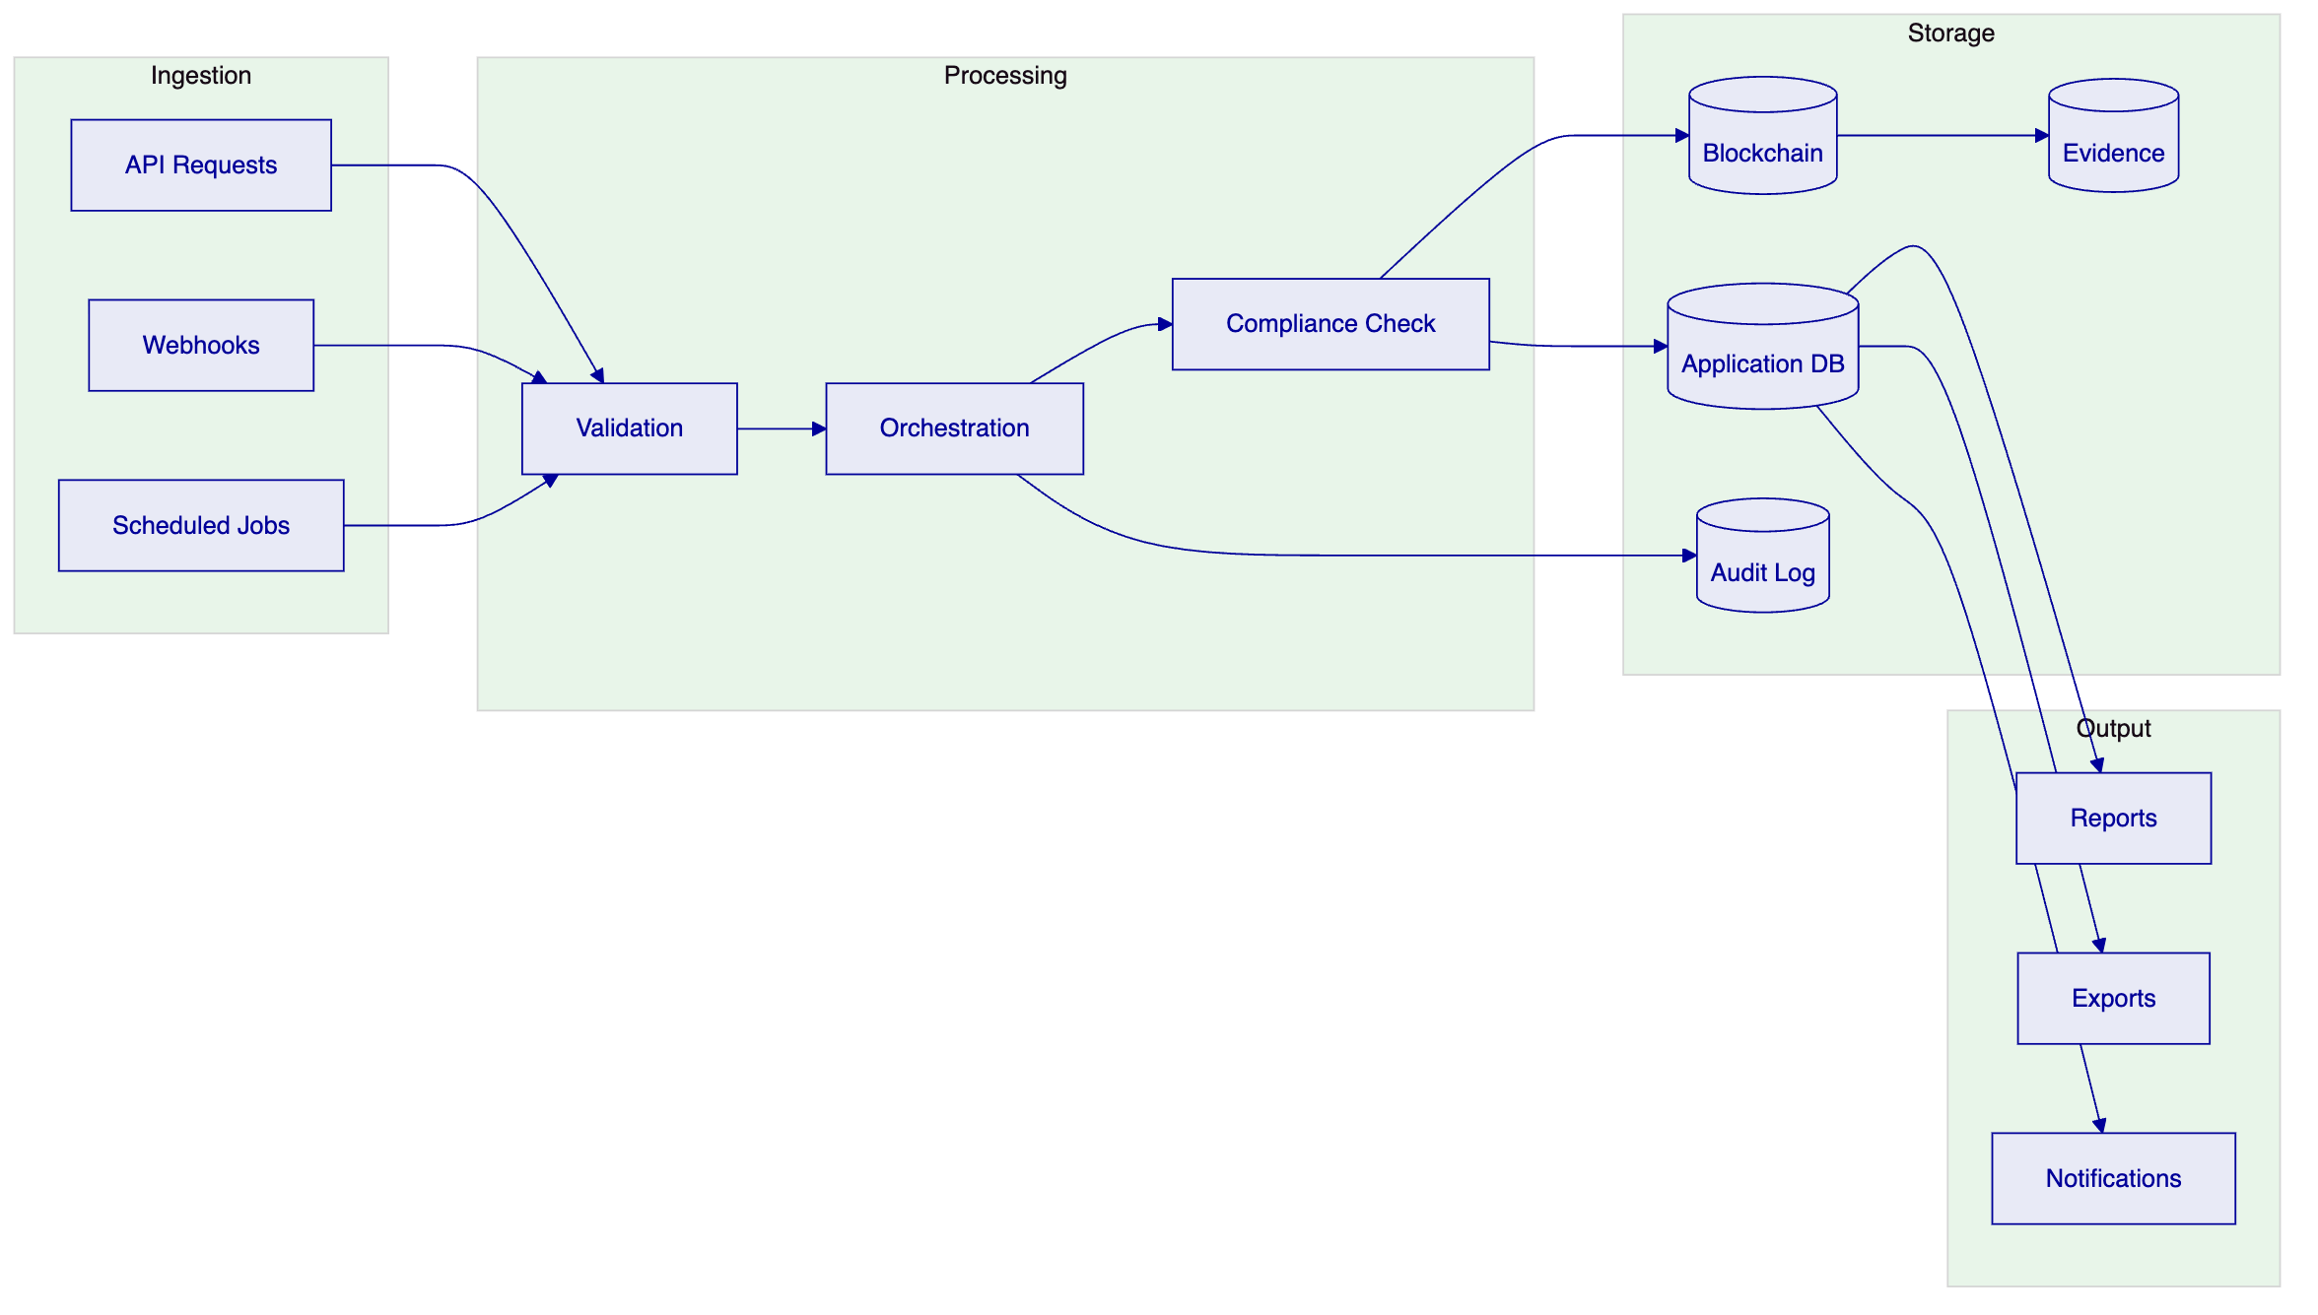

End of Technical Proposal

