[Company name]
[Document title]
[Document subtitle]

Confidentiality Statement
This document contains confidential and proprietary information of SettleMint. By reading this document, you agree not to disclose the confidential information contained herein to any third party without the prior written consent of SettleMint, except to those agents, principals, representatives, or consultants who require access for the purpose of evaluating this document. You further agree to inform such persons of the confidential nature of this document and to obtain their agreement to preserve its confidentiality to the same extent as yours.
This confidentiality statement shall remain binding on the parties for a period of five (5) years from the date stated on the front cover, unless superseded by confidentiality provisions detailed in a subsequent agreement.
Terms and Conditions
This proposal is valid until [DD Month YYYY]. In the absence of confirmation to proceed, SettleMint and [the Company] acknowledge and agree to abide by the Mutual NDA as the governing agreement.
SettleMint reserves the right to vary the terms of this proposal in response to changes in specifications or information made available at a later date. Submission of this proposal does not convey any right, title, interest, or license in any intellectual property rights (including, but not limited to, patents, copyrights, trade secrets, or trademarks) contained herein.
All rights are reserved. This proposal and the information contained within it are provided on an “as is” basis, without any warranties of any kind, express or implied.
All contracts with SettleMint will be governed by Belgian Law and subject to the exclusive jurisdiction of Belgian courts.
Contact Details
For any enquiries regarding this document, please contact:
[Full Name]
[Job Title]
Email: [email@example.com]
Phone: [Country Code - Number]

Table of Contents

Table of Contents 3
Executive Summary 4
Understanding Nordea's Programme Objectives 5
The European Fund Tokenization Landscape 6
Programme Challenges 7
Proposed DALP Operating Model for Tokenized Funds 8
Deployment Model Recommendation 9
Target Asset Scope 10
Regulatory Alignment Approach 11
Technical Architecture and Integration Boundaries 12
Platform Architecture 13
Integration Architecture 14
Network Deployment Options 15
Fund-Specific Smart Contract Architecture 16
SMART Protocol Foundation 17
Fund Contract Architecture 18
Factory Deployment 19
Identity, Compliance, and MiFID II Controls 20
Identity Management 21
Compliance Module System 22
MiFID II Alignment 23
Fund Servicing and Distribution 24
Fund Distribution 25
Dividend Processing 26
Settlement 27
Security, Resilience, and Operational Assurance 28
Security Architecture 29
Certifications 30
Disaster Recovery 31
Implementation Approach and Delivery Phases 32
Implementation Timeline 33
Resource Requirements 34
Current Coverage, Dependencies, and Qualified Gaps 35
Platform Coverage 36
Dependencies 37
Appendices 38
Appendix A: API Namespace Reference 39
Appendix B: Glossary 40

Field | Value
Proposal title | Technical Proposal — Tokenized Funds Distribution Platform
Client | Nordea
Submitted by | SettleMint NV
Date | March 2026
Version | v1.0
Confidentiality | Confidential
RFP Reference | NORDEA-RFP-TOKENIZED-FUNDS-202603
Primary contact | Adam Popat, CEO

  - Table of Contents
- Executive Summary
- Understanding Nordea's Programme Objectives
- Proposed DALP Operating Model for Tokenized Funds
- Technical Architecture and Integration Boundaries
- Fund-Specific Smart Contract Architecture
- Identity, Compliance, and MiFID II Controls
- Fund Servicing and Distribution
- Security, Resilience, and Operational Assurance
- Implementation Approach and Delivery Phases
- Current Coverage, Dependencies, and Qualified Gaps
- Appendices

  - Executive Summary
Nordea is establishing a production-grade platform for tokenized investment fund distribution across the Nordic region and broader European markets. The EU's Capital Markets Union agenda, combined with updated UCITS and AIFMD frameworks, has created the regulatory environment for digital fund units. The challenge is operational: building infrastructure that can issue, distribute, service, and redeem tokenized fund units at institutional scale within Nordic banking supervision requirements.
SettleMint's Digital Asset Lifecycle Platform (DALP) provides the complete fund lifecycle, from fund structuring and issuance through investor onboarding, distribution, dividend processing, and redemption at maturity, with compliance enforcement embedded at the smart contract level and enterprise integration designed for Nordic banking group requirements.
Why DALP fits Nordea's requirements:
- Production-proven fund infrastructure. DALP powers institutional fund tokenization programmes across European banks, with production deployments handling significant AUM. This demonstrates production readiness for Nordic fund distribution.
- MiFID II compliance readiness. DALP's compliance engine supports jurisdiction-specific regulatory configurations including MiFID II investor eligibility, cross-border distribution rules, and reporting obligations. Compliance modules enforce investor eligibility, jurisdiction restrictions, and transfer restrictions at the smart contract level.
- Nordic banking integration. DALP provides the integration patterns required for Nordic banking infrastructure, including integration with Nordea's existing fund administration systems and Nordic securities depositories.
- Deterministic settlement. Under tested conditions, DALP achieves median settlement latency of 2.3 seconds with P99 at 4.1 seconds using IBFT consensus. This provides T+0 settlement with deterministic finality.
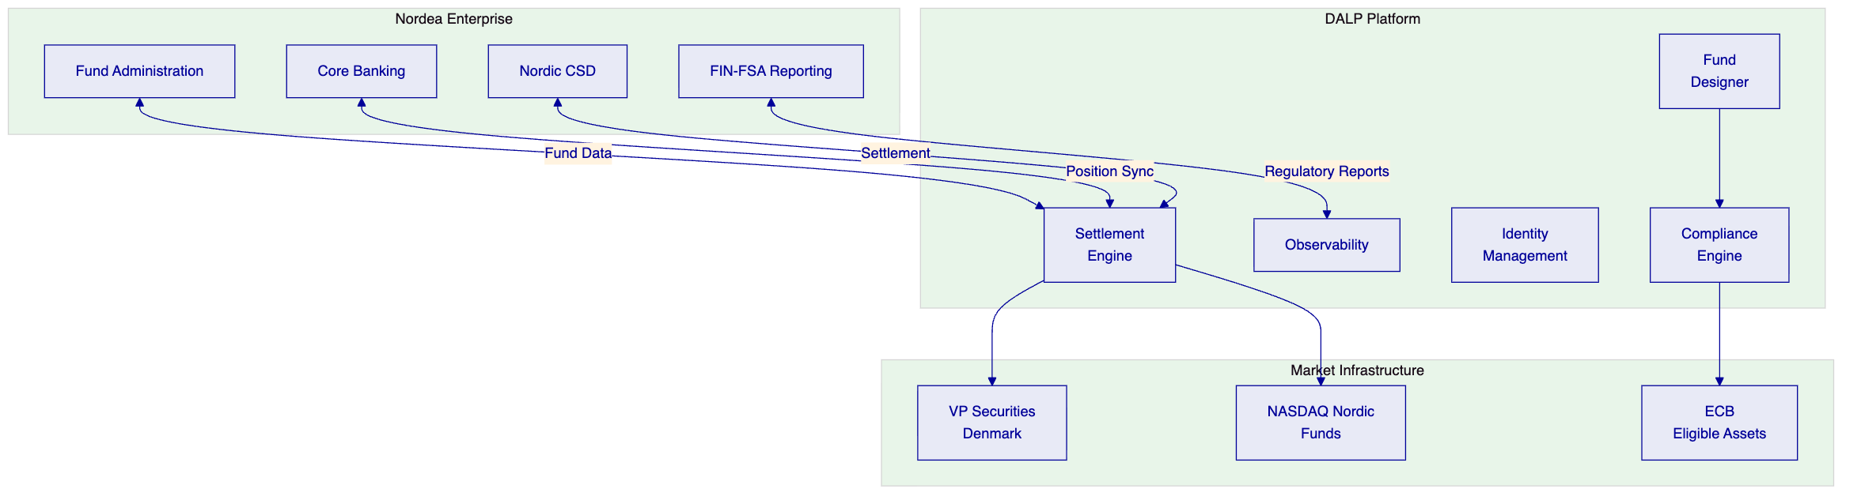

  - Understanding Nordea's Programme Objectives
    - The European Fund Tokenization Landscape
The EU's Digital Finance Package and updated AIFMD guidance have established the regulatory framework for fund tokenization. Combined with the Capital Markets Union agenda, European asset managers can now issue and distribute digital fund units across member states.
Nordea's programme objectives center on three requirements:
First, Nordic fund market leadership. The platform must support distribution of tokenized fund units to Nordic investors (Denmark, Sweden, Finland, Norway) with local language support and integration to Nordic securities infrastructure.
Second, cross-border distribution. The platform must support AIFMD-compliant distribution across EU member states, with appropriate investor disclosures and regulatory reporting.
Third, institutional-grade operations. The platform must integrate with Nordea's existing fund administration, custody, and reporting infrastructure while providing the control environment expected of a Nordic systemic bank.
    - Programme Challenges
Regulatory complexity across jurisdictions. Nordic fund distribution involves multiple regulatory frameworks (MiFID II, AIFMD, national transposition) with varying investor protection requirements.
Integration with existing infrastructure. Nordea's fund tokenization programme will integrate with existing fund administration systems, Nordic CSDs (VP Securities, Euroclear Sweden), and banking core systems.
Investor onboarding at scale. The platform must support efficient investor onboarding with appropriate KYC/AML verification while maintaining positive investor experience.

  - Proposed DALP Operating Model for Tokenized Funds
    - Deployment Model Recommendation
For Nordea's initial deployment, we recommend the dedicated cloud model with deployment in AWS eu-west-2 (London) or AWS eu-north-1 (Stockholm) to satisfy Nordic data residency requirements.
    - Target Asset Scope
The initial deployment will support:
- UCITS fund units: Undertakings for Collective Investment in Transferable Securities
- AIF fund units: Alternative Investment Funds
- Multi-tranche structures: Support for senior and subordinated units within single fund programmes
- Dividend distribution: Automated distribution processing
- Redemption processing: Atomic redemption with settlement
    - Regulatory Alignment Approach
DALP addresses Nordea's regulatory requirements through:
MiFID II Compliance: Pre-built compliance modules for MiFID II investor categorization, target market assessment, and distribution rules.
AIFMD Alignment: Support for AIFMD reporting, investor disclosure, and valuation requirements.
Nordic CSD Integration: Native integration patterns for VP Securities (Denmark), Euroclear Sweden, and Finnish CSD infrastructure.

  - Technical Architecture and Integration Boundaries
    - Platform Architecture
DALP is built as a four-layer stack:
Layer | Responsibility | Key Components
Application | User-facing interfaces | Asset Console (React web UI)
API | Programmatic access surface | Unified API (OpenAPI 3.1), TypeScript SDK
Middleware | Workflow orchestration, key management | Execution Engine, Key Guardian, Transaction Signer
Smart Contract | On-chain compliance and asset logic | SMART Protocol (ERC-3643), DALPAsset contracts

    - Integration Architecture
API Integration: REST API at `/api/v2` with organization-scoped API keys, configurable rate limits.
SDK Integration: TypeScript SDK (@settlemint/dalp-sdk) for custom applications.
Event Integration: Blockchain events index in real-time (<5 seconds) with SSE streaming.
Database Integration: 18 PostgreSQL analytics views for BI tool connectivity.
    - Network Deployment Options
Network Type | Option | Characteristics
Permissioned | Hyperledger Besu | IBFT 2.0 consensus, transaction privacy
Public L1 | Polygon PoS | Lower gas costs, faster finality
Public L2 | Arbitrum One | Ethereum L1 security

  - Fund-Specific Smart Contract Architecture
    - SMART Protocol Foundation
All DALP smart contracts build on the SMART Protocol (ERC-3643), providing:
- Token: ERC-20 compatible with compliance hooks
- Compliance: Modular compliance engine
- Identity: OnchainID for investor verification
    - Fund Contract Architecture
DALP's fund implementation provides:
Feature | Description
AUM Fee | Periodic fee based on assets under management
Dividend Distribution | Pull-based yield distribution
Voting Power | ERC-5805 governance for fund votes
Historical Balances | Checkpoint-based balance tracking

    - Factory Deployment
All fund contracts deploy through factory pattern using CREATE2 deterministic addressing, ensuring atomic deployment with no partially configured funds.

  - Identity, Compliance, and MiFID II Controls
    - Identity Management
DALP implements identity through OnchainID (ERC-734/735):
- Investor identity registration
- Claim structure (topic, issuer, signature, data)
- Trusted issuer model for KYC/AML verification
    - Compliance Module System
DALP provides 18 compliance module types:
Module | Function
Identity Verification | Requires verified OnchainID
Country Allow List | Permits transfers to approved jurisdictions
Country Block List | Blocks transfers to restricted jurisdictions
Investor Count Limit | Caps unique holder count
Transfer Approval | Requires manual approval per transfer

    - MiFID II Alignment
Investor Eligibility: Compliance modules enforce MiFID II investor categories (retail, professional, eligible counterparty).
Target Market: Module configurations support target market assessment requirements.
Reporting: Transaction data exports support MiFID II transaction reporting.

  - Fund Servicing and Distribution
    - Fund Distribution
DALP supports multiple distribution mechanisms:
- Primary issuance: Direct fund unit creation
- Secondary trading: Peer-to-peer transfer with compliance checks
- Subscription/Redemption: Atomic creation/redemption with NAV calculation
    - Dividend Processing
DALP handles dividend distribution through:
- Pull-based distribution: Investors claim dividends rather than push
- Snapshot-based allocation: Balance-based pro-rata calculation
- Multi-currency support: Distribution in multiple currencies
    - Settlement
DvP Settlement: Atomic settlement for fund purchases with cash equivalent.
CSD Integration: Native integration with Nordic securities depositories.
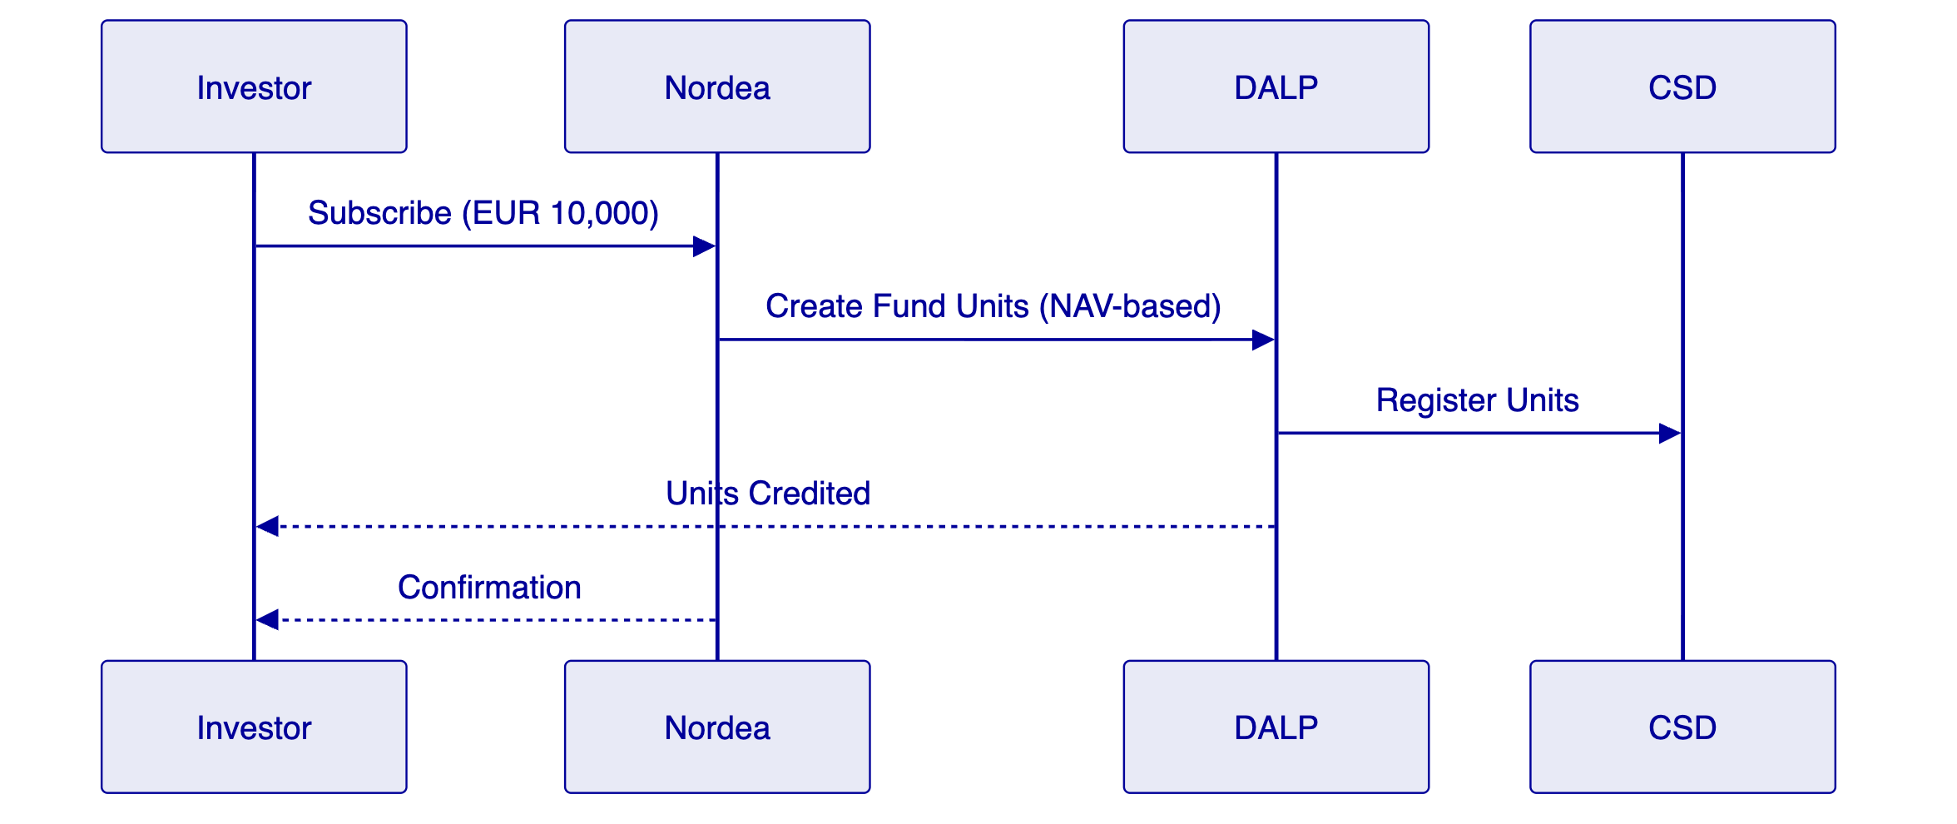

  - Security, Resilience, and Operational Assurance
    - Security Architecture
DALP implements defense-in-depth:
Layer | Control
Authentication | Session, API keys, SSO
Authorization | Role-based permissions
Wallet Verification | PIN, TOTP, backup codes
On-Chain Compliance | Modules, identity
Custody Policy | DFNS, Fireblocks

    - Certifications
- ISO 27001 certification
- SOC 2 Type II certification
    - Disaster Recovery
Scenario | RTO | RPO
Cloud-native | 2-15 min | Seconds to 1 min
Hot-warm | 30-180 min | 5-60 min

  - Implementation Approach and Delivery Phases
    - Implementation Timeline
19-week structured implementation:
Phase | Duration | Focus
1. Discovery | 2 weeks | Requirements, architecture
2. Foundation | 3 weeks | Environment, network setup
3. Configuration | 4 weeks | Fund configuration, compliance
4. Integration | 4 weeks | Testing, UAT
5. Go-Live | 6 weeks | Production, hypercare

    - Resource Requirements
SettleMint: Delivery Lead, Solution Architect, Platform Engineers, QA Lead
Nordea: Project Manager, Technical Lead, DevOps, Compliance/Risk

  - Current Coverage, Dependencies, and Qualified Gaps
    - Platform Coverage
Capability | Status
Fund lifecycle | Full
Compliance | Full
Identity | Full
Settlement | Full
API integration | Full

    - Dependencies
- Cloud infrastructure (AWS)
- Identity provider (Azure AD)
- Custody arrangement (DFNS/Fireblocks)
- Nordic CSD connectivity (VP Securities, Euroclear Sweden)

  - Appendices
    - Appendix A: API Namespace Reference
Namespace | Capabilities
token | Asset lifecycle
system | Infrastructure
user | User management
account | Wallet operations
addons | Optional features

    - Appendix B: Glossary
Term | Definition
AIFMD | Alternative Investment Fund Managers Directive
CSD | Central Securities Depository
DALP | Digital Asset Lifecycle Platform
DvP | Delivery-versus-Payment
MiFID II | Markets in Financial Instruments Directive II
NAV | Net Asset Value
OnchainID | ERC-734/735 identity standard
SMART Protocol | SettleMint's ERC-3643 implementation
UCITS | Undertakings for Collective Investment in Transferable Securities

End of Technical Proposal
Document Control
- Version: 1.0
- Date: March 2026
- Classification: Confidential
- Prepared by: SettleMint NV

