[Company name]
[Document title]
[Document subtitle]

Confidentiality Statement
This document contains confidential and proprietary information of SettleMint. By reading this document, you agree not to disclose the confidential information contained herein to any third party without the prior written consent of SettleMint, except to those agents, principals, representatives, or consultants who require access for the purpose of evaluating this document. You further agree to inform such persons of the confidential nature of this document and to obtain their agreement to preserve its confidentiality to the same extent as yours.
This confidentiality statement shall remain binding on the parties for a period of five (5) years from the date stated on the front cover, unless superseded by confidentiality provisions detailed in a subsequent agreement.
Terms and Conditions
This proposal is valid until [DD Month YYYY]. In the absence of confirmation to proceed, SettleMint and [the Company] acknowledge and agree to abide by the Mutual NDA as the governing agreement.
SettleMint reserves the right to vary the terms of this proposal in response to changes in specifications or information made available at a later date. Submission of this proposal does not convey any right, title, interest, or license in any intellectual property rights (including, but not limited to, patents, copyrights, trade secrets, or trademarks) contained herein.
All rights are reserved. This proposal and the information contained within it are provided on an “as is” basis, without any warranties of any kind, express or implied.
All contracts with SettleMint will be governed by Belgian Law and subject to the exclusive jurisdiction of Belgian courts.
Contact Details
For any enquiries regarding this document, please contact:
[Full Name]
[Job Title]
Email: [email@example.com]
Phone: [Country Code - Number]

Table of Contents

Table of Contents 3
Executive Summary 4
Understanding Societe Generale's Objectives 5
French Digital Securities Framework 6
Objectives 7
Proposed DALP Operating Model 8
Deployment Model 9
Asset Scope 10
Technical Architecture 11
Platform Layers 12
Integration 13
Smart Contract Architecture 14
SMART Protocol 15
Bond Features 16
Compliance and Regulatory Controls 17
Compliance Modules 18
AMF Alignment 19
Settlement and Servicing 20
Settlement Options 21
Servicing 22
Security and Resilience 23
Security Layers 24
Certifications 25
Implementation Approach 26
Timeline 27
Dependencies and Gaps 28
Dependencies 29

Field | Value
Proposal title | Technical Proposal — Digital Bonds Issuance Platform
Client | Societe Generale
Submitted by | SettleMint NV
Date | March 2026
Version | v1.0
Confidentiality | Confidential
RFP Reference | SOCIETE-GENERALE-RFP-DIGITAL-BONDS-202603
Primary contact | Adam Popat, CEO

  - Table of Contents
- Executive Summary
- Understanding Societe Generale's Programme Objectives
- Proposed DALP Operating Model for Digital Bonds
- Technical Architecture
- Smart Contract Architecture
- Compliance and Regulatory Controls
- Settlement and Servicing
- Security and Resilience
- Implementation Approach
- Dependencies and Gaps

  - Executive Summary
Societe Generale is establishing a production-grade platform for digital bond issuance to modernize its fixed-income operations and serve institutional investors through digital channels. The French financial market framework and EU MiCA regulation provide the regulatory foundation for digital securities in France and across Europe.
SettleMint's Digital Asset Lifecycle Platform (DALP) provides complete bond lifecycle management with compliance enforcement at the smart contract level and enterprise integration designed for French banking requirements.
Key Points:
- Production-proven bond infrastructure with European bank references
- MiCA and French regulatory compliance readiness
- Integration with French market infrastructure (Euroclear France, Banque de France)
- Deterministic T+0 settlement
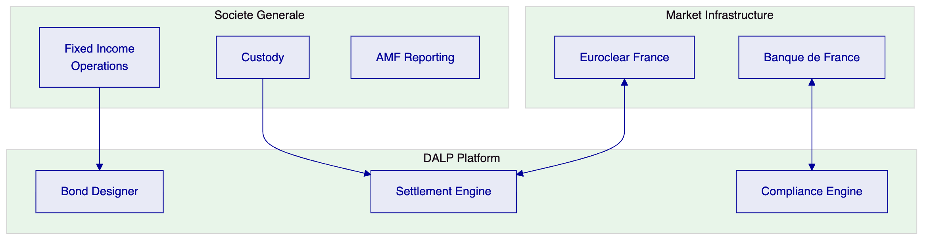

  - Understanding Societe Generale's Objectives
    - French Digital Securities Framework
France's transposition of the EU Digital Finance Package and AMF guidance creates the regulatory environment for digital bond issuance in France.
    - Objectives
- Modernize fixed-income operations: Digital bond issuance and servicing
- Regulatory compliance: AMF and Banque de France reporting
- Market infrastructure integration: Euroclear France connectivity

  - Proposed DALP Operating Model
    - Deployment Model
Recommended: Dedicated cloud deployment in AWS eu-west-2 (London) or OVHcloud (France)
    - Asset Scope
- Corporate bonds
- Sovereign bonds
- Multi-tranche structures

  - Technical Architecture
    - Platform Layers
Layer | Components
Application | Asset Console
API | REST API, SDK
Middleware | Execution Engine, Key Guardian
Smart Contract | ERC-3643, DALPAsset

    - Integration
- REST API with OpenAPI 3.1
- TypeScript SDK
- Event streaming (SSE)
- PostgreSQL analytics

  - Smart Contract Architecture
    - SMART Protocol
ERC-3643 foundation with:
- Token contracts
- Compliance orchestration
- Identity management (OnchainID)
    - Bond Features
Feature | Description
Maturity Redemption | Atomic redemption at maturity
Coupon Distribution | Pull-based yield
Voting Power | ERC-5805 governance

  - Compliance and Regulatory Controls
    - Compliance Modules
18 module types including:
- Identity Verification
- Country Restrictions
- Investor Count Limits
- Transfer Approval
    - AMF Alignment
- MiFID II compliance
- Transaction reporting
- Investor disclosure

  - Settlement and Servicing
    - Settlement Options
- DvP (Delivery-versus-Payment)
- T+0 finality on permissioned networks
    - Servicing
- Coupon distribution
- Maturity redemption
- Corporate actions

  - Security and Resilience
    - Security Layers
- Authentication (session, API keys)
- Authorization (roles)
- Wallet verification
- On-chain compliance
- Custody policy
    - Certifications
- ISO 27001
- SOC 2 Type II

  - Implementation Approach
    - Timeline
19 weeks:
- Discovery: 2 weeks
- Foundation: 3 weeks
- Configuration: 4 weeks
- Integration: 4 weeks
- Go-Live: 6 weeks

  - Dependencies and Gaps
    - Dependencies
- Cloud infrastructure
- Custody provider
- Euroclear France integration

End of Technical Proposal
Document Control
- Version: 1.0
- Date: March 2026
- Prepared by: SettleMint NV

