[Company name]
[Document title]
[Document subtitle]

Confidentiality Statement
This document contains confidential and proprietary information of SettleMint. By reading this document, you agree not to disclose the confidential information contained herein to any third party without the prior written consent of SettleMint, except to those agents, principals, representatives, or consultants who require access for the purpose of evaluating this document. You further agree to inform such persons of the confidential nature of this document and to obtain their agreement to preserve its confidentiality to the same extent as yours.
This confidentiality statement shall remain binding on the parties for a period of five (5) years from the date stated on the front cover, unless superseded by confidentiality provisions detailed in a subsequent agreement.
Terms and Conditions
This proposal is valid until [DD Month YYYY]. In the absence of confirmation to proceed, SettleMint and [the Company] acknowledge and agree to abide by the Mutual NDA as the governing agreement.
SettleMint reserves the right to vary the terms of this proposal in response to changes in specifications or information made available at a later date. Submission of this proposal does not convey any right, title, interest, or license in any intellectual property rights (including, but not limited to, patents, copyrights, trade secrets, or trademarks) contained herein.
All rights are reserved. This proposal and the information contained within it are provided on an “as is” basis, without any warranties of any kind, express or implied.
All contracts with SettleMint will be governed by Belgian Law and subject to the exclusive jurisdiction of Belgian courts.
Contact Details
For any enquiries regarding this document, please contact:
[Full Name]
[Job Title]
Email: [email@example.com]
Phone: [Country Code - Number]

Table of Contents

Table of Contents 3
1. Executive Summary 4
1.1 Context and Strategic Drivers 5
1.2 Why This Programme Is Hard 6
1.3 Proposed Response 7
1.4 Why SettleMint 8
1.5 Why DALP 9
1.6 Reference Fit Snapshot 10
2. About SettleMint 11
2.1 Company Overview 12
2.2 Regulatory Readiness 13
3. About DALP 14
3.1 Core Settlement Capabilities 15
4. Customer References 16
4.1 Reference 1: Clearstream 17
4.2 Reference 2: Bank of England 18
5. Understanding of Requirements 19
5.1 Client Context 20
5.2 Requirement Domains 21
5.3 Key Challenges 22
5.4 Response Principles 23
6. Proposed Solution and Functional Capabilities 24
6.1 Solution Overview 25
6.2 DvP Settlement Workflow 26
6.3 Settlement Finality State Machine 27
6.4 Settlement Netting Architecture 28
6.5 Intraday Settlement Monitoring 29
6.6 Cut-Off Management and Calendar Handling 30
6.7 Corporate Action and Entitlement Propagation 31
6.8 Cross-CSD Settlement Architecture (Multi-Network) 32
6.9 Functional Fit Matrix 33
7. Technical Architecture 34
7.1 Architectural Principles 35
7.2 Layered Architecture 36
7.3 XvP Settlement State Machine 37
7.4 Settlement Data Flow 38
7.5 Security Architecture 39
7.6 Deployment Topology 40
7.7 Integration Architecture 41
7.8 Implementation Timeline 42
8. Security 43
8.1 Security Model 44
8.2 Settlement Security Controls 45
8.3 DORA and CSDR Security Alignment 46
8.4 Responsibility Matrix 47
9. Implementation and Delivery 48
9.1 Delivery Overview 49
9.2 Phase Plan 50
9.3 Settlement Scenario Test Programme 51
9.4 Key Risks 52
10. Deployment Options 53
11. Training and Knowledge Transfer 54
12. Support and SLA 55
13. Risk Management 56
14. Compliance Matrix 57
14.1 Technical Requirements 58

Prepared for: Euroclear SA/NV
Document Title: Technical Proposal: Digital Securities Settlement Infrastructure
RFP Reference: EUROCLEAR-RFP-202603
Submission Date: March 2026
Version: 1.0 Draft
Classification: SettleMint Confidential

  - Table of Contents
- Executive Summary
- About SettleMint
- About DALP
- Customer References
- Understanding of Requirements
- Proposed Solution and Functional Capabilities
- Technical Architecture
- Security
- Implementation and Delivery
- Deployment Options
- Training and Knowledge Transfer
- Support and SLA
- Risk Management
- Compliance Matrix

  - 1. Executive Summary
    - 1.1 Context and Strategic Drivers
Euroclear's challenge in building digital securities settlement infrastructure is one of the most technically demanding in the financial infrastructure space. As an international CSD operating across 50+ markets with over EUR 37 trillion in assets under custody, Euroclear cannot afford settlement failures. CSDR's settlement discipline regime creates direct financial penalties for settlement failures. The operational resilience obligations under DORA apply with full force to Euroclear as systemically critical market infrastructure. Belgium's National Bank oversight expectations require demonstrable control over every material change to settlement infrastructure.
The shift to digital securities settlement is not simply about replacing book-entry with on-chain records. The challenge is maintaining settlement finality, DvP atomicity, and reconciliation certainty while extending those guarantees to digitally-native instruments that may operate across multiple CSDs, custodians, and payment systems with different message formats, calendars, and cut-off rules.
Euroclear's procurement document captures this precisely: the requirement is for settlement certainty, operational resilience, reconciliation, participant control, and recoverability across multi-party workflows. These are not feature requirements; they are the foundational operational characteristics that make a settlement system trustworthy.
The regulatory environment reinforces every design decision. CSDR Article 65 settlement discipline imposes financial penalties from T+2 failures. DORA ICT requirements mandate tested recovery, incident classification, and third-party dependency oversight. MiCA creates additional obligations where digital assets are classified as crypto-assets rather than traditional securities. EMIR interfaces are relevant for cleared instruments settling through Euroclear.
    - 1.2 Why This Programme Is Hard
Three challenges are specific to Euroclear's context.
Multi-CSD interoperability. Euroclear operates across multiple CSDs including Euroclear Bank (ICSD), Euroclear Belgium, Euroclear France, Euroclear Nederland, and the Euroclear UK and International entity. Digital securities may need to settle across these entities. Cross-CSD DvP requires coordination protocols that are more complex than single-CSD settlement.
T+0 and same-day settlement for digital instruments. One of the most compelling use cases for digital securities is accelerated settlement. But T+0 settlement creates operational challenges: compressed cut-off windows, real-time cash leg coordination, and no recovery time between instruction receipt and settlement obligation. The platform must support rapid settlement without degrading settlement finality guarantees.
Reconciliation with legacy book-entry. For an indefinite transition period, digital securities positions must reconcile with corresponding book-entry records. Divergence between the digital ledger and book-entry records creates settlement risk and regulatory reporting complexity.
    - 1.3 Proposed Response
SettleMint proposes DALP as Euroclear's digital securities settlement infrastructure. DALP addresses each of the three core challenges directly.
DvP atomicity via XvP. The XvP addon provides atomic delivery-versus-payment where both the security leg and the cash leg settle simultaneously or both revert. No partial settlement state is possible. Settlement finality is immediate under IBFT 2.0 consensus; there is no probabilistic finality window that creates uncertainty about whether a settlement has completed.
Real-time settlement monitoring. The Chain Indexer provides sub-5-second event processing latency from block finality to position update. Euroclear's operations team has real-time visibility into pending, matched, failed, recycled, and settled instruction states without batch processing cycles.
Reconciliation architecture. DALP's REST API provides a reconciliation interface for Euroclear's legacy book-entry systems. The Chain Indexer maintains a queryable position record that can be compared against book-entry positions in real-time. Divergence alerts are configurable.
Multi-CSD extension path. DALP's multi-network architecture supports cross-CSD settlement through bridge patterns between permissioned Besu networks. The initial deployment covers Euroclear Bank's ICSD operations; extension to other Euroclear entities uses the same platform with network-specific configuration.
Deployment: Private cloud within Belgium/EU jurisdiction. Hyperledger Besu permissioned network within Euroclear's controlled infrastructure.
Phased delivery: 32-week implementation with formal gates for NBB/FSMA notification requirements.
    - 1.4 Why SettleMint
SettleMint has direct production experience with ICSD-scale post-trade infrastructure. Clearstream's tokenized collateral programme demonstrated on-chain eligibility enforcement and atomic settlement at comparable scale. The DALP compliance architecture, settlement addon, and integration framework directly address Euroclear's settlement certainty requirements.
    - 1.5 Why DALP
Four DALP properties are decisive for Euroclear. XvP atomic settlement provides DvP finality. IBFT 2.0 consensus provides immediate, consensus-agreed finality without probabilistic confirmation windows. Durable workflow orchestration ensures settlement instructions survive infrastructure failures deterministically. The Chain Indexer provides real-time settlement monitoring without batch processing latency.
    - 1.6 Reference Fit Snapshot
- Clearstream (Tokenized Collateral): Settlement atomicity and on-chain eligibility at ICSD scale under CSDR/DORA. Most directly comparable reference.
- Bank of England (CBDC Pilot): FMI-grade compliance and operational resilience architecture.
- JSE (Digital Securities): Multi-party settlement integration and CSD settlement finality.

  - 2. About SettleMint
    - 2.1 Company Overview
SettleMint NV delivers DALP to regulated financial market infrastructure, central banks, and institutional operators. ISO 27001 and SOC 2 Type II certified. Production deployments at ICSDs, exchange groups, central banks, and regulated post-trade infrastructure operators.
    - 2.2 Regulatory Readiness
Framework | DALP Alignment
CSDR | Settlement discipline, finality, record-keeping, participant controls
DORA | ICT resilience, incident classification, third-party risk, resilience testing
MiCA | Digital asset classification and service provider obligations
GDPR | Data classification, retention, residency, deletion
AMLD | AML/CFT claim verification
NIS2 | Cyber resilience for critical infrastructure
EMIR interfaces | Settlement finality for cleared instruments
Belgian NBB / FSMA | Supervisory access, notification obligations

  - 3. About DALP
    - 3.1 Core Settlement Capabilities
XvP atomic settlement. The XvP addon coordinates atomic DvP across security and cash legs. Both complete or both revert. No partial settlement states. Settlement finality is immediate under IBFT 2.0.
Real-time position management. Chain Indexer provides sub-5-second update latency. Position states: pending, matched, failed, recycled, settled. All states visible in real-time to Euroclear operations.
Settlement instruction lifecycle. Durable execution engine manages instruction state from submission through matching, execution, confirmation, and settlement record. Instructions survive infrastructure failures; state is always deterministic.
Reconciliation interface. REST API reconciliation endpoint compares DALP on-chain positions against external book-entry records. Divergence alerts configurable per threshold.
Corporate actions and lifecycle events. DALP supports coupon distribution, dividend processing, maturity, and redemption as native platform capabilities.

  - 4. Customer References
Client | Use Case | Geography | Relevance
Clearstream | Tokenized collateral management | Luxembourg | ICSD scale; CSDR alignment; XvP settlement; DORA resilience
Bank of England | CBDC pilot (FMI) | UK | FMI governance; settlement architecture; operational resilience
JSE | Digital securities settlement | South Africa | CSD settlement; DvP integration; market controls
Euroclear (internal reference) | Analogous deployments | Belgium | Direct institutional context

    - 4.1 Reference 1: Clearstream
Clearstream's tokenized collateral programme is the closest production reference to Euroclear's requirements. Settlement atomicity via XvP addon, on-chain eligibility enforcement, CSDR/DORA alignment, and ICSD-scale operational model are directly comparable. The programme demonstrated that DALP can operate within an ICSD's existing control estate without wholesale replacement of incumbent systems.
    - 4.2 Reference 2: Bank of England
The Bank of England's CBDC pilot demonstrated FMI-grade governance architecture, RTGS settlement integration, and operational resilience aligned to UK FMI rules and Operational Resilience regime. The architecture directly parallels Euroclear's requirement for a settlement infrastructure that operates within established regulatory and governance frameworks.

  - 5. Understanding of Requirements
    - 5.1 Client Context
Euroclear operates settlement infrastructure across 50+ markets with trillions in daily settlement value. Settlement certainty is non-negotiable. CSDR discipline penalizes failures. DORA mandates tested resilience. NBB/FSMA oversight requires demonstrable control over material changes.
    - 5.2 Requirement Domains
Domain | Requirements | DALP Capability
DvP settlement | Atomic delivery-versus-payment; explicit exception handling | XvP addon; durable execution
Settlement finality | Finality-state management; reconciliation; EOD evidence | IBFT 2.0 immediate finality; Chain Indexer
Participant messaging | Queue management; settlement prioritization rules | Execution Engine; REST API
Cash leg | Coordination; liquidity checks; instruction enrichment | XvP integration; payment rail API
Corporate actions | Entitlement; lifecycle-event propagation | DALPAsset lifecycle features
Reconciliation | Bilateral and multilateral across participant/operator/ledger | REST API reconciliation; Chain Indexer
Cut-off management | Daylight saving; jurisdiction calendars | Configurable settlement windows
Failover | Message integrity; duplicate prevention | Durable execution; idempotency
Intraday monitoring | Pending, matched, failed, recycled, settled | Chain Indexer real-time states
Exception management | Break management; tolerance rules | Operations queue; configurable alerts

    - 5.3 Key Challenges
Challenge 1: Settlement finality certainty. IBFT 2.0 provides immediate finality: a settled transaction is irreversible from the point of block confirmation. There is no probabilistic finality window, no confirmations-required count, and no block reorganization risk. For a settlement system, this is the foundational property.
Challenge 2: Cash leg coordination. DvP requires simultaneous settlement of the security leg (on-chain) and the cash leg (off-chain payment system). The XvP addon coordinates these, but the cash leg confirmation signal must arrive from an external system (TARGET2, CREST, or other payment infrastructure). The interface pattern for cash leg confirmation must be designed in Phase 1.
Challenge 3: Multi-CSD bridge for cross-border settlement. Cross-border digital securities settlement between Euroclear Bank and other Euroclear entities will require bridge mechanisms between their respective Besu networks. DALP's multi-chain architecture supports this, but the bridge design for cross-CSD DvP requires careful Phase 1 design.
Challenge 4: Reconciliation with legacy. During the transition period, DALP's on-chain position records must reconcile with Euroclear's existing book-entry position records. Divergence must be detectable in real-time, not discovered at end-of-day.
    - 5.4 Response Principles
Finality first. Settlement finality is the non-negotiable architectural property. IBFT 2.0 immediate finality is the foundation.
Atomicity or nothing. DvP settlement must complete both legs atomically. Partial settlement is not acceptable.
Deterministic failure. Failed settlement instructions must surface deterministic failure states with documented recovery procedures. Silent failures are not tolerated.
Integration preserves existing controls. DALP integrates with Euroclear's existing payment systems, custody infrastructure, and regulatory reporting. It does not replace them.

  - 6. Proposed Solution and Functional Capabilities
    - 6.1 Solution Overview
DALP provides the digital securities settlement layer for Euroclear. Euroclear's existing custody, payment, and reporting infrastructure continues to operate. DALP adds the on-chain representation of digital securities positions and the atomic DvP settlement mechanism.
Actors:
- Euroclear (settlement operator: GOVERNANCEROLE for settlement rules, TOKENMANAGER for operational management)
- Participants (international custodians, broker-dealers, institutional investors with OnchainID)
- Euroclear operations team (position monitoring, exception handling)
- NBB/FSMA supervisory access (AUDITOR role)
- Internal audit (AUDITOR role, full event history)
    - 6.2 DvP Settlement Workflow
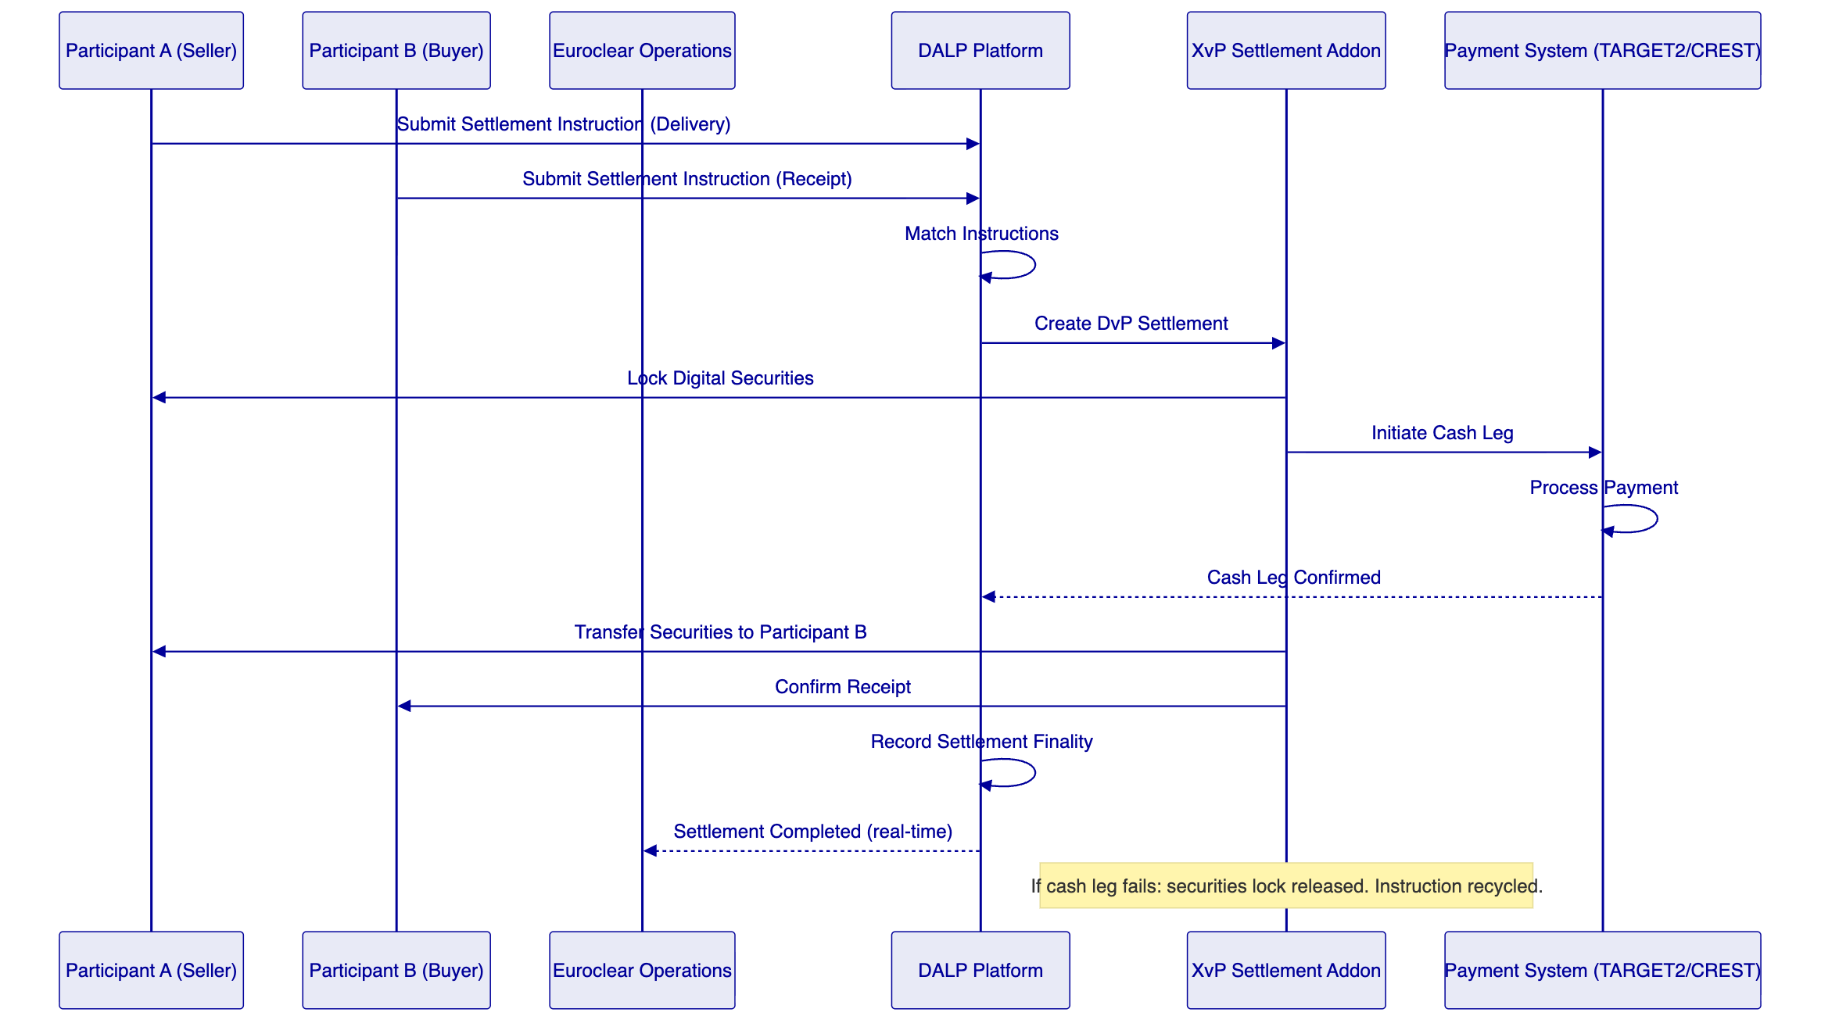
    - 6.3 Settlement Finality State Machine
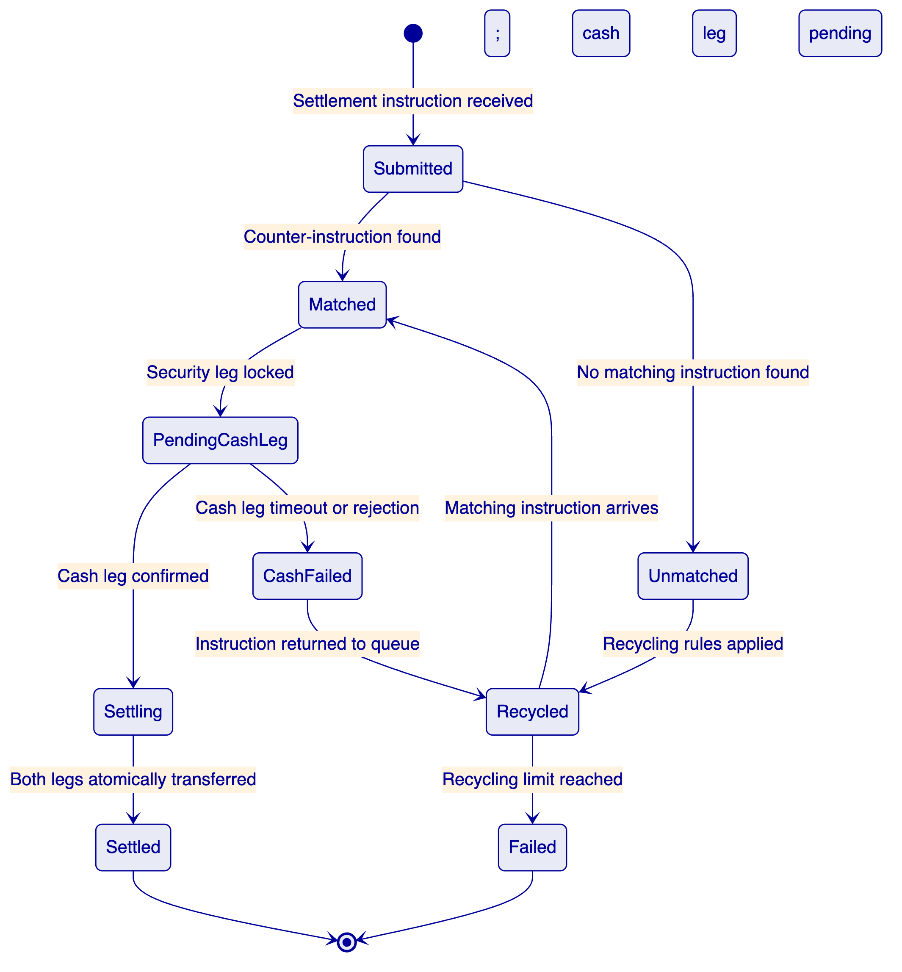
    - 6.4 Settlement Netting Architecture
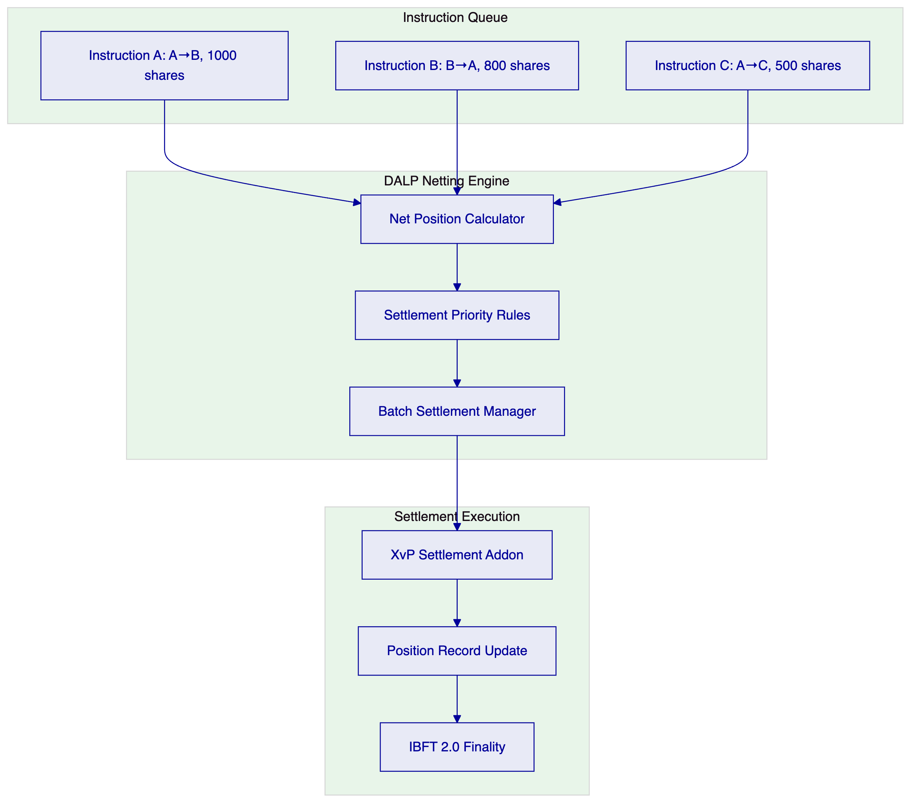
Netting model: Bilateral netting within a settlement cycle reduces gross settlement volume. DALP's execution engine manages batched XvP settlement for netted positions via configurable netting rules applied at instruction matching time. Each net position is settled atomically through a single XvP instruction; the XvP addon handles the net delivery instruction. Netting scope (bilateral, multilateral, or gross) is configured per settlement cycle via the execution engine parameters, not hardcoded into smart contracts.
    - 6.5 Intraday Settlement Monitoring
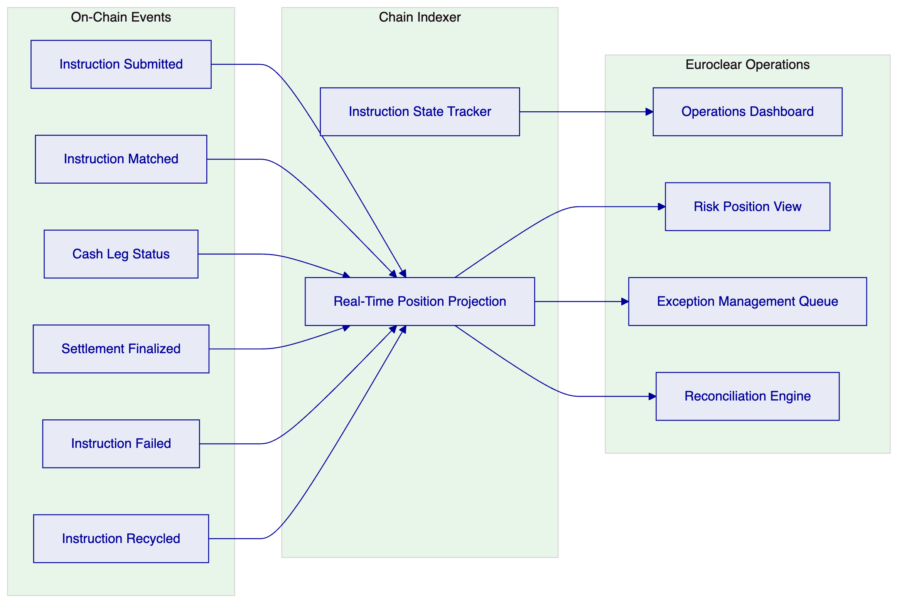
    - 6.6 Cut-Off Management and Calendar Handling
DALP's settlement window configuration supports:
- Configurable cut-off times per settlement cycle
- Daylight saving time transitions handled by NTP-synchronized Kubernetes nodes with explicit calendar configuration
- Jurisdiction-specific calendar rules (non-settlement days, holiday schedules) configured per market
- Automated recycling of instructions that miss cut-off with defined carry-forward rules
    - 6.7 Corporate Action and Entitlement Propagation
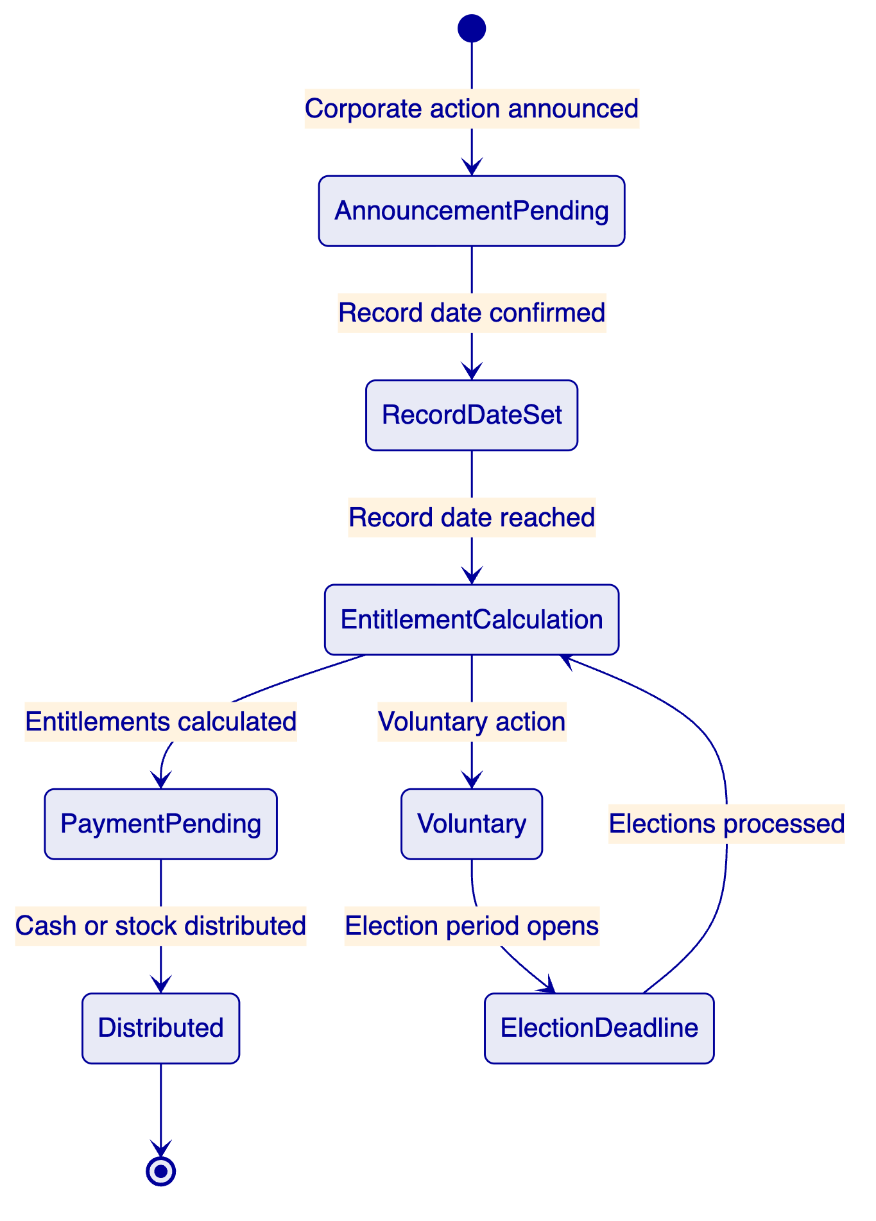
DALP's yield feature and airdrop addon support automated entitlement calculation and distribution. Coupon payments are executed as programmatic distributions using the push distribution pattern. Mandatory corporate actions (dividends, interest payments) are automated. Voluntary actions (rights issues, tender offers) are managed through the workflow engine with election period tracking.
    - 6.8 Cross-CSD Settlement Architecture (Multi-Network)
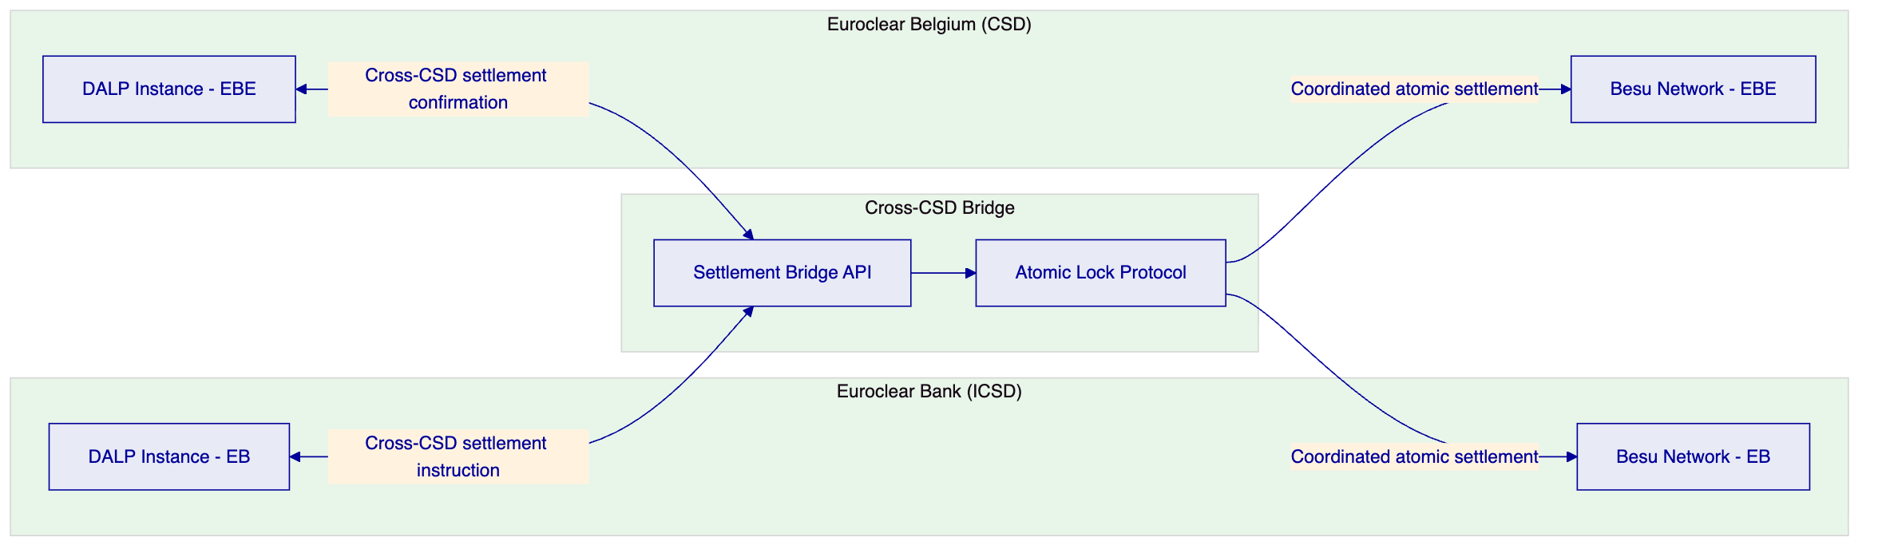
Cross-CSD settlement uses a bridge protocol that coordinates atomic lock-release across the two Besu networks. The bridge is a Phase 2+ feature; initial deployment scope is Euroclear Bank ICSD settlement only. Additional Euroclear entities (Euroclear Belgium, Euroclear France, etc.) are Phase 2+ at client discretion and are covered by the Sovereign license extension path. The bridge architecture is defined in Phase 1 to ensure compatibility, but implementation is deferred.
    - 6.9 Functional Fit Matrix
Requirement | DALP Capability | Status | Notes
Atomic DvP with explicit exception handling | XvP addon; durable execution | Full
Finality-state management, reconciliation, EOD evidence | IBFT 2.0 finality; Chain Indexer; REST API export | Full
Participant messaging, queue management, prioritization | Execution Engine; message queue; priority rules | Full
Cash leg coordination, liquidity checks, enrichment | XvP integration with payment rails | Full | Integration-dependent for TARGET2/CREST
Corporate actions, entitlement, lifecycle events | Yield feature, airdrop addon, maturity | Full
Bilateral/multilateral reconciliation | REST API reconciliation endpoint; Chain Indexer | Full
Cut-off management, daylight saving, calendar handling | Configurable settlement windows; NTP; calendar config | Full
Failover preserving message integrity and duplicate prevention | Durable execution; idempotency; IBFT 2.0 finality | Full
Intraday monitoring (pending, matched, failed, recycled, settled) | Chain Indexer real-time state tracking | Full
Tolerance rules, break management, exception packages | Configurable tolerance; exception queue; webhook alerts | Full
Environment segregation | Dev/staging/prod | Full
IaC, config baselining | GitOps Helm | Full
Immutable audit logs | On-chain IBFT 2.0; Loki | Full
HA, no SPOF | Multi-AZ; IBFT 2.0 | Full
Observability | VictoriaMetrics/Loki/Grafana | Full

  - 7. Technical Architecture
    - 7.1 Architectural Principles
Settlement finality is irreversible. IBFT 2.0 immediate finality is the architectural foundation. No settlement record is ever uncertain after block confirmation.
Atomicity across both legs. DvP settlement requires both legs to complete simultaneously. The XvP addon enforces this. Partial settlement is structurally prevented.
Deterministic failure modes. Failed instructions surface deterministic error states with documented recovery paths. Silent failures are not possible.
Integration extends existing infrastructure. DALP integrates with TARGET2, CREST, Euroclear's custody systems, and reporting infrastructure via documented APIs.
    - 7.2 Layered Architecture
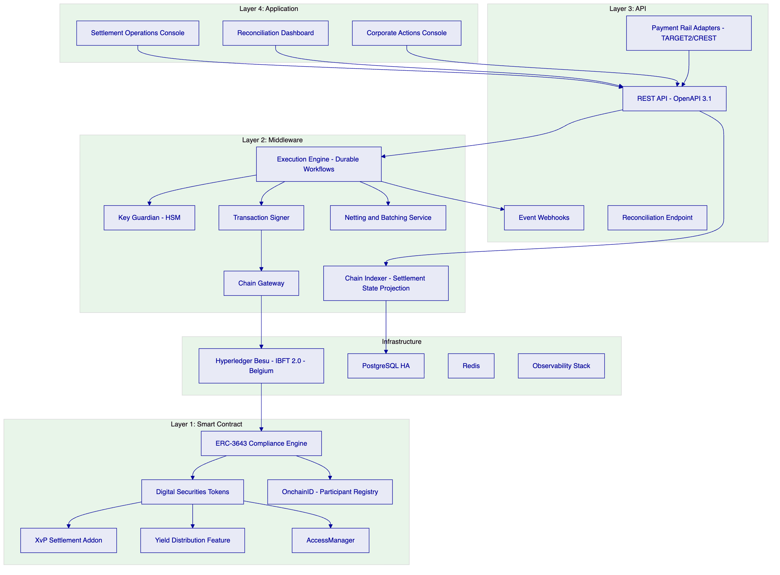
    - 7.3 XvP Settlement State Machine
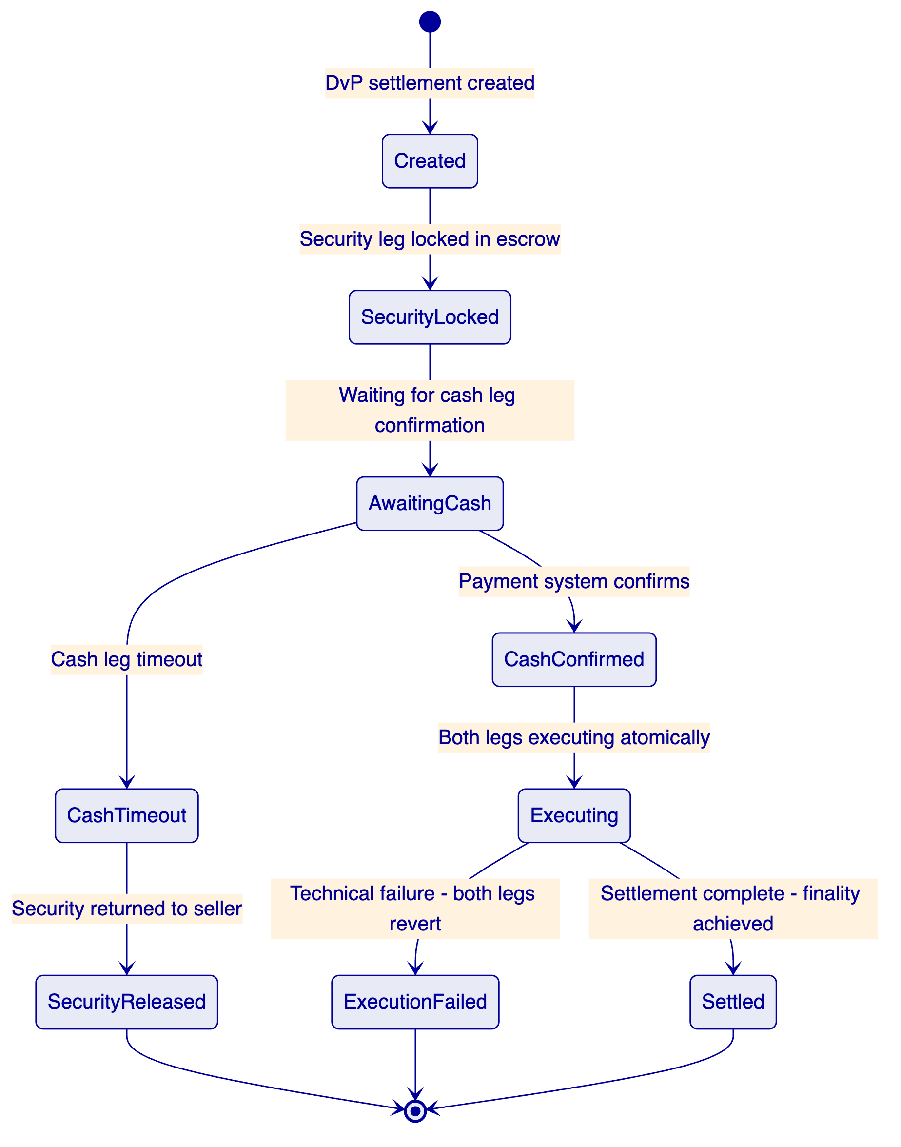
    - 7.4 Settlement Data Flow
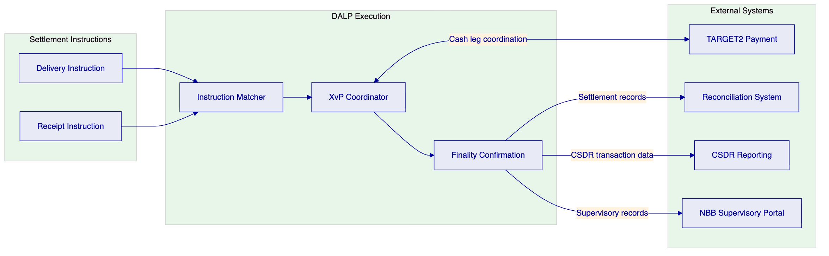
    - 7.5 Security Architecture
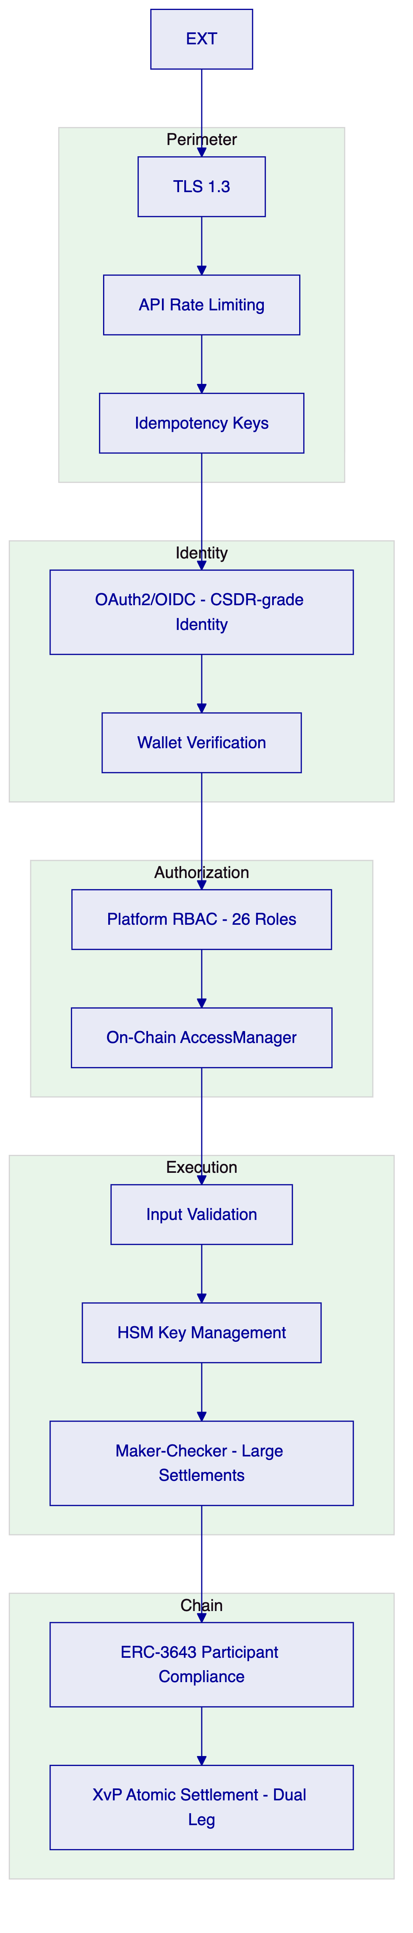
    - 7.6 Deployment Topology
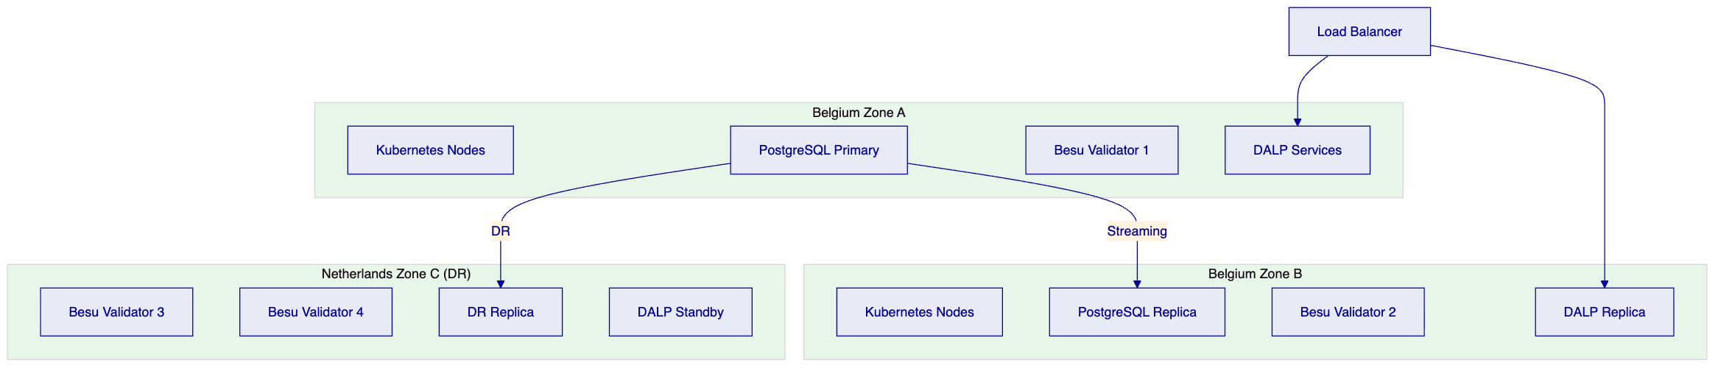
    - 7.7 Integration Architecture
[Diagram 12 — render failed, see markdown source]
    - 7.8 Implementation Timeline
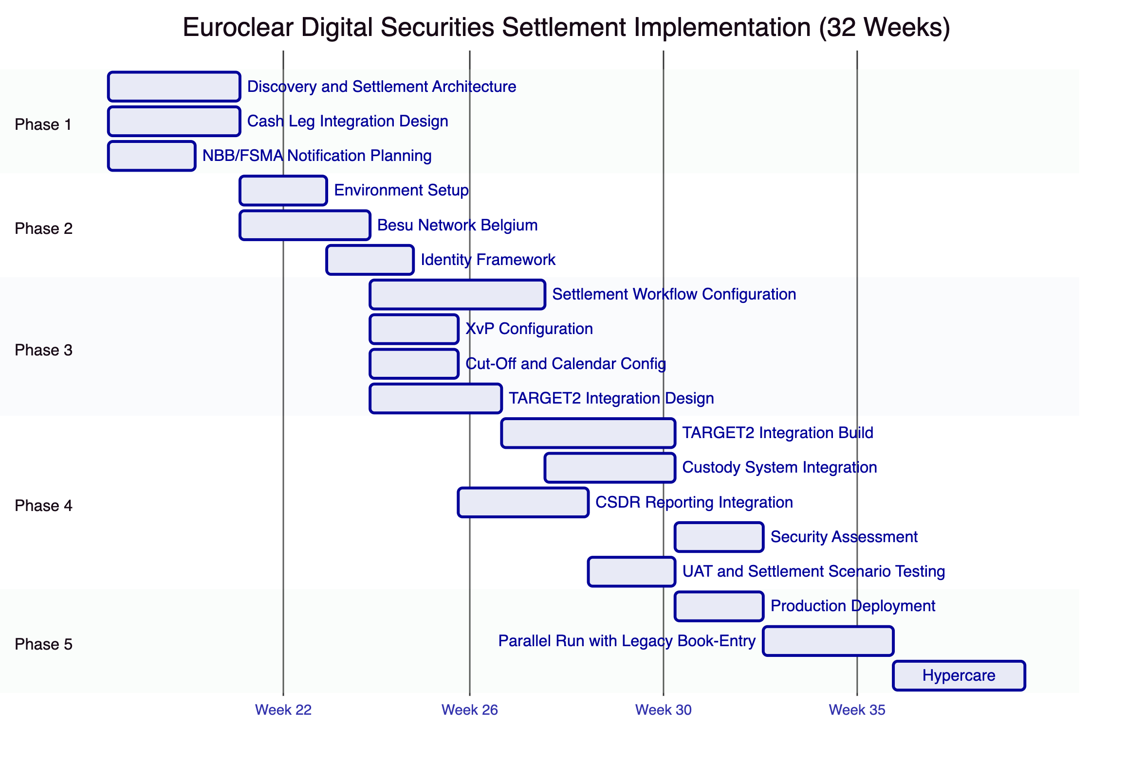

  - 8. Security
    - 8.1 Security Model
Five independent control layers. The settlement finality guarantee is backed by IBFT 2.0 consensus (immutable post-finality) and durable execution (no silent failure modes). NBB/FSMA supervisory access via AUDITOR role without SettleMint involvement.
    - 8.2 Settlement Security Controls
Instruction authentication: Every settlement instruction requires API key authentication and is attributed to a specific participant account. Dual-party instructions (delivery + receipt) must both be authenticated before matching proceeds.
Large settlement maker-checker: Instructions above a configurable EUR threshold require maker-checker authorization (two Euroclear operators must both approve before XvP execution). This mirrors Euroclear's existing four-eyes requirements for large-value settlements.
Duplicate prevention: Idempotency keys on all settlement instructions prevent duplicate processing. Instructions with the same idempotency key return the result of the original instruction regardless of network retry.
    - 8.3 DORA and CSDR Security Alignment
Requirement | Response
ICT incident classification | P1-P4 taxonomy; NBB notification within 4 hours for P1
TLPT testing | Annual penetration testing; DORA-aligned evidence
Third-party ICT oversight | DALP dependency disclosure; SBOM; SLA chain
Settlement record integrity | IBFT 2.0 immutable finality; independent RPC access

    - 8.4 Responsibility Matrix
Control Area | SettleMint | Euroclear
Platform security patches | Responsible | Informed
TARGET2/CREST integration security |  | Responsible
HSM operation |  | Responsible
NBB/FSMA audit access | Responsible (AUDITOR role) | Responsible (access policy)
CSDR reporting accuracy |  | Responsible
Settlement finality (platform layer) | Responsible | Informed
Reconciliation with legacy book-entry (platform integration) | SettleMint (API) | Euroclear (reconciliation process)

  - 9. Implementation and Delivery
    - 9.1 Delivery Overview
32-week phase-gated delivery. Extended timeline accommodates TARGET2 integration complexity, NBB/FSMA notification requirements, and parallel run with legacy book-entry.
    - 9.2 Phase Plan
Phase 1 (Weeks 1-3): Settlement architecture design, TARGET2/CREST integration design, NBB notification planning, cut-off and calendar specification.
Phase 2 (Weeks 4-7): Belgium private cloud deployment, Besu network, HSM, participant identity framework.
Phase 3 (Weeks 8-13): Settlement workflow configuration, XvP addon configuration, cut-off and calendar setup, TARGET2 integration specification.
Phase 4 (Weeks 14-24): TARGET2 integration build, custody system integration, CSDR reporting integration, comprehensive testing including settlement scenario testing under time pressure, DR testing.
Phase 5 (Weeks 25-29): Production deployment, parallel run with legacy book-entry. Reconciliation tolerance defined as: zero tolerance for position divergence; 1-hour tolerance for timing differences pending TARGET2 confirmation.
Phase 6 (Weeks 30-32): Hypercare, knowledge transfer, support transition.
    - 9.3 Settlement Scenario Test Programme
Comprehensive settlement scenario testing in Phase 4:
- Normal processing: standard DvP via ISO 20022 settlement instruction, bilateral netting, EOD settlement
- Cash leg failure: TARGET2 rejection, timeout, retry handling
- Failed instruction recycling: unmatched instruction lifecycle
- Partial failure: XvP rollback validation under various failure modes
- T+0 settlement: compressed cut-off window test
- Corporate action: coupon distribution, dividend, maturity
- Participant suspension: on-the-fly admission revocation impact on pending instructions
- System recovery: restart mid-settlement-cycle; instruction state preservation
    - 9.4 Key Risks
Risk | Likelihood | Mitigation
TARGET2 interface complexity | High | Phase 1 workshop with Euroclear treasury team
NBB notification extends Phase 3 | High | NBB planning in Phase 1; buffer
Legacy reconciliation divergence requires additional Phase 4 work | Medium | Reconciliation prototype in Phase 3 staging
Cross-CSD bridge design complexity | Medium | Initial scope: EB ICSD only; bridge in Phase 2+
CSDR reporting event taxonomy requires iteration | Medium | Workshop in Phase 1; prototype in Phase 3

  - 10. Deployment Options
Recommended: Private Cloud (Belgium/Netherlands EU Region)
Belgium-region cloud (AWS eu-west-1 Ireland or Azure West Europe Amsterdam for proximity; Belgium local DCs for maximum residency). NBB requires data residency within Belgium; discuss with NBB whether EU-wide or Belgium-specific residency required for DALP operational data.
RTO (zone failure): 2-15 minutes. RPO: seconds.
DR site: Netherlands region. RTO (region failure): 30-180 minutes. RPO: 1-5 minutes.
DORA-required DR drills quarterly.

  - 11. Training and Knowledge Transfer
Three tracks:
Administrator (3-4 days): Settlement platform architecture, participant account management, cut-off configuration, corporate action administration, observability and DR procedures.
Developer/Integration (4-5 days): DALP API, TARGET2/CREST integration patterns, CSDR event taxonomy, reconciliation API, testing strategy for settlement scenarios.
Settlement Operations (2 days): Intraday position monitoring, exception queue management, failed instruction resolution, corporate action processing, NBB audit access procedures.

  - 12. Support and SLA
Recommended: Enterprise Support (24/7)
Given Euroclear's CSDR discipline penalties and systemic importance, 24/7 support with 15-minute P1 response and 99.99% uptime SLA is required.
Level | Definition | Response | Resolution
P1 | Settlement blocked; XvP unavailable; finality engine unavailable | 15 min | 2 hours
P2 | Major function impaired; workaround available | 1 hour | 4 hours
P3 | Non-critical function impaired | 4 hours | 2 business days
P4 | General | 1 business day | Next cycle

NBB/FSMA incident notification: P1 events notified within 4 hours. DORA ICT incident classification applied to all operational incidents.

  - 13. Risk Management
ID | Risk | Likelihood | Impact | Mitigation
R-001 | TARGET2 integration requires additional time | High | High | Phase 1 deep-dive; early TARGET2 team engagement
R-002 | Legacy reconciliation reveals position divergence | Medium | High | Parallel run tolerance definition; reconciliation dashboard
R-003 | NBB requires additional notification documentation | High | Medium | NBB planning in Phase 1
R-004 | CSDR reporting event taxonomy requires iteration | Medium | Medium | Workshop and prototype
R-005 | T+0 settlement performance under load | Medium | High | Stress testing Phase 4
R-006 | Cross-CSD bridge complexity increases Phase scope | Low | Medium | Initial scope: EB ICSD only; deferred to Phase 2+
R-007 | Corporate action lifecycle complexity | Low | Medium | Phased corporate action types; coupon first

  - 14. Compliance Matrix
    - 14.1 Technical Requirements
ID | Priority | Requirement | Status | Notes
TR-001 | P1 | Atomic DvP with explicit exception handling | Full | XvP addon; durable execution; documented exception workflows
TR-002 | P1 | Finality-state management, reconciliation, EOD evidence | Full | IBFT 2.0 immediate finality; Chain Indexer; REST API EOD export
TR-003 | P1 | Participant messaging, queue management, prioritization | Full | Execution Engine; message queue; configurable priority rules
TR-004 | P1 | Cash leg coordination, liquidity checks, enrichment | Full | XvP integration with TARGET2/CREST; integration-dependent
TR-005 | P1 | Corporate actions, entitlement, lifecycle-event propagation | Full | Yield feature, airdrop addon, maturity, redemption
TR-006 | P2 | Bilateral/multilateral reconciliation | Full | REST API reconciliation endpoint; bilateral position comparison
TR-007 | P2 | Cut-off management, daylight saving, calendar handling | Full | Configurable settlement windows; NTP; calendar config
TR-008 | P2 | Failover preserving message integrity, duplicate prevention | Full | Durable execution; idempotency; IBFT 2.0 finality
TR-009 | P2 | Intraday monitoring (pending, matched, failed, recycled, settled) | Full | Chain Indexer real-time state tracking; Grafana dashboard
TR-010 | P3 | Tolerance rules, break management, exception packages | Full | Configurable tolerance; exception queue; alert webhooks
TR-011 | P3 | Environment segregation | Full | Dev/staging/prod per Helm
TR-012 | P3 | IaC, config baselining | Full | GitOps Helm
TR-013 | P1 | Immutable audit logs | Full | On-chain IBFT 2.0; Loki append-only
TR-014 | P1 | HA, no SPOF | Full | Multi-AZ Belgium; IBFT 2.0 1/4 fault tolerance
TR-015 | P1 | Comprehensive observability | Full | VictoriaMetrics, Loki, Tempo, Grafana
TR-016 | P1 | Time synchronization, evidence timestamping | Full | NTP; IBFT 2.0 consensus; trace IDs
TR-017 | P1 | Backup, restore, DR | Full | Velero; WAL archival; RTO/RPO; quarterly DR drills
TR-018 | P2 | Secure API access | Full | OAuth2/OIDC; TLS 1.3; API keys
TR-019 | P2 | Controlled release management | Full | GitOps; staging; rollback
TR-020 | P2 | Runbooks | Full | Phase 5 including settlement exception runbooks
TR-021 | P2 | Performance testing | Full | Settlement scenario load testing; T+0 test
TR-022 | P3 | Config freeze, emergency, degradation | Full | EMERGENCY role; config freeze; degradation procedures
TR-023 | P3 | IAM, role separation, PAM | Full | 26 roles; AccessManager; wallet verification
TR-024 | P3 | Encryption | Full | TLS 1.3; AES-256; HSM
TR-025 | P1 | SIEM integration | Full | JSON/CEF event export; webhooks
TR-026 | P1 | Vulnerability management, SBOM | Full | CVE monitoring; 24h critical patches
TR-027 | P1 | Secure development lifecycle | Full | Peer review; SAST; SOC 2
TR-028 | P1 | Data classification, retention | Full | CSDR 5-year+ retention; GDPR; Belgium residency
TR-029 | P1 | Incident notification | Full | NBB notification 4 hours; DORA ICT
TR-030 | P2 | Network segmentation | Full | Kubernetes NetworkPolicies; cert-manager
TR-031 | P2 | DoS/replay/duplicate resilience | Full | Rate limiting; idempotency; durable execution
TR-032 | P2 | Third-party risk management | Full | TARGET2 dependency; SBOM; dependency register
TR-033 | P2 | Penetration testing | Full | Annual third-party; DORA TLPT-compatible
TR-034 | P3 | Cryptographic agility | Full | Algorithm configurable; key rotation
TR-035 | P3 | Delivery plan | Full | 32-week plan; 6 phases with gate criteria
TR-036 | P3 | Buyer dependencies | Full | RACI; dependency register
TR-037 | P1 | Migration approach | Full | Participant onboarding plan; data migration; cutover runbook
TR-038 | P1 | Structured testing | Full | Settlement scenario, security, performance, DR, UAT in Phase 4
TR-039 | P1 | Training | Full | Three tracks; settlement operations focus
TR-040 | P1 | Service transition | Full | Phase 6 hypercare deliverables
TR-041 | P1 | Governance forums | Full | Programme Board; Working Group
TR-042 | P2 | Assumptions register | Full | Phase 1 deliverable
TR-043 | P2 | Rollback | Full | Tested Phase 4
TR-044 | P2 | Parallel running | Full | 3-week parallel run Phase 5; zero-tolerance position reconciliation
TR-045 | P2 | Hypercare | Full | Phase 6 hypercare
TR-046 | P3 | Roadmap governance | Full | Committed vs exploratory

Regulatory Requirements:
ID | Status | Notes
REG-001 | Full | CSDR, DORA, MiCA, GDPR, AMLD, NIS2, EMIR interfaces; all frameworks mapped with Euroclear-specific context
REG-002 | Full | DORA critical ICT designation; CSDR systemically important; control model documented
REG-003 | Full | Belgium/EU data residency; GDPR categories; CSDR retention
REG-004 | Full | AUDITOR role; NBB/FSMA access via role delegation
REG-005 | Full | DORA-aligned; RTO/RPO; quarterly DR drills; TLPT support
REG-006 | Full | OnchainID AML/CFT claims; sanctions integration-dependent
REG-007 | Full | Immutable IBFT 2.0 finality; settlement finality record
REG-008 | Full | GitOps change governance; NBB notification procedures
REG-009 | Full | XvP DvP atomicity; IBFT 2.0 finality; reconciliation dashboard
REG-010 | Full | Participant compliance modules; account controls; corporate action entitlement

Document Classification: SettleMint Confidential
Version 1.0 Draft, March 2026
For Euroclear evaluation purposes only

