[Company name]
[Document title]
[Document subtitle]

Confidentiality Statement
This document contains confidential and proprietary information of SettleMint. By reading this document, you agree not to disclose the confidential information contained herein to any third party without the prior written consent of SettleMint, except to those agents, principals, representatives, or consultants who require access for the purpose of evaluating this document. You further agree to inform such persons of the confidential nature of this document and to obtain their agreement to preserve its confidentiality to the same extent as yours.
This confidentiality statement shall remain binding on the parties for a period of five (5) years from the date stated on the front cover, unless superseded by confidentiality provisions detailed in a subsequent agreement.
Terms and Conditions
This proposal is valid until [DD Month YYYY]. In the absence of confirmation to proceed, SettleMint and [the Company] acknowledge and agree to abide by the Mutual NDA as the governing agreement.
SettleMint reserves the right to vary the terms of this proposal in response to changes in specifications or information made available at a later date. Submission of this proposal does not convey any right, title, interest, or license in any intellectual property rights (including, but not limited to, patents, copyrights, trade secrets, or trademarks) contained herein.
All rights are reserved. This proposal and the information contained within it are provided on an “as is” basis, without any warranties of any kind, express or implied.
All contracts with SettleMint will be governed by Belgian Law and subject to the exclusive jurisdiction of Belgian courts.
Contact Details
For any enquiries regarding this document, please contact:
[Full Name]
[Job Title]
Email: [email@example.com]
Phone: [Country Code - Number]

Table of Contents

Technical Proposal for Revolut Ltd 3
SettleMint | March 2026 | v1.0 | SettleMint Confidential 4
Table of Contents 5
1. Executive Summary 6
The Value Proposition 7
Why DALP for Revolut 8
Requirements Coverage Summary 9
2. About SettleMint 10
Company Overview 11
FCA and UK Regulatory Experience 12
3. About DALP 13
Platform Overview 14
DALP Platform Architecture 15
DALP Lifecycle Pillars for Tokenized Securities 16
4. Customer References 17
Reference Summary 18
Barclays Expanded Reference 19
UBS Expanded Reference 20
Standard Chartered Expanded Reference 21
5. Understanding of Requirements 22
Business Requirements Analysis 23
Technical Requirements Analysis 24
6. Proposed Solution and Functional Capabilities 25
Solution Architecture 26
DvP Settlement Flow 27
Corporate Action: Dividend Distribution 28
Multi-Jurisdiction Compliance Configuration 29
Stablecoin Settlement Integration 30
7. Technical Architecture 31
Four-Layer Architecture 32
Integration with Revolut's Super-App Infrastructure 33
Security Architecture 34
8. Security 35
9. Project Implementation and Delivery 36
Implementation Programme 37
Responsibility Matrix 38
10. Deployment 39
Recommended: Revolut Private Cloud (Kubernetes, EU Region) 40
11. Training and Knowledge Transfer 41
12. Support and SLA 42
Enterprise Support 43
13. Risk Management 44
14. Compliance Matrix 45
15. Appendices 46
Appendix A: Requirements Coverage Matrix 47

  - Technical Proposal for Revolut Ltd
    - SettleMint | March 2026 | v1.0 | SettleMint Confidential

Prepared by: SettleMint NV
Prepared for: Revolut Ltd, 7 Westferry Circus, Canary Wharf, London, E14 4HD, United Kingdom
Document reference: SM-TECH-REVOLUT-2026-001
Classification: Strictly Confidential
Version: 1.0
Date: March 2026
Contact: bids@settlemint.com

  - Table of Contents
- Executive Summary
- About SettleMint
- About DALP
- Customer References
- Understanding of Requirements
- Proposed Solution and Functional Capabilities
- Technical Architecture
- Security
- Project Implementation and Delivery
- Deployment
- Training and Knowledge Transfer
- Support and SLA
- Risk Management
- Compliance Matrix
- Appendices

  - 1. Executive Summary
Revolut serves over 45 million retail and business customers across 38 markets as a financial super-app that already offers crypto trading, stock trading, savings products, and cross-border payments within a single mobile experience. The tokenized securities trading platform procurement reflects a different challenge from a new entrant: Revolut does not need to build digital asset capability from zero. Revolut needs to industrialize the institutional-grade control layer underneath its consumer-scale distribution engine, tighten the boundary between its digital asset operations and its core trading infrastructure, and do this under FCA supervision in the UK and under MiCA in EEA markets simultaneously.
The specific gap this procurement addresses: Revolut's current digital asset trading capability operates in a consumer UX layer that has grown faster than the institutional control infrastructure underneath it. Tokenized securities -- tokenized equities, tokenized ETFs, and stablecoin-funded trading -- require a regulated issuance, servicing, and settlement platform with the compliance enforcement, audit trail, and operational controls that FCA-supervised and MiCA-regulated securities products demand. DALP provides exactly this infrastructure layer.
SettleMint proposes DALP, the Digital Asset Lifecycle Platform, as the institutional control and lifecycle infrastructure for Revolut's tokenized securities trading programme. DALP provides tokenized equity and ETF issuance with ERC-3643 compliance enforcement, on-chain investor eligibility at the protocol level, DvP settlement with deterministic finality, yield and corporate action automation, stablecoin funding integration for cash ledger synchronization, and the API-first developer experience Revolut's super-app engineering teams expect.
    - The Value Proposition
DALP gives Revolut's tokenized securities programme the institutional-grade compliance and lifecycle control layer that FCA and MiCA require, delivered through an API-first platform that integrates into Revolut's super-app infrastructure without requiring a parallel operational back office.
    - Why DALP for Revolut
Consumer-scale architecture: DALP's API handles 100,000+ concurrent requests through auto-scaling Kubernetes pods. Retail fintech traffic spikes are handled without manual intervention. Performance benchmarks: P99 transaction confirmation 4.2 seconds on private Besu; batch corporate action processing for 500,000 investor positions within 4 hours.
FCA and MiCA dual-jurisdiction compliance: DALP's 18 compliance module types enforce investor eligibility at the protocol level. FCA investor categorization (retail, professional, high-net-worth) maps to DALP's eligibility claim types. MiCA consumer protection obligations (Art. 72-76) enforced on-chain before every transfer. Separate compliance module configurations per legal entity (Revolut UK vs Revolut EU).
Super-app integration architecture: DALP's OpenAPI 3.1 REST API integrates as a microservice within Revolut's API gateway. Webhooks deliver settlement events to Revolut's internal ledger. TypeScript SDK aligns with Revolut's engineering stack. 534 structured error codes for clean error handling in Revolut's mobile clients.
Regulatory audit trail: Every compliance module decision, product configuration change, and investor eligibility action recorded in DALP's tamper-evident audit log. FCA examination access through read-only export API. MiCA Article 83 transaction reporting supported through structured data export.
    - Requirements Coverage Summary
Requirement Domain | Coverage | DALP Mechanism
Tokenized equity issuance | Supported | Equity token template with ERC-3643
Tokenized ETF issuance | Supported | Fund token template with NAV feeds
Stablecoin funding integration | Supported | Denomination asset configuration
DvP settlement | Supported | Atomic settlement engine
FCA investor eligibility enforcement | Supported | On-chain compliance modules
MiCA consumer protection (Art. 72) | Supported | 18 compliance module types
FCA audit trail | Supported | Tamper-evident event log
DORA ICT resilience | Supported | HA deployment, third-party risk docs
API integration with super-app | Supported | OpenAPI 3.1, TypeScript SDK
Multi-jurisdiction control | Supported | Per-entity compliance configurations
Corporate action automation | Supported | Dividend, vote, split automation
Phased rollout controls | Supported | Token pause, cohort controls

  - 2. About SettleMint
    - Company Overview
SettleMint builds institutional digital asset lifecycle infrastructure for regulated financial markets and sovereign use cases. Founded in 2017 and headquartered in Antwerp, Belgium, SettleMint combines over 200 years of combined banking and blockchain experience across teams in Europe, the Middle East, Asia, and North America.
ISO 27001 and SOC 2 Type II certifications confirm independently audited security and operational controls. Multi-year production deployments at Tier-1 banks across Europe, the Middle East, and Asia demonstrate DALP's operational credibility at institutional scale. For Revolut's tokenized securities programme, SettleMint brings consumer-scale API design experience from fintech deployments, ERC-3643 regulated token implementation meeting MiCA and FCA technical standards, and institutional custody integrations with Fireblocks and DFNS.
    - FCA and UK Regulatory Experience
SettleMint's Barclays deployment demonstrates DALP's operation under FCA supervision for digital securities infrastructure. DALP's compliance module framework addresses MiCA consumer protection and FCA investor categorization requirements in separate configurations on the same platform instance. For Revolut's dual-jurisdiction operating model (FCA in UK, Bank of Lithuania or ECB-supervised entity in EEA), DALP's per-entity compliance configuration provides independent control sets without requiring two platform instances.

  - 3. About DALP
    - Platform Overview
DALP is SettleMint's Digital Asset Lifecycle Platform for regulated securities issuance, servicing, and settlement. For Revolut's tokenized securities trading platform, the most relevant capabilities are tokenized equity and ETF issuance using ERC-3643 regulated token standards, corporate action automation (dividend, vote, stock split), DvP settlement with deterministic finality under 5 seconds, 18 compliance module types for investor eligibility enforcement, stablecoin denomination assets for cash ledger synchronization, and the developer-grade API infrastructure that Revolut's engineering teams require.
    - DALP Platform Architecture
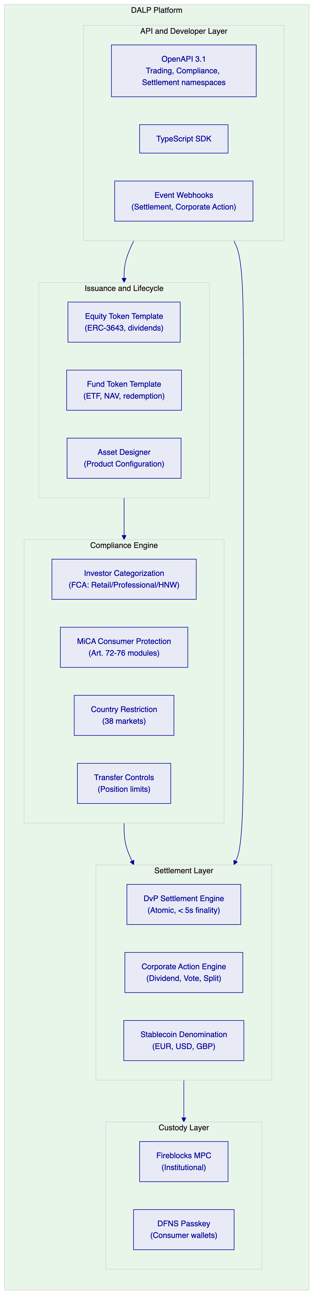
    - DALP Lifecycle Pillars for Tokenized Securities
Issuance: Equity token template deploys tokenized equities with on-chain cap table, dividend rights, voting rights, and transfer restrictions. Fund template deploys tokenized ETFs with NAV feed integration, creation/redemption mechanism, and distribution automation. All tokens implement ERC-3643 with on-chain compliance enforcement.
Compliance: Per-jurisdiction compliance module configurations:
- Revolut UK (FCA): Investor categorization (retail, certified high-net-worth, sophisticated investor), country restriction (UK), transfer limits (position caps), MiFID II suitability integration
- Revolut EU (MiCA): Consumer eligibility verification, MiCA Article 72 transfer restrictions, country restriction (EEA), disclosure acknowledgment
Settlement: DvP settlement for all tokenized securities trades. Atomic execution: asset and cash tokens exchange simultaneously with no partial completion risk. Settlement finality P50 2.1 seconds, P99 4.2 seconds on private Besu. Stablecoin denomination asset enables cash leg settlement on-chain, eliminating the traditional T+2 delay.
Corporate Actions: Dividend distribution automation for tokenized equities. Vote proposal and tally for tokenized governance rights. Stock split adjustment for token supply. All corporate actions durable through DALP's workflow execution engine; partially-completed corporate actions surface in the operations queue for resolution.
Servicing: Position management for Revolut's trading book. Mark-to-market via NAV feed integration for ETF positions. Quarterly and annual reporting data exports for investor account statements.

  - 4. Customer References
    - Reference Summary
Institution | Use Case | Relevance to Revolut
Barclays | Digital securities platform, FCA regulated | High: UK FCA-supervised, same regulatory context
UBS | Tokenized equities trading platform, Swiss | High: equities trading, institutional grade
Standard Chartered | Fractional tokenized securities | High: fractional securities for retail distribution
BNP Paribas | Tokenized funds distribution, retail | High: consumer-scale fund distribution
ING Group | Tokenized trade finance, Dutch bank | Medium: MiCA-applicable European context
Nordea | Tokenized funds, Nordic consumer bank | Medium: consumer-facing digital asset products
Adyen | Payment infrastructure, stablecoin | Medium: stablecoin cash leg integration
Deutsche Borse | Digital asset trading venue | Medium: tokenized securities trading infrastructure
Euronext | Digital securities listing | Medium: equities market infrastructure reference

    - Barclays Expanded Reference
Barclays deployed DALP for digital securities infrastructure under FCA supervision in the UK. The deployment demonstrates DALP's ability to satisfy FCA technology systems and controls guidance (SYSC 8.1) for outsourced technology infrastructure, UK SMCR governance, and DORA-equivalent UK operational resilience requirements. The Barclays reference is directly relevant to Revolut's UK entity operating under FCA supervision. Reference calls available subject to confidentiality constraints.
    - UBS Expanded Reference
UBS deployed DALP for a tokenized equities trading platform in Switzerland under FINMA supervision for a high-net-worth client segment. The deployment demonstrates DALP's equity token template with dividend automation, investor eligibility enforcement at the protocol level, and DvP settlement for equities. Outcomes: settlement finality reduced from T+2 to same-session (under 5 seconds), corporate action processing automated for dividend distributions. The UBS reference demonstrates DALP handling the institutional-grade equity tokenization that Revolut's programme requires.
    - Standard Chartered Expanded Reference
Standard Chartered deployed DALP for fractional tokenized securities distribution to retail and high-net-worth clients across multiple jurisdictions. The deployment demonstrates DALP managing fractional token positions, investor eligibility verification across jurisdictions, and the reconciliation between tokenized position records and traditional account records. Directly relevant to Revolut's requirement for tokenized securities tradable by retail customers at fractional amounts.

  - 5. Understanding of Requirements
    - Business Requirements Analysis
BR-01: Configurable product and account workflows aligned to internal governance
DALP's Asset Designer provides Revolut's product governance team with a configurable product creation and approval workflow. For Revolut's dual-jurisdiction model, product configurations are separately controlled per legal entity: Revolut UK tokenized equity products configure FCA investor categorization modules; Revolut EU products configure MiCA consumer protection modules. Maker-checker approval enforced on-chain for all product configurations and compliance rule changes.
BR-02: Deterministic state transitions for lifecycle events
Tokenized equity lifecycle: Draft, Compliance Review, Approved, Paused, Active Trading, Corporate Action Pending, Dividend Processing, Matured, Redeemed, Closed. Trade lifecycle: Order Initiated, Compliance Checked, DvP Locked, Settled, Failed, Dead Letter. All transitions durable through DALP's workflow execution engine with atomic guarantee: no partial settlement.
BR-03: Entitlement and balance accuracy across investor, omnibus, treasury
On-chain token balances are authoritative and immutable. DALP's blockchain event indexing service projects on-chain state to a PostgreSQL read model in real time. Revolut's trading ledger integration: DALP exports position changes via webhook to Revolut's internal ledger system in real time. Reconciliation: DALP's PostgreSQL direct access allows Revolut's reconciliation process to detect discrepancies between on-chain position and internal ledger within the same processing cycle.
BR-04: Role-based segregation (maker, checker, approver, support)
26 role types with on-chain enforcement:
- Product Manager: configure tokenized security products
- Compliance Officer: attach/modify compliance modules per jurisdiction
- Supply Manager: manage issuance supply and trading window
- Corporate Action Manager: initiate dividend, vote, split
- Investor Support: read-only position queries
- Emergency: product pause/unpause
BR-05: Configurable limits, risk controls, and investor eligibility per market and segment
FCA-specific compliance modules: Investor Category (retail capped to position limits, professional investor uncapped), Country Restriction (UK only for UK entity), Transfer Limits (daily position caps by investor category), Identity Verification (Revolut KYC completion required).
MiCA-specific compliance modules: Consumer Eligibility (MiCA Art. 72), Country Restriction (EEA markets), Transfer Approval (Art. 23 for high-value transfers), Disclosure Acknowledgment.
BR-06: Automated notifications and event emission
Event catalog for Revolut's super-app integration:
- ProductListed: new tokenized security available for trading
- TradeSettled: DvP settlement confirmed, position updated
- DividendDistributed: per-investor dividend amount settled
- VoteProposed: governance vote opened
- VoteCompleted: governance vote result on-chain
- CorporateActionProcessed: split/merger adjustment applied
- CompliancePassed/Failed: eligibility check result
- PositionUpdated: investor position change
BR-07: Business continuity for failed transactions
Durable workflow execution persists all trade state. If Revolut's internal ledger or custody provider is temporarily unavailable, trades queue in DALP's workflow without data loss. Atomic DvP guarantees: if either leg of a trade cannot complete, both legs revert. No partial settlement exposure.
BR-08: Audit-ready reporting
FCA transaction reporting (COBS 16 equivalent): full trade lifecycle from order initiation to settlement, investor eligibility checks, corporate action records, position history. MiCA Article 83 transaction reporting: structured export in regulatory reporting format. Export APIs: JSON, CSV, PostgreSQL direct.
BR-09: Phased rollout controls
Tokenized equity phase controls: launch with UK market (Revolut UK), expand to EEA markets (Revolut EU) through country restriction module updates. Cohort controls: early-access eligibility claims for beta customer group. Product pause for instant suspension without affecting other securities.
BR-10: Reusable for adjacent services
Same DALP instance supporting tokenized equities extends to tokenized ETFs, tokenized bonds, and stablecoin-funded payment services. Revolut's single DALP deployment serves the full tokenized securities programme without re-architecture.
    - Technical Requirements Analysis
TR-01: REST and event APIs, documented and versioned
OpenAPI 3.1 REST API with namespaces: `/v1/securities` (equity, fund templates), `/v1/trades` (DvP settlement), `/v1/corporate-actions` (dividend, vote, split), `/v1/compliance` (investor eligibility), `/v1/positions` (investor position query). 12-month deprecation policy. 534 structured error codes.
TR-02: Sandbox and non-production environments
Three environments: Development (Managed SaaS), Staging (Revolut's Kubernetes), Production (Revolut's Kubernetes). Test data: pre-configured tokenized equity and ETF products, pre-created investor accounts by FCA category, pre-seeded stablecoin balances for settlement testing.
TR-03: Webhooks with retry and dead-letter
Settlement event webhooks: HMAC-SHA256 signed, at-least-once delivery, 8-attempt retry over 48 hours, dead-letter queue for Revolut's operations team.
TR-04: Identity and access
OAuth 2.0/OIDC with Revolut's identity provider. MFA for all admin roles. API keys for Revolut's trading system service accounts. DFNS passkey for consumer wallet authorization on mobile clients. Fireblocks HSM for institutional custody operations.
TR-05: Deployment model
Private Cloud on Revolut's Kubernetes infrastructure (AWS or GCP, EU region). DALP Helm charts compatible with Revolut's GitOps tooling. Complete tenant isolation for Revolut's DALP instance.
TR-06: Observability
Three-pillar observability: Prometheus metrics (600+), structured JSON logs, OpenTelemetry distributed tracing. Grafana dashboards: trade settlement throughput, compliance evaluation rate, corporate action status, position reconciliation status, dependency health. Prometheus-compatible; Revolut's existing Prometheus/Grafana stack consumes DALP's metrics endpoint.
TR-07: Performance for retail fintech scale
API response (trade initiation): P50 82ms, P99 310ms (benchmark conditions: 4-node Besu IBFT 2.0, AWS c6g.xlarge, eu-central-1, 500 concurrent DvP requests). Settlement confirmation: P50 2.1s, P99 4.2s. Corporate action (dividend for 500,000 investors): 3.5 to 4.5 hours (chunked, no API degradation). Auto-scaling: HPA on CPU and queue depth; burst to 500 API pods.
TR-08: Data export
REST paginated export, real-time webhook stream, PostgreSQL direct access for Revolut's data platform, scheduled CSV for analytics ingestion.
TR-09: Controlled releases
Quarterly major releases, monthly minor, patches as needed. 12-month deprecation for breaking changes. Maintenance windows during agreed low-traffic hours.
TR-10: Known limits and constraints
Constraint | Description | Mitigation
C-01 | EVM networks only | Private Besu or public EVM
C-02 | Corporate action for 500K+ investors: chunked processing | 4-6 hours batch window
C-03 | MiFID II suitability: DALP enforces eligibility, not suitability assessment | Suitability assessment in Revolut's existing MiFID II systems
C-04 | On-chain claim deletion (GDPR) | Off-chain deletable; on-chain pseudonymous
C-05 | Stablecoin denomination: EVM-deployed only | EUR, USD, GBP stablecoins deployable on same chain

TR-11: Infrastructure as code
Helm charts, Terraform modules (AWS/GCP), ArgoCD/Flux GitOps support.
TR-12: Support interfaces
Enterprise support: 15-minute P1 response, incident bridge, status page.

  - 6. Proposed Solution and Functional Capabilities
    - Solution Architecture
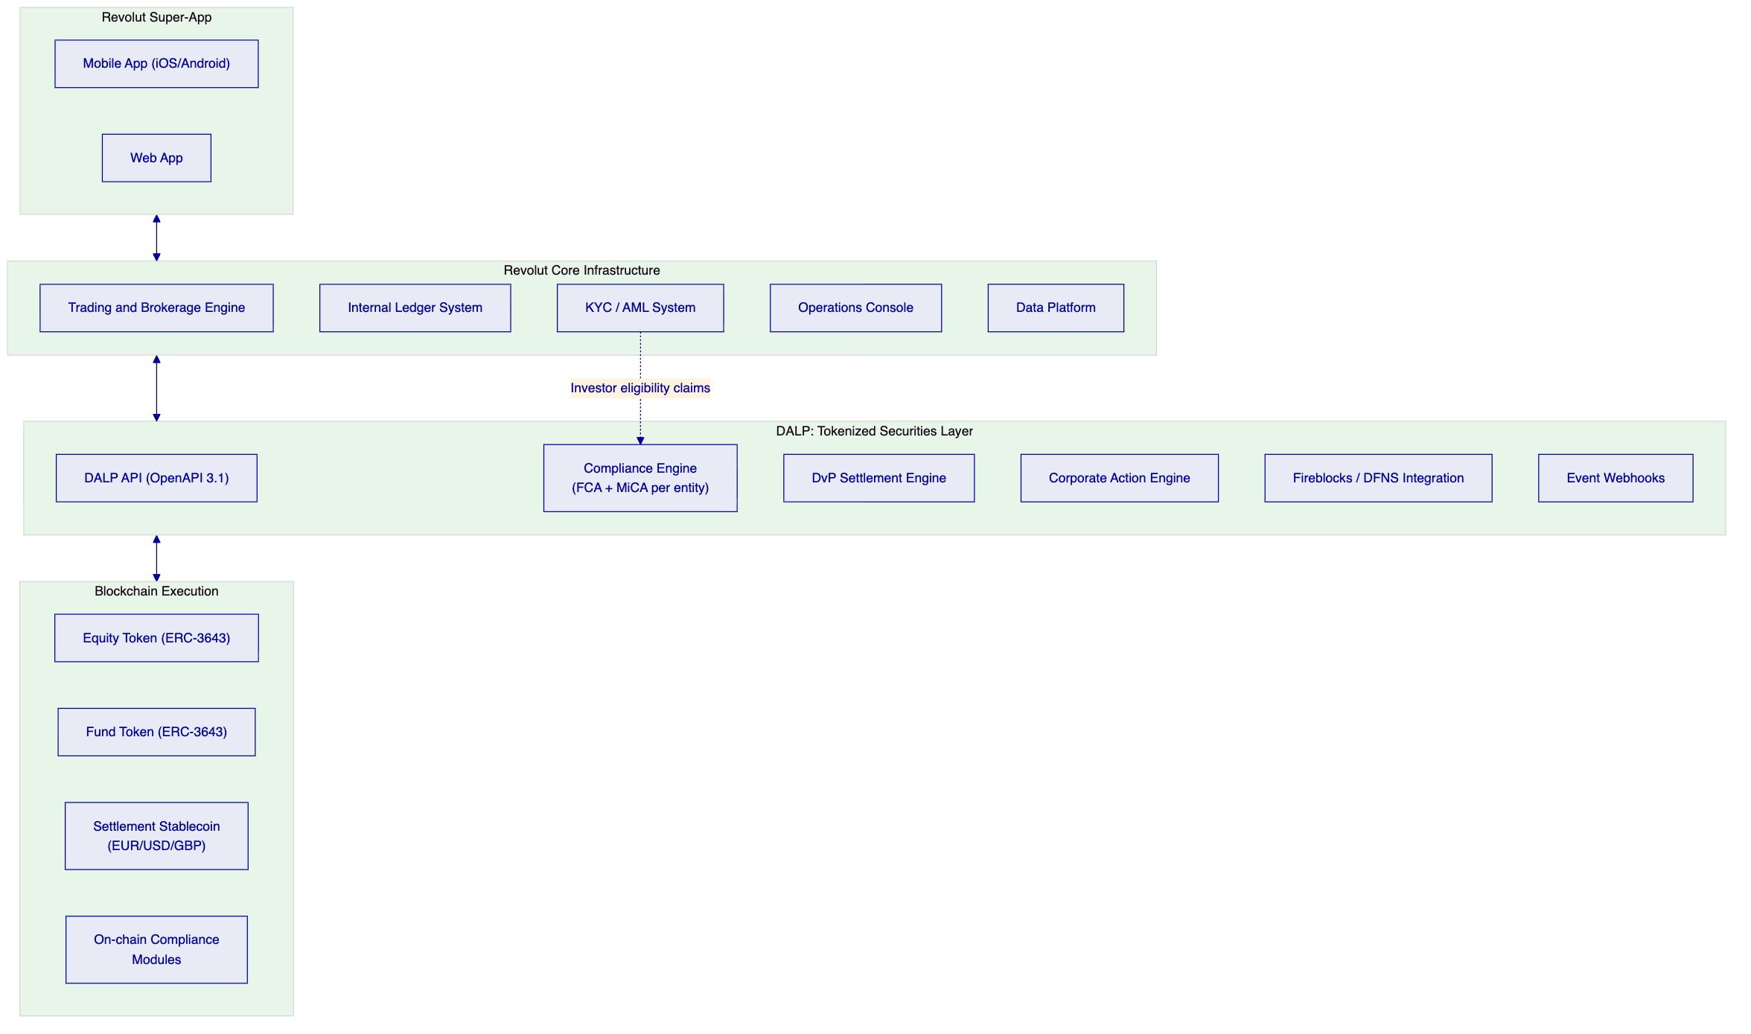
    - DvP Settlement Flow
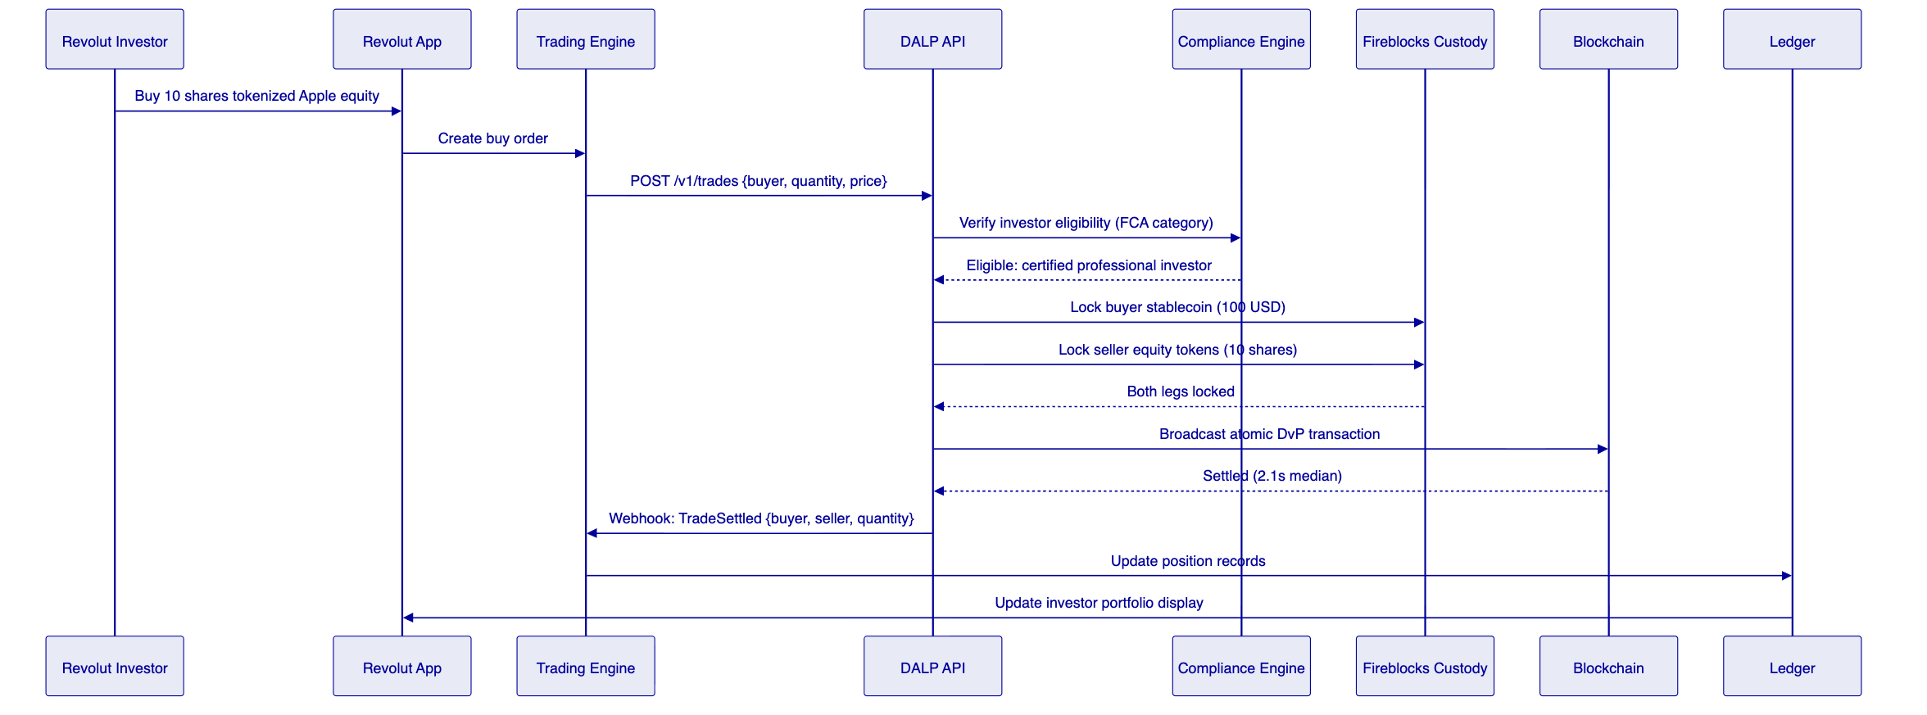
    - Corporate Action: Dividend Distribution
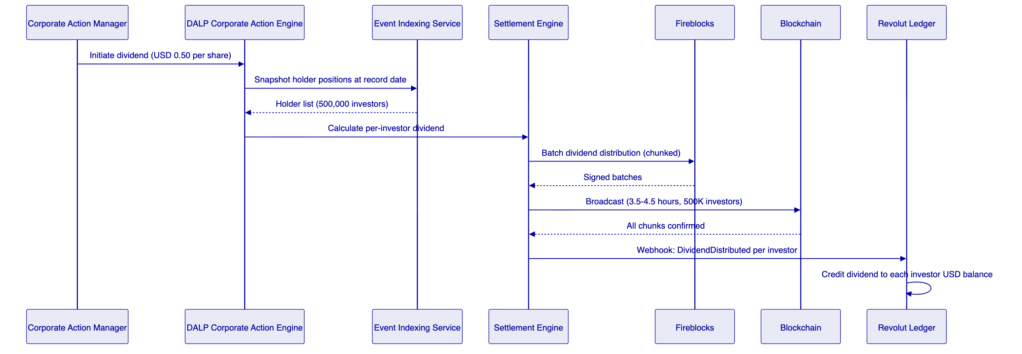
    - Multi-Jurisdiction Compliance Configuration
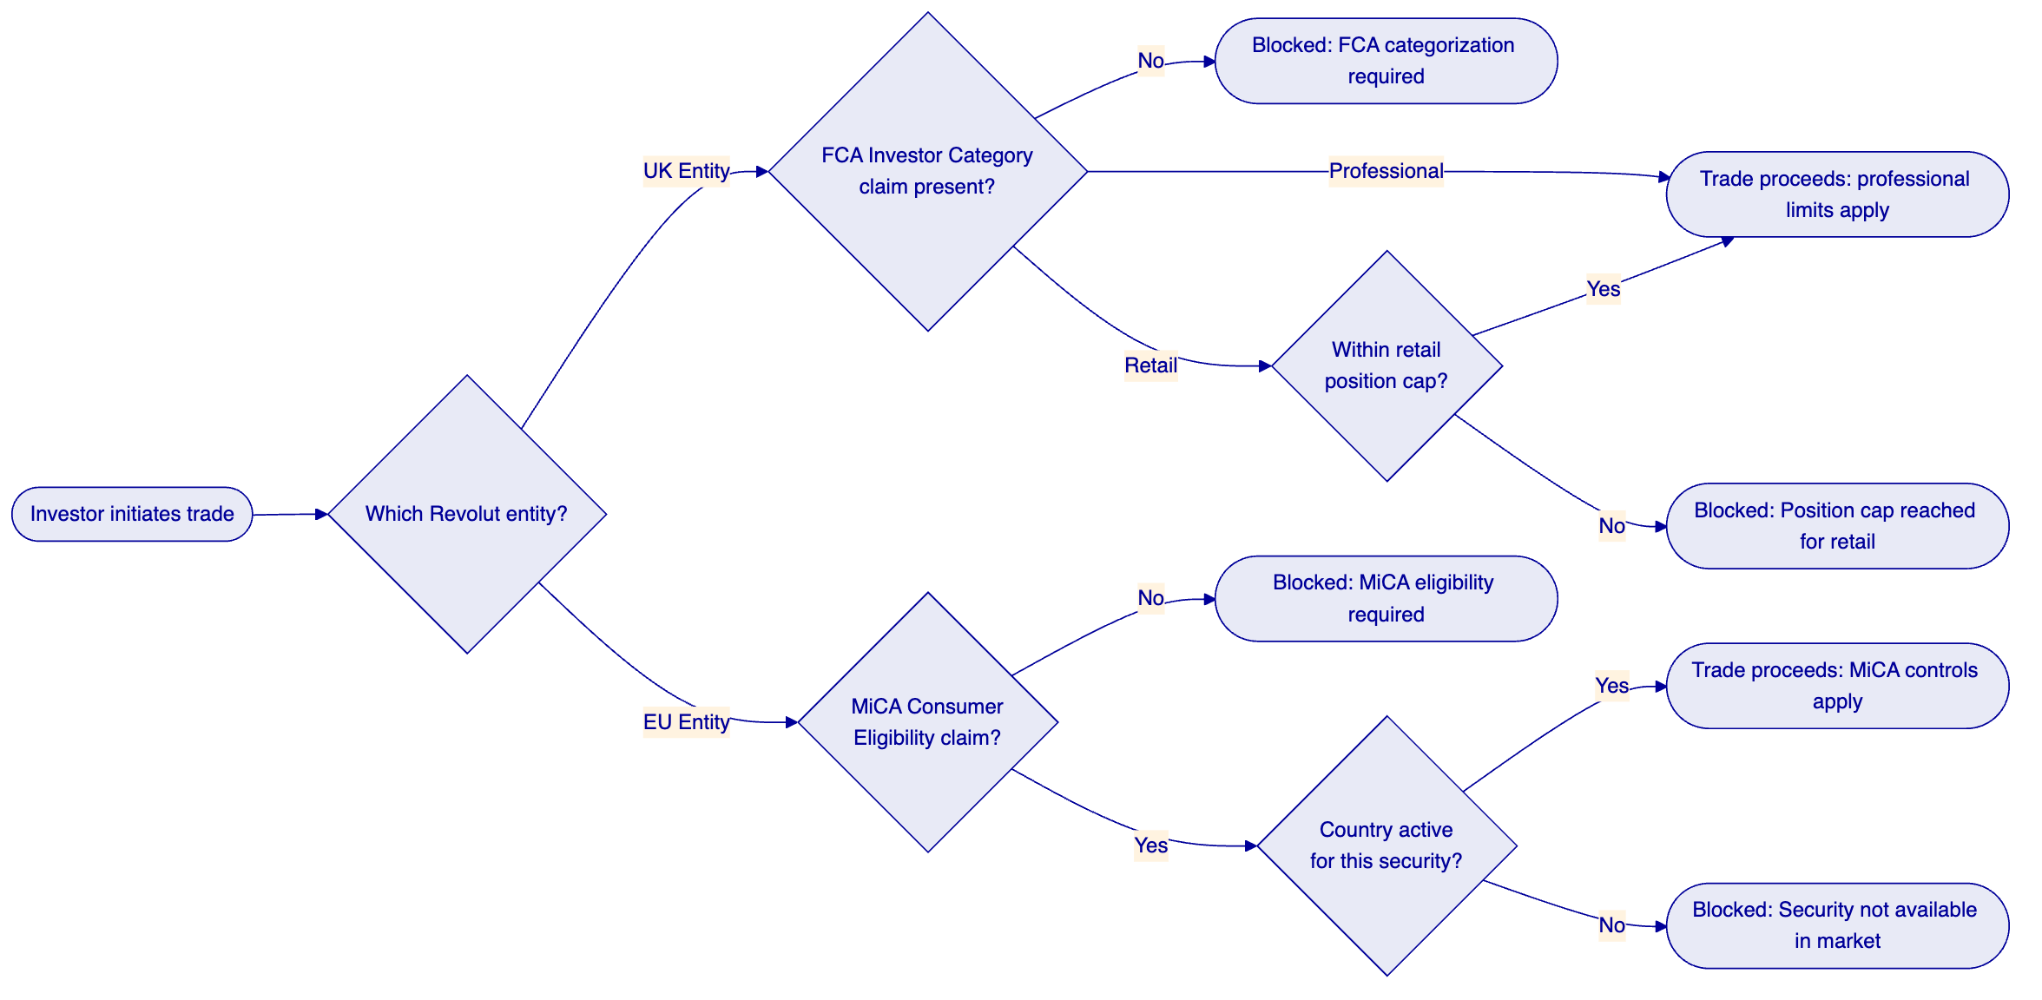
    - Stablecoin Settlement Integration
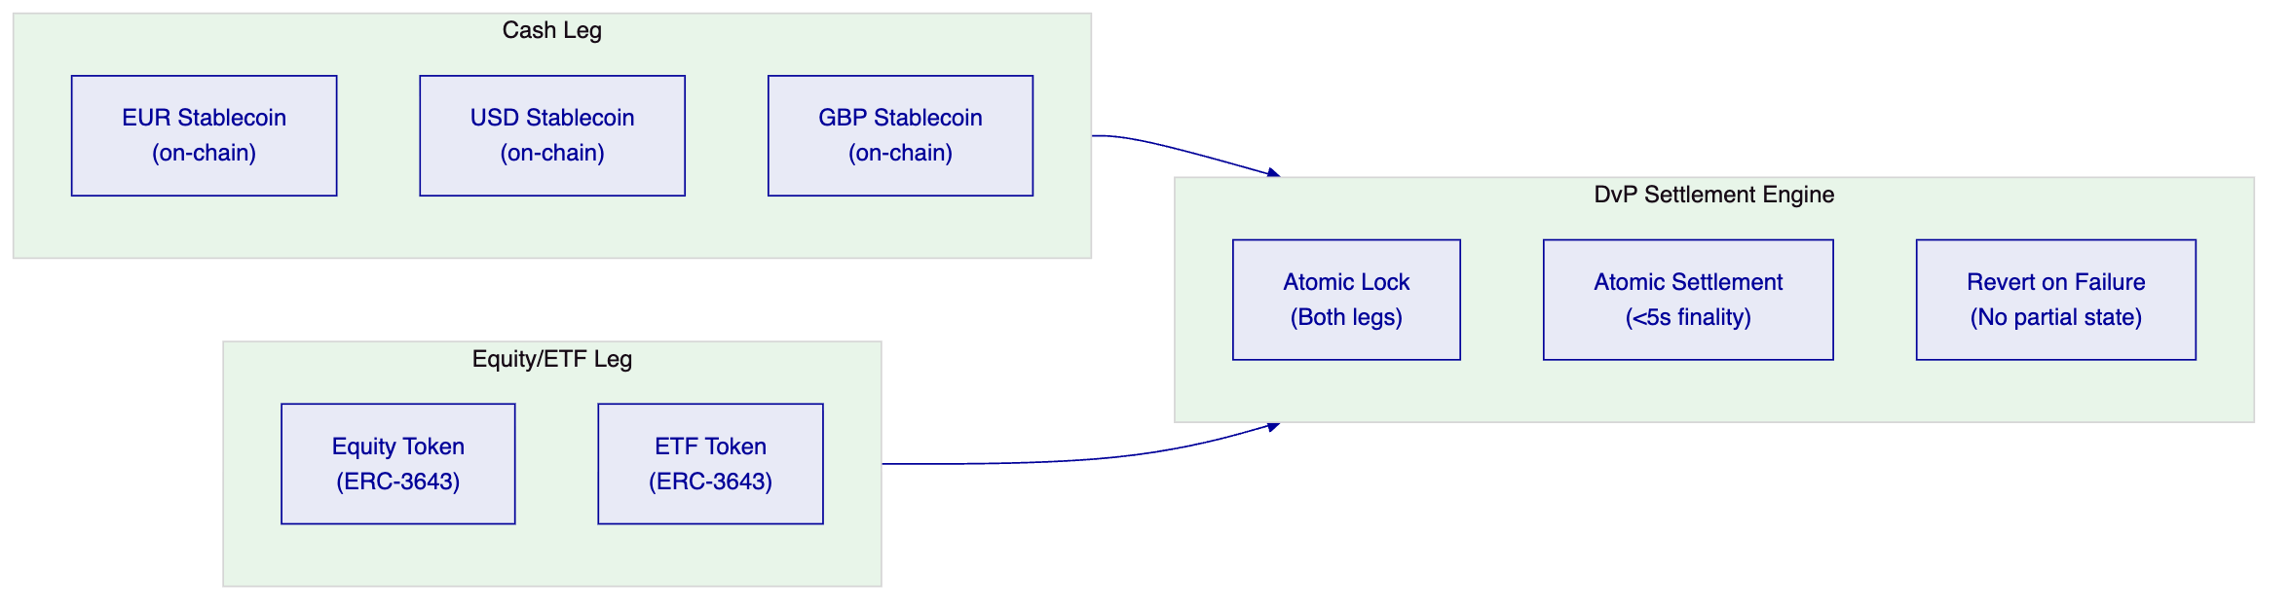

  - 7. Technical Architecture
    - Four-Layer Architecture
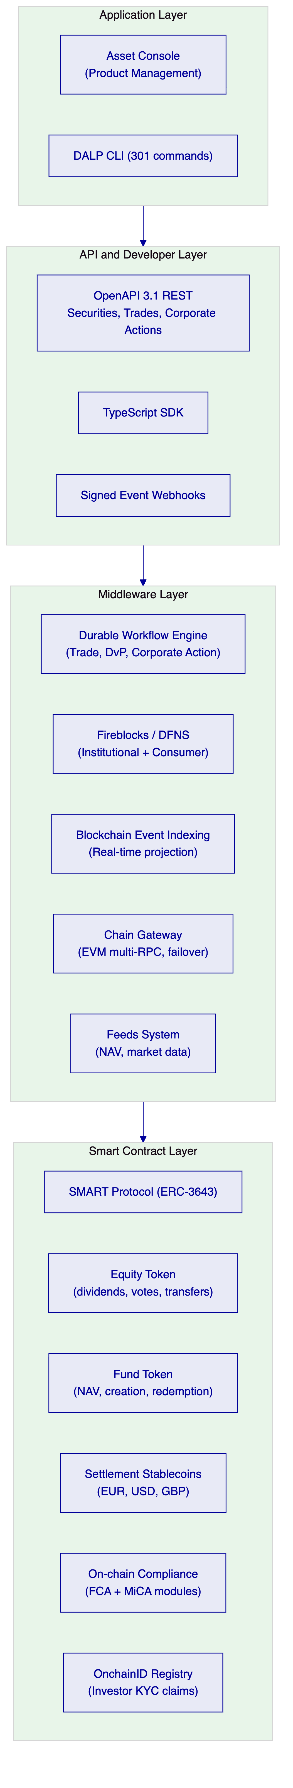
Unlike platforms that couple asset logic to a specific blockchain network, DALP's layered architecture separates product configuration from network execution. Revolut can define tokenized equity parameters, compliance rules, and corporate action schedules independently of which EVM network is chosen, preserving optionality as FCA and MiCA regulatory guidance on DLT networks develops.
    - Integration with Revolut's Super-App Infrastructure
Trading engine integration: DALP REST API integrates within Revolut's trading API gateway. Trade events (settlement confirmations, compliance results) delivered via webhooks to Revolut's internal event bus. Trade status polling available for UI synchronization.
Internal ledger synchronization: DALP's real-time webhook events drive Revolut's ledger position updates. On-chain authoritative balance available through DALP's REST API for reconciliation. Discrepancy detection through DALP's PostgreSQL direct access.
KYC/AML integration: Revolut's existing KYC and AML systems issue investor eligibility claims to DALP's OnchainID registry. Trade compliance checks validate eligibility before settlement. AML screening results reflected in transfer approval compliance module.
Data platform: DALP's REST export API and PostgreSQL direct access feed Revolut's data platform for trading analytics, compliance reporting, and investor account statement generation.
    - Security Architecture
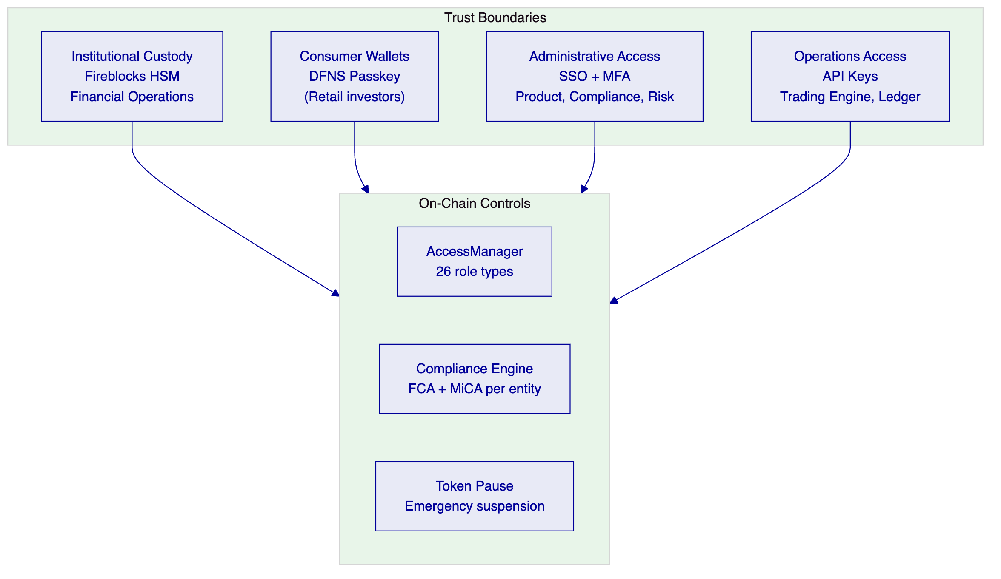

  - 8. Security
Key management (dual-custody model):
Institutional operations (market maker, treasury): Fireblocks HSM-backed MPC. Consumer investor wallets: DFNS passkey MPC. Dual-custody model supports Revolut's separation between institutional asset management and retail investor access.
FCA and MiCA compliance evidence:
Tamper-evident audit log records every compliance decision, product change, and investor eligibility action. FCA examination access via read-only export API. MiCA Article 83 transaction reporting export in structured format.
DORA and UK operational resilience:
Multi-AZ Kubernetes deployment with documented third-party ICT dependencies. Quarterly resilience testing. RTO 1 hour, RPO 15 minutes. Annual penetration test with CISO-reported remediation governance.
GDPR and UK GDPR:
Personal data stored in Revolut's systems. DALP stores hashed investor references only. EU data residency for EEA entity; UK data residency option for UK entity.

  - 9. Project Implementation and Delivery
    - Implementation Programme
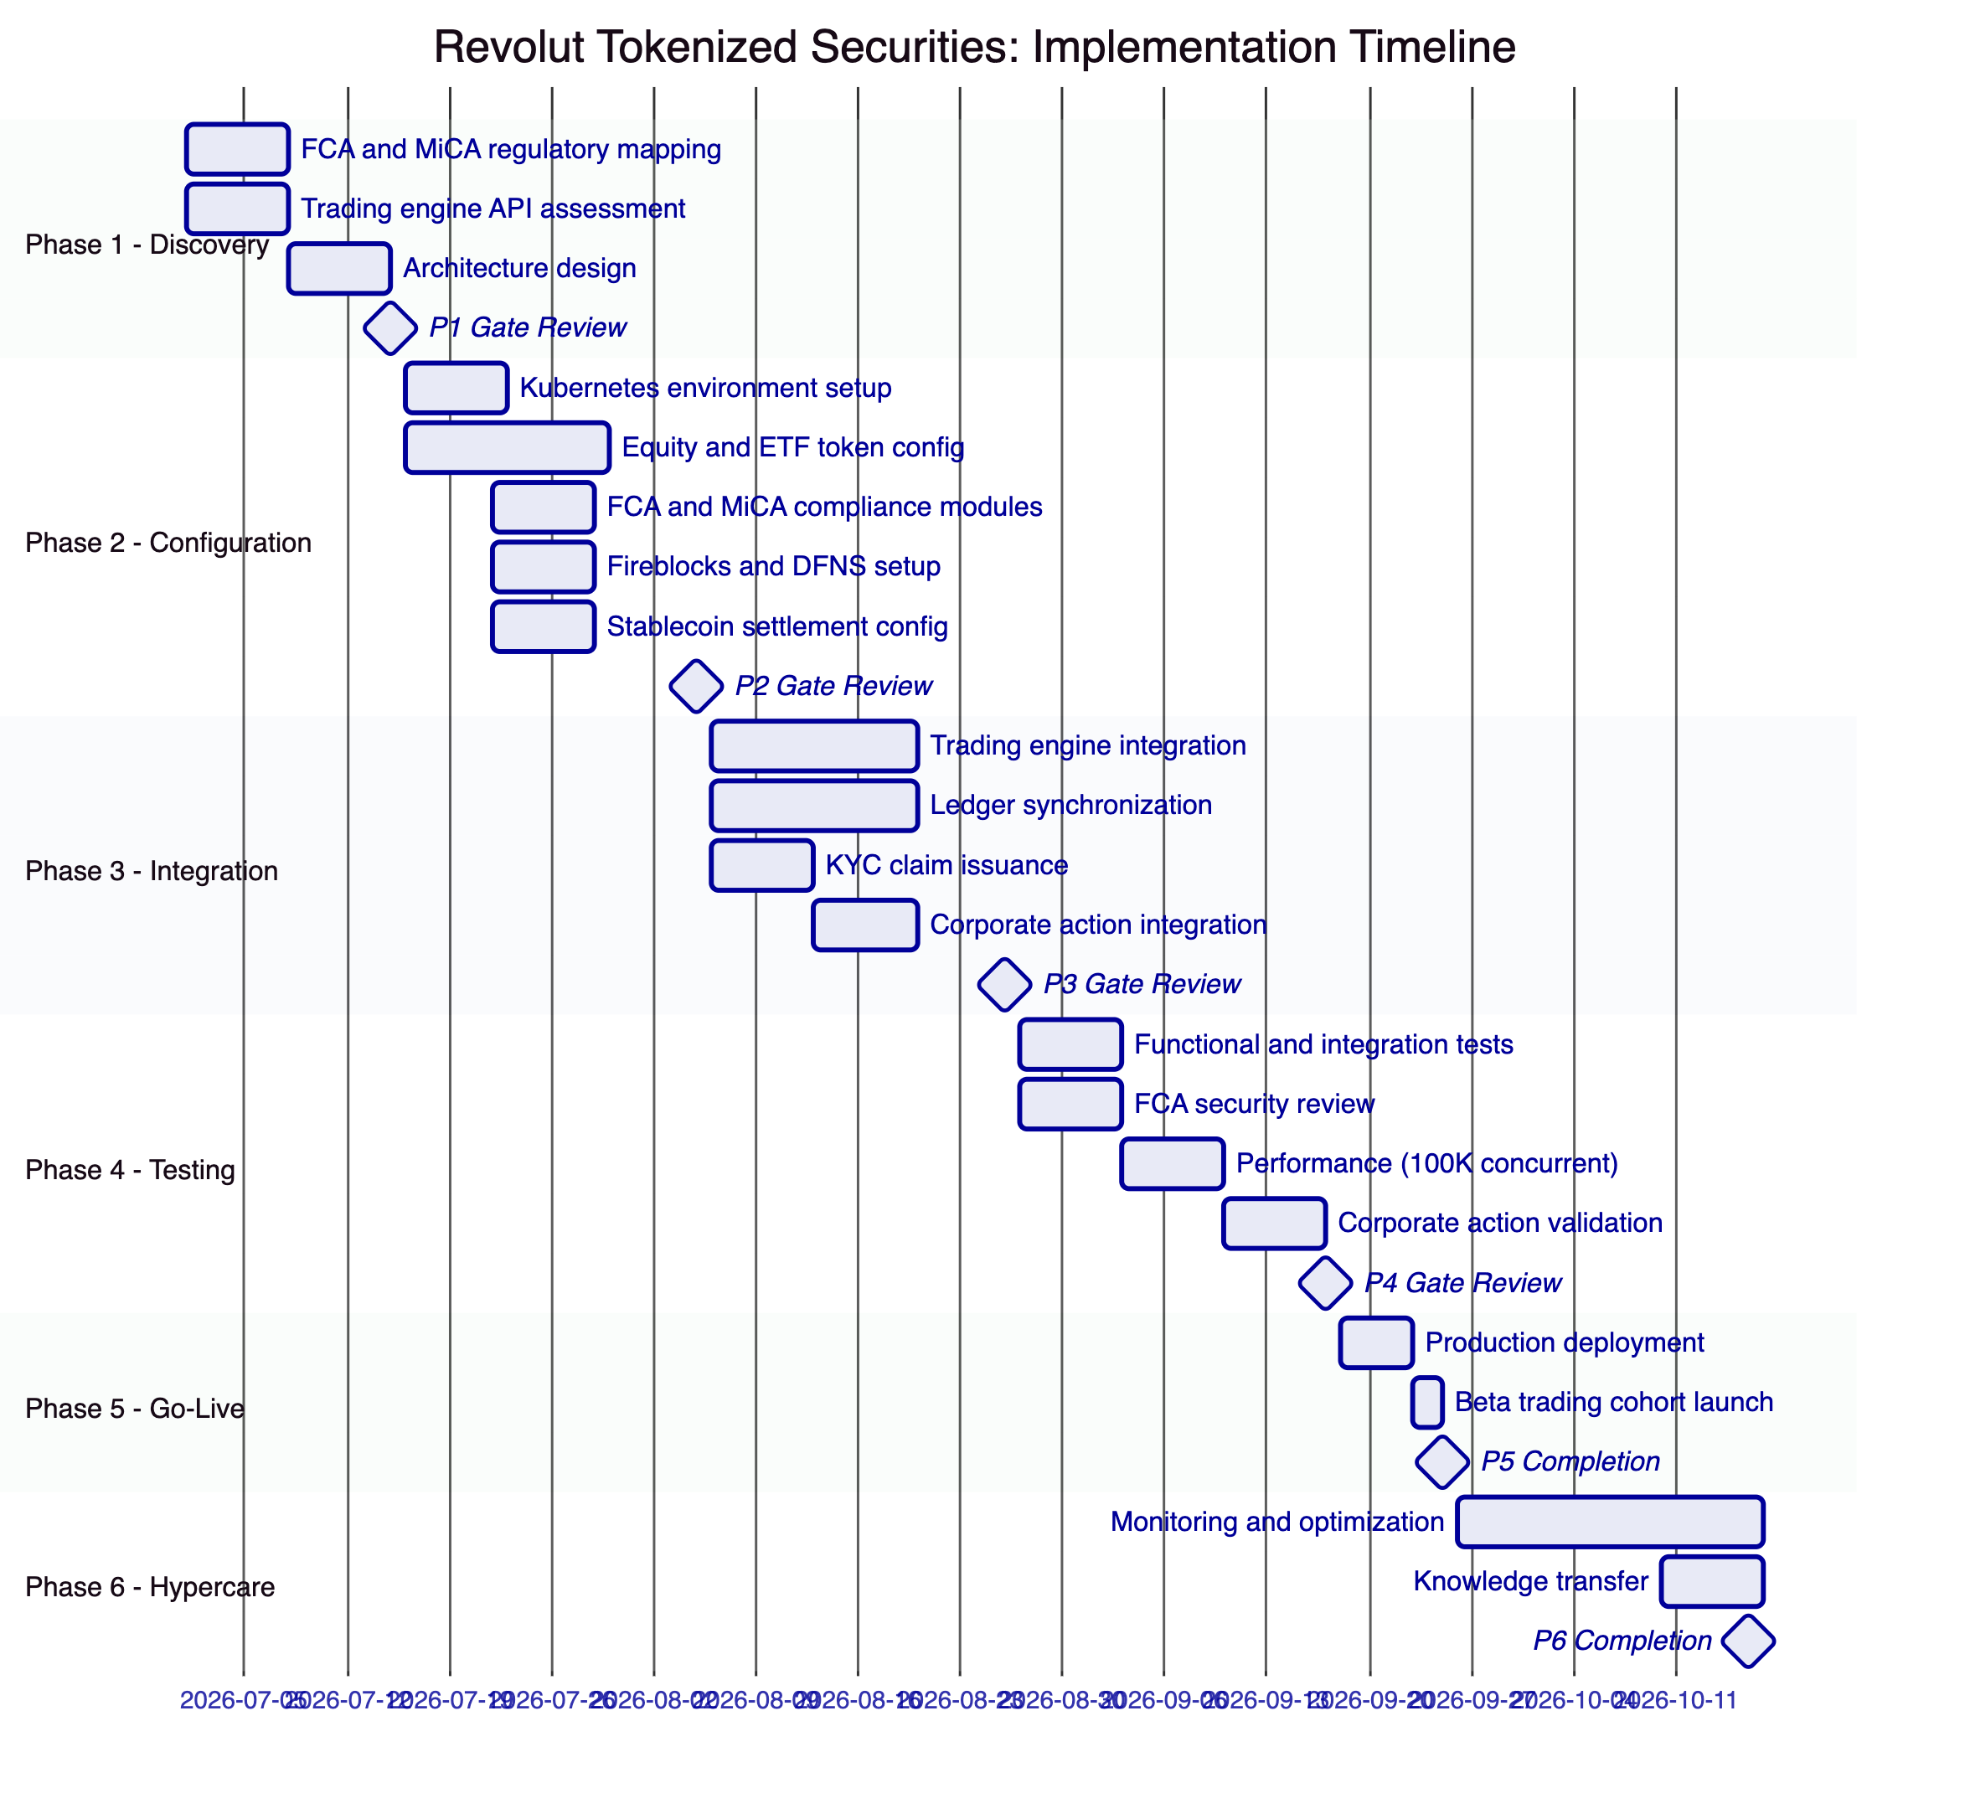
    - Responsibility Matrix
Activity | SettleMint | Revolut | Shared
Architecture design | Lead | Review
Token configuration | Lead
FCA/MiCA regulatory mapping | Support | Lead
Trading engine integration | Support | Lead
Fireblocks/DFNS setup | Lead | Support
KYC claim issuance | Support | Lead
Security review | Support | Lead
Performance testing | Support | Lead
Beta cohort launch | Support | Lead

  - 10. Deployment
    - Recommended: Revolut Private Cloud (Kubernetes, EU Region)
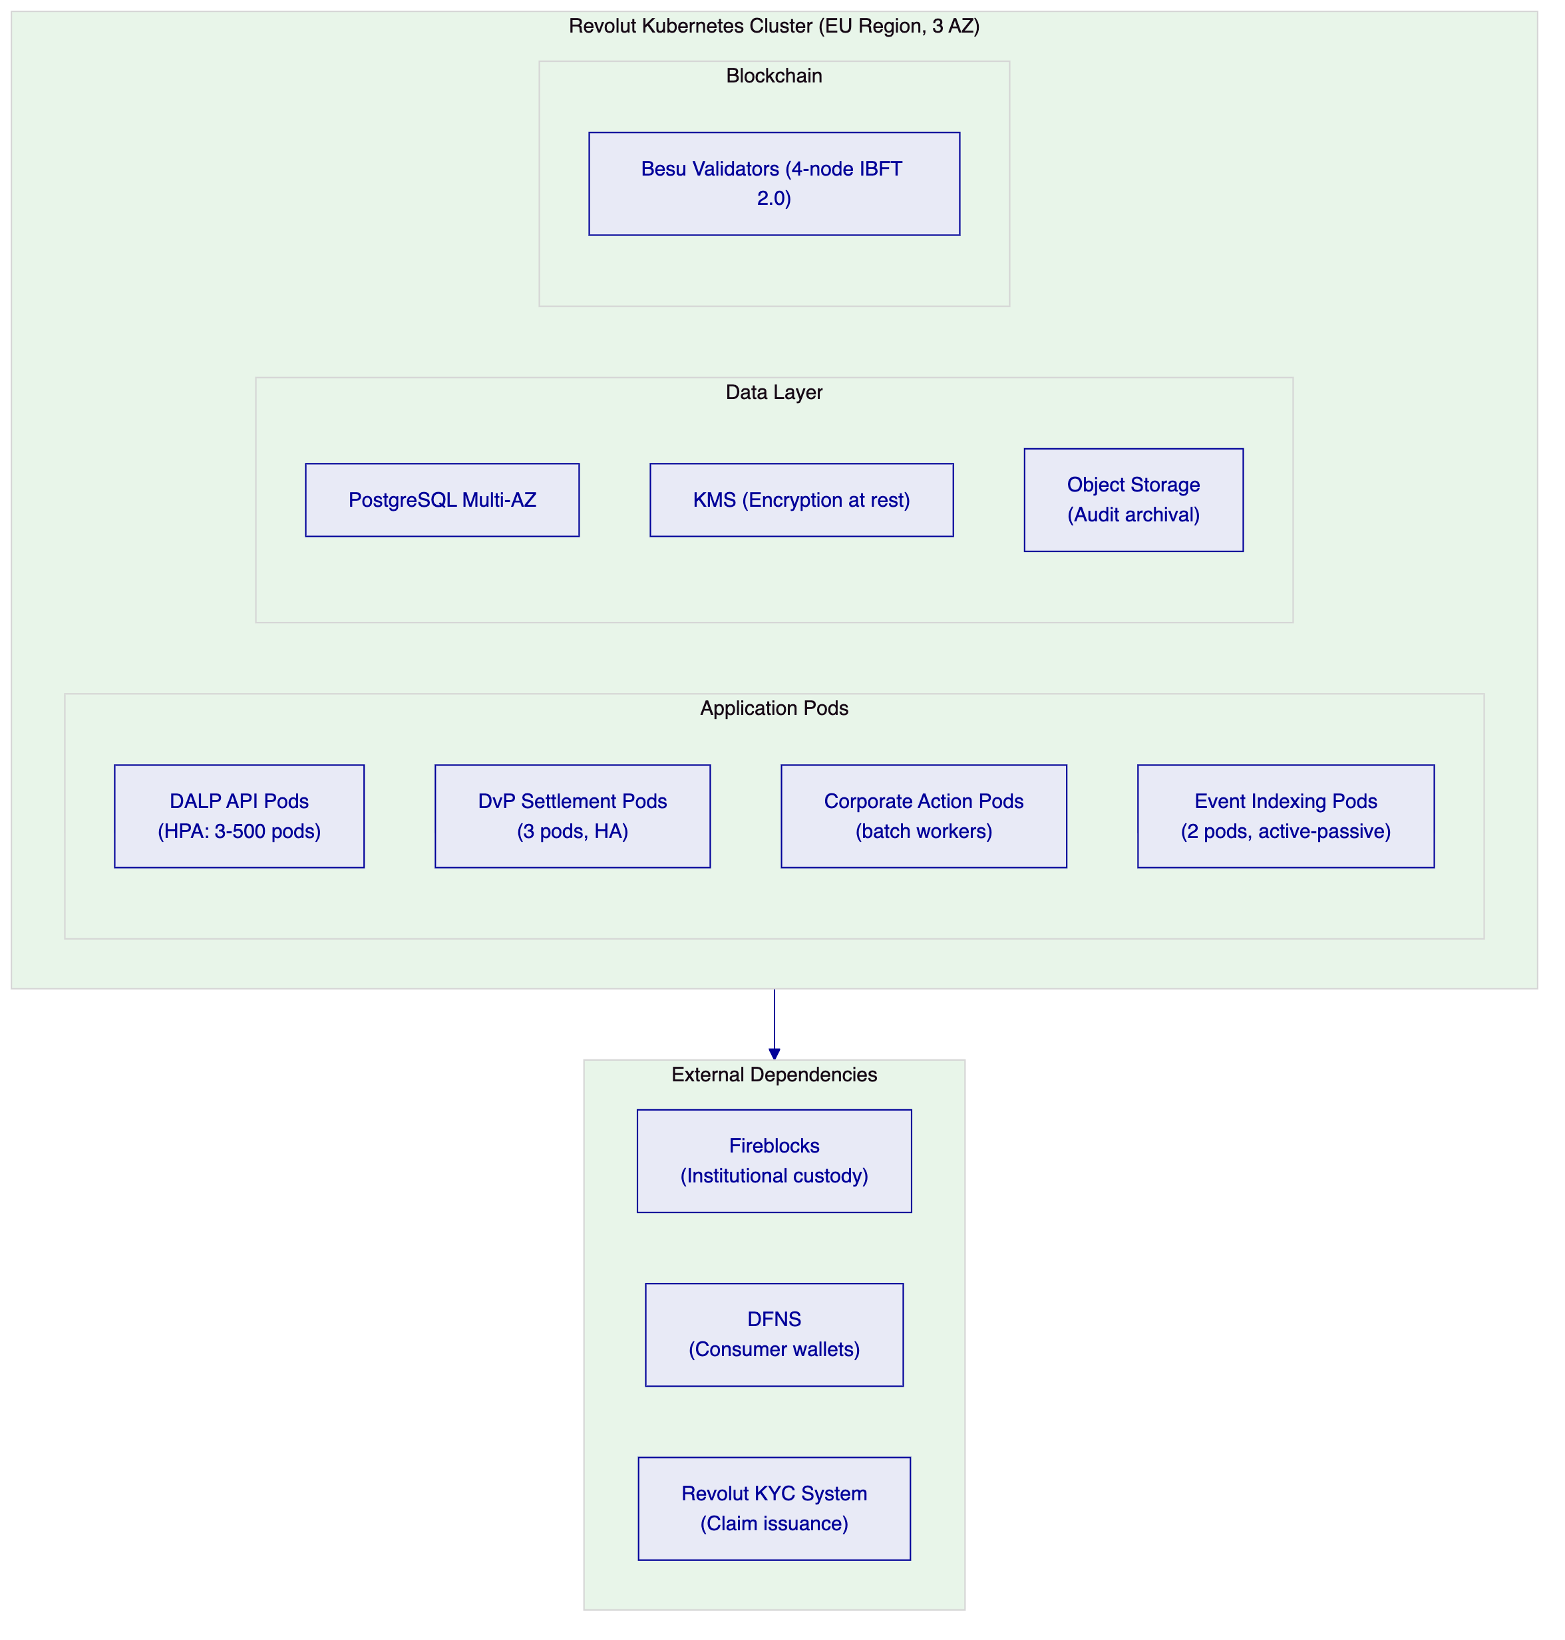

  - 11. Training and Knowledge Transfer
Trading Operations Team (1 day): DALP API for trade submission and settlement status; corporate action management; position query and reconciliation; operations dashboard interpretation.
Product and Compliance Teams (1 day): Asset Designer for tokenized security configuration; FCA and MiCA compliance module management; investor eligibility management; audit log navigation and regulatory export.
Platform Engineering (1 day): Helm deployment and GitOps; webhook integration; TypeScript SDK; performance tuning; monitoring dashboards.
Security and Incident Response (half day): Administrative access monitoring; P1 incident bridge; evidence preservation; FCA notification procedures.

  - 12. Support and SLA
    - Enterprise Support
Attribute | Enterprise
Annual Fee | EUR 120,000
Coverage | 24/7/365
Uptime SLA | 99.99% monthly
P1 Response | 15 minutes
P1 Resolution Target | 2 hours
Dedicated Team | Named
CSM | Named

  - 13. Risk Management
Risk | Likelihood | Impact | Mitigation
FCA approval timeline for tokenized securities | Medium | High | Phase 1 regulatory mapping produces FCA evidence package
Fireblocks integration complexity | Low | Medium | Fireblocks is DALP's primary institutional custody; reference integration available
Trading engine webhook latency affecting settlement UX | Low | Medium | DALP settlement confirmation webhook under 5 seconds; async UI pattern recommended
Multi-jurisdiction compliance configuration | Low | Low | Per-entity compliance module sets fully independent on same DALP instance
Corporate action batch performance for 500K+ investors | Low | Medium | Chunked processing with configurable batch size; no API degradation during processing

  - 14. Compliance Matrix
Requirement | Coverage | DALP Mechanism
FCA COBS 3.5 investor categorization | Supported | On-chain investor category compliance modules
FCA SYSC 8.1 outsourced technology | Supported | ISO 27001, SOC 2 Type II, UK DORA-equivalent
MiCA consumer protection (Art. 72) | Supported | Consumer eligibility, transfer limits, disclosure modules
MiCA transaction reporting (Art. 83) | Supported | Structured data export in regulatory format
DORA ICT risk and third-party | Supported | Third-party dependency documentation, quarterly resilience testing
UK GDPR and EU GDPR | Supported | UK and EU data residency options; off-chain personal data
AML/CFT (UK POCA, EU AMLD) | Supported with partner | Revolut's AML system issues eligibility claims
FCA Market Abuse Regulation | Supported with controls | Transfer approval module; audit trail for MAR investigation support

  - 15. Appendices
    - Appendix A: Requirements Coverage Matrix
Req ID | Status | DALP Mechanism
BR-01 | Supported | Configurable product workflows, Asset Designer
BR-02 | Supported | State machine, durable workflow engine, atomic DvP
BR-03 | Supported | On-chain authoritative, real-time event indexing
BR-04 | Supported | 26 role types, on-chain enforcement
BR-05 | Supported | FCA + MiCA compliance modules, per-entity config
BR-06 | Supported | Event catalog, HMAC-signed webhooks
BR-07 | Supported | Durable workflows, atomic DvP, dead-letter
BR-08 | Supported | Audit log, FCA/MiCA export APIs
BR-09 | Supported | Token pause, cohort claims, market activation
BR-10 | Supported | Multi-product, single platform, shared compliance
TR-01 | Supported | OpenAPI 3.1, TypeScript SDK, versioning
TR-02 | Supported | Three environments, FCA/MiCA test data
TR-03 | Supported | Signed webhooks, at-least-once, dead-letter
TR-04 | Supported | OAuth 2.0/OIDC, MFA, Fireblocks HSM, DFNS passkey
TR-05 | Supported | Kubernetes, Helm, GitOps, EU region
TR-06 | Supported | Prometheus, Grafana, OpenTelemetry
TR-07 | Supported | P99 4.2s, auto-scaling to 500 pods
TR-08 | Supported | REST, webhooks, PostgreSQL direct, CSV
TR-09 | Supported | Quarterly releases, 12-month deprecation
TR-10 | Supported | Constraints register disclosed
TR-11 | Supported | Helm, Terraform, ArgoCD/Flux
TR-12 | Supported | 15-min P1, incident bridge, status page

Document Classification: SettleMint Confidential
SettleMint NV | Simon Bolivarlaan 5, 2600 Antwerp, Belgium | www.settlemint.com
Version 1.0 | March 2026

