[Company name]
[Document title]
[Document subtitle]

Confidentiality Statement
This document contains confidential and proprietary information of SettleMint. By reading this document, you agree not to disclose the confidential information contained herein to any third party without the prior written consent of SettleMint, except to those agents, principals, representatives, or consultants who require access for the purpose of evaluating this document. You further agree to inform such persons of the confidential nature of this document and to obtain their agreement to preserve its confidentiality to the same extent as yours.
This confidentiality statement shall remain binding on the parties for a period of five (5) years from the date stated on the front cover, unless superseded by confidentiality provisions detailed in a subsequent agreement.
Terms and Conditions
This proposal is valid until [DD Month YYYY]. In the absence of confirmation to proceed, SettleMint and [the Company] acknowledge and agree to abide by the Mutual NDA as the governing agreement.
SettleMint reserves the right to vary the terms of this proposal in response to changes in specifications or information made available at a later date. Submission of this proposal does not convey any right, title, interest, or license in any intellectual property rights (including, but not limited to, patents, copyrights, trade secrets, or trademarks) contained herein.
All rights are reserved. This proposal and the information contained within it are provided on an “as is” basis, without any warranties of any kind, express or implied.
All contracts with SettleMint will be governed by Belgian Law and subject to the exclusive jurisdiction of Belgian courts.
Contact Details
For any enquiries regarding this document, please contact:
[Full Name]
[Job Title]
Email: [email@example.com]
Phone: [Country Code - Number]

Table of Contents

Technical Proposal for Scalable Capital GmbH 3
SettleMint | March 2026 | v1.0 | SettleMint Confidential 4
Table of Contents 5
1. Executive Summary 6
The Value Proposition 7
Why DALP for Scalable Capital 8
Requirements Coverage Summary 9
2. About SettleMint 10
3. About DALP 11
Platform Overview 12
DALP Platform Architecture for Scalable Capital 13
DALP Lifecycle Pillars for Tokenized Funds 14
4. Customer References 15
BNP Paribas Expanded Reference 16
Commerzbank Expanded Reference 17
5. Understanding of Requirements 18
Business Requirements 19
Technical Requirements 20
6. Proposed Solution and Functional Capabilities 21
Solution Architecture 22
Fund Subscription Flow 23
NAV Feed Integration 24
Yield Distribution (Distributing Share Class) 25
7. Technical Architecture 26
Four-Layer Architecture 27
Performance Specifications 28
8. Security 29
9. Project Implementation and Delivery 30
Implementation Programme 31
Responsibility Matrix 32
10. Deployment 33
11. Training and Knowledge Transfer 34
12. Support and SLA 35
13. Risk Management 36
14. Compliance Matrix 37
15. Appendices 38
Appendix A: Requirements Coverage Matrix 39

  - Technical Proposal for Scalable Capital GmbH
    - SettleMint | March 2026 | v1.0 | SettleMint Confidential

Prepared by: SettleMint NV
Prepared for: Scalable Capital GmbH, Seitzstrasse 8, 80538 Munich, Germany
Document reference: SM-TECH-SCALABLE-2026-001
Classification: Strictly Confidential
Version: 1.0
Date: March 2026
Contact: bids@settlemint.com

  - Table of Contents
- Executive Summary
- About SettleMint
- About DALP
- Customer References
- Understanding of Requirements
- Proposed Solution and Functional Capabilities
- Technical Architecture
- Security
- Project Implementation and Delivery
- Deployment
- Training and Knowledge Transfer
- Support and SLA
- Risk Management
- Compliance Matrix
- Appendices

  - 1. Executive Summary
Scalable Capital serves over 7 million customers across Germany, Austria, the UK, and other European markets as a digital wealth and brokerage platform specializing in automated investing, ETF-based wealth management, and scalable brokerage operations. Scalable Capital's operational model -- automated portfolio rebalancing, cost-efficient execution, and lean operations -- shapes exactly what a tokenized investment platform must deliver: a programmable, API-first infrastructure that handles tokenized fund issuance, NAV-linked portfolio servicing, investor eligibility enforcement, and yield distribution automation without creating a manual operational back-office that contradicts Scalable Capital's lean operating philosophy.
Scalable Capital's procurement focus is a tokenized investment platform that integrates with its existing brokerage and wealth management infrastructure, satisfies BaFin and MiCA requirements for tokenized fund products, and provides the API-first automation that Scalable Capital's engineering culture demands. DALP provides precisely this infrastructure.
SettleMint proposes DALP, the Digital Asset Lifecycle Platform, as the tokenized investment infrastructure for Scalable Capital. DALP provides tokenized fund issuance with NAV feed integration, automated portfolio yield distribution, compliance enforcement for MiCA and BaFin consumer fund regulations, DvP settlement aligned with Scalable Capital's brokerage settlement flows, and the developer-grade API infrastructure that Scalable Capital's teams require.
    - The Value Proposition
DALP delivers a production-grade tokenized investment infrastructure in 12 to 16 weeks that integrates into Scalable Capital's automated wealth management stack without requiring a parallel manual operations team, at a total Year 1 cost of approximately EUR 840,000.
    - Why DALP for Scalable Capital
Automation-first design: DALP's programmable yield schedules, NAV-feed-driven price updates, and automated portfolio rebalancing events align with Scalable Capital's automated wealth management philosophy. Operations teams monitor distribution status through dashboards; manual intervention is exception-handling only.
BaFin and MiCA fund compliance: DALP's 18 compliance module types enforce investor eligibility for tokenized fund products under BaFin's KAGB framework and MiCA's Title III consumer protection requirements. Fund token configurations for retail and professional investor segments with independent compliance modules.
Lean integration: DALP's OpenAPI 3.1 REST API integrates as a microservice within Scalable Capital's existing brokerage API layer. Webhook events drive Scalable Capital's portfolio management system updates in real time. No proprietary SDK lock-in.
German regulatory alignment: Commerzbank deployment under BaFin supervision provides direct regulatory reference for Scalable Capital's BaFin-supervised operations. DALP's audit trail satisfies BaFin Circular 05/2023 outsourcing requirements and the KAGB record-keeping obligations for fund administration.
    - Requirements Coverage Summary
Requirement Domain | Coverage | DALP Mechanism
Tokenized fund issuance (ETF, UCITS) | Supported | Fund token template with NAV feeds
Automated NAV updates | Supported | Feeds system with configurable price sources
Portfolio yield distribution | Supported | Automated yield schedule engine
MiCA consumer fund eligibility | Supported | 18 compliance module types
BaFin KAGB compliance | Supported | Audit trail, compliance modules, reporting
DvP settlement | Supported | Atomic settlement engine
API integration with brokerage | Supported | OpenAPI 3.1, webhooks
Phased market expansion | Supported | Country restriction modules
Automated portfolio rebalancing events | Supported | Token transfer with compliance validation
Observability for automated operations | Supported | Three-pillar observability, Grafana

  - 2. About SettleMint
SettleMint builds institutional digital asset lifecycle infrastructure for regulated financial markets. ISO 27001 and SOC 2 Type II certified. The Commerzbank deployment under BaFin supervision in Germany is the primary reference for Scalable Capital's BaFin-regulated operations. For tokenized fund products, the BNP Paribas and Nordea deployments demonstrate DALP's fund distribution capabilities at consumer banking scale. Over 200 years of combined banking and blockchain experience across the SettleMint team.

  - 3. About DALP
    - Platform Overview
DALP is SettleMint's Digital Asset Lifecycle Platform. For Scalable Capital's tokenized investment platform, the most relevant capabilities are: fund token template with NAV feed integration and automated subscription/redemption; compliance enforcement for fund investor eligibility under KAGB and MiCA; automated yield and distribution scheduling; DvP settlement for subscription and redemption flows; and API-first integration with Scalable Capital's automated wealth management stack.
    - DALP Platform Architecture for Scalable Capital
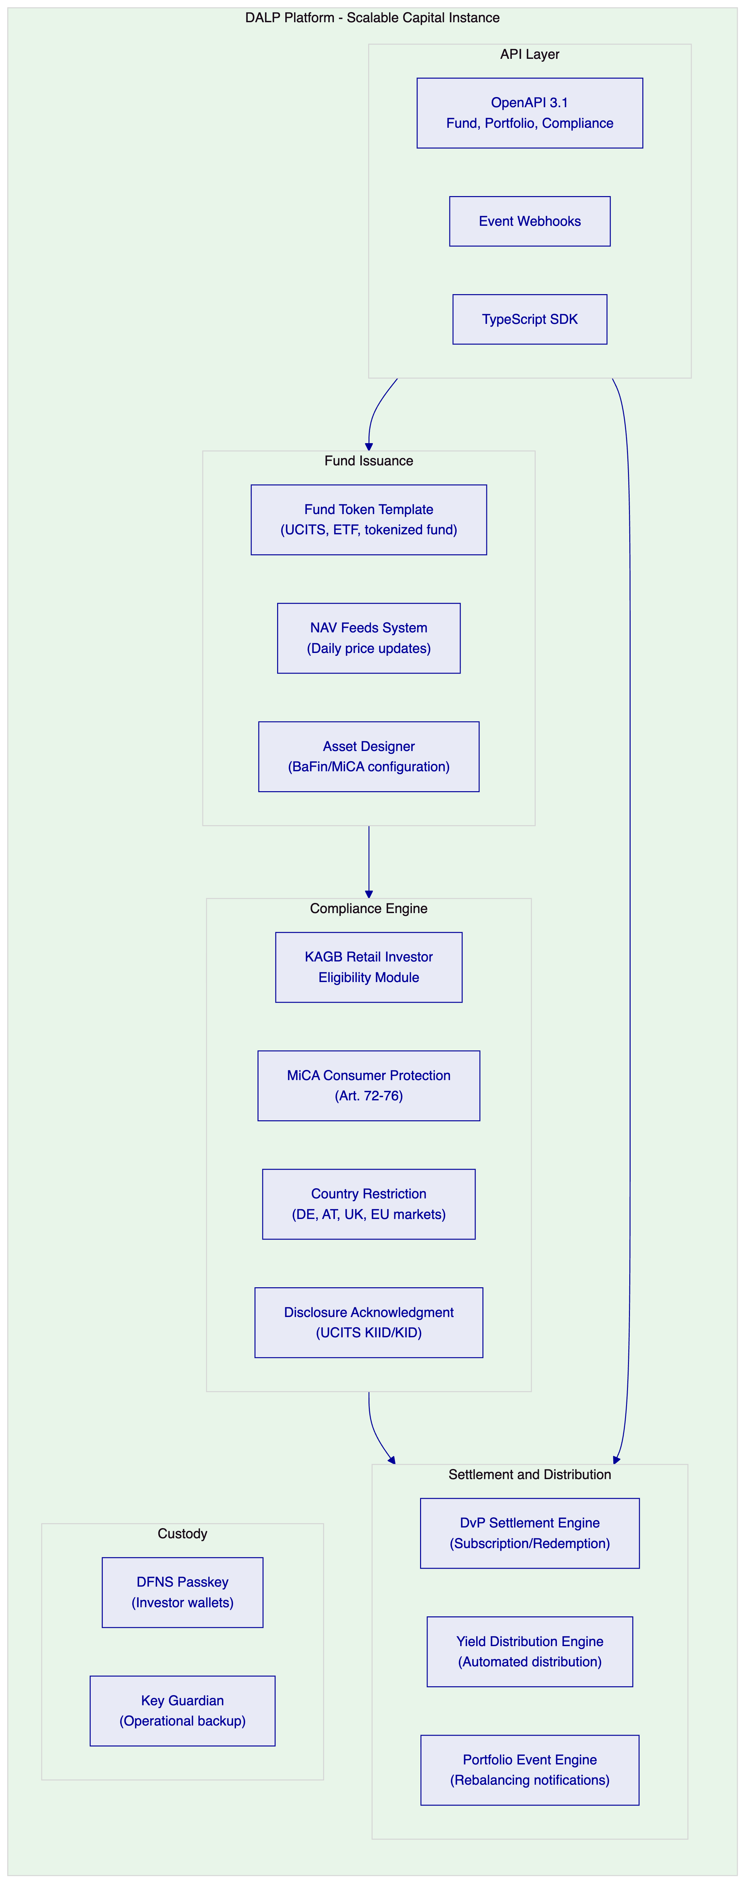
    - DALP Lifecycle Pillars for Tokenized Funds
Issuance: Fund token template deploys tokenized fund products with daily NAV feed integration, creation and redemption mechanism, distribution schedule, and KAGB/MiCA compliance module attachment. Paused-by-default creates BaFin review gate before investor access.
NAV Feed Integration: DALP's Feeds system connects to Scalable Capital's existing price sources (Bloomberg, Refinitiv, or internal fund administrator) via configurable data adapters. Daily NAV updates reflected in fund token reference price. Stale NAV detection alerts operations team within 15 minutes of missed update.
Compliance: KAGB and MiCA compliance modules per fund product:
- Retail fund (KAGB): KIID/KID disclosure acknowledgment, retail investor eligibility, country restriction (DE, AT)
- Professional fund (KAGB): qualified investor eligibility, country restriction (EEA)
- MiCA consumer protection: Art. 72 eligibility, transfer limits, disclosure
Settlement: DvP for subscription (EUR stablecoin for fund tokens) and redemption (fund tokens for EUR stablecoin). T+0 settlement versus T+2 or T+3 for traditional fund settlement. Atomic: no partial subscription or redemption.
Distribution: Automated dividend and income distribution for distributing fund share classes. Accumulating share class: automatic reinvestment through token supply adjustment. Distributing share class: cash distribution to investor accounts through webhook to Scalable Capital's ledger.

  - 4. Customer References
Institution | Relevance to Scalable Capital
BNP Paribas | Tokenized fund distribution at consumer scale -- directly relevant to retail fund product
Nordea | Tokenized funds under Finansinspektionen; MiCA-adjacent regulatory context
Commerzbank | BaFin-supervised Germany; outsourcing guidance compliance
KBC Securities | Retail brokerage and SME investment products
ADI Finstreet | DFNS passkey integration for investor wallets

    - BNP Paribas Expanded Reference
BNP Paribas deployed DALP for tokenized fund distribution at consumer banking scale. The deployment demonstrates DALP's fund token template with NAV integration, automated distribution, and retail investor compliance controls. BNP Paribas serves millions of retail fund investors; the reference confirms DALP's ability to handle the investor volume and compliance requirements that Scalable Capital's 7 million customer base requires.
    - Commerzbank Expanded Reference
Commerzbank deployed DALP under BaFin supervision in Germany, demonstrating DALP's compliance with BaFin Circular 05/2023 on outsourced IT systems and its ability to pass German institutional security review. EUR 7 million in annual operational savings in Phase 1. Directly relevant to Scalable Capital's BaFin-supervised operations.

  - 5. Understanding of Requirements
    - Business Requirements
BR-01: Configurable product workflows aligned to internal approval
Asset Designer provides Scalable Capital's product governance team with configurable fund product workflows. Fund product creation approval chain: Product Manager (configures parameters), Risk (validates risk limits), Compliance (BaFin and MiCA alignment), BaFin liaison (documentation). Fund configuration changes tracked with maker-checker approval on-chain.
BR-02: Deterministic state transitions
Fund lifecycle: Draft, BaFin Review, Approved, Paused, Active Subscription, Subscription Closed, Distribution Pending, Distribution Complete, Redeemed. Investor transaction states: Initiated, Compliance Checked, DvP Locked, Settled, Dead Letter.
BR-03: Entitlement and balance accuracy
On-chain fund token balances authoritative. Blockchain event indexing service projects to PostgreSQL in real time. Scalable Capital's portfolio management system reads fund positions via DALP's REST API. Daily reconciliation between DALP on-chain balances and Scalable Capital's account ledger; discrepancies surfaced as alerts within 15 minutes.
BR-04: Role-based segregation
Key roles: Fund Product Manager, Compliance Officer, NAV Administrator (updates feed configuration), Distribution Manager (triggers yield distribution), Investor Support (read-only), Emergency (fund pause).
BR-05: Configurable limits and eligibility
Per-fund compliance configuration:
- Retail UCITS fund: KIID disclosure, country restriction (DE, AT, UK), retail transfer limits
- Professional fund: qualified investor claim, country restriction (EEA), position limits
- ETF product: continuous creation/redemption, daily NAV-linked price
BR-06: Automated notifications and events
Event catalog: FundLaunched, SubscriptionWindowOpen, SubscriptionCompleted, NAVUpdated, DistributionTriggered, DistributionCompleted, RedemptionSettled, CompliancePassed/Failed, FundPaused/Resumed.
BR-07: Business continuity
Durable workflows for all subscription and redemption flows. DFNS unavailability: transactions queue without loss. Atomic DvP: no partial subscription or redemption. Dead-letter queue for permanently failed transactions.
BR-08: Audit-ready reporting
BaFin KAGB record-keeping: subscription and redemption audit trail, NAV update history, distribution records per investor, compliance decision log. Export: JSON, CSV, PostgreSQL direct. Retention: 10 years.
BR-09: Phased rollout
Fund product launch: Germany first, expand to Austria and UK through country restriction module update. Cohort access: early-access eligibility claims for pilot investor group. Fund pause for compliance review.
BR-10: Adjacent product reuse
Same DALP instance: add tokenized bond funds, tokenized equity products, and stablecoin payment features without re-architecture.
    - Technical Requirements
TR-01: OpenAPI 3.1 with fund, portfolio, and compliance namespaces. TypeScript SDK. 12-month deprecation policy.
TR-02: Three environments with seeded Scalable Capital test data: 3 fund products, 500 test investor wallets, NAV feed mock.
TR-03: Fund event webhooks: signed, at-least-once, dead-letter.
TR-04: OAuth 2.0/OIDC with Scalable Capital's identity provider. DFNS passkey for investor wallet authorization.
TR-05: Private Cloud on Scalable Capital's Kubernetes infrastructure (AWS, eu-central-1) or SettleMint Managed SaaS for development.
TR-06: Prometheus metrics, Grafana dashboards, JSON logs. Fund-specific dashboards: subscription throughput, NAV feed status, distribution progress, reconciliation status.
TR-07: API response P99 300ms. Subscription/redemption finality P99 4.2 seconds. Yield distribution for 100,000 investors: 35-45 minutes.
TR-08: REST export, webhooks, PostgreSQL direct access, CSV for Scalable Capital's data warehouse.
TR-09: Quarterly major releases, 12-month deprecation. Maintenance windows coordinating with Scalable Capital's change management.
TR-10 Constraints:
Constraint | Description | Mitigation
C-01 | EVM only | Private Besu or public EVM
C-02 | NAV feed: stale data detection only; DALP does not calculate NAV | Scalable Capital's fund administrator provides NAV
C-03 | Distribution batch: 100K investors in 35-45 min | Chunked processing; no API degradation
C-04 | GDPR deletion: on-chain pseudonymous | Off-chain deletable

TR-11: Helm charts, Terraform, ArgoCD/Flux GitOps.
TR-12: Enterprise support, 15-minute P1, incident bridge, status page.

  - 6. Proposed Solution and Functional Capabilities
    - Solution Architecture
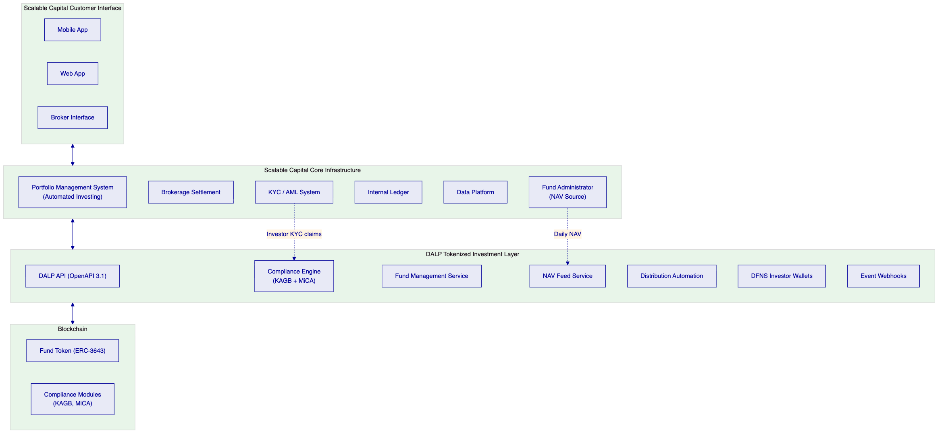
    - Fund Subscription Flow
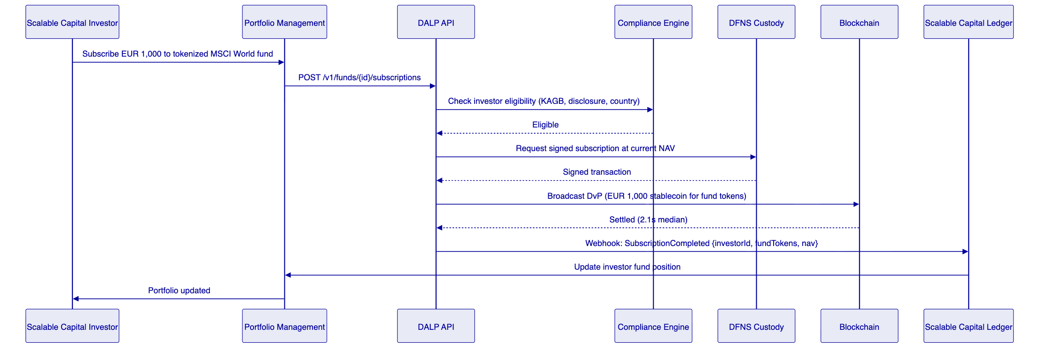
    - NAV Feed Integration
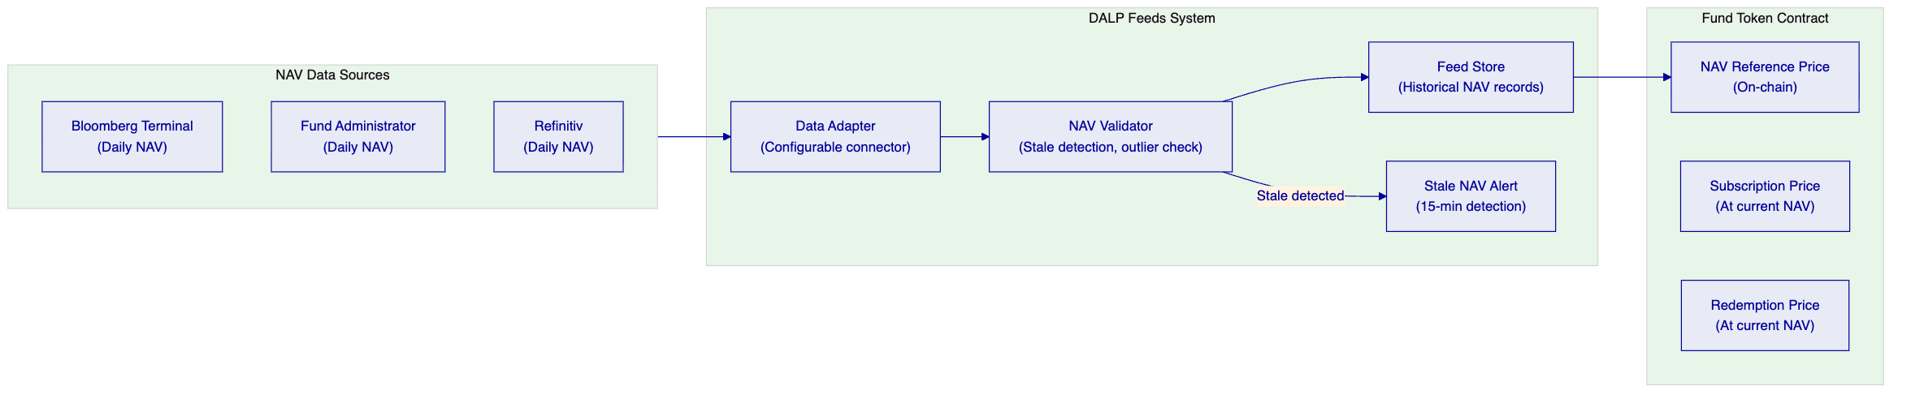
    - Yield Distribution (Distributing Share Class)
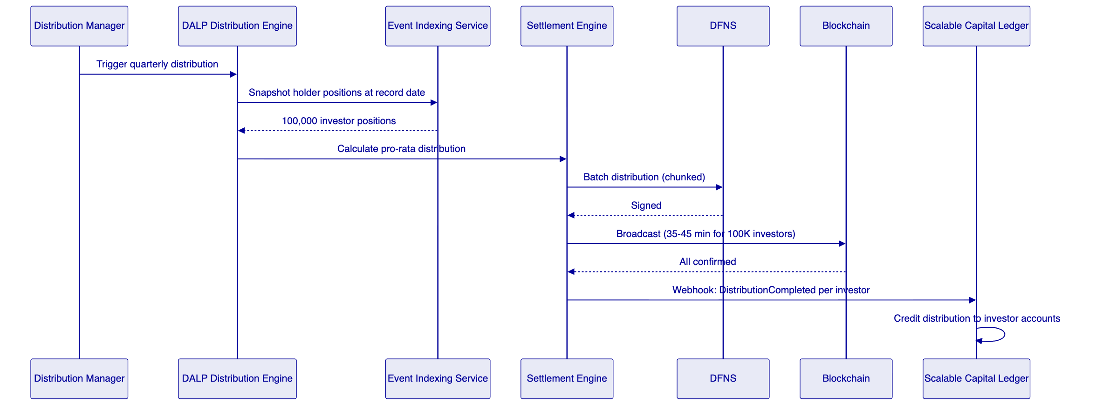

  - 7. Technical Architecture
    - Four-Layer Architecture
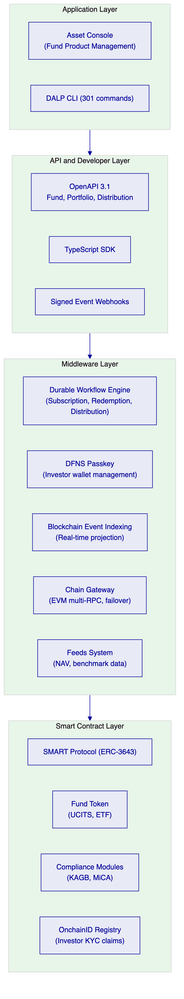
Unlike platforms that bundle NAV calculation with token management, DALP's architecture separates the price feed from the token contract. Scalable Capital's fund administrator remains the authoritative NAV source; DALP provides the token infrastructure that uses that NAV for subscription and redemption pricing. This boundary preserves Scalable Capital's existing fund administration relationships and BaFin valuation independence requirements.
    - Performance Specifications
Operation | P50 | P99 | Notes
API response (subscription initiation) | 85ms | 300ms | Kubernetes auto-scaling active
Settlement confirmation (subscription) | 2.1s | 4.2s | Private Besu IBFT 2.0
NAV feed update propagation | <500ms | <1s | After feed ingestion
Distribution (100K investors) | 35-45 min | 55 min | Chunked processing
Distribution (500K investors) | 3-4 hours | 5 hours | Background workers, no API degradation

  - 8. Security
Consumer data privacy: Personal data in Scalable Capital's systems. DALP stores hashed investor references only. EU data residency (Frankfurt). BaFin audit trail preserved 10 years.
Key management: DFNS threshold MPC for investor wallet keys. No single key exposure. Investor transactions authorized through DFNS passkey (biometric or PIN in Scalable Capital's app).
BaFin compliance evidence: Tamper-evident audit log for every compliance decision, fund configuration change, and investor eligibility action. BaFin examination API. KAGB record-keeping: subscription/redemption audit trail, NAV history, distribution records.
DORA: Multi-AZ Kubernetes, PostgreSQL Multi-AZ, RTO 1 hour, RPO 15 minutes. Quarterly resilience tests.

  - 9. Project Implementation and Delivery
    - Implementation Programme
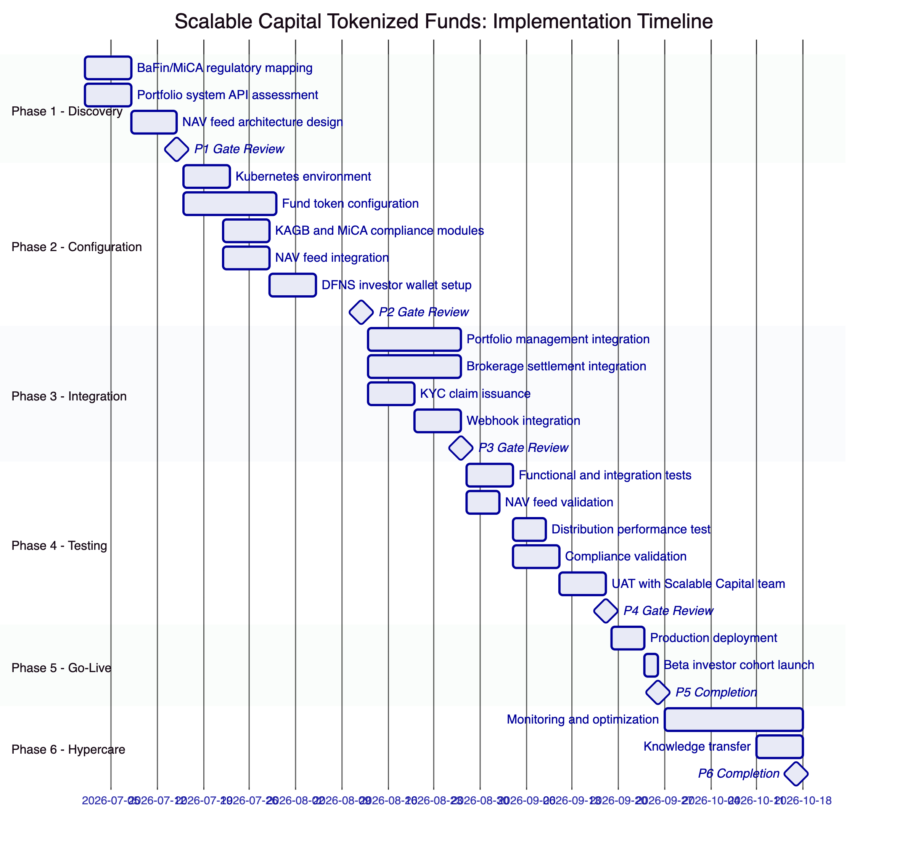
    - Responsibility Matrix
Activity | SettleMint | Scalable Capital | Shared
Architecture design | Lead | Review
Token and fund configuration | Lead
NAV feed connector configuration | Lead | Support
BaFin/MiCA regulatory mapping | Support | Lead
Portfolio management integration | Support | Lead
KYC claim issuance setup | Support | Lead
Security and BaFin review | Support | Lead
Investor UAT | Support | Lead

  - 10. Deployment
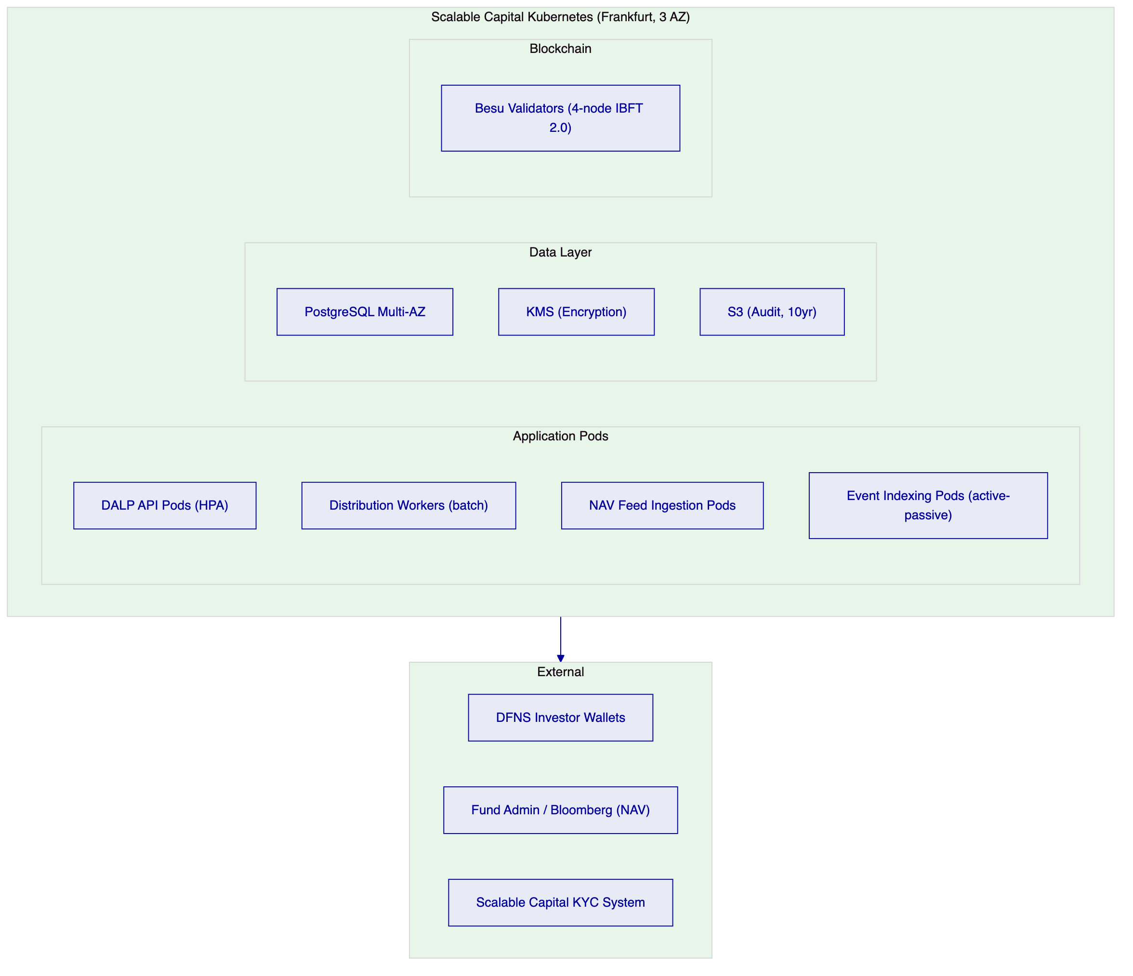

  - 11. Training and Knowledge Transfer
Portfolio Engineering (1 day): Fund subscription/redemption API integration, NAV feed connector, webhook event handling, TypeScript SDK.
Operations and Fund Administration (1 day): Asset Designer for fund configuration, NAV feed monitoring, distribution management, reconciliation dashboards.
Compliance and BaFin Reporting (half day): KAGB audit log, investor eligibility management, compliance module configuration, BaFin evidence export.

  - 12. Support and SLA
Enterprise Support: EUR 120,000/year, 24/7/365, 99.99% uptime, 15-min P1 response, 2-hour P1 resolution, named team and CSM.

  - 13. Risk Management
Risk | Likelihood | Impact | Mitigation
NAV feed integration delays | Medium | Medium | Phase 2 proof-of-concept; mock NAV source for development
BaFin KAGB approval for tokenized fund products | Medium | High | Phase 1 regulatory mapping; BaFin liaison documentation
DFNS investor wallet mobile integration | Low | Medium | DFNS iOS/Android SDKs; Phase 2 PoC
Distribution performance for 7M investor base | Low | Medium | Chunked processing scales linearly; batch windows configured
Portfolio management API integration complexity | Low | Low | Scalable Capital's API-first architecture; standard REST integration

  - 14. Compliance Matrix
Requirement | Coverage | DALP Mechanism
BaFin KAGB fund administration (§ 87) | Supported | Audit trail, compliance modules, reporting
BaFin Circular 05/2023 outsourcing | Supported | ISO 27001, SOC 2 Type II, access controls
MiCA consumer fund eligibility (Art. 72) | Supported | Consumer eligibility, disclosure modules
MiCA consumer protection (Art. 73) | Supported | Disclosure acknowledgment, transfer limits
DORA ICT resilience | Supported | HA deployment, quarterly resilience testing
GDPR fund investor data | Supported | EU data residency (Frankfurt), off-chain personal data
AML/CFT (GwG) | Supported with partner | KYC claims from Scalable Capital's AML system
MiFID II (for investment funds) | Supported with controls | Suitability: Scalable Capital's existing MiFID II system

  - 15. Appendices
    - Appendix A: Requirements Coverage Matrix
Req ID | Status | DALP Mechanism
BR-01 | Supported | Asset Designer, maker-checker approval
BR-02 | Supported | Fund state machine, durable workflows
BR-03 | Supported | On-chain authoritative, event indexing projection
BR-04 | Supported | 26 role types including NAV Administrator
BR-05 | Supported | KAGB and MiCA compliance module configurations
BR-06 | Supported | Fund event catalog, signed webhooks
BR-07 | Supported | Durable workflows, atomic DvP, dead-letter
BR-08 | Supported | KAGB audit trail, BaFin export APIs
BR-09 | Supported | Token pause, country restriction, cohort claims
BR-10 | Supported | Multi-product, single DALP instance
TR-01 | Supported | OpenAPI 3.1, TypeScript SDK, 12-month deprecation
TR-02 | Supported | Three environments, seeded fund test data
TR-03 | Supported | Signed webhooks, at-least-once, dead-letter
TR-04 | Supported | OAuth 2.0/OIDC, MFA, DFNS passkey
TR-05 | Supported | Kubernetes, Helm, GitOps, Frankfurt
TR-06 | Supported | Prometheus, Grafana NAV/distribution dashboards
TR-07 | Supported | P99 4.2s settlement; 35-45min for 100K distribution
TR-08 | Supported | REST, webhooks, PostgreSQL direct, CSV
TR-09 | Supported | Quarterly releases, 12-month deprecation
TR-10 | Supported | Constraints register disclosed
TR-11 | Supported | Helm, Terraform, ArgoCD/Flux
TR-12 | Supported | 15-min P1, incident bridge, status page

Document Classification: SettleMint Confidential
SettleMint NV | Simon Bolivarlaan 5, 2600 Antwerp, Belgium | www.settlemint.com
Version 1.0 | March 2026

