[Company name]
[Document title]
[Document subtitle]

Confidentiality Statement
This document contains confidential and proprietary information of SettleMint. By reading this document, you agree not to disclose the confidential information contained herein to any third party without the prior written consent of SettleMint, except to those agents, principals, representatives, or consultants who require access for the purpose of evaluating this document. You further agree to inform such persons of the confidential nature of this document and to obtain their agreement to preserve its confidentiality to the same extent as yours.
This confidentiality statement shall remain binding on the parties for a period of five (5) years from the date stated on the front cover, unless superseded by confidentiality provisions detailed in a subsequent agreement.
Terms and Conditions
This proposal is valid until [DD Month YYYY]. In the absence of confirmation to proceed, SettleMint and [the Company] acknowledge and agree to abide by the Mutual NDA as the governing agreement.
SettleMint reserves the right to vary the terms of this proposal in response to changes in specifications or information made available at a later date. Submission of this proposal does not convey any right, title, interest, or license in any intellectual property rights (including, but not limited to, patents, copyrights, trade secrets, or trademarks) contained herein.
All rights are reserved. This proposal and the information contained within it are provided on an “as is” basis, without any warranties of any kind, express or implied.
All contracts with SettleMint will be governed by Belgian Law and subject to the exclusive jurisdiction of Belgian courts.
Contact Details
For any enquiries regarding this document, please contact:
[Full Name]
[Job Title]
Email: [email@example.com]
Phone: [Country Code - Number]

Table of Contents

Table of Contents 3
Executive Summary 4
Understanding of Solarisbank's Requirements 5
Regulatory Context 6
Operational Requirements 7
BaaS Client Profile 8
SettleMint and DALP Overview 9
Platform Architecture 10
Module Integration Architecture 11
Digital Asset Module Design 12
Supported Token Types 13
Token Operations 14
Module Capabilities 15
BaaS Integration Framework 16
API Integration Pattern 17
API Endpoints 18
Compliance and Regulatory Framework 19
BaFin and MiCA Compliance 20
Compliance Module Configuration 21
Custody and Key Management 22
Security Architecture 23
Integration Architecture 24
Integration with Solarisbank Systems 25
Integration Points 26
Operational Model 27
Support Tiers 28
Monitoring and Operations 29
Implementation Plan 30
Reference Deployments 31
Compliance Matrix 32

Document Title: Technical Proposal for BaaS Digital Asset Module
Client: Solarisbank (Germany)
Reference: SOLARISBANK-RFP-BAAS-DIGITAL-ASSET-MODULE-202603
Submitted by: SettleMint
Date: March 2026
Version: 1.0 (Draft)
Confidentiality: Strictly Confidential

  - Table of Contents
- Executive Summary
- Understanding of Solarisbank's Requirements
- SettleMint and DALP Overview
- Platform Architecture
- Digital Asset Module Design
- BaaS Integration Framework
- Compliance and Regulatory Framework
- Custody and Key Management
- Security Architecture
- Integration Architecture
- Operational Model
- Implementation Plan
- Reference Deployments
- Compliance Matrix

  - Executive Summary
Solarisbank operates as a Banking-as-a-Service (BaaS) platform enabling fintech companies and non-bank entities to offer banking products through a modular API infrastructure. As institutional demand for digital asset custody, tokenization, and settlement services grows among Solarisbank's B2B clients, Solarisbank requires a digital asset module that extends its BaaS platform to support regulated digital asset operations.
The challenge is that building a compliant digital asset infrastructure from scratch requires specialized engineering, regulatory licensing, and operational expertise that distracts from Solarisbank's core BaaS value proposition. Integrating point solutions creates fragmentation, increases operational overhead, and complicates the regulatory story.
SettleMint's DALP platform provides the digital asset module as an integrated component of Solarisbank's BaaS infrastructure. The module handles tokenization, compliance enforcement, custody integration, and settlement across the digital asset lifecycle while maintaining the modular, API-first architecture that defines Solarisbank's BaaS offering. Solarisbank's B2B clients gain access to digital asset capabilities through the same integration patterns they use for banking services.
Three capabilities define this fit. First, modular API integration: DALP exposes digital asset functionality through REST APIs and webhooks that integrate into Solarisbank's existing API gateway, maintaining consistency with the BaaS platform's integration model. Second, BaFin compliance: compliance modules enforce German and EU regulatory requirements for digital asset custody and tokenization, including the upcoming MiCA framework. Third, unified operational view: a single operational dashboard manages both banking and digital asset operations, reducing the learning curve for Solarisbank's operations team.

  - Understanding of Solarisbank's Requirements
    - Regulatory Context
Solarisbank holds a German banking license (Kreditinstitut) and an e-money institution license from BaFin. Adding digital asset capabilities to the BaaS platform requires adherence to:
- BaFin requirements: Digital asset custody, token issuance, and trading platform operations require specific BaFin authorization or registration depending on the activity. The upcoming EU Markets in Crypto-Assets (MiCA) regulation adds harmonized EU-wide requirements effective 2026.
- German banking law (KWG): Activities that constitute banking business or financial services require appropriate licensing. Tokenization of securities falls within the Wertpapierhandelsgesetz (WpHG) framework.
- EU AMLD5/AMLD6: Anti-money laundering obligations for crypto asset service providers (CASPs).
- PSD2 (potential): If payment services are integrated, PSD2 requirements apply.
The digital asset module must be configurable to support multiple regulatory regimes as Solarisbank's B2B clients operate across different jurisdictions.
    - Operational Requirements
- API-first architecture: All digital asset functionality must be accessible through APIs, matching the BaaS platform's integration model
- Modular enablement: B2B clients can enable digital asset capabilities independently of other BaaS modules
- Custody abstraction: Support for multiple custody providers so Solarisbank can choose or integrate based on client needs
- Compliance automation: Automated enforcement of investor eligibility, AML screening, and transaction limits
- Unified reporting: Single reporting interface for both banking and digital asset regulatory obligations
- Multi-currency/token support: Support for Euro-denominated stablecoins, crypto-native tokens, and security tokens
    - BaaS Client Profile
Solarisbank's B2B clients include:
- Fintech companies seeking banking licenses without building infrastructure
- E-commerce platforms offering embedded financial services
- Corporate treasury teams needing banking-as-a-service for payments and liquidity
- Emerging digital asset institutions requiring banking rails

  - SettleMint and DALP Overview
SettleMint's DALP platform provides the infrastructure for designing, launching, and operating tokenized assets and digital asset services. The platform's composable token architecture supports representation of various asset classes as tokens, from stablecoins to security tokens to tokenized real-world assets.
For Solarisbank's BaaS context, DALP provides the digital asset module layer that sits on top of Solarisbank's existing banking infrastructure. The module exposes digital asset functionality through APIs that Solarisbank's API gateway aggregates with its other BaaS services. B2B clients access digital asset capabilities through the same authentication, rate limiting, and monitoring infrastructure used for banking services.
DALP's 18 compliance module types provide the regulatory enforcement layer that BaFin and MiCA require. The identity verification through OnchainID supports investor eligibility enforcement, and the audit trail service produces structured evidence for regulatory examination.

  - Platform Architecture
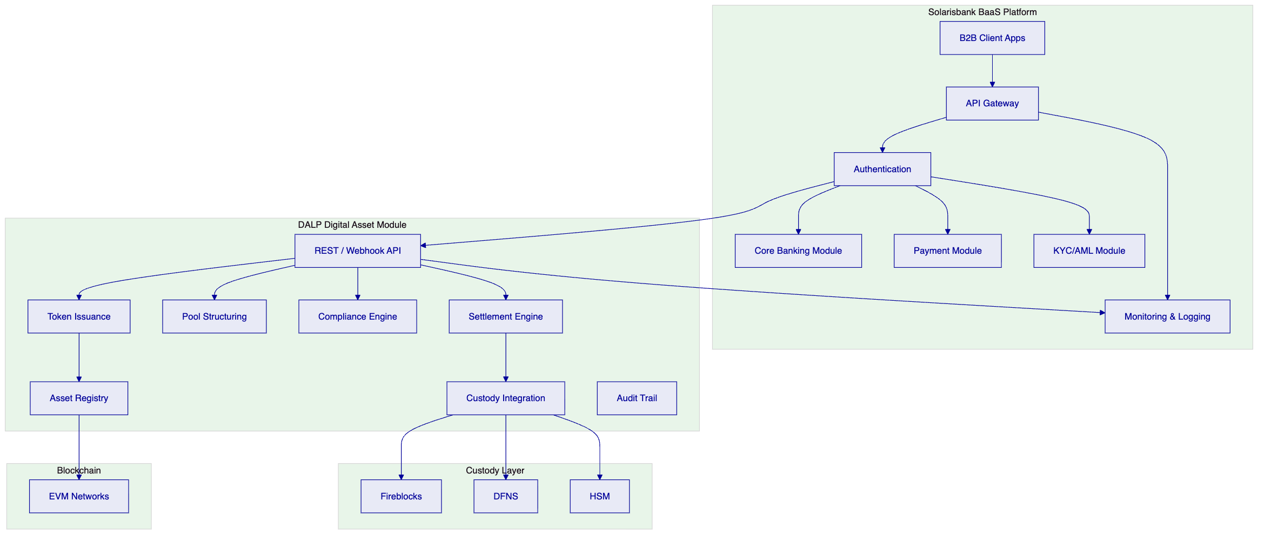
Figure 1: DALP Digital Asset Module Architecture within Solarisbank BaaS
    - Module Integration Architecture
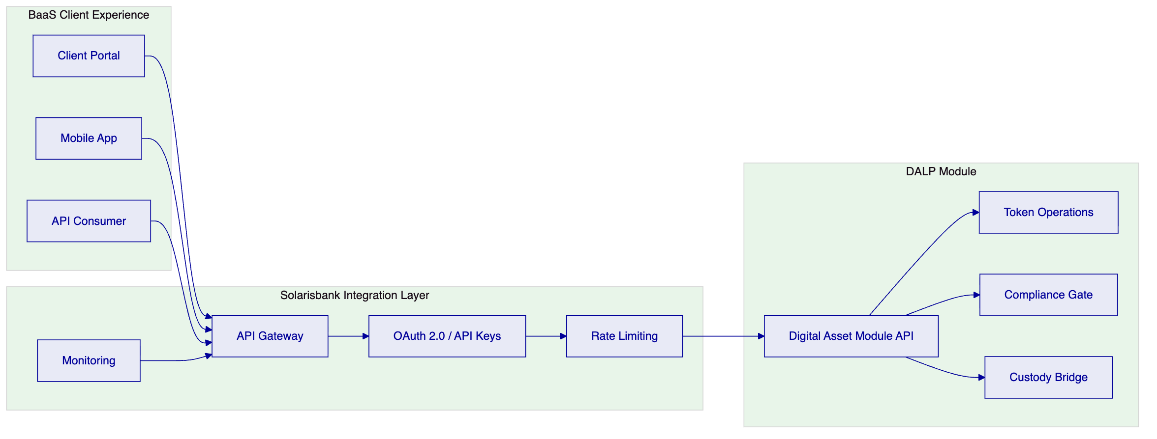
Figure 2: Module Integration with BaaS Gateway

  - Digital Asset Module Design
    - Supported Token Types
Token Type | Description | Regulatory Classification
Stablecoins | Euro-denominated stablecoins | E-money / CASP
Security Tokens | Tokenized securities | WpHG / MiCA
Utility Tokens | Platform access tokens | MiCA (utility)
Tokenized RWA | Real-world asset tokens | Case-by-case

    - Token Operations
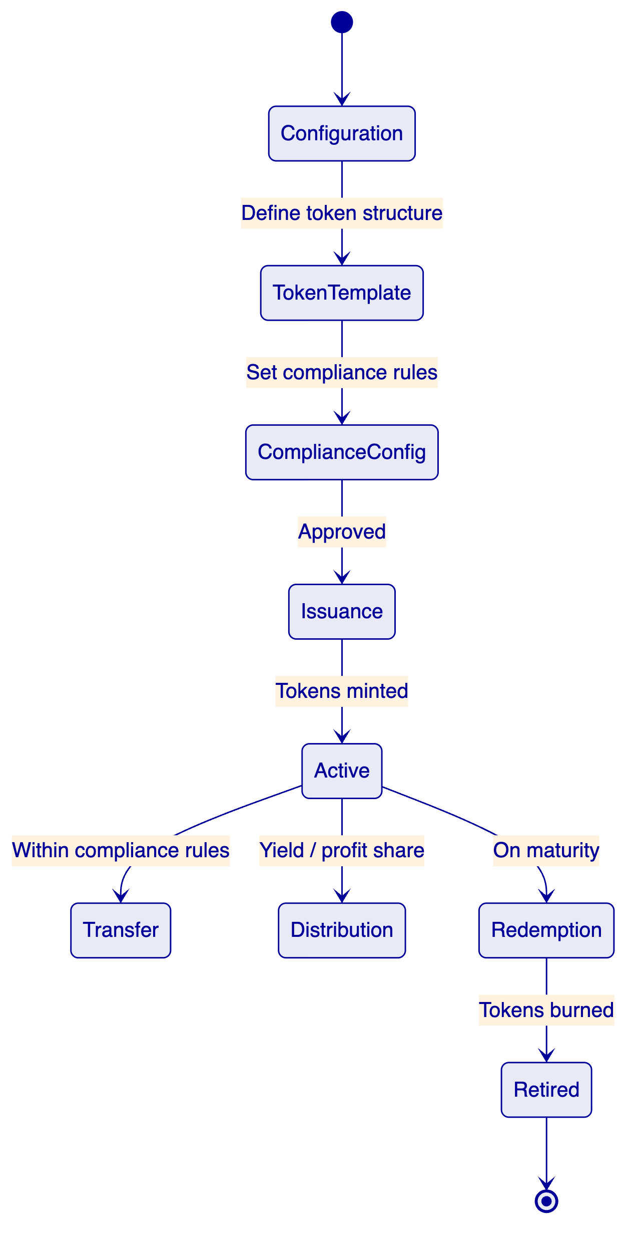
Figure 3: Token Lifecycle State Machine
    - Module Capabilities
Capability | Description
Token issuance | Create and mint tokens with configurable features
Transfer | Peer-to-peer transfers with compliance gates
Custody | Integrated with Fireblocks, DFNS, or HSM
Settlement | Atomic swap or settlement finality
Compliance | 18 module types for investor, transaction, jurisdictional controls
Reporting | Automated regulatory reports for BaFin, ECB

  - BaaS Integration Framework
    - API Integration Pattern
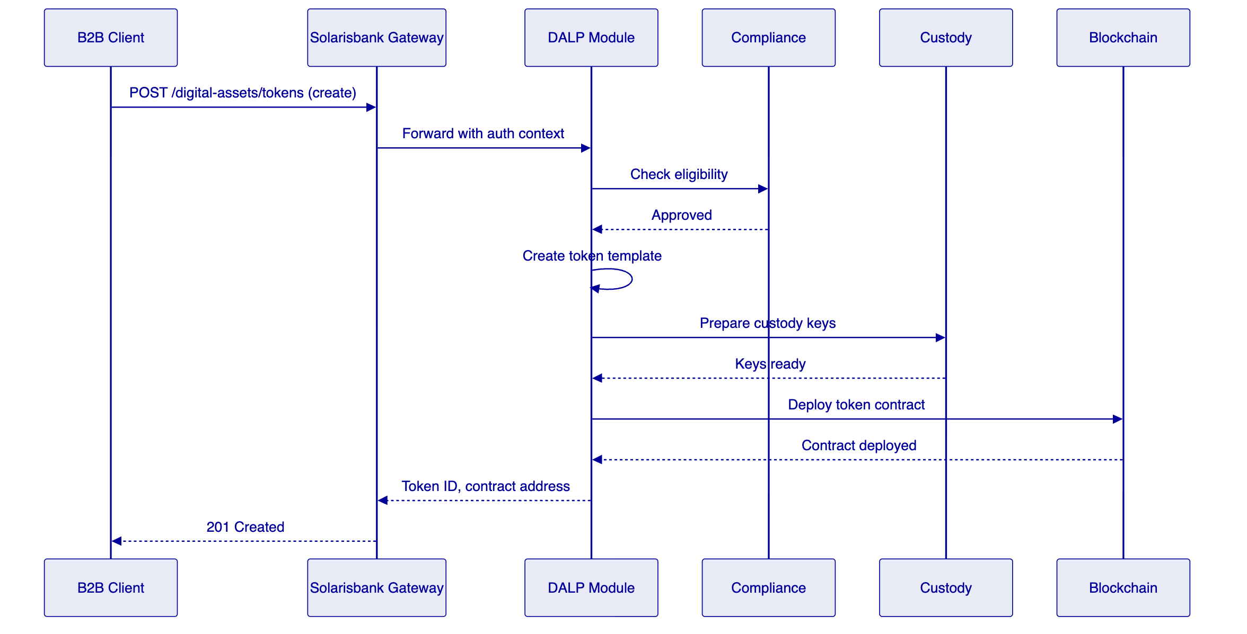
Figure 4: Token Creation API Flow
    - API Endpoints
Endpoint | Method | Description
/digital-assets/tokens | POST | Create new token
/digital-assets/tokens/{id} | GET | Get token details
/digital-assets/tokens/{id}/mint | POST | Mint tokens
/digital-assets/tokens/{id}/transfer | POST | Transfer tokens
/digital-assets/issuers | GET | List authorized issuers
/digital-assets/compliance/check | POST | Pre-transaction compliance check
/digital-assets/reports/{type} | GET | Regulatory reports

  - Compliance and Regulatory Framework
    - BaFin and MiCA Compliance
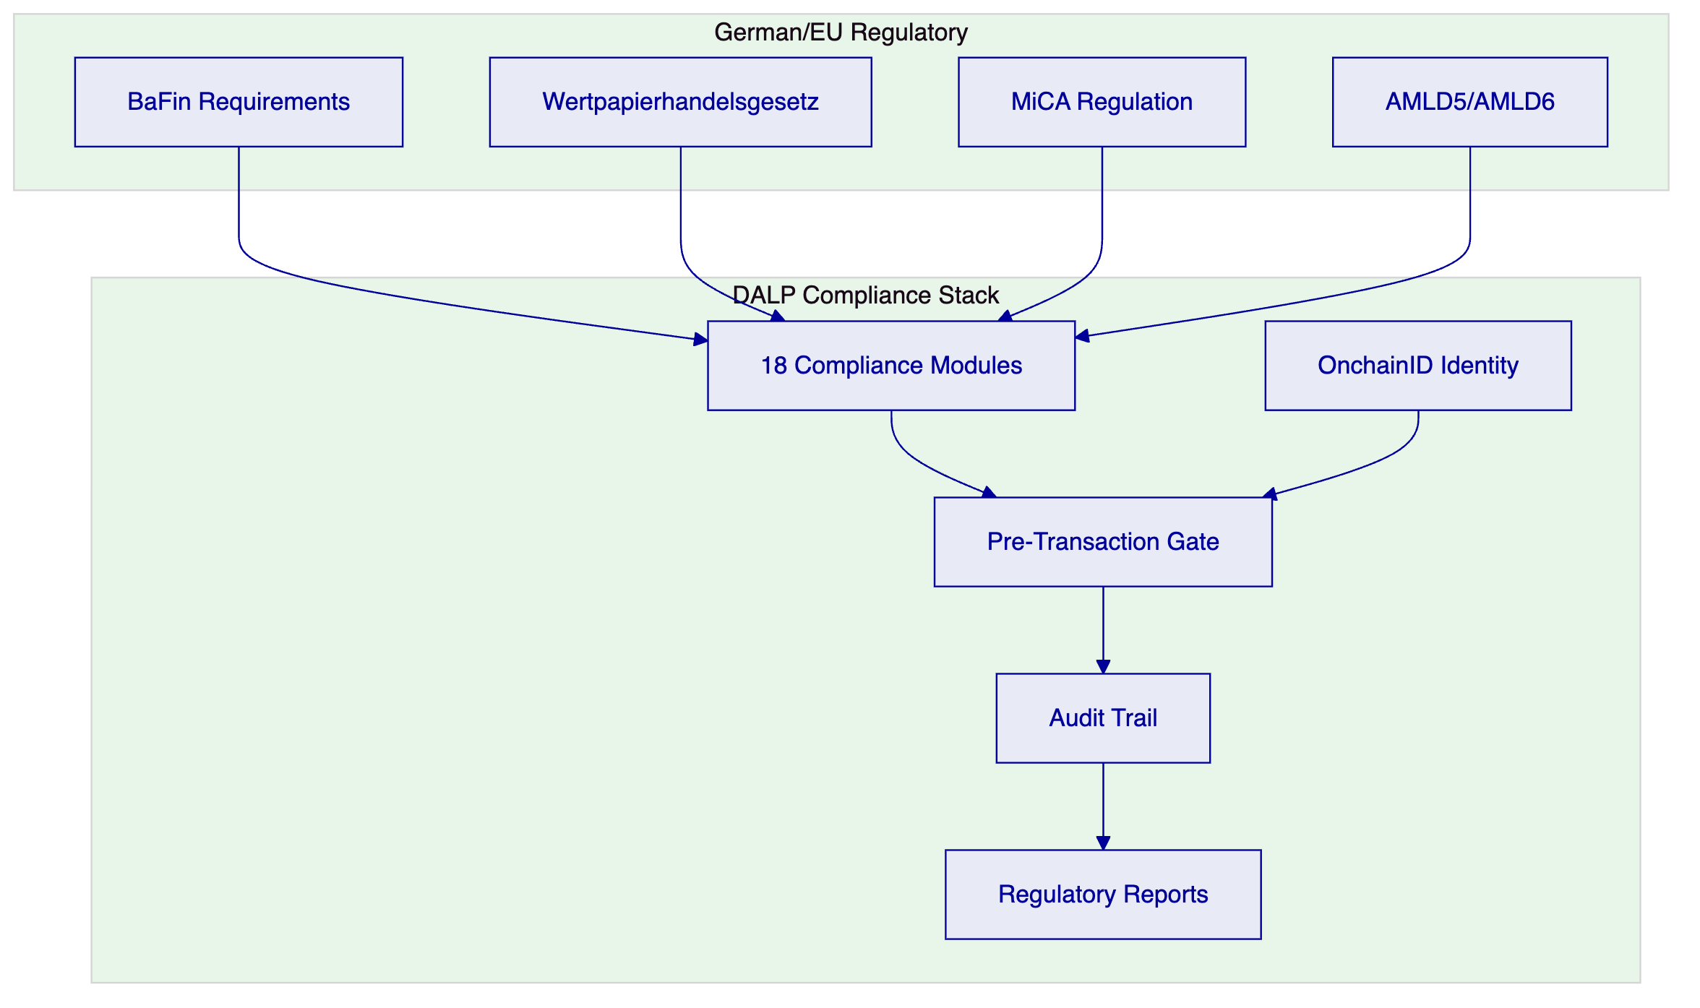
Figure 5: Regulatory Compliance Framework
    - Compliance Module Configuration
Module | Regulation | Application
Investor Eligibility | BaFin | Gate to qualified investors for securities tokens
AML Status | AMLD5/6 | Block transactions on sanctions/PEP matches
Jurisdiction | Sanctions | Block prohibited jurisdictions
Transaction Limits | BaFin | Per-transaction and cumulative limits
Token Classification | MiCA | Apply correct regulatory treatment
Reporting | BaFin/MiCA | Automated regulatory reports
Custody Authorization | BaFin | Verify custody provider authorization
Cooling-off Period | MiCA | Apply mandatory cooling-off for tokens

  - Custody and Key Management
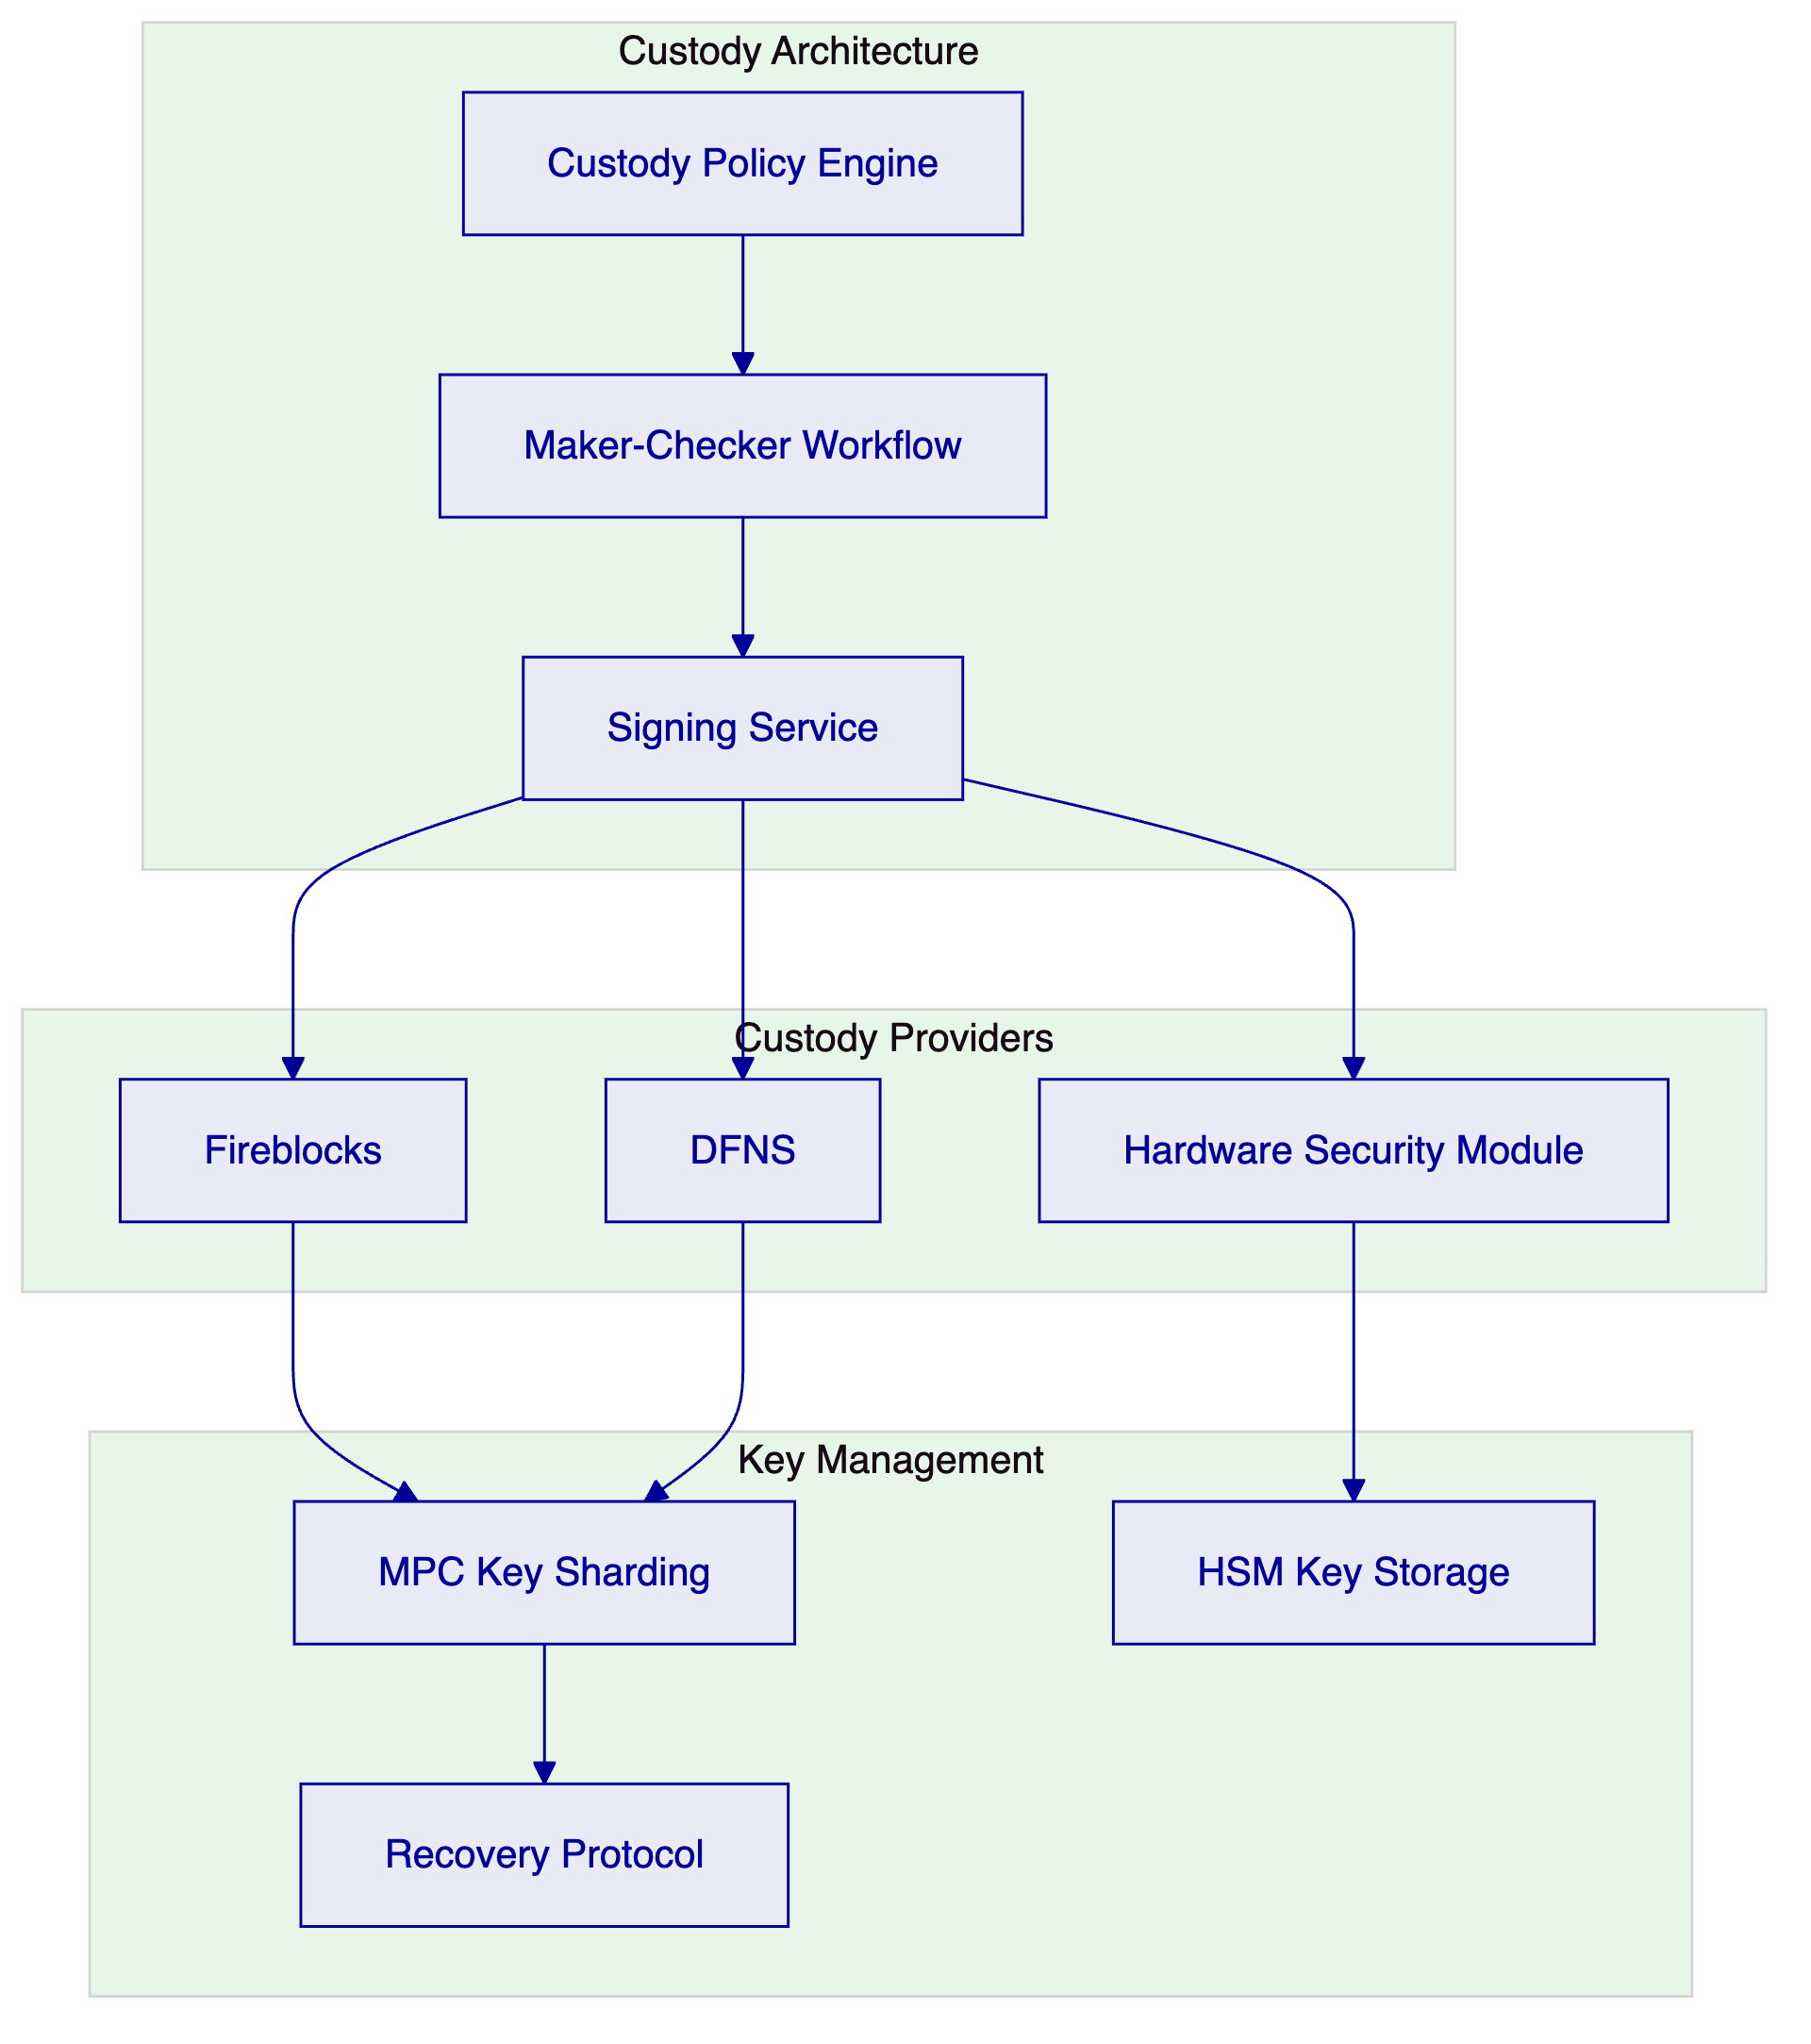
Figure 6: Custody and Key Management Architecture
For Solarisbank's BaaS context, a multi-provider custody strategy is recommended:
- Fireblocks: Primary for institutional-grade digital asset custody with insurance
- DFNS: Self-custody alternative for clients with specific requirements
- HSM (local): For clients requiring German data residency or self-custody

  - Security Architecture
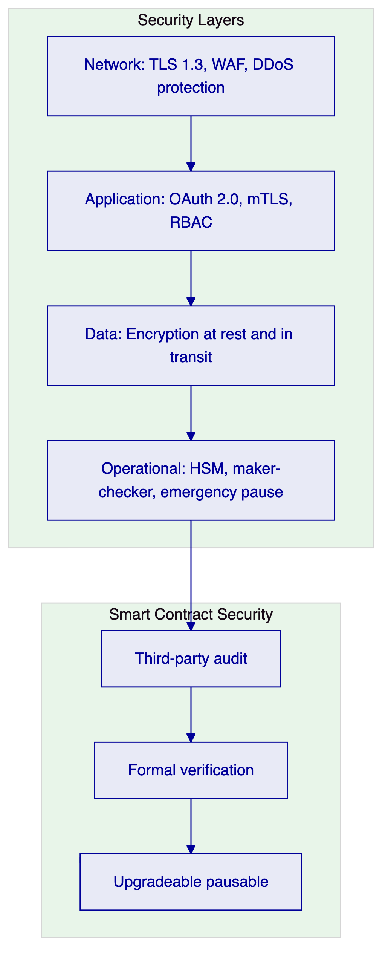
Figure 7: Security Architecture
Security measures specific to the BaaS context:
- Tenant isolation: Logical separation between B2B client digital asset operations
- API security: OAuth 2.0, API keys, rate limiting consistent with BaaS gateway
- Audit isolation: Each B2B client has isolated audit trail access
- Key segregation: Custody keys are segregated by client where required

  - Integration Architecture
    - Integration with Solarisbank Systems
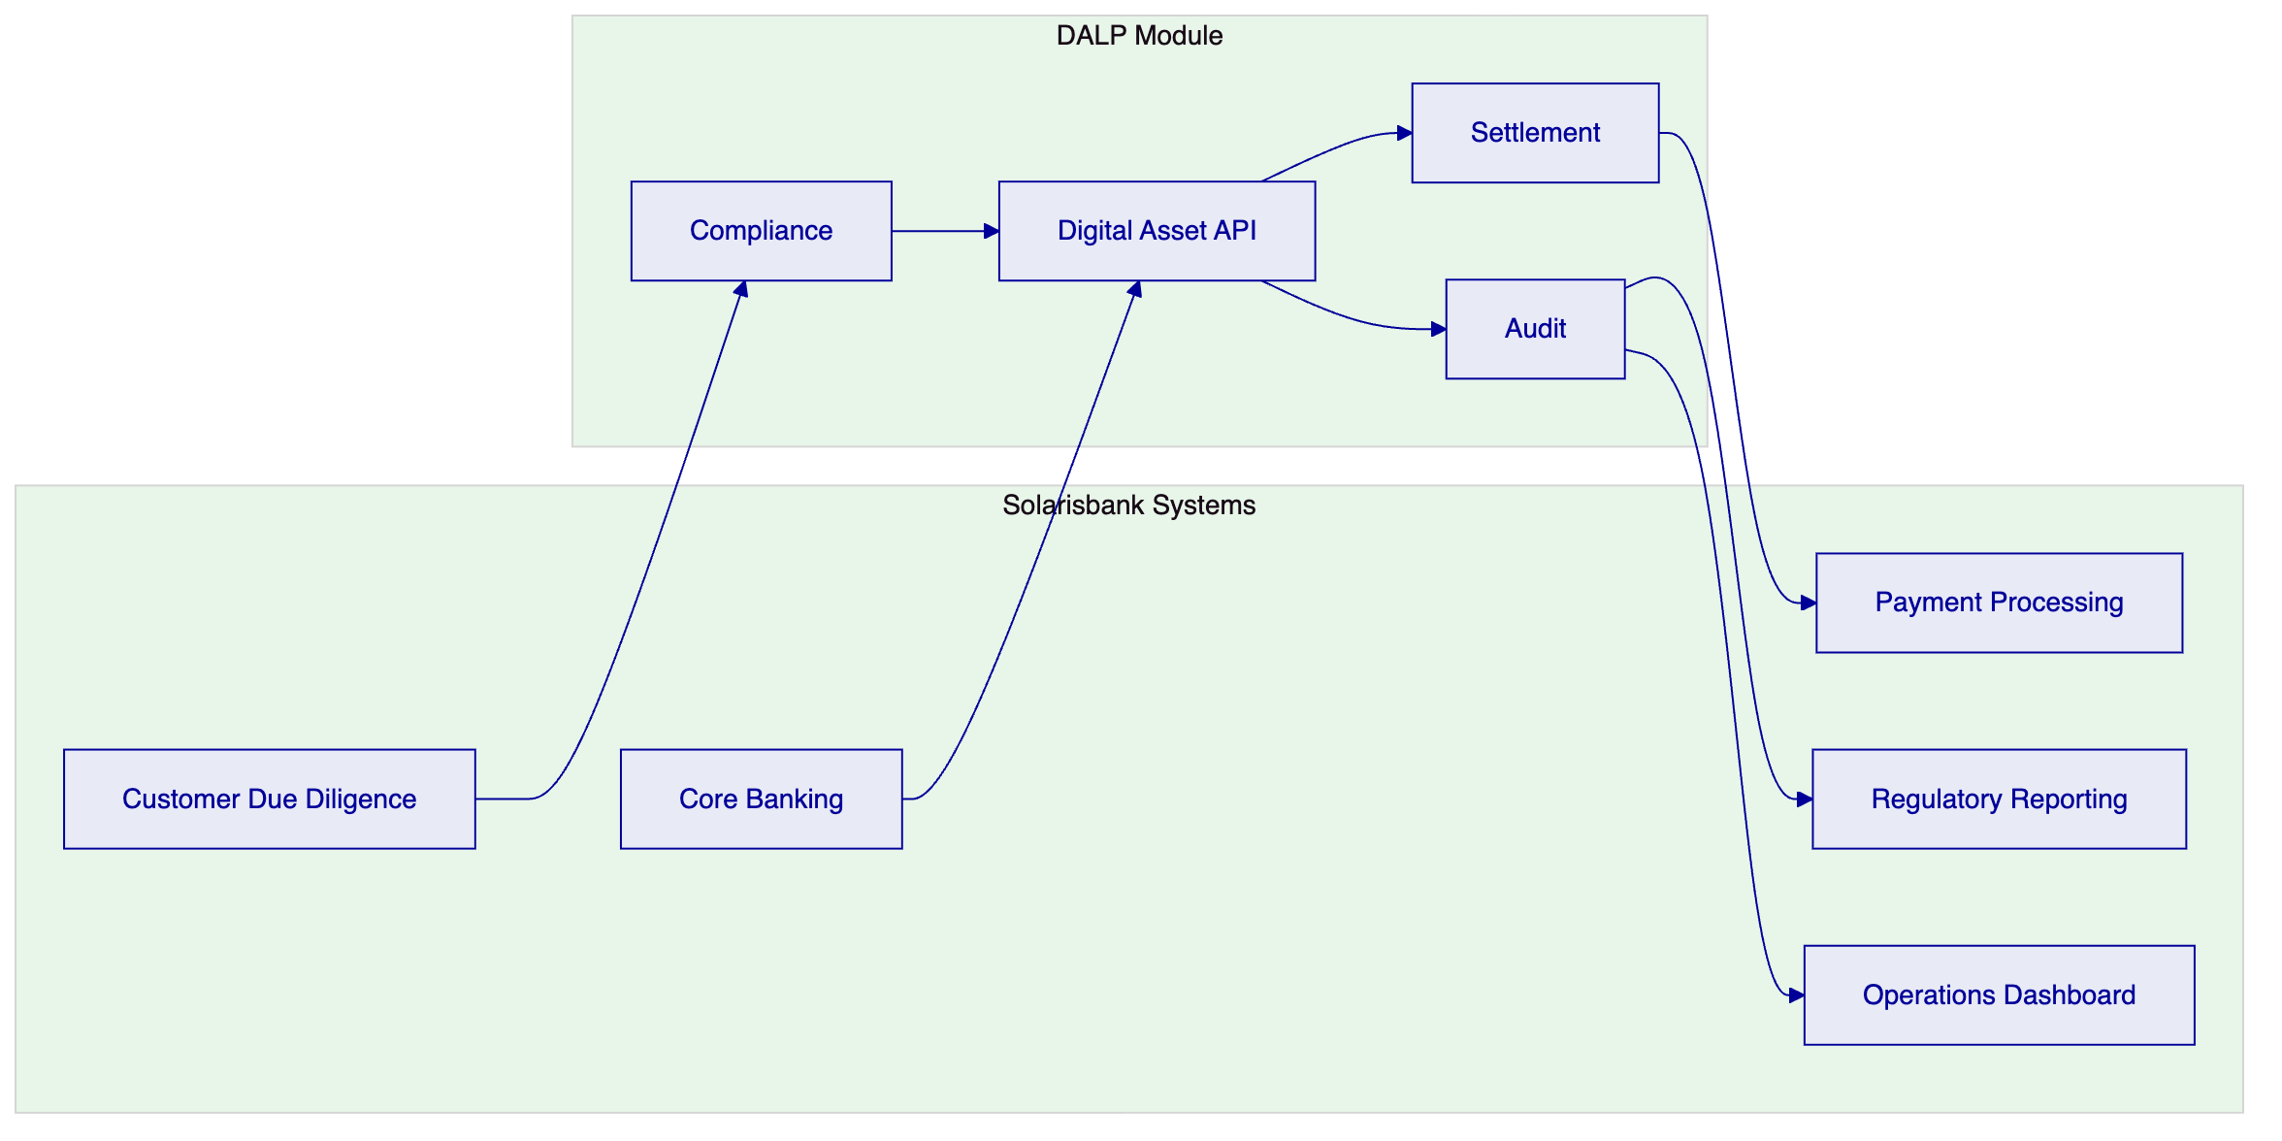
Figure 8: Integration with Solarisbank Core Systems
    - Integration Points
Solarisbank System | Integration | Data Flow
Customer KYC | Compliance lookup | AML status, risk rating
Core Banking | Account linking | Euro settlements
Payment Processing | Settlement | Fiat on/off ramp
Regulatory Reporting | Batch export | BaFin, MiCA reports
Operations | Dashboard | Real-time monitoring

  - Operational Model
    - Support Tiers
Tier | Availability | Critical Response | Features
Enterprise | 24/5 | 2 hours | TAM, SLA 99.9%
Sovereign | 24/7 | 1 hour | Dedicated TAM, SLA 99.95%

    - Monitoring and Operations
Real-time monitoring covers:
- Token operations (issuance, transfer, redemption)
- Compliance engine events
- Custody provider status
- Settlement success rates
- Blockchain network health
- API performance and errors
Operational alerts integrate with Solarisbank's existing monitoring infrastructure through webhooks.

  - Implementation Plan
Phase | Duration | Scope
Phase 1 | Weeks 1-8 | Platform deployment, API integration, custody setup
Phase 2 | Weeks 9-14 | Compliance module configuration, regulatory alignment
Phase 3 | Weeks 15-20 | Client onboarding flow, reporting, operational procedures
Phase 4 | Weeks 21-26 | Security review, BaFin alignment, go-live, hypercare

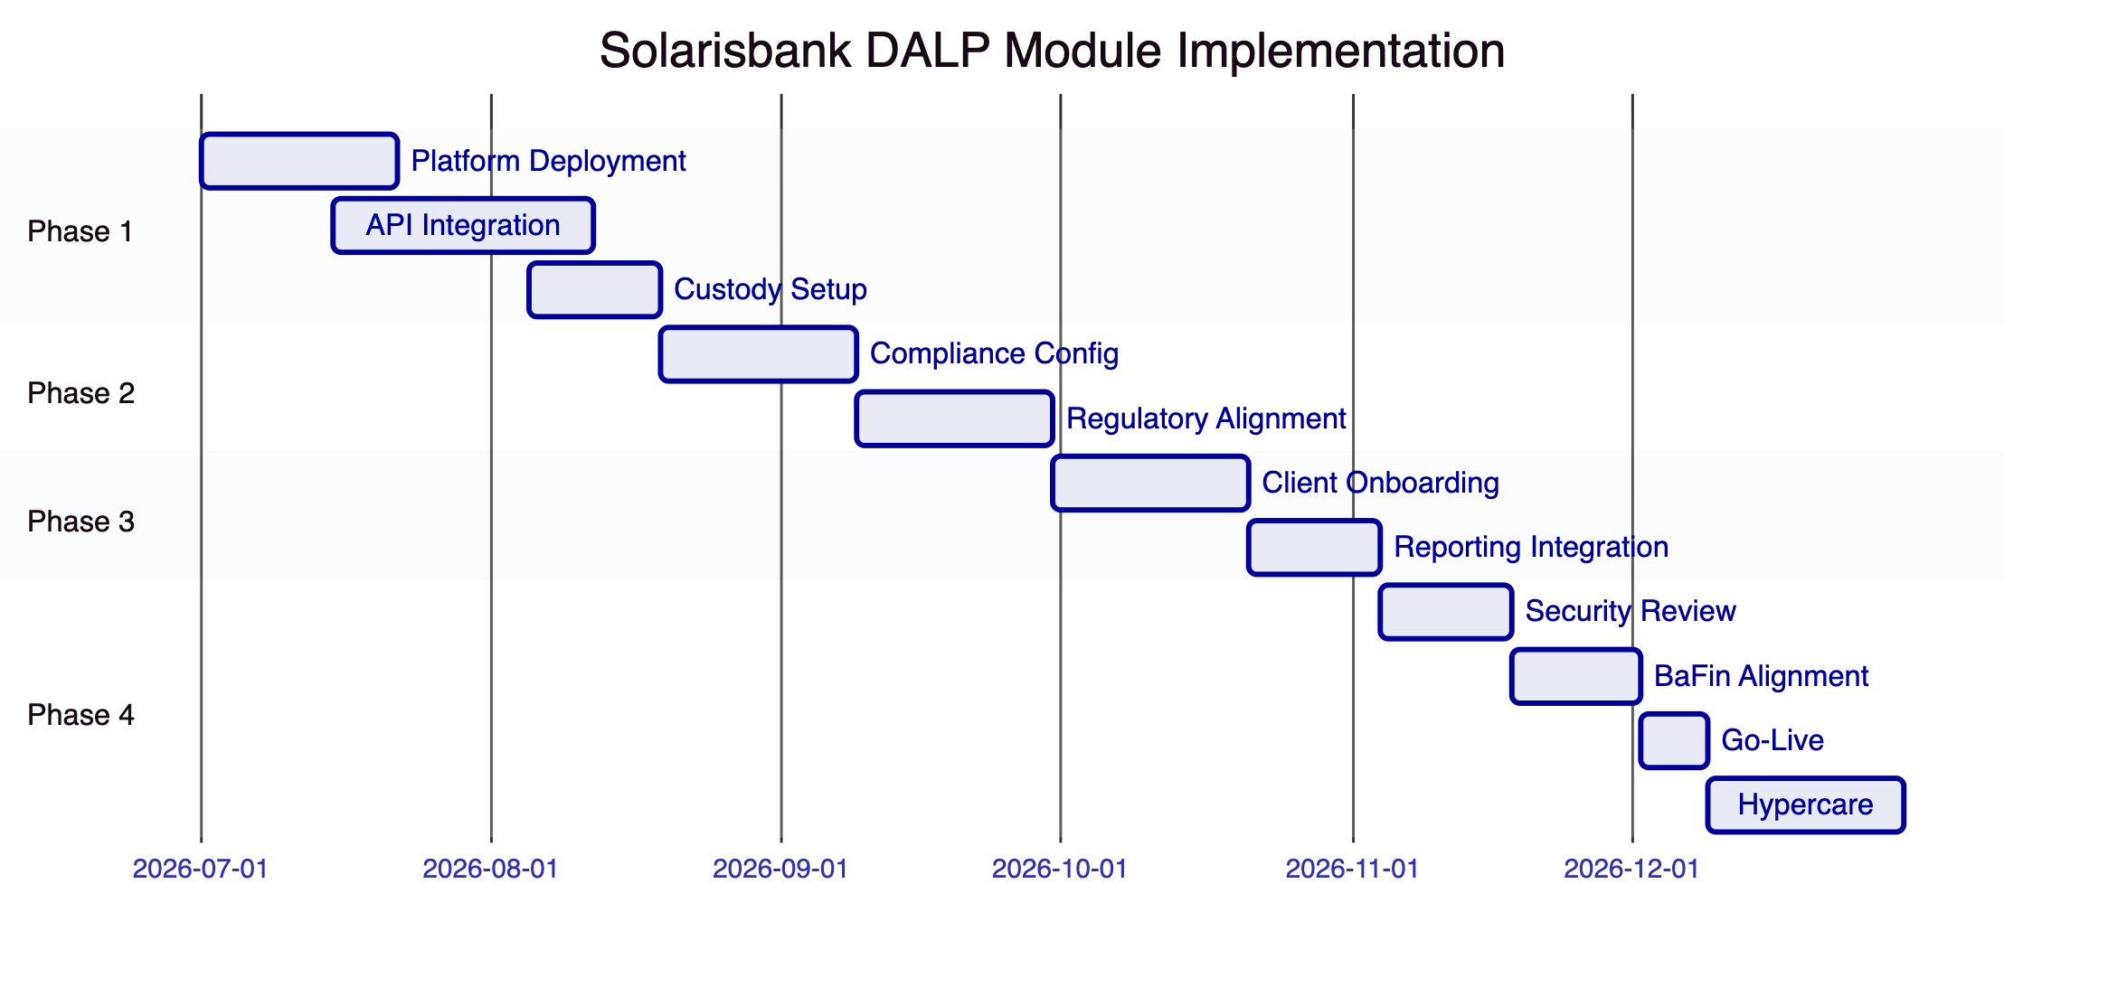
Figure 9: Implementation Timeline

  - Reference Deployments
European BaaS Platform (NDA): A regulated BaaS platform in Europe deployed DALP to add digital asset capabilities, enabling their B2B clients to offer tokenized products.
German Digital Asset Custodian (NDA): A German financial institution deployed DALP for digital asset custody and tokenization under BaFin supervision.
Multi-Jurisdiction Banking Group (NDA): A European banking group deployed DALP across multiple jurisdictions with unified compliance and separate custody arrangements per jurisdiction.

  - Compliance Matrix
Requirement | DALP Response | Status
Token issuance | DALPAsset with configurable features | Fully Supported
Custody integration | Fireblocks, DFNS, HSM | Fully Supported
BaFin compliance | Configurable compliance modules | Fully Supported
MiCA alignment | Token classification, reporting | Fully Supported
AMLD5/AMLD6 | Real-time AML screening gate | Fully Supported
Qualified investor | OnchainID investor eligibility | Fully Supported
Multi-tenant BaaS | Logical tenant isolation | Fully Supported
API-first integration | REST APIs, webhooks | Fully Supported
Regulatory reporting | BaFin, MiCA report templates | Fully Supported
Audit trail | Immutable, structured logs | Fully Supported
Settlement | Fiat on/off ramp integration | Fully Supported
Multi-currency | Euro stablecoins, crypto-native | Fully Supported

This proposal is submitted in strict confidence by SettleMint in response to SOLARISBANK-RFP-BAAS-DIGITAL-ASSET-MODULE-202603.

