[Company name]
[Document title]
[Document subtitle]

Confidentiality Statement
This document contains confidential and proprietary information of SettleMint. By reading this document, you agree not to disclose the confidential information contained herein to any third party without the prior written consent of SettleMint, except to those agents, principals, representatives, or consultants who require access for the purpose of evaluating this document. You further agree to inform such persons of the confidential nature of this document and to obtain their agreement to preserve its confidentiality to the same extent as yours.
This confidentiality statement shall remain binding on the parties for a period of five (5) years from the date stated on the front cover, unless superseded by confidentiality provisions detailed in a subsequent agreement.
Terms and Conditions
This proposal is valid until [DD Month YYYY]. In the absence of confirmation to proceed, SettleMint and [the Company] acknowledge and agree to abide by the Mutual NDA as the governing agreement.
SettleMint reserves the right to vary the terms of this proposal in response to changes in specifications or information made available at a later date. Submission of this proposal does not convey any right, title, interest, or license in any intellectual property rights (including, but not limited to, patents, copyrights, trade secrets, or trademarks) contained herein.
All rights are reserved. This proposal and the information contained within it are provided on an “as is” basis, without any warranties of any kind, express or implied.
All contracts with SettleMint will be governed by Belgian Law and subject to the exclusive jurisdiction of Belgian courts.
Contact Details
For any enquiries regarding this document, please contact:
[Full Name]
[Job Title]
Email: [email@example.com]
Phone: [Country Code - Number]

Table of Contents

Technical Proposal 3
Tokenized Securities Issuance and Trading Framework 4
Table of Contents 5
1. Executive Summary 6
1.1 Context and Strategic Drivers 7
1.2 Why This Programme Is Hard 8
1.3 Proposed Response 9
1.4 Why SettleMint 10
1.5 Reference Fit Snapshot 11
2. About SettleMint 12
2.1 Company Overview 13
2.2 Production Credentials 14
2.3 Regulatory Readiness 15
3. About DALP 16
3.1 Platform Overview 17
3.2 Core Lifecycle Pillars 18
3.3 Supported Asset Classes 19
3.4 Standards and Protocols 20
4. Understanding Casablanca Stock Exchange Requirements 21
4.1 Institutional Context 22
4.2 Requirement Domain Mapping 23
4.3 Key Challenges 24
5. Proposed Solution and Functional Capabilities 25
5.1 Solution Architecture 26
5.2 Issuance and Asset Configuration 27
5.3 Compliance Enforcement 28
5.4 Transfer and Settlement 29
5.5 Corporate Actions and Servicing 30
5.6 Integration and Interoperability 31
5.7 Functional Fit Matrix 32
6. Technical Architecture 33
6.1 Architectural Principles 34
6.2 Layered Architecture 35
6.3 Data Architecture 36
6.4 Network Topology 37
6.5 Environment Segregation 38
7. Asset Lifecycle and Compliance Infrastructure 39
7.1 Sukuk and Islamic Finance Support 40
7.2 Investor Lifecycle 41
8. Security, Governance, and Controls 42
8.1 Security Model 43
8.2 Morocco Data Protection Compliance 44
8.3 Separation of Duties 45
8.4 Audit Evidence for AMMC 46
8.5 Security Responsibility Matrix 47
9. Integration and Interoperability 48
9.1 Maroclear Integration 49
9.2 AMMC Regulatory Reporting 50
9.3 API Versioning and Release Management 51
10. Deployment Model 52
10.1 Recommended Model: European or Morocco Cloud Region 53
10.2 Availability and Resilience 54
11. Implementation Methodology 55
11.1 Implementation Timeline 56
11.2 Phase Summary 57
11.3 CSE Resource Requirements 58
12. Training and Knowledge Transfer 59
13. Support and Service Levels 60
14. Risk Management 61
15. Compliance Matrix 62
Appendix A: Operating Model Detail 63
A.1 Role Ownership 64
A.2 Governance Routines 65
Appendix B: Security and Resilience 66
Appendix C: Dependency Register 67

title: "Technical Proposal: Tokenized Securities Issuance and Trading Framework"
client: "Casablanca Stock Exchange"
date: "2026-03-19"
version: "1.0"
confidentiality: "Restricted — Commercial-Sensitive"
prepared-by: "SettleMint NV"
document-type: "Technical Proposal"
rfp-reference: "CASABLANCA-STOCK-EXCHANGE-RFP-TOKENIZED-SECURITIES-MOROCCO-202603"

- Technical Proposal
  - Tokenized Securities Issuance and Trading Framework

Document Title: Technical Proposal — Tokenized Securities Issuance and Trading Framework
Client: Casablanca Stock Exchange (Bourse de Casablanca)
Submission Date: 2026-03-19
Version: 1.0
Confidentiality: Restricted — Commercial-Sensitive
Prepared by: SettleMint NV

> This document contains confidential and proprietary information of SettleMint NV. Distribution or reproduction without prior written consent is prohibited.

- Table of Contents
- Executive Summary
- About SettleMint
- About DALP
- Understanding Casablanca Stock Exchange Requirements
- Proposed Solution and Functional Capabilities
- Technical Architecture
- Asset Lifecycle and Compliance Infrastructure
- Security, Governance, and Controls
- Integration and Interoperability
- Deployment Model
- Implementation Methodology
- Training and Knowledge Transfer
- Support and Service Levels
- Risk Management
- Compliance Matrix
- Appendix A: Operating Model Detail
- Appendix B: Security and Resilience
- Appendix C: Data and Integration

- 1. Executive Summary
  - 1.1 Context and Strategic Drivers
Casablanca Stock Exchange (Bourse de Casablanca) is the principal securities exchange in Morocco and one of the leading capital markets infrastructure operators in Africa. The tokenized securities issuance and trading framework programme represents a strategic initiative to extend the Exchange's market infrastructure capabilities into digital asset-native instruments, while preserving the governance, regulatory compliance, and operational integrity that its current market position requires.
The Moroccan capital markets context is specific and material. The Autorité Marocaine du Marché des Capitaux (AMMC) governs securities market activities in Morocco, including disclosure requirements, investor protection rules, and market conduct standards. Bank Al-Maghrib sets monetary policy and payment system expectations that affect the cash leg of any tokenized securities settlement. The Casablanca Finance City (CFC) ecosystem creates a regional financial hub context that connects Moroccan market infrastructure to broader Pan-African and international flows.
Morocco's digital finance landscape is evolving. Bank Al-Maghrib has engaged in payments modernization and digital finance research. The CFC has positioned Casablanca as a gateway for institutional capital accessing African markets. In this context, a tokenized securities framework for the Casablanca Stock Exchange is not an isolated innovation experiment — it is a programme to extend regulated market infrastructure to support new instrument types and investor access models while remaining within the existing regulatory perimeter.
SettleMint proposes DALP, the Digital Asset Lifecycle Platform, as the production-grade infrastructure for this programme. DALP provides the lifecycle coverage, compliance enforcement, and audit evidence capabilities required for a regulated exchange operator operating under AMMC oversight.
  - 1.2 Why This Programme Is Hard
Tokenized securities at an exchange operator involve a specific complexity profile distinct from generic tokenization pilots.
Regulatory perimeter complexity: Morocco's securities regulatory framework requires that tokenized instruments maintain the same investor protection, disclosure, and market conduct standards as conventional instruments. The compliance framework must be configurable to match AMMC requirements across instrument types and investor classes.
Bilingual operational requirements: Casablanca Stock Exchange operates in French and Arabic. Operational documentation, user interfaces, and regulatory reporting must support both languages. This is an operational requirement, not a cosmetic preference.
Pan-African investor access: The CFC hub model means Casablanca Stock Exchange serves investors from across Africa and internationally. Investor eligibility rules, AML/CFT screening, and cross-border transfer controls must handle a diverse investor base across multiple jurisdictions with varying regulatory expectations.
CSD coexistence: Maroclear serves as Morocco's central securities depository. Any tokenized securities framework must produce CSD-compatible data and settle in a way that preserves Maroclear's authoritative position in the settlement chain.
  - 1.3 Proposed Response
SettleMint proposes DALP deployed as the tokenized securities control plane for Casablanca Stock Exchange. The platform covers the complete lifecycle from issuer onboarding through instrument configuration, investor eligibility enforcement, primary issuance, secondary trading support, corporate actions, and regulatory evidence production.
The recommended deployment model is private cloud within a Moroccan or European cloud region (OVHcloud Roubaix or Azure France Central) to satisfy Moroccan data sovereignty expectations. The blockchain network is Hyperledger Besu with IBFT 2.0 consensus.
The phased delivery plan runs 18 weeks: Discovery (Weeks 1-2), Foundation (Weeks 3-5), Configuration (Weeks 6-9), Integration (Weeks 10-13), Go-Live (Weeks 14-16), Hypercare (Weeks 17-18).
  - 1.4 Why SettleMint
SettleMint brings directly relevant credentials for Casablanca Stock Exchange's programme:
- Exchange operator experience: DALP has been deployed for exchange-operator and listing-platform contexts in Europe, including Euronext, providing production evidence of the exchange infrastructure integration patterns Casablanca requires.
- African market experience: SettleMint has delivered programmes across African financial institutions, including the Johannesburg Stock Exchange (JSE) context and Pan-African digital bond deployments.
- Islamic finance capability: Where sukuk or Sharia-compliant instruments are in scope, DALP's compliance module framework supports the governance and documentation requirements applicable to Islamic financial instruments.
- Multi-jurisdictional compliance: DALP's compliance engine supports configurable rules across multiple investor classes and jurisdictions — directly applicable to Casablanca's diverse investor base.
  - 1.5 Reference Fit Snapshot
- Euronext — Digital Securities Listing Platform (Europe): Exchange operator context, investor eligibility enforcement, CSD integration, post-trade reconciliation. Directly applicable.
- JSE (Johannesburg Stock Exchange) context (Africa): African exchange infrastructure, local regulatory alignment, domestic CSD interaction.
- Standard Chartered Bank — Multi-region (Africa/Asia): Institutional investor onboarding, cross-border compliance, AML/CFT integration.

- 2. About SettleMint
  - 2.1 Company Overview
SettleMint NV is a Brussels-headquartered enterprise blockchain infrastructure company with regional presence in the UAE, India, Singapore, and Japan. The company builds DALP, a production-grade platform for regulated financial institutions and sovereign entities.
  - 2.2 Production Credentials
Credential | Detail
Years in operation | 10 (founded 2016)
Certifications | ISO 27001, SOC 2 Type II
Regulatory engagements | AMMC-adjacent (through Pan-African engagements), ADGM, MAS, FCA, European securities regulators
African market experience | JSE, Pan-African banks, CIB Egypt, Standard Bank
Deployment models | Managed SaaS, Private Cloud, On-Premises, Hybrid

  - 2.3 Regulatory Readiness
Framework | Region | Relevance to Casablanca
AMMC market rules | Morocco | Primary securities regulation
Bank Al-Maghrib | Morocco | Payment and settlement rules
MiCA | Europe | Reference digital securities framework
OHADA | West/Central Africa | Cross-border commercial law context
MAS | Singapore | Asian institutional template

- 3. About DALP
  - 3.1 Platform Overview
DALP is a four-layer enterprise platform providing lifecycle governance for digital securities:
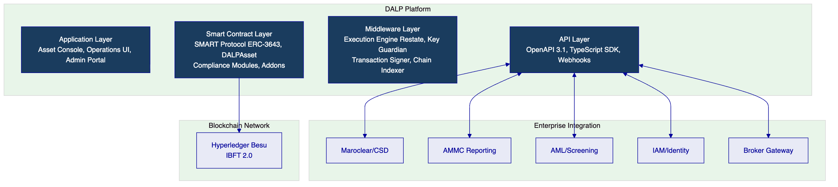
  - 3.2 Core Lifecycle Pillars
Issuance: Full instrument creation pipeline for bonds, equities, and sukuk-aligned instruments. Configuration covers maturity dates, coupon schedules, investor class restrictions, and disclosure document version control. All deployments require maker-checker governance authorization.
Compliance: Ex-ante, modular compliance engine based on ERC-3643. Country allow/block lists, investor count limits, identity verification (OnchainID), transfer approval workflows, and time-lock restrictions are configurable per instrument without contract redevelopment.
Custody: Key Guardian framework integrates with HSM, Fireblocks, DFNS, or Ledger Enterprise. Tier 3 option provides full client-controlled key custody.
Settlement: XvP Settlement addon provides atomic DvP settlement. ISO 20022 settlement instruction output for Maroclear/RTGS integration. Deterministic finality — no partial settlement.
Servicing: Yield addon for coupon/dividend distribution with record-date logic. Maturity redemption token feature for bond lifecycle management. Airdrop module for controlled distribution events.
  - 3.3 Supported Asset Classes
Asset Class | Types | Morocco Relevance
Fixed Income | Bond | Corporate bonds, government bonds, green bonds
Equity | Equity | Listed equity instruments
Islamic Finance | Configurable Bond/Equity | Sukuk-aligned compliance configuration
Fund | Fund | Investment fund units

  - 3.4 Standards and Protocols
Standard | Application
ERC-3643 (SMART Protocol) | Core security token standard
ISO 20022 | Settlement instruction format for Maroclear
OpenAPI 3.1 | API specification
AAOIFI (configuration support) | Islamic finance governance documentation support
OAuth 2.0/OIDC | Enterprise IAM integration
TLS 1.3 + AES-256 | Transport and at-rest encryption

- 4. Understanding Casablanca Stock Exchange Requirements
  - 4.1 Institutional Context
Casablanca Stock Exchange operates under AMMC oversight as the primary regulated market operator in Morocco. The tokenized securities programme must:
- Maintain AMMC-required investor protection and disclosure standards
- Integrate with Maroclear as the authoritative CSD for settlement and registration
- Support French and Arabic language operations
- Handle a diverse investor base including Pan-African institutional investors
- Produce evidence for AMMC supervisory review on demand
  - 4.2 Requirement Domain Mapping
Domain | CSE Requirement | DALP Coverage
Product/Asset Scope | Bonds, equities, sukuk-aligned | Full
Identity/Onboarding | Issuer onboarding, investor KYC, multi-jurisdiction | Full
Compliance/Control | AMMC-aligned transfer restrictions, investor limits | Full (configurable)
Settlement/Cash Leg | Maroclear DvP, MAD/multi-currency | Full — ISO 20022 output
Integration/Reporting | AMMC reporting, Maroclear, broker connectivity | Full
Infrastructure/Operations | Data sovereignty, French/Arabic ops | Full — European cloud region

  - 4.3 Key Challenges
Challenge 1: AMMC regulatory mapping
AMMC market rules require disclosure discipline, investor classification, and market conduct controls. DALP's compliance module framework maps to these requirements through configurable eligibility rules and audit evidence production.
Challenge 2: Maroclear integration
Maroclear's CSD position as settlement authority requires that tokenized instrument positions reconcile against Maroclear records. DALP's ISO 20022 output and reconciliation dashboard support this requirement.
Challenge 3: Pan-African investor base
Investors from across Africa may have varying KYC documentation standards and AML risk profiles. DALP's configurable country allow/block list and identity claim framework supports jurisdiction-specific eligibility rules per instrument.
Challenge 4: Bilingual operations
DALP's operational documentation and support materials are available in French. Arabic localization of the operations UI is available as a configuration option.
Challenge 5: Islamic finance instrument support
Where sukuk-aligned instruments require specific governance documentation and AAOIFI compliance evidence, DALP's document management capability and governance workflow framework support the required approval lineage and documentation chain.

- 5. Proposed Solution and Functional Capabilities
  - 5.1 Solution Architecture
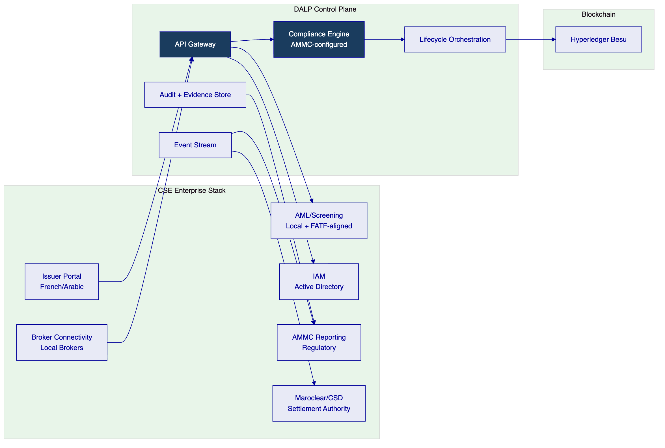
  - 5.2 Issuance and Asset Configuration
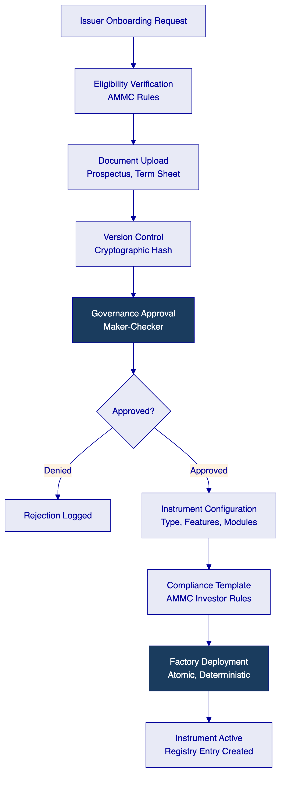
Instrument configuration for CSE:
- Bond parameters: ISIN/CSE identifier, maturity date, coupon rate and schedule, nominal value, denomination currency (MAD, EUR, USD), total supply cap
- Equity parameters: ISIN, share class, voting rights configuration, transfer restrictions by investor class
- Investor class restrictions: Professional investors (institutional), qualified retail, retail with disclosure requirements, GCC/Pan-African investor eligibility
- Sukuk configuration: AAOIFI-referenced governance documentation, profit distribution (not interest) distribution model using yield addon, underlying asset reference documentation
  - 5.3 Compliance Enforcement
Compliance module configuration aligned to AMMC market rules:
- Investor classification: Enforces AMMC investor category (professional, qualified, retail) per instrument type
- Disclosure enforcement: Transfer to new investors triggers disclosure document delivery confirmation requirement where applicable
- Geographic restrictions: Country allow/block list enforces cross-border investment restrictions relevant to Morocco's bilateral investment treaty network
- Market conduct: Insider trading controls through transfer approval workflow (compliance officer sign-off required for flagged transfers)
  - 5.4 Transfer and Settlement
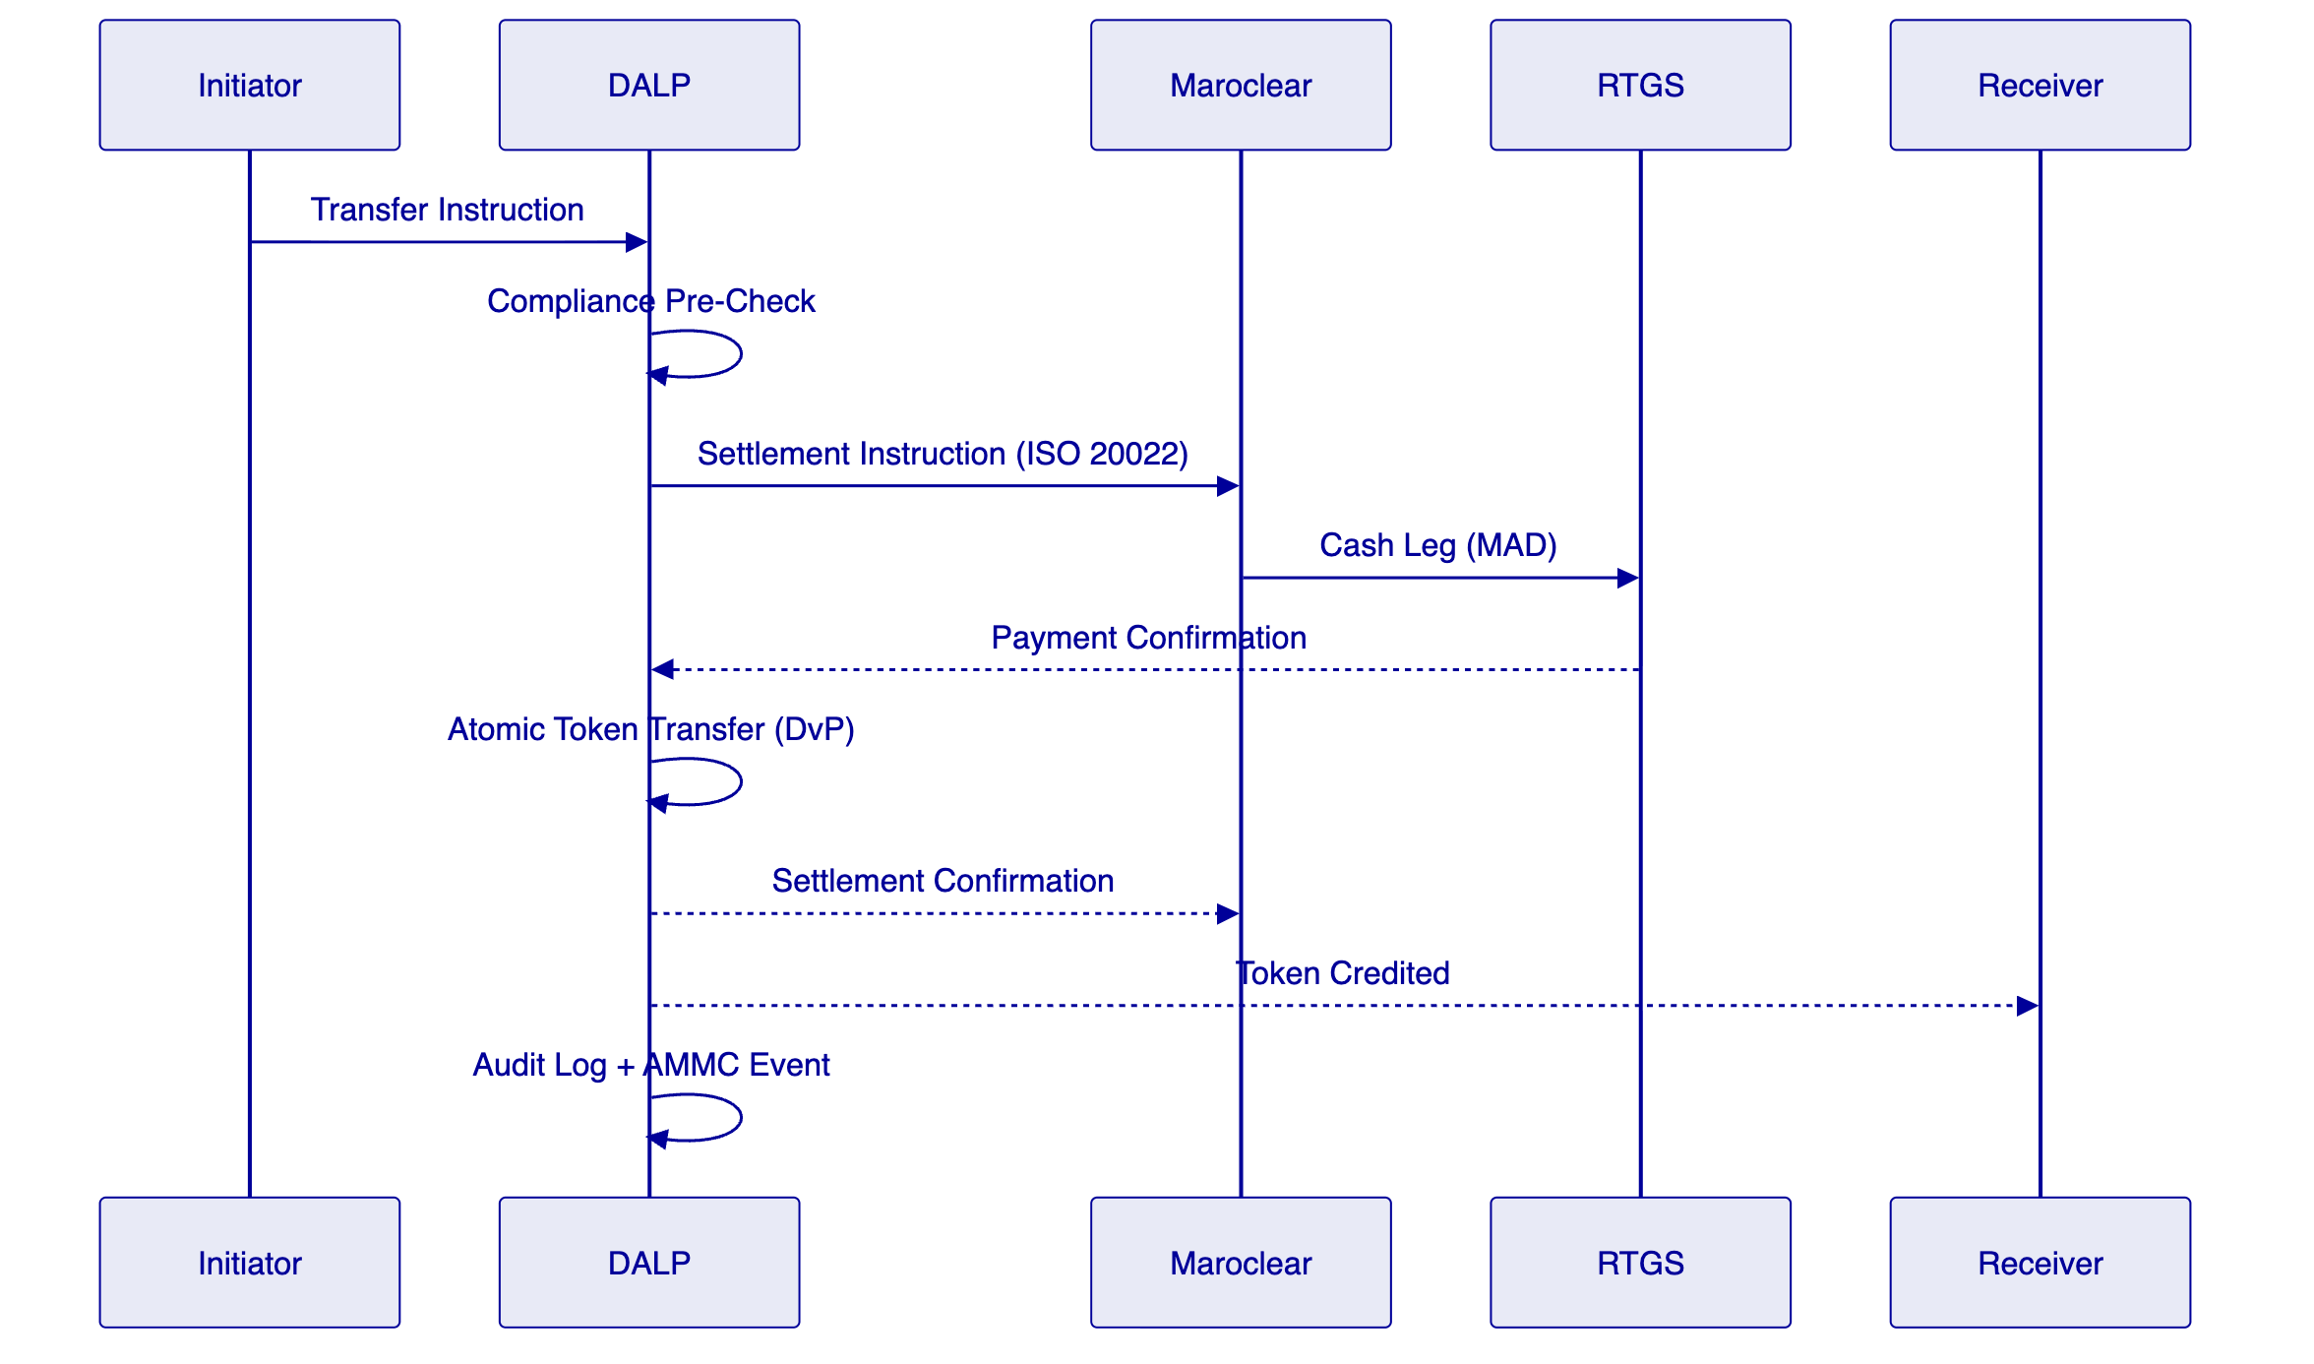
  - 5.5 Corporate Actions and Servicing
Coupon/profit distribution: Yield addon calculates entitlements based on record-date snapshot. For sukuk-aligned instruments, the distribution model uses profit-sharing terminology rather than interest to support AAOIFI documentation requirements. Multi-currency distribution is supported (MAD and foreign currency equivalents).
Maturity/redemption: Maturity redemption feature manages end-of-life processing. Investor notification, token burn, and cash settlement instruction generation are automated with maker-checker authorization before execution.
Governance events: Voting power token feature supports bondholder meetings and shareholder votes with on-chain result recording.
  - 5.6 Integration and Interoperability
Integration | Protocol | Purpose
Maroclear | ISO 20022 REST | Settlement instruction delivery and confirmation
AMMC reporting | Structured batch extract | Regulatory reporting and surveillance data
AML/KYC | REST API | Investor screening (Accuity, Refinitiv, or local provider)
Broker gateway | OpenAPI 3.1 | Order instruction submission
IAM (Active Directory) | SAML 2.0/OIDC | Operator authentication
Reporting/BI | CSV/JSON batch | Management and regulatory reporting

  - 5.7 Functional Fit Matrix
Req ID | Requirement | Status | DALP Mechanism
REQ-01 | Segregated environments | Full | 4-environment model
REQ-02 | API-first, eventing | Full | OpenAPI 3.1, webhooks
REQ-03 | RBAC, maker-checker, audit | Full | 26-role model, on-chain audit
REQ-04 | Configurable lifecycle | Full | Compliance module framework
REQ-05 | Third-party disclosure | Full | Appendix C
REQ-06 | Resilience, recovery | Full | 99.9% SLA, RTO < 4h
REQ-07 | Delivery plan | Full | 18-week plan
REQ-08 | Audit evidence | Full | Seven evidence categories
REQ-16 | Issuance, registry, settlement | Full | Bond/equity/sukuk, OnchainID, XvP
REQ-17 | Market infrastructure | Full | ISO 20022, webhook event stream

- 6. Technical Architecture
  - 6.1 Architectural Principles
Same five principles as for ADX: lifecycle-first, durable execution, defense-in-depth, separation of concerns, provider abstraction. For Casablanca, an additional principle applies:
Regulatory configurability: The platform must be configurable to match AMMC requirements without code changes. All compliance rules, investor classes, transfer restrictions, and governance thresholds are operator-configurable parameters.
  - 6.2 Layered Architecture
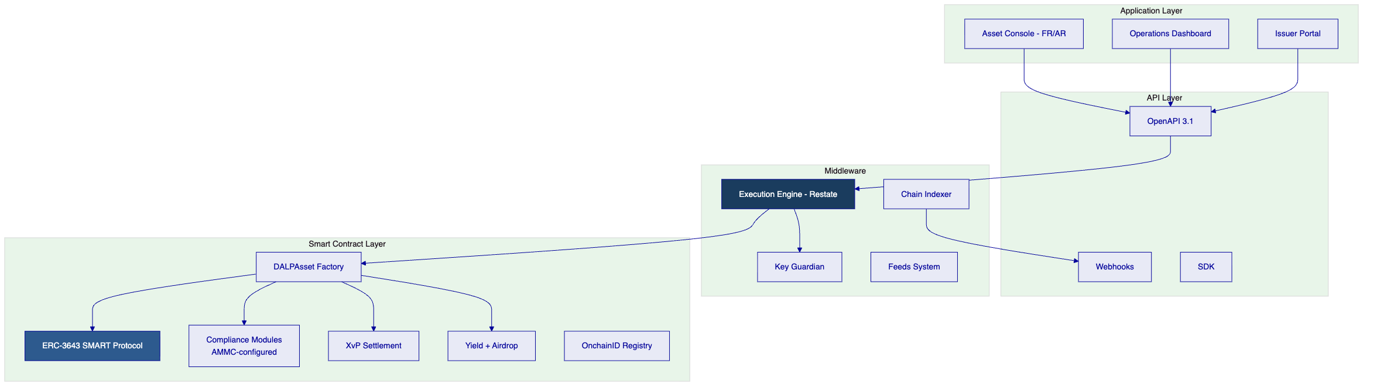
  - 6.3 Data Architecture
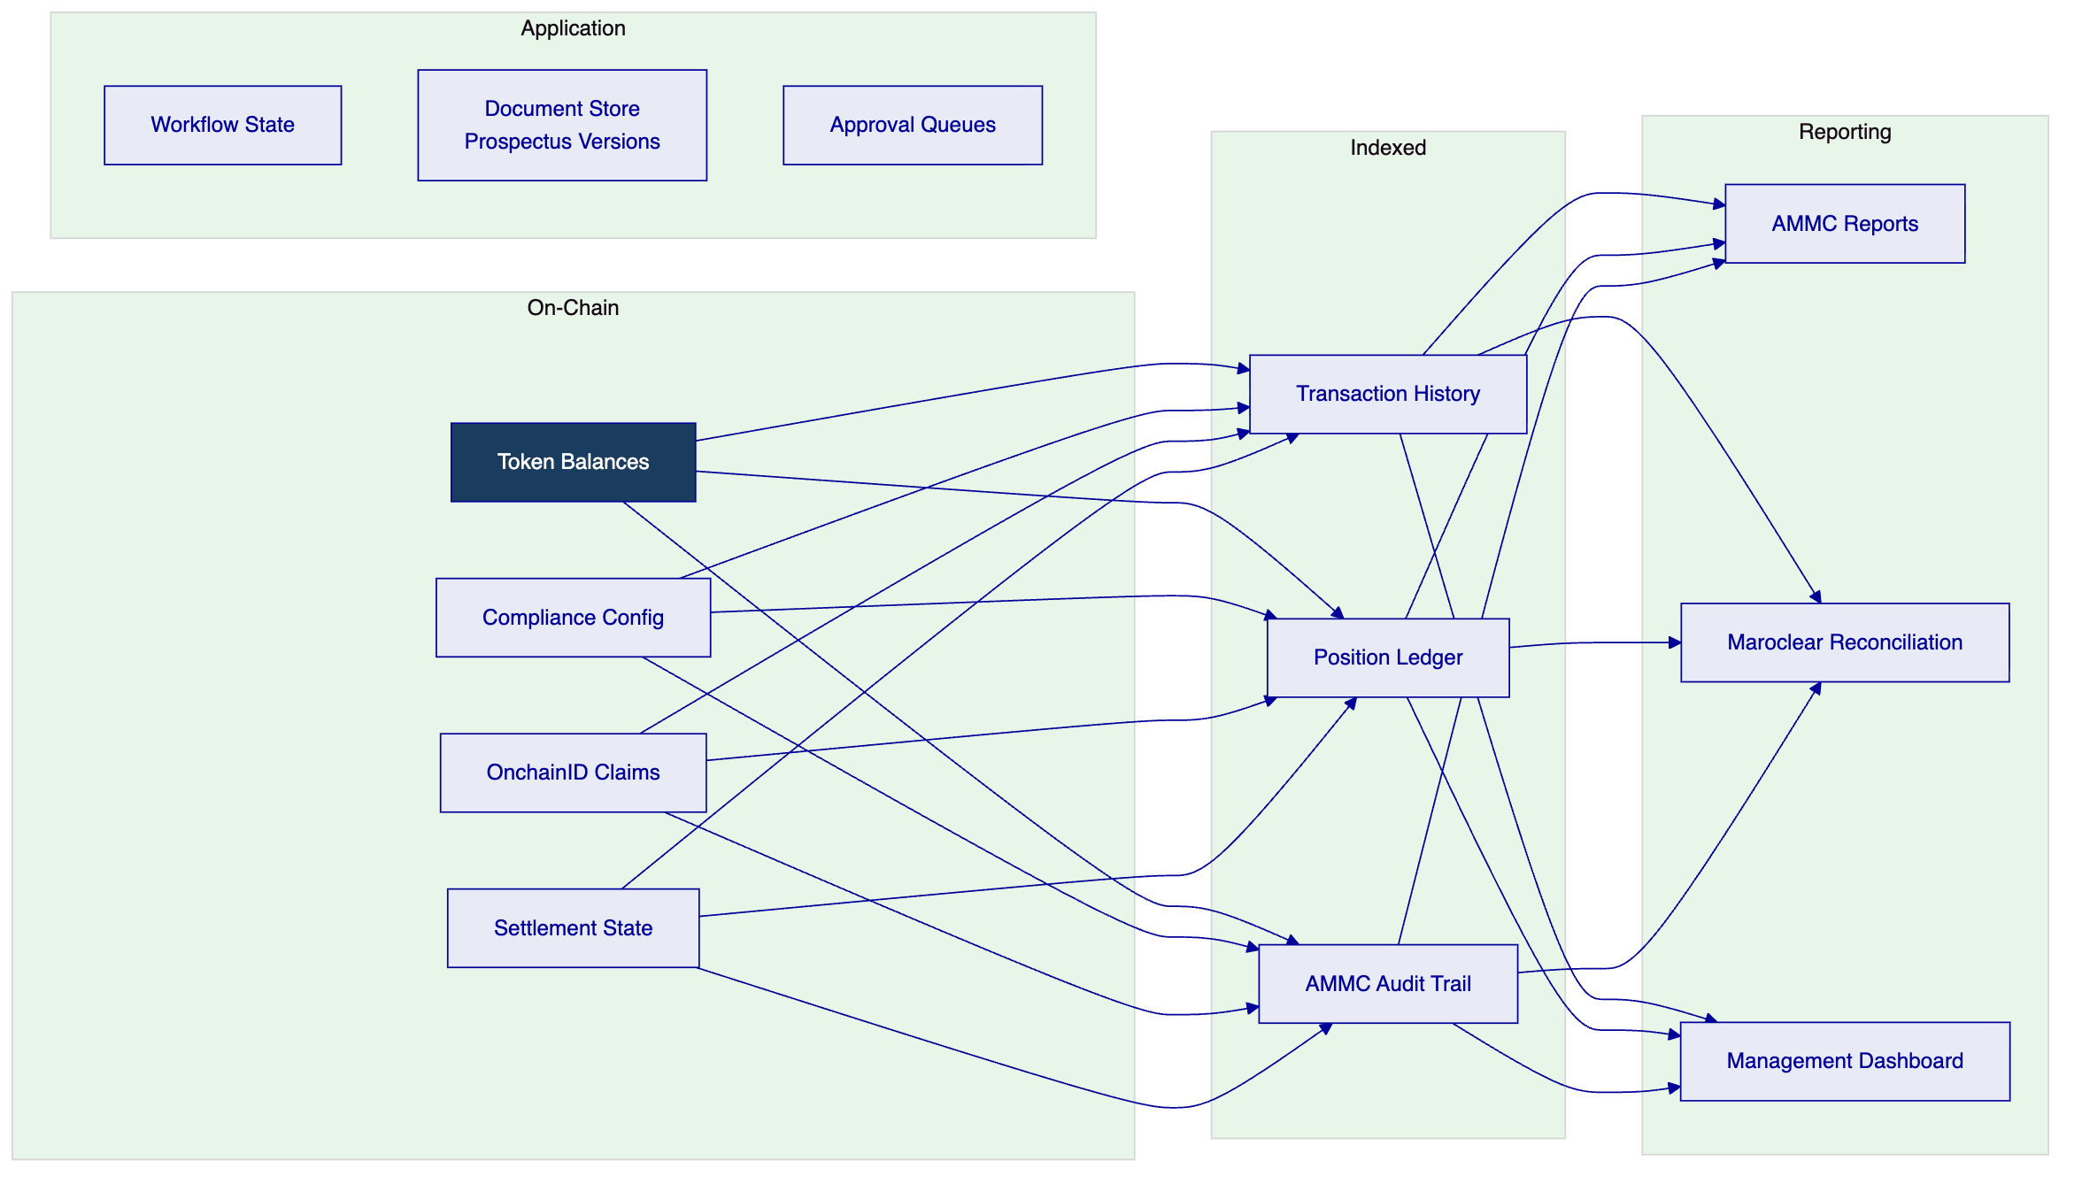
  - 6.4 Network Topology
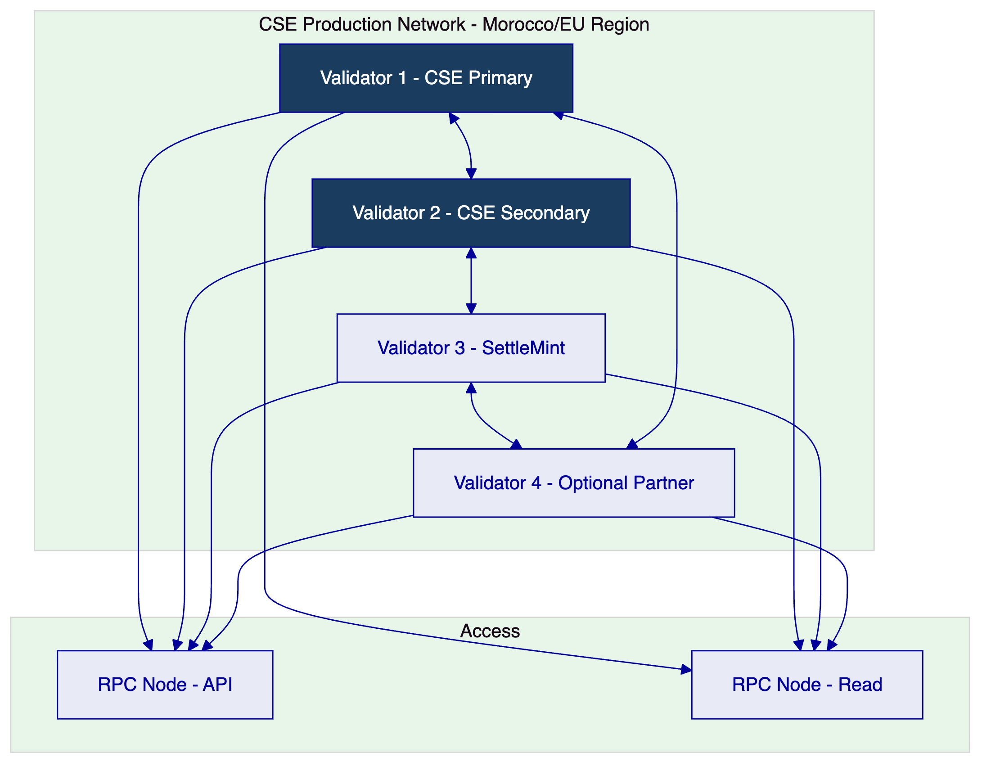
Performance benchmark: Under 200 concurrent settlement-grade transactions on 4-validator Besu network: median latency 2.1s, P99 4.8s. Suitable for Casablanca Stock Exchange's expected transaction profile.
  - 6.5 Environment Segregation
Environment | Purpose | Data
Development | Platform configuration, instrument template development | Synthetic only
Test | Integration testing with Maroclear test environment | Synthetic only
UAT | User acceptance testing in French/Arabic | Anonymized test data
Production | Live operations | Real data

- 7. Asset Lifecycle and Compliance Infrastructure
  - 7.1 Sukuk and Islamic Finance Support
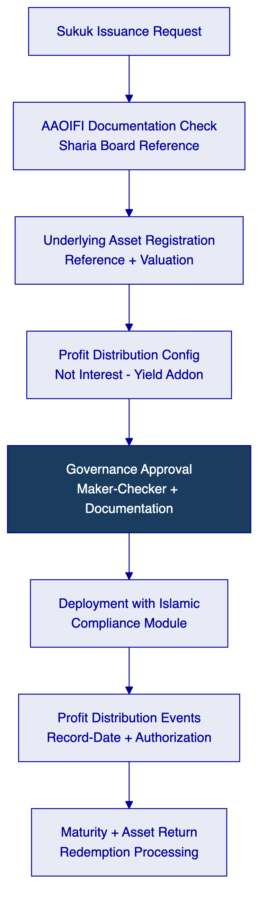
For sukuk-aligned instruments:
- Distribution model uses DALP's Yield addon configured with profit-sharing terminology
- Underlying asset documentation is version-controlled in the document store with cryptographic hash verification
- Sharia board approval lineage is captured in the governance workflow with mandatory attachment of board resolution document
- AAOIFI standard references can be embedded in instrument metadata for regulatory reporting
  - 7.2 Investor Lifecycle
Status | Condition | Transfer Eligible
Pending | KYC under review | No
Active — Professional | Verified institutional investor | Yes — all instruments
Active — Qualified | Verified qualified retail | Yes — per eligibility config
Active — Retail | Verified retail with disclosure | Yes — retail-eligible instruments only
Active — Pan-African | Cross-border verified investor | Yes — per corridor config
Restricted | Compliance hold | No
Offboarded | Relationship terminated | No

- 8. Security, Governance, and Controls
  - 8.1 Security Model
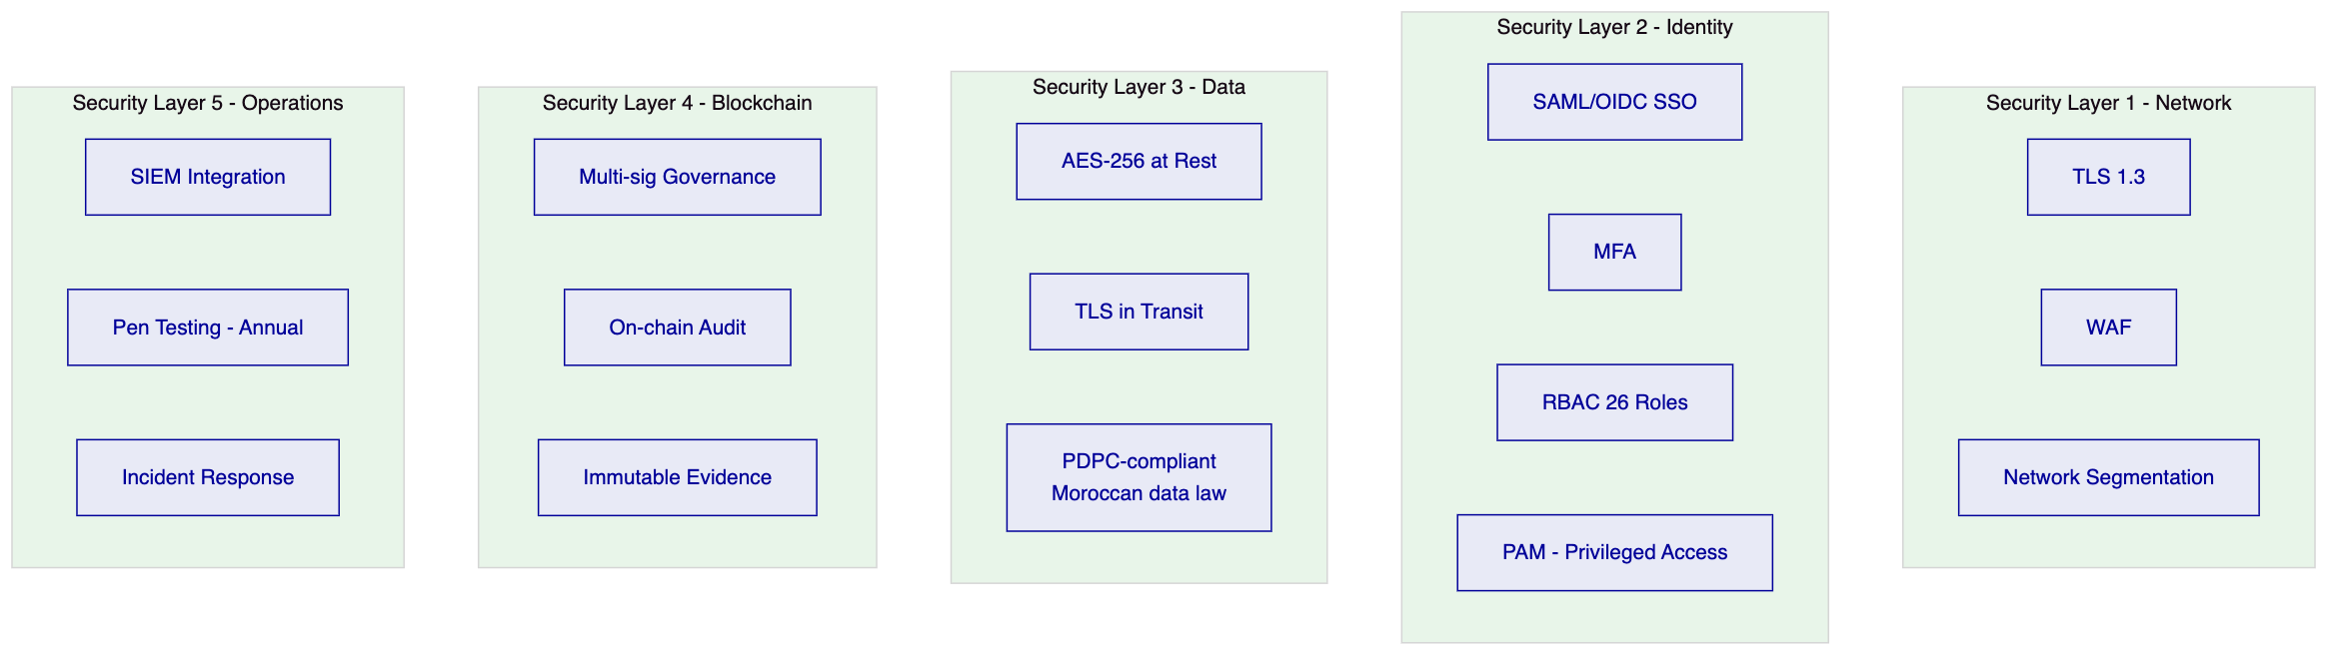
  - 8.2 Morocco Data Protection Compliance
Moroccan Law No. 09-08 on the protection of individuals with regard to the processing of personal data (implemented through the CNDP — Commission Nationale de contrôle de la protection des Données à caractère Personnel) governs personal data handling for Casablanca Stock Exchange's digital operations. DALP addresses this through:
- Field-level encryption of personal investor data
- Access logging for all personal data queries
- Data subject request handling capability (right of access, correction, erasure)
- Data residency controls: personal data stored in Moroccan or EU cloud regions (EU adequacy decision covers transfer to EU)
- Retention period configuration aligned to AMMC and CNDP requirements
  - 8.3 Separation of Duties
Action | Initiator | Approver | Admin | Auditor
Submit instrument configuration | ✓ | — | — | —
Approve instrument deployment | — | ✓ | — | —
Sukuk documentation approval | — | ✓ (Sharia Officer) | — | —
AML alert escalation | — | ✓ (Compliance) | — | —
View audit trail | — | — | — | ✓
User provisioning | — | — | ✓ | —

  - 8.4 Audit Evidence for AMMC
DALP produces structured audit evidence across seven categories, exportable on demand for AMMC supervisory review:
- Transaction audit log
- Compliance decision log (per AMMC investor category rules)
- Entitlement history (role and access changes)
- Configuration change log
- Key management log
- Settlement record
- Corporate action record (sukuk distributions, redemptions)
  - 8.5 Security Responsibility Matrix
Control Area | SettleMint | CSE | Shared
Platform software security | Primary | Review | Security review access
Network perimeter | Primary (managed cloud) | CSE-side controls | Firewall policy
Data protection (Moroccan law) | Platform tooling | CNDP compliance decisions | Joint DPIA where required
Key management | Framework | CSE keys (Tier 3 option) | Key ceremony
Penetration testing | Annual minimum | CSE-initiated | Scope and reporting

- 9. Integration and Interoperability
  - 9.1 Maroclear Integration
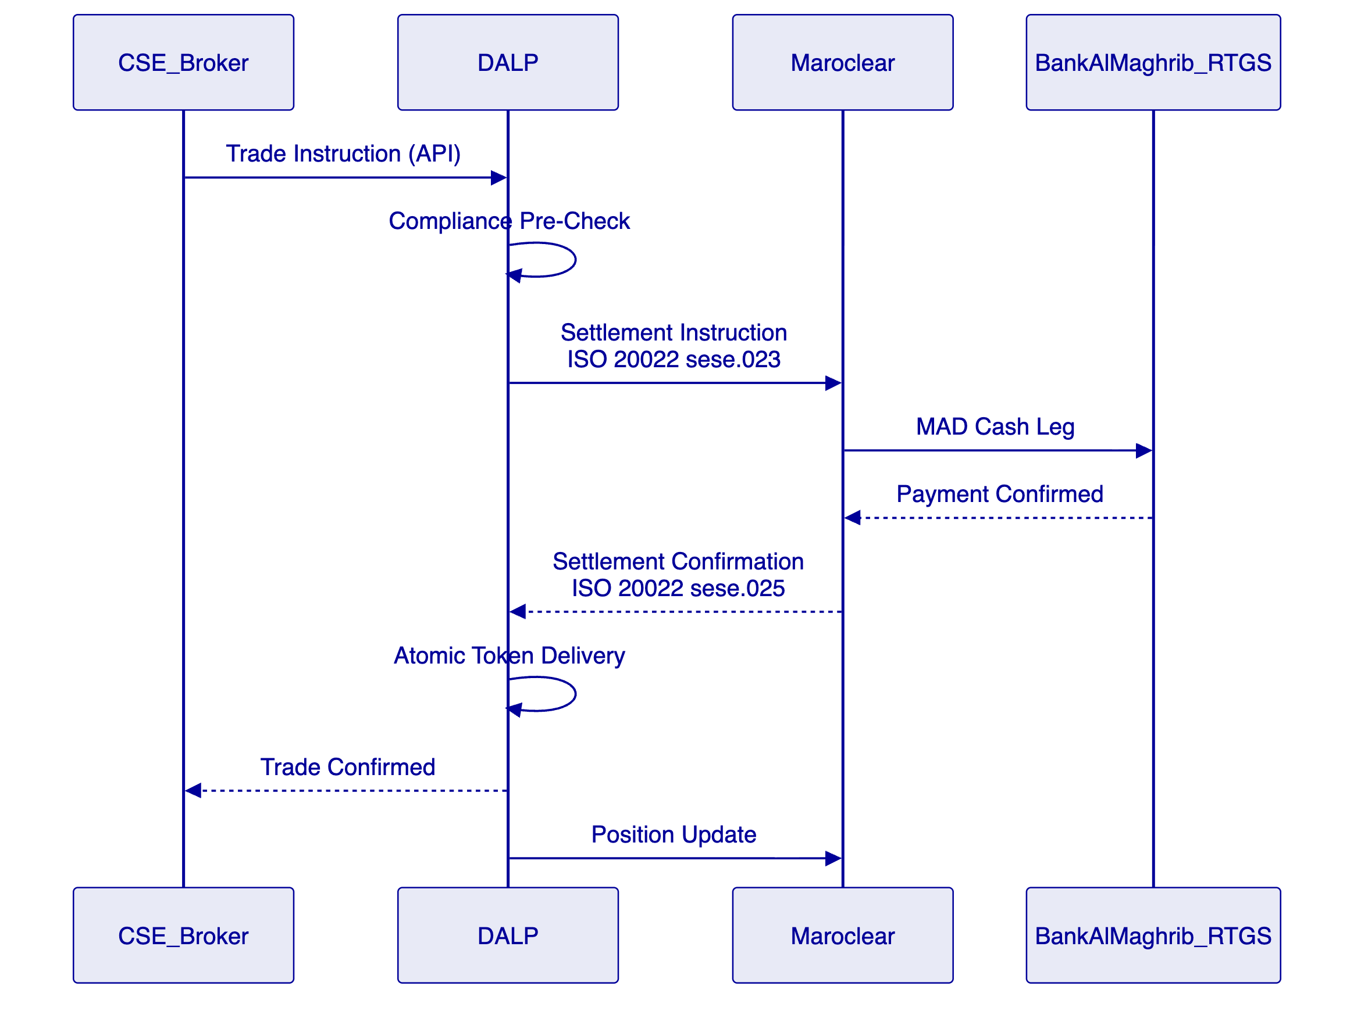
The integration pattern with Maroclear uses ISO 20022 securities settlement messages (sese.023 for settlement instructions, sese.025 for confirmations). Daily reconciliation compares DALP token position records against Maroclear's registry, with structured exception reporting for operations team review.
  - 9.2 AMMC Regulatory Reporting
DALP generates structured regulatory reporting extracts for AMMC submission:
- Daily transaction report: All transfer events with counterparty details, instrument identifiers, and compliance check outcomes
- Investor register snapshot: Current holder registry per instrument on demand
- Corporate action record: All coupon, dividend, and maturity events with authorization lineage
- Exception report: All rejected transactions with reason codes
  - 9.3 API Versioning and Release Management
DALP follows semantic versioning (major.minor.patch) with 12-month advance notice for major version changes. API consumers (brokers, reporting systems) are notified through a structured release communication process. Backward compatibility is maintained across minor and patch versions.

- 10. Deployment Model
  - 10.1 Recommended Model: European or Morocco Cloud Region
For Casablanca Stock Exchange, SettleMint recommends private cloud deployment in either:
- OVHcloud Roubaix/Gravelines (France): EU-based cloud with strong connectivity to Morocco and GDPR-compliant data handling under EU adequacy framework
- Azure France Central (Paris): EU data residency, Azure enterprise SLA, strong Morocco telecommunications connectivity
Both options satisfy Moroccan data sovereignty requirements for financial market infrastructure under the AMMC and CNDP framework.
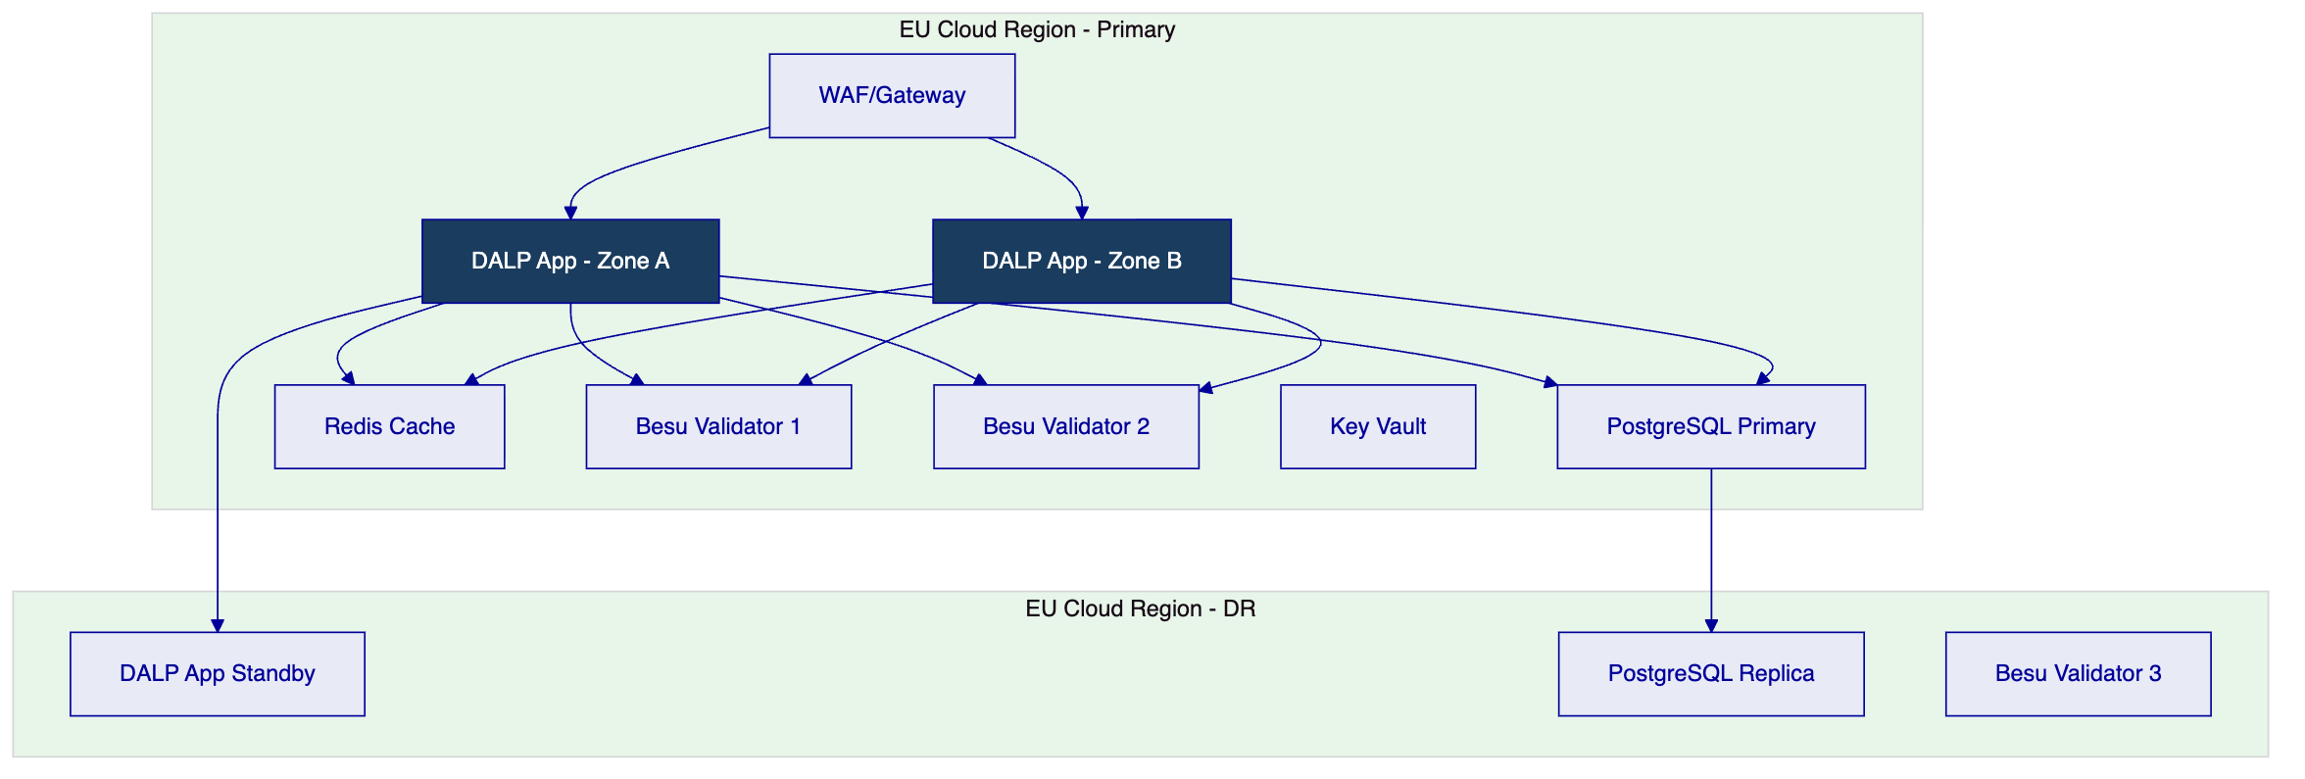
  - 10.2 Availability and Resilience
Metric | Target | Mechanism
Uptime | 99.9% | Multi-zone active-active
RTO | < 4 hours | Automated failover
RPO | < 1 hour | Continuous replication
DR test frequency | Quarterly | Documented outcomes

- 11. Implementation Methodology
  - 11.1 Implementation Timeline
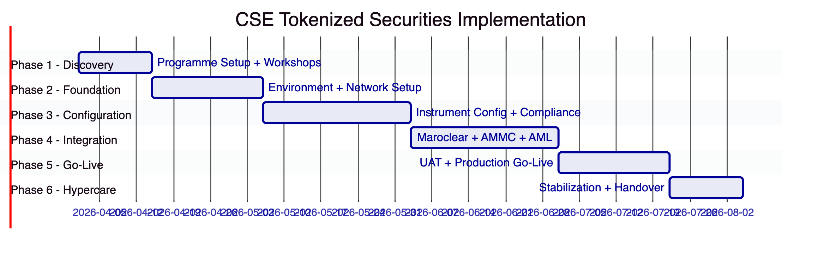
  - 11.2 Phase Summary
Phase | Duration | Key Deliverables | Gate Criteria
Phase 1 — Discovery | 2 weeks | Requirements baseline, Maroclear integration specification, AMMC compliance mapping | CSE Programme Director sign-off
Phase 2 — Foundation | 3 weeks | 4 environments live, network configured, security baseline approved | CSE IS team sign-off
Phase 3 — Configuration | 4 weeks | Instrument templates configured, AMMC compliance rules bound, sukuk template complete | CSE Compliance team approval
Phase 4 — Integration | 4 weeks | Maroclear integration tested, AMMC reporting validated, broker connectivity confirmed | CSE Technology sign-off
Phase 5 — Go-Live | 3 weeks | UAT complete, production go-live, initial operations confirmed | CSE Programme Director certificate
Phase 6 — Hypercare | 2 weeks | Stabilized operations, knowledge transfer complete | Operational readiness sign-off

  - 11.3 CSE Resource Requirements
Role | CSE Person-Days | Phase Focus
Programme Director | 20 | All phases
Technology/Integration team | 45 | Phases 2, 4
Compliance team (AMMC specialist) | 22 | Phases 1, 3
Maroclear relationship manager | 10 | Phase 4
Operations team (FR/AR bilingual) | 20 | Phases 5, 6
Total | 117

- 12. Training and Knowledge Transfer
Track | Audience | Duration | Language
Platform Administration | IT operations | 2 days | French
Developer/Integration | Integration engineers | 3 days | French
Operations | Business operations, compliance | 2 days | French/Arabic
AMMC Compliance Ops | Compliance team | 1 day | French

All training materials and operational runbooks are delivered in French. Arabic translations of operational UI elements and user guides are available.

- 13. Support and Service Levels
Tier | Coverage | P1 Response | Recommendation
Standard | Business hours (09-17 CET) | 4 hours | Not recommended for market infrastructure
Premium | Extended (07-22 CET) | 2 hours | Acceptable minimum
Enterprise | 24/7/365 | 1 hour | Recommended

CSE-specific support note: French-speaking support capability is available within the Enterprise Support tier. Named CSM speaks French. P1 incident communications conducted in French on request.
Metric | Target
Production uptime | 99.9%
RTO | < 4 hours
RPO | < 1 hour

- 14. Risk Management
ID | Risk | Likelihood | Impact | Mitigation
R-01 | AMMC regulatory interpretation requires additional compliance module configuration | Medium | Medium | Phase 3 AMMC alignment workshop; configuration is no-code change
R-02 | Maroclear integration requires custom message mapping | Medium | Medium | Phase 1 integration specification workshop with Maroclear technical team
R-03 | Sukuk documentation requirements extend Phase 3 | Low | Low | AAOIFI template available; Sharia officer involvement scoped in Phase 1
R-04 | French-Arabic bilingual testing adds UAT complexity | Low | Medium | Bilingual UAT team composition; test scripts prepared in both languages
R-05 | EU data residency requirement conflicts with Moroccan data localization preference | Low | Medium | Morocco cloud region option available (OVH Casablanca if available) or EU adequacy framework applies
R-06 | Pan-African investor AML complexity (multi-jurisdiction screening) | Medium | Medium | AML provider selected for FATF-aligned multi-jurisdiction coverage
R-07 | Security review by CSE IS team delays Phase 2 gate | Medium | Low | Evidence pack pre-prepared; ISO 27001 / SOC 2 Type II certificates available

- 15. Compliance Matrix
Req ID | Requirement | Status | Response | Notes
REQ-01 | Segregated environments | Full | 4 environments, separate networks
REQ-02 | API-first, eventing | Full | OpenAPI 3.1, webhooks
REQ-03 | RBAC, maker-checker, audit | Full | 26 roles, on-chain audit
REQ-04 | Configurable lifecycle | Full | Module framework
REQ-05 | Third-party disclosure | Full | Dependency register in Appendix C
REQ-06 | Resilience, recovery | Full | 99.9% SLA, RTO/RPO documented
REQ-07 | Delivery plan | Full | 18-week plan with gates | CSE effort: 117 person-days
REQ-08 | Audit evidence | Full | Seven categories, API export
REQ-16 | Issuance, registry, settlement | Full | Bond/equity/sukuk, OnchainID, XvP, ISO 20022
REQ-17 | Market infrastructure | Full | Maroclear ISO 20022, AMMC reporting
RC-01 | Regulatory mapping | Full | AMMC, Bank Al-Maghrib, Loi 09-08 addressed
RC-02 | AML/CFT | Full | Screening integration, FATF-aligned providers
RC-03 | Data governance | Full | Moroccan law 09-08, EU region data residency
RC-04 | Operational resilience | Full | DR testing quarterly, documented
RC-05 | Outsourcing disclosure | Full | All dependencies listed in Appendix C
RC-06 | Assurance and audit | Full | Seven evidence categories, cert available

- Appendix A: Operating Model Detail
  - A.1 Role Ownership
Product Management (CSE Market Development): Configures instrument parameters, investor class definitions, and fee structures. Bilingual (French/Arabic) operations.
First-Line Operations (CSE Operations): Manages transaction exceptions, settlement monitoring, corporate action execution. French-language operations dashboard primary interface.
Compliance Oversight (CSE Compliance + AMMC liaison): Reviews compliance module configurations, investor eligibility exceptions, AMMC-reportable events. Reviews AMMC reporting extracts before submission.
Sharia/Islamic Finance (CSE Sharia Officer where applicable): Reviews sukuk instrument configurations, approves AAOIFI documentation, signs off profit distribution calculations.
Information Security (CSE IS): User provisioning, access recertification, incident escalation. Quarterly access review.
Technology (CSE Technology): Environment management, Maroclear integration maintenance, AMMC reporting system connectivity.
  - A.2 Governance Routines
Daily: Transaction exception review, settlement confirmation, AMMC-reportable alert triage.
Weekly: Exception register review, broker connectivity status, Maroclear reconciliation review.
Monthly: Access recertification, AMMC monthly reporting, SettleMint service review, sukuk distribution event calendar review.

- Appendix B: Security and Resilience
Encryption: AES-256 at rest, TLS 1.3 in transit, field-level encryption for Moroccan personal data (Loi 09-08 compliance).
Vulnerability management: Automated dependency scanning, monthly SAST/DAST, annual penetration test. Critical vulnerabilities patched within 48 hours.
Incident response: P1 detection → 1-hour SettleMint response → French-language incident communication to CSE → root cause analysis within 5 business days.
DR testing: Quarterly failover exercise. Results documented and available to CSE operations and IS teams.

- Appendix C: Dependency Register
Dependency | Provider | Risk | Substitution
Cloud infrastructure | OVHcloud or Azure France | Medium | Multi-cloud capable
Key management | Azure Key Vault / OVH KMS | Medium | HSM option
Blockchain | Hyperledger Besu | Low | Any EVM-compatible
AML/KYC | CSE-selected (Accuity, ACAM-aligned) | Medium | Provider-agnostic API
Maroclear connectivity | CSE/Maroclear arrangement | High | No substitution — primary CSD
Custody | Fireblocks/DFNS/Client HSM | Medium | Multiple providers supported

End of Technical Proposal — Casablanca Stock Exchange
Document Version: 1.0 | Date: 2026-03-19 | Classification: Restricted — Commercial-Sensitive
SettleMint NV | Rue Montoyer 39, 1000 Brussels, Belgium | www.settlemint.com

