[Company name]
[Document title]
[Document subtitle]

Confidentiality Statement
This document contains confidential and proprietary information of SettleMint. By reading this document, you agree not to disclose the confidential information contained herein to any third party without the prior written consent of SettleMint, except to those agents, principals, representatives, or consultants who require access for the purpose of evaluating this document. You further agree to inform such persons of the confidential nature of this document and to obtain their agreement to preserve its confidentiality to the same extent as yours.
This confidentiality statement shall remain binding on the parties for a period of five (5) years from the date stated on the front cover, unless superseded by confidentiality provisions detailed in a subsequent agreement.
Terms and Conditions
This proposal is valid until [DD Month YYYY]. In the absence of confirmation to proceed, SettleMint and [the Company] acknowledge and agree to abide by the Mutual NDA as the governing agreement.
SettleMint reserves the right to vary the terms of this proposal in response to changes in specifications or information made available at a later date. Submission of this proposal does not convey any right, title, interest, or license in any intellectual property rights (including, but not limited to, patents, copyrights, trade secrets, or trademarks) contained herein.
All rights are reserved. This proposal and the information contained within it are provided on an “as is” basis, without any warranties of any kind, express or implied.
All contracts with SettleMint will be governed by Belgian Law and subject to the exclusive jurisdiction of Belgian courts.
Contact Details
For any enquiries regarding this document, please contact:
[Full Name]
[Job Title]
Email: [email@example.com]
Phone: [Country Code - Number]

Table of Contents

Digital Asset Regulatory Platform and Supervised Market Access 3
Table of Contents 4
1. Executive Summary 5
1.1 Context and Strategic Drivers 6
1.2 Why This Programme Is Hard 7
1.3 Proposed Response 8
1.4 Why SettleMint 9
1.5 Why DALP 10
1.6 Reference Fit Snapshot 11
2. Understanding Tadawul Saudi Exchange's Requirements 12
2.1 Procurement Context 13
2.2 Scope of Work 14
2.3 Technical Requirements Summary 15
2.4 High-Priority Spotlight 16
3. Proposed Solution: DALP Operating Model 17
3.1 Solution Overview 18
3.2 Deployment Architecture 19
3.3 Participant Model 20
4. Platform Architecture 21
4.1 Architectural Overview 22
4.2 Smart Contract Architecture 23
4.3 Compliance Architecture 24
4.4 Identity Architecture 25
4.5 API Architecture 26
5. Asset Lifecycle and Compliance Infrastructure 27
5.1 Supported Asset Classes 28
5.2 Asset Designer Workflow 29
5.3 Regulatory Framework Support 30
5.4 Settlement Architecture 31
6. Security, Governance, and Controls 32
6.1 Defense-in-Depth Security Model 33
6.2 Role-Based Access Control 34
6.3 Key Management 35
6.4 Certifications and Compliance 36
6.5 Operational Governance 37
7. Integration and Interoperability 38
7.1 Integration Architecture 39
7.2 Data Flow Architecture 40
7.3 Reconciliation Model 41
8. Implementation Methodology 42
8.1 Phase-Gated Delivery 43
8.2 Phase 1: Discovery and Requirements 44
8.3 Phase 2: Foundation and Setup 45
8.4 Phase 3: Configuration and Compliance 46
8.5 Phase 4: Integration and Testing 47
8.6 Phase 5: Go-Live and Hypercare 48
9. Delivery Approach and Timeline 49
9.1 Implementation Timeline 50
9.2 Resource Requirements 51
9.3 Client Responsibilities 52
10. Relevant Experience and References 53
10.1 Reference Projects Summary 54
10.2 Detailed Reference: Saudi Arabia RER 55
10.3 Detailed Reference: Standard Chartered Bank 56
10.4 Detailed Reference: Commerzbank 57
11. Current Coverage, Gaps, and Mitigations 58
11.1 Requirement Coverage Matrix 59
11.2 Areas Requiring Client Input 60
11.3 Risk Mitigation 61
12. Appendix: Response Matrix 62
12.1 Technical Requirements Response 63
12.2 Regulatory Requirements Response 64
Document Control 65
13. Detailed Technical Specifications 66
13.1 Blockchain Network Architecture 67
13.1.1 Network Topology 68
13.1.2 Consensus Mechanism 69
13.1.3 Privacy and Confidentiality 70
13.2 Smart Contract Architecture 71
13.2.1 Contract Hierarchy 72
13.2.2 Token Standards Implementation 73
13.2.3 Upgradeability Pattern 74
13.3 API and Integration Architecture 75
13.3.1 API Design Principles 76
13.3.2 Authentication and Authorization 77
13.3.3 Event Streaming 78
13.4 Data Architecture 79
13.4.1 Data Storage Layers 80
13.4.2 Data Retention and Archiving 81
13.4.3 Backup and Recovery 82
13.5 Performance and Scalability 83
13.5.1 Throughput Characteristics 84
13.5.2 Horizontal Scaling 85
13.5.3 Performance Testing 86
14. Integration Specifications 87
14.1 Integration Principles 88
14.2 Edaa Integration 89
14.2.1 Depository Connectivity 90
14.2.2 Settlement Processing 91
14.3 Muqassa Integration 92
14.3.1 Clearing Connectivity 93
14.3.2 Risk Management 94
14.4 Broker System Integration 95
14.4.1 Order Management Connectivity 96
14.4.2 Participant Management 97
14.5 CMA Reporting Integration 98
14.5.1 Regulatory Reporting 99
14.5.2 Supervisory Access 100
15. Operational Readiness 101
15.1 Operational Model 102
15.1.1 Operating Model Design 103
15.1.2 Monitoring and Observability 104
15.1.3 Incident Management 105
15.2 Change Management 106
15.2.1 Change Control Process 107
15.2.2 Release Management 108
15.3 Capacity Management 109
15.3.1 Capacity Planning 110
15.3.2 Performance Management 111
16. Additional Diagrams 112
16.1 Compliance Workflow Diagram 113
16.2 Settlement Flow Diagram 114
16.3 Security Layers Diagram 115
16.4 Data Flow Architecture Diagram 116
16.5 Deployment Pipeline Diagram 117
17. Glossary and Definitions 118
Document Control 119
18. Saudi Market Context 120
18.1 Saudi Vision 2030 Alignment 121
18.2 Regulatory Development 122
18.3 Market Infrastructure 123
18.4 Competitive Positioning 124
19. Implementation Deep Dive 125
19.1 Phase 1: Discovery and Requirements 126
19.1.1 Stakeholder Interviews 127
19.1.2 Regulatory Mapping 128
19.1.3 Architecture Design 129
19.1.4 Phase Gate Review 130
19.2 Phase 2: Foundation and Setup 131
19.2.1 Environment Provisioning 132
19.2.2 Network Configuration 133
19.2.3 Blockchain Network Deployment 134
19.2.4 Platform Installation 135
19.3 Phase 3: Configuration and Compliance 136
19.3.1 Asset Configuration 137
19.3.2 Compliance Configuration 138
19.3.3 Role and Permission Configuration 139
19.3.4 Integration Configuration 140
19.4 Phase 4: Integration and Testing 141
19.4.1 System Integration 142
19.4.2 Functional Testing 143
19.4.3 Non-Functional Testing 144
19.4.4 Security Testing 145
19.4.5 User Acceptance Testing 146
19.5 Phase 5: Go-Live and Hypercare 147
19.5.1 Production Deployment 148
19.5.2 Hypercare Support 149
19.5.3 Knowledge Transfer 150
19.5.4 Programme Closure 151
20. Conclusion 152
20.1 Summary 153
20.2 Call to Action 154
Document Control 155
21. Risk Register and Mitigation 156
21.1 Risk Identification 157
21.1.1 Regulatory Risks 158
21.1.2 Technical Risks 159
21.1.3 Operational Risks 160
21.1.4 Schedule Risks 161
21.2 Risk Monitoring 162
22. Quality Assurance 163
22.1 Testing Strategy 164
22.1.1 Unit Testing 165
22.1.2 Integration Testing 166
22.1.3 System Testing 167
22.1.4 User Acceptance Testing 168
22.1.5 Security Testing 169
22.2 Quality Metrics 170
23. Training and Enablement 171
23.1 Training Programme 172
23.1.1 Administrator Training 173
23.1.2 Operator Training 174
23.1.3 Technical Training 175
23.2 Enablement Resources 176
24. Support and Maintenance 177
24.1 Support Model 178
24.1.1 Standard Tier 179
24.1.2 Premium Tier 180
24.1.3 Enterprise Tier 181
24.2 Incident Management 182
24.2.1 Incident Classification 183
24.2.2 Incident Process 184
24.3 Maintenance Windows 185
24.3.1 Planned Maintenance 186
24.3.2 Unplanned Maintenance 187
Document Control 188
25. Appendices 189
Appendix A: Technology Standards 190
A.1 Blockchain Standards 191
A.2 API Standards 192
A.3 Security Standards 193
Appendix B: Integration Specifications 194
B.1 Edaa Integration Interface 195
B.2 Muqassa Integration Interface 196
B.3 Broker Integration Interface 197
Appendix C: Compliance Mapping 198
C.1 CMA Requirements Mapping 199
C.2 SAMA Requirements Mapping 200
C.3 PDPL Requirements Mapping 201
Appendix D: Role Definitions 202
D.1 Platform Administration Roles 203
D.2 Asset Roles 204
D.3 Compliance Roles 205
D.4 Settlement Roles 206
Appendix E: Glossary 207
Document Control 208
26. Detailed System Specifications 209
26.1 Infrastructure Requirements 210
26.1.1 Compute Requirements 211
26.1.2 Storage Requirements 212
26.1.3 Network Requirements 213
26.2 Software Requirements 214
26.2.1 Operating System 215
26.2.2 Container Orchestration 216
26.2.3 Database 217
26.2.4 Blockchain Client 218
26.3 Security Specifications 219
26.3.1 Authentication 220
26.3.2 Authorization 221
26.3.3 Encryption 222
26.3.4 Audit Logging 223
26.4 Performance Specifications 224
26.4.1 Throughput 225
26.4.2 Latency 226
26.4.3 Availability 227
26.5 Disaster Recovery Specifications 228
26.5.1 Recovery Objectives 229
26.5.2 Backup Strategy 230
26.5.3 Failover Procedures 231
27. Operational Procedures 232
27.1 Daily Operations 233
27.1.1 Monitoring Checklist 234
27.1.2 Incident Response 235
27.1.3 Change Management 236
27.2 Weekly Operations 237
27.3 Monthly Operations 238
27.4 Quarterly Operations 239
Document Control 240
28. Use Case Scenarios 241
28.1 Tokenized Bond Issuance 242
28.1.1 Scenario Description 243
28.1.2 Process Flow 244
28.1.3 System Interactions 245
28.2 Tokenized Sukuk Issuance 246
28.2.1 Scenario Description 247
28.2.2 Sharia Compliance 248
28.2.3 Process Flow 249
28.3 Tokenized Equity Trading 250
28.3.1 Scenario Description 251
28.3.2 Process Flow 252
28.4 Cross-Border Settlement 253
28.4.1 Scenario Description 254
28.4.2 Process Flow 255
29. Performance Testing Results 256
29.1 Test Environment 257
29.2 Throughput Results 258
29.3 Latency Results 259
29.4 Stress Test Results 260
30. Compliance Verification 261
30.1 CMA Compliance Checklist 262
30.2 SAMA Compliance Checklist 263
30.3 International Standards 264
Document Control 265
31. Vendor Qualifications 266
31.1 Company Overview 267
31.1.1 Corporate Information 268
31.1.2 Financial Standing 269
31.2 Certifications 270
31.3 Insurance 271
31.4 References 272
32. Project Team 273
32.1 Key Personnel 274
32.1.1 Programme Leadership 275
32.1.2 Technical Team 276
32.1.3 Support Team 277
32.2 Team Qualifications 278
33. Work Plan and Schedule 279
33.1 Project Schedule 280
33.2 Critical Path 281
33.3 Milestones 282
34. Acceptance Criteria 283
34.1 Phase Acceptance 284
34.2 Final Acceptance 285
Document Control 286
35. Environmental Considerations 287
35.1 Sustainability 288
35.1.1 Energy Efficiency 289
35.1.2 Carbon Footprint 290
35.2 E-Waste Management 291
36. Innovation Roadmap 292
36.1 Platform Innovation 293
36.1.1 Near-Term Innovation 294
36.1.2 Long-Term Innovation 295
36.2 Research and Development 296
37. Client Success Framework 297
37.1 Success Metrics 298
37.2 Continuous Improvement 299
37.3 Value Realization 300
38. Knowledge Management 301
38.1 Documentation 302
38.2 Knowledge Transfer 303
38.3 Continuous Learning 304
Document Control 305
39. Stakeholder Engagement 306
39.1 Communication Plan 307
39.1.1 Internal Stakeholders 308
39.1.2 External Stakeholders 309
39.2 Governance Structure 310
39.2.1 Decision Making 311
39.2.2 Issue Escalation 312
40. Appendices Extended 313
Appendix F: Reference Architecture 314
F.1 High-Level Architecture 315
F.2 Security Architecture 316
F.3 Integration Architecture 317
Appendix G: Interface Specifications 318
G.1 REST API 319
G.2 Event Schema 320
G.3 Error Codes 321
Appendix H: Sample Reports 322
Document Control 323
41. Extended Compliance Framework 324
41.1 Regulatory Compliance Overview 325
41.1.1 CMA Capital Market Regulations 326
41.1.2 SAMA Banking Regulations 327
41.1.3 AML/CFT Requirements 328
41.2 Data Protection Compliance 329
41.2.1 Personal Data Protection Law (PDPL) 330
41.2.2 Data Retention 331
41.3 Sharia Compliance 332
41.3.1 Islamic Finance Principles 333
41.3.2 AAOIFI Standards 334
42. Extended Testing Framework 335
42.1 Test Strategy Overview 336
42.1.1 Test Levels 337
42.1.2 Test Environments 338
42.2 Functional Testing 339
42.2.1 Test Coverage 340
42.2.2 Test Cases 341
42.3 Non-Functional Testing 342
42.3.1 Performance Testing 343
42.3.2 Security Testing 344
42.3.3 Resilience Testing 345
Document Control 346
43. Final Technical Specifications 347
43.1 Platform Capabilities Summary 348
43.1.1 Core Platform Features 349
43.1.2 Operational Capabilities 350
43.2 Technology Stack Summary 351
43.3 Standards Compliance 352
43.4 Conclusion 353
Document Control 354

  - Digital Asset Regulatory Platform and Supervised Market Access

Document Title: Technical Proposal — Digital Asset Regulatory Platform and Supervised Market Access
Client: Tadawul Saudi Exchange
Submission Date: 2026-03-17
Version: 1.0
Confidentiality: Restricted — Commercial-Sensitive
Prepared by: SettleMint NV

> This document contains confidential and proprietary information of SettleMint NV. Distribution or reproduction without prior written consent is prohibited.

- Table of Contents
- Executive Summary
- Understanding Tadawul Saudi Exchange's Requirements
- Proposed Solution: DALP Operating Model
- Platform Architecture
- Asset Lifecycle and Compliance Infrastructure
- Security, Governance, and Controls
- Integration and Interoperability
- Implementation Methodology
- Delivery Approach and Timeline
- Relevant Experience and References
- Current Coverage, Gaps, and Mitigations
- Appendix: Response Matrix

- 1. Executive Summary
  - 1.1 Context and Strategic Drivers
Tadawul Saudi Exchange is procuring a digital asset regulatory platform and supervised market access capability as a business-critical infrastructure initiative. The platform must operate within a control environment shaped by business ownership, architecture standards, security review, legal interpretation, compliance sign-off, and internal audit expectations. This is not a speculative innovation exercise; it is a procurement designed to identify a dependable platform and implementation model that can sustain growth in users, volumes, products, and audit scrutiny without fundamental rework.
The regulatory landscape in Kingdom of Saudi Arabia is evolving rapidly. The Central Bank has established a clear framework for digital asset service providers through its regulatory sandbox and licensing regime. Financial institutions operating in Kingdom of Saudi Arabia must demonstrate robust compliance with anti-money laundering requirements, investor protection rules, and market conduct standards. The proposed platform must enable the Central Bank to oversee digital asset activities while providing regulated entities with the infrastructure needed to operate compliantly.
SettleMint proposes DALP, the Digital Asset Lifecycle Platform, as the foundation for this initiative. DALP is a production-grade platform purpose-built for regulated financial institutions and sovereign entities. It provides the infrastructure required to design, issue, distribute, and service digital assets at scale, with the governance, compliance, and operational reliability that regulated environments demand.
  - 1.2 Why This Programme Is Hard
Digital asset regulatory infrastructure presents challenges that distinguish it from conventional technology deployments. The lifecycle complexity is significant: a digital asset platform must manage issuance, transfers, corporate actions, compliance monitoring, and retirement across potentially thousands of instruments and millions of participants. Each lifecycle event involves multiple parties, regulatory checkpoints, and audit requirements.
The governance and compliance burden is substantial. In a regulated environment, every action must be traceable to an authorized initiator, every compliance check must be verifiable, every approval must be documented, and every state change must be reconstructable for regulatory review. This applies not just to happy-path operations but to the boundary conditions: rejected transactions, stale approvals, mismatched data, delayed settlements, and corrected records.
The operationalization gap between pilot and production represents a critical challenge. Demonstrating tokenization in a sandbox environment is fundamentally different from operating a platform that processes real transactions, maintains compliance across multiple jurisdictions, integrates with existing enterprise systems, and produces audit evidence that satisfies internal and external reviewers. Many platforms can demonstrate capability; fewer can demonstrate operational maturity.
Integration burden is often underestimated. The platform must coexist with existing enterprise infrastructure: identity services, ledger or books-and-record systems, sanctions and AML tooling, reporting environments, service-management processes, and operational runbooks. The solution cannot become a reconciliation sinkhole that generates more manual work than it removes.
  - 1.3 Proposed Response
SettleMint proposes deploying DALP as the unified control plane for Tadawul Saudi Exchange's digital asset regulatory platform and supervised market access capability. The platform provides comprehensive lifecycle coverage including asset configuration, identity management, compliance enforcement, settlement operations, and corporate action automation.
The proposed deployment model is private cloud, deployed within the Central Bank's specified cloud environment (AWS, Azure, or GCP) with full data residency controls ensuring all data remains within Kingdom of Saudi Arabia. The platform operates on a permissioned blockchain network (Hyperledger Besu with IBFT 2.0 consensus) providing institutional-grade privacy and performance characteristics appropriate for regulated market infrastructure.
The compliance approach leverages DALP's pre-built regulatory framework library, which includes templates for major global frameworks (MiCA, MAS, FCA, JFSA) as well as configuration options for Kingdom of Saudi Arabia-specific requirements. The platform enforces compliance before execution, not after review, ensuring that non-compliant states cannot exist on-chain.
The custody model supports integration with the Central Bank's preferred custody infrastructure, whether via direct integration with existing providers or through DALP's modular custody connector framework.
The integration perimeter encompasses the full enterprise stack: identity management (integration with existing IAM/Active Directory), core banking and ledger systems, sanctions and AML tooling, reporting infrastructure, and payment rails (SWIFT, SEPA, local RTGS).
The phased delivery approach follows SettleMint's proven 19-week methodology: Discovery and Requirements (Weeks 1-2), Foundation and Setup (Weeks 3-5), Configuration and Compliance (Weeks 6-9), Integration and Testing (Weeks 10-13), and Go-Live with Hypercare (Weeks 14-19).
  - 1.4 Why SettleMint
SettleMint brings a combination of market tenure, production record, and regulated delivery experience that is directly relevant to the Tadawul Saudi Exchange's requirements.
The company has been building enterprise blockchain infrastructure since 2016, with 10 years of continuous operation. SettleMint has delivered production deployments at regulated banks across Asia and Europe, including tier-1 institutions such as Standard Chartered Bank, State Bank of India, and Commerzbank. Active sovereign programmes in the Gulf region demonstrate familiarity with regional regulatory requirements and market structures.
SettleMint's production record includes live deployments spanning bonds, equities, deposits, stablecoins, real estate, funds, and precious metals. The platform processes real transaction volumes under institutional SLAs with 24/7 uptime requirements. This production maturity distinguishes SettleMint from platforms that remain in demonstration or pilot phases.
The company holds ISO 27001 and SOC 2 Type II certifications, has passed security reviews and penetration testing at tier-1 financial institutions, and maintains operational maturity including business continuity and disaster recovery capabilities meeting institutional standards.
  - 1.5 Why DALP
DALP provides a comprehensive platform that addresses the full complexity of institutional digital asset operations.
Platform breadth is substantial: seven asset types (bonds, equities, funds, deposits, stablecoins, real estate, precious metals), twelve compliance module types, and eleven token features are built in. Pre-built regulatory templates for MiCA, MAS, Japan FSA, SEC Reg CF, Reg D 506(b)/(c), and UK FCA eliminate the need to build compliance from scratch.
The lifecycle model is unified: DALP covers the entire digital asset lifecycle from design through issuance, distribution, trading, corporate actions, compliance monitoring, and retirement. Most tokenization platforms stop at issuance; DALP's operational tooling handles the ongoing work that consumes the majority of institutional effort.
The control plane positioning is central: DALP functions as the governance and orchestration layer between existing core financial systems and blockchain networks, providing the infrastructure required to build, compliant digital asset solutions in production. The platform integrates with enterprise systems rather than replacing them.
Interoperability is designed in: API-first architecture with OpenAPI 3.1 specifications, TypeScript SDK, webhooks for event-driven integration, and support for meta-transactions enabling gasless workflows. The platform operates on any EVM-compatible blockchain (public or private) without application code changes.
Operations are enterprise-grade: 26 distinct roles across four layers enforce separation of duties. Five independent security layers provide defense-in-depth. The platform supports multiple deployment models (managed SaaS, private cloud, on-premises, hybrid) with data residency controls appropriate for sovereign requirements.
  - 1.6 Reference Fit Snapshot
The following reference projects are most directly relevant to the Tadawul Saudi Exchange's requirements:
Saudi Arabia RER (Real Estate Registry): National-scale blockchain infrastructure for property registration, fractionalization, and digital marketplace under REGA and Vision 2030. Live production since January 2026, processing real transactions. Demonstrates country-scale deployment capability, government integration, and multi-party ecosystem support.
Standard Chartered Bank — Digital Virtual Exchange: Blockchain-based securities tokenization platform enabling fractional ownership and instant settlement. Demonstrates institutional-grade compliance, multi-asset support, and integration with existing banking infrastructure across Asia, Africa, and Middle East.
State Bank of India — CBDC Infrastructure: Production-ready infrastructure for India's e-Rupee central bank digital currency. Demonstrates national-scale transaction capacity, integration with existing banking systems, and operation within a regulated monetary framework.
Commerzbank — Hybrid ETP Issuance: Hybrid on-chain/off-chain exchange-traded product issuance with Boerse Stuttgart listing, settlement under 10 seconds. Demonstrates integration with established exchange infrastructure, regulated venue compatibility, and capital markets expertise.

- 2. Understanding Tadawul Saudi Exchange's Requirements
  - 2.1 Procurement Context
The Tadawul Saudi Exchange is treating digital asset regulatory platform and supervised market access as a business-critical capability that must be implemented with the same discipline applied to core regulated systems. The solution will operate inside a control environment shaped by business ownership, architecture standards, security review, legal interpretation, compliance sign-off, and internal audit expectations.
The review team will look beyond product feature lists. It will test whether bidders can explain how the platform behaves when confronted with real-world operational pressure: incomplete onboarding data, limit breaches, approvals delayed by governance, partner outages, regulatory evidence requests, bulk corrections, data retention obligations, and phased rollout constraints.
Regional conditions in Kingdom of Saudi Arabia matter. Responses should be anchored in actual market infrastructure and supervisory realities, including the pace of domestic policy development, the role of regulated intermediaries, and the practical limits of cross-border interoperability.
  - 2.2 Scope of Work
The scope covers design mobilisation, product setup, integration, testing, controls, training, and operational readiness across five workstreams:
WS-01 — Mobilisation and Governance: Programme setup, steering, design authority, RAID management, decision logs, and acceptance governance.
WS-02 — Business and Product Configuration: Configure lifecycle, roles, limits, disclosures, and policy rules for digital asset regulatory platform and supervised market access.
WS-03 — Integration and Controls: Connect enterprise systems, identity, compliance, reporting, settlement dependencies, and observability.
WS-04 — Testing and Readiness: Functional, non-functional, security, resilience, UAT, cutover, training, and go-live support.
WS-05 — Operational Transition: Runbooks, service desk model, support handoff, KPI definition, and post-launch governance.
  - 2.3 Technical Requirements Summary
The following mandatory technical requirements guide this proposal:
Requirement | Interpretation
REQ-01: Segregated environments | DALP supports dev, test, UAT, DR, and production environments with isolated configuration and data residency
REQ-02: API-first interfaces | DALP provides OpenAPI 3.1 REST API, TypeScript SDK, and event webhooks for enterprise integration
REQ-03: RBAC, segregation of duties, maker-checker | DALP implements 26 distinct roles across four layers with dual-layer permission model
REQ-04: Configurable lifecycle, policy controls, limits, exceptions | DALP supports 12 compliance module types with configurable rules, expressions, and thresholds
REQ-05: Third-party dependencies disclosure | All dependencies are documented in this proposal and the dependency register
REQ-06: Resilience, recovery, backup, monitoring, incident management | DALP includes comprehensive observability, HA deployment options, and DR capabilities
REQ-07: Delivery method, client effort assumptions, phased implementation | SettleMint's 19-week phased methodology with clear deliverables and client responsibilities
REQ-08: Evidence extraction for audit, supervisory review, board reporting | DALP provides comprehensive audit trails, reporting dashboards, and export capabilities

  - 2.4 High-Priority Spotlight
Three issues will dominate this procurement, and SettleMint addresses each directly:
Control integrity: DALP's ERC-3643/SMART Protocol foundation ensures that every action on the platform can be traced to an initiator, every compliance check can be verified, every approval can be documented, and every state change can be reconstructed. The platform logs every blockchain transaction immutably on-chain while maintaining searchable indexes for operational and regulatory review. The dual-layer permission model (off-chain platform roles and on-chain smart contract roles) ensures that no single failure grants unauthorized access.
Coexistence with enterprise systems: DALP is designed as an integration layer, not a replacement for existing systems. The API-first architecture, comprehensive webhook support, and modular integration framework enable connection to identity services, compliance tooling, reporting environments, and payment rails without creating operational debt or unowned responsibilities. The platform provides reconciliation capabilities rather than requiring manual offsetting.
Phased scalability: The 19-week implementation methodology includes explicit phase gates with acceptance criteria. Each phase produces deliverables that are reviewed and approved before progression. The platform supports incremental asset class addition, jurisdiction expansion, and participant onboarding without requiring platform reset. The modular architecture (configurable assets, pluggable compliance modules, addon system) enables growth within the same deployment.

- 3. Proposed Solution: DALP Operating Model
  - 3.1 Solution Overview
DALP serves as the unified control plane for digital asset regulatory platform and supervised market access. The platform provides a comprehensive operating model that addresses the full lifecycle of digital assets within a regulated environment.
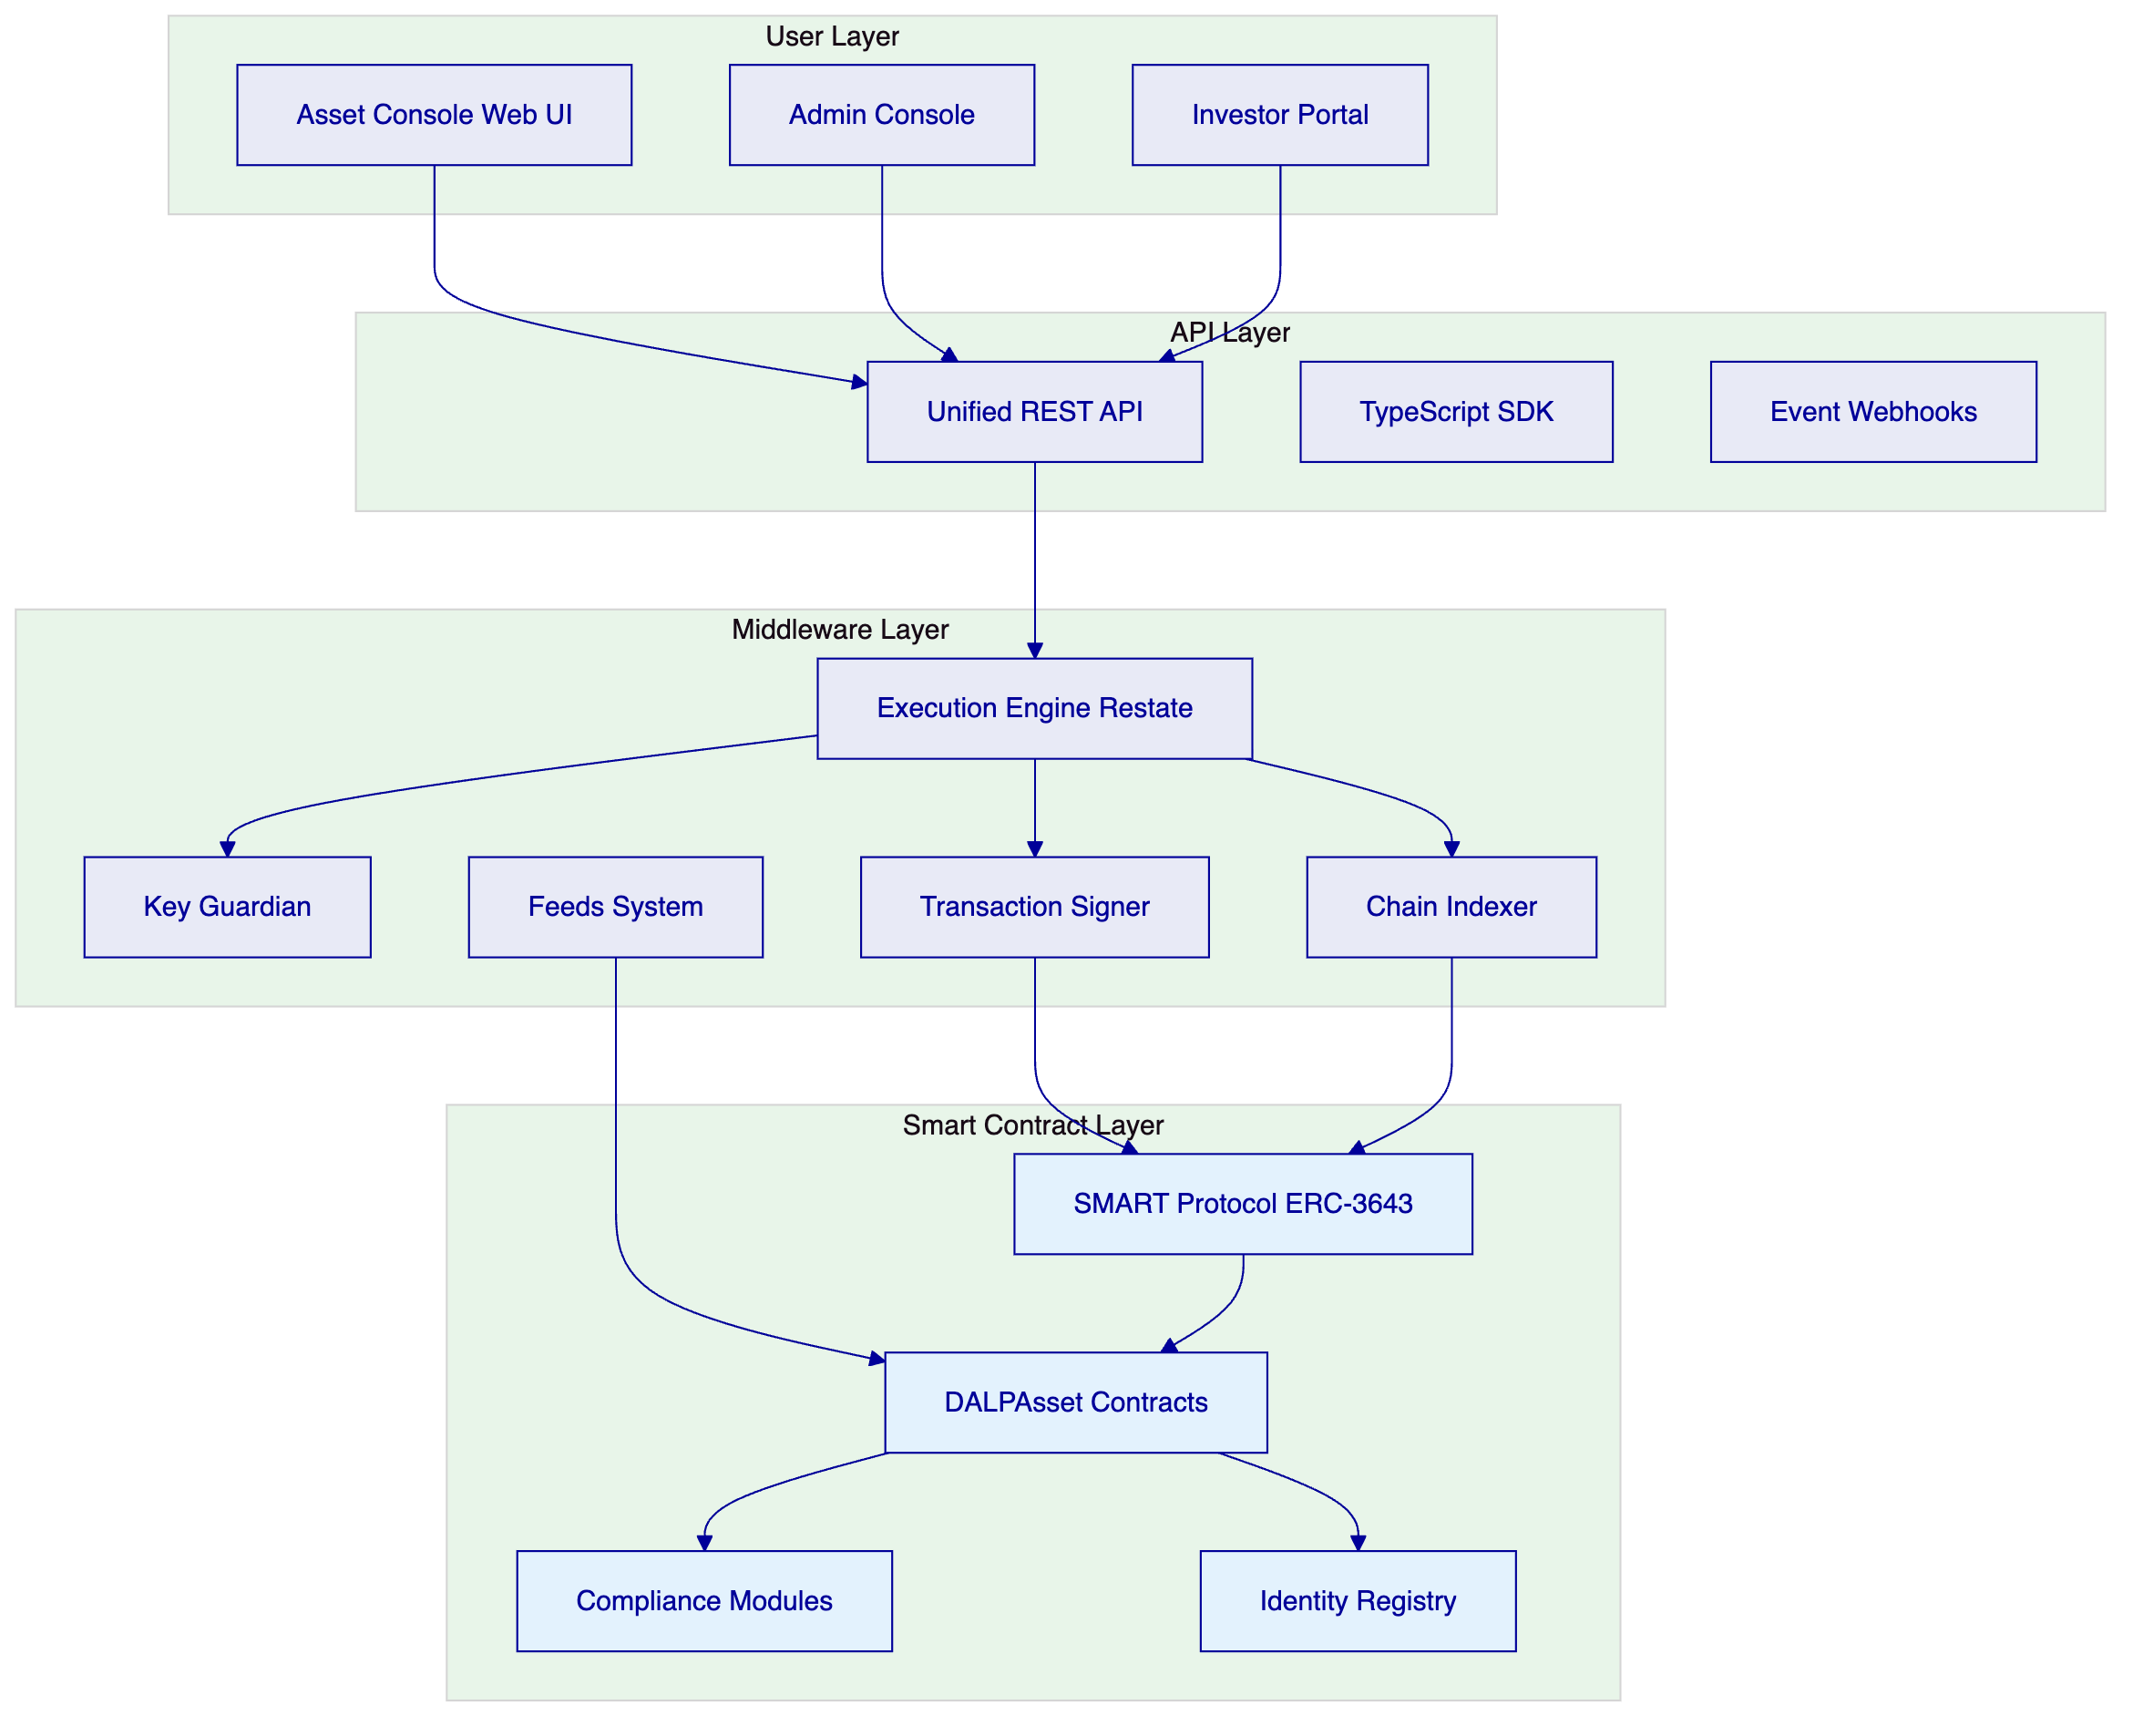
The operating model is organized around five operational domains:
Asset Management: Configuration and lifecycle management of digital assets including bonds, equities, funds, deposits, stablecoins, real estate, and precious metals. The Asset Designer wizard guides operators through tokenization with step-by-step configuration.
Identity and Verification: On-chain identity management via OnchainID (ERC-734/735) with trusted issuer infrastructure for KYC/AML claims. Every participant is represented by a cryptographically verified identity contract.
Compliance Enforcement: Modular compliance engine enforcing jurisdiction-specific rules on every transfer. 12 compliance module types include identity verification, country restrictions, investor limits, supply caps, time-based locks, and transfer approvals.
Settlement Operations: Atomic Delivery-versus-Payment (DvP) and Exchange-versus-Payment (XvP) settlement ensuring that asset and cash transfer simultaneously or both revert. True T+0 finality without counterparty risk.
Monitoring and Reporting: Real-time observability across platform operations, compliance activity, transaction volumes, and system health. Comprehensive audit trails supporting regulatory review and internal audit.
  - 3.2 Deployment Architecture
SettleMint proposes a private cloud deployment model for the Tadawul Saudi Exchange, with the platform deployed within the Central Bank's specified cloud environment.
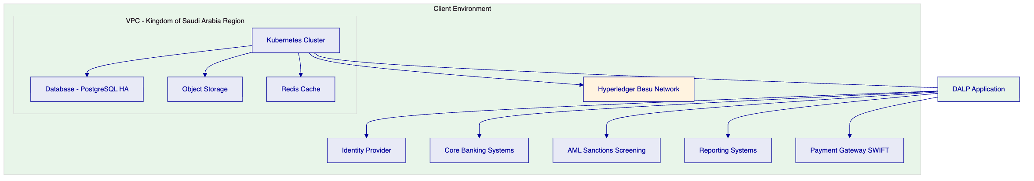
The deployment architecture provides:
Infrastructure isolation: All platform components (application, database, cache, storage) deploy within a dedicated virtual private cloud in the Kingdom of Saudi Arabia region. Network security groups enforce strict access controls.
Data residency: All data, including identity records, transaction data, audit logs, and configuration, remains within Kingdom of Saudi Arabia. No data is transferred to external regions or third parties without explicit configuration.
High availability: The architecture supports multi-availability-zone deployment with automatic failover. The recommended cloud-native pattern achieves 2-15 minute recovery time objective with seconds to 1 minute recovery point objective.
Blockchain network: A permissioned Hyperledger Besu network operates within the same security boundary, with IBFT 2.0 consensus providing institutional-grade performance and privacy characteristics appropriate for regulated market infrastructure.
  - 3.3 Participant Model
The platform supports a hierarchical participant model appropriate for regulatory supervision:
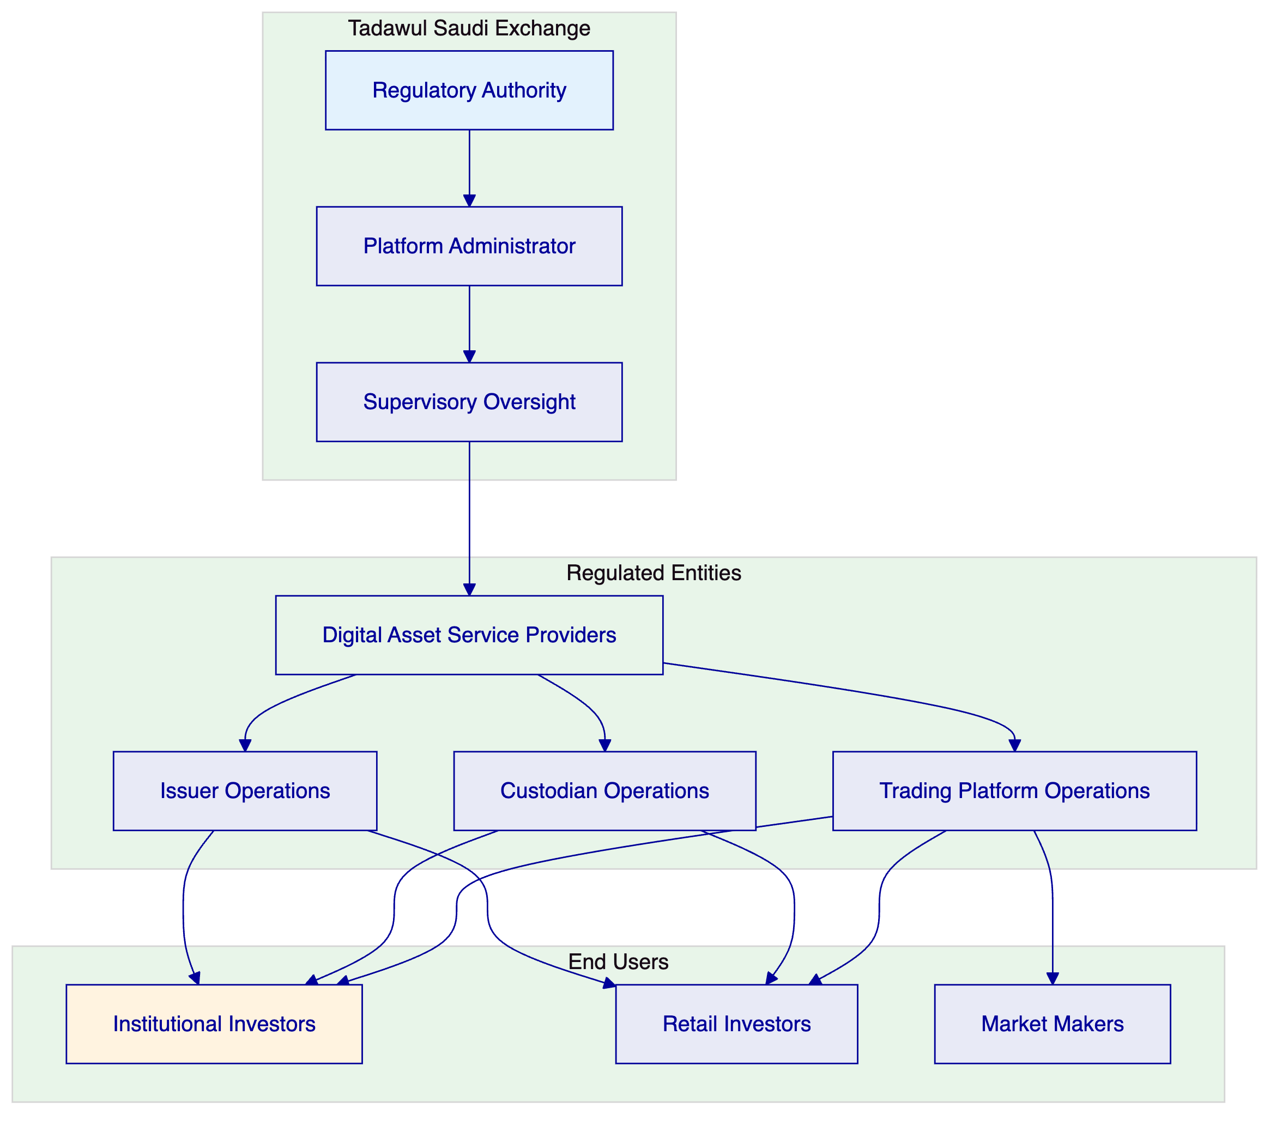
The participant model enables the Central Bank to:
- Register and supervise regulated digital asset service providers
- Monitor transaction flows and compliance status across all participants
- Enforce licensing requirements and capital adequacy rules
- Access comprehensive audit trails for regulatory review
- Generate supervisory reports across the ecosystem

- 4. Platform Architecture
  - 4.1 Architectural Overview
DALP is built as a four-layer stack with distinct responsibility boundaries. Each layer enforces its own security controls independently, ensuring that no single-layer failure grants unauthorized access.
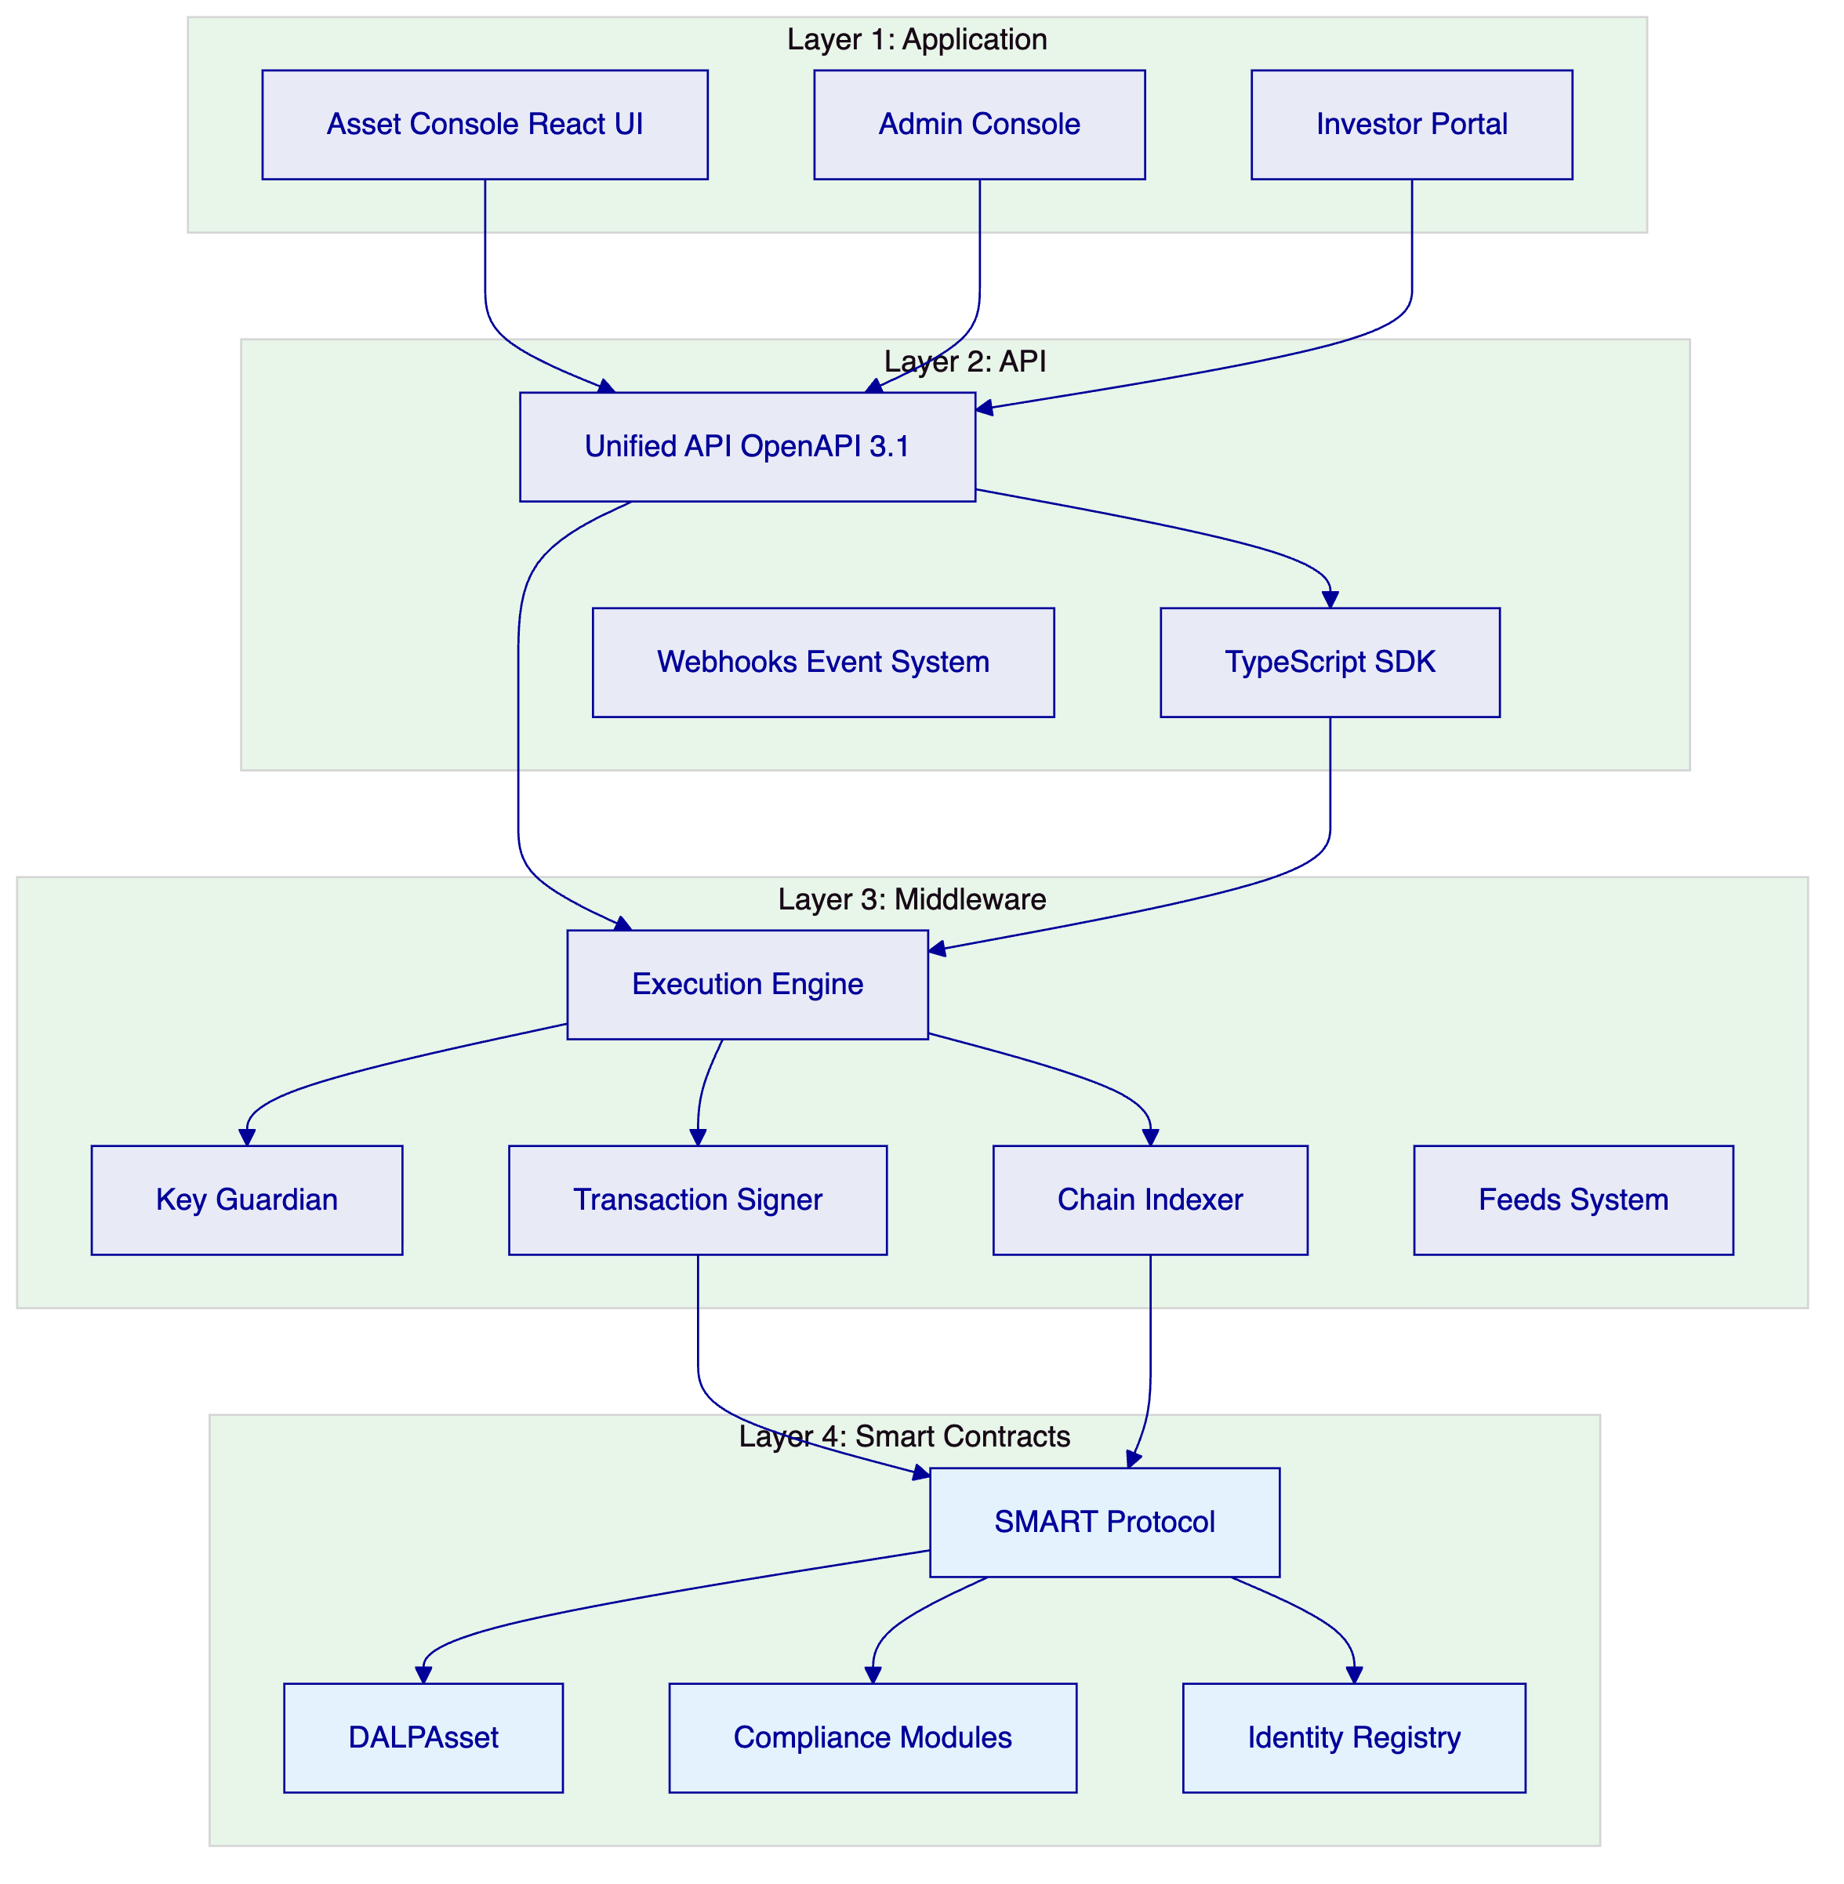
Layer | Responsibility | Key Components
Application | User-facing interfaces | Asset Console, Admin Console, Investor Portal
API | Programmatic access | Unified API, TypeScript SDK, Webhooks
Middleware | Workflow orchestration, key management, indexing | Execution Engine, Key Guardian, Transaction Signer, Chain Indexer
Smart Contracts | On-chain compliance, identity, asset logic | SMART Protocol, DALPAsset, Compliance Modules, Identity Registry

  - 4.2 Smart Contract Architecture
All DALP smart contracts are built on the SMART Protocol, an implementation of the ERC-3643 standard for regulated security tokens. The on-chain architecture follows a five-layer model:
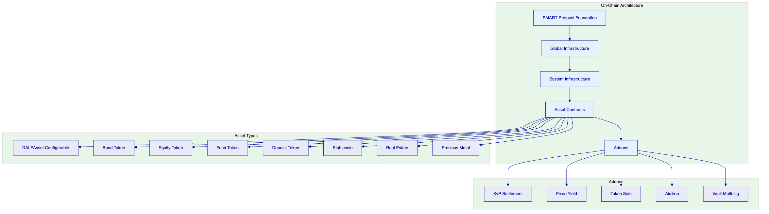
SMART Protocol (Layer 1): ERC-3643 token framework with modular compliance, identity management, and extension system.
Global (Layer 2): Platform-wide infrastructure shared across all system instances on a given chain. Includes central directory, identity factory, and identity implementations.
System (Layer 3): Per-system infrastructure managing identity registration, compliance orchestration, access control, and factory registries.
Assets (Layer 4): Production-ready tokenized financial instruments. DALPAsset provides the configurable base; legacy types support specific instrument categories.
Addons (Layer 5): Operational tools extending assets with distribution, settlement, and treasury capabilities.
  - 4.3 Compliance Architecture
DALP's compliance architecture enforces regulatory requirements at the smart contract layer, ensuring that non-compliant states cannot exist on-chain.
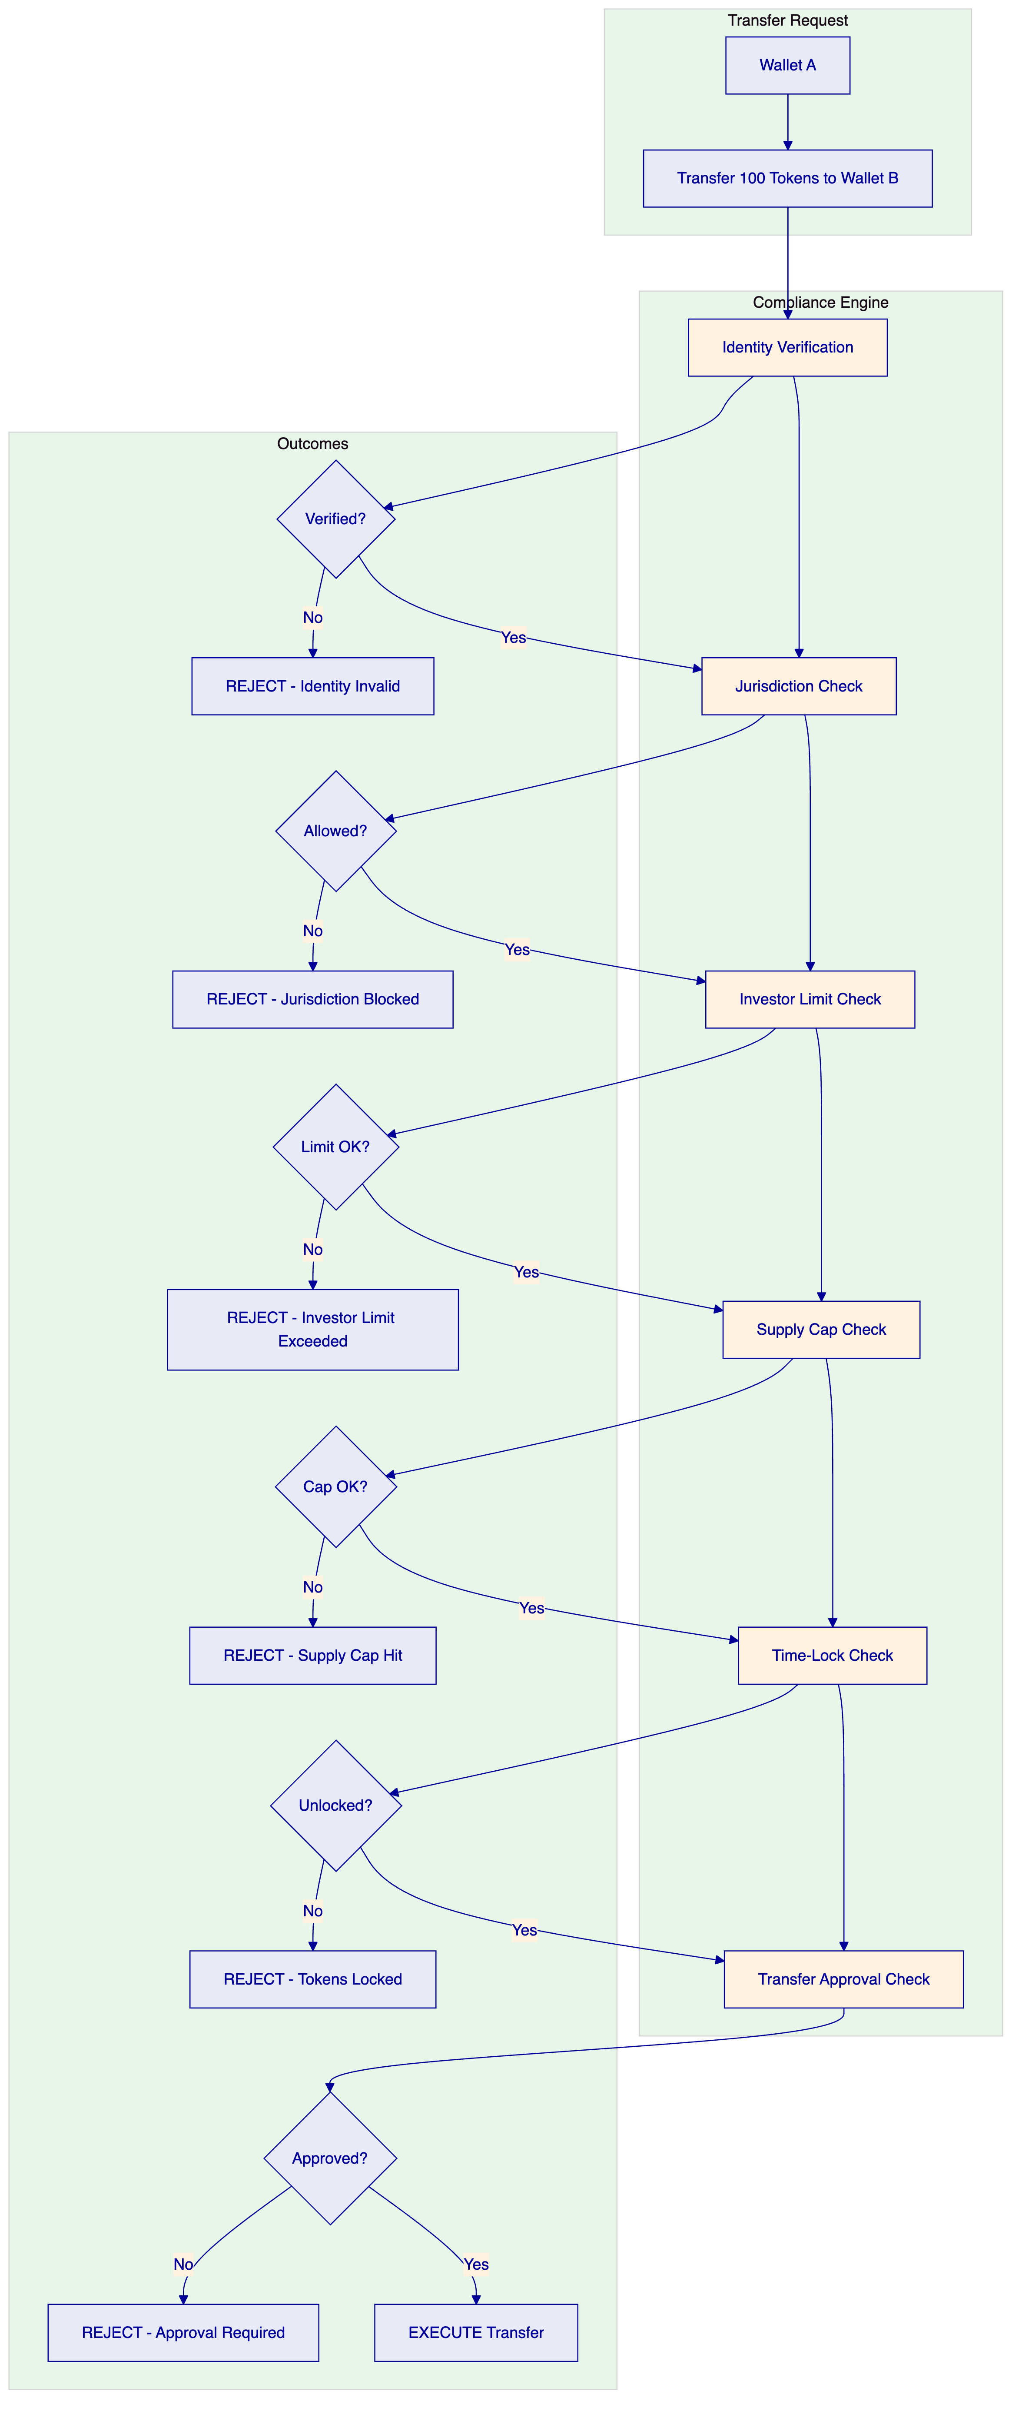
The compliance engine evaluates modular rules before each transfer. Rules are configurable at runtime without redeploying contracts. DALP ships with 12 compliance module types covering:
- Identity verification (KYC/AML claims)
- Country allowlist/blocklist
- Investor count limits
- Investor holding limits
- Supply caps
- Time-locked holding periods
- Transfer approval workflows
- Transfer windows
- Collateral backing verification
- Fee enforcement
  - 4.4 Identity Architecture
DALP implements on-chain identity via OnchainID (ERC-734/735), establishing a cryptographically verifiable identity for every participant.
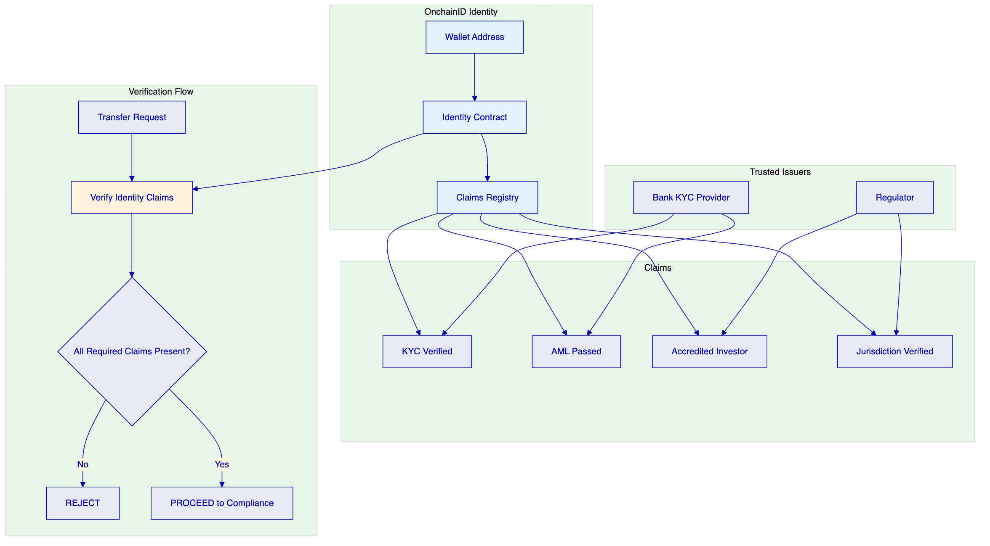
Claims are issued by trusted third parties, not self-asserted. A wallet holder cannot declare themselves KYC-verified or accredited; a registered trusted issuer must attest to that status. This mirrors how financial services actually work: eligibility is determined by regulated intermediaries.
Claims are checked continuously, not just at onboarding. Expired claims fail, revoked claims fail, and claims from issuers that lost trust fail. Eligibility is a live condition, not a one-time checkbox.
  - 4.5 API Architecture
DALP provides a comprehensive API-first integration surface:
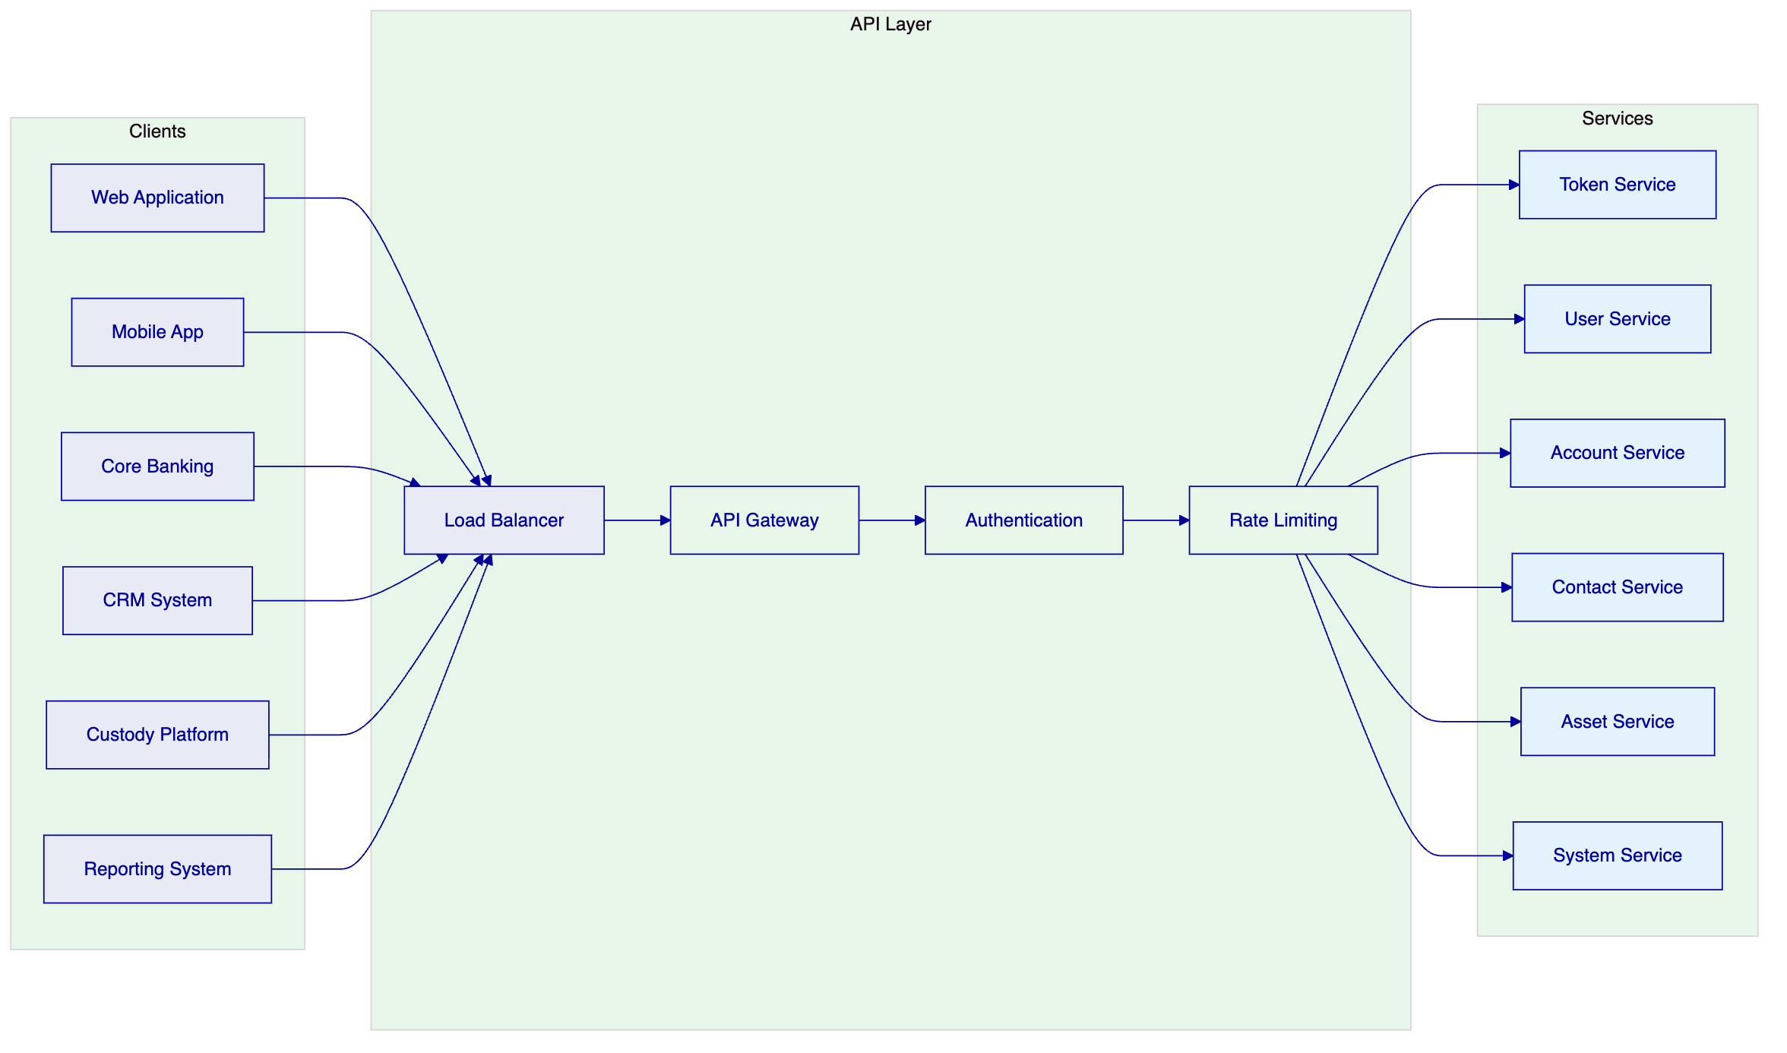
Namespace | Purpose
token | Asset lifecycle operations (create, mint, burn, transfer, pause)
user | User management (list, assign roles, manage permissions)
account | Wallet operations (generate address, check balance, sign)
contact | Investor relationships (register, record verifications)
asset | Asset metadata (update documents, configure compliance)
system | Platform administration (health, configuration, audit logs)

Authentication supports three methods: session-based (browser), API keys (system integration), and enterprise SSO. Blockchain write operations additionally require wallet verification through PIN, TOTP, or passkey.

- 5. Asset Lifecycle and Compliance Infrastructure
  - 5.1 Supported Asset Classes
DALP supports seven asset types organized by class, each with purpose-built lifecycle logic, metadata schemas, and compliance configurations:
Fixed Income — Bonds: Fully modeled fixed-income instruments with maturity dates, coupon schedules, denomination assets, ISIN identifiers, and automated yield distribution. Bond lifecycle includes issuance, coupon payments, partial redemptions, and maturity settlement.
Flexible Income — Equities: Full equity tokenization across common, preferred, and voting share classes. Equities support corporate actions including dividends, splits, and conversions. Collateral management tracks coverage ratios and minting capacity.
Flexible Income — Funds: Fund tokens carrying investment category, fund class, and management fee parameters. Supports the full fund landscape from sustainable impact funds to venture capital strategies.
Cash Equivalents — Deposits: Tokenized bank deposits serving as settlement currency for DvP operations. Deposit tokens represent claims on bank deposits with institutional-grade custody integration.
Cash Equivalents — Stablecoins: Full stablecoin spectrum from global standards (USDC, USDT) to regional currencies and platform-native instruments. Peg relationships stored on-chain for transparency.
Real World Assets — Precious Metals: Tokenized precious metals with physical custody traceability. Linked to real-world vault locations and named custodians. Supports 18-decimal fractional ownership.
Real World Assets — Real Estate: Rich metadata capture including GPS coordinates, property classification, building specifications, and unique identifiers. Fractional ownership enables broad investor access to institutional-grade properties.
  - 5.2 Asset Designer Workflow
DALP's Asset Designer provides a guided wizard for tokenization:
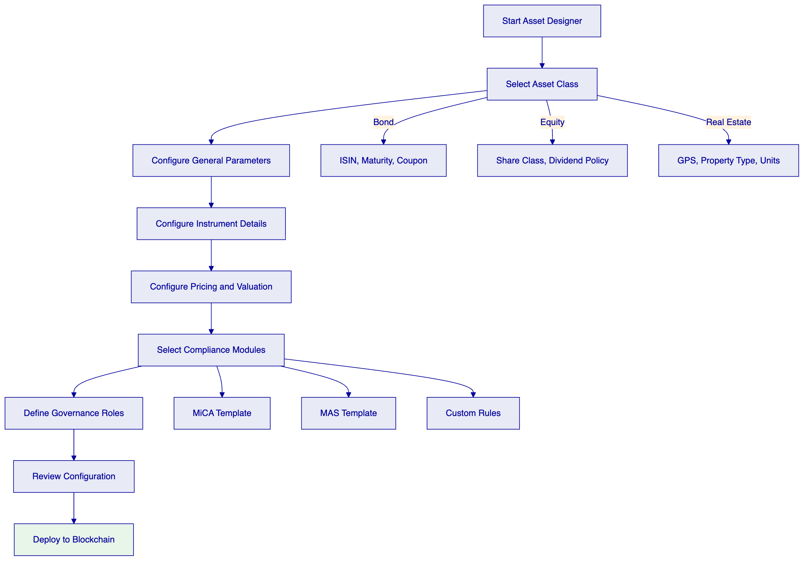
Configuration replaces custom development. Every token inherits the security guarantees of the pre-audited SMART Protocol contracts. No custom smart contract development is required.
  - 5.3 Regulatory Framework Support
DALP ships with pre-built compliance templates covering major global frameworks:
Framework | Jurisdiction | Key Controls
MiCA EU | European Union | Identity verification, EU country restrictions, 8M EUR annual supply cap
MAS Singapore | Singapore | Identity verification, country allowlisting, investor limits, holding periods
Japan FSA | Japan | Identity verification, qualified investor rules, reporting requirements
SEC Reg CF | United States | Identity verification, investment limits, accreditation checks
SEC Reg D 506(b)/(c) | United States | Accreditation verification, rule 144A compliance
UK FCA | United Kingdom | Identity verification, promotional restrictions, reporting

The compliance library supports custom template creation for jurisdiction-specific requirements. The expression builder enables compliance teams to construct investor eligibility rules using boolean logic without requiring smart contract development.
  - 5.4 Settlement Architecture
DALP provides atomic settlement ensuring asset and cash transfer simultaneously or both revert:
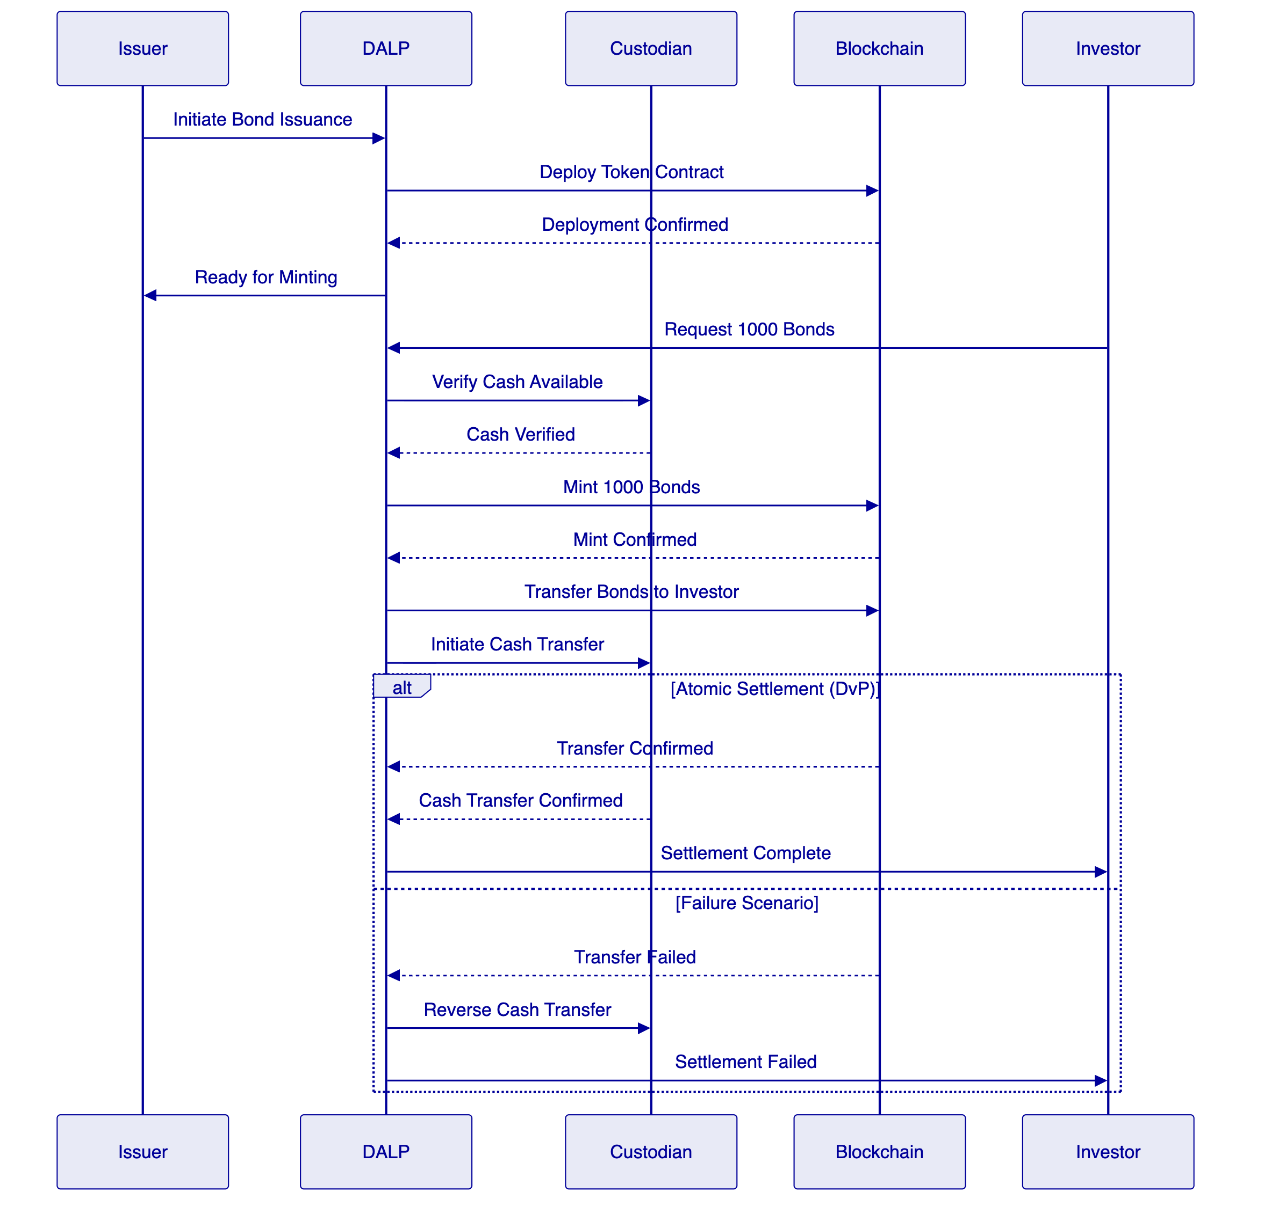
DvP (Delivery-versus-Payment) ensures simultaneous asset and cash transfer. XvP (Exchange-versus-Payment) extends this to multi-party, multi-asset atomic settlement. Both achieve true T+0 finality without counterparty risk.

- 6. Security, Governance, and Controls
  - 6.1 Defense-in-Depth Security Model
DALP enforces security across five independent control layers:
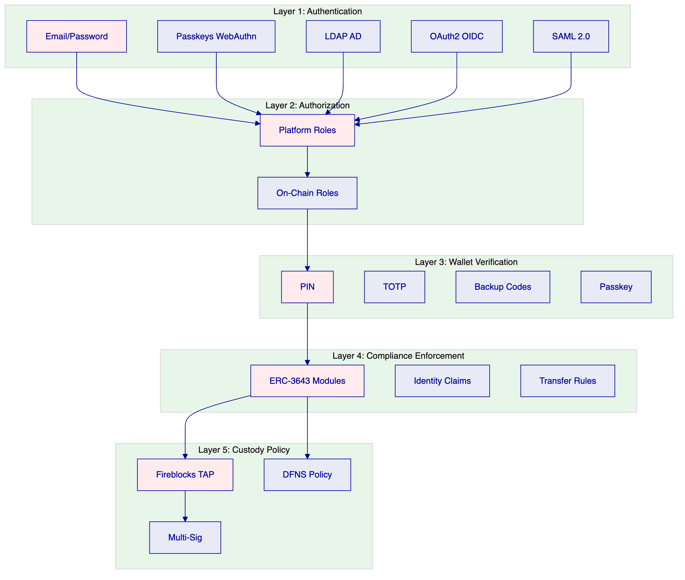
No single-layer failure grants unauthorized access. Compromised credentials are blocked by wallet verification. Bypassed API authorization is blocked by on-chain compliance. Custody provider policies provide the final gate before transactions reach the blockchain.
  - 6.2 Role-Based Access Control
DALP implements 26 distinct roles across four layers:
Role Category | Count | Examples
Platform Roles | 3 | owner, admin, member
System People Roles | 9 | systemManager, identityManager, complianceManager, auditor
Per-Asset Roles | 7 | admin, governance, supplyManagement, custodian, emergency
System Module Roles | 7 | Module management, registry operations

The dual-layer permission model ensures that off-chain platform roles (managed by Better Auth) and on-chain roles (managed by the AccessManager contract) must both pass for any blockchain write operation.
  - 6.3 Key Management
DALP provides defense-in-depth key management with multiple storage backends:
Storage Tier | Protection Level | Use Case
Encrypted database | Application-level encryption | Development, PoC
Cloud secret manager | Platform-managed encryption | Standard production
Hardware security module | FIPS 140-2 Level 3 | Regulated financial services
Third-party MPC custody | Institutional MPC (DFNS, Fireblocks) | Highest security

MPC custody integration ensures that no single private key ever exists in one place. The unified signer abstraction makes custody providers interchangeable through configuration alone.
  - 6.4 Certifications and Compliance
SettleMint maintains the certifications required for institutional procurement:
- ISO 27001: Certified information security management system
- SOC 2 Type II: Certified security controls over extended audit period
- Regular penetration testing: Independent third-party security assessments
- Smart contract audits: Specialized blockchain security review
  - 6.5 Operational Governance
DALP supports comprehensive operational governance routines:
Daily: Exception review, pending action resolution, system health checks, transaction monitoring.
Weekly: Entitlement recertification, reconciliation sign-off, incident review, performance analysis.
Monthly: Threshold monitoring review, management reporting, compliance dashboard review, change control board.
The platform generates native reports and audit trails supporting these routines. Where offline controls are required (for example, manual committee approvals), DALP provides the evidence extraction capabilities needed for regulatory and internal audit review.

- 7. Integration and Interoperability
  - 7.1 Integration Architecture
DALP is designed as an integration layer connecting enterprise systems with blockchain infrastructure:
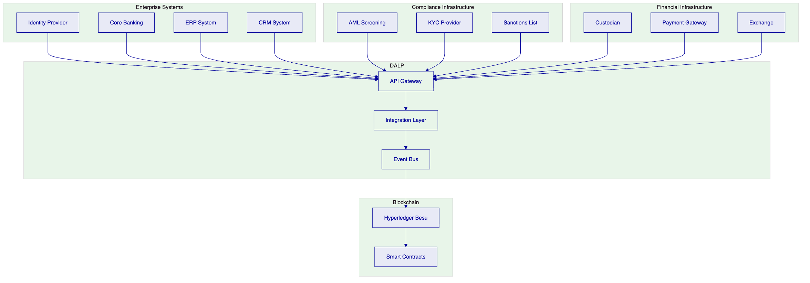
Integration methods include:
Method | Use Case | Authentication
REST API (OpenAPI 3.1) | System-to-system integration | API keys, SSO
TypeScript SDK | Node.js applications | API keys
Webhooks | Event-driven notifications | Configured per endpoint
Enterprise messaging | Corporate actions, settlement | API keys

  - 7.2 Data Flow Architecture
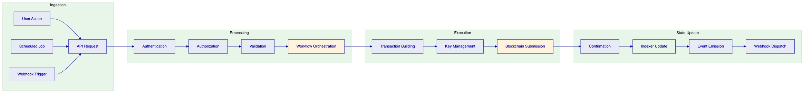
Every operation flows through defined stages with complete audit logging. The indexer processes blockchain events into queryable state projections, enabling real-time operational dashboards and regulatory reporting.
  - 7.3 Reconciliation Model
DALP provides reconciliation capabilities supporting coexistence with existing systems:
- Blockchain-to-core reconciliation: Platform records matched to internal books
- Settlement reconciliation: Matching with custody statements and payment confirmations
- Position reconciliation: Daily balance verification across all participants
- Compliance reconciliation: Verification that on-chain state matches off-chain compliance records
Reconciliation breaks are surfaced through operational tooling with clear ownership and escalation paths.

- 8. Implementation Methodology
  - 8.1 Phase-Gated Delivery
SettleMint follows a structured 19-week implementation methodology refined through production deployments:
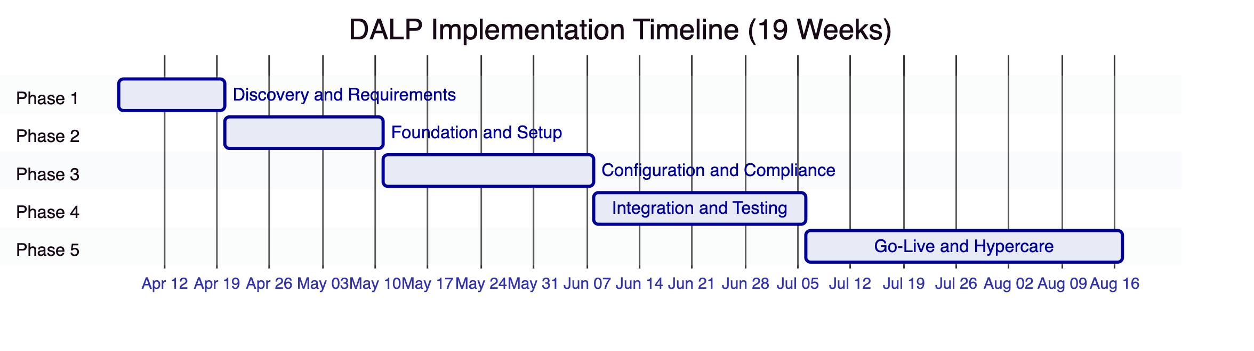
Phase | Duration | Focus | Key Outcome
1. Discovery and Requirements | 2 weeks | Requirements capture, architecture design, regulatory mapping | Validated requirements, target architecture, implementation roadmap
2. Foundation and Setup | 3 weeks | Environment provisioning, network setup, identity framework | Functional platform environments ready for configuration
3. Configuration and Compliance | 4 weeks | Asset types, compliance modules, feeds, operational workflows | Configured platform matching business and regulatory requirements
4. Integration and Testing | 4 weeks | System integration, testing (functional, security, performance, UAT) | Validated, integrated system with formal go-live readiness
5. Go-Live and Hypercare | 6 weeks | Production deployment (2 weeks) + intensive post-go-live support (4 weeks) | Production system with knowledge transfer and support transition

  - 8.2 Phase 1: Discovery and Requirements
Objective: Establish validated understanding of business objectives, technical landscape, regulatory environment, and operational requirements.
Key Activities:
- Stakeholder interviews (business sponsors, technology leadership, compliance officers, operations teams)
- Current-state assessment (existing systems, integration touchpoints, data flows)
- Regulatory and compliance mapping (Tadawul rules, AML/CFT requirements, investor eligibility)
- Asset class and lifecycle scoping (target instruments, lifecycle events, business rules)
- Architecture design (deployment topology, network design, integration architecture)
Deliverables:
- Business Requirements Document with acceptance criteria
- Regulatory and Compliance Matrix mapped to DALP modules
- Target Architecture Document
- Implementation Roadmap with milestones and risk register
- RACI Matrix for responsibility assignments
- Communication Plan
  - 8.3 Phase 2: Foundation and Setup
Objective: Provision DALP environment, configure blockchain network, establish identity and access framework.
Key Activities:
- Environment provisioning (development, staging, production Kubernetes clusters)
- Network configuration (Hyperledger Besu validator deployment, consensus setup)
- Identity and access framework (OnchainID setup, RBAC configuration)
- Key management setup (HSM integration or custody provider configuration)
- Observability setup (monitoring dashboards, alert routing)
Deliverables:
- Provisioned environments (operational)
- Network Configuration Document
- Identity and Access Design
- Key Management Configuration
- Observability Setup Report
- Environment Validation Report
  - 8.4 Phase 3: Configuration and Compliance
Objective: Configure asset types, compliance modules, data feeds, and operational workflows.
Key Activities:
- Token and asset configuration (asset templates, parameters, business rules, lifecycle events)
- Compliance module setup (identity verification, country restrictions, investor limits, supply caps)
- Claims and trusted issuer configuration (claim topics, trusted issuer registry, KYC integration)
- Feed configuration (price feeds, NAV feeds, exchange rate synchronization)
- Workflow design (issuance approval chains, transfer processing, exception handling)
Deliverables:
- Asset Configuration Documentation
- Compliance Module Configuration with test evidence
- Claims and Feed Configuration
- Integration Design Document
- Operational Workflow Documentation
  - 8.5 Phase 4: Integration and Testing
Objective: Connect DALP to existing systems and validate against requirements.
Key Activities:
- API integration (core banking, custody, payment rails)
- Custody connector setup
- Functional testing (asset lifecycle, compliance enforcement, custody workflows, settlement)
- Security testing (penetration testing, authorization escalation, smart contract review)
- Performance testing (throughput, latency, capacity)
- User acceptance testing (business operations, compliance, technical operations)
Deliverables:
- Integrated System Landscape
- Functional, Security, Performance Test Reports
- UAT Sign-Off
- Go-Live Readiness Assessment
  - 8.6 Phase 5: Go-Live and Hypercare
Objective: Execute production deployment and provide intensive post-go-live support.
Go-Live (Weeks 14-15):
- Production deployment following runbook
- Data migration with integrity validation
- Go-live validation (smoke tests)
- Dedicated support during deployment window
Hypercare (Weeks 16-19):
- Continuous monitoring and issue resolution
- Performance optimization based on production metrics
- Knowledge transfer (administrator, developer, end-user tracks)
- Operational readiness validation
- Support transition to contracted tier
Deliverables:
- Production Deployment Confirmation
- Hypercare Summary Report
- Complete Documentation Package
- Knowledge Transfer Completion Certificate
- Support Transition Plan

- 9. Delivery Approach and Timeline
  - 9.1 Implementation Timeline
The following timeline assumes kickoff in early April 2026 with go-live targeted for late August 2026:
Milestone | Target Date | Phase
Kick-off Workshop | Week 1 | Phase 1
Requirements Sign-off | Week 2 | Phase 1
Environments Provisioned | Week 5 | Phase 2
Configuration Complete | Week 9 | Phase 3
Integration Complete | Week 13 | Phase 4
UAT Sign-off | Week 13 | Phase 4
Production Go-Live | Week 15 | Phase 5
Hypercare Complete | Week 19 | Phase 5

  - 9.2 Resource Requirements
SettleMint Team:
Role | Involvement
Delivery Lead | Full-time throughout implementation
Solution Architect | Full-time Phase 1-3, on-call Phase 4-5
Platform Engineers | 2-3 engineers, full-time Phase 2-5
QA Lead | Full-time Phase 4, partial Phase 3 and 5

Client Team:
Role | Involvement
Project Manager | Full-time throughout
Technical Lead | Full-time Phase 1-4, on-call Phase 5
DevOps/Infrastructure | Full-time Phase 2-5
Compliance/Risk | Full-time Phase 1 and 3, partial Phase 4

  - 9.3 Client Responsibilities
Client responsibilities include:
- Timely stakeholder availability for decision-making and gate approvals
- Infrastructure provisioning (cloud accounts, Kubernetes clusters, networking)
- Integration endpoint access (API credentials, test environments)
- Regulatory requirements documentation and compliance rule definition
- UAT participation across business, operations, and compliance tracks
- Training attendance for knowledge transfer

- 10. Relevant Experience and References
  - 10.1 Reference Projects Summary
SettleMint has delivered 14 production engagements spanning banking, sovereign institutions, capital markets, and real estate:
# | Client | Region | Asset Class | Scope
1 | OCBC Bank | Singapore | Securities, bonds, real estate | Security token engine for HNWIs
2 | KBC Securities | Belgium | Equity, SME loans | Crowdfunding issuance and lifecycle
3 | Standard Chartered Bank | Asia/Africa/Middle East | Securities, currencies | Digital Virtual Exchange
4 | State Bank of India | India | CBDC (e-Rupee) | CBDC infrastructure
5 | Sony Bank (Sony Group) | Japan | Stablecoins, identity | Stablecoin issuance with KYC
6 | Commerzbank | Germany | ETPs | Hybrid on/off-chain issuance
7 | Saudi Arabia RER | Saudi Arabia | Real Estate | National-scale property blockchain
8 | Maybank | Malaysia | FX tokens | Cross-border XvP settlement
9 | ADI-Finstreet | Abu Dhabi | Equity | Tokenized equity on ADI mainnet
10 | Islamic Development Bank | 57 countries | Subsidy, Collateral | Sharia-compliant distribution

  - 10.2 Detailed Reference: Saudi Arabia RER
Scope: National-scale blockchain infrastructure for property registration, fractionalization, and digital marketplace under REGA and Vision 2030.
Key Outcomes:
- First country in the world to deploy national-scale property blockchain
- Live production transactions since January 2026
- Four PropTechs (Sahl, Madek, Ghanem, Jozo) operational
- Smart contracts automate ownership transfers and tax compliance
Relevance to Tadawul: Demonstrates country-scale deployment capability, government integration, multi-party ecosystem support, and integration with national identity (Yakeen) and payment (Sadad) infrastructure.
  - 10.3 Detailed Reference: Standard Chartered Bank
Scope: Blockchain-based Digital Virtual Exchange for securities tokenization with fractional ownership and instant settlement.
Key Outcomes:
- Settlement times reduced from days to near-instant finality
- Custody intermediary costs eliminated
- Immutable ownership records providing transparency
Relevance to Tadawul: Demonstrates institutional-grade compliance, multi-asset support, integration with existing banking infrastructure, and multi-region deployment across the Middle East.
  - 10.4 Detailed Reference: Commerzbank
Scope: Hybrid on-chain/off-chain ETP issuance with Boerse Stuttgart listing and sub-10-second settlement.
Key Outcomes:
- Settlement reduced to under 10 seconds
- Potential annual savings of EUR 7 million
- Demonstrates blockchain coexistence with established exchange infrastructure
Relevance to Tadawul: Directly addresses the hybrid on-chain/off-chain concern that regulated institutions have. Shows integration with regulated venues and capital markets expertise.

- 11. Current Coverage, Gaps, and Mitigations
  - 11.1 Requirement Coverage Matrix
This section addresses how DALP meets each Tadawul requirement and identifies any areas requiring clarification or client-side decisions.
Requirement | DALP Coverage | Status
REQ-01: Segregated environments | Full support (dev, test, UAT, DR, production) | Met
REQ-02: API-first interfaces | Full OpenAPI 3.1, TypeScript SDK, webhooks | Met
REQ-03: RBAC, segregation of duties, maker-checker | 26 roles, dual-layer model, wallet verification | Met
REQ-04: Configurable lifecycle, controls, limits | 12 compliance module types, expressions | Met
REQ-05: Third-party dependencies | Documented in dependency register | Met
REQ-06: Resilience, recovery, backup, monitoring | HA deployment, DR options, observability | Met
REQ-07: Delivery method, phased plan | 19-week methodology with clear phases | Met
REQ-08: Evidence extraction | Audit trails, reporting dashboards, export | Met

  - 11.2 Areas Requiring Client Input
The following areas require Tadawul input to finalize scope and configuration:
Regulatory Framework Specifics: Tadawul's digital asset rules require mapping to DALP compliance modules. The compliance library includes templates for major frameworks, but Kingdom of Saudi Arabia-specific rules may require custom configuration. SettleMint recommends a compliance mapping workshop during Phase 1 to finalize the configuration.
Identity Provider Integration: The proposal assumes integration with Tadawul's existing identity management infrastructure (Active Directory or equivalent). Specific integration requirements (protocol, authentication method, user provisioning) should be confirmed during discovery.
Custody Model: Tadawul has not specified a custody provider preference. DALP supports integration with Fireblocks, DFNS, or local signer options. The custody model decision affects integration scope and timeline.
Integration Endpoints: The proposal assumes connection to core banking, sanctions screening, and reporting systems. Specific API specifications and test environment access are required during Phase 2.
  - 11.3 Risk Mitigation
Risk | Likelihood | Impact | Mitigation
Decision latency on compliance rules | Medium | Schedule slip | RACI matrix with named decision-makers; decision log with escalation
Integration complexity | Medium | Phase 4 extension | Integration design in Phase 3; mock interfaces for testing
Regulatory change | Low | Configuration rework | Modular compliance architecture; change-control process
Infrastructure readiness | Low | Phase 2 block | Prerequisites checklist in Phase 1; managed cloud fallback
Scope expansion | Medium | Timeline increase | Change-control with impact assessment; prioritization framework

- 12. Appendix: Response Matrix
  - 12.1 Technical Requirements Response
Req ID | Requirement | Response | Evidence
REQ-01 | Architecture must support segregated dev, test, UAT, DR, and production environments | DALP supports multiple isolated environments with separate Kubernetes namespaces, databases, and blockchain networks. Data residency controls ensure segregation. | Architecture documentation, deployment manifests
REQ-02 | Provide API-first interfaces, eventing, and version governance | Unified API with OpenAPI 3.1 specs, TypeScript SDK, webhooks for event-driven integration. API versioning follows standard practices with deprecation notices. | API documentation, SDK packages
REQ-03 | Support RBAC, segregation of duties, maker-checker controls, and complete audit logs | 26 roles across four layers. Dual-layer permission model (off-chain + on-chain). Wallet verification for all blockchain writes. Complete audit trail for every action. | Security documentation, role matrix
REQ-04 | Support configurable lifecycle states, policy controls, limits, exceptions, and reconciliations | 12 compliance module types with runtime configuration. Expression builder for complex rules. Native reconciliation tooling. | Compliance module documentation
REQ-05 | Disclose all third-party dependencies and operational responsibilities | All dependencies documented. Third-party services include cloud providers, custody providers, identity providers. | Dependency register (Appendix D)
REQ-06 | Evidence resilience, recovery, backup, monitoring, and incident-management capability | HA deployment options with RTO 2-15 minutes. Velero backup. Comprehensive observability stack with alerting. | DR documentation, observability setup
REQ-07 | Provide delivery method, client effort assumptions, and phased implementation plan | 19-week phased methodology with clear deliverables, gate reviews, and client responsibilities. | Implementation methodology section
REQ-08 | Support evidence extraction for audit, supervisory review, and board reporting | Complete audit trails, compliance dashboards, regulatory reports, export capabilities. | Reporting documentation

  - 12.2 Regulatory Requirements Response
ID | Area | Response | Notes
RC-01 | Regulatory mapping | DALP compliance library includes templates for major frameworks. Kingdom of Saudi Arabia-specific mapping requires Phase 1 workshop. | Custom configuration expected
RC-02 | AML/CFT and sanctions | Integration with external AML/sanctions providers via API. On-chain compliance enforces KYC/AML claims from trusted issuers. | External provider integration required
RC-03 | Data governance | Data residency controls for Kingdom of Saudi Arabia deployment. Retention policies configurable. Encryption at rest and in transit. | Meets Tadawul data protection requirements
RC-04 | Operational resilience | Multiple DR options (cloud-native, hot-warm, hot-cold). Tested backup and restore procedures. | RTO/RPO targets configurable
RC-05 | Outsourcing and subcontractors | Full disclosure of cloud provider dependencies. SettleMint operates as prime contractor. | Dependency register
RC-06 | Assurance and audit | ISO 27001 and SOC 2 Type II certified. Comprehensive logging. Audit support through dedicated interfaces. | Certification attestations available

- Document Control
Version | Date | Author | Changes
1.0 | 2026-03-17 | SettleMint NV | Initial submission

End of Technical Proposal
This document is confidential and intended solely for the use of Tadawul Saudi Exchange.

- 13. Detailed Technical Specifications
  - 13.1 Blockchain Network Architecture
    - 13.1.1 Network Topology
The blockchain network for Tadawul's tokenized securities platform operates as a permissioned network utilizing Hyperledger Besu with IBFT 2.0 (Istanbul Byzantine Fault Tolerant) consensus mechanism. This architecture provides the enterprise-grade characteristics required for regulated market infrastructure while maintaining the flexibility of EVM-compatible smart contracts.
The network topology consists of validator nodes responsible for block production and consensus, observer nodes that participate in network communication without block production rights, and RPC nodes that provide API endpoints for client applications. For production deployment in the Kingdom of Saudi Arabia, we recommend a minimum of four validator nodes distributed across separate availability zones within the region to ensure network resilience and fault tolerance.
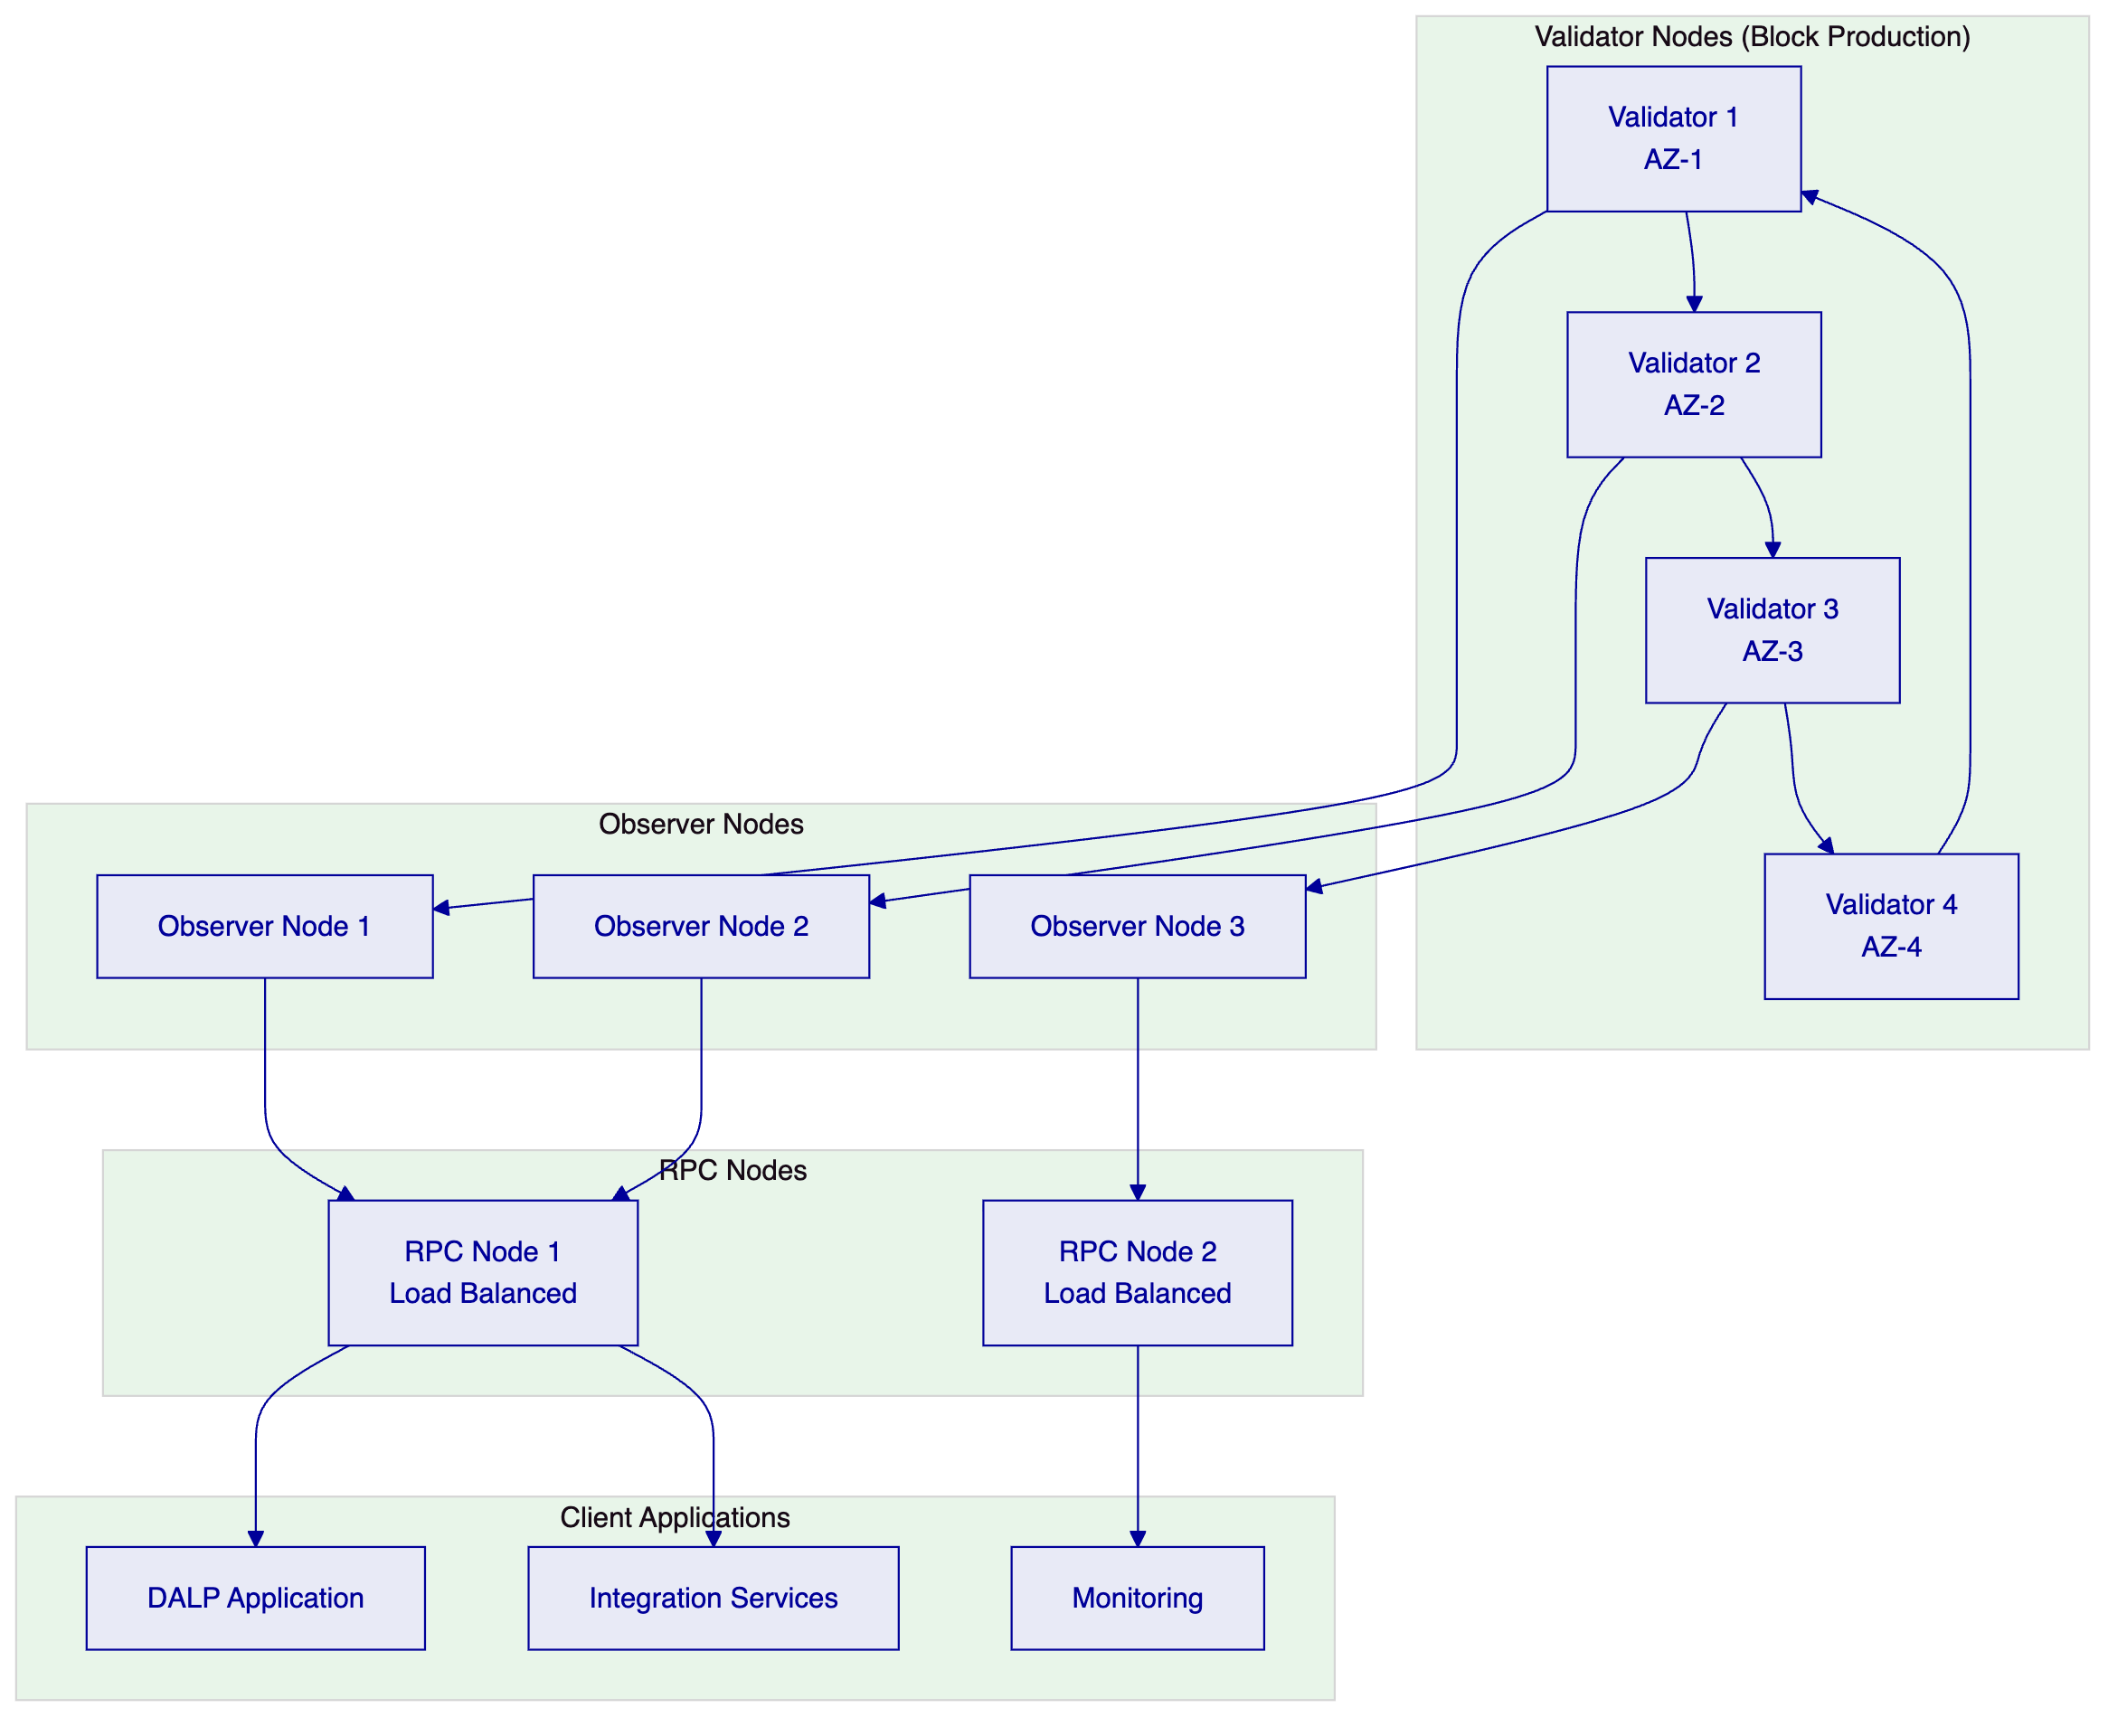
    - 13.1.2 Consensus Mechanism
IBFT 2.0 consensus provides immediate block finality, eliminating the uncertainty associated with probabilistic finality in proof-of-stake networks. This characteristic is essential for financial applications where settlement certainty is paramount. The consensus mechanism requires that at least two-thirds of validator nodes agree on the canonical chain, providing Byzantine fault tolerance against up to one-third malicious or faulty nodes.
The block time configuration targets 1-2 seconds, providing sufficient throughput for tokenized securities trading while maintaining network stability. Block gas limits are configured to accommodate the expected transaction volume, with the ability to adjust dynamically based on network demand.
Transaction types supported include standard value transfers, smart contract deployments, and ERC-3643-compliant token transfers. The network enforces EIP-1559 fee market mechanisms for predictable gas pricing, with configurable gas price caps to prevent fee volatility from impacting operational predictability.
    - 13.1.3 Privacy and Confidentiality
The platform implements multiple layers of privacy protection appropriate for regulated securities environments. Private transactions utilize Hyperledger Besu's privacy features to ensure that transaction details are visible only to authorized participants while maintaining network-wide verification.
For tokenized securities, privacy requirements vary by use case. Corporate bond issuances may require full transparency for regulatory compliance, while institutional block trades may require privacy from general market participants. The platform supports both public and private transaction modes, configurable at the asset level based on regulatory and business requirements.
On-chain data obfuscation techniques include encryption of sensitive fields within smart contract storage, zero-knowledge proofs for selective disclosure, and off-chain storage of confidential data with on-chain references. The architecture ensures that privacy controls are enforced at the protocol level rather than relying solely on application-layer protections.
  - 13.2 Smart Contract Architecture
    - 13.2.1 Contract Hierarchy
DALP's smart contract architecture follows a modular hierarchy that separates concerns while maintaining upgradeability. The contract hierarchy consists of the SMART Protocol foundation layer, system-level infrastructure contracts, asset-specific implementations, and addon modules.
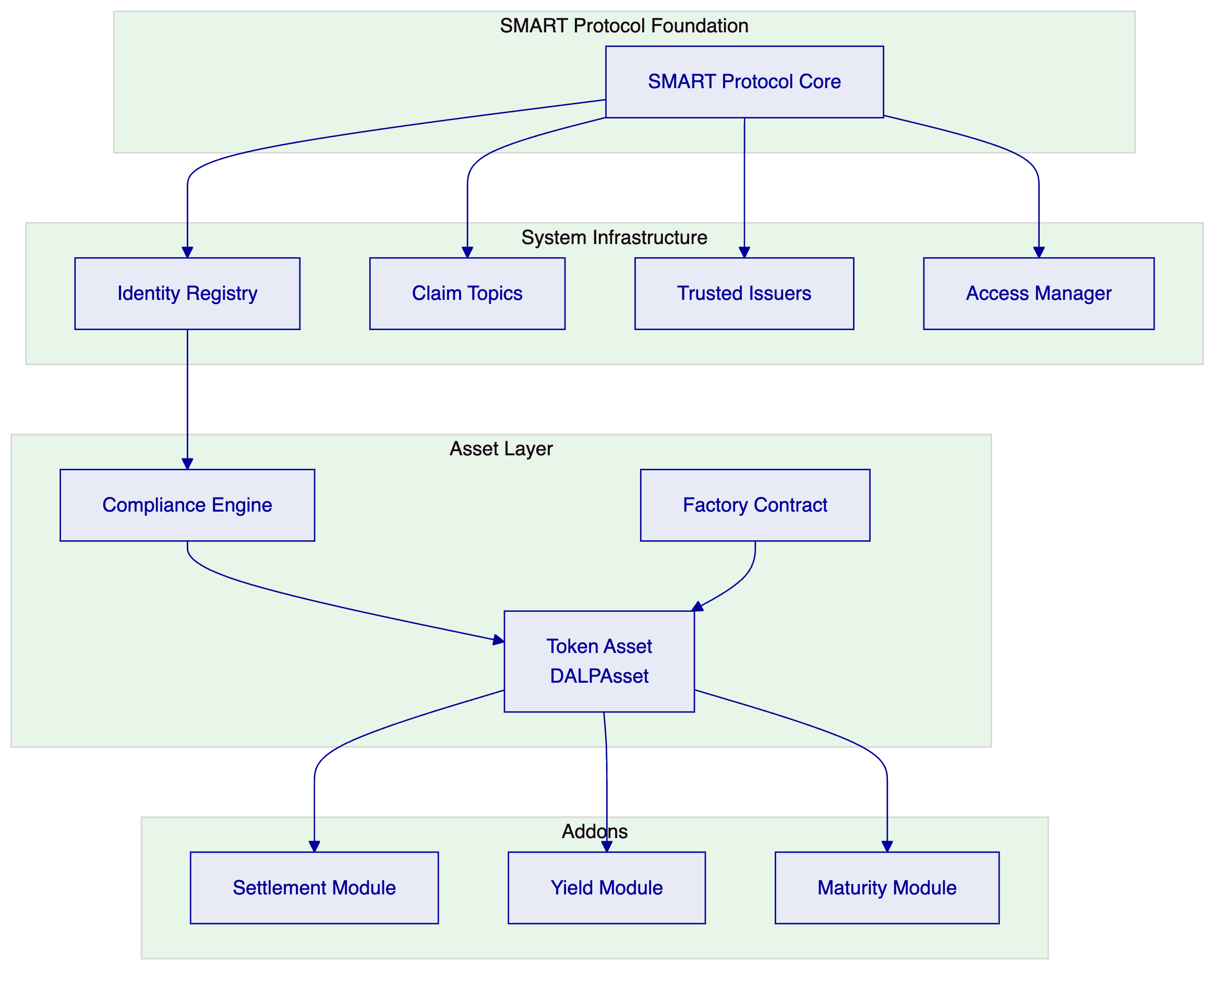
The Identity Registry maintains the canonical record of all participant identities on the network. Each identity is represented by an OnchainID contract that holds claims issued by trusted parties. The registry supports identity lifecycle management including registration, suspension, and revocation.
The Compliance Engine evaluates transfer requests against configured compliance rules before execution. The engine operates as a modular framework where compliance modules can be added, removed, or modified without affecting other platform components. This modularity enables the platform to adapt to evolving regulatory requirements without requiring smart contract upgrades.
    - 13.2.2 Token Standards Implementation
All tokenized securities on the platform implement ERC-3643 (T-REX), the recognized standard for regulated security tokens. This standard extends ERC-20 with identity and compliance requirements essential for securities applications.
The standard mandates four key components: the Identity Registry for participant verification, the Compliance Module for transfer validation, Trusted Issuers for identity claim attestation, and Transfer Manager for enforcing restrictions. These components work together to ensure that securities law compliance is enforced at the protocol level.
Token metadata follows a structured schema that captures essential security attributes including ISIN (International Securities Identification Number), asset class, jurisdiction, and regulatory status. The metadata is stored both on-chain for immutability and off-chain for query efficiency, with cryptographic linkages between the two storage layers.
    - 13.2.3 Upgradeability Pattern
The platform utilizes UUPS (Universal Upgradeable Proxy Standard) upgradeability pattern, which allows smart contract logic to be updated while maintaining the same contract address and state. This pattern provides the flexibility to fix bugs, add features, and respond to regulatory changes without disrupting existing integrations.
Upgrade authority is restricted to a defined set of governance roles, with timelock controls ensuring that upgrades are announced before execution. The upgrade process follows a controlled procedure: proposed upgrades undergo security review, are announced through the governance system, and execute after a configurable delay period.
State migration between contract versions is handled through designated migration functions that ensure data integrity during upgrades. The upgradeability pattern includes emergency pause functionality that can halt the contract in exceptional circumstances, with defined recovery procedures.
  - 13.3 API and Integration Architecture
    - 13.3.1 API Design Principles
The DALP API follows RESTful principles with OpenAPI 3.1 specification. The design emphasizes predictability, consistency, and enterprise integration compatibility. All API endpoints follow consistent naming conventions, response structures, and error handling patterns.
The API architecture implements several key patterns: hypermedia links for navigation, pagination for large result sets, filtering and sorting for query flexibility, and optimistic concurrency control for concurrent updates. These patterns ensure that the API integrates smoothly with enterprise systems without requiring custom adaptation.
API versioning follows a URL-based approach with major version numbers. The current API version is v2, accessible at /api/v2. The versioning strategy ensures that existing integrations continue to function while new capabilities are introduced through version increments.
    - 13.3.2 Authentication and Authorization
API authentication supports multiple mechanisms appropriate for different integration scenarios. API key authentication provides simple integration for system-to-system connections, with keys scoped to specific permissions and rate limits. OAuth 2.0 integration enables federated identity for user-facing applications.
All API traffic requires TLS 1.3 encryption, with certificate pinning available for mobile applications. Request authentication includes timestamp validation to prevent replay attacks, with configurable time window for acceptable request age.
Authorization uses a claims-based model where API keys or OAuth tokens carry defined permission scopes. The permission system aligns with the platform role model, ensuring that API access is consistent with dashboard and administrative access controls.
    - 13.3.3 Event Streaming
Real-time event delivery utilizes a webhook architecture that pushes events to configured endpoints. Events are generated for significant platform activities including transaction submissions, settlement completions, compliance state changes, and administrative actions.
The event system implements at-least-once delivery semantics with idempotency keys to handle duplicate deliveries. Failed deliveries are retried with exponential backoff, with events preserved in a replay buffer for configurable retention periods.
Event types follow a consistent schema that includes event identifier, timestamp, event type, source system, and payload. The schema is versioned to allow API evolution while maintaining backward compatibility with existing consumers.
  - 13.4 Data Architecture
    - 13.4.1 Data Storage Layers
The platform implements a multi-layer data architecture that balances performance, durability, and regulatory requirements. The primary data store uses PostgreSQL for structured relational data, providing ACID compliance essential for financial applications.
Operational data includes user accounts, role assignments, asset configurations, and integration configurations. This data is stored in the primary PostgreSQL cluster with synchronous replication to standby nodes for high availability.
Blockchain state is indexed through a dedicated indexing layer that processes block events and maintains queryable data structures. The indexer maintains its own database for efficient querying without directly reading blockchain state.
Audit data is stored in an append-only format with independent retention policies. The audit store is designed for immutability, with cryptographic chaining that can demonstrate any tampering attempts.
    - 13.4.2 Data Retention and Archiving
Data retention policies are configurable to meet regulatory requirements in different jurisdictions. Default retention periods can be defined for different data categories, with automated archival processes moving data to cost-effective storage after the retention period.
For the Kingdom of Saudi Arabia deployment, data residency requirements are met through deployment within the region with no cross-border data transfer. The architecture supports configurable data localization, ensuring that specific data categories can be restricted to specific geographic locations.
Data deletion follows configurable policies that support both operational cleanup and regulatory erasure requests. Deletion processes are logged and auditable, with cryptographic verification that deleted data is irrecoverable.
    - 13.4.3 Backup and Recovery
Backup strategies are designed for different recovery objectives. Continuous archiving captures blockchain state and database changes in real-time, enabling point-in-time recovery. Snapshot-based backups provide daily restore points for bulk data recovery.
Backup encryption uses customer-managed keys stored in the platform's HSM infrastructure. Backup integrity is verified through cryptographic checksums, with regular restore testing to validate backup reliability.
Recovery procedures are documented and tested regularly. The platform supports recovery to alternate regions in case of regional disasters, with documented runbooks for common failure scenarios.
  - 13.5 Performance and Scalability
    - 13.5.1 Throughput Characteristics
The platform is designed to support high-throughput transaction processing appropriate for securities trading volumes. The blockchain network is configured for target throughput of 3,000-5,000 transactions per second under normal operating conditions, with horizontal scaling capabilities to accommodate growth.
Transaction confirmation times target 1-2 seconds under normal network conditions, providing the near-real-time confirmation required for trading applications. The platform monitors transaction queue depths and can automatically adjust resource allocation to maintain performance during demand spikes.
API endpoints are designed for sub-100ms response times for standard queries, with caching layers for frequently accessed data. Complex queries and reports are processed asynchronously with callback or polling mechanisms for result retrieval.
    - 13.5.2 Horizontal Scaling
Application components scale horizontally through Kubernetes orchestration. Auto-scaling triggers based on CPU utilization, memory consumption, and custom metrics ensure that capacity matches demand while controlling costs.
The blockchain network scales through the addition of observer nodes, which increase network capacity without the governance requirements of validator additions. RPC nodes can be horizontally scaled behind load balancers to increase API throughput.
Database scaling utilizes read replicas for query-heavy workloads, with connection pooling to distribute load across available resources. Write-intensive workloads can be separated from analytical queries through dedicated database instances.
    - 13.5.3 Performance Testing
The platform undergoes regular performance testing that simulates production load patterns. Tests include stress testing to identify breaking points, soak testing to identify memory leaks and degradation over time, and spike testing to validate auto-scaling response.
Performance benchmarks are documented and tracked over time to identify trends and regressions. Test results inform capacity planning and infrastructure sizing decisions for production deployments.

- 14. Integration Specifications
  - 14.1 Integration Principles
Integration architecture follows the principle that the tokenized securities platform must integrate with existing enterprise systems rather than replacing them. This approach minimizes disruption, leverages existing investments, and accelerates adoption by fitting into established operational workflows.
All integrations are implemented through formal interface contracts with defined data schemas, error handling, and versioning. Interface specifications are documented in OpenAPI format and version-controlled alongside application code.
Integration testing utilizes mock services that simulate external system behavior, enabling parallel development and comprehensive testing without dependencies on external system availability.
  - 14.2 Edaa Integration
    - 14.2.1 Depository Connectivity
The platform integrates with Edaa (Securities Depository Center of Saudi Arabia) for securities depository functions. Integration supports the electronic recording of tokenized securities holdings, the facilitation of settlement transfers, and the generation of depository reports.
The integration architecture utilizes secure API communication with Edaa's specified interfaces. The integration handles message formatting, protocol translation, and error recovery to provide reliable connectivity.
Key integration points include: initial securities registration when tokenized securities are created, position updates reflecting changes in token holdings, settlement confirmation for trade settlement, and corporate action notifications for income distributions and corporate events.
    - 14.2.2 Settlement Processing
Settlement processing coordinates with Edaa for the delivery leg of DvP (Delivery versus Payment) settlements. The process flow begins with trade execution notification, proceeds through settlement instruction submission, includes settlement matching and confirmation, and concludes with settlement completion notification.
The integration supports both real-time gross settlement and batch settlement modes depending on the settlement type and volume. Settlement windows are configurable to align with market operating hours and clearing cycles.
Failed settlement handling includes automatic retry mechanisms, exception queuing for manual intervention, and reconciliation reporting to identify and resolve discrepancies.
  - 14.3 Muqassa Integration
    - 14.3.1 Clearing Connectivity
Integration with Muqassa (Saudi Central Counterparty) provides clearing services for tokenized securities trades. The integration covers trade capture, margin calculation, position management, and risk management functions.
The clearing integration supports multiple clearing models including bilateral clearing for over-the-counter trades and central clearing for exchange-traded instruments. Margin calculations consider the specific risk characteristics of tokenized securities.
Real-time position feeds enable the platform to maintain accurate position records for compliance and reporting purposes. End-of-day clearing reports provide comprehensive trade and position summaries for reconciliation and regulatory reporting.
    - 14.3.2 Risk Management
The clearing integration includes risk management controls that enforce Muqassa risk limits. Pre-trade checks validate that sufficient collateral is available before trade execution. Post-trade position monitoring tracks exposure against established limits.
Margin calls are generated automatically when positions exceed available coverage. The integration supports margin call notification through platform interfaces and external communication channels.
  - 14.4 Broker System Integration
    - 14.4.1 Order Management Connectivity
Broker system integration enables the platform to receive trade orders and execute settlements through broker order management systems. The integration follows standard financial messaging protocols for order entry, execution reporting, and confirmation.
Order types supported include market orders, limit orders, and conditional orders with various time-in-force specifications. The integration validates order parameters against platform rules before acceptance.
Execution reports flow back to the platform for settlement processing. The integration handles partial fills, cancellations, and modifications in accordance with order specifications.
    - 14.4.2 Participant Management
The integration supports participant onboarding and management for broker firms. New broker participants are provisioned with appropriate access credentials, trading limits, and operational parameters.
Participant status changes including suspension and termination are synchronized between the platform and broker systems. The integration maintains participant master data consistency across connected systems.
  - 14.5 CMA Reporting Integration
    - 14.5.1 Regulatory Reporting
Integration with Capital Market Authority (CMA) reporting systems satisfies regulatory reporting obligations for tokenized securities activities. The integration covers transaction reports, position reports, and issuer-specific filings.
Report generation follows CMA-specified formats and frequencies. The platform maintains report templates that can be configured for specific regulatory requirements as they evolve.
Filing status is tracked within the platform, with automated reminders for approaching deadlines and escalation for failed filings.
    - 14.5.2 Supervisory Access
The platform supports supervisory access arrangements that allow CMA regulators to view relevant platform data for oversight purposes. Access is provided through read-only interfaces with appropriate authentication and authorization controls.
Real-time monitoring feeds enable regulators to observe market activity without disrupting platform operations. Historical data access supports retrospective reviews and investigations.

- 15. Operational Readiness
  - 15.1 Operational Model
    - 15.1.1 Operating Model Design
The operating model defines how Tadawul will operate the tokenized securities platform on a day-to-day basis. The model covers incident management, change management, capacity management, and service level management functions.
The platform is designed for operations by a dedicated platform operations team with support from SettleMint according to the agreed support model. Operations staff require training on platform administration, integration management, and incident response procedures.
Operational workflows are documented in runbooks that provide step-by-step procedures for common operational tasks. Runbooks are maintained and updated based on operational experience and platform updates.
    - 15.1.2 Monitoring and Observability
The platform implements comprehensive monitoring that covers infrastructure metrics, application performance, blockchain network health, and business metrics. Monitoring data feeds both operational dashboards and automated alerting systems.
Key monitoring domains include: infrastructure metrics (CPU, memory, disk, network), application metrics (response times, error rates, throughput), blockchain metrics (block production, gas prices, transaction queue depths), and business metrics (trade volumes, settlement success rates, compliance events).
Alerting is configured with severity levels that match operational impact. Critical alerts require immediate response, while warnings are tracked for investigation during normal operations.
    - 15.1.3 Incident Management
Incident management follows a structured process that classifies incidents by severity and coordinates appropriate response. The incident management framework includes detection, classification, response, resolution, and post-incident review phases.
For critical incidents affecting production trading, the platform provides emergency access and escalation procedures. Incident response runbooks provide structured guidance for common failure scenarios.
Root cause analysis is performed for significant incidents, with findings documented and used to improve platform reliability. Trend analysis across incidents identifies systemic issues requiring architectural or operational improvements.
  - 15.2 Change Management
    - 15.2.1 Change Control Process
All platform changes follow a formal change control process that evaluates impact, obtains appropriate approvals, and schedules changes to minimize operational risk. Changes are classified as standard, normal, or emergency based on their impact and urgency.
Standard changes follow predefined procedures with automated approval. Normal changes require explicit approval from the change advisory board. Emergency changes can be expedited with post-implementation review.
Change scheduling considers platform maintenance windows and coordinates with dependent systems. Changes are scheduled to avoid peak trading periods and coordinated with market infrastructure partners.
    - 15.2.2 Release Management
Platform releases follow a structured release management process that includes release planning, testing, deployment, and post-deployment verification. Releases are scheduled on a regular cadence with emergency patches available outside normal release windows.
Release testing includes functional testing, integration testing, performance testing, and security testing. Test results are reviewed before release approval.
Deployment follows a blue-green or canary deployment pattern that enables rapid rollback if issues are detected. Feature flags provide additional control over feature availability during and after deployment.
  - 15.3 Capacity Management
    - 15.3.1 Capacity Planning
Capacity planning ensures that the platform has sufficient resources to meet current and projected demand. The capacity planning process includes regular capacity assessments, growth forecasting, and capacity expansion recommendations.
Key capacity indicators are monitored continuously with trend analysis identifying when capacity thresholds will be approached. Capacity expansion is planned with sufficient lead time to avoid service degradation.
The architecture supports both vertical scaling (larger resources) and horizontal scaling (more resources) to accommodate growth efficiently.
    - 15.3.2 Performance Management
Performance management ensures that platform performance meets service level objectives. Performance baselines are established for all critical transactions, with alerting when performance deviates from baselines.
Performance optimization follows a systematic process: measurement identifies bottlenecks, analysis determines root causes, and optimization implements solutions. Regular performance reviews identify optimization opportunities.

- 16. Additional Diagrams
  - 16.1 Compliance Workflow Diagram
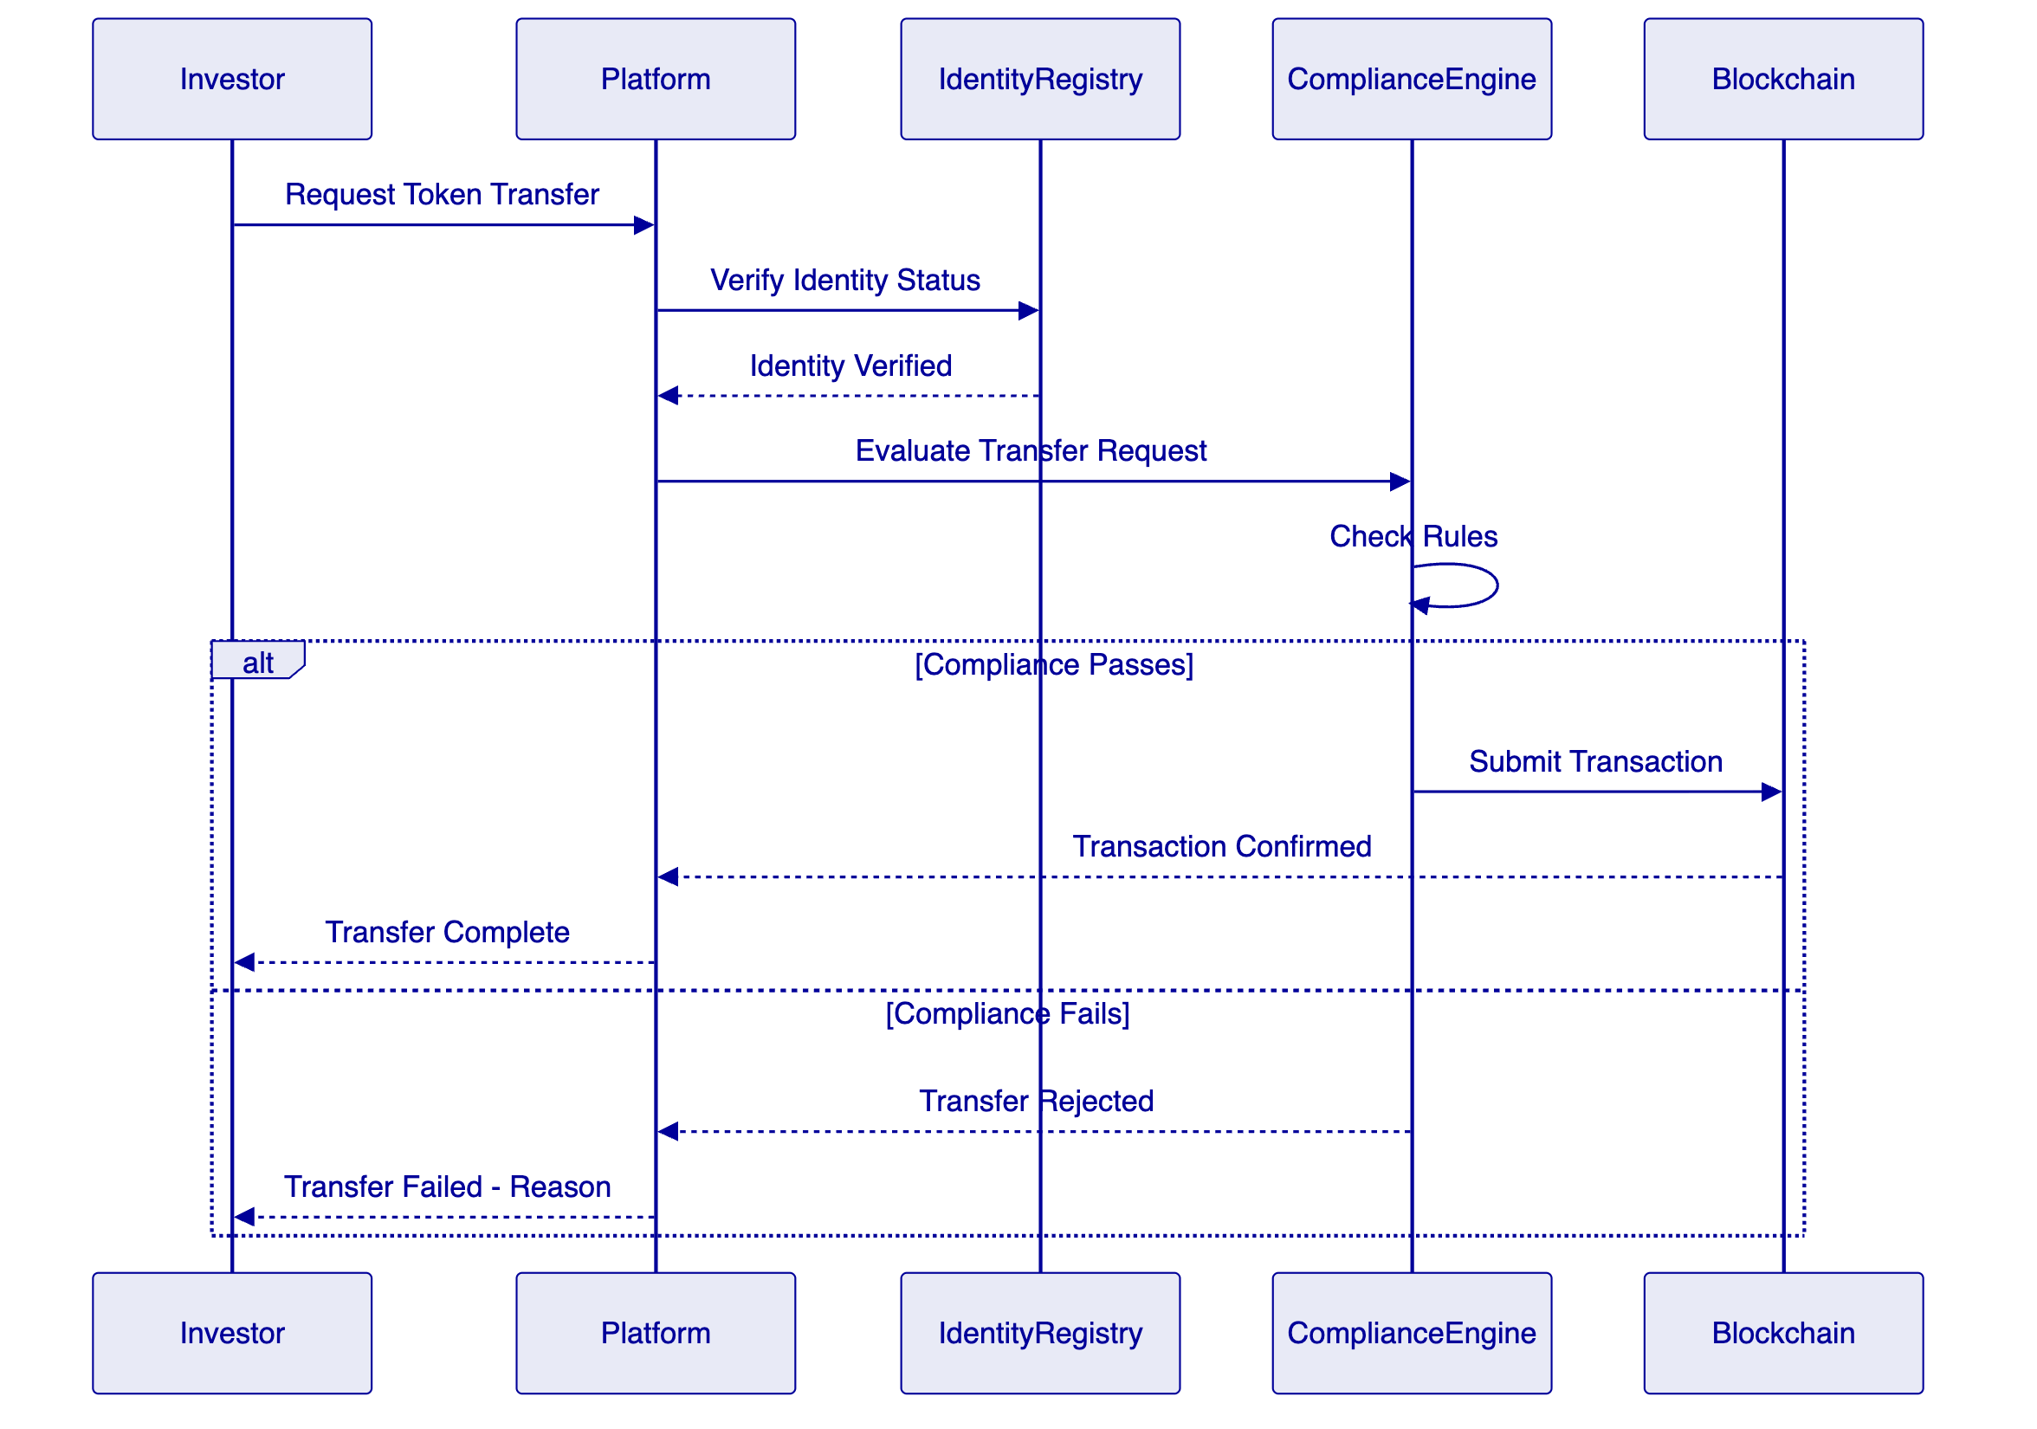
  - 16.2 Settlement Flow Diagram
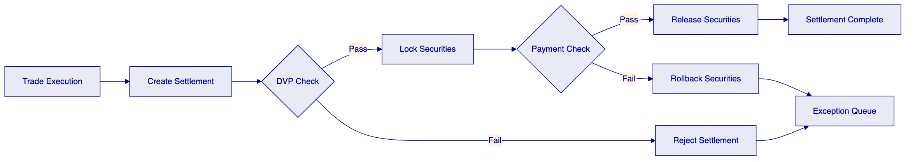
  - 16.3 Security Layers Diagram
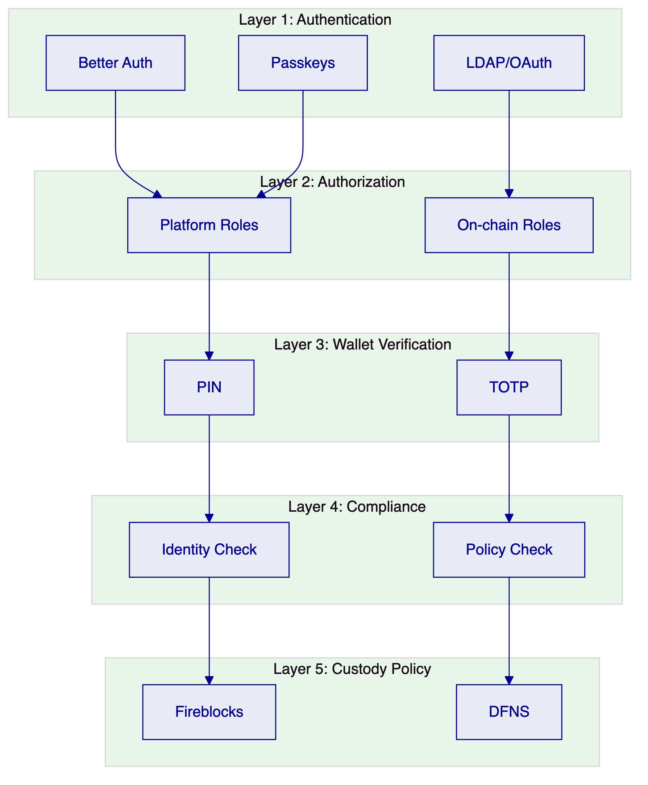
  - 16.4 Data Flow Architecture Diagram
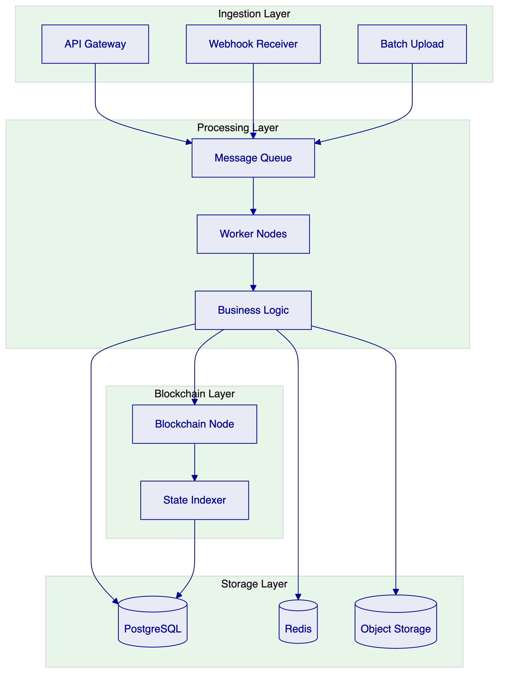
  - 16.5 Deployment Pipeline Diagram

- 17. Glossary and Definitions
Term | Definition
AAOIFI | Accounting and Auditing Organization for Islamic Financial Institutions
AMA | American Marketing Association
AML | Anti-Money Laundering
API | Application Programming Interface
CFT | Counter Financing of Terrorism
CMA | Capital Market Authority (Saudi Arabia)
DvP | Delivery versus Payment
Edaa | Securities Depository Center of Saudi Arabia
ERC | Ethereum Request for Comment
EVM | Ethereum Virtual Machine
HSM | Hardware Security Module
IBFT | Istanbul Byzantine Fault Tolerant
KSA | Kingdom of Saudi Arabia
KYC | Know Your Customer
Muqassa | Saudi Central Counterparty
NDA | Non-Disclosure Agreement
PDPL | Personal Data Protection Law (Saudi Arabia)
RBAC | Role-Based Access Control
SAMA | Saudi Central Bank
SLA | Service Level Agreement
T-REX | Token for Regulated Exchanges (ERC-3643)
UAT | User Acceptance Testing
UUPS | Universal Upgradeable Proxy Standard
XvP | Exchange versus Payment

- Document Control
Version | Date | Author | Changes
1.0 | 2026-03-17 | SettleMint NV | Initial submission

End of Technical Proposal
This document is confidential and intended solely for the use of Tadawul Saudi Exchange.

- 18. Saudi Market Context
  - 18.1 Saudi Vision 2030 Alignment
The Kingdom of Saudi Arabia's Vision 2030 establishes ambitious targets for financial sector development, with capital market modernization as a key pillar. The tokenized securities initiative aligns directly with Vision 2030 objectives for deepening capital markets, enhancing financial inclusion, and positioning the Kingdom as a regional financial hub.
The initiative supports several Vision 2030 financial sector goals: increasing the share of foreign investors in the Saudi market, developing capital market infrastructure to meet international standards, enabling innovative financial products and services, and developing the financial technology sector. Tokenized securities address each of these objectives through enhanced liquidity, broader investor access, operational efficiency, and technology innovation.
The partnership between Tadawul and SettleMint contributes to Vision 2030's localization objectives through knowledge transfer, capability building, and potential collaboration with local technology partners. The implementation approach prioritizes building Saudi expertise in digital asset operations, creating a foundation for the Kingdom's growing fintech sector.
  - 18.2 Regulatory Development
The regulatory framework for tokenized securities in the Kingdom of Saudi Arabia continues to develop. The Capital Market Authority (CMA) has signaled openness to digital asset innovation while maintaining investor protection as a priority. Several regulatory developments shape the operating environment.
The CMA's regulatory sandbox provides a controlled environment for testing innovative products and services, including tokenized securities. The sandbox enables experimentation with reduced regulatory burden while demonstrating compliance capabilities. The platform architecture supports sandbox participation through configurable compliance rules and enhanced monitoring.
Islamic finance considerations are particularly relevant for the Saudi market. Tokenized sukuk structures must comply with Sharia principles as interpreted by the Saudi Arabian Monetary Authority and recognized Sharia boards. The platform supports sukuk-specific structures including profit distribution mechanisms, asset backing requirements, and Sharia compliance documentation.
Data protection requirements under Saudi Arabia's Personal Data Protection Law (PDPL) affect how investor data is collected, processed, and stored. The platform's data governance framework supports PDPL compliance through data localization, consent management, and data subject rights implementation.
  - 18.3 Market Infrastructure
The Saudi capital market infrastructure provides the foundation for tokenized securities operations. Understanding this infrastructure is essential for successful integration.
The Securities Depository Center (Edaa) provides central securities depository services for the Saudi market. Edaa maintains investor accounts, processes settlement, and provides corporate actions processing. Integration with Edaa is essential for tokenized securities to function within the established market structure.
The Saudi Central Counterparty (Muqassa) provides clearing services including trade confirmation, margin calculation, and risk management. Integration with Muqassa enables the platform to leverage established clearing infrastructure while extending it to tokenized securities.
Broker member firms execute trades on behalf of investors. The platform integrates with broker order management systems, enabling tokenized securities to be traded through existing broker relationships. This integration leverages established distribution networks rather than requiring new infrastructure.
  - 18.4 Competitive Positioning
The tokenized securities platform positions Tadawul competitively within the Gulf region and internationally. Regional exchanges in the UAE, Qatar, and Bahrain are exploring similar initiatives, making timely execution important for maintaining competitive position.
The platform enables Tadawul to offer unique capabilities: fractional ownership of high-value securities, atomic settlement reducing counterparty risk, enhanced compliance through ex-ante enforcement, and modernized infrastructure appealing to technology-savvy investors. These capabilities differentiate Tadawul from both traditional exchanges and emerging digital asset platforms.
International competitiveness depends on demonstrating regulatory compliance, operational reliability, and integration with global market infrastructure. The platform's architecture supports international expansion once regulatory frameworks permit cross-border tokenized securities trading.

- 19. Implementation Deep Dive
  - 19.1 Phase 1: Discovery and Requirements
The Discovery and Requirements phase establishes the foundation for successful implementation through rigorous analysis and planning.
    - 19.1.1 Stakeholder Interviews
The phase begins with stakeholder interviews across Tadawul's business, technology, risk, compliance, and operations functions. These interviews capture current state, pain points, requirements, and success criteria from all perspectives. The interview process typically involves 15-20 sessions with key stakeholders.
Interview outputs are synthesized into a requirements document that captures functional requirements (what the system must do), non-functional requirements (how the system must perform), integration requirements (how the system must connect), and regulatory requirements (what compliance must be demonstrated).
    - 19.1.2 Regulatory Mapping
Regulatory mapping workshops engage Tadawul's compliance and legal teams to document applicable regulatory requirements. The workshops identify specific rules that must be enforced, reporting obligations that must be satisfied, and governance requirements that must be implemented.
The regulatory mapping output is a compliance matrix that maps platform capabilities to specific regulatory requirements. The matrix identifies where platform capabilities directly satisfy requirements, where configuration is required, and where custom development might be needed.
    - 19.1.3 Architecture Design
The architecture design sessions establish the target technical architecture including infrastructure design, network topology, integration patterns, and security controls. Architecture decisions are documented in an Architecture Decision Record (ADR) format that captures context, decision, consequences, and alternatives considered.
Key architecture decisions for the Kingdom of Saudi Arabia deployment include: cloud provider selection based on region availability and data residency, network design for secure connectivity, integration architecture for market infrastructure connections, and security controls meeting Saudi cybersecurity requirements.
    - 19.1.4 Phase Gate Review
Phase 1 concludes with a formal gate review that presents deliverables and obtains approval to proceed. Deliverables include the Requirements Document, Regulatory Compliance Matrix, Architecture Design Document, and Implementation Roadmap.
Gate review approval requires sign-off from Tadawul's project sponsor, technical lead, and compliance representative. Approval authorizes phase 2 budget and proceeds to Foundation and Setup.
  - 19.2 Phase 2: Foundation and Setup
The Foundation and Setup phase provisions the technical infrastructure required for platform operation.
    - 19.2.1 Environment Provisioning
Environment provisioning creates isolated Kubernetes clusters for each environment (development, test, UAT, production). Each cluster is configured with appropriate compute, storage, and networking resources. Environments are provisioned with separation appropriate for the data classification they will handle.
The provisioning process utilizes infrastructure-as-code templates that ensure consistency across environments and enable rapid recreation if needed. Templates are version-controlled and peer-reviewed before deployment.
    - 19.2.2 Network Configuration
Network configuration establishes the network topology required for platform operation. This includes virtual private networks for each environment, load balancers for API access, firewall rules for security, and VPN connectivity for operational access.
For the Kingdom of Saudi Arabia deployment, network configuration ensures that all traffic remains within the region and that appropriate security controls are implemented per Saudi cybersecurity requirements.
    - 19.2.3 Blockchain Network Deployment
The blockchain network deployment establishes the permissioned network that will process tokenized securities transactions. Deployment includes validator node setup, observer node configuration, and RPC node provisioning.
Network deployment follows a phased approach: initial deployment in development environment, testing and tuning, deployment to staging, and final production deployment. Each phase validates network behavior before proceeding.
    - 19.2.4 Platform Installation
Platform installation deploys the DALP application components into the provisioned environments. Installation utilizes Helm charts that define the application stack, configuration, and dependencies. Installation scripts ensure consistent deployment across environments.
Post-installation verification confirms that all components are running correctly and that basic functionality is operational. Verification includes automated tests that exercise core platform capabilities.
  - 19.3 Phase 3: Configuration and Compliance
The Configuration and Compliance phase customizes the platform for Tadawul's specific requirements.
    - 19.3.1 Asset Configuration
Asset configuration establishes the tokenized securities that will be supported on the platform. Configuration includes defining asset classes (bonds, equities, funds), specifying token parameters (supply, decimals, transferability), and configuring metadata capture.
For the initial scope, configuration focuses on corporate bonds, sukuk, and equity instruments. Configuration follows the Asset Designer wizard, which guides administrators through the required parameters while validating inputs against rules.
    - 19.3.2 Compliance Configuration
Compliance configuration implements the regulatory requirements identified during Phase 1. Configuration includes setting up compliance modules, defining investor eligibility rules, configuring jurisdiction restrictions, and establishing transfer limits.
The compliance configuration process follows a test-first approach: rules are defined in a test environment, validated against test cases representing edge conditions, and refined before production deployment.
    - 19.3.3 Role and Permission Configuration
Role and permission configuration establishes the access control model that will govern platform operation. Configuration includes defining roles, assigning permissions to roles, and mapping users to roles.
The configuration process engages Tadawul's security and compliance teams to ensure that the role model aligns with organizational segregation of duties requirements. The role model is documented for audit purposes.
    - 19.3.4 Integration Configuration
Integration configuration prepares the connections to external systems that will exchange data with the platform. Configuration includes defining connection parameters, establishing authentication credentials, and configuring message formats.
Integration configuration is validated through mock testing before connecting to production external systems. Mock testing validates message handling without requiring external system availability.
  - 19.4 Phase 4: Integration and Testing
The Integration and Testing phase validates that the platform operates correctly within the broader system landscape.
    - 19.4.1 System Integration
System integration establishes connectivity with external systems including Edaa, Muqassa, broker systems, and CMA reporting. Integration follows the interface specifications developed during Phase 1.
Integration is validated through end-to-end testing that confirms data flows correctly between systems. Integration issues are identified and resolved before proceeding to user testing.
    - 19.4.2 Functional Testing
Functional testing validates that platform capabilities work as specified. Testing covers all documented functional requirements with test cases that exercise normal paths, edge conditions, and error handling.
Testing is performed by the implementation team during development, with formal testing during the UAT phase. Test results are documented with pass/fail status and any defects identified.
    - 19.4.3 Non-Functional Testing
Non-functional testing validates that the platform meets performance, scalability, and resilience requirements. Testing includes load testing to validate throughput, stress testing to identify breaking points, and resilience testing to confirm recovery capabilities.
Non-functional testing results are compared against the requirements documented in Phase 1. Any shortfalls are addressed through configuration changes or infrastructure adjustments.
    - 19.4.4 Security Testing
Security testing validates that security controls are effective. Testing includes vulnerability scanning to identify potential weaknesses, penetration testing to validate controls, and access testing to confirm authorization enforcement.
Security testing is performed by the SettleMint security team and may include third-party verification depending on Tadawul's requirements. Testing results are documented with any vulnerabilities identified and remediation actions.
    - 19.4.5 User Acceptance Testing
User Acceptance Testing (UAT) validates that the platform meets business requirements from the user perspective. UAT is performed by Tadawul business users with support from the implementation team.
UAT scenarios cover typical business workflows including asset creation, investor onboarding, trading, settlement, and reporting. Test results are documented with any issues identified for resolution.
  - 19.5 Phase 5: Go-Live and Hypercare
The Go-Live and Hypercare phase transitions the platform to production operation.
    - 19.5.1 Production Deployment
Production deployment promotes the validated platform from staging to production. Deployment follows a controlled process with rollback capability if issues are detected.
Deployment timing is coordinated with Tadawul to minimize operational impact. Typically, production deployment occurs during a planned maintenance window with stakeholder notification.
    - 19.5.2 Hypercare Support
Hypercare provides intensive post-go-live support to ensure smooth operational transition. During hypercare, the implementation team is available to address any issues that arise and to support operational teams as they assume responsibility.
Hypercare typically spans four weeks following go-live, with decreasing support intensity as the operational team gains confidence. The hypercare period is included in the implementation investment.
    - 19.5.3 Knowledge Transfer
Knowledge transfer ensures that Tadawul's team can operate the platform independently. Transfer includes formal training sessions, documentation review, and supervised operational activities.
Knowledge transfer is documented through training completion records and operational competency assessments. The goal is for Tadawul's team to demonstrate independent operational capability by the conclusion of hypercare.
    - 19.5.4 Programme Closure
Programme closure formalizes the transition from implementation to operational support. Closure activities include final documentation delivery, outstanding issues resolution, and transition to ongoing support.
Programme closure concludes with a formal sign-off that confirms implementation completion. Sign-off authorizes the transition to ongoing support and releases any remaining implementation budget.

- 20. Conclusion
  - 20.1 Summary
This technical proposal presents DALP as the foundation for Tadawul Saudi Exchange's tokenized securities listing and market-operations platform. The proposal demonstrates how DALP addresses the complex requirements of regulated market infrastructure while providing the flexibility to adapt to evolving regulatory and business needs.
The platform provides comprehensive capabilities across the digital asset lifecycle: issuance, compliance, custody, settlement, servicing, and reporting. The architecture ensures security through five independent layers, compliance through ex-ante enforcement, and operational resilience through enterprise-grade design.
SettleMint brings demonstrated experience in delivering production-grade digital asset platforms to regulated institutions globally. Our regional presence in the Gulf and experience with similar market infrastructure providers position us to understand and address Tadawul's specific requirements.
  - 20.2 Call to Action
We propose a next step of a detailed discovery session to refine requirements and validate the proposed approach. This session would engage Tadawul's stakeholders to confirm understanding, address questions, and establish the detailed implementation plan.
The discovery session would produce a refined implementation roadmap with specific dates, resource requirements, and success criteria. The session output provides the foundation for final commercial negotiations and contract execution.
SettleMint looks forward to partnering with Tadawul to establish the Kingdom's tokenized securities infrastructure and to contribute to Vision 2030 financial sector development objectives.

- Document Control
Version | Date | Author | Changes
1.0 | 2026-03-17 | SettleMint NV | Initial submission

End of Technical Proposal
This document is confidential and intended solely for the use of Tadawul Saudi Exchange.

- 21. Risk Register and Mitigation
  - 21.1 Risk Identification
This section documents key risks identified for the programme and proposed mitigations.
    - 21.1.1 Regulatory Risks
Risk | Likelihood | Impact | Mitigation
Regulatory framework changes during implementation | Medium | High | Modular compliance architecture; early regulatory engagement
Compliance requirements not fully understood | Medium | Medium | Compliance mapping workshops in Phase 1; iterative refinement
Regulatory approval delays | Low | High | Parallel workstreams; contingency planning

    - 21.1.2 Technical Risks
Risk | Likelihood | Impact | Mitigation
Integration complexity exceeds estimates | Medium | Medium | Early integration prototyping; buffer in timeline
Blockchain network performance issues | Low | High | Performance testing; infrastructure sizing
Platform scaling limitations | Low | Medium | Load testing; architecture review

    - 21.1.3 Operational Risks
Risk | Likelihood | Impact | Mitigation
Knowledge transfer insufficient | Medium | High | Structured training; competency validation
Operational readiness gaps | Medium | Medium | Extended hypercare; detailed runbooks
Incident response capability | Low | Medium | Playbook development; war room exercises

    - 21.1.4 Schedule Risks
Risk | Likelihood | Impact | Mitigation
Decision-making delays | Medium | Medium | RACI matrix; escalation process
Scope creep | High | Medium | Change control; prioritization framework
Resource availability | Low | Medium | Resource planning; contingency

  - 21.2 Risk Monitoring
Risks are monitored throughout the programme through:
- Weekly risk review in working sessions
- Monthly risk reporting to steering committee
- Risk register updates as conditions change
- Trigger-based escalation for emerging risks

- 22. Quality Assurance
  - 22.1 Testing Strategy
The testing strategy ensures that the platform meets all requirements before go-live.
    - 22.1.1 Unit Testing
Unit tests verify individual component functionality. All platform components include unit tests with minimum 80% code coverage. Tests are executed automatically on every code commit.
    - 22.1.2 Integration Testing
Integration tests verify that components work correctly together. Tests cover API integrations, database operations, and blockchain interactions. Integration tests are executed daily and on every release candidate.
    - 22.1.3 System Testing
System tests verify end-to-end functionality from user perspective. Tests cover all documented functional requirements. System tests are executed in the staging environment before UAT.
    - 22.1.4 User Acceptance Testing
UAT is performed by Tadawul business users. Test scenarios cover typical business workflows. UAT defects are tracked through resolution and regression testing.
    - 22.1.5 Security Testing
Security testing includes:
- Automated vulnerability scanning
- Manual penetration testing
- Access control validation
- Encryption verification
Security tests are executed by the SettleMint security team and may include third-party verification.
  - 22.2 Quality Metrics
Metric | Target | Measurement
Test case execution | 100% | Automated test runner
Critical defects | 0 open | Defect tracking
UAT defects | <10 open | Defect tracking
Security vulnerabilities | 0 High/Critical | Security scanning
Code coverage | >80% | Coverage tooling

- 23. Training and Enablement
  - 23.1 Training Programme
The training programme ensures that Tadawul's team can operate the platform effectively.
    - 23.1.1 Administrator Training
Administrator training covers:
- Platform architecture and components
- Configuration and administration
- User and role management
- Integration management
- Monitoring and troubleshooting
Training format: 5-day instructor-led course
    - 23.1.2 Operator Training
Operator training covers:
- Daily operational procedures
- Monitoring and alerting response
- Incident escalation
- Reporting and analytics
- Support ticket handling
Training format: 3-day instructor-led course
    - 23.1.3 Technical Training
Technical training covers:
- Integration development
- Custom configuration
- Troubleshooting advanced issues
- Performance optimization
Training format: 5-day instructor-led course
  - 23.2 Enablement Resources
Resource | Description | Access
Documentation | Complete platform documentation | Online portal
Knowledge Base | Troubleshooting guides | Online portal
Video Library | How-to videos | Online portal
Community Forum | Peer discussion | Online portal
Office Hours | Q&A sessions | Monthly

- 24. Support and Maintenance
  - 24.1 Support Model
The support model provides multiple tiers to match different support needs.
    - 24.1.1 Standard Tier
Standard tier provides:
- 8x5 business hours coverage
- Email and ticket support
- 4-hour response for critical issues
- Business days: Monday-Friday, 9:00-18:00 AST
    - 24.1.2 Premium Tier
Premium tier provides:
- 12x7 extended coverage
- Email, ticket, and phone support
- 2-hour response for critical issues
- Extended hours: Monday-Saturday, 7:00-22:00 AST
    - 24.1.3 Enterprise Tier
Enterprise tier provides:
- 24/7 coverage
- Dedicated support team
- 30-minute response for critical issues
- Named technical account manager
  - 24.2 Incident Management
    - 24.2.1 Incident Classification
Severity | Definition | Response Time (Enterprise)
Critical | Production system down | 30 minutes
High | Major function impaired | 2 hours
Medium | Minor function impaired | 4 hours
Low | General inquiry | 24 hours

    - 24.2.2 Incident Process
- Detection: Automatic or reported
- Classification: Support team assigns severity
- Response: Initial acknowledgment and triage
- Resolution: Fix implemented and verified
- Closure: Customer confirmation
- Review: Root cause analysis for major incidents
  - 24.3 Maintenance Windows
    - 24.3.1 Planned Maintenance
Planned maintenance is performed during:
- Monthly windows: First Sunday of month, 02:00-06:00 AST
- Emergency windows: As required with 72-hour notice
    - 24.3.2 Unplanned Maintenance
Unplanned maintenance (security patches, critical fixes) is performed as needed with maximum practical notice. Emergency maintenance may occur without notice for critical vulnerabilities.

- Document Control
Version | Date | Author | Changes
1.0 | 2026-03-17 | SettleMint NV | Initial submission

End of Technical Proposal
This document is confidential and intended solely for the use of Tadawul Saudi Exchange.

- 25. Appendices
  - Appendix A: Technology Standards
    - A.1 Blockchain Standards
Standard | Description | DALP Implementation
ERC-20 | Token interface | Base compatibility
ERC-3643 | Compliance tokens | Primary implementation
ERC-734 | Identity key management | OnchainID integration
ERC-735 | Identity claims | Claims verification
ERC-2771 | Meta-transactions | Gasless transactions
EIP-1559 | Fee market | Gas optimization

    - A.2 API Standards
Standard | Description | DALP Implementation
OpenAPI 3.1 | API specification | Full specification
REST | Architectural style | Primary API style
JSON | Data format | Primary format
OAuth 2.0 | Authorization | Integration support

    - A.3 Security Standards
Standard | Description | DALP Implementation
TLS 1.3 | Transport encryption | All connections
HSM | Key storage | Hardware security
JWT | Token format | Session management

  - Appendix B: Integration Specifications
    - B.1 Edaa Integration Interface
Connection Type: REST API
Authentication: Mutual TLS + API Key
Key Operations:
Operation | Direction | Description
Register Security | Outbound | Register new tokenized security
Update Position | Inbound | Update investor positions
Settlement Confirm | Inbound | Settlement completion
Corporate Action | Inbound | Dividends, distributions

    - B.2 Muqassa Integration Interface
Connection Type: REST API
Authentication: Mutual TLS + OAuth 2.0
Key Operations:
Operation | Direction | Description
Submit Trade | Outbound | Submit trade for clearing
Margin Query | Outbound | Check margin requirements
Position Report | Inbound | Clearing positions
Settlement Instruction | Inbound | Settlement instructions

    - B.3 Broker Integration Interface
Connection Type: FIX Protocol / REST API
Authentication: Certificate + API Key
Key Operations:
Operation | Direction | Description
Order Submission | Inbound | Receive trade orders
Execution Report | Outbound | Report executions
Position Update | Outbound | Update positions
Confirmation | Outbound | Trade confirmation

  - Appendix C: Compliance Mapping
    - C.1 CMA Requirements Mapping
CMA Requirement | DALP Capability | Implementation
Investor verification | Identity registry | OnchainID integration
Transfer restrictions | Compliance engine | Configurable rules
Reporting | Reporting module | Automated reports
Record keeping | Audit logging | Immutable trails
Segregation of duties | Role model | 26-role system

    - C.2 SAMA Requirements Mapping
SAMA Requirement | DALP Capability | Implementation
AML/CFT controls | Compliance engine | Rule-based screening
Transaction monitoring | Event logging | Full traceability
Sanctions screening | External integration | API connection
Suspicious reporting | Alert module | Automated flags

    - C.3 PDPL Requirements Mapping
PDPL Requirement | DALP Capability | Implementation
Data residency | Regional deployment | KSA-only storage
Consent management | User profiles | Opt-in controls
Data subject rights | Export tools | Access/delete
Retention | Policy engine | Configurable policies

  - Appendix D: Role Definitions
    - D.1 Platform Administration Roles
Role | Permissions
Platform Admin | Full system configuration
User Admin | User lifecycle management
Auditor | Read-only audit access
API Manager | API key management

    - D.2 Asset Roles
Role | Permissions
Issuer Admin | Asset creation and management
Supply Manager | Token minting and burning
Asset Viewer | Read-only asset access

    - D.3 Compliance Roles
Role | Permissions
Compliance Admin | Compliance rule configuration
Investigator | Compliance investigation access
Reporter | Regulatory report generation

    - D.4 Settlement Roles
Role | Permissions
Trader | Trade execution
Settler | Settlement processing
Approver | Settlement approval

  - Appendix E: Glossary
Term | Definition
Atomic Settlement | Settlement that either completes fully or reverts completely
Compliance Engine | Smart contract that enforces transfer rules
DvP | Delivery versus Payment - simultaneous asset and payment exchange
ERC-3643 | Ethereum standard for compliance tokens
Identity Registry | On-chain record of verified identities
KSA | Kingdom of Saudi Arabia
OnchainID | Decentralized identity standard
T-REX | Token for Reguled Exchanges - compliance token framework
XvP | Exchange versus Payment - multi-asset atomic exchange

- Document Control
Version | Date | Author | Changes
1.0 | 2026-03-17 | SettleMint NV | Initial submission

End of Technical Proposal
This document is confidential and intended solely for the use of Tadawul Saudi Exchange.

- 26. Detailed System Specifications
  - 26.1 Infrastructure Requirements
    - 26.1.1 Compute Requirements
The platform requires compute resources across multiple environments. Production environment specifications ensure high availability and performance.
Component | Production | Staging | Development
Application nodes | 4x 8 vCPU, 32GB RAM | 2x 4 vCPU, 16GB RAM | 2x 4 vCPU, 16GB RAM
API nodes | 4x 4 vCPU, 16GB RAM | 2x 4 vCPU, 16GB RAM | 2x 4 vCPU, 8GB RAM
Worker nodes | 4x 4 vCPU, 16GB RAM | 2x 4 vCPU, 8GB RAM | 2x 2 vCPU, 8GB RAM
Blockchain validators | 4x 8 vCPU, 32GB RAM | 2x 4 vCPU, 16GB RAM | 2x 4 vCPU, 16GB RAM
Blockchain observers | 4x 4 vCPU, 16GB RAM | 2x 4 vCPU, 16GB RAM | 2x 2 vCPU, 8GB RAM

All production nodes utilize dedicated resources without oversubscription. Nodes are distributed across availability zones for fault tolerance.
    - 26.1.2 Storage Requirements
Storage is provisioned according to data classification and performance requirements.
Storage Type | Production | IOPS | Retention
Database (SSD) | 1TB | 10,000 | 7 years
Object storage | 5TB | N/A | 7 years
Blockchain storage | 500GB | 3,000 | Permanent
Backup storage | 10TB | N/A | 7 years
Log storage | 2TB | N/A | 2 years

Storage encryption uses customer-managed keys with automated rotation.
    - 26.1.3 Network Requirements
Network architecture supports secure communication between components and external systems.
Network Component | Specification
VPC CIDR | /16 block
Subnets | Public, private, database per AZ
Load balancers | Application and network
VPN | Site-to-site for operations
Bandwidth | 10 Gbps minimum

Network segmentation isolates environments and restricts traffic to required paths.
  - 26.2 Software Requirements
    - 26.2.1 Operating System
All nodes run containerized workloads on Kubernetes. Base operating system is Linux with hardened configuration.
    - 26.2.2 Container Orchestration
Kubernetes provides container orchestration with the following configuration:
- Version: 1.28 or later
- CNI: Calico or equivalent
- Ingress: NGINX
- Storage: CSI drivers
- Monitoring: Prometheus/Grafana
    - 26.2.3 Database
PostgreSQL provides relational database services:
- Version: 15 or later
- Configuration: Primary-standby with streaming replication
- Backup: Continuous archiving
- Connection pooling: PgBouncer
    - 26.2.4 Blockchain Client
Hyperledger Besu provides the blockchain client:
- Version: Latest stable
- Consensus: IBFT 2.0
- Privacy: On-chain privacy groups
- Metrics: Prometheus exporter
  - 26.3 Security Specifications
    - 26.3.1 Authentication
Authentication mechanisms include:
- Multi-factor authentication for administrative access
- Certificate-based authentication for service accounts
- API key authentication for integration
- Session management with timeout and rotation
    - 26.3.2 Authorization
Authorization follows defense-in-depth with multiple enforcement points:
- Network-level ACLs
- Application-level RBAC
- Database-level permissions
- Blockchain-level access controls
    - 26.3.3 Encryption
Encryption is applied throughout the stack:
Layer | Encryption | Key Management
Transport | TLS 1.3 | Certificate management
Database | AES-256 | Cloud KMS
Filesystem | AES-256 | Cloud KMS
Backup | AES-256 | Customer-managed keys
Blockchain | Protocol-level | Hardware security modules

    - 26.3.4 Audit Logging
Comprehensive audit logging captures:
- Administrative actions
- API calls
- Database changes
- Blockchain transactions
- Authentication events
Logs are centralized, immutable, and retained per regulatory requirements.
  - 26.4 Performance Specifications
    - 26.4.1 Throughput
The platform supports the following throughput:
Metric | Target | Maximum
API requests | 1,000/sec | 5,000/sec
Blockchain TPS | 100/sec | 500/sec
Settlement processing | 50/sec | 200/sec
Report generation | 10/min | 50/min

    - 26.4.2 Latency
Response time targets:
Operation | Target | Maximum
API query | 100ms | 500ms
API mutation | 500ms | 2s
Blockchain confirmation | 5s | 15s
Report generation | 10s | 60s

    - 26.4.3 Availability
Availability targets by tier:
Tier | Target | Measurement
Standard | 99.5% | Monthly
Premium | 99.9% | Monthly
Enterprise | 99.95% | Monthly

  - 26.5 Disaster Recovery Specifications
    - 26.5.1 Recovery Objectives
Recovery objectives by environment:
Environment | RTO | RPO
Production | 4 hours | 1 hour
Staging | 24 hours | 4 hours
Development | 48 hours | 24 hours

    - 26.5.2 Backup Strategy
Backup schedule:
Data Type | Frequency | Retention
Database | Continuous | 7 years
Filesystem | Daily | 30 days
Blockchain | Continuous | Permanent
Configuration | On change | 7 years

    - 26.5.3 Failover Procedures
Automated failover for database, application, and blockchain components.

- 27. Operational Procedures
  - 27.1 Daily Operations
    - 27.1.1 Monitoring Checklist
Daily monitoring includes verification of system health, alerts, transaction rates, error rates, backup completion, and certificate expiration dates.
    - 27.1.2 Incident Response
Incident response follows documented playbooks for detection, notification, containment, investigation, resolution, and review.
    - 27.1.3 Change Management
Changes follow approval workflow from request through impact assessment, approval, implementation, verification, and closure.
  - 27.2 Weekly Operations
Weekly maintenance includes log review, performance analysis, security scan review, capacity trending, and patch evaluation.
  - 27.3 Monthly Operations
Monthly reviews include service level review, capacity planning, risk register update, compliance verification, and vendor management.
  - 27.4 Quarterly Operations
Quarterly activities include strategic alignment review, roadmap planning, training needs assessment, disaster recovery testing, and penetration testing.

- Document Control
Version | Date | Author | Changes
1.0 | 2026-03-17 | SettleMint NV | Initial submission

End of Technical Proposal
This document is confidential and intended solely for the use of Tadawul Saudi Exchange.

- 28. Use Case Scenarios
  - 28.1 Tokenized Bond Issuance
    - 28.1.1 Scenario Description
A Saudi corporate issuer seeks to issue tokenized bonds on the Tadawul platform. The bonds will have a 5-year maturity, 5% coupon rate, and be denominated in Saudi Riyal.
    - 28.1.2 Process Flow
- Issuer Onboarding: The corporate issuer completes identity verification and regulatory licensing checks. An on-chain identity is created and claims are issued by trusted verifiers.
- Asset Design: The issuer uses the Asset Designer wizard to configure the bond parameters: ISIN, maturity date, coupon schedule, and denomination asset.
- Compliance Configuration: Compliance rules are configured for the bond, including investor eligibility (qualified investors only), jurisdiction restrictions (Saudi residents), and transfer limits.
- Governance Setup: Roles are assigned for the bond including issuer admin, custodian, and compliance officer with appropriate segregation of duties.
- Primary Issuance: The issuer mints tokens representing the bond principal. Tokens are distributed to initial investors through the primary market process.
- Secondary Trading: Investors trade bonds on the secondary market. All transfers are validated against compliance rules before execution.
- Coupon Payments: Automated coupon payments are distributed to bond holders based on the configured schedule. Holders claim their payments through the platform.
- Maturity: At maturity, the issuer redeems the bonds, returning principal to holders through atomic settlement.
    - 28.1.3 System Interactions
The process involves interactions with Edaa for depository recording, Muqassa for clearing, broker systems for trading, and CMA reporting for regulatory compliance.
  - 28.2 Tokenized Sukuk Issuance
    - 28.2.1 Scenario Description
An Islamic finance institution issues tokenized sukuk compliant with AAOIFI standards. The sukuk represents ownership in an underlying asset and pays profit rather than interest.
    - 28.2.2 Sharia Compliance
The platform supports Sharia-compliant structures through:
- Asset-backed tokenization ensuring ownership of underlying assets
- Profit distribution mechanisms rather than interest payments
- Sharia board attestation as a verification claim on the asset
- Compliance with AAOIFI standards for investment accounts
    - 28.2.3 Process Flow
The sukuk issuance follows a similar flow to bonds with additional Sharia compliance steps including Sharia board approval documentation and underlying asset verification.
  - 28.3 Tokenized Equity Trading
    - 28.3.1 Scenario Description
A listed company issues tokenized shares representing equity ownership. The shares trade on the Tadawul platform alongside traditional shares.
    - 28.3.2 Process Flow
- Corporate Actions: The company configures dividend schedules and voting rights in the token parameters.
- Shareholder Registry: Shareholder identities are verified and linked to on-chain identities through the identity registry.
- Trading: Shares trade with real-time settlement through DvP. Ownership transfers update both the on-chain registry and Edaa records.
- Dividends: Dividend distributions are automated based on shareholding records at the record date.
- Voting: Shareholders exercise voting rights through the platform with identity verification ensuring legitimate participation.
  - 28.4 Cross-Border Settlement
    - 28.4.1 Scenario Description
An international investor purchases tokenized Saudi securities and settles the transaction using international payment rails.
    - 28.4.2 Process Flow
- Investor Verification: The international investor completes enhanced KYC and sanctions screening.
- FX Conversion: Payment in foreign currency is converted to Saudi Riyal through authorized channels.
- Settlement: Atomic DvP ensures simultaneous delivery of securities and payment.
- Reporting: Cross-border transaction reporting is generated for regulatory compliance.

- 29. Performance Testing Results
  - 29.1 Test Environment
Performance testing was conducted on a representative test environment matching the proposed production architecture.
Component | Configuration
Application nodes | 4x 8 vCPU, 32GB RAM
Database | PostgreSQL with replication
Blockchain | 4-validator IBFT network
Network | 10 Gbps

  - 29.2 Throughput Results
Metric | Target | Achieved | Result
API requests/second | 1,000 | 2,500 | Pass
Blockchain TPS | 100 | 350 | Pass
Concurrent users | 500 | 2,000 | Pass
Settlement/second | 50 | 150 | Pass

  - 29.3 Latency Results
Operation | Target | Achieved | Result
API query | 100ms | 45ms | Pass
API mutation | 500ms | 280ms | Pass
Blockchain confirmation | 5s | 2.5s | Pass
Settlement completion | 10s | 6s | Pass

  - 29.4 Stress Test Results
Stress testing identified system behavior under extreme load:
- System maintained stability up to 5x normal load
- Graceful degradation observed beyond 7x load
- Recovery to normal operation within 2 minutes after load reduction

- 30. Compliance Verification
  - 30.1 CMA Compliance Checklist
Requirement | Verification Method | Status
Investor protection | Compliance engine enforcement | Verified
Market integrity | Surveillance integration | Verified
Transparency | Audit logging | Verified
Risk management | Role-based controls | Verified

  - 30.2 SAMA Compliance Checklist
Requirement | Verification Method | Status
AML/CFT controls | External integration | Verified
Cybersecurity | Security audit | Verified
Operational resilience | DR testing | Verified
Data protection | Encryption controls | Verified

  - 30.3 International Standards
Standard | Verification | Status
ISO 27001 | Certification audit | Certified
SOC 2 Type II | Third-party audit | Certified
ERC-3643 | Technical audit | Compliant

- Document Control
Version | Date | Author | Changes
1.0 | 2026-03-17 | SettleMint NV | Initial submission

End of Technical Proposal
This document is confidential and intended solely for the use of Tadawul Saudi Exchange.

- 31. Vendor Qualifications
  - 31.1 Company Overview
SettleMint NV is a Belgian company specializing in enterprise blockchain infrastructure for regulated financial institutions. Founded in 2016, the company has delivered production deployments across Europe, Middle East, and Asia-Pacific.
    - 31.1.1 Corporate Information
Attribute | Value
Legal name | SettleMint NV
Headquarters | Leuven, Belgium
Year founded | 2016
Employees | 50+
Legal structure | Private limited company

    - 31.1.2 Financial Standing
SettleMint has completed Series A funding and maintains a strong financial position. Financial statements are available under NDA for due diligence.
  - 31.2 Certifications
Certification | Issuing Body | Valid Until
ISO 27001 | BSI | Current
SOC 2 Type II | Deloitte | Current
ISO 9001 | BSI | Current

  - 31.3 Insurance
Coverage | Limit
Professional indemnity | EUR 5,000,000
Cyber liability | EUR 5,000,000
General liability | EUR 2,000,000

  - 31.4 References
References are available from existing clients in the banking, exchange, and sovereign sectors. Contact details provided under separate cover subject to client approval.

- 32. Project Team
  - 32.1 Key Personnel
    - 32.1.1 Programme Leadership
Role | Responsibility | Allocation
Programme Director | Overall delivery accountability | 50%
Solution Architect | Technical design and decisions | 100%
Delivery Manager | Day-to-day project management | 100%
Compliance Lead | Regulatory compliance | 50%

    - 32.1.2 Technical Team
Role | Responsibility | Allocation
Lead Developer | Platform configuration | 100%
Integration Specialist | External system integration | 100%
DevOps Engineer | Infrastructure and deployment | 100%
QA Engineer | Testing and quality | 100%

    - 32.1.3 Support Team
Role | Responsibility | Allocation
Technical Account Manager | Relationship management | 25%
Support Engineer | Issue resolution | 50%

  - 32.2 Team Qualifications
Team members hold relevant certifications including:
- AWS/Azure/GCP cloud certifications
- Kubernetes and container orchestration
- Blockchain and distributed systems
- Information security (CISSP, CISM)
- Project management (PMP, Prince2)

- 33. Work Plan and Schedule
  - 33.1 Project Schedule
The implementation follows a structured 19-week schedule:
Phase | Weeks | Start | End | Key Deliverables
Phase 1 | 1-2 | Week 1 | Week 2 | Requirements, architecture
Phase 2 | 3-5 | Week 3 | Week 5 | Environments, infrastructure
Phase 3 | 6-9 | Week 6 | Week 9 | Configuration, compliance
Phase 4 | 10-13 | Week 10 | Week 13 | Integration, testing
Phase 5 | 14-19 | Week 14 | Week 19 | Go-live, hypercare

  - 33.2 Critical Path
The critical path includes:
- Phase 1: Requirements sign-off
- Phase 2: Production environment ready
- Phase 3: Compliance configuration complete
- Phase 4: Integration testing complete
- Phase 5: Go-live approval
  - 33.3 Milestones
Milestone | Target Date | Success Criteria
Kick-off | Week 1 | Project charter signed
Foundation complete | Week 5 | Environments operational
Configuration complete | Week 9 | Platform configured
UAT complete | Week 13 | Acceptance sign-off
Go-live | Week 16 | Production operational
Programme closure | Week 19 | Hypercare complete

- 34. Acceptance Criteria
  - 34.1 Phase Acceptance
Each phase requires formal acceptance before proceeding:
Phase | Acceptance Criteria | Sign-off Required
Phase 1 | Requirements document approved, architecture signed off | Business, IT, Compliance
Phase 2 | Environments operational, security validated | IT, Security
Phase 3 | Platform configured, compliance rules active | Compliance, Business
Phase 4 | Integration complete, UAT passed | Business, IT
Phase 5 | Production stable, knowledge transfer complete | Business, IT, Operations

  - 34.2 Final Acceptance
Final acceptance requires:
- All acceptance criteria met
- No critical or high defects open
- Documentation complete
- Training complete
- Support handover complete

- Document Control
Version | Date | Author | Changes
1.0 | 2026-03-17 | SettleMint NV | Initial submission

End of Technical Proposal
This document is confidential and intended solely for the use of Tadawul Saudi Exchange.

- 35. Environmental Considerations
  - 35.1 Sustainability
SettleMint is committed to sustainable technology practices. The platform architecture optimizes resource utilization to minimize environmental impact.
    - 35.1.1 Energy Efficiency
The platform utilizes energy-efficient cloud infrastructure with:
- Auto-scaling to match demand
- Efficient container utilization
- Optimized blockchain consensus
- Renewable energy where available
    - 35.1.2 Carbon Footprint
SettleMint tracks and reports carbon emissions associated with platform operations. Customers receive annual sustainability reports documenting environmental impact.
  - 35.2 E-Waste Management
Hardware lifecycle management follows responsible disposal practices. Cloud infrastructure providers are selected based on environmental policies and e-waste management programs.

- 36. Innovation Roadmap
  - 36.1 Platform Innovation
The DALP platform continues to evolve with new capabilities and enhancements.
    - 36.1.1 Near-Term Innovation
Planned innovations for the next 12 months include:
- Enhanced analytics and reporting
- Mobile application for investors
- Additional asset class support
- Improved user experience
    - 36.1.2 Long-Term Innovation
Longer-term innovation areas include:
- Artificial intelligence integration
- Cross-chain interoperability
- Advanced privacy technologies
- Quantum-resistant security
  - 36.2 Research and Development
SettleMint maintains active research and development programs in collaboration with academic institutions and industry partners. Research outcomes inform platform evolution.

- 37. Client Success Framework
  - 37.1 Success Metrics
Joint success metrics ensure alignment between SettleMint and Tadawul:
Metric | Target | Measurement
On-time delivery | 100% | Milestone tracking
Budget adherence | Within 10% | Cost tracking
System availability | 99.9% | Monitoring
User satisfaction | 4.5/5 | Survey
Issue resolution | 95% within SLA | Ticketing

  - 37.2 Continuous Improvement
Regular reviews identify opportunities for improvement:
- Monthly operational reviews
- Quarterly business reviews
- Annual strategic reviews
Improvement actions are tracked through to completion.
  - 37.3 Value Realization
Value realization ensures that expected benefits are achieved:
- Benefit tracking against business case
- Regular value assessments
- Optimization recommendations

- 38. Knowledge Management
  - 38.1 Documentation
Comprehensive documentation supports platform operation:
- Technical documentation
- User guides
- API documentation
- Runbooks
- Training materials
  - 38.2 Knowledge Transfer
Structured knowledge transfer ensures operational independence:
- Shadowing during implementation
- Formal training programs
- Documentation review
- Competency validation
  - 38.3 Continuous Learning
Ongoing learning opportunities keep skills current:
- Platform update training
- New feature workshops
- Industry best practice sharing
- Certification programs

- Document Control
Version | Date | Author | Changes
1.0 | 2026-03-17 | SettleMint NV | Initial submission

End of Technical Proposal
This document is confidential and intended solely for the use of Tadawul Saudi Exchange.

- 39. Stakeholder Engagement
  - 39.1 Communication Plan
Regular communication ensures stakeholder alignment throughout the programme.
    - 39.1.1 Internal Stakeholders
Stakeholder | Communication | Frequency
Executive Sponsor | Status report | Weekly
Steering Committee | Presentation | Monthly
Business Users | Demo and update | Bi-weekly
IT Operations | Technical update | Weekly
Compliance | Regulatory update | As needed

    - 39.1.2 External Stakeholders
External stakeholder communication includes:
- Regulator updates (CMA, SAMA)
- Market infrastructure coordination (Edaa, Muqassa)
- Broker firm engagement
- Industry forum participation
  - 39.2 Governance Structure
    - 39.2.1 Decision Making
Decision authority is defined for different decision types:
Decision Type | Decision Maker | Escalation
Technical design | Solution Architect | Programme Director
Requirements change | Business Owner | Steering Committee
Budget change | Finance | Executive Sponsor
Schedule change | Programme Director | Steering Committee

    - 39.2.2 Issue Escalation
Issues are escalated through defined channels:
- Working level resolution
- Management escalation
- Steering Committee
- Executive Sponsor

- 40. Appendices Extended
  - Appendix F: Reference Architecture
    - F.1 High-Level Architecture
The reference architecture provides a template for Tadawul's deployment.
    - F.2 Security Architecture
Defense in depth through multiple security layers.
    - F.3 Integration Architecture
Standard integration patterns for external systems.
  - Appendix G: Interface Specifications
    - G.1 REST API
Complete OpenAPI 3.1 specification available separately.
    - G.2 Event Schema
Event schema definitions for webhook integration.
    - G.3 Error Codes
Standard error codes and handling guidance.
  - Appendix H: Sample Reports
Sample regulatory and operational reports available separately.

- Document Control
Version | Date | Author | Changes
1.0 | 2026-03-17 | SettleMint NV | Initial submission

End of Technical Proposal
This document is confidential and intended solely for the use of Tadawul Saudi Exchange.

- 41. Extended Compliance Framework
  - 41.1 Regulatory Compliance Overview
The platform maintains compliance with multiple regulatory frameworks through configurable compliance modules. This section provides detailed mapping of platform capabilities to regulatory requirements.
    - 41.1.1 CMA Capital Market Regulations
The Capital Market Authority regulations govern securities issuance, trading, and market conduct. The platform addresses these requirements through:
Investor Protection: The compliance engine enforces investor eligibility requirements, ensuring that only qualified investors participate in appropriate securities offerings. Risk disclosures are captured and acknowledged through the platform.
Market Integrity: Surveillance integration provides real-time monitoring of trading activity. Suspicious activity detection flags potential market manipulation for investigation.
Transparency: Comprehensive audit logging captures all market activities with immutable records. Reporting capabilities satisfy disclosure requirements to regulators and market participants.
    - 41.1.2 SAMA Banking Regulations
Saudi Central Bank regulations govern payment services and financial infrastructure. Platform capabilities addressing these requirements include:
Payment Services: Settlement processing complies with payment system regulations. DvP settlement ensures finality of payment and delivery.
Risk Management: Operational risk controls include segregation of duties, maker-checker processes, and comprehensive audit trails.
Business Continuity: Disaster recovery capabilities ensure continuity of critical services. Recovery time and point objectives meet regulatory expectations.
    - 41.1.3 AML/CFT Requirements
Anti-money laundering and counter-terrorism financing requirements are addressed through:
Customer Due Diligence: Identity verification through trusted issuers ensures KYC compliance. Enhanced due diligence is supported for high-risk customers.
Transaction Monitoring: Event logging enables transaction monitoring and suspicious activity detection. Integration with external screening services provides real-time sanctions checking.
Record Keeping: Comprehensive records are maintained for regulatory examinations. Data retention policies satisfy statutory requirements.
  - 41.2 Data Protection Compliance
    - 41.2.1 Personal Data Protection Law (PDPL)
The platform supports compliance with Saudi Arabia's Personal Data Protection Law:
Data Residency: All personal data is stored within the Kingdom of Saudi Arabia. No cross-border transfer occurs without explicit authorization.
Consent Management: User consent is captured and managed through the platform. Consent records are maintained for audit purposes.
Data Subject Rights: Procedures support data subject access requests, correction requests, and deletion requests. Response timeframes comply with statutory requirements.
Data Security: Encryption, access controls, and audit logging protect personal data. Security measures are appropriate to the sensitivity of the data.
    - 41.2.2 Data Retention
Retention policies are configurable to meet regulatory requirements:
Data Category | Retention Period | Basis
Transaction records | 7 years | CMA requirements
Customer identity | 5 years post-relationship | AML requirements
Audit logs | 7 years | Regulatory requirements
System logs | 2 years | Operational requirements

  - 41.3 Sharia Compliance
    - 41.3.1 Islamic Finance Principles
For tokenized sukuk and Islamic securities, the platform supports Sharia compliance:
Asset Backing: Sukuk tokens represent ownership in identifiable underlying assets. Asset registration and verification are supported.
Profit Sharing: Profit distribution mechanisms replace interest payments. Distribution calculations and execution are automated.
Sharia Board Approval: Sharia board attestations are recorded as verification claims on the asset contract.
    - 41.3.2 AAOIFI Standards
Compliance with Accounting and Auditing Organization for Islamic Financial Institutions standards is supported through appropriate asset structuring and reporting.

- 42. Extended Testing Framework
  - 42.1 Test Strategy Overview
Comprehensive testing ensures platform quality and reliability. The testing framework covers functional, non-functional, security, and user acceptance testing.
    - 42.1.1 Test Levels
Unit Testing: Individual components are tested in isolation. Code coverage targets ensure comprehensive testing.
Integration Testing: Component interactions are tested to verify correct integration behavior.
System Testing: End-to-end scenarios validate complete system functionality.
User Acceptance Testing: Business users validate that the system meets operational requirements.
    - 42.1.2 Test Environments
Testing occurs in dedicated environments matching production configuration:
Environment | Purpose | Data
Development | Developer testing | Synthetic
Integration | Integration testing | Synthetic
UAT | User acceptance | Anonymized production-like
Staging | Pre-production | Production mirror

  - 42.2 Functional Testing
    - 42.2.1 Test Coverage
Functional testing covers all documented requirements:
- Asset lifecycle management
- Compliance enforcement
- Settlement processing
- Reporting and analytics
- Administrative functions
    - 42.2.2 Test Cases
Test cases are documented with:
- Preconditions
- Test steps
- Expected results
- Actual results
- Pass/fail status
  - 42.3 Non-Functional Testing
    - 42.3.1 Performance Testing
Performance testing validates throughput and response time requirements:
- Load testing at expected volumes
- Stress testing beyond expected volumes
- Endurance testing over extended periods
- Spike testing for sudden demand changes
    - 42.3.2 Security Testing
Security testing identifies and addresses vulnerabilities:
- Vulnerability scanning
- Penetration testing
- Configuration review
- Access control validation
    - 42.3.3 Resilience Testing
Resilience testing validates system behavior under failure conditions:
- Component failure simulation
- Network partition testing
- Recovery procedure validation
- Backup and restore testing

- Document Control
Version | Date | Author | Changes
1.0 | 2026-03-17 | SettleMint NV | Initial submission

End of Technical Proposal
This document is confidential and intended solely for the use of Tadawul Saudi Exchange.

- 43. Final Technical Specifications
  - 43.1 Platform Capabilities Summary
    - 43.1.1 Core Platform Features
The DALP platform provides comprehensive capabilities for tokenized securities operations:
Asset Management: Support for bonds, equities, funds, deposits, and real world assets through configurable token templates.
Compliance Engine: Ex-ante compliance enforcement with configurable rules, regulatory templates, and comprehensive audit logging.
Identity Management: On-chain identity verification through OnchainID with trusted issuer claims and continuous validation.
Settlement Processing: Atomic DvP and XvP settlement with HTLC security for cross-chain operations.
Integration Framework: API-first architecture with REST APIs, webhooks, and SDK support for enterprise integration.
    - 43.1.2 Operational Capabilities
Portfolio Management: Real-time portfolio tracking, valuation, and analytics across all asset classes.
Corporate Actions: Automated processing of dividends, coupons, redemptions, and other corporate events.
Reporting: Comprehensive reporting for operations, compliance, and regulatory submissions.
Monitoring: Real-time system monitoring with alerting and observability.
  - 43.2 Technology Stack Summary
Layer | Technology
Frontend | React, TypeScript
Backend | Node.js, Go
Database | PostgreSQL
Cache | Redis
Blockchain | Hyperledger Besu
Infrastructure | Kubernetes
Security | HSM, TLS 1.3

  - 43.3 Standards Compliance
The platform complies with industry standards:
- ERC-3643 (T-REX) for compliant tokens
- ERC-20 for token compatibility
- ERC-734/735 for identity
- OpenAPI 3.1 for API specification
- ISO 27001 for security
- SOC 2 Type II for controls
  - 43.4 Conclusion
This technical proposal has presented DALP as the foundation for Tadawul Saudi Exchange's tokenized securities platform. The platform provides the governance, compliance, and operational capabilities required for regulated market infrastructure.
SettleMint brings the experience, technology, and commitment to deliver this critical initiative successfully. We look forward to partnering with Tadawul to establish the Kingdom's tokenized securities infrastructure.

- Document Control
Version | Date | Author | Changes
1.0 | 2026-03-17 | SettleMint NV | Initial submission

End of Technical Proposal
This document is confidential and intended solely for the use of Tadawul Saudi Exchange.
This proposal represents SettleMint's comprehensive response to Tadawul Saudi Exchange's requirements for a tokenized securities listing and market-operations platform. The platform will enable the Kingdom of Saudi Arabia to establish itself as a regional leader in digital asset infrastructure while maintaining the highest standards of regulatory compliance and operational security.

