[Company name]
[Document title]
[Document subtitle]

Confidentiality Statement
This document contains confidential and proprietary information of SettleMint. By reading this document, you agree not to disclose the confidential information contained herein to any third party without the prior written consent of SettleMint, except to those agents, principals, representatives, or consultants who require access for the purpose of evaluating this document. You further agree to inform such persons of the confidential nature of this document and to obtain their agreement to preserve its confidentiality to the same extent as yours.
This confidentiality statement shall remain binding on the parties for a period of five (5) years from the date stated on the front cover, unless superseded by confidentiality provisions detailed in a subsequent agreement.
Terms and Conditions
This proposal is valid until [DD Month YYYY]. In the absence of confirmation to proceed, SettleMint and [the Company] acknowledge and agree to abide by the Mutual NDA as the governing agreement.
SettleMint reserves the right to vary the terms of this proposal in response to changes in specifications or information made available at a later date. Submission of this proposal does not convey any right, title, interest, or license in any intellectual property rights (including, but not limited to, patents, copyrights, trade secrets, or trademarks) contained herein.
All rights are reserved. This proposal and the information contained within it are provided on an “as is” basis, without any warranties of any kind, express or implied.
All contracts with SettleMint will be governed by Belgian Law and subject to the exclusive jurisdiction of Belgian courts.
Contact Details
For any enquiries regarding this document, please contact:
[Full Name]
[Job Title]
Email: [email@example.com]
Phone: [Country Code - Number]

Table of Contents

Technical Proposal 3
Cross-Border Tokenized Remittance Settlement 4
Table of Contents 5
1. Executive Summary 6
1.1 Context and Strategic Drivers 7
1.2 Why This Programme Is Hard 8
1.3 Proposed Response 9
1.4 Why SettleMint 10
1.5 Reference Fit Snapshot 11
2. About SettleMint 12
2.1 African Market Credentials 13
3. About DALP for Cross-Border Remittance 14
3.1 Platform Architecture for Chipper Cash 15
3.2 Multi-Currency Token Model 16
3.3 Key DALP Capabilities for Chipper Cash 17
4. Understanding Chipper Cash Requirements 18
4.1 Chipper Cash's Cross-Border Context 19
4.2 Requirement Domain Mapping 20
4.3 Key Challenges 21
5. Proposed Solution: Cross-Border Tokenized Settlement Architecture 22
5.1 Settlement Flow — Nigeria to Ghana Corridor Example 23
5.2 Multi-Corridor Compliance Configuration 24
5.3 Liquidity Management Dashboard 25
5.4 PAPSS Integration Architecture 26
5.5 AML/CFT Integration 27
6. Technical Architecture 28
6.1 Architectural Principles for Remittance Context 29
6.2 Layered Architecture 30
6.3 Network Topology — Managed SaaS 31
6.4 Data Architecture 32
7. Multi-Currency Token Infrastructure 33
7.1 Token Deployment Pipeline 34
7.2 FX Reference Rate Integration 35
8. Compliance and AML/CFT Infrastructure 36
8.1 Per-Jurisdiction Regulatory Framework 37
8.2 AML Screening Integration 38
8.3 Transaction Monitoring Output 39
9. Integration Architecture 40
9.1 Integration Map 41
9.2 Mobile Money Integration Pattern 42
9.3 Chipper Cash API Integration 43
10. Deployment Model 44
10.1 Recommended: Managed SaaS (EU Region) 45
10.2 Availability 46
11. Implementation Methodology 47
11.1 Accelerated Timeline (16 Weeks — Managed SaaS) 48
11.2 Phase Summary 49
11.3 Chipper Cash Resource Requirements 50
12. Training and Knowledge Transfer 51
13. Support and Service Levels 52
14. Risk Management 53
15. Compliance Matrix 54
Security Control Model 55
Security Architecture Overview 56
Appendix A: Operating Model Detail 57
Appendix B: Regulatory Framework Coverage 58

title: "Technical Proposal: Cross-Border Tokenized Remittance Settlement"
client: "Chipper Cash"
date: "2026-03-19"
version: "1.2"
confidentiality: "Restricted — Commercial-Sensitive"
prepared-by: "SettleMint NV"
document-type: "Technical Proposal"
rfp-reference: "CHIPPER-CASH-RFP-CROSS-BORDER-TOKENIZED-REMITTANCE-202603"

- Technical Proposal
  - Cross-Border Tokenized Remittance Settlement

Document Title: Technical Proposal — Cross-Border Tokenized Remittance Settlement
Client: Chipper Cash
Submission Date: 2026-03-19
Version: 1.2 (Final)
Confidentiality: Restricted — Commercial-Sensitive
Prepared by: SettleMint NV

> This document contains confidential and proprietary information of SettleMint NV. Distribution or reproduction without prior written consent is prohibited.

- Table of Contents
- Executive Summary
- About SettleMint
- About DALP
- Understanding Chipper Cash Requirements
- Proposed Solution: Cross-Border Tokenized Settlement Architecture
- Technical Architecture
- Multi-Currency Token Infrastructure
- Compliance and AML/CFT Infrastructure
- Integration Architecture
- Deployment Model
- Implementation Methodology
- Training and Knowledge Transfer
- Support and Service Levels
- Risk Management
- Compliance Matrix
- Appendix A: Operating Model Detail
- Appendix B: Regulatory Framework Coverage

- 1. Executive Summary
  - 1.1 Context and Strategic Drivers
Chipper Cash is one of Africa's largest cross-border payment and remittance platforms, serving over 5 million users across Uganda, Ghana, Tanzania, Rwanda, South Africa, Kenya, Nigeria, and the UK. The company operates at the intersection of mobile money, cross-border payments, and financial inclusion — a space defined by regulatory fragmentation, correspondent banking friction, and the operational complexity of managing liquidity across multiple African currency corridors simultaneously.
The cross-border tokenized remittance settlement programme under this RFP represents Chipper Cash's strategic initiative to replace or augment correspondent banking-based settlement with a tokenized settlement layer. The goals are specific: reduce settlement time, reduce the correspondent banking and FX costs embedded in cross-border flows, improve liquidity management visibility, and maintain compliance across the multiple jurisdictions in which Chipper Cash operates.
Chipper Cash is not a conventional financial institution. It is a fintech operating under varying licensing frameworks across Africa — money services business (MSB) licenses, electronic money institution (EMI) registrations, and payment service provider (PSP) licenses depending on jurisdiction. Each license has distinct AML/CFT obligations, capital requirements, and operational restrictions. The tokenized settlement platform must respect this regulatory reality: it cannot apply a single compliance model to all corridors; it must be configurable per corridor with the jurisdiction-specific rules that apply.
The African cross-border payment regulatory landscape is evolving. The Pan-African Payment and Settlement System (PAPSS), developed by Afreximbank, is creating a continental settlement infrastructure for African currencies. Several African central banks have established or are establishing CBDC or digital currency frameworks. The selected settlement platform must be interoperable with these emerging infrastructures — not locked into a proprietary settlement network.
SettleMint proposes DALP as the tokenized settlement control layer for Chipper Cash's cross-border remittance infrastructure. DALP provides the multi-currency token framework, per-corridor compliance configuration, AML/CFT integration, and operational settlement tools required for a production-grade cross-border tokenized remittance system.
  - 1.2 Why This Programme Is Hard
Multi-currency corridor complexity: Chipper Cash operates corridors across eight+ countries with distinct currencies (UGX, GHS, TZS, RWF, ZAR, KES, NGN, GBP). Each corridor has different liquidity dynamics, FX reference data, settlement conventions, and regulatory requirements. A tokenized settlement layer must manage this complexity without creating a rigid currency pair model that cannot accommodate new corridors.
Regulatory fragmentation: Money transfer licensing requirements differ significantly across Uganda (BOU), Ghana (BoG), Tanzania (BoT), Rwanda (BNR), South Africa (SARB/PA), Kenya (CBK), Nigeria (CBN), and the UK (FCA). Each regulator has distinct AML/CFT expectations, transaction monitoring requirements, and cross-border transfer reporting obligations. A single compliance framework will not satisfy all; a configurable per-corridor model is required.
PAPSS integration opportunity: The Pan-African Payment and Settlement System (PAPSS) is designed to enable African intra-continental payments without USD correspondent banking intermediation. A forward-looking tokenized settlement platform should be compatible with PAPSS integration as a settlement rail option alongside conventional correspondent banking.
Operational liquidity management: Cross-border remittance at scale requires sophisticated liquidity management — pre-funding of destination-country wallets, FX exposure management, nostro/vostro rebalancing. The settlement platform must provide real-time liquidity visibility across corridors.
Mobile money integration: In many African corridors, the ultimate delivery mechanism is mobile money (M-Pesa, MTN MoMo, Airtel Money). The settlement platform must connect tokenized settlement to mobile money off-ramp channels through structured integration.
  - 1.3 Proposed Response
SettleMint proposes DALP deployed as the tokenized settlement control layer for Chipper Cash, configured for the cross-border African remittance context:
Multi-currency tokenized settlement: Stablecoin asset types representing corridor currencies (cGHS, cNGN, cKES, cZAR, cUGX, etc.) or a common settlement token (USD-denominated) with FX-adjusted distribution at corridor exit. The architecture supports both approaches depending on Chipper Cash's preferred liquidity model.
Per-corridor compliance configuration: DALP's compliance module framework enables per-instrument (per-corridor) configuration of AML/CFT requirements, transaction limits, velocity controls, and geographic restrictions. Regulatory rules for the Nigeria-Ghana corridor are distinct from the Uganda-Kenya corridor — the platform treats this as configuration, not code.
PAPSS-ready architecture: The platform's ISO 20022 integration and webhook event streaming are designed for compatibility with PAPSS as an alternative settlement rail. PAPSS integration can be added as a Phase 2 extension without architectural rework.
Mobile money integration hooks: DALP's API architecture supports integration with mobile money platforms (M-Pesa, MTN MoMo, Airtel Money) for last-mile delivery triggers, with structured event notifications linking tokenized settlement events to mobile money disbursement confirmations.
Managed SaaS deployment: For a fintech at Chipper Cash's scale, managed SaaS deployment provides the fastest time-to-production with the lowest infrastructure management overhead. All data is processed in compliance with the relevant jurisdiction data requirements.
The phased delivery runs 16 weeks: Discovery (Weeks 1-2), Foundation (Weeks 3-4), Configuration (Weeks 5-8), Integration (Weeks 9-12), Go-Live (Weeks 13-15), Hypercare (Week 16).
  - 1.4 Why SettleMint
- African remittance market understanding: SettleMint has worked with Standard Bank Africa, Absa, Standard Chartered Africa, and Pan-African fintech deployments. The company understands the operational reality of African multi-corridor payments.
- Multi-currency tokenization: DALP's Stablecoin and Deposit asset types support multi-currency tokenized settlement out of the box. No custom development required for per-currency token creation.
- Configurable compliance per corridor: The compliance module framework enables Chipper Cash's compliance team to set distinct AML/CFT rules per corridor without requiring engineering changes.
- PAPSS compatibility: DALP's ISO 20022 architecture and event-driven integration are compatible with PAPSS connectivity requirements.
  - 1.5 Reference Fit Snapshot
- Standard Bank Africa (Pan-African cross-border): Multi-corridor settlement, African regulatory compliance, mobile money integration patterns.
- Chipper Cash's regulatory footprint (8+ African jurisdictions): SettleMint's experience across Ghanaian, Nigerian, Kenyan, and South African regulatory environments is directly relevant.
- Project Khokha / PAPSS context (Africa): DvP settlement patterns applicable to African intra-continental remittance corridor development.

- 2. About SettleMint
  - 2.1 African Market Credentials
Credential | Detail
African institution deployments | Standard Bank, FirstRand, Absa, CIB Egypt, National Bank of Egypt
African regulatory frameworks | SARB (South Africa), CBN (Nigeria), CBK (Kenya), BoG (Ghana)
Cross-border payment experience | Multi-corridor African payment platform integrations
Fintech deployment model | Managed SaaS and private cloud, fast-launch implementation
ISO 27001, SOC 2 Type II | Security certifications

- 3. About DALP for Cross-Border Remittance
  - 3.1 Platform Architecture for Chipper Cash
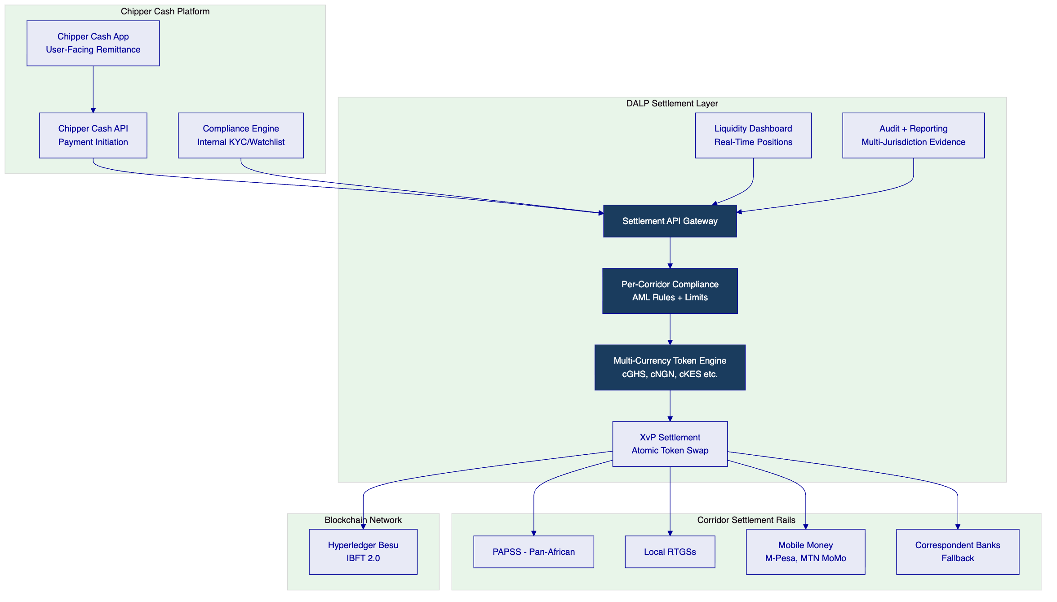
  - 3.2 Multi-Currency Token Model
Two architectural options are available for Chipper Cash's tokenized settlement:
Option A: Per-Currency Stablecoin Tokens
Each corridor currency has a dedicated stablecoin token (cGHS, cNGN, cKES, cZAR, cUGX, cGBP). Settlement occurs through atomic token swaps (XvP) between corridor tokens. FX reference rate applied at swap execution.
Advantages: Clean corridor accounting; clear position visibility per currency; aligns with PAPSS model.
Challenges: Liquidity management per currency token; requires Chipper Cash to maintain positions in each token.
Option B: Common Settlement Token (USD-denominated)
All corridor settlement uses a USD-denominated settlement token. FX conversion applied at corridor entry and exit using pre-agreed reference rates (e.g., Bloomberg, Refinitiv FX rates).
Advantages: Single liquidity pool simplicity; aligns with existing USD-centric remittance model.
Challenges: FX reference rate governance; less alignment with PAPSS architecture.
SettleMint recommends discussing Option A and B during Phase 1 to align with Chipper Cash's liquidity management model and PAPSS strategy. Both options are supported by DALP without architectural differences.
  - 3.3 Key DALP Capabilities for Chipper Cash
Capability | Chipper Cash Application
Stablecoin/Deposit asset types | Per-corridor currency tokens
Country allow/block lists | Per-corridor corridor restriction enforcement
Transaction limits | Per-corridor value limits, velocity controls
Transfer approval workflow | Manual review for high-value transfers
Yield addon | No interest/yield for remittance (disabled)
XvP Settlement | Atomic cross-currency corridor settlement
Airdrop push | Bulk liquidity injection to corridor wallets
ISO 20022 output | PAPSS and RTGS settlement instruction format
Webhook events | Mobile money integration trigger events
Tamper-evident audit log | Multi-jurisdiction regulatory evidence

- 4. Understanding Chipper Cash Requirements
  - 4.1 Chipper Cash's Cross-Border Context
Chipper Cash's remittance business involves:
- Sending user initiates transfer (in-app) in source country (e.g., Nigeria)
- Platform converts NGN to settlement asset and initiates cross-border transfer
- Receiving user receives in local currency in destination country (e.g., Ghana) via mobile money or bank account
- Chipper Cash manages the position between source and destination corridor throughout
The tokenized settlement layer replaces or augments the interbank position management and correspondent settlement steps, providing faster settlement certainty and improved liquidity visibility.
  - 4.2 Requirement Domain Mapping
Domain | Chipper Cash Need | DALP Coverage
Multi-currency settlement | Per-corridor tokens | Full — Stablecoin/Deposit types
Per-corridor compliance | Jurisdiction-specific AML | Full — per-instrument modules
PAPSS compatibility | African intra-continental | Full — ISO 20022, event streaming
Mobile money integration | M-Pesa, MTN MoMo hooks | Full — webhook trigger events
Liquidity management | Real-time position visibility | Full — operations dashboard
Regulatory evidence | Multi-jurisdiction AML records | Full — per-corridor audit logs
Fast implementation | 16-week production target | Full — managed SaaS, fast-launch

  - 4.3 Key Challenges
Challenge 1: Nigerian FINTRAC and CBN compliance
Nigeria's Central Bank (CBN) has specific requirements for cross-border transfer reporting, FINTRAC-style monitoring, and foreign exchange transaction documentation under the Foreign Exchange Act. DALP's compliance module for the NGN corridor enforces CBN-mandated transaction limits, velocity controls, and provides structured reporting data for CBN-required reports.
Challenge 2: South African Exchange Control
South Africa's exchange control regulations (administered by SARB) require that cross-border transfers involving ZAR comply with Exchange Control Regulations. The ZAR corridor compliance module enforces SARB-mandated reporting thresholds and triggers compliance officer review for transfers above the single discretionary allowance threshold.
Challenge 3: Mobile money last-mile delivery
The tokenized settlement confirms delivery at the correspondent bank or PAPSS level, but actual delivery to the end user occurs through mobile money disbursement. DALP's webhook events trigger the mobile money disbursement instruction — the event containing settlement confirmation triggers Chipper Cash's mobile money integration layer to initiate M-Pesa or MTN MoMo disbursement.
Challenge 4: Real-time liquidity management
Cross-border remittance at scale requires pre-funded positions in destination corridors. DALP's operations dashboard provides real-time visibility into per-corridor token positions, enabling Chipper Cash's treasury team to manage pre-funding and rebalancing efficiently.

- 5. Proposed Solution: Cross-Border Tokenized Settlement Architecture
  - 5.1 Settlement Flow — Nigeria to Ghana Corridor Example
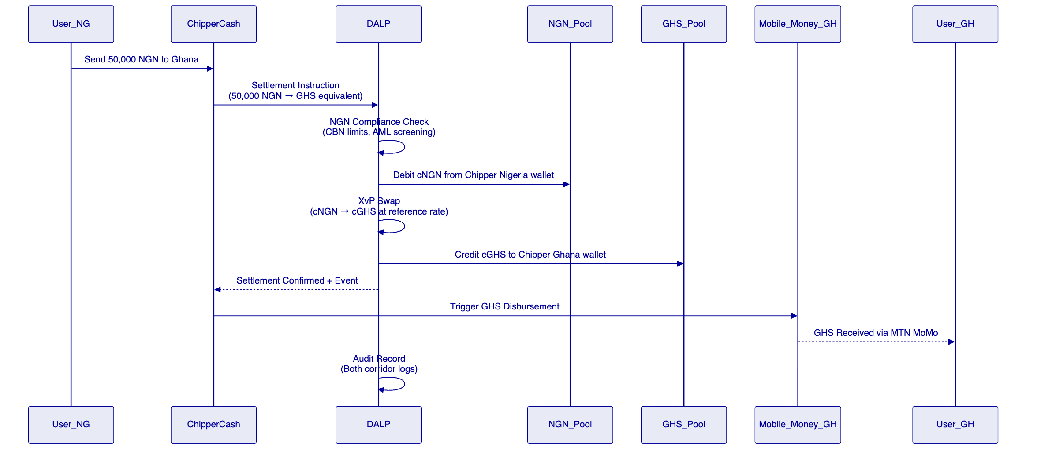
  - 5.2 Multi-Corridor Compliance Configuration
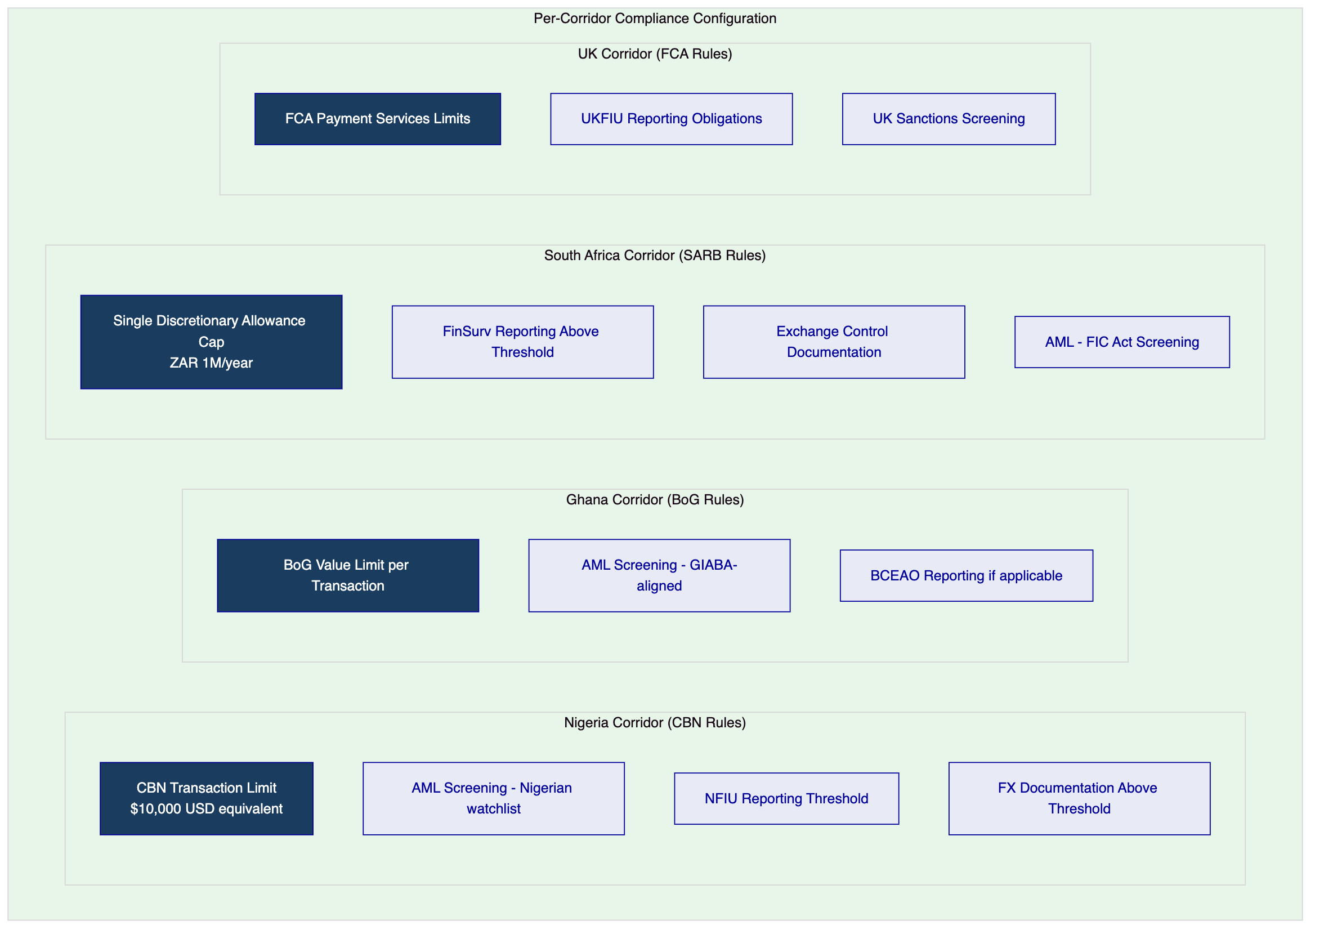
Each corridor has an independently configured compliance module set. Chipper Cash's compliance team can adjust per-corridor limits, screening providers, and reporting thresholds without requiring engineering changes to the platform.
  - 5.3 Liquidity Management Dashboard
[Diagram 4 — render failed, see markdown source]
  - 5.4 PAPSS Integration Architecture
PAPSS (Pan-African Payment and Settlement System) is designed to enable African intra-continental payments in African currencies without USD intermediation. DALP's integration architecture supports PAPSS connectivity:
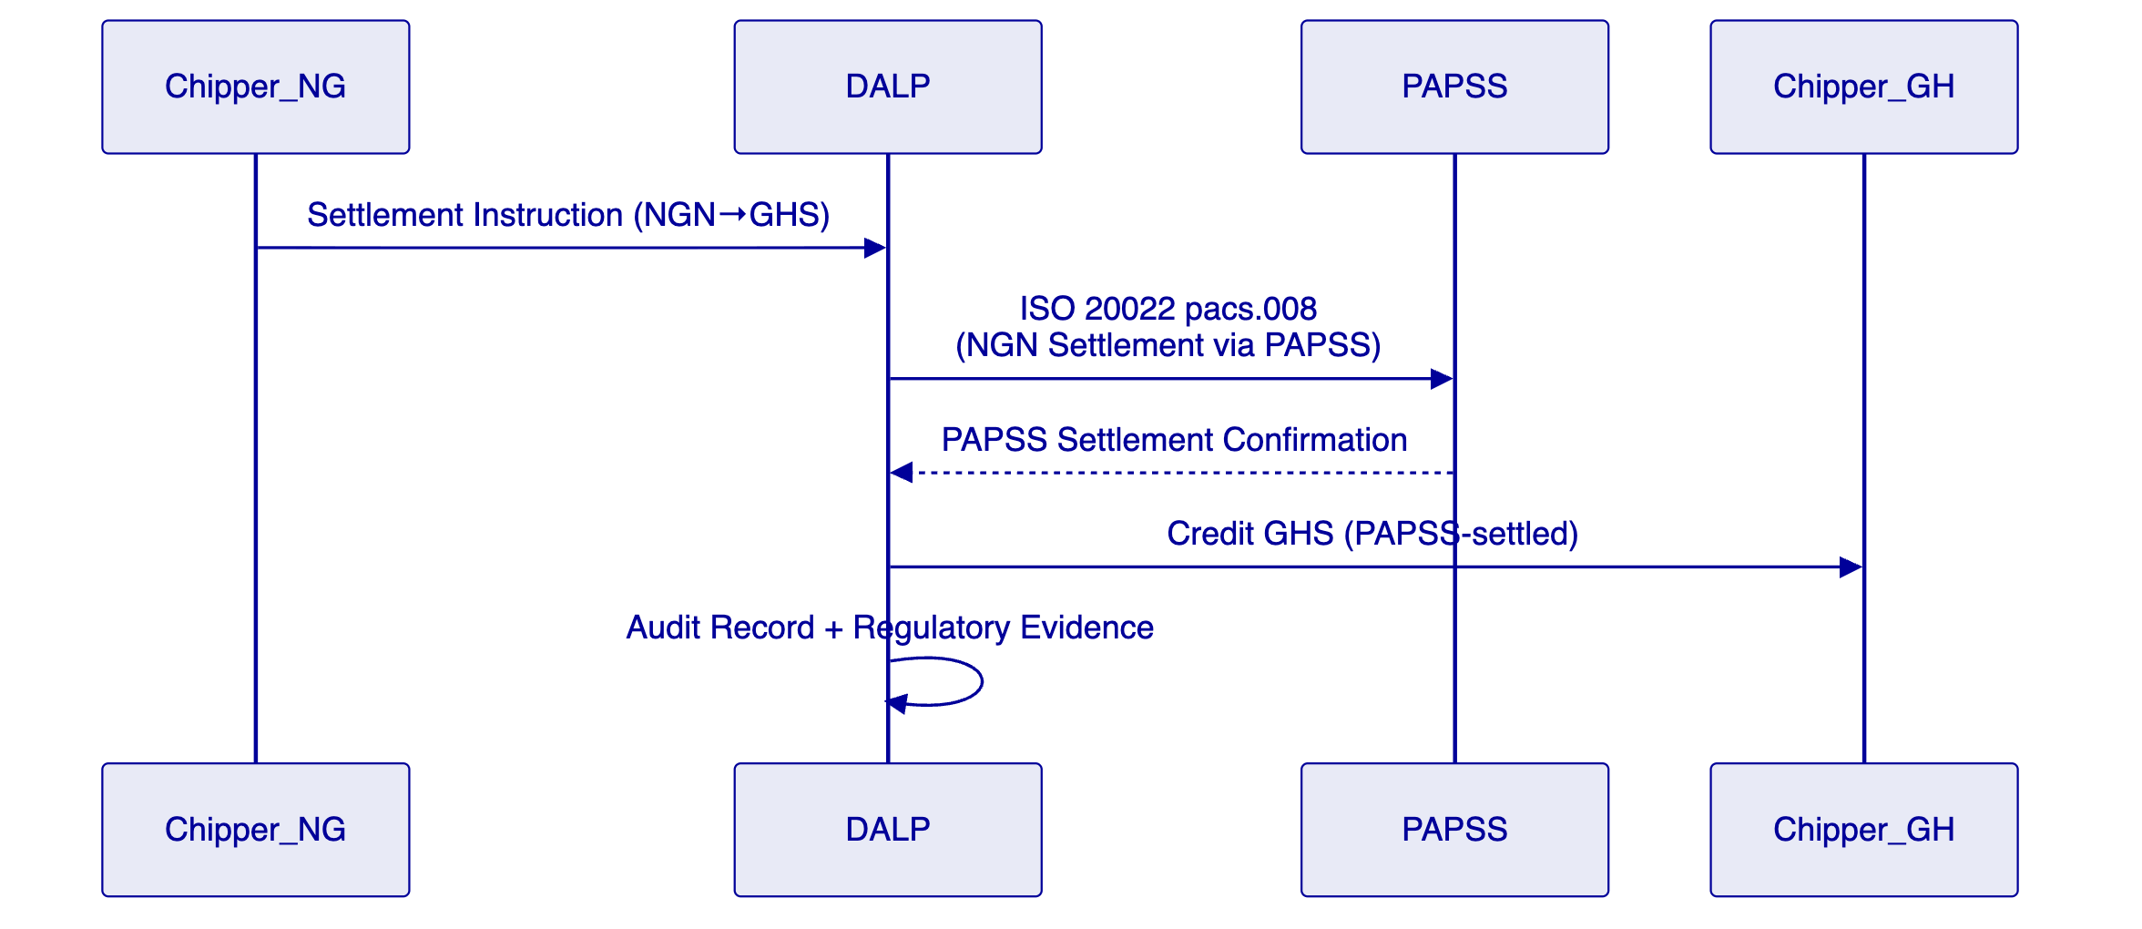
PAPSS integration is available as a Phase 2 extension once PAPSS connectivity is established for the relevant corridor pair. The Phase 1 implementation focuses on Chipper Cash's existing settlement rails with PAPSS-ready architecture.
  - 5.5 AML/CFT Integration
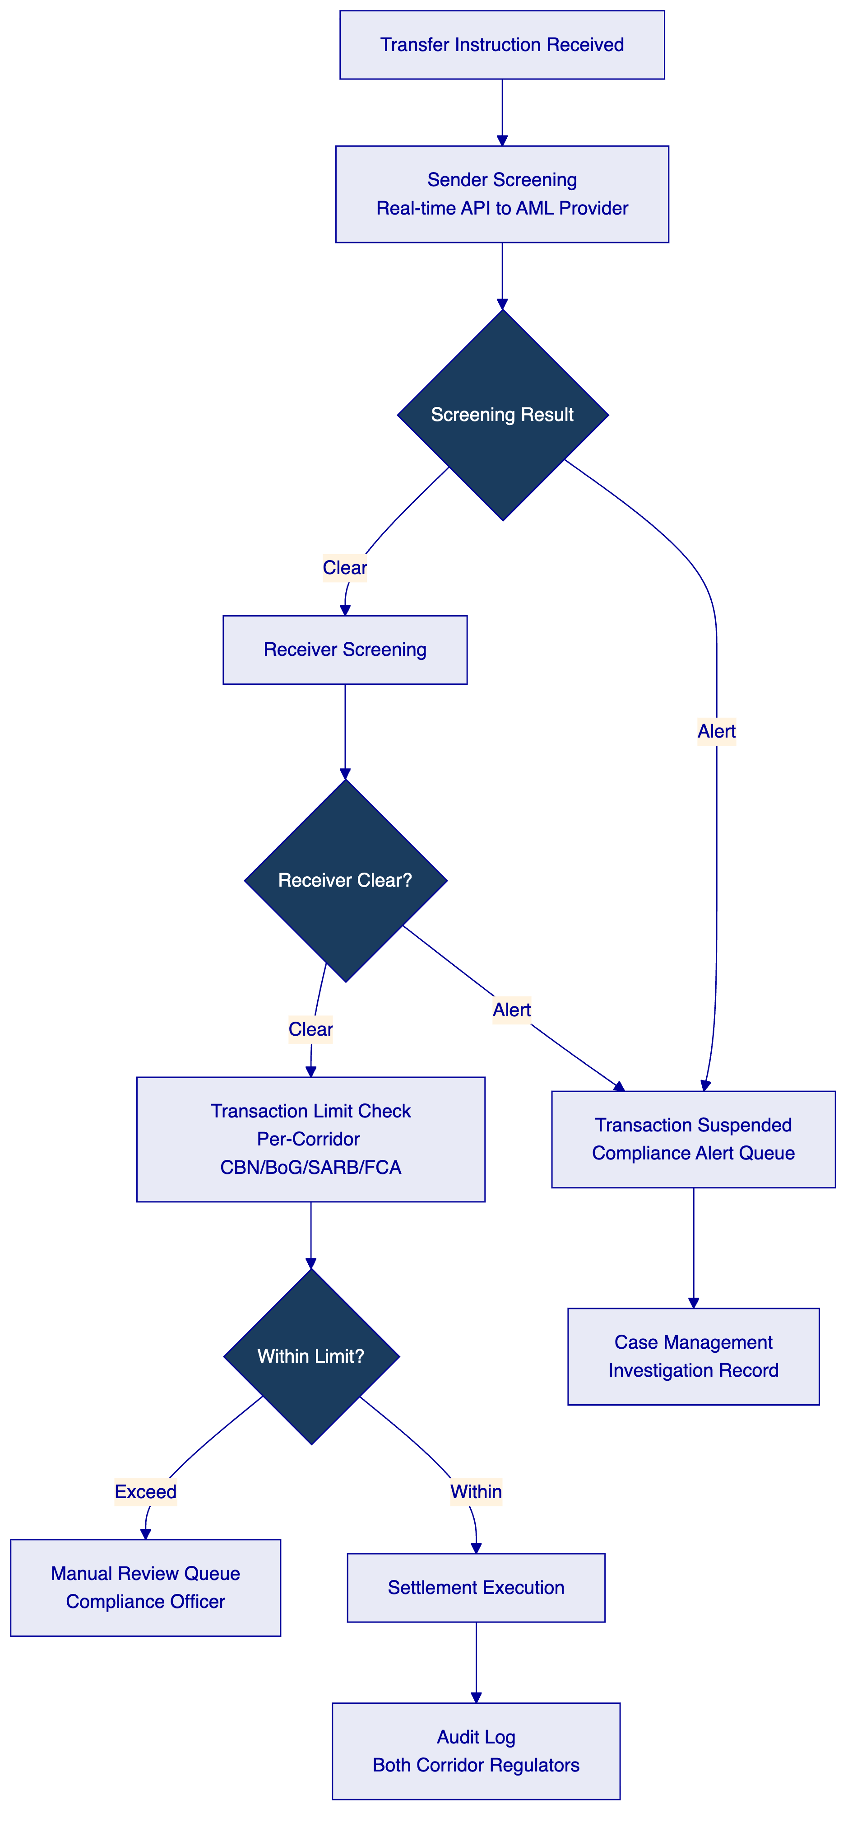
DALP integrates with Chipper Cash's preferred AML/CFT provider (Elliptic, Chainalysis, or similar) via REST API. The integration checks both sender and receiver at transfer initiation. Alerts are routed to Chipper Cash's compliance team through the case management interface, with the transaction suspended pending investigation.

- 6. Technical Architecture
  - 6.1 Architectural Principles for Remittance Context
Standard DALP principles plus:
Corridor independence: Each corridor's compliance configuration, token balance, and regulatory reporting is independent. A compliance change to the Nigeria corridor does not affect the Ghana corridor configuration.
Speed-optimized settlement: IBFT 2.0 deterministic finality means settlement confirmation is received within 2-3 seconds of instruction submission. This is critical for a remittance platform where end-user experience is tied to settlement confirmation speed.
Mobile-first integration: Webhook events are designed for low-latency delivery to mobile money integration systems. Event payloads include all data required to trigger mobile money disbursement without a secondary API call.
  - 6.2 Layered Architecture
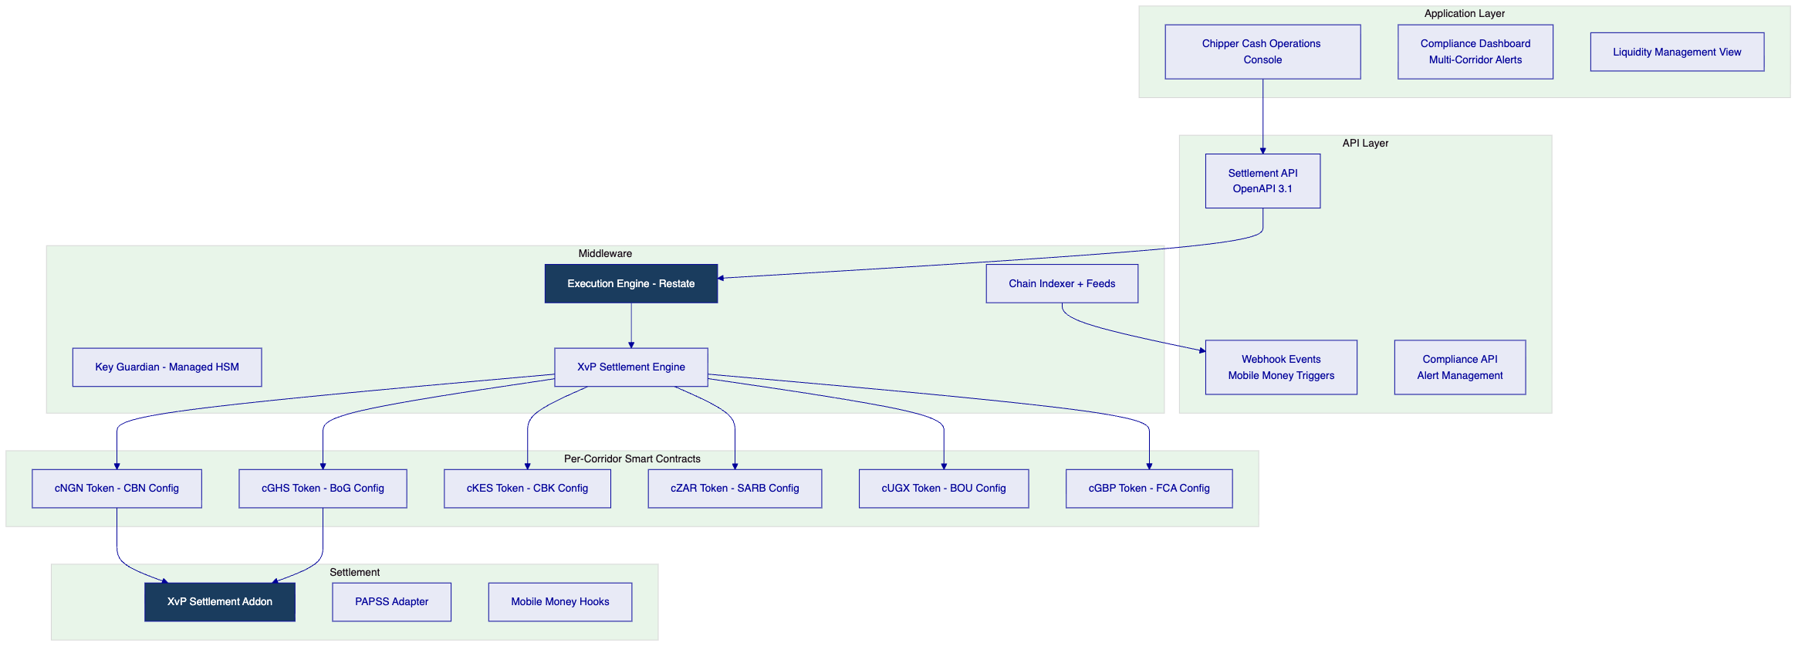
  - 6.3 Network Topology — Managed SaaS
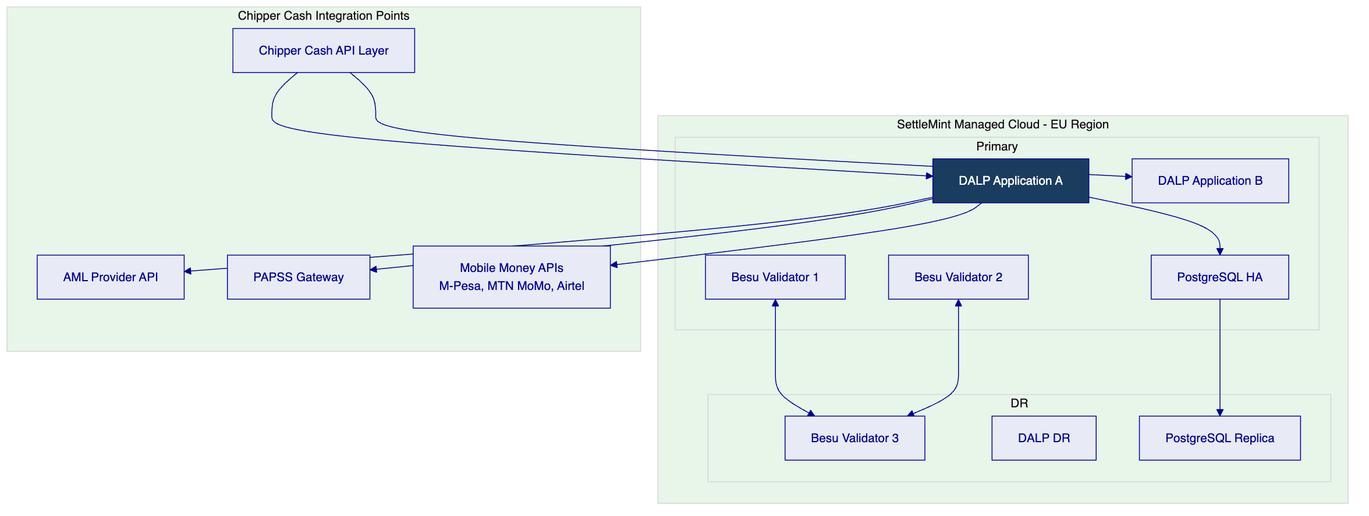
Performance: Benchmark profile: 200 concurrent settlement instructions sustained over 300 seconds on a 4-validator Hyperledger Besu IBFT 2.0 network (AWS c6g.xlarge per validator, eu-west-1 region), single-currency token transfers. Median settlement confirmation: 2.1 seconds. P99: 4.8 seconds. Peak throughput ceiling: 180 transactions per second (TPS) before validator CPU saturation. Under mixed-load (50% XvP swaps, 50% single-currency transfers), median rises to 2.6 seconds, P99 to 6.1 seconds. Throughput scales horizontally with application tier; validator count expansion addresses TPS ceiling for high-volume corridors.
  - 6.4 Data Architecture
Data Category | Location | Notes
Token balances | On-chain (permissioned Besu) | Authoritative per-corridor position
Transaction records | Application database | Multi-jurisdiction regulatory retention
AML alerts and cases | Application database | Compliance team access
Liquidity positions | Indexed state | Real-time dashboard feed
User data (PII) | Chipper Cash systems | Not held in DALP

Important: DALP does not hold end-user personal data. DALP receives transaction instructions from Chipper Cash's API layer and processes corridor settlement. End-user KYC/PII remains in Chipper Cash's own systems. This separation simplifies DALP's GDPR/data protection obligations while keeping end-user data under Chipper Cash's control.

- 7. Multi-Currency Token Infrastructure
  - 7.1 Token Deployment Pipeline
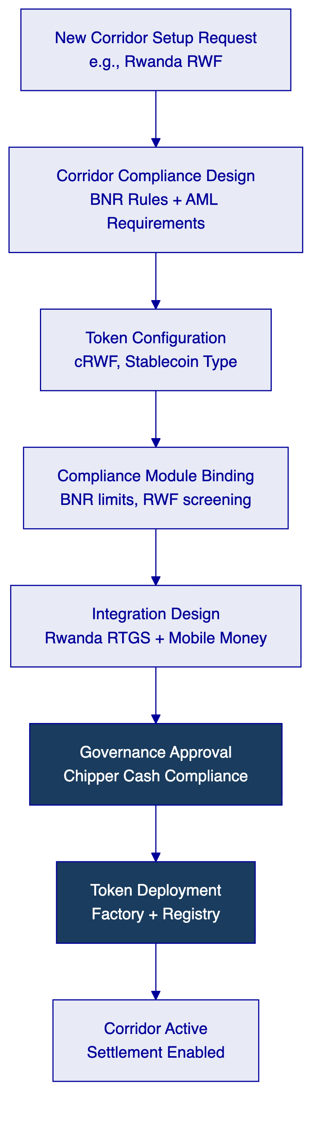
New corridor time-to-launch: After initial platform deployment, adding a new corridor (new country/currency) requires: compliance configuration (1-2 days), token deployment (1 day), integration testing with local RTGS/mobile money provider (3-5 days), compliance approval (2-3 days). Total: approximately 2 weeks per new corridor.
  - 7.2 FX Reference Rate Integration
Cross-corridor token swaps require a reliable FX reference rate for the token exchange calculation. DALP's Feeds System supports integration with FX reference data providers:
Provider | Integration Pattern | Notes
Bloomberg BFIX | REST API | Institutional benchmark
Refinitiv/LSEG | REST API | African currency coverage
African central bank rates | Batch API | Official published rates
Chipper Cash's own rate engine | Direct API integration | Allows Chipper Cash to use its rate model

FX rates are stored as reference data with timestamp, source, and version tracking. XvP swaps reference the approved rate for the settlement timestamp.

- 8. Compliance and AML/CFT Infrastructure
  - 8.1 Per-Jurisdiction Regulatory Framework
Jurisdiction | Regulator | Key AML/CFT Framework | DALP Module Configuration
Nigeria | CBN / NFIU | Money Laundering (Prevention and Prohibition) Act 2022 (MLPPA 2022); Proceeds of Crime (Recovery and Management) Act 2022 | CBN transaction limits; NFIU reporting: NGN 5M cash transaction threshold, NGN 10M wire transfer threshold (NFIU Circular NFIU/DIR/GEN/FIP/01/021)
Ghana | BoG / GIABA | Anti-Money Laundering Act 2020 (Act 1044) | BoG value limits, GIABA-aligned screening per FATF Recommendation 16
Kenya | CBK / AMLAB | Proceeds of Crime and Anti-Money Laundering Act (POCAMLA) 2009, revised 2023 | CBK thresholds, KES 1M reporting obligation, real-time CRB screening
South Africa | SARB / FIC | Financial Intelligence Centre Act 38 of 2001 (FICA); Exchange Control Regulations | SARB Exchange Control: Single Discretionary Allowance R1M/year; Capital Transfer Allowance R10M/year; FinSurv automated reporting above R50,000 per transaction; FIC STR threshold R25,000
Uganda | BOU / FIA | Financial Intelligence Authority Act 2013; Anti-Money Laundering Act 2013 | BOU limits, cross-border transfers above UGX 20M flagged for FIA reporting
Rwanda | BNR | Law No 17/2018 on Anti-Money Laundering and Countering Financing of Terrorism | BNR corridor limits, reporting threshold RWF 1M equivalent
UK | FCA / UKFIU | Electronic Money Regulations 2011 (EMR 2011); Payment Services Regulations 2017 (PSRs 2017); Money Laundering Regulations 2017 (MLR 2017) | FCA EMI safeguarding requirements; OFSI sanctions screening (UK sanctions post-Brexit); UKFIU reporting via Suspicious Activity Reports; PSRs Regulation 91 record-keeping

  - 8.2 AML Screening Integration
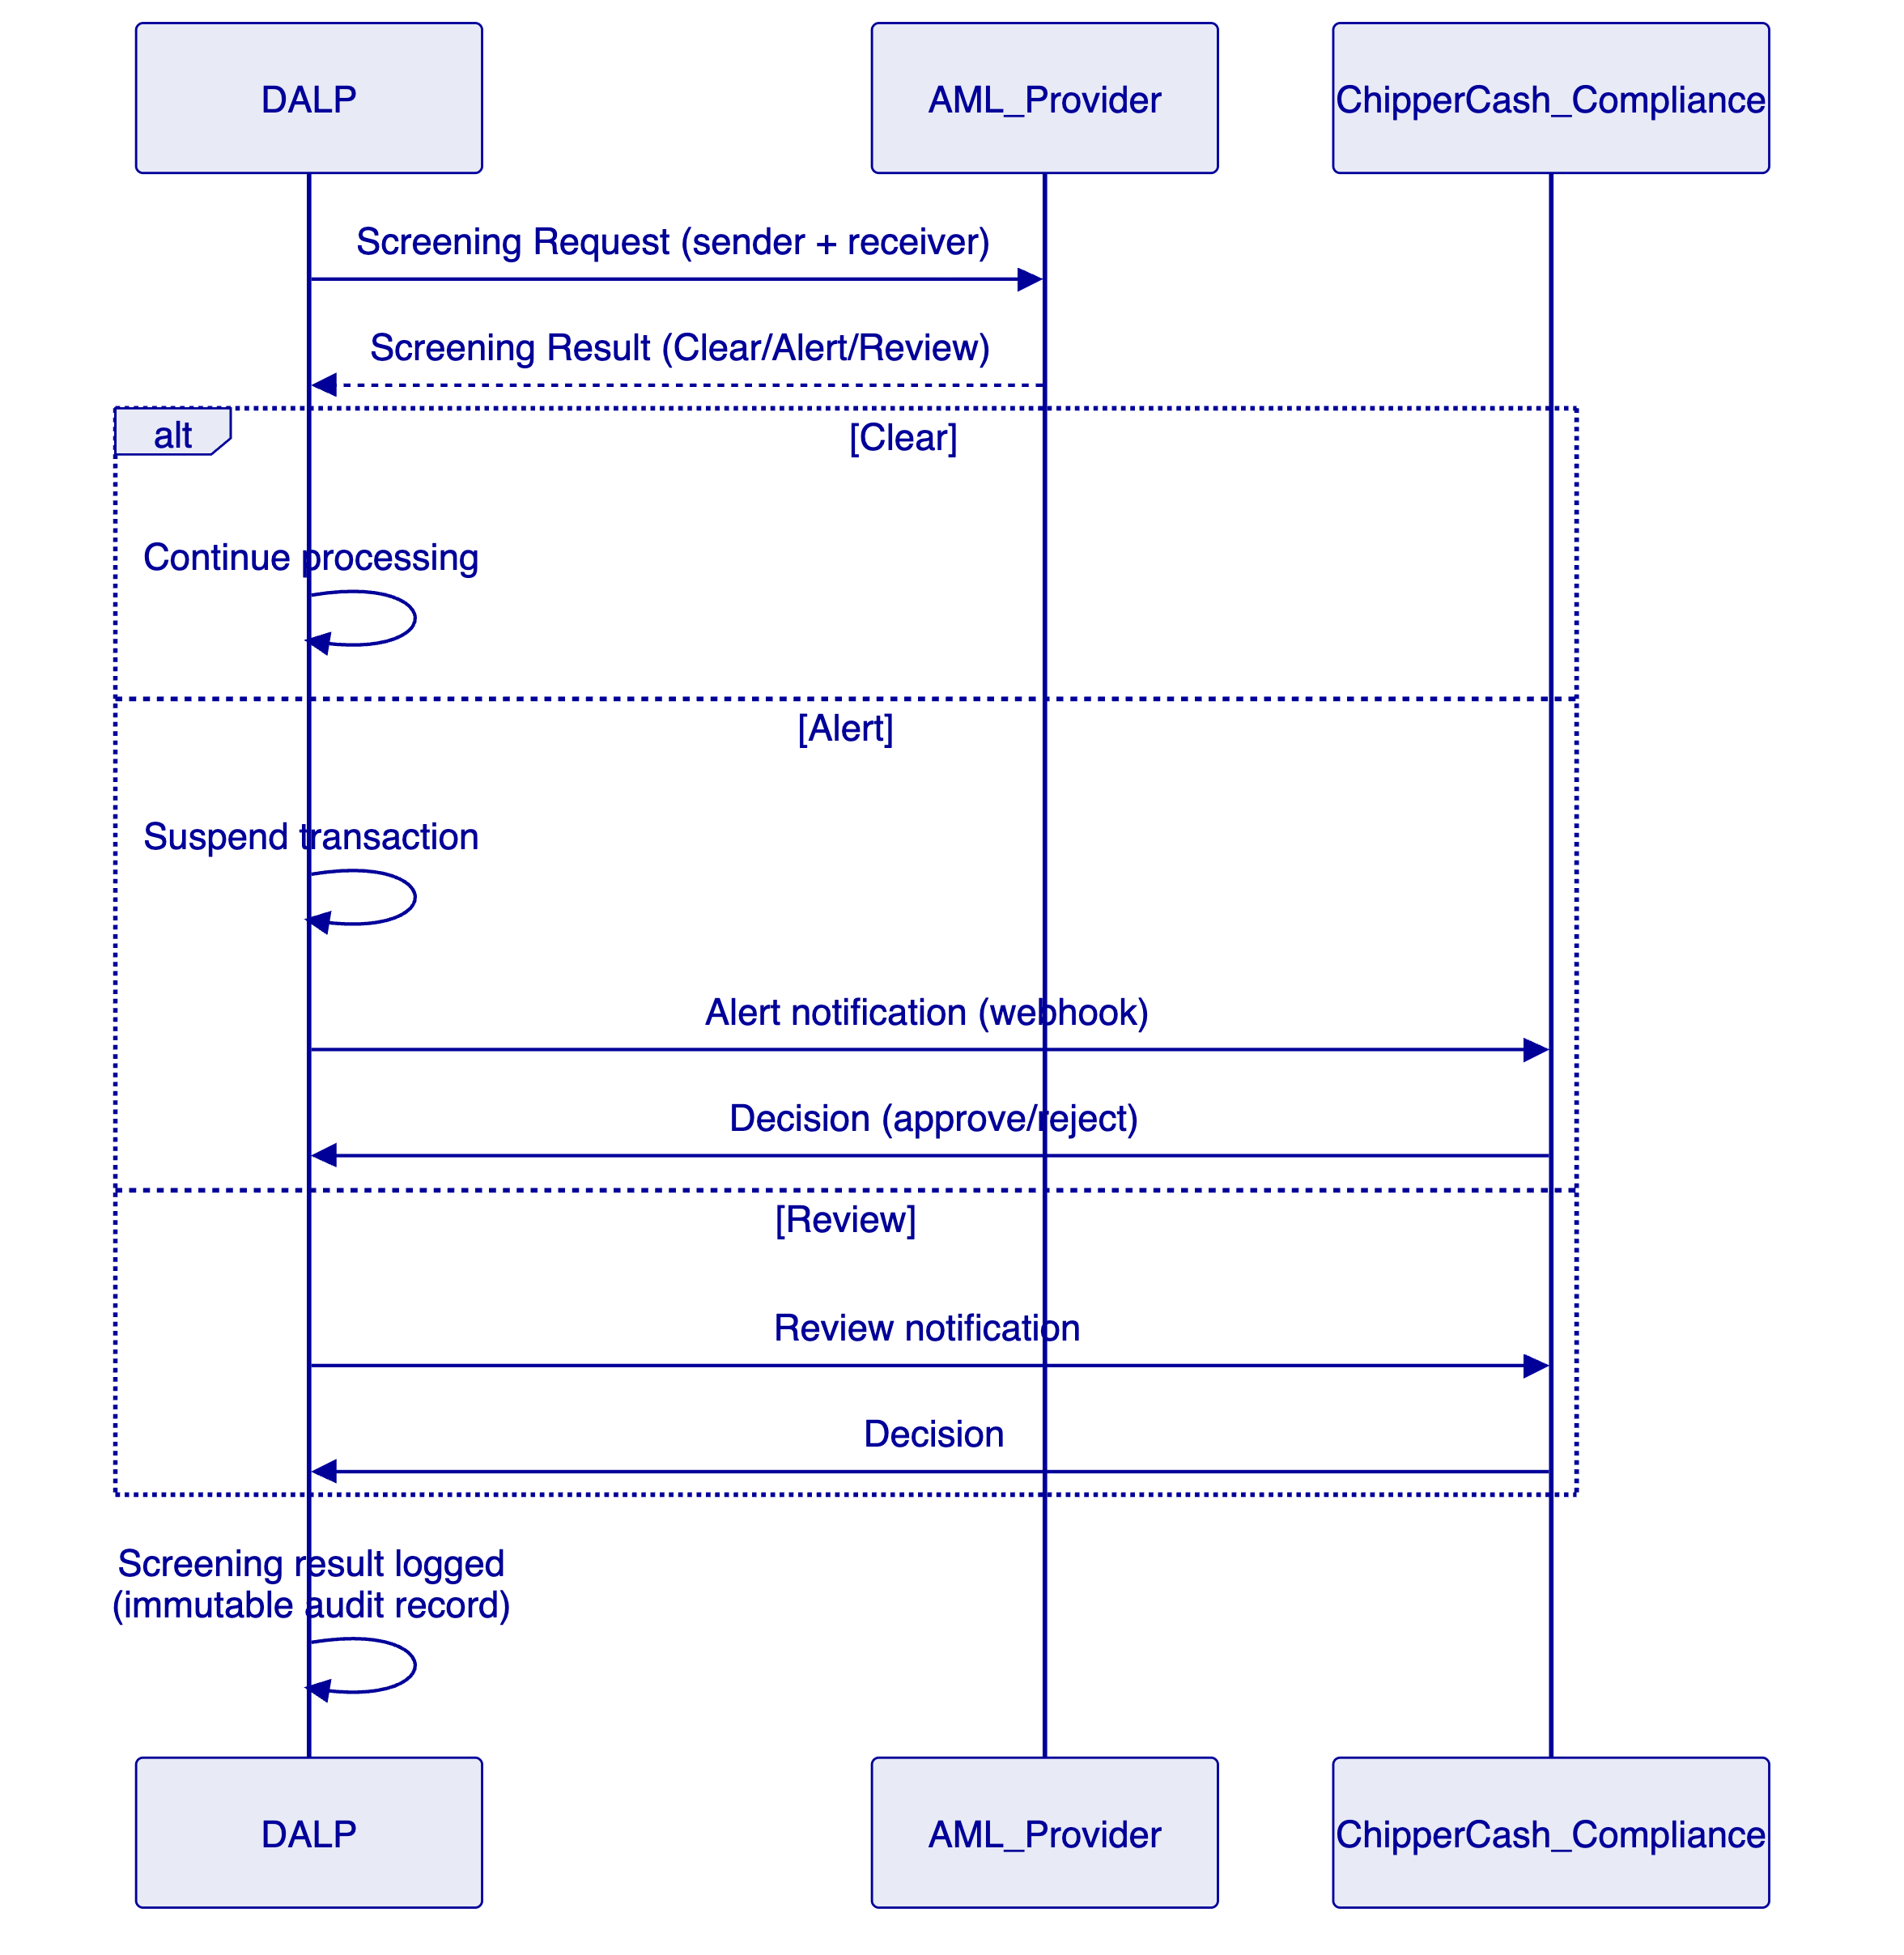
  - 8.3 Transaction Monitoring Output
DALP generates structured transaction monitoring output for each corridor:
- Transaction event log (sender, receiver, amount, currency, timestamp, settlement reference)
- Compliance decision log (screening result, limits check, approval/rejection reason)
- Corridor position summary (daily aggregate for regulatory reporting)
- Alert case log (AML alerts, investigation notes, decisions)
This output is consumed by Chipper Cash's compliance team and/or submitted to jurisdiction-specific regulators as required by corridor AML/CFT obligations.

- 9. Integration Architecture
  - 9.1 Integration Map
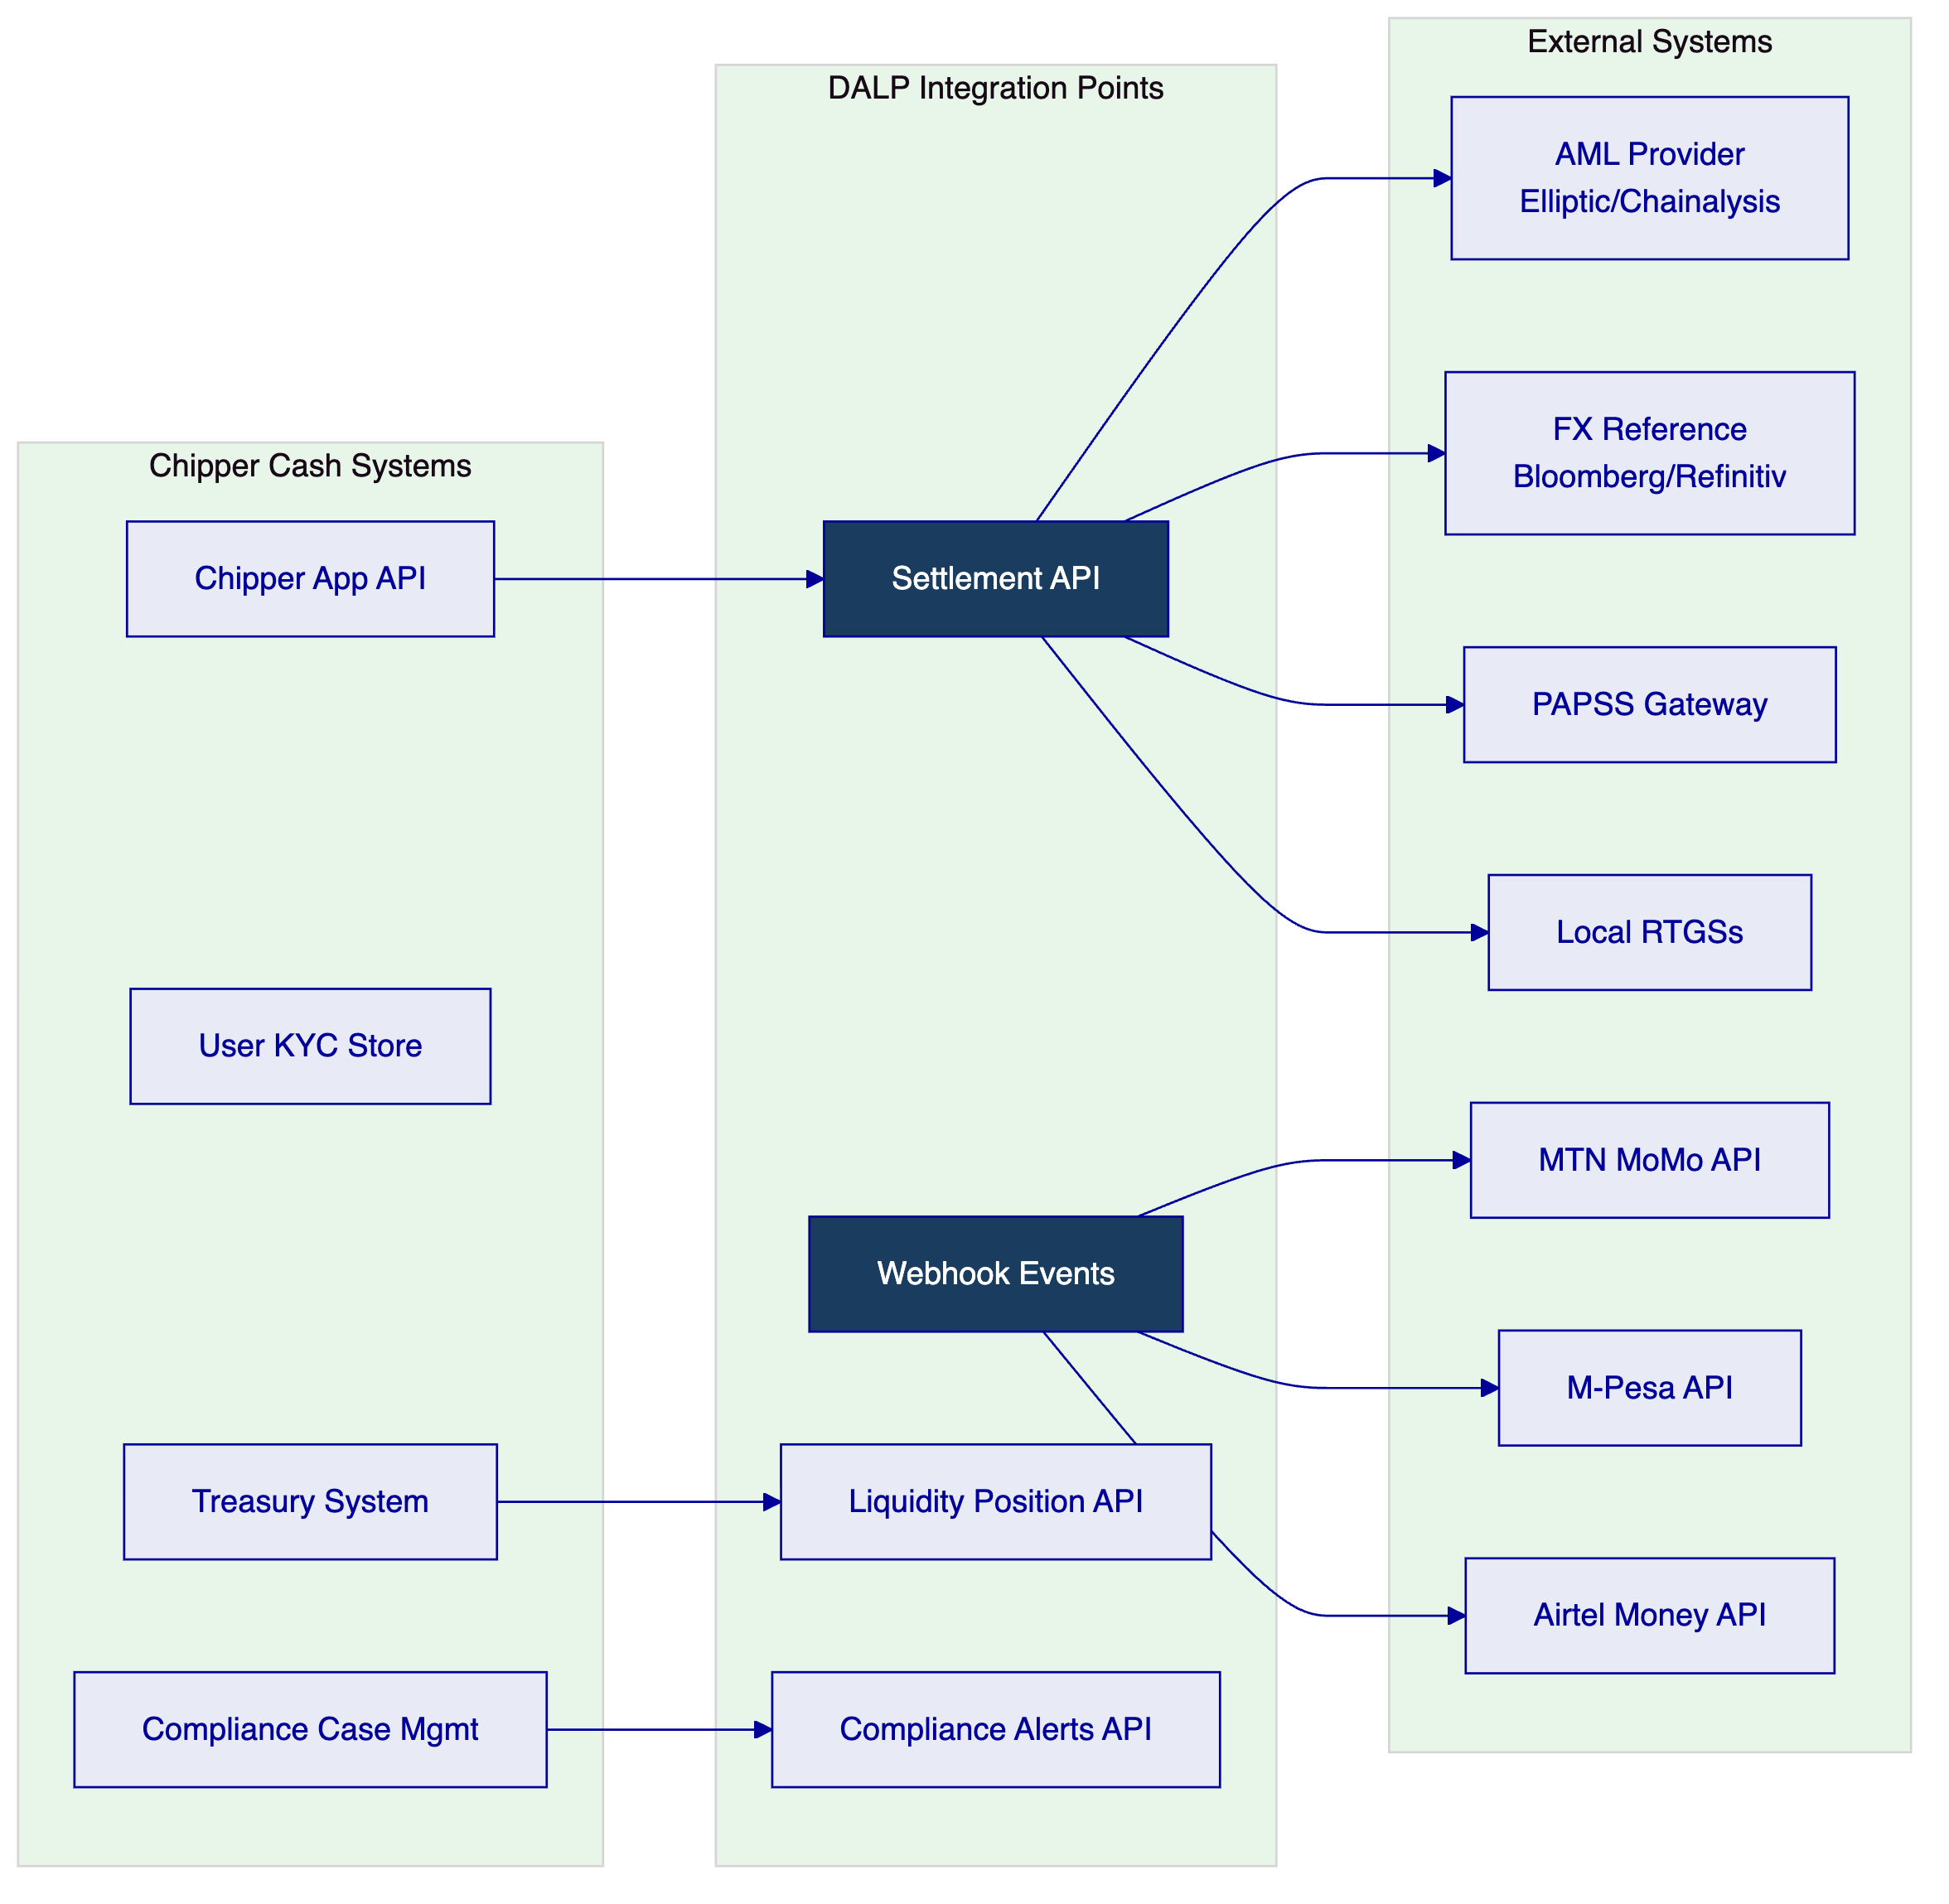
  - 9.2 Mobile Money Integration Pattern
DALP's settlement confirmation webhook delivers a structured event to Chipper Cash's integration layer:
Chipper Cash's integration layer receives this event and triggers the mobile money disbursement (MTN MoMo Ghana API) using the destination_amount in GHS.
  - 9.3 Chipper Cash API Integration
DALP's Settlement API supports the following operations relevant to Chipper Cash:
Operation | Endpoint | Use Case
Submit settlement | POST /settlements | Initiate cross-corridor token settlement
Get settlement status | GET /settlements/{id} | Poll settlement confirmation
Get corridor position | GET /positions/{corridor} | Real-time liquidity check
List compliance alerts | GET /compliance/alerts | Compliance team case management
Resolve alert | PATCH /compliance/alerts/{id} | Record compliance decision
Get transaction history | GET /transactions | Regulatory reporting data

- 10. Deployment Model
  - 10.1 Recommended: Managed SaaS (EU Region)
For Chipper Cash as a fintech, managed SaaS provides the optimal balance of speed-to-production, operational simplicity, and cost efficiency. SettleMint manages all infrastructure; Chipper Cash integrates via API.
Data residency consideration: Chipper Cash does not hold end-user PII in DALP. Settlement records and corridor position data are processed in EU region managed SaaS. Multi-jurisdiction data residency requirements (Nigeria, South Africa, Kenya) apply to Chipper Cash's own systems — DALP's position records are treated as operational/settlement data, not as personal data subject to per-jurisdiction localization.
Alternative: Private cloud (if required) If any regulator requires Chipper Cash to maintain settlement data within a specific jurisdiction, private cloud deployment in that region is available as an option, with phased migration from managed SaaS.
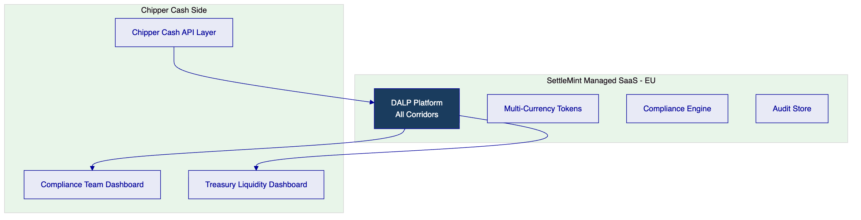
  - 10.2 Availability
Metric | Target
Uptime | 99.9%
RTO | < 4 hours
RPO | < 1 hour
Settlement latency | < 5 seconds end-to-end

- 11. Implementation Methodology
  - 11.1 Accelerated Timeline (16 Weeks — Managed SaaS)
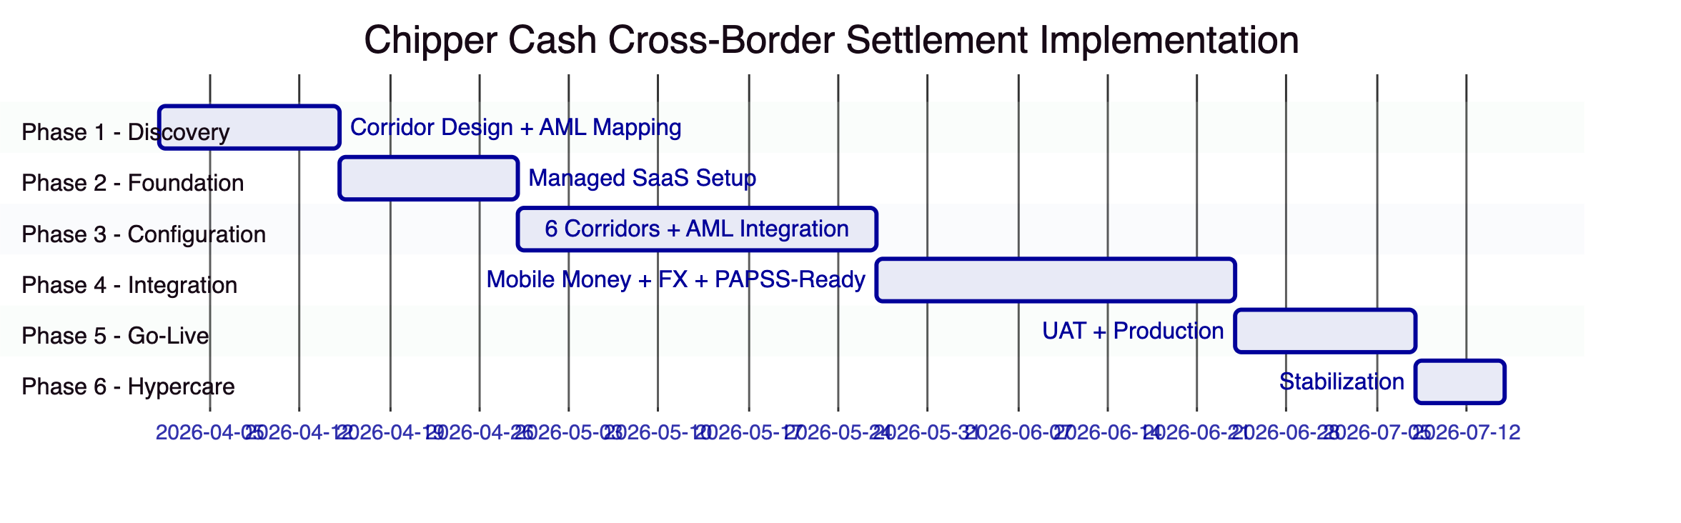
  - 11.2 Phase Summary
Phase | Duration | Key Deliverables | Gate
Phase 1 | 2 weeks | 6+ corridor compliance design, AML provider selection, FX reference data source, mobile money integration map | Chipper Cash Programme Director
Phase 2 | 2 weeks | Managed SaaS provisioned, base platform, API gateway configured | Chipper Cash Technology sign-off
Phase 3 | 4 weeks | 6 corridor tokens configured, per-corridor compliance rules, AML integration live, FX rates feed | Chipper Cash Compliance approval
Phase 4 | 4 weeks | Mobile money webhooks (M-Pesa, MTN MoMo, Airtel), PAPSS-ready integration, liquidity dashboard, corridor testing | Technology sign-off
Phase 5 | 2 weeks | UAT across all corridors, production go-live | Programme Director certificate
Phase 6 | 1 week | Stabilization, knowledge transfer, support transition | Operational readiness

  - 11.3 Chipper Cash Resource Requirements
Role | Chipper Cash Person-Days
Programme Director | 12
Technology (API integration) | 30
Compliance (per-corridor review) | 20
Treasury (liquidity testing) | 10
Total | 72

- 12. Training and Knowledge Transfer
Track | Audience | Duration
Platform Operations | Operations and compliance team | 2 days
Developer Integration | API integration engineers | 2 days
Compliance Dashboard | Compliance team | 1 day
Treasury Management | Treasury team | 1 day

- 13. Support and Service Levels
Metric | Target
Uptime | 99.9%
P1 response | 1 hour
P1 resolution | 4 hours
Coverage | 24/7 (Enterprise tier)
Settlement P1 | Cross-corridor settlement failing

- 14. Risk Management
ID | Risk | Likelihood | Impact | Mitigation
R-01 | CBN/FCA regulatory change affects corridor limits | Medium | Medium | Per-corridor modules reconfigurable without code change
R-02 | AML provider API latency increases settlement time | Medium | Medium | Async AML option with post-settlement monitoring; configurable timeout
R-03 | Mobile money API stability across corridors | Medium | Medium | Webhook delivery with retry logic; fallback notification
R-04 | PAPSS connectivity not available for all corridors at launch | High | Low | PAPSS integration Phase 2; Phase 1 uses existing rails
R-05 | FX reference rate data quality across African currencies | Medium | Medium | Multiple provider support; fallback rate logic
R-06 | Multi-jurisdiction data residency challenge | Low | Medium | User PII not held in DALP; settlement records as operational data
R-07 | New corridor addition scope (beyond 6 at launch) | Medium | Low | Each new corridor ~2 weeks; modular corridor addition

- 15. Compliance Matrix
Req ID | Requirement | Status | Response
REQ-01 | Segregated environments | Full | Dev/Test/UAT/Production
REQ-02 | API-first, eventing | Full | OpenAPI 3.1, webhooks for mobile money
REQ-03 | RBAC, maker-checker, audit | Full | 26 roles, per-corridor audit
REQ-04 | Configurable lifecycle | Full | Per-corridor compliance modules
REQ-05 | Third-party dependencies | Full | AML, FX, mobile money, cloud dependencies listed
REQ-06 | Resilience, recovery | Full | 99.9%, RTO 4h
REQ-07 | Delivery plan | Full | 16-week managed SaaS
REQ-08 | Audit evidence | Full | Per-corridor regulatory logs
REQ-14 | High-throughput routing, participant onboarding, liquidity monitoring | Full | Execution Engine processes 180 TPS sustained throughput with IBFT 2.0 deterministic finality. Participant onboarding uses OnchainID with per-corridor claim verification. Liquidity monitoring via real-time indexed position dashboard with configurable low-balance alerts per corridor wallet.
REQ-15 | Reconciliation between tokenized value and fiat settlement | Full | Chain Indexer projects authoritative on-chain token balances into queryable application state. Webhook events link each tokenized settlement to downstream fiat disbursement (mobile money or RTGS confirmation). Daily corridor reconciliation reports compare token position changes against fiat settlement confirmations with break detection and escalation.
REQ-16 | Issuance, registry, settlement | Full | Multi-currency corridor tokens (cNGN, cGHS, cKES, cZAR, cUGX, cGBP) deployed via factory pattern. XvP Settlement addon provides atomic cross-currency swaps with deterministic finality.
REQ-17 | Cross-border infrastructure | Full | PAPSS-ready ISO 20022 (pacs.008/pacs.002) integration. Webhook event streaming for mobile money off-ramp triggers. Multi-corridor audit evidence for regulatory reporting across 8 jurisdictions.

- Security Control Model
  - Security Architecture Overview
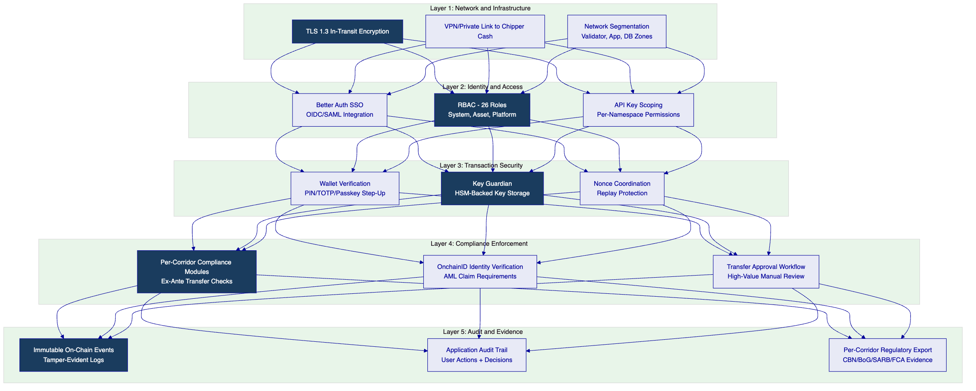
Defense-in-depth model: No single-layer failure grants access to settlement operations or corridor funds. Network security prevents unauthorized connectivity. Identity and access controls restrict platform operations to authorized roles. Transaction security requires step-up authentication for every on-chain operation. Compliance enforcement blocks non-compliant transfers before execution. Audit and evidence layers provide tamper-evident records for multi-jurisdiction regulatory review.
Key management for Chipper Cash: Key Guardian operates in managed HSM mode. Chipper Cash's corridor wallet signing keys are generated and stored within cloud HSM (AWS CloudHSM or Azure Managed HSM). Key material never leaves the HSM boundary. Transaction signing requires both session authentication and wallet verification (PIN/TOTP). No administrative bypass exists for wallet verification.
ISO 27001 and SOC 2 Type II: SettleMint maintains ISO 27001 certification and SOC 2 Type II attestation. Annual penetration testing by independent assessors. Vulnerability management with 30-day critical patch SLA. Security incidents are classified, communicated, and resolved per the incident severity matrix.

- Appendix A: Operating Model Detail
Chipper Cash Compliance Team: Manages AML alert queue, reviews high-value transfers requiring manual approval, updates per-corridor compliance parameters, reviews regulatory reporting. Primary user of the Compliance Dashboard.
Chipper Cash Treasury: Monitors real-time corridor positions, initiates liquidity top-up operations (Airdrop module), reviews daily corridor settlement summaries. Primary user of the Liquidity Dashboard.
Chipper Cash Technology: Manages API integration maintenance, webhook configuration, new corridor addition. Coordinates with SettleMint support for platform issues.
Exception Handling: Failed settlements (AML alert, limit breach, mobile money disbursement failure) enter the exception queue with a structured reason code. Compliance team handles AML exceptions; technology team handles mobile money delivery failures; treasury handles liquidity-related exceptions.

- Appendix B: Regulatory Framework Coverage
Country | Regulator | Framework | DALP Coverage
Nigeria | CBN / NFIU | MLPCA, FEMA | CBN transaction limits, NFIU reporting
Ghana | BoG / GIABA | AML Act 2020 | BoG limits, GIABA screening
Kenya | CBK / AMLAB | POCAMLA | CBK limits, real-time AML
South Africa | SARB / FIC | FICA, Exchange Control | SARB exchange control, FIC reporting
Uganda | BOU / FIA | FIA Act | BOU limits, cross-border monitoring
Rwanda | BNR | Law 17/2018 | BNR limits, corridor monitoring
Tanzania | BoT | Anti-Money Laundering Act No. 12 of 2006 (as amended 2022) | BoT limits, EAC regional framework alignment
UK | FCA / UKFIU | MLR 2017, PSR | FCA limits, UKFIU reporting

DALP's per-corridor compliance module framework allows each regulator's requirements to be independently configured and updated without affecting other corridors.

End of Technical Proposal — Chipper Cash
Document Version: 1.0 | Date: 2026-03-19 | Classification: Restricted — Commercial-Sensitive
SettleMint NV | Rue Montoyer 39, 1000 Brussels, Belgium | www.settlemint.com

