[Company name]
[Document title]
[Document subtitle]

Confidentiality Statement
This document contains confidential and proprietary information of SettleMint. By reading this document, you agree not to disclose the confidential information contained herein to any third party without the prior written consent of SettleMint, except to those agents, principals, representatives, or consultants who require access for the purpose of evaluating this document. You further agree to inform such persons of the confidential nature of this document and to obtain their agreement to preserve its confidentiality to the same extent as yours.
This confidentiality statement shall remain binding on the parties for a period of five (5) years from the date stated on the front cover, unless superseded by confidentiality provisions detailed in a subsequent agreement.
Terms and Conditions
This proposal is valid until [DD Month YYYY]. In the absence of confirmation to proceed, SettleMint and [the Company] acknowledge and agree to abide by the Mutual NDA as the governing agreement.
SettleMint reserves the right to vary the terms of this proposal in response to changes in specifications or information made available at a later date. Submission of this proposal does not convey any right, title, interest, or license in any intellectual property rights (including, but not limited to, patents, copyrights, trade secrets, or trademarks) contained herein.
All rights are reserved. This proposal and the information contained within it are provided on an “as is” basis, without any warranties of any kind, express or implied.
All contracts with SettleMint will be governed by Belgian Law and subject to the exclusive jurisdiction of Belgian courts.
Contact Details
For any enquiries regarding this document, please contact:
[Full Name]
[Job Title]
Email: [email@example.com]
Phone: [Country Code - Number]

Table of Contents

Table of Contents 3
1. Executive Summary 4
1.1 Context and Strategic Drivers 5
1.2 Why This Programme Requires Care 6
1.3 Proposed Response 7
1.4 Why SettleMint and DALP 8
2. About SettleMint 9
3. About DALP 10
3.1 Platform Architecture 11
3.2 Key Capabilities for Mobile Payment Overlays 12
4. Understanding of Requirements 13
4.1 M-Pesa's Operational Context 14
4.2 Requirement Coverage 15
4.3 Key Challenges 16
5. Proposed Solution and Functional Capabilities 17
5.1 Overlay Architecture 18
5.2 Cross-Border Corridor Settlement Flow 19
5.3 Compliance Enforcement Per Corridor 20
5.4 Token Issuance Flow 21
5.5 Merchant Settlement Flow 22
5.6 Functional Fit Matrix 23
6. Platform Architecture 24
6.1 Four-Layer Detail 25
6.2 Degraded-Mode Architecture 26
6.3 Network Design 27
7. Token and Asset Lifecycle 28
7.1 Corridor Token Lifecycle 29
8. Compliance and Regulatory Framework 30
8.1 Kenyan Regulatory Context 31
8.2 Cross-Corridor Regulatory Matrix 32
8.3 CBK Evidence Architecture 33
9. Security Architecture 34
9.1 Security Model 35
9.2 Key Management 36
9.3 Audit Trail 37
9.4 Security Responsibility Matrix 38
10. Integration Architecture 39
10.1 Integration Overview 40
10.2 Settlement Engine Integration 41
10.3 Degraded-Mode Integration 42
11. Deployment Architecture 43
11.1 Kenya-Based Deployment 44
11.2 Environment Segregation 45
11.3 HA and DR Parameters 46
12. Data Management and Governance 47
12.1 Data Residency 48
12.2 Consumer Data Boundary 49
13. Operational Model and Governance 50
13.1 Operating Model 51
13.2 Daily Governance 52
14. Implementation Plan 53
14.1 Phased Implementation 54
14.2 Phase Descriptions 55
15. Support and SLA 56
15.1 Support Recommendation 57
15.2 Severity Matrix 58
16. References and Experience 59
17. Third-Party Dependencies 60
Appendix A: Requirement Response Matrix 61
Appendix B: Regulatory Mapping 62
Appendix C: Security and Resilience Evidence 63

Prepared for: M-Pesa Safaricom (Kenya)
Prepared by: SettleMint NV
Date: March 2026
Version: v1.0
Reference: M-PESA-SAFARICOM-RFP-DIGITAL-ASSET-MOBILE-PAYMENT-202603
Classification: SettleMint Confidential

  - Table of Contents
- Executive Summary
- About SettleMint
- About DALP
- Understanding of Requirements
- Proposed Solution and Functional Capabilities
- Platform Architecture
- Token and Asset Lifecycle
- Compliance and Regulatory Framework
- Security Architecture
- Integration Architecture
- Deployment Architecture
- Data Management and Governance
- Operational Model and Governance
- Implementation Plan
- Support and SLA
- References and Experience
- Appendix A: Requirement Response Matrix
- Appendix B: Regulatory Mapping
- Appendix C: Security and Resilience Evidence

  - 1. Executive Summary
    - 1.1 Context and Strategic Drivers
M-Pesa is Kenya's dominant mobile money platform, serving over 30 million active users with a product portfolio spanning peer-to-peer transfers, merchant payments, international remittances (M-Pesa Global), bill payments, and Lipa Na M-Pesa merchant ecosystem services. The platform processes tens of millions of transactions per day, operates within Central Bank of Kenya (CBK) supervised rails, and is embedded in Kenya's daily economic life as critical payment infrastructure.
Any digital asset initiative at M-Pesa Safaricom must be measured against this baseline. The correct framing is not "bringing crypto to M-Pesa customers." The correct framing is: how can programmable money mechanics improve the settlement layer, treasury management, cross-border corridor efficiency, and merchant settlement infrastructure that sits underneath the consumer experience which already works at scale?
DALP is positioned as a settlement infrastructure layer, not a consumer-facing product. The consumer experience on M-Pesa remains unchanged. What changes is the settlement and liquidity management layer below it: tokenized settlement positions replace manual correspondent banking entries for cross-border corridors, programmable merchant settlement instruments improve Lipa Na M-Pesa funding cycles, and treasury liquidity management benefits from atomic settlement precision.
The scope of this proposal addresses three specific overlays on M-Pesa's existing stored-value network:
Overlay 1 - Cross-border corridor settlement: Tokenized settlement instruments for M-Pesa Global corridors (Kenya-Tanzania, Kenya-DRC, Kenya-Mozambique, Kenya-Egypt, and others) that replace correspondent banking settlement messages with atomic, on-chain settlement events providing CBK with verifiable, tamper-evident corridor settlement records.
Overlay 2 - Merchant treasury settlement: Tokenized merchant funding instruments for Lipa Na M-Pesa that represent merchant settlement obligations and enable programmable funding cycles, reducing settlement float requirements and providing audit-grade evidence for merchant dispute resolution.
Overlay 3 - Internal treasury liquidity: Tokenized liquidity position management for M-Pesa Safaricom's treasury operations, representing inter-entity funding positions with atomic settlement between M-Pesa Kenya, M-Pesa Tanzania, M-Pesa DRC, and other operating entities.
    - 1.2 Why This Programme Requires Care
M-Pesa's scale and national importance create specific constraints that make this programme demanding in ways that a greenfield fintech programme would not face.
First, consumer trust is paramount. Any failure in the settlement layer must not be visible to or impact end consumers. Tokenized settlement instruments must operate in a completely segregated layer from the consumer wallet experience. If the tokenized settlement layer fails, the consumer payment flow must degrade gracefully to existing correspondent banking settlement, not halt.
Second, CBK regulatory confidence. CBK monitors M-Pesa as critical national payment infrastructure. Any tokenized overlay must be characterised clearly (as a settlement utility, not a speculative digital asset), must operate within CBK's supervisory perimeter, and must be able to produce evidence of every settlement operation on demand. CBK must have confidence before any tokenized overlay touches live customer funds.
Third, operational resilience at telecom scale. M-Pesa operates at telecommunications-grade uptime expectations. The tokenized settlement layer must meet the same resilience standards, with clear degraded-mode behavior and zero-impact failover to conventional settlement.
Fourth, phased rollout discipline. The programme must prove each overlay works at contained scale before expanding. M-Pesa cannot run a failed experiment on nationally important infrastructure.
    - 1.3 Proposed Response
SettleMint proposes DALP as the settlement control plane for M-Pesa's digital asset overlays. The architecture explicitly maintains segregation between the consumer experience layer (M-Pesa platform, unchanged) and the tokenized settlement layer (DALP, handling inter-entity and cross-corridor net settlement positions).
For each overlay:
Cross-border corridors: StableCoin-type instruments representing corridor settlement positions for each M-Pesa Global corridor pair. XvP Settlement provides atomic bilateral settlement between corridor positions. Country-specific compliance modules enforce CBK and partner-country regulatory requirements per corridor.
Merchant settlement: Deposit-type instruments representing merchant funding obligations. Programmable settlement timing and configurable trigger conditions (balance threshold, time-based) automate Lipa Na M-Pesa merchant funding cycles with full audit trail.
Treasury liquidity: Bond or Deposit instruments representing inter-entity liquidity positions within Safaricom Group. Atomic settlement between Safaricom Kenya, Safaricom Tanzania, and other operating entity treasury wallets provides precision liquidity management with CBK-submittable evidence.
    - 1.4 Why SettleMint and DALP
For M-Pesa's programme, the critical selection criteria are not feature breadth. They are: (a) the ability to operate in a completely segregated settlement layer without touching the consumer experience, (b) the ability to satisfy CBK supervisory evidence requests on demand, (c) production-grade resilience at the availability expectations of critical national infrastructure, and (d) a delivery model disciplined enough to earn CBK and Safaricom board approval before going live.
SettleMint's ISO 27001 and SOC 2 Type II certifications, production track record with central banks and national payment infrastructure, and structured phase-gate delivery model directly address all four criteria.

  - 2. About SettleMint
SettleMint NV, founded 2017, holds ISO 27001 and SOC 2 Type II certifications. The company's track record includes central bank infrastructure (wholesale CBDC pilots, digital currency infrastructure), national payment infrastructure tokenization, and multi-corridor settlement platforms across regulated environments. For a platform of M-Pesa's national significance, SettleMint's central bank and payment infrastructure experience is the directly relevant credential.

  - 3. About DALP
    - 3.1 Platform Architecture
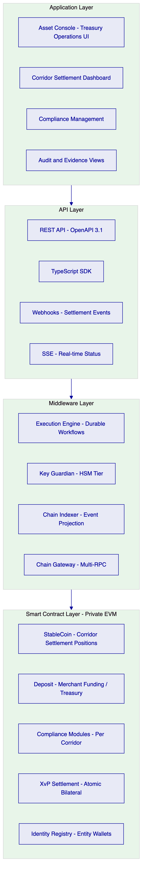
Figure 1: DALP Platform Architecture for M-Pesa Safaricom
    - 3.2 Key Capabilities for Mobile Payment Overlays
Settlement segregation: DALP operates as a separate settlement layer. The consumer-facing M-Pesa system calls DALP APIs to record and settle net positions; individual consumer transactions are not submitted as blockchain operations. This is a critical architectural boundary.
Atomic bilateral settlement (XvP): Corridor settlement requires simultaneous debit of one corridor position and credit of another. XvP's atomic mechanics guarantee no partial settlement state.
Per-corridor compliance: Each corridor carries its own compliance modules reflecting the specific regulatory requirements of the origin and destination country. Kenya-Tanzania corridor rules differ from Kenya-DRC rules. Configuration changes per-corridor without affecting others.
Telecom-grade audit: Every settlement operation is recorded on-chain with tamper-evident events accessible to CBK on demand. The Chain Indexer provides real-time queryable access without requiring raw blockchain queries.

  - 4. Understanding of Requirements
    - 4.1 M-Pesa's Operational Context
M-Pesa processes consumer payments at very high frequency, with each individual transaction handled by Safaricom's existing mobile money platform. The tokenized overlay operates on net settlement positions, not individual transactions. This architectural distinction is fundamental and must be reinforced throughout the implementation.
Consumer experience layer: Safaricom M-Pesa platform (unchanged). Individual transactions, wallet balances, USSD and app interfaces remain exactly as they are today.
Settlement layer (DALP scope): Net corridor settlement positions between M-Pesa operating entities and partner institutions. Merchant funding settlement obligations. Inter-entity treasury positions within Safaricom Group.
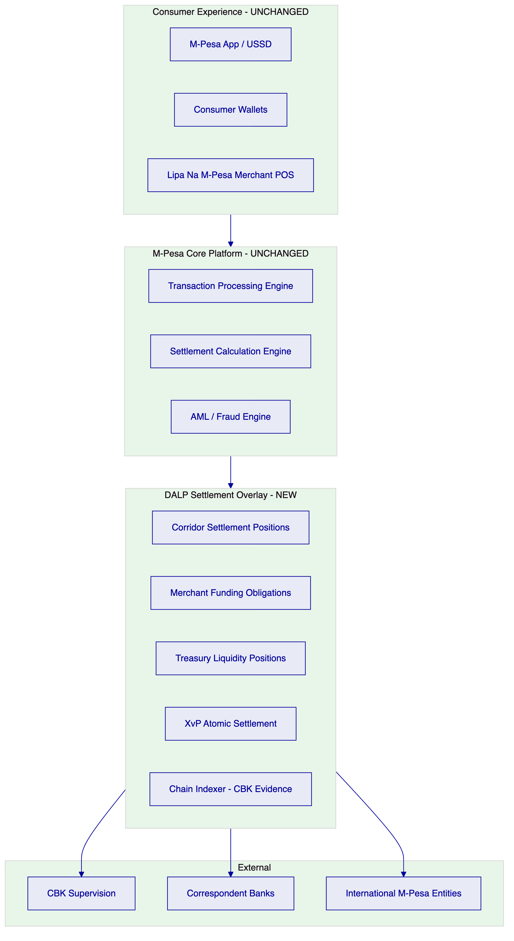
Figure 2: M-Pesa Architecture Positioning - Overlay Not Replacement
    - 4.2 Requirement Coverage
Requirement | Coverage | Notes
REQ-01: Environment segregation | Full | 5 environments
REQ-02: API-first | Full | OpenAPI 3.1, SDK, webhooks
REQ-03: RBAC, maker-checker, audit | Full | 26-role RBAC, approval module
REQ-04: Lifecycle controls | Full | Per-corridor token lifecycle
REQ-05: Dependencies | Full | Section 17
REQ-06: Resilience and DR | Full | Multi-AZ HA, degraded-mode support
REQ-07: Implementation plan | Full | 6-phase, Section 14
REQ-08: Audit evidence | Full | On-chain events, CBK-ready exports
REQ-14: Throughput and onboarding | Full | Batch settlement, entity onboarding
REQ-15: Tokenized/fiat reconciliation | Partial | On-chain settlement side; fiat via integration

    - 4.3 Key Challenges
Challenge 1: Consumer protection segregation. Ensuring consumer wallet balances are never at risk from settlement layer operations.
DALP response: DALP operates exclusively on net settlement positions held by M-Pesa treasury wallets. Consumer wallet data is not in DALP and consumer wallets are not participants in the settlement network. If the DALP settlement layer becomes unavailable, M-Pesa's existing correspondent banking settlement continues as fallback. Consumer payments are not blocked.
Challenge 2: CBK regulatory confidence. CBK must be able to inspect and audit the tokenized settlement layer before it touches live settlement flows.
DALP response: Phase 1 of implementation includes a CBK read-only access provision: CBK can query the Chain Indexer API for settlement events before the overlay becomes live. The phased rollout (Section 14) is designed with explicit CBK comfort gate before any corridor goes live.
Challenge 3: Corridor-by-corridor regulatory variation. Kenya-Tanzania corridors operate under different joint CBK-BoT supervision than Kenya-DRC or Kenya-Egypt corridors.
DALP response: Each corridor is a separate token. Each token carries its own compliance modules reflecting the specific regulatory requirements. Adding a new corridor or changing an existing corridor's compliance rules requires only configuration operations on the new or affected token, with no impact on other corridors.
Challenge 4: Merchant settlement timing. Lipa Na M-Pesa merchant settlement has specific timing requirements tied to merchant contract terms and CBK merchant fund safeguarding rules.
DALP response: The Deposit contract type with time lock and transfer approval compliance modules implements configurable settlement timing. Merchant settlement can be triggered automatically at configured times (e.g., T+1 at 23:00 EAT) or manually by treasury operations. All triggers are logged with the initiator identity.

  - 5. Proposed Solution and Functional Capabilities
    - 5.1 Overlay Architecture
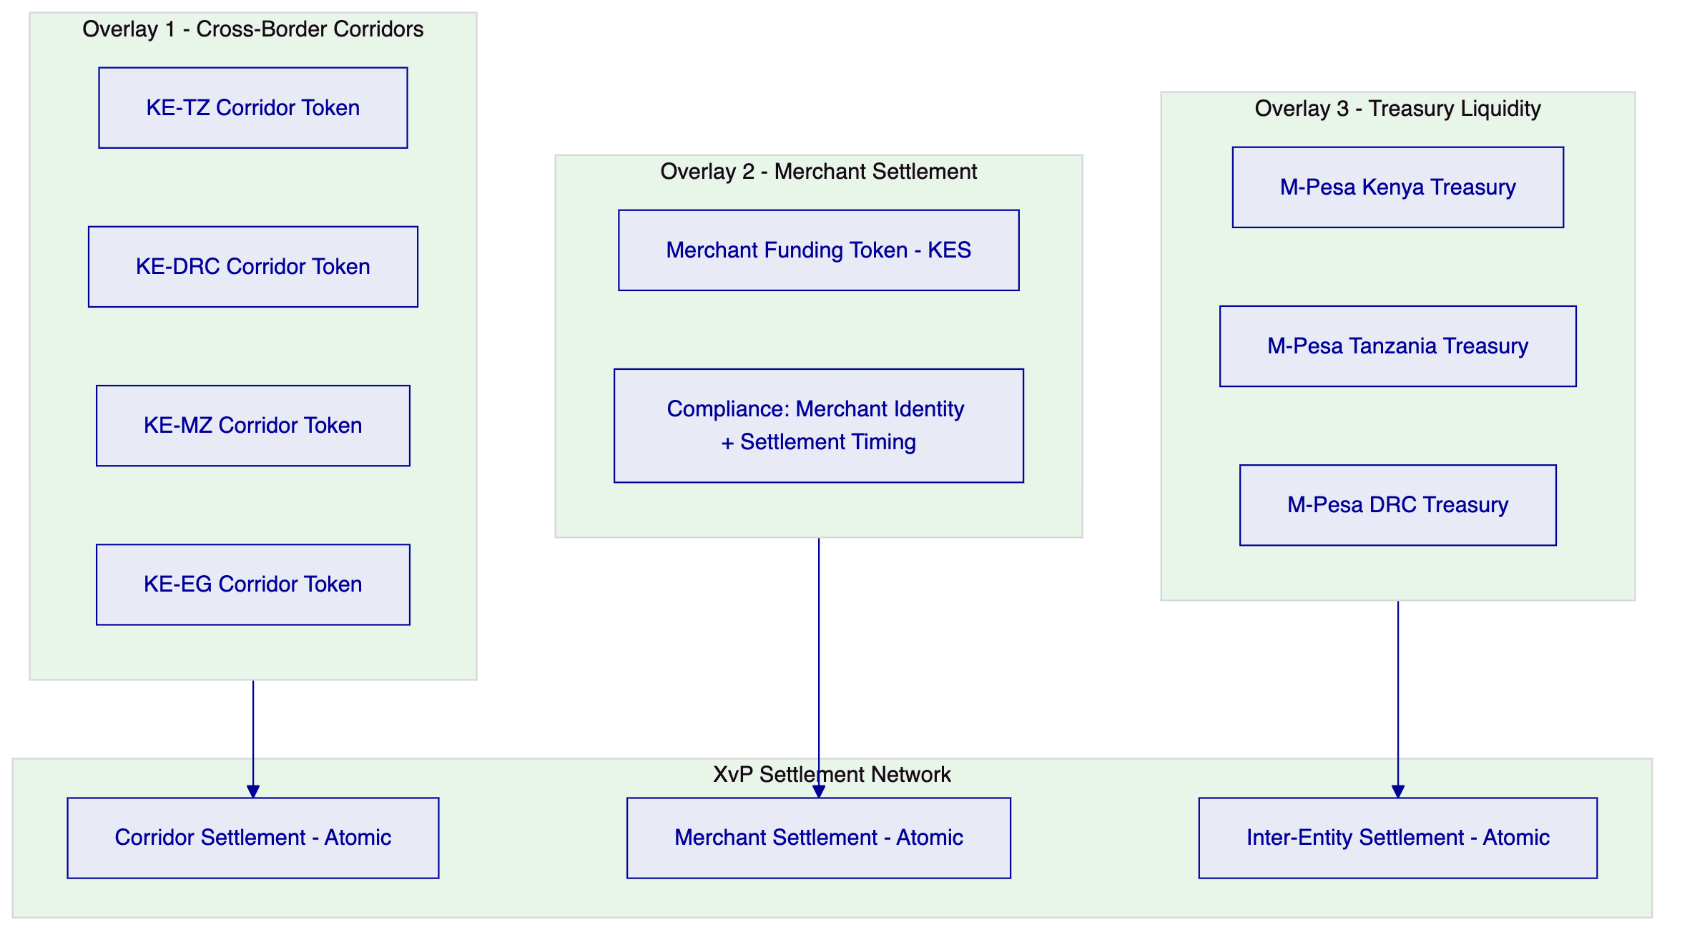
Figure 3: Three-Overlay Architecture
    - 5.2 Cross-Border Corridor Settlement Flow
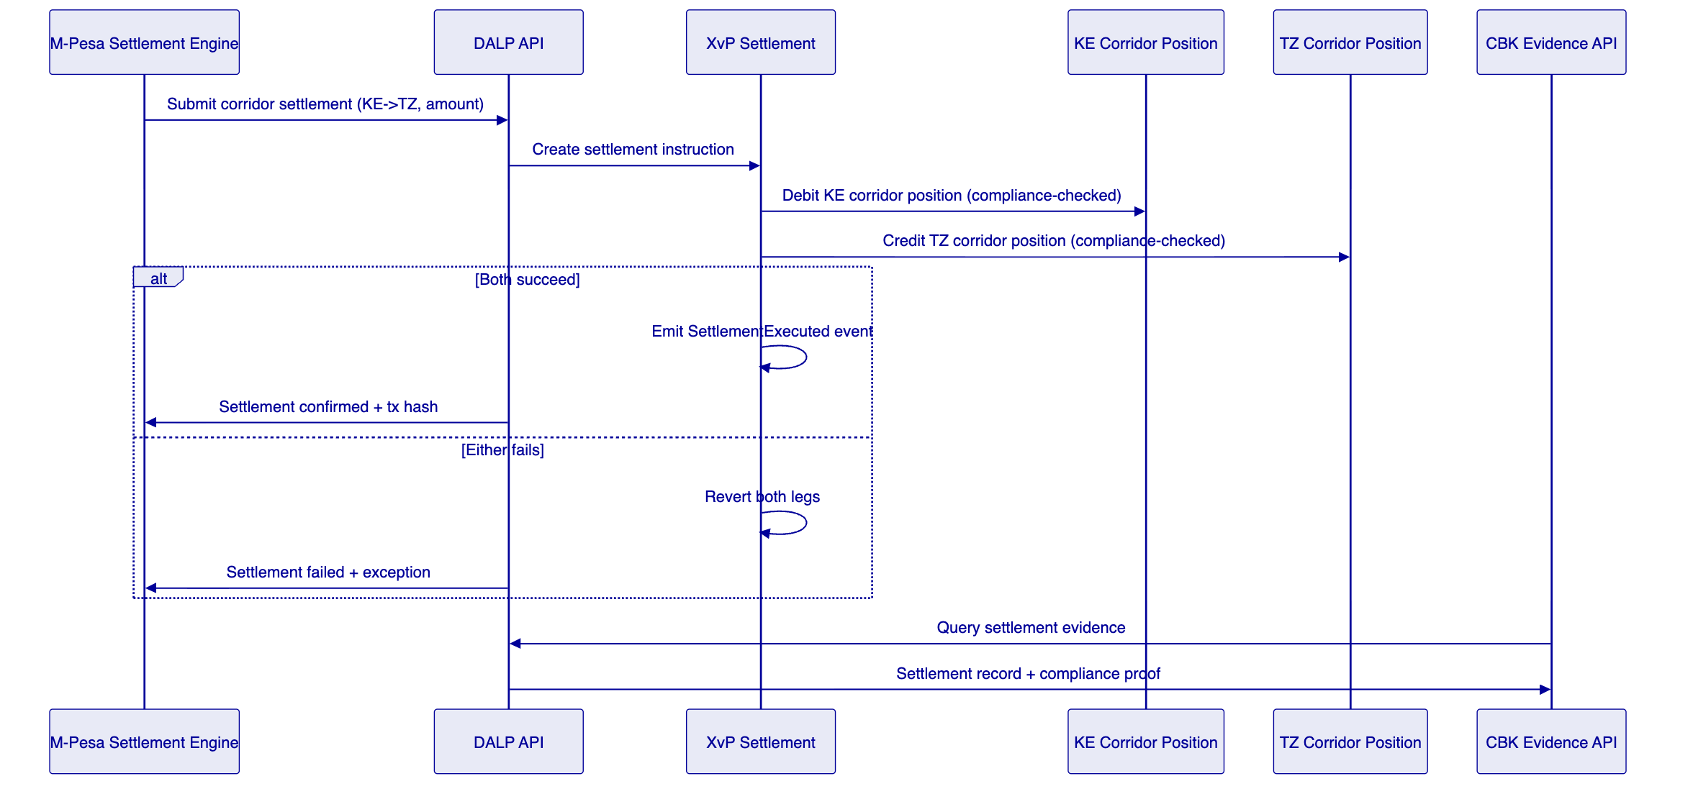
Figure 4: Cross-Border Corridor Settlement Flow
    - 5.3 Compliance Enforcement Per Corridor
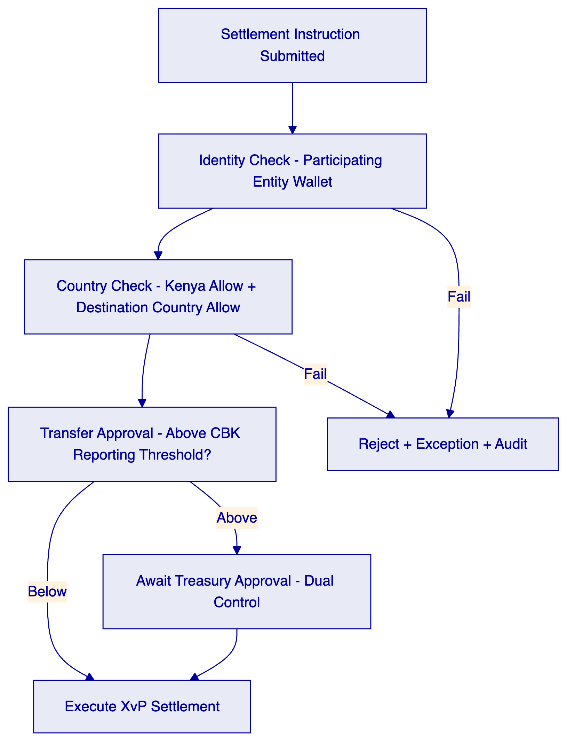
Figure 5: Compliance Enforcement Flow
    - 5.4 Token Issuance Flow
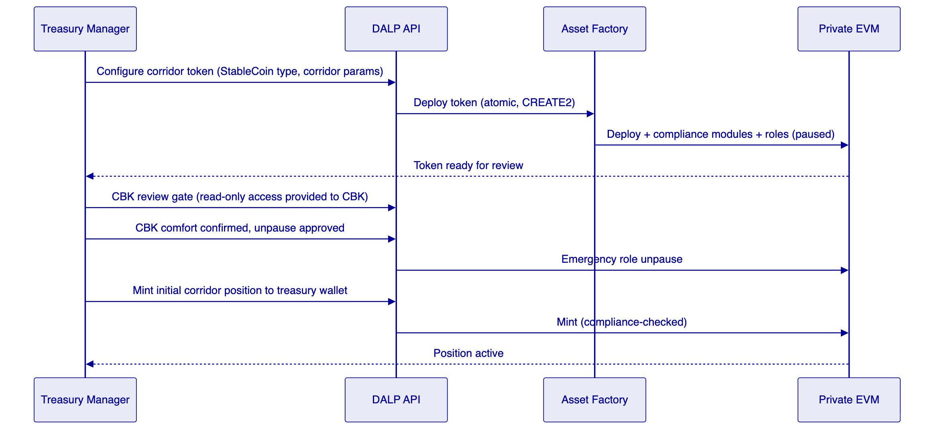
Figure 6: Corridor Token Deployment and CBK Approval Gate
    - 5.5 Merchant Settlement Flow
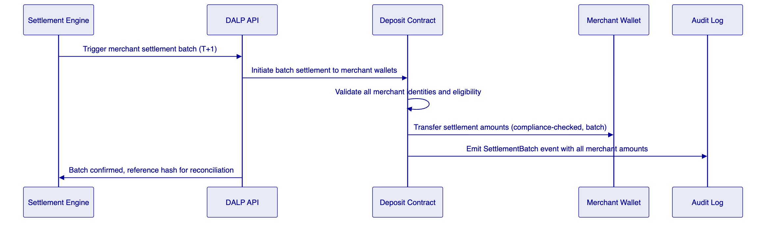
Figure 7: Merchant Settlement Batch Flow
    - 5.6 Functional Fit Matrix
Requirement | DALP Capability | Status
Cross-border corridor settlement | StableCoin + XvP per corridor | Full
Merchant treasury settlement | Deposit + batch transfer | Full
Treasury liquidity management | Bond/Deposit inter-entity positions | Full
CBK evidence production | Chain Indexer API (read-only CBK access) | Full
Per-corridor compliance rules | Per-token compliance module config | Full
Consumer experience segregation | Settlement layer only, no consumer wallet data | Full
Degraded-mode fallback | DALP failure does not block consumer payments | Full

  - 6. Platform Architecture
    - 6.1 Four-Layer Detail
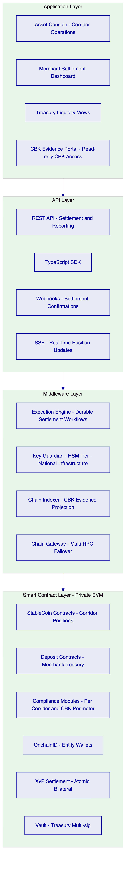
Figure 8: DALP Four-Layer Architecture for M-Pesa
    - 6.2 Degraded-Mode Architecture
DALP failure must not block M-Pesa consumer payments. The architecture implements this through:
- DALP settlement is additive to, not a replacement for, existing correspondent banking settlement
- M-Pesa's settlement engine detects DALP API unavailability and routes to conventional settlement fallback
- All in-flight DALP workflows complete via durable execution when DALP recovers; no settlement is lost
- Consumer wallet balances are never held in DALP contracts; consumer protection is independent of DALP availability
    - 6.3 Network Design
A private Hyperledger Besu network operated by Safaricom within Kenya-based infrastructure, with CBK read-only node access. Validator nodes distributed across Safaricom data centres (minimum 3 validators for IBFT 2.0 Byzantine fault tolerance). DALP connects to this network through the Chain Gateway service.

  - 7. Token and Asset Lifecycle
    - 7.1 Corridor Token Lifecycle
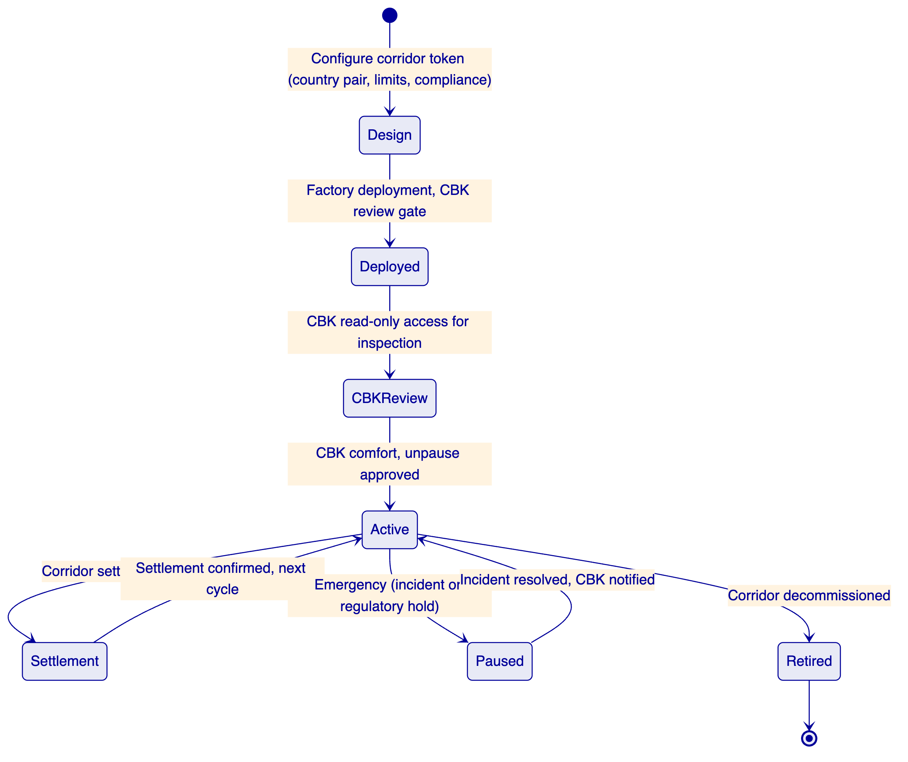
Figure 9: Corridor Token Lifecycle with CBK Gate

  - 8. Compliance and Regulatory Framework
    - 8.1 Kenyan Regulatory Context
Framework | Platform Control
CBK National Payments System Act | Settlement position governance, audit trail for CBK inspection, reporting API
CBK Guidance on Digital Currency | Permissioned settlement utility characterisation, not public crypto
Data Protection Act 2019 | Kenya-region data deployment, access logging, retention controls
Proceeds of Crime and Anti-Money Laundering Act | AML identity verification, address block list for sanctioned entities
Capital Markets Act | Applicable characterisation if instruments have capital markets features
CBK Consumer Protection Framework | Consumer funds never in DALP layer (segregation architecture)

    - 8.2 Cross-Corridor Regulatory Matrix
Corridor | Origin Regulator | Destination Regulator | Specific Controls
Kenya-Tanzania | CBK | Bank of Tanzania | Joint oversight, country allow lists for both
Kenya-DRC | CBK | BCC (Banque Centrale du Congo) | FX controls, country allow list
Kenya-Mozambique | CBK | Banco de Mozambique | Corridor-specific limits
Kenya-Egypt | CBK | Central Bank of Egypt | EGP/KES pair, country controls
Kenya-Ethiopia | CBK | NBE | Strict FX regime, enhanced controls

    - 8.3 CBK Evidence Architecture
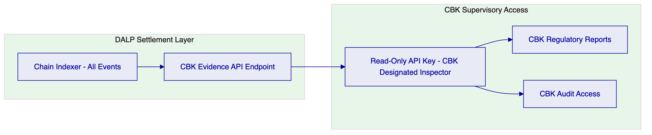
Figure 10: CBK Evidence Architecture - Read-Only Supervisory Access
CBK receives a read-only API key scoped to the Chain Indexer API. This key provides access to all settlement events, compliance decision records, and position history. CBK can query by corridor, date range, amount, or entity. The API returns structured JSON suitable for CBK's internal reporting systems. No CBK staff require Asset Console access; evidence is available through API alone.

  - 9. Security Architecture
    - 9.1 Security Model
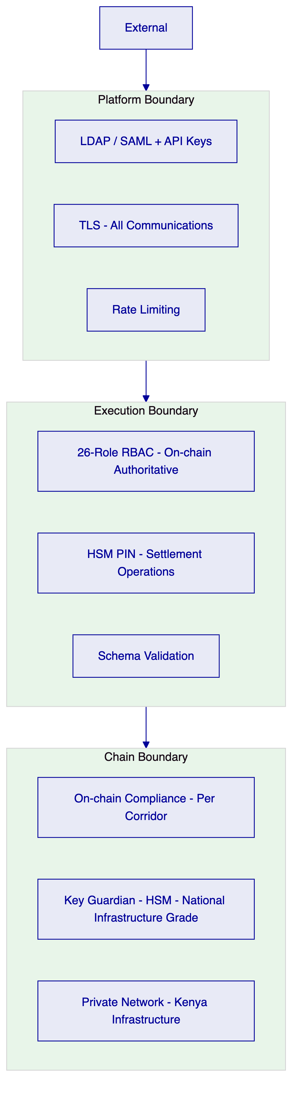
Figure 11: Security Architecture - HSM Tier for National Infrastructure
    - 9.2 Key Management
For M-Pesa's national infrastructure status, SettleMint recommends HSM-backed key management (FIPS 140-2 Level 3) for all treasury settlement wallets. This ensures signing keys for settlement operations never leave hardware security boundaries within Kenya-based infrastructure. This is the same key management tier used by central banks in SettleMint's prior deployments.
    - 9.3 Audit Trail
Every settlement operation, compliance decision, and role change is recorded on-chain in the private Kenyan blockchain network. The Chain Indexer provides queryable access to these records. CBK's read-only API key provides direct, auditor-accessible evidence without requiring SettleMint or Safaricom intermediation.
    - 9.4 Security Responsibility Matrix
Control | SettleMint | Safaricom M-Pesa
Platform patching | Quarterly + critical | Apply on schedule
HSM management | Key Guardian service | HSM hardware, physical security
Private network security | Chain Gateway, DALP services | Validator nodes, network infrastructure
CBK read-only access | API key scoping | CBK inspector credential management
Consumer protection | Settlement layer segregation | Consumer wallet security
AML enforcement | Block list enforcement on-chain | AML screening engine

  - 10. Integration Architecture
    - 10.1 Integration Overview
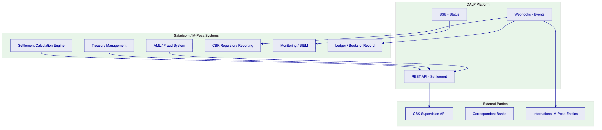
Figure 12: Integration Architecture
    - 10.2 Settlement Engine Integration
M-Pesa's settlement calculation engine submits net settlement instructions to DALP API after each settlement cycle calculation. The integration is synchronous REST: submit instruction, receive confirmation or failure with exception details. Webhooks provide settlement confirmation events to M-Pesa's ledger system for reconciliation.
    - 10.3 Degraded-Mode Integration
The integration design explicitly handles DALP unavailability:
- Settlement engine detects DALP API timeout or error response
- Settlement engine routes to conventional correspondent banking settlement as fallback
- DALP resumes processing when available; in-flight workflows complete via durable execution
- Reconciliation identifies which settlements went through DALP and which through conventional routes
- No consumer payments are delayed due to DALP layer unavailability

  - 11. Deployment Architecture
    - 11.1 Kenya-Based Deployment
All DALP infrastructure is deployed within Kenya-based data centres operated by Safaricom, satisfying Data Protection Act 2019 requirements for Kenyan personal data and CBK's requirement for Kenya-based critical payment infrastructure.
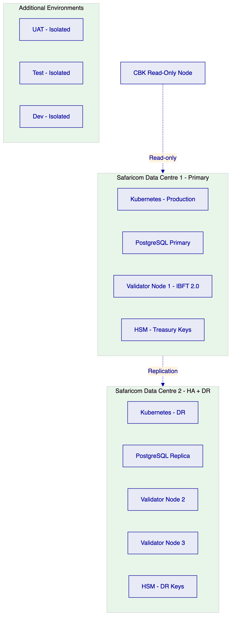
Figure 13: Kenya-Based Deployment Architecture
    - 11.2 Environment Segregation
5 fully isolated environments: development, test, UAT, DR, production. No environment shares data with any other. Secrets, keys, and blockchain networks are environment-specific.
    - 11.3 HA and DR Parameters
Scenario | RTO | RPO
Single DC failure (multi-DC HA) | 5-20 minutes | Seconds to 1 minute
DALP layer failure (fallback to conventional) | Consumer: zero impact; Settlement: 5-30 minutes | Per durable workflow recovery

  - 12. Data Management and Governance
    - 12.1 Data Residency
Data Protection Act 2019 (Kenya) requires that personal data of Kenyan data subjects be stored in Kenya or in countries with adequate protection. All DALP data (including entity identity claims, settlement events, and application audit logs) is stored in Safaricom-operated Kenya-based data centres. No data crosses to international infrastructure without explicit Safaricom approval.
    - 12.2 Consumer Data Boundary
Consumer personal data is not in the DALP layer. DALP operates on treasury entity wallets (M-Pesa treasury, correspondent banks, international M-Pesa entities). Consumer wallet addresses are never submitted to DALP. This boundary is a structural property of the architecture, not a configuration option.

  - 13. Operational Model and Governance
    - 13.1 Operating Model
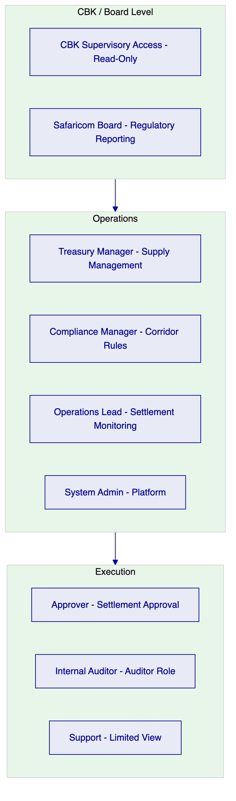
Figure 14: Operational Role Hierarchy
    - 13.2 Daily Governance
Per settlement cycle: Settlement batch submission, confirmation monitoring, exception queue review, CBK reporting queue check.
Daily: Exception resolution, reconciliation of DALP settlement records vs ledger system, CBK threshold report generation.
Weekly: Entitlement recertification, corridor compliance review, capacity and performance review.
Monthly: Full compliance module configuration review, CBK regulatory report submission, incident trend analysis, management reporting.

  - 14. Implementation Plan
    - 14.1 Phased Implementation
The implementation is designed to earn CBK confidence at each gate before proceeding.
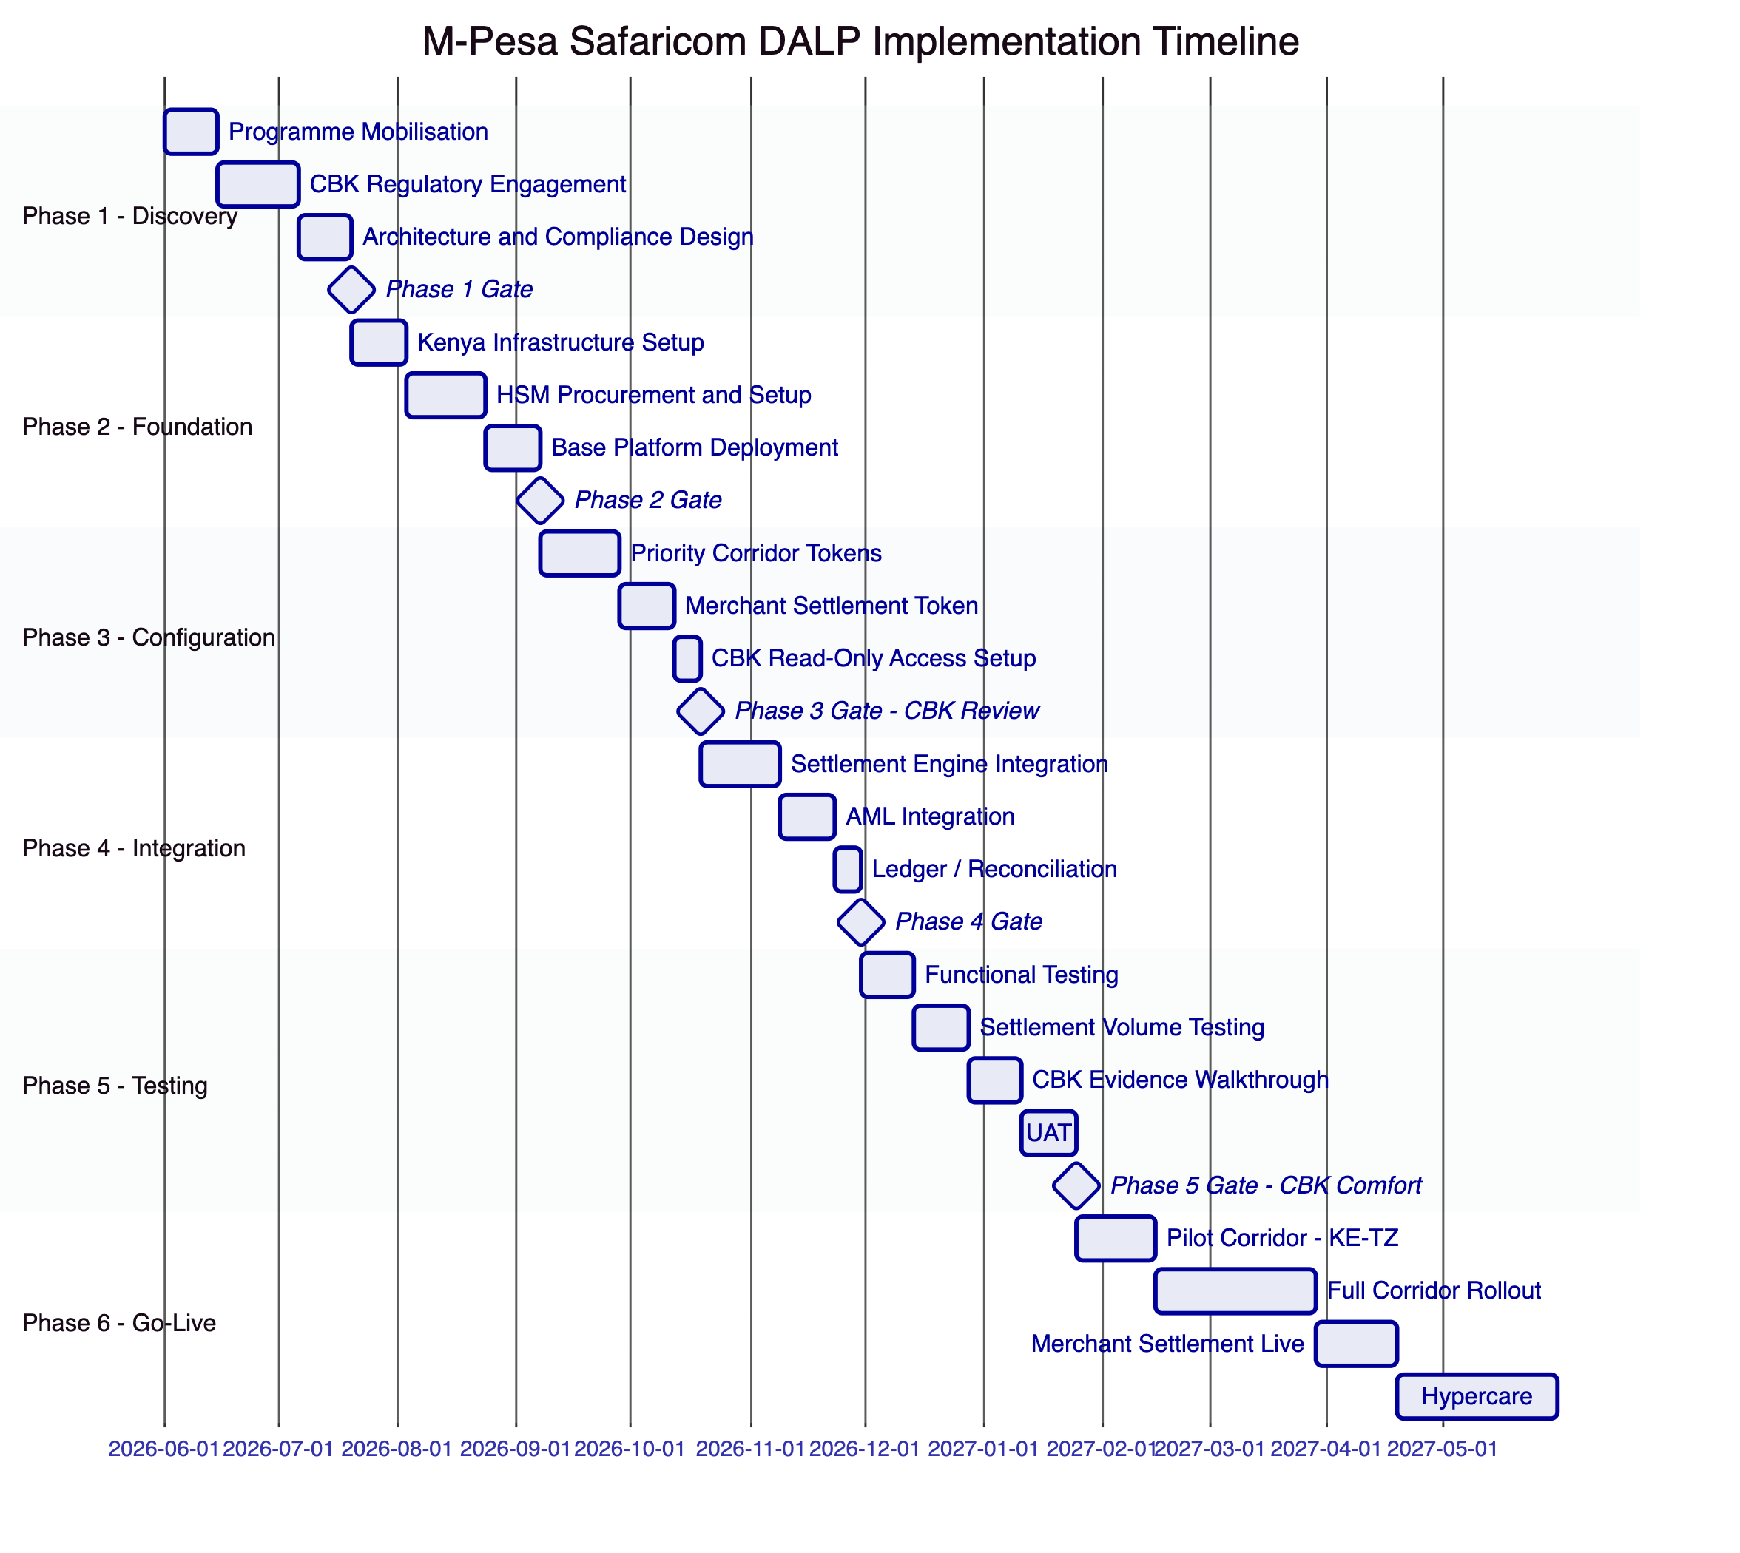
Figure 15: Implementation Timeline with CBK Gates
    - 14.2 Phase Descriptions
Phase 1 (7 weeks): Programme mobilisation, CBK regulatory engagement (initial briefing, proposed structure presentation, supervisory approach discussion), corridor architecture design, Kenya Data Protection Act mapping.
Phase 2 (7 weeks): Kenya-based Safaricom data centre infrastructure provisioning, HSM procurement and installation, private Besu network setup with minimum 3 validators, base DALP deployment.
Phase 3 (6 weeks): Priority corridor tokens deployed (KE-TZ first, then KE-DRC, KE-MZ), merchant settlement token deployed, CBK read-only access configured and tested. Phase 3 gate includes CBK technical review of the deployed but inactive settlement layer.
Phase 4 (6 weeks): Settlement engine integration, AML engine integration (block list updates, identity claims), ledger and reconciliation feed integration.
Phase 5 (8 weeks): Full functional testing, settlement volume testing (capacity for Safaricom's settlement cycle volumes), CBK evidence walkthrough (CBK team reviews audit trail quality), UAT with treasury and operations teams. Phase 5 gate includes CBK written comfort before production launch.
Phase 6 (20 weeks): Pilot launch with KE-TZ corridor only, full corridor rollout on two-week cadence, merchant settlement live after corridor rollout confirmed stable, hypercare.

  - 15. Support and SLA
    - 15.1 Support Recommendation
For national payment infrastructure, 24/7 Premium support is required with no exception.
Feature | Premium
Annual cost | $85,000
Coverage | 24/7/365
P1 response | 1 hour
P2 response | 4 hours
Named support lead | Yes
Quarterly CBK evidence pack reviews | Included

    - 15.2 Severity Matrix
Severity | Definition | Response | Resolution
P1 | Settlement layer failure (consumer fallback activated) | 1 hour | 4 hours
P2 | Settlement delayed, compliance workflow blocked | 4 hours | 24 hours
P3 | Non-critical, fallback not required | 8 hours | 72 hours
P4 | Enhancement, documentation | Next business day | Roadmap

  - 16. References and Experience
SettleMint's directly relevant references include: wholesale CBDC infrastructure for central banks, national payment infrastructure tokenization, and multi-corridor settlement platforms. The company's experience with CBK-equivalent regulatory engagement (Bank of England, Swiss National Bank, Central Bank of Bahrain) provides directly applicable evidence of supervisory confidence-building methodology. Reference details available under NDA.

  - 17. Third-Party Dependencies
Component | Provider | Type | Substitution
Blockchain | Hyperledger Besu (open source) | Infrastructure | Any EVM network
HSM | Thales / Safenet or equivalent | Key management | Alternative FIPS-certified HSM
Kubernetes | On-premises in Safaricom DCs | Runtime | Self-managed
Execution engine | Restate (open source) | Workflow | Self-hosted
Database | Self-managed PostgreSQL | Database | Cloud-managed if preferred

  - Appendix A: Requirement Response Matrix
Req ID | Summary | Status | Capability
REQ-01 | Environment segregation | Full | 5 isolated environments
REQ-02 | API-first | Full | OpenAPI 3.1, SDK, webhooks, SSE
REQ-03 | RBAC, maker-checker, audit | Full | 26-role RBAC, approval, on-chain audit
REQ-04 | Lifecycle controls | Full | Per-corridor token lifecycle
REQ-05 | Dependencies | Full | Section 17
REQ-06 | Resilience and DR | Full | Multi-DC HA, degraded-mode for consumer protection
REQ-07 | Implementation | Full | 6-phase with CBK gates
REQ-08 | Audit evidence | Full | On-chain events, CBK read-only API
REQ-14 | Throughput and onboarding | Full | Batch settlement operations
REQ-15 | Tokenized/fiat reconciliation | Partial | On-chain side; fiat via settlement engine integration

  - Appendix B: Regulatory Mapping
Regulation | DALP Control
CBK National Payments System Act | Settlement finality, audit trail, CBK read-only API evidence
CBK Digital Currency Guidance | Permissioned network, payment utility not speculative asset
Data Protection Act 2019 | Kenya-based deployment, access logging, retention controls
Proceeds of Crime and AMLA | AML identity verification, block list for sanctioned entities
CBK Consumer Protection Framework | Consumer segregation: consumer wallet data not in DALP
Country-specific corridor regulations | Per-corridor compliance module configuration

  - Appendix C: Security and Resilience Evidence
ISO 27001 and SOC 2 Type II certifications. Available to shortlisted bidders under NDA: architecture security review, HSM integration documentation, penetration test summary, DR test reports, incident response process, CBK evidence demonstration pack.

This document is classified SettleMint Confidential. Distribution is restricted to authorised M-Pesa Safaricom procurement personnel.

